SUNDAY AT VESPERS

Our Father. Hail, Mary. silently . Then is said aloud:
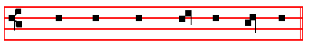
O GOD, make speed to save me.
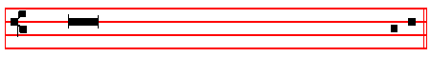
 O Lord, make haste to help me.
 Glory be to the Father, and to the Son, and to the Ho - ly Ghost.
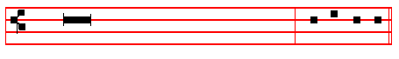
R/. As it was in the beginning, is now,
and ever shall be, world without end. Amen. Al - le - lu- ia or
Praise be to thee, O Lord, King of eternal glory, according to the season.

Antiphon. Tone vij, 4
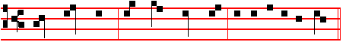 The Lord said * un – to my Lord. E u o u a e.

In Eastertide, Antiphon. Tone vij, 4
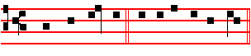
Al - le - lu - ia. E u o u a e.
Under which one Antiphon are said all the Psalms of Vespers, both on Sundays and on Ferias.

Ps. 110 Dixit Dominus CIX

201
THE Lord said unto my Lord * Sit thou on my right hand, until I make thine enemies thy footstool.
2 The Lord shall send the rod of thy power out of Syon * be thou ruler, even in the midst among thine enemies.
3 In the day of thy power shall the people offer thee free-will offerings with an holy worship * the dew of thy birth is of the womb of the morning.
4 The Lord sware, & will not repent * Thou art a Priest for ever after the order of Melchisedech.
5 The Lord upon thy right hand * shall wound even kings in the day of his wrath.
6 He shall judge among the heathen * he shall fill the places with the dead bodies; and smite in sunder the heads over divers countries.
7 He shall drink of the brook in the way * therefore shall he lift up his head.

Antiphon.
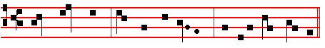
The Lord said un - to my Lord, Sit thou on my right hand.

Antiphon. Tone iv, 3.
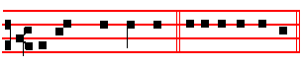
All his comandments. E u o u a e.

Ps. 111 Confitebor tibi CX

I WILL give thanks unto the Lord with my whole heart * secretly among the faithful, and in the congregation.
2 The works of the Lord are great * sought out of all them that have pleasure therein.
3 His work is worthy to be praised, and had in honour * and his righteousness endureth for ever.
4 The merciful and gracious Lord hath so done his marvellous works * that they ought to be had in rernembrance.
5 He hath given meat unto them that fear him * he shall ever be mindful of his

202
covenant.
6 He hath shewed his people the power of his works * that he may give them the heritage of the heathen.
7 The works of his hands are verity and judgement * all his commandments are true.
8 They stand fast for ever and ever * and are done in truth and equity.
9 He sent redemption unto his people * he hath commanded his covenant for ever; holy & reverend is his Name.
10 The fear of the Lord is the beginning of wisdom * a good understanding have all they that do thereafter; the praise of it endureth for ever.
Antiphon.
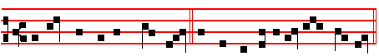
All his commandments are true: they stand fast for ever and ev - er.

Antiphon.. Tone iv, 3.
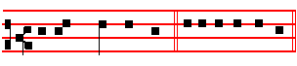
He hath great de - light. E u o u a e.

Ps. 112 Beatus vir CXI

BLESSED is the man that feareth the Lord * he hath great delight in his commandments.
2 His seed shall be mighty upon earth * the generation of the faithful shall he blessed.
3 Riches and plenteousness shall be in his house * and his righteousness endureth for ever.
4 Unto the godly there ariseth up light in the darkness * he is merciful, loving, and righteous.
5 A good man is merciful, and lendeth * and will guide his words with discretion.

6 For he shall never he moved * and the righteous shall be had in everlasting remembrance.
203
7 He will not be afraid of any evil tidings * for his heart standeth fast, and believeth in the Lord.
8 His heart is established, and. will not shrink * until he see his desire upon his enemies.
9 He hath dispersed abroad, and given to the poor * and his righteousness remaineth for ever ; his horn shall be exalted with honour.
10 The ungodly shall see it, and it shall grieve him * he shall gnash with his teeth, and consume away ; the desire of the ungodly shall perish.
Antiphon.
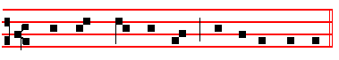
He hath great de – light in his commandments.
Antiphon.. Tone vij, 1.
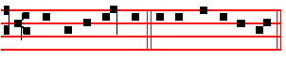
Blessed be the Name. E u o u a e.

Ps. 113 Laudate, pueri CXII

PRAISE the Lord, ye servants * O praise the Name of the Lord.
2 Blessed be the Name of the Lord * from this time forth for evermore.
3 The Lord's Name is praised * from the rising up of the sun unto the going down of the same.
4 The Lord is high above all heathen * and his glory above the heavens.
5 Who is like unto the Lord our God, that hath his dwelling so high * and yet humbleth himself to behold the things that are in heaven and earth ?
6 He taketh up the simple out of the dust * and lifteth the poor out of the mire.

7 That he may set him with the princes * even with the princes of his people.
8 He maketh the barren woman to keep house * and to be a joyful mother of children

Antiphon.
204
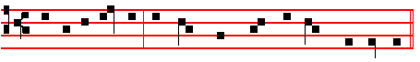
Blessed be the Name of the Lord for ev – er and ev - er.

Antiphon. Irregular or PeregrineTone
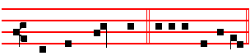
But we who live. E u o u a e

Ps. 114 In exitu Israel CXIII

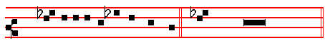
WHEN Israel came out of E-gypt * and the house of Jacob from among

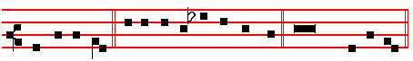
the strange people.2 Juda was his sanctu- ar- y * and Israel his dominion.

3 The sea saw that, and fled * Jordan was driven back.

4 The mountains skipped like rams * and the little hills like young sheep.

5 What aileth thee, O thou sea, that thou fleddest * and thou Jordan, that thou wast driven back?

6 Ye mountains, that ye skipped like rams * and ye little hills like young sheep ?

7 Tremble, thou earth, at the presence of the Lord * at the presence of the God of Jacob.
8 Who turned the hard rock into a standing water * and the flintstone into a
springing well.

205
Psalm 115 continues here without Glory be CXIV, 9

NOT unto us, O Lord, not unto us, but unto thy Name give the praise * for thy loving mercy, and for thy truth's sake.
2 Wherefore shall the heathen say * Where is now their God ?

3 As for our God, he is in heaven * he hath done whatsoever pleased him.

4. Their idols are silver and gold * even the work of men's hands.

5 They have mouths, and speak not * eyes have they, and see not.

6 They have ears, and hear not * noses have they, and smell not.
7 They have hands, and handle not ; feet have they, and walk not * neither speak they through their throat.
8 They that make them are like unto them * and so are all such as put their trust in them.
9 But thou, house of Israel, trust thou in the Lord * he is their succour and defence.
10 Ye house of Aaron, put your trust in the Lord * he is their helper and defender.
11 Ye that fear the Lord, put your trust in the Lord * he is their helper and defender.
12 The Lord hath been mindful of us, & he shall bless us * even he shall bless the house of Israel, he shall bless the house of Aaron.
13 He shall bless them that fear the Lord * both small and great.

14 The Lord shall increase you more and more * you and your children.

15 Ye are the blessed of the Lord * who made heaven and earth.

16 All the whole heavens are the Lord's * the earth hath he given to the children of men.

17 The dead praise not thee, O Lord * neither all they that go down into silence.

18 But we will praise the Lord * from this time forth for evermore. Praise the Lord.

206
Antiphon.
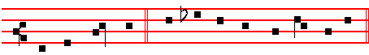
But we who live from this time forth will praise the Lord.
In Eastertide, Antiphon.
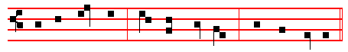
Al - le - lu - ia, al - le - lu - ia, al - le - lu - ia.
Chapter 2 Cor.1
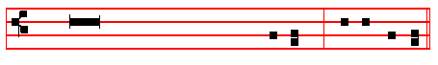
BLESSED be God, even the Father of our
Lord Jesus Christ, the Father of mercies,
and the God of all comfort, who comforteth
us in all our tribu- la-tion. R/.Thanks be to God.

HYMN E.H.51 Lucis Creator optime. Mode viij.
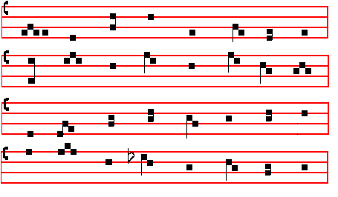

207
O BLEST Creator of the light, 3 Lest, sunk in sin, and whelm'd with strife,
Who mak’st the day with radiance bright, They lose the gift of endless life ;
And o'er the forming world didst call While thinking but the thoughts of time,
The light from chaos first of all; They weave new chains of woe and crime.
2 Whose wisdom joined in meet array 4 But grant them grace that they may strain
The morn and eve, and named them Day. The heavenly gate and prize to gain:
Night comes with all its darkling f'ears: Each harmful lure aside to cast,
Regard thy people's prayers and tears, And purge away each error past
5 O Father, that we ask be done,
Through Jesus Christ, thine only Son;
Who, with the Holy Ghost and thee.
Doth live and reign eternally.

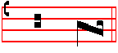
A - - men.
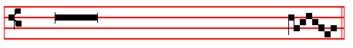 Let our prayer be set forth, O Lord.
 In thy sight as the in - cense.
The above hymn with its  is said from the second Sunday after Epiphany until the first Sunday of Lent, and from the third Sunday after Pentecost until Advent.
The Chapter above is said on the same Sundays after Epiphany until Septuagesima only, and on the same Sundays after Pemtecost. It is said also in the ferial Office from the Octave of the Epiphany until the first Sunday of Lent, and from the Octave of Pentecost until Advent.Likewise also the 
But the Antiphons with the Psalms are always said as above, when it is the Office of Sunday, excepting the Sundays of Advent which have proper Antiphons.

On Magnificat, Proper Antiphon.

THE SONG OF THE BLESSED VIRGIN MARY

208

Luke 1 Magnificat Tone j, 1.
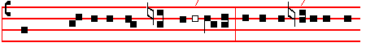MY soul doth mag-ni-f/y the Lord * and my spi/rit hath re -
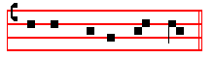
-joiced in God my Sa - viour.
Tone ij.
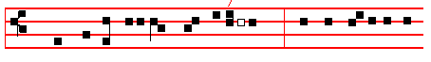
 MY soul doth magnif/y the Lord * and my spi / rit hath re-
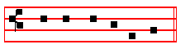
-joiced in God my Sa –viour.
Tone iij, 1.
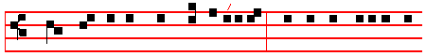
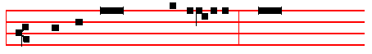
 MY soul doth m/agnify the Lord * and my spirit hath re-
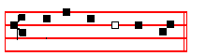
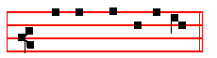
-joiced in God my Saviour.
Tone iv.
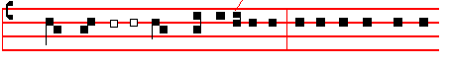
MY soul doth magnif/y the Lord * and my spirit hath re-

209

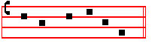
-joiced in God my Saviour.

Tone v.
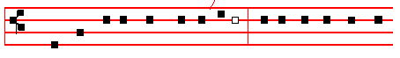
MY soul doth mag- ni – fy the Lord * and my spirit hath re-
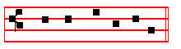
-joiced in God my Saviour.
Tone vj.
MY soul doth mag- nify the Lord* and my sp/irit hath re-
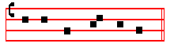
-joiced in God my Saviour.
Tone vij, 1.
+MY soul doth magnify the Lord * and my spirit hath rejoiced
in God my Sav-iour.

Tone viij,1.

210
+MY soul doth magnif/y the Lord * and my sp/irit hath re-
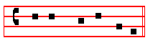
-joiced in God my Saviour.
12468 37 5/ 4 15678 23
*2 For he hath re-gard-ed : * the 1owliness of his hand-maiden.
12468 37 5/ / 4 15678 23
*3 For be - hold, from. hence-forth : * all generations shall call me blessed.
12468 37 / 5 47 1568 23
4 For he that is mighty hath magni-fi-ed me : * and ho -ly is his Name.
12468 37 5 / 4 15678 23
5 And his mercy is on them that fear him : * throughout all ge - ne-rations.
12468 37 / 5 /
6 He hath shew – ed strength with his arm : * he hath scattered the proud in the
47 1568 23
imagi-na-tion of their hearts.
12468 37 / 5 / 15678 23
7 He hath put down the mighty from their seat : * and hath exalted the hum-ble

and meek.
16 23478 / 5 / 4 68 157 23
8 He hath filled the hun-gry with good things : * and the rich he hath sent emp–ty

a-way.
12468 37 5 / /
9 He, remembering his mercy, hath holpen his servant Is-ra-el : * as he promised
4 15678 23
to our forefathers, Abraham and his seed for ever.
16 23478 / 5 4 15678 23
Glory be to the Fa- ther, and to the Son : * and to the Holy Ghost.
12468 37 5/ 4 15678 23
As it was in the beginning, is now, and ever shall be: * world with – out end.

Amen.
Then is said the proper Antiphon and Collect:

__________________________________________________________________
* The Intonation is omitted in these verses.
211
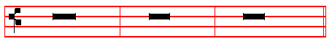 V/.The Lord be with you. R/. And with thy spirit. V/.Let us pray
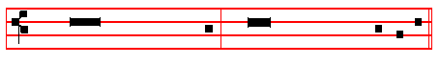
Through Jesus Christ, thy Son, our Lord: who .. unity of the Holy Ghost,
world without end. R/. Amen. (but on Simples and ferias, on one note.)
Then, if there occur on that day any simple feast, commemoration is made of it.
Finally, (if the season require it) the commemorations are made of S. Mary, of the Apostles, and of the patron of the Church in order among the other commemorations according to its dignity, and in the last olace of Peace, as below in Vespers of Saturday. Then is said:
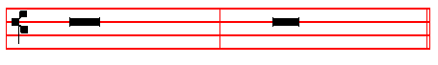V/. The Lord be with you. R/. And with thy spirit.
1. On a solemn Feast. (Double of the I Class)
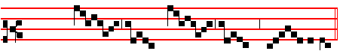
V/. Let us bless the Lord.
R/. Thanks be to God.
2. Of the Blessed Virgin and throughout the whole Octave of Corpus Christi and of her Nativity. 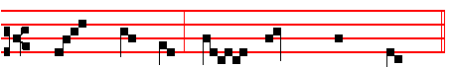
V/. Let us bless the Lord.
R/. Thanks be to God.
3. Of Apostles, and on Double Feasts.
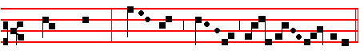
V/. Let us bless the Lord.
212
R/. Thanks be to God.
4. Of Sunday throughout the whole year, on semidouble Feasts, and within Octaves, which are not of the Blessed Virgin Mary.

V/. Let us bless the Lord.
R/. Thanks be to God.

5. In Eastertide, beginning from Vespers of Holy Saturday until Vespers of the following Saturday exclusively.
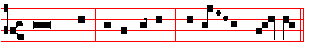
V/. Let us bless the Lord, al- le – lu - ia, al- le - - lu - ia.
R/. Thanks be to God, al- le - lu – ia, al- le - - lu - ia.

6. On simple Feasts at Matins, Lauds, and Vespers.

V/. Let us bless the Lord.
R/. Thanks be to God.
7. In the ferial Office throughout the whole year at Vespers, Matins, and Lauds. 
V/. Let us bless the Lord.
R/. Thanks be to God.

V/.May the souls of the faithful, through the mercy of God, rest in peace.R/. Amen.

213
MONDAY AT VESPERS

Our Father. Hail, Mary. I believe. O God, make speed, as above, p. 201.
Antiphon. The Lord hath inclined.

Ps. 116 Dilexi, quoniam CXIV
I AM well pleased * that the Lord hath heard the voice of my prayer.
2 That he hath inclined his ear unto me * therefore will I call upon him as long as I live.
3 The snares of death compassed me round about * and the pains of hell gat hold upon me.
4 I shall find trouble and heaviness, and I will call upon the Name of thc Lord : * O Lord, I beseech thee, deliver my soul.
5 Gracious is the Lord, and righteous : * yea, our God is merciful.

6 The Lord preserveth the simple : * I was in misery, and he helped me.

7 Turn again then unto thy rest, O my soul: * for the Lord hath rewarded thee.

8 And-why thou hast delivered my soul from death: * mine eyes from tears,
and my feet from falling.
9 I will walk before the Lord: * in the land of the living.

Antiphon. The Lord hath inclined his ear.
Antiphon. I believed.

Ps. 116, v.10 Credidi CXV
10 I BELIEVED, and therefore will I speak; but I was sore troubled : * I said in my haste, All men are lialrs.
11 What reward shall I give unto the Lord: * for all the benefits that he hath done unto me ?
12 I will receive the cup of salvation : * and call upon the Name of the Lord.

13 I will pay my vows now in the presence of all his people: * right dear in the sight of the Lord is the death of his saints.

214
14 Behold, O Lord, how that I am thy servant : * I am thy servant, and the son of thine handmaid; thou hast broken my bonds in sunder.
15 I will offer to thee the sacrifice of thanksgiving : * and will call upon the Name of the Lord,
16 I will pay my vows unto the Lord, in the sight of all his people : * in the courts of the Lord's house, even in the midst of thee, O Jerusalem. Praise the Lord.

Antiphon. I believed, and therefore will I speak.
Antiphon. Praise.
Ps. I 17 Laudate Dominun CXVI
O PRAISE the Lord, all ye heathen : * praise him, all ye nations.
2 For his merciful kindness is ever more and more towards us : * and the truth of the Lord endureth for ever. Praise the Lord.

Antiphon. Praise the Lord, a1l ye heathen.

(Psalm 118 Confitemini Domino, Sunday at Prime. p. 23)
(Psalm 119 Beati immaculati, at Prime, .p.2,. Terce, p.49,
Sext, p.1, and None, p.6)

Antiphon. I called.

GRADUAL PSALM Ps. 120 Ad Dominum CXIX
W HEN I was in trouble I called upon the Lord: * and he heard me.
2 Deliver my soul, O Lord, from lying lips: * and from a deceitful tongue.

3 What reward shall be given or done unto thee, thou false tongue: * even mighty and sharp arrrows, with hot burning coals.
4 Wo is me, that I am constrained to dwell with Mesech : * and to have my habitation among the tents of Cedar.
5 My soul hath long dwelt among thcm : * that are enemies unto peace.

6 I labour for peace, but when I speak unto them thereof: * they make them ready to battle.

Antiphon. I called, and he heard me.
Antiphon. From whence.

215
Ps 121 Levavi oculos CXX
I WILL 1ift up minle eyes unto the hills: * from whence cometh my help.
2 My help cometh even from the Lord: * who hath made heaven and earth.

3 He will not suffer thy foot to be moved : * and he that keepeth thee will not sleep.
4 Behold, he that keepeth Israel : * shall neither slumber nor sleep.

5 The Lord himself is thy keeper : * the Lord is thy defence upon thy right hand;

6 So that the Sun shall not burn thee by day: * neither the moon by night.

7 The Lord shall preserve thee from all evil: * yea, it is even he that shall keep thy soul.
- The Lord shall preserve thy going out, and thy coming in : * from this time
forth for evermore.

Antiphon. From whence cometh my help.
In Eastertide, Antiphon. Alleluia, alleluia, alleluia.

Chapter 2 Cor.1
BLESSED be God, even the Father of our Lord Jesus Christ, the Father of mercies, and the God of all comfort, who comforteth us in all our tribulation.

HYMN. E.H. 58 Immense caeli Conditor Mode ij.
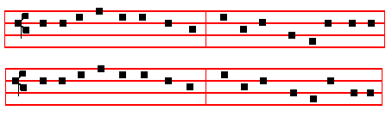
O BOUNDLESS Wisdom, God most high 2 The streams on earth, the clouds in heaven,
O Maker of the earth and sky, By thee their ordered bounds were given,
Who bid'st the parted waters flow Lest 'neath the untempered fires of day
In heaven above, on earth below: The parchèd soil should waste away

216
3 E'en so on us who seek thy face 4 Let faith discern the eternal Light
Pour forth the waters of thy grace Beyond the darkness of the night
Renew the fount of life within, And through the mists of falsehood, see
And quench the wasting fires of sin. The path of truth revealed by thee.

5 O Father, that we ask be done,
Through Jesus Christ, thine only Son;
Who, with the Holy Ghost and thee,
Doth live and reign eternally.
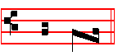
A – men.
V/. Let my prayer be set forth, O Lord.
R/. In tby sight as the incense. as on Sunday, p.
On Magnificat, Antiphon. Tone viij.

My soul * doth mag - ni - fy the Lord,

for he hath regarded my low-li -ness.
__________________________________________________________________

On Ferias of Advent and Lent, Ember Days, and Vigils which are fasted, after the Antiphon on Magnificat, are said the following Prayers kneeling, if they are to be said.
KYRIE,eleison. Christe, eleison. Kyrie, eleison.
Our Father is said all aloud.
V/. And lead us not into temptation.
R/. But deliver us from evil.
V/. I said, Lord, have mercy upon me.
R/. Heal my soul, for I have sinned against thee.
V/. Turn again, O Lord, at the last.
R/. And be gracious unto thy servants,

217
V/. May thy merey, O Lord, be upon us,
R/. As we have put our trust in thee.
V/. Let thy priests be clothed with righteousness.
R/. And thy saints sing with joyfulness.
V/. O Lord, save the Queen.
R/. And mercifully hear us when we call upon thee.
V/. O Lord, save thy people, and bless thine inheritance.
R/. Govern them, and lift them up for ever.
V/. Remember thy congregation.
R/. Which thou hast possessed from the beginning.
V/. Peace be within thy walls.
R/. And righteousness within thy palaces.
V/. Let us pray for the faithful departed.
R/. Rest eternal grant unto them, O Lord, and let light perpetual shine upon them.
V/. May they rest In peace. R/. Amen.
V/. For our absent brethren.
R/. My God, save thy servants, who put their trust in thee.
V/. For the afflicted and the captives.
R/. Deliver them, O Lord God of Israel, from all their tribulations.
V/. Send them help, O Lord, from thy holy place.
R/. And strengthen them out of Sion.
V/. O Lord, hear my prayer.
R/. And let my cry come unto thee.
Then is said Psalm 51 Miserere, p.75, and at the end Glory be to the Father.
The Psalm being ended, is said
V/. Turn us again, O Lord God of Hosts,
R/. Shew thy countenance upon us,and we shall be whole.
V/. Arise, O Christ, and help us.
R/. And deliver us for thy name's sake.
V/. O Lord, hear our prayer.
R/. And let our cry come unto thee.
__________________________________________________________________

V/. The Lord be with you.
R/. And with thy spirit.

The Collect, when a proper one is not assigned, is said from the preceding Sunday, as is to be found in the Proper of the Season.
The Antiphons with the Psalms are always said in the ferial Office, as here in the Psalter. But the Hymns, from the Octave of the Epiphany until the first Sunday of Lent, and from the Octave of Pentecost until Advent; and the Antiphons on Magnificat in the same seasons, until Septuagesima.
218
TUESDAY AT VESPERS
Antiphon.We will go.
In Eastertide, Antiphon. Alleluia.

Ps. 122 Laetatus sum CXXI
I WAS glad when they said unto me : * We will go into the house of the Lord.
2 Our feet shall stand in thy gates: * O Jerusalem.

3 Jerusalem is built as a city : * that is at unity in itself.

4 For thither the tribes go up, even the tribes of the Lord: * to testify unto Israel, to give thanks unto the Name of the Lord.

5 For there is the seat of judgement; * even the seat of the house of David.

6 O pray for the peace of Jerusalem : * they shall prosper that love thee.

7 Peace be within thy walls: * and plenteousness within thy palaces.

8 For my brethren and companions' sakes : * I will wish thee prosperity.

9 Yea, because of the house of the Lord our God: * I will seek to do thee good.

Antiphon. We will go with gladness into the house of the Lord.

Antiphon. O thou that dwellest.

Ps.123 Ad te levavi CXXII
UNTO thee lift I up mine eyes : O thou that dwellest in the heavens.
2 Behold, even as the eyes of servants look unto the hand of their masters, and as the eyes of a maiden unto the hand of her mistress: * even so our eyes wait upon the Lord our God, until he have mercy upon us.
3 Have mercy upon us, O Lord, have mercy upon us: * for we are utterly despised.

4 Our soul is filled with the scornful reproof of the wealthy: * and with the despitefulness of the proud.

219
Antiphon. O thou that dwellest in the heavens, have mercy upon us.
Antiphon. Our help.

Ps. 124 Nisi quia Dominus CXXIII
IF the Lord himself had not been on our side, now may Israel say: * if the Lord himself had not been on our side, when men rose up against us;
2 They had swallowed us up quick: * when they were so wrathfully displeased at us.
3 Yea, the waters had drowned us: * and the stream had gone over our soul.

4 The deep waters of the proud: * had gone even over our soul.

5 But praised be the Lord: * who hath not given us over for a prey unto their teeth.
6 Our soul is escaped even as a bird out of the snare of the fowler : * the snare is broken, and we are delivered.
7 Our help standeth in the Name of the Lord: * who hath made heaven and earth.

Antiphon. Our help standeth in the Name of the Lord.
Antiphon. Do well.

Ps. 125 Qui confidunt CXXIV
THEY that put their trust in the Lord shall be even as the mount Syon : * which may not be removed, but standeth fast for ever.
2 The hills stand about Jerusalem : * even so stanldeth the Lord round about his people, from this time forth for evermore.
3 For the rod of the ungodly cometh not into the lot of the righteous : * lest the righteous put their hand unto wickedness.
4 Do well, O Lord: * unto those that are good and true of heart.

5 As for such as turn back unto their own wickedness : * the Lord shall lead them forth with thc evildoers; but peace shall be upon Israel.

Antiphon. Do well,O Lord, unto those that are good and true of heart.
Antiphon. Then were we.

Ps. 126 . In convertendo CXXV

220
WHEN the Lord turned again the captivity of Syon ; * then were we like unto them that dream.
2 Then was our mouth filled with laughter : * and our tongue with joy.

3 Then said they among the heathen : * The Lord hath done great things for them.

4 Yea, the Lord hath done great things for us already : * whereof we rejoice.

5 Turn our captivity, O Lord: * as the rivers in the south.

6 They that sow in tears : * shall reap in joy.

7 He that now gocth on his way weeping, and beareth forth good seed: * shall doubtless come again with joy, and bring his sheaves with him.

Antiphon. Then were we like unto them that dream.
In Eastertide, Antiphon. Alleluia, alleluia, alleluia.

Chapter 1 Cor.1
BLESSED be God, even the Father of our Lord Jesus Christ, the Father of mercies, and the God of all comfort, who comforteth us in all our tribulation.

Hymn. E.H. 59 Telluris ingens Conditor Mode ij, as on Monday.

EARTH'S mighty Maker,whose command 3 Our spirit's rankling wounds efface
Raised from the sea the solid land, With dewy freshness of thy grace:
And drove each billowy heap away, That grief may cleanse each deed of ill,
And bade the earth stand firm for aye: And o'er each lust may triumph still.

2 That so, with flowers of golden hue, 4 Let every soul thy law obey,
The seeds of each it might renew; And keep from every evil way;
And fruit-trees bearing fruit might yield - Rejoice each promised good to win
And pleasant pasture of the field; And flee from every mortal min.

5. O Father, that we ask be done,
Through Jesus Christ, thine only Son;
Who, with the holy Ghost and thee,
Doth, live and reign eternally. Amen.

221
V/. Let my prayer be set forth, O Lord.
R/. In thy sight as the incense. as on Sunday, p.
On Magnificat, Antiphon. Tone v.
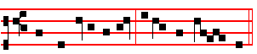
Let my spirit rejoice * in God my Saviour.
The Prayers, if they are to be said, on p. 217.
__________________________________________________________________

WEDNESDAY AT VESPERS

Antiphon. They shall not be ashamed.

Ps. 127 'Nisi Dominus CXXVI
EXCEPT the Lord build the house: * their labour is but lost that build it.
2 Except the Lord keep the ci ty : * the watchman waketh but in vain.

3 It is but lost labour that ye haste to rise up early, and so late takc rest, and eat the bread of carefulness : * for so he giveth his beloved sleep.
4 Lo, children and the fruit of the womb: * are an heritage and gift that cometh of the Lord.
5 Like as the arrows in the hand of the giant: * even so are the young children.

6 Happy is the man that hath his quiver full of them : * they shall not be ashamed when they speak with their enemies in the gate.

Antiphon.They shall not be ashamed when they speak with their enemies in the gate.
Antiphon. Blessed.

Ps. 128 Beati omnes CXXVII
BLESSED are all they that fear thc Lord : * and walk in his ways.
2 For thou shalt eat the labours of thine hands: * O well is thee, and happy shalt thou be.
3 Thy wife shall be as the fruitful vine: * upon the walls of thine house.

222
4 Thy children like the olive branches : * round about thy table.

5 Lo, thus shall the man be blessed : * that feareth the Lord.

6 The Lord from out of Syon shall so bless thee: * that thou shalt see Jerusalem in prosperity all thy life long.

7 Yea, that thou shalt see thy children's children : * and peace upon Israel.

Antiphon. Blessed are all they that fear the Lord.
Antiphon.Many a time.

Ps. 129 Saepe expugnaverunt CXXVIII
MANY a time have they fought against me from my youth up : * may Israel now say.
2 Yea, many a time have they vexed me from my youth up : * but they have not prevailed against me.
3 The plowers plowed upon my back: * and made long furrows.

4 But the righteous Lord: * hath hewn the snares of the ungodly in pieces.

5 Let them be confounded & turned backward: * as many as have evil will at Syon.
6 Let them be even as the grass growing upon the house-tops: * which withereth afore it be plucked up;
7 Whereof the mower filleth not his hand: * neither he that bindeth up the sheaves his bosom.
8 So that they who go by say not so much as, The Lord prosper you: * we wish you good luck in the Name of the Lord.

Antiphon. Many a time have they fought against me from my youth up.
Antiphon. Out of the deep.

Ps. 130 De profundis CXXIX
OUT of the deep have I called unto thee, O Lord: * Lord, hear my voice.
2 O let thine ears consider well: * the voice of my complaint.
3 If thou, Lord, wilt be extreme to mark what is done amiss: * O Lord, who may
223
abide it ?
4 For there is mercy with thee: * therefore shalt thou be feared.

5 I look for the Lord; my soul doth wait for him: * in his word is my trust.

6 My soul fleeth unto the Lord: * before the morning watch, I say, before the morning watch.
7 O Israel, trust in the Lord, for with the Lord there is mercy : * and with him is plenteous redemption.

8 And he shall redeem Israel : * from all his sins.

Antiphon.Out of the deep have I called unto thee, O Lord.
Antiphon.O Israel.
Ps. 131 Domine, non est CXXX
LORD, I am not high-mind-ed : * I have no proud looks,
2 I do not exercise myself in great matters: * which are too high for me.

3 But I refrain my soul, and keep it low, like as a child that is weaned from his mother : * yea, my soul is even as a weaned child.
4 O Israel, trust in the Lord: * from time forth for evermore.

Antiphon. O Israe1, trust in the Lord.
In Eastertide, Antiphon. Allel1uia, alleluia, alleluia.

Chapter 2 Cor. l
BLESSED be God, even the Father of our Lord Jesus Christ, the Father of mercies, and the God of all comfort, who comforteth us in all our tribulation.

Hymn.E.H.60 Caeli Deus sanctissime. Mode ij, as on Monday.

MOST holy Lord and God of heaven, 3 That each in Its appointed way
Who to the glowing sky hast given Might separate the night from day,
The fires that in the ew4 are horn And of theseasons through the year
With gradual tiplondwr-a of the morn; The well-remembered signs declare

2 Who, on the fourth day, didst reveal 4 Illuminate our hearts within,
The sun's enkindled flaming wheel, And cleanse our minds from stain of sin;
Didst set the moon her ordered ways, Unburdened of our guilty load
And stars their ever-winding maze; May we unfettered serve our God.
224
5. O Father, that we ask be done,
Through Jesus Christ, thine only Son.,
Who, with the lloly Ghost and thee,
Doth live and reign eternally. Amen.

V/. Let my prayer be set forth, O Lord.
R/. In thy sight as the incense. as on Sunday, p.
On Magnificat, Antiphon. Tone viij.


The Lord * hath regarded my low - li - ness:
and he that is mi-ghty hath done in me great things.
The Prayers, if they are to be said, on p.217.
__________________________________________________________________

THURSDAY AT VESPERS

Antiphon. And all.
In Eastertide, Antiphon. Alleluia.
Ps.132 Memento, Domine CXXXI
LORD, re-member David : * and all his trouble.
2 How he sware unto the Lord : * and vowed a vow unto the Almighty God of Jacob;
3 I will not come within the tabernacle of mine house: * nor climb up into my bed;

4 I will not suffer mine eyes to sleep, nor mine eyelids to slumber : * neither the temples of my head to take any rest.
5 Until I find out a place for the temple of the Lord : * an habitation for the mighty God of Iacob.
6 Lo, we heard of the same at Ephrata : * and found it in the wood.

7 We will go into his tabernacle : * and fall low on our knees before his foot-stool.

8 Arise, O Lord, into thy resting-place : * thou, and the ark of thy strength.

225
9 Let thy priests be clothed with righteousness : * and let thy saints sing with joyfulness.
10 For thy servant David's sake: * turn not away the presence of thine Anointed..

11 The Lord hath made a faithful oath unto David : * & he shall not shrink from it;
12 Of the fruit of thy body : * shall I set upon thy seat.

13 If thy children will keep my covenant, and my testimonies that I shall learn them: * their children also shall sit upon thy seat for evermore.
14 For the Lord hath chosen Syon to be an habitation for himself: * he hath longed for her.
15 This shall be my rest for ever : * here will I dwell, for I have a delight therein.

16 I will bless her victuals with increase: * and will satisfy her poor with bread.

17 I will deck her priests with health : * and her saints shall rejoice and sing.

18 There shall I make the horn of David to flourish : * I have ordained a lantern for mine Anointed.
19 As for his enemies, I shall clothe them with shame : * but upon himself shall his crown flourish.

Antiphon. And all his trouble.
Antiphon. Behold.

Ps. 133 Ecce quam bonum CXXXII
BEHOLD, how good and joyful a thing it is: * brethren, to dwell together in unity!
2 It is like the precious ointment upon the head that ran down unto the beard: * even unto Aalron's beard, and went down to the skirts of his clothing.
3 Like as the dew of Hermon : * which fell upon the hill of Syon.

4 For there the Lord promised his blessing : * and life for evermore.

Antiphon. Behold, how good and joyful a thing it is, brethren to dwell together in unity.
(Psalm 134, Ecce nunc, at Compline, p.l )
Antiphon. Whatsoever.

226
Ps. 135 Laudate nomen CXXXIV
O PRAISE the Lord, laud ye the Name of the Lord : * praise it, O ye servants of the Lord.
2 Ye that stand in the house of the Lord: * in the courts of the house of our God.

3 O praise the Lord, for the Lord is gracious : * O sing praises unto his Name, for it is lovely.
4 For-why the Lord hath chosen Jacob unto himself: * and Israel for his own possession.
5 For I know that the Lord is great: * and that our Lord is above all gods.

6 Whatsoever the Lord pleased, that did he in heaven, and in earth: * and in the sea, and in all deep places.
7 He bringeth forth the cloud from the ends of the world: and sendeth forth lightnings with the rain, bringing the winds out of his treasures.
8 He smote the firstborn of Egypt : * both of man and beast.

9 He hath sent tokens & wonders into the midst of thee, O thou land of Egypt : * upon Pharaoh, and all his servants.
10 He smote divers nations : * and slew mighty kings.

11 Sehon king of the Amorites, and Og the king of Basan: * and all the kingdoms of Chanaan.
12 And gave their land to be an heritage : * even an heritage unto Israel his people.
13 Thy Name, O Lord, endureth for ever : * so doth thy memorial, O Lord, from one generation to another.
14 For the Lord will avenge his people : * and be gracious unto his servants.

15 As for the images of the heathen, they are but silver and gold: * the work of men's hands.
16 They have mouths, and speak not: * eyes have they, but they see not.

17 They have ears, and yet they hear not : * neither is there any breath in their mouths.
18 They that make them are like unto them: * and so are all they that put their trust in them.
19 Praise the Lord, ye house of Israel : * praise the Lord, ye house of Aaron.

20 Praise the Lord, ye house of Levi : * ye that fear the Lord, praise the Lord.
227
21 Praised be the Lord out of Syon : * who dwelleth at Jerusalem.

Antiphon.Whatsoever the Lord pleased, that did he.
Antiphon.For his mercy.

Ps. 136 Confitemini CXXXV
O GIVE thanks unto the Lord, for he is gracious : * and his mercy endureth for ever.
2 O give thanks unto the God of all gods: * for his mercy endureth for ever.

3 O thank the Lord of all lords: * for his mercy endureth for ever.

4 Who only doeth great wonders : * for his mercy endureth for ever.

5 Who by his excellent wisdom made the heavens : * for his mercy endureth for ever.
6 Who laid out the earth above the waters : * for his mercy endureth for ever.

7 Who hath made great lights: * for his mercy endureth for ever.

8 The sun to rule the day: * for his mercy endureth for ever.

9 The moon and the stars to govern the night: * for his mercy endureth for ever.

10 Who smote Egypt with their first-born : * for his mercy endureth for ever.

11 And brought out Israel from among them: * for his mercy endureth for ever.

12 With a mighty hand, and stretched out arm: * for his mercy endureth for ever.

13 Who divided the Red sea in two parts: * for his mercy endureth for ever.

14 And made Israel to go through the midst of it : * for his mercy endureth for ever.
15 But as for Pharaoh and his host, he overthrew them in the Red sea: * for his mercy endureth for ever.
16 Who led his people through the wilderness: * for his mercy endureth for ever.

17 Who smote great kings: * for his mercy endureth for ever.

228
18 Yea, and slew mighty kings: * for his mercy endureth for ever.

19 Sehon king of the Amorites : * for his mercy endureth for ever.

20 And Og the king of Basan : * for his mercy endureth for ever.

21 And gave away their land for an heritage : * for his mercy endureth for ever.

22 Even for an heritage unto Israel his servant : * for his mercy endureth for ever.

23 Who remembered us when we were in trouble : * for his mercy endureth for ever.
24 And hath delivered us from our enemies : * for his mercy endureth for ever.

25 Who giveth food to all flesh: * for his mercy endureth for ever.

26 O give thanks unto the God of heaven: * for his mercy endureth for ever.

27 O give thanks unto the Lord of lords: * for his mercy endureth for ever.

Antiphon.For his mercy endureth for ever.
Antiphon. Sing us one.

Ps. 137 Super flumina CXXXVI
BY the waters of Babylon we sat down and wept: * when we remembered thee, O Syon.
2 As for our harps, we hanged them up : * upon the trees that are therein.

3 For they that led us away captive required of us then a song and melody in our heaviness : * Sing us one of the songs of Syon.
4 How shall we sing the Lord's song: * in a strange land ?

5 If I forget thee, O Jerusalem : * let my right hand forget her cunning.

6 If I do not remember thee, let my tongue cleave to the roof of my mouth: * yea, if I prefer not Jerusalem in my mirth.
7 Remember the children of Edom, O Lord, in the day of Jerusalem : * how they said, Down with it, down with it, even to the ground.
8 O daughter of Babylon, wasted with misery: * yea, happy shall he be that rewardeth thee, as thou hast served us.

229
9 Blessed shall he be that taketh thy children : * and throweth them against the stones

Antiphon. Sing us one of the songs of Sion. .
In Eastertide, Antiphon. Alleluia, alleluia, alleluia.

Chapter 2 Cor. 1
BLESSED be God, even the Father of our Lord Jesus Christ, the Father of mercies, and the God of all comfort, who comforteth us in all our tribulation.

HYMN E.H. 61 Magnae Deus potentiae Mode ij, as on Monday.
ALMIGHTY God, who from the flood 3 Grant that thy servants, by the tide
Didst bring to light a twofold brood; Of blood and water purified,
Part in the firmament to fly, No guilty fall from thee may know
And part in ocean's depths to lie; Nor death eternal undergo.

2 Appointing fishes in the sea, 4 Be none submerged in sin's distress,
And fowls in open air to be, None lifted up in boastfulness;
That each, by origin the same,, That contrite hearts be not dismayed,
Its separate dwelling-place might claim: Nor haughty souls in ruin laid.

5. O Father, that we ask be done,
Through Jesus Christ, thine only Son;
Who, with the Holy Ghost and thee,
Doth live and reign eternally

Amen.

V/.Let my prayer be set forth, O Lord.
R/.In thy sight as the incense.

On Magnificat, Antiphon. Tone vij.
Shew strength, O God, * with thine arm:

scatter the proud, and exalt the humble.

The Prayers, if they are said, on p. 217.

230
FRIDAY AT VESPERS

Antiphon.Before the gods.
In Eastertide, Antiphon. Alleluia.

Ps. 138 Confitebor tibi CXXXVII
I WILL give thanks unto thee, O Lord, with my whole heart: * even before the gods will I sing praise unto thee.
2 I will worship toward thy holy temple, and praise thy Name, because of thy loving-kindness and truth: * for that thou hast magnified thy Name, and thy Word above all things.
3 When I called upon thee, thou heardest me : * and enduedst my soul with much strength.
4 All the kings of the earth shall praise thee, O Lord: * for they have heard the words of thy mouth.
5 Yea, they shall sing in the ways of the Lord: * that great is the glory of the Lord.

6 For though the Lord be high, yet hath he respect unto the lowly : * as for the proud, he beholdeth them afar off.
7 Though I walk in the midst of trouble, yet shalt thou refresh me : * thou shalt stretch forth thy hand upon the furiousness of mine enemies, and thy right hand shall save me.
8 The Lord shall make good his loving-kindness toward me : * yea, thy mercy, O Lord, endureth for ever; despise not then the works of thine own hands.

Antiphon.Before the gods wlll I sing praise unto thee, my God.
Antiphon. O Lord.

Ps. 139 Domine, probasti CXXXVII
O LORD, thou hast searched me out, and known me : * thou knowest my down-sitting, and mine uprising; thou understandest my thoughts long before.
2 Thou art about my path, and about my bed : * and spiest out all my ways.

3 For lo, there is not a word in my tongue : * but thou, O Lord, knowest it altogether.
4 Thou hast fashioned me behind and before: * and laid thine hand upon me.

5 Such knowledge is too wonderful and excellent for me : * I cannot attain unto it.

231
6 Whither shall 1 go then from thy Spirit : * or whither shall I go then from thy presence?
7 If I climb up into heaven, thou art there: * if I go down to hell, thou art there also.
8 If I take the wings of the morning : * and remain in the uttermost parts of the sea;
9 Even there also shall thy hand lead me : * and thy right hand shall hold me.

10 If I say, Peradventure the darkness shall cover me : * then shall my night be turned to day.
11 Yea, the darkness is no darkness with thee, but the night is as clear as the day: * the darkness & light to thee are both alike.
12 For my reins are thine: * thou hast covered me in my mother's womb.

13 I will give thanks unto thee, for I am fearfully and wonderfully made: * marvellous are thy works, and that my soul knoweth right well.
14 My bones are not hid from thee : * though I be made secretly, and fashioned beneath in thc earth.
15 Thine eyes did see my substance, yet being unperfect: * and in thy book were all my members written;
16 Which day by day were fashioned: * when as yet there was none of them.

17 How dear are thy counsels unto me, O God: * O how great is the sum of them.

18 If I tell them, they are more in number than the sand: * when I wake up, I am present with thce.
19 Wilt thou not slay the wicked, O God: * depart from me, ye blood-thirsty men.

20 For they speak unrighteously against thee: * and thine enemies take thy Name in vain. .
21 Do not I hate them, O Lord, that hate thee : * and am not I grieved with those that rise up against thee?
22 Yea, I hate them right sore : * even as though they were mine enemies.

23 Try me, O God, and seek the ground of my heart : * prove me, and examine my thoughts.
24 Look well if there be any way of wickedness in me: * and lead me in the way everlasting.

Antiphon. O Lord, thou hast searched me out and known me.
Antiphon. Deliver me.

232
Ps. 140 Eripe me, Domine CXXXIX
DELIVER me, O Lord, from the evil man: * and preserve me from the wicked man.
2 Who imagine mischief in their hearts : * and stir up strife all the day long.

3 They have sharpened their tongues like a serpent : * adders' poison is under their lips.
4 Keep me, O Lord, from the hands of the ungodly : * preserve me from the wicked men, who are purposed to overthrow my goings.
5 The proud have laid a snare for me, and spread a net abroad with cords : * yea, and set traps in my way.
6 I said unto the Lord, Thou art my God: * hear the voice of my prayers, O Lord.

7 O Lord God, thou strength of my health: * thou hast covered my head in the day of battle.
8 Let not the ungodly have his desire, O Lord: * let not his mischievous imagination prosper, lest they be too proud.

9 Let the mischief of their own lips fall upon the head of them: * that compass me about.
10 Let hot burning coals fall upon them: * let them be cast into the fire, and into the pit, that they never rise up again.
11 A man full of words shall not prosper upon the earth: * evil shall hunt the wicked person to overthrow him.
12 Sure I am that the Lord will avenge the poor: * and maintain the cause of the helpless.
13 The righteous also shall give thanks unto thy Name : * and the just shall continue in thy sight.

Antiphon.De1iver me, O Lord, from the wicked man.
Antiphon. Lord, I call.
Ps. 141 Domine, clamavi CXL
LORD, I call upon thee, haste thee unto me : * and consider my voice when I cry unto thee.
2 Let my prayer be set forth in thy sight as the incense : * and let the lifting up of my hands be an evening sacrifice.
3 Set a watch, O Lord, before my mouth: * and keep the door of my lips.

233
4 O let not mine heart be inclined to any evil thing: * let me not bc occupied in ungodly works with the men that work wickedness, lest I eat of such thngs as please them.
5 Let the righteous rather smite me friendly : * and reprove me.

6 But let not their precious balms break my head: * yea, I will pray yet against their wickedness.
I7 Let their judges be overthrown in stony places: * that hey may hear my words, for they are sweet.
18 Our bones lie scattered before the pit: * like as when one breaketh and heweth wood upon the earth.
19 But mine eyes look unto thee, O Lord God: * in thee is my trust, O cast not out my soul.
10 Keep me from the snare that they have laid for me: * and from the traps of the wicked doers.
11 Let the ungodly fall into their own nets together : * and let me ever escape them.

Antiphon. Lord, I call upon thee, haste thee unto me.
Antiphon. O Lord, let my portion.

Ps. 142 Voce mea ad Dominum CXLI
I CRIED unto the Lord with my voice: * yea, even unto the Lord did I make my supplication.
2 I poured out my complaints before him: * and shewed him of my trouble.

3 When my spirit was in heaviness thou knewest my path: * in the way wherein I walked have they privily laid a snare for me.
4 I looked also upon my right hand: * and saw there was no man that would know me.
5 I had no place to flee unto: * and no man cared for my soul.

6 I cried unto thee, O Lord, and said : * Thou art my hope, and my portion in the land of the living.
7 Consider my complaint: * for I am brought very low.

8 O deliver me from my persecutors : * for they are too strong for me.

9 Bring my soul out of prison, that I may give thanks unto thy Name: * which thing if thou wilt grant me, then shall the righteous resort unto my company.

234
Antiphon. O Lord, let my portion be in the land of the living.
In Eastertide, Antiphon. Alleluia, alleluia, alleluia.

Chapter 2 Cor.1
BLESSED be God, even the Father of our Lord Jesus Christ, the Father of mercies, and the God of all comfort, who comforteth us in all our tribulation.

Hymn.E.H. 62 Plasmator hominis, Deus. Mode ij, as on Monday.

MAKER of man,who from thy throne 3 From all thy servants drive away
Dost order all things, God alone; Whate'er of thought impure to-day
By whose decree the teenting earth Hath been with open action blent,
To reptile and to beast gave birth: Or mingled with the heart's intent.

2 The mighty forms that fill the land, 4 In heaven thine endless joys bestow,
Instinct with life at thy command, And grant thy gifts of grace below;
Are given subdued to humankind, From chains of strife our souls release,
For service in their rank assigned. Bind fast the gentle bands of peace.

5 O Father, that we ask be done,
Through Jesus Christ thine only Son;
Who, with the Holy Ghost and thee,
Doth live and reign eternally.

Amen.

V/. Let my prayer be set forth, O Lord.
R/. In thy sight as the incense. as on Sunday, p.

On Magnificat, Antiphon. Tone j.

He hath put down the mighty * that per-secute the ho-ly;

and hath ex-alted the humble that confess his Christ.

The Prayers, if they are to be said, on p.217.

235
SATURDAY AT VESPERS

Antiphon. Tone vj.
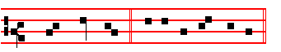
Bless - ed be. E u o u a e.
In Eastertide, Antiphon. Tone vj.
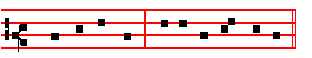
Al - le - lu - ia. E u o u a e.

Ps. 144 Benedictus Dominus CXLIII
BLESSED be the Lord my strength: * who teacheth my hands to war, and my fingers to fight;
2 My hope and my fortress, my castle and deliverer, my defender, in whom I trust: * who subdueth my people that is under me.
3 Lord, what is man, that thou hast such respect unto him: * or the son of man, that thou so regardest him?
4 Man is like a thing of naught: * his time passeth away like a shadow.

5 Bow thy heavens, O Lord, and come down : * touch the mountains, and they shall smoke.
6 Cast forth thy lightning, and tear them: * shoot out thine arrows, and consume them.
7 Send down thine hand from above : * deliver me, and take me out of the great waters, from the hand of strange children.
8 Whose mouth talketh of vanity : * and their right hand is a right hand of wickedness.
9 I will sing a new song unto thee, O God: * and sing praises unto thee upon a ten- stringed lute.
10 Thou hast given victory unto kings: * and hast delivered David thy servant from the peril of the sword.
11 Save me, and deliver me from the hand of strange children : * whose mouth talketh of vanity, and their right hand is a right hand of iniquity.
12 That our sons may grow up as the young plants: * and that our daughters may be as the polishcd corners of the temple.
236
13 That our garners may be full, and plenteous with all manner of store : * that our sheep may bring forth thousands and ten thousands in our streets.
14 That our oxen may be strong to labour, that there be no decay: * no leading into captivity, & no complaining in our streets.
15 Happy are the people that are in such a case : * yea, blessed are the people who have the Lord for their God.

Antiphon.
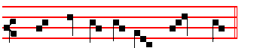
Bles - sed be the Lord my God.
Antiphon. Tone viij, 2.
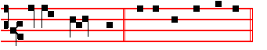
Ev-er - y day . E u o u a e.

Ps. 145 Exaltabo te, Deus CXLIV
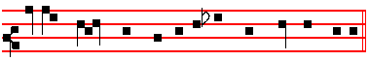
I WILL magnify thee, O God, my King : * and I will praise thy Name for ever and ever.
2 Every day will I give thanks unto thee: * and praise thy Name for ever and ever.

3 Great is the Lord, and marvellous-worthy to be praised: * there is no end of his greatness.
4 One generation shall praise thy works unto another : * and declare thy power.

5 As for me, I will be talking of thy worship : * thy glory, thy praise, and wondrous works;
6 So that men shall speak of the might of thy marvellous acts: * and I will also tell of thy greatness.
7 The memorial of thine abundant kindness shall be shewed : * and men shall sing of thy righteousness.
8 The Lord is gracious and merciful : * long-suffering, and of great goodness.

9 The Lord is loving unto every man: * and his mercy is over all his works.

10 All thy works praise thee, O Lord: * and thy saints give thanks unto thee.

237
11 They shew the glory of thy kingdom : * and talk of thy power.

12 That thy power, thy glory, and mightiness of thy kingdom: * might be known unto men.
13 Thy kingdom is an everlasting kingdom : * and thy dominion endureth throughout all ages.
14 The Lord upholdeth all such as fall: * and lifteth up all those that are down.

15 The eyes of all wait upon thee, O Lord: * and thou givest them their meat in due season.
16 Thou openest thine hand: * and fillest all things living with plenteousness.

17 The Lord is righteous in all his ways: * and holy in all his works.

18 The Lord is nigh unto all them that call upon him: * yea, all such as call upon him faithfully.
19 He will fulfil the desire of them that fear him: * he also will hear their cry, and will help them.
20 The Lord preserveth all them that love him: * but scattereth abroad all the ungodly.
21 My mouth shall speak the praise of the Lord: * and let all flesh give thanks unto his holy Name for ever and ever.

Antiphon.
Ev-er - y day, O Lord, will I give thanks un - to thee.
Antiphon.
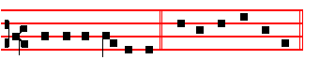
While I have my being. E u o u a e.

Ps. 146 Lauda, anima mea CXLV
PRAISE the Lord, O my soul; while I live will I praise the Lord: * yea, as long as I have any being, I will sing praises unto my God.
2 O put not your trust in princes, nor in any child of man: * for there is no help in
238
them.
3 For when the breath of man goeth forth he shall turn again to his earth: * and then all his thoughts perish.
4 Blessed is he that hath the God of Jacob for his help: * and whose hope is in the Lord his God;
5 Who made heaven & earth, the seal, and all that therein is : * who keepeth his promise for ever;
6 Who helpeth them to right that suffer wrong: * who feedeth the hungry.

7 The Lord looseth men out of prison : * the Lord giveth sight to the blind.

8 The Lord helpeth them that are fallen : * the Lord careth for the righteous.

9 The Lord careth for the strangers; he defendeth the fatherless and widow :* as for the way of the ungodly, he turneth it upside down.

10 The Lord thy God, O Syon, shall be King for evermore : * and throughout all generations.

Antiphon.
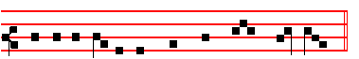
While I have my being will I praise my God.
Antiphon. Tone viij, 2.
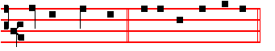
O how joy - ful. E u o u a e.

Ps 147 Laudate Dominum CXLVI
O PRAISE the Lord, for it is a good thing to sing praises unto our God: * yea, a joyful and pleasant thing it is to be thankful.
2 The Lord doth build up Jerusalem : * and gather together the out-casts of Israel.

3 He healeth those that are broken in heart : * and giveth medicine to heal their sickness.
4 He telleth the number of the stars: * and calleth them all by their names.

239
5 Great is our Lord, and great is his power : * yea, and his wisdom is infinite.

6 The Lord setteth up the meek: * and bringeth the ungodly down to the ground.

7 O sing unto the Lord with thanksgiving : * sing praises upon the harp unto our God;
8 Who covereth the heaven with clouds, and prepareth rain for the earth: * and maketh the grass to grow upon the mountains, and herb for the use of men ;

9 Who giveth fodder unto the cattle: * and feedeth the young ravens that call upon him.
10 He hath no pleasure in the strength of an horse: * neither delighteth he in a ny man's legs.
11 But the Lord's delight is in them that fear him * and put their trust in his mercy.

Antiphon.
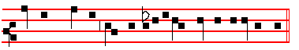
O how joy - ful a thing it is to be thankfu1 unto our God.
Antiphon. Tone j, 4.
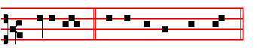
Praise the Lord. E u o u a e.

Ps.147, v. 12 Lauda Jerusalem CXLVII
12PRAISE the Lord, O Jerusalem * praise thy God, O Syon.

13 For he hath made fast the bars of thy gates * and hath blessed thy children within thee.
14 He maketh peace in thy borders * and filleth thee with the flour of wheat.
15 He sendeth forth his commandment upon earth * and his word runneth very swiftly.
16 He giveth snow like wool * and scattereth the hoar-frost like ashes.

17 He casteth forth his ice like morsels * who is able to abide his frost?

240
18 He sendeth out his word, and melteth them * he bloweth with his wind, and the waters flow.
19 He showcth his word unto Jacob * his statutes and ordinances unto Israel.

20 He hath not dealt so with any nation * neither have the heathen knowledge of his laws.

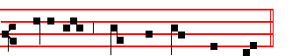
Antiphon.
Praise the Lord, O Je - ru - sa - lem.
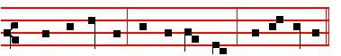
In Eastertide, Antiphon.
Al - le - lu - ia, al - le - lu - ia, al -le - lu - ia.

Chapter Rom. 11
O THE depth of the riches both of
the wisdom and knowledge of God!
how unsearchable are his judgments,
and his ways past find - - - - - ing out! R/.Thanks be to God.

HYMN EH 164 O Lux beata Trinitas Mode viij.
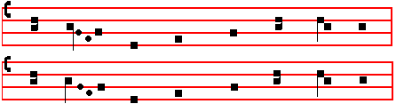

241
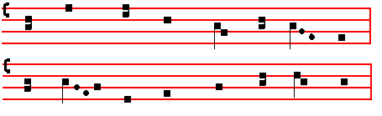
O TRINITY of blessed 1ight, 2 To thee our morning song of praise,
O Unity of princely might, To thee our evening prayer we raise;
The fiery sun now goes his way; Thy glory suppliant we adore
Shed thou within our hearts thy ray. For ever and for evermore.

3. All laud to God the Father be;
All praise, eternal Son, to thee;
All glory, as is ever meet,
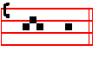
To God the holy Paraclete.
A - men.
V/. Let our evening prayer come up before thee, O Lord.
R/. And let thy mercy come down upon us.
On Magnificat, Antiphon. Tone vij, 3.
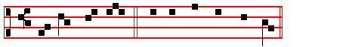
God hath hol - pen Canticle Magnificat, p. 209
On Magnificat, Antiphon.
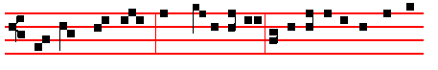
God hath hol - pen his servant Israel: as he promised to Ab-ra-

242
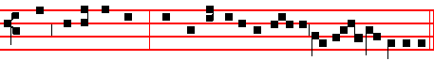
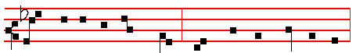
ham and to his seed : and hath ex-alted the humble for ev - er and ever.

The Chapter O the depth is said in Vespers of Saturday from the Octave of the Epiphany until Septuagesima, and from the Octave of Pentecost until Advent, and the Hymn and Versicle also, until Lent. The Antiphon on Magnificat, from the Octave of the Epiphany until Septuagesima only.

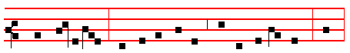
After the Antiphon is said the proper Collect.

Then are made the following common Commemorations, or Suffrages of the Saints, which are said at Lauds also.
__________________________________________________________________

COMMEMORATION OF THE CROSS
in the ferial Office only

At Vespers and Lauds, Antiphon.
By the sign of the Cross deliver us from our enemies * O our God.
V/. All the earth shall worship thee,and sing unto thee.
R/. And shall sing praises unto thy Name, O Lord.

Let us pray. COLLECT
Keep us, O Lord, we beseech thee, in perpetual peace, whom thou hast vouchsafed to redeem by the wood of the holy Cross.
__________________________________________________________________

COMMON COMEMORATIONS or SUFFRAGES OF THE SAINTS

Of S.Mary when her Office is not said:

At Vespers and Lauds, Antiphon. Tone j.
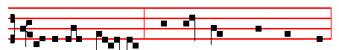
O ho - ly Ma - ry, help thou the suf - fer - ing,

243
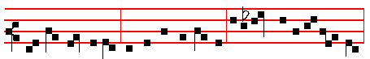
strength-en the faint- heart - ed, com - fort the sor - row - ful;
pray for the people, entreat for the clergy, intercede for all womankind
vowed un-to God; may all acknowledge the help of thy prayer, who
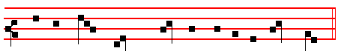
ce - le - brate thy ho - ly com-me-mo- ra - tion.
V/. Pray for us, O holy Mother of God.
R/. That we may be made worthy of the promises of Christ.
Let us pray COLLECT
Grant, we beseech thee, O Lord God, that we thy servants may rejoice in continual health of mind and body:and that by the glorious intercession of blessed Mary ever Virgin we may be delivered fromthis present heaviness,and have the fruition of eternal joys.
From the Octave of the Epiphany until the Purification is said
V/.After child-bearing, O Virgin, thou didst remain invio - late.
R/. Mother of God, intercede for us.

Let us pray COLLECT
O GOD, who by the virgin child-bearing of blessed Mary hast bestowed upon
244
mankind the rewards of eternal salvation, we beseech thee; that we may perceive
her intercession for us, through whom we have been counted worthy to receive the
Author of life, Jesus Christ thy Son our Lord.
-

Of the Apostles
At Vespers,Antiphon.
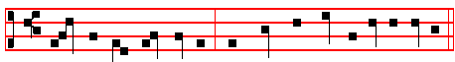

Pe - ter the A - pos-tle and Paul the Doc- tor of the Gentiles:
these have taught us thy law, O Lord.
V/. Thou shalt make them princes in all lands.
R/. They shall remember thy name, O Lord.
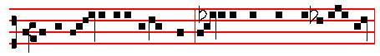At Lauds, Antiphon.
Glorious princes over all the earth, as in life they loved one an- o - ther,

so even in death they were not di - vided.
V/. Their sound is gone out into all lands.
R/. And their words unto the ends of the world.

Let us pray COLLECT

245
O God,whose right hand upheld blessed Peter lest he should sink while walking on the waves; and delivered his fellow-Apostle Paul from the depth of the sea when thrice he suffered shipwreck: mercifully hear us.and grant that by the prayers of them both we may attain unto the glory of eternal life.

Commemoration of the patron or title of the Church is made as usual before or after the above commemorations,according to rank, and finally of peace:

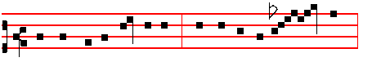
Ant.at Vespers and Lauds
Give peace in our time, O Lord, for there is none o - - - - ther
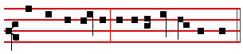
that fighteth for us, but only thou, O our God.
V/. Peace be within thy walls.
R/. And plenteousness within thy pala - - ces.

Let us pray COLLECT

O God.from whom all holy desires,all good counsels.and all just works do proceed, give unto thy servants that peace whic the world cannot give; that both:
our hearts may be set to obey thy commandments, and also that by thee we being defended from the fear of our enemies may pass our time in rest and quietness. Through. R/. Amen.
V/. The Lord be with you.R/. And with thy spirit.
V/. Let us bless the Lord.R/. Thanks be to God.
V/. May the souls of the faithful.R/. Amen.

Then is said silently Our Father.

Thus the Office is finished when another Hour does not follow, as is said in the Rubric of the Lord's Prayer.
246
-The above Commemorations or Suffrages are said from the Octave of the Epiphany until Passion Sunday, and from the Octave of Pentecost until Advent, except on Doubles and withing Octaves. When an Office is said of blessed Mary, no other commemoration is made of her.
__________________________________________________________________

COMMEMORATION OF THE CROSS

In Eastertide

Which is made daily in Lauds and Vespers both in the Office of the Season and of Saints, unless it be a Double, or within Octaves. The other commemorations of S. Mary, of the Apostles, and of Peace, are not said in Eastertide.

At Vespers, Antiphon.
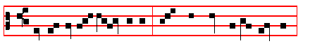
He the ho - ly Cross endured, Burst the gates of hell in twain:
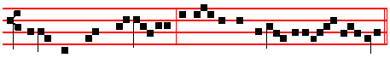
Begirt with might and majesty, On Easter morn he rose again, al- le- luia.
V/. Tell it out among the nations, allelu - - ia.
R/. That the Lord reigneth from the Tree, allelu - - ia.
Let us pray COLLECT
O GOD, who didst will that thy Son should for us undergo the burden of the Cross, that he might deliver us from the power of the enemy: grant unto us thy servants, that we may attain unto the joy of his resurrection.Through the same.
At Lauds, Antiphon.
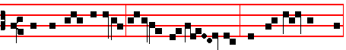

He that was crucified is risen from the dead; and hath re-deemed us,
247
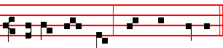
al - le - lu - ia, al - le - - lu - ia.

V/. and Collect as above.

+

248

