FERIA III. MAJORIS HEBDOMADÆ

TUESDAY IN HOLY WEEK

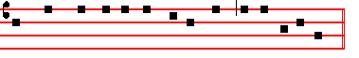
The PASSION of our Lord Jesus Christ according to Mark (xiv. I and xv. I)

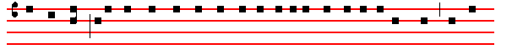
AT that time; after two days was the feast of the Passover, and of unleavened bread, and the

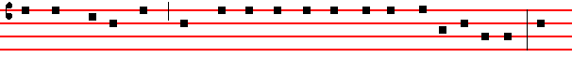
chief priests and the scribes sought how they might take Jesus by craft, and put him to death. But 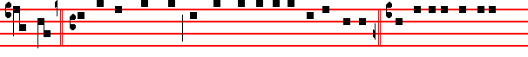
they said: S. Not on the feast-day, lest there be an uproar of the people. C. And being in Bethany
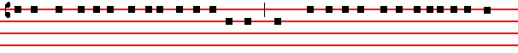
in the house of Simon the leper, as he sat at meat: there came a woman having an alabaster box
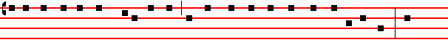
of ointment of spikenard, very precious, and she brake the box, and poured it on his head. And
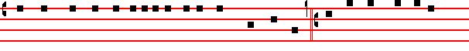
there were some that had indignation within themselves, and said: S.Why was this waste of the
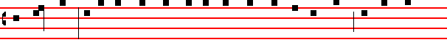
ointment made? For it might have been sold for more than three hundred pence, and have been

given to the poor. C. And they murmured against her. And Jesus said:  Let her alone: why
1
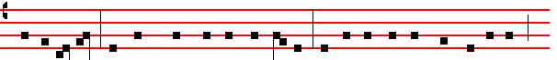
trouble ye her? She hath wrought a good work on me. For ye have the poor with you always:
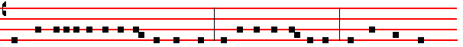
and whensoever ye will ye may do them good: but me ye have not always. She hath done what

she could: she is come aforehand to anoint my body to the burying. Verily I say unto you:
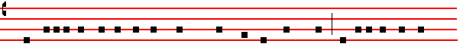
Wheresoever this Gospel shall be preached throughout the whole world, this also that she hath 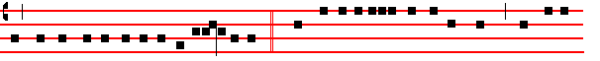done shall be spoken of for a memorial of her. C. And Judas Iscariot, one of the twelve, went unto
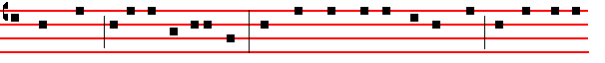
the chief priests to betray him unto them. And when they heard it they were glad: and promised to
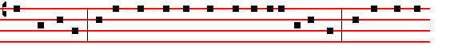
give him money. And he sought how he might conveniently betray him. And the first day
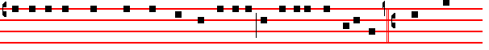
of unleavened bread, when they killed the passover, his disciples said unto him: S. Where wilt
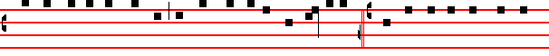
thou that we go and prepare, that thou mayest eat the passover? C. And he sendeth forth two of
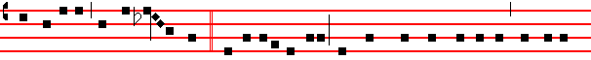
his disciples, and saith unto them:  Go ye into the city: and there shall meet you a man bearing a

2
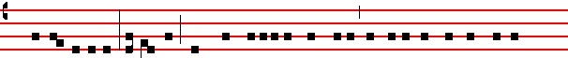 pitcher of water, follow him: and wheresoever he shall go in, say ye to the goodman of the
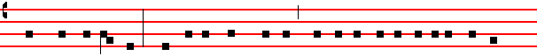 house, The Master saith: Where is the guest-chamber, where I shall eat the passover with my
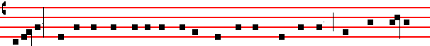
disciples? And he will shew you a large upper- room furnished, and prepared: there make ready
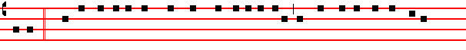
for us. C. And his disciples went forth, and came into the city: and found as he had said unto
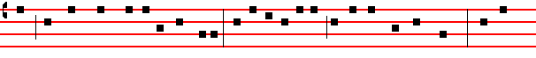
them, and they made ready the passover. And in the evening he cometh with the twelve. And as
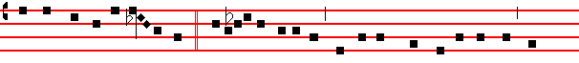
they sat, and did eat, Jesus said:  Verily I say unto you: One of you which eateth with me shall
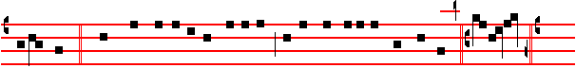
betray me. C. And they began to be sorrowful, and to say unto him one by one: S. Is it I ? C.
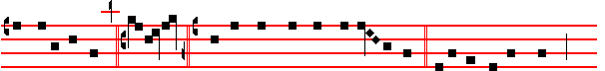
And another said: S.Is it I? C. And he answered and said un-to them: It is one of the twelve 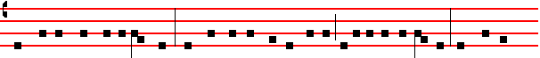 that dippeth with me in the dish. The Son of man indeed goeth, as it is written of him: but woe to
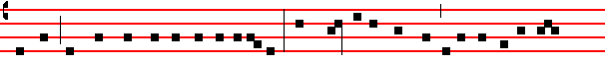
that man by whom the Son of man is betrayed. Good were it for that man if he had never been

3
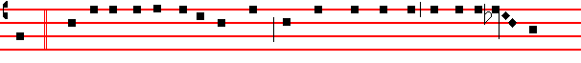
born. C. And as they did eat, Jesus took bread, and blessed, and brake it, and gave to them, and
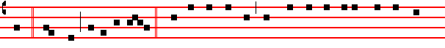
said: Take, eat, this is my body.C. And he took the cup. and when he had given thanks he gave
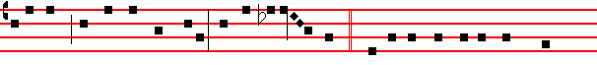
it to them: and they all drank of it. And he said unto them:  This is my blood of the new Tes-
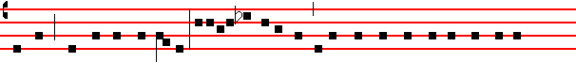
tament, which is shed for many. Verily I say unto you, I will drink no more of the fruit of the
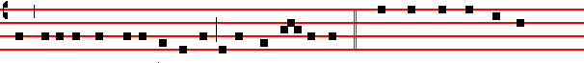
vine, until that day that I drink it new in the kingdom of God. C. And when they had sung an
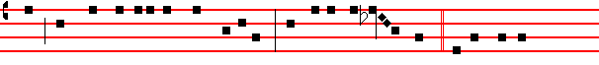
hymn they went out into the mount of Olives. And Jesus saith unto them:  All ye shall be 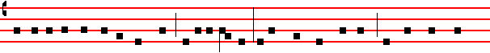
offended because of me this night: for it is written: I will smite the shepherd, and the sheep shall
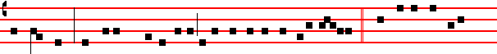
be scattered. But, after that I am risen, I will go before you into Galilee. C. But Peter said unto
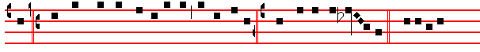
him: S. Although all shall be offended, yet will not I. C. And Jesus saith unto him: Verily. I
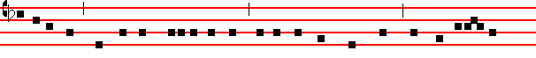
say unto thee, That this day, even in this night, before the cock crow twice, thou shalt deny me

4
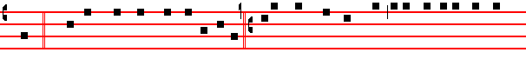
thrice. C.But he spake the more vehemently: S. If I should die with thee, I will not deny thee in
any wise. C. Likewise also said they all. And they came to a place which was named Gethsema-
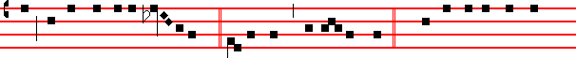
ne. And he saith to his disciples:  Sit ye here, while I shall pray.C.And he taketh with him
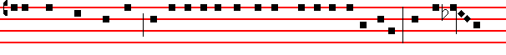
Peter, and James, and John: and began to be sore amazed, and to be very heavy. And saith unto
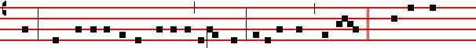
them:  My soul is exceeding sorrowful unto death: tarry ye here, and watch. C. And he went 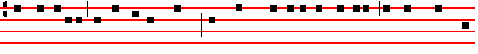
forward a little, and fell on the ground: and prayed, that, if it were possible, the hour might pass
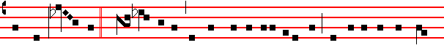from him: and he said: Ab-ba, Father, all things are possible unto thee, take away this cup from 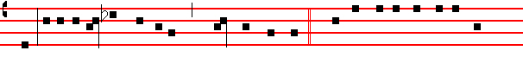
me: nevertheless, not what I will, but what thou wilt. C. And he cometh and findeth them
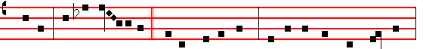
sleeping. And saith un- to Peter:  Simon, sleepest thou? couldest not thou watch one hour?
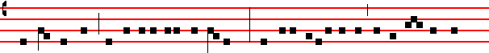
Watch ye and pray, lest ye enter into temptation. The spirit truly is ready, but the flesh is weak.
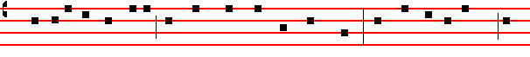C. And again he went away, and prayed, and spake the same words. And when he returned he 5
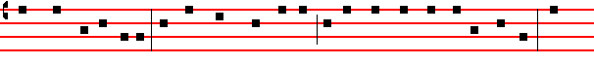
found them asleep again, (for their eyes were heavy), neither wist they what to answer him. And
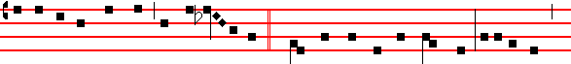he cometh the third time, and saith unto them:  Sleep on now, and take your rest. It is enough:
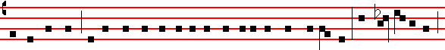
the hour is come: behold, the Son of man is betrayed into the hands of sinners. Rise up, let us go:
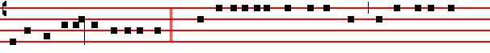
lo, he that betrayeth me is at hand. C. And immediately, while he yet spake, cometh Judas, one
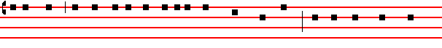
of the twelve, and with him a great multitude with swords and staves, from the chief priests, and
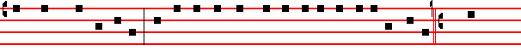
the scribes. and the elders. And he that betrayed him had given them a token, saying: S. Whom-
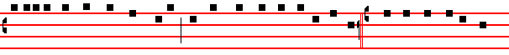
soever I shall kiss, that same is he, take him, and lead him away safely. C. And as soon as he was
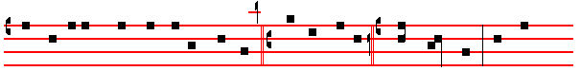
come, he goeth straightway to him, and saith: S. Master, master. C. And kissed him. And they 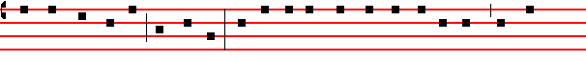laid their hands on him, and took him. And one of them that stood by drew a sword, and smote 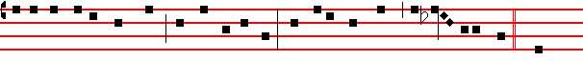a servant of the high priest: and cut off his ear. And Jesus answered, and said unto them:  Are

6
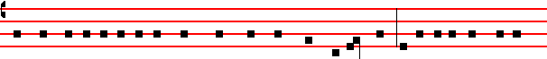 ye come out as against a thief, with swords and with staves, to take me? I was daily with you in
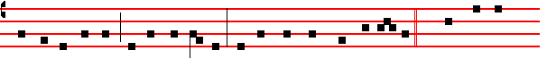
the temple teaching, and ye took me not. But the Scriptures must be fulfilled. C. And they all
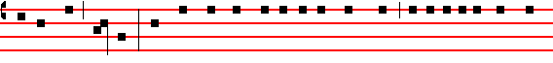
forsook him, and fled. And there followed him a certain young man, having a linen cloth cast
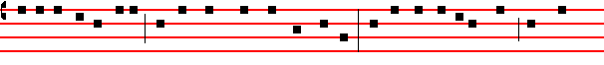
about his naked body: and the young men laid hold on him. And he left the linen cloth, and fled
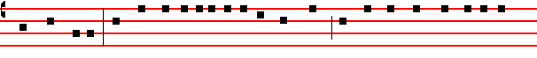
from them naked. And they led Jesus away to the high priest: and with him were assembled all
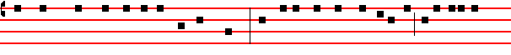
the chief priests, and the elders, and the scribes. And Peter followed him afar off, even into the
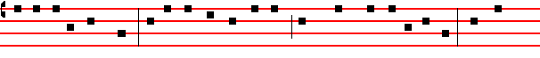
palace of the high priest: and he sat with the servants, and warmed himself at the fire. And the
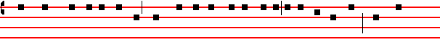
chief priests and all the council sought for witness against Jesus to put him to death, and found
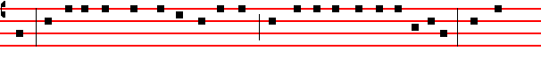
none. For many bare false witness against him : but their witness agreed not together. And there

arose certain, and bare false witness against him, saying: S.We heard him say: I will destroy this

7
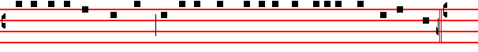temple that is made with hands, and within three days I will build another made without hands. C.
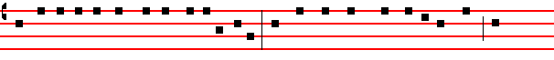
But neither so did their witness agree together. And the high priest stood up in the midst, and
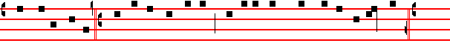
asked Jesus, saying: S. Answerest thou nothing, what is it which these witness against thee? C.
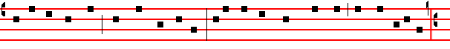
But he held his peace, and answered nothing. Again the high priest asked him, and said unto him:
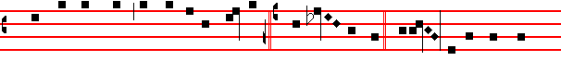
S. Art thou the Christ, the Son of the Blessed? C. And Je- sus said:  I am: and ye shall see
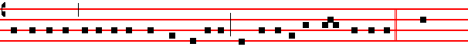
the Son of man sitting on the right hand of power, and coming in the clouds of heaven. C. Then
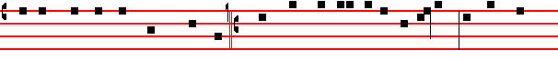
the high priest rent his clothes, and saith: S. What need we any further witnesses? Ye have heard
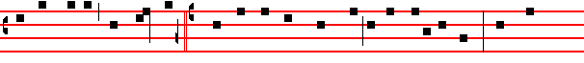
the blasphemy: what think ye? C. And they all condemned him to be guilty of death. And some
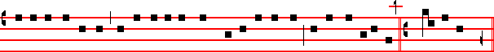
began to spit on him, and to cover his face, and to buffet him, and to say unto him: S. Prophesy.
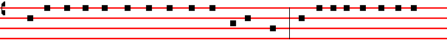
C. And the servants did strike him with the palms of their hands. And as Peter was beneath in

8
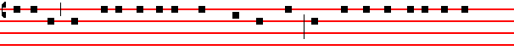
the palace there cometh one of the maids of the high priest: and when she saw Peter warming 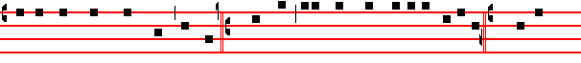himself she looked upon him, and said: S. And thou also wast with Jesus of Nazareth. C. But he
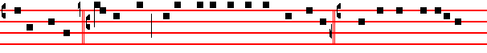 denied, saying: S. I know not, neither understand I what thou sayest. C. And he went out into the
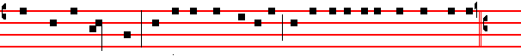
porch, and the cock crew. And a maid saw him again, and began to say to them that stood by: S.
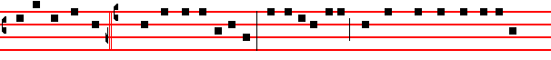
This is one of them. C. And he denied it again. And a little after, they that stood by said again to
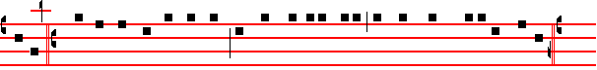
Peter: S. Surely thou art one ot them: for thou art a Galilean, and thy speech agreeth thereto. C.
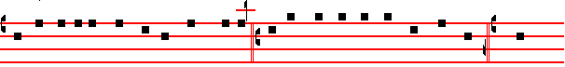
But he began to curse and to swear, saying: S. I know not this man of whom ye speak: C. And
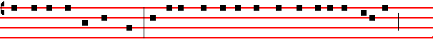
the second time the cock crew. And Peter called to mind the word that Jesus said unto him:
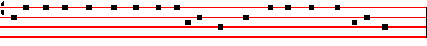
Before the cock crow twice, thou shalt deny me thrice. And when he thought thereon he wept.
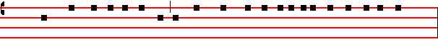
(xv.j.). And straightway in the morning the chief priests held a consultation with the elders, and

9
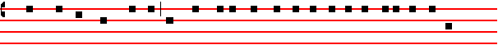
scribes, and the whole council, and bound Jesus, and carried him away, and delivered him to
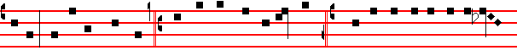
Pilate. And Pilate asked him: S. Art thou the King of the Jews? C. And he answering said un- to

him:  Thou sayest it. C. And the chief priests accused him of many things: but he answered
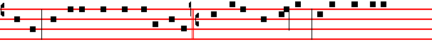
nothing. And Pilate asked him again, saying: S. Answerest thou nothing? behold how many
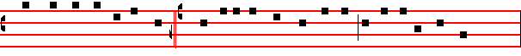
things they witness against thee. C. But Jesus yet answered nothing, so that Pilate marvelled.
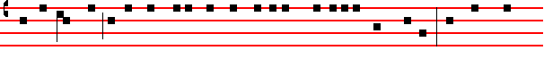
Now at that feast he released unto them one prisoner, whomsoever they desired. And there was
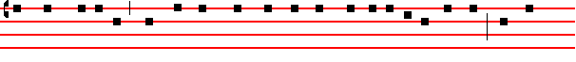
one named Barabbas, which lay bound with them that had made insurrection with him, who had 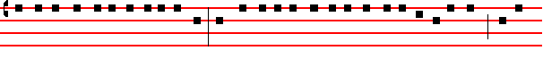
committed murder in the insurrection. And the multitude, crying aloud, began to desire him to do 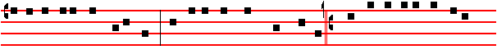 as he had ever done unto them. But Pilate answered them, saying: S. Will ye that I release unto
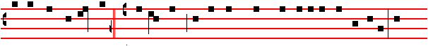
you the King of the Jews? C. For he knew that the chief priests had delivered him for envy. But

10
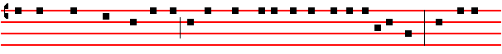
the chief priests moved the people, that he should rather release Barabbas unto them. And Pilate
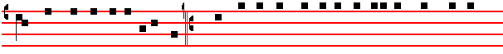
answered, and said again unto them: S. What will ye then That I shall do unto him whom ye call 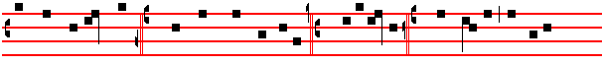 the King of the Jews? C. And they cried out again : S. Crucify him. C. Then Pilate said unto 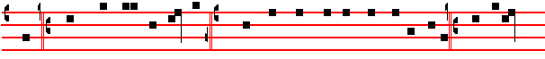 them: S. Why, what evil hath he done? C. And they cried out the more exceedingly: S. Crucify
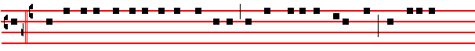
him.C. And so Pilate, willing to content the people, released Barabbas unto them, and delivered
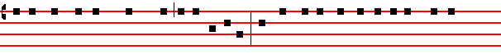
Jesus, when he had scourged him, to be crucified. And the soldiers led him away into the hall,
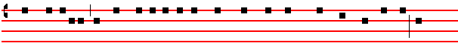 called prætorium, and they call together the whole band, and they clothed him with purple, and
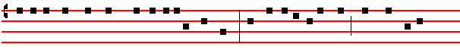 platted a crown of thoms, and put it about his head. And began to salute him: Hail, King of the 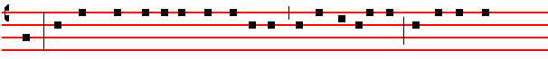 Jews. And they smote him on the head with a reed, and did spit upon him, and bowing their
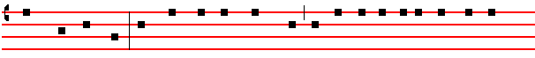 knees worshipped him. And when they had mocked him they took off the purple from him, and

11
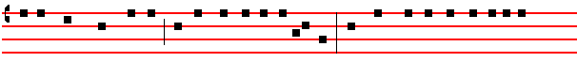
put his own clothes on him, and led him out to crucify him. And they compel one Simon a Cy-
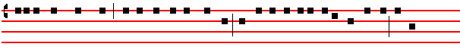
renian, who passed by, coming out of the country, the father of Alexander and Rufus, to bear
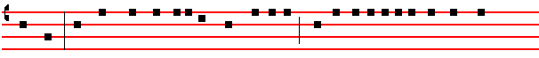
his cross. And they bring him unto the place Golgotha, which is, being interpreted, The place

of a skull. And they gave him to drink wine mingled with myrrh: but he received it not. And
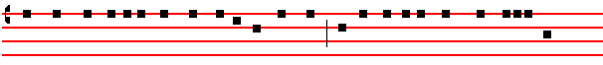
when they had crucified him they parted his garments, casting lots upon them, what every man
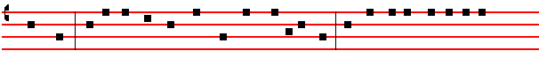
should take. And it was the third hour, and they crucified him. And the superscription of his 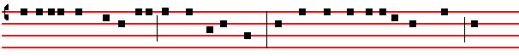 accusation was written over: the king of the Jews. And with him they crucify two thieves: the
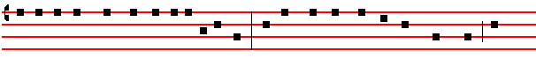
one on his right hand, and the other on his left. And the Scripture was fulfilled, which saith: And
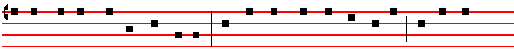
he was numbered with the transgressors. And they that passed by railed on him, wagging their
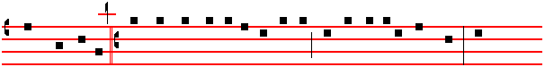
heads, and saying: S. Ah, thou that destroyest the temple, and buildest it in three days: save

12
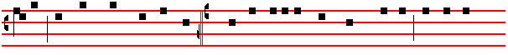 thyself, and come down from the cross C. Likewise also the chief priests mocking said among
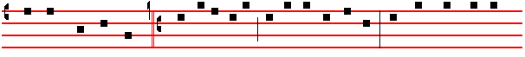
themselves, with the scribes : S. He saved others, himself he cannot save. Let Christ the King of
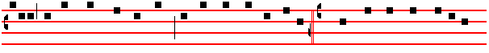
Israel descend now from the cross, that we may see and believe. C. And they that were crucified
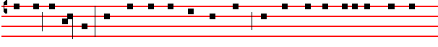
with him reviled him. And when the sixth hour was come, there was darkness over the whole land
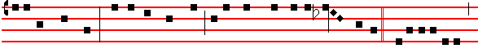until the ninth hour. And at the ninth hour Jesus cried with a loud voice, saying:  E-lo-i, E-lo-i,
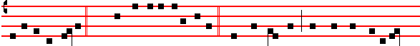 lama sabachthani ? C. Which is, being interpreted:  My God, my God, why hast thou forsaken
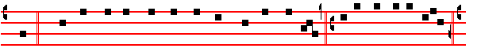
me? C. And some of them that stood by, when they heard it, said: S. Behold, he calleth Elias.

C. And one ran and filled a spunge full of vinegar, and put it on a reed, and gave him to drink,
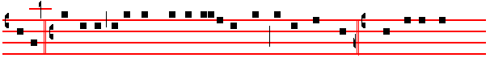
saying: S. Let alone, let us see whether Elias will come to take him down. C. And Jesus cried
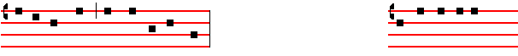
with a loud voice, and gave up the ghost. Here genuflect, and pause awhile And the vail of the

13
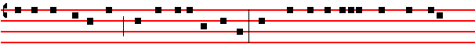
temple was rent in twain from the top to the bottom. And when the centurion, which stood over
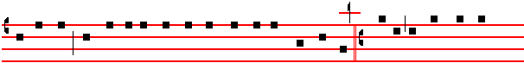
against him, saw that he so cried out, and gave up the ghost, he said: S. Truly this man was the 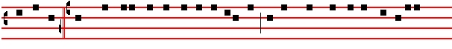
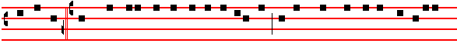 Son of God. C. There were also women looking on afar off: among whom was Mary Magdalene,
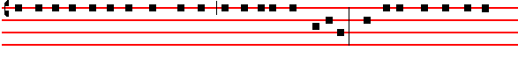
and Mary the mother of James the less and of Joses, and Salome: (who also, when he was in
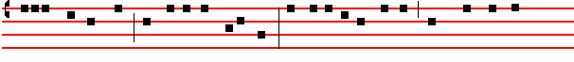 Galilee, followed him, and ministered unto him,) and many other women which came up with
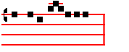
him unto Jerusalem.

What follows is sung in the tone of the Gospel, and the rest is done as above on Sunday.

Tone of the Gospel ad lib.
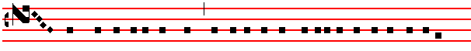
AND now when the even was come, because it was the Preparation, that is, the day before

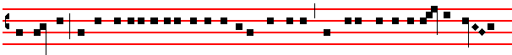
the sabbath, Joseph of Arimathæa, an honourable counsellor, which also waited for the kingdom

14
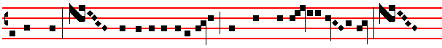 of God, came, and went in boldly unto Pilate, and craved the bo- dy of Je- sus. And 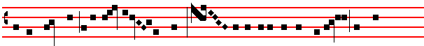
Pilate marvelled if he were alrea- dy dead. And calling unto him the centurion, he asked  him whether he had been any while dead. And when he knew it of the centu-ri-on, he
 gave the bo- dy to Joseph. And he bought fine linen, and took him down, and wrapped 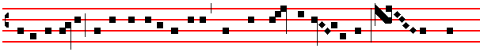 him in the linen, and laid him in a sepulchre which was hewn out of a rock, and rolled a
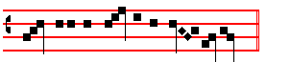
stone unto the door of the se- pul-chre.

15

