FERIA IV. MAJORIS HEBDOMADÆ

WEDNESDAY IN HOLY WEEK

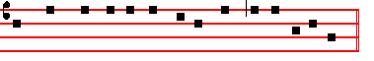
The PASSION of our Lord Jesus Christ according to Luke (xxij. I and xxiij.)


AT that time: The feast of unleavened bread drew nigh, which is called the Passover:

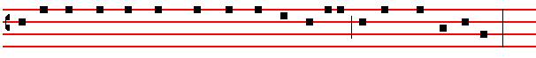
and the chief priests and scribes sought how they might kill Jesus: for they feared the people.
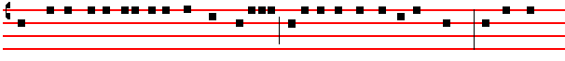
Then entered Satan into Judas surnamed Iscariot, being of the number of the twelve. And he went
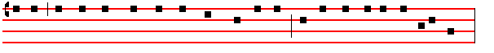 his way, and communed with the chief priests and captains, how he might betray him unto them.

And they were glad, and covenanted to give him money. And he promised. And sought

opportunity to betray him unto them in the absence of the multitude. Then came the day of 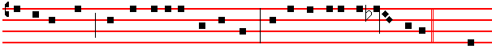unleavened bread, when the passover must be killed. And he sent Peter and John, saying:  Go
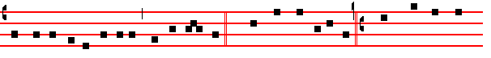and prepare us the passover, that we may eat. C. And they said unto him: S. Where wilt thou that
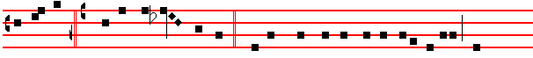
we prepare? C. And he said un- to them:  Behold, when ye are entered into the city, there
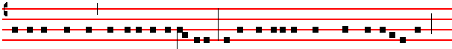
shall a man meet you, bearing a pitcher of water: follow him into the house where he entereth in, 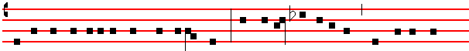and ye shall say unto the good-man of the house: The Master saith unto thee: Where is the guest-
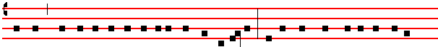
chamber, where I shall eat the passover with my disciples? And he shall shew you a large upper
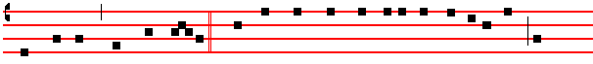
room furnished, there make ready. C. And they went, and found as he had said unto them, and
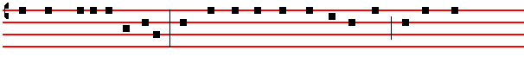
they made ready the passover. And when the hour was come he sat down, and the twelve
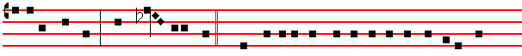
Apostles with him. And he said unto them:  With desire I have desired to eat this passover with
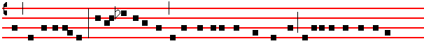
you before I suffer. For I say unto you: I will not any more eat thereof, until it be fulfilled in the
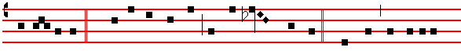 kingdom of God. C. And he took the cup, and gave thanks. and said:  Take this, and divide it
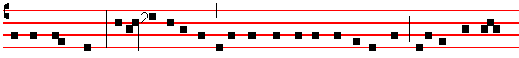
among yourselves. For I say unto you, I will not drink of the fruit of the vine, until the kingdom

2
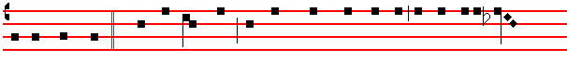
of God shall come. C. And he took bread, and gave thanks, and brake it, and gave unto them,
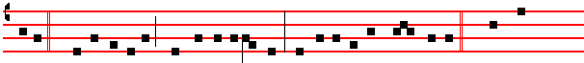
saying:  This is my body, which is given for you: this do in remembrance of me. C. Likewise 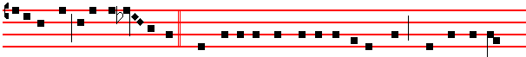also the cup after supper, saying:  This cup is the new Testament in my blood, which is shed for
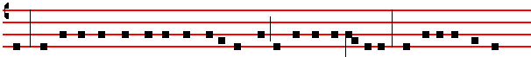
you. But behold. the hand of him that betrayeth me is with me on the table. And truly the Son of
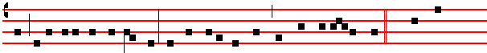
man goeth as it was determined: but woe unto that man by whom he is betrayed. C. And they
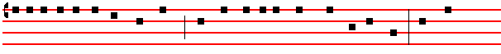
began to enquire among themselves, which of them it was that should do this thing. And there
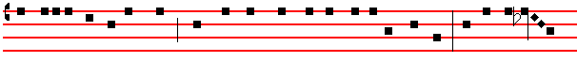
was also a strife among them, which of them should be accounted the greatest. And he said unto
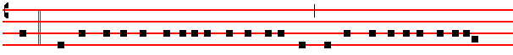
them:  The kings of the Gentiles exercise lordship over them: and they that exercise authority
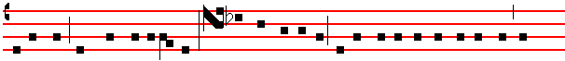
upon them are called benefactors. But ye shall not be so: but he that is greatest among you, let
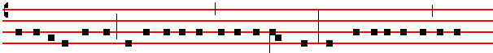
him be as the younger: and he that is chief, as he that doth serve. For whether is greater, he that

3
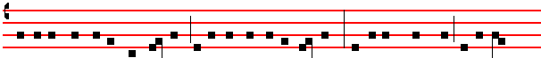
sitteth at meat, or he that serveth? is not he that sitteth at meat? But I am among you as he that
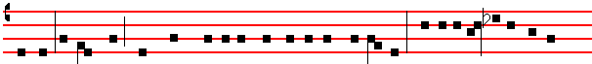
serveth: ye are they which have continued with me in my temptations. And I appoint unto you a
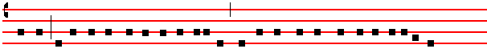
kingdom, as my Father hath appointed unto me, that ye may eat and drink at my table in my

kingdom: and sit on thrones, judging the twelve tribes of Israel. C. And the Lord said: 
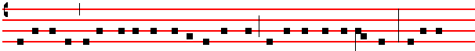
Simon, Simon, behold, Satan hath desired to have you, that he may sift you as wheat: but I have
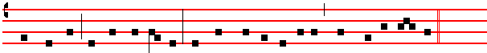
prayed for thee, that thy faith fail not: and when thou art converted, strengthen thy brethren. C.
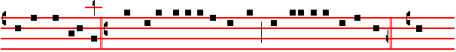
And he said unto him: S. Lord, I am ready to go with thee both into prison and to death. C. And
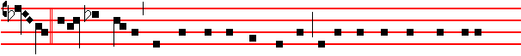 he said:  I tell thee, Peter: The cock shall not crow this day, before that thou shalt thrice deny 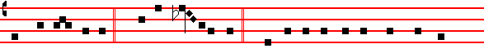 that thou knowest me. C. And he said unto them:  When I sent you without purse, and scrip,
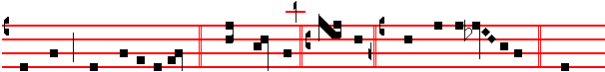 and shoes, lacked ye any thing? C. And they said: S. Nothing. C. Then said he unto them:  But
4
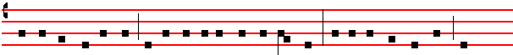
now, he that hath a purse, let him take it, and likewise his scrip: and he that hath no sword, let
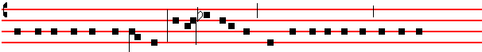
him sell his garment, and buy one: For I say unto you, That this that is written must yet be
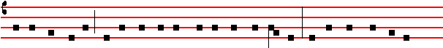
accomplished in me: And he was reckoned among the transgressors. For the things concerning
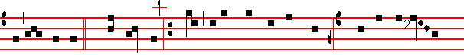
me have an end. C. And they said: S. Lord, behold, here are two swords. C. And he said un- to
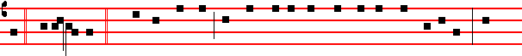
them:  It is enough. C. And he came out, and went, as he was wont, to the mount of Olives. And
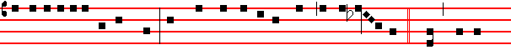
his disciples also followed him. And when he was at the place, he said unto them:  Pray, that ye
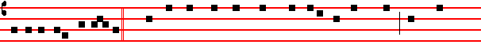
enter not into temptation. C. And he was withdrawn from them about a stone's cast, and kneeled
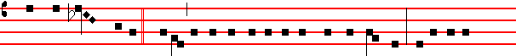
down and prayed, saying:  Father, if thou be willing, remove this cup from me: nevertheless,
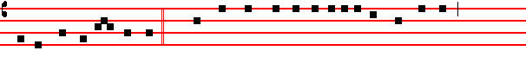
not my will, but thine be done. C. And there appeared an Angel unto him from heaven,
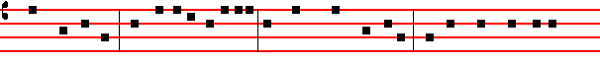
strengthening him. And being in an agony, he prayed more earnestly. And his sweat was as it
5
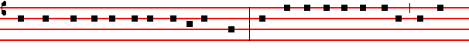
were great drops of blood falling down to the ground. And when he rose up from prayer, and was
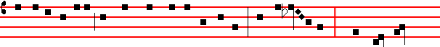
come to his disciples, he found them sleeping for sorrow. And said unto them:  Why sleep ye ?
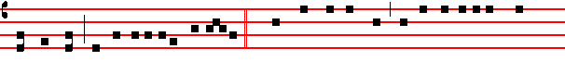
rise and pray, lest ye enter into temptation. C. And while he yet spake, behold. a multitude: and
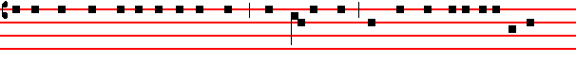
he that was called Judas, one of the twelve, went before them, and drew near unto Jesus to kiss
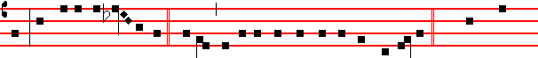
him. But Jesus said unto him:  Judas, betrayest thou the Son of man with a kiss? C. When they
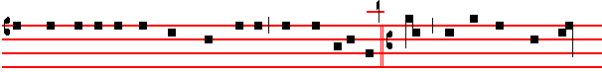
who were about him saw what would follow, they said unto him: S. Lord, shall we smite with the
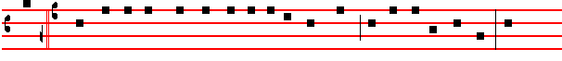
sword? C. And one of them smote the servant of the high priest, and cut off his right ear. And 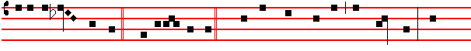 Jesus answered and said:  Suffer ye thus far. C. And he touched his ear, and healed him. Then
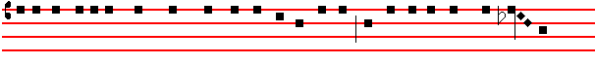
Jesus said unto the chief priests, and captains of the temple, and the elders who were come to
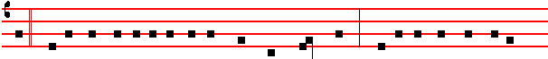
him:  Be ye come out as against a thief, with swords and staves? When I was daily with you in
6
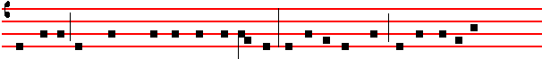
the temple, ye stretched forth no hands against me: but this is your hour, and the power of
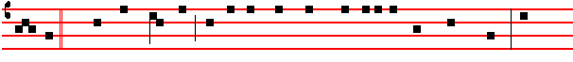
darkness. C. Then took they him, and led him, and brought him into the high priest's house: and
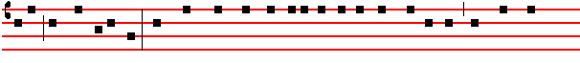
Peter followed afar off. And when they had kindled a fire in the midst of the hall, and were set
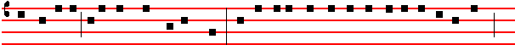
down together, Peter sat down among them. But a certain maid beheld him, as he sat by the fire,
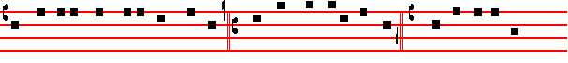
and earnestly looked upon him, and said: S. This man was also with him. C. And he denied him,
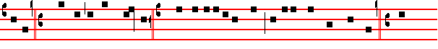
saying: S. Woman, I know him not. C. And after a little while another saw him, and said: S. Thou
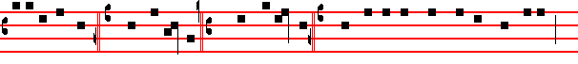
art also of them. C. And Peter said : S. Man, I am not. C. And about the space of one hour after,
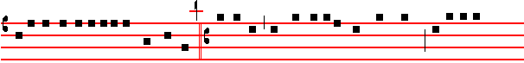 another confidently affirmèd, saying: S. Of a truth this fellow also was with him: for he is a
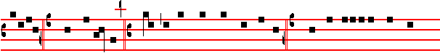
Galilean. C. And Peter said: S. Man, I know not what thou sayest. C. And immediately, while he
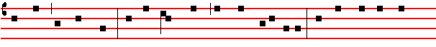
yet spake, the cock crew. And the Lord turned, and looked upon Peter. And Peter remembered
7

the word of the Lord, how he had said unto him: Before the cock crow, thou shalt deny me
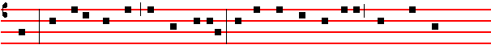
thrice. And Peter went out, and wept bitterly. And the men that held Jesus mocked him, and
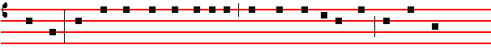
smote him. And when they had blindfolded him, they struck him on the face, and asked him,
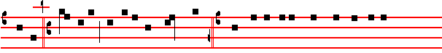
saying: S. Prophesy, who is it that smote thee? C. And many other things blasphemously
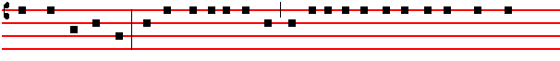
spake they against him. And as soon as it was day, the elders of the people, and the chief priests, 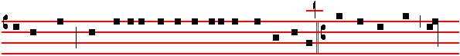and the scribes, came together, and led him into their council, saying: S. Art thou the Christ? tell
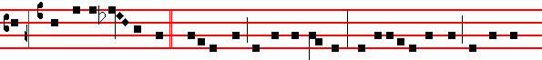
us. C. And he said un- to them: If I tell you, ye will not believe:and if I also ask you, ye will not
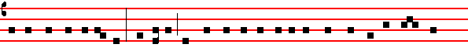
answer me, nor let me go. Hereafter shall the Son of man sit on the right hand of the power of
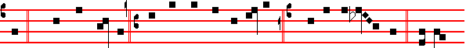
God. C. Then said they all: S. Art thou then the Son of God? C. And he said unto them:  Ye say
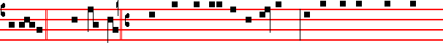
that I am. C. And they said: S. What need we any further witness ? For we ourselves have heard

8
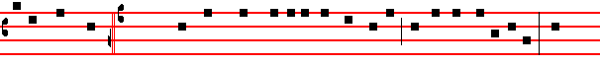
of his own mouth. (xxiij.I). And the whole multitude of them arose, and led him unto Pilate. And
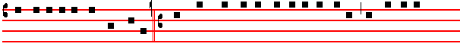
they began to accuse him, saying: S. We found this fellow perverting the nation, and forbidding
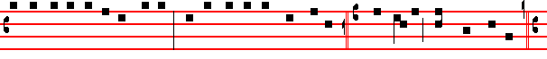
to give tribute to Cæsar, saying, That he himself is Christ a king.C.And Pilate asked him, saying:
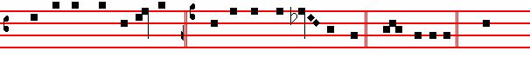
S. Art thou the King of the Jews? C. And he answered him, and said:  Thou sayest it. C. Then
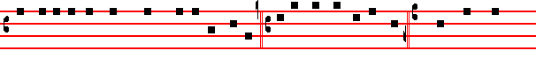
said Pilate to the chief priests, and to the people: S. I find no fault in this man. C. And they were
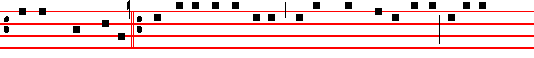the more fierce, saying: S. He stirreth up the people, teaching throughout all Jewry, beginning
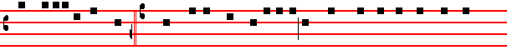
from Galilee to this place. C. When Pilate heard of Galilee, he asked whether the man were a 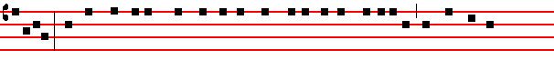Galilean. And as soon as he knew that he belonged unto Herod's jurisdiction, he sent him to 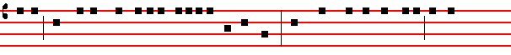 Herod, who himself was also at Jerusalem at that time. And when Herod saw Jesus he was
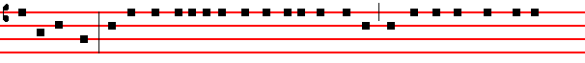
exceeding glad. For he was desirous to see him of a long season, because he had heard many

9
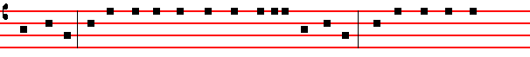
things of him, and he hoped to have seen some miracle done by him. Then he questioned with
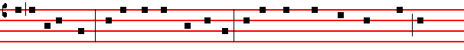
him in many words. But he answered him nothing. And the chief priests and scribes stood and
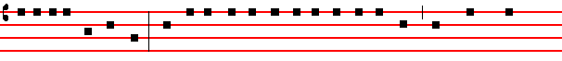
vehemently accused him. And Herod with his men of war set him at nought: and mocked him,
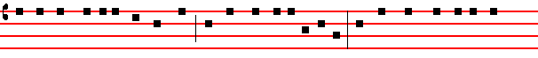
and arrayed him in a gorgeous robe, and sent him again to Pilate. And the same day Pilate and
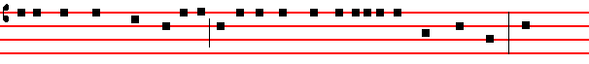
Herod were made friends together: for before they were at enmity between themselves. And
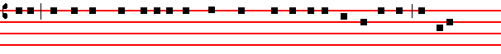
Pilate, when he had called together the chief priests, and the rulers, and the people, said unto
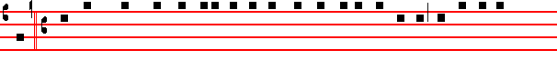
them: S. Ye have brought this man unto me, as one that perverteth the people, and behold, I,
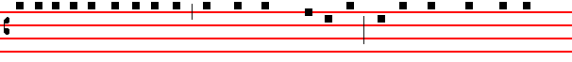
having examined him before you, have found no fault in this man touching those things whereof
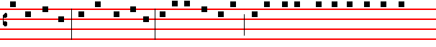
ye accuse him. No, nor yet Herod: for I sent you to him, and lo, nothing worthy of death is done
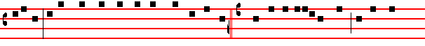
unto him. I will therefore chastise him, and release him. C. For of necessity he must release one

10
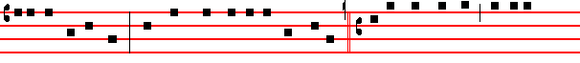
unto them at the feast. And they cried out all at once, saying: S. Away with this man, and release
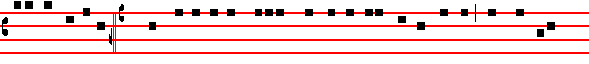
unto us Barabbas. C. (Who for a certain sedition made in the city, and for murder, was cast into
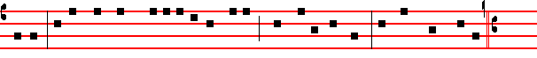
prison). Pilate therefore, willing to release Jesus, spake again to them. But they cried, saying: S.
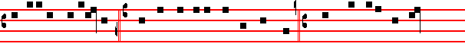Crucify him, crucify him. C. And he said unto them the third time: S. Why, what evil hath he
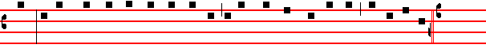
done? I have found no cause of death in him : I will therefore chastise him, and let him go. C.
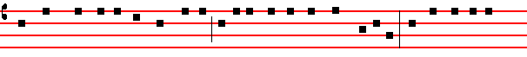
And they were instant with loud voices, requiring that he might be. crucified. And the voices of
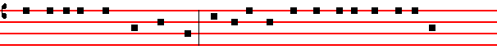
them and of the chief priests prevailed. And Pilate gave sentence that it should be as they
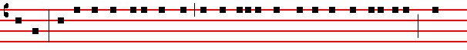
required. And he released unto them him that for sedition and murder was cast into prison, whom
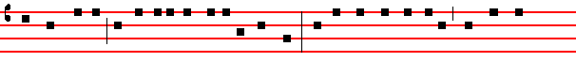
they had desired: but he delivered Jesus to their will. And as they led him away, they laid hold 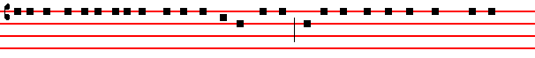
upon one Simon a Cyrenian, coming out of the country: and on him they laid the cross, that he +
11
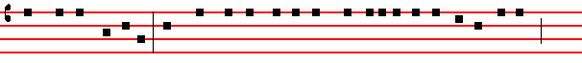
might bear it after Jesus. And there followed him a great company of people, and of women,
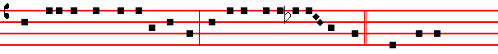 which also bewailed and lamented him. But Jesus, turning unto them, said:  Daughters of
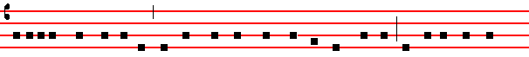
Jerusalem, weep not for me, but weep for yourselves, and for your children. For behold, the days
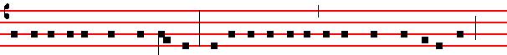are coming, in the which they shall say: Blessed are the barren, and the wombs that never bare,
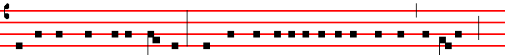
and the paps which never gave suck.Then shall they begin to say to the mountains: Fall on us:
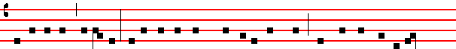
and to the hills: Cover us. For if they do these things in a green tree, what shall be done in the
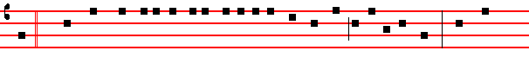
dry? C. And there were also two other, malefactors, led with him to be put to death. And when
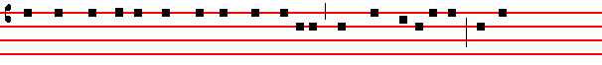
they were come to the place which is called Calvary, there they crucified him: and the
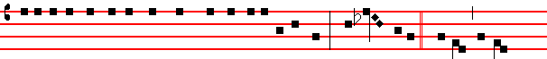
malefactors, one on the right hand, and the other on the left. Then said Jesus:  Father, forgive
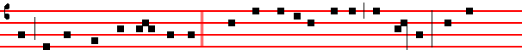
them: for they know not what they do. C. And they parted his raiment, and cast lots. And the

12
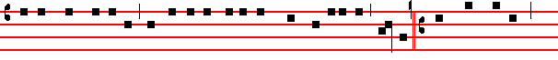
people stood beholding, and the rulers , also with them derided him, saying: S. He saved others:
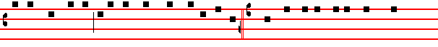
let him save himself, if he be Christ, the chosen of God. C. And the soldiers also mocked him,
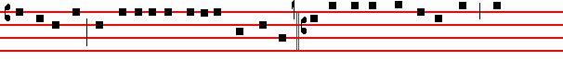
coming to him, and offering him vinegar, and saying: S. If thou be the King of the Jews. save
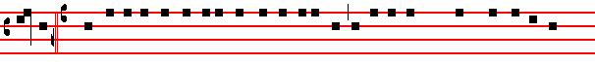 thyself. C. And a superscription also was written over him in letters of Greek, and Latin, and
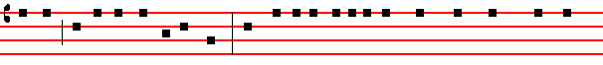
Hebrew: This is the King of the Jews. And one of the malefactors, which were hanged, railed on
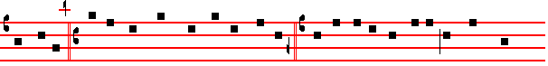him, saying: S. If thou be Christ, save thyself, and us. C. But the other answering rebuked him,
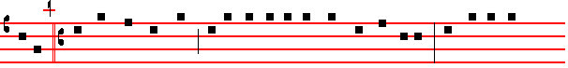
saying: S. Dost not thou fear God, seeing thou art in the same condemnation? And we indeed
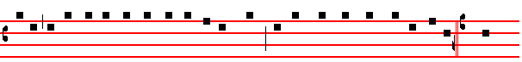
justly, for we receive the due reward of our deeds: but this man hath done nothing amiss. C. And
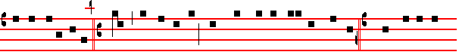
he said unto Jesus: S. Lord, remember me when thou comest into thy kingdom. C. And Jesus said
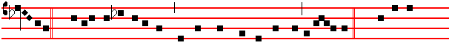
unto him:  Verily I say unto thee: To-day shalt thou be with me in paradise. C. And it was
13
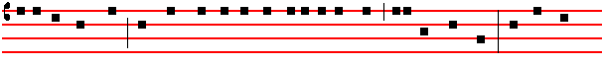
about the sixth hour, and there was a darkness over all the earth until the ninth hour. And the sun
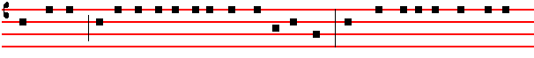
was darkened: and the vail of the temple was rent in the midst. And when Jesus had cried with a

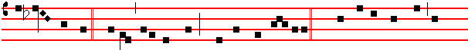loud voice, he said:  Father, into thy hands I commend my spirit. C. And having said thus, he
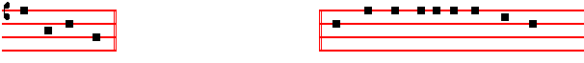
gave up the ghost. Here genuflect, and pause awhile Now when the centurion saw what was 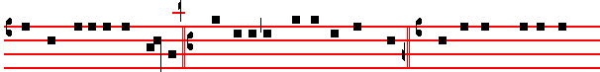done, he glorified God, saying: S. Certainly this was a righteous man. C. And all the people that
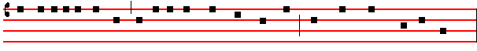
came together to that sight; beholding the things that were done, smote their breasts, and returned.
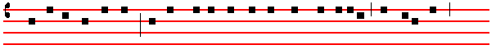
And all his acquaintance, and the women that followed him from Galilee, stood afar off,
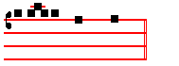
beholding these things.

What follows is sung in the tone of the Gospel: and the rest is done as above on Sunday.

AND, behold, there was a man named Joseph, a counseller, and he was a good man, and a

14
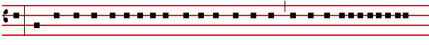
just: (the same had not consented to the counsel and deed of them,) he was of Arimathæa, a city
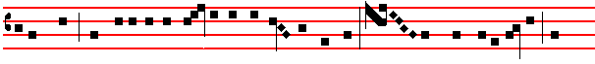 of the Jews, who also himself waited for the kingdom of God. This man went unto Pilate, and
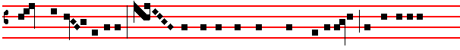
begged the body of Jesus: and he took it down, and wrapped it in linen, and laid it in a
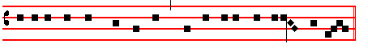
sepulchre that was hewn in stone, wherein never man before was laid.

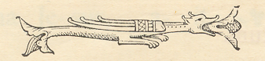

15

