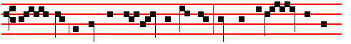
laid wait for me have prevailed against me; he whom I loved hath be-
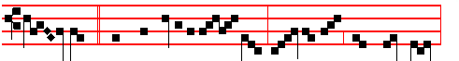
trayed me: * And with fury in their eyes, smit- ing me with cruel blows,
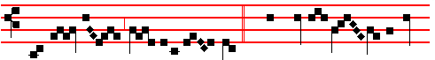
they gave me vin - egar to drink.  They cast me out among
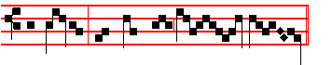
the wicked, and spared not my soul. And with fury.

Lesson ij
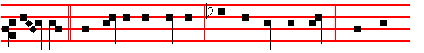
LAMED. They say to their mothers, Where is corn and wine? when they
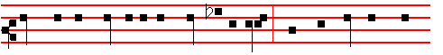
swooned as the wounded in the streets of the city, when their soul was poured
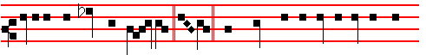
out into their mothers' bos- om. Mem. What thing shall I take to witness for
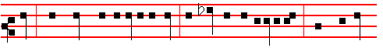
thee? what thing shall I liken to thee, O daughter of Jerusalem? what shall I

685
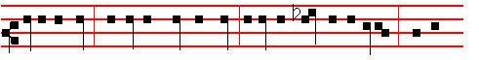
equal to thee, that I may comfort thee, O virgin daughter of Sion? for thy
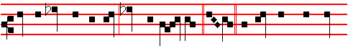
breach is great like the sea; who can heal thee? Nun. Thy prophets have seen
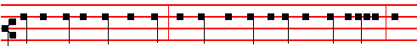
vain and foolish things for thee; and they have not discovered thine iniquity, to
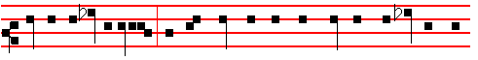
turn away thy captivity; but have seen for thee false burdens and causes of
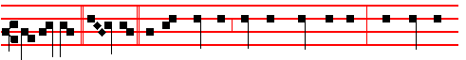 banishment. Samech. All that pass by clap their hands at thee; they hiss and
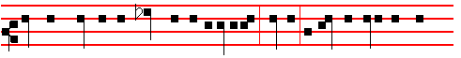
wag their head at the daughter of Jerusalem, saying, Is this the city that men
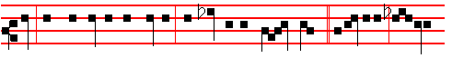
call The perfection of beauty, The joy of the whole earth? Jerusalem, Jerusa-
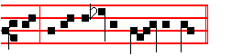
lem, return unto the Lord thy God.

 II Tone ij

686
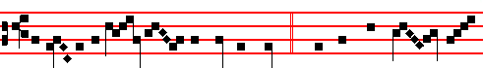
The veil of the tem - ple was rent in twain, * And the whole earth did
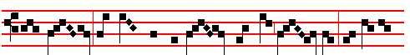
quake: the thief from the cross cried out, say - ing: Remember
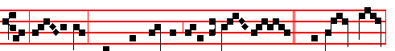
me, O Lord, when thou comest into thy king - dom .  The rocks rent,
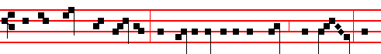
and the graves were opened; and many bodies of the saints which slept a-
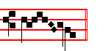
rose. And the whole earth.

Lesson iij Chapter 3: 1-9
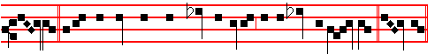
ALEPH. I am the man that hath seen affliction by the rod of his wrath. Aleph.
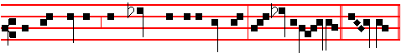
He hath led me, and brought me into darkness, but not into light. A- leph.
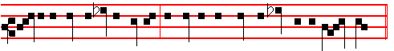
Surely against me is he turned; he turneth his hand against me all the day.

687
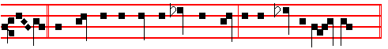
Beth. My flesh and my skin hath he made old; he hath broken my bones.
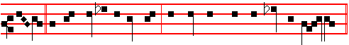
Beth. He hath builded against me, and compassed me with gall and tra-vail.
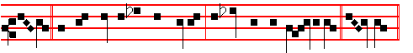
Beth. He hath set me in dark places, as they that be dead of old. Ghi - mel.
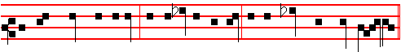
He hath hedged me about, that I cannot get out: he hath made my chain heavy.
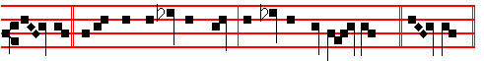
Ghi-mel. Also when I cry and shout, he shutteth out my prayer. Ghi - mel.
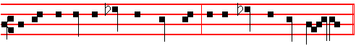
He hath inclosed my ways with hewn stone, he hath made my paths crooked.
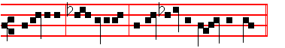
Jerusalem, Je - rusalem, return unto the Lord thy God.

 III Tone viij
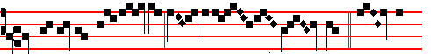
O my vineyard, my chosen, did I not plant thee? * How then

688
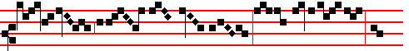
art thou turned into such bit - terness as to crucify me and
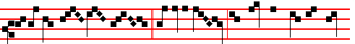
to release Bar- ab- bas?  I fenced thee, and gathered out the stones
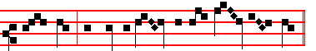
from thee, and built a tower in the midst of thee. How then.
O my vineyard.
IN THE SECOND NOCTURN
Antiphon 1. Tone viij, 1.
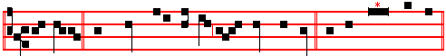
They also that sought after my life laid snares for me. Psalm 38 Domine,
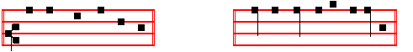
ne in furore p. 73, ending slowly: * O Lord God of my salvation.
Antiphon 2. Tone iv, 1.
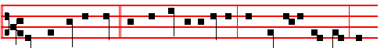
Let them be ashamed and confounded together, that seek after my soul to
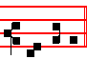
destroy it. Psalm 40 Expectans expectavi p. 78, ending slowly:
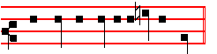
* make no long tarrying, O my God.

689
Antiphon 3. Tone iv, 1.
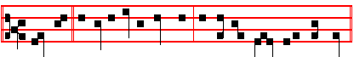
Strangers are risen up against me, and tyrants seek after my soul.
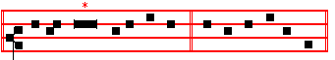
Psalm 54, Deus in nomine p. 99, ending slowly:
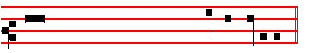
* and mine eye hath seen his desire upon mine enemies.
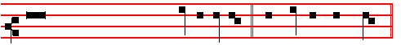
 There are false witnesses risen up against me.  And such as speak wrong.
Our Father secretly.
From the Treatise of Saint Augustine the Bishop, on the Psalms.
Lesson iv Ps. 64: 2
HIDE me from the gathering together of the froward, and from the insurrection of wicked doers. Tone as above, p. 667-668.
NOW let us contemplate our Head himself. Many martyrs have suffered like things, but naught shineth out in such wise as the Head of the martyrs: in him we best perceive what they endured. He was hidden from the insurrection of the froward: God protected himself; the Very Son, with the manhood which he took upon him, protected his own flesh. For he is both Son of Man and Son of God: Son of God, being in the form of God; and Son of Man, being in the form of a servant, having power to lay down his life, and to take it again. What could his enemies do against him? They killed the body, the soul they killed not. Give heed: it were not enough for the Lord to encourage martyrs by his word, did he not strengthen them by his example.

 IV Tone viij
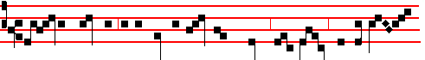
Are ye come out as against a thief with swords and staves, for to take

690
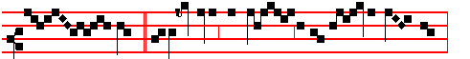
me? * I was daily with you in the tem- ple teach-ing,
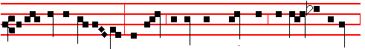
and ye laid no hold on me: and now, behold, ye scourge me, and lead me away
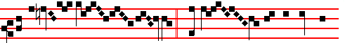
to be cru -ci - fied.  And when they had laid their
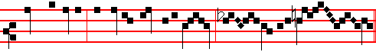
hands on Jesus, and taken hold upon him, he said unto them.
I was daily.

Lesson v
YE know what was 'the gathering together of the froward' Jews, and what was 'the insurrection of the wicked doers', What was their wicked deed? It was that they wished to kill the Lord Jesus Christ, ' Many good works,' saith he, 'have I shewed you; for which of them do you wish to kill me?' He bore all their infirmities, he healed all their sick, he preached unto them the kingdom of heaven; he held not his peace at their iniquities, so that they might rather hate the same, than the Physician who made them whole. Yet being unthankful for all these his remedies, like men frenzied with a great fever, they raved against the Physician who had come to heal them, and took counsel together to destroy him; as though they would therein prove whether he were very man, that could die; or somewhat more than man, and would not suffer himself to die. We perceive the saying of these men in the Wisdom of Solomon: 'Let us condemn him,' they say, 'with a shameful death. Let us examine him: for by his own saying he shall be respected. If he be truly the Son of God, let him deliver him.'
 V Tone vij
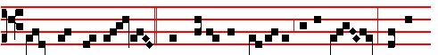
Now there was darkness, when Jesus was crucified by the Jews: and a-

691
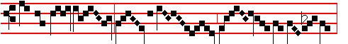
bout the ninth hour, Jes - us cried with a loud voice:
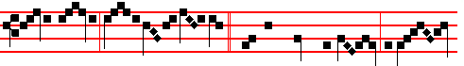
El- i, El- i, la - ma sabachthan-i. * And he bowed his head, and yield-
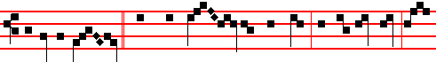
ed up the ghost.  And when Jes - us had cried with a loud voice, he
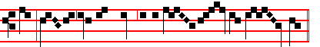
said: Fath-er, into thy hands I commend my spir - it.
And he bowed his head.

Lesson vj
THEY have whet their tongues like a sword.' Let not the Jews say, we did not kill Christ. For they delivered him up to Pilate the judge, to the end that they themselves should seem guiltless of his death. Thus when Pilate had said unto them, 'Take ye him, and crucify him;' they answered him, 'It is not lawful for us to put any man to death,' They desired to cast the injustice of their wicked deed upon a human judge: deceived they anywise God the Judge? What Pilate did, made him somewhat a partaker of their guilt: but in comparison with them he was much more innocent. For he did what he could to deliver him out of their hands, and therefore ordered him to be scourged and brought before them. He scourged not the Lord in persecution, but to satisfy their rage; that, when they saw him scourged, they might be touched with compassion, and cease to desire his death. This then he did. But when they persisted, ye know how he washed his hands, and said that he did it not himself, that he was innocent of his death. Nevertheless he did do it. But if he be guilty that did it against his will, shall they be innocent who compelled him to do it? By no means. He gave sentence upon him, and delivered him to be crucified, and thus in a manner slew him: but ye also, O Jews, have killed him. How did ye kill him? With the sword of the tongue: for ye have whet your tongue. And when smote ye, but when ye cried out, 'Crucify him, crucify him?'

692
 VI Tone viij
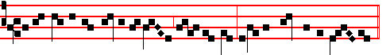
I have given the dearly belov - ed of my soul into the hand of the wick-ed:
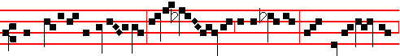
mine heritage is unto me as a li- on in the forest: mine ad-versar - y
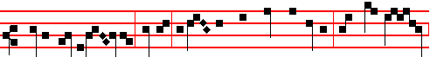
crieth out against me, saying: Assemble yourselves together, and make haste
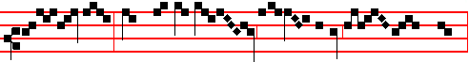
to devour him: they have set me in a des- olate wil - der - ness,
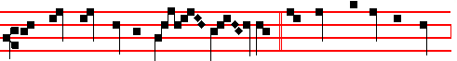 the whole land mourneth un - to me: * Because there is none found
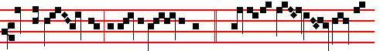
that will know me, or do me an- y good.  Merciless men rose up a-
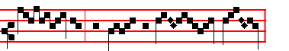
gainst me, and spared not my soul.

Because there. I have given.

IN THE THIRD NOCTURN
Antiphon 1. Tone j, 2.

693
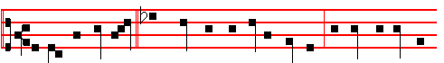
Defend me, O Lord, from them that rise up against me: for they are in pos-
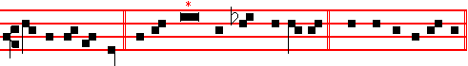
session of my soul. Psalm 59 Eripe me de inimicis, p. 102, ending slowly:
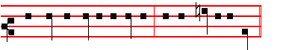
* for thou, O God, art my refuge, and my merciful God.
Antiphon 2. Tone viij, 1.
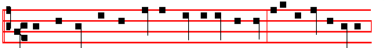
Thou hast put mine acquaintance far away from me: I am so fast in prison
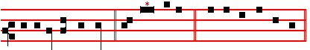
that I cannot get forth. Psalm 88 Domine Deus, p. 139, ending slowly:
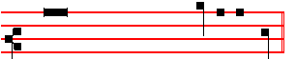
* and hid mine acquaintance out of my sight.
Antiphon 3. Tone viij, 1.
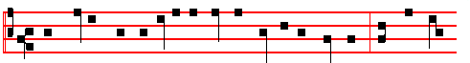
They gather them together against the soul of the righteous, and condemn
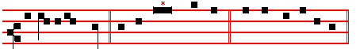
the innocent blood. Psalm 94 Deus ultionum p. 150, ending slowly:

694
* yea, the Lord our God shall destroy them.

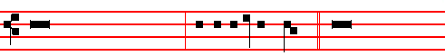
 They have spoken against me with a deceitful tongue.  They compassed
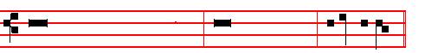
me about also with words of hatred, and fought against me without a cause.

Our Father secretly.

From the Epistle to the Hebrews Tone as above, p. 667-668
Lesson vij Chapter 4: 11-16
LET us labour therefore to enter into that rest, lest any man fall after the same example of unbelief. For the word of God is quick, and powerful, and sharper than any two-edged sword, piercing even to the dividing asunder of soul and spirit, and of the joints and marrow, and is a discerner of the thoughts and intents of the heart. Neither is there any creature that is not manifest in his sight: but all things are naked and opened unto the eyes of him with whom we have to do. Seeing then that we have a great high priest, that is passed into the heavens, Jesus the Son of God, let us hold fast our profession. For we have not an high priest which cannot be touched with the feeling of our infirmities; but was in all points tempted like as we are, yet without sin.

 VII Tone vj.
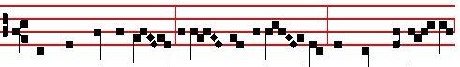
They have cast me out a-mong the un-god- ly, and turned me ov- er
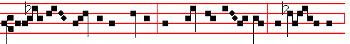
into the hands of the wicked, and spared not my soul: the migh- ty men

695
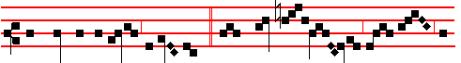
are gathered together against me: * They stood up against me ev- en as
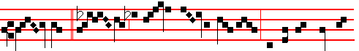
gi- ants.  Strangers are ris- en up against me, and tyrants seek af-
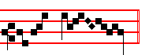
ter my soul. They stood up.

Lesson viij
LET us therefore come boldly unto the throne of grace, that we may obtain mercy, and find grace to help in time of need. For every high priest taken from among men is ordained for men in things pertaining to God, that he may offer both gifts and sacrifices for sins: who can have compassion on the ignorant, and on them that are out of the way; for that he himself also is compassed with infirmity. And by reason hereof he ought, as for the people, so also for himself, to offer for sins.

 VIII Tone vj
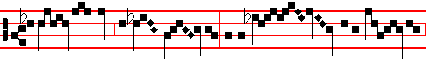
A wic - ked man betrayed Jes- us to the chief priests & the rul - ers,
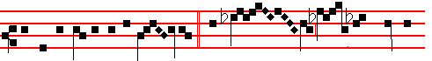
and to the elders of the peo - ple: * But Pet - er foll - owed him a-
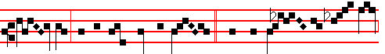
far off, that he might see the end.  And they led him a - way

696
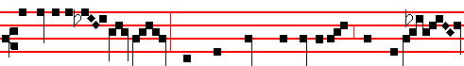
to Caiaphas the high priest, where the scribes and Pharisees were assem -
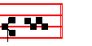
-bled. But Peter.
Lesson ix
AND no man taketh this honour unto himself, but he that is called of God, as was Aaron. So also Christ glorified not himself to be made an high priest; but he that said unto him, Thou art my Son, to-day have I begotten thee. As he saith also in another place, Thou art a priest for ever after the order of Melchisedech. Who in the days of his flesh, when he had offered up prayers and supplications with strong crying and tears unto him that was able to save him from death, and was heard in that he feared; though he were a Son, yet learned he obedience by the things which he suffered; and being made perfect, he became the author of eternal salvation unto all them that obey him; called of God an high priest after the order of Melchisedech.
 IX. Tone vj.
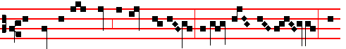
The sight of mine eyes is gone from me, because of my weep- ing: for
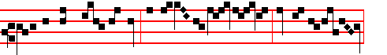
he is removed far from me, that alone did com-fort me: O all ye peo - ple,
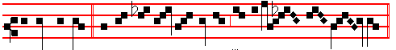
behold and see * If there be an - y sorrow like unto my sor - row.
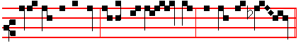
 Is it nothing to you, all ye that pass by? Behold and see. If there.
The sight.
697
AT LAUDS
Antiphon 1. Tone vij, 1.
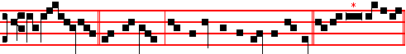
God spared not his own Son, but delivered him up for us all. Psalm 51
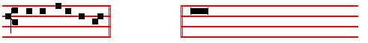
Miserere, p. 53, ending slowly: * Then shall they offer young bullocks
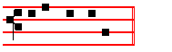
upon thine altar.
Antiphon 2. Tone iv, 1.
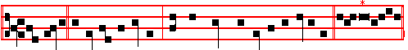
My spirit is vexed within me: and my heart within me is desolate. Psalm
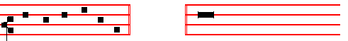
143 Domine, exaudi, p. 179 ending slowly: * and destroy all them that vex my
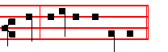
soul; for I am thy servant.
Antiphon 3. Tone j, 1.
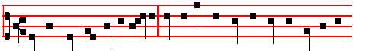
Said the one thief to the other, We indeed receive the due reward of our
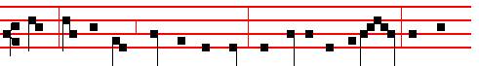
deeds; but this man, what hath he done? Remember me, O Lord, when thou

698
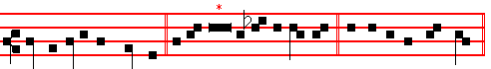
comest into thy kingdom. Psalms 63 67 Deus, Deus meus, p. 29,
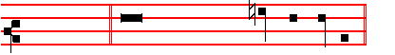
ending slowly: * and all the ends of the world shall fear him.
Antiphon 4. Tone j, 1.
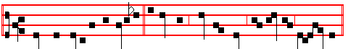
When my spirit is disquieted within me, thou, O Lord, remember merc- y.
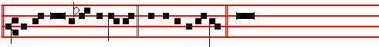
Canticle Domine, audivi, p.177, ending slowly: * and he will make me to walk
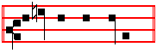
upon mine high places.
Antiphon 5. Tone viij, 1
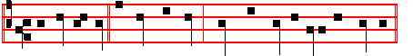
Remember me, O Lord my God, when thou comest into thy kingdom.
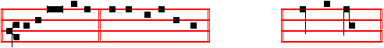
Psalms 148 149 150 Laudate Dominum, pp. 59-60, ending: * praise the Lord.
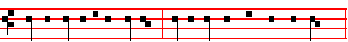
 He hath laid me in the darkness.  As the men that have been long dead.

On Benedictus, Antiphon. Tone j, 2.
699
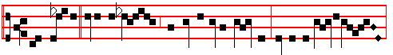 They set up over his head his accusation written: Jesus of Naz-a-reth,
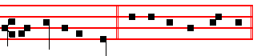
the King of the Jews. Canticle Benedictus, p. 37.

 Christ for our sake became obedient unto death, even the death of the cross. Our Father, secretly. Psalm Miserere, p. 53, and Collect Almighty God, p. 678.

At Vespers, Antiphons and Psalms of the previous day are said without singing, p. 679.
On Magnificat, Antiphon. When he had received the vinegar, he said, It is finished: and he bowed his head, and gave up the ghost.

 Christ for our sake, and the rest as above at Lauds.
__________________________________________________________________


___________________________________________________________________

IN THE FIRST NOCTURN

Antiphon 1. Tone viij, 1.
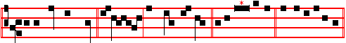
I will lay me down in peace, and take my rest. Psalm 4 Cum invocarem
p. 242, ending slowly:

700
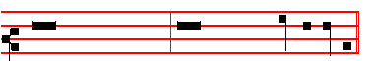
* For it is thou, Lord, only, that makest me dwell in safety.
Antiphon 2. Tone iv, 1.
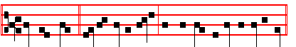
He shall dwell in thy tabernacle: he shall rest upon thy holy hil1.
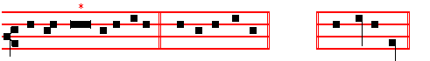
Psalm 15 Domine, quis habitabit, p. 18, ending slowly: * shall never fall.
Antiphon 3. Tone vij, 1.
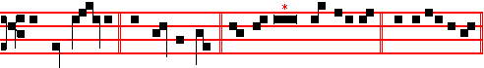
My flesh al - so shall rest in hope. Psalm 16 Conserva me, Domine, p.18,
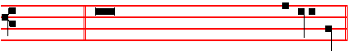
ending slowly: * and at thy right hand there is pleasure for evermore.
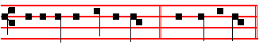
 I will lay me lawn in peace.  And take my rest. Our Father, secretly
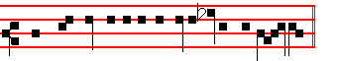
From the Lamentation of Jeremiah the Proph-et.
Lesson j Chapter 3: 22-30
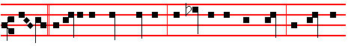
HETH. It is of the Lord's mercies that we are not consumed, because his
701
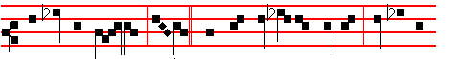
compassions fail not. Heth. They are new every morning: great is thy
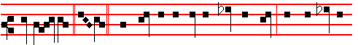
faithful - ness. Heth. The Lord is my portion, saith my soul; therefore will I
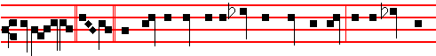
hope in him. Teth. The Lord is good unto them that wait for him, to the soul that
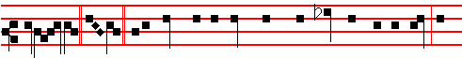
seeketh him. Teth. It is good that a man should both hope and quietly wait for
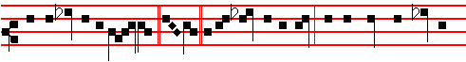
the salvation of the Lord. Teth. It is good for a man that he bear the yoke in
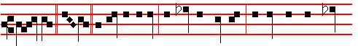
his youth. Jod. He sitteth alone and keepeth silence, because he hath borne
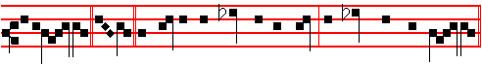
it upon him. Jod. He putteth his mouth in the dust; if so be there may be hope.

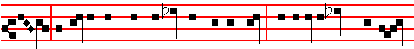

Jod. He giveth his cheek to him that smiteth him: he is filled full with re-

702
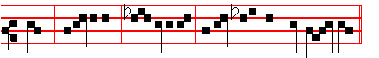
-proach. Jerusalem, Je - rusalem, return unto the Lord thy God.

 I Tone iv
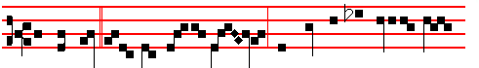
He was led as a lamb to the slaught-er, and while he was evil en- treat-
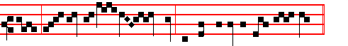
ed, he opened not his mouth: he was delivered un - to death.
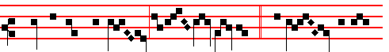
* That he might give life unto his peo-ple.  He poured out his
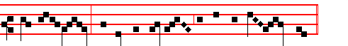
soul unto death, and he was numbered with the transgres- sors.
That he might.

Lesson ij Chapter 4:1-6
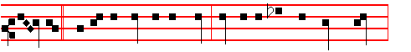
ALEPH. How is the gold become dim! how is the most fine gold changed!

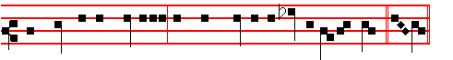
The stones of the sanctuary are poured out in the top of every street. Beth.

703
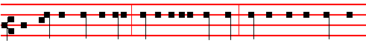
The precious sons of Sion, comparable to fine gold, how are they esteemed as
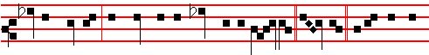
earthen pitchers, the work of the hands of the pot- ter. Ghimel. E-ven the sea
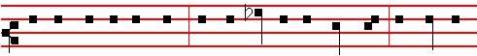
monsters draw out the breast, they give suck to their young ones: the daughter
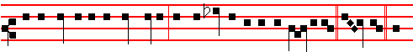
of my people is become cruel, like the ostriches in the wilderness. Daleth. The
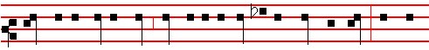
tongue of the sucking child cleaveth to the roof of his mouth for thirst: the young
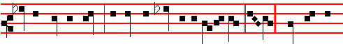
children ask for bread, and no man breaketh it unto them. He. They that did
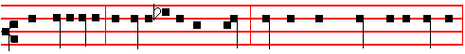
feed delicately are desolate in the streets: they that were brought up in scarlet
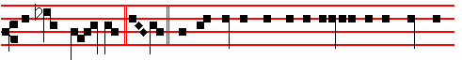
embrace dung- hills. Vau. For the punishment of the iniquity of the daughter
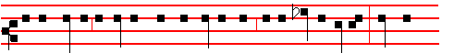
of my people is greater than the punishment of the sin of Sodom, that was

704
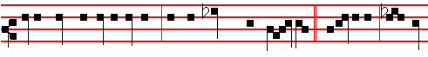
overthrown as in a moment, and no hands stayed on her. Jerusalem, Je- ru-
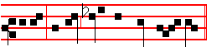
salem, return unto the Lord thy God.

 II Tone v.
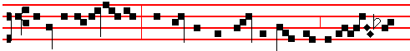
Arise, O Jeru- sal-em, and put off from thee the garments of joy and
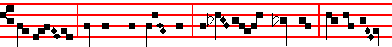
gladness: gird thee with sackcloth, and lie in ash - es: * For the Sav-
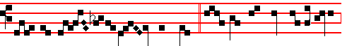
iour of Is - ra-el hath been slain.  Let tears run down like a river
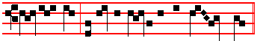
day and night: let not the apple of thine eye cease. For the Saviour.

Lesson iij Chapter 5:1-11
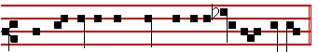
Here beginneth the Prayer of Jeremiah the Prophet.
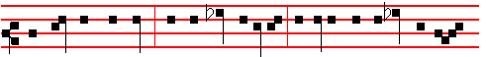
REMEMBER, O Lord, what is come upon us: consider, and behold our re-

705
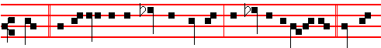
proach. Our inheritance is turned to strangers, our houses to a- li- ens. We are
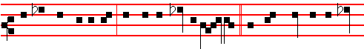
orphans and fatherless, our mothers are as wid-ows. We have drunken our wa-
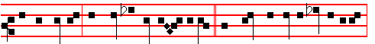
ter for money; our wood is sold un - to us. Our necks are under persecution:
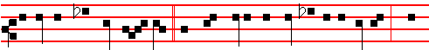 we labour, and have no rest. We have given the hand to the Egyptians, and
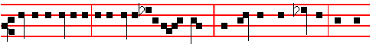
to the Assyrians, to be satisfi-ed with bread. Our fathers have sinned, and are
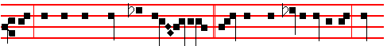
not; and we have borne their ini - quities. Servants have ruled over us: there
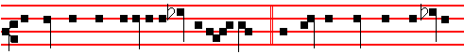
is none that doth deliver us out of their hands. We gat our bread with the peril
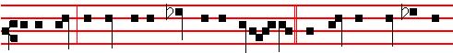
of our lives because of the sword of the wil-derness. Our skin was black like an
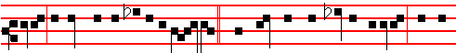
oven because of the terrible fam-ine.They ravished the women in Sion, and the

706
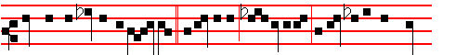 maids in the cities of Jud- ah. Jer-usalem, Jer- usalem, return unto the Lord
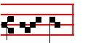
thy God.
 III Tone v.
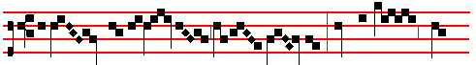
Lament like a vir- gin, O my peo - ple: cry and howl, ye
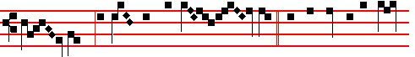
shep- herds, in sackcloth and ash - es: * For the day of the Lord
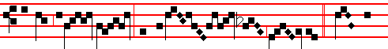
is nigh, a great day and exceed- ing bit - ter.  Gird your-
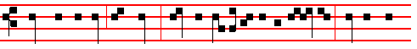
selves and lament, ye priests: howl, ye ministers of the al - tar; wallow your-
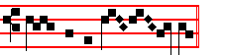
selves in the ash - es. For the day. Lament.

IN THE SECOND NOCTURN
Antiphon 1. Tone v.
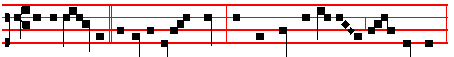
Be ye lift up, ye everlasting doors, and the King of glory shall come in.

707
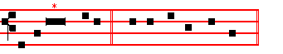
Psalm 24 Domini est terra p. 31, ending slowly:
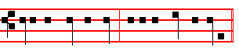
* even the Lord of hosts, he is the King of glory.
Antiphon 2. Tone iv, 1.
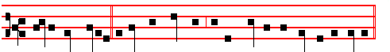
I believe verily to see the goodness of the Lord in the land of the living.
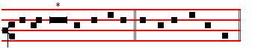
Psalm 27 Dominus iIluminatio p. 35, ending slowly:
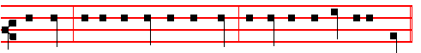
* be strong, and he shall comfort thine heart, and put thou thy trust in the Lord.
Antiphon 3. Tone viij, 1.
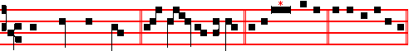
Thou, Lord, hast brought my soul out of hell. Psalm 30 Exaltabo te, Domine
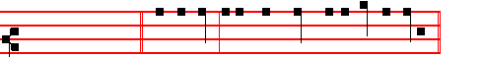
p. 37, ending slowly: * O my God, I will give thanks unto thee for ever.
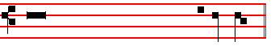
 But thou, O Lord, have mercy upon me.
 Raise thou me up again, and I shall reward them.

708
Our Father secretly.

From the Treatise of Saint Augustine, Bishop, on the Psalms.
Lesson iv Ps 64: 6, 7
MAN shall come to a deep mind, and God shall be exalted. (Accedet homo ad cor altum, et exaltabitur Deus.) Tone as above, p. 667-668.
THEY said: 'No man shall see us. The diligent searchers out of evil counsels have failed.' A Man came to these very counsels, and suffered himself to be laid hold upon, as Man. For he could not have been held had he not been Man: neither could he have been seen, had he not been Man: nor been scourged, had he not been Man: nor been crucified, nor died, had he not been Man. As Man therefore, he came to all these sufferings, which would have availed naught against him, had he not been Man. But had he not been Man, man could nowise have been redeemed. He came, as Man, 'to a deep mind', - that is, to a secret mind; shewing the Manhood to the eyes of men, and keeping the Godhead hidden within: concealing the form of God, wherein he is equal to the Father, and presenting the form of a servant, wherein he is inferior to the Father.

 IV. Tone vij
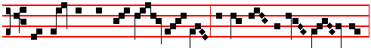
Our Shepherd hath withdrawn him- self , the Fountain of living wat - er,
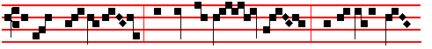
at whose departure the sun was dark- ened: * For he also is
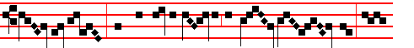
led captive, who had taken captive our first par- ent: to-
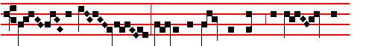
day hath our Sav- iour broken the gates of death, and burst the
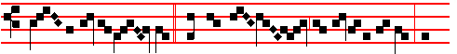
bars thereof asund - er.  He hath destroyed the barriers of hell, and

709
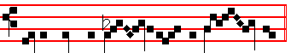
overthrown the pow- er of the dev - il. For he also.

Lesson v
HOW far did they carry those diligent searchings, wherein they failed so much, that even after the Lord was dead and buried, they set a watch over the sepulchre? For they said to Pilate: 'That deceiver' (by the which name the Lord Jesus Christ was called, to the comfort of his servants when they are called deceivers), 'that deceiver', say they to Pilate, 'said, while he was yet alive, After three days I will rise again. Command therefore that the sepulchre be made sure until the third day, lest his disciples come by night, and steal him away, and say unto the people, He is risen from the dead: so the last error shall be worse than the first. Pilate said unto them, Ye have a watch: go your way, make it as sure as ye can. So they went, and made the sepulchre sure, sealing the stone, and setting a watch.'
 V Tone viij.
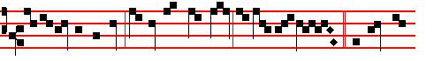
Is it nothing to you, all ye that pass by? Behold and see * If there be
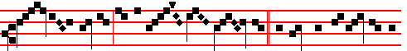
an - y sorrow like unto my sor - row.  Behold, and consider my
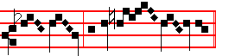
re - proach, O all ye peop - les. If there be.

Lesson vj
THEY set a watch of soldiers over the sepulchre. The earth shook: the Lord rose again. Such wonders were wrought about the sepulchre that the very soldiers who kept watch might be witnesses thereto, would they declare the truth. But the same covetousness that led captive a disciple and fellow of Christ enslaved also the guard set to watch his tomb. We will give you money,' said the chief priests, 'and say ye, that his disciples came and stole him away while ye

710
slept.' Verily, 'the diligent searchers out have failed.' What is this thou sayest, O sterile cunning? Dost thou so far forsake the light of prudence and justice, and plunge thyself so deep in guile, as to speak thus: 'Say ye that his disciples came and stole him away while ye slept.' Thou callest upon sleeping witnesses: surely thou hast fallen asleep thyself, seeing thou hast 'failed in searching out' so notable a matter.

 VI. Tone iv.
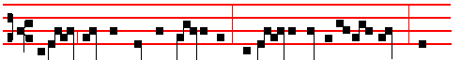
Behold how the righteous perisheth, and no man layeth it to heart: and

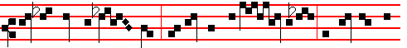
upright men are tak - en, and no man consid - ereth: the righteous is
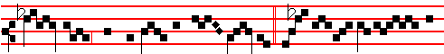
tak - en from the presence of ev - il: * And he shall en-ter in-

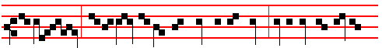
to peace.  As a lamb before her shearers is dumb, so he opened not his

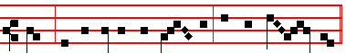
mouth: he was taken from pris - on and from judg - ment. And he. Behold.

IN THE THIRD NOCTURN
Antiphon 1. Tone viij, 1.
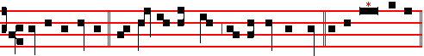
God is my helper, the Lord is with them that uphold my soul. Ps. 54 Deus, in

711
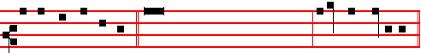
nomine, p. 99, ending: * and mine eye hath seen his desire upon mine enemies.
Antiphon 2. Tone vij. 3.
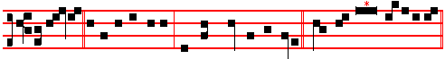
At Salem is his tabernacle, and his dwelling in Sion. Psalm 76 Notus in
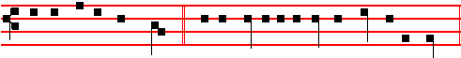
Judæa, p. 157, ending slowly: * and is wonderful among the kings of the earth.
Antiphon 3. Tone iv, 3.
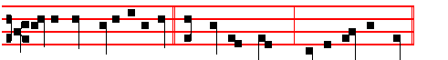
I have been even as a man that hath no strength; free among the dead. Ps.
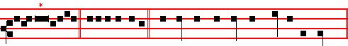
88 Domine Deus p. 139, ending: * and hid mine acquaintance out of my sight.
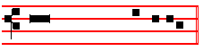
 At Salem is his tabernacle.
 And his dwel - ling in Sion. Our Father secretly.

From the Epistle to the Hebrews Tone as above, pp. 667-8.
Lesson vij Chapter 9: 11-22
CHRIST being come an high priest of good things to come, by a greater and more perfect tabernacle, not made with hands, that is to say, not of this building; neither by the blood of goats and calves, but by his own blood he entered in once into the holy place, having obtained eternal redemption for us. For if the blood of bulls and of goats, and the ashes of an heifer sprinkling the unclean, sanctifieth to the purifying of the flesh: how much more shall the blood of Christ, who through the eternal Spirit offered himself without spot to God, purge your

712
conscience from dead works to serve the living God?
 VII Tone viij.
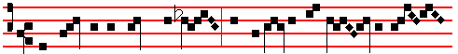
The kings of the earth stand up, and the rulers take coun - sel to-
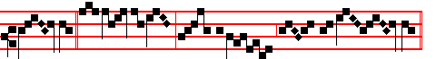
geth - er * Against the Lord, and a-gainst his A-noint- ed.
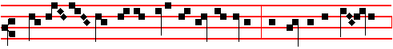
 Why do the heathen so furiously rage together? and why do the peop- le
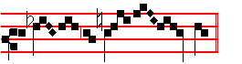
imag- ine a vain thing? Against.

Lesson viij
AND for this cause he is the mediator of the new testament, that by means of death, for the redemption of the transgressions that were under the first testament, they which are called might receive the promise of eternal inheritance. For where a testament is, there must also of necessity be the death of the testator. For a testament is of force after men are dead: otherwise it is of no strength at all while the testator liveth. Whereupon neither the first testament was dedicated without blood.

 VIII Tone iv 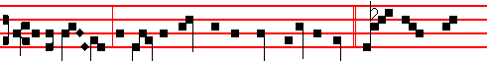
I am counted as one of them that go down into the pit: * And I have
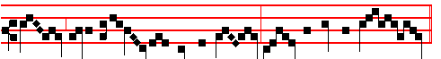
been even as a man that hath no strength, free among the dead.

713
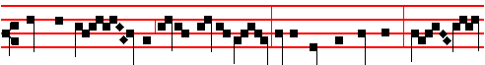
 Thou hast laid me in the lowest pit, in a place of darkness, and in
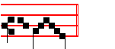
the deep. And I.
Lesson ix
FOR when Moses had spoken every precept to all the people according to the law, he took the blood of calves and of goats, with water, and scarlet wool, and hyssop, and sprinkled both the book, and all the people, saying, This is the blood of the testament which God hath enjoined unto you. Moreover, he sprinkled with blood both the tabernacle and all the vessels of the ministry. And almost all things are by the law purged with blood; and without shedding of blood is no remission.
 IX Tone ij
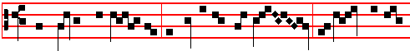
When Jesus was bur - ied, the sepulchre was sealed: and rol - ling a
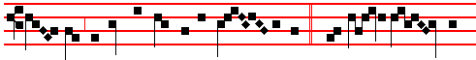
great stone before the door of the sep - ulchre, * They set a band of
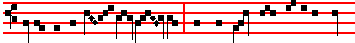
soldiers to keep watch ov - er him.  The chief priests and Pharisees came
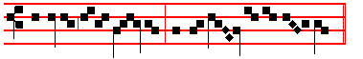
together unto Pi - late, and besought of him a watch. They set.
When Jesus.

AT LAUDS

Antiphon 1. Tone iv, 1.
714
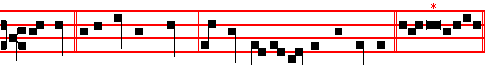
O death, I will be thy plagues: O grave, I will be thy destruction. Psalm 51
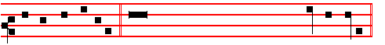
Miserere , p.53, ending: * then shall they offer young bullocks upon thine altar.
Antiphon 2. Tone iv, 1.
My spirit is vexed within me: and my heart within me is desolate. Psalm 43
Judica me, Deus, p. 104, ending slowly: * for I will yet give him thanks, which
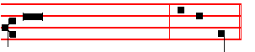
is the help of my countenance, and my God..
Antiphon 3. Tone vij, 1.
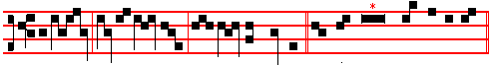
Behold, all ye nat-ions, and see my sorrow. Psalms 63 67 Deus, Deus
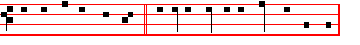
meus, pp. 57, 53, ending slowly: * and all the ends of the world shall fear him.
Antiphon 4. Tone ij.
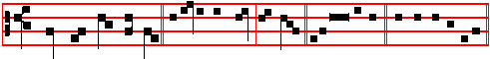
From the gate of hell, deliver my soul, O Lord. Canticle Ego dixi, p. 105,
ending slowly:

715
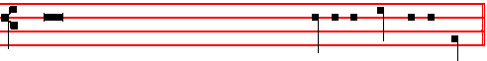
* therefore we will sing my songs to the
stringed instruments all the days of our life in the house of the Lord.
Antiphon 5. Tone viij, 2.
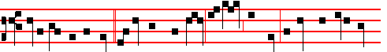
Is it nothing to you, all ye that pass by? behold, and see if there be any sor-
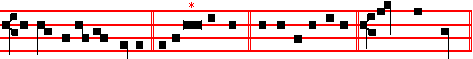
-row like unto my sorrow. Pss 148-150 Laudate , p.59, ending * praise the Lord.
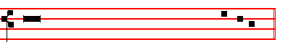
 My flesh shall rest in hope.
 And thou wilt not suffer thy Holy One to see corruption.
On Benedictus, Antiphon. Tone j, 2.
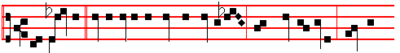
The women, sitting over against the sepulchre, made lamentation, weeping
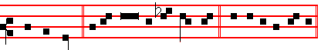
for the Lord. Canticle Benedictus, p. 62.

 Christ for our sake became obedient unto death, even the death of the cross: wherefore God also hath highly exalted him, and given him a Name which is above every name.
Our Father, secretly. Psalm 51 Miserere, p. 53, and the Collect Almighty God, p. 678. And thus it is said until None.

¶ The Hours having been said, as above, Mass is said, as in the Ordinary : and the Communion of the Priest having been made, immediately for Vespers is said:

716
Antiphon Tone vj
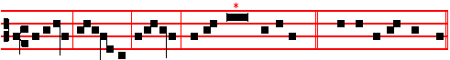
Alleluia, allelu- ia, alle-luia. Ps. 117 Laudate, p. 217-8. E u o u a e.
And the Antiphon is repeated Alleluia, alleluia, alleluia.
The Chapter, Short , Hymn and  are not said.
On Magnificat, Antiphon. * Tone viij.
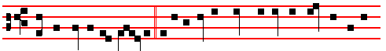
IN the end of the Sabbath, as it began to dawn toward the first day of the
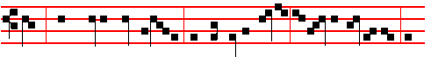
week, came Mary Magdale- ne and the other Mary to see the se-pulchre, al-
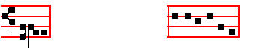
leluia. Cant. Magnificat, p. 212, E u o u a e, with Glory be to the Father.
And the Antiphon is repeated In the end of the Sabbath.

Then the Priest says: The Lord be with you. Let us pray.
COLLECT
POUR forth upon us,O Lord, the spirit of thy charity: that as thou hast fulfilled us with these paschal sacraments, so of thy goodness thou wouldest make us to be of one heart and mind. Through. in the unity of the same Holy Spirit.
Then The Lord be with you.
Afterwards the Deacon says:
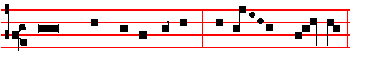
Ite, missa est, al- le- lu- ia, al- le - lu - ia.
 Thanks be to God, al- le- lu- ia, al- le - lu - ia.

717

* Or, as noted in the Missal for the intonation: see below at Compline, p. 716.
¶ Out of choir, after Our Father and Hail Mary have been said, Vespers are begun at once with the Antiphon Alleluia, with the rest as above, and in place of Ite, missa est, alleluia, alleluia, is said  Let us bless the Lord, alleluia, alleluia.
 Thanks be to God, alleluia, alleluia.
Then is added Our Father, and nothing else.

¶ At Compline the  Bid, Lord. The short Lesson Brethren, be sober,  Our help, Our Father, and after the Confession and Absolution, is said  Turn thou us,  O God, make speed, Glory be, and no longer is said Praise be to thee, O Lord, King of eternal glory, but in its place henceforth is said Alleluia.

Then without Antiphon are said as above on Maundy Thursday
Tone viij. 1.
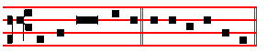
Psalm 4, p..242, Ps. 31:1-6, p. 38, Ps. 91, E u o u a e.
p. 243, and Ps. 134, p. 244, with Glory be at the end of each: which being finished, only the Antiphon is begun..
Tone viij, (as above, p. 717, or:)
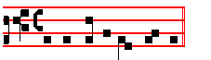
IN the end of the Sabbath * as in the Missal, and the rest as above. p. 717
Nunc Dimittis, p. 656. Glory be. Antiphon In the end.
 The Lord be with you.  And with thy spirit.
Collect Visit, we beseech thee, p. 245.
 The Lord be with you.  And with thy spirit.
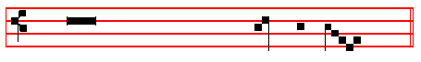
 Let us bless the Lord.
 Thanks be to God.

Blessing. - The Almighty, p. 245.
Finally the Antiphon. Joy to thee, O Queen of heaven, alleluia. as in the Psalter, p. 247.
¶ And there is no kneeling throughout all of Eastertide.

718
 __________________________________________________________________

AT MATINS
Our Father. Hail, Mary. I believe.  O God, make speed, etc.
Invitatory: The Lord is risen indeed, * Aleluia. Psalm 95 Venite XCIV
HYMN Rex sempiterne
O CHRIST, the heavens' eternal King, 4 Once of a virgin born to save,
Creator, unto thee we sing, And now new-born from death's dark grave,
With God the Father ever One, O Christ, thou bidst us rise with thee
Co-equal, co-eternal Son. From death to immortality.

2 Thy hand, when first the world began, 5 Eternal Shepherd, thou art wont
Made in thine own pure image man, To cleanse thy chosen at the font,
And linked to fleshly form of earth That mystic bath. that grave of sin,
A living soul of heavenly birth. Where ransomed souls new life begin.

3 And when the envious crafty foe 6 Divine Redeemer, thou didst deign
Had marred thy noblest work below, To bear for us the cross of pain,
Thou didst our ruined state repair And gavest there thy blood to be
By deigning flesh thyself to wear. Thc price of our eternity.

7 To thee who, dead, again dost live,
All glory, Lord. thy people give;
All glory, as is ever meet
To Father and to Paracete. Amen.
Thus end all Hymns of the same metre until the Ascension, except in the Office of the B.V.M., and in Hymns iof the Holy Cross at Vespers; and of many Martyrs at Matins.

IN THE FIRST NOCTURN
Antiphon 1. I am that I am, * and my counsel is not with the ungodly, but my delight is in the law of the Lord, alleluia. Psalm 1 Beatus vir Psalm 2 Quare fremuerunt, p. 3, Psalm 8 Domine Dominus noster, p. 25, Psalm 16 Conserva me, p. 18, Psalm 24 Domini est terra, p. 31. Psalm 28 Ad te, Domine, p. 36.
 The Lord is risen from the tomb, alleluia.
 Who for our sakes hung upon the tree, alleluia.
Our Father. Absolution. Hear, O Lord. Blessing. May the blessing.
From S. Paul's Epistle to the Romans
Lesson j Ch. 6, 2-13
719
HOW shall we, that are dead to sin, live any longer therein'? Know ye not, that so many of us as were baptized into Jesus Christ were baptized into his death? Therefore we are buried with him by baptism into death: that like as Christ was raised up from the dead by the glory of the Father, even so we also should walk in newness of life.
 The Angel of the Lord descended from heaven, and came and rolled back the stone from the door, and sat upon it, and said unto the women: * Fear not ye: for I know that ye seek him that was crucified: he is risen: come, see the place where the Lord lay, alleluia.
 And entering into the sepulchre, they saw a young man sitting on the right side, clothed in a long white garment; and they were affrighted, and he saith unto them. Fear not. Glory be. And the  is repeated The Angel of the Lord. until the 

Blessing May the Only-begotten.
Lesson ij
FOR if we have been planted together in the likeness of his death, we shall be also in the likeness of his resurrection: knowing this, that our old man is crucified with him, that the body of sin might be destroyed, that henceforth we should not serve sin. For he that is dead is freed from sin.
 When the sabbath was passed, Mary Magdalene and Mary the mother of James, and Salome, had brought sweet spices, * That they might come and anoint Jesus, alleluia, alleluia.
 And very early in the morning, the first day of the week, they came unto the sepulchre at the rising of the sun. That they.

Blessing May the grace
Lesson iij
NOW if we be dead with Christ, we believe that we shall also live with him: knowing that Christ being raised from the dead dieth no more; death hath no more dominion over him. For in that he died, he died unto sin once: but in that he liveth, he liveth unto God.
 As it began to dawn, came Mary Magdalene and the other Mary to the sepulchre. * Ye seek Jesus; he is not here; for he is risen, as he said, he goeth before you into Galilee; there shall ye see him, alleluia, alleluia.
 And very early in the morning, the first day of the week, they came unto the sepulchre at the rising of the sun: and entering into the sepulchre they saw a young man sitting on the right side: and he saith unto them. Ye seek.

Blessing May the blessing.
Lesson iv
LIKEWISE reckon ye also yourselves to be dead indeed unto sin, but alive unto God through Jesus Christ our Lord. Let not sin therefore reign in your mortal
720
body, that ye should obey it in the lusts thereof. Neither yield ye your members as instruments of unrighteousness unto sin: but yield yourselves unto God, as those that are alive from the dead, and your members as instruments of righteousness unto God.

 The good Shepherd is risen, who hath laid down his life for the sheep, and hath vouchsafed to die for his flock, * Alleluia, alleluia, alleluia.
 For Christ our Passover is sacrificed for us. Alleluia. Glory be. Alleluia.

IN THE SECOND NOCTURN
Antiphon. The earth trembled * and was still, when God arose to judgment, alleluia. Psalm 30, p. 37, Psalm 64, p. 120, Psalm 66, p. 110, Psalm 76, p. 157, Psalm 88, p. 139, Psalm 108, p. 176.
 The Lord is risen indeed, alleluia.  And hath appeared to Simon, alleluia.
Absolution May his mercy Blessing May God the Father.
Sermon by S. Gregory Nazianzen, Bishop
Lesson v Sermon on Easter
THE Passover of the Lord, the Passover, and again, in honour of the Holy Trinity, I say, the Passover. This is to us the festival of all festivals and the celebration of all celebrations, not only among the feasts that pertain unto men and are established upon earth, but even among those that belong to Christ himself, and are celebrated to his glory, for this feast outshines all others, even as the sun outshines the stars. Yesterday the Lamb was slain and the doorposts anointed, while Egypt bewailed her first-born, but the Angel of death has passed us by, (for the sign was even to him a thing of terror and awe,) for we were protected by the Precious Blood.
 With great power gave the Apostles * Witness of the resurrection of our Lord Jesus Christ, alleluia, alleluia.
 They were all filled with the Holy Ghost, and they spake the word of God with boldness. Witness.

Blessing May Christ.
Lesson vj
TO-DAY we leave Egypt utterly behind us, and Pharaoh our cruel master, and his harsh officers; for we are delivered from the clay and the making of bricks. Nor is there any to forbid us to celebrate the feast of our exodus in the Lord our God, for indeed we celebrate it not with the leaven of our former malice and wickedness, but with the unleavened bread of sincerity and truth, bringing with us nothing of the unholy leaven of Egypt. Yesterday I suffered with Christ upon the cross, to-day I am glorified with him. Yesterday I shared his death, to-day I am made alive again with him. Yesterday I was buried with him, to-day with him I arise.
719
 From the mouth of the wise proceedeth honey, alleluia, the sweetness of honey is under his tongue, alleluia. * His lips drop as the honey- comb, alleluia, alleluia.
 Wisdom doth abide in his heart, and out of his mouth cometh understanding. His lips.

Blessing May God enkindle.
Lesson vij
BUT, indeed, let us bring gifts to him who for our sakes suffered and rose again. Perchance ye think that I speak of gold or silver or embroideries or shining jewels of great price, which are but the weak and fragile substance of the earth, that remaineth in the ground, and which are for the most part in the hands of unregenerate men, servants of things terrestrial, princes of this present world? Nay, rather, let us bring ourselves., as the riches most dear to God and most worthy of his acceptance. Let us give back the copy to him, whose image we are, let us recognize our dignity, let us render honour to our pattern, let us understand the power of this mystery, and the end for which Christ's death was consummated. Let us be like Christ, even as Christ is become like us. Let us be made as gods through him, inasmuch as he, for our sakes, was made Man.
 Behold, the lion of the tribe of Judah, the root of David, hath prevailed to open the book and to loose the seven seals thereof. * Alleluia, alleluia.. alleluia.
 Worthy is the Lamb that was slain to receive power, and riches, and wisdom, and strength, and honour, and glory, and blessing. Alleluia.

Blessing May the power.
Lesson viij
CHRIST took what was lower, in order that he might give us the higher. He became poor that by his poverty we might be made rich. He took upon him the form of a servant, to set us at liberty. He stooped, that we might be exalted. He was tempted, that we might overcome. He was despised, that he might bring us to glory. He died, to bring us salvation. He ascended on high, to draw unto himself those who were sunk in sin. Let a man give all things to him who gave himself for us as the price of redemption and as the substitute for our guilt. Nothing so great, however, can be given in return, as the offering of ourselves, if we rightly understand this mystery, and if we, for his sake, become all things, whatsoever he for our sakes became.

 I am the true vine, ye are the branches: * He that abideth in me and I in him, the same bringeth forth much fruit, alleluia, alleluia.
 As the Father hath loved me, so have I loved you. He that. Glory be. He that.

IN THE THIRD NOCTURN

720
Antiphon. Be not affrighted, * ye seek Jesus of Nazareth, which was crucified: he is risen, he is not here, alleluia. Canticles of Easter, p.46.
 Then were the disciples glad, alleluia.  When they saw the Lord, alleluia.
Absolution From the chains. Blessing May the Gospel
The Lesson from the Holy Gospel according to Mark
Lesson ix Ch. 16
AT that time : Mary Magdalene, and Mary the mother of James, and Salome, had bought sweet spices, that they might come and anoint Jesus. And the rest.
Homily by S. Gregory the Great Homily 2 on the Gospel.
YOU have heard, beloved brethren. how the holy women who had followed the Lord. came to the sepulchre with sweet spices, that they might zealously care for him even in death, whom they had loved when he was living. But these things signify something in holy Church which we must do. And so it is nccessary for us to hear what was done then, so that as we ponder over it we see what we have to do by way of imitation. Therefore if we, who believe in him who died, seek the Lord, bearing the good odour of virtues together with the repute of good works, then we do come to his sepulchre bringing sweet spices.
 They have taken away my Lord, and I know not where they have laid him. The Angels said unto her, Woman, why weepest thou? He is risen as he said: * He goeth before you into Galilee: there shall ye see him, alleluia, alleluia.
 As she wept, she stooped down, and looked into the sepulchre: and seeth two Angels in white sitting, and they say unto her: He.

Blessing May he bless us
Lesson x
THOSE women saw the Angels, when they came with sweet spices: for truly they who go forth to seek the Lord with holy desire in the odour or virtue do mentally behold the heavenly citizens. We must consider why it was that the Angel was seen sitting on the right side. For what is meant hy the left, but this present life: what by the right, but life eternal? Whence it is written in the Song of Songs: His left hand is under my head, and his right hand doth embrace me.
. Rejoice with me, all ye that love the Lord, for I sought him and he hath appeared unto me: * And while I was weeping at the sepulchre, I saw the Lord, alleluia, alleluia.
 I would not leave. even when the disciples had left; enkindled with the fire of his love, I was aflame with longing. And while.

Blessing May the divine assistance.
Lesson xj
THEREFORE since our Redeemer had gone forth from the corruption of this present life, rightly was the Angel, who had come to announce his eternal life,

721
sitting on the right side. He appeared clothed in a white garment, because he announced the joys of our festival. For white garments declare the splendour of our solemnity. Shall we say ours, or his? To speak more accurately, we should say, both his and ours. For the Resurrection of our Redeemer was both our festival, because it brought us back to immortality, and yet it was even more the Angels' festival, because our being brought back to heaven filled up their number.
 After that our Lord Jesus was risen, he came and stood in the midst of his disciples, and said: * Peace be unto you, alleluia: then were the disciples glad, when they saw the Lord, alleluia.
 The first day of the week, when the doors were shut where the disciples were assembled, came Jesus, and stood in the midst of them, and saith unto them. Peace.

Blessing May the King.
Lesson xij
THEREFORE at this, both his festival and ours, the Angel appeared in white garments: for while we are led back to the supernal kingdom by the Lord's Resurrection, the losses in the heavenly country are repaired. But let us hear what the Angel said to the women as they arrived. Be not affrighted. As though he were to say openly, Let those fear, who do not love the approach of heavenly citizens; let them be greatly afraid, who, oppressed by carnal desires, despair of attaining to the company of Angels. But you, what need have you to fear when you behold your fellow- citizens? Whence also Matthew, describing the appearance of the Angel, says: His countenance was like lightning, and his raiment white as snow. For in lightning there is the error of fear, while in snow there is the pleasure of whiteness.
 Purge out therefore the old leaven, that ye may be a new lump: for even Christ our Passover is sacrificed for us: * Therefore let us keep the Feast in the Lord, alleluia.
 He died for our sins, and rose again for our justification. Therefore. Glory be. Therefore.

The Lesson from the Holy Gospel according to S. Mark
AT that time : Mary Magdalene, and Mary the mother of James, and Salome, had bought sweet spices, that they might come and anoint Jesus. And very early in the morning the first day of the week, they came unto the sepulchre at the rising of the sun. And they said among themselves, Who shall roll us away the stone from the door of the sepulchre? And when they looked, they saw that the stone was rolled away: for it was very great. And entering into the sepulchre, they saw a young man sitting on the right side, clothed in a long white garment; and they were

722
affrighted. And he saith unto them, Be not affrighted: Ye seek Jesus of Nazareth, which was crucified: he is risen; he is not here: behold the place where they laid him. But go your way, tell his disciples and Peter that he goeth before you into Galilee: there shall ye see him, as he saith unto you.

Collect as below in Lauds
AT LAUDS, and the Hours
Antiphon 1. The Angel of the Lord * descended from heaven, and rolled back the stone from the door, and sat upon it, alleluia, alleluia. Psalm. 93 Dominus regnavit, with the rest, p. 56 ff.
Antiphon 2. And behold, * there was a great earthquake: for the Angel of the Lord descended from heaven, alleluia.
Antiphon 3. His countenance * was like lightning, and his raiment white as snow, alleluia, alleluia.
Antiphon 4. And for fear of him * the keepers did shake, and became as dead men, alleluia.
Antiphon 5. And the Angel answered and said * unto the women, Fear not ye, for I know that ye seek Jesus, alleluia.
Chapter I Cor. 5:7
BRETHREN: Purge out therefore the old leaven, that ys may be a new lump, as yre are unleavened. For even Christ our passover is sacrificed for us.
Short  The Lord is risen from the tomb, * Alleluia, alleluia. The Lord.
 Who for our sakes hung upon the tree. Alleluia. Glory be. The Lord.

Hymn. E.H. 123 (Part I) Aurora lucis rutilat.
THE day draws on with golden light, 3 Enclosed he lay in rocky cell,
Glad songs go echoing throngh the height, With guard of armed sentinel;
The broad earth lifts an answering cheer, But thence returning, strong and free,
The deep makes moan with wailing fear. He comes with pomp of jubilee.

2 For lo, he comes, the mighty King, 4 Hell's pains are loosed, and tears are fled;
To take from death his power and sting, , Captivity is captive led;
When death assails, grant, Lord, that we For by the grave, with flashing eyes,
May share thy Paschal victory. 'Your Lord is risen,' the Angel cries.

5 Maker of all, to thee we pray, 6 To thee who, dead, again dost live,
Fulfil in us thy joy today; All glory, Lord, thy people give; .
To trample down his gloomy reign All glory, as is ever meet,
And break the weary prisoner's chain To Father and to Paraclete. Amen.

 This is the day which the Lord hath made, alleluia.
 We will rejoice and be glad in it, alleluia.

723
On Benedictus, Antiphon. And very early in the morning * the first day of the week, they came unto the sepulchre at the rising of the sun, alleluia.

COLLECT
O GOD, who through thine only-begotten Son hast this day overcome death, and opened unto us the gate of eternity: prosper by thine assistance our desires, which by thy preventing grace thou dost put into our minds. Through the same.

 The Lord be with you.  And with thy spirit.
 Let us bless the Lord, alleluia, alleluia.  Thanks be to God, alleluia, alleluia.
Thus it is said in Vespers and Lauds only until Vespers on Saturday before Low Sunday exclusively.

¶ To the short  alleluia is added twice, but to the  only once, until the Saturday after Pentecost, except in the  in the prayers at Prime and Compline when they are said. Nor is it said at Right dear, and that which is said at the end of Prime, nor also in the  of the Responsories..

AT PRIME
Antiphon. The Angel of the Lord. And the Creed of S. Athanasius is not said. The Chapter  and Collect as in the Psalter.
At the Close of the Chapter, Short Lesson If ye then, as below at None..

AT TERCE
Antiphon. And behold, p. 723.
Chapter as above at Lauds, p. 723..
 This is the day which the Lord hath made, alleluia.
 We will rejoice and be glad in it, alleluia.

AT SEXT
Antiphon. His countenance, p. 723
Chapter I Cor. 5:8
THEREFORE let is keep the feast, not with old leaven, neither with the leaven of malice asnd wickedness; but with the unleavened bread of sincerity and truth.
 This is the day, as above..

AT NONE
Antiphon. And the Angel answered and said.
Chapter Col. 3:1, 2

724

