Prophet says, Seek the Lord and his strength, seek his face evermore. No-one should be so presumptuous as to think that he can find all that he seeks, lest he should fail to draw near by the very fact that he no longer strives after it.

 Save me, O God, for the waters are come in, even unto my soul: hide not thy face from thy servant: * For I am in trouble: O haste thee, and hear me.
 Draw nigh unto my soul, and save it: O deliver me, because of mine enemies.
For I.

Lesson vij
BUT among all the works of God that hold and absorb man's marvelling gaze, what so delights and ravishes our soul's contemplation as the Saviour's Passion? For the purpose of freeing mankind from the chains of his fatal transgression, he both hid the power of his majesty from the raging devil, and opposed him with the weakness of our low estate. For if the proud and cruel enemy had been able to know the counsel of God's mercy, he would have tried to soften the hearts of the Jews to gentleness, rather than kindle them to unrighteous hatred; lest by pursuing the freedom of one who owed him nothing he should lose the servitude of those who were his captives.

 O Lord, be not a terror unto me: thou art my hope in the day of evil. * Let them be confounded that persecute me, but let not me be confounded.
 Let them be confounded, and put to shame, that seek after my soul. Let them be.

Lesson viij
THEREFORE his own wickedness foiled him: he punished the Son of God, and this punishment was turned into the remedy for all the sons of men. He shed righteous blood, which became both the price and the healing draught for the restoration of the world. The Lord underwent that which he had chosen in accordance with the proposition of his own will. He allowed himself to be taken by the wicked hands of cruel men: who in performing their own wickedness ministered to the Redeemer. His merciful love even towards his murderers was so great that he besought his Father from the cross, not asking to be avenged, but seeking their forgiveness.

 I became also a reproach unto them: they that looked upon me shaked their heads. * Hear me, O Lord my God.
 They have spoken against me with false tongues: they compassed me about also with words of hatred. Hear me.
 I became. Hear me

645
IN THE THIRD NOCTURN
On the Canticles, Antiphon. Hosanna * to the Son of David: Blessed is he that cometh in the name of the Lord, the King of Israel; Hosanna in the highest. Canticle Deducant oculi mei with the others as on the I Sunday of Lent.
 Shut not up my soul with the sinners, O God.
 Nor my life with the bloodthirsty.

The Lesson from the Holy Gospel according to S. Matthew.
Lesson ix Ch. 21
AT that time: When Jesus drew nigh unto Jerusalem, and was come to Bethphage unto the mount of Olives, then sent he two disciples, saying unto them. And the rest.
Homily by S. Ambrose, Bishop Bk. 9 on Luke.
IT is fitting that the Lord, when he had left the Jews and was about to dwell in the Gentiles' hearts, went up into the temple. For the true temple is that one which is built upon courses of stone. Therefore the men who hated him were abandoned, and those who loved him were chosen. For this reason did he come to the mount of Olives: to plant the olive branches on the heights of virtue, those olive branches whose mother is the heavenly Jerusalem.

 The Lord is with me as a mighty terrible one: therefore my persecutors shall stumble and shall not prevail. But, O Lord of hosts, that triest the righteous and seest the reins of the heart, * Unto thee have I revealed my cause.
 O Lord, thou hast seen my wrong: judge thou my cause. Unto thee.

Lesson x
HE is the divine husbandman on that mountain: so that each one of all those that are planted in the house of God may be able to say, As for me, I am like a green olive-tree in the house of God. And perhaps the mountain is Christ himse1f. For who else bears such fruitful olive- trees, not laden with profuse olives indeed, but with the spiritual fruit of the fulness of the Gentiles. He it is through whom we go up, and into whom we go. He is the door he is the way, it is he who is opened and who opens: he is knocked upon by those who enter, and is worshipped by those who find entrance.

 The ungodly said, reasoning with themselves, but not aright: Let us lie in wait for the righteous, because he is clean contrary to our doings. He professeth to have knowledge of God: he calleth himself the Child of the Lord, and maketh his boast that God is his Father. * Let us see if his words be true; if he be verily the Son of God, let him deliver him out of our hands. Let us condemn him with a shameful death.

646
 We are esteemed of him as counterfeits: he abstaineth from our ways as from filthness; he pronounceth the end of the just to be blessed. Let us see.

Lesson xj
FOR this reason was there a village, and an ass tied, and a colt with her: nor could she be loosed without the Lord's command. She was loosed by the hand of an apostle. Such was the act, such the life, such the grace. Be ye also such an one, that ye may loose that which is bound. Now let us consider who they were that were discovered in sin, and were cast out of paradise and bound in this village. See how Life recalled those whom death had expelled.

 Liars are come round about: they have fallen upon me with scourges without a cause. * But thou, O Lord, art my succour, haste thee to help me.
 For trouble is hard at hand, and there is none to help me. But thou

Lesson xij
THUS in Matthew we read both of an ass and of a colt; for as both sexes were represented in the two cast out of paradise, so were both sexes in the two animals recalled. Therefore by the mother-ass, Eve, as the mother of sin, is denoted: while the colt represents the multitude of the Gentiles. It is well said, Whereon yet never man sat, for before Christ no-one had called the Gentiles into the Church. And Mark also says this, Whereon never man sat.

 When the people t heard that Jesus was come to Jerusalem, they went forth to meet him. And a very great multitude spread their garments in the way: others strawed branches from the trees, and cried: * Hosanna to the Son of David: Blessed is he that cometh in the name of the Lord.
 And the multitude that went before, and that followed, cried with a loud voice. Hosanna.  When the. Hosanna.

The Continuation of the Holy Gospel according to S. Matthew Ch. 21, 1-9
AT that time: When Jesus drew nigh unto Jerusalem, and was come to Bethphage, unto the mount of Olives, then sent he two disciples, saying unto them, Go into the village over against you, and straightway ye shall find an ass tied, and a colt with her: loose them, and bring them unto me. And if any man say ought unto you, ye shall say, The Lord hath need of them; and straightway he will send them. All this was done, that it might be fulfilled which was spoken by the prophet, saying, Tell ye the daughter of Sion, Behold, thy King cometh unto thee, meek, and sitting upon an ass, and a colt the foal of an ass. And the disciples went, and did as Jesus commanded them, and brought the ass, and the colt, and put on them their clothes, and they set him thereon. And a very great multitude spread

647
their garments in the way; others cut down branches from the trees, and strawed them in the way. And the multitudes that went before, and that followed, cried, saying, Hosanna to the Son of David: Blessed is he that cometh in the name of the Lord.
AT LAUDS
Antiphon 1 For the Lord God * will help me: and therefore shall I not be confounded. Psalm 51 Miserere
Antiphon 2. They compassed me about, * yea, they compassed me about: but in the Name of the Lord will I be avenged on them.
Antiphon 3. Judge thou * my cause: defend me, for thou, O Lord, art mighty.
Antiphon 4. May the faithful * today be found among the Angels and the children, crying unto the Conqueror of death, Hosanna in the highest.
Antiphon 5. Let them be confounded * that persecute me, but let not me be confounded, O Lord my God.
Chapter Phil. 2
BRETHREN: Let this mind be in you, which was also in Christ Jesus: who, being in the form of God, thought it not robbery to be equal with God; but made himself of no reputation, and took upon him the form of a servant, and was made in the likeness of men: and was found in fashion as a man.
Short , Hymn E.H. 96 Lustra sex, and  Deliver me, p. 619-620.
On Benedictus, Antiphon. The multitudes * which came together for the feast day cried unto the Lord: Blessed is he that cometh in the Name of the Lord. Hosanna in the highest.
COLLECT
ALMIGHTY and everlasting God, who didst cause our Saviour to take upon him our flesh, and to suffer on the cross, that mankind might follow the example of his humility: mercifully grant; that we may both keep in mind the lessons of his patience, and be worthy to be partakers of his resurrection. Through the same.
AT PRIME
Antiphon. The children of the Hebrews, * carrying palms and olive branches, went forth to meet the Lord, crying out and saying: Hosanna in the highest.
At the Close of the Chapter Short Lesson I hid not, as in the Psalter.

AT TERCE
Antiphon. The children of the Hebrews * spread their garments in the way, and cried, saying: Hosanna to the Son of David; blessed is he that cometh in the Name
of the Lord.
Chapter Brethren: Let this mind, above.
 Deliver my soul, O God, from the sword.
 My darling from the power of the dog. .

648
AT SEXT
Antiphon. Unto thee, O Lord, * have I revealed my cause: thou hast defended my life, O Lord my God.
Chapter Phil. 2
HE humbled himself, and became obedient unto death, even the death of the Cross. Wherefore God also hath highly exalted him, and given him a Name which is above every name.
 Save me, O Lord, from the lion's mouth. .
 Thou hast heard me also from among the horns of the unicorns.

AT NONE
Antiphon. I will call * upon thy Name, O Lord: turn not away thy face from my calling.
Chapter Phil. 2
AT the Name of Jesus every knee should bow, of things in heaven, and things in earth, and things under the earth; and every tongue should confess that Jesus Christ is Lord, to the glory of God the Father.
 O shut not up my soul with the sinners, O God.
 Nor my life with the bloodthirsty.

AT VESPERS
Antiphon and Psalm Dixit Dominus, with the rest of Sunday.
Chapter: Brethren: Let this mind, p. 648.
Short , Hymn: E.H. 94 Vexilla regis and  Deliver me, p. 611-2.
On Magnificat, Antiphon. For it is written, * I will smite the shepherd, and the sheep shall be scattered. But after I am risen again, I will go before you into Galilee: there shall ye see me, saith the Lord.

COLLECT
Almighty and everlasting God, p. 648.

¶ From this day until the Octave of Easter, if there occur any feast of xij. Lessons, which can be translated, it is translated after the Octave: otherwise commemoration is made of it, except on the three days preceding Easter and the two following, according to the Rubric on Commemorations. Of a feast of three Lessons, likewise from Maundy Thursday to Easter Tuesday inclusively, no commemoration is made, nor also in Vespers of Wednesday, if a simple Feast should occur on Mandy Thursday.
__________________________________________________________________

Monday

649
Invitatory.- Today if ye will hear the voice of the Lord, * Harden not your hearts. Psalm 95 Venite Hymn. E.H. 95 Pange lingua

IN THE FIRST NOCTURN
Antiphons and Psalms of the Psalter
 Deliver my soul, O God, from the sword.
 My darling from the power of the dog.
Our Father. Absolution Hear, O Lord. Blessing. May the Gospel Lection.
The Lesson from the Holy Gospel according to S. John
Lesson j Ch. 12, 1-9
SIX days before the passover Jesus came to Bethany, where Lazarus was which had been dead, whom he raised from the dead. And the rest.
Homily by S. Augustine, Bishop Homily 50 on John
LEST men should think that he had become a phantom because he had risen from the dead, Lazarus was one of those who reclined at table. He lived, he spoke, he feasted; the truth was made manifest, and the disbelief of the Jews brought to confusion. Jesus then, sat down to table with Lazarus and the rest; Martha, one of the sisters of Lazarus, served. But Mary, the other sister of lazarus, took a ;pound of ointment of genuine nard of great value, and anointed the feet of Jesus, and wiped his feet with her hair; and the house was filled with the fragrance of the ointment. We have heard what was done: let us seek out the nystery.

 The ungodly said, Let us oppress the righteous man without cause, and swallow him up alive as the grave: let us make his memory to perish from the earth: and let us cast lots for his spoils: and those murderers laid up stores for themselves of evil. * Fools and evil men hate wisdom: and are guilty in their thoughts.
 Such things they imagined and were deceived: and their wickedness blinded them. Fools.

Blessing May the Divine assistance
Lesson ij
OTHOU, whosoever wouldest be a faithful soul, with Mary anoint thou the Lord's feet with precious ointment! that ointment was righteousness, therefore was it a pound: moreover it was ointment of costly spikenard. That he calls it pisticum, we ought to take it to mean some place from which this costly ointment came: yet neither is this expression idle, but chimes in excellently with the inward and spiritual meaning. Pistis is Greek for Faith. Thou wast seeking to work righteousness: the righteous liveth by faith. Anoint the feet of Jesus: by good

650
living follow the Lord's footsteps. Wipe his feet with thine hair: if thou hast super- fluities, give to the poor, and thou has wiped the feet of the Lord: for the hair seems to be the superfluity of the body. Thou hast what thou mayest do with thy superfluity: to thee it is superfluous, but to the Lord's feet necessary. Perchance on earth the Lord's feet suffer need.

 I became also a reproach unto them: they that looked upon me shaked their heads. * Hear me, O Lord my God.
 They have spoken against me with false tongues: they compassed me about also with words of hatred. Hear me.

Blessing. May the King
Lesson iij
FOR of whom but his members will he say in the end of the world, While ye did it to one of the least of mine, ye did it unto me? Your superfluities ye bestowed, but it was to my feet that ye showed the kindness. But, The house was filled with the odour; the world was filled with the good fame: for good odour is good fame. They that live ill, and are called Christians, do wrong to Christ: such are they of whom it is said, that through them the name of the Lord is blasphemed. If through such the Name of God is blasphemed through the good the Name of the Lord is praised. Hear the Apostle: We are a good odour of Christ, saith he, in every place.

 False witnesses tare risen up against me, and such as speak wrong. They have gone about to kill me, and spared not to spit in my face; their spears have wounded me, and all my bones are out of joint. * But as for me, I am like to one that is dead upon the earth.
 They poured forth their fury upon me, they gnashed upon me with their teeth. But as. False witnesses. But as.

IN THE SECOND NOCTURN
Chapter Jeremiah 11, 18-19
AND the Lord hath given me knowledge of it, and I know it: then thou shewest me their doings. But I was like a lamb or an ox that is brought to the slaughter.
 Deliver me, O Lord, from the evil man.
 And preseve me from the wicked man.
Kyrie, eleison etc., is said kneeling. Collect as below.

AT LAUDS, AND THROUGHOUT THE HOURS

651
Antiphon 1. I hid not * my face from shame and spitting. Psalms of Monday.
Antiphon 2. Awake, O sword, * against them that scatter my flock.
Antiphon 3. So they weighed * for my price thirty pieces of silver, the price that I was prised at of them.
Antiphon 4. Water flowed over * mine head: then I said, I am cut off: I will call upon thy Name, O Lord God.
Antiphon 5. Behold, O Lord, * the lips of them that rise up against me, and their devices.
Chapter Jer. 11
LET us destroy the tree with the fruit thereof, and let us cut him off from the land of the living, that his name may be no more remembered.

Short , Hymn E.H. 96 Lustra sex, and  Deliver me, p. 619-620.
On Benedictus, Antiphon. O Father, glorify thou me * with thine own self, with the glory which I had with thee before the world began.

COLLECT
GRANT, we beseech thee, almighty God: that we who amidst so many adversities do fail by reason of our weakness, may be renewed through the pleading of the Passion of thy only-begotten Son: Who liveth and reigneth with thee.
AT PRIME
Antiphon from Lauds I hid not.
Chapter Love the truth.
The Prayers are said kneeling.
Short Lesson I hid not.
AT TERCE
Antiphon. Awake.
Chapter Jer. 17:13
O LORD, all that forsake thee shall be ashamed, and they that depart from me shall be written in the earth, because they have forsaken the Lord, the fountain of living waters.
 Deliver my soul, O God, from the sword.
 My darling from the power of the dog

AT SEXT
Antiphon. So they weighed.
Chapter Jer. 17:18
LET them be confounded that persecute me,but let not me be confounded: let them be dismayed, but let not me be dismayed: bring upon them the day of evil, and destroy them with double destruction, O Lord our God.

652
 Save me, O Lord, from the lion's mouth.
 Thou hast heard me also from among the horns of the unicorns.

AT NONE
Antiphon. Behold, O Lord.
Chapter Jer. 18:20
REMEMBER that I stood before thee to speak good for them, and to turn away thy wrath from them.
 O shut not up my soul with the sinners, O God.
 Nor my life with the bloodthirsty.

AT VESPERS
Antiphons and Psalms as in the Psalter for Monday.
Chapter Jer. 11
BUT, O Lord of hosts, that judgest righteously, that triest the reins and the heart, let me see thy vengeance on them: for unto thee have I revealed my cause, O Lord my God.
Short , Hymn E.H. 94 Vexilla Regis, and  Deliver me, p. 611-612.
On Magnificat, Antiphon.Thou couldest have no power * at all ever me, except it were given thee from above.
COLLECT
HELP us, O God of our salvation: and grant, that we may come with joy to the celebration of those benefits by which thou hast vouchsafed to redeem us. Through.
__________________________________________________________________

Tuesday
Invitatory and Hymn, p. 250
 Save me, O Lord, from the lion's mouth.
 Thou hast heard me also from among the horns of the unicorns
Absolution May his mercy..
Blessing May God the Father almighty.
From the Prophet Jeremiah
Lesson j Ch. 11, 15-20
WHAT hath my beloved to do in mine house, seeing she hath wrought lewdness with many, and the holy flesh is passed from thee? when thou doest evil, then thou rejoicest. The Lord called thy name, A green olive tree, fair, and of goodly fruit: with the noise of a great tumult he hath kindled fire upon it, and the branches of it are broken. For the Lord of hosts, that planted thee, hath pronounced evil against thee, for the evil of the house of Israel and of the house of Judah, which they have done against themselves to provoke me to anger in

653
offering incense unto Baal. And the Lord hath given me knowledge of it, and I know it: then thou shewedst me their doings. But I was like a lamb or an ox that is brought to the slaughter; and I knew not that they had devised devices against me, saying, Let us destroy the tree with the fruit thereof, and let us cut him off from the land of the living, that his name may be no more remembered. But, O Lord of hosts, that judgest righteously, that triest the reins and the heart, let me see thy vengeance on them: for unto thee have I revealed my cause.

 For I heard the defaming of many, fear on every side. All my familiars watched for my hasting, saying: Peradventure he will be enticed and we shall prevail against him, and we shall take our revenge on him. But the Lord is with me as a mighty terrible one: therefore my persecutors shall stumble and they shall not prevail. * Let me see thy vengeance on them, for unto thee have I revealed my cause.
 O Lord, thou hast pleaded the causes of my soul, thou hast redeemed my life. Let me.

Blessing May Christ grant.
Lesson ij Ch. 12. 1-4
RIGHTEOUS art thou, O Lord, when I plead with thee: yet let me talk with thee of thy judgments: Wherefore doth the way of the wicked prosper? Wherefore are all they happy that deal very treacherously.? Thou hast planted them, yea, they have taken root: they grow, yea, they bring forth fruit: thou art near in their mouth, and far from their reins. But thou, O Lord, knowest me: thou hast seen me, and tried mine heart toward thee: pull them out like sheep for the slaughter, and prepare them for the day of slaughter. How long shall the land mourn, and the herbs of every field wither, for the wickedness of them that dwell therein? the beasts are consumed, and the birds; because they said, He shall not see our last end.

 O Lord God of Israel for thy sake have I suffered reproof; shame hath covered my face. I am become a stranger unto my brethren; even an alien unto my mother's children. * For the zeal of thine house hath even eaten me.
 Draw nigh unto my soul, and save it; O deliver me because of mine enemies. For the zeal.

Blessing May God enkindle.
Lesson iij Ibid. 7-11
I HAVE forsaken mine house, I have left mine heritage; I have given the dearly beloved of my soul into the hand of her enemies. Mine heritage is unto me as a lion in the forest; it crieth out against me: therefore have I hated it. Mine heritage is unto me as a speckled bird, the birds round about are against her; come ye,

654
assemble all the beasts of the field, come to devour. Many pastors have destroyed my vineyard, they have trodden my portion under foot, they have made my pleasant portion a desolate wilderness. They have made it desolate, and being desolate it mourneth unto me; the whole land is made desolate, because no man layeth it to heart.

 The congregation of the people came about me, but I rewarded not evil unto him that dealt wickedly with me. * Let the wickedness of the ungodly come to an end; but guide thou the just.
 The Lord shall judge me; give sentence with me, O Lord, according to my righteousness, and according to the innocency that is in me. Let the.
 The congregation. Let the.

IN THE SECOND NOCTURN
Chapter Jeremiah 11, 18-19
AND the Lord hath given me knowledge of it, and I know it: then thou shewest me their doings. But I was like a lamb or an ox that is brought to the slaughter.
 Deliver me, O Lord, from the evil man.
 And preseve me from the wicked man.
Kyrie, eleison etc., is said kneeling. Collect as below.

AT LAUDS, AND THROUGH THE HOURS,
Antiphon 1. See, O Lord, * and consider, for I am in trouble: O haste thee and hear me. Psalms of Tuesday.
Antiphon 2. Defend thou * my cause, O Lord: O deliver me from the deceitful and wicked man.
Antiphon 3. When I was in trouble * I cried unto the Lord out of the belly of hell, and he heard me.
Antiphon 4. Lodi, I am oppressed, * undertake for me: for I know not what I shall say unto mine enemies.
Antiphon 5. The ungodly said, * Let us oppress the righteous man, because he is clean contrary to our doings.
Chapter Let us destroy, p. 648.
Short , Hymn E.H. 96 Lustra sex, and  Deliver me, p. 626-7.
On Benedictus, Antiphon. Now before the feast * of the Passover, when Jesus knew that his hour was come, having loved his own, he loved them unto the end.
.
COLLECT
ALMIGHTY an everlasting God: grant unto us so to celebrate the mysteries of the passion of the Lord; that we may be worthy to obtain thy pardon. Through the same.
655
At the Hours, Antiphons of Lauds; Chapter and the rest, 652-3. Collect as above in Lauds.
On Magnificat, Antiphon. I have power * to lay down my life, and I have power to take it again.
C OLLECT
LET thy merciful kindness, O God, cleanse us throughly from all the corruption of our former nature, and make us to be effectually renewed unto holiness of life. Through.
__________________________________________________________________

Wednesday
Invitatory and Hymn, p. 250. Antiphons and Psalms of the Psalter.
 Shut not up my soul with the sinners, O God.
 Nor my life with the bloodthirsty.
Absolution From the chains. Blessing May he bless us.
From the Prophet Jeremiah
Lesson j Ch. 17, 13-18
O LORD, the hope of Israel, all that forsake thee shall be ashamed, and they that depart from me shall be written in the earth, because they have forsaken the Lord, the fountain of living waters. Heal me, O Lord, and I shall be healed; save me, and I shall be saved: for thou art my praise. Behold, they say unto me, Where is the word of the Lord? let it come now. As for me, I have not hastened from being a pastor to follow thee: neither have I desired the woeful day; thou knowest: that which came out of my lips was right before thee. Be not a terror unto me: thou art my hope in the day of evil. Let them be confounded that persecute me, but let not me be confounded: let them be dismayed, but let not me be dismayed: bring upon them the day of evil, and destroy them with double destruction.

 They have spoken against me with false tongues; they compassed me about also with words of hatred. For the love that I had unto them, lo, they take now my contrary part: * But I give myself unto prayer, and thou hast heard me ,O Lord my God.
 Thus have they rewarded me evil for good, and hatred for my good will. But I give.

Blessing May the divine.
Lesson ij Ch. 18, 13-23
WHO hath heard such things: the virgin of Israel hath done a very horrible thing; Will a man leave the snow of Lebanon which cometh from the rock

656
of the field? or shall the cold flowing waters that come from another place be forsaken? Because my people hath forgotten me, they have burned incense to vanity, and they have caused them to stumble in their ways from the ancient paths, to walk in paths, in a way not cast up; to make their land desolate, and a perpetual
hissing; every one that passeth thereby shall be astonished, and wag his head. I will scatter them as with an east wind before the enemy; I will shew them the back, and not the face, in the day of their calamity. Then said they, Come, and let us devise devices against Jeremiah; for the law shall not perish from the priest, nor counsel from the wise, nor the word from the prophet. Come, and let us smite him with the tongue, and let us not give heed to any of his words.

 The ungodly said, reasoning with themselves, but not aright: Let us lie in wait for the righteous, because he is clean contrary to our doings. He professeth to have knowledge of God: he calleth himself the Child of the Lord, and maketh his boast that God is his Father. * Let us see if his words be true; if he be verily the Son of God, let him deliver him out of our hands. Let us condemn him with a shameful death.
 We are esteemed of him as counterfeits: he abstaineth from our ways as from filthiness: he pronounceth the end of the just to be blessed. Let us see.

Blessing May the King of.
Lesson iij
GIVE heed to me, O Lord, and hearken to the voice of them that contend with me. Shall evil be recompensed for good? for they have digged a pit for my soul. Remember that I stood before thee to speak good for them, and to turn away thy wrath from them. Therefore deliver up their children to the famine, and pour out their blood by the force of the sword; and let their wives be bereaved of their children, and be widows; and let their men be put to death; let their young men be slain by the sword in battle. Let a cry be heard from their houses, when thou shalt bring a troop suddenly upon them: for they have digged a pit to take me, and hid snares for my feet. Yet, Lord, thou knowest all their counsel against me to slay me; forgive not their iniquity, neither blot out their sin from thy sight, but let them be overthrown before thee; deal thus with them in the time of thine anger.

 Liars are come round about: they have fallen upon me with scourges without a cause. * But thou, O Lord, art my succour, haste thee to help me.
 For trouble is hard at hand, and there is none to help me. But thou.
 Liars are. But thou.

AT LAUDS, AND THROUGH THE HOURS,
Antiphon 1. Deliver me * from blood-guiltiness, O God my God: and my tongue

657
shall sing of thy righteousness. Psalms of Wednesday.
Antiphon 2. Reproaches * and terrors have I suffered of them: and the Lord is with me as a mighty terrible one.
Antiphon 3. These also * that seek the hurt of my soul, they shall go under the earth.
Antiphon 4. All mine enemies * have heard of my trouble, O Lord: they are glad that thou hast done it.
Antiphon 5. Bind the nations * of the heathen with chains, O Lord, and their princes with fetters.
On Benedictus, Antiphon. Simon, sleepest thou? * couldest not thou watch with me one hour?
COLLECT
GRANT, we beseech thee, almighty God: that we, who are continually afflicted by reason of our transgressions, may be delivered by the passion of thine only-begotten Son: Who liveth and reigneth with thee.
On Magnificat, Antiphon. A maid said unto Peter: * Surely thou art one of them, for thy speech bewrayeth thee.
COLLECT
ALMIGHTY God, we beseech thee graciously to behold this thy family, for which our Lord Jesus Christ was contented to be betrayed, and given up into the hands of wicked men, and to suffer death upon the Cross: Who liveth and reigneth with thee.

¶ On the following three days, having said secretly Our Father, Hail, Mary and at Matins, and at the beginning of Prime I believe, all else being omitted, the Office is begun at once at Matins and Vespers from the Antiphon of the first Psalm: and the Antiphons are doubled, as on a Double Feast.

At the end of the Psalms Glory be to the Father is not said throughout all the Hours, nor in the esponsories, and at the end of every Psalm at Matins, one is extinguished of the fifteen candles placed in a triangular candelabrum before the Altar

(The text in this Triduum folloiws the 1884 edition of the Breviarium Monasticum and the Ratisbon Compendium of 1901, from which also the melody as taken.)

658


.

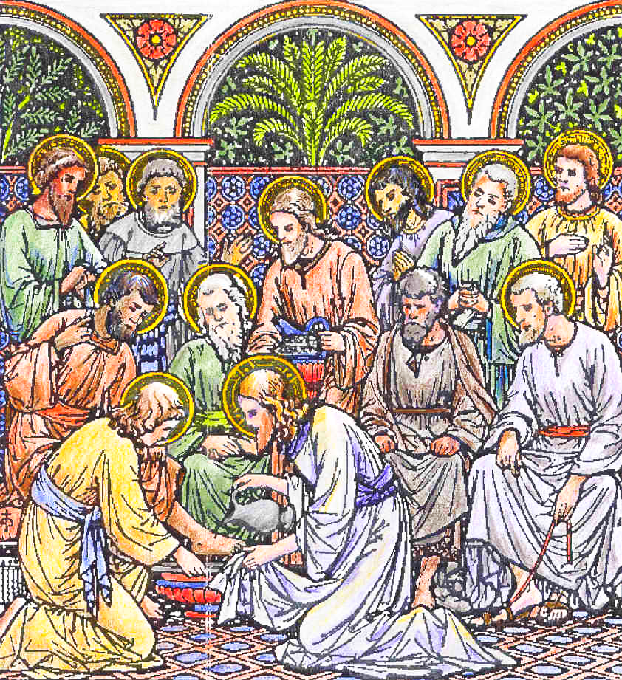

Our Father. Hail, Mary. I believe, secretly.

659
IN THE FIRST NOCTURN
Antiphon 1. Tone viij, 2.
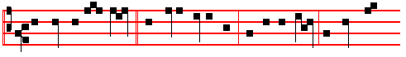
The zeal of thine house hath even eaten me: and the rebukes of them that
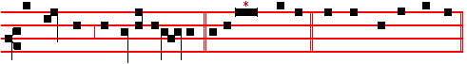
rebuked thee are fallen upon me. Ps. 69 Salvum me fac, p. 114, ending, slower:
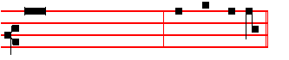
* and they that love his Name shall dwell therein. And the Antiphon is repeated. And the other Psalms in the Psalter on the pages following.
Antiphon 2. Tone viij, 2.
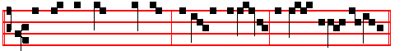
Let them be turned backward and put to confusion that seek to do me evil.
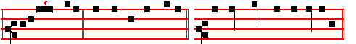
Psalm 70 Deus in adjutorium ending, slower: * O Lord, make no long tarrying.
Antiphon 3. Tone viij, 2.
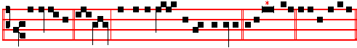
Deliver me, O God., out of the hand of the ungodly. Psalm 71 In te, Domine,
speravi, ending, slower:
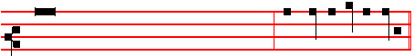
* for they are confounded, and brought unto shame, that seek to do me evil.

660
* From this note marked with an asterisk begin verses II and following.
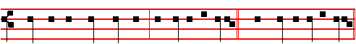
 Let them be turned backward and put to confusion.  That seek to do me evil.

During this triduum after the  of the Nocturn Our Father is said secretly. And lead us is not said aloud, nor is the Absolution said or the Blessings given before the Lessons. After the Lessons But thou is not said, but the first iij Lessons from Jeremiah are ended as below.
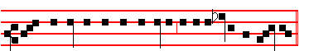
Here beginneth the Lamentation of Jeremiah the Prophet.

Lesson j Ch. 1:1-14
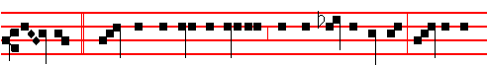
A- LEPH. How doth the city sit solitary, that was full of people! how is she
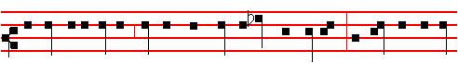
become as a widow! she that was great among the nations, and princess among
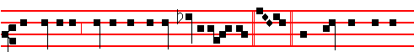
the provinces, how is she become tributa - ry ! Beth. She weepeth sore in
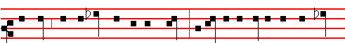
the night, and her tears are on her cheeks; among all her lovers she hath none
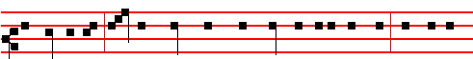
to comfort her: all her friends have dealt treacherously with her, they are be-

661

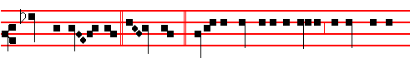
come her en - emies. Ghi - mel. Judah is gone into captivity, because of af-
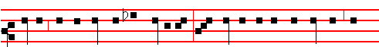
fliction, and because of great servitude: she dwelleth among the heathen, she
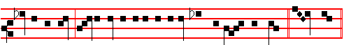
findeth no rest: all her persecutors overtook her between the straits. Daleth.

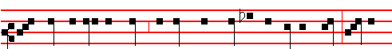
The ways of Sion do mourn, because none come to the solemn feasts: all her
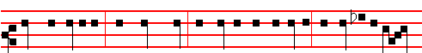
gates are desolate; her priests sigh, her virgins are afflicted, and she is in bit-
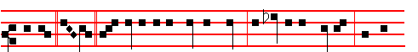
terness. He. Her adversaries are the chief, her enemies prosper; for the
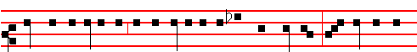
Lord hath afflicted her for the multitude of her transgressions: her children are

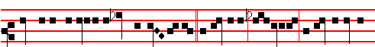
gone into captivity before the en- em-y. Jerusalem, Jer-usalem, return unto the

662
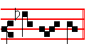
Lord thy God. Thus are ended the Lessons from the Lamentation during this Triduum.
 I . Tone viij.
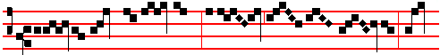
Upon the mount of Ol - ives he prayed to the Fath - er: Fath-
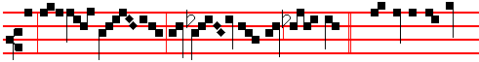
er, if it be pos - sible, let this cup pass from me: * The spirit indeed
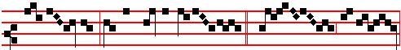
is wil - ling but the flesh is weak.  Watch and pray,
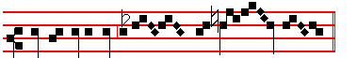
that ye enter not in-to temp- ta - tion. The spirit.

Lesson ij
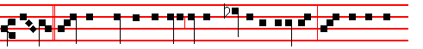
VAU. From the daughter of Sion all her beauty is departed: her princes are
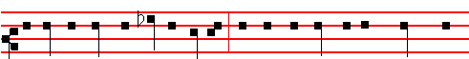
become like harts that find no pasture: and they are gone without strength be-
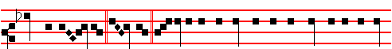
fore the pur-su-er. Za- in. Jer-usalem remembered in the days of her af-flic-

663
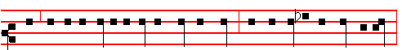
-tion and of her miseries all her pleasant things that she had in the days of old,
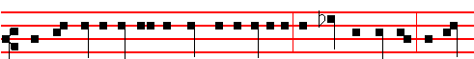
when her people fell into the hand of the enemy, and none did help her: the ad-
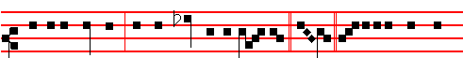
versaries saw her, and did mock at her sabbaths. Heth. Jerusalem hath grie-
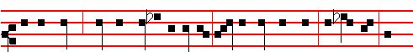
vously sinned; therefore she is removed: all that honoured her despise her, be-
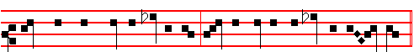
cause they have seen her nakedness; yea, she sigheth, and turneth back- ward.
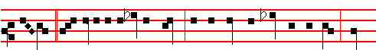
Teth. Her filthiness is in her skirts; she remembereth not her last end; there-
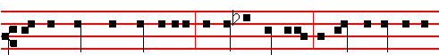
fore she came down wonderfully: she had no comforter. O Lord, behold my af-
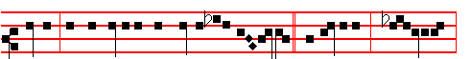
fliction; for the enemy hath magnifi-ed him - self. Je-ru-salem, Je- rusalem,
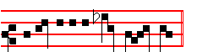
return unto the Lord thy God. 664
 II. Tone viij.
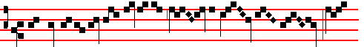
My soul is exceeding sorrowful, ev- en un - to death; tar-
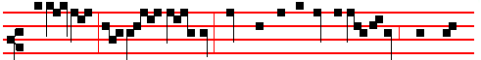
-ry ye here, and watch with me: now shall ye behold a multitude which will
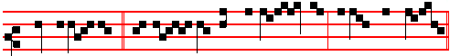
come about me: * Ye will flee and forsake me, and I shall go
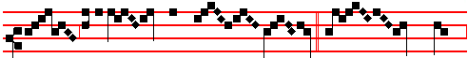
hence to be of - fered for you.  Be - hold,
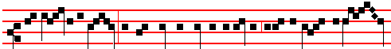
the hour is at hand, and the Son of man is betrayed into the hands of sin-
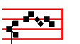
ners. Ye will flee.

Lesson iij
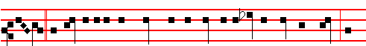
JOD. The adversary hath spread out his hand upon all her pleasant things: for
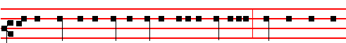
she hath seen that the heathen entered into her sanctuary, whom thou didst com-

665
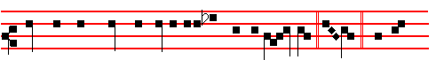
mand that they should not enter into thy congrega - tion. Caph. All her
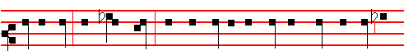
people sigh, they seek bread: they have given their pleasant things for meat to
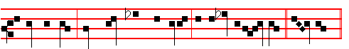
relieve the soul: see, Lord, and con - sid-er; for I am become vile. La-med.

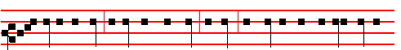
Is it nothing to you, all ye that pass by? behold, and see if there be any sorrow
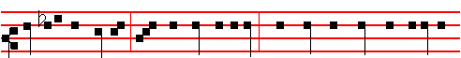
like unto my sorrow, which is done unto me, wherewith the Lord hath afflicted
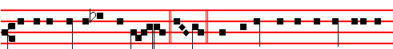
me in the day of his fierce anger. Mem. From above hath he sent fire into my
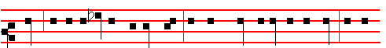
bones, and it prevaileth against them: he hath spread a net for my feet, he hath
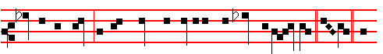
turned me back; he hath made me desolate and faint all the day. Nun. The

666
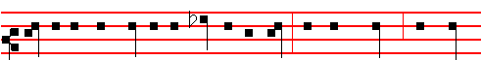
yoke of my transgressions is bound by his hand; they are wreathed, and come
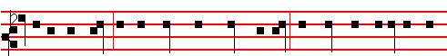
up upon my neck; he hath made my strength to fall, the Lord hath delivered me
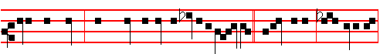
into their hands, from whom I am not able to rise up. Jeru-salem, Je-rusalem,
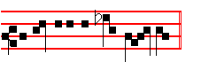
return unto the Lord thy God.

 III Tone v.
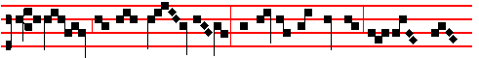
Behold we have seen him, and lo, he hath no form nor come- li-
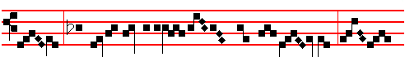
ness; there is no beauty in him, that we should de - sire him: he hath
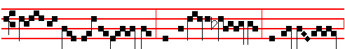
borne our sins and of-fen- ces, and for us he griev- eth: but he was
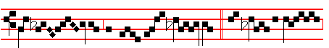
woun - ded for our trans-gres-sions, * And with his stripes

667
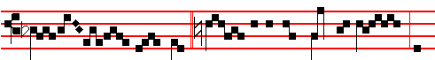
we are healed.  Sure- ly he hath borne our griefs, and
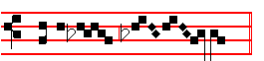
carried our sor- rows. And with.  Behold to the 
Antiphon 1 . IN THE SECOND NOCTURN Tone viij, 2.
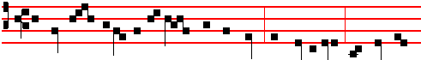
The Lord hath delivered the poor when he cried: the needy also, and him that
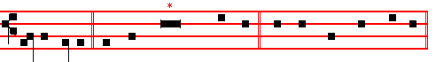
hath no helper. Psalm 72 Deus, judicium tuum LXXI, ending slowly:
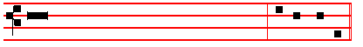
* and all the earth shall be filled with his Majesty. Amen, Amen.
Antiphon 2 Tone viij, 2.
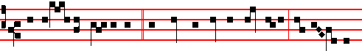
They imag-ine wick-edness, and speak of wicked blas-phemy: their talk - ing
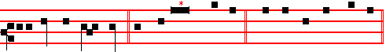
is against the Most High. Psalm 73 Quam bonus Israel. LXXII, ending slowly:
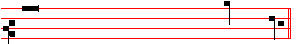
* and to speak of all thy works in the gates of the daughter of Syon.

668
Antiphon 3. Tone j, 1.
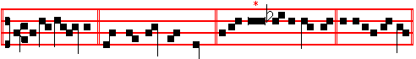
Arise, O Lord, and maintain my cause. Ps. 74 Ut quid, Deus, ending slowly:
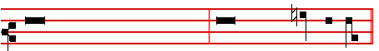
* the presumption of them that hate thee increaseth ever more and more.
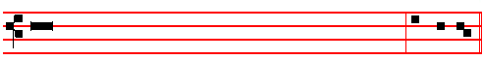
 Deliver me, O my God, out of the hand of the un-god- ly.
 Out of the hand of the unrighteous and cru-el man.

Our Father, secretly.
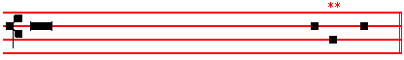
From the Treatise of Saint Augustine the Bishop, on the Psalms.

Lesson iv On Psalm 55:1
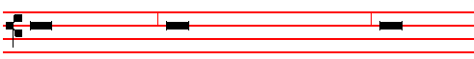
'HEAR my prayer, O God: and hide not thyself from my petition. Take heed unto
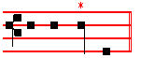
me, and hear me.'

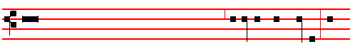
These are the words of an earnest and anxious man, beset by great trouble. He

* The punctum is sung thus. ** A monosyllabic word is sung thus.

669
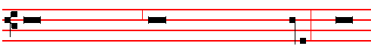
prayeth as one suffering much, and longing to be delivered from evil. It remaineth
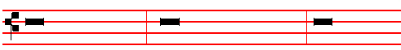
for us to see in what evil he is: and when he beginneth to tell us, to acknowledge
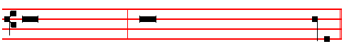
that we also suffer therefrom: that sharing his trouble, we may join in his prayer.
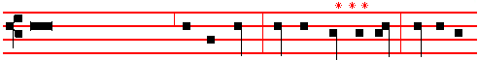
'I mourn,' saith he, 'in my trial, and am vexed,' Wherein mourneth he? Wherein is
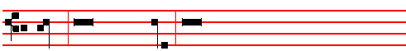
he vexed? He saith, 'In my tri-al,' He remembereth the wicked men whom he
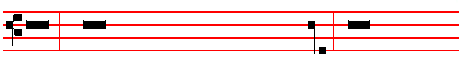
suffereth, and that sufferance of evil men he calleth his trial. Think ye not that the
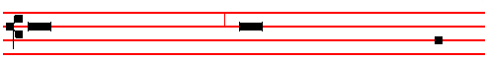
wicked are in this world for naught, and that God nowise doeth good through
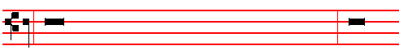
them. Every wicked man either liveth that he may be made righteous; or else he
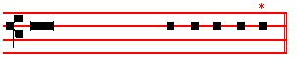
liveth that the righteous may be tried by him.
*** An interrogation is sung thus. 670 * Thus end the Lessons in this Triduum.
 IV Tone viij
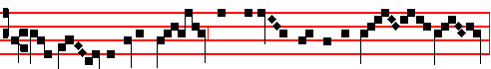
Mine own familiar friend hath betrayed me by the sign of a kiss:
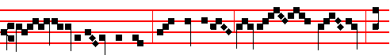
Whom-so-ever I shall kiss, that same is he; hold him fast: he
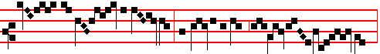
gave this wick- ed sig- nal, and so by a kiss accom-plished murder.
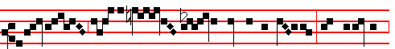
* Unhappy, he cast down the price of blood in the tem-ple, and departed,
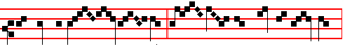
and went and hanged him- self.  It had been good for that man
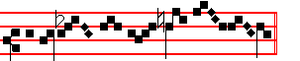
if he had not been born. Unhappy.

Lesson v Tone as above, pp. 667-668.
O WOULD to God, therefore, that they who now try us might be converted, and tried together with us! Nevertheless, as long as they continue to try us, let us not hate them: for we know not whether any one of them will endure to the end in his wickedness. And for the most part, when thou deemest thyself to be hating thine enemy, thou hatest thy brother, and knowest it not. The devil and his angels are pointed out to us in the holy Scriptures as doomed unto fire everlasting. Of their amendment alone need we despair, against whom we wage a hidden strife; to which strife the Apostle armeth us, saying, 'We wrestle not against flesh and blood' (that is, not against men whom ye may see,) 'but against principalities,

671
against powers, against the rulers of the darkness of this world.' He said not, 'the rulers of this world,' lest perchance thou shouldest deem that devils are the lords of heaven and earth: but he said, 'the rulers of the darkness of this world'; when he spake of the world, he meant the lovers of the world: ungodly and unrighteous men, he called the world: of that world he spake, whereof the Gospel saith, 'and the world knew him not'.

 V Tone ij
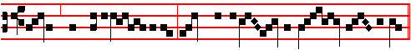
Judas, most evil traf - ficker, sought to betray the Lord with a kiss:
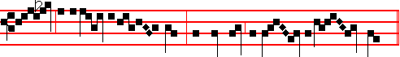
he, as an in - no-cent lamb, refused not the kiss of Jud- as: *
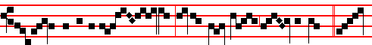
For thir- ty pieces of sil - ver, he be-trayed Christ to the Jews.  Bet-
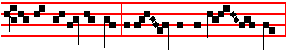
ter were it for that man if he had not been born. For thirty.

Lesson vj Tone as above, pp. 667-668.
FOR I have spied unrighteousness and strife in the city.' Give heed unto the glory of the Cross itself. Now upon the brow of kings that Cross firmly resteth, which foes did once revile. Effect hath proven strength: it hath conquered the world not with the sword, but with wood. The wood of the Cross seemed worthy of scorn to his enemies, as they stood before that very wood, wagging their heads, and saying, 'If he be the Son of God, let him come down from the Cross! ' He stretched forth his hands unto a disobedient and gainsaying people. If he is just which liveth by faith, he that hath not faith is unrighteous. What then he calleth unrighteousness, know thou to be unbelief. Therefore the Lord 'spied unrighteousness and strife in the city' and 'stretched forth his hands unto a disobedient and gainsaying people': and yet, looking forth upon these very same,

672
he said; 'Father, forgive them, for they know not what they do.'

 VI Tone viij
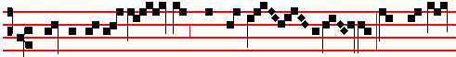
One of my dis- cip- les shall this day betray me: Woe un- to
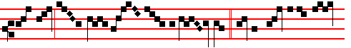
that man by whom I am betray- ed: * Better were it for that
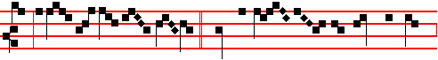
man if he had not been born.  He that dip - peth his hand with me
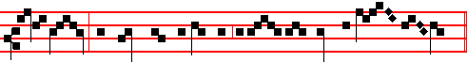
in the dish, the same shall betray me into the hands of sin - ners.

Better. One.
IN THE THIRD NOCTURN
Antiphon 1. Tone vij, 1.
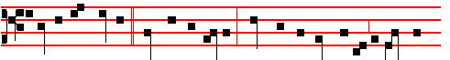
I said to the wicked, Deal not so madly: speak not unrighteously against the
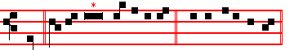
Lord. Psalm 75 Confitebimur E u o u a e. Ending slowly:
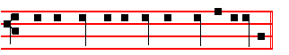
* and the horns of the righteous shall be exalted. 673
Antiphon 2. Tone viij, 2.
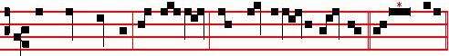
The earth trembled and was still, when God arose to judgment. Psalm 76
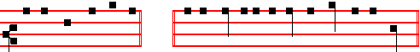
Notus in Judæa ending slowly: * and is wonderful among the kings of the earth.

Antiphon 3. Tone vij, 3.
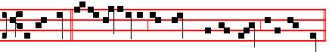
In the time of my tribulation, I stretched out my hands unto the Lord. Psalm
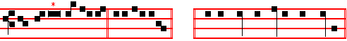
77 Voce mea ad Domimum. ending slowly: * by the hand of Moses and Aaron.
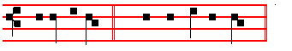
 Arise, O Lord.  And maintain my cause. Our Father secretly.
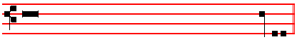
From the First Epistle of Saint Paul the Apostle to the Corinthians.
Lesson vij Ch. 11:17-34
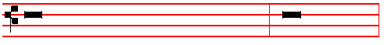
NOW in this that I declare unto you I praise you not, that ye come together,
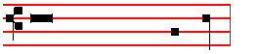
not for the better, but for the worse. Tone as above, p. 667-668

674
For first of all, when ye come together in the church, I hear that there be divisions among you; and I partly believe it. For there must be also heresies among you, that they which are approved may be made manifest among you. When ye come together therefore into one place, this is not to eat the Lord's supper. For in eating, everyone taketh before other his own supper: and one is hungry, and another is drunken. What? have ye not houses to eat and to drink in? or despise ye the church of God, and shame them that have not? : What shall I say to you? shall I praise you in this? I praise you not.

 VII Tone vij.
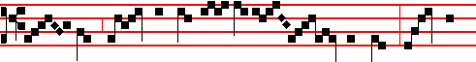
Be - hold, I was like an in- no - cent lamb; I was
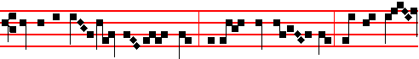
led to the sac- ri - fice, and I knew it not, that mine en-
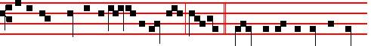
emies took counsel together against me, saying: * Come, let us destroy the tree
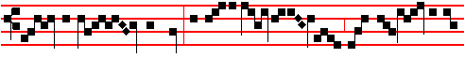
with the fruit thereof, and let us cut him off from the land of the
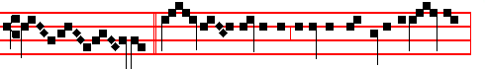
liv- ing.  All mine enemies imagined this evil against me;
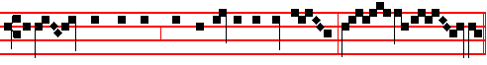
an un - just sentence they delivered against me, say - ing.
Come.

675
Lesson viij
FOR I have received of the Lord that which also I delivered unto you, That the Lord Jesus the same night in which he was betrayed took bread: and when he: had given thanks, he brake it, and said, Take, eat: this is my body, which is broken for you: this do in remembrance of me. After the same manner also he took the cup, when he had supped, saying, This cup is the new testament in my blood: this do ye, as oft as ye drink it, in remembrance of me. For as often as ye eat this bread, and drink this cup, ye do shew the Lord's death till he come.

 VIII Tone vij
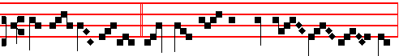
Wherefore sleep ye? What, could ye not watch with me one hour,
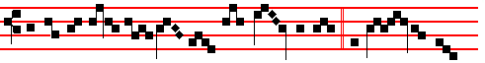
ye that exhorted each oth - er to die for me? * Or see ye not
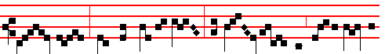
Jud - as, how he sleepeth not, but hast - en - eth to betray me
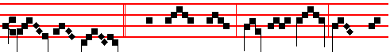
to the Jews? . Why sleep ye? Rise and pray, lest ye
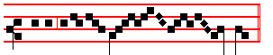
enter into tempta- tion. Or see.

Lesson ix
WHEREFORE whosoever shall eat this bread, and drink this cup of the Lord, unworthily, shall be guilty of the body and blood of the Lord. But let a man examine himself, and so let him eat of that bread, and drink of that cup. For he that eateth and drinketh unworthily, eateth and drinketh damnation to himself, not discerning the Lord's body. For this cause many are weak and sickly among you, and many sleep. For if we would judge ourselves, we should not be judged. But
676
when we are judged, we are chastened of the Lord, that we should not be condemned with the world. Wherefore, my brethren, when ye come together to eat, tarry one for another. And if any man hunger, let him eat at home: that ye come not together unto condemnation. And the rest will I set in order when I come.

 IX. Tone j.
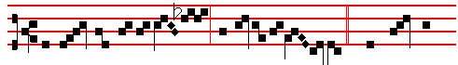
The eld- ers of the peo -ple consulted to-geth- er. * That they might
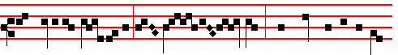
take Jesus by sub- til- ty and kill him: they came out as against
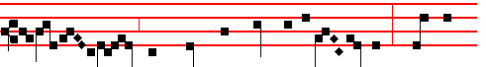
a thief with swords and staves for to take him.  The chief
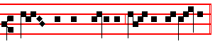
priests and the Pharisees gathered a council. That they. The elders.

AT LAUDS

Antiphon l. Tone viij, 1.
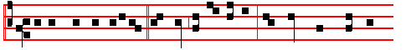
Mayest thou be justified, O Lord, in thy saying, and clear when thou art
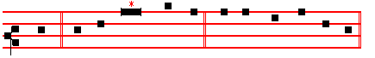
judged. Psalm 51 Miserere mei Deus p.53, ending slowly:

677
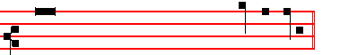
* then shall they offer young bullocks upon thine altar.
Antiphon 2. Tone ij
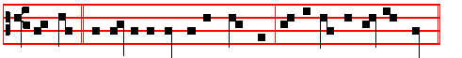
The Lord was led as a lamb to the slaughter: and he opened not his mouth.
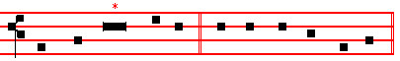
Psalm 90 Domine refugium, p. 140 , ending slowly:
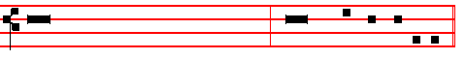
* prosper thou the work of our hands upon us, O prosper thou our handiwork.
Antiphon 3. Tone viij, 1.
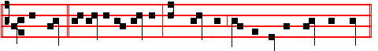
My heart within me is broken: and trembling maketh all my bones to shake.
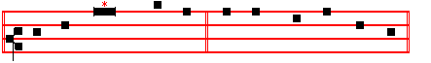
Psalms 63 ,67 Deus, Deus meus, pp. 57, 53, ending slowly:
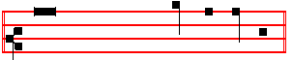
* and all the ends of the world shall fear him.
Antiphon 4. Tone iv, 1.
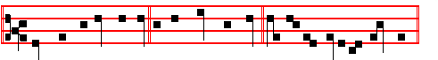
Thou dost encourage us by thy might, O Lord, and by thy holy refreshment.
678
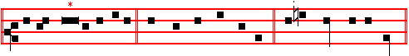
Canticle Cantemus Domino, p. 141, ending slowly: * in the midst of the sea.
Antiphon 5. Tone ij.
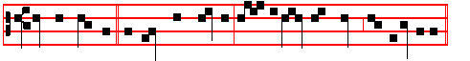
He was offered because he willed it: and himself hath borne our iniquities.
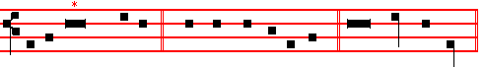
Psalms 148 149 150 Laudate Dominum, ending slowly: * praise the Lord.
The Chapter, Short  and Hymn are not said.
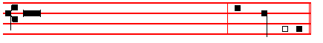
 Mine own familiar friend whom I trust - ed.
 Who did also eat of my bread, hath laid great wait for me.

On Benedictus, Antiphon. Tone j, 2.
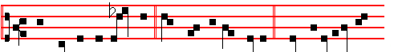
Now he that betrayed him gave them a sign, saying: Whomsoever I shall
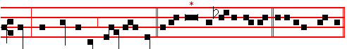
kiss, that same is he; hold him fast. Canticle Benedictus, p. 62, ending slowly:
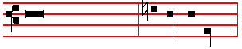
* and to guide our feet into the way of peace.
¶ During the saying of the Canticle Benedictus, all the candles upon the triangular stand having first been put out, except the one placed at the top, the six candles

679
placed from the beginning upon the Altar are also extinguished one by one so that at the last verse the last candle is put out; the lamps and other lights throughout the
Church are likewise extinguished. As the Antiphon Now he that betrayed is being repeated, the topmost candle is taken from the candelabrum, and hidden under the Altar on the Epistle side. When the Antiphon has been repeated after Benedictus, is said
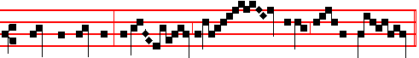
 Christ for our sake became obed - i-ent un- to death.
On the second night is added:
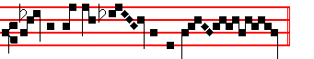
Ev - en the death of the cross. On the third night is added:
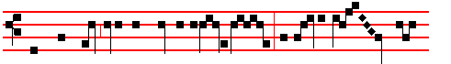
Wherefore God also hath highly exalt-ed him, and given him a
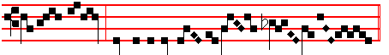
Name which is above eve -ry name.

And so it is said also through all the Hours of the day.

When the  Christ for our sake is begun, all kneel, and when it is ended, Our Father is said entirely in secret. Afterwards is said a little louder: Ps. 51 Miserere mei. Which being ended, without Let us pray, is said in a like voice:

COLLECT
ALMIGHTY God, we beseech thee graciously to behold this thy family, for which our Lord Jesus Christ was contented to be betrayed, and given up into the hands of wicked men, and to suffer death upon the Cross, but Who liveth and reigneth with thee is said in silence.

The Collect being ended, some crack and clatter is made: and soon the lighted candle is brought from under the Altar, and all rise, and depart in silence.

680
AT THE HOURS

At Prime, Terce, Sext, and None, Our Father, Hail Mary, and at Prime I believe having been said secretly, they are begun at once with the usual Psalms, which at Prime are 54, p.99 119, 1-32, : which being ended, is said  Christ for our sake etc. kneeling: and secretly is said Our Father, the Psalm Miserere, and the Collect, Almighty God, as in Lauds.
In this Triduum nothing is read from the Martyrology, nor is Right dear in the sight said.
At Terce: Ps. 119, 33-80; At Sext: Ps. 119, 81-128; At None: Ps 119, 129-176.

AT VESPERS
Vespers, when Our Father and Hail Mary have been said secretly, are begun immediately with the first Antiphon without singing. *
Antiphon. I will receive the cup of salvation, and call upon the Name of the Lord. Psalm 116, v.10 Credidi.
Antiphon. I am for for peace, but when I speak unto them thereof, they make them ready for battle. Psalm 120 Ad Dominum.
Antiphon. Preserve me, O Lord, from the wicked men. Psalm 140 Eripe me, Domine.
Antiphon. Keep me from the snare that they have laid for me, and from the wicked doers. Psalm 141 Domine, clamavi.
Antiphon. I looked also upon my right hand, and saw there was no man that would know me. Psalm 142 Voce mea.
The Chapter, Short , Hymn and  are not said in this triduum.
On Magnificat, Antiphon. As they were eating, Jesus took bread, and blessed it, and brake it, and gave it to his disciples.
 Christ for our sake, with the rest as in Lauds.
At Compline is not said Bid, Lord, nor the Short Lesson, nor Our help, nor the Lord's Prayer, but the Confession and Absolution having been made, it is begun with Psalm 4, Ps. 31:1-6, Ps. 91, and Ps. 134. The Psalms having been said, is said Nunc Dimittis
L ORD now lettest thou thy servant depart in peace:* according to thy word.

2 For mine eyes have seen * thy salvation.

3 Which thou hast prepared * before the face of all people.

4 To be a light to lighten the Gentiles * and to be the glory of thy people Israel.

Then  Christ for our sake, with the rest as at Lauds.
Thus are ended all Hours in this Triduum, until Vespers of Holy Saturday exclusively.
* ( but see Holy Week Missal for former noted text) 681

__________________________________________________________________

IN THE FIRST NOCTURN
Antiphon 1. Tone viij, 1.
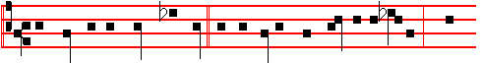
The kings of the earth stand up, and the rulers take counsel together a -
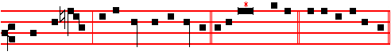
gainst the Lord, and against his Anointed. Psa1m 2 Quare fremuerunt, p. 3.
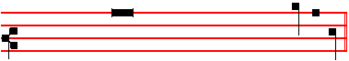
ending slowly: * blessed are all they that put their trust in him.
Antiphon 2. Tone viij, 1.
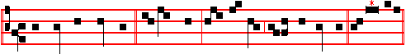
They part my garments among them, and cast lots upon my vesture. Psalm 22
Deus,Deus meus, p. 29, ending slowly:
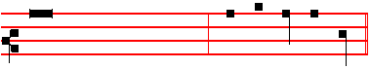
* unto a people that shall be born, whom the Lord hath made.
Antiphon 3. Tone viij, 1.
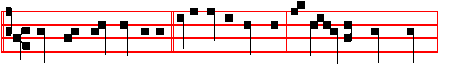
There are false witnesses risen up against me, and such as speak wrong.

682
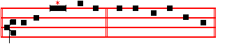
Psalm 27 Deus illuminatio mea , p. 35, ending slowly:
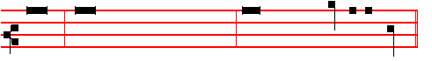
* be strong,and he shall comfort thine heart, and put thou thy trust in the Lord.
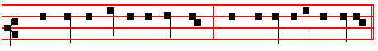
 They part my garments among them.  And cast lots upon my vesture.
Our Father secretly.
From the Lamentation of Jeremiah the Prophet.
Lesson j Chapter 2: 8-15
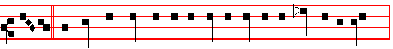
HETH. The Lord hath purposed to destroy the wall of the daughter of Sion;
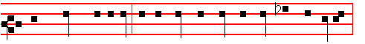
he hath stretched out a line, he hath not withdrawn his hand from destroying:
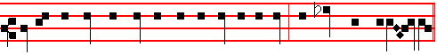
therefore he made the rampart and the wall to lament; they languished togeth-er
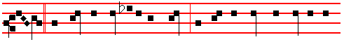
Teth. Her gates are sunk into the ground; he hath destroyed and broken her
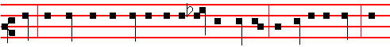
bars: her King and her princes are among the Gentiles: the law is no more; her

683
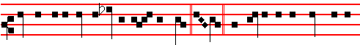
prophets also find no vision from the Lord. Jod. The elders of the daughter of
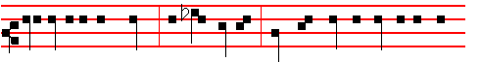
Sion sit upon the ground, and keep silence: they have cast up dust upon their
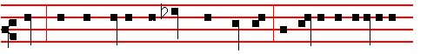
heads; they have girded themselves with sackcloth: the virgins of Jerusalem
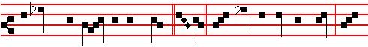
hang down their heads to the ground. Caph. Mine eyes do fail with tears, my
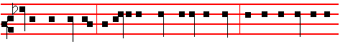
bowels are troubled, my liver is poured upon the earth, for the destruction of
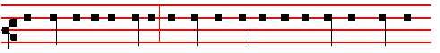
the daughter of my people; because the children and the sucklings swoon in
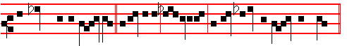
the streets of the ci - ty. Jerusalem, Jerusalem, return unto the Lord thy God.

 I Tone iij 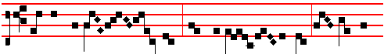
All mine acquaint - ance have forsak - en me, and they that

684

