DECEMBER 25

THE NATIVITY OF THE LORD
COMMONLY CALLED

CHRISTMAS DAY
DOUBLE OF THE FIRST CLASS

AT THE FIRST MASS
IN THE NIGHT AFTER TE DEUM OF MATINS
Station at S. Mary Major at the Crib
INTROIT. Psalm 2 Dominus dixit Tone ij
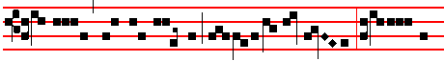
THE Lord hath said unto me: thou art my Son, this day have
Psalm ibid. Quare fremuerunt
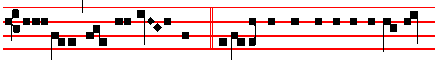
I be- got- ten thee. Why do the heathen so furiously rage
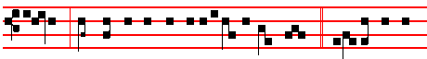
together : and why do the people imagine a vain thing?  Glo- ry be to
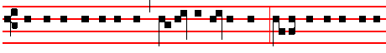
the Father, and to the Son : and to the Holy Ghost : as it was in the begin-
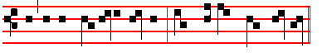
ning, is now, and ever shall be : world without end. A- men. Repeat The Lord up to the Psalm.
Kyrie for Solemn Feasts I fons bonitatis Tone iij
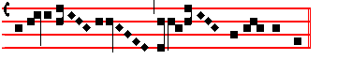
Kyri- e- e-le- i- son iij

49
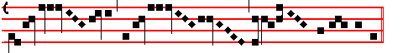
Christe * e- le- i- son. iij.
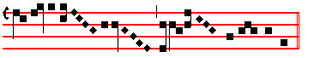
Ky-ri- e e-le- i-son. ij.
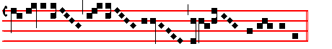
Ky-ri- e * e- le- i- son. Tone j
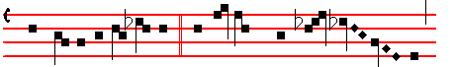
GLORY be to God on high, And in earth peace, good will
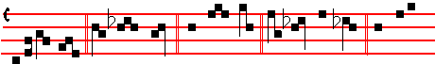
towards men. We praise thee. We bless thee. We worship thee. We glori-
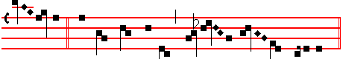
fy thee. We give thanks to thee for thy great glo- ry.
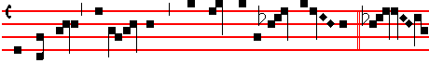
O Lord God, heavenly King, God the Father al- migh- ty. O Lord,
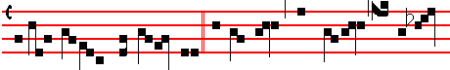
the only-begotten Son Jesu Christ. O Lord God, Lamb of God, Son of the

50
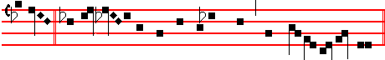
Father. That takest away the sins of the world, have mercy u-pon us.
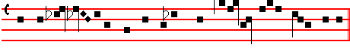
Thou that takest away the sins of the world, receive our prayer.
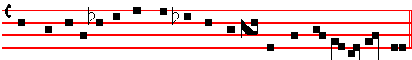
Thou that sittest at the right hand of God the Father, have mercy u-pon us.
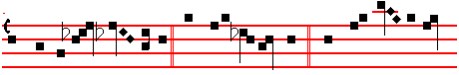
For thou only art holy. Thou only art the Lord. Thou only, O Je- su
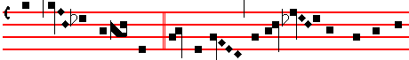
Christ, with the Holy Ghost, art most high in the glo- ry + of God the
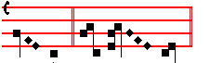
Fa- ther. A- men.
COLLECT
O GOD, who hast made this most sacred night to shine with the brightness of the true light : grant, we beseech thee ; that we, who have known the mysteries of his light on earth, may also attain to the fruition of his joys in heaven; Who liveth and reigneth with thee.

The LESSON from the Epistle of blessed Paul the Apostle to Titus (ij. 11)
DEARLY beloved : The grace of God that bringeth salvation hath appeared to all men, teaching us that, denying ungodliness and worldly lusts, we should live soberly, righteously, and godly, in this present world, looking for that blessed hope, and the glorious appearing of our great God and Saviour Jesus Christ : who

51
gave himself for us : that he might redeem us from all iniquity, and purify unto himself a peculiar people, zealous of good works. These things speak, and exhort : in Christ Jesus our Lord.

GRADUAL Psalm 110.
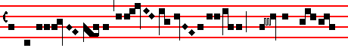
In the day of thy pow- er shall the peo-
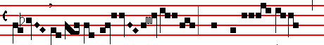
ple of- fer thee free-will offer- ings
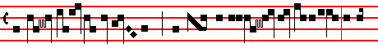
with an ho-ly wor- ship : the dew of thy birth is of
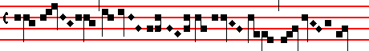
the womb of
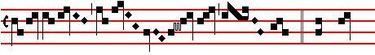
the mor- ning.  The Lord
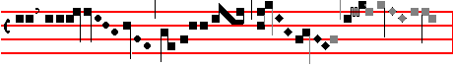
said unto my Lord :

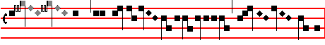
Sit hou on my right hand

52 :
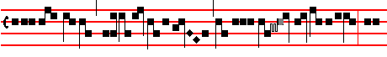
un-til I make thine en- e- mies thy
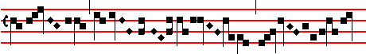
foot- stool
Tone viij
.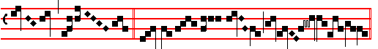
............................................ Al- le lu- ia, * ij.
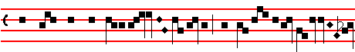
 The Lord hath said unto me : Thou art my Son
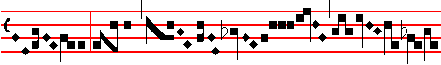
, this day have I be- got-
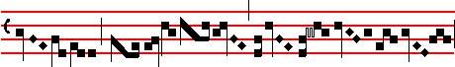
ten thee. 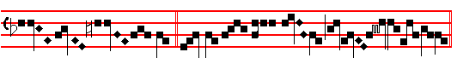
..................................................Al- le- lu- ia.............................................

 The Continuation of the holy Gospel according to Luke. (ij. 1.)
AT that time: There went out a decree from Cæsar Augustus, that all the world should be taxed. (And this taxing was first made when Cyrenius was governor of Syria : ) and all went to be taxed, every one into his own city. And Joseph also went up from Galilee, out of the city of Nazareth, into Judæa, unto the

53
city of David, which is called Bethlehem : (because he was of the house and lineage of David,) to be taxed with Mary his espoused wife, being great with child. And so it was, that, while they were there, the days were accomplished that she should be delivered. And she brought forth her firstborn son, and wrapped him in swaddling clothes, and laid him in a manger ; because there was no room for them in the inn. And there were in the same country shepherds abiding in the field, keeping watch over their flock by night. And, lo, the Angel of the Lord came upon them, and the glory of the Lord shone round about them, and they were sore afraid. And the Angel said untoi them: Fear not: for, behold, I bring you good tidings of great joym which shall be to all people: for unto you is born this day in the city of David a saviour, which is Christ the Lord. And this shall be a sign unto you. Ye shall find the babe wrapped in swaddling clothes, lying in a manger. And suddenly there was with the Angel a multitude of the heavenly host praising God, and saying : Glory to God in the highest, and on earth peace, good will toward men.
Creed. Authentic Tone iv
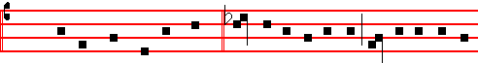
 I be- lieve in one God  The Father al-mighty, maker of heaven
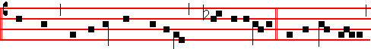
and earth, and of all thngs vi-si-ble and i nvi-sib-le. And in one Lord
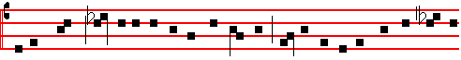
Jesus Christ , the only-be-got-ten Son of God, Begot- ten of his Father before
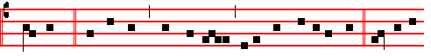
all worlds, God of God, Light of Light , very God of very God, Be-gotten,

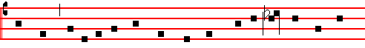
not made, Being of one substance with the Father: by whom all things

54
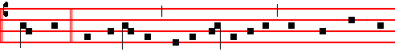
were made. Who for us men, and for our salvation, came down from hea-
here all kneel
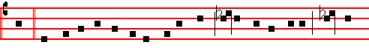
ven, and was in-carnate by the Holy Ghost of the Virgin Mary: and was
and rise
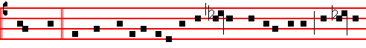
made man. And was crucified al-so for us under Pon-ti-us Pilate: he suf-fer
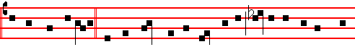
-ed, and was buri-ed. And the third day he rose again, according to the scrip-
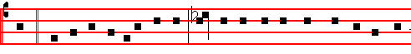
tures. And ascend-ed into heaven: And sitteth on the right hand of the Fa-
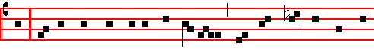
ther. And he shall come again with glo- ry, to judge both the quick and
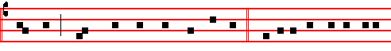
the dead : Whose kingdom shall have no end. And I believe in the Holy 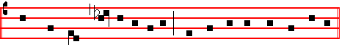
Ghost, the Lord, and Giver of life: Who procee- deth from the Father :

55
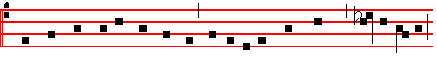 Who with the Father and the Son to-ge-ther is worshipped and glori-fied:
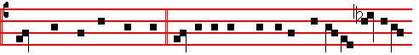
Who spake by the Prophets. And I believe one holy, catholick and apo-
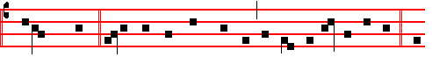
stolick Church. I acknowledge one Baptism for the remis-sion of sins. And
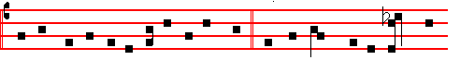
I look for the resur-rection of the dead, and the life  of the world to
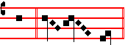
come. A- men.

OFFERTORY. Psalm 96 Tone iv
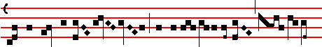
Let the heavens re- joice , and let the earth be
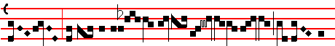
glad before the Lord : for he is
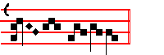
come .

56
SECRET
WE beseech thee, O Lord, that the oblation of this day’s festival may be acceptable unto thee: that by thy bountiful grace we may, through this holy communion, be found in the likeness of him in whom our substance is united unto thee: Who liveth and reigneth with thee.

¶ Preface of the Nativity, which is said throughout the Octave in all Masses, even in those which would otherwise have a proper Preface; provided that there be a commemoration in them of the Octave, or of the Sunday within the Octave, and the Mass itself or the commemoration do not demand another Preface of the Divine Mysteries or Persons. It is also said, acording to the Rubrics, up to the Vigil of the Epiphany, inclusive.

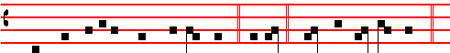
Throughout all ages, world without end.  Amen  The Lord be with you.
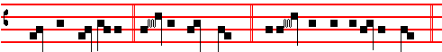
 And with thy spirit.  Lift up your hearts.  We lift them up unto the Lord.
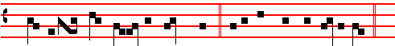
 Let us give thanks unto our Lord. God.  It is meet and right so to do. 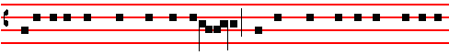
 It is very meet, right, just and salu- ta-ry, that we should at all times and in all
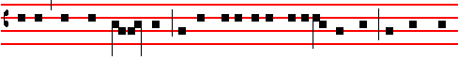
places give thanks un-to thee : O Lord holy Father, everlasting God: Because by
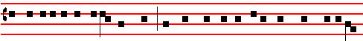
the mystery of the Incarnate Word the new light of thy glory hath shone upon the

57
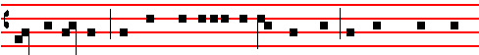 eyes of our mind: that while we visibly acknowledge God, we may through him
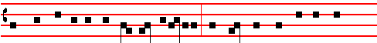
be caught up to the love of things invisible. And therefore with Angels and
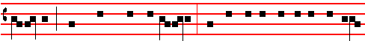
Archangels, with Thrones and Dominations and with all the host of the heavenly
SANCTUS Tone j
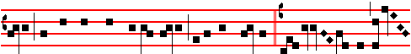
army we sing the hymn of thy glory, evermore saying: Ho- ly, Ho-
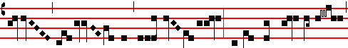
ly, Ho- ly, Lord God of Hosts, Heaven and earth are full
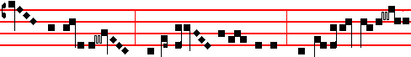
of thy glo- ry. Hosanna in the highest.Blessed is he that cometh
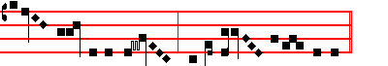
in the name of the Lord. Hosanna in the highest.

¶ Infra actionem, Joining in communion and celebrating the most sacred night, which is said daily up to the Octave of the Nativity, inclusive ; but in this Mass only is said night, afterward day.

AGNUS DEI Tone j

58
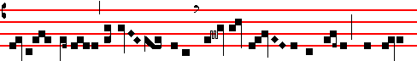
O Lamb of God, that ta- kest away the sins of the world, have mer-
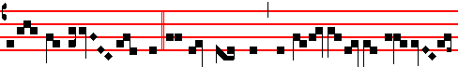
cy upon us. O Lamb of God, that takest away the sins of the
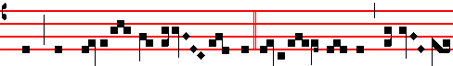
world, have mer- cy upon us. O Lamb of God, that ta- kest
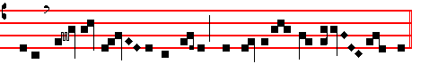
away the sins of the world, grant us peace.

¶ In the first and second Mass, if the Priest is to celebrate another Mass, having consumed the divine Blood, he does not purify nor wipe the Chalice, but places it upon the Corporal and covers it with a Pall; then with hands joined he says in the middle of the Aslter: Grant, O Lord, etc., and then washes his fingers in a vesel made ready with water, saying: Let thy Body, etc., and wipes them. This done, he removes the Pall and again arranges the Chalice still remaining on the Corporal, and covers it in the accustomed mannaer, namely, first with the linen Purificator, then the paten with the Host to be consecrated and the Pall, and finally with the Veil.
COMMUNION. Psalm 110. In splendoribus Tone vj
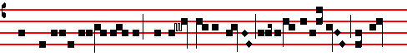
With an holy wor- ship, the dew of thy birth is of the womb of the
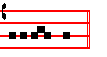
mor- ning.
59
POSTCOMMUNION
GRANT to us, we beseech thee, O Lord our God, that we who in these mysteries draw near with gladness unto the Nativity of Jesus Christ our Lord; may by godly conversation be found worthy to attain unto his fellowship: Who liveth and reigneth with thee.

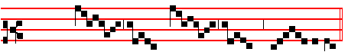
I- te, Mis- sa est
(Go ye, Mass is done)
Thanks be to God.

¶ The Priest must say the Confession before the following Masses also, and bless the people at the end of each. But at the end of this and the following Mass he reads, as usual,, the Gospel of S. John, In the beginning.

Lauds is said.
__________________________________________________________________

AT THE SECOND MASS

AT DAWN AFTER PRIME
Station at S. Anastasia.
INTROIT Isaiah 9 Lux fulgebit Tone viij
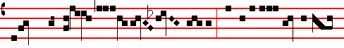
LIGHT shall shine up- on us to- day : for unto us the Lord

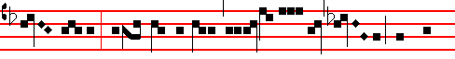
is born : and he shall be called Won- der- ful, God , the Prince
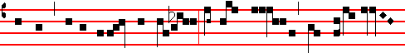
of Peace, Father of the world to come: of whose king- dom there shall be

60
Psalm 93
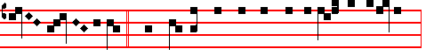
no end.. The Lord is King, and hath put on glorious apparel :
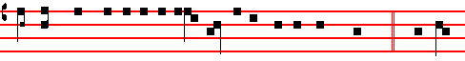
the Lord hath put on his apparel, and girded himself with strength.  Glo- ry
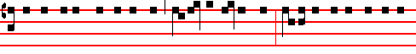
be to the Father, and to the Son, and to the Holy Ghost: as it was in the beginning,
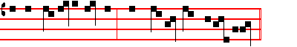
is now, and ever shall be: world without end. Amen. Repeat Light shall as far as the Psalm.
Kyrie and Gloria, pp. 49-51.
COLLECT
GRANT to us, we beseech thee, almighty God : that as thou dost pour forth on us the new light of thine incarnate Word ; so he, who doth illuminate our minds by faith, may likewise in our works shew forth his brightness. Through the same.
And Commemoration is made of S. Anastasia Martyr :
COLLECT
GRANT, we beseech thee, almighty God : that we who devoutly keep the festival of thy blessed Martyr Anastasia ; may know her to be our advocate with thee.

The LESSON from the Epistle of blessed Paul the Apostle to Titus. (iij. 4.)
DEARLY beloved : The kindness and love of God our Saviour toward man hath appeared : not by works of righteousness which we have done, but according to his mercy he saved us, by the washing of regeneration, and renewing of the Holy Ghost, which he shed on us abundantly through Jesus Christ our Saviour : that being justified by his grace, we should be made heirs according to the hope of eternal life : in Christ Jesus our Lord.

GRADUAL Psalm 118 Tone v 61
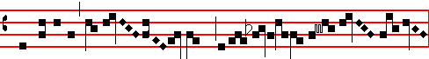
Blessed is he that co- meth in the name of the Lord :
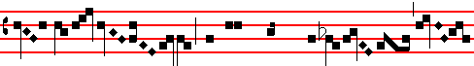
God is the Lord who hath shewed us light
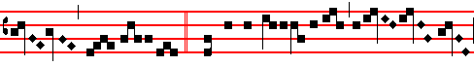
.  This is the Lord’s
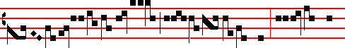
do- ing : and it is
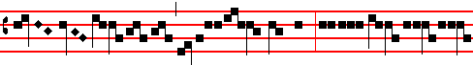
mar- vel-lous in our eyes
Tone ij
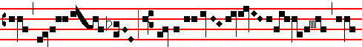
Al- le lu- ia . * ij.
Psalm 93
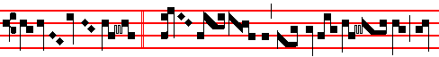
. The Lord is King , and
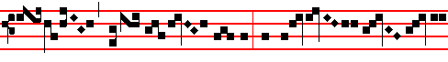
hath put on glo-ri- ous ap- pa- rel : the Lord hath put on
62
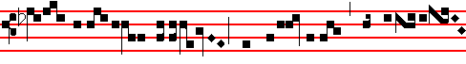
his ap-pa- rel and girded himself with strength
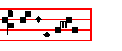.
............................... Repeat Alleluia as far as the .

The Continuation of the holy GOSPEL according to Luke. (ij. 15)
AT that time : The shepherds said one to another : Let us now go even unto Bethlehem, and see this thing which is come pass, which the Lord hath made known unto us. And they came with haste : and found Mary and Joseph, and the babe lying in a manger. And when they has seen it, they made known abroad the saying which was told them conserning this Child. And all they that heard it wondered : at those things which were told them by the shephards. But Mary kept all these things, and pondered them in her heart. And the shepherds returned, glorifying and praising God for all the things that they had heard and seen, as it was told unto them. Creed, p. 54.

OFFERTORY. Psalm 93. Tone viij
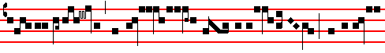
God hath made the round world so sure, that it can-
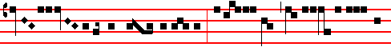
not be moved : ever since the world began, hath
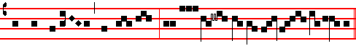
thy seat, O God, been prepared, thou art from e- ver- las- ting.

¶ In the second and third Mass, the Priest, if he has celebrated the first Mass, on coming to the Offertory, removes the Veil from the Chalice, which he places a

63
little towards the Epistle corner, but not outside the Corporal ; and having offered the Host he does not wipe the Chalice with the Purificator, but having it within the Corporal, slightly raises it, and carefully pours wine and water into it, and offers the Chalice in the accustomed manner, without wiping the inside.

SECRET
WE beseech thee, O Lord, that these our gifts may be worthy of the mysteries of this day’s Nativity, and may evermore shed forth thy peace upon us : that even as he who was born in our manhood did shew forth therein the glory of his Godhead, so we in these thy earthly creatures may be made partakers of that which is heavenly. Through the same.
For S. Anastasia
SECRET
ACCEPT, we beseech thee, O Lord, the gifts which which we duly offer : that, by the intercession of blessed Anastasia thy martyr, they may be profitable to the advancement of our salvation. Through.

The Preface, Sanctus, Joining in communion, and Agnus Dei, as above in the first Mass, pp. 57-60..

COMMUNION Zech. 9 Tone iv
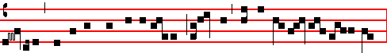
Re- joice greatly, O daughter of Zi-on, shout, O daughter of Je- ru- sa- lem :
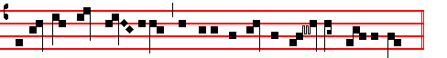
behold, thy King co- meth, the holy one and the Sav- iour of the world.

POSTCOMMUNION
O LORD, who by the wondrous Birth of thy Son hast put away the old nature of our manhood : grant that by this sacrament of his Nativity we may be restored unto newness of life. Through the same.

For S. Anastasia
POSTCOMMUNION
O LORD, who hast satisfied thy family with sacred gifts : we beseech thee, that we may at all times be conforted by the intercession of her whose feast we celebrate. Through.

64
AT THE THIRD MASS
AFTER TERCE ON THE DAY OF THE NATIVITY OF THE LORD

Station at S. Mary Major
INTROIT. Isaiah 9 Puer natus est Tone vij
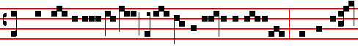
UNTO us a child is born, unto us a son is gi- ven: & the govern-

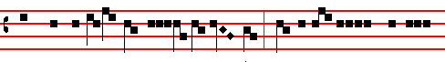
ment shall be upon his shoul- der : and his name shall be
Psalm 98
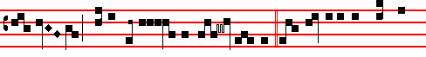
called, Angel of migh- ty coun- sel.. O sing unto the Lord a
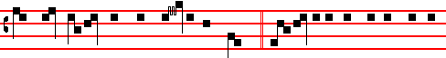
new song, for he hath done marvellous things.  Glory be to the Father, and to
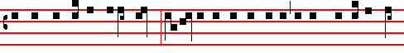
the Son, and to the Holy Ghost. As it was in the beginning, is now, and ever shall
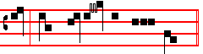
be : world without end. A- men. Repeat unto us as far as the Psalm.
Kyrie and Gloria, pp. 49-51.
COLLECT
GRANT, we beseech thee, almighty, that we, who through our ancient bondage are held beneath the yoke of sin; may by the new Birth of thy only-begotten Son in the flesh obtain deliverance. Through the same.

65
The LESSON from the Epistle of blessed Paul the Apostle to the Hebrews. (j. 1.)
GOD, who at sundry times and in divers manners spake in time past unto the fathers by the Prophets : hath in these last days spoken unto us by his Son, whom he hath appointed heir of all things, by whom also he made the worlds: who being the brightness of his glory, and the express image of his person, and upholding all things by the word of his power, when he had by himself purged our sins, sat down on the right hand of the Majesty on high : being made so much better than the Angels, as he hath by inheritance obtained a more excellent name than they. For unto which of the Angels said he at any time : Thou art my Son, this day have I begotten thee? And again : I will be to him a Father, and he shall be to me a Son? And again, when he bringeth in the First-begotten into the world, he saith: And let all the Angels of God worship him. And of the Angels he saith : Who maketh his Angels spirits, and his ministers a flame of fire. But unto the Son he saith : Thy throne, O God, is for ever and ever : a sceptre of righteousness is the sceptre of thy kingdom. Thou has loved righteousness, and hated iniquity : therefore God, even thy God, hath anointed thee with the oil of gladness above thy fellows. And : Thou, Lord, in the beginning hast laid the foundation of the earth: and the heavens are the work of thine hands. They shall perish, but thou remainest: and they shall all wax old as doth a garment : and as a vesture shalt thou fold them up, and they shall be changed : but thou art the same, and thy years shall not fail.

GRADUAL. Psalm 98. Tone v
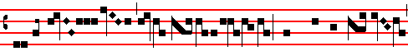 All the ends of the earth have seen the sal-va- tion
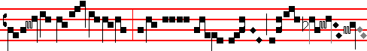
of our God : O be joyful in God , all 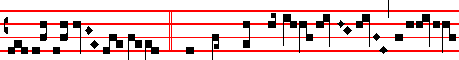 ye lands .  The Lord hath declared
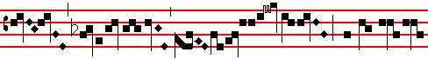
66 his sal-va-
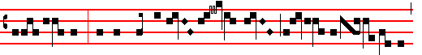
tion : in the sight of the hea- then hath he o- penly
Tone ij
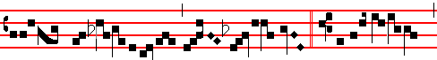 shewed his right- eous- ness. Alleluia. *
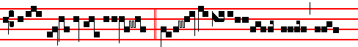
ij  A hal- lowed day hath
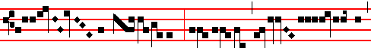
dawned upon us : come, ye na- tions,
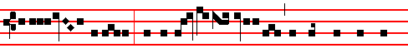
and worship the Lord : for on this day a great light hath des-
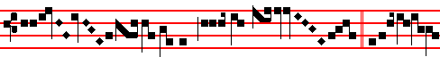
cen- ded upon the earth. ........................ Alleluia .........
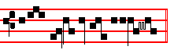
........................................................
 The beginning of the holy GOSPEL according to John. ( j.1.)
IN the beginning was the Word, and the Word was with God, and the Word was God. The same was in the beginning with God. All things were made by him : and without him was not anything made that was made : in him was life, and the life was the life of men : and the light shineth in darkness, abd the darkness

67
comprehended it not. There was a man sent from God, whose name was John. The same came for a witness, to bear witness of the light, that all men through him might believe. He was not that light, but was sent to bear witness of that light. That was the light, which lighteth every man, that cometh into the world. He was in the world, and the world was made by him, and the world knew him not. He came unto his own, and his own received him not. But as many as received him, to them gave he power to become the sons of God, even to them that believe on his name : which were born, not of blood, nor of the will of the flesh, nor of the will of man, but of God. (Here genuflect) And the Word was made flesh, and dwelt among us : and we beheld his glory, the glory as of the only-begotten of the Father, full of grace and truth. Creed, p. 54.

OFFERTORY. Psalm 89. Tone iv
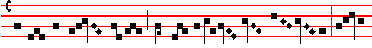
The heavens are thine, the earth also is thine : thou
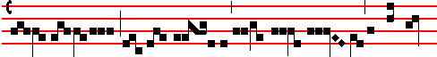
hast laid the founda- tion of the round world , and all that
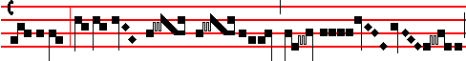
therein is : right- eous- ness and e- qui- ty
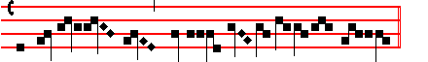
are the habita- tion of thy seat.......................................
.
SECRET
SANCTIFY, O Lord, by the new Birth of thine only-begotten Son, the gifts which we offer : and cleanse us from the defilements of our iniquities. Through the same.

The Preface, Sanctus, Joining in communion, and Agnus Dei, as above in the first Mass, pp. 57-60..

COMMUNION. Psalm 98 Tone j
68
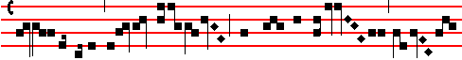 All the ends of the world have seen the salva- tion of our God
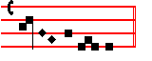
......................................
POSTCOMMUNION
GRANT, we beseech thee, almighty God : that as he who was born this day the Saviour of the world is the author of our heavenly birth ; so he may likewise bestow on us the gift of everlasting life : Who liveth and reigneth with thee.

¶ At the end of this Mass the following Gospel is read:
 The Continuation of the holy GOSPEL according to Matthew (ij, 1)
WHEN Jesus was born in Bethlehem of Judæa, in the days of Herod the king, behold, there came wise men from the east to Jerusalem, saying : Where is
he that is born king of the Jews? For we have seen his star in the east, and are come to worship him. When Herod the king had heard these things, he was troubled, and all Jerusalem with him. And when he ahd gathered all the chief priests and scribes of the people together, he demanded of them, where Christ should be born. And they said unto him : In Bethlehem of Judæa : for thus it is written by the prophet: And thou, Bethlehem, in the land of Juda, art not the least among the princes of Juda ; for out of thee shall come a governor that shall rule my people Israel. Then Herod, when he had privily called the wise men, inquired of them diligently what time the star appeared : and he sent them to Bethlehem, and said : Go, and search diligently for the young child : and when ye have found him, bring me word again, that I may come and worship him also. When they had heard the king, they departed. And lo, the star which they saw in the east went before them, till it came and stood over where the young child was. When they saw the star, they rejoiced with exceeding great joy. And when they were come into the house, they saw the yopung child with mary his mother, (here genuflect) and fell down and worshipped him. And when they had opened their treasures, they presentted unto him gifts, gold, and frankincense, and myrrh. And being warned of God.in a dream that they should not return to Herod, they departed into their own country another way.

¶ If within the Octave of the Nativity and from the 2nd to the 4th of January inclusive, any solemn Votive Mass of our Lord which is of the Nativity or of a Mystery for which no Votive Mass is provided, is to be said, the Mass Puer natus est, which is given below for January 30, is to be used.
69
DECEMBER 26
S. STEPHEN THE FIRST MARTYR
DOUBLE OF 2ND CLASS WITH SIMPLE OCTAVE

Station at S. Stephen on the Cælian Hill

INTROIT Psalm 119 Sederunt Tone j
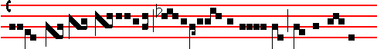
PRINCES did sit , and speak against me, and the wicked

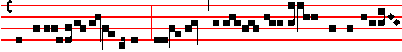
persecu- ted me : help me, O Lord my God, for thy ser-
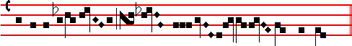
vant is occupied in thy com-mand- ments.
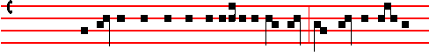
Psalm ibid. Bles-sed are they that are undefilèd in the way, and walk in the law
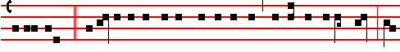
of the Lord.  Glory be to the Father, and to the Son, and to the Holy Ghost : as
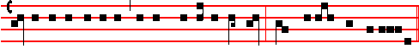
it was in the beginning, is now, and ever shall be : world without end. Amen.

Repeat Princes until the Psalm.

Kyrie and Gloria, pp. 49-51.

70
COLLECT
GRANT us, we beseech thee, O Lord, so to imitate that whiich we revere : that we may learn to love even our enemies; forasmuch as we celebrate the burthday of him who knew how to pray even for his persecutors to out Lord Jesus Christy thy Son: Who liveth.

¶ On the Octave Day is said the following:
COLLECT
ALMIGHTY and everlasting God, who, in the blood of the blessed Levite Stephen, didst consevrate the first-fruits of the Martyrs: grant, we beseech thee ; thet he may intercede for us, who prayed even for his persecutirs to our Lord Jesus Christ, thy Son: Who liveth and reigneth with thee.

And Commemoration is made of the Octave of the Nativity.

COLLECT
GRANT, we beseech thee, almighty, that we, who through our ancient bondage are held beneath the yoke of sin; may by the new Birth of thy only-begotten Son in the flesh obtain deliverance. Through the same.

The LESSON from the Acts of the Apostles. (vj.8 and vij 54)
IN those days: Stephen, full of faith and power, did great wonders and miracles among the people. Then there arose certain of the synagogue, which is called the synagogue of the Libertines, and Cyrenians, and Alexandrians, and them of Cilicia and of Asia, disputing with Stephen: and they were not able to resist the wisdom and the spirit by which he spake. When they heard these things, they were cut to the heart, and they gnashed on him with their teeth. But Stephen, being full of the Holy Ghost, looked up steadfastly into heaven, and saw the glory of God, and Jesus standing on the right hand of God. And said: Behold, I see the heavens opened, and the Son of man standing on the right hand of God. Then they cried out with a loud voice, and stopped their ears, and ran upon him with one accord, and cast him out of the city, and stoned him ; and the witnesses laid down their clothes at a young man’s feet, whose name was Saul. And they stoned Stephen, calling upon God, and saying: Lord Jesus, receive my spirit. And he kneeled down, and cried with a loud voice: Lord, lay not this sin to their charge. And when he had said this, he fell asleep in the Lord.

GRADUAL. Psalm 119. Tone v
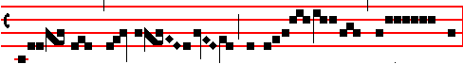
Prin- ces did sit and speak against me;

71
Psalm 6.
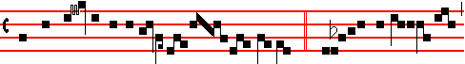 and the wicked perse-cu- ted me.  Help me, O Lord
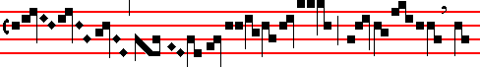
my God
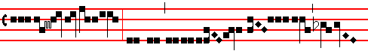
: save me for thy mer- cy’s sake
Tone ij Acts 7
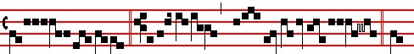
Alleluia. * ij.  I
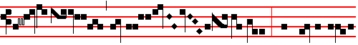 see the heavens o- pened, and Jesus stan-
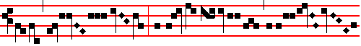 ding on the right hand of the pow-
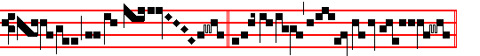
er of God. Alleluia ....................................................

¶ In Votive Masses after Septuagesima, the Alleluia and  following being omitted, is said the

TRACT. Psalm 21 Tone viij

72
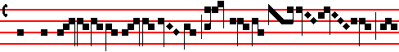
Thou hast gi- ven him his heart’s de-
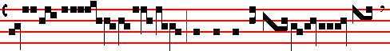
sire : and hast not de-nied
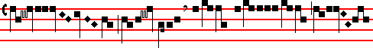
him the re- quest
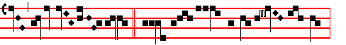
of his lips.  For thou hast preven- ted him
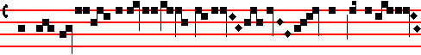
with the bles- sings of good-
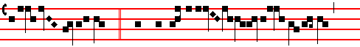
ness.  And hast set a crown
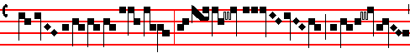
of pure gold upon
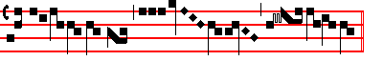
his head. ....................................................................................

¶ In Eastertide the Gradual is omitted, and in its place is said:

73
Acts 7. Tone ij
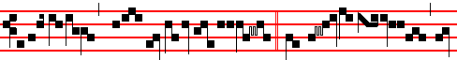
Alleluia. * ij  I see the
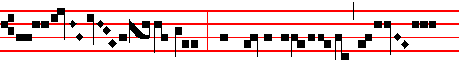
heavens o- pened, and Jesus stan-
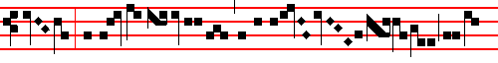
ding on the right hand of the pow- er of God.
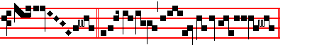
Alleluia.
 Psalm 21. Tone j
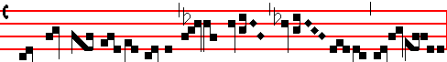
Thou hast set , O Lord,
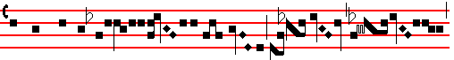
a crown of pure gold up- on his
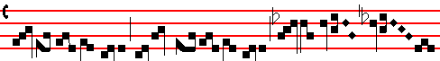 head. 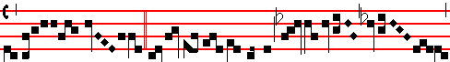
Al-le- lu- ia.

74
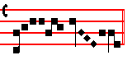
.......................................

 The Continuation of the holy GOSPEL according to Matthew (xxiij.34.)
AT that time: Jesus said unto the scribes and Pharisees: Behold, I send unto you prophets, and wise men, and scribes, and some of them ye shall kill and crucify, and some of them shall ye scourge in your synagogues, and persecute them from city to city: that upon you may come all the righteous blood shed upon the earth, from the blood of righteous Abel unto the blood of Zacharias, son of Barachias, whom ye slew between the temple and the altar. Verily I say unto you, All these things shall come upon this generation. O Jerusalem, Jerusalem, thou that killest the prophets, and stonest them which which are sent unto thee, how often would I have gathered thy children together, even as a hen gathereth he chickens under her wings, and ye would not? Behold, your house is left unto you desolate. For I say unto you, Ye shall not see me henceforth, till ye shall say : Blessed is he that cometh in the name of the Lord.
Creed, p. 54, because of the Octave.

OFFERTORY. Acts 6 and 7. Tone viij
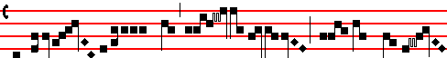
The Apost- les chose Ste- phen the Le-
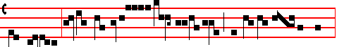
vite, a man full of faith and of the Ho- ly Ghost :
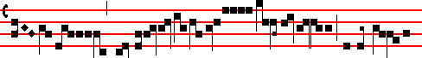
whom the Jews stoned as he prayed,
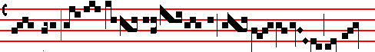 sayi- ng: Lord Je- sus, re- ceive my spi-
75
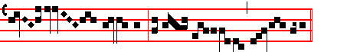
............................................rit, alle- luia.

SECRET
ACCEPT, O Lord, these gifts for the commemoration of thy Saints: that like as their passion hath raised them to glory; so our devotion may lead us to innocency of life. Through.

For the Octave of the Nativity
SECRET
SANCTIFY, O Lord, by the new Birth of thine only-begotten Son, the gifts which we offer : and cleanse us from the defilements of our iniquities. Through the same.

The Preface, Sanctus, Joining in communion because of the Octave, and Agnus Dei, as above in the first Mass, pp. 57-60..

COMMUNION. Acts 7. Tone viij
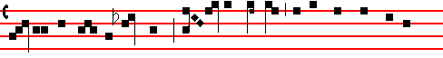
I see the heavens opened, and Jesus standing on the right hand of the
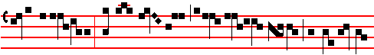
power of God: O Lord Je- sus, receive my spi- rit, and lay not this
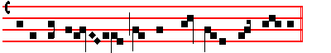
sin to their charge, for they know not what they do..

POSTCOMMUNION
MAY the mysteries which we have received be for our help, O Lord: and at the intercession of blessed Stephen thy Martyr, may they establish us with thine everlasting protection. Through.

For the Octave of the Nativity.
76
POSTCOMMUNION
GRANT, we beseech thee, almighty God : that as he who was born this day the Saviour of the world is the author of our heavenly birth ; so he may likewise bestow on us the gift of everlasting life : Who liveth and reigneth with thee.
__________________________________________________________________

DECEMBER 27

S. JOHN, APOSTLE AND EVANGELIST

DOUBLE OF 2ND CLASS WITH SIMPLE OCTAVE

Station at S. Mary Major

INTROIT. Ecclus. 15 In medio Ecclesiæ .. Tone vj
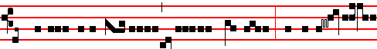
IN the midst of the Church he opened his mouth : and the Lord filled

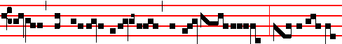 him with the spiirit of wisdom and un-der- stan-ding : in a robe of
Psalm 92.
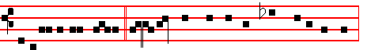
glory he arrayed him. It is a good thing to give thanks unto the Lord :
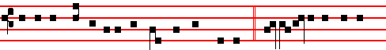
and to sing praises unto thy name, O most Highest.  Glory be to the Father,
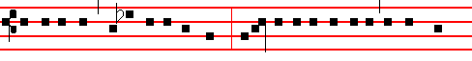
and to the Son, and to the Holy Ghost : as it was in the beginning, is now, and

77
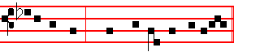
ever shall be : world without end. A- men. Repeat In the midst until the Psalm.

Kyrie and Gloria, pp. 49-51.
COLLECT
O LORD, graciously illumine thy Church : that it, being enlightened by the doctrine of blessed John thy Apostle and Evangelist, may attain unto everlasting gifts. Through.

Commemoration of the Octave of the Nativity.
COLLECT
GRANT, we beseech thee, almighty, that we, who through our ancient bondage are held beneath the yoke of sin; may by the new Birth of thy only-begotten Son in the flesh obtain deliverance. Through the same.

And Commemoration is made of the Octave of S. Stephen.
COLLECT
GRANT us, we beseech thee, O Lord, so to imitate that which we revere : that we may learn to love even our enemies; forasmuch as we celebrate the burthday of him who knew how to pray even for his persecutors to out Lord Jesus Christ thy Son: Who liveth.

The LESSON from the book of Wisdom. (Ecclus. xv.1)
HE that feareth the Lord will do good : and he that possesseth justice shall lay hold on her, and as a mother shall she meet him, and receive him as a wife married of a virgin. With the bread of understanding shall she feed him, and give him the water of wisdom to drink: he shall be stayed uponnher, and shall not be confounded : she shall exalt him above his neighbours, and in the midst of the congregation shall she open his mouth. He shall find joy and a crown of gladness, and the Lord our God shall cause him to inherit an everlasting name.

GRADUAL. John 21 Tone v
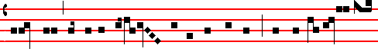 Then went this saying abroad among the brethren : That that disci-

78
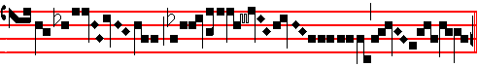
ple should not die:
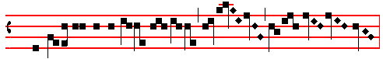
 But: If I will that he tar-ry
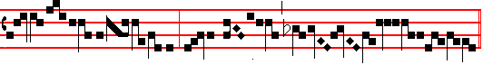
till I come : follow thou me.
Tone ij
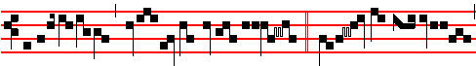
Alleluia. * ij.  This is
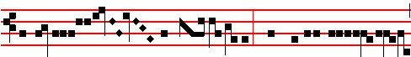
the disci- ple which testifi- eth
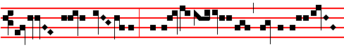
of these things : and we know that his tes-
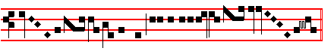
timo- ny is true.
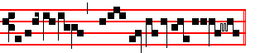
Alleluia.
79
¶ In Votive Masses after Septuagesima, the Alleluia and Verse following being omitted, is said:
TRACT. Psalm 112. Tone viij
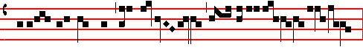
Blessed is the man that fear- eth the Lord :
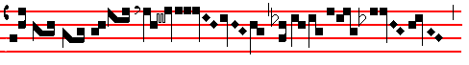
he hath great de-light in his com- mand-
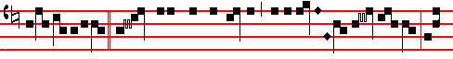
ments.  His seed shall be mighty upon earth : the
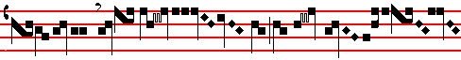
ge- nera- tion of the faith- ful shall be bles-
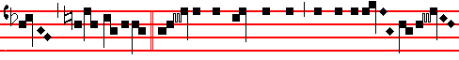
sed  Riches and plenteousness shall be in his house
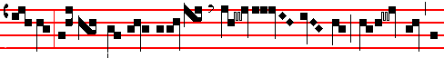 : and his right- eous-ness endu- reth for
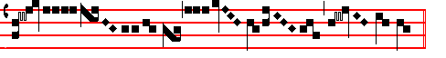
e- ver.

¶ But in Eastertide the Gradual is omitted, and in its place is said:
Tone ij

80
Alleluia. * ij.  This is
the disci- ple which testifi- eth
of these things : and we know that his tes-
timo- ny is true.
Alleluia.
 Psalm 92 Tone j
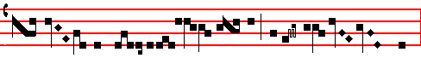
. The just shall flour- ish like a palm- tree: 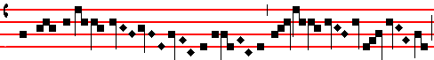
and shall spread a- broad
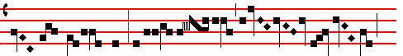
like a ce- dar in Li-

81
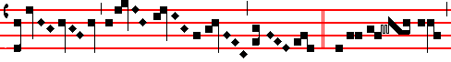
ba- nus. Alle- lu- ia. *
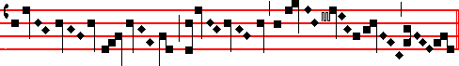
...................................................................................................................................

 The Continuation of the holy GOSPEL according to John (xxj. 19)
AT that time: Jesus said unto Peter: Follow me. Then Peter, turning about, seeth the disciple whom Jesus loved following, which also leaned on his breast at supper, and said: Lord, which is he that betrayeth thee? Peter seeing him saith to Jesus: Lord, and whart shall this man do? Jesus saith unto him: If I will that he tarry till I come, what is that to thee? Follow thou me. Then went this saying abroad among the brethren, that that disciple should not die. Yet Jesus said not unto him: He shall not die; but: If I will that he tarry till I come : what is that to thee? This is disciple which testifieth of these things, and wrote these things: and we know that his testimony is true. Creed.

OFFERTORY. Psalm 92. Tone iv
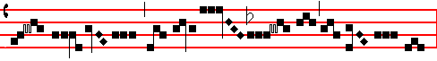
The just shall flou- rish like a palm -tree:
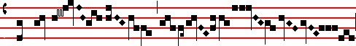
and shall spread a- broad like a ce- dar
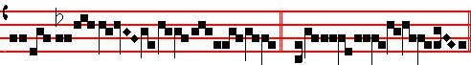
in Li- ba- nus. (E.T. Al- le- lu-ia)
SECRET
RECEIVE, O Lord, the gifts which we offer unto thee on the solemnity (commemoration) of him, in whose advocacy we trust for deliverance. Through.
82
For the Octave of the Nativity
SECRET
SANCTIFY, O Lord, by the new Birth of thine only-begotten Son, the gifts which we offer : and cleanse us from the defilements of our iniquities. (Through the same.)
For the Octave of S. Stephen
SECRET
ACCEPT, O Lord, these gifts for the commemoration of thy Saints: that like as their passion hath raised them to glory; so our devotion may lead us to innocency of life. Through.

The Preface, Sanctus, Joining in communion because of the Octave, and Agnus Dei, as above in the first Mass of Christmas, pp. 57-60..

COMMUNION. John 21. Tone ij
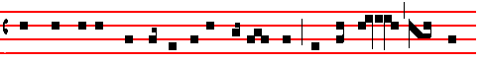
Then went abroad this saying among the brethren, that that disciple should not
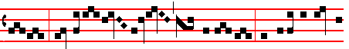
die : yet Jesus said not: He shall not die ; but: If I will that he
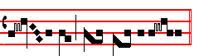
tar- ry till I come.

POSTCOMMUNION
O GOD, who hast refreshed us with heavenly meat and drink, we humbly beseech thee : that we may be defended by the prayers of him, in whose memory we have received the same. Through.

For the Octave of the Nativity.
POSTCOMMUNION
GRANT, we beseech thee, almighty God : that as he who was born this day the Saviour of the world is the author of our heavenly birth ; so he may likewise bestow on us the gift of everlasting life : (Who liveth and reigneth with thee.)

83
For the Octave of S. Stephen.
POSTCOMMUNION
MAY the mysteries which we have received be for our help, O Lord: and at the intercession of blessed Stephen thy Martyr, may they establish us with thine everlasting protection. Through.
__________________________________________________________________

DECEMBER 28
THE HOLY INNOCENTS
DOUBLE OF THE 2ND CLASS WITH SIMPLE OCTAVE
Station at S. Paul

INTROIT Psalm 8 Ex ore infantium Tone ij
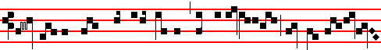
OUT of the mouths of babes, O God, and of suck- lings, hast thou perfected

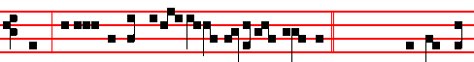
praise because of thine adver- sa- ries. Psalm ibid. O Lord our
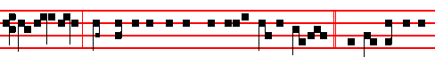
Gover- nor: how excellent is thy name in all the world.  Glory be to the
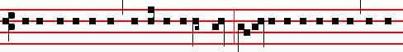
Father, and to the Son, and to the Holy Ghost: as it was in the beginning, is now,
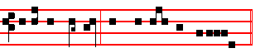
and ever shall be: world without end. A- men. Repeat Out of up to the Psalm.

¶ Glory be to God is not said, nor Alleluia, nor Ite, Missa est, unless this Feast falls on a Sunday, or enjoys the rite of a double of the First Class ; but on the Octave they are always said.
84
Kyrie (and Gloria), pp. 49-51.
COLLECT
O ALMIGHTY God, whose praise the Innocents thy Martyrs did this day not by speaking but by dying confess: mortify all evil vices in us : that, as our thoughts confess thy faith, so our lives may by their actions set forth the same. Through.

Commemoration of the Octave of the Nativity.
COLLECT
GRANT, we beseech thee, almighty, that we, who through our ancient bondage are held beneath the yoke of sin; may by the new Birth of thy only-begotten Son in the flesh obtain deliverance. Through the same.

And Commemoration is made of the Octave of S. Stephen.
COLLECT
GRANT us, we beseech thee, O Lord, so to imitate that which we revere : that we may learn to love even our enemies; forasmuch as we celebrate the burthday of him who knew how to pray even for his persecutors to out Lord Jesus Christ thy Son: Who liveth.

And Commemoration is made of the Octave of S. John.
COLLECT
O LORD, graciously illumine thy Church : that it, being enlightened by the doctrine of blessed John thy Apostle and Evangelist, may attain unto everlasting gifts. Through.

The LESSON from the book of the Revelation of blessed John the Apostle.
(xlv. 1.)
IN those days: I looked, and lo, a Lamb stood on the mount Sion, and with him an hundred and forty and four thousand, having his Father’s name written in their foreheads. And I heard a voice from heaven, as the voice of many waters, and as the voice of a great thunder: and I heard the voice of harpers harping with their harps. And they sung as it were a new song before the throne, and before the four beasts, and the elders: and no man could learn that song, but the hundred and forty and four thousand, which were redeemed from the earth. These are they which were not defiled with women: for they are virgins. These are they which follow the Lamb whithersoever he goeth. These were redeemed from among men, being the first fruits unto God, and to the Lamb: and in their mouth was found no guile: for they are without fault before the throne of God.

GRADUAL. Psalm 124 Tone v

85
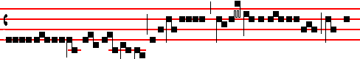
Our soul is escaped, e-ven as a bird, out of
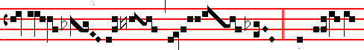
the snare of the fow- ler.  The snare

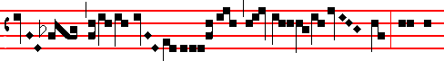
is bro- ken, and we
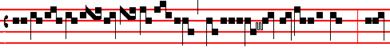
are de- li- vered: our
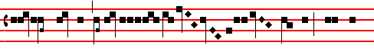
help standeth in the name of the Lord, who hath
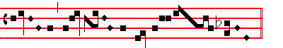
made hea-ven and earth.

¶ The following Alleluia with its Verse is said when this Feast falls on Sunday or enjoys the rite of a double of the First Class: but on the Octave-day it is always said, as also in Votive Masses before Septuagesima or after Pentecost.
Tone iv , Psalm 113
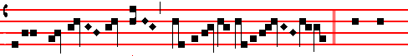
Al- le- lu- ia. * ij Praise the

86
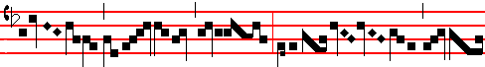
Lord, ye child- ren, O praise the name 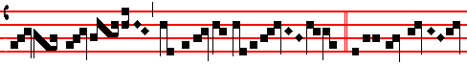 of the Lord . Al- le- lu-
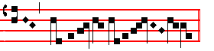
ia . The Tract is not said when the Alleluia has been said as above. TRACT. Psalm 79 Tone viij
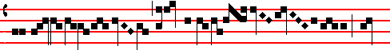
The blood of the Saints have
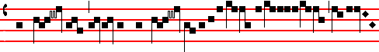 they shed on every side of Je-rusalem
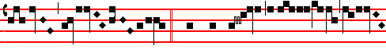
.  And there was no man
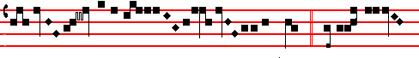
to bu- ry them.  Avenge, O Lord
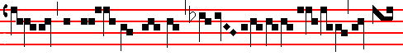
, the blood of thy Saints

87
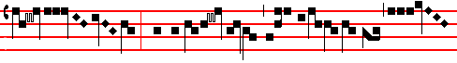
, that is shed upon the earth...............................
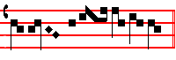
.......................................................... In Votive Masses in Eastertide the Gradual and Tract being omitted, is said: Tone iv  Psalm 113
Al- le- lu- ia. * ij Praise the
Lord, ye child- ren, O praise the name of the Lord . Al- le- lu-
ia  Ecclus. 39. Tone viij
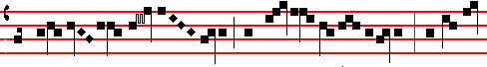
Thy Saints , O Lord , shall grow as the li- ly, and as the
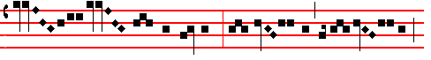
o- dour of balsam shall they be before thee.............

88.

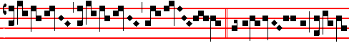
.................................................................................. Allelu- ia...............
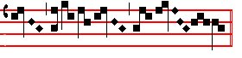
..............................................................................

 The Continuation of the holy GOSPEL according to Matthew. (ij. 13)
AT that time: The Angel of the Lord appeared to Joseph in a dream, saying: Arise, and take the young Child and his Mother, and flee into Egypt, and be thou there until I bring thee word. For Herod will seek the young Child to destroy him. When he arose, he took the young Child and his Mother by night, and departed unto Egypt: and was there until the death of Herod: that it might be fulfilled which was spoken of the Lord by the Prophet, saying: Out of Egypt have I called my Son. Then Herod, when he saw that he was mocked of the wise men, was exceeding wroth, and sent forth, and slew all the children that were in Bethlehem, and in all the coasts thereof, from two years old and under, according to the time which he had diligently enquired of the wise men. Then was fulfilled that which was spoken by Jeremy the Prophet, saying: In Rama was there a voice heard, lamentation, and weeping, and great mourning: Rachel weeping for her children, and would not be comforted, because they are not.

Creed, because of the Octave, p. 54..

OFFERTORY. Psalm 124. Tone ij
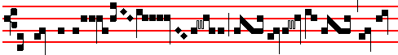
Our soul is escaped , e- ven as a bird out of
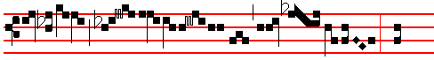
the snare of the fow- ler : the

89
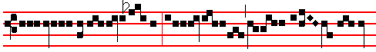
snare is bro- ken, and we are de- li-
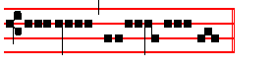
vered.
SECRET
MAY the devout prayers of thy Saints never fail us, O Lord: that they may render our gifts acceptable unto thee, and ever obtain for us thy pardon. Through.
For the Octave of the Nativity
SECRET
SANCTIFY, O Lord, by the new Birth of thine only-begotten Son, the gifts which we offer : and cleanse us from the defilements of our iniquities. (Through the same.)
For the Octave of S. Stephen
SECRET
ACCEPT, O Lord, these gifts for the commemoration of thy Saints: that like as their passion hath raised them to glory; so our devotion may lead us to innocency of life. .
For the Octave of S. John
SECRET
RECEIVE, O Lord, the gifts which we offer unto thee on the solemnity (commemoration) of him, in whose advocacy we trust for deliverance. Through.
The Preface, Sanctus, Joining in communion because of the Octave, and Agnus Dei, as above in the first Mass of Christmas, pp. 57-60..
COMMUNION Matthew 2. Tone vij
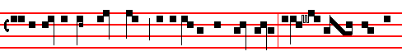
In Rama, a voice was heard, lamentation and weeping: Ra- chel weeping
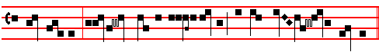
for her children, and would not be com- forted, because they are not.
90
POSTCOMMUNION
WE beseech thee, O Lord: that the gifts, which we have offered and received, may through the prayers of thy saints effectually avail for our succour both in this life and in that which is to come. Through.

For the Octave of the Nativity.
POSTCOMMUNION
GRANT, we beseech thee, almighty God : that as he who was born this day the Saviour of the world is the author of our heavenly birth ; so he may likewise bestow on us the gift of everlasting life : (Who liveth and reigneth with thee.)

For the Octave of S. Stephen.
POSTCOMMUNION
MAY the mysteries which we have received be for our help, O Lord: and at the intercession of blessed Stephen thy Martyr, may they establish us with thine everlasting protection. Through.

For the Octave of S. John.
POSTCOMMUNION
O GOD, who hast refreshed us with heavenly meat and drink, we humbly beseech thee : that we may be defended by the prayers of him, in whose memory we have received the same. Through.

¶ Within the Octave of Holy Innocents commemoration only is made of that Feast; but if a Votive Mass of the Holy Innocents is celebrated on January 2 or 3, Gloria in excelsis is said.
__________________________________________________________________
.
THE SUNDAY IN THE OCTAVE OF THE NATIVITY
Semidouble
This Mass is said according to the Rubric in the Office:
¶ If the Feast of the Nativity of the Lord, S. Stephen, John Evangelist, the Holy Innocents, or their Octave Days, come on Sunday, on the day itself nothing is said of the Sunday, but its Office is said on the fifth day within the Octave of the Nativity, December 29.

INTROIT. Wisdom 18 Dum medium. Tone viij
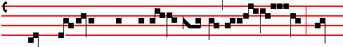
WHILE all things were in qui-et si- lence, and
91
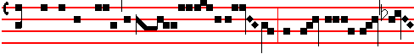 night was in the midst of her swift course, thine al- mighty Word, O
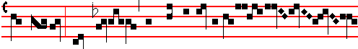
Lord, leaped down from heaven out of thy roy- al throne.
Psalm 93
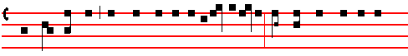
The Lord is King, and hath put on glorious apparel: the Lord hath put on his
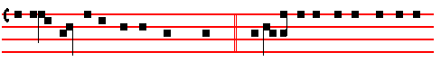
apparel, and girded himself with strength.  Glory be to the Father, and to the
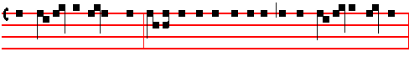
Son, and to the Holy Ghost: As it was in the beginning, is now and ever shall be :
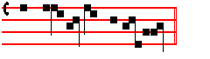
world with out end. A-men.. Repeat While all things as far as the Psalm.
¶ Kyrie and Gloria of the Nativity, pp 49-50. Gloria in excelsis is said., even if this Mass is resumed after January 1.

COLLECT
ALMIGHTY and everlasting God, direct our actions according to thy good pleasure: that in the name of thy well-beloved Son we may be made worthy to abound in good works: Who liveth and reigneth with thee.
Commemoration of the Octave of the Nativity.
COLLECT
GRANT, we beseech thee, almighty God, that we, who through our ancient bondage are held beneath the yoke of sin; may by the new Birth of thy only-

92
begotten Son in the flesh obtain deliverance. Through the same.

And Commemoration is made of the Octave of S. Stephen.

COLLECT
GRANT us, we beseech thee, O Lord, so to imitate that which we revere : that we may learn to love even our enemies; forasmuch as we celebrate the burthday of him who knew how to pray even for his persecutors to our Lord Jesus Christ thy Son: Who liveth.

And Commemoration is made of the Octave of S. John.

COLLECT
O LORD, graciously illumine thy Church : that it, being enlightened by the doctrine of blessed John thy Apostle and Evangelist, may attain unto everlasting gifts. Through.

And Commemoration is made of the Octave of the Holy Innocents.

COLLECT
O ALMIGHTY God, whose praise the Innocents thy Martyrs did this day not by speaking but by dying confess: mortify all evil vices in us : that, as our thoughts confess thy faith, so our lives may by their actions set forth the same. Through.

The Lesson from the Epistle of blessed Paul the Apstle to the Galatians (iv.1.)
BRETHREN: Now this I say: that the heir, as long as he is a child, differeth nothing from a servant, though he be lord of all: but is under tutors and governors, until the time appointed of the father: even so we, when we were children, were in bondage under the elements of the world.But when the fullness of the time was come, God sent forth his Son, made of a woman, made under the law, to redeem them that wwre under the law, that we might receive the adoption of sons. And because ye are sons, God hath sent forth the Spirit of his Son into your hearts, crying: Abba, Father. Wherefore, thou art no more a servant, but a son: and if a son, then an heir of God through Christ.

GRADUAL. Psalm 45 Tone iij
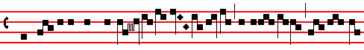 Thou art fairer than the child- ren of men

93
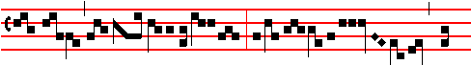 : full of
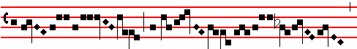
grace are thy
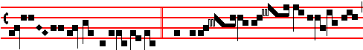
lips.  My heart
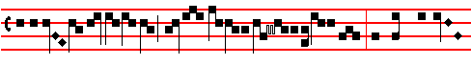 is indi- ting of a good matt- er, I speak of the
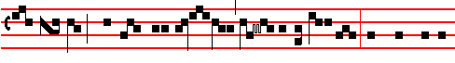
things which I have made un- to the King : my tongue is the
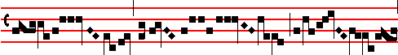
pen of a rea- dy
Tone ij
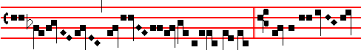
wri- ter. Alle- lu-
Psalm 93.
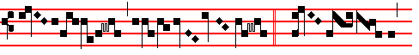
ia. * ij.  The Lord
94
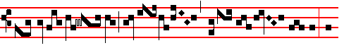 is King, and hath put on glo-ri- ous ap- pa- rel: the
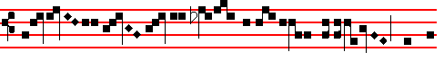
Lord hath put on his a-ppa- rel , and gir-
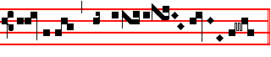
ded himself with strength . Repeat Alleluia. as far as the 
 The Continuation of the holy Gospel according to Luke (ij. 33.)
AT that time: Joseph and Mary, the Mother of Jesus, marvelled at those things which were spoken of him. And Simeon blessed them, and said unto Mary his mother: Behold this child is set for the fall and rising of many in Israel: and for a sign which shall be spoken against: yea, a sword shall pierce through thy own soul also, that the thoughts of many hearts may be revealed. And there was one Anna, a prophetess, the daughter of Phanuel, of the tribe of Aser: she was of a great age, and had lived with an husband seven years from her virginity. And she was a widow of about fourscore and four years: which departed not from the temple, but served God with fastings and prayers night and day. And she coming in that instant gave thanks likewise unto the Lord, and spake of him to all them that looked for redemption in Jerusalem. And when they had performed all things according to the law of the Lord, they returned into Galilee to their own city Nazareth. And the child grew and waxed strong in spirit filled with wisdom: and the grace of God was upon him. Creed.
OFFERTORY. Psalm 93 Tone viij
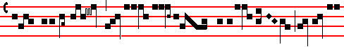
God hath made the round world so sure, that it can-
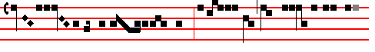
not be mo- ved: e-ver since the world began hath
95
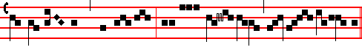 thy seat, O God, been prepared, thou art from e-ver- las- ting.

SECRET
GRANT, we beseech thee, almighty God: that the gift which we offer in the sight of thy majesty, may obtain for us grace to serve thee with all godliness, and bring us in the end to everlasting felicity. Through.
For the Octave of the Nativity
SECRET
SANCTIFY, O Lord, by the new Birth of thine only-begotten Son, the gifts which we offer : and cleanse us from the defilements of our iniquities. (Through the same.)
For the Octave of S. Stephen
SECRET
ACCEPT, O Lord, these gifts for the commemoration of thy Saints: that like as their passion hath raised them to glory; so our devotion may lead us to innocency of life. .
For the Octave of S. John
SECRET
RECEIVE, O Lord, the gifts which we offer unto thee on the solemnity (commemoration) of him, in whose advocacy we trust for deliverance. Through.
For the Octave of the Holy Innocents.
SECRET
MAY the devout prayers of thy Saints never fail us, O Lord: that they may render our gifts acceptable unto thee, and ever obtain for us thy pardon. Through.

The Preface, and Sanctus of the Nativity; and Joining in communion is said thereof, unless the Mass is resumed after the Octave, and Agnus Dei, as above in the first Mass of Christmas, pp. 57-60.

COMMUNION Matthew 2. Tone vij
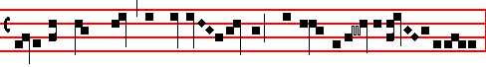
Take the young Child and his Mo- ther, and go into the land of Isra- el:

96
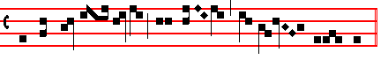
for they are dead which sought the young Child’s life.

POSTCOMMUNION
MAY the operation of this mystery, O Lord, avail for the cleansing of our sins, and for the fulfulment of our godly desires. Through.
.For the Octave of the Nativity.
POSTCOMMUNION
GRANT, we beseech thee, almighty God : that as he who was born this day the Saviour of the world is the author of our heavenly birth ; so he may likewise bestow on us the gift of everlasting life : (Who liveth and reigneth with thee.)

For the Octave of S. Stephen.
POSTCOMMUNION
MAY the mysteries which we have received be for our help, O Lord: and at the intercession of blessed Stephen thy Martyr, may they establish us with thine everlasting protection. Through.
For the Octave of S. John.
POSTCOMMUNION
O GOD, who hast refreshed us with heavenly meat and drink, we humbly beseech thee : that we may be defended by the prayers of him, in whose memory we have received the same. Through.
For the Octave of the Holy Innocents.
POSTCOMMUNION
WE beseech thee, O Lord: that the gifts, which we have offered and received, may through the prayers of thy saints effectually avail for our succour both in this life and in that which is to come. Through
__________________________________________________________________

¶ From this day until the 2nd of February inclusive, when the Prayers assigned for the various Seasons are to be said, according to the Rubrics, they will be as follows, even on Vigils and within Octaves, excepting the 2nd Collect, which, in Masses of the blessed Virgin Mary, and those, wherein Commemoration is made of the same, and also in Votive Masses of All Saints, is said of the Holy Spirit.
COLLECT
GOD, who didst teach the hearts of thy faithful people by the sending to them the light of thy Holy Spirit: grant us by the same Spirit to have a right judgment in all things; and evermore to rejoice in his holy comfort. (Through......in the unity of the same Holy Spirit.)

97
SECRET
SANCTIFY, we bexeech thee, O Lord, the gifts which we offer: and cleanse our hearts by the enlightening of the Holy Spirit. (Through......in the unity of the same Holy Spirit.

POSTCOMMUNION
POUR thy Holy Spirit upon us, O Lord, and cleanse our hearts that they may be made fruitful by the inward sprinkling of his dew. (Through......in the unity of the same Holy Spirit.)

2nd of S Mary
COLLECT
O GOD, who by the virgin child-bearing of blessed Mary hast bestowed upon mankind the rewards of eternal salvation: grant, we beseech thee, that we may perceive her intercession for us, through whom we have been counted woorthy to receive the author of life, Jesus Christ hy Son our Lord. (Who liveth and reigneth with thee.)
SECRET
THROUGH thy mercy, O Lord, and the intercession of blessed mary ever Virgin, may this oblation avail for our prosperity and peace both now and for ever. (Through.)

POSTCOMMUNION
MAY this communion, O Lord, cleanse us from guilt: and, at the intercession of blessed Mary the Virgin Mother of God, make us partakers of thy heavenly healing. (Through the same.)

3rd against the percecutors of the Church.
COLLECT
WE beseech thee, O Lord, mercifully to hear the prayers of thy Church: that all adversities being done away, she may serve thee in freedom and quietness. Through.
SECRET
DEFEND us, O Lord, who waith upon thy mysteries: that we, cleaving fast to things heavenly, may serve thee both in body and soul. Through

POSTCOMMUNION
WE beseech thee, O Lord our God: that we whom thou makest to rejoice in the partaking of heavenly things may by thee be defended against all earthly perils. Through.

Or 3rd for the Chief Bishop.
98
COLLECT
O GOD, the pastor and ruler of all the faithful, mercifully look upon thy servant N., whom thou hast been pleased to set as pastor over thy Church: grant him, we beseech thee, to be in woird and conversation a wholesome example to the people committed to his charge; that he with them may attain unto everlasting life. Through.
SECRET
LOOK favourably, we beseech thee, O Lord, upon the gifts which we offer: and guide with thy continual protection thy servant N., whom thou hast been pleased to set as pastor over thy Church. Through.

POSTCOMMUNION
WE beseech thee, O Lord, that the divine sacrament which we have here received may be our protection: and together with the flock entrusted to his charge ever save and defend thy servant N., whom thou hast been pleased to set as pastor over thy Church. Through.
___________________________________________________________________________________________

December 30
THE SIXTH DAY WITHIN THE OCTAVE OF THE NATIVITY.
Semidouble
This Mass is said according to the Rubric in the Office:
¶ If December 30 comes on a Sunday, the above Office is said on that day, and on December 29 is said the Office that follows.
INTROIT. Isaiah 9 Puer natus est Tone vij
UNTO us a child is born, unto us a son is gi- ven: & the govern-

ment shall be upon his shoul- der : and his name shall be
Psalm 98
called, Angel of migh- ty coun- sel.. O sing unto the Lord a

99
new song, for he hath done marvellous things.  Glory be to the Father, and to
the Son, and to the Holy Ghost. As it was in the beginning, is now, and ever shall
be : world without end. A- men. Repeat unto us as far as the Psalm.
Kyrie and Gloria, pp. 49-51.
COLLECT
GRANT, we beseech thee, almighty, that we, who through our ancient bondage are held beneath the yoke of sin; may by the new Birth of thy only-begotten Son in the flesh obtain deliverance. Through the same.

And Commemoration is made of the Octave of S. Stephen.
COLLECT
GRANT us, we beseech thee, O Lord, so to imitate that which we revere : that we may learn to love even our enemies; forasmuch as we celebrate the burthday of him who knew how to pray even for his persecutors to our Lord Jesus Christ thy Son: Who liveth.

And Commemoration is made of the Octave of S. John.
COLLECT
O LORD, graciously illumine thy Church : that it, being enlightened by the doctrine of blessed John thy Apostle and Evangelist, may attain unto everlasting gifts. Through.

And Commemoration is made of the Octave of the Holy Innocents.
COLLECT
O ALMIGHTY God, whose praise the Innocents thy Martyrs did this day not by speaking but by dying confess: mortify all evil vices in us : that, as our thoughts confess thy faith, so our lives may by their actions set forth the same. Through.

The Lesson from the Epistle of blessed Paul the Apostle to Titus (iij.4.)

100
DEARLY beloved: The kindness and love of God our Saviour toward man hath appeared: not by works of righteousnass which we have done, but according to his mercy he saved us, by the washing of regeneration, and renewing of the Holy Ghost, which he shed on us abundantly through Jesus Christ our Saviour: that being justiofied by his grace, we should be made heirs according to the hope of eternal life: in Christ Jesus our Lord.

GRADUAL. Psalm 98. Tone v
All the ends of the earth have seen the sal-va- tion
of our God : O be joyful in God , all ye lands .  The Lord hath declared
his sal-va-
-tion : in the sight of the hea- then hath he o- pen-ly
Tone ij
shewed his right- eous- ness. Alleluia. *

101
ij  A hal- lowed day hath
dawned upon us : come, ye na- tions,
and worship the Lord : for on this day a great light hath des-
cen- ded upon the earth. ........................ Alleluia .........

 The Continuation of the holy Gospel according to Luke (ij. 15.)
AT that time: The shepherds said one to another: Let us now go even unto Bethlehem, and see this thing which is come to pass, which the Lord hath made known unto us. And they came with haste: and found Mary and Joseph, and the Babe lying in a manger. And when they had seen it, they made known abroad the saying which was told them concerning this Child. And all they that heard it wondered: at those things which were told them by the shephards. But Mary kept all these things, and pondered them in her heart. And the shepherds returned, glorifying and praising God for all the things that they had heard and seen, as it was told unto them. Creed.

OFFERTORY. Psalm 89. Tone iv
The heavens are thine, the earth also is thine : thou

102
hast laid the founda- tion of the round world , and all that
therein is : right- eous- ness and e- qui- ty
are the habita- tion of thy seat.......................................
.
SECRET
SANCTIFY, O Lord, by the new Birth of thine only-begotten Son, the gifts which we offer : and cleanse us from the defilements of our iniquities. Through the same.
For the Octave of S. Stephen
SECRET
ACCEPT, O Lord, these gifts for the commemoration of thy Saints: that like as their passion hath raised them to glory; so our devotion may lead us to innocency of life. .
For the Octave of S. John
SECRET
RECEIVE, O Lord, the gifts which we offer unto thee on the solemnity (commemoration) of him, in whose advocacy we trust for deliverance. Through.
For the Octave of the Holy Innocents.
SECRET
MAY the devout prayers of thy Saints never fail us, O Lord: that they may render our gifts acceptable unto thee, and ever obtain for us thy pardon. Through.
The Preface, Sanctus, Joining in communion, and Agnus Dei, as above pp. 57-60..
COMMUNION. Psalm 98 Tone j
All the ends of the world have seen the salva- tion of our God.

103
......................................
POSTCOMMUNION
GRANT, we beseech thee, almighty God : that as he who was born this day the Saviour of the world is the author of our heavenly birth ; so he may likewise bestow on us the gift of everlasting life : Who liveth and reigneth with thee.
For the Octave of S. Stephen.
POSTCOMMUNION
MAY the mysteries which we have received be for our help, O Lord: and at the intercession of blessed Stephen thy Martyr, may they establish us with thine everlasting protection. Through.
For the Octave of S. John.
POSTCOMMUNION
O GOD, who hast refreshed us with heavenly meat and drink, we humbly beseech thee : that we may be defended by the prayers of him, in whose memory we have received the same. Through.
For the Octave of the Holy Innocents.
POSTCOMMUNION
WE beseech thee, O Lord: that the gifts, which we have offered and received, may through the prayers of thy saints effectually avail for our succour both in this life and in that which is to come. Through
__________________________________________________________________

DECEM BER 31
S. Silvester I, Pope and Confessor
DOUBLE

INTROIT Psalm 132 Sacerdotes tui Tone iij
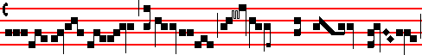
LET thy priests, O Lord, be clothed with right- eousness,

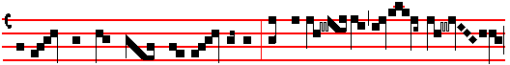
and let thy saints sing with joy- fulness: for thy ser- vant Da- vid’s sake,

104
Psalm ibid.
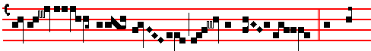
turn not a- way the pre- sence of thine A- noin- ted. Lord, re-
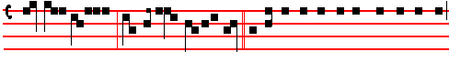
member David : and all his trou- ble. Glory be to the Father, and to the Son,
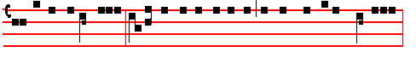
and to the Holy Ghost : as it was in the beginning, is now, and ever shall be :
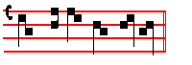
world without end. Amen. Repeat Let thy as far as the Psalm.

Kyrie and Gloria, pp. 49-51
COLLECT
GRANT, we beseech thee, almighty God: that the venerable solemnity of blessed Silvester, thy Confessor and Bishop, may increase our devotion and set forward our salvation. Through.

And Commoration is made of the Octave of the Nativity.
COLLECT
GRANT, we beseech thee, almighty, that we, who through our ancient bondage are held beneath the yoke of sin; may by the new Birth of thy only-begotten Son in the flesh obtain deliverance. Through the same.

And Commemoration is made of the Octave of S. Stephen.
COLLECT
GRANT us, we beseech thee, O Lord, so to imitate that which we revere : that we may learn to love even our enemies; forasmuch as we celebrate the burthday of him who knew how to pray even for his persecutors to our Lord Jesus Christ thy Son: Who liveth.

And Commemoration is made of the Octave of S. John.

105
COLLECT
O LORD, graciously illumine thy Church : that it, being enlightened by the doctrine of blessed John thy Apostle and Evangelist, may attain unto everlasting gifts. Through.

And Commemoration is made of the Octave of the Holy Innocents.
COLLECT
O ALMIGHTY God, whose praise the Innocents thy Martyrs did this day not by speaking but by dying confess: mortify all evil vices in us : that, as our thoughts confess thy faith, so our lives may by their actions set forth the same. Through.

The LESSON from the Epistle of blessed Paul the Apostle to Timothy (II., iv. I.)
DEARLY beloved: I charge thee before God, and the Lord Jesus Christ, who shall judge the quick and the dead at his appearing and his kingdom : preach the word, be instant in season, out of season: reprove, rebuke, exhort with all longsuffering and doctrine. For the time will come when they will not endure sound doctrine, but after their own lusts shall they heap up to themselves teachers, having itching ears, and they shall turn away their ears from the truth, and shall be turned unto fables. But watch thou in all things, endure afflictions, do the work of an Evangelist, make full proof of thy ministry. For I am now ready to be offered, and the time of my departure is at hand. I have fought a good fight, I have finished my course, I have kept the faith. Henceforth there is laid up for me a crown of righteousness, which the Lord, the righteous judge, shall give me at that day : and not to me only, but unto all them also that love his appearing.

GRADUAL. Ecclus. 44 Tone v
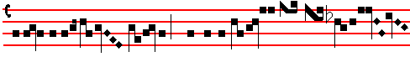
Behold, a great priest, who in his days
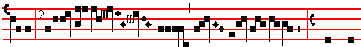
pleased God.  There was
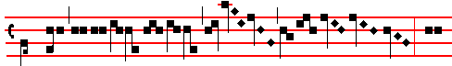
none like un- to him , who
106
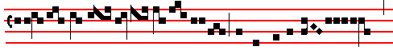
kept the law of the most
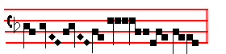
High. Tone viij
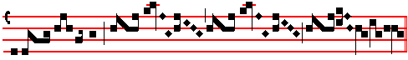
Alle- lu-ia. * ij,
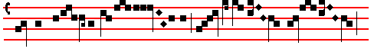
 I have found Da- vid my ser- vant :
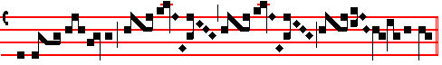
with my ho- ly oil have I a- noin- ted him.
(This , now missing from the Liber Usualis, is noted as in the Common.)
Repeat ij. Alleluia as above as far as the  .

¶ In Votive Masses after Septuagesima the Tract, and in Eastertide Alleluia with its Verses, from the Mass Statuit in the Common of a Confessor Bishop.

 The Continuation of the holy Gospel according to Luke (xij.35.)
AT that time : Jesus said unto his disciples: Let your loins be girded about, and your lights burning, and ye yourselves like unto men that wait for their lord, when he will return from the wedding : that when he cometh and knocketh, they may open unto him immediately. Blessed are those servants, whom the lord when he cometh shall find watching: verily I say unto you, that he shall gird himself, and make them to sit down to meat, and will come forth and serve them. And if he shall come in the second watch, or come in the third watch, and find them so, blessed are those servants. And this know, that if the goodman of the house had

107
known what hour the thief would come, he would have watched, and not suffered his house to be broken through. Be ye therefore ready also, for the Son of man cometh at an hour when ye think not. Creed, because of the Octave.

OFFERTORY . Psalm 89. Tone viij
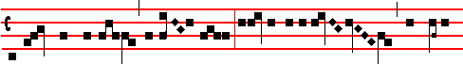
I have found David , my ser- vant, with my holy oil have I a-
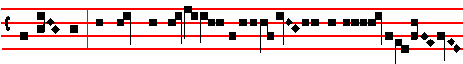
noin-ted him : my hand shall hold him fast
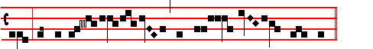
, and my arm shall streng- then him.

SECRET
WE beseech thee, O Lord, that we, remembering with gladness the merits of thy Saints, may in all places feel the succour of their intercession. Through.

For the Octave of the Nativity
SECRET
SANCTIFY, O Lord, by the new Birth of thine only-begotten Son, the gifts which we offer : and cleanse us from the defilements of our iniquities. (Through the same.)
For the Octave of S. Stephen
SECRET
ACCEPT, O Lord, these gifts for the commemoration of thy Saints: that like as their passion hath raised them to glory; so our devotion may lead us to innocency of life. .
For the Octave of S. John
SECRET
RECEIVE, O Lord, the gifts which we offer unto thee on the solemnity (commemoration) of him, in whose advocacy we trust for deliverance. Through.
For the Octave of the Holy Innocents.
SECRET

108
MAY the devout prayers of thy Saints never fail us, O Lord: that they may render our gifts acceptable unto thee, and ever obtain for us thy pardon. Through.
The Preface, and Sanctus of the Nativity; and Joining in communion and Agnus Dei thereof, pp. 57-60.
COMMUNION. Matthew 24. Tone iij 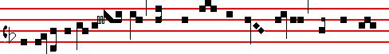 Blessed is the ser- vant, whom the lord when he cometh shall find wat-
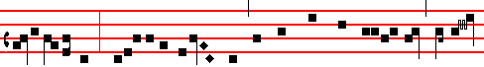
ching : verily I say unto you, he shall make him ru- ler o- ver
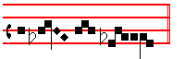
all his goods .
POSTCOMMUNION
GRANT, we beseech thee, almighty God : that we, shewing forth our thankfulness for the gifts which we have received, may, at the intercession of blessed Silvester, they Confessor and Bishop, obtain yet more abundant mercies. Through.
For the Octave of the Nativity.
POSTCOMMUNION
GRANT, we beseech thee, almighty God : that as he who was born this day the Saviour of the world is the author of our heavenly birth : so he may likewise bestow on us the gift of everlasting life : (Who liveth and reigneth with thee.)
For the Octave of S. Stephen.
POSTCOMMUNION
MAY the mysteries which we have received be for our help, O Lord: and at the intercession of blessed Stephen thy Martyr, may they establish us with thine everlasting protection. Through.
For the Octave of S. John.
POSTCOMMUNION
O GOD, who hast refreshed us with heavenly meat and drink, we humbly beseech thee : that we may be defended by the prayers of him, in whose memory we have received the same. Through.

109
For the Octave of the Holy Innocents.
POSTCOMMUNION
WE beseech thee, O Lord: that the gifts, which we have offered and received, may through the prayers of thy saints effectually avail for our succour both in this life and in that which is to come. Through

__________________________________________________________________

JANUARY 1
CIRCUMCISION OF OUR LORD AND OCTAVE OF THE NATIVITY
DOUBLE OF 2nd CLASS

Station at S. Mary beyond the Tiber.
INTROIT. Isaiah 9 Puer natus est Tone vij
UNTO us a child is born, unto us a son is gi- ven: & the govern-

ment shall be upon his shoul- der : and his name shall be
Psalm 98
called, Angel of migh- ty coun- sel.. O sing unto the Lord a
new song, for he hath done marvellous things.  Glory be to the Father, and to
the Son, and to the Holy Ghost. As it was in the beginning, is now, and ever shall

110
be : world without end. A- men. Repeat Unto us as far as the Psalm.

Kyrie and Gloria, pp. 49-51.
COLLECT
O GOD, who by the virgin child-bearing of blessed Mary hast bestowed upon mankind the rewards of eternal salvation: grant, we beseech thee: that we may perceive her intercession for us, through whom we have been counted worthy to receive the author of life, Jesus Christ thy Son, our Lord. Who liveth.

The LESSON from the Epistle of blessed Paul the Apostle to Titus (ij. 11)
DEARLY beloved: The grace of God that brongeth salvation hath appeared to all men, teaching us that, denying ungodliness and worldly lusts, we should live soberly, righteously, and godly, in this present world, looking for that blessed hope, and the glorious appearing of our great God and Saviour Jesus Christ : who gave himself for us, that he might redem us from all iniquity, and purify unto himself a peculiar people, zealous of good works. These things speak, and exhort: in Christ Jesus our Lord.

GRADUAL. Psalm 98. Tone v
All the ends of the earth have seen the sal-va- tion
of our God : O be joyful in God , all ye lands .  The Lord hath declared
111 his sal-va-
-tion : in the sight of the hea- then hath he o- pen-ly
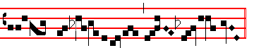
shewed his right- eous- ness Tone vij
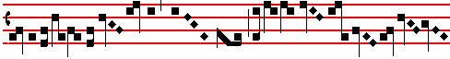
Al- le- lu- ia.* ij. 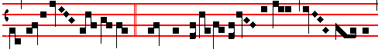  God, who at sun- dry times spake in time
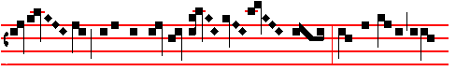
past unto the fathers by the Pro- phets, hath in these last
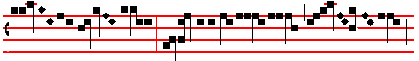
days spoken unto us.....................................................
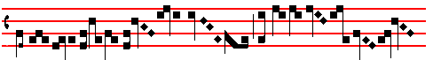 by his Son.........................................................................................................
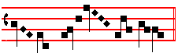
........................................................... Repeat alleluia up to the 

112
 The Continuation of the holy GOSPEL according to Luke (ij. 21)
AT that time: When eight days were accomplished for the circumcising of the Child: his name was called Jesus, which was so named of the Angel before he was conceived in the womb. Creed.

OFFERTORY. Psalm 93. Tone viij
God hath made the round world so sure, that it can-
not be moved : ever since the world began, hath
thy seat, O God, been prepared, thou art from e- ver- las- ting.
.
SECRET
WE beseech thee, O Lord, to accept our prayers and oblations: and graciously hearken unto us, whom thou dost cleanse by thy heavenly mysteries. Through.

Preface and Joining in communion of the Nativity, p. 37.

COMMUNION Zech. 9 Tone iv
Re- joice greatly, O daughter of Zi-on, shout, O daughter of Je- ru- sa- lem :
behold, thy King co- meth, the holy one and the Sav- iour of the world.
.
POSTCOMMUNION

113
MAY this communion, O Lord, cleanse us from guilt: and at the intercession of blessed Mary the Virgin Mother of God, make us partakers of thy heavenly healing. Through the same.
__________________________________________________________________

JANUARY 2
OCTAVE DAY OF S. STEPHEN THE FIRST MARTYR
DOUBLE

The Mass Sederunt, as on the Feast, p. 70, except the Collect, as follows: the Commemoration of the Nativity is omitted, however, and only its Preface is taken, p. 57, because of the Season; and the Creed is not said.

COLLECT
ALMIGHTY and everlasting God, who, in the blood of the blessed Levite Stephen, didst consecrate the first-fruits of the Martyrs: grant, we beseech thee; that he may ever intercede for us, who prayed even for his persecutors to our Lord Jesus Christ, thy Son: Who with thee liveth.

Secret and Postcommunion of the Feast..
__________________________________________________________________

JANUARY 3
OCTAVE DAY OF S. JOHN, APOSTLE AND EVANGELIST
DOUBLE
The Mass In Medio, as on the Feast, p.77, the commemoration of the Nativity and the Creed being omitted. Preface of the Apostles.

¶ If a Commemoration only is made of the Octave, the prayers will be of the Feast.
If the Postcommunion of this Mass shall have already been said for some other Saint, the Psotcommunion for S. John shall be that of his Feast before the Latin gate, May 6.
__________________________________________________________________

JANUARY 4
OCTAVE DAY OF THE HOLY INNOCENTS
DOUBLE
The Mass Ex ore is said as on the feast, p.84, except that Gloria in excelsis, Alleluia and Ite, Missa est are said. The commemoration of the Nativity and the Creed are omitted. Preface of the Nativity on account of the Season, p. 57..
If a Commemoration only is made of the Octave, the Prayers will be of the Feast.

114
January 5
The Vigil of the Epiphany
Semidouble

The Mass Dum medium, p. 91, except:

Commemoration of S. Telesphorus, Pope and martyr.

COLLECT
O GOD, who makest us glad with the yearly solemnity of blessed Telesphorus thy Martyr and Bishop: mercifully grant; that as we now celebrate his birthday, so we may likewise rejoice in his protection. Through.
Of S. Mary
COLLECT
O GOD, who by the virgin child-bearing of blessed Mary hast bestowed upon mankind the rewards of eternal salvation: grant, we beseech thee, that we may perceive her intercession for us, through whom we have been counted woorthy to receive the author of life, Jesus Christ hy Son our Lord. (Who liveth and reigneth with thee.)

The Lesson from the Epistle of blessed Paul the Apstle to the Galatians (iv.1.)
BRETHREN: The heir, as long as he is a child, differeth nothing from a servant, though he be lord of all: but is under tutors and governors, until the time appointed of the father: even so we, when we were children, were in bondage under the elements of the world.But when the fullness of the time was come, God sent forth his Son, made of a woman, made under the law, to redeem them that wwre under the law, that we might receive the adoption of sons. And because ye are sons, God hath sent forth the Spirit of his Son into your hearts, crying: Abba, Father. Wherefore, thou art no more a servant, but a son: and if a son, then an heir of God through Christ.

GRADUAL Psalm 45, p. 93.

 The Continuation of the holy GOSPEL according to Matthew (ij. 19.)
AT that time: When Herod was dead, behold, an Angel appeareth in a dream to Joseph in Egypt saying: Arise, and take the young Child and his Mother, and go into the land of Israel: for they are dead which sought the young Child’s life. And he arose, and took the young Child and his Mother, and came intot heland of Israel. But when he heard that Archelaus did reign in Judæa in the room of his father Herod, he was afraid to go thither: notwithstanding, being warned of God in a dream, he turned aside into the parts of Galilee. And he came and dwelt in a city

115

called Nazareth: that it might be fulfilled which was spoken by the Prophets: He shall be called a Nazarene. Creed, which is said even if the Vigil is only commemorated.

OFFERTORY. Psalm 93, p. 95.

For S. Telesphorus
SECRET
WE beseech thee, O Lord, graciously enlighten thy Church by the gifts we offer : that in every place thy flock may increase and prosper, and the shepherds by thy governance may be made pleasing to thy name. (Through)
Of S. Mary
SECRET
THROUGH thy mercy, O Lord, and the intercession of blessed Mary ever Virgin, may this oblation avail for our prosperity and peace both now and for ever. (Through.)

Preface of the Nativity, p. 57.

COMMUNION. Matthew 2, p. 96.

For S. Telesphorus
POSTCOMMUNION
WE beseech thee, O Lord, mercifully to govern thy Church, which thou hast refreshed with holy food: that it being guided by thy mighty power, may obtain an increase of freedom, and continue steadfast in purity of faith. Through.
Of S. Mary
POSTCOMMUNION
MAY this communion, O Lord, cleanse us from guilt: and, at the intercession of blessed Mary the Virgin Mother of God, make us partakers of thy heavenly healing. (Through the same.) .
__________________________________________________________________

The same day, January 5
S. Telesphorus, Pope, M.

The Mass Sacerdotes Dei, from the Common of one Martyr in the 2nd place.
__________________________________________________________________

116

