ENGLISH ORTHODOX MISSAL

THE PROPER OF THE SEASON

PART ONE

ADVENT

Noted as in the Liber Usualis, 1952

ENGLISH ORTHODOX MISSAL
THE PROPER OF THE SEASON
_____________________________________________

The first Sunday in Advent
FIRST CLASS SEMIDOUBLE
Station at S. Mary Major.
INTROIT. Psalm 25. Ad te levavi Tone viij
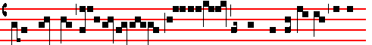
UNTO thee lift I up my soul: my God, in thee have I trusted, let me

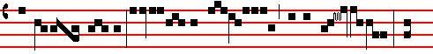
not be con- founded: nei- ther let mine enemies triumph o- ver me : for
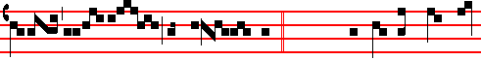
all they that look for thee shall not be ashamed. Ps. ibid. Shew me thy ways, O
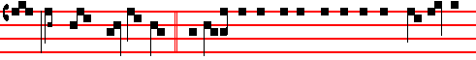
Lord: and teach me thy paths. Glory be to the Father, and to the Son, and to the
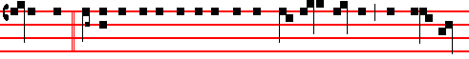
Holy Ghost. As it was in the beginning, is now, and ever shall be, world without
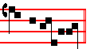
end. A- men. Repeat Unto thee as far as the Psalm.

This manner of repeating the Introit is observed throughout the year.

3
For the Sundays of Advent and Lent Tone j
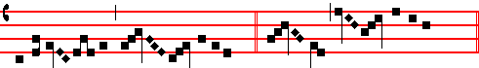
Ky-ri-e e- le-i-son iij Chris- te e- le-i-son iij
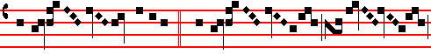
Ky-ri- e e- le-i-son ij Ky -ri-e *
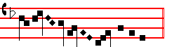
** e- le-i-son.
¶ Gloria in excelsis is not said in Masses of the Season from this Sunday up to the Vigil of the Nativity of the Lord, inclusive.
Let us pray.
COLLECT
STIR up, we beseech thee, O Lord, thy power and come: that by thy protection we may be found worthy to be set free from the dangers of our sins which beset us, and to be saved by thy deliverance: Who livest and reignest with God the Father in the unity of the Holy Ghost, God: throughout all ages, world without end. Amen.
From this day up to the 23rd December inclusive, when they are to be said according to the Rubrics, the Collects assigned for the different seasons, even within octaves or on vigils, will be the following, excepting nevertheless the 2nd Collect, which in Masses of the B. V .M., or those in which she is commemorated, also in a Votive Mass of All Saints, is of the Holy Spirit.
2nd of St. Mary
COLLECT
O GOD, who wast pleased that thy Word should take flesh of the womb of the blessed Virgin Mary at the message of an Angel: grant to thy humble servants; that we, who believe her to be truly the Mother of God, may be aided by her intercession in thy sight. (Through the same.)

Or on her Feasts, 2nd of the Holy Spirit.
COLLECT
GOD, who didst teach the hearts of thy faithful people, by the sending to them
the light of thy Holy Spirit : grant us by the same Spirit to have a right

4
judgment in all things; and evermore to rejoice in his holy comfort. (Through. . . in the unity of the same Holy Spirit.)

3rd against the persecutors of the Church
COLLECT
WE beseech thee, O Lord, mercifully to hear the prayers of thy Church: that all adversities and errors being done away, she may serve thee in freedom and quietness. Through.

Or 3rd , for the Chief Bishop
COLLECT
O GOD, the pastor and ruler of all the faithful, mercifully look upon thy servant N., whom thou hast been pleased to set as pastor over thy Church: grant him, we beseech thee, to be in word and conversation a wholesome example to the people committed to his charge; that he with them may attain unto everlasting life. Through.

The LESSON from the Epistle of blessed Paul the Apostle to the Romans (xiij. 8.)
BRETHREN: Knowing that now it is high time for us to wake out of sleep, For now is our salvation nearer than when we beieved. The night is far spent, the day is at hand. Let us therefore cast off the works of darkness, and let us put on the armour of light. Let us walk honestly as in the day: not in rioting and drunkenness, not in chambering and wantonness, not in strife and envying: but put ye on the Lord Jesus Christ.

GRADUAL. Psalm 25. Universi Tone j.
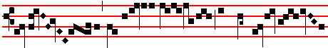
All they that look for thee shall not be a- shamed, O
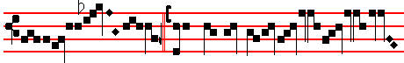
Lord.  Shew me thy ways
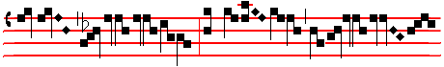
, O Lord:

5
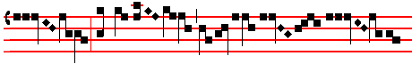
: and teach me
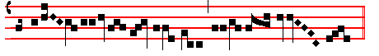
thy paths Tone 8 .
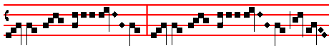
Al- le- lu- ia, * al- le- lu- ia
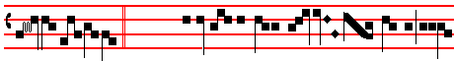
 Psalm 85. Shew us thy mer- cy, O
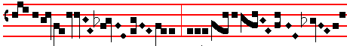
Lord , and grant
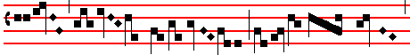
us thy
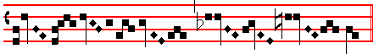
sal- va- tion.
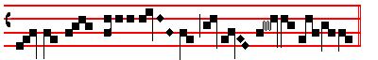
Al- le- lu- ia .
On Ferias in Advent, when during the week the Sunday Mass is resumed, Alleluia is not said nor the following Verse, but only the Gradual.

6
 The Continuation of the holy GOSPEL according to Luke (xxi. 25.)
AT that time : Jesus said unto his disciples: There shall be signs in the sun, and in the moon, and in the stars, and upon the earth distress of nations, with perplexity, the sea and the waves roaring: men's hearts failing them for fear, and for looking after those things which are coming on the earth: for the powers of heaven shall be shaken. And then shall they see the Son of man coming in a cloud with power and great glory. And when these things begin to come to pass, then look up, and lift up your heads: for our redemption draweth nigh. nd he spake to them a arable: Behold the fig-tree. nd all the trees: when they now shoot forth, ye see and know of your own selves that summer is now nigh at hand. So likewise ye, when ye see these things come to pass, know ye that the kingdom of God is nigh at hand. Verily I say unto you, This generation shall not pass away, till all be fulfilled. Heaven and earth shall pass away: but my words shall not pass away.

The Creed, which is said on all Sundays throughout the year, whether occurring or anticipated or even, as regards the Office, postponed. But it is not said on ferial days, when the Mass of the preceding Sunday is resumed.

Creed. Authentic Tone iv
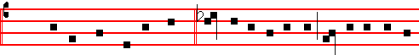
 I be- lieve in one God  The Father al-mighty, maker of heaven
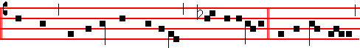
and earth, and of all thngs vi-si-ble and i nvi-sib-le. And in one Lord
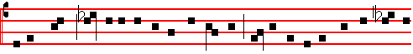
Jesus Christ , the only-be-got-ten Son of God, Begot- ten of his Father before
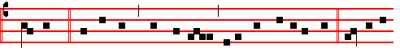
all worlds, God of God, Light of Light , very God of very God, Be-gotten,

7
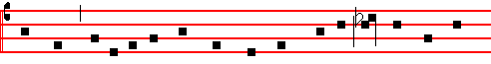
not made, Being of one substance with the Father: by whom all things
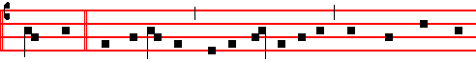
were made. Who for us men, and for our salvation, came down from hea-
here all kneel
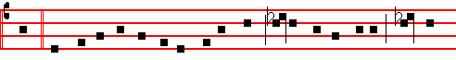
ven, and was in-carnate by the Holy Ghost of the Virgin Mary: and was
and rise
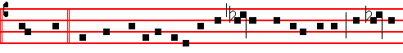
made man. And was crucified al-so for us under Pon-ti-us Pilate: he suf-fer
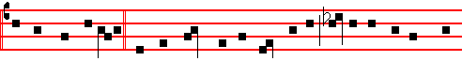
-ed, and was buri-ed. And the third day he rose again, according to the scrip-
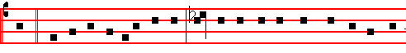
tures. And ascend-ed into heaven: And sitteth on the right hand of the Fa-
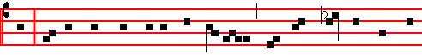
ther. And he shall come again with glo- ry, to judge both the quick and
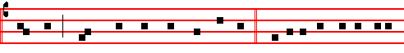
the dead : Whose kingdom shall have no end. And I believe in the Holy

8
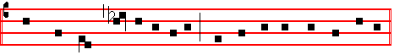
Ghost, the Lord, and Giver of life: Who procee- deth from the Father :

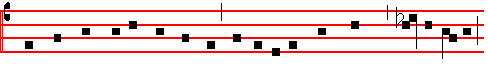 Who with the Father and the Son to-ge-ther is worshipped and glori-fied:
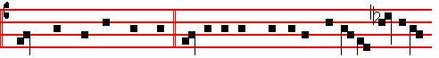
Who spake by the Prophets. And I believe one holy, catholick and apo-
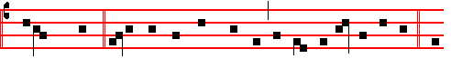
stolick Church. I acknowledge one Baptism for the remis-sion of sins. And
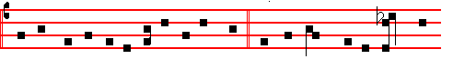
I look for the resur-rection of the dead, and the life  of the world to
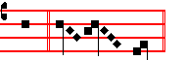
come. A- men.

OFFERTORY. Psalm 25. Ad te Domine Tone ij
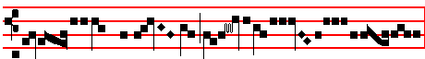
Unto thee lift I up my soul
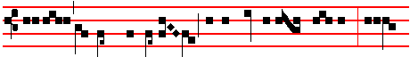
my God in thee have I trusted, let me not be con- founded: nei-

9
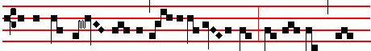
ther let mine e- nemies triumph o- ver me: for all they that
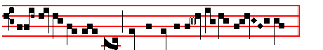
look for thee shall not be asha- med.

SECRET
MAY these sacred mysteries, O Lord, so cleanse us by their.mighty power, that growing In purity, we may attain unto thee who art the author of the same. Through.

2nd of St. Mary.
SECRET.
WE beseech thee, 0 Lord, stablish in our hearts the mysteries of thy true religion: that, as we believe thy Son, conceived of a Virgin, to be very God and very man; so by the power of his life-giving resurrection we may be found worthy to attain unto everlasting felicity. Through the same.

Or on her Feasts, of the Holy Spirit
SECRET
SANCTIFY, we beseech thee, O Lord, the gifts which we offer: and cleanse our hearts by the enlightening of the Holy Spirit. (Through. . . in the unity of the same Holy Spirit.)

3rd against the persecutors of the Church.
SECRET.

DEFEND us, O Lord, who wait upon thy mysteries: that we cleaving fast to things heavenly, may serve thee both in body and soul. Through.

Or 3rd, for the Chief Bishop.
SECRET
LOOK favourably, we beseech thee, O Lord, upon the gifts which we offer: and guide with thy continual protection thy servant N., whom thou hast been pleased to set as pastor over thy Church. Through.

The Preface of the most Holy Trinity: which is said on Sundays, even anticipated

10
on Saturday, if they have no proper Preface according to the Rubrics; but not on Ferias, when the Sunday Mass is resumed, for then is said the Common Preface, unless any commemoration is to be made which requires a proper Preface according to the Rubrics. In Masses of the Advent Season, however, the Preface of the B.V. Mary is never said.

Solemn Preface Sanctus on Sundays in Advent Tone v 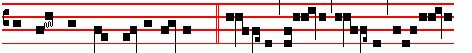
with suppliant thanksgiving saying:  Ho- ly, Ho- ly, Ho- ly, Lord God
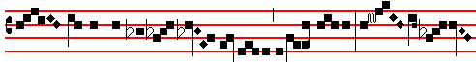
of Hosts. Heaven and earth are full of thy glory. Ho- sanna
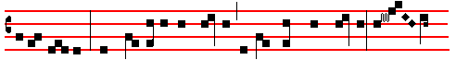
in the highest. Blessed is he that cometh in the name of the Lord. Ho- san-
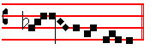
na in the highest.

Agnus Dei on Sundays in Advent Tone v
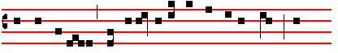
O Lamb of God, that takest away the sins of the world: have
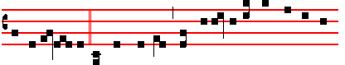
mercy up-on us. O Lamb of God, that takest away the sins of the

11
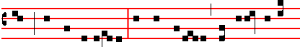
world : have mercy upon us. O Lamb of God, that takest away

the sins of the world : grant us peace.

COMMUNION. Psalm 8. Dominus dabit Tone j.
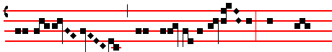
The Lord shall shew loving-kind- ness: and our
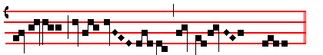
land shall give her in- crease.

POSTCOMMUNION.
GRANT, O Lord, that we may so wait for thy loving-kindness in the midst of thy temple: that we mav with worthy reverence prevent the coming festival of our redemption. Through.
2nd of St. Mary.
POSTCOMMUNION.
WE beseech thee, O Lord, pour thy grace into our hearts: that, as we have known the incarnation of thy Son Christ by the message of an Angel; so by his cross and passion we may be brought unto the glory of his resurrection. (Through the same.)

Or on her Feasts, 2nd of the Holy Spirit
POSTCOMMUNION
POUR thy Holy Spirit upon us, O Lord, and cleanse our hearts: that they may be made fruitful by the inward sprinkling of his dew. (Through . . . in the unity of the same Holy Spirit.)

3rd against the perseutors of the Church.

12
POSTCOMMUNION.
WE beseech thee, O Lord our God: that we, whom thou makest to rejoice in the partaking of heavenly things, may by thee be defended against all earthly perils. Through.

Or 3rd , for the Chief Bishop.
POSTCOMMUNION.
WE beseech thee, O Lord, that the divine sacrament which we have here received may be our protection: and together with the flock entrusted to his charge ever save and defend thy servant N., whom thou hast been pleased to set as pastor over thy Church. Through.

Let us bless the Lord is said. And so always when Glory be to God is not said: otherwise Ite, Missa est is said.

¶ Throughout the year, if the Mass of the Feria is to be said during the week, the Mass of the preceding Sunday is resumed, unless there be a proper Mass.
For chants of the Ordinary, see Ember Wednesday below.
And in the same way, the Sunday Collects are taken, when according to the Rubrics a commemoration is to be made of a Feria which has not a proper Mass.

¶ When in the seasons of Advent, of Lent, from Ash Wednesday up to Saturday after Passion Sunday inclusive, on Ember Days, Vigils, and the greater and lesser
Litanies, Mass is said of any Pestival, or a Votive Mass, a commemoration of the Feria is always made, outside the conventual or sung Mass: which is also done in conventual and sung Masses unless another Mass also conventual or sung is said of the Feria. The same rule is observed on all Vigils: excepting when on a Common Vigil, a Double of the 1st class is kept, or when a Votive Mass is celebrated for a grave or public cause, because then there is no commemmoration of the same Vigil.
__________________________________________________________________

Second Sunday of Advent
2ND CLASS SEMIDOUBLE
Station at Holy Cross in Jerusalem
INTROIT. Isaiah. 30 Populus Sion. Tone vij
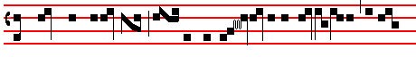
O PEOPLE of Si-on, be- hold the Lord is nigh at hand to re-

13
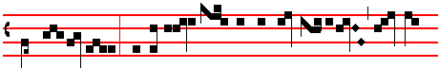
deem the na- tions: and in the glad- ness of your heart the Lord
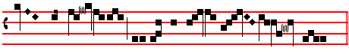
shall cause his glorious voice to be heard..
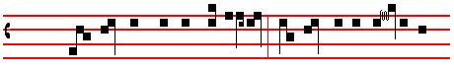
Psalm 79. Hear, O thou Shepherd of Is-rael: thou that leadest Jo- seph like
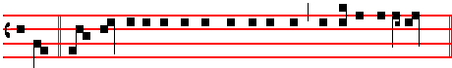
a sheep. Glo- ry be to the Father, and to the Son, and to the Holy Ghost:
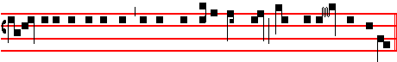
as it was in the beginning, is now, and ever shall be: world without end. Amen.

Repeat O people up to the Psalm. Kyrie as above, p. 4.

COLLECT
STIR up our hearts, O Lord, to prepare the ways of thine only-begotten Son: that through his advent we may be worthy to serve thee with pure minds: Who liveth.

Other Collects as on the 1st Sunday, pp. 4-5.

The LESSON from the Epistle of blessed Paul the Apostle to the Romans. (xv.4.)
BRETHREN: Whatsoever things were written aforetime, were written for our learning: that we through patience, and comfort of the Scriptures, might have hope. Now the God of patience and consolation grant you to be like-minded one towards another according to Christ Jesus: that ye may with one mind and one

14
mouth glorify God, even the Father of our Lord Jesus Christ. Wherefore receive ye one another, as Christ also received us, to the glory of God. Now I say, that Jesus Christ was a minister of the circumcision for the truth of God to confirm the promises made unto the fathers: and that the Gentiles might glorify God for his mercy, as it is written: For this cause I will confess to thee among the Gentiles, and sing unto thy name. And again he saith: Rejoice, ye Gentiles, with his people. And again: Praise the Lord, all ye Gentiles: and laud him, all ye people. And again, Esaias saith: There shall be a root of Jesse, and he that shall rise to reign over the gentiles, in him shall the Gentiles trust. Now the God of hope fill you with all joy and peace in believing: that ye may abound in hope, through the power of the Holy Ghost.

GRADUAL. Psalm 50. Ex Sion Tone v
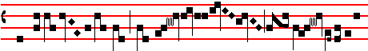
Out of Si- on hath God ap- peared
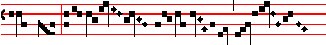
: in per fect beau-
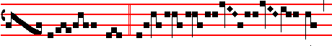
ty.  Ga- ther
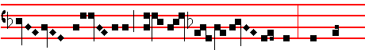
my saints unto me , those that
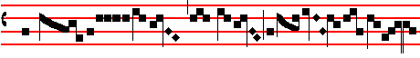
have made
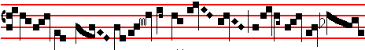
a co- ve- nant with me with sac- ri- fice....

15
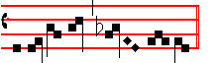The following Alleluia with the Verse is said
................................................. on Sunday only, on Ferias it is omitted. Tone j.
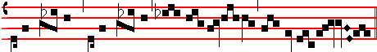
Alle- lu- ia, * alle- lu- ia ...........................................................................
 Psalm 122.
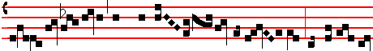
I was glad when they said unto me: we will
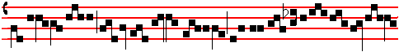
go into the house
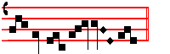

of the Lord. Repeat Alleluia from the *

 The Continuation of the holy GOSPEL according to Matthew ( xj. 2)
AT that time: When John had heard in the prison the works of Christ, he sent two of his disciples, and said unto him: Art thou he that should come, or do we look for another? Jesus answered and said unto them: Go and shew John those things which ye do hear and see. The blind receive their sight, and the lame walk, the lepers are cleansed, and the deaf hear, the dead are raised up, and the poor have the Gospel preached to them: and blessed is he whosoever shall not be offended in me. And as they departed, Jesus began to say unto the multitudes concerning John: What went ye out into the wilderness to see? A reed shaken by the wind? But what went ye out for to see? A man clothed in soft raiment? Behold they that wear soft clothing are in kings’ houses. But what went ye out for to see? a prophet? Yea, I say unto you, and more than a prophet. For this is he of whom it is written: Behold I send my messenger before thy face, which shall prepare thy way before thee. Creed.

16
OFFERTORY. Psalm 85. Deus tu convertens Tone Iij
.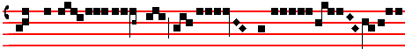
Wilt not thou turn a- gain, O God , and quick- en us
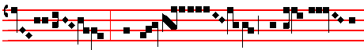
? That thy peo- ple may re- joice
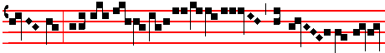
in thee: shew us thy mer- cy, O
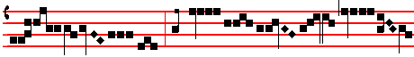
Lord , and grant us thy sal-
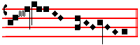
va- tion.
SECRET
WE beseech thee, O Lord, mercifully to accept the prayers and sacrifices of thy humble servants: that we, who cannot of our own prayers and merits help ourselves, may be defended by thy succour. Through.
Other secrets as above, p. 8..
Preface of the Most Holy Trinity. Sanctus and Agnus Dei as above, p. 11
COMMUNION Baruch 5, 4. Jerusalem surge Tone ij
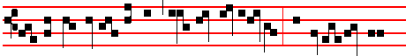
A- rise, O Jeru- salem, and stand on high, and behold the
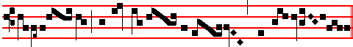
joy that cometh un- to thee from thy God .

17
POSTCOMMUNION
O LORD, who hast satisfied us with spiritual food and sustenance, we humbly beseech thee: that through the partaking of this mystery, we may learn to despise things earthly, and to love the things that are heavenly. Through.

Other Postcommunions as above, pp. 12-13.

The Third Sunday of Advent.

2ND CLASS. SEMIDOUBLE.

Station at S. Peter

INTROIT. Phil. 4. Gaudete Tone j.
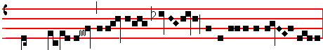
RE- JOICE in the Lord al- way: and again I say re- joice.

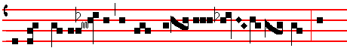
Let your modera- tion be known unto all men: for
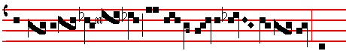
the Lord is at hand. Be careful for no- thing: but
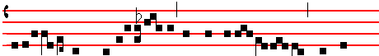
in all things by pray- er let your requests be made
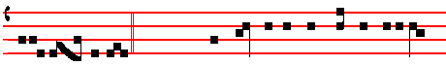
known un- to God. Psalm 85. Lord, thou art become gracious unto thy

18
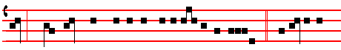
land * thou hast turned away the captivity of Ja-cob.  Glory be to
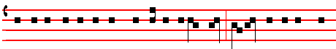
the Father, and to the Son : and to the Holy Ghost. As it was in the be-

ginning, is now, and ever shall be : world without end. Amen. Repeat Rejoice
up to the Psalm.
Kyrie, eleison as above, p. 2
COLLECT
INCLINE thine ear to our prayers, we beseech thee, O Lord: and by the grace of thy visitation enlighten the darkness of our minds: who livest.

Other Collects as on Ist Sunday of Advent, pp. 4-5.

The LESSON from the Epistle of blessed Paul the Apostle to the Philippians
(iv. 4)
BRETHREN: Refoice in the Lord alway: and again I say, rejoice. Let your moderation be known unto all men: the Lord is at hand. Be careful for nothiong: but in everything by prayer and supplication with thanksgiving, let your requests be made known unto God. And the peace of God, which passeth all understanding keep your hearts and minds in Christ Jesus our Lord.

GRADUAL. Psalm 80. Qui sedes Tone vij
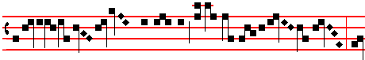
O Lord, thou that sittest upon the Cherubim , stir
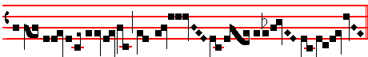
up thy strength and come .
19
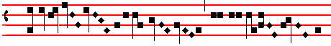
 Hear , O thou Shep-
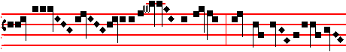
herd of Is- ra-el : thou that lea-
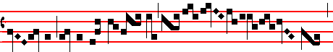
dest Joseph like a sheep
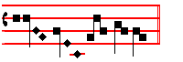¶ The following Alleluia with the Verse is said .......................................... on Sunday only, on Ferias it is omitted. Tone iv
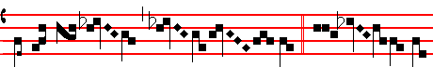
Al- le- lu- ia. * ij.  Stir up thy
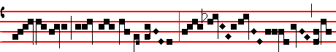
strength, O Lord , and come
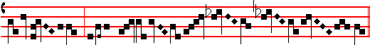
and help us..................................................
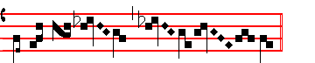
Al- le- lu- ia...........................................................

20
 The Continuation of the holy GOSPEL according to John. (j. 19)
AT that time: The Jews sent priests and levites from Jerusalem to John to ask him: Who art thou? And he confessed, and denied not; but confessed: I am not the Christ. And they asked him: What then? Art thou Elias? And he saith: I am not.Art thou that Prophet? And he answered: No. Then said they unto him: Who art thou, that we may give an answer to them that sent us? What sayest thou of thyself? He said: I am the voice of one crying in the wilderness: Make straight the way of the Lord, as said the Prophet Esaias. And they which were sent were of the Pharisees. And they asked him, and said unto him: Why baptizest thou then, if thou be not that Christ, nor Elias, neither that Prophet? John answered them, sayting: I baptize with water: but there standeth one among you, whom ye know not. He it is who coming after me is preferred before me: whose shoe’s latchet I am not worthy to unloose. These things were done in Bethabara beyond Jordan, where John was baptizing. Creed.

OFFERTORY. Psalm 85 Benedixisti Tone iv
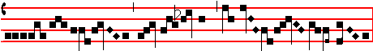
O Lord thou art become gracious unto thy land :
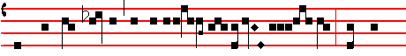
thou hast turned away the captivi-ty of Ja- cob : thou hast
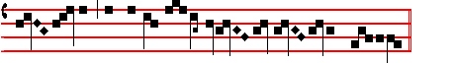
for- giv-en the offence of thy peo- ple.

SECRET
WE beseech thee, O Lord, that the continual offering of this sacrifice of our devotion may fulfil thine institution of this sacred mystery: and may accomplish in us the wondrous work of thy salvation. Through.

Other Secrets, as above, p. 10. Preface of the Most Holy Trinity. Sanctus and Agnus Dei as above, p. 11.

COMMUNION. Isaiah 35 Dicite Tone vij

21
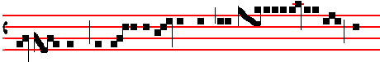
Say*to them that are of a fearful heart: be strong and
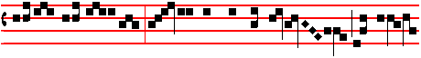
fear not : be- hold our God will come and save
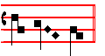
................... us.
POSTCOMMUNION
WE entreat, O Lord, thy mercy: that these means of heavenly gracve may so clelanse us from our sins, thet we may be made ready for thy coming festival. Through.
Other Postcommunions as above., pp. 12-13.

Ember Wednesday in Advent
Station at S. Mary Major
INTROIT. Isaiah 45 Rorate. *
DROP down, ye heavens, from above, and let the skies pour down justice: let the earth open, and bring forth a Saviour. Psalm 19 The heavens declare the glory of God: and the firmament sheweth his handywork.  Glory.

Kyrie, eleison as below on Saturday, p. 25. After which is said immediately: Let us pray. Let us bow the knee.  Arise.

COLLECT
GRANT, we beseech thee, almighty God: that coming solemnity of our redemption may bestow on us thy succour in the present life, and win for us the rewards of everlasting blessedness. Through.

The Lesson from the Prophet Isaiah (ij. 2.)
IN those days: Said Isaiah the Prophet: It shall come to pass in the last days, that the mountain of the Lord’s house shall be established in the top of the mountains, and shall be exalted above the hills, and all nations shall flow into it.
__________________________________________________________________
- Wednesday. & Friday not given in Liber Usualis; but some proper chants are available on A4 sheets

22
And many people shall go and say: Come ye, and let us go up to the mountain of the Lord, to the house of the God of Jacob, and he will teach us of his ways, and we will walk in his paths: for out of Zion shall go forth the law, and the word of the Lord from Jerusalem. And he shall judge among the nations, and shall rebuke many people: and they shall beat their swords into plowshares, and their spears into pruning-hooks. Nation shall not lift up sword against nation: neither shall they learn war any more. O house of Jacob, come ye, and let us walk in the light of the Lord our God.

GRADUAL. Psalm 24. Lift up your heads, O ye gates: and be ye lift up, ye everlasting doors: and the King of glory shall come in.  Who shall ascend into the hill of the Lord? Or who shall rise up in his holy place? Even he that hath clean hands and a pure heart.

Here is said  The Lord be with you, without Let us bow the knee
Let us pray
COLLECT
O LORD, make haste, we pray thee, and delay not to bestow upon us the assistance of thy heavenly might: that they who put their confidence in thy mercy may be succoured by the consolations of thine advent: Who livest and reignest.

Other Collects as on the 1st Sunday in Advent, pp. 2-3.

The LESSON from the Prophet Isaiah (vij. 10.)
IN those days: The Lord spake unto Ahaz, saying: Ask thee a sign of the Lord thy God, ask it either in the depth, or in the height above. But Ahaz said: I will not ask, neither will I tempt the Lord. And he said: Hear ye now, O house of David: Is it a small thing for you to weary men, but will ye weary my God also? Therefore, the Lord himself will give you a sign. Behold, a Virgin shall conceive, and bear a son, and shall call his name Immanuel. Butter and honey shall he eat, that he may know to refuse the evil, and choose the good.

GRADUAL. Psalm 145. The Lord is nigh unto all them that call upon him: yea all such as call upon him faithfully.  My mouth shall speak the praise of the Lord: and let all flesh give thanks unto his holy name.

 The Continuation of the holy GOSPEL according to Luke. (j. 26)
AT that time: The Angel Gabriel was sent from God unto a city of Galilee, named Nazareth, to a Virgin espoused to a man whose name was Joseph, of the house of David, and the Virgin’s name was Mary. And the Angel came in unto

23
her, and saod: Hail, thou that art highly favoured, the Lord is with htee: blessed art thou among women. And when she saw him, she was troubled at his saying:and cast in her mind what manner of salutation this should be.. And the Angel said unto her: Fear not, Marty, for thou hast found favour with God: and, behold, thou shalt conceive in thy womb, and bring forth a son, and shalt call his name JESUS. He shall be great, and shall be called the Son of the Highest, and the Lord God shall give unto him the throne of his father David: and he shall reign over the house of Jacob for ever, and of his kingdon there shall be no end. Then said Mary unto the Angel: How shall this be, seeing I know not a man? And the Angel answered and said unto her: The Holy Ghost shall come upon thee, and the power of the Highest shall overshadow thee. Therefore also that Holy Thing which shall be born of thee shall be called the Son of God. And, behold, thy cousin Elisabeth, she hath also conceived a son in her old age: and this is the sixth month wit5h her, who was called barren: for with God nothing shall be impossible. And Mary said: Behold the handmaid of the Lord, be it unto me according to thy word.

OFFERTORY. Isaiah 35. Be strong, fear not: behold, our God shall come with vengeance, even Gid with a recompence: he will come and save us.

SECRET
WE beseech thee, O Lord, that these our fasts may be acceptable in thy sight: that we, being cleansed thereby and made worthy of thy grace, may be brought unto thine everlasting promises. Through.

Other Secrets, as above, p. 10. Preface of the Most Holy Trinity. Sanctus and Agnus Dei as below on Saturday

COMMUNION. Isaiah 7. Behold, a Virgin shall conceive and bear a son: and shall call his name Immanuel.

POSTCOMMUNION
O LORD, who hast satisfied us with the gift of thy salvatio, we humbly beseech thee: that as we joyfully taste thereof, so we may effectually be renewed by the same. Through.

Other Postcommunions as above., pp. 12-13.

Ember Friday in Advent
Station at the twelve Holy Apostles.

INTROIT. Psalm 119. Prope es tu.
BE thou nigh at hand, O Lord, for all thy commendments are true: as concerning thy testimonies, I have known long since, that thou art from

24
everlasting. Psalm ibid. Blessed are those that are undefiled in the way: and walk in the law of the Lord.  Glory.

Kyrie, eleison as below on Saturday, p. 27.

COLLECT
STIR up, we beseech thee, O Lord, thy power, and come among us: that they who put their confidence in thy goodness may speedily be delivered from all adversity: Who livest.

Other Collects as on the 1st Sunday in Advent, pp. 2-3.

The LESSON from the Prophet Isaiah (xj. 1.)
THUS saith the Lord God: There shall come forth a rod out of the stem of Jesse, and a Branch shall grow out of his roots. And the spirit of the Lord shall rest upon him : the spiirit of wisdom and understanding, the spirit of counsel and might, the spirit of knowledge and of the fear of the Lord; and shall make him of quick understanding in the fear of the Lord. And he shall not judge after the sight of his eyes: neither reprove after the hearing of his ears: but with righteousness shall he judge the poor, and reprove with equity for the meek of the earth: and he shall smite the earth with the rod of his mouth, and with the breath of his lips shall he slay the wicked. And righteousness shall be the girdle of his loins: and faithfulness the girdle of his reins.

GRADUAL. Psalm 85. Shew us thy mercy, O Lord: and granr us thy salvation.  Lord, thou art become gracious unto thy land: thou hast turned away the captivity of Jacob.

 The Continuation of the holy GOSPEL according to Luke (j. 39.)
AT that time:Mary arose, and went into the hill country with haste, into a city of Juda: and entered into the house of Zacharias, and saluted Elisabeth. And it came to pass, that, when Elisabeth heard the salutation of Mary, the babe leaped in her womb: and Elisabeth was filled with the Holy Ghost, and she spake out with a loud voice, and said: Blessed art thou among women, and blessed is the fruit of thy womb. And whence is this to me, that the Mother of my Lord should come unto me? For, lo, as soon as the voice of thy salutation sounded in mine ears, the babe leaped in my womb for joy. And blessed is she that believed, for there shall be a performance of those things that were told her from the Lord. And Mary said: My soul doth magnify the Lord: and my spirit hath rejoiced in God my Saviour.

25
OFFERTORY. Psalm 85. Wilt thou not turn again, O God, and quicken us, that thy people may rejoice in thee: shew us thy mercy, O Lord, and grant us thy salvation.
SECRET
WE beseech thee, O Lord, to accept our prayers and oblations: and graciously hearken unto us, whom thou dost cleanse by thy heavenly mysteries. Through.

Other Secrets, as above, p. 10. Preface of the Most Holy Trinity. Sanctus and Agnus Dei as below on Saturday

COMMUNION. Zech. 14. Behold, the Lord, the Lord shall come, and all his sasints with him: and in that day there shall be a great light.

POSTCOMMUNION
MAY the holy.partaking of thy sacrament, O Lord, in such wise restore us: that we, being cleansed from our former nature, may enter into the fellowship of this saving mystery. Through.

Other Postcommunions as above, pp. 12-13.

Ember Saturday in Advent

Station at S. Peter.
INTROIT. Psalm 80. Veni et ostende. Tone ij
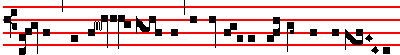
COME and shew us the light of thy countenance, O Lord ,


that sit- test upon the Cherubim: and we shall be whole . Psalm ibid.
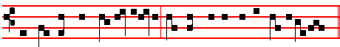
Hear, O thou Shepherd of Is-ra-el: thou that leadest Joseph like a sheep.

26
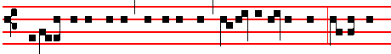
 Glory be to the Father, and to the Son: and to the Holy Ghost: As it was
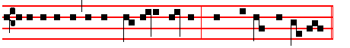
in the beginning, is now, and ever shall be : world without end. Amen.

Repeat Come up to the Psalm..

Kyrie Deus Genitor Alme Tone iv
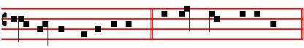
Ky- ri- e * e- le- i- son. iij. Chris-te e- le- i- son. iij.
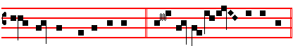
Ky- ri- e e- le- i- son. ij. Ky- ri- e * e- le- i-son.
After Kyrie, eleison, is said:
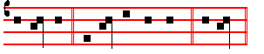
Let us pray. Let us bow the knee.  Arise.

COLLECT
O GOD, who seest us that we are afflicted by reason of our iniquity: mercifully grant; that we may be comforted by thy visitation. Who livest.

The LESSON from the Prophet Isaiah (xix.20)
IN those days: They shall cry unto the Lord because of the oppressors, and he shall send them a Saviour, and a great one, and he shall deliver them. And the Lord shall be known to Egypt, and the Egyptians shall know the Lord in that day: and shall do sacrifice and oblation: yea, they shall vow a vow unto the Lord, and perform it. And the Lord shall smite Egypt, he shall smite and heal it: and they shall return even to the Lord, and he shall be intreated of them, and shall heal them, the Lord our God.
27
GRADUAL. Psalm 19. A summo cælo Tone ij.
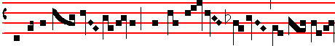
He goeth forth from the ut- ter- most part of the hea-
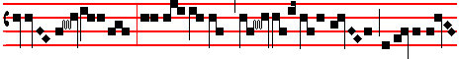
ven: and run- neth about unto the end
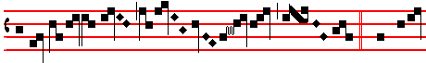
of it a- gain .  The hea-
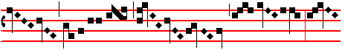
vens de- clare the
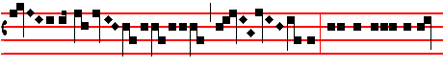
glo- ry of God : and the fir- mament
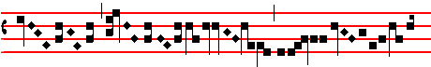
shew- eth his han- di-work
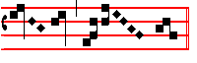
................................................
Let us pray. Let us bow the knee.  Arise.

28
COLLECT
GRANT, we beseech thee, almighty God: that, whereas through our ancient bondage we are bowed down beneath the yoke of sin; the new birth of thine only-begotten Son which we await may be for our deliverance. Who liveth.

The LESSON from the Prophet Isaiah. (xxxv.1.)
THUS saith the Lord: The wilderness and the solitary place shall be glad for them, and the desert shall rejoice, and blossom as the rose. It shall blossom abundantly, and rejoice even with with joy and singing: the glory of Lebanon shall be given unto it: the excellency of Carmel and Sharon, they shall see the glory of the Lord, and the excellency of our God. Strengthen ye the weak hands, and confirm the feevle knees, Say to them that are of a fearful heart: Be strong, fear not: behold, your God will come with vengeance, even God with a recompence: he will come and save you. Then the eyes of the blind shall be opened, and the ears of the deaf shall be unstopped. Then shall the lame man leap as an hart, and the tongue of the dumb sing: for in the wilderness shall waters break out, and streams in the desert. And the parched ground shall become a pool, and the thirsty land springs of water: saith the Lord almighty.

GRADUAL. Psalm 19. In sole posuit Tone ij.
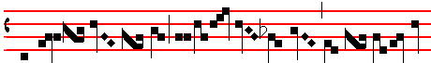
He hath set his ta- ber- na- cle in the sun
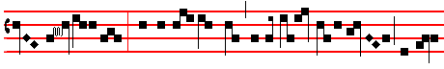
: and he cometh forth as a bride- groom out of
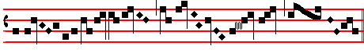
his cham- ber .
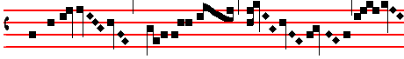 .  He goeth forth from the ut- ter- most part

29
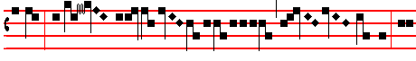
of the hea- ven: and
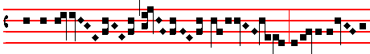
runneth a- bout un- to the end of it a- gain.......
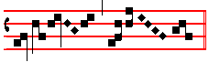
.........................................................
Let us pray. Let us bow the knee.  A- rise.

COLLECT
O LORD, we pray thee, that we thine unworthy servants, who now bewail the guilt of our misdeeds, may be gladdened by the advent of thy only-begotten Son: Who liveth.

The LESSON from the Prophet Isaiah (xl.9.)
THUS saith the Lord: O Zion, that bringest good tidings, get thee up into the high mountain: O Jerusalem, that bringest good tidings, lift up thy voice with strength: lift it up, be not afraid. Say unto the cities of Judah: Behold your God: behold, the Lord God will come with strong hand, and his arm shall rule for him: behold his reward is with him, and his work before him. He shall feed his flock like a shepherd: he shall gather the lambs with his arm, and carry them in his bosom, the Lord our God..

GRADUAL. Psalm 80. Domine Deus Tone ij.
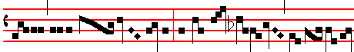
Turn us a- gain , O Lord God of hosts ............................

30
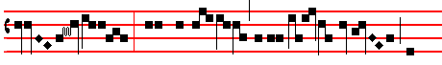
................................... : shew the light of thy coun- te-nance , and
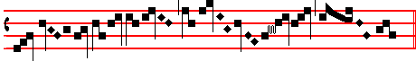
we shall be whole...................................................................................
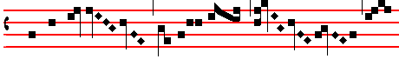
 Stir up thy strength.......................................................................................
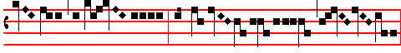
....................., O Lord..................., and come..........................................................,
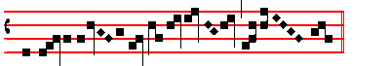
and save ................................................ us........................
Let us pray. Let us bow the knee.  Arise.

COLLECT
GRANT, we beseech thee, almighty God: that the coming solemnity of thy Son may bestow upon us healing in this present life, and obtain for us everlasting rewards. Through the same.

The LESSON from the Pprophet Isaiah (xlv. 1.)
THUS saith the Lord to his anointed, to Cyrus, whose right hand I have holden, to subdue nations before him, and I will loose the loins of kings, to open before him the two leaved gates, and the gates shall not be shut. I will go before thee: and make the crooked places straight: I will break in pieces the gates of brass, and cut in sunder the bars of iron. And I will give thee the treasures of

31
darkness, and hidden riches of secret places: that thou mayest know that I, the Lord, which call thee by thy name, am the God of Israel. For Jacob my servant’s sake, and Israel mine elect, I have even called thee by thy name: I have surnamed thee, though thou hast not known me. I am the Lord, and there is none else: there is no God beside me: I girded thee, though thou hast not known me: that they may know from the risiing of the sun, and from the west, that there is none beside me. I am the Lord, and there is none else, I form the light, and create darkness, I make peace, and create evil: I the Lord do these things. Drop down, ye heavens, from above, and let the skies pour down righteousness: let the earth open, and let them bring forth salvation: and let righteousness spring up together: I the Lord have created it.

GRADUAL. Psalm 80. Excita Tone ij.
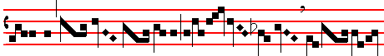
Stir up, O Lord , thy strength
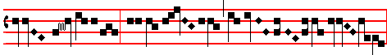
, and come.......................................................................,
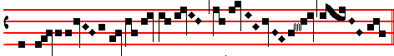
and save .................................us......................................................................
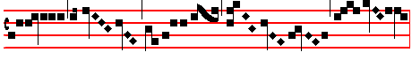
 Hear, O thou Shep- herd of Is- ra- el:
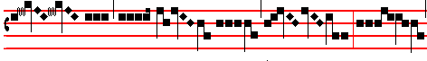
thou that lea- dest Jo- seph like a sheep : shew

32
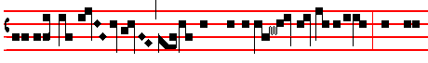
thy- self, thou that sit-test up- on the Cherubim , be- fore
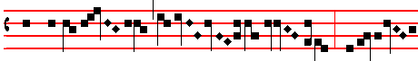
Eph-ra- im, Benja- min
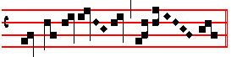
and Ma-nas-ses........................................
Let us pray. Let us bow the knee.  Arise.

COLLECT
O LORD, we beseech thee favourably to hear the prayers of thy people: that we, who are justly punished for our offences, may be comforted by the visitation of thy mercy. Who livest.

The LESSON from the Prophet Daniel (Song of the Three Children 26)
IN those days: The Angel of the Lord came down together with Azarias and his fellows: and smote the flame of the fire out of the oven, and made the midst of the furnace as it had been a moist whistling wind. Now the flame streamed forth above the furnace forty and nine cubits: and it passed through, and burned of the Chaldeans it found about the furnace the king’s servants that made it hot. And the fire touched them not at all, neither hurt nor troubled them. Then the three, as out of one mouth, praised, glorified and blessed God in the furnace, saying:
Here is not said, Thanks be to God.
HYMN Song, ibid. Tone vij
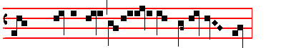
BLES- SED art thou, O Lord God of our fa- thers.

33
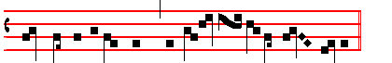
* And wor-thy to be praised and glor- i- ous for ev-er.
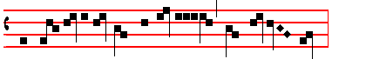
And bles-sed is the name of thy glo-ry, which is ho- ly. * And worthy.
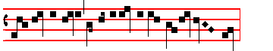
Bles-sed art thou in the holy temple of thy glo- ry. * And worthy.
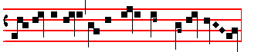
Bles-sed art thou on the holy throne of thy kingdom. * And worthy.

Bles-sed art thou in the sceptre of thy Godhead. * And worthy.
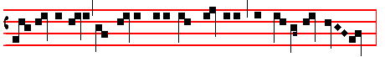
Bles-sed art thou that sittest upon the Cherubim, and beholdest the depths.
* And worthy.
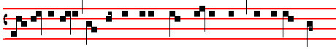
Bles-sed art thou that walkest on the wings of the winds and on the waves
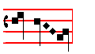
of the sea. * And worthy.

34

Let all thine Angels and Saints bless thee.
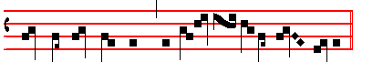
* And let them praise thee and glori-fy thee for e- ver.
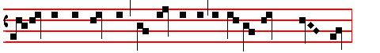
Let the heavens, the earth, the sea, and all that in them is, bless thee.
* And let them.
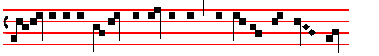
Glo- ry be to the Father, and to the Son, and to the Ho- ly Ghost.
* And worthy. to be praised and glor- i- ous for e- ver.
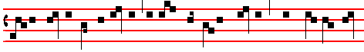
As it was in the beginning, is now, and ev- er shall be: world without end.
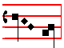
A- men. * And worthy.
Bles- sed art thou, O Lord God of our fa- thers. * And worthy

35
Here is said  The Lord be with you without Let us bow the knee.

COLLECT.
O GOD, who to the three children didst assuage the flames of fire: mercifully grant; that the flames of sin may not kindle upon us thy servants. Through.

The LESSON from the Epistle of blessed Paul the Apostle to the Thessalonians
(II. ij 1.)
BRETHREN: We beseech you, by the coming of our Lord Jesus Christ, and by our gathering together unto him: that ye be not soon shaken in mind, or be troubled, neither by spirit, nor by word, nor by letter as from us, as the day of Christ is at hand. Let no man deceive you by any means: for that day shall not come, except there come a falling away first, and that man of sin be revealed, the son of perdition, who opposeth and exalteth himself above all that is called God, or that is worshipped, so that he as God sitteth in the temple of God, shewing himself that he is God. Remember ye not, that, when I was yet with you, I told you these things? And now ye know what withholdeth, that he might be revealed in his time. For the mystery of iniquity doth already work: only he who now letteth will let, until he be taken out of the way. And then shall that wicked be destroy with the brightness of his coming.

TRACT. Psalm 80. Qui regis Tone viij
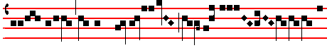
Hear, O thou Shep- herd of Is-ra- el
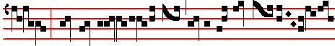
: thou that lea- dest Joseph like a sheep
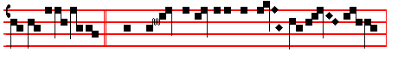
.  Thou that sittest upon the Che- ru- bim ,
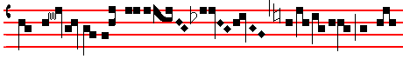
shew thyself before Ephraim , Ben-ja-
36
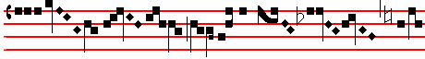
min and Ma-nas-ses............................................
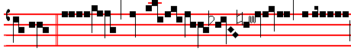
................ Stir up thy strength , O Lord ,
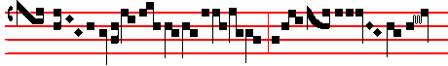
and come , and save.................................
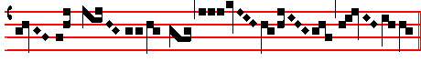
...................... us................................................................................................

.
 The Continuation of the holy GOSPEL according to Luke (iij. 1.)
IN the fifteenth year of the reign of Tiberius Cæsar, Pontius Pilate being governor of Judæa, and Herod being tetrarch of Galilee, and his brother Philip tetrarch of Ituræa and of the region of Trachonitis, and Lysanias the tetrarch of Abilene, Annas and Caiaphas being the high priests : the word of God came unto John the son of Zacharias in the wilderness. And he came into all the country about Jordan, preaching the baptism of repentance for the remission of sins, as it is written in the book of he words of Esaias the prophet, saying: The voice of one crying in the wilderness: Prepare ye the way of the Lord: make his paths straight: every valley shall be filled: and every mountain and hill shall be brought low: and the crooked shall be made straight, and the rough ways shall be made smooth: and all flesh shall see the salvation of God.

OFFERTORY. Zech. 9. Exsulta Tone iij
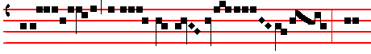
Rejoice great-ly, O daugh- ter of Zi- on , shout

37
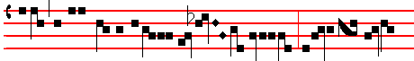
aloud, O daughter of Jeru-sa- lem : behold, thy King
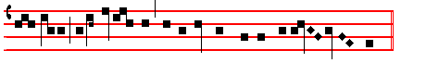
cometh to thee, he is just and having salva- tion.

SECRET
WE beseech thee, O Lord, mercifully to have respect unto these our sacrifices: that they may increase our devotion, and set forward our salvation. Through.
Other Secrets, as above, p. 10.

Common Ferial Preface. Sanctus Deus Genitor alme Tone xiij, 3
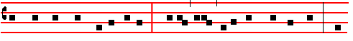
with suppliant thanksgiving saying:  Holy, Holy, Holy, Lord God of Hosts. Hea-
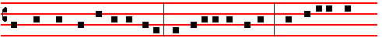
ven and earth are full of thy glory. Hosanna in the highest. Blessed is he that
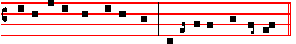
cometh in the name of the Lord. Hosanna in the highest.
Lord's Prayer, ferial tone
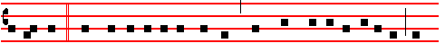
Let us pray: Commanded by saving precepts, and taught by divine example, we

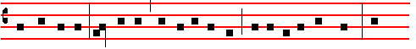
are bold to say: Our Father, who art in heaven: Hallowed be thy name: Thy

38
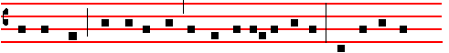
kingdom come: Thy will be done, in earth as it is in heaven. Give us this day
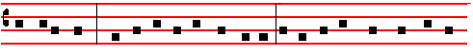
our daily bread: And forgive us our trespasses, as we forgive them that trespass
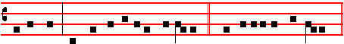
against us. And lead us not into temptation.  But deliver us from evil.

Agnus Dei Deus Genitor alme Tone xij, 3 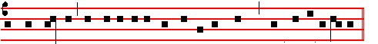
O Lamb of God, that takest away the sins of the world: have mercy upon us.
O Lamb of God, that takest away the sins of the world: have mercy upon us.

O Lamb of God, that takest away the sins of the world: grant us peace.

COMMUNION. Psalm 19 Exsultavit Tone vij
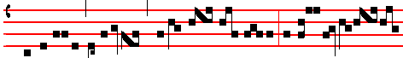
He rejoiceth as a gi- ant to run his course : he goeth forth from the
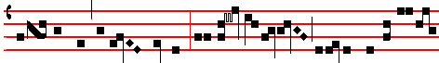
utter-most part of the heaven, and runneth a- bout unto the end of it a-
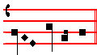
gain. 39
POSTCOMMUNION.
WE beseech, O Lord our God: that these holy mysteries which thou hast given to us for the assurance of our redemption; may be for our healing both in this life and in that which is to come. Through.

Other Postcommunions as above, pp. 12-13.

The Fourtb Sunday in Advent
2ND CLASS. SEMIDOUBLE
Station at the twelve Holy Apostles.
INTROIT. Isaiah. 45 Rorate Tone j.
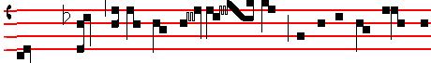
DROP down, ye heavens, from a- bove, and let the skies pour down
Psalm. 19.
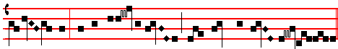
jus- tice: let the earth o-pen, and bring forth a Sa- viour
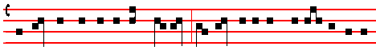
The heavens declare the glory of God : and the firmament sheweth his handy-
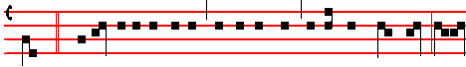
work. . Glory be to the Father, and to the Son, and to the Holy Ghost: as it
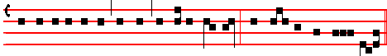
was.in the beginning, is now, and ever shall be: world without end. A- men.
Repeat Drop down up to the Psalm.

Kyrie, eleison as above, p. 4

40
COLLECT.
STIR up, we beseech thee, O Lord, thy power, and come: and with great might succour us; . that whereas through our sins we are hindered, we may through the help of thy grace speedily obtain thy merciful pardon: Who livest.

Other Collects as on the 1st Sunday of Advent, pp. 4-5.

The LESSON from the Epistle of blessed Paul the Apostle to the Corinthians
(I. Cor iv. I.)
BRETHREN: Let a man so account of us, as the ministers of Christ, and stewards of the mysteries of God. Moreover, it is required in stewards, that a man be found faithful; But with me it is a very small thing that I should be judged of you, or of man's judgment: yea, I judge not mine own self. For I know nothing by myself: yet am I not hereby justified: but he that judgeth me is the Lord. Therefore judge nothing before the time, until the Lord come: who both will bring to light the hidden things of darkness, and will make manifest the counsels of the hearts and then shall every man have praise of God.

GRADUAL. Psalm 145. Prope est Tone v
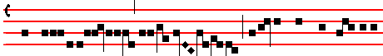
The Lord is nigh unto all them that call upon
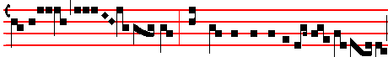
him : yea, all such as call upon him..................
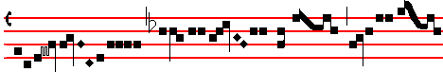
faith- ful- ly........................
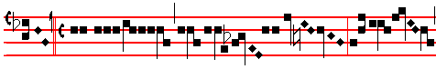
............. . My mouth shall speak the praise..........

41
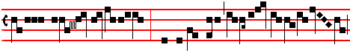
of the Lord : and let all flesh give thanks......................
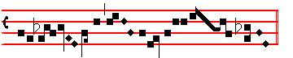
unto his holy name...............................................

¶ The following Alleluia with the Verse is said on Sunday only, on Ferias it is omitted. Tone iij
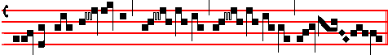
Al- le- lu- ia. * ij.
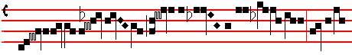
.Come, O Lord , and tar- ry not : for- give
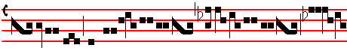
the misdeeds of thy peo-
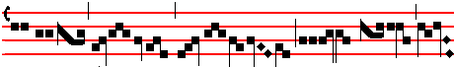
ple Is- ra- el.......
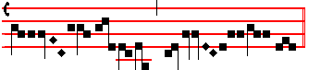
......................................................................................

Repeat Alleluia as far as .

42
 The Continuation of the holy GOSPEL according to Luke (iij. I.)
IN the fifteenth year of the reign of Tiberius Cæsar, Pontius Pilate being governor of Judrea, and Herod being tetrarch of Galilee, and his brother Philip tetrarch of Iturrea and of the region of Trachonitis, and Lysanias the tetrarch of Abilene, Annas and Caiaphas being the high priests: the word of God came unto John the son of Zacharias in the wilderness. And he came into all the country about Jordan, preaching the baptism of repentance for the remission of sins, as it is written in the book of the words of Esaias the prophet, saying: The voice of one crying in the wilderness: Prepare ye the way of the Lord: make his paths straight: every valley shail be filled: and every mountain and hill shall be brought low: and the crooked shall be made straight: and the rough ways shall be made smooth: and all flesh shall see the salvation of God. Creed.

OFFERTORY. Luke I. Ave Maria Tone viij
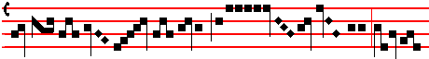
Hail , Ma- ry, full ........
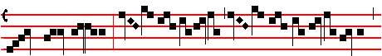
......... of grace ; the Lord.......................................................................
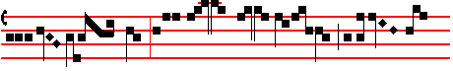
is with thee: bles- sed art thou among
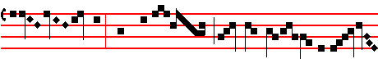
wo- men, and bles- sed is the fruit of thy
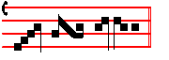
womb.............................. SECRET.
WE beseech thee, O Lord, mercifully to have respect unto these our sacrifices: that they may increase our devotion and set forward our salvation. Through.

43
Other Secrets, as above, p. 10.
Preface of the Most Holy Trinity. Sanctus and Agnus Dei as above, p. 11

COMMUNION. Isaiah 7. Ecce virgo Tone j
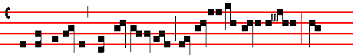
Behold, a Virgin shall conceive , and bear a son : and

his name shall be called Im- ma- nu- el.

POSTCOMMUNION
E beseech thee, O Lord : that as we have now received thy gifts, so, continually drawing near to this mystery, we may set forward the work of our salvation. Through.

W

Other Postcommunions as above, pp. 12-13.

¶ If the Vigil of the Nativity fall on a Sunday, the whole Office of the Mass is of the Vigil, with commemoration of the Sunday, but its Gospel is not read at the end.

DECEMBER 24
THE VIGIL OF THE NATIVITY OF THE LORD

IST CLASS
Station at St Mary Major
INTROIT. Exod. 16. Hodie scietis. Tone vj
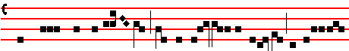
TO-DAY shall ye know that the Lord will come to deli- ver
Psalm 24.
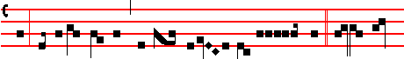
us: and in the morning shall ye be-hold his glo- ry. The earth

44
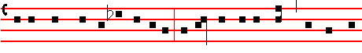
is the Lord's, and all that therein is: the compass of the world, and they that
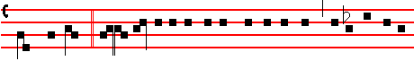
dwell therein. . Glo- ry be to the Father, and to the Son, and to the Ho-ly
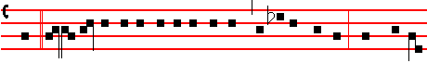
Ghost. As it was in the beginning, is now, and ever shall be: world without
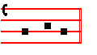
end. A-men. Repeat Today as far as the Psalm.

Kyrie as above, p. 4.
COLLECT.
OGOD, who makest us glad with the yearly exectation of our redemption: vouchsafe; that as we joyfully receive thine Only-begotten Son for our Redeemer, so we may with sure confidence behold him when he shall come to be our judge, even Jesus Christ thy Son our Lord: Who liveth.

And the Prayers assigned for the various Seasons are not said.

The LESSON from the Epistle of blessed Paul the Apostle to the Romans (j. I.)
PAUL, a servant of Jesus Christ, called to be an Apostle, separated unto the Gospel of God (which he had promised afore by his Prophets in the holy Scriptures), concerning his Son Jesus Christ our Lord, which was made of the seed of David according to the flesh: and declared to be the Son of God with power, according to the spirit of holiness, by the resurrection from the dead: by whom we have received grace and apostleship, for obedience to the faith among all nations, for his name, among whom are ye also the called of Jesus Christ our Lord.

GRADUAL. Exodus. 16. Hodie scieritis Tone ij

45
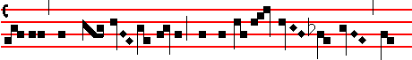
To- day shall ye know that the Lord will
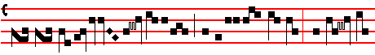
come to de-li- ver us : and in the
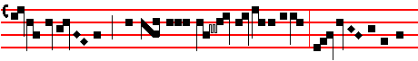
mor- ning shall ye be- hold his

glo- ry. . Psalm 80.
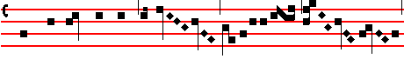
Hear, O thou Shepherd of Is- ra- el............................
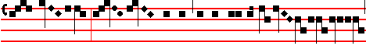
: thou that leadest Joseph like a sheep............................
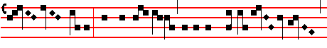
............................. : thou that sit- test upon the Cheru-bim....................,
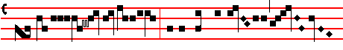
shew thyself before Ephra- im......................................

46
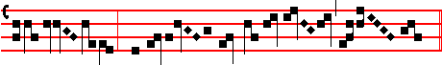
, Benjamin , and Manasses.......................................
Alleluia with the following Verse is not said unless the Vigil fall on a Sunday.
Tone viij
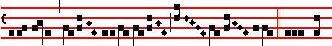
Alle- lu-ia, * ij.  On the
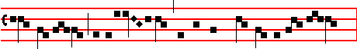
mor- row the iniqui- ty of the earth shall be blotted out :
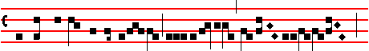
and the Saviour of the world shall reign over us.......................................
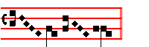
......................................... Repeat Alleluia as far as the 

 The Continuation of the holy GOSPEL according to Matthew (j. 18.)
WHEN as Mary the Mother of Jesus was espoused to Joseph, before they came together, she was found with child of the Holy Ghost. Then Joseph her husband, being a just man, and not willing to make her a publick example, was minded to put her away privily. But while he thought on these things, behold, the Angel of the Lord appeared unto him in a dream, saying: Joseph, thou son of David, fear not to take unto thee Mary thy wife: for that which is conceived in her is of the Holy Ghost. And she shall bring forth a son, and thou shalt call his name JESUS: for he shall save his people from their sins.

If it be a Sunday, the Creed is said.

OFFERTORY. Psalm 24. Tollite Tone ij.

47
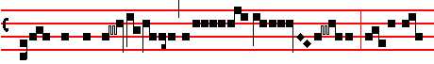
Lift up your heads , O ye gates : and be ye
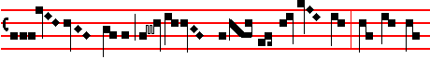
lift up , ye ever- las- ting doors, and the King..
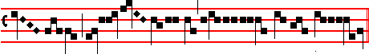
of glo- ry shall come in.

SECRET.
GRANT to us, we beseech thee, almighty God: that like as we do prevent the feast of the adorable Birth of thy Son, so we may joyfully receive his everlasting gifts: Who with thee liveth.

The Common Preface; but if it fall on a Sunday that of the Most Holy Trinity is said. Sanctus and Agnus Dei as above, p. 11

COMMUNION. Isaiah 40. Revelabitur Tone j.
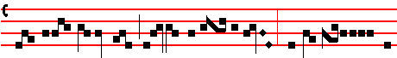
The glory of the Lord shall be revea- led : and all flesh shall

see the salva- tion of our God.

POSTCOMMUNION.
GRANT to us, we beseech thee, O Lord: that like as we do eat and drink of the heavenly mystery of thine only begotten Son; so we may be renewed by the remembrance of his birth. Through the same.

48

