Lesson ij
AND his wife, says the Evangelist, was of the daughters of Aaron. Therefore the nobility of S. John was derived not only from his parents, but from his ancestors as well, who were not distinguished as regards worldly power, but who were venerable in their religious succession. For it behoved the Forerunner of Christ to have such ancestors; that it might be seen that his preaching the faith of the Lord's coming was not a sudden conception, but had been received and infused into him by the law of nature. And, says the Evangelist, They were both righteous before God, walking in all the commandments and ordinances of the Lord blameless. What do they make of this, who, to console themselves for their own sins, consider it impossible for man to be without frequent sin, and who make use of that sentence in the Book of Job: Not one is clean, even though his life on earth be but one day?

Lesson iij
WE must answer them first, What do they mean by a man without sin: whether they mean one who has never sinned at all, or one who has ceased to sin. For if they consider that to be without sin is never to havc sinned at all, then I agree with them. For all have sinned, and come short of the glory of God. But if they deny that a man can avoid wrong-doing who has corrected his former fault and transformed the quality of his life in such a way that he can refrain from sin; I cannot agree with their opinion, since we read: Christ so loved the church, that he might present it to himself a glorious church, not having spot, or wrinkle, or any such thing: but that it should be holy and without blemish.

Antiphon on Benedictus, as in the Psalter, and the ferial prayers, kneeling.

COLLECT

GRANT, we beseech thee, almighty God: that thy family may walk in the way of salvation; and, following the teachings of blessed John the Forerunner, may attain in safety unto him whom he foretold, Jesus Christ thy Son, our Lord: Who liveth.

¶ Note that if on the following day, the 24th, there occur the solemnity of the Most Holy Body of Christ ,the Office is to be of the said Solemnity. And then the Feast of S. John Baptist is to be observed on the 25th, as if on its own day, and any other Double Feast, if it ever occurs, is to be transferred after the Octave: but if it be of the I or II Class, it is transferred to the first day not impeded by a double Office, even within the Octave of the SS. Corpus Christi.

1690
AT LAUDS
And through the Hours
Antiphon 1. Tone viij, 1
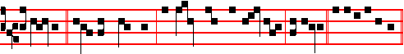
I planted, * Apollos watered, but God gave the increase, alleluia. Psalm 93
etc., as on Sundays. Antiphon 2. Tone viij, 1
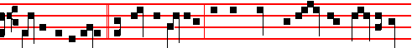
Gladly will I glory * in mine infirmities, that the power of Christ may rest upon
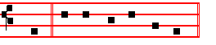
me. E u o u a e.
Antiphon 3. Tone iv, 1
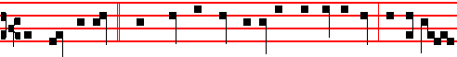
The grace of God * which was bestowed upon me was not in vain, but his grace
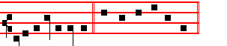
ever abideth in me. E u o u a e.

Antiphon 4. Tone viij, 1
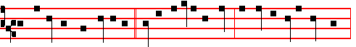
In Damascus, the governor * under Aretas the king desired to apprehend me:
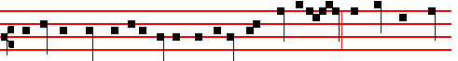
and by the brethren in a basket was I let down by the wall, and thus escaped

1731
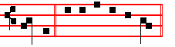
with him. E u o u a e. Antiphon 5. Tone v
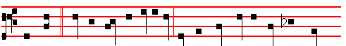 This child * shall be called a Nazarite, he shall drink neither wine nor strong
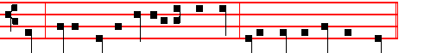
drink;. neither shall he eat any unclean thing, even from his mother's womb.

E u o u a e.
Chapter Is. 49
LISTEN, O isles, unto me; and hearken, ye people, from far; The Lord hath called me from the womb; from the bowels of my mother hath he made mention of my name.
The following melody, or that given below at Lauds, serves for the three Hymns.
Hymn E.H. 223 Ut queant laxis Mode j
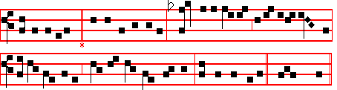
Let thine example, holy John, remind us,
Ere we can meetly sing thy deeds of wonder,
Hearts must be chastened, and the bonds that bind us, Broken asunder!

2 Lo! a swift Angel, from the skies' descending,
Tells to thy father, what shall be thy naming;
All thy life's greatness to its bitter ending Duly proclaiming.

3 But when hc doubted what the Angel told him
Came to him dumbness to confirm the story;
At thine appearing, healed again behold him, Chanting thy glory!
1692
 By the grace of God I am what I am: * And his grace which was bestowed upon me was not in vain, but his grace abideth with me always.
 He that wrought effectually in Peter to the Apostleship, the same was mighty in me toward the Gentiles. And his.

Lesson vj
I HAVE fought a good fight, he said. And I ask in whose strength he fought, whether it was his own, or was given him from on high? But it is impossible that so great a teacher of the law should not know the law of God, as it is written in Deuteronomy: And thou say in thine heart, My power and the might of mine hand hath gotten me this wealth. But thou shalt remember the Lord thy God: for it is he that giveth thee power to get wealth. And again, what is the use of a fight, except to gain the victory? And who gives the victory, except he of whom Paul himself says: Thanks be to God, which giveth us the victory through our Lord Jesus Christ.

 Saul, who also is called Paul, a great preacher, * Was by God increased the more in strength, and confounded the Jews.
 Proving that this is very Christ, the Son of God. Was by. Glory be. Was by.

IN THE THIRD NOCTURN
Antiphon. Saul, * who also is called Paul, a great preacher, was by God increased the more in strength, and confounded the Jews. Psalm 15. Confitebimur tibi
Antiphon. Lest I should be exalted * above measure through the abundance of the revelations, there was given to me a thorn in the flesh, the messenger of Satan. to buffet me; for this thing I besought the Lord thrice, that it might depart from me; and the Lord said unto me: Paul, my grace is sufficient for thee. Psalm 97 Dominus regnavit
Antiphon. There is laid up * for me a crown of righteousness, which the Lord, the righteous Judge, shall give me at that day. Psalm 99. Dominus regnavit
 Exceedinaly honoured are thy friends, O God.
 Firmly stablished is their princedom.
The Lesson from the Holy Gospel according to S. Matthew
Lesson vij Ch. 10
JESUS said unto his disciples: Behold, I send you forth as sheep in the midst of wolves.
Homily by S. John Chrysostom Homily 33 on Matt.
BE not thou troubled, (so he speaks,) that sending you among wolves, I command you to be like sheep and like doves. For I might indeed have done the contrary, and have suffered you to undergo nothing terrible, nor as sheep to be

1729
4 Than John the Baptist, none of all Eve's daughters
E'er bore a greater, whether high or lowly:
He was thought worthy, washing in the waters Jesus the holy.

5 Angels in orders everlasting praise thee,
God, in thy triune Majesty tremendous;
Hark to the prayers we, penitents, upraise thee: Save and defend us. Amen.

IN THE FIRST NOCTURN

Antiphon. Before I formed thee in the belly * I knew thee; and before thou camest forth out of the womb I sanctified thee. Psalms from the Common of a Confessor Bishop, except the last, as below. Psalm 1 Beatus Vir
Antiphon. Thou shalt go to all * that I shall send thee, saith the Lord: Be not afraid, and whatsoever I command thee thou shalt speak. Psalm 2 Quare fremuerunt
Antiphon. Be not afraid * of their faces: for I am with thee, saith the Lord. Psalm 3 Domine, quid.

 There was a man sent from God.  Whose name was John.
The Beginning of the Book of the Prophet Jeremiah
Lesson j Ch. 1, 1-10
THE words of Jeremiah the son of Hilkiah, of the priests that were in Anathoth in the land of Benjamin: to whom the word of the Lord came, in the days of Josiah the son of Amon king of Judah, in the thirteenth year of his reign. It came also in the days of Jehoiakim the son of Josiah king of Judah, unto the end of the eleventh year of Zedekiah the son of Josiah king of Judah, unto the carrying away of Jerusalem captive in the fifth month. Then the word of the Lord came unto me, saying. Before I formed thee in the belly I knew thee; and before thou camest forth out of the womb I sanctified thee, and I ordained thee a prophet unto the nations.

 There was a man sent from God whose name was John: * The same came for a witness to bear witness of the light, and to make ready a people prepared for the Lord.
 John was in the wilderness preaching the baptism of repentance. The same.

Lesson ij
THEN said I, Ah; Lord God!I behold, I cannot speak: for I am a child. But the Lord said unto me, Say not, I am a child: for thou shalt go to all that I shall send thee, and whatsoever I command thee thou shalt speak. Be not afraid of their faces: for I am with thee to deliver thee, saith the Lord. Then the Lord put forth

1694
Barnabas and Saul for the work whereunto I have called them. And when they had fasted and prayed, and laid their hands on them, they sent them away. So they, being sent forth by the Holy Ghost, departed unto Seleucia; and from thence they sailed to Cyprus.

 He that wrought t effectually in Peter to the Apostleship, the same was mighty in me toward the Gentiles, * And they perceived the grace that was given unto me of the Lord Christ.
 The grace which was bestowed upon me was not in vain, but his grace abideth with me always. And they.

Lesson ij
AND when they were at Salamis, they preached the word of God in the synagogues of the Jews: and they had also John to their minister. And when they had gone through the isle unto Paphos, they found a certain sorcerer, a false prophet, a Jew. whose name was Bar-jesus: which was with the deputy of the country, Sergius Paulus, a prudent man; who called for Barnabas and Saul, and desired to hear the word of God. But Elymas the sorcerer (for so is his name by interpretation) withstood them, seeking to turn away the deputy from the faith.

 I have fought a good fight, I have finished my course, I have kept the faith: * Henceforth there is laid up for me a crown of righteousness.
 I know whom I have believed, and am persuaded that he is able to keep that which I have committed unto him against that day. Henceforth.

Lesson iij
THEN Saul, (who also is called Paul,) filled with the Holy Ghost, set his eyes on him, and said, O full of all subtilty and all mischief, thou child of the devil, thou enemy of all righteousness, wilt thou not cease to pervert the right ways of the Lord? And now, behold, the hand of the Lord is upon thee, and thou shalt be blind, not seeing the sun for a season. And immediately there fell on him a mist and a darkness; and he went about seeking some to lead him by the hand. Then the deputy, when he saw what was done believed, being astonished at the doctrine of the Lord. Now when Paul and his company loosed from Paphos, they came to Perga in Pumphylia: and John departing. from them returned to Jerusalem.

 There is laid up for me a crown of righteousness, * Which the Lord, the righteous Judge, shall give me all that day.
 I know whom I have believed, and am persuaded that he is able to keep that which I have committed unto him against that day. Which. Glory be. Which.

1727
unexpectedly, men might not recognize him. But John was a figure of the old Testament, and typified the law in himself; and therefore John foretold the Saviour, just as the law preceded grace.

 The Angel of the Lord came down to Zacharias, saying: Receive a son in thine old age: * And his name shall be called John the Baptist.
 This child shall be great in the sight of the Lord, for his hand is with him. And his.

Lesson v
WHEN not yet born, he prophesied from the hiding-place of his mother's womb, and already bore witness to the truth though himself being without light. This is to be understood, that, hidden under the veil and flesh of the letter, by the spirit he preached the Redeemer to the world, and proclaimed our Lord to us as from the womb of the Law. Therefore, because the Jews went astray from the womb, that is, from the Law which was pregnant with Christ, they went astray from the womb, speaking lies; and so John came for a witness, to bear witness of the light.

 This is the beloved Forerunner, a burning and shining light before the Lord: * For verily this is John who made straight in the desert a highway for our God, and, moreover, bore witness unto the Lamb of God, and enlightened the minds of men.
 He shall go before him in the spirit and power of Elias. For verily.

Lesson vj
JOHN, from prison, directs his disciples to Christ. So the Law points on to the Gospel. The same Law is typified by John, enclosed as it were in the prison of ignorance, lying in the dark in a hidden place, and held captive in the letter by Jewish blindness. Of him the blessed Evangelist proclaims: He was a shining light, that is, he was enkindled by the fire of the Holy Spirit, that to a world held in the night of ignorance he might show forth the light of salvation, and amid the thickest darkness of sin might by his ray point out the most resplendent Sun of righteousness, saying of himself: I am the voice of one crying in the wilderness.

 They made signs to his father, how he would have him called. And he asked for a writing table, and wrote, saying: * His name is John.
 The mouth of Zacharias was opened, and he prophesied, saying. His name. Glory be. His name.

IN THE THIRD NOCTURN
Antiphon. The Lord * hath made my mouth like a sharp sword: in the shadow of

1696
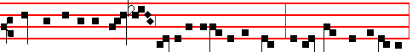
Key-bearer of the Kingdom joyfully departed to Christ: today Paul the Apostle,
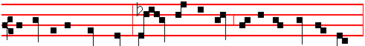
the light of the whole world, bowed down his head; and for the Name of Christ,
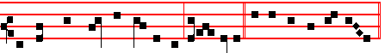
received the crown of martyrdom, alle- luia. Canticle Magnificat
Collect O God who hast hallowed.
And commemoration is not made of S. Paul, nor of the Octave of S. John.

BUT WHEN IT IS
the Office of S. Paul in a Church of his name,
At Vespers, Antiphons of Lauds, Psalms 110, 111, 112, 113, 117 as in I Vespers of Apostles.
Chapter 2 Tim. 4
I HAVE fought a good fight, I have finished my course, I have kept the faith: henceforth there is laid up for me a crown of righteousness, which the Lord, the righteous judge, shall give me at that day.
Hymn E.H. 226 vv. 4, 6 Egregie Doctor Paule, as above at Lauds, p. 1723.
 Thou art a chosen vessel, holy Apostle Paul.
 A preacher of the truth throughout all the world.
On Magnificat, Antiphon. Tone viij,1
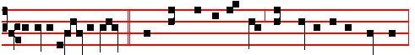
O holy Apostle Paul, * thou preacher of the truth and Doctor of the Gentiles,
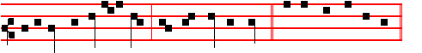
intercede for us unto God, who hath chosen thee. Canticle Magnificat
Collect as below at Lauds.

Then commemoration is made of S. Peter. Antiphon as on p. 1717.

1725
foretold to Zacharias by the Angel. And, being dumb, he could not tell his wife his son's name; but Elisabeth learned through prophecy what she had not learned from her husband.

 The Angel Gabriel appeared unto Zacharias, and said to him: Thy wife Elisabeth shall bear thee a son, and thou shalt call his name John. * And many shall rejoice at his birth.
 He shall be great in the sight of the Lord, and shall drink neither wine nor strong drink. And many. Glory be. And many.

Lesson ix
JOHN, she said, is his name; that is, it is not for us to give a name to him who has already received a name from God. For he has his name, which we have acknowledged, but which we have not chosen. To receive a name from God is one of the merits of the Saints. Thus Jacob was called Israel, because he saw God face to face. Thus our Lord Jesus was named before he was born; not the Angel, but the Father gave him his Name. Notice that the Angels declare what they hear, and not what they take upon themselves. And be not surprised that the woman declared what she did not hear, when the Holy Spirit revealed what he had told the Angel.
Te Deum Laudamus, p. 24.

AT LAUDS, AND THROUGH THE HOURS

Antiphon 1. Tone iij, 1
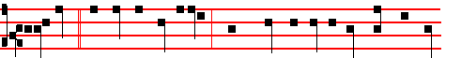
Elisabeth, * the wife of Zacharias , brought forth a mighty son, John the Bap-
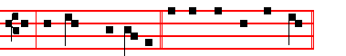
tist, the Lord's Forerunner. Psalm 93 Dominus regnavit, and the rest, p. 28.
Antiphon 2. Tone iv, 1
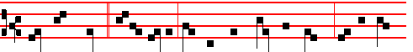
They made signs * to his father, how he would have him called: and he wrote,

1698
Jam, bone pastor, Petre
3 Good shepherd, Peter, unto whom the charge was given
To close or open ways of pilgrimage to heaven,
In sin's hard bondage held may we have grace to know
The full remission thou wast granted to bestow.

4 O noble Teacher, Paul, we trust to learn of thee
Both earthly converse and the flight of ecstasy;
Till from the fading truths that now we know in part
We pass to fulness of delight for mind and heart.

6 Now to the glorious Trinity be duly paid
Worship and honour, praise and service unafraid,
Who in unchanging Unity, one Lord sublime,
Hath ever lived as now and to unending time. Amen.

 They declared the work of God.  And wisely considered of his doing.
On Benedictus, Antiphon. Tone viij, 1
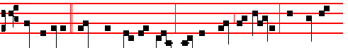
Whatsoever * thou shalt bind on earth shall be bound in heaven: and whatso-
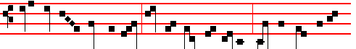 ever thou shalt loose on earth shall be loosed in heaven: saith the Lord un- to
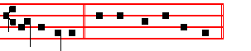
Simon Peter. Canticle Benedictus

COLLECT
OGOD who hast hallowed this day by the martyrdom of thine Apostles Peter and Paul: grant unto thy Churcn in all things to follow the commandment of those: through whom she received the beginning of religion. Through.

AT TERCE
Antiphon. Silver.
Chapter Herod the king, as above.
1723
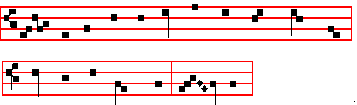
(or as at Vespers above)
O MORE than blessed, merit high attaining,
Pure as the snow-drift, innocent of evil,
Child of the desert, mightiest of martyrs,
Greatest of prophets.

Thirty-fold increase some with glory crowneth;
Sixty-fold fruitage prize for others winneth;
Hundred-fold measure, thrice repeated, decks thee,
Blest one, for guerdon.

O may the virtue of thine intercession,
All stony hardness from our hearts expelling,
Smooth the rough places, and the crooked straighten
Here in the desert.

Thus may our gracious Maker and Redeemer,
Seeking a station for his hallow'd footsteps,
Find, when he cometh, temples undefiled,
Meet to receive him.

Angels in orders everlasting praise thee,
God, in thy triune Majesty tremendous;
Hark to the prayers we, penitents, upraise thee:
Save and defend us. Amen.

 This child shall be great in the sight of the Lord.
 For the hand of the Lord is with him.
On Benedictus, Antiphon. Tone viij, 1
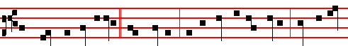
The mouth of Zacharias * was opened, and he prophesied, saying: Blessed be

1700
 Jesus asked his disciples, saying: Whom do men say that I the Son of man am? Peter answered and said, Thou art the Christ, the Son of the living God. * And I say also unto thee, That thou art Peter, and upon this rock I will build my church.  Blessed art thou, Simon Bar-Jona: for flesh and blood hath not revealed it unto thee, but my Father which is in heaven. And I. Glory be. And I.

Lesson ix
AND Jesus answered and said unto him, Blessed art thou, Simon Bar-Jona. The Apostle testified of him, and he in turn testifies of the Apostle. Peter had said: Thou art the Christ, the Son of the living God; his true confession received the reward: Blessed art thou, Simon Bar-Jona. Why? For flesh and blood hath not revealed it unto thee. but my Father.What flesh and blood could not reveal, the grace of the Holy Spirit did reveal. Therefore his name was in keeping with his confession, be:cause he received a revelation from the Holy Spirit, whose son he should also be called. For Bar-Jona in our language means, Son of a dove.
Te Deum Laudamus, p. 24.

AT LAUDS, AND THROUGH THE HOURS

Antiphon 1. Tone viij, 1
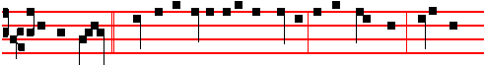
Peter and John * went up together into the temple at the ninth hour, being the

hour of prayer. Psalm 93 Dominus regnavit and the rest, p. 28.
Antiphon 2. Tone vij, 3
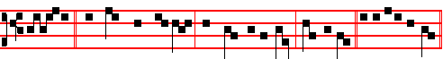
Silver * and gold have I none; but such as I have, give I thee. E u o u a e.
Antiphon 3. Tone viij, 2
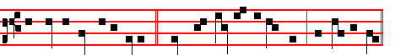
The Angel said unto Peter, * Cast thy garment about thee, and follow me.

1721
unto the end of the earth.
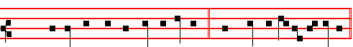
Short  Among them that are born of women. * There hath not ris-en a greater.
Among them.
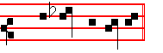
 Than John the Baptist. There hath not. Glory be.
Among them.
 Elisabeth, the wife of Zacharias, brought forth a mighty son.
 John the Baptist, the Lord's forerunner.

AT NONE
Antiphon. Thou, child, p. 1699..
Chapter Isaiah 49
KINGS shall see and arise, princes also shall worship the Lord thy God, and the Holy One of Israel,who hath chosen thee.
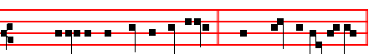
Short  Elisabeth, the wife of Zacharias. * Brought forth a migh-ty son.
Elisabeth.
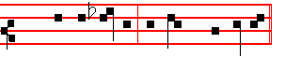
 John the Baptist, the Lord's Fore-runner.
Brought forth. Glory be.
Elisabeth.
 This child shall be great in the sight of the Lord.
 For the hand of the Lord is with him.

AT VESPERS
Antiphons and Chapter of Lauds. Psalms and Hymn as in I Vespers.
 This child sha.ll be great in the sight of the Lord.
 For the hand of the Lord is with him.

1702
Lesson iv Sermon 82 On the Birthday of the
Holy Apostles Peter and Paul
THE whole world, dearly beloved, shares in the festivals of all the Saints; and the piety of the one Faith demands that whatever act is commemorated that pertains to the salvation of all, should also be celebrated with joy by all. Nevertheless, to-day's festival is to be reverenced with special and singular rejoicing in this our city, over and above that reverence which it merits from the whole world: for where the glorious departure of the foremost of the Apostles took place, there, on the day of their martyrdom, should be thc greatest gladness. For these are thc men through whom the Gospel of Christ shone upon you, O Rome; and you who were the teacher of error have become thc disciple of truth.

 Lord, if it be thou, bid me come unto thee on the water. * And Jesus stretched forth his hand, and caught him, and said unto him: O thou of little faith, wherefore didst thou doubt?
 But when he saw the wind boisterous, he was afraid, and beginning to sink, he cried, saying, Lord, save me. And Jesus.

Lesson v
THESE are your fathers and your true shepherds, who, as touching the kingdom of heaven, founded you in a much better and happier way than did they by whose efforts your first bulwarks were laid; from among whom he who gave you your namc defiled you with his brother's blood. These are the men who raised you to this glory, that you have bccome a holy nation, a chosen people, a priestly and royal city, made the head of the world through the holy chair of blessed Peter, that your rule should extend further by the divine bounds of religion than by the earthly bounds of domination. For although, made great by many victories, you extended your imperial rule over land and sea; yet warlike toil subdued less to you than was subjected by Christian peace.

 Arise, O Peter, cast thy garment about thee, and receive strength for the saving of the nations. * The chains are fallen from off thy hands,
 The Angel of the Lord came upon him, and a light shined in the prison: and he smote Peter on the side, and raised him up, saying: Arise up quickly. The chains are fallen.

Lesson vj
FOR it was well-pleasing to the operation of the Divine dispensation that many kingdoms should be gathered together under one empire, so that the world-wide preaching might have a swift passage to the nations who were ruled by the one city. But this city, not knowing the Author of that power of hers, at the very

1719
 The Angel of the Lord came down to Zacharias, saying: Receive a son in thine old age: * And his name shall be called John the Baptist.
 This child shall be great in the sight of the Lord, for his hand is with him. And his.

Lesson v
THIS is he, beloved, of whom it was foretold by prophetic revelation: The voice of one crying in the wilderness, Prepare ye the way of the Lord, make straight a highway for our God. For he was to cry, even as he did cry, that by the loud heralding of salvation the heavenly preaching should open the long-closed ears of mortal men: Who therefore would not receive such a prophet with all wonder whom he recognizes to have obtained from God so great favour that his merits were praised even before his birth took place?

 This is the beloved Forerunner, a burning and shining light before the Lord: * For verily this is John who made straight in the desert a highway for our God, and, moreover, bore witness unto the Lamb of God, and enlightened the minds of men.
 He shall go before him in the spirit and power of Elias. For verily.

Lesson vj
THIS man, therefore, through the care of God and by an Angel, was promised in future birth to the most righteous priest, Zacharias, who had reached a great age, and who had despaired, because of the barrenness of his aged consort, that the promised offspring should come forth. And well it was that the new-born son should be given to very old parents, for he was to show the only-begotten Son of God, the hope of future generations, to a world growing old in sin. With how much wonder are we to behold the fact that Zacharias himself, when he could hardly believe that the Forerunner of the Word of Salvation was to be conceived in an aged womb, was struck dumb with sudden silence, and did not receive back the power of speech until, on being asked by what name the child should be called, the bonds of his closed mouth were relaxed. So it happened, that the priest's mouth, which the trembling doubt had fast closed, was set free by the merit of the new-born son, so that, the speech restored to the father might testify to the glory of the babe.

 They made signs to his father, how he would have him called. And he asked for a writing table, and wrote, saying: * His name is John.
 The mouth of Zacharias was opened, and he prophesied, saying. His name. Glory be. His name.

IN THE THIRD NOCTURN

1704
4 Glory eternal to the blessed Trinity,
With laud and honour, virtue and supremacy,
Trinal yet Onely, reigning in his majesty
Both now and ever, through the ages infinite. Amen.

 Their sound is gone out into all lands.
 And their words into the ends of the world.
On Magnificat, Antiphon. Tone j, 1
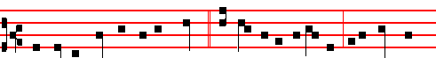
Thou art the shepherd of the sheep, * a chief of the Apostles: unto thee were
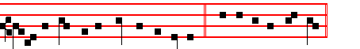
given the keys of the kingdom of heaven. Canticle Magnificat

COLLECT
O GOD who hast hallowed this day by the martyrdom of thine Apostles Peter and Paul: grant unto thy Church in all things to follow the commandment of those: through whom she received the beginning of religion. Through.
And commemoration is not made of S. Paul, since the Collect is common, nor of the Octave of S. John.
AT MATINS

All from the Common of Apostles, v, except the Lessons and 

IN THE FIRST NOCTURN
From the Acts of the Apostles
Lesson j Ch. 3, 1-16
NOW Peter and John went up together into the temple at the hour of prayer, being the ninth hour, and a certain man lame from his mother's womb was carried, whom they laid daily at the gate or the temple which is called Beautiful, to ask alms of them that entered into the temple; who seeing Peter and John about to go into the temple asked an alms. And Peter, fastening his eyes upon him with John, said, Look on us. And he gave heed unto them, expecting to receive something of them.

 Simon Peter, before I called thee out of the ship I knew thee, and made thee a

1717
Lesson ix
ALL wonder, and are filled with amazement, and say in the movements of their hearts that which has been read, that it may be written for us: What manner of child shall this be? And the hand of the Lord is with him. He exceeds the measure of human nature. Children we know; but what manner of child shall this be? The hand of the Lord is with him. That the hand of the Lord is with him we know already, but what he shall be we know not. He shall be great indeed, who as so great began. What shall he be who, while yet so tiny, was so much? Human weakness is dumb, the hearts of those who consider these things are awestruck. What manner or child shall this be? He shall be great, but what shall he be, who is greater yet? John is great, but what shall he be who is greater than the great one? If he, who only began to be, shall be so great, what shall he be, who had been already?
Te Deum Laudamus, p. 24.
Vespers of the following, with commemoration of the Octave.
__________________________________________________________________

THE TWENTY-SIXTH OF JUNE
ON THE FEAST OF SS. JOHN AND PAUL, MARTYRS
DOUBLE

All from the Common of Many Martyrs, xlvij, except the following.
Antiphons from Lauds below. Psalms 110, 111, 112, 113 of Sunday and 117, as in the I Vespers of Apostles.
Chapter, Hymn and  from the Common of Many Martyrs, pp. xlvij, xlviij.
On Magnificat, Antiphon. Tone j, 2
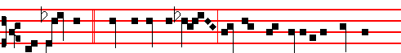
The righteous * stood before the Lord, and were not separated one from
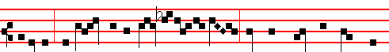
another: they drank of the chalice of the Lord, and were called the friends of
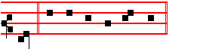
God. Canticle Magnificat
COLLECT

1706
on the twenty-eighth of June. In one ordination in the month of June he made nine Priests, three Deacons, and twenty-three Bishops for various places.

 This is he which wrought great wonders before God, and the whole earth is full of his teaching: * May he pray for all people, that their sins may be forgiven unto them.
 This is he which hated his life in this world, and is come unto life eternal. May he. Glory be. May he.

IN THE THIRD NOCTURN

Homily on the Gospel, a man travelling into a far country, lxxix.

Lesson ix of the Vigil of SS. Peter and Paul, Apostles.
The Lesson from the holy Gospel according to S. John
Lesson ix Ch. 2, 15-29
JESUS saith to Simon Peter: Simon, son of Jonas, lovest thou me more than these? And the rest.
Homily by S. Augustine, Bishop Homily 23 on John
FOR the thrice denying there is rendered a thrice confessing, that the tongue be not less servant unto love than it hath been servant unto fear, nor death imminent seem to have elicited more of speech than life present shall elicit now. Be it the office of love to feed the Lord's flock, if it was the token of fear to deny the Shepherd. They who with this mind feed the sheep of Christ, that they will needs have them to be theirs, not Christ's, are convicted of loving themselves, not Christ: through lust of getting either glory, or dominion, or gain; not through charity, of obeying, and succouring, and pleasing God.
Te Deum Laudamus, p. 24.
In Lauds, commemoration of the Octave of S. John.
Then, for commemoration of the Vigil, Antiphon and  of the occurrent Feria, as in the Psalter.
COLLECT
GRANT, we beseech thee, almighty God: that as thou hast stablished us on the rock of the apostolic confession; so thou wouldest not suffer us to be troubled by any adversities. Through.
Vespers of the following without any commemoration.
__________________________________________________________________

THE TWENTY-NINTH OF JUNE
ON THE FEAST OF THE HOLY APOSTLES PETER AND PAUL
DOUBLE OF THE FIRST CLASS WITH OCTAVE

1715
Lesson v
DURING that time they distributed the rest of their goods to the poor, that they might the more easily depart to the Lord, and that there might be more helped by them, to receive them into everlasting habitations. On the tenth day Terentianus, head of the Prætorian Guard, was sent to them, the image of Jupiter was brought for them to worship, and the Emperor's command explained to them, that unless they accepted the worship of Jupiter, they would die. They, continuing at their prayers, replied that for the faith of Christ, whom they worshipped as God with mind and mouth, they would unhesitatingly submit to death.

 The Saints of God feared not the blows or the, executioners, but died for the name of Christ. * That they might dwell in the house of the Lord for ever.
 They delivered up their bodies to be punished for God's sake. That they.

Lesson vj
BUT Terentianus was afraid that if they were killed publicly there would be an uppoar of the people, had them beheaded there, where they were, on the twenty-sixth of June, and buried secretly; and he spread the rumour that John and Paul had been sent into exile. But their death was made public by the unclean spirits who were vexing the bodies of many, among whom the son of Terentianus,
himself also being troubled by a demon, was brought to the tomb of the Martyrs and set free. At this miracle both he believed in Christ, and his father Terentianus, by whom the life of these blessed Martyrs is said to have been written.

 As gold in the furnace hath the Lord tried them, and received them as a burnt offering: and he hath care for his elect. * For grace and mercy is to his Saints.
 They that put their trust in him shall understand the truth, and such as be faithful in love shall abide with him. For grace. Glory be. For grace.

In the third Nocturn, Homily on the Gospel, Beware ye of the leaven, from the Common in the iij place, p.lxiv, with  viij Theirs was a brotherhood, p. liv.

AT LAUDS, AND THROUGH THE HOURS

Antiphon 1. Tone viij, 1
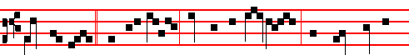
Paul and John * said unto Julian: We worship one God, who made heaven

1708
saying: . * Among them that are born of women there hath not risena greater than John the Baptist.
 This is that prophet, and more than a prophet, of whom the Saviour said. Among.

Lesson viij
AND thou, child, shalt be called the Prophet of the Highest. Well did he turn his words to Prophet, as he was prophesying from the Lord; that he might shew that this benefit also was from tne Lord: and lest, as he publicly recounted his benefits, he might seem ungratefully to have passed over those that he perceived in his son. But perhaps some may think it an irrational excess of mind, that he addressed an eight-day-old infant. But if we refrain we shall soon understand that he who heard Mary's salutation before he was born could hear his father's voice when he was born.

 The Angel Gabriel appeared unto Zacharias, and said to him: Thy wife Elisabeth shall bear thee a son, and thou shalt call his name John. * And many shall rejoice at his birth.
 He shall be great in the sight of the Lord, and shall drink neither wine nor strong drink. And many. Glory be. And many.

Lesson ix
HE knew immediately that the Prophet had other ears, opened by the Spirit of God, not by bodily age. He had the sense to understand, as he had the feeling to exult. At the same time, notice this: how few Elisabeth prophesies to,and how many Zacharias: and both spoke, filled with the Holy Spirit: but the discipline is observed, that the woman should study rather to learn divine matters than to teach them.
Te Deum Laudamus, p. 24.
Vespers from the Chapter of the following, with commemoration of the Octave. (Vespers entire of S. Irenaeus, comm. Oct.)
__________________________________________________________________

The Twenty eighth of June
(S. IRENAEUS, below, p. )
On the Feast of S.Leo, Pope and Confessor.
Semidouble
If this Feast shall come on a Sunday, it is transferred after the Octave of the Apostles, and on the Saturday on which the Office is of the Octave of S. John, the ninth Lesson is read from the Homily of the Vigil of the Apostles, with commemoration of the same at Lauds only.

1713
shalt be conqueror more than before.
Chapter, Hymn and  of the Common, xli-xliii.
On Benedictus, Antiphon. Tone j, 2
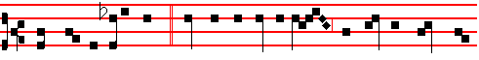
These are the holy ones, * who for the love of Christ despised the threats of
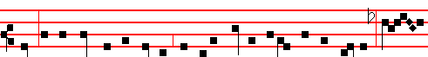
men: in the kingdom of heaven, the holy Martyrs exult with the Angels: O
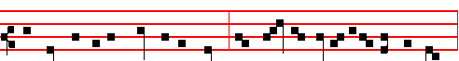
how precious is the death of the Saints, who stand unceasingly before the Lord,

and are not separated one from another. Canticle Benedictus

COLLECT
WE beseech thee, almighty God: that, as their faith and passion did cause blessed John and Paul to be brothers indeed: so this day's festival may bestow upon us a twofold gladness in their glory. Through.
Then commemoration is made of the Octave of S. John, as above on the Feast.

At the Hours, Antiphons of Lauds, Chapters and Short .of the Common, p. lviij.
In II Vespers, Antiphons of Lauds above. Psalms 110, 111, 112, 113 of Sunday, and in the last place, Psalm 116, vv.10-16 Credidi
Chapter and Hymn of the Common, p. xlvij.
 Let the Saints be joyful with glory.  Let them rejoice in their beds.
On Magnificat, Antiphon. Tone j, 1
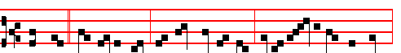
These are * two olive trees, and two candlesticks giving light before the Lord:

1710
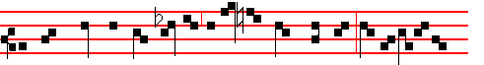
they have power to close heaven so that the clouds rain not, and to op-en its
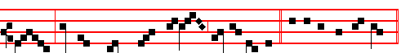
gates: for their tongues have become keys of heaven. Canticle Magnificat
And commemoration is made of the Octave of S. John.
__________________________________________________________________

The Twenty-seventh of June.
Fourth day within the Octave of the Nativity of S.John

In the first Nocturn Lessons from the occurrent Scripture.

IN THE SECOND NOCTURN
Sermon of S. Basil the Great
Lesson iv Homily 2 on Psalm 29 (XXVIII)
THE VOICE of the Lord over the waters. What voice? over what waters? We take what was said as a prophecy. Rememberest thou John, who when he was asked by the Jews, Who art thou? what answer shall we give to them that sent us? replied: I am the voice of one crying in the desert. So the voice of the Lord is John, an Angel sent by God before the face of the Lord, to prepare for the Lord a people ready for him.Therefore this voice over the waters was over Jordan, in which he baptized preaching the baptism of repentance. And not only in Jordan, but also in Aenon near Salem, for there was much water there.

 The Angel of the Lord came down to Zacharias, saying: Receive a son in thine old age: * And his name shall be called John the Baptist.
 This child shall be great in the sight of the Lord, for his hand is with him. And his.

Lesson v
SO the voice of the Lord commanding the waters is John commanding baptism. There also the glorious God made the thunder. For a voice came from heaven, saying: This is my beloved Son, in whom I am well pleased. Then also the Lord, ruling the sea ,vouchsafed to come down in the baptism of John, that he might fulfil all righteousness that is in the Law. The voice of the Lord is mighty in operation. For it takes away the weakness of the people through the baptism of

1711

