AT COMPLINE
The Reader begins:
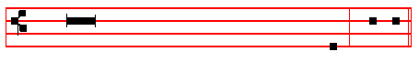
V/. Bid, Lord, a bles - - sing.
Blessing. - The Lord Almighty grant us a quiet night
and a perfect end. R/. Amen.
SHORT LESSON I Peter 5
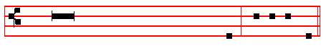
BRETHREN, be sober, be vigilant; because your
adversary the devil, as a roaring lion, walketh
about, seeking whom he may devour:
whom resist, stedfast in the faith.
But thou, O Lord, have mercy upon us. R/.Thanks be to God.
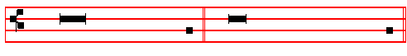
V/. Our help is in the name of the Lord. R/. Who hath made heaven and earth.

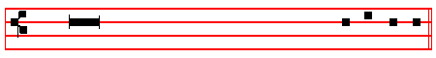
Our Father is said entirely in secret.
Then the Officiant maketh the Confession,
I confess to God Almighty, to blessed Mary ever Virgin, to blessed Michael the Archangel, to blessed John the Baptist, to the holy Apostles Peter and Paul, to all the Saints, and to you, brethren, that I have sinned exceedingly, in thought, word, and deed; by my fault, my own fault, my own most grievous fault. Wherefore I pray blessed Mary ever Virgin, blessed Michael the Archangel, blessed John the Baptist, the holy Apostles Peter and Paul, all the Saints, and you, brethren, to pray for me to the Lord our God.

The Choir responds:
Almighty God have mercy upon thee, forgive thee thy sins, and bring thee to everlasting life. R/. Amen
Then they repeat the Confession:
I confess to God Almighty, to blessed Mary ever Virgin, to blessed Michael the Archangel, to blessed John the Baptist, to the holy Apostles Peter and Paul, to all the Saints, and to thee, father, that I have sinned exceedingly, in thought, word,
249
and deed; by my fault, my own fault, my own most grievous fault. Wherefore I pray blessed Mary ever Virgin, blessed Michael the Archangel, blessed John the Baptist, the holy Apostles Peter and Paul, all the Saints, and thee, father, to pray for me to the Lord our God.
When the Choir have made confession, the Officiant says:
Almighty God have mercy upon you, forgive you your sins, and bring you to everlasting life. R/. Amen.
The Almighty and merciful Lord grant us pardon, remission and absolution of our sins. R/. Amen.
And after the Absolution is said
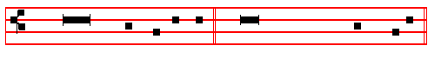
V/. Turn thou us, O God our Saviour. R/. And let thine anger cease from us.
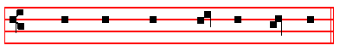
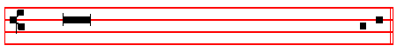
+ O GOD, make speed to save me.
R/. O Lord, make haste to help me
V/. Glory be to the Father, and to the Son, and to the Ho - ly Ghost.
R/. As it was in the beginning, is now,
and ever shall be, world without end. Amen. Al- le - lu- ia.
or Praise be to thee, O lord, King of eternal glory, according to the season.

Antiphon. Tone viij, 1.
Have mercy. Ps. 4, 31, 91, 134, as below.
In Eastertide, Antiphon. Tone viij,1.
250
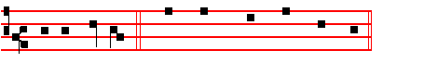
Al- le - lu - ia. Ps. 4, 31, 91, 134, as below.

Ps. 4 Cum invocarem IV
Hear me when I call, O God of my righteousness * thou hast set me at liberty when I was in trouble; have mercy upon me, and hearken unto my prayer.
2 O ye sons of men, how long will ye blaspheme mine honour * & have such pleasure in vanity, & seek after leasing?
3 Know this also, that the Lord hath chosen to himself the man that is godly * when I call upon the Lord, he will hear me.
4 Stand in awe, & sin not * commune with your own heart, and in your chamber, and be still.
5 Offer the sacrifice of righteousness * and put your trust in the Lord.

6 There be many that say * Who will shew us any good?

7 Lord, lift thou up * the light of thy countenance upon us.

8 Thou hast put gladness in my heart * since the time that their corn and wine and oil increased.
9 I will lay me down in peace, and take my rest * for it is thou Lord only, that makest me dwell in safety.

Glory be to the Father is said, as above, here and at the end of all Psalms and Canticles, unless otherwise noted.
Ps. 31 In te, Domine, speravi XXX
IN thee, O Lord, have I put my trust, * let me never be put to confusion * deliver me in thy righteousness.
2 Bow down thine ear to me * make haste to deliver me.
3 And be thou my strong rock, and house of defence * that thou mayest save me.
4 For thou art my strong rock, and my castle * be thou also my guide, and lead me for thy Name's sake.
5 Draw me out of the net that they have laid privily for me * for thou art my

251
strength.
6 Into thy hands I commend my spirit * for thou hast redeemed me, O Lord, thou God of truth.
Ps. 91 Qui habitat XL
WHOSO dwelleth under the defence of the most High * shall abide under the shadow of the Almighty.
2 I will say unto the Lord, Thou art my hope, and my stronghold * my God, in him will I trust.
3 For he shall deliver thee from the snare of the hunter * and from the noisome pestilence.
4 He shall defend thee under his wings, and thou shalt be safe under his feathers * his faithfulness and truth shall be thy shield and buckler.
5 Thou shalt not be afraid for any terror by night * nor for the arrow that flieth by day
6 For the pestilence that walketh in darkness * nor for the sickness that destroyeth in the noon-day.
7 A thousand shall fall beside thee, and ten thousand at thy right hand * but it shall not come nigh thee.
8 Yea, with thine eyes shalt thou behold * and see the reward of the ungodly.

9 For thou, Lord, art my hope * thou hast set thine house of defence very high

10 There shall no evil happen unto thee * neither shall any plague come nigh thy dwelling.
11 For he shall give his angels charge over thee * to keep thee in all thy ways.

12 They shall bear thee in their hands * that thou hurt not thy foot against a stone.
13 Thou shalt go upon the lion and adder * the young lion and the dragon
shalt thou tread under thy feet.
14 Because he hath set his love upon me, therefore will I deliver him * I
will set him up, because he hath known my Name.

15 He shall call upon me, and I will hear him * yea, I am with him in trouble; I will deliver him, and bring him to honour.
16 With long life will I satisfy him * and shew him my salvation.

Ps. 134 Ecce nunc CXXXIII
BEHOLD now, praise the Lord * all ye servants of the Lord ;
252
2 Ye that by night stand in the house of the Lord * even in the courts of the house of our God.
3 Lift up your hands in the sanctuary * and praise the Lord.

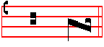
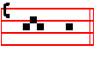
4 The Lord that made heaven and earth * give thee blessing out of Syon.

Antiphon. Tone viij, 1.
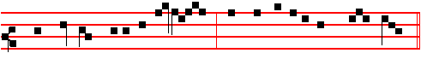
Have mercy upon me, O God : and hearken unto my pray - er.

In Eastertide, Antiphon. Tone viij, 1.
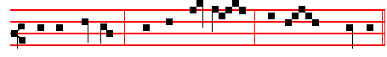
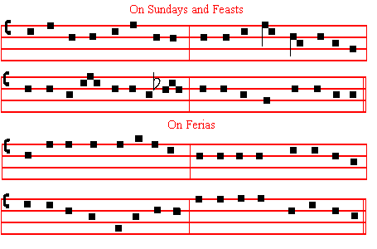
Al - le - lu - ia, al - le - lu - ia, al - le - lu - ia.
HYMN E.H 264 Te lucis ante terminum Mode viij.
Before the ending of the day, 2 From all ill dreams defend our eyes,
Creator of the world, we pray From nightly fears and fantasies;
That with thy wonted favour thou Tread under foot our ghostly foe,
Wouldst be our Guard and Keeper now That no pollution we may know.
253
3 O Father, that we ask be done,
Through Jesus Christ, thine only Son,
Who, with the Holy Ghost and thee,
Shall live and reign eternally.
On Sundays and Feasts On Ferias
A - men. A - men.

The foregoing Hymn is to be ended thus in Lent and throughout the year, unlesss otherwise noted.

But in Eastertide, that is from Compline before Low Sunday until the Ascension exclusively, both on Sundays and on Ferias (and also on Feasts occurring in that season unless otherwise noted) the said Hymn is sung and concluded as follows:
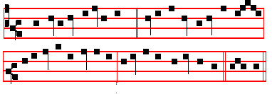
Mode viij
To thee who, dead, again dost live, But from the All glory, Lord, to thee we pay,
All glory, Lord, thy people give; Ascension until Ascending o'er the stars today,
All glory, as is ever meet, the Feast of All glory, as is ever meet,
To Father and to Paraclete. Pentecost exclusively, To Father and to Paraclete.
Amen. it is to be ended thus: Amen.

On the Feasts of Corpus Christi and of the Blessed Virgin Mary and on other Feasts
and throughout their Octaves, the Modes are given in their Proper places.

CHAPTER Jer.14
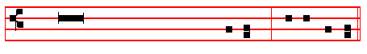
Thou, O Lord, art in the midst of us,
and we are called by thy Name:
leave us not, O Lord our God. R/. Thanks be to God.

254
Short R/.
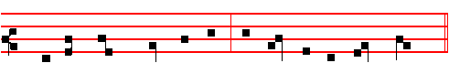
In- to thy hands, O Lord, * I com- mend my spi - rit.
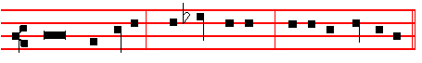
In- to thy hands, O Lord, I com- mend my spi - rit.
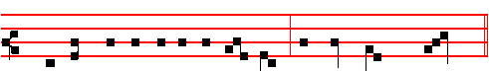V/. For thou hast redeem- ed us, O Lord, thou God of truth.
R/. * I com- mend my spi - rit.
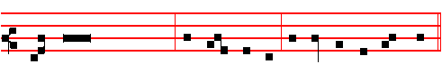
Glo - ry be to the Father, and to the Son, and to the Ho- ly Ghost.
In -to thy hands.
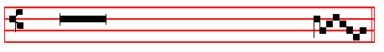
V/. Keep us, O Lord, as the apple of an eye.
R/. Hide us under the shadow of thy wings.
From Compline of Saturday before Low Sunday inclusively to Saturday after the Feast of Pentecost exclusively, is said the following Short R/. :
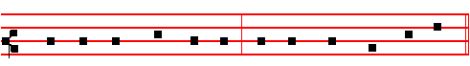
In - to thy hands, O Lord, I com- mend my spi - rit.
In - to thy hands, O Lord, I com- mend my spi - rit.
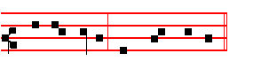
Al- le - lu- ia, al - le - lu - ia. It is repeated:
Al- le - lu- ia, al - le - lu - ia.

255
V/. For thou hast re - deemed us, O Lord, thou God of truth.
*Al - le - lu - ia, al - le - lu - ia.
Glory be to the Father and to the Son and to the Holy Ghost.
In - to thy hands.
V/. Keep, us, O Lord, as the apple of an eye. Allelu - ia.
R/. Hide us under the shadow of thy wings. Allelu - ia.
Antiphon. Tone iij, 1.
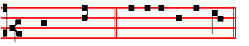

Save us. E u o u a e.
The Song of Symeon

Nunc dimittis
LORD, now lettest thou thy servant depart in peace * according to thy word.
2 For mine eyes have seen * thy salvation.

3 Which thou hast prepared * before the face of all people.

4 To be a light to lighten the Gentiles * and to be the glory of thy people Israel.

Antiphon.
Save us O Lord, while waking, and guard us while sleeping:

256
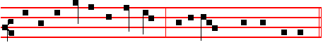
that awake we may be with Christ, and in peace may take our rest.
In Eastertide is added
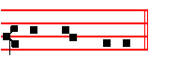
Al - le - lu - ia.
__________________________________________________________________

The following prayers are always said, except in the Double Office, and within Octaves: in Lent, and on Ember Days, when the Prayers are said at Vespers, they are said kneeling.

Kyrie eleison. Christe eleison. Kyrie eleison. Our Father silently.
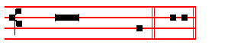
V/. And lead us not into temptation. R/. But deliver us from evil.
I believe in God silently.
V/. The resurrection of the body. R/. And the life everlasting. Amen.
Blessed art thou, Lord God of our fathers;
R/. And to be praised and glorified for ever.
V/. Let us bless the Father,and the Son,and the Holy Ghost.
R/. Let us praise him and magnify him for ever.
V/. Blessed art thou, O Lord, in the firmament of heaven.
R/. To be praised and glorified above all for ever.
V/. The Almighty and merciful Lord guard us and give us his blessing. R/. Amen.
V/. Vouchsafe, O Lord. R/. To keep us this night without sin.
V/. O Lord, have mercy upon us. R/. Have mercy upon us.
V/. O Lord, let thy mercy lighten upon us. R/. As our trust is in thee.
V/. O Lord, hear my prayer. R/. And let my cry come unto thee.
___________________________________________________________________________________________
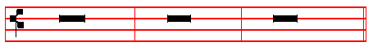
V/. The Lord be with you.R/. And with thy spirit. Let us pray.
COLLECT
VISIT, we beseech thee, O Lord, this dwelling, and drive from it all the snares of the enemy; let thy holy angels dwell herein to preserve us in peace; and may thy blessing be upon us evermore. Through.
257
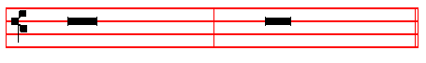
world without end. R/. Amen.
V/. The Lord be with you. R/. And with thy spirit.
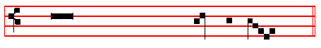
V/. Let us bless the Lord.
R/. Thanks be to God.
Blessing. -
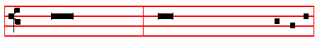
The Almighty and merciful Lord, the Father, the Son, and the Holy Ghost,
bless and preserve us. R/. Amen.

And May the souls of the faithful is not said, but immediately is said one of the Antiphons below, according to the season.
__________________________________________________________________

From Vespers of Saturday before the first Sunday of Advent until the second day of February inclusive, Antiphon. xj.
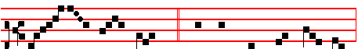
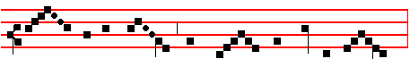
MOTH- ER be - nign of our re - deem- ing Lord,
Star of the sea and por - tal of the skies,

258
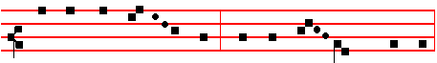
Un - to thy fal - len peo - ple help af - ford,
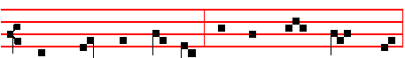
Fal - len, but stri - ving still a - new to rise.
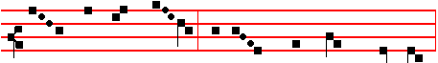
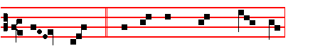
Thou who didst once, while won - d'ring worlds a - dored,
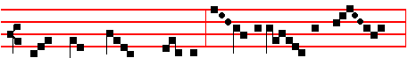
Bear thy Cre - a - tor, Vir - gin then as now,
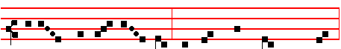
O, by the ho - ly joy at Ga - bri - el's word,
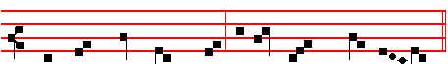
Pi - ty the sin - ners who be - fore thee bow.
In Advent,
V/. The angel of the Lord announced unto Ma - ry.
R/. And she conceived of the Holy Ghost.
Let us pray COLLECT
We beseech thee, O Lord, to pour thy grace into our hearts; that as we have known the incarnation of thy Son Jesus Christ by the message of an angel, so by his Cross and Passion we may be brought unto the glory of His resurrection. Through the same Christ our Lord. Amen. 259
From first Vespers of the Nativity and thenceforth,
V/. After childbearing, O Virgin, thou didst remain invio- late.
R/. Mother of God, intercede for us.
Let us pray COLLECT
O God, who by the virgin child-bearing of blessed Mary hast bestowed upon mankind the rewards of eternal salvation: grant, we beseech thee, that we may perceive her intercession for us, through whom we have been counted worthy to receive the author of life, Jesus Christ, thy Son, our Lord. R/. Amen.

After the Purification, that is from the end of Compline of that day the second of February inclusive, even when the Feast of the Purification of the Blessed Virgin Mary is transferred, until Maundy Thursday exclusive, Antiphon. xij.
HAIL, O Queen of hea - ven en- throned!
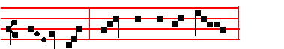
Hail, by an - gels Mis-tress owned!
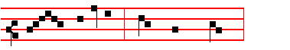
Root of Jes-se, Gate of morn,

Whence the world's true Light was born;

Glor-ious Vir - gin, joy to thee,

260
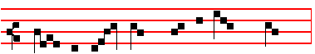
Love- liest whom in heav-en they see;
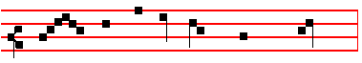
Fair - est thou where all are fair,
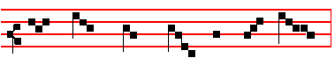
Plead with Christ our sins to spare.
V/. Vouchsafe that I may praise thee, O holy Vir - gin.
R/. Give me strength against thine enem - ies.
Let us pray COLLECT
O most merciful God, grant succour unto our frailty, that as we celebrate the memory of the holy Mother of God, so by the help of her intercessions we may
rise again from our transgressions.Through the same Christ, our Lord. R/. Amen.

From Compline of Holy Saturday until None of Saturday after Pentecost inclusive, Antiphon. xij.
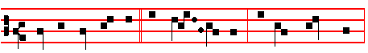
JOY to thee, O Queen of hea - ven. al - le - lu - ia.
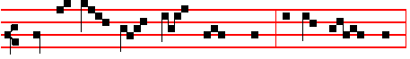
He whom thou wast meet to bear. al - le - lu - ia.
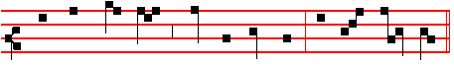
As he pro-mised, hath a - ri - sen. al - le - lu - ia.
261
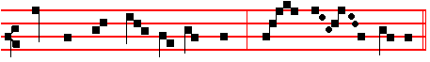
Pour for us to him thy prayer. al - le - lu - ia.
V/. Rejoice and be glad, O Virgin Mary. Allelu - ia.
R/. For the Lord is risen indeed. Allelu - ia.
Let us pray COLLECT
O God, who by the resurrection of thy Son, Jesus Christ, didst vouchsafe to give gladness unto the world; grant. we beseech thee, that we, being holpen by the Virgin Mary, his Mother, may attain unto the joys of everlasting life. Through the same Christ our Lord. R/. Amen.

From first Vespers of the Feast of the Most Holy Trinity until None of the Saturday before Advent, Antiphon. 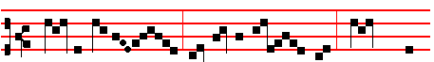
HAIL, ho-ly Queen, mo-ther of mer - cy, hail , our
life, our sweet - ness, and our hope.
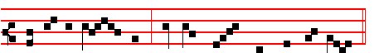
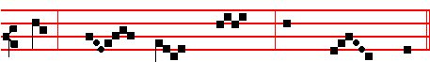
To thee do we cry, poor ba - nished chil - dren of Eve;
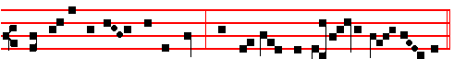
to thee do we send up our sighs, mourning and weeping in this vale of tears.

262
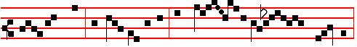
Turn, then, most gracious Advocate, thine eyes of mer - cy to-
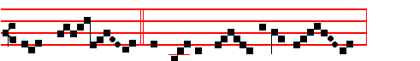
-wards us; and af - ter this our ex- ile
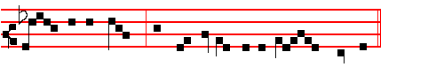
show un-to us the blessed fruit of thy womb, Je- sus.
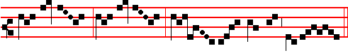
O cle- ment, O lo - ving, O sweet Vir - gin Ma- ry.
V/. Pray for us, O holy Mother of God.
R/. That we may be made worthy of the promises of Christ.

Let us pray COLLECT
Almighty and everlasting God, who by the cooperation of the holy Ghost didst prepare the body and soul of the glorious Virgin Mary to become an habitation meet for thy Son; grant that as we rejoice in her commemoration, we may be delivered by her loving intercession from our present evils and from eternal death. Through the same Christ our Lord. R/. Amen.
__________________________________________________________________

V/. May the divine assistance remain with us always. R/. Amen.
Then is said silently

OUR FATHER, which art in heaven, hallowed be thy name, thy kingdom come. Thy will be done, on earth as it is in heaven. Give us this day our daily bread. And forgive us our trespasses, as we forgive them that trespass against us. And lead us not into temptation, but deliver us from evil. Amen.
263
HAIL, MARY, full of grace, the Lord is with thee. Blessed art thou amongst women, and blessed is the fruit of thy womb, Jesus. Holy Mary, Mother of God, pray for us sinners, now and in the hour of our death. Amen.

and

I BELIEVE in God the Father Almighty, Maker of heaven and earth: And in Jesus Christ his only Son our Lord: Who was conceived by the Holy Ghost, Born of the Virgin Mary: Suffered under Pontius Pilate, Was crucified, dead, and buried: He descended into hell: The third day he rose again from the dead: He ascended into heaven, And sitteth on the right hand of God the Father Almighty: From thence he shall come to judge the quick and the dead.
I believe in the Holy Ghost: The holy Catholic Church: The Communion of Saints: The Forgiveness of sins: The Resurrection of the body: And the Life everlasting. Amen.

-Thus Compline is said throughout the whole year, except in the three great days of Holy Week,and throughout the Octave of Easter, as is said in its place.

-If after Compline Matins is to follow immediately, then Our Father, Hail Mary, and I believe are to be said twice, since Compline, which is the end of the Office, is to be finished thus: and it is repeated again before Matins for the beginning of the Office of the following day.

-The above Antiphons are said also at the end of Lauds when the Choir is to be left: but if immediately after Matins there follows Prime or another Hour, they are said at the end of the last Hour, as they are likewise to be said whenever the Choir is to be left at the end of any Hour: and then, after V./ May the souls of the faithful, and Our Father silently, is said:
V/. The Lord give us his peace. R/. And life everlasting. Amen.

Then one of the above Antiphons, and at the end: May the Divine assistance remain with us always. R/. Amen.

Outside Choir however they are said at the end of Lauds, if the Office is to end there, otherwise at the end of the last Hour. But after other Hours, when the Office is to end, is said only Our Father silently.

+

264

