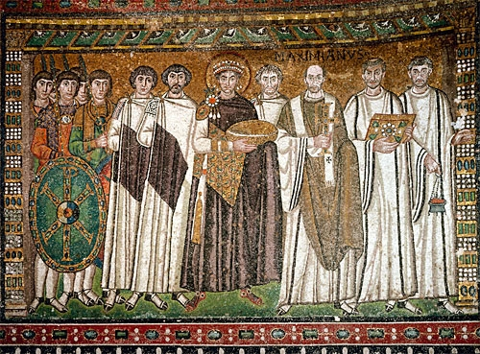

S.Peter Orthodox Truth Service
August, 2003

ENGLISH ORTHODOX
MISSAL

THE HOLY MASS

OF S. GREGORY THE GREAT

Priest, silently:
LET this my bounden duty and service be pleasing unto thee, O holy Trinity: and grant; that the sacrifice, which I unworthy have offered before the eyes of thy majesty, may be acceptable to thee, and through thy mercy obtain thy gracious favour for me and all for whom I have offered it. Through Christ our Lord. Amen.

Priest: May almighty God bless you, the Father, the Son,  and the Holy Ghost.  Amen

Priest: The Lord be with you.  And with thy spirit.
The beginning of the holy Gospel according to John. or: The Continuation.
 Glory be to thee, O Lord.

IN the beginning was the Word, and the Word was with God, and the Word was God. The same was in the beginning with God. All things were made by him: and without him was not any thing made that was made: in him was life, and the life was the light of men: and the light shineth in darkness, and the darkness comprehended it not. There was a man sent from God, whose name was John. The same came for a witness, to bear witness of the light, that all men through him might believe. He was not that light, but was sent to bear witness of that light. That was the true light, which lighteth every man that cometh into the world,. He was in the world and the world was made by him, and the world knew him not. He came unto his own, and his own received him not. But as many as received him, to them gave he power to become the sons of God, even to them that believe on his name: which were born, not of blood, nor of the will of the flesh, nor of the will of man, but of God. All kneel And the Word was made flesh, and rise and dwelt among us: and we beheld his glory, the glory as of the only-begotten of the Father, full of grace and truth.

 Thanks be to God.



___________________________________________________________________________________________

13

