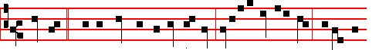
Know ye * that the kingdom of God is nigh: verily I say unto you, it will not
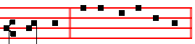
tar - ry. Psalm 113 Laudate
Antiphon 5. Tone ij.
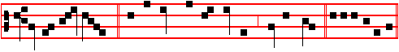
Lift up your heads, * for behold, your redemption draweth nigh Psalm 117.

Chapter Titus 3.
AFTER that the kindness and love of God our Saviour toward man appeared, not by works of righteousness which we have done, but according to his mercy he saved us.
Hymn: E.H. 17 Christe Redemptor omnium Mode j
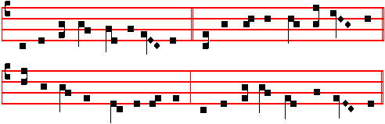
JESU, the Father's only Son, , 4 Thus testifies the present day,
Whose death for all redemption won Through every year in long array,
Before the worlds, of God most high That thou, salvation’s source aIone,
Begotten all ineffably:. Proceededst from the Father's throne.

2 The Father's light and splendour thou, 5 Whence sky, and stars, and sea’s abyss
Their endless hope to thee that bow; And earth, and all that therein is,
Accept the praycrs and praise today Shall still, with laud and carol meet,
That through the world thy servants pay The Author of thine advent greet

3 Salvation's author, call to mind 6 And we who by thy precious blood
How, taking form of humankind, From sin redeemed, are marked for God
Born of a Virgin undefiled: On this the day that saw thy birth,
Thou in man s flesh becam’st a child. Sing the new song of ransomed earth:
354
again their captivity; The Lord bless thee, O habitation of justice, and mountain of holiness.
 They worship him that liveth for ever and ever, * And cast their crowns before the throne of the Lord their God.
 And they fall down on their faces before the throne, and worship him that liveth for ever and ever. And cast. Glory be. And cast.

IN THE SECOND NOCTURN
Sermon by Saint Augustine, Bishop.
Lesson iv. Sermon 10 on the Saints
TODAY, beloved brethren, we are celebrating the birthday of those children, who, as the Gospel tells us, were slain by the cruel king Herod. Let the world rejoice with great gladness, because she is the fecund parent of this great and powerful army of heavenly soldiers. The heathen foe could never have benefitted these little ones by his goodwill as much as he did by his hatred. This day's holy festival shows that in proportion as his wickedness abounded towards these blessed little ones, so was the grace of blessedness poured forth upon them.
 The blood of the Saints have they shed like water on every side of Jerusalem. * And there was no man to bury them.
 The dead bodies of thy servants have they given to be meat unto the fowls of the air, and the flesh of thy Saints unto the beasts of the land. And there.

Lesson v .
BLESSED art thou, O Bethlehem in the land of Juda; In thee was perpetuated the wicked crime of Herod the king; his massacre of these chIldren: and therefore hast thou been found worthy to offer to God in one offering a white-robed multitude of innocent children. Most fittingly do we keep the festival of their birthday, for their birth from this world into life eternal is more blessed than that from their mothers' wombs. They attained unto life eternal and joined the ranks of the blessed before they had tasted life here on earth.
 These are Saints, who suffered for thy sake, 0 Lord; take vengeance for them, * For day by day they cry unto thee.
 Avenge, O Lord the blood of thy Saints, which is shed. For day.

Lesson vj
THE precious death of other martyrs deserves praise for its testimony - those who have fought a good fight and finished their course; but death gave glory to these Innocents at the beginning of their life, by closing it immediately. Herod in his wickedness snatched these sucklings from their mothers' breasts; rightly are they called the flowers of martyrdom, for they sprang up in the midst of the winter of unbelief as the first opening buds of the Church, and were nipped by the frost of persecution.
395
Psalm 95 Venite, exultemus Domino XCIV
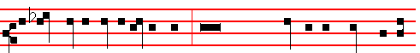
O come, let us sing unto the Lord * let us heartily rejoice in the strength of our
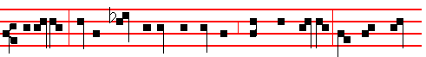
salvation. Let us come before his presence with thanksgiving; and shew our-
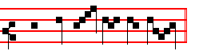
selves glad in him with psalms. Unto us.
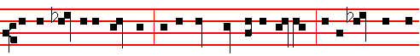
For the Lord is a great God, and a great King above all gods. In his hand are all
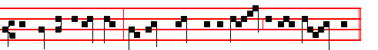
the corners of the earth, and the strength of the hills is his al - so.
O come, let us.
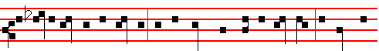
The sea is his, and he made it, and his hands prepared the dry land. O come let
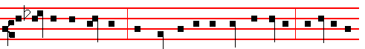
us worship and fall down, and kneel before the Lord our Maker. For he is the
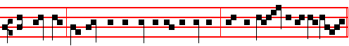
Lord our God, and we are the people of his pasture, and the sheep of his hand.
Unto us.
356
For S. Stephen, Antiphon, as above, p. 383.
Devout men carried Stephen to his burial, and made great lamentation over him.
 Stephen saw the heavens opened.
 He saw, and entered in: how blessed is the man unto whom heaven stood open.
COLLECT
GRANT us, we beseech thee, O Lord, so to imitate that which we revere: that we may leatrn to love even our enemies; forasmuch as we celebrate the birthday of him who knew how to pray even for his persecutors to our Lord Jesus Christ thy Son: Who liveth.
__________________________________________________________________

DECEMBER 28

The Holy Innocents, Martyrs
Double II Class
AlI as in the Common of Many Martyrs, except for the following:
Hymn. Audit tyrannus
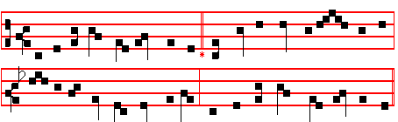

THE moody tyrant hears aghast 3 What is the gain of such a sin?
News that the King of kings at last What doth his crime for Herod win?
Hath come to rule o'er Israel's name, One from so many slain that day,
And David's royal throne to claim. The Christ is borne unharm’d away.

2 The rumour wakes his frantic cry; 4 All honour, laud, and glory be,
A king who drives me forth is nigh- O Jesu, Virgin-born, to thee;
Depart my guard, snatch up the sword: All glory, as is ever meet
Let cradles flow with blood outpoured. To Father and to Paraclete.

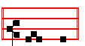
A - men.

393

IN THE FIRST NOCTURN

Antiphon. Tone viij, 2.
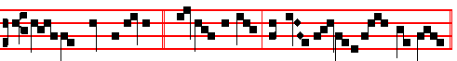
The Lord said un-to me: * thou art my Son, this day have I begot - ten thee.
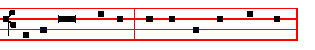
Psalm 2 Quare fremuerunt. E u o u a e.
Antiphon. Tone viij, 1.
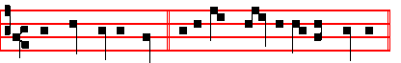
The Lord cometh forth * as a bridegroom out of his chamber.
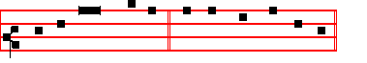
Psalm 19 Cæli enarrant. E u o u a e.
Antiphon Tone j, 4.
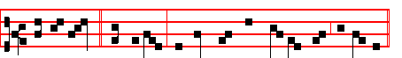
Full of grace * are thy lips, because God hath blessèd thee for ev-er.
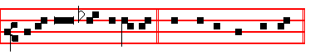
Psalm 45 Eructavit. E u o u a e.
 The Lord cometh forth.  As a bridegroom out of his chamber.
Absolution Hear, O Lord
Blessing May the blessing of the eternal.
The following Lessons from Isaiah are read without title.
Lesson j Ch. 9.
AT the first he lightly afflicted the land of Zebulun and the land of Naphtali, and afterward did more grievously afflict her by the way of the sea, beyond

358
Chapter He that feareth, as above at Lauds, p. 389.
Short  as in the Common, p. xj.
Their sound is gone out * Into all lands. Their sound.
 And their words into the ends of the world. Into all. Glory be. Their sound.
 Thou shalt make them princes in all lands.
 They shall remember thy name, O Lord.

At Sext, Antiphon This is my disciple, p. 389.
Chapter Ecclus.15
WITH the bread of understanding shall she feed him, * and give him the water of wisdom to drink.
Short  as in the Common, p. xij.
Thou shalt make them princes * In all lands. Thou shalt
 They shall remember thy name, O Lord. In all. Glory be. Thou shalt.
 Exceedingly honourable are thy friends, O God.
 Firmly established is their princedom.

At None, Antiphon Behold, my servant, p. 389.
Chapter Ecclus.15
IN the midst of the congregation shall she open his mouth. He shall find joy and a crown of gladness, and she shall cause him to inherit an everlasting name.
Short  as in the Common, p. xiij.
Right honourable are thy friends * Unto me, O God. Right honourable.
 Right well is their princedom established. Unto me. Glory be.
Right honourable.
 They declared the work of God.
 And wisely considered of his doing.

At Vespers, Antiphons and Psalms of the Nativity, as above, p. 374-5.
Chapter He that feareth, p.389.
Hymn Exultet E.H. 176 of the Common, pp. iv, 371.

 Right worthy of honour is blessed John the Apostle.
 Who leaned on the Lord's bosom at the last supper.
On Magnificat, Antiphon. Tone vj.
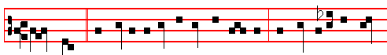
There went * this saying abroad among the brethren, that that disciple should

391
Blessing May the Only-begotten.
Lesson ij
COMFORT ye, comfort ye my people, saith your God. Speak ye comfortably to Jerusalem, and cry unto her, that that her warfare is accomplished, that her iniquity is pardoned: for she hath received of the Lord's hand double for all her sins. The voice of him that crieth in the wilderness, Prepare ye the way of the Lord, make straight in the desert a highway for our God. Every valley shall be exalted, and every mountain and hill shall be made low: and the crooked shall be made straight, and the rough places plain: and the glory of the Lord shall be revealed, and all flesh shall see it together: for the mouth of the Lord hath spoken it. The voice said, Cry. And he said, What shall I cry? All flesh is grass, and all the goodliness thereof is as the flower of the field: the grass withereth, the flower fadeth: because the spirit of the Lord bloweth upon it. Surely the people is grass. The grass withereth, the flower fadeth: but the word of our God shall stand for ever.
 II Tone viij
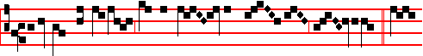
Today the true peace cometh down from hea- ven un - to us. * To-
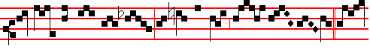
day throughout the whole world the heavens drop down sweet -ness.  To-
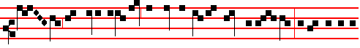
day hath risen upon us the daystar of our new redemption, of the restora-
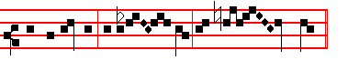
tion of the old, of eter - nal re- demp- tion. Today throughout.

Blessing May the grace of.
Lesson iij
AWAKE, awake, put on thy strength, O Zion; put on thy beautiful garments, O Jerusalem, the holy city: for henceforth there shall be no more come into thee

360
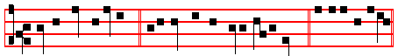
This is my disciple, * if I will that he tarry till I come. E u o u a e.
Antiphon 4. Tone j, 1.
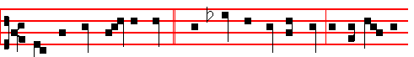
There be some standing here * which shall not taste of death till they see the
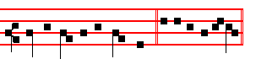
Son of man in his kingdom. E u o u a e.
Antiphon 5. Tone j, 1.
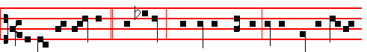
Behold, my servant, * mine elect, whom I have chosen: I have put my spi -rit
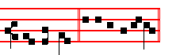
up- on him. E u o u a e.

Chapter Ecclus. 15
HE that feareth the Lord will do good; and he that hath the knowledge of the law shall obtain Wisdom, and as a mother shall she meet him.

Hymn. E.H. 176 Exsultet caelum laudibus as in the Common of Apostles out of Eastertide, p. iv, with the ending for Christmas as above, E.H. 18, p. 371.
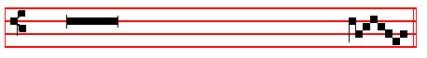
 This is that disciple which testifieth of these things.
 And we know that his testimony is true.

On Benedictus, Antiphon. Tone j, 2.
389
Psalm 48 Magnus Dominus. E u o u a e.
Antiphon. Tone iij, 1.
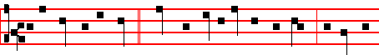
In the time of the Lord * there shall be abundance of peace, and he shall
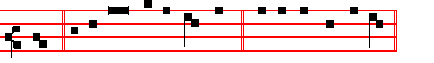
reign. Psalm 72 Deus judicium tuum. E u o u a e.
Antiphon. Tone viij, 2.
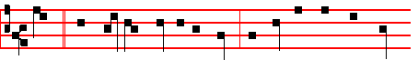
Truth * hath flourished out of the earth, and righteousness hath looked
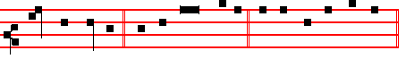
down from heaven. Psalm 85 Benedixisti E u o u a e.

 Thou art fairer than the children of men.  Full of grace are thy lips.
Absolution May his mercy.
Blessing May God the Father almighty.
Sermon by S. Leo the Great.
Lesson iv Sermon 21: On the Lord’s Nativity.
OUR Saviour, dearly beloved, is born today: let us rejoice. No trace of sadness may be permitted on this birthday of Life. This day abolishes the fear of death and fills us with joy by reason of the promise of eternal life. No-one is excluded from a share in this eagerness. The joy is for one and all: our Lord is the Destroyer of sin and death; he finds no-one free from guilt, so he comes to set every-one free. Let the Saint rejoice, for he shall soon receive his palm; let the sinner be glad, for he is offered his pardon; let the Gentile awake, for he is summoned to life. When the fullnes of time was come, that time ordained by the high and inscrutable counsel of God, the Son of God took flesh from our human

362
only with difficulty that his disciples could carry him to church, nor was he able to gather together more than a few words. It became his custom to utter only the single sentence, My little children, love one another. At length the disciples and brethren grew weary of always hearing this same thing, and said to him, Master, why do you keep on saying this? And John, with that true greatness of his, replied, Because it is the Lord's commandment, and if only it is kept, it is enough.
 In the midst of the Church he opened his mouth. * And the Lord filled him with
the Spirit of wisdom and understanding.
 He shall find joy and a crown of gladness. And the. G1ory be. And the.

IN THE THIRD NOCTURN

The Lesson from the Holy Gospel according to S. John
Lesson vij Ch. 21
JESUS saith unto Peter, Follow me. Then Peter, turning about, seeth the disciple whom Jesus loved following. And the rest.
Homily by S. Augustine, Bishop Homily 124 on John
TWO lives, therefore, preached and commended to her of God, the Church knoweth: of which, one is in faith, the other in sight, one in time of sojourning, the other in eternity of abiding; one in labour, the other in rest; one in the way, the other in its home; one in the work of action, the other in the wages of contemplation; one declines from evil and does good, the other hath no evil to decline from, and hath great good to enjoy; one fights, with the enemy, the other reigns without an enemy; one is courageous in things adverse, the other hath no sense of ought adverse.
 In that day will I take thee, O my servant, and will make thee as a signet before me. * For I have chosen thee saith the Lord.
 Be thou faithful unto death, and I will give thee a crown of life. For I have.

Lesson viij
ONE curbs carnal lusts, the other is wholly given up to spiritual delights; one is anxious with care of getting the victory, the other in the peace of the victory is without a care; one in temptations is helped, the other without any temptation rejoices in the Helper himself: one succours the needy, the other is there where it finds none needy: one forgives others' sins that its own may be forgiven, the other neither hath ought done to it that it need forgive, nor does ought that it need ask to be forgiven. One is scourged by evils that it be not lifted up in its good things, the other with such fulness of grace is free from all evil that without any temptation to pride it cleaves to the Supreme Good; one discerns between good and evil, the other beholds the things that alone are good:
 This is the same John which leaned on the Lord's breast at the last supper. *

387
heaven were yet unknown to her she was troubled at the strange annunciation, and so she learned from her conversation with the Angel that it was by the co-operation of the Holy Ghost that this thing was to happen to her: so she believed that without loss of her virginity she was soon to be the Mother of God.

 V. Tone vij
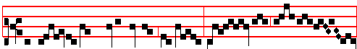
Blessed is God’s holy Mother, Ma-ry, mai-den un- de- filed. *
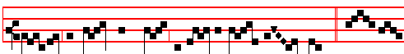
This day hath she brought forth the Saviour of the world.  Bles- sed
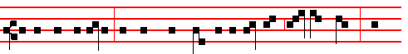
is she that believed, for there hath been a performance of those things which
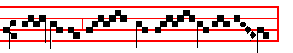
were told her of the Lord. This day hath.

Blessing May God enkindle.
Lesson vj
LET us give thanks, dearly beloved, to God the Father, through his Son, in the unity of the Holy Spirit; for God who is rich in mercy towards us, even when we were dead in our sins hath quickened us together with Christ, and made us to be a new creature in him, and a new workmanship. Let us put off the old man with his deeds: and let us obtain a share in Christ's sonship, laying aside the works of the flesh. O Christian, learn how great you have become, you who have been made a partaker of the divine nature. Do not return to the former vileness of your old and corrupt conversation. Remember the Head and Body of which you are a member. Never forget that you have been delivered out of the power of darkness and translated into the light and kingdom of God.

 VI. Tone ij

364
ON THE FEAST OF S. JOHN, APOSTLE AND EVANGELIST
DOUBLE of the SECOND CLASS.
At Matins, Invitatory, Hymn, Antiphons, Psalms, and  of the Nocturns from the Common of Apostles.

IN THE FIRST NOCTURN

The Beginning of the First Epistle of S.John the Apostle.
Lesson j Ch. 1, 1-10
THAT which was from the beginning, which we have heard, which we have seen with our eyes, which we have looked upon, and our hands have handled, of the Word of life; (for the life was manifested, and we have seen it and bear witness, and shew unto you that eternal life, which was with the Father, and was manifested unto us;) that which we have seen and heard declare we unto you, that ye also may have fellowship with us: and truly our fellowship is with the Father, and with his Son Jesus Christ. And these things write we unto you, that your joy may be full. This then is the message which we have heard of him, and declare unto you, that God is light, and in him is no darkness at all.
 Right worthy of honour is blessed John, who leaned on the Lord's breast at the last supper. * To him did Christ upon the cross commit his Mother, as virgin to virgin.
 As a virgin he was chosen by the Lord, who loved him more than the others. To him did.

Lesson ij
IF we say that have fellowship with him, and walk in darkness, we lie, and do not the truth: but if we walk in the light, as he is in the light, we have fellowship one with another, and the blood of Jesus Christ his Son cleanseth us from all sin. If we say that we have no sin, we deceive ourselves, and the truth is not in us. If we confess our sins, he is faithful and just to forgive us our sins, and to cleanse us from all unrighteousness. If we say a that we have not sinned, we make him a liar, and his word is not in us.
 This is the disciple which testifieth of these things, and wrote these things: * And we know that his testimony is true.
 He drank the flowing Gospel from the sacred fountain of the Lord's breast. And we know.

Lesson iij
MY little children, these things write I unto you, that ye sin not. And if any man sin, we have an advocate with the Father, Jesus Christ the righteous: and he is the propitiation for our sins: and not for ours only, but also for the sins of the whole world. And hereby we do know that we know him, if we keep his

385
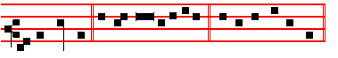
for he cometh. Ps.96 Cantate Domino E u o u a e.
Antiphon. Tone vj
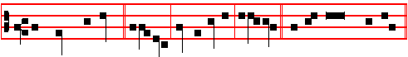
The Lord declared, * alleluia, his salvation, alleluia. Psalm 98 Cantate Dno.
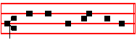
E u o u a e.
 He shall call me, alleluia.  Thou art my Father,
Blessing May the Gospel Lection be to us salvation and protection.  Amen.
The Lesson from the Holy Gospel according to S. Luke
Lesson vij Ch. 2.
THERE went out a decree from Cæsar Augustus, that all the world should be enrolled.
Homily by S. Gregory the Great Homily 8 on the Gospels
BY the bounty of the Lord, we celebrate three solemn Masses to-day, so that we cannot spend long on the Gospel lesson; yet because it is the Lord's Birthday we must say a few words. Why was it that all the world was enrolled when the Lord was born? It was to show plainly that he who was going to enter up his chosen ones in the book of eternal life was now appearing in flesh. Concerning the reprobate, it is said in the words of the Psalmist, Let them be wiped out of the book of the living, and not be written among the righteous. It is fitting that he was born in Bethlehem, for Bethlehem means, House of Bread, and he it was who said, I am the living bread which came down from heaven. Therefore his birth-place was called in former times, The House of Bread, as a prophecy that he who would be born there was going to replenish the souls of his chosen ones with spiritual refreshment. There was also a reason for his being born while on a journey, instead of at his parents’ home: he was born in the human flesh which he assumed, as in a strange land.
 VII. Tone vij
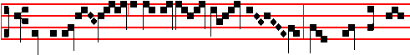
Blessed is the womb of the Virgin Ma- ry, which bore the Son
366
Chapter Acts 6
THEN there arose certain of the synagogue, which is called the synagogue of the Libertines, and Cyrenians, and Alexandrians, and of them of Cilicia and of Asia, disputing with Stephen. And they were not able to resist the wisdom and the spirit by which he spake.
Short  , as p. xl.
Thou hast set * Upon his head, O Lord. Thou hast set.
 A crown of pure gold. Upon his. Glory be. Thou hast set.
 His honour is great in thy salvation.
 Glory and great worship shalt thou lay upon him.

At None Antiphon Behold, I see, p. 381.
Chapter Acts 7
AND he kneeled down, and cried with a loud voice, Lord, lay not this sin to their charge. And when he had said this, he fell asleep.
Short , as p. xlj.
His honour is great * in thy salvation. His honour.
 Glory and great worship shalt thou lay upon him. In thy. Glory be. His honour.
 The righteous shall flourish like a palm-tree.
 And shall spread abroad like a cedar in Libanus.

At Vespers, Antiphons and Psalms of the Nativity, as above, pp.374-5.
And they are said also in other Feasts occurring in this Octave.
Chapter And Stephen, as above at Lauds, p. 381.

Hymn E.H. 18l Deus tuorum militum, as in the Common, p. xxix, with ending for Christmas as above, p. 371.
 Stephen saw the heavens o- -pened.
 He saw, and entered in: how blessed
is the man unto whom heaven stood o- -pen.

On Magnificat, Antiphon. Tone viij, 1.
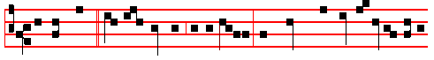
Devout men * carried Stephen to his burial, and made great lamentation over

383
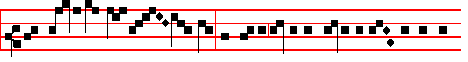
And we beheld his glo - ry, the glory as of the Only-begot - ten of the
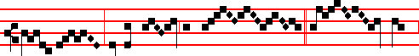
Fa - ther, full of grace and truth.  All things
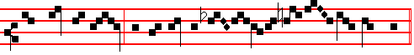
were made by him; and without him was not a-ny thing made that was made.
And we.
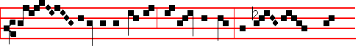
Glo - ry be to the Fa-ther, and to the Son, and to the
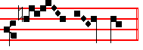
Ho - ly Ghost. And we.

Blessing. May Christ the the Son of God teach us the words of the holy Gospel.  Amen.
The Lesson from the Holy Gospel according to S. John.
Lesson ix
IN the beginning was the Word, and the Word was with God, and the Word was God.
Homily by S. Augustine, Bishop Homily 1 on John
LEST thou shouldest suppose it to mean ought so valueless as thou hast used thyself to associate with the customary mention of man's words, hear what meaning thou must associate with this Word: The Word was God. Now let some unbelieving Arian stand forth, and say. The Word of God was made. How could the Word of God be made, when, by the Word, God made all things? If the Word of God was Itself also made, by what other Word was It made? If thou meanest this; that there is the Word of the Word; then this Word by which that was made the same I call the only-begotten Son of God. But if thou dost not mean the Word

368
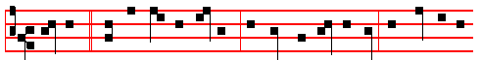
Stephen * saw the heavens opened; he saw, and entered in: how blessed is
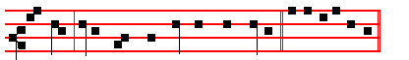
the man unto whom the heaven stood open! E u o u a e.
Antiphon 5. Tone iv, 1.
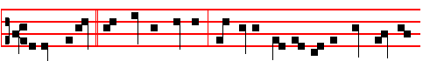
Behold, I see * the heavens opened; and Jesus standing on the right hand of
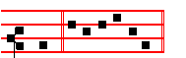
God. E u o u a e.
Chapter Acts 6
AND Stephen, full of faith and power, did great wonders and miracles among
the people.
Hymn. E.H. 180 Martyr Dei qui unicum, p.xxxviij, but with the ending for Christmas as above, E.H. 18, p. 371.
 Devout men carried Spephen to his buri - al.
 And made great lamentation over him.
On Benedictus, Antiphon. Tone viij, 2.
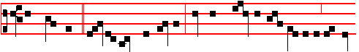
And Stephen, full of faith and power, did great wonders and miracles among
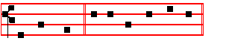
the peo- ple. Canticle Benedictus, p. 39.

381
Antiphon 3. Tone vij, 4.
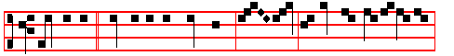
The Angel * said unto the shepherds, Be - hold, I bring you joyful tidings:
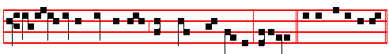
for unto you is born this day the world's Redeemer, alleluia. E u o u a e.
Antiphon 4. Tone vij, 4.
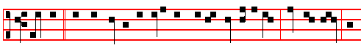
There was * with the Angel a multitude of the heavenly host, praising God, and
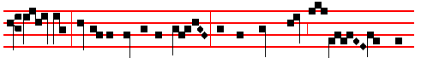
say- ing, Glory to God in the highest, and on earth peace to men of
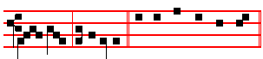
good will, al-le-lu-ia. E u o u a e.
Antiphon 5. Tone viij, 1.
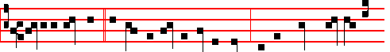
Unto us this day * a Child is born a Son is given: and his Name shall be the
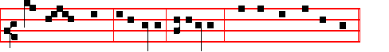
migh-ty God, al-le-lu-ia, al-le-lu-ia. E u o u a e.
Chapter Heb. l
GOD,who at sundry times and in divers manners spake in time past unto the fathers by the prophets, hath in these last days spoken unto us by his Son, whom he hath appointed heir of all things, by whom also he made the worlds.

370
JESUS said unto the scribes and Pharisees: Behold, I send unto you prophets, and wise men, and scribes, and some of them ye shall kill and crucify.
Homily by S. Jerome, Priest Commentary on Matthew Ch. 23
AS we have said before, the words, Fill ye up then the measure of your fathers,
may be applied to the Person of the Lord, he who was to be slain by them; they may also apply to his disciples, as he was now referring to them in saying, Behold, I send unto you prophets, and wise men, and scribes. In connection with this, note that, according to the Apostle's letter to the Corinthians, the gifts given to the disciples were manifold: some were made prophets, to foretell his advent; others were gifted with wisdom, to know when was the acceptable time to preach the word; others became most learned scribes, versed in the law, and among all these, Stephen was stoned, Paul was slain, Peter was crucified, and the disciples
mentioned in the Acts of the Apostles were scourged.
 Stephen the servant of God, who was stoned by the Jews, saw the heavens opened: he saw, and entered in. * Blessed is the man, unto whom heaven lay open.
 While he was crushed by the hurtling shower of stones, God’s brightness broke upon him out of heavenly places. Blessed.

Lesson viij
WHO was this Zacharias, son of Barachias, for we read of more than one Zacharias? To prevent a mistake, Whom ye slew between the temple and the altar, is added. I have read different opinions about this in different places, and so I must give you each of them. Some say that this Zacharias is the eleventh of the twelve prophets, and the giving of the father's name agrees with this: but there is no mention in the Bible of his being slain between the temple and the altar, and this is not to be wondered at, for in his time scarcely the ruins of the temple were left standing. Others would understand by Zacharias the father of John, relying on the evidence of certain phantasies of apocryphal writers which make out that he was slain for preaching the advent of the Saviour.
 The gates of heaven were opened to Christ's blessed Martyr Stephen, and he is found the first among all the Martyrs. * Wherefore he reigneth crowned in heaven.
 For he was the first to make an offering of his death to that Saviour who vouchsafed to suffer death for us. Wherefore. Glory be. Wherefore.

Lesson ix
OTHERS again would say that this is the Zacharias who was slain by Joash king of the Jews, between the temple and the altar, as it is written in the Books of the Kings. But notice here that this Zacharias was the son, not of Barachias, but of Jehoiada the priest, whence the Bible says that Joash remembered not the kindness which Jehoiada his father had done to him. The evidence here agrees, both in the man named Zacharias, and in the place where he

379
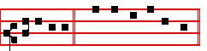
al-le-lu-ia. Canticle Benedictus, p. 39.
COLLECT
GRANT we beseech thee, almighty God: that we who through our ancient bondage are held beneath the yoke of sin; may by the new Birth of thine Only-begotten Son in the flesh obtain deliverance. Through the same.

In the morning Prime is said: which being ended, is celebrated the second Mass at Dawn, and in it commemoration is made of S. Anastasia, Martyr.

AT PRIME
Antiphon Whom beheld ye, p. 369.
Chapter Now unto the King.
Short  O Christ, Son of the living God, * Have mercy upon us.
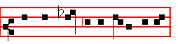
 Who wast born of the Virgin Ma-ry.
And thus it is said daily until the Epiphany.
At the close of the Chapter, short Lesson They shall perish, as below at None.
At Terce is said its Hour, which being ended, is celebrated the third Mass of Christmas Day.

AT TERCE
Antiphon. She that travailled.
Chapter. God, who at sundry.
Short  .
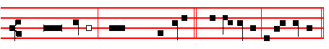
The Word was made flesh, * Al-le- lu- ia, al- le- lu-ia.
The Word.
 And dwelt among us. Al-le- lu- ia, al- le- lu-ia.
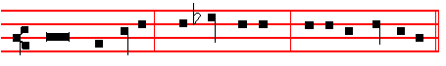
Glory be to the Fa-ther, and to the Son, and to the Ho- ly Ghost.
The Word.
372
Lesson ij
ND the saying pleased the whole multitude: and they chose Stephen, a man full of faith and of the Holy Ghost, and PhIlip, and Prochorus and Nicanor, and Timon, and Parmenas, and Nicolas a proselyte of AntIoch: whom they set before the apostles: and when they had prayed, they laid their hands on them. And the word of God increased; and the number of the disciples multiplied in Jerusalem greatly; and a great company of the priests were obedient to the faith. And Stephen, full of faith and power, did great wonders and miracles among the people.

A
 All that sat in the council, looking steadfastly on Stephen, saw * His face as it had been the face of an Angel standing among them.
 Full of grace and power, he did great wonders and miracles among the people. His face.

Lesson iij
THEN there arose certain of the Synagogue which is called the synagogue of the Libertines and Cyrenians and Alexandrians and of them of Cilicia and of Asia disputing with Stephen. And they were not able to resist the wisdom and the spirit by which he spake. Then they suborned men, which said, We have heard him speak blasphemous words against Moses, and against God. And they stirred up the peopIe, and the elders, and the scribes, and came upon him, and brought him to the council, and set up false witnesses, which said,This man ceaseth not to speak blasphemous words against this holy place, and the law.
 Blessed Stephen looked up steadfstly into heaven, and saw the glory of God, and said: * Behold, I see the heavens opened, and the the Son of Man standing at the right hand of the power of God.
 But Stephen, being full of the Holy Ghost looked up stesdfastly into heaven, and said: Beho1d. G1ory be. Behold

IN THE SECOND NOCTURN

Sermon by S. Fulgentius, Bishop.
Lesson iv Sermon III on S. Stephen.
YESTERDAY we celebrated the birth in time of our eternal King: to-day we celebrate the triumphant passion of his soldier. For yesterday our King, clothed in the robe of flesh, proceeding forth from his palace in the Virgin's womb, condescended to visit the world. To-day his soldier, coming forth from his
tent of the body, migrates as a conqueror to heaven. The former, while conserving the majesty of his everlasting Divinity, assumes and girds himself in the servile garment of the flesh, and enters the battle-ground of this world, to come and fight;

377
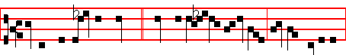
In the day of thy power * shall the people offer thee free-will offerings
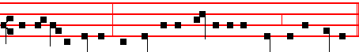
with an holy worship: the dew of thy birth is of the womb of the morning.
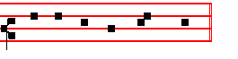
Psalms 110, 111, 112, of Sunday, 130 De Profundis and 132 Memento, Domine.
Antiphon 2. Tone vij, 3.
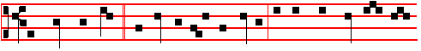 The Lord hath sent * redemption unto his peop1e: he hath command-ed his
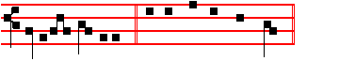
covenant for ever . Psalm 111 Confitebor, p. 202.
Antiphon 3. Tone vij, 3 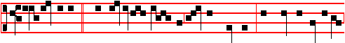
Unto the godly * there a- ris-eth up light in the darkness: the Lord is merciful,
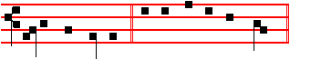
loving, and righteous. Psalm 112 Beatus vir, p. 203
Antiphon 4. Tone iv, 1
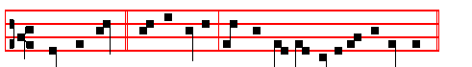 With the Lord * there is mercy, and with him is plenteous redemption.
374
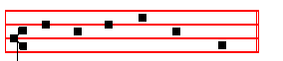
Psalm 130 De profundis CXXIX , p. 223.
Antiphon 5. Tone viij, 1.
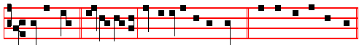 Of the fruit * of thy body shall I set upon thy seat. Psalm 132 Memento, Domine, CXXI, p.225. Chapter God who at sundry, as above at Lauds, p. 370.
Hymn. E.H. 17 Christe Redemptor omnium, as above in I Vespers, p. 354.
 The Lord declared, allelu - ia.
 His salvation, allelu - ia.
On Magnificat, Antiphon Tone j, 1.
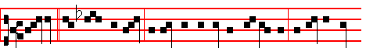
Today * the Christ is born; today hath a Saviour appeared: today on earth
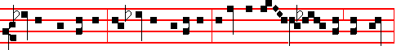
Angels are singing, Archangels rejoicing: today the righteous ex-ult and say,
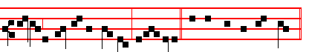
Glory to God in the highest, alleluia. Canticle Magnificat, p. 209.
Collect Grant, as above at Lauds, p. 372.

Then for commemoration of S.Stephen, Antiphon. Tone viij, 2.
And Stephen, * full of faith and power, did great wonders and miracles among

375

