 These are they which. have not defiled their garments, * They shall walk with me in white, for they are worthy.
 These are they which are not defiled with women, for they are virgins. They shall. Glory be. They shall.

IN THE THIRD NOCTURN

In place of the second Antiphon They gave up, is said the following Antiphon 8. These are they which came out of great tribulation, and have washed their robes, and made them white in the Blood of the Lamb.

The Lesson from the Holy Gospel according to S. Matthew
Lesson vij Ch. 2

THE angel of the Lord appeareth to Joseph in a dream, saying, Arise, and take the young child and his mother, and flee into Egypt, and be thou there until I bring thee word.
Homily by S. Jerome, Priest. Book 1. Commentary on Matthew Ch. 2
WHEN Joseph took the Child and his Mother and fled into Egypt, he took them by night, in darkness: because he left the night of ignorance to those unbelievers from whom he fled. But on his return to Judæa, neither light nor darkness are mentioned in the Gospel, because at the end of the world the Jews will receive the light of faith, as though receiving Christ returning from Egypt.
 The Saints sung a new song before the throne of God and the Lamb; * And their voices resounded on earth.
 These were redeemed from among men, being the first-fruits unto God, and to the Lamb, and in their mouth was found no guile. And their voices.

Lesson viij
THAT it might be fulfilled which was spoken of the Lord by the prophet, saying, Out of Egypt have I called my son. Let those who deny the truth of the Hebrew Scriptures ask where this is to be found in the Septuagint version. Though they do not find it there, yet we declare that it was written in the Book of Hosea, as the copies which we have recently published prove.
 I saw under the altar of God the souls of them that were slain for the Word of God which they held, and they cried with a loud voice: * Avenge, O Lord, the blood of thy Saints which is shed.
 Under the throne of God all the Saints cry aloud. Avenge.

If this Feast comes on a Sunday, then at the end of the aforesaid eighth  is added Glory be. Avenge. And after the ninth Lesson (omitting the ninth ) is said Te Deum Laudamus. On other days, as below.
396
ON THE NATIVITY OF THE LORD

DOUBLE OF THE FIRST CLASS
AT VESPERS

Antiphon 1 Tone viij, 1.
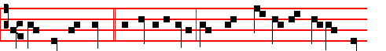
THE King of peace * is highly exalted, for whose countenance all the earth
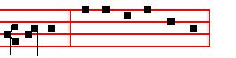
longeth. Psalms 110, 111, 112, 113 of Sunday, p. 201-4, and in the last place 117 Laudate Dominum as in I Vespers of Apostles, p. iij.
Antiphon 2. Tone vij, 3.
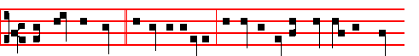
The King of peace * is highly exalted, exceeding the kings of the whole
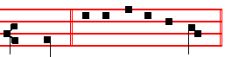
earth. Psalm 111 Confitebor
Antiphon 3. Tone viij, 1.
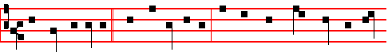
The days of Mary * were accomplishèd; that she should bring forth her first-
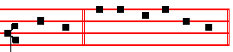
born Son. Psalm 112 Beatus vir

Antiphon 4. Tone viij, 1.

353
The Antiphons, Psalms and  of the Nocturns are taken from the Common of many Martyrs, except the second Antiphon of the III Nocturn, as is noted in its place below.
IN THE FIRST NOCTURN
From the Prophet Jeremiah
Lesson j Ch. 31.
THUS saith the Lord; A voice was heard in Ramah, lamentation, and bitter weeping; Rachel weeping for her children refused to be comforted for her children, because they were not. Thus saith the Lord; Refrain thy voice from weeping, and thine eyes from tears: for thy work shall be rewarded, saith the Lord; and they shall come again from the land of the enemy. And there is hope in thine end, saith the Lord, that thy children shall come again to their own border.
 An hundred forty and four thousand which were redeemed from the earth, these are they which are not defiled with women. * For they are virgins; therefore are they reigning with God, and the Lamb of God is with them.
 These are they which came out of great tribulation, and have washed their robes, and made them white in the Blood of the Lamb. For they.

Lesson ij
IHAVE surely heard Ephraim bemoaning himself thus; Thou hast chastised me, and I was chastised, as a bullock unaccustomed to the yoke: turn thou me, and I shall be turned; for thou art the Lord my God. . Surely after that I was turned, I repented; and after that I was instructed, I smote upon my thigh: I was ashamed, yea, even confounded, because I did bear the reproach of my youth. Is Ephraim my dear son? is he a pleasant child? for since I spake against him, I do earnestly remember him still: therefore my bowels are troubled for him; I will surely have mercy upon him, saith the Lord.
 I heard under the altar of God the voices of them that were slain, saying: * How long dost thou not avenge our blood? And it was said unto them from God: Rest yet for a little season, until the number of your brethren be fulfilled.
 I saw under the altar of God the souls of them which were slain for the Word of God, and for the testimony which they held, and they cried with a loud voice, saying. How long.

Lesson iij
SET thee up waymarks, make thee high heaps: set thine heart toward the highway, even the way which thou wentest: turn again, O virgin of Israel, turn again to these thy cities. How long wilt thou go about, O thou backsliding daughter! For the Lord hath created a new thing in the earth. A woman shall compass a man. Thus saith the Lord of hosts, the God of Israel; As yet they shall use this speech in the land of Judah and in the cities thereof, when I shall bring

394
But with this conclusion : 7 All honour, laud, and glory be,
O Jesu, Virgin-born, to thee;
All glory, as is ever meet,
To Father and to Paraclete.
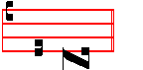
A - men.
Thus end all hymns of the same metre until Epiphany.
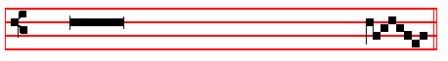
 Tomorrow the iniquity of the earth shall be blotted out.
 And the Saviour of tbe world shall reign over us.
On Magnifieat, Antiphon. Tone viij, 1.
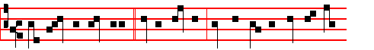
When the sun hath risen * in the heavens, ye shall see the King of kings
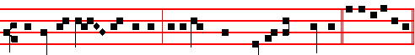
proceeding from the Father, as a bridegroom out of his chamber. Cant. Magn.

COLLECT

GRANT, we beseech thee, almighty God: that we, who through our ancient bondage are held beneath the yoke of sin; may bythe new birth of thine only-begotten Son in the flesh obtain deliverance.Through the same.

At Compline the Tone of the Hymn as above at Vespers.

At Matins, Invitatory. Tone iv
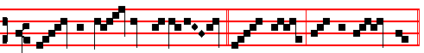
Un - to us Christ is born * O come, let us wor - ship.
Repeat. Un - to us.
355
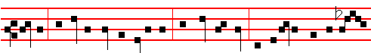
not die: yet Jesus said not unto him, He shall not die; but, If I will that he tar-
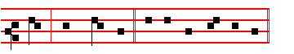
-ry till I come. Canticle Magnificat, p. 211.
Collect O Lord, graciously, as above at Lauds, p. 390.
Then for the Holy Innocents, Antiphon. Tone j, 2.
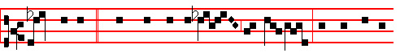
These are they * which were not defiled with wo-men; for they are vir-
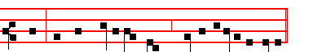
-gins: and they follow the Lamb whithersoever he goeth.
 Herod was exceeding wroth, and slew many child- ren.
 In Bethlehem Judah, the city of Da- vid.
COLLECT
O GOD, whose praise the Innocents thy Martyrs did this day not by speaking but by dying confess: mortify all evil vices in us; that, as our tongues confess thy faith, so our lives may by their actions set forth the same. Through.
Then commemoration is made of the Nativity, as above, p. 382
Antiphon. Today * the Christ is born; today hath a Saviour appeared: today on earth Angels are singing, Archangels rejoicing: today the righteous exult and say, Glory to God in the highest, alleluia.
 The Lord declared, alleluia.  His salvation, alleluia.
COLLECT
GRANT we beseech thee almighty God: that we who through our ancient bondage are held beneath the yoke of sin;may by the new Birth of thine only-begotten Son in the flesh obtain deliverance. Through the same.

392
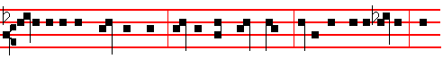
Today if ye will hear his voice, harden not your hearts, as in the provocation, and
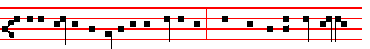
as in the day of temptation in the wilderness; When your fathers tempted me,
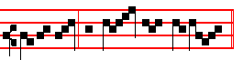
provèd me, and saw my works. O come, let us.
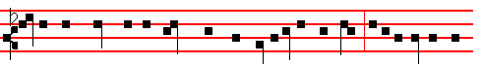
Forty years long was I grieved with this generation and said, It is a people that
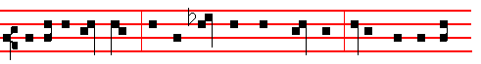
do err in their hearts, for they have not known my ways: Unto whom I sware
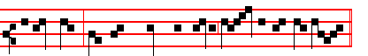
in my wrath, that they should not enter in - to my rest. Unto us.
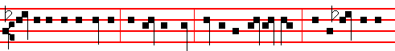
Glory be to the Father, and to the Son, and to the Holy Ghost; As it was in the
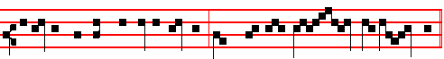
beginning, is now, and ever shall be, world without end. A - men.
O come, let us. Unto us.

Hymn. E. H. 17 Christe Redemptor omnium, as above at Vespers.

357
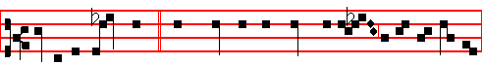
This is the same John, * who leaned on the Lord's bo- som at the last supper:
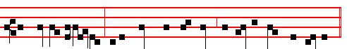
the blessed Apos-tle, unto whom were revealed the secret things of heaven.
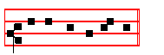
Canticle Benedictus, p. 39.
COLLECT

O LORD, graciously illumine thy Church: that it, being enlightened by the doctrine of blessed John thine Apostle and Evangelist, may attain unto everlasting gifts. Through.

Then commemoration is made of the Nativity, Antiphon, as above, p. 382. Glory to God in the highest, and on earth peace to men of good will, alleluia, alleluia.
 The Lord declared, alleluia.  His salvation, alleluia.

COLLECT
GRANT, we beseech thee, almighty God: that we who through our ancient bondage are held beneath the yoke of sin; may by the new Birth of thine only-begotten Son in the flesh obtain deliverance.Through the same.

For S. Stephen, Antiphon, as above, p. 381. And Stephen, full of faith and power, did great wonders and miracles among the people.
 Devout men carried Stephen to his burial.
 And made great lamentation over him.

COLLECT
GRANT us, we beseech thee, O Lord, so to imitate that which we revere: that we may learn to love even our enemies; forasmuch as we celebrate the birthday of him who knew how to pray even for his persecutors to our Lord Jesus Christ thy Son: who liveth.
At Terce, Antiphon This is that disciple, p. 388

390
Jordan, in Galilee of the nations. The people that walked in darkness have seen a great light: they that dwell in the land of the shadow of death, upon them hath the light shined. Thou hast multiplied the nation, thou hast increased the joy: they joy before thee according to the joy in harvest, and as men rejoice when they divide the spoil. For thou hast broken the yoke of his burden, and the staff, of his shoulder, the rod of his oppressor, as in the day of Midian. For every battle of the warrior is with confused noise, and garments rolled in blood; but this shall be with burning and fuel of fire. For unto us a child is born, unto us a son is given: and the government shall be upon his shoulder; and his name shall be called: Wonderful, Counsellor, The mighty God, The everlasting Father, The Prince of Peace.
Responsory I Tone v
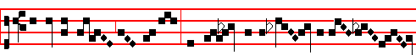
Today the King of heaven was pleased to be born of a Vir - gin
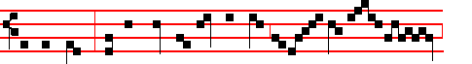
for our sakes, that he might restore lost man to the hea-ven - ly
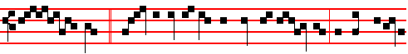
king - dom. * There is joy among the host of An - gels, because eternal
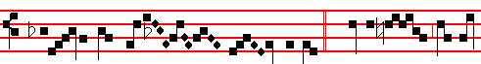
salvation hath ap-peared un - to men.  Glory to God in
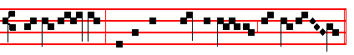
the high - est, and on earth peace to men of good will. There is joy.
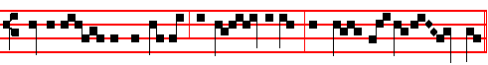
 Glory be to the Fa-ther, and to the Son, and to the Ho-ly Ghost.
 To-day the King is repeated as far as unto men.
359
The blessed Apostle unto whom were revealed the secret things of heaven.
 He drank the flowing Gospel from the sacred fountain of the Lord's breast. The blessed. Glory be. The blessed.

Lesson ix
THEREFORE the one is good but as yet wretched; the other better, and blessed. The first is signified by the Apostle Peter; the last by John.The first is wholly spent here even unto the end of this world, and there finds an end; the last is deferred, to be completed after the end of this world, but in the world to come hath no end. Therefore concerning this it is said, Follow me; but of that other, Thus will I that he tarry till I come; What is that to thee? Follow thou me. For what is this? So far as I take it in, what is this but, Follow thou me, by copying the pattern of enduring temporal evils; let the other tarry till I come, to render the good things that are for ever and ever.
Te Deum Laudamus.

AT LAUDS, and through the Hours
Antiphon 1. Tone viij, 1.
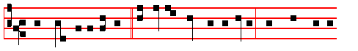
Right worthy of honour * is blessed John the Apostle, who leaned on the
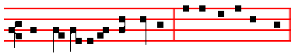
Lord's bosom at the last supper. E u o u a e. Psalm 93 Dominus regnavit, and the rest, p..
Antiphon 2. Tone iij, 1.
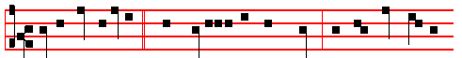
This is that disciple * which testifieth of these things: and we know that his
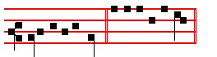
testimony is true. E u o u a e.

Antiphon 3. Tone iij, 1.

388
the uncircumcised and unclean. Shake thyself from the dust; arise, and sit down, O Jerusalem: loose thyself from the bands of thy neck, O captive daughter of Zion. For thus saith the Lord God, My people went down aforetime into Egypt to sojourn there; and the Assyrian opporessed them without cause. Now, therefore, what have I here, saith the Lord, that my people is taken away for nought? They that rule over them make them to howl, saith the Lord; and my name continually every day is blasphemed. Therefore my people shall know my name: therefore they shall know in that day that I am he that doth speak: behold, it is I.
 III Tone iv
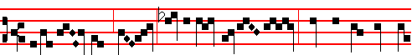
O ye shep- herds, speak, tell us what ye have seen: who hath appeared u-
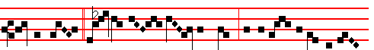
pon the earth? * We saw the new- born Child, and a mul- titude of the
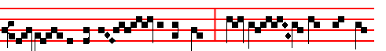
hea-ven - ly host prais - ing the Lord.  Tell us what ye have
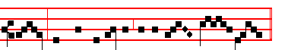
seen, and bring us tidings of the birth of Christ. We saw.
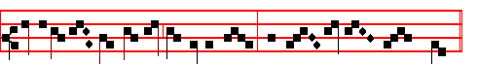
Glory be to the Father, and to the Son, and to the Ho - ly Ghost.
We saw.

IN THE SECOND NOCTURN
Antiphon. Tone viij, 1.
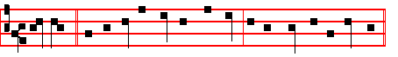
We wait * for thy loving-kindness, O God, in the midst of thy temple.

361
commandments. He that saith, I know him, and keepeth not his commadments, is a liar, and the truth is not in him. But whoso keepeth his word, in him verily is the love of God perfected.
 This is that most blessed Apostle and Evangelist John, * Who was found worthy to be honoured by the Lord above all others, with a sIngular privilege of love.
 This is the disciple whom Jesus loved, who leaned on the Lord's bosom at the last supper. Who was. Glory be. Who was.

IN THE SECOND NOCTURN

From the book of S. Jerome, Priest on Ecclesiastical Writers.
Lesson iv Ch. 9
JOHN the Apostle whom Jesus loved most, was the son of Zebedee, and the brother of James the Apostle, who was beheaded by Herod soon after the Lord's Passion. He was the last of the four to write his Gospel, and he wrote it at the request of the bishops of Asia, to combat Cerinthus and other heretics, and against
the rising dogma of the Ebionites who asserted that Christ had not existed before Mary: thus he was compelled to expound his divine nature.
 Him that overcometh will I make a pillar in my temple, saith the Lord. * And
I will write my Name upon him, and the name of the city, which is New Jerusalem.
 To him that overcometh will l give to eat of the tree of life, which is in the midst of the paradise of my God. And I will.

Lesson v
FOURTEEN years after Nero, when the second persecution arose at the instigation of Domitian, John was banished to the Island of Patmos, where he wrote the Revelation and both Justin Martyr and Irenæus have written commentaries on it. On the death of Domitian the Senate annulled his acts, shocked by his excessive cruelty. Then John returned to Ephesus, during the reign of Nerva, and from there until the time of Trajan, he both founded and governed Churches throughout Asia. He lived to a great age, and died in the sixty-eighth year after the Lord’s Passlon, and was buried at Ephesus.
 Jesus loved him, for his special mark of chastity made him worthy of greater love. * He chose him for a virgin unto himself, and he remalneth a virgin for ever.  At the end, when he was dying upon the cross, he committed his Mother to him, as virgin to virgin. He chose.

Lesson vj
BLESSED John lived to an extreme old age and at the end of his life it was

386
nature, that he might reconcile that nature to its Creator, and that the devil, the inventor of death, might be overcome by that same flesh which had been the cause of his victory.
 iv Tone iij
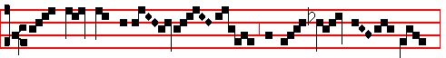
O great myster-y . . . . . and wond- rous sac- ra- ment,
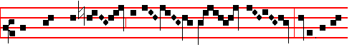
that beasts may see the new - born Lord lying in a
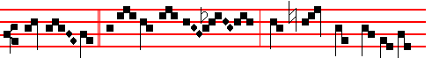
man - ger. * O blessed Vir-gin, whose womb was worthy to
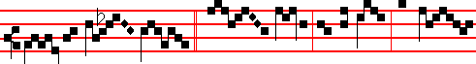
bear the Lord Christ.  Hail , Mary, full of grace, the Lord
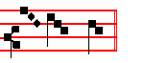
is with thee. O blessed.

Blessing. May Christ grant to us.
Lesson v
GOD joins battle on our behalf, and there is a great and wonderful equity in the
battle-array; for Almighty God comes forth to meet our raging foe, armed, not in his majesty, but in our weakness. He meets him with the same body, the same nature, even with a share of our mortality, yet with no spot of sin. How different is this Child's birth from all others; it is written: No-one is free from tainting sin, not even an infant that has lived but one day on the earth. Now no spot of the concupiscence of the flesh had penetrated into this unique Birth, no trace of the law of sin remained. A royal virgin of the stem of David was chosen; she who was, to be pregnant with holy Fruit, conceived mentally before bodily that Offspring of hers who was both human and divine. While the counsels of

363
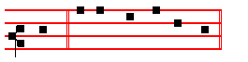
him. Canticle Magnificat, p. 211.
Collect Grant us, as above at Lauds, p. 382
Then for S.John, Antiphon. Tone j, 2.
This is the same John, * who leaned upon the Lord's bosom at the last supper:
the blessed Apos-tle, unto whom were revealed the secret things of heaven.
 Right worthy of honour is blessed John the Apos - tle.
 Who leaned on the Lord's bosom at the last sup - per.

COLLECT

O LORD, graciously illumine thy Church: that it, being enlightened by the doctrine of blessed John thine Apostle and Evangelist, may attain unto everlasting gifts.Through.

Then commemoration is made of the Nativity. Antiphon as above, p. 382.
Today the Christ is born; today hath a Saviour appeared: today on earth Angels are singing, Archangels rejoicing: today the righteous exult and say, Glory to God in the highest, alleluia.
 The Lord declared,alleluia.  His salvation, alleluia.

COLLECT

GRANT we beseech thee almighty God: that we who through our ancient bondage are held beneath the yoke of sin; may by the new Birth of thine only-begotten Son in the flesh obtain deliverence. Through the same.

384
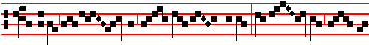
O holy and spot- less vir- gin- i-ty! I know not how to
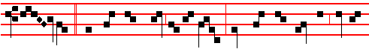
praise thee, * For thou hast borne in thy breast him whom the heavens cannot
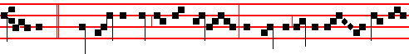
contain.  Bles-sed art thou among wo-men, and blessed is the fruit of thy
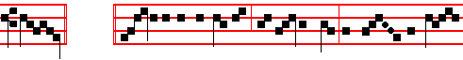
womb. For thou. Glory be to the Father, and to the Son, and to the Ho-
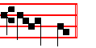
ly Ghost. For thou.

IN THE THIRD NOCTURN
Antiphon. Tone vj
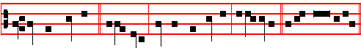
He shall call me, * alle- luia; thou art my Father, alle-luia. Psalm 89 Miseri-
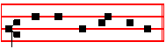
cordias Domini. E u o u a e.
Antiphon. Tone iv
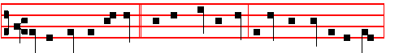
Let the heavens rejoice * and the earth be glad before the face of the Lord,

365
COLLECT

GRANT us, we beseech thee, O Lord, so to imitate that which we revere: that we may learn to love even our enemies; forasmuch as we celebrate the birthday of him who knew how to pray even for his persecutors to our Lord Jesus Christ thy Son: Who liveth.
Then commemoration is made of the Nativity.
Antiphon. Tone viij, 1.
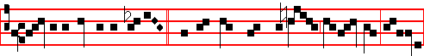
Glory to God in the highest, and on earth peace to men of good will, alleluia,
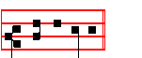
al - le -lu -ia.
 The Lord declared, allelu- ia.
 His salvation,allelu- ia.

COLLECT
GRANT we beseech thee,almighty God: that we who through our ancient bondage are held beneath the yoke of sin; may by the new birth of thine only-begotten Son in the flesh obtain deliverance.Through the same.

At Prime, Who wast born, p. 372.

At Terce, Antiphon The stones of the torrent, p. 380.
Chapter And Stephen, as above, p. 381.
Short  , as p.xxxix.
Thou hast crowned him * With glory and honour, O Lord. Thou hast.
 And madest him to have dominion of the works of thy hands. With glory.
Glory be. Thou hast.
 Thou hast set upon his head, O Lord.  A crown of pure gold.

At Sext, Antiphon My soul, p. 380.

382
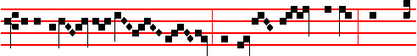
of the Eter- nal Fa- ther, and blessed are the paps which gave
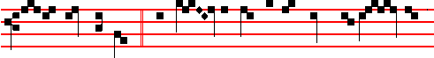
suck to Christ the Lord. * Who on this day for the world’s sal-va - tion
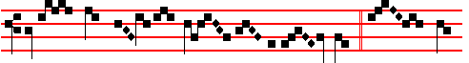
hath been pleased to be born of a Vir - gin.  This day
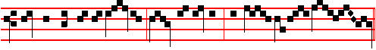
which is breaking is ho- ly: come, ye nations, and wor-ship the Lord.
Who on.
Blessing By the words of the Gospel may our sins be blotted out.  Amen
The Lesson from the Holy Gospel accordIng to S. Luke
Lesson viij Ch. 2.
THE shepherds said one to another, Let us now go even unto Bethlehem and see this thing which is come to pass, which the Lord hath made known unto us. And the rest.
Homily by S. Ambrose, Bishop Book 2 on Luke 2
BEHOLD the beginning of the rising Church: Christ is born and the Shepherds begin their watch; they gather the flocks of the Gentiles, like new-born lambs, into the sheep-fold of the Lord, protecting them from the incursion of spiritual wild beasts that prowl in the dark night. And rightly do the shepherds watch, as instructed by the Good Shepherd. The flock is the congregation, the night is the world, and the shepherds are the priests. Or perhaps he to whom it was said, be watchful and strengthen, might be the shepherd. For the Lord has not only appointed bishops to watch over his flock; he has stationed the Angels as well.
 VIII. Tone viij
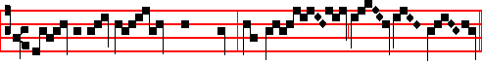
And the Word was made flesh, and dwelt a - mong us, *

367
was slain. But why is he called the son of Barachias, and not of Jehoiada? Barachias means in our language, Blessed of the Lord, and in Hebrew the name of the priest Jehoiada is, Righteousness. In the Gospel used by the Nazarenes we find, Son of Jehoiada, in place of, Son of Barachias.

Te Deum Laudamus
AT LAUDS
and through the Hours,
Antiphon 1. Tone viij, 1.
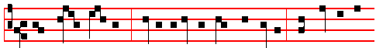
They stoned Stephen, * calling upon the Lord and saying, Lord, lay not this
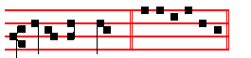
sin to their charge. E u o u a e. Psalm 93 Dominus regnavit, and the rest.
Antiphon 2. Tone vij, 3.
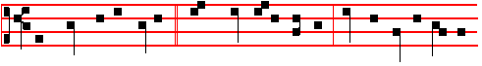
The stones of the torrent * were sweet unto Stephen: him doth every soul of
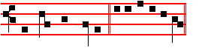
the righteous follow. E u o u a e.
Antiphon 3. Tone iij, 1.
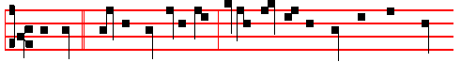
My soul * cleaveth fast unto thee, forasmuch as my flesh hath been stoned
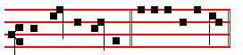
for thee, O my God. E u o u a e.

Antiphon 4. Tone viij, 1.

380
of the Word, then, acknowledge that the Word by which all things were made was not Itself made. For that, by which all things were made, could not be made by Itself. Believe then the Evangelist.
¶ Then is said the Hymn Te Deum Laudamus, and when it is ended, is said  The Lord be with you.  And with thy spirit. The Collect Grant, as below at Lauds.
Let us bless the Lord is said, and the first Mass is said after Midnight, as in the Ordinary: which being ended, Lauds are said.

AT LAUDS, and the Hours,
Antiphon 1. Tone ij
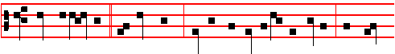
Whom beheld ye, * O shepherds? Tell us, declare to us the tidings, on earth
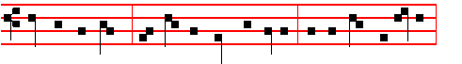
who hath appeared? We saw the new-born infant, and the choir of Angels,
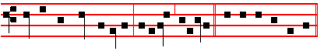
praising the Lord together, alleluia, alleluia. E u o u a e. Psalm 93 Dominus regnavit and the rest.
Antiphon 2. Tone ij
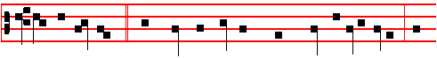
She that travailled * hath borne the Monarch whose name is everlasting: she
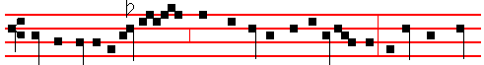
hath the joy of a mo-ther , with the honour of virgini - ty; before her none
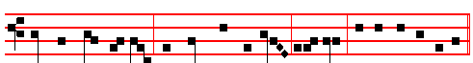
hath been seen like her, nor shall there be after, alleluia. E u o u a e.

369
the latter, laying aside the corruptible garments of the body, ascends to the palace of heaven, to reign there for ever, The former descended, veiled in flesh: the latter ascends, crowned as a martyr.
 They stoned Stephen, calling upon God and saying, * Lord Jesus, receive my spirit, and lay not this sin to their charge.
 And he kneeled down, and cried with a loud voice, saying, Lord Jesus.

Lesson v
THE latter ascends from out the stoning of the Jews; while the former descends from out the gladness of the Angels. Glory to God m the highest, sang the holy Angels yesterday, rejoicing; to-day they welcome Stephen into their glad company. Yesterday the Lord came forth from the Virgin's womb. Today his soldier leaves the prisonhouse of the flesh. Yesterday Christ for our sakes was wrapped in swaddling clothes: to-day Stephen is clothed in a robe of glory. Yesterday the confines of the crib supported Christ as an infant: to-day the immensity of heaven receives Stephen as a victor. Christ descended alone, that he might raise many: our King humbled himself, that he might exalt his soldiers.
 They ran upon him with one accord, and cast him out of the city, calling upon God, and saying: * Lord Jesus, receive my spirit.
 And the witnesses laid down their clothes at a young man's feet, whose name was Saul; and they stoned Stephen, calling upon God and saying: Lord Jesus.

Lesson vj
WE must needs learn, my brethren, with what weapons Stephen was armed, when he overcame the raging of the Jews and won his happy victory. Stephen was rewarded with his crown (the name Stephen means crown), because he was armed with the weapons of love, and by this means he conquered all things. For love of God he quailed not before the raging of the Jews. For love of his neighbour he prayed for his enemies who stoned him. Out of love he rebuked the erring, that they might mend their ways; for love’s sake he entreated for those who stoned him, to avert their punishment. Mounted on the strength of love, he overthrew Saul in his savage raging: and he whom he had for his persecutor on earth he won for his friend in heaven.
 The ungodly fell upon the righteous to put him to death. * But he received the stones with joy, that he might earn a crown of glory.
 They stopped their ears, and ran upon him with one accord. But he received. Glory be. But.

IN THE THIRD NOCTURN

The Lesson from the Holy Gospel according to S. Matthew.
Lesson vij Ch. 23

378
Hymn E H 18 A solis ortus cardine Mode iij.
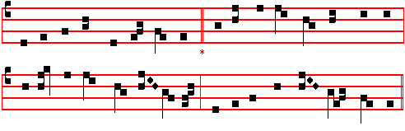
From east to west, from shore to shore, 4 She bowed her to the Angel’s word
Let every heart awake and sing Declaring what the Father willed,
The holy Child whom Mary bore, And suddenly the promised Lord
The Christ, the everlasting King. : That pure and hallowed temple fi1led.

2 Behold, the world's Creator wears 5 He shrank not from the oxen's stall,
The form and fashion of a slave He lay within the manger-bed,
Our very flesh our Maker shares, And he, whose bounty feedeth all,
His fallen creature, man, to save. At Mary's breast himself was fed.

3 For this how wondrously he wrought! 6 And while the Angels in the sky
A maiden, in her lowly place, Sang praise above the silent field,
Became in ways beyond all thought, To shepherds poor the Lord most high,
The chosen vessel of his grace. The one great Shepherd, was revealed.

The following final verse is said instead of those of E.H.17 and 18:

7 All honour, laud, and glory be
O Jesu, Virgin-born, to thee;
All glory, as is ever meet,
To Father and to Paraclete.
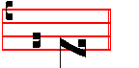
A - men.
 The Lord declared, alleluia.  His salvation, alleluia.
On Benedictus, Antiphon. Tone viij, 1.
Glory to God in the highest, * and on earth peace to men of good will, alleluia,

371
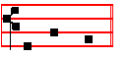
the peo- ple.
 Thou hast crowned him with glory and honour, O Lord.
 And madest him to have dominion of the works of thy hands.

COLLECT

GRANT us,we beseech thee, O Lord, so to imitate that which we revere: that we may learn to love even our enemies; forasmuch as we celebrate the birthday of him who knew how to pray even for his persecutors to our Lord Jesus Christ thy Son: Who liveth.
__________________________________________________________________

ON THE FEAST OF S.STEPHEN, FIRST MARTYR
Double of the first class.

At Matins, Invitatory.- The new-born Christ who today crowned blessed Stephen, * O come, let us worship.
Hymn, Antiphons, Psalms and  of the Nocturns from the Common of One Martyr Out of Eastertide.
IN THE FIRST NOCTURN
From the Acts of the Apostles
Lesson j Ch. 6
IN those days, when the number of the disciples was multiplied, there arose a murmuring of the Grecians against the Hebrews, because their widows were neglected in the daily ministration. Then the twelve called the multitude of the disciples unto them, and said, It is not reason that we should leave the word of God, and serve tables. Wherefore brethren, look ye out among you seven men of honest report, full of the Holy Ghost and wisdom, whom we may appoint over this business. But we will give ourselves continually to prayer, and to the ministry of the word.
 And Stephen, full of faIth and power, * Did great wonders and miracles among
the people.
 There arose certain of the synagogue, disputing with Stephen: and they were not able to resist the wisdom and the spirit by which he spake. Did great.

376
 He shall call me, allelu- ia.
 Thou art my Father, allelu- ia.

AT SEXT
Antiphon. The Angel.
Chapter Heb.l
AND: Thou, Lord, in the beginning hast laid the foundation of the earth; and the heavens are the works of thine hands.
Short 
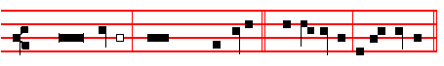
The Lord declared, * Al-le- lu-ia, al- le- lu- ia.
The Lord.
 His salvation. A-lle- lu-ia, al-le- lu- ia.
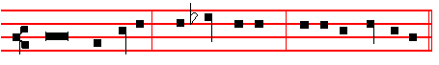
Glory be to the Fa-ther, and to the Son, and to the Ho- ly Ghost.
The Lord.
 All the ends of the world have seen, alleluia.
 The salvation of our God, alleluia.
AT NONE
Antiphon Unto us this day.
Chapter. Heb. l
THEY shall perish, but thou remainest; and they all shall wax old as doth a garment; and as a vesture shalt thou fold them up, and they shall be changed: but thou art the same, and thy years shall not fail.

Short  All the ends of the world have seen. * Alleluia, alleluia. All the ends.
 The salvation of our God. Alleluia, alleluia. G1ory be. All the ends. The Word was made flesh, alleluia. And dwelt among us, alleluia.

AT VESPERS

Antiphon 1 Tone j, 2.
373

