ON THE NATIVITY OF THE LORD

DOUBLE OF THE FIRST CLASS
AT VESPERS

Antiphon 1 Tone viij, 1.
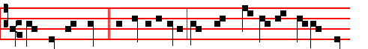
THE King of peace * is highly exalted, for whose countenance all the earth
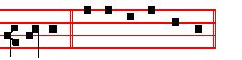
longeth. Psalms 110, 111, 112, 113 of Sunday, p. 201-4, and in the last place 117 Laudate Dominum as in I Vespers of Apostles, p. iij.
Antiphon 2. Tone vij, 3.
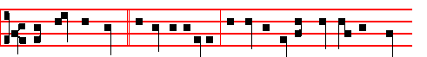
The King of peace * is highly exalted, exceeding the kings of the whole
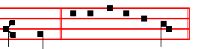
earth. Psalm 111 Confitebor
Antiphon 3. Tone viij, 1.
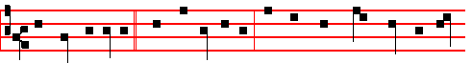
The days of Mary * were accomplishèd; that she should bring forth her first-
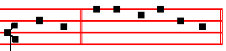
born Son. Psalm 112 Beatus vir

Antiphon 4. Tone viij, 1.

353
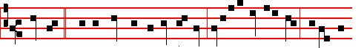
Know ye * that the kingdom of God is nigh: verily I say unto you, it will not
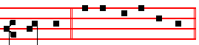
tar - ry. Psalm 113 Laudate
Antiphon 5. Tone ij.
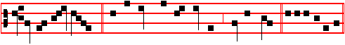
Lift up your heads, * for behold, your redemption draweth nigh Psalm 117.

Chapter Titus 3.
AFTER that the kindness and love of God our Saviour toward man appeared, not by works of righteousness which we have done, but according to his mercy he saved us.
Hymn: E.H. 17 Christe Redemptor omnium Mode j
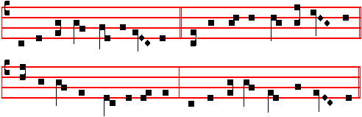
JESU, the Father's only Son, , 4 Thus testifies the present day,
Whose death for all redemption won Through every year in long array,
Before the worlds, of God most high That thou, salvation’s source aIone,
Begotten all ineffably:. Proceededst from the Father's throne.

2 The Father's light and splendour thou, 5 Whence sky, and stars, and sea’s abyss
Their endless hope to thee that bow; And earth, and all that therein is,
Accept the praycrs and praise today Shall still, with laud and carol meet,
That through the world thy servants pay The Author of thine advent greet

3 Salvation's author, call to mind 6 And we who by thy precious blood
How, taking form of humankind, From sin redeemed, are marked for God
Born of a Virgin undefiled: On this the day that saw thy birth,
Thou in man s flesh becam’st a child. Sing the new song of ransomed earth:
354
But with this conclusion : 7 All honour, laud, and glory be,
O Jesu, Virgin-born, to thee;
All glory, as is ever meet,
To Father and to Paraclete.
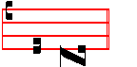
A - men.
Thus end all hymns of the same metre until Epiphany.
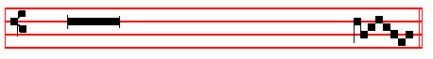
 Tomorrow the iniquity of the earth shall be blotted out.
 And the Saviour of tbe world shall reign over us.
On Magnifieat, Antiphon. Tone viij, 1.
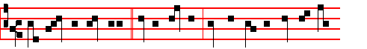
When the sun hath risen * in the heavens, ye shall see the King of kings
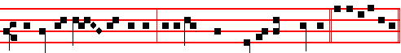
proceeding from the Father, as a bridegroom out of his chamber. Cant. Magn.

COLLECT

GRANT, we beseech thee, almighty God: that we, who through our ancient bondage are held beneath the yoke of sin; may bythe new birth of thine only-begotten Son in the flesh obtain deliverance.Through the same.

At Compline the Tone of the Hymn as above at Vespers.

At Matins, Invitatory. Tone iv
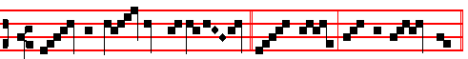
Un - to us Christ is born * O come, let us wor - ship.
Repeat. Un - to us.
355
Psalm 95 Venite, exultemus Domino XCIV
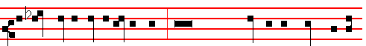
O come, let us sing unto the Lord * let us heartily rejoice in the strength of our
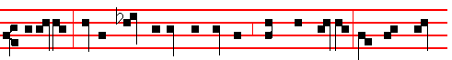
salvation. Let us come before his presence with thanksgiving; and shew our-
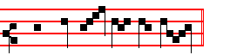
selves glad in him with psalms. Unto us.
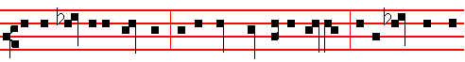
For the Lord is a great God, and a great King above all gods. In his hand are all
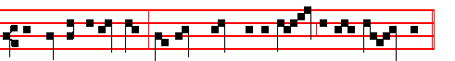
the corners of the earth, and the strength of the hills is his al - so.
O come, let us.
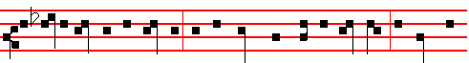
The sea is his, and he made it, and his hands prepared the dry land. O come let
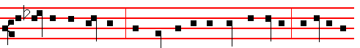
us worship and fall down, and kneel before the Lord our Maker. For he is the
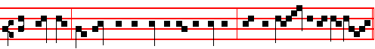
Lord our God, and we are the people of his pasture, and the sheep of his hand.
Unto us.
356
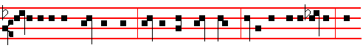
Today if ye will hear his voice, harden not your hearts, as in the provocation, and
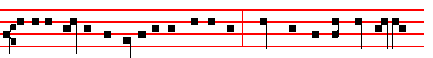
as in the day of temptation in the wilderness; When your fathers tempted me,
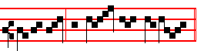
provèd me, and saw my works. O come, let us.
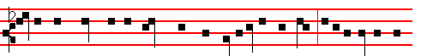
Forty years long was I grieved with this generation and said, It is a people that
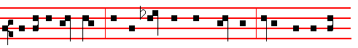
do err in their hearts, for they have not known my ways: Unto whom I sware
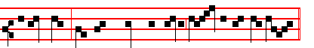
in my wrath, that they should not enter in - to my rest. Unto us.
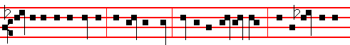
Glory be to the Father, and to the Son, and to the Holy Ghost; As it was in the
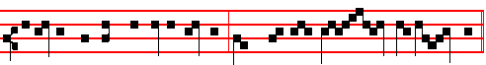
beginning, is now, and ever shall be, world without end. A - men.
O come, let us. Unto us.

Hymn. E. H. 17 Christe Redemptor omnium, as above at Vespers.

357

IN THE FIRST NOCTURN

Antiphon. Tone viij, 2.
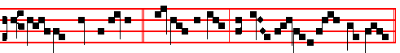
The Lord said un-to me: * thou art my Son, this day have I begot - ten thee.
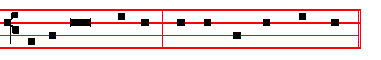
Psalm 2 Quare fremuerunt. E u o u a e.
Antiphon. Tone viij, 1.
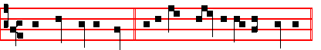
The Lord cometh forth * as a bridegroom out of his chamber.
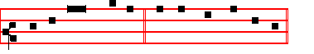
Psalm 19 Cæli enarrant. E u o u a e.
Antiphon Tone j, 4.
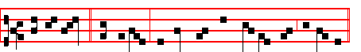
Full of grace * are thy lips, because God hath blessèd thee for ev-er.
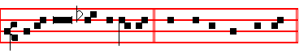
Psalm 45 Eructavit. E u o u a e.
 The Lord cometh forth.  As a bridegroom out of his chamber.
Absolution Hear, O Lord
Blessing May the blessing of the eternal.
The following Lessons from Isaiah are read without title.
Lesson j Ch. 9.
AT the first he lightly afflicted the land of Zebulun and the land of Naphtali, and afterward did more grievously afflict her by the way of the sea, beyond

358
Jordan, in Galilee of the nations. The people that walked in darkness have seen a great light: they that dwell in the land of the shadow of death, upon them hath the light shined. Thou hast multiplied the nation, thou hast increased the joy: they joy before thee according to the joy in harvest, and as men rejoice when they divide the spoil. For thou hast broken the yoke of his burden, and the staff, of his shoulder, the rod of his oppressor, as in the day of Midian. For every battle of the warrior is with confused noise, and garments rolled in blood; but this shall be with burning and fuel of fire. For unto us a child is born, unto us a son is given: and the government shall be upon his shoulder; and his name shall be called: Wonderful, Counsellor, The mighty God, The everlasting Father, The Prince of Peace.
Responsory I Tone v
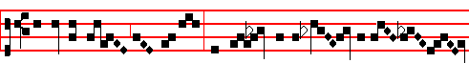
Today the King of heaven was pleased to be born of a Vir - gin
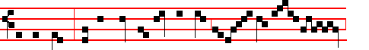
for our sakes, that he might restore lost man to the hea-ven - ly
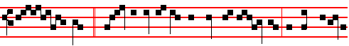
king - dom. * There is joy among the host of An - gels, because eternal
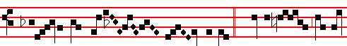
salvation hath ap-peared un - to men.  Glory to God in
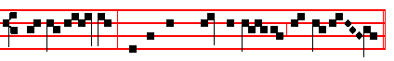
the high - est, and on earth peace to men of good will. There is joy.
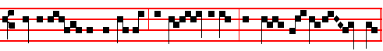
 Glory be to the Fa-ther, and to the Son, and to the Ho-ly Ghost.
 To-day the King is repeated as far as unto men.
359
Blessing May the Only-begotten.
Lesson ij
COMFORT ye, comfort ye my people, saith your God. Speak ye comfortably to Jerusalem, and cry unto her, that that her warfare is accomplished, that her iniquity is pardoned: for she hath received of the Lord's hand double for all her sins. The voice of him that crieth in the wilderness, Prepare ye the way of the Lord, make straight in the desert a highway for our God. Every valley shall be exalted, and every mountain and hill shall be made low: and the crooked shall be made straight, and the rough places plain: and the glory of the Lord shall be revealed, and all flesh shall see it together: for the mouth of the Lord hath spoken it. The voice said, Cry. And he said, What shall I cry? All flesh is grass, and all the goodliness thereof is as the flower of the field: the grass withereth, the flower fadeth: because the spirit of the Lord bloweth upon it. Surely the people is grass. The grass withereth, the flower fadeth: but the word of our God shall stand for ever.
 II Tone viij
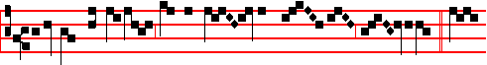
Today the true peace cometh down from hea- ven un - to us. * To-
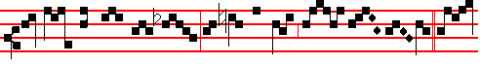
day throughout the whole world the heavens drop down sweet -ness.  To-
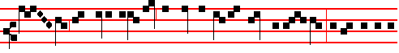
day hath risen upon us the daystar of our new redemption, of the restora-
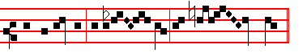
tion of the old, of eter - nal re- demp- tion. Today throughout.

Blessing May the grace of.
Lesson iij
AWAKE, awake, put on thy strength, O Zion; put on thy beautiful garments, O Jerusalem, the holy city: for henceforth there shall be no more come into thee

360
the uncircumcised and unclean. Shake thyself from the dust; arise, and sit down, O Jerusalem: loose thyself from the bands of thy neck, O captive daughter of Zion. For thus saith the Lord God, My people went down aforetime into Egypt to sojourn there; and the Assyrian opporessed them without cause. Now, therefore, what have I here, saith the Lord, that my people is taken away for nought? They that rule over them make them to howl, saith the Lord; and my name continually every day is blasphemed. Therefore my people shall know my name: therefore they shall know in that day that I am he that doth speak: behold, it is I.
 III Tone iv
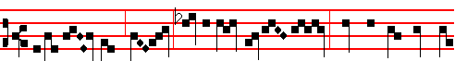
O ye shep- herds, speak, tell us what ye have seen: who hath appeared u-
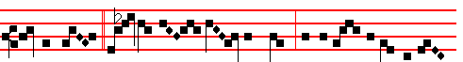
pon the earth? * We saw the new- born Child, and a mul- titude of the
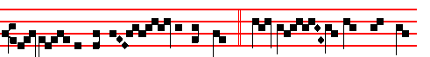
hea-ven - ly host prais - ing the Lord.  Tell us what ye have
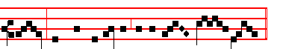
seen, and bring us tidings of the birth of Christ. We saw.
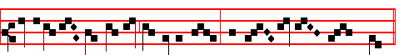
Glory be to the Father, and to the Son, and to the Ho - ly Ghost.
We saw.

IN THE SECOND NOCTURN
Antiphon. Tone viij, 1.
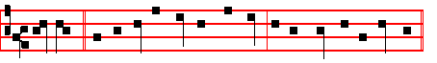
We wait * for thy loving-kindness, O God, in the midst of thy temple.

361
Psalm 48 Magnus Dominus. E u o u a e.
Antiphon. Tone iij, 1.
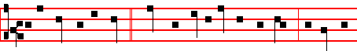
In the time of the Lord * there shall be abundance of peace, and he shall
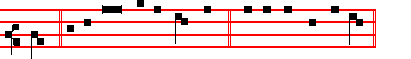
reign. Psalm 72 Deus judicium tuum. E u o u a e.
Antiphon. Tone viij, 2.
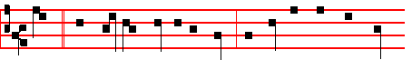
Truth * hath flourished out of the earth, and righteousness hath looked
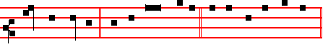
down from heaven. Psalm 85 Benedixisti E u o u a e.
 Thou art fairer than the children of men.  Full of grace are thy lips.
Absolution May his mercy.
Blessing May God the Father almighty.
Sermon by S. Leo the Great.
Lesson iv Sermon 21: On the Lord’s Nativity.
OUR Saviour, dearly beloved, is born today: let us rejoice. No trace of sadness may be permitted on this birthday of Life. This day abolishes the fear of death and fills us with joy by reason of the promise of eternal life. No-one is excluded from a share in this eagerness. The joy is for one and all: our Lord is the Destroyer of sin and death; he finds no-one free from guilt, so he comes to set every-one free. Let the Saint rejoice, for he shall soon receive his palm; let the sinner be glad, for he is offered his pardon; let the Gentile awake, for he is summoned to life. When the fullnes of time was come, that time ordained by the high and inscrutable counsel of God, the Son of God took flesh from our human

362
nature, that he might reconcile that nature to its Creator, and that the devil, the inventor of death, might be overcome by that same flesh which had been the cause of his victory.
 iv Tone iij
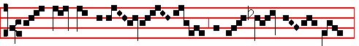
O great myster-y . . . . . and wond- rous sac- ra- ment,
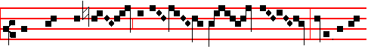
that beasts may see the new - born Lord lying in a
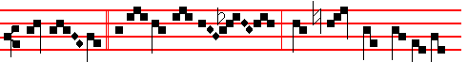
man - ger. * O blessed Vir-gin, whose womb was worthy to
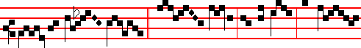
bear the Lord Christ.  Hail , Mary, full of grace, the Lord
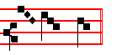
is with thee. O blessed.

Blessing. May Christ grant to us.
Lesson v
GOD joins battle on our behalf, and there is a great and wonderful equity in the
battle-array; for Almighty God comes forth to meet our raging foe, armed, not in his majesty, but in our weakness. He meets him with the same body, the same nature, even with a share of our mortality, yet with no spot of sin. How different is this Child's birth from all others; it is written: No-one is free from tainting sin, not even an infant that has lived but one day on the earth. Now no spot of the concupiscence of the flesh had penetrated into this unique Birth, no trace of the law of sin remained. A royal virgin of the stem of David was chosen; she who was, to be pregnant with holy Fruit, conceived mentally before bodily that Offspring of hers who was both human and divine. While the counsels of

363
heaven were yet unknown to her she was troubled at the strange annunciation, and so she learned from her conversation with the Angel that it was by the co-operation of the Holy Ghost that this thing was to happen to her: so she believed that without loss of her virginity she was soon to be the Mother of God.

 V. Tone vij
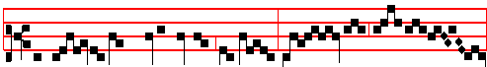
Blessed is God’s holy Mother, Ma-ry, mai-den un- de- filed. *
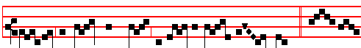
This day hath she brought forth the Saviour of the world.  Bles- sed
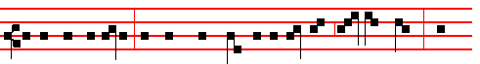
is she that believed, for there hath been a performance of those things which
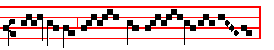
were told her of the Lord. This day hath.

Blessing May God enkindle.
Lesson vj
LET us give thanks, dearly beloved, to God the Father, through his Son, in the unity of the Holy Spirit; for God who is rich in mercy towards us, even when we were dead in our sins hath quickened us together with Christ, and made us to be a new creature in him, and a new workmanship. Let us put off the old man with his deeds: and let us obtain a share in Christ's sonship, laying aside the works of the flesh. O Christian, learn how great you have become, you who have been made a partaker of the divine nature. Do not return to the former vileness of your old and corrupt conversation. Remember the Head and Body of which you are a member. Never forget that you have been delivered out of the power of darkness and translated into the light and kingdom of God.

 VI. Tone ij

364
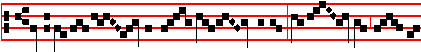
O holy and spot- less vir- gin- i-ty! I know not how to
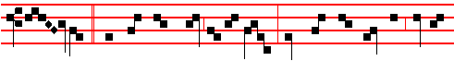
praise thee, * For thou hast borne in thy breast him whom the heavens cannot
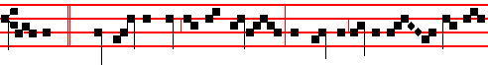
contain.  Bles-sed art thou among wo-men, and blessed is the fruit of thy
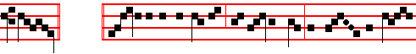
womb. For thou. Glory be to the Father, and to the Son, and to the Ho-
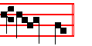
ly Ghost. For thou.

IN THE THIRD NOCTURN
Antiphon. Tone vj
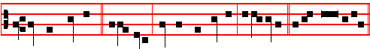
He shall call me, * alle- luia; thou art my Father, alle-luia. Psalm 89 Miseri-
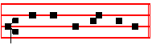
cordias Domini. E u o u a e.
Antiphon. Tone iv
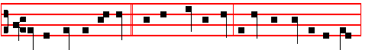
Let the heavens rejoice * and the earth be glad before the face of the Lord,

365
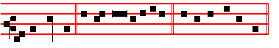
for he cometh. Ps.96 Cantate Domino E u o u a e.
Antiphon. Tone vj
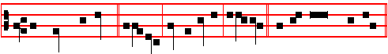
The Lord declared, * alleluia, his salvation, alleluia. Psalm 98 Cantate Dno.
E u o u a e.
 He shall call me, alleluia.  Thou art my Father,
Blessing May the Gospel Lection be to us salvation and protection.  Amen.
The Lesson from the Holy Gospel according to S. Luke
Lesson vij Ch. 2.
THERE went out a decree from Cæsar Augustus, that all the world should be enrolled.
Homily by S. Gregory the Great Homily 8 on the Gospels
BY the bounty of the Lord, we celebrate three solemn Masses to-day, so that we cannot spend long on the Gospel lesson; yet because it is the Lord's Birthday we must say a few words. Why was it that all the world was enrolled when the Lord was born? It was to show plainly that he who was going to enter up his chosen ones in the book of eternal life was now appearing in flesh. Concerning the reprobate, it is said in the words of the Psalmist, Let them be wiped out of the book of the living, and not be written among the righteous. It is fitting that he was born in Bethlehem, for Bethlehem means, House of Bread, and he it was who said, I am the living bread which came down from heaven. Therefore his birth-place was called in former times, The House of Bread, as a prophecy that he who would be born there was going to replenish the souls of his chosen ones with spiritual refreshment. There was also a reason for his being born while on a journey, instead of at his parents’ home: he was born in the human flesh which he assumed, as in a strange land.
 VII. Tone vij
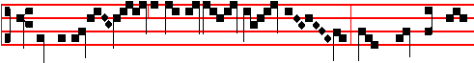
Blessed is the womb of the Virgin Ma- ry, which bore the Son
366
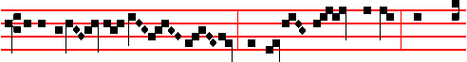
of the Eter- nal Fa- ther, and blessed are the paps which gave
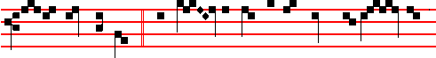
suck to Christ the Lord. * Who on this day for the world’s sal-va - tion
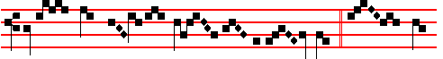
hath been pleased to be born of a Vir - gin.  This day
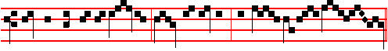
which is breaking is ho- ly: come, ye nations, and wor-ship the Lord.
Who on.
Blessing By the words of the Gospel may our sins be blotted out.  Amen
The Lesson from the Holy Gospel accordIng to S. Luke
Lesson viij Ch. 2.
THE shepherds said one to another, Let us now go even unto Bethlehem and see this thing which is come to pass, which the Lord hath made known unto us. And the rest.
Homily by S. Ambrose, Bishop Book 2 on Luke 2
BEHOLD the beginning of the rising Church: Christ is born and the Shepherds begin their watch; they gather the flocks of the Gentiles, like new-born lambs, into the sheep-fold of the Lord, protecting them from the incursion of spiritual wild beasts that prowl in the dark night. And rightly do the shepherds watch, as instructed by the Good Shepherd. The flock is the congregation, the night is the world, and the shepherds are the priests. Or perhaps he to whom it was said, be watchful and strengthen, might be the shepherd. For the Lord has not only appointed bishops to watch over his flock; he has stationed the Angels as well.
 VIII. Tone viij
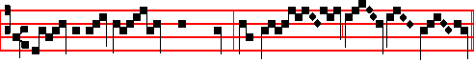
And the Word was made flesh, and dwelt a - mong us, *

367
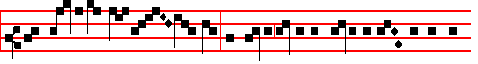
And we beheld his glo - ry, the glory as of the Only-begot - ten of the
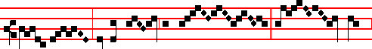
Fa - ther, full of grace and truth.  All things
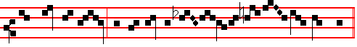
were made by him; and without him was not a-ny thing made that was made.
And we.
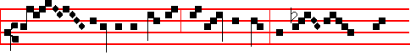
Glo - ry be to the Fa-ther, and to the Son, and to the
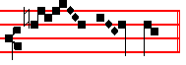
Ho - ly Ghost. And we.

Blessing. May Christ the the Son of God teach us the words of the holy Gospel.  Amen.
The Lesson from the Holy Gospel according to S. John.
Lesson ix
IN the beginning was the Word, and the Word was with God, and the Word was God.
Homily by S. Augustine, Bishop Homily 1 on John
LEST thou shouldest suppose it to mean ought so valueless as thou hast used thyself to associate with the customary mention of man's words, hear what meaning thou must associate with this Word: The Word was God. Now let some unbelieving Arian stand forth, and say. The Word of God was made. How could the Word of God be made, when, by the Word, God made all things? If the Word of God was Itself also made, by what other Word was It made? If thou meanest this; that there is the Word of the Word; then this Word by which that was made the same I call the only-begotten Son of God. But if thou dost not mean the Word

368
of the Word, then, acknowledge that the Word by which all things were made was not Itself made. For that, by which all things were made, could not be made by Itself. Believe then the Evangelist.
¶ Then is said the Hymn Te Deum Laudamus, and when it is ended, is said  The Lord be with you.  And with thy spirit. The Collect Grant, as below at Lauds.
Let us bless the Lord is said, and the first Mass is said after Midnight, as in the Ordinary: which being ended, Lauds are said.

AT LAUDS, and the Hours,
Antiphon 1. Tone ij
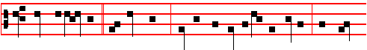
Whom beheld ye, * O shepherds? Tell us, declare to us the tidings, on earth
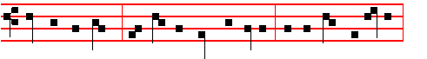
who hath appeared? We saw the new-born infant, and the choir of Angels,
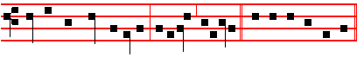
praising the Lord together, alleluia, alleluia. E u o u a e. Psalm 93 Dominus regnavit and the rest.
Antiphon 2. Tone ij
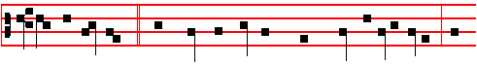
She that travailled * hath borne the Monarch whose name is everlasting: she
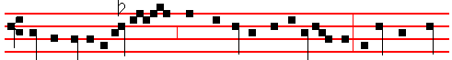
hath the joy of a mo-ther , with the honour of virgini - ty; before her none
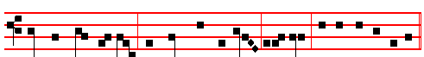
hath been seen like her, nor shall there be after, alleluia. E u o u a e.

369
Antiphon 3. Tone vij, 4.
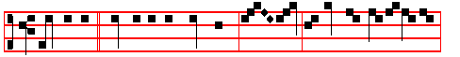
The Angel * said unto the shepherds, Be - hold, I bring you joyful tidings:
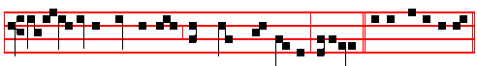
for unto you is born this day the world's Redeemer, alleluia. E u o u a e.
Antiphon 4. Tone vij, 4.
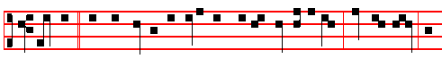
There was * with the Angel a multitude of the heavenly host, praising God, and
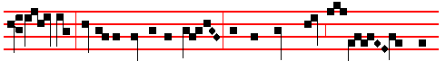
say- ing, Glory to God in the highest, and on earth peace to men of
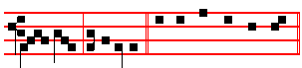
good will, al-le-lu-ia. E u o u a e.
Antiphon 5. Tone viij, 1.
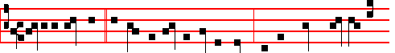
Unto us this day * a Child is born a Son is given: and his Name shall be the
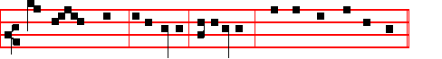
migh-ty God, al-le-lu-ia, al-le-lu-ia. E u o u a e.
Chapter Heb. l
GOD,who at sundry times and in divers manners spake in time past unto the fathers by the prophets, hath in these last days spoken unto us by his Son, whom he hath appointed heir of all things, by whom also he made the worlds.

370
Hymn E H 18 A solis ortus cardine Mode iij.
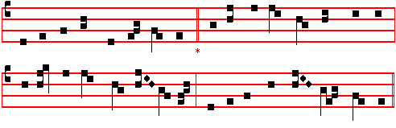
From east to west, from shore to shore, 4 She bowed her to the Angel’s word
Let every heart awake and sing Declaring what the Father willed,
The holy Child whom Mary bore, And suddenly the promised Lord
The Christ, the everlasting King. : That pure and hallowed temple fi1led.

2 Behold, the world's Creator wears 5 He shrank not from the oxen's stall,
The form and fashion of a slave He lay within the manger-bed,
Our very flesh our Maker shares, And he, whose bounty feedeth all,
His fallen creature, man, to save. At Mary's breast himself was fed.

3 For this how wondrously he wrought! 6 And while the Angels in the sky
A maiden, in her lowly place, Sang praise above the silent field,
Became in ways beyond all thought, To shepherds poor the Lord most high,
The chosen vessel of his grace. The one great Shepherd, was revealed.

The following final verse is said instead of those of E.H.17 and 18:

7 All honour, laud, and glory be
O Jesu, Virgin-born, to thee;
All glory, as is ever meet,
To Father and to Paraclete.
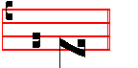
A - men.
 The Lord declared, alleluia.  His salvation, alleluia.
On Benedictus, Antiphon. Tone viij, 1.
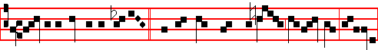
Glory to God in the highest, * and on earth peace to men of good will, alleluia,

371
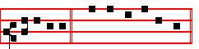
al-le-lu-ia. Canticle Benedictus, p. 39.
COLLECT
GRANT we beseech thee, almighty God: that we who through our ancient bondage are held beneath the yoke of sin; may by the new Birth of thine Only-begotten Son in the flesh obtain deliverance. Through the same.

In the morning Prime is said: which being ended, is celebrated the second Mass at Dawn, and in it commemoration is made of S. Anastasia, Martyr.

AT PRIME
Antiphon Whom beheld ye, p. 369.
Chapter Now unto the King.
Short  O Christ, Son of the living God, * Have mercy upon us.
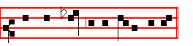
 Who wast born of the Virgin Ma-ry.
And thus it is said daily until the Epiphany.
At the close of the Chapter, short Lesson They shall perish, as below at None.
At Terce is said its Hour, which being ended, is celebrated the third Mass of Christmas Day.

AT TERCE
Antiphon. She that travailled.
Chapter. God, who at sundry.
Short  .
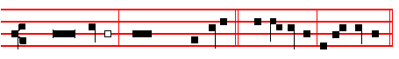
The Word was made flesh, * Al-le- lu- ia, al- le- lu-ia.
The Word.
 And dwelt among us. Al-le- lu- ia, al- le- lu-ia.
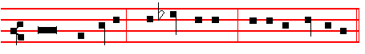
Glory be to the Fa-ther, and to the Son, and to the Ho- ly Ghost.
The Word.
372
 He shall call me, allelu- ia.
 Thou art my Father, allelu- ia.

AT SEXT
Antiphon. The Angel.
Chapter Heb.l
AND: Thou, Lord, in the beginning hast laid the foundation of the earth; and the heavens are the works of thine hands.
Short 
The Lord declared, * Al-le- lu-ia, al- le- lu- ia.
The Lord.
 His salvation. A-lle- lu-ia, al-le- lu- ia.
Glory be to the Fa-ther, and to the Son, and to the Ho- ly Ghost.
The Lord.
 All the ends of the world have seen, alleluia.
 The salvation of our God, alleluia.
AT NONE
Antiphon Unto us this day.
Chapter. Heb. l
THEY shall perish, but thou remainest; and they all shall wax old as doth a garment; and as a vesture shalt thou fold them up, and they shall be changed: but thou art the same, and thy years shall not fail.

Short  All the ends of the world have seen. * Alleluia, alleluia. All the ends.
 The salvation of our God. Alleluia, alleluia. G1ory be. All the ends. The Word was made flesh, alleluia. And dwelt among us, alleluia.

AT VESPERS

Antiphon 1 Tone j, 2.

373
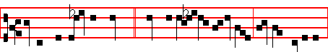
In the day of thy power * shall the people offer thee free-will offerings
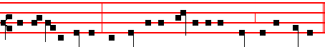
with an holy worship: the dew of thy birth is of the womb of the morning.
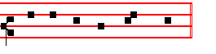
Psalms 110, 111, 112, of Sunday, 130 De Profundis and 132 Memento, Domine.
Antiphon 2. Tone vij, 3.
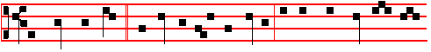 The Lord hath sent * redemption unto his peop1e: he hath command-ed his
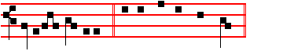
covenant for ever . Psalm 111 Confitebor, p. 202.
Antiphon 3. Tone vij, 3 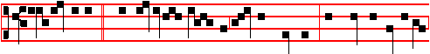
Unto the godly * there a- ris-eth up light in the darkness: the Lord is merciful,
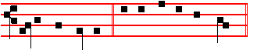
loving, and righteous. Psalm 112 Beatus vir, p. 203
Antiphon 4. Tone iv, 1
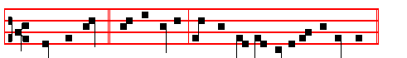 With the Lord * there is mercy, and with him is plenteous redemption.
374
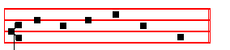
Psalm 130 De profundis CXXIX , p. 223.
Antiphon 5. Tone viij, 1.
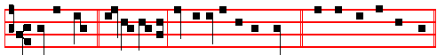
Of the fruit * of thy body shall I set upon thy seat. Psalm 132 Memento, Domine, CXXI, p.225. Chapter God who at sundry, as above at Lauds, p. 370.
Hymn. E.H. 17 Christe Redemptor omnium, as above in I Vespers, p. 354.
 The Lord declared, allelu - ia.
 His salvation, allelu - ia.
On Magnificat, Antiphon Tone j, 1.
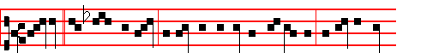
Today * the Christ is born; today hath a Saviour appeared: today on earth
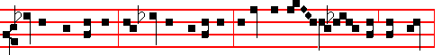
Angels are singing, Archangels rejoicing: today the righteous ex-ult and say,
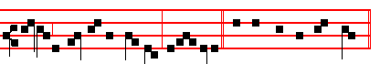
Glory to God in the highest, alleluia. Canticle Magnificat, p. 209.
Collect Grant, as above at Lauds, p. 372.

Then for commemoration of S.Stephen, Antiphon. Tone viij, 2.
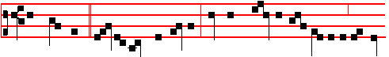
And Stephen, * full of faith and power, did great wonders and miracles among

375
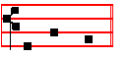
the peo- ple.
 Thou hast crowned him with glory and honour, O Lord.
 And madest him to have dominion of the works of thy hands.

COLLECT

GRANT us,we beseech thee, O Lord, so to imitate that which we revere: that we may learn to love even our enemies; forasmuch as we celebrate the birthday of him who knew how to pray even for his persecutors to our Lord Jesus Christ thy Son: Who liveth.
__________________________________________________________________

ON THE FEAST OF S.STEPHEN, FIRST MARTYR
Double of the first class.

At Matins, Invitatory.- The new-born Christ who today crowned blessed Stephen, * O come, let us worship.
Hymn, Antiphons, Psalms and  of the Nocturns from the Common of One Martyr Out of Eastertide.
IN THE FIRST NOCTURN
From the Acts of the Apostles
Lesson j Ch. 6
IN those days, when the number of the disciples was multiplied, there arose a murmuring of the Grecians against the Hebrews, because their widows were neglected in the daily ministration. Then the twelve called the multitude of the disciples unto them, and said, It is not reason that we should leave the word of God, and serve tables. Wherefore brethren, look ye out among you seven men of honest report, full of the Holy Ghost and wisdom, whom we may appoint over this business. But we will give ourselves continually to prayer, and to the ministry of the word.
 And Stephen, full of faIth and power, * Did great wonders and miracles among
the people.
 There arose certain of the synagogue, disputing with Stephen: and they were not able to resist the wisdom and the spirit by which he spake. Did great.

376
Lesson ij
ND the saying pleased the whole multitude: and they chose Stephen, a man full of faith and of the Holy Ghost, and PhIlip, and Prochorus and Nicanor, and Timon, and Parmenas, and Nicolas a proselyte of AntIoch: whom they set before the apostles: and when they had prayed, they laid their hands on them. And the word of God increased; and the number of the disciples multiplied in Jerusalem greatly; and a great company of the priests were obedient to the faith. And Stephen, full of faith and power, did great wonders and miracles among the people.

A
 All that sat in the council, looking steadfastly on Stephen, saw * His face as it had been the face of an Angel standing among them.
 Full of grace and power, he did great wonders and miracles among the people. His face.

Lesson iij
THEN there arose certain of the Synagogue which is called the synagogue of the Libertines and Cyrenians and Alexandrians and of them of Cilicia and of Asia disputing with Stephen. And they were not able to resist the wisdom and the spirit by which he spake. Then they suborned men, which said, We have heard him speak blasphemous words against Moses, and against God. And they stirred up the peopIe, and the elders, and the scribes, and came upon him, and brought him to the council, and set up false witnesses, which said,This man ceaseth not to speak blasphemous words against this holy place, and the law.
 Blessed Stephen looked up steadfstly into heaven, and saw the glory of God, and said: * Behold, I see the heavens opened, and the the Son of Man standing at the right hand of the power of God.
 But Stephen, being full of the Holy Ghost looked up stesdfastly into heaven, and said: Beho1d. G1ory be. Behold

IN THE SECOND NOCTURN

Sermon by S. Fulgentius, Bishop.
Lesson iv Sermon III on S. Stephen.
YESTERDAY we celebrated the birth in time of our eternal King: to-day we celebrate the triumphant passion of his soldier. For yesterday our King, clothed in the robe of flesh, proceeding forth from his palace in the Virgin's womb, condescended to visit the world. To-day his soldier, coming forth from his
tent of the body, migrates as a conqueror to heaven. The former, while conserving the majesty of his everlasting Divinity, assumes and girds himself in the servile garment of the flesh, and enters the battle-ground of this world, to come and fight;

377
the latter, laying aside the corruptible garments of the body, ascends to the palace of heaven, to reign there for ever, The former descended, veiled in flesh: the latter ascends, crowned as a martyr.
 They stoned Stephen, calling upon God and saying, * Lord Jesus, receive my spirit, and lay not this sin to their charge.
 And he kneeled down, and cried with a loud voice, saying, Lord Jesus.

Lesson v
THE latter ascends from out the stoning of the Jews; while the former descends from out the gladness of the Angels. Glory to God m the highest, sang the holy Angels yesterday, rejoicing; to-day they welcome Stephen into their glad company. Yesterday the Lord came forth from the Virgin's womb. Today his soldier leaves the prisonhouse of the flesh. Yesterday Christ for our sakes was wrapped in swaddling clothes: to-day Stephen is clothed in a robe of glory. Yesterday the confines of the crib supported Christ as an infant: to-day the immensity of heaven receives Stephen as a victor. Christ descended alone, that he might raise many: our King humbled himself, that he might exalt his soldiers.
 They ran upon him with one accord, and cast him out of the city, calling upon God, and saying: * Lord Jesus, receive my spirit.
 And the witnesses laid down their clothes at a young man's feet, whose name was Saul; and they stoned Stephen, calling upon God and saying: Lord Jesus.

Lesson vj
WE must needs learn, my brethren, with what weapons Stephen was armed, when he overcame the raging of the Jews and won his happy victory. Stephen was rewarded with his crown (the name Stephen means crown), because he was armed with the weapons of love, and by this means he conquered all things. For love of God he quailed not before the raging of the Jews. For love of his neighbour he prayed for his enemies who stoned him. Out of love he rebuked the erring, that they might mend their ways; for love’s sake he entreated for those who stoned him, to avert their punishment. Mounted on the strength of love, he overthrew Saul in his savage raging: and he whom he had for his persecutor on earth he won for his friend in heaven.
 The ungodly fell upon the righteous to put him to death. * But he received the stones with joy, that he might earn a crown of glory.
 They stopped their ears, and ran upon him with one accord. But he received. Glory be. But.

IN THE THIRD NOCTURN

The Lesson from the Holy Gospel according to S. Matthew.
Lesson vij Ch. 23
378
JESUS said unto the scribes and Pharisees: Behold, I send unto you prophets, and wise men, and scribes, and some of them ye shall kill and crucify.
Homily by S. Jerome, Priest Commentary on Matthew Ch. 23
AS we have said before, the words, Fill ye up then the measure of your fathers,
may be applied to the Person of the Lord, he who was to be slain by them; they may also apply to his disciples, as he was now referring to them in saying, Behold, I send unto you prophets, and wise men, and scribes. In connection with this, note that, according to the Apostle's letter to the Corinthians, the gifts given to the disciples were manifold: some were made prophets, to foretell his advent; others were gifted with wisdom, to know when was the acceptable time to preach the word; others became most learned scribes, versed in the law, and among all these, Stephen was stoned, Paul was slain, Peter was crucified, and the disciples
mentioned in the Acts of the Apostles were scourged.
 Stephen the servant of God, who was stoned by the Jews, saw the heavens opened: he saw, and entered in. * Blessed is the man, unto whom heaven lay open.
 While he was crushed by the hurtling shower of stones, God’s brightness broke upon him out of heavenly places. Blessed.

Lesson viij
WHO was this Zacharias, son of Barachias, for we read of more than one Zacharias? To prevent a mistake, Whom ye slew between the temple and the altar, is added. I have read different opinions about this in different places, and so I must give you each of them. Some say that this Zacharias is the eleventh of the twelve prophets, and the giving of the father's name agrees with this: but there is no mention in the Bible of his being slain between the temple and the altar, and this is not to be wondered at, for in his time scarcely the ruins of the temple were left standing. Others would understand by Zacharias the father of John, relying on the evidence of certain phantasies of apocryphal writers which make out that he was slain for preaching the advent of the Saviour.
 The gates of heaven were opened to Christ's blessed Martyr Stephen, and he is found the first among all the Martyrs. * Wherefore he reigneth crowned in heaven.
 For he was the first to make an offering of his death to that Saviour who vouchsafed to suffer death for us. Wherefore. Glory be. Wherefore.

Lesson ix
OTHERS again would say that this is the Zacharias who was slain by Joash king of the Jews, between the temple and the altar, as it is written in the Books of the Kings. But notice here that this Zacharias was the son, not of Barachias, but of Jehoiada the priest, whence the Bible says that Joash remembered not the kindness which Jehoiada his father had done to him. The evidence here agrees, both in the man named Zacharias, and in the place where he

379
was slain. But why is he called the son of Barachias, and not of Jehoiada? Barachias means in our language, Blessed of the Lord, and in Hebrew the name of the priest Jehoiada is, Righteousness. In the Gospel used by the Nazarenes we find, Son of Jehoiada, in place of, Son of Barachias.

Te Deum Laudamus
AT LAUDS
and through the Hours,
Antiphon 1. Tone viij, 1.
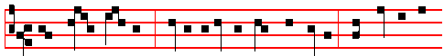
They stoned Stephen, * calling upon the Lord and saying, Lord, lay not this
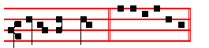
sin to their charge. E u o u a e. Psalm 93 Dominus regnavit, and the rest.
Antiphon 2. Tone vij, 3.
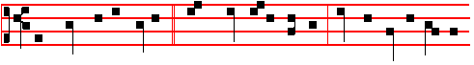
The stones of the torrent * were sweet unto Stephen: him doth every soul of
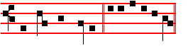
the righteous follow. E u o u a e.
Antiphon 3. Tone iij, 1.
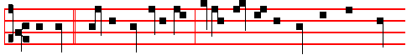
My soul * cleaveth fast unto thee, forasmuch as my flesh hath been stoned
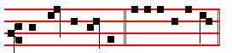
for thee, O my God. E u o u a e.

Antiphon 4. Tone viij, 1.
380
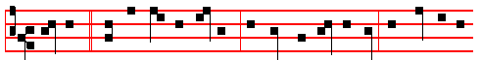
Stephen * saw the heavens opened; he saw, and entered in: how blessed is
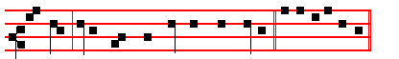
the man unto whom the heaven stood open! E u o u a e.
Antiphon 5. Tone iv, 1.
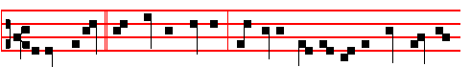
Behold, I see * the heavens opened; and Jesus standing on the right hand of
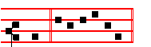
God. E u o u a e.
Chapter Acts 6
AND Stephen, full of faith and power, did great wonders and miracles among
the people.
Hymn. E.H. 180 Martyr Dei qui unicum, p.xxxviij, but with the ending for Christmas as above, E.H. 18, p. 371.
 Devout men carried Spephen to his buri - al.
 And made great lamentation over him.
On Benedictus, Antiphon. Tone viij, 2.
And Stephen, full of faith and power, did great wonders and miracles among
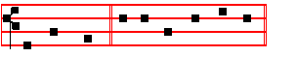
the peo- ple. Canticle Benedictus, p. 39.
381
COLLECT

GRANT us, we beseech thee, O Lord, so to imitate that which we revere: that we may learn to love even our enemies; forasmuch as we celebrate the birthday of him who knew how to pray even for his persecutors to our Lord Jesus Christ thy Son: Who liveth.
Then commemoration is made of the Nativity.
Antiphon. Tone viij, 1.
Glory to God in the highest, and on earth peace to men of good will, alleluia,
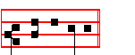
al - le -lu -ia.
 The Lord declared, allelu- ia.
 His salvation,allelu- ia.

COLLECT
GRANT we beseech thee,almighty God: that we who through our ancient bondage are held beneath the yoke of sin; may by the new birth of thine only-begotten Son in the flesh obtain deliverance.Through the same.

At Prime, Who wast born, p. 372.

At Terce, Antiphon The stones of the torrent, p. 380.
Chapter And Stephen, as above, p. 381.
Short  , as p.xxxix.
Thou hast crowned him * With glory and honour, O Lord. Thou hast.
 And madest him to have dominion of the works of thy hands. With glory.
Glory be. Thou hast.
 Thou hast set upon his head, O Lord.  A crown of pure gold.

At Sext, Antiphon My soul, p. 380.

382
Chapter Acts 6
THEN there arose certain of the synagogue, which is called the synagogue of the Libertines, and Cyrenians, and Alexandrians, and of them of Cilicia and of Asia, disputing with Stephen. And they were not able to resist the wisdom and the spirit by which he spake.
Short  , as p. xl.
Thou hast set * Upon his head, O Lord. Thou hast set.
 A crown of pure gold. Upon his. Glory be. Thou hast set.
 His honour is great in thy salvation.
 Glory and great worship shalt thou lay upon him.

At None Antiphon Behold, I see, p. 381.
Chapter Acts 7
AND he kneeled down, and cried with a loud voice, Lord, lay not this sin to their charge. And when he had said this, he fell asleep.
Short , as p. xlj.
His honour is great * in thy salvation. His honour.
 Glory and great worship shalt thou lay upon him. In thy. Glory be. His honour.
 The righteous shall flourish like a palm-tree.
 And shall spread abroad like a cedar in Libanus.

At Vespers, Antiphons and Psalms of the Nativity, as above, pp.374-5.
And they are said also in other Feasts occurring in this Octave.
Chapter And Stephen, as above at Lauds, p. 381.

Hymn E.H. 18l Deus tuorum militum, as in the Common, p. xxix, with ending for Christmas as above, p. 371.
 Stephen saw the heavens o- -pened.
 He saw, and entered in: how blessed
is the man unto whom heaven stood o- -pen.

On Magnificat, Antiphon. Tone viij, 1.
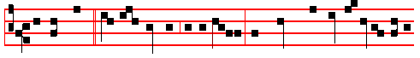
Devout men * carried Stephen to his burial, and made great lamentation over

383
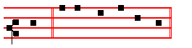
him. Canticle Magnificat, p. 211.
Collect Grant us, as above at Lauds, p. 382
Then for S.John, Antiphon. Tone j, 2.
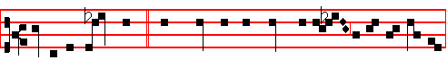
This is the same John, * who leaned upon the Lord's bosom at the last supper:
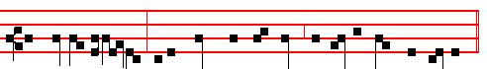
the blessed Apos-tle, unto whom were revealed the secret things of heaven.
 Right worthy of honour is blessed John the Apos - tle.
 Who leaned on the Lord's bosom at the last sup - per.

COLLECT

O LORD, graciously illumine thy Church: that it, being enlightened by the doctrine of blessed John thine Apostle and Evangelist, may attain unto everlasting gifts.Through.

Then commemoration is made of the Nativity. Antiphon as above, p. 382.
Today the Christ is born; today hath a Saviour appeared: today on earth Angels are singing, Archangels rejoicing: today the righteous exult and say, Glory to God in the highest, alleluia.
 The Lord declared,alleluia.  His salvation, alleluia.

COLLECT

GRANT we beseech thee almighty God: that we who through our ancient bondage are held beneath the yoke of sin; may by the new Birth of thine only-begotten Son in the flesh obtain deliverence. Through the same.

384
ON THE FEAST OF S. JOHN, APOSTLE AND EVANGELIST
DOUBLE of the SECOND CLASS.
At Matins, Invitatory, Hymn, Antiphons, Psalms, and  of the Nocturns from the Common of Apostles.

IN THE FIRST NOCTURN

The Beginning of the First Epistle of S.John the Apostle.
Lesson j Ch. 1, 1-10
THAT which was from the beginning, which we have heard, which we have seen with our eyes, which we have looked upon, and our hands have handled, of the Word of life; (for the life was manifested, and we have seen it and bear witness, and shew unto you that eternal life, which was with the Father, and was manifested unto us;) that which we have seen and heard declare we unto you, that ye also may have fellowship with us: and truly our fellowship is with the Father, and with his Son Jesus Christ. And these things write we unto you, that your joy may be full. This then is the message which we have heard of him, and declare unto you, that God is light, and in him is no darkness at all.
 Right worthy of honour is blessed John, who leaned on the Lord's breast at the last supper. * To him did Christ upon the cross commit his Mother, as virgin to virgin.
 As a virgin he was chosen by the Lord, who loved him more than the others. To him did.

Lesson ij
IF we say that have fellowship with him, and walk in darkness, we lie, and do not the truth: but if we walk in the light, as he is in the light, we have fellowship one with another, and the blood of Jesus Christ his Son cleanseth us from all sin. If we say that we have no sin, we deceive ourselves, and the truth is not in us. If we confess our sins, he is faithful and just to forgive us our sins, and to cleanse us from all unrighteousness. If we say a that we have not sinned, we make him a liar, and his word is not in us.
 This is the disciple which testifieth of these things, and wrote these things: * And we know that his testimony is true.
 He drank the flowing Gospel from the sacred fountain of the Lord's breast. And we know.

Lesson iij
MY little children, these things write I unto you, that ye sin not. And if any man sin, we have an advocate with the Father, Jesus Christ the righteous: and he is the propitiation for our sins: and not for ours only, but also for the sins of the whole world. And hereby we do know that we know him, if we keep his

385
commandments. He that saith, I know him, and keepeth not his commadments, is a liar, and the truth is not in him. But whoso keepeth his word, in him verily is the love of God perfected.
 This is that most blessed Apostle and Evangelist John, * Who was found worthy to be honoured by the Lord above all others, with a sIngular privilege of love.
 This is the disciple whom Jesus loved, who leaned on the Lord's bosom at the last supper. Who was. Glory be. Who was.

IN THE SECOND NOCTURN

From the book of S. Jerome, Priest on Ecclesiastical Writers.
Lesson iv Ch. 9
JOHN the Apostle whom Jesus loved most, was the son of Zebedee, and the brother of James the Apostle, who was beheaded by Herod soon after the Lord's Passion. He was the last of the four to write his Gospel, and he wrote it at the request of the bishops of Asia, to combat Cerinthus and other heretics, and against
the rising dogma of the Ebionites who asserted that Christ had not existed before Mary: thus he was compelled to expound his divine nature.
 Him that overcometh will I make a pillar in my temple, saith the Lord. * And
I will write my Name upon him, and the name of the city, which is New Jerusalem.
 To him that overcometh will l give to eat of the tree of life, which is in the midst of the paradise of my God. And I will.

Lesson v
FOURTEEN years after Nero, when the second, persecution arose at the instigation of Domitian, John was banished to the Island of Patmos, where he wrote the Revelation and both Justin Martyr and Irenæus have written commentaries on it. On the death of Domitian the Senate annulled his acts, shocked by his excessive cruelty. Then John returned to Ephesus, during the reign of Nerva, and from there until the time of Trajan, he both founded and governed Churches throughout Asia. He lived to a great age, and died in the sixty-eighth year after the Lord’s Passlon, and was buried at Ephesus.
 Jesus loved him, for his special mark of chastity made him worthy of greater love. * He chose him for a virgin unto himself, and he remalneth a virgin for ever.  At the end, when he was dying upon the cross, he committed his Mother to him, as virgin to virgin. He chose.

Lesson vj
BLESSED John lived to an extreme old age and at the end of his life it was

386
only with difficulty that his disciples could carry him to church, nor was he able to gather together more than a few words. It became his custom to utter only the single sentence, My little children, love one another. At length the disciples and brethren grew weary of always hearing this same thing, and said to him, Master, why do you keep on saying this? And John, with that true greatness of his, replied, Because it is the Lord's commandment, and if only it is kept, it is enough.
 In the midst of the Church he opened his mouth. * And the Lord filled him with
the Spirit of wisdom and understanding.
 He shall find joy and a crown of gladness. And the. G1ory be. And the.

IN THE THIRD NOCTURN

The Lesson from the Holy Gospel according to S. John
Lesson vij Ch. 21
JESUS saith unto Peter, Follow me. Then Peter, turning about, seeth the disciple whom Jesus loved following. And the rest.
Homily by S. Augustine, Bishop Homily 124 on John
TWO lives, therefore, preached and commended to her of God, the Church knoweth: of which, one is in faith, the other in sight, one in time of sojourning, the other in eternity of abiding; one in labour, the other in rest; one in the way, the other in its home; one in the work of action, the other in the wages of contemplation; one declines from evil and does good, the other hath no evil to decline from, and hath great good to enjoy; one fights, with the enemy, the other reigns without an enemy; one is courageous in things adverse, the other hath no sense of ought adverse.
 In that day will I take thee, O my servant, and will make thee as a signet before me. * For I have chosen thee saith the Lord.
 Be thou faithful unto death, and I will give thee a crown of life. For I have.

Lesson viij
ONE curbs carnal lusts, the other is wholly given up to spiritual delights; one is anxious with care of getting the victory, the other in the peace of the victory is without a care; one in temptations is helped, the other without any temptation rejoices in the Helper himself: one succours the needy, the other is there where it finds none needy: one forgives others' sins that its own may be forgiven, the other neither hath ought done to it that it need forgive, nor does ought that it need ask to be forgiven. One is scourged by evils that it be not lifted up in its good things, the other with such fulness of grace is free from all evil that without any temptation to pride it cleaves to the Supreme Good; one discerns between good and evil, the other beholds the things that alone are good:
 This is the same John which leaned on the Lord's breast at the last supper. *

387
The blessed Apostle unto whom were revealed the secret things of heaven.
 He drank the flowing Gospel from the sacred fountain of the Lord's breast. The blessed. Glory be. The blessed.

Lesson ix
THEREFORE the one is good but as yet wretched; the other better, and blessed. The first is signified by the Apostle Peter; the last by John.The first is wholly spent here even unto the end of this world, and there finds an end; the last is deferred, to be completed after the end of this world, but in the world to come hath no end. Therefore concerning this it is said, Follow me; but of that other, Thus will I that he tarry till I come; What is that to thee? Follow thou me. For what is this? So far as I take it in, what is this but, Follow thou me, by copying the pattern of enduring temporal evils; let the other tarry till I come, to render the good things that are for ever and ever.
Te Deum Laudamus.

AT LAUDS, and through the Hours
Antiphon 1. Tone viij, 1.
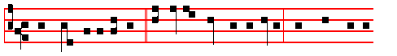
Right worthy of honour * is blessed John the Apostle, who leaned on the
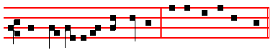
Lord's bosom at the last supper. E u o u a e. Psalm 93 Dominus regnavit, and the rest, p..
Antiphon 2. Tone iij, 1.
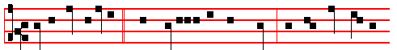
This is that disciple * which testifieth of these things: and we know that his
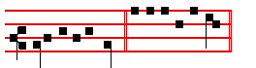
testimony is true. E u o u a e.

Antiphon 3. Tone iij, 1.

388
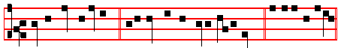
This is my disciple, * if I will that he tarry till I come. E u o u a e.
Antiphon 4. Tone j, 1.
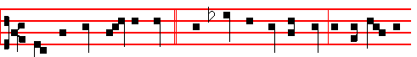
There be some standing here * which shall not taste of death till they see the
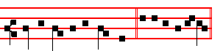
Son of man in his kingdom. E u o u a e.
Antiphon 5. Tone j, 1.
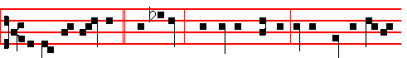
Behold, my servant, * mine elect, whom I have chosen: I have put my spi -rit
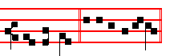
up- on him. E u o u a e.

Chapter Ecclus. 15
HE that feareth the Lord will do good; and he that hath the knowledge of the law shall obtain Wisdom, and as a mother shall she meet him.

Hymn. E.H. 176 Exsultet caelum laudibus as in the Common of Apostles out of Eastertide, p. iv, with the ending for Christmas as above, E.H. 18, p. 371.
 This is that disciple which testifieth of these things.
 And we know that his testimony is true.

On Benedictus, Antiphon. Tone j, 2.
389
This is the same John, * who leaned on the Lord's bo- som at the last supper:
the blessed Apos-tle, unto whom were revealed the secret things of heaven.
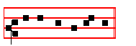
Canticle Benedictus, p. 39.
COLLECT

O LORD, graciously illumine thy Church: that it, being enlightened by the doctrine of blessed John thine Apostle and Evangelist, may attain unto everlasting gifts. Through.

Then commemoration is made of the Nativity, Antiphon, as above, p. 382. Glory to God in the highest, and on earth peace to men of good will, alleluia, alleluia.
 The Lord declared, alleluia.  His salvation, alleluia.

COLLECT
GRANT, we beseech thee, almighty God: that we who through our ancient bondage are held beneath the yoke of sin; may by the new Birth of thine only-begotten Son in the flesh obtain deliverance.Through the same.

For S. Stephen, Antiphon, as above, p. 381. And Stephen, full of faith and power, did great wonders and miracles among the people.
 Devout men carried Stephen to his burial.
 And made great lamentation over him.

COLLECT
GRANT us, we beseech thee, O Lord, so to imitate that which we revere: that we may learn to love even our enemies; forasmuch as we celebrate the birthday of him who knew how to pray even for his persecutors to our Lord Jesus Christ thy Son: who liveth.
At Terce, Antiphon This is that disciple, p. 388

390
Chapter He that feareth, as above at Lauds, p. 389.
Short  as in the Common, p. xj.
Their sound is gone out * Into all lands. Their sound.
 And their words into the ends of the world. Into all. Glory be. Their sound.
 Thou shalt make them princes in all lands.
 They shall remember thy name, O Lord.

At Sext, Antiphon This is my disciple, p. 389.
Chapter Ecclus.15
WITH the bread of understanding shall she feed him, * and give him the water of wisdom to drink.
Short  as in the Common, p. xij.
Thou shalt make them princes * In all lands. Thou shalt
 They shall remember thy name, O Lord. In all. Glory be. Thou shalt.
 Exceedingly honourable are thy friends, O God.
 Firmly established is their princedom.

At None, Antiphon Behold, my servant, p. 389.
Chapter Ecclus.15
IN the midst of the congregation shall she open his mouth. He shall find joy and a crown of gladness, and she shall cause him to inherit an everlasting name.
Short  as in the Common, p. xiij.
Right honourable are thy friends * Unto me, O God. Right honourable.
 Right well is their princedom established. Unto me. Glory be.
Right honourable.
 They declared the work of God.
 And wisely considered of his doing.

At Vespers, Antiphons and Psalms of the Nativity, as above, p. 374-5.
Chapter He that feareth, p.389.
Hymn Exultet E.H. 176 of the Common, pp. iv, 371.

 Right worthy of honour is blessed John the Apostle.
 Who leaned on the Lord's bosom at the last supper.
On Magnificat, Antiphon. Tone vj.
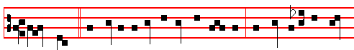
There went * this saying abroad among the brethren, that that disciple should

391
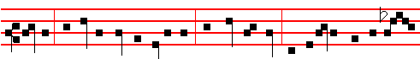
not die: yet Jesus said not unto him, He shall not die; but, If I will that he tar-
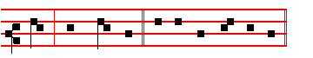
-ry till I come. Canticle Magnificat, p. 211.
Collect O Lord, graciously, as above at Lauds, p. 390.
Then for the Holy Innocents, Antiphon. Tone j, 2.
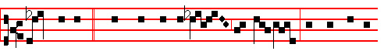
These are they * which were not defiled with wo-men; for they are vir-
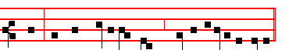
-gins: and they follow the Lamb whithersoever he goeth.
 Herod was exceeding wroth, and slew many child- ren.
 In Bethlehem Judah, the city of Da- vid.
COLLECT
O GOD, whose praise the Innocents thy Martyrs did this day not by speaking but by dying confess: mortify all evil vices in us; that, as our tongues confess thy faith, so our lives may by their actions set forth the same. Through.
Then commemoration is made of the Nativity, as above, p. 382
Antiphon. Today * the Christ is born; today hath a Saviour appeared: today on earth Angels are singing, Archangels rejoicing: today the righteous exult and say, Glory to God in the highest, alleluia.
 The Lord declared, alleluia.  His salvation, alleluia.
COLLECT
GRANT we beseech thee almighty God: that we who through our ancient bondage are held beneath the yoke of sin;may by the new Birth of thine only-begotten Son in the flesh obtain deliverance. Through the same.

392
For S. Stephen, Antiphon, as above, p. 383.
Devout men carried Stephen to his burial, and made great lamentation over him.
 Stephen saw the heavens opened.
 He saw, and entered in: how blessed is the man unto whom heaven stood open.
COLLECT
GRANT us, we beseech thee, O Lord, so to imitate that which we revere: that we may leatrn to love even our enemies; forasmuch as we celebrate the birthday of him who knew how to pray even for his persecutors to our Lord Jesus Christ thy Son: Who liveth.
__________________________________________________________________

DECEMBER 28

The Holy Innocents, Martyrs
Double II Class
AlI as in the Common of Many Martyrs, except for the following:
Hymn. Audit tyrannus
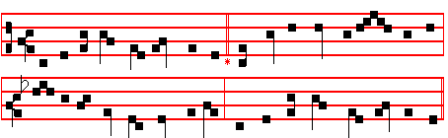

THE moody tyrant hears aghast 3 What is the gain of such a sin?
News that the King of kings at last What doth his crime for Herod win?
Hath come to rule o'er Israel's name, One from so many slain that day,
And David's royal throne to claim. The Christ is borne unharm’d away.

2 The rumour wakes his frantic cry; 4 All honour, laud, and glory be,
A king who drives me forth is nigh- O Jesu, Virgin-born, to thee;
Depart my guard, snatch up the sword: All glory, as is ever meet
Let cradles flow with blood outpoured. To Father and to Paraclete.

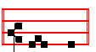
A - men.

393
The Antiphons, Psalms and  of the Nocturns are taken from the Common of many Martyrs, except the second Antiphon of the III Nocturn, as is noted in its place below.
IN THE FIRST NOCTURN
From the Prophet Jeremiah
Lesson j Ch. 31.
THUS saith the Lord; A voice was heard in Ramah, lamentation, and bitter weeping; Rachel weeping for her children refused to be comforted for her children, because they were not. Thus saith the Lord; Refrain thy voice from weeping, and thine eyes from tears: for thy work shall be rewarded, saith the Lord; and they shall come again from the land of the enemy. And there is hope in thine end, saith the Lord, that thy children shall come again to their own border.
 An hundred forty and four thousand which were redeemed from the earth, these are they which are not defiled with women. * For they are virgins; therefore are they reigning with God, and the Lamb of God is with them.
 These are they which came out of great tribulation, and have washed their robes, and made them white in the Blood of the Lamb. For they.

Lesson ij
IHAVE surely heard Ephraim bemoaning himself thus; Thou hast chastised me, and 1 was chastised, as a bullock unaccustomed to the yoke: turn , thou me, and I shall be turned; for thou art the Lord my God. Surely after that I was turned, I repented; and after that I was instructed, I smote upon my thigh: I was ashamed, yea, even confounded, because I did bear the reproach of my youth. Is Ephraim my dear son? is he a pleasant child? for since I spake against him, I do earnestly remember him still: therefore my bowels are troubled for him; I will surely have mercy upon him, saith the Lord.
 I heard under the altar of God the voices of them that were slain, saying: * How long dost thou not avenge our blood? And it was said unto them from God: Rest yet for a little season, until the number of your brethren be fulfilled.
 I saw under the altar of God the souls of them which were slain for the Word of God, and for the testimony which they held, and they cried with a loud voice, saying. How long.

Lesson iij
SET thee up waymarks, make thee high heaps: set thine heart toward the highway, even the way which thou wentest: turn again, O virgin of Israel, turn again to these thy cities. How long wilt thou go about, O thou backsliding daughter! For the Lord hath created a new thing in the earth. A woman shall compass a man. Thus saith the Lord of hosts, the God of Israel; As yet they shall use this speech in the land of Judah and in the cities thereof, when I shall bring

394
again their captivity; The Lord bless thee, O habitation of justice, and mountain of holiness.
 They worship him that liveth for ever and ever, * And cast their crowns before the throne of the Lord their God.
 And they fall down on their faces before the throne, and worship him that liveth for ever and ever. And cast. Glory be. And cast.

IN THE SECOND NOCTURN
Sermon by Saint Augustine, Bishop.
Lesson iv. Sermon 10 on the Saints
TODAY, beloved brethren, we are celebrating the birthday of those children, who, as the Gospel tells us, were slain by the cruel king Herod. Let the world rejoice with great gladness, because she is the fecund parent of this great and powerful army of heavenly soldiers. The heathen foe could never have benefitted these little ones by his goodwill as much as he did by his hatred. This day's holy festival shows that in proportion as his wickedness abounded towards these blessed little ones, so was the grace of blessedness poured forth upon them.
 The blood of the Saints have they shed like water on every side of Jerusalem. * And there was no man to bury them.
 The dead bodies of thy servants have they given to be meat unto the fowls of the air, and the flesh of thy Saints unto the beasts of the land. And there.

Lesson v .
BLESSED art thou, O Bethlehem in the land of Juda; In thee was perpetuated the wicked crime of Herod the king; his massacre of these chIldren: and therefore hast thou been found worthy to offer to God in one offering a white-robed multitude of innocent children. Most fittingly do we keep the festival of their birthday, for their birth from this world into life eternal is more blessed than that from their mothers' wombs. They attained unto life eternal and joined the ranks of the blessed before they had tasted life here on earth.
 These are Saints, who suffered for thy sake, 0 Lord; take vengeance for them, * For day by day they cry unto thee.
 Avenge, O Lord the blood of thy Saints, which is shed. For day.

Lesson vj
THE precious death of other martyrs deserves praise for its testimony - those who have fought a good fight and finished their course; but death gave glory to these Innocents at the beginning of their life, by closing it immediately. Herod in his wickedness snatched these sucklings from their mothers' breasts; rightly are they called the flowers of martyrdom, for they sprang up in the midst of the winter of unbelief as the first opening buds of the Church, and were nipped by the frost of persecution.
395
 These are they which. have not defiled their garments, * They shall walk with me in white, for they are worthy.
 These are they which are not defiled with women, for they are virgins. They shall. Glory be. They shall.

IN THE THIRD NOCTURN

In place of the second Antiphon They gave up, is said the following Antiphon 8. These are they which came out of great tribulation, and have washed their robes, and made them white in the Blood of the Lamb.

The Lesson from the Holy Gospel according to S. Matthew
Lesson vij Ch. 2

THE angel of the Lord appeareth to Joseph in a dream, saying, Arise, and take the young child and his mother, and flee into Egypt, and be thou there until I bring thee word.
Homily by S. Jerome, Priest. Book 1. Commentary on Matthew Ch. 2
WHEN Joseph took the Child and his Mother and fled into Egypt, he took them by night, in darkness: because he left the night of ignorance to those unbelievers from whom he fled. But on his return to Judæa, neither light nor darkness are mentioned in the Gospel, because at the end of the world the Jews will receive the light of faith, as though receiving Christ returning from Egypt.
 The Saints sung a new song before the throne of God and the Lamb; * And their voices resounded on earth.
 These were redeemed from among men, being the first-fruits unto God, and to the Lamb, and in their mouth was found no guile. And their voices.

Lesson viij
THAT it might be fulfilled which was spoken of the Lord by the prophet, saying, Out of Egypt have I called my son. Let those who deny the truth of the Hebrew Scriptures ask where this is to be found in the Septuagint version. Though they do not find it there, yet we declare that it was written in the Book of Hosea, as the copies which we have recently published prove.
 I saw under the altar of God the souls of them that were slain for the Word of God which they held, and they cried with a loud voice: * Avenge, O Lord, the blood of thy Saints which is shed.
 Under the throne of God all the Saints cry aloud. Avenge.

If this Feast comes on a Sunday, then at the end of the aforesaid eighth  is added Glory be. Avenge. And after the ninth Lesson (omitting the ninth ) is said Te Deum Laudamus. On other days, as below.
396

Lesson ix
THEN was fulfilled that which was spoken by Jeremy the Prophet, saying, In Rama was there a voice heard, lamentation, and weeping, and great mourning, Rachel weeping for her children. Rachel gave birth to Benjamin, and his tribe is not of Bethlehem. The question is then, why should Rachel weep for the children of Juda, that is, of Bethlehem, as though they were her own? This is soon answered: because she is buried in Ephrata, near Bethlehem, and the name of Mother has become associated with the resting place of her maternal body: or else because the two tribes of Juda and Benjamin had been joined together, and Herod had commanded that all the children, not only of Bethlehem, but in the adjoining territory, should be slain.

The following  is said when this Feast does not come on a Sunday.
 What are these that are arrayed in white robes? And whence came they? And he
said to me: * These are they which came out of great tribulation, and have washed their robes, and made them white in the Blood of the Lamb, .
 I saw under the altar of God the souls of them which were slain for the Word of
God, and for the testimony which they held. These. Glory be. These.

AT LAUDS, and through the Hours,
Antiphon 1. Tone j, 1.
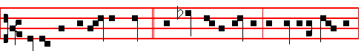
Herod was exceeding wroth, * and slew many children in Bethlehem Judah,
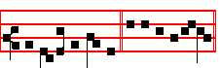
the city of David. E u o u a e. Psalm 93 Dominus regnavit and the rest.
Antiphon 2. Tone j, 1.
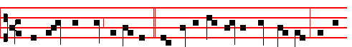
From two years old and under * did Herod slay all the male children, for the
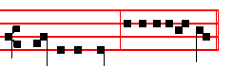
sake of the Lord. E u o u a e. 397
Antiphon 3. Tone viij, 1.
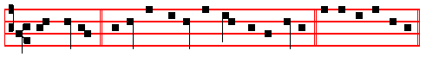
Their Angels * do always behold the face of my Father. E u o u a e.
Antiphon 4. Tone ij.
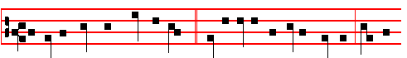
In Rama there was heard a voice, * lamentation and bitter weeping, Rachel
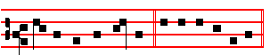
weeping for her children. E u o u a e.
Antiphon 5. Tone viij, 2.
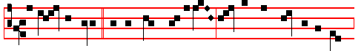
Beneath the altar * all the Saints cry aloud: Shall not our blood be avenged,
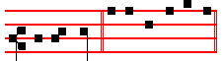
O our God. E u o u a e.
Chapter Rev. 14
I LOOKED, and lo, a Lamb stood on the mount Sion, and with him an hundred and forty and four thousand, having his Father’s name written in their foreheads.

Hymn E.H. 34, vv. 1, 2, 4. Salvete flores Martyrum

398
All hail, ye little Martyr flowcrs, 2. First victims of the Martyr bands,
Sweet rosebuds cut in dawning hours With crowns and palms in tender hands,
When Herod sought the Christ to find Around the very altar, gay
Ye fell as bloom before the wind. And innocent ye seem to play

4. All honour, laud, and glory be,
O Jesu, virgin-born, to thee;
All glory, as is over meet;
To Father and to Paraclete.

A - men.

 Herod was exceeding wroth, and slew many children.
 In Bethlehem Judah, the city of David.
On Benedictus, Antiphon. Tone j, 2.
These are they * which were not de-filed with wo- men; for they are vir-
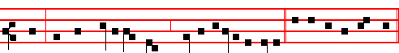
gins: and they follow the Lamb whithersoever he goeth. Canticle Benedictus, p. 39.
COLLECT

O GOD, whose praise the Innocents thy Martyrs did this day not by speaking but by dying confess: mortify all evil vices in us; that, as our tongues confess thy faith, so our lives may by their actions set forth the same. Through.
Then commemoration is made of the Nativity, of S.Stephen, and of S.John, as below.
At Terce Antiphon From two years old and under, p. 397.
Chapter I looked, as above at Lauds, p. 398.
Short  as in the Common, p. xxxix-xl.
Be glad, O ye righteous, * And rejoice in the Lord. Be glad.
 And be joyful, all ye that are true of heart. And rejolce. Glory be. Be glad.

399
 Let the righteous rejoice before God.
 Let them also be merry and joyful.

At Sext, Antiphon Their Angels, p. 398.
Chapter Rev. 14
THESE are they which were not defiled with women; for they are virgins. These are they which follow the Lamb whithersoever he goeth.
Short  , as in the Common, p. xl.
Let the righteous rejoice * Before God. Let the.
 Let them also be merry and joyful. Before God. Glory be. Let the righteous.
 The righteous live for evermore.
 Their reward also is with the Lord.

At None, Antiphon Beneath the altar, p. 398.
Chapter Rev. 14
THESE were redeemed from among men, being the firstfruits unto God and to the Lamb. And in their mouth was found no guile: for they are without fault before the throne of God.
Short  , as in the Common, p. xlj.
The righteous live * For evermore .The righteous.
 Their reward also is with the Lord. For evermore. Glory be. The righteous.
 Let the Saints be joyful with glory.
 Let them rejoice in their beds.

At Vespers, Antiphons and Psalms of the Nativity, pp. 374-5
Chapter I looked, as above, p. 398. Hymn. Salvete, as above, p. 399.
 Beneath the altar all the Saints do cry aloud.
 Shall not our blood be avenged, O our God.

On Magnificat, Antiphon. Tone ij.
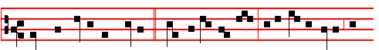
Then were innocent children * slain instead of Christ by a wicked ruler; the
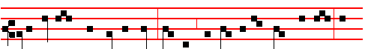
very sucklings were put to death: spotless, they f'ollow the Lamb himself, and

400
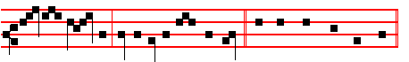
say for ev - er: Glory be to thee, O Lord. Canticle Magnificat, p. 209 ?
Collect O God, whose, as above, p. 399.
Then commemoration is made of the Nativity, of S. Stephen, and of S. John, as below.
For Commemoration of Octaves:

Of the Nativity.
At Vespers, Antiphon as above, p. 375.
Today the Christ is born; today hath a Saviour appeared: today on earth the
Angels are singing, Archangels rejoicing: today the righteous exult and say, Glory
to God in the highest.
 The Lord declared, alleluia.  His salvation, alleluia.
At Lauds, Antiphon. as above, p. 371
Glory to God in the highest, and on earth peace to men of good will, alleluia, alle1uia.
 The Lord declared, alleluia.  His salvation, alleluia.

COLLECT
GRANT we beseech thee, almighty God: that we who through our ancient bondage are held beneath the yoke of sin; may by the new Birth of thine only-begotten Son in the flesh obtain deliverance. Through the same

Of S. Stephen.
At Vespers, Antiphon as above, p. 383
Devout men carried Stephen to his butial, and made great lamentation over him.
 Stephen saw the heavens opened.
 He saw, and entered in: how blessed is the man unto whom heaven stood open.
At Lauds, Antiphon as above, p. 381.
And Stephen, full of faith and power, did great wonders and miracles among the people.
 Devout men carried Stephen to his burial.
 And made great lamentation over him.

COLLECT
GRANT us, we beseech thee, O Lord, so to imitate that which we revere: that we may learn to love even our enemies; forasmuch as we celebrate the birthday of him who knew how to pray even for his persecutors to our Lord Jesus Christ thy Son: Who liveth.
401
Of S. John.
At Vespers, Antiphon as above, p. 391.
There went this saying abroad among the brethren that that disciple should not die: yet Jesus said not unto him, he shall not die, but, If I will that he tarry till I come.
 Right worthy of honour is blessed John the Apostle.
 Who leaned on the Lord s bosom at the last supper.
At Lauds, Antiphon as above, p. 390.
This is the same John,who leaned on the Lord’s bosom at the last supper: the blessed Apostle, unto whom were revealed the secret things of heaven.
 as above, p. 389. This is that disciple which testifieth of these things.
 And we know that his testimony is true.

COLLECT
O LORD, graciously illumine thy Church: that it, being enlightened by the doctrine of blessed John thine Apostle and Evangelist, may attain unto everlasting gifts. Through.

Of the Holy Innocents.
At Vespers, as above, p. 400.
Antiphon. Then were innocent children slain instead of Christ by a wicked ruler; the very sucklings were put to death: spotless, they follow the Lamb himself, and say for ever: Glory be to thee, O Lord.
 Beneath the altar all the Sains do cry aloud.
 Shall not our blood be avenged, O our God.

At Lauds, Antiphon as above, p. 399.
These are they which were not defiled with women; for they are virgins: and they follow the Lamb whithersoever he goeth. .
 Herod was exceeding wroth, and slew many children.
 In Bethlehem Judah, the city of David.

COLLECT
O GOD, whose praise the Innocents thy Martyrs did this day not by speaking but by dying confess: mortify all evil vices in us; that, as our tongues confess thy faith, so our lives may by their actions set forth the same. Through.

¶ If the feast of the Nativity of the Lord, S. Stephen, John Evangelist, the Holy Innocents, or their Octave Days, come on Sunday, on the day itself nothing is said of the Sunday, but its Office is said on the fifth day within the Octave of the Nativity, December 29.
402
THE SUNDAY WITHIN THE OCTAVE OF THE NATIVITY

If Sunday be December 30, and Vespers said entire, Psalms with Antiphons of the Nativity, II Vespers.
Chapter GaI.4
BRETHREN: The heir, as long as he is a child, differeth nothing from a servant, though he be lord of all; but is under tutors and governors until the time appointed of the father.
Hymn. E.H. 17 Christe Redemptor Omnium, of the Nativity, pp. 354-5.
 The Word was made flesh, alleluia.
 And dwelt among us, alleluia.
On Magnificat, Antiphon. Tone viij, 1.
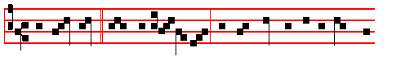
While all things * were in quiet silence, and that night was in the midst of
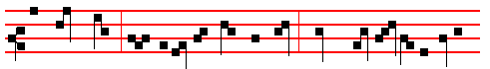
her swift course, thine almighty Word, O Lord, leaped down out of thy royal
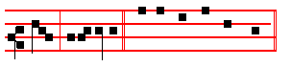
throne, al-le-lu-ia. Canticle Magnificat, p.211.

COLLECT
ALMIGHTY and everlasting God, direct our actions according to thy good pleasure: that in the name of thy well-beloved Son we may be made worthy to abound in good works: Who liveth and reigneth with thee.
Then commemoration of the Octaves, as above.

¶ If December 29 be Sunday, then commemoration is made of it in the II Vespers of the Holy Innocents above, before the other commemorations. Otherwise nothing is said of it at I Vespers.
At Matins, Invitatory, Antiphons and Psalms of the Nocturns as on the Nativity.

S. Paul's Epistle to the Romans is read on this day, and the Lessons are from this and his other Epistles until Septuagesima.

403

IN THE FIRST NOCTURN
Here beginneth S. Paul’s Epistle to the Romans.
Lesson j Ch. 1, 1-19
PAUL, a servant of Jesus Christ, called to be an apostle, separated unto the gospel of God, (which he had promised afore by his prophets in the holy scriptures), concerning his Son Jesus Christ our Lord, which was made of the seed of David according to the flesh; and declared to be the Son of God with power receive grace an apost esh!p for obedience to the faith among all nations, for his name: among whom are ye also the called of Jesus Christ: to all that be in Rome, beloved of God, called to be Saints: Grace to you and peace from God our Father, and the Lord Jesus Christ.
 To-day the true peace cometh down from heaven unto us. * To-day throughout the whole world the heavens drop down sweetness.
 To-day hath risen upon us the daystar of our new redemption, of the restoration
of the old, of eternal redemption. To-day throughout.

Lesson ij
FIRST, I thank my God through Jesus Christ for you all, that your faith is spoken of throughout the whole world. For God is my witness, whom I serve with my spirit in the gospel of his Son, that without ceasing I making request, if by any means now at length I might have a prosperous journey by the will of God to come unto you. For I long to see you, that I may impart unto you some spiritual gift, to the end ye may established, that is, that I may be comforted together with you by the mutual faith both of you and me.
 O ye shepherds, speak, tell us what ye have seen: who hath appeared on the earth? * We saw the new-born Child, and a multitude of the heavenly host praising the Lord.
 Tell us what ye have seen, and bring us tidings of the birth of Christ. We saw.

Lesson iij
NOW I would not have you ignorant, brethren, that oftentimes I purposed to come unto you, (but was let hitherto), that I might have some fruit among you also, even as among other Gentiles. I am debtor both to the Greeks, and to the Barbarians; both to the wise, and to the unwise. So, as much as in me is, I am ready to preach the gospel to you that are at Rome also. For I am not ashamed of the gospel of Christ: for it is the power of God unto salvation to everyone that believeth; to the Jew first, and also to the Greek. For therein is the righteousness of God revealed from faith to faith: as it is written, The just shall live by faith. For the wrath of God is revealed from heaven against all ungodliness and unrighteousness of men, who hold the truth m unrighteousness; because that which may be known of God is manifest in them; for God hath shewed it unto them.
404
 O great mystery and wondrous sacrament, that beasts may see the new-born Lord lying in a manger. * O blessed Virgin, whose womb was worthy to bear the Lord Christ.
 Hail, Mary, full of grace the Lord is with thee. O blessed. Glory be. O blessed.

IN THE SECOND NOCTURN
Sermon by S. Leo the Great
Lesson iv Sermon 29; 9 on the Lord's Nativity
DEARLY beloved, the magnitude of the works of God exceeds by far the power of human speech: yet hard as it is to discourse on these wonders, we cannot keep silence. The saying of the prophet, Who shall declare his generation? points to the Human Nature as well as to the Divine Essence of Jesus Christ the Son of God. Unless faith first believes, no words can explain how the two natures were united in one person. Here is room for everlasting praise, because the entire fulness of everlasting praise is not sufficient to overflow it.
 Blessed is God's holy Mother, Mary, maiden undefiled. * This day hath she brought forth the Saviour of of the world.
 Blessed is she that believed, for there hath been a performance of those things which were told her of the Lord This day hath.

Lesson v
COME, let us rejoice, in that this great mystery of mercy is beyond the power of expression; let us realize that it is good to be overpowered, when the heights of our salvation are so far above our powers of utterance. No-one comes nearer to understanding the truth than he who grasps the fact that in divine matters the further he advances the further he must realize the distance to be towards the object of his search. For he who thinks that he is within reach of his goal will not attain to it, but rather will fall in his search.
 O holy and spotless virginity! I know not how to praise thee, * For thou hast borne in thy breast him whom the heavens cannot contain.
 Blessed art thou among women, and blessed is the fruit of thy womb. For thou.

Lesson vj
TO save us from being distressed by the confines of our weakness, we are given the help of the voices of the Prophets and Evangelists; they teach us, and enkindle our hearts, so that we seem to see the Lord's Nativity, by which the Word was made flesh, not as a past event but as ever present before us. The Angels' tidings to the shepherds while they were keeping watch over their flocks fill our ears also: so may we, as we watch over the Lord's sheep, ever hear the heavenly message ringing in our inmost hearts; even as on this day's festival it cries: Behold I bring you good tidings of great joy which shall be to all people.

405
For unto you is born this day in the city of David a Saviour which is Christ the Lord.
 Blessed is the womb of the Virgin Mary, which bore the Son of the eternal Father, and blessed. are the paps which gave suck to Christ the Lord. * Who on this day hath been pleased to be born of a Virgin. This day which is breaking is holy: come, ye nations, and worship the Lord. Who on. Glory be. Who on.

IN THE THIRD NOCTURN
The Lesson from the holy Gospcl according to Luke.
Lesson vij Ch. 2
JOSEPH and his mother marvelled at those things which wcre spoken of him. And the rest.
Homily by S. Ambrose, Bishop Book 2 on Luke 2
THE Lord's Birth bestows an abundance of grace on all mankind, and prophecy is withheld only from the unbelieving, not from the just. Simeon foretold the rise and fall of many in Israel, and saw that many would come to our Lord Jesus Christ, that the thoughts of the righteous and the wicked should be revealed. He saw that by the nature of our actions the true and righteous Judge would reveal either our punishment or our reward.
 The Word was made flesh, and dwelt among us, * And we beheld his glory, the glory as of the Only-begotten of the Father, full of grace and truth.
 All things were made by him, and without him was not anything made that was
made. And we.

Lesson viij
YEA, a sword shall pierce through thine own soul also. There is no evidence, either written or handed down by tradition, that Mary's departure from this life was preceded by a violent death. Now an actual sword can only pass through the body, not through the soul. This shows the wisdom of Mary, in that she was far from being unaware of the divine mystery. For the Word of God is quick, and powerful, and sharper than any two-edged sword, piercing even to the dividing asunder of soul and spirit, and of the joints and marrow, and is a discerner of the thoughts and intents of the heart; because all things are naked and open unto the Son of God, neither is there any conscience hidden from his sight.
 O King of heaven, followed by such strange retinue: thou art lodged in a stable, who upholdest the world. * He lies in a manger, and reigns in heaven.
 Unto us is born this day in the city of David a Saviour Which is Christ the Lord. He lies. Glory be. He lies.

Lesson ix
SO Simeon prophesied, and the Virgin had prophesied, and one in the wedded state had prophesied, and now it behoved a widow to prophesy, so that no
406
state of life nor sex should be wanting, Therefore Anna is brought forward, and, with her long years of widowhood and her virtuous life, we may well believe in her worthiness to proclaim the coming of the Saviour of the world. We have already written about her merits in another place, in our address to widows; we shall not repeat it again here, as we must move on to other things.
Te Deum Laudamus.

At Lauds, Antiphons and Psalms as on the Nativity, pp.369-370
Chapter Brethren, the heir, as above at Vespers, p. 403.
Hymn. E.H. 18 A solis ortus, as on the Nativity above, p. 371
 The Word. was made flesh, alleluia.  And dwelt among us, alleluia.
On Benedictus, Antiphon. Tone viij, 1.
While all things * were in quiet silence, and that night was in the midst of
her swift course, thine almighty Word, O Lord, leaped down out of thy royal
throne, al-le-lu-ia. Canticle Benedictus, p. 39.

COLLECT
ALMIGHTY and everlasting God, direct our actions according to thy good pleasure: That in the name of thy well-beloved Son we may be made worthy to abound in good works: Who liveth and reigneth with thee.
And commemoration is made of the Nativity and of the other Octaves, as above, pp. 401-2..
At Prime, at the close of the Chapter, is said the Chapter of None.

At Terce, Antiphon She that travailled, p. 369.
Chapter Brethren: the heir, as above, p. 403.
Short  as on the Nativity, pp. 372-3

At Sext, Antiphon The Angel, p. 370.

407
Chapter Gal. 4
BUT when the fullness of time was come, God sent forth his Son, made of a woman, made under the law, to redeem them that were under the law that we might receive the adoption of sons.
Short  as on the Nativity, p. 373.

At None, Antiphon Unto us this day, p.370.
Chapter Gal. 4
WHEREFORE thou art no more a servant, but a son; and if a son, then an heir of God through Christ.
Short  as on the Nativity, p. 373.

In II Vespers, Antiphons, Psalms, Chapter, Hymn and  as above in I Vespers, p.
403.
On Magnificat Antiphon. Tone vj.
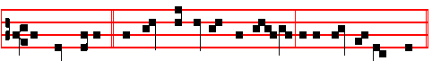
The Child Jesus * increased in wisdom and stature in the sight of God and
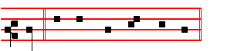
man. Canticle Magnificat, p.211
Collect Almighty, as above, p. 409.
¶ If December 30 comes on a Sunday, the above Office is said on that day, and on December 29 is said the Office that follows.
__________________________________________________________________

THE SIXTH DAY IN THE OCTAVE OF THE NATIVITY
All is said as on the Nativity, except the Lessons of the Third Nocturn, which are said as below.
The Lesson from the Holy Gospel according to S. Luke.
Lesson vij Ch 2
THE shepherds said one to another, Let us now go even unto Bethlehem, and see this thing which is come to pass, which the Lord hath made known unto us.
Homily by S. Ambrose, Bishop. Book 2 on Luke Ch. 2
SEE how the shepherds come with haste, for no-one should look for Christ slothfully. See how the shepherds believe the Angel: and then can you be

408
unwilling to believe the Father, the Son and the Holy Ghost, the Angels and Prophets and Apostles? See how every word of the Scriptures is weighed and measured with care and purpose. They came with haste, it says, To see this Saying. For by, This Saying, when the Flesh is seen, the Word is seen, which is the Son.
 The Word was made flesh, as above on Sunday, p. 408.

Lesson viij
THINK not this but a mean example offered to your belief, because shepherds are of humble station: their lack of education made their faith all the greater. The Lord sought out, not men from lecture halls and debating rooms, but simple, unlettered folk who were incapable of embellishing and gilding what they heard. It is simplicity that is required: ambition is out of place.
 O King of heaven, as above on Sunday, p. 498.

Lesson ix
DO not imagine that because they were humble, the shepherds' sayings are to be made light of. Mary's faith is strengthened by them, and through them the.people come together to worship God. All they that heard it wondered at them by the shepherds. But Mary kept all these things, and pondered them in her heart. Let us learn from the chastity of the holy Virgin in all things: no less modest in speech than in body, she collected together all these proofs of the faith, and hid them in her heart.
Te Deum Laudamus.

At Lauds all is said as on the Nativity above, pp. 369 ff. And after the Collect commemoration is made of S. Stephen and the other Octaves, as above, pp 401-2.
At the Hours all is said as on the Nativity of the Lord, above, pp. 369 ff.
At Vespers, Antiphons and Psalms of the Nativity, and if it is the 30th, the Antiphons are doubled.
__________________________________________________________________

ON THE FEAST OF S. SYLVESTER
Pope and Confessor. Double

From the Chapter all from the Common of a Confessor and Bishop.

COLLECT

GRANT , we beseech thee, almighty God: that the reverend solemnity of blessed Sylvester, thy Confessor and Bishop, may both increase our devotion and set forward our salvation. Through.
409
And commemoration is made of the Octaves, as above, pp. 401-2.

At Matins all from the Common of a Confessor and Bishop, except the Collect and the Lessons of the first and second Nocturns, as below.

IN THE FIRST NOCTURN

From the Epistle of S. Paul the Apostle to the Romans
Lesson j Ch 2, 1-13
THEREFORE thou art inexcusable, O man, whosoever thou art that judgest: for wherein thou judgest another, thou condemnest thyself; for thou that judgest doest the same things. But we are sure that the judgment of God is according to truth against them which commit such things. And thinkest thou this, O man, that judgest them which do such things, and doest the same, that thou shalt escape the judgment of God? Or despisest thou the riches of his goodness and forbearance and longsuffering; not knowing that the goodness of God leadeth thee to repentance?
Lesson ij
BUT after thy hardness and impenitent heart treasurest up unto thyself wrath against the day of wrath and revelation of the righteous judgment of God; who will render to every man according to his deeds: to them who by patient continuance in well doing seek for glory and honour and immortality, eternal life: unto them that are contentious, and do not obey the truth, but obey unrighteousness, indigna tion and wrath.
Lesson iij
TRIBULATION and anguish, upon every soul of man that doeth evil, of the Jew first, and also of the Gentile; but glory, honour, and peace, to every man that worketh good, to the Jew first, and also to the Gentile: for there is no respect of persons with God. For as many as have sinned in the law shall be judged by the law; (for not the hearers of the law are just before God, but the doers of the law shall be justified.)
IN THE SECOND NOCTURN
Lesson iv
SYLVESTER was a Roman and his father's name was Rufinus. From earliest years he helped. the priest Cyrinus: and imitating excellently his teaching and practice, was made a priest of the holy Church of Rome at the age of thirty by Pope Marcellinus. In this work he earned general praise and outshone the other clerics, and later succeeded Melchiades in his see, during the reign of Constantine. This Emperor, in order to be cured of leprosy, had on the advice of his doctors ordered a bath to be prepared for him from the blood of infants when the holy Apostles Peter and Paul appeared to him during sleep, instructing him, if he wanted to be free of leprosy, to forsake the madness of the wicked bath and send
410
for Sylvester who was hiding on Mount Soracte; and being restored by that washing of salvation, to command in all parts of the Roman Empire temples to be built in the christian manner, and, taking away the images of vain gods, to permit the worship of the true God. Therefore Constantine, obeying the heavenly command, diligently sought out Sylvester and summoned him. Recognising the images of the Apostles, he was healed by him through baptism, and inspired to protect and promote the christian religion.
Lesson v
AND so at Sylvester’s urging he built many Churches, which he adorned with holy images, gifts and magnificant bequests, having also given permission to the Christians to build temples publicly, which had been forbidden until then. In his pontificate there were held two Councils: that of Nicaea, where in the presence of his legates and of the Emperor Constantine and of three hundred and eighteen Bishops, Arius and his followers were condemned, and the holy Catholic faith was explained; which Synod was also confirmed by Sylvester at the request of all the Fathers of the Council: and that of Rome, at which were present two hundred and eighty-four Bishops, where Arius was condemned again.
Lesson vj
HE made made many decrees useful to the Church of God: among these, That the Chrism should be consecrated only by a Bishop: That the priest should annoint the head of the baptised with chrism: That Deacons should wear dalmatics in Church, and a linen stole on the left shoulder: That the Sacrifice of the altar should be consecrated only upon a linen cloth.He prescribed a time to all who were admitted to orders, to exercise each Order in the Church, before each was raised to the higher grade: That a layman should. not accuse a cleric of a crime. That a cleric should not plead his cause before a secular judge Keeping the names of the Lord's Day and Saturday, he wanted the rest of the days of the week to be called as the different Ferias,as hai already begun to be done in the Church: so as to signify that clerics, forsaking other cares, should henceforth have leisure for God alone.To this heavenly wisdom with which he administered the Church, corresponded a remarkable sanctity of life and constant kindness to the poor. In this way he attached the needy to rich clerics, and things necessary for living were provided for dedicated Virgins. He lived in his Pontificate twenty-one years, ten months and one day. He was buried in the cemetery of Priscilla, on the Sa1arian Way. He held seven ordinations in the month of December in which he ordained forty-two priests, twenty-five deacons, and sixty-five Bishops for various places.

In the third Nocturn Homily on the Gospel, Let your loins be girded, as in the Common of a Confessor not a Bishop, in the first place,with  from the Common of a Confessor and Bishop.
And at the end of Lauds commemoration is made of the Octaves, as above, pp. 401-2.
411

ON THE CIRCUMCISION OF THE LORD
and Octave of the Nativity
Double of the Second Class.
At Vespers, Antiphons from Lauds below. Psalms as on Feasts of the Blessed Virgin Mary 110, 113, 122, 127, 147, vv. 12-20.
Chapter Titus 2
THE grace of God that bringeth salvation hath appeared to all men, teaching us that, denying ungodliness and worlily lusts, we should live soberly, righteously, and godly in this present world.
Hymn: E.H. 17 Christe Redemptor omnium as above on the Nativity, p. 354.
 The Word was made flesh, alleluia.
 And dwelt among us, alleluia.
On Magnificat, Antiphon Tone vj.
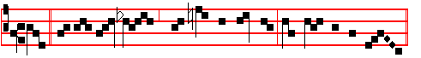
God, * for his great love wherewith he loved us, hath sent his own Son
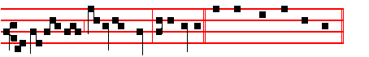
in the likeness of sinful flesh, al-le-lu-ia. Canticle Magnificat, p. 211.
COLLECT
O GOD, who by the virgin child-bearing of blessed Mary hast bestowed upon mankind the rewards of eternal salvation: grant, we beseech thee, that we may perceive her intercession for us, through whom we have been counted worthy to receive the author of life, Jesus Christ thy Son our Lord: Who liveth.
And no commemoration is made.
At Matins, Invitatory Unto us Christ is born. * O come, let us worship.
Hymn: E.H. 17 Christe Redemptor omnium, as on the Nativity, p. 354.

IN THE FIRST NOCTURN
Antiphon. The Lord said unto me: * thou art my Son, this day have I begotten thee. Psalm 2 Quare fremuerunt.
Antiphon. In thee * hath he set a tabernacle for the sun, whieh cometh f'orth as a bridegroom out of his chamber. Psalm 19 Cæli enarrant.
Antiphon. Be ye lift up, ye everlasting doors, and the King of glory shall come in. Psalm 24 Domini est terra.

 The Lord cometh forth.  As a bridegroom out of his chamber.

412
From the Epistle of blessed Paul the Apostle to the Romans.
Lesson j Ch.3 and 4
WHAT advantage then hath the Jew? or what profit is there of circumcision? Much every way: chiefly, because that unto them were committed the oracles of God. For what, if some did not believe? shall their unbelief make the faith of God without effect? God forbid: yea, let God be true, but every man a liar; as it is written, That thou mightest be justified in thy sayings,and mightest overcome when thou art judged. But if our unrighteousness commend the righteousness of God, what shall we say? Is God unrighteous,who taketh vengeance? (I speak as a man) God forbid: for then how shall God judge the world?
 Behold the Lamb of God, behold. him that taketh away the sin of the world, behold him of whom I said unto you: There cometh one after me which is preferred before me: * The latchet of whose shoes I am not worthy to unloose.
 He that is of the earth speaketh of the things of the earth, but he that cometh from heaven is above all things. The latchet.

Lesson ij
IS he the God of the Jews only? is he not also of the Gentiles? Yes, of the Gentiles also: seeing it is one God which shall justify the circumcision by faith, and uncircumcision through faith. Do we then make void the law through faith? God forbid: yea, we establish the law. What shall we say then that Abraham our father, as pertaining to the flesh, hath found? For if Abraham were justified by works, he hath whereof to glory, but not before God. For what saith the scripture? Abraham believed God, and it was counted unto him for righteousness. Now to him that worketh is the reward not reckoned of grace, but of debt. But to him that worketh not, but believeth on him that justifieth the ungodly, his faith is counted for righteousness. Even as David also describeth the blessedness of the man, unto whom God Imputeth righteousness without works, saying, Blessed are they whose iniquities are forgiven, and whose sins are covered.
 This day which is breaking is holy: come, ye nations, and worship the Lord. *
Today a great Iight is come down upon earth.
 This is the day which the Lord hath made: we will ejoice and be glad in it. To-day.

Lesson iij
COMETH this blessedness then upon the circumcision only, or upon the uncircumcision also? for we say that faith was reckoned to Abraham for righteousness. How was it then reckoned? when he was in circumcision, or in uncircumcision? Not in circumcision, but in uncircumcision. And he received the sign of circumcision, a seal of the righteousness of the faith which he had yet

413
being uncircumcised: that he might be the father of all them that believe, though they be not circumcised; that righteousness might be imputed unto them also: and the father of circumcision to them who are not of the circumcision only, but who also walk in the steps of that faith of our father Abraham, which he had being yet uncircumcised.
 Blessed is he that cometh in the Name of the Lord. God is the Lord who hath shewed us light. * Alleluia, alleluia.
 This is the day which the Lord hath made: we will rejoice and be glad in it. Alleluia. Glory be. Alleluia.

IN THE SECOND NOCTURN

Antiphon. Thou art fairer than the children of men; full of grace are thy lips. Psalm 45 Eructavit cor meum.
Antiphon. He was born in her, and the Most High shall stabllsh. her. Psalm 87
Fundamenta eius.
Antiphon. All the trees * of the wood shall rejoice before the Lord, for he cometh. Psalm 96 Cantate Domino.
 Thou art fairer than the children of men.  Full of grace are thy lips.
Sermon by S. Leo the Great
Lesson iv Sermon 27; 7 on the Lord’s Nativity
FOR the keeping of today’s festival with true reverence and devotion, dearly beloved, it is necessary to have no erroneous ideas about the Lord's Incarnation, nor limited ideas concerning the Godhead. For there is equal danger in both these errors: in denying both that he truly took our nature, and that his glory is equal with the Father’s. Therefore when we attempt to understand the sacred mystery of the Nativity of Christ, who was born of the Virgin Mother, we must come out of the fog of earthly reasonings, leave it utterly behind us, and the mist of worldly wisdom must give place to the shining eye of enlightened faith.
 Rejoice with me, all ye that love the Lord, for although I was lowly I pleased the Most High. * And from my womb I have brought forth God and man.
 All generations shall call me blessed for the Lord hath regarded the lowliness of his handmaiden. And from.

Lesson v
THE authority which we own and believe is of God: so is the doctrine which we hold and follow. Whether it is the testimony of the law, or the declaration of the prophets, or the proclamation of the Evangelist that rouses our inward hearing, it was the Truth that John, full of the Hol Spirit, thundered forth, In the beginning was the Word, and the Word was with God, and the Word was God. The same was in the beginning with God. All things were made by him; and

414
without him was not anything made that was made.The peal that followed from the same preacher was also the Truth. And the Word was made flesh and dwelt among us, (and we beheld his glory, the glory as of the only-begotten of the Father).
 The Virgin’s heart was strengthened, and in it, at the message of an Angel, she
conceived divine mysteries: then did she receive in her pure womb him that is fairer than the children of men. * And she that is blessed for ever brought forth for us God and man.
 The humble home of the lowly heart becomes the temple of God; inviolate, by man unknown, she in her womb conceived the Son. And she.

Lesson vj
THE Person of the Son of God, then, is in both Natures, and he takes ours without losing his own: as Man he restores man; In himself he remains immutable. The Deity with which he co-exists with the Father suffers no loss of its omnipotence, nor does the form of a servant dishonour the form of God. For the almighty and eternal Essence stooped down for the sake of mankind, and translated us into his glory, yet he by no means ceased to be what he already was. Whence it is that the Only-begotten Son of God declares himself to be less than the Father, to whom he also says that he is equal; thus he shows that both natures are truly in him; he proves himself to be inferior as touching his Manhood, and declares himself equal as touching his Divinity.
 Blessed and holy art thou, O Virgin Mary; who, without spot of sin,
became the Mother of the Saviour. * He lies in a manger and his glory fills the heaven.
 O Lord I have heard thy speech and was afraid: I beheld thy works and trembled: O thou that dwellest between the Cherubim. He lies. Glory be. He lies.

~
IN THE THIRD NOCTURN

Antiphon. In the beginning * and before all ages was God the Word: he is born unto us the Saviour of the world. Psalm 97 Dominus regnavit.
Antiphon. He who was begotten * before the daystar and before all worlds, the Lord the Redeemer, is on this day pleased to be born unto us. Psalm 98 Cantate Domino.
Antiphon. When the Lord was born, * the choir of Angels sang, saying, Salvation unto our God, that sitteth upon the throne, and unto the Lamb Psalm 99. Dominus regnavit.
 The Lord declared, alleluia.  His salvation, alleluia.

The Lesson from the Holy Gospel according to S. Luke

415
Lesson vij Ch. 2
AND when eight days were accomplished for the circumcising of the child, his
name was called JESUS, which was so named of the angel before he was conceived in the womb.
Homily by S. Ambrose, Bishop Book 2 on Luke Ch. 2
SO the Child was circumcised. Who is this Child? Who but he of whom it was said, Unto us a Son is given. Made under the law to redeem them that were under the law.To present him to the Lord. I would discuss the meaning of this presenting him to the Lord in Jerusalem, had I not already done so in my commentary on Isaiah. He that is circumcised from his sins is, in the Lord’s eyes, deemed honourable, for the eyes of the Lord are over the righteous. You may observe that every rite under the old law is a type to be fulfilled m the new; thus circumcision signifies the cleansing of sins.
 O holy and spotless Virginity! I know not how to praise thee, * For thou hast
borne in thy breast him whom the heavens cannot contain.
 Blessed art thou among women and blessed is the fruit of thy womb. For thou.

Lesson viij
BY reason of a certain proneness and tendency to sin, our frail human minds and bodies are enmeshed in wrongdoing, and so by the eighth day of Circumcision, future cleansing of all our sins at the time of the Resurrection is prefigured. Here is the meaning of, Every male that openeth the womb shall be called holy to the Lord: by these words from the law, the Child-bearing of the Virgin was promised. And truly he who opened her womb was holy, for he was spotless. Finally the Angel repeats these same words that declare that this is the Child designated by the law: That holy thing which shall be born of thee shall be called the Son of God.
 The Virgin Mother knew not a man, and brought forth without travailing. * The Saviour of the world and very King of Angels was suckled at her heaven-filled breast.
 The humble home of the lowly heart becomes the temple of God; inviolate, by man unknown, she in her womb conceived the Son. The Saviour. Glory be. The Saviour.

Lesson ix
OF all that were born of women, the Lord Jesus alone was holy. His unique stainless birth could not have known the contagion of earthly corruption, and in his divine Majesty he would have expelled it. Now if we take this saying literally, how can every male be said to be holy, when clearly some have been very wicked? Surely Ahab was not holy, nor the false prophets who were consumed by avenging fire from heaven at Elijah’s prayer? But these devout

416
precepts of the divine law figuratively denote the mystery that is to be: that He is the Holy One who alone may open the closed womb of stainless fecundity of the holy virgin the Church, so that she may give birth to God's people.
Te Deum Laudamus.
At Lauds and the Hours,
Antiphon 1. Tone vj
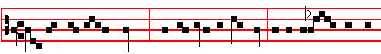
O wondrous interchange! * The Creator of mankind, taking upon him a 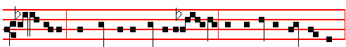
living body, vouchsafed to be born of a Vir- gin: and proceeding forth as Man,
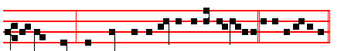
without seed, hath made us partakers of his Divin-ity. E u o u a e. Ps. 93
Dominus regnavit and the rest, p.

Antiphon 2. Tone iij, 3.
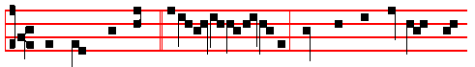
When thou wast born * inef-fably of a Virgin, then were the Scriptures ful-
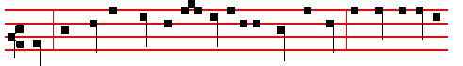
filled: thou camest down Iike the rain into a fleece of wool, to bring salvation
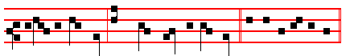
unto all mankind: we praise thee, O our God. E u o u a e.

Antiphon 3. Tone iv, 1.

417
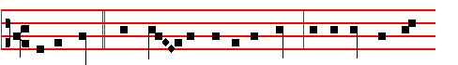
In the bush * which Mo - ses saw unconsumed, we acknowledge the
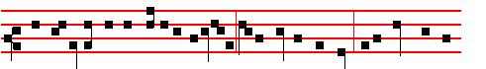
preservation of thy glorious virginity: holy Mother of God, intercede for thy
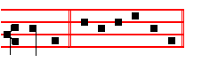
chil-dren. E u o u a e.
Antiphon 4. Tone j, 1.
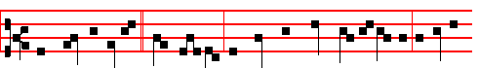
The Root of Jesse * hath budded: the Star hath come out of Jacob: a Vir-gin
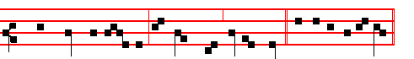
hath borne the Saviour: we praise thee, O our God. E u o u a e.
Antiphon 5. Tone ij.
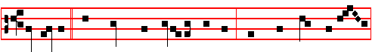
Lo, Mary * hath brought forth to us the Saviour; whom when John be-held,
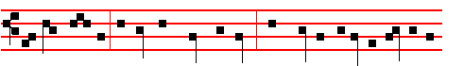
he cried saying: Behold the Lamb of God, which taketh away the sin of the
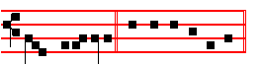
world, al-le-lu-ia. E u o u a e. 418
Chapter Titus 2
THE grace of God that bringeth salvation hath appeared to all men, teaching us that, denying ungodliness and worldly lusts, we should live soberly, righteously, and godly in this present world.
Hymn: E.H. 18 A solis ortus, as above on the Nativity, p. 371.
 The Word was made flesh, alleluia  And dwelt among us, alleluia.
On Benedictus, Antiphon viij, 1.
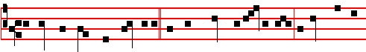
A great and wondrous mystery * is made known to us this day; a new thing is
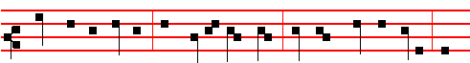
wrought in both natures: that God is made man; that which was remained, and
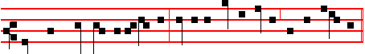
that which was not, he assumed; suffering no confusion, nor yet division.
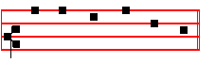
Canticle Benedictus, p. 39.
COLLECT

O GOD, who by the virgin child-bearing of blessed. Mary hast bestowed upon mankind the rewards of eternal salvation: grant, we beseech thee, that we may perceive her intercession for us, through whom we have been counted worthy to receive the author of life, Jesus Christ thy Son our Lord: Who liveth.

At Terce, Antiphon When thou wast born, p. 419.
Chapter The grace, as above.
Short  as above on the Nativity, p. 372-3.
The Word was made flesh. * Alleluia, alleluia. The Word.
 And dwelt among us. Alleluia, alleluia. Glory be. The Word.
 He shall call me, alleluia.  Thou art my Father, alleluia.

At Sext, Antiphon In the bush, p. 420.
419
Chapter Heb. l.
AND: Thou, Lord, in the beginning hast laid the foundation of the earth; and the heavens are the works of thine hands .
Short  as above on the Nativity, p. 373.
The Lord declared, * Alleluia ,alleluia. The Lord.
 His salvation. Alleluia, alleluia. Glory be. The Lord.
 All the ends of the world have seen, alleluia.
 The salvation of our God, alleluia.

At None, Antiphon Lo, Mary, p.420.
Chapter Heb. 1
THEY shall perish, but thou remainest; and they all shall wax old as doth a gament; and as a vesture shalt thou fold them up, and they shall be changed: but thou art the same, and thy years shall not fail.
Short  as above on the Nativity, p. 373.
All the ends of the world have seen. *Alleluia, alleluia. All the ends.
 The salvation of our God. Alleluia, alleluia, Glory be. All the ends.
 The Word was made flesh, alleluia.  And dwelt among us, alleluia.

In second Vespers, all as in first Vespers above, except
 The Lord declared. alleluia  His salvation alleluia
On Magnificat, Antiphon. Tone ij.
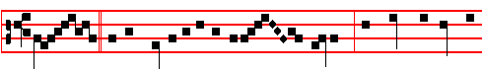
Great * is the mystery of the inher- - itance: the womb of her that
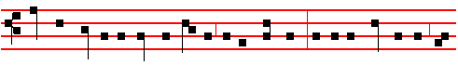
knew not man is become the temple of the Godhead: by taking flesh of her, he
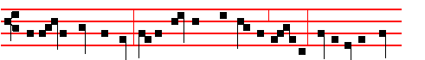
was in no way defiled: all the nations shall gather, saying: Glory be to thee,
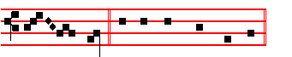
O Lord. Canticle Magnificat, p.209. 420
Collect O God, who by the virgin child-bearing, as above, p. 421.

Then for S. Stephen, as above, p. 375.
Antiphon. And Stephen, full of faith and power, did great wonders and miracles among the people.
 Stephen saw the heavens opened.
 He saw, and entered in: how blessed is the man unto whom heaven stood open.
COLLECT

ALMIGHTY and everlasting God, who, in the blood of the blessed Levite Stephen didst consecrate the first-fruits of the Martyrs: grant, we beseech thee; that he may ever intereede for us, who prayed even for his persecutors to our Lord Jesus Christ, thy Son: Who with thee liveth.
Of the other Octaves nothing is said in these Vespers.
__________________________________________________________________

ON THE OCTAVE OF SAINT STEPHEN
Double.
¶ At Matins, Invitatory.- The new-born Christ,who today crowned blessed Stephen, * O Come, let us worship.
Hymn, Antiphons, Psalms and  of the Nocturns from the Common of one Martyr.

IN THE FIRST NOCTURN

From the Acts of the Apostles.
Lesson j. Ch.7 and 8
YE stiff-necked, and uncircumcised in heart and ears, ye do always resist the Holy Ghost: as your fathers did, so do ye. Which of the prophets have not your fathers persecuted? and they have slain them which shewed before of the coming of the Just One; of whom ye have been now the betrayers and murderers: who have received the law by the disposition of angels, and have not kept it. When they heard these things, they were cut to the heart, and they gnashed on him with their teeth.
 And Stephen, full of faith and power,* Did great wonders and miracles among the people.
 There arose certain of the synagogue, disputing with Stephen; and they were not able to resist the wisdom and the spirit by which he spake. Did great.

Lesson ij
BUT he, being full of the Holy Ghost, looked up steadfastly into heaven: and saw the glory of God, and Jesus standing on the right hand of God and said,

421
Behold, I see the heavens opened, and the Son of man standing on the right hand of God. Then they cried out with a loud voice, and stopped their ears, and ran upon him with one accord and cast him out of the city,and stoned him: and the witnesses laid down their clothes at a young man’s feet, whose name was Saul. And they stoned Stehen, calling upon God, and saying, Lord Jesus, receive my spirit!
 All that sat in the council, looking steadfastly on Stephen, saw: * His face as it had been the face of an Angel standing among them.
 Full of grace and power, he did great wonders and miracles among the people. His face.

Lesson iij
AND he kneeled down, and cried with a loud voice, Lord, lay not this sin to their charge. And when he had said this, he fell asleep. And Saul was consenting unto his death. And at that time there was a great persecution against the church which was at Jerusalem; and they were all scattered abroad throughout the regions of Judaea and Samaria, except the Apostles. And devout men carried Stephen to his burial, and made great lamentation over him.
 Blessed Stephen looked up steadfastly into heaven, and saw the glory of God, and said: * Behold, I see the heavens opened, and the Son of man standing at the right hand of the power of God.
 But Stephen, being full of the Holy Ghost, looked up steadfastly into heaven, and said: Behold. Glory be. Behold.

IN THE SECOND NOCTURN

Sermon of Saint Augustine,Bishop.
Lesson iv. Sermon 2 on S. Stephen.
AFTER yesterday, the most festal of days, on which the Nativity of our Saviour Christ illumined us, today also is illumined by the crown of the blessed Martyr Stephen.That Martyr's merits are known in all parts of the world; for he suffered in the very beginning of the Church, that is in the city of Jerusalem itself. For there he ministered as Deacon: and in the very flower of youth he dyed in blood the beauty of his age. His passion is famous and most wonderful. When it is merely read from the book of the Acts of the Apostles, we not only hear, but also see with our eyes.

 They stoned Stephen, calling upon God, and saying: * Lord Jesus, receive my spirit, and lay not this sin to their charge.
 And he kneeled down, and cried with a loud voice, saying: Lord Jesus.

422
Lesson v
SO Christ the Head of the Martyrs first suffered for us; leaving you an example,that ye should follow his steps.Blessed Stephen followed the steps of his suffering,when he was stoned by the Jews for confessing Christ, and he earned his crown, as the name given him signifies.For the Greek word, Stephen, means crown. He already had his name, Crown, and this foreshadowed the Martyr's palm that he would gain.
 They ran upon him with one accord, and cast him out of the city, calling upon God, and saying: * Lord Jesus, receive my spirit.
 And the witnesses laid down their clothes at a young man's feet, whose name was Sau1; and they stoned Stephen, calling upon God and saying: Lord Jesus.

Lesson vj.
WHO, when he was stoned, not only wished for no revenge on his enemies, but even besought God to pardon them. For he remembered that the Lord had said: Vengeance is mine, I will repay, saith the Lord. And again: Say not, I will avenge myself upon mine enemies; but wait for the Lord, to help thee. The Lord commands us to wait to be vindicated with the holy Martyrs in the coming day of retribution.
 The ungodly fell upon the righteous to put him to death. * But he received the stones with joy, that he might earn a crown of glory.
 They stopped their ears, and ran upon him with one accord. But he received. Glory be. But he received.
IN THE THIRD NOCTURN

The Lesson from the holy Gospel according to S. Matthew.
Lesson vij Ch. 23
AT that time: Jesus said unto the scribes and. Pharisees: Behold, I send unto you prophets, and wise men, and scribes: and some of them ye shall kill and crucify. And the rest.
Homily by S Jerome, Priest Book 4 Commentary on Matthew 23
O JERUSALEM, Jerusalem, thou that killest the prophets. He calls not the earth and buildings of the city Jerusalem, but the inhabitants: and he laments over it with a father's love as we read. also in another place, that seeing it he wept over it. But in that he says: How often would I have gathered thy children together: he witnesses that all the prophets before were sent by himself. The image of a hen gathering her chickens under her wings, we read in the Canticle of Deuteronomy: As an eagle stirreth up her nest, fluttereth over her young, spreadeth abroad her wings, taketh them, beareth them on her wings.
 Stephen the servant of God, who was stoned by the Jews, saw the heavens : he saw and entered in. * Blessed is the man, unto whom heaven lay open.

423
 While he was crushed by the hurtling shower of stones, God's brightness broke upon him out of heavenly places. Blessed.

Lesson viij.
BEHOLD, your house is left unto you desolate. This very thing he had already said before in the person of Jeremiah: I have left mine house, I have forsaken mine inheritance, mine inheritance is become unto me as a den of jackals. That the house of the Jews is desolate, that is, that temple that shone gloriously, we can see with our own eyes: because it lost Christ who dwelt in it, and seeking to seize the inheritance it killed the heir.
 The gates of heaven were opened to Christ's blessed martyr Stephen, and he is found the first among all the martyrs. * Wherefore he reigneth crowned in heaven.
 For he was the first to make an offering of his death to that Saviour who vouchsafed to suffer death for us. Wherefore. Glory be. Wherefore.

Lesson ix.
FOR I say unto you, Ye shall not see me henceforth, till ye shall say, Blessed is he that cometh in the name of the Lord. He speaketh to Jerusalem, and to the people of the Jews. And that verse, which was also used at the entry of the Lord and Saviour into Jerusalem by children and infants, when they said: Blessed is he that cometh in the name of the Lord, hosanna in the highest; he took from the 117th Psalm **, which obviously was written of the coming of the Lord.
Te Deum Laudamus.

At Lauds, and the Hours, Antiphon They stoned Stephen, with the rest, as above on the Feast, p. 380-1.
COLLECT

ALMIGHTY and everlasting God, who, in the blood of the blessed Levite Stephen didst consecrate the first-fruits of the Martyrs: grant, we beseech thee; that he may ever intercede for us, who prayed even for his persecutors to our Lord Jesus Christ thy Son: Who with thee liveth.

For commemoration of S John, as above, p. 390.
Antiphon.This is the same John who leaned on the Lord's bosom at the last supper: the blessed Apostle, unto whom were revealed the secret things of heaven.
 This is that disciple which testifieth of these things.
 And we know that his testimony is true.

COLLECT
__________________________________________________________________
** psalm 118 in the Hebrew numbering
424
O LORD, graciously illumine thy Church, that it being enlightened by the doctrine of blessed John thine Apostle and Evangelist, may attain unto everlasting gifts. Through.

For the Holy Innocents, as above, p. 392.
Antiphon. These are they which were were not defiled with women; for they are virgins: and they follow the Lamb whithersoever he goeth.
 Herod was exceeding wroth, and slew many children
 In Bethlehem Judah, the city of David.
COLLECT
O GOD,whose praise the Innocents thy Martyrs did this day not by speaking but by dying confess: mortify all evil vices in us; that, as our tongues confess thy faith, so our lives may by their actions set forth the same. Through.

In second Vespers Antiphons of Lauds of the Feast above. Psalms 110, 111, 112, 113 of Sunday, and in the last place 116, 10-16 Credidi, as in the Common of Apostles, II Vespers, 3rd place.

Thenceforth it is of S. John, Chapter He that feareth, as above in Lauds of the Feast, and Hymn. E.H. 176 as in the Common, but with the Doxology of Christmas.
 Right worthy of honour is blessed John the Apostle.
 Who leaned on the Lord's bosom at the last supper.
On Magnificat, Antiphon.This is the same John, as above, p. 390.
Collect O Lord, graciously illumine, as above.

For S. Stephen, as above, p. 383.
Antiphon. Devout men carried Stephen to his burial, and made lamentation over him.
 Stephen saw the heavens opened.
 He saw, and entered in: how blessed is the man unto whom the heaven stood open.
Collect Almighty and everlasting, as above.

For the Holy Innocents, as above, p. 400.
Antiphon. Then were innocent children slain instead of Christ by a wicked ruler; the very sucklings were put to death: spotless, they follow the Lamb himself, and say for ever: Glory be to thee, O Lord.
 Beneath the altar all the Saints cry aloud:
 Shall not our blood be avenged, O our God.
Collect O God, whose praise, as above.

425
ON THE OCTAVE OF SAINT JOHN.
Double.
At Matins all as in the Common of Apostles except the Lessons.

IN THE FIRST NOCTURN

From the book of the Revelation of blessed. John the Apostle.
Lesson j Ch.4
AFTER this I looked, and behold, a door was opened in heaven; and the first voice which I heard was as it were of a trumpet talking with me, which said, Come up hither, and I will shew thee things which must be hereafter. And immediately I was in the Spirit: and behold, a throne was set in heaven, and one sat on the throne. And he that sat was to look upon like a jasper and a sardine stone: and there was a rainbow round about the throne, in sight like unto an emerald. And round about the throne were four and twenty seats: and upon the seats I saw four and twenty elders sitting, clothed in white raiment; and they had on their heads crowns of gold.
 Right worthy of honour is blessed John, who leaned on the Lord's breast at the last supper. * To him did Christ upon the cross commit his Mother, as virgin to virgin.
 As a virgin he was chosen by the Lord, who loved him more than all the rest. To him did.

Lesson ij
AND out of the throne proceeded lightnings and thunderings and voices: and
there seven lamps of fire burning before the throne, which are the seven Spirits of God. And before the throne there was a sea of glass like unto crysta1: and in the midst of the throne, and round about the throne, were four beasts,full of eyes before and behind. And the first beast was like a lion, and the second beast like a calf, and tle third beast had a face as a man, and the fourth beast was like a flying eagle. And the four beasts had each of them six wings about him; and they were full of eyes within.
 This is the disciple which testifieth of these things, and wrote these things. * And we know that his testimony is true.
 He drank the flowing Gospel from the sacred fountain of the Lord’s breast. And we know.

Lesson iij.
ND they rest not day and night, saying, Holy, holy, holy, Lord God Almighty, which was, and is, and is to come. And when those beasts give glory and honour and thanks to him that sat on the throne, who liveth for ever and

A

426
ever, the four and twenty elders fall down before him that sat on the throne, and worship him that liveth for ever and ever, and cast their crowns before the throne, saying, Thou art worthy, O Lord, to receive glory and honour and power, for thou hast created all things, and for thy pleasure they are and were created.
 This is that most blessed Apostle and Evangelist John, * Who was found worthy to be honoured by the Lord above all others, with a singular privilege of love.
 This is the disciple whom Jesus loved who leaned on the Lord's bosom at the last supper. Who was. Glory be. Who was.

IN THE SECOND NOCTURN
From the Treatise of S.Augustine, Bishop, on John.
Lesson iv. Treatise 36
IN the four Gospels, or rather the four books of the one Gospel, Saint John the Apostle, not unworthily in respect of spiritual intelligence compared to the eagle, hath taken a higher flight, and soared in his preaching far more sublimely, than the other three, and in the lifting up thereof would have our hearts lifted up likewise. For the other three Evangelists did as man walk with the Lord on earth:. of his Godhead they told but little: but this Evangelist, as if he thought scorn to walk on earth, even as in the very opening of his discourse he thundered upon us, hath taken flight, not only above the earth and above the whole compass of air and sky, but above the whole army of Angels, and the whole array of invisible Powers, and passed through to him by whom all things were made, saying, In the beginning was the Word, and the Word was with God, and the Word was God.
 Him that overcometh will I make a pillar in my temple, saith the Lord * And I will write my Name upon him, and the name of the city, which is New Jerusalem.
 To him that overcometh will I give to eat of the tree of life, which is in the midst of the paradise of my God. And I will.

Lesson v.
HE proclaimed also other things appropriate to this so sublime beginning, and on the divinity of the Lord he gave forth what he had drunk in, in a way that no other has spoken. For not without cause is it related of him in that very Gospel, that even at the supper he leaned upon the Lord's breast. From that breast then he had drunk in secret; but what he drank in secret, he gave forth openly, that all nations might receive not only the incarnation of the Son of God, his passion and resurrection, but also that before the incarnation he was the Only Son, the Word of the Father, coeternal with Him who begot Him, equal to Him by whom He was sent.
 Jesus loved him, for his special mark of chastity made him worthy of greater love. * He chose him for a virgin unto himself, and he remaineth a virgin for ever.

427
 At the end, when he was dying upon the cross, he committed his Mother to him, as virgin to virgin. He chose.

Lesson vj.
AS an eagle John is a preacher of sublime things, and an intent gazer at the inward and everlasting light. For it is said, that the young of eagles are tested by their parents as follows: they are held in the talon of their father, and faced into the rays of the sun: he who looks intently, is acknowledged as a son; but if his gaze wavers, he is dropped from the talon as a changeling. Now therefore see, what sublime things he must speak, who is compared to an eagle: and yet even we worms of earth, feeble, and lasting hardly a moment among men, dare to treat of those things, and to expound them ,and we think that we can understand them when thinking, or be understood while we are speaking of them.
 In the midst of the Church he opened his mouth. * And the Lord filled him with the spirit of wisdom and understanding.
 He shall find joy and a crown of gladness. And he. Glory be. And he.

IN THE THIRD NOCTURN

The Lesson from the holy Gospel according to John.
Lesson vij Ch. 21
AT that time: Jesus saith unto Peter: Follow me. Then Peter, turning about, seeth the disciple whom Jesus loved, following. And the rest.
Homily by S.John Chrysostom Homily 87 on John.
CHRIST had imparted great things to Peter, committed to him the care of the
whole world, foretold his martyrdom, and shown greater love towards him. Peter, wanting John as a friend and colleague, said: And what shall this man do? Shall he go the same way? And as, when at supper he dared not ask he acted through John; so now he does the opposite, thinking that he wants to ask but does not dare. Then Christ says: If I will that he tarry till I come, what is that to thee?
 In that day will I take thee, O my servant, and will make thee as a signet before me. * For I have chosen thee, saith the Lord.
 Be thou faithful unto death, and I will give thee a crown of life. For I have.

Lesson viij
FOR since Peter said this from excess of love, not wanting to be separated from him, Christ, to show him that however much love he followed him with, he could not equal his own, said, If I will that he tarry,what is that to thee? Teaching us by these words not to grieve nor enquire too curiously beyond the divine will. For since Peter was always bursting out too fervently with this sort of question, he replied in this way so as to restrain his fervour and show that he ought not to

428
inquire further.
 This is the same John which leaned on the Lord's breast at the last supper. * The blessed Apostle unto whom were revealed the secret things of heaven .
 He drank the flowing Gospel from the sacred fountain of the Lord's breast. The blessed. Glory be. The blessed.

Lesson ix.
THEN went this saying abroad among the brethren that that disciple should not die: yet Jesus said not unto him, He shall not die, but, If I will that he tarry till I come, what is that to thee? Do not think, he says, that I have provided for you both in the same way. And this he said, to remove unruly affection and the desire for the familiar. For since they were to undertake the care of the whole world, they ought not to be together any more; for that would have been a great loss to the world. For this reason he saith: Thou hast taken up a work, consider it: carry it out, labour, and show thyself in struggles. What is it to thee, if I will that he remain here? Do thou care for thy duty, and perform it.
Te Deum Laudamus.

AT LAUDS

Antiphon. Right worthy of honour, p. 388, with the rest, as above on the Feast. Likewise the Chapter, Hymn, Versicle, and Antiphon on Benedictus.

For commemoration of the Holy Innocents, as above, p. 399.
Antiphon. These are they which were not defiled with women; for they are virgins: and they follow the Lamb whithersoever he goeth.
 Herod was exceeding wroth, and slew many children.
 In Bethlehem Judah, the city of David.

COLLECT

O GOD, whose praise the Innocents thy Martyrs did this day not by speaking but by dying confess: mortify all evil vices in us; that, as our tongues confess thy faith, so our lives may by their actions set forth the same. Through.

At the Hours, as on the Feast above, p. 390-1.

In second Vespers, Antiphons from Lauds of the Feast Right worthy of honour, above. Psalms as in second Vespers of the Common of Apostles.
Chapter and the rest, as on the day of the Feast above, with commemoration of the Holy Innocents. Antiphon. These are they.
 Herod was exceeding wroth. Collect O God, whose praise, as above.

429

ON THE OCTAVE OF THE HOLY INNOCENTS
Double
All is said as on the Feast, above, except the Lessons, and the ninth Responsory is omitted, and in its place is said Te Deum Laudamus.

IN THE FIRST NOCTURN
From the Epistle to the Romans
Lesson j Ch. 5, 1-9
THEREFORE being justified by faith, we have peace with God through our Lord Jesus Christ, by whom also we have access by faith into this grace wherein we stand, and rejoice in hope of the glory of God. And not only so, but we glory in tribulations also, knowing that tribulation worketh patience; and patience experience; and experience, hope: and hope maketh not ashamed, because the love of God is shed abroad in our hearts by the Holy Ghost which is given unto us.
 An hundred forty and four thousand which were redeemed from the earth, these are they which are not defiled with women, * For they are virgins; therefore are they reigning with God, and the Lamb of God is with them.
 These are they which came out of great tribulation, and have washed their robes in the blood of the Lamb. For they.

Lesson ij
FOR when we were yet without strength, in due time Christ died for the ungodly. For scarcely for a righteous man will one die: yet peradventure for a good man some would even dare to die. But God commendeth his love toward us, in that, while we were yet sinners, Christ died for us. Much more then being now justified by his blood, we shall be saved from wrath through him.
 I heard under the altar of God the voices of them that were slain, saying: * How long dost thou not avenge our blood? And it was said unto them from God: Rest yet for a little season, until the number of your brethren be fulfilled.
 I saw under the altar of God the souls of them which were slain for the Word of God and for the testimony which they held, and they cried. with a loud voice, saying. How long.

Lesson iij
FOR if, when we were enemies, we were reconciled to God by the death of his Son, much more, being reconciled, we shall be saved by his life. And not only so, but we also joy in God., through our Lord Jesus Christ, by whom we have now received the atonement. Wherefore, as by one man sin entered into the world, and death by sin; and so death passed upon all men, for that all have sinned.
 They worship him that liveth for ever and ever, * and cast their crowns before the throne of the Lord God.
430
 And they fall down on their faces before the throne, and worship him that liveth tor ever and ever. And cast. Glory be. And cast.

IN THE SECOND NOCTURN
Sermon by S.Augustine, Bishop.
Lesson iv Sermon 1 on Innocents.
At the Lord's birth mourning begins, not in heaven but on earth. The lamentation ot mothers is shown, the joy ot Ange1s, the translation ot babes. It is God who is born: the Innocents must be offered to him who comes to condemn the wickeuess of the world. Little lambs must be sacrificed, for the Lamb is going to be crucified, who taketh away the sin ot the world. But the mother sheep lament because their lambs bleat no more. O what a martyrdom, what a piteous sight!
The sword is drawn, though there is no provocation: jea1ousy alone is shrieking,
since he who is born has done no wrong. Behold the mother sheep mourning their
lambs: In Ramah was there a voice heard, lamentation and weeping, and great mourning. The lambs are pledges: not credits but creatures, not deposits but offerings. ((non credita, sed creata: non deposita, sed exposita.))
 The blood of the Saints have they shed like water on every side of Jerusalem. * And there was no man to bury them.
 The dead bodies of thy servants have they given to be meat unto the fowls of the air, and the flesh of thy Saints unto the beasts of the land. And there.

Lesson v
NATURE herself is a witness who fought in the martyrs, when the tyrant attacked the infants. The mother scattered the hair of her head, who was losing the adornment of her head. In how many ways she wanted to hide the infant, but the babe proclaimed his presence. It did not know to be silent, for it had not yet learned to fear. The mother fought with the executioner: he pulled, she held.The other cried to the executioner: Why dost thou part from me him whom I brought forth from me? My womb groaned, he was hardly alive, and he was gone, bursting my breast in vain with milk. I carried him carefully, whom I see attacked by thy cruel hands. My womb had only just brought him out, and thou dost dash him to the ground.
 These are Saints, who suffered for thy sake, O Lord; take vengeance for them. * For day by day they cry unto thee.
 Avenge, O Lord, the blood of thy Saints, which is shed. For day.
Lesson vj.
ANOTHER mother, since the merciless soldier did not compel the mother to be killed together with the child, cried out: Why dost thou leave me empty? If there is a fault, it is mine, if there is no crime, kill us together, and free the mother. Another said: What do ye seek? Ye seek one, and kill many; and the one,

431
who is the One, ye cannot reach. Another on the contrary cried: Come now, come, O Saviour of the workld, how long wilt thou tarry? Thou fearest none, let the soldier see thee, and he will not kill our infants. So mingled the lamentation of the mothers,and the oblation of the little ones went up to heaven.
 These are they which have not defiled their garments,* They shall walk with me in white, for they are worthy.
 These are they which are not defiled with women, for they are virgins.They shall. Glory be. They shall.

IN THE THIRD NOCTURN

The Lesson from the holy Gospel according to Matthew.
Lesson vij Ch. 2
AT that time: the Angel of the Lord appearelh to Joseph in a dream, saying, Arise, and take the young child and his mother and flee into Egypt, and be there unti1 I bring thee word. And the rest.
Homily by S.John Chrysostom. From Homily 8 on Matthew.
WHEN Joseph heard this, he was not at all offended, and did not say: The thing is uncertain and quite ambiguous.Thou saidst a little earlier, that he would save his people, and now he cannot even save himself from dangers: but flight is necessary for us, and long pilgrimage and exile.The facts are utterly contrary to the promises.But he said none of this in opposition, for he was a man of faith: nor did he curiously inquire of the time of return, which certainly had not been expressed in any sealed way by the Angel: And be thou there, he said, unti1 I bring thee word.
 The Saints sung a new song before the throne of God and the Lamb * And their voices resounded on earth.
 These were redeemed from among men, beinl the firstfruits unto God, and to the Lamb, and in their mouth was found no guile. And their voices.

Lesson viij
BUT he did not even hesitate because of these things, but freely obeyed, and believed, and went forth bearing all tribulations with joy. For the merciful God indeed mixes in also some joys with sorrows. Which certainly he does with all his Saints, whom he never allows to have either tribulations or pleasures continually, but weaves the life of the just, now from adversity, now from prosperity, as it were in an admirable variety. Consider that he did this here also.
 I saw under the altar of God the souls of them that were slain for the Word of God, which they held, and they cried with a loud voice: Avenge, O Lord, the blood of thy Saints, which is shed.
 Under the throne of God all the Saints cry aloud: Avenge. Glory be. Avenge.

432
Lesson ix
FOR by seeing the Virgin great with child Saint Joseph was thrown into great distress: but quickly the Angel was there to extinguish fear utterly. Then, seeing the boy born, he was filled with great exultation: but again this joy was succeeded by great danger, when indeed the whole city was in turmoil, the king himself was raging and seeking the child to kill him. But also this sorrow was followed again by another joy; that is, the appearance of the star, and the adotation of the Magi. After this happiness also, again danger, again fear. Herod, he saith, will seek the young child to destroy him,and it is necessary to flee, and go into long exile.
Te Deum Laudamus.
At Lauds and the Hours, all as on the day of the Feast, above, p. 397-9, omitting the commemorations.

In Vespers, Antiphons from Lauds above, Psalms 111, 112, 113, of Sunday, and in the last place Ps.116, 10-16 Credidi, as in II Vespers of the Common of Apostles, in the 3rd place.
The Rest as on the day, above.
After the Collect of the Holy Innocents commemoration is made of the Vigil of the Epiphany, as above, p. 410.
Antiphon. The Child Jesus * increased in wisdom and stature in the sight of God and man.
 The Lord declared, alleluia.  His salvation, alleluia.

COLLECT
ALMIGHTY and everlasting God, direct our actions according to thy good pleasure: that in the name of thy well-beloved Son we may be made worthy to abound in good works: Who liveth and reigneth with thee.

Then commemoration is made of S.Telesphorus, Pope and Martyr, as p. xxx.
Antiphon. This is a Martyr * who strove for his Master's precepts, even unto death:and feared not the words of evil men, forasmuch as he was established on a sure foundation.
 Thou hast crowned him with glory and honour, O Lord.
 And madest him to have dominion of the works of thy hands.

COLLECT
O GOD, who makest us glad with the yearly solemnity of blessed Telesphorus, thy Martyr and Bishop: mercifully grant; that as we now celebrate his birthday, so we may likewise rejoice in his protection. Through.

433
On the Vigil of the Epiphany

The Office is Semidouble. At Matins, all is said as on the Octave of the Nativity, above, except the Lessons etc., placed below.

IN THE FIRST NOCTURN
From the Epistle to the Romans
Lesson j Ch.7
KNOW ye not, brethren, (for I speak to them that know the law),how that the law hath dominion over a man as long as he liveth. For the womn is bound by the law to her husband for so long as he liveth; but if the husband be dead, she is loosed from the law of her husband. So then if, while her husband liveth, she be married to another man, she shall be called an adulteress: but if her husband be dead, she is free from that law; so that she is no adulteress, though she be married to another.
 Behold the Lamb of God, behold him that taketh away the sin of the world, behold him of who I said unto you:There cometh one after me which is preferred before me: * The latchet of whose shoes I am not worthy to unloose.
 He that is of the earth speaketh of the things of the earth, but he that cometh from heaven is above all things. The latchet.

Lesson ij
HEREFORE, my brethren, ye also are become dead to the law by the body of Christ; that ye should be married to another, even to him who is raised from the dead, that we should bring forth fruit unto God. For when we were in the flesh, the motions of sins, which were by the law, did work in our members to bring forth fruit unto death. But now we are delivered from the law, that being dead wherein we were held; that we should serve in newness of spJ.rit and not in the oldness of the letter.

W
 This day which is breaking is holy: come, ye nations,and worship the Lord * Today a great light is come down upon earth.
 This is the day wh1ch the Lord hath made: we will rejoice and be glad in it. Today.

Lesson iij
WHAT shall we sav then? Is the law sin? God forbid. Nay I had not known sin, but by the law: for I had not known lust, except the law had said, Thou shalt not covet. But sin, taking occasion by the commandment wrought in me all manner of concupiscence. For without the law, sin was dead. For I was alive

434
without the law once: but when the commandment came, sin revived.
 Blessed is he that cometh in the name of the Lord. God is the Lord who hath shewed us light. * Alleluia, alleluia.
 This is the day which the Lord hath made: we will rejoice and be glad in it. Alleluia. Glory be. Alleluia.

IN THE SECOND NOCTURN

Sermon by Saint Augustine, Bishop.
Lesson iv Sermon 13 on the Season
OUR Lord Jesus Christ, dearly beloved brethren, who in eternity is the creator of all things, today by being born of his Mother, hath been made our Saviour. He was born today willingly in time, that he might bring us to his Father's eternity. God was made man, that man might be made God: that man might eat the bread of Angels, the Lord of Angels today was made man.
 Rejoice with me, all ye that love the Lord, for although I was lowly I pleased the Most High. * And from my womb I have brought forth God and man.
 All generations shall call me blessed, for the Lord hath regarded the lowliness of his handmaiden. And from.

Lesson v
TODAY was fulfilled the prophecy which says: Drop down, ye heavens, from above, and let the skies pour down righteousness, let the earth open, and bring forth a Saviour. Therefore, he who had made, was made, that he who had perished might be found. For thus in the Psalms man confesses: Before I was troubled, I went wrong. Man went wrong, and became guilty, God was born man, that the guilty might go free. Man therefore fell, but God descended; man fell miserably, God descended mercifully; man fell through pride,God descended with grace.
 The Virgin's heart was strengthened, and in it, at the message of an Angel, she conceived divine mysteries: then did she receive in her pure womb him that is fairer than the children of men. * And she that is blessed for ever brought forth for us God and man.
 The humble home of the lowly heart becomes the temple of God: inviolate, by man unknown, she in her womb conceived the Son. And she.

Lesson vj
O MIRACLE, o wonder, my brethren! The laws of nature are changed in man: God is born, a virgin is with child without a man, the word of God marries her that knows no man: she is made at once mother and virgin; made mother, but incorrupt; having a son, knowing no man; ever closed, yet not fruitless. For he alone was born without sin, who was begotten without a man's embrace, not by

435
the desire of the flesh, but by the obedience of the mind.
 Blessed and holy art thou, O Virgin Mary, who without spot of sin, became the Mother of the Saviour. * He lies in a manger, and his glory fills the heavens.
 O Lord, I have heard thy speech, and was afraid: I beheld thy works and trembled: O thou that dwellest between the Cherubim. He lies. Glory be. He lies.

IN THE THIRD NOCTURN

The Lesson from the Holy Gospel according to S. Matthew
Lesson vij Ch. 2.
WHEN Herod was dead, behold, an angel of the Lord appeareth in a dream to Joseph in Egypt, saying, Arise, and, take the young child and his mother, and go into the land of Israel. And the rest.
Homily by S. Jerome, Priest Book 1 Commentary on Matt Ch. 2
WE learn here that the priests and scribes were also plotting the Lord's death at the same time as Herod. And he arose, and took the young child and his mother. It does not say, He took his son and his wife, but, The child and his mother; as guardian, not husband.
 O holy and spotless Virginity! I know not how to praise thee, * For thou hast
borne in thy breast him whom the heavens cannot contain.
 Blessed art thou among women and blessed is the fruit of thy womb. For thou.

Lesson viij
BUT when he heard that Archelaus did relgn in Judæa in the room of his father Herod, he was afraId to go thither. Many make the mistake, through their ignorance of history, of thinking that this is the same Herod who mocked the Lord In his Passion, who is here referred to as being dead. That Herod, the one who later made friends with Pilate, was the son of this Herod, and the brother of Archelaus.
 The Virgin Mother knew not a man, and brought forth without travailing. * The Saviour of the world and very King of Angels was suckled at her heaven-filled breast.
 The humble home of the lowly heart becomes the temple of God; inviolate, by man unknown, she in her womb conceived the Son. The Saviour. Glory be. The Saviour.

Lesson ix
HE shall be called a Nazarene. If the Evangelist had taken a definite quotation from the Scriptures, he would surely not have saId, WhIch was spoken by the prophets, but simply, WhIch was spoken by the prophet, in the singular. In saying prophets, in the plural, he shows that he is using the sense, and not the actual

436
words, of the Scnptures. Nazarene means holy, and all the Scriptures declare that the Lord will be holy.
Te Deum Laudamus
At Lauds, Antiphons as above on the Circumcision, p. 419-20.
Chapter Gal. 4
BRETHREN: The heir, as 1ong as he is a child, differeth nothing from a servant, though he be lord of all; but is under tutors and governors until the me appointed of the father.
Hymn: E.H.18 A solis ortus, as on the Nativity, above, p. 371.
 The Word was made flesh, alleluia.  And dwelt among us, alleluia.
On Benedictus, Antiphon.
While all things * were in quiet silence, and that night was in the midst of
her swift course, thine almighty Word, O Lord, leaped down out of thy royal
throne, al-le-lu-ia. Canticle Benedictus, p. 39.

COLLECT

ALMIGHTY and everlasting God, direct our actions according to thy good pleasure:that in the name of thy well-beloved Son we may be worthy to abound in good works:Who liveth and reigneth with thee.

And commemoration is made of S.Telesphorus, Pope and Martyr, p. xxxviij.
Antiphon. He that hateth his life in this world shall keep it unto life eternal.
 The righteous shall flourish like a palm-tree.
 And shall spread abroad like a cedar in Libanus.

COLLECT
O GOD, who makest us glad with the yearly solemnity of blessed Telesphorus thy Martyr and Bishop: mercifully grant; that as we now celebrate his birthday, so we may likewise rejoice in his protection. Through.

437
At Prime the Prayers are not said. At the close of the Chapter the Chapter of None is said.

AT TERCE
Antiphon When thou wast born, from Lauds of the Circumcision above, 419.
Chapter Brethren: the heir, as above.
Short  as above, 372-3.
The Word was made flesh, * Alleluia, alleluia. The Word.
 And dwelt among us. Alleluia, alleluia. Glory be. The Word.
 He shall call me, alleluia.  Thou art my Father, alleluia.

AT SEXT
Antiphon In the bush, as above, p. 420.
Chapter Gal. 4
BUT when the fulness of time was come, God sent forth his Son, made of a woman, made under the law, to redeem them that were under the law, that we might receive the adoption of sons.
Short  as above, p. 373.
The Lord declared, *Alleluia, aIleluia. The Lord.
 His salvation. Alleluia, alleluia. Glory be. The Lord.
 All the ends of the world have seen, alleluia.
 The salvation of our God, alleluia.

AT NONE
Antiphon Lo, Mary, as above, p.420.
Chapter Gal. 4
WHEREFORE thou art no more a servant, but a son; and if a son, then an heir of God through Christ.
Short  as above, p. 373.
All the ends of the world have seen. * Alleluia, alleluia. All the ends.
 The salvation of our God. Alleluia, alleluia. Glory be. All the ends.
 The Word was made flesh, alleluia  And dwelt among us, alleluia.
Vespers of the Epiphany. Double.

____________________________________________________

ON THE EPIPHANY OF THE LORD

AT VESPERS

Antiphon. Before the morning star begotten, with the rest from Lauds below. Psalms 110, 111, 112, 113 from Sunday, and in the last place 117 Laudate Dominum as in I Vespers of of Common of Apostles.

438
Chapter Isaiah 60.
ARISE, shine, for thy light is come, and the glory of the Lord is risen upon thee.
Hymn. E.H. 38 . Mode iij.
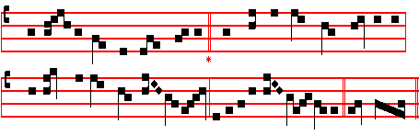
Hostis Herodes impie
WHY, impious Herod, shouldst thou fear 3 The Lamb of God is manifest
Because the Christ is come so near? Again in Jordan’s water blest,
He who doth heavenly kingdoms grant And he who sin had never known
Thine earthly realm can never want By washing hath our sins undone.

2 Lo, sages from the East are gone 4 Yet he that ruleth everything
To where the star hath newly shone Can change the nature of the spring,
Led on by light to Light they press, And gives at Cana this for sign-
And by their gifts their God confess. The water reddens into wine.

5 Then glory, Lord, to thee we pay
For thine Epiphany to-day;
All glory through eternity
To Father, Son and Spirit be. Amen.

Thus end the Hymns throughout the Octave.

 The Kings of Tharsis and of the isles shall give pre-sents.
- The kings of Arabia and Saba shall bring gifts.

On Magnificat, Antiphon. Tone viij, 1.
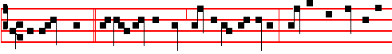
The wise men, * beholding the star, said to one another: This is the sign of a

439

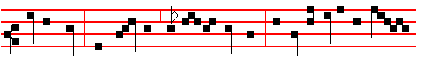
mighty King; forth fare we, and let us seek him: and let us offer him gifts,
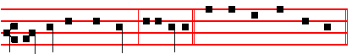
gold, incense and myrrh, al-le-lu-ia. Canticle Magnificat, p. 209.

COLLECT
O GOD who on this day by the leading of a star didst manifest thy only-begotten Son to the Gentiles: mercifully grant that we, who know thee now by faith, may be brought even to the contemplation of the beauty of thy majesty. Through the same.

At Compline, and through the Hours, the Hymns are sung to the Tone as below at Lauds, with the same doxology.

AT MATINS
Having said Our Father, Hai1, Mary, and I believe, omitting  O Lord, open thou, the Invitatory, with the Psalm Venite, and the Hymn, it is begun from the Antiphon Bring unto the Lord.
Throughout the Octave, however the  O Lord, open thou is said; Invitatory.- Christ is manifested unto us, * O come, let us worship. Psalm Venite. Hymn. E.H. 38 Hostis Herodes, above.
Antiphon. Bring unto the Lord, * O ye mighty; worship the Lord with holy worship. Psalm 29 Afferte Domino
Antiphon. The rivers of the flood thereof * shall make glad. Alleluia. The city of God. Alleluia. Ps.46 Deus, noster refugium
Antiphon. O sing praises, * sing praises unto our God, O sing praises, sing praises unto our King with understanding. Psalm 47 Omnes gentes, plaudite.
 All the world shall worship thee and sing of thee.
 And shall praise thy Name, O Lord.

From the Prophet Isaiah
Lesson j Ch. 55.
HO, every one that thirsteth, come ye to the waters, and he that hath no money; come ye, buy, and eat; come, buy wine and, milk without money and without
price. Wherefore do ye spend money for that which is not bread? and your labour

440

