THE Lord said unto my Lord * Sit thou on my right hand, until I make thine enemies thy footstool.
2 The Lord shall send the rod of thy power out of Syon * be thou ruler, even in the midst among thine enemies.
3 In the day of thy power shall the people offer thee free-will offerings with an holy worship * the dew of thy birth is of the womb of the morning.
4 The Lord sware, & will not repent * Thou art a Priest for ever after the order of Melchisedech.
5 The Lord upon thy right hand * shall wound even kings in the day of his wrath.
6 He shall judge among the heathen * he shall fill the places with the dead bodies; and smite in sunder the heads over divers countries.
7 He shall drink of the brook in the way * therefore shall he lift up his head.

Antiphon. Tone j.
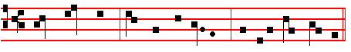
The Lord said un - to my Lord, Sit thou on my right hand.

Antiphon. Tone iv, 3.
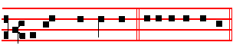
All his comandments. E u o u a e.

Ps. 111 Confitebor tibi CX

I WILL give thanks unto the Lord with my whole heart * secretly among the faithful, and in the congregation.
2 The works of the Lord are great * sought out of all them that have pleasure therein.
3 His work is worthy to be praised, and had in honour * and his righteousness endureth for ever.
4 The merciful and gracious Lord hath so done his marvellous works * that they ought to be had in rernembrance.
5 He hath given meat unto them that fear him * he shall ever be mindful of his

202
-The above Commemorations or Suffrages are said from the Octave of the Epiphany until Passion Sunday, and from the Octave of Pentecost until Advent, except on Doubles and within Octaves. When an Office is said of blessed Mary, no other commemoration is made of her.
__________________________________________________________________

COMMEMORATION OF THE CROSS
In Eastertide

Which is made daily in Lauds and Vespers both in the Office of the Season and of Saints, unless it be a Double, or within Octaves. The other commemorations of S. Mary, of the Apostles, and of Peace, are not said in Eastertide.

At Vespers, Antiphon.
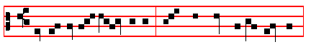

He the ho - ly Cross endured, Burst the gates of hell in twain:
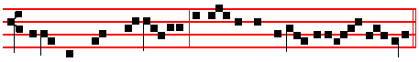 Begirt with might and majesty, On Easter morn he rose again, al- le- luia.
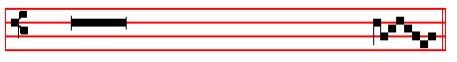
 Tell it out among the nations, allelu - - ia.
 That the Lord reigneth from the Tree, allelu - - ia.
Let us pray COLLECT
O GOD, who didst will that thy Son should for us undergo the burden of the Cross, that he might deliver us from the power of the enemy: grant unto us thy servants, that we may attain unto the joy of his resurrection.Through the same.
At Lauds, Antiphon.
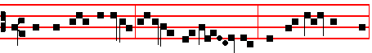 He that was crucified is risen from the dead; and hath re-deemed us,

247
7 He will not be afraid of any evil tidings * for his heart standeth fast, and believeth in the Lord.
8 His heart is established, and. will not shrink * until he see his desire upon his enemies.
9 He hath dispersed abroad, and given to the poor * and his righteousness remaineth for ever ; his horn shall be exalted with honour.
10 The ungodly shall see it, and it shall grieve him * he shall gnash with his teeth, and consume away ; the desire of the ungodly shall perish.

Antiphon.
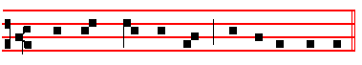
He hath great de – light in his commandments.
Antiphon.
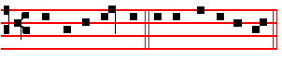
Blessed be the Name. E u o u a e.

Ps. 113 Laudate, pueri CXII

PRAISE the Lord, ye servants * O praise the Name of the Lord.
2 Blessed be the Name of the Lord * from this time forth for evermore.
3 The Lord's Name is praised * from the rising up of the sun unto the going down of the same.
4 The Lord is high above all heathen * and his glory above the heavens.
5 Who is like unto the Lord our God, that hath his dwelling so high * and yet humbleth himself to behold the things that are in heaven and earth ?
6 He taketh up the simple out of the dust * and lifteth the poor out of the mire.

7 That he may set him with the princes * even with the princes of his people.
8 He maketh the barren woman to keep house * and to be a joyful mother of children

Antiphon.
204
mankind the rewards of eternal salvation, we beseech thee; that we may perceive
her intercession for us, through whom we have been counted worthy to receive the
Author of life, Jesus Christ thy Son our Lord.

Of the Apostles
At Vespers, Antiphon.
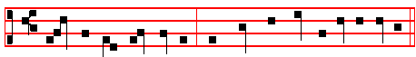
Pe - ter the A - pos-tle and Paul the Doc- tor of the Gentiles:

these have taught us thy law, O Lord.
 Thou shalt make them princes in all lands.
 They shall remember thy name, O Lord.

At Lauds, Antiphon.
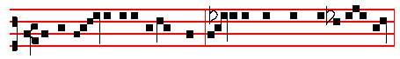
Glorious princes over all the earth, as in life they loved one an- o - ther,
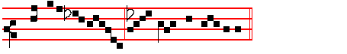
so even in death they were not di - vided.
 Their sound is gone out into all lands.
 And their words unto the ends of the world.

Let us pray COLLECT

245
Psalm 115 continues here without Glory be CXIV, 9

NOT unto us, O Lord, not unto us, but unto thy Name give the praise * for thy loving mercy, and for thy truth's sake.
2 Wherefore shall the heathen say * Where is now their God ?

3 As for our God, he is in heaven * he hath done whatsoever pleased him.

4. Their idols are silver and gold * even the work of men's hands.

5 They have mouths, and speak not * eyes have they, and see not.

6 They have ears, and hear not * noses have they, and smell not.
7 They have hands, and handle not ; feet have they, and walk not * neither speak they through their throat.
8 They that make them are like unto them * and so are all such as put their trust in them.
9 But thou, house of Israel, trust thou in the Lord * he is their succour and defence.
10 Ye house of Aaron, put your trust in the Lord * he is their helper and defender.
11 Ye that fear the Lord, put your trust in the Lord * he is their helper and defender.
12 The Lord hath been mindful of us, & he shall bless us * even he shall bless the house of Israel, he shall bless the house of Aaron.
13 He shall bless them that fear the Lord * both small and great.

14 The Lord shall increase you more and more * you and your children.

15 Ye are the blessed of the Lord * who made heaven and earth.

16 All the whole heavens are the Lord's * the earth hath he given to the children of men.
17 The dead praise not thee, O Lord * neither all they that go down into silence.

18 But we will praise the Lord * from this time forth for evermore. Praise the Lord.

206
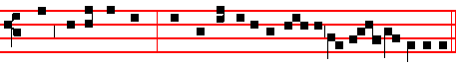
ham and to his seed : and hath ex-alted the humble for ev - er and ever.

The Chapter O the depth is said in Vespers of Saturday from the Octave of the Epiphany until Septuagesima, and from the Octave of Pentecost until Advent, and the Hymn and Versicle also, until Lent. The Antiphon on Magnificat, from the Octave of the Epiphany until Septuagesima only.

After the Antiphon is said the proper Collect.

Then are made the following common Commemorations, or Suffrages of the Saints, which are said at Lauds also.
__________________________________________________________________

COMMEMORATION OF THE CROSS

in the ferial Office only

At Vespers and Lauds, Antiphon.
By the sign of the Cross deliver us from our enemies * O our God.
 All the earth shall worship thee,and sing unto thee.
 And shall sing praises unto thy Name, O Lord.

Let us pray. COLLECT
Keep us, O Lord, we beseech thee, in perpetual peace, whom thou hast vouchsafed to redeem by the wood of the holy Cross.
__________________________________________________________________

COMMON COMEMORATIONS or SUFFRAGES OF THE SAINTS

Of S.Mary when her Office is not said:

At Vespers and Lauds, Antiphon. Tone j.
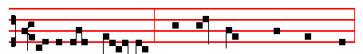
O ho - ly Ma - ry, help thou the suf - fer - ing,

243
O BLEST Creator of the light, 3 Lest, sunk in sin, and whelm'd with strife,
Who mak’st the day with radiance bright, They lose the gift of endless life ;
And o'er the forming world didst call While thinking but the thoughts of time,
The light from chaos first of all; They weave new chains of woe and crime.
2 Whose wisdom joined in meet array 4 But grant them grace that they may strain
The morn and eve, and named them Day. The heavenly gate and prize to gain:
Night comes with all its darkling f'ears: Each harmful lure aside to cast,
Regard thy people's prayers and tears, And purge away each error past
5 O Father, that we ask be done,
Through Jesus Christ, thine only Son;
Who, with the Holy Ghost and thee.
Doth live and reign eternally.
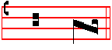
A - - men.
 Let our prayer be set forth, O Lord.
 In thy sight as the in - cense.
The above hymn with its  is said from the second Sunday after Epiphany until the first Sunday of Lent, and from the third Sunday after Pentecost until Advent.

The Chapter above is said on the same Sundays after Epiphany until Septuagesima only, and on the same Sundays after Pemtecost. It is said also in the ferial Office from the Octave of the Epiphany until the first Sunday of Lent, and from the Octave of Pentecost until Advent. Likewise also the 

But the Antiphons with the Psalms are always said as above, when it is the Office of Sunday, excepting the Sundays of Advent which have proper Antiphons.

On Magnificat, Proper Antiphon.

THE SONG OF THE BLESSED VIRGIN MARY

208

18 He sendeth out his word, and melteth them * he bloweth with his wind, and the waters flow.
19 He showeth his word unto Jacob * his statutes and ordinances unto Israel.

20 He hath not dealt so with any nation * neither have the heathen knowledge of his laws.

Antiphon.
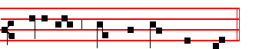
Praise the Lord, O Je - ru - sa - lem.

In Eastertide, Antiphon.
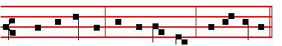
Al - le - lu - ia, al - le - lu - ia, al -le - lu - ia.

(Psalms 148 149 150 Laudate Dominum, at Lauds, p.15)
Chapter Rom. 11
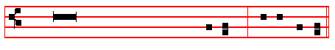
OTHE depth of the riches both of
the wisdom and knowledge of God!
how unsearchable are his judgments,
and his ways past find - - - - - ing out!  Thanks be to God.

HYMN EH 164 O Lux beata Trinitas Mode viij.
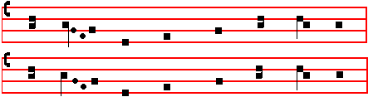

241
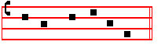
-joiced in God my Saviour.
Tone v.
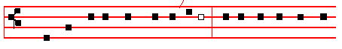
MY soul doth mag- ni – fy the Lord * and my spirit hath re-
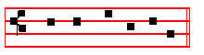
-joiced in God my Saviour.
Tone vj.
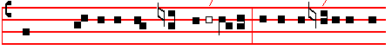
MY soul doth mag-nify the Lord* and my sp/irit hath re-

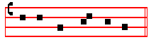
-joiced in God my Saviour.
Tone vij, 1.
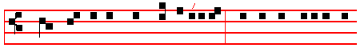
MY soul doth magnify the Lord * and my spirit hath rejoiced
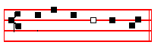
in God my Sav-iour.

Tone viij,1.

210
them.
3 For when the breath of man goeth forth he shall turn again to his earth: * and then all his thoughts perish.
4 Blessed is he that hath the God of Jacob for his help: * and whose hope is in the Lord his God;
5 Who made heaven and earth, the seal, and all that therein is : * who keepeth his promise for ever;
6 Who helpeth them to right that suffer wrong: * who feedeth the hungry.

7 The Lord looseth men out of prison : * the Lord giveth sight to the blind.

8 The Lord helpeth them that are fallen : * the Lord careth for the righteous.

9 The Lord careth for the strangers; he defendeth the fatherless and widow :* as for the way of the ungodly, he turneth it upside down.

10 The Lord thy God, O Syon, shall be King for evermore : * and throughout all generations.

Antiphon.
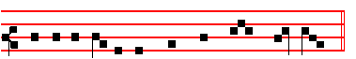
While I have my being will I praise my God.
Antiphon. Tone viij, 2.
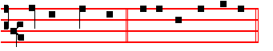
O how joy - ful. E u o u a e.

Ps 147 Laudate Dominum CXLVI

O PRAISE the Lord, for it is a good thing to sing praises unto our God: * yea, a joyful and pleasant thing it is to be thankful.
2 The Lord doth build up Jerusalem : * and gather together the out-casts of Israel.

3 He healeth those that are broken in heart : * and giveth medicine to heal their sickness.
4 He telleth the number of the stars: * and calleth them all by their names.

239
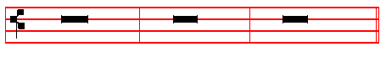
 The Lord be with you.  And with thy spirit.  Let us pray
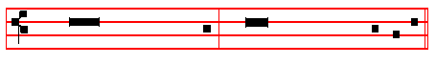
Through Jesus Christ, thy Son, our Lord: who .. unity of the Holy Ghost,
.....world without end.  Amen. (but on Simples and ferias, on one note.)
Then, if there occur on that day any simple feast, commemoration is made of it.
Finally, (if the season require it) the commemorations are made of S. Mary, of the Apostles, and of the patron of the Church in order among the other commemorations according to its dignity, and in the last place of Peace, as below in Vespers of Saturday. Then is said:
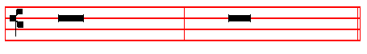
 The Lord be with you.  And with thy spirit.
1. On a solemn Feast. (Double of the I Class)
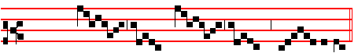
 Let us bless the Lord.
 Thanks be to God.
2. Of the Blessed Virgin and throughout the whole Octave of Corpus Christi and of her Nativity.
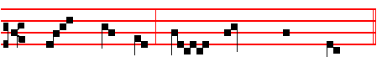
 Let us bless the Lord.
 Thanks be to God.
3. Of Apostles, and on Double Feasts.
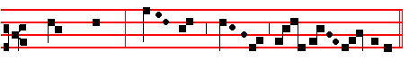
 Let us bless the Lord.
212
13 That our garners may be full, and plenteous with all manner of store : * that our sheep may bring forth thousands and ten thousands in our streets.
14 That our oxen may be strong to labour, that there be no decay: * no leading into captivity, and no complaining in our streets.
15 Happy are the people that are in such a case : * yea, blessed are the people who have the Lord for their God.

Antiphon.
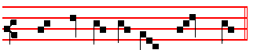
Bles - sed be the Lord my God.
Antiphon. Tone viij, 2.
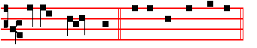
Ev-er - y day . E u o u a e.

Ps. 145 Exaltabo te, Deus CXLIV

I WILL magnify thee, O God, my King : * and I will praise thy Name for ever and ever.
2 Every day will I give thanks unto thee: * and praise thy Name for ever and ever.

3 Great is the Lord, and marvellous-worthy to be praised: * there is no end of his greatness.
4 One generation shall praise thy works unto another : * and declare thy power.

5 As for me, I will be talking of thy worship : * thy glory, thy praise, and wondrous works;
6 So that men shall speak of the might of thy marvellous acts: * and I will also tell of thy greatness.
7 The memorial of thine abundant kindness shall be shewed : * and men shall sing of thy righteousness.
8 The Lord is gracious and merciful : * long-suffering, and of great goodness.

9 The Lord is loving unto every man: * and his mercy is over all his works.

10 All thy works praise thee, O Lord: * and thy saints give thanks unto thee.

237
MONDAY AT VESPERS

Our Father. Hail, Mary. I believe. O God, make speed, as above, p. 201.
Antiphon. The Lord hath inclined.

Ps. 116 Dilexi, quoniam CXIV

I AM well pleased * that the Lord hath heard the voice of my prayer.

2 That he hath inclined his ear unto me * therefore will I call upon him as long as I live.
3 The snares of death compassed me round about * and the pains of hell gat hold upon me.
4 I shall find trouble and heaviness, and I will call upon the Name of thc Lord : * O Lord, I beseech thee, deliver my soul.
5 Gracious is the Lord, and righteous : * yea, our God is merciful.

6 The Lord preserveth the simple : * I was in misery, and he helped me.

7 Turn again then unto thy rest, O my soul: * for the Lord hath rewarded thee.

8 And-why thou hast delivered my soul from death: * mine eyes from tears,
and my feet from falling.
9 I will walk before the Lord: * in the land of the living.

Antiphon. The Lord hath inclined his ear.
Antiphon. I believed.

Ps. 116, v.10 Credidi CXV

I BELIEVED, and therefore will I speak; but I was sore troubled : * I said in my haste, All men are liars.
11 What reward shall I give unto the Lord: * for all the benefits that he hath done unto me ?
12 I will receive the cup of salvation : * and call upon the Name of the Lord.

13 I will pay my vows now in the presence of all his people: * right dear in the sight of the Lord is the death of his saints.

214
Antiphon. O Lord, let my portion be in the land of the living.
In Eastertide, Antiphon. Alleluia, alleluia, alleluia.

Chapter 2 Cor.1
BLESSED be God, even the Father of our Lord Jesus Christ, the Father of mercies, and the God of all comfort, who comforteth us in all our tribulation.

Hymn.E.H. 62 Plasmator hominis, Deus. Mode ij, as on Monday.

MAKER of man,who from thy throne 3 From all thy servants drive away
Dost order all things, God alone; Whate'er of thought impure to-day
By whose decree the teenting earth Hath been with open action blent,
To reptile and to beast gave birth: Or mingled with the heart's intent.

2 The mighty forms that fill the land, 4 In heaven thine endless joys bestow,
Instinct with life at thy command, And grant thy gifts of grace below;
Are given subdued to humankind, From chains of strife our souls release,
For service in their rank assigned. Bind fast the gentle bands of peace.

5 O Father, that we ask be done,
Through Jesus Christ thine only Son;
Who, with the Holy Ghost and thee,
Doth live and reign eternally.

Amen.

 Let my prayer be set forth, O Lord.
 In thy sight as the incense. as on Sunday, p.

On Magnificat, Antiphon. Tone j.
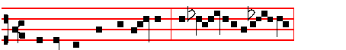
He hath put down the mighty * that persecute the ho-ly;

and hath ex-alted the humble that confess his Christ.

The Prayers, if they are to be said, on p.217.

235
Ps 121 Levavi oculos CXX

I WILL 1ift up minle eyes unto the hills: * from whence cometh my help.

2 My help cometh even from the Lord: * who hath made heaven and earth.

3 He will not suffer thy foot to be moved : * and he that keepeth thee will not sleep.
4 Behold, he that keepeth Israel : * shall neither slumber nor sleep.

5 The Lord himself is thy keeper : * the Lord is thy defence upon thy right hand;

6 So that the Sun shall not burn thee by day: * neither the moon by night.

7 The Lord shall preserve thee from all evil: * yea, it is even he that shall keep thy soul.
8 The Lord shall preserve thy going out, and thy coming in : * from this time forth for evermore.

Antiphon. From whence cometh my help.
In Eastertide, Antiphon. Alleluia, alleluia, alleluia.

Chapter 2 Cor.1
BLESSED be God, even the Father of our Lord Jesus Christ, the Father of mercies, and the God of all comfort, who comforteth us in all our tribulation.

HYMN. E.H. 58 Immense caeli Conditor Mode ij.
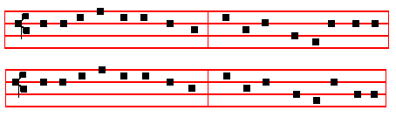
O BOUNDLESS Wisdom, God most high 2 The streams on earth, the clouds in heaven,
O Maker of the earth and sky, By thee their ordered bounds were given,
Who bid'st the parted waters flow Lest 'neath the untempered fires of day
In heaven above, on earth below: The parchèd soil should waste away

216
Ps. 140 Eripe me, Domine CXXXIX

DELIVER me, O Lord, from the evil man: * and preserve me from the wicked man.
2 Who imagine mischief in their hearts : * and stir up strife all the day long.

3 They have sharpened their tongues like a serpent : * adders' poison is under their lips.
4 Keep me, O Lord, from the hands of the ungodly : * preserve me from the wicked men, who are purposed to overthrow my goings.
5 The proud have laid a snare for me, and spread a net abroad with cords : * yea, and set traps in my way.
6 I said unto the Lord, Thou art my God: * hear the voice of my prayers, O Lord.

7 O Lord God, thou strength of my health: * thou hast covered my head in the day of battle.
8 Let not the ungodly have his desire, O Lord: * let not his mischievous imagination prosper, lest they be too proud.

9 Let the mischief of their own lips fall upon the head of them: * that compass me about.
10 Let hot burning coals fall upon them: * let them be cast into the fire, and into the pit, that they never rise up again.
11 A man full of words shall not prosper upon the earth: * evil shall hunt the wicked person to overthrow him.
12 Sure I am that the Lord will avenge the poor: * and maintain the cause of the helpless.
13 The righteous also shall give thanks unto thy Name : * and the just shall continue in thy sight.

Antiphon.De1iver me, O Lord, from the wicked man.
Antiphon. Lord, I call.
Ps. 141 Domine, clamavi CXL

LORD, I call upon thee, haste thee unto me : * and consider my voice when I cry unto thee.
2 Let my prayer be set forth in thy sight as the incense : * and let the lifting up of my hands be an evening sacrifice.
3 Set a watch, O Lord, before my mouth: * and keep the door of my lips.

233
 May thy mercy, O Lord, be upon us,
 As we have put our trust in thee.
 Let thy priests be clothed with righteousness.
 And thy saints sing with joyfulness.
 O Lord, save the Queen.
 And mercifully hear us when we call upon thee.
 O Lord, save thy people, and bless thine inheritance.
 Govern them, and lift them up for ever.
 Remember thy congregation.
 Which thou hast possessed from the beginning.
 Peace be within thy walls.
 And righteousness within thy palaces.
 Let us pray for the faithful departed.
 Rest eternal grant unto them, O Lord, and let light perpetual shine upon them.
 May they rest in peace.  Amen.
 For our absent brethren.
 My God, save thy servants, who put their trust in thee.
 For the afflicted and the captives.
 Deliver them, O Lord God of Israel, from all their tribulations.
 Send them help, O Lord, from thy holy place.
 And strengthen them out of Sion.
 O Lord, hear my prayer.
 And let my cry come unto thee.
Then is said Psalm 51 Miserere, p.75, and at the end Glory be to the Father.
The Psalm being ended, is said
 Turn us again, O Lord God of Hosts,
 Shew thy countenance upon us,and we shall be whole.
 Arise, O Christ, and help us.  And deliver us for thy name's sake.
 O Lord, hear our prayer.  And let our cry come unto thee.
__________________________________________________________________

 The Lord be with you.  And with thy spirit.

The Collect, when a proper one is not assigned, is said from the preceding Sunday, as is to be found in the Proper of the Season.
The Antiphons with the Psalms are always said in the ferial Office, as here in the Psalter. But the Hymns, from the Octave of the Epiphany until the first Sunday of Lent, and from the Octave of Pentecost until Advent; and the Antiphons on Magnificat in the same seasons, until Septuagesima.

218
FRIDAY AT VESPERS

Antiphon.Before the gods.
In Eastertide, Antiphon. Alleluia.

Ps. 138 Confitebor tibi CXXXVII

I WILL give thanks unto thee, O Lord, with my whole heart: * even before the gods will I sing praise unto thee.
2 I will worship toward thy holy temple, and praise thy Name, because of thy loving-kindness and truth: * for that thou hast magnified thy Name, and thy Word above all things.
3 When I called upon thee, thou heardest me : * and enduedst my soul with much strength.
4 All the kings of the earth shall praise thee, O Lord: * for they have heard the words of thy mouth.
5 Yea, they shall sing in the ways of the Lord: * that great is the glory of the Lord.

6 For though the Lord be high, yet hath he respect unto the lowly : * as for the proud, he beholdeth them afar off.
7 Though I walk in the midst of trouble, yet shalt thou refresh me : * thou shalt stretch forth thy hand upon the furiousness of mine enemies, and thy right hand shall save me.
8 The Lord shall make good his loving-kindness toward me : * yea, thy mercy, O Lord, endureth for ever; despise not then the works of thine own hands.

Antiphon.Before the gods wlll I sing praise unto thee, my God.
Antiphon. O Lord.

Ps. 139 Domine, probasti CXXXVIII

O LORD, thou hast searched me out, and known me : * thou knowest my down-sitting, and mine uprising; thou understandest my thoughts long before.
2 Thou art about my path, and about my bed : * and spiest out all my ways.

3 For lo, there is not a word in my tongue : * but thou, O Lord, knowest it altogether.
4 Thou hast fashioned me behind and before: * and laid thine hand upon me.

5 Such knowledge is too wonderful and excellent for me : * I cannot attain unto it.

231
Antiphon. O thou that dwellest in the heavens, have mercy upon us.
Antiphon. Our help.

Ps. 124 Nisi quia Dominus CXXIII

IF the Lord himself had not been on our side, now may Israel say: * if the Lord himself had not been on our side, when men rose up against us;
2 They had swallowed us up quick: * when they were so wrathfully displeased at us.
3 Yea, the waters had drowned us: * and the stream had gone over our soul.

4 The deep waters of the proud: * had gone even over our soul.

5 But praised be the Lord: * who hath not given us over for a prey unto their teeth.
6 Our soul is escaped even as a bird out of the snare of the fowler : * the snare is broken, and we are delivered.
7 Our help standeth in the Name of the Lord: * who hath made heaven and earth.

Antiphon. Our help standeth in the Name of the Lord.
Antiphon. Do well.

Ps. 125 Qui confidunt CXXIV

THEY that put their trust in the Lord shall be even as the mount Syon : * which may not be removed, but standeth fast for ever.
2 The hills stand about Jerusalem : * even so standeth the Lord round about his people, from this time forth for evermore.
3 For the rod of the ungodly cometh not into the lot of the righteous : * lest the righteous put their hand unto wickedness.
4 Do well, O Lord: * unto those that are good and true of heart.

5 As for such as turn back unto their own wickedness : * the Lord shall lead them forth with thc evildoers; but peace shall be upon Israel.

Antiphon. Do well,O Lord, unto those that are good and true of heart.
Antiphon. Then were we.

Ps. 126 . In convertendo CXXV

220
18 Yea, and slew mighty kings: * for his mercy endureth for ever.

19 Sehon king of the Amorites : * for his mercy endureth for ever.

20 And Og the king of Basan : * for his mercy endureth for ever.

21 And gave away their land for an heritage : * for his mercy endureth for ever.

22 Even for an heritage unto Israel his servant : * for his mercy endureth for ever.

23 Who remembered us when we were in trouble : * for his mercy endureth for ever.
24 And hath delivered us from our enemies : * for his mercy endureth for ever.

25 Who giveth food to all flesh: * for his mercy endureth for ever.

26 O give thanks unto the God of heaven: * for his mercy endureth for ever.

27 O give thanks unto the Lord of lords: * for his mercy endureth for ever.

Antiphon.For his mercy endureth for ever.
Antiphon. Sing us one.

Ps. 137 Super flumina CXXXVI

BY the waters of Babylon we sat down and wept: * when we remembered thee, O Syon.
2 As for our harps, we hanged them up : * upon the trees that are therein.

3 For they that led us away captive required of us then a song and melody in our heaviness : * Sing us one of the songs of Syon.
4 How shall we sing the Lord's song: * in a strange land ?

5 If I forget thee, O Jerusalem : * let my right hand forget her cunning.

6 If I do not remember thee, let my tongue cleave to the roof of my mouth: * yea, if I prefer not Jerusalem in my mirth.
7 Remember the children of Edom, O Lord, in the day of Jerusalem : * how they said, Down with it, down with it, even to the ground.
8 O daughter of Babylon, wasted with misery: * yea, happy shall he be that rewardeth thee, as thou hast served us.

229
 Let my prayer be set forth, O Lord.
 In thy sight as the incense. as on Sunday, p.
On Magnificat, Antiphon. Tone v.
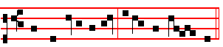
Let my spirit rejoice * in God my Saviour.
The Prayers, if they are to be said, on p. 217.
__________________________________________________________________

WEDNESDAY AT VESPERS

Antiphon. They shall not be ashamed.

Ps. 127 'Nisi Dominus CXXVI

EXCEPT the Lord build the house: * their labour is but lost that build it.

2 Except the Lord keep the city : * the watchman waketh but in vain.

3 It is but lost labour that ye haste to rise up early, and so late take rest, and eat the bread of carefulness : * for so he giveth his beloved sleep.
4 Lo, children and the fruit of the womb: * are an heritage and gift that cometh of the Lord.
5 Like as the arrows in the hand of the giant: * even so are the young children.

6 Happy is the man that hath his quiver full of them : * they shall not be ashamed when they speak with their enemies in the gate.

Antiphon.They shall not be ashamed when they speak with their enemies in the gate.
Antiphon. Blessed.

Ps. 128 Beati omnes CXXVII

BLESSED are all they that fear thc Lord : * and walk in his ways.

2 For thou shalt eat the labours of thine hands: * O well is thee, and happy shalt thou be.
3 Thy wife shall be as the fruitful vine: * upon the walls of thine house.

222
Ps. 135 Laudate nomen CXXXIV

O PRAISE the Lord, laud ye the Name of the Lord : * praise it, O ye servants of the Lord.
2 Ye that stand in the house of the Lord: * in the courts of the house of our God.

3 O praise the Lord, for the Lord is gracious : * O sing praises unto his Name, for it is lovely.
4 For-why the Lord hath chosen Jacob unto himself: * and Israel for his own possession.
5 For I know that the Lord is great: * and that our Lord is above all gods.

6 Whatsoever the Lord pleased, that did he in heaven, and in earth: * and in the sea, and in all deep places.
7 He bringeth forth the cloud from the ends of the world: and sendeth forth lightnings with the rain, bringing the winds out of his treasures.
8 He smote the firstborn of Egypt : * both of man and beast.

9 He hath sent tokens & wonders into the midst of thee, O thou land of Egypt : * upon Pharaoh, and all his servants.
10 He smote divers nations : * and slew mighty kings.

11 Sehon king of the Amorites, and Og the king of Basan: * and all the kingdoms of Chanaan.
12 And gave their land to be an heritage : * even an heritage unto Israel his people.
13 Thy Name, O Lord, endureth for ever : * so doth thy memorial, O Lord, from one generation to another.
14 For the Lord will avenge his people : * and be gracious unto his servants.

15 As for the images of the heathen, they are but silver and gold: * the work of men's hands.
16 They have mouths, and speak not: * eyes have they, but they see not.

17 They have ears, and yet they hear not : * neither is there any breath in their mouths.
18 They that make them are like unto them: * and so are all they that put their trust in them.
19 Praise the Lord, ye house of Israel : * praise the Lord, ye house of Aaron.

20 Praise the Lord, ye house of Levi : * ye that fear the Lord, praise the Lord.

227
abide it ?
4 For there is mercy with thee: * therefore shalt thou be feared.

5 I look for the Lord; my soul doth wait for him: * in his word is my trust.

6 My soul fleeth unto the Lord: * before the morning watch, I say, before the morning watch.
7 O Israel, trust in the Lord, for with the Lord there is mercy : * and with him is plenteous redemption.

8 And he shall redeem Israel : * from all his sins.

Antiphon.Out of the deep have I called unto thee, O Lord.
Antiphon.O Israel.
Ps. 131 Domine, non est CXXX

LORD, I am not high-minded : * I have no proud looks.

2 I do not exercise myself in great matters: * which are too high for me.

3 But I refrain my soul, and keep it low, like as a child that is weaned from his mother : * yea, my soul is even as a weaned child.
4 O Israel, trust in the Lord: * from time forth for evermore.

Antiphon. O Israel, trust in the Lord.
In Eastertide, Antiphon. Allel1uia, alleluia, alleluia.

Chapter 2 Cor. l
BLESSED be God, even the Father of our Lord Jesus Christ, the Father of mercies, and the God of all comfort, who comforteth us in all our tribulation.

Hymn.E.H.60 Caeli Deus sanctissime. Mode ij, as on Monday.

MOST holy Lord and God of heaven, 3 That each in its appointed way
Who to the glowing sky hast given Might separate the night from day,
The fires that in the east are born And of the seasons through the year
With gradual splendours of the morn; The well-remembered signs declare

2 Who, on the fourth day, didst reveal 4 Illuminate our hearts within,
The sun's enkindled flaming wheel, And cleanse our minds from stain of sin;
Didst set the moon her ordered ways, Unburdened of our guilty load
And stars their ever-winding maze; May we unfettered serve our God.

224
5. O Father, that we ask be done,
Through Jesus Christ, thine only Son.,
Who, with the Holy Ghost and thee,
Doth live and reign eternally. Amen.

 Let my prayer be set forth, O Lord.
 In thy sight as the incense. as on Sunday, p.
On Magnificat, Antiphon. Tone viij.

The Lord * hath regarded my low - li - ness.

and he that is mi-ghty hath done in me great things.
The Prayers, if they are to be said, on p.217.
__________________________________________________________________

THURSDAY AT VESPERS

Antiphon. And all.
In Eastertide, Antiphon. Alleluia.
Ps.132 Memento, Domine CXXXI

LORD, remember David : * and all his trouble.

2 How he sware unto the Lord : * and vowed a vow unto the Almighty God of Jacob;
3 I will not come within the tabernacle of mine house: * nor climb up into my bed;

4 I will not suffer mine eyes to sleep, nor mine eyelids to slumber : * neither the temples of my head to take any rest.
5 Until I find out a place for the temple of the Lord : * an habitation for the mighty God of Jacob.
6 Lo, we heard of the same at Ephrata : * and found it in the wood.

7 We will go into his tabernacle : * and fall low on our knees before his foot-stool.

8 Arise, O Lord, into thy resting-place : * thou, and the ark of thy strength.

225

