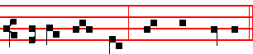
al - le - lu - ia, al - le - - lu - ia.

 and Collect as above.

+

248
SUNDAY AT VESPERS

Our Father. Hail, Mary. silently . Then is said aloud:
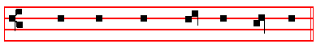
O GOD, make  speed to save me.

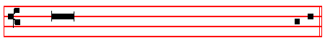
 O Lord, make haste to help me.
 Glory be to the Father, and to the Son, and to the Ho - ly Ghost.
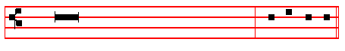
 As it was in the beginning, is now,
and ever shall be, world without end. Amen. Al - le - lu - ia or
Praise be to thee, O Lord, King of eternal glory, according to the season.
Antiphon. Tone vij, 4
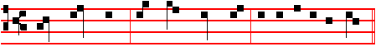
The Lord said * un – to my Lord. E u o u a e.
In Eastertide, Antiphon.
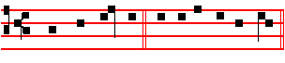
Al - le - lu - ia. E u o u a e.

Under which one Antiphon are said all the Psalms of Vespers, both on Sundays and on Ferias.

Ps. 110 Dixit Dominus CIX

201
O GOD, whose right hand upheld blessed Peter lest he should sink while walking on the waves; and delivered his fellow-Apostle Paul from the depth of the sea when thrice he suffered shipwreck: mercifully hear us; and grant that by the prayers of them both we may attain unto the glory of eternal life.

Commemoration of the patron or title of the Church is made as usual before or after the above commemorations, according to rank, and finally of peace:
Antiphon at Vespers and Lauds
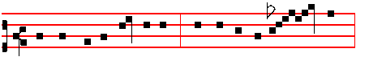
Give peace in our time, O Lord, for there is none o - - - - ther
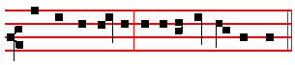
that fighteth for us, but only thou, O our God.
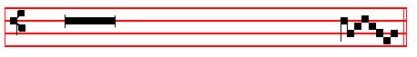
 Peace be within thy walls.
 And plenteousness within thy pala - - ces.

Let us pray COLLECT

O GOD.from whom all holy desires, all good counsels.and all just works do proceed, give unto thy servants that peace which the world cannot give; that both: our hearts may be set to obey thy commandments, and also that by thee we being defended from the fear of our enemies may pass our time in rest and quietness. Through.  Amen.

 The Lord be with you.  And with thy spirit.
 Let us bless the Lord.  Thanks be to God.
 May the souls of the faithful.  Amen.

Then is said silently Our Father.

Thus the Office is finished when another Hour does not follow, as is said in the Rubric of the Lord's Prayer.
246
covenant.
6 He bath shewed his people the power of his works * that he may give them the heritage of the heathen.
7 The works of his hands are verity and judgement * all his commandments are true.
8 They stand fast for ever and ever * and are done in truth and equity.

9 He sent redemption unto his people * he hath commanded his covenant for ever; holy and reverend is his Name.
10 The fear of the Lord is the beginning of wisdom * a good understanding have all they that do thereafter; the praise of it endureth for ever.

Antiphon.
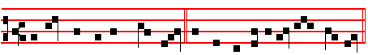
All his commandments are true: they stand fast for ever and ev - er.

Antiphon.
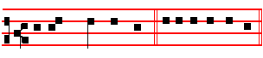
He hath great de - light. E u o u a e.
Ps. 112 Beatus vir CXI

BLESSED is the man that feareth the Lord * he hath great delight in his commandments.
2 His seed shall be mighty upon earth * the generation of the faithful shall he blessed.
3 Riches and plenteousness shall be in his house * and his righteousness endureth for ever.
4 Unto the godly there ariseth up light in the darkness * he is merciful, loving, and righteous.
5 A good man is merciful, and lendeth * and will guide his words with discretion.

6 For he shall never he moved * and the righteous shall be had in everlasting remembrance.

203
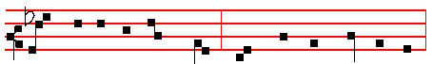
strength-en the faint- heart - ed, com - fort the sor - row - ful;
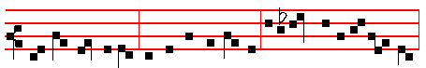
pray for the people, entreat for the clergy, intercede for all womankind
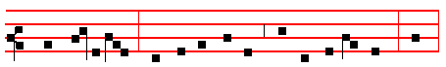
vowed un-to God; may all acknowledge the help of thy prayer, who
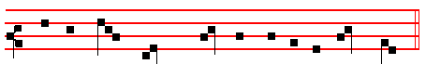
ce - le - brate thy ho - ly com-me-mo- ra - tion.
 Pray for us, O holy Mother of God.
 That we may be made worthy of the promises of Christ.
Let us pray COLLECT
GRANT, we beseech thee, O Lord God, that we thy servants may rejoice in continual health of mind and body: and that by the glorious intercession of blessed Mary ever Virgin we may be delivered from this present heaviness, and have the fruition of eternal joys.
From the Octave of the Epiphany until the Purification is said
 After child-bearing, O Virgin, thou didst remain invio - late.
 Mother of God, intercede for us.

Let us pray COLLECT
O GOD, who by the virgin child-bearing of blessed Mary hast bestowed upon

244
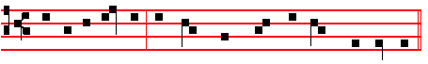

Blessed be the Name of the Lord for ev – er and ev - er.

Antiphon. Irregular or Peregrine Tone.
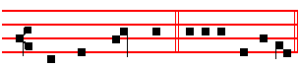
But we who live. E u o u a e

Ps. 114 In exitu Israel CXIII
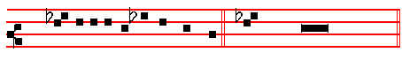
WHEN Israel came out of E-gypt * and the house of Jacob from among

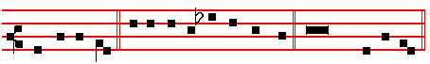
the strange people. 2 Juda was his sanctu-ar - y * and Israel his dominion.

3 The sea saw that, and fled * Jordan was driven back.

4 The mountains skipped like rams * and the little hills like young sheep.

5 What aileth thee, O thou sea, that thou fleddest * and thou Jordan, that thou wast driven back?

6 Ye mountains, that ye skipped like rams * and ye little hills like young sheep ?

7 Tremble, thou earth, at the presence of the Lord * at the presence of the God of Jacob.

8 Who turned the hard rock into a standing water * and the flintstone into a
springing well.

205
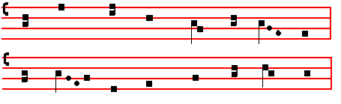
O TRINITY of blessed 1ight, 2 To thee our morning song of praise,
O Unity of princely might, To thee our evening prayer we raise;
The fiery sun now goes his way; Thy glory suppliant we adore
Shed thou within our hearts thy ray. For ever and for evermore.

3. All laud to God the Father be;
All praise, eternal Son, to thee;
All glory, as is ever meet,
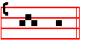
To God the holy Paraclete.
A - men.
 Let our evening prayer come up before thee, O Lord.
 And let thy mercy come down upon us.
On Magnificat, Antiphon. Tone vij, 3.

God hath hol - pen Canticle Magnificat, p. 209
On Magnificat, Antiphon.
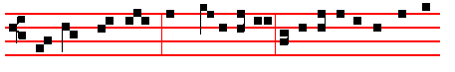
God hath hol - pen his servant Israel: as he promised to Ab-ra-

242
Antiphon.
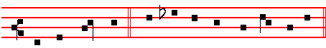
But we who live from this time forth will praise the Lord.
In Eastertide, Antiphon.
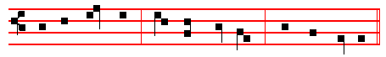 Al - le - lu - ia, al - le - lu - ia, al - le - lu - ia.
Chapter 2 Cor.1
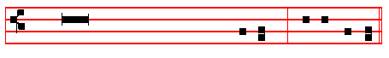
BLESSED be God, even the Father of our
Lord Jesus Christ, the Father of mercies,
and the God of all comfort, who comforteth
us in all our tribu- la-tion. R/.Thanks be to God.

HYMN E.H.51 Lucis Creator optime. Mode viij.
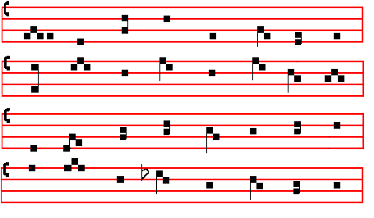

207
5 Great is our Lord, and great is his power : * yea, and his wisdom is infinite.

6 The Lord setteth up the meek: * and bringeth the ungodly down to the ground.

7 O sing unto the Lord with thanksgiving : * sing praises upon the harp unto our God;
8 Who covereth the heaven with clouds, and prepareth rain for the earth: * and maketh the grass to grow upon the mountains, and herb for the use of men ;

9 Who giveth fodder unto the cattle: * and feedeth the young ravens that call upon him.
10 He hath no pleasure in the strength of an horse: * neither delighteth he in a ny man's legs.
11 But the Lord's delight is in them that fear him * and put their trust in his mercy.

Antiphon.
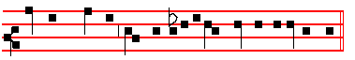
O how joy - ful a thing it is to be thankful unto our God.
Antiphon. Tone j, 4.
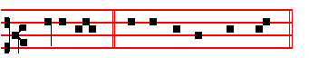
Praise the Lord. E u o u a e.

Ps.147, v. 12 Lauda Jerusalem CXLVII

PRAISE the Lord, O Jerusalem * praise thy God, O Syon.

13 For he hath made fast the bars of thy gates * and hath blessed thy children within thee.
14 He maketh peace in thy borders * and filleth thee with the flour of wheat.

15 He sendeth forth his commandment upon earth * and his word runneth very swiftly.
16 He giveth snow like wool * and scattereth the hoar-frost like ashes.

17 He casteth forth his ice like morsels * who is able to abide his frost?

240

Luke 1 Magnificat Tone j, 1.
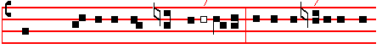
MY soul doth magnif/y the Lord * and my spi/rit hath re -

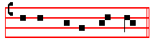
-joiced in God my Sa - viour.
Tone ij.
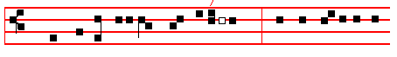
MY soul doth magnif/y the Lord * and my spi / rit hath re-
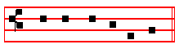
-joiced in God my Sa –viour.
Tone iij, 1.

 MY soul doth m/agnify the Lord * and my spirit hath re-
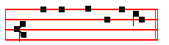
-joiced in God my Saviour.
Tone iv.
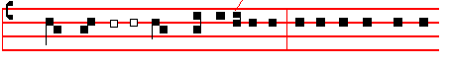
 MY soul doth magnif/y the Lord * and my spirit hath re-

209
11 They shew the glory of thy kingdom : * and talk of thy power.

12 That thy power, thy glory, and mightiness of thy kingdom: * might be known unto men.
13 Thy kingdom is an everlasting kingdom : * and thy dominion endureth throughout all ages.
14 The Lord upholdeth all such as fall: * and lifteth up all those that are down.

15 The eyes of all wait upon thee, O Lord: * and thou givest them their meat in due season.
16 Thou openest thine hand: * and fillest all things living with plenteousness.

17 The Lord is righteous in all his ways: * and holy in all his works.

18 The Lord is nigh unto all them that call upon him: * yea, all such as call upon him faithfully.
19 He will fulfil the desire of them that fear him: * he also will hear their cry, and will help them.
20 The Lord preserveth all them that love him: * but scattereth abroad all the ungodly.
21 My mouth shall speak the praise of the Lord: * and let all flesh give thanks unto his holy Name for ever and ever.

Antiphon.
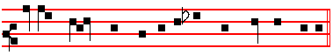
Ev-er - y day, O Lord, will I give thanks un - to thee.
Antiphon. Tone iv,1.
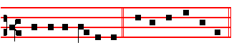
While I have my being. E u o u a e.

Ps. 146 Lauda, anima mea CXLV

PRAISE the Lord, O my soul; while I live will I praise the Lord: * yea, as long as I have any being, I will sing praises unto my God.
2 O put not your trust in princes, nor in any child of man: * for there is no help in

238
MY soul doth magnif/y the Lord * and my sp/irit hath re-
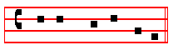
-joiced in God my Saviour.
12468 37 5/ 4 15678 23
*2 For he hath re-gard-ed : * the 1owliness of his hand-maiden.
12468 37 5/ / 4 15678 23
*3 For be - hold, from. hence-forth : * all generations shall call me blessed.
12468 37 / 5 47 1568 23
4 For he that is mighty hath magni-fi-ed me : * and ho -ly is his Name.
12468 37 5 / 4 15678 23
5 And his mercy is on them that fear him : * throughout all ge - ne-rations.
12468 37 / 5 /
6 He hath shew – ed strength with his arm : * he hath scattered the proud in the
47 1568 23
imagi-na-tion of their hearts.
12468 37 / 5 / 15678 23
7 He hath put down the mighty from their seat : * and hath exalted the hum-ble

and meek.
16 23478 / 5 / 4 68 157 23
8 He hath filled the hun-gry with good things : * and the rich he hath sent emp–ty

a-way.
12468 37 5 / /
9 He, remembering his mercy, hath holpen his servant Is-ra-el : * as he promised
4 15678 23
to our forefathers, Abraham and his seed for ever.
16 23478 / 5 4 15678 23
Glory be to the Fa- ther, and to the Son : * and to the Holy Ghost.
12468 37 5/ 4 15678 23
As it was in the beginning, is now, and ever shall be: * world with – out end.

Amen.
Then is said the proper Antiphon and Collect:

__________________________________________________________________
* The Intonation is omitted in these verses.

211
SATURDAY AT VESPERS

Antiphon. Tone vj.
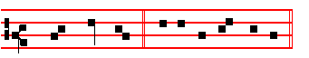
Bless - ed be. E u o u a e.
In Eastertide, Antiphon. Tone vj.
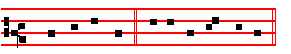
Al - le - lu - ia. E u o u a e.

Ps. 144 Benedictus Dominus CXLIII

BLESSED be the Lord my strength: * who teacheth my hands to war, and my fingers to fight;
2 My hope and my fortress, my castle and deliverer, my defender, in whom I trust: * who subdueth my people that is under me.
3 Lord, what is man, that thou hast such respect unto him: * or the son of man, that thou so regardest him?
4 Man is like a thing of naught: * his time passeth away like a shadow.

5 Bow thy heavens, O Lord, and come down : * touch the mountains, and they shall smoke.
6 Cast forth thy lightning, and tear them: * shoot out thine arrows, and consume them.
7 Send down thine hand from above : * deliver me, and take me out of the great waters, from the hand of strange children.
8 Whose mouth talketh of vanity : * and their right hand is a right hand of wickedness.
9 I will sing a new song unto thee, O God: * and sing praises unto thee upon a ten- stringed lute.
10 Thou hast given victory unto kings: * and hast delivered David thy servant from the peril of the sword.
11 Save me, and deliver me from the hand of strange children : * whose mouth talketh of vanity, and their right hand is a right hand of iniquity.
12 That our sons may grow up as the young plants: * and that our daughters may be as the polishcd corners of the temple.

236
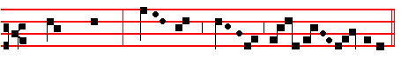
 Let us bless the Lord.
 Thanks be to God.
4. Of Sunday throughout the whole year, on semidouble Feasts, and within Octaves, which are not of the Blessed Virgin Mary.

 Let us bless the Lord.
 Thanks be to God.
5. In Eastertide, beginning from Vespers of Holy Saturday until Vespers of the following Saturday exclusively.
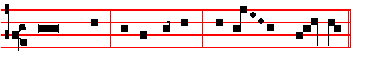
 Let us bless the Lord, al- le – lu - ia, al- le - - lu - ia.
 Thanks be to God, al- le - lu – ia, al- le - - lu - ia.

6. On simple Feasts at Matins, Lauds, and Vespers.

 Let us bless the Lord.
 Thanks be to God.

7. In the ferial Office throughout the whole year at Vespers, Matins, and Lauds.

 Let us bless the Lord.
 Thanks be to God.
May the souls of the faithful, through the mercy of God, rest in peace. Amen.

213
4 O let not mine heart be inclined to any evil thing: * let me not be occupied in ungodly works with the men that work wickedness, lest I eat of such things as please them.
5 Let the righteous rather smite me friendly : * and reprove me.

6 But let not their precious balms break my head: * yea, I will pray yet against their wickedness.
I7 Let their judges be overthrown in stony places: * that they may hear my words, for they are sweet.
18 Our bones lie scattered before the pit: * like as when one breaketh and heweth wood upon the earth.
19 But mine eyes look unto thee, O Lord God: * in thee is my trust, O cast not out my soul.
10 Keep me from the snare that they have laid for me: * and from the traps of the wicked doers.
11 Let the ungodly fall into their own nets together : * and let me ever escape them.

Antiphon. Lord, I call upon thee, haste thee unto me.
Antiphon. O Lord, let my portion.

Ps. 142 Voce mea ad Dominum CXLI

I CRIED unto the Lord with my voice: * yea, even unto the Lord did I make my supplication.
2 I poured out my complaints before him: * and shewed him of my trouble.

3 When my spirit was in heaviness thou knewest my path: * in the way wherein I walked have they privily laid a snare for me.
4 I looked also upon my right hand: * and saw there was no man that would know me.
5 I had no place to flee unto: * and no man cared for my soul.

6 I cried unto thee, O Lord, and said : * Thou art my hope, and my portion in the land of the living.
7 Consider my complaint: * for I am brought very low.

8 O deliver me from my persecutors : * for they are too strong for me.

9 Bring my soul out of prison, that I may give thanks unto thy Name: * which thing if thou wilt grant me, then shall the righteous resort unto my company.

234
14 Behold, O Lord, how that I am thy servant : * I am thy servant, and the son of thine handmaid; thou hast broken my bonds in sunder.
15 I will offer to thee the sacrifice of thanksgiving : * and will call upon the Name of the Lord,
16 I will pay my vows unto the Lord, in the sight of all his people : * in the courts of the Lord's house, even in the midst of thee, O Jerusalem. Praise the Lord.

Antiphon. I believed, and therefore will I speak.
Antiphon. Praise.
Ps. 117 Laudate Dominun CXVI

O PRAISE the Lord, all ye heathen : * praise him, all ye nations.

2 For his merciful kindness is ever more and more towards us : * and the truth of the Lord endureth for ever. Praise the Lord.

Antiphon. Praise the Lord, a1l ye heathen.

(Psalm 118 Confitemini Domino, Sunday at Prime. p. 23)
(Psalm 119 Beati immaculati, at Prime, .p.2,. Terce, p.49,
Sext, p.1, and None, p.6)

Antiphon. I called.

GRADUAL PSALM Ps. 120 Ad Dominum CXIX

WHEN I was in trouble I called upon the Lord: * and he heard me.

2 Deliver my soul, O Lord, from lying lips: * and from a deceitful tongue.

3 What reward shall be given or done unto thee, thou false tongue: * even mighty and sharp arrrows, with hot burning coals.
4 Wo is me, that I am constrained to dwell with Mesech : * and to have my habitation among the tents of Cedar.
5 My soul hath long dwelt among them : * that are enemies unto peace.

6 I labour for peace, but when I speak unto them thereof: * they make them ready to battle.

Antiphon. I called, and he heard me.
Antiphon. From whence.

215
6 Whither shall I go then from thy Spirit : * or whither shall I go then from thy presence?
7 If I climb up into heaven, thou art there: * if I go down to hell, thou art there also.
8 If I take the wings of the morning : * and remain in the uttermost parts of the sea;
9 Even there also shall thy hand lead me : * and thy right hand shall hold me.

10 If I say, Peradventure the darkness shall cover me : * then shall my night be turned to day.
11 Yea, the darkness is no darkness with thee, but the night is as clear as the day: * the darkness and light to thee are both alike.
12 For my reins are thine: * thou hast covered me in my mother's womb.

13 I will give thanks unto thee, for I am fearfully and wonderfully made: * marvellous are thy works, and that my soul knoweth right well.
14 My bones are not hid from thee : * though I be made secretly, and fashioned beneath in the earth.
15 Thine eyes did see my substance, yet being unperfect: * and in thy book were all my members written;
16 Which day by day were fashioned: * when as yet there was none of them.

17 How dear are thy counsels unto me, O God: * O how great is the sum of them.

18 If I tell them, they are more in number than the sand: * when I wake up, I am present with thee.
19 Wilt thou not slay the wicked, O God: * depart from me, ye blood-thirsty men.

20 For they speak unrighteously against thee: * and thine enemies take thy Name in vain. .
21 Do not I hate them, O Lord, that hate thee : * and am not I grieved with those that rise up against thee?
22 Yea, I hate them right sore : * even as though they were mine enemies.

23 Try me, O God, and seek the ground of my heart : * prove me, and examine my thoughts.
24 Look well if there be any way of wickedness in me: * and lead me in the way everlasting.

Antiphon. O Lord, thou hast searched me out and known me.
Antiphon. Deliver me.

232
3 E'en so on us who seek thy face 4 Let faith discern the eternal Light
Pour forth the waters of thy grace Beyond the darkness of the night
Renew the fount of life within, And through the mists of falsehood, see
And quench the wasting fires of sin. The path of truth revealed by thee.

5 O Father, that we ask be done,
Through Jesus Christ, thine only Son;
Who, with the Holy Ghost and thee,
Doth live and reign eternally.
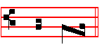
A – men.
 Let my prayer be set forth, O Lord.
 In tby sight as the incense. as on Sunday, p.
On Magnificat, Antiphon. Tone viij.

My soul * doth mag - ni - fy the Lord,

for he hath regarded my low-li -ness.
__________________________________________________________________

On Ferias of Advent and Lent, Ember Days, and Vigils which are fasted, after the Antiphon on Magnificat, are said the following Prayers kneeling, if they are to be said.
KYRIE,eleison. Christe, eleison. Kyrie, eleison.
Our Father is said all aloud.
 And lead us not into temptation.
 But deliver us from evil.
 I said, Lord, have mercy upon me.
 Heal my soul, for I have sinned against thee.
 Turn again, O Lord, at the last.
 And be gracious unto thy servants,

217
9 Blessed shall he be that taketh thy children : * and throweth them against the stones

Antiphon. Sing us one of the songs of Sion. .
In Eastertide, Antiphon. Alleluia, alleluia, alleluia.

Chapter 2 Cor. 1
BLESSED be God, even the Father of our Lord Jesus Christ, the Father of mercies, and the God of all comfort, who comforteth us in all our tribulation.

HYMN E.H. 61 Magnae Deus potentiae Mode ij, as on Monday.
ALMIGHTY God, who from the flood 3 Grant that thy servants, by the tide
Didst bring to light a twofold brood; Of blood and water purified,
Part in the firmament to fly, No guilty fall from thee may know
And part in ocean's depths to lie; Nor death eternal undergo.

2 Appointing fishes in the sea, 4 Be none submerged in sin's distress,
And fowls in open air to be, None lifted up in boastfulness;
That each, by origin the same,, That contrite hearts be not dismayed,
Its separate dwelling-place might claim: Nor haughty souls in ruin laid.

5. O Father, that we ask be done,
Through Jesus Christ, thine only Son;
Who, with the Holy Ghost and thee,
Doth live and reign eternally

Amen.

 Let my prayer be set forth, O Lord.
 In thy sight as the incense.
On Magnificat, Antiphon. Tone vij.

Shew strength, O God, * with thine arm:

scat - ter the proud, and exalt the humble.

The Prayers, if they are said, on p. 217.

230
TUESDAY AT VESPERS
Antiphon.We will go.
In Eastertide, Antiphon. Alleluia.

Ps. 122 Laetatus sum CXXI

I WAS glad when they said unto me : * We will go into the house of the Lord.

2 Our feet shall stand in thy gates: * O Jerusalem.

3 Jerusalem is built as a city : * that is at unity in itself.

4 For thither the tribes go up, even the tribes of the Lord: * to testify unto Israel, to give thanks unto the Name of the Lord.

5 For there is the seat of judgement; * even the seat of the house of David.

6 O pray for the peace of Jerusalem : * they shall prosper that love thee.

7 Peace be within thy walls: * and plenteousness within thy palaces.

8 For my brethren and companions' sakes : * I will wish thee prosperity.

9 Yea, because of the house of the Lord our God: * I will seek to do thee good.

Antiphon. We will go with gladness into the house of the Lord.

Antiphon. O thou that dwellest.

Ps.123 Ad te levavi CXXII

UNTO thee lift I up mine eyes : O thou that dwellest in the heavens.

2 Behold, even as the eyes of servants look unto the hand of their masters, and as the eyes of a maiden unto the hand of her mistress: * even so our eyes wait upon the Lord our God, until he have mercy upon us.
3 Have mercy upon us, O Lord, have mercy upon us: * for we are utterly despised.

4 Our soul is filled with the scornful reproof of the wealthy: * and with the despitefulness of the proud.

219
21 Praised be the Lord out of Syon : * who dwelleth at Jerusalem.

Antiphon.Whatsoever the Lord pleased, that did he.
Antiphon.For his mercy.

Ps. 136 Confitemini CXXXV

O GIVE thanks unto the Lord, for he is gracious : * and his mercy endureth for ever.
2 O give thanks unto the God of all gods: * for his mercy endureth for ever.

3 O thank the Lord of all lords: * for his mercy endureth for ever.

4 Who only doeth great wonders : * for his mercy endureth for ever.

5 Who by his excellent wisdom made the heavens : * for his mercy endureth for ever.
6 Who laid out the earth above the waters : * for his mercy endureth for ever.

7 Who hath made great lights: * for his mercy endureth for ever.

8 The sun to rule the day: * for his mercy endureth for ever.

9 The moon and the stars to govern the night: * for his mercy endureth for ever.

10 Who smote Egypt with their first-born : * for his mercy endureth for ever.

11 And brought out Israel from among them: * for his mercy endureth for ever.

12 With a mighty hand, and stretched out arm: * for his mercy endureth for ever.

13 Who divided the Red sea in two parts: * for his mercy endureth for ever.

14 And made Israel to go through the midst of it : * for his mercy endureth for ever.
15 But as for Pharaoh and his host, he overthrew them in the Red sea: * for his mercy endureth for ever.
16 Who led his people through the wilderness: * for his mercy endureth for ever.

17 Who smote great kings: * for his mercy endureth for ever.

228
WHEN the Lord turned again the captivity of Syon ; * then were we like unto them that dream.
2 Then was our mouth filled with laughter : * and our tongue with joy.

3 Then said they among the heathen : * The Lord hath done great things for them.

4 Yea, the Lord hath done great things for us already : * whereof we rejoice.

5 Turn our captivity, O Lord: * as the rivers in the south.

6 They that sow in tears : * shall reap in joy.

7 He that now goeth on his way weeping, and beareth forth good seed: * shall doubtless come again with joy, and bring his sheaves with him.

Antiphon. Then were we like unto them that dream.
In Eastertide, Antiphon. Alleluia, alleluia, alleluia.

Chapter 1 Cor.1
BLESSED be God, even the Father of our Lord Jesus Christ, the Father of mercies, and the God of all comfort, who comforteth us in all our tribulation.

Hymn. E.H. 59 Telluris ingens Conditor Mode ij, as on Monday.

EARTH'S mighty Maker,whose command 3 Our spirit's rankling wounds efface
Raised from the sea the solid land, With dewy freshness of thy grace:
And drove each billowy heap away, That grief may cleanse each deed of ill,
And bade the earth stand firm for aye: And o'er each lust may triumph still.

2 That so, with flowers of golden hue, 4 Let every soul thy law obey,
The seeds of each it might renew; And keep from every evil way;
And fruit-trees bearing fruit might yield - Rejoice each promised good to win
And pleasant pasture of the field; And flee from every mortal min.

5. O Father, that we ask be done,
Through Jesus Christ, thine only Son;
Who, with the holy Ghost and thee,
Doth, live and reign eternally. Amen.

221
9 Let thy priests be clothed with righteousness : * and let thy saints sing with joyfulness.
10 For thy servant David's sake: * turn not away the presence of thine Anointed..

11 The Lord hath made a faithful oath unto David : * and he shall not shrink from it;
12 Of the fruit of thy body : * shall I set upon thy seat.

13 If thy children will keep my covenant, and my testimonies that I shall learn them: * their children also shall sit upon thy seat for evermore.
14 For the Lord hath chosen Syon to be an habitation for himself: * he hath longed for her.
15 This shall be my rest for ever : * here will I dwell, for I have a delight therein.

16 I will bless her victuals with increase: * and will satisfy her poor with bread.

17 I will deck her priests with health : * and her saints shall rejoice and sing.

18 There shall I make the horn of David to flourish : * I have ordained a lantern for mine Anointed.
19 As for his enemies, I shall clothe them with shame : * but upon himself shall his crown flourish.

Antiphon. And all his trouble.
Antiphon. Behold.

Ps. 133 Ecce quam bonum CXXXII

BEHOLD, how good and joyful a thing it is: * brethren, to dwell together in unity!
2 It is like the precious ointment upon the head that ran down unto the beard: * even unto Aaron's beard, and went down to the skirts of his clothing.
3 Like as the dew of Hermon : * which fell upon the hill of Syon.

4 For there the Lord promised his blessing : * and life for evermore.

Antiphon. Behold, how good and joyful a thing it is, brethren to dwell together in unity.
(Psalm 134, Ecce nunc, at Compline, p.l )

Antiphon. Whatsoever.

226
4 Thy children like the olive branches : * round about thy table.

5 Lo, thus shall the man be blessed : * that feareth the Lord.

6 The Lord from out of Syon shall so bless thee: * that thou shalt see Jerusalem in prosperity all thy life long.

7 Yea, that thou shalt see thy children's children : * and peace upon Israel.

Antiphon. Blessed are all they that fear the Lord.
Antiphon.Many a time.

Ps. 129 Saepe expugnaverunt CXXVIII

MANY a time have they fought against me from my youth up : * may Israel now say.
2 Yea, many a time have they vexed me from my youth up : * but they have not prevailed against me.
3 The plowers plowed upon my back: * and made long furrows.

4 But the righteous Lord: * hath hewn the snares of the ungodly in pieces.

5 Let them be confounded & turned backward: * as many as have evil will at Syon.
6 Let them be even as the grass growing upon the house-tops: * which withereth afore it be plucked up;
7 Whereof the mower filleth not his hand: * neither he that bindeth up the sheaves his bosom.
8 So that they who go by say not so much as, The Lord prosper you: * we wish you good luck in the Name of the Lord.

Antiphon. Many a time have they fought against me from my youth up.
Antiphon. Out of the deep.

Ps. 130 De profundis CXXIX

OUT of the deep have I called unto thee, O Lord: * Lord, hear my voice.

2 O let thine ears consider well: * the voice of my complaint.

3 If thou, Lord, wilt be extreme to mark what is done amiss: * O Lord, who may

223

