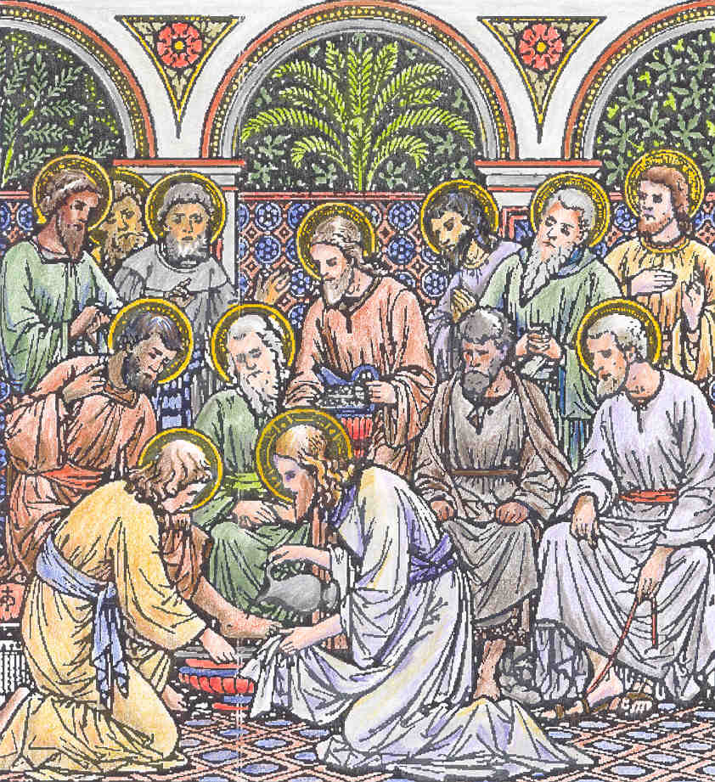
THE THURSDAY OF THE LORD'S SUPPER MAUNDY THURSDAY
DOUBLE OF FIRST CLASS
Station at St. John Lateran

INTROIT. Gal. 6. Nos autem Tone 4 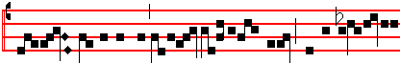
But it behoveth us to glo- ry in the Cross
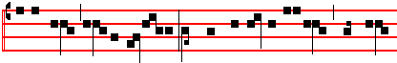
of our Lord Jesus Christ: in whom is our salvation, life, and
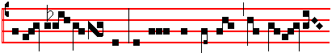
resur- rec- tion: by whom we are saved and set
Psalm. 67.
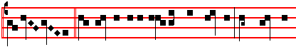
free. God be merciful unto us, and bless us: and shew us
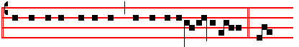 the light of his countenance, and be merciful unto us. But &c

Kyrie IV Cunctipotens Genitor Deus For Doubles 1. Tone j
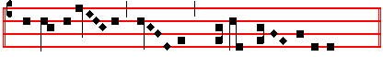
Ky-ri-e * e- le-i-son iij
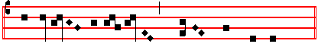
Chris-te e- le- i- son iij
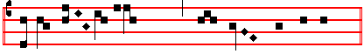
Ky-ri- e e- le- i- son ij
30
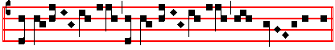
Ky-ri-e * **e- le-ison.
(Or the Mass II Fons Bonitatis for Solemn Feasts 1. Or the Mass VIII De Angelis for Doubles 5. The 1962 Vatican edition gives the Mass IX Cum jubilo for Feasts of the Blessed Virgin 1.)

¶ Gloria in excelsis is said, and after the intonation thereof the bells are rung: and, the Hymn being ended, they are silent until Holy Saturday, as is there noted.
Tone iv
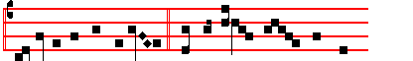
Glo- ry be to God on high, And in earth peace, good will
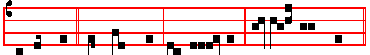
among men. We praise thee. We bless thee. We worship thee. 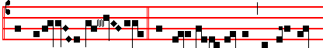
We glorify thee. We give thanks to thee for thy great
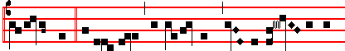
glo- ry. O Lord God, heavenly King, God the Fa- ther al-
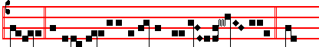
mighty. O Lord, the only-begotten Son Jes-u Christ. O
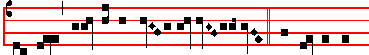
Lord God, Lamb of God, Son of the Fa- ther. That takest a-
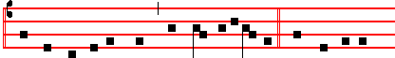
way the sins of the world, have mercy upon us. Thou that takest
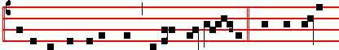
away the sins of the world, receive our pray- er. Thou that sit-test
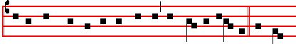
at the right hand of God the Father, have mercy upon us. For thou
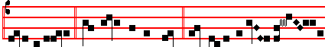
only art ho- ly. Thou only art the Lord. Thou on-ly, O Jes-u Christ,
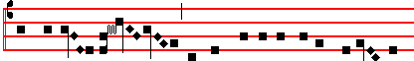
with the Ho-l y Ghost, art most high in the glory  of God the
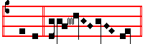
Father. A- men.

COLLECT
O GOD, from whom Judas received the punishment of his guilt, and the thief the reward of his confession, grant unto us the effects of thy propitiation: that as in his passion Jesus Christ, our Lord, gave unto both the divers rewards of their merits; so he may take away the transgressions of our old nature, and bestow upon us the grace of his resurrection: Who liveth and reigneth with thee.

The LESSON from the Epistle of blessed Paul the Apostle to the Corinthians (I, xj. 20-32)
BRETHREN: When ye come together into one place, this is not to eat the Lord's supper. For in eating every one taketh before other his own supper. And one is hungry, and another is drunken. What, have ye not houses to eat and to drink in? or despise ye the church of God, and shame them that have not? What shall I say to you? Shall I praise you in this? I praise you not. For I have received of the Lord that which also. I delivered unto you, That the Lord Jesus, the same night in which he was betrayed, took bread; and when he had given thanks, he brake it, and said: Take, eat: this is my body, which is broken for you: this do in remembrance of me. After the same manner also he took the cup, when he had supped, saying: This cup is the new Testament in my blood: this do ye, as oft as ye drink it, in remembrance of me. For as often as ye eat this bread and drink this up, ye do shew the Lord's death till he come. Wherefore whosoever shall eat this bread and drink this cup of the Lord, unworthily, shall be guilty of the body and blood of the Lord. But let a man examine himself: and so let him eat of that bread, and drink of that cup. For he that eateth and drinketh unworthily eateth and drinketh damnation to himself: not discerning the Lord's body. For this cause many are weak and sickly among you, and many sleep. For if we would judge ourselves, we should not be judged. But when we are judged, we are chastened of the Lord, that. we should not be condemned with the world.

GRADUAL. Phil. 2. Tone v
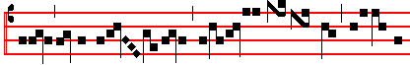
Christ for us became obe- di- ent un- to
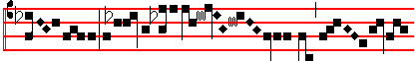
death, e-ven the death of the cross 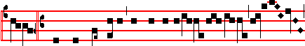
.  Therefore God also hath highly exal- ted
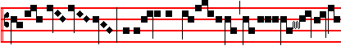 him: and gi- ven him a name 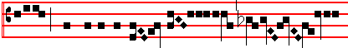 , which is above eve-ry name
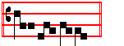
. 31
The Continuation of the holy GOSPEL according to John
(xiij. I.)
BEFORE the feast of the passover, when Jesus knew that his hour was come that he should depart out of this world unto the Father : having loved his own which were in the world, he loved them unto the end. And supper being ended, the devil having now put into the heart of Judas Iscariot, Simon's son, to betray him: Jesus knowing that the Father had given all things into his hands, and that he was come from God, and went to God: he riseth from supper, and laid aside his garments: and took a towel, and girded himself. After that he poureth water into a bason, and began to wash the disciples' feet, and to wipe them with the towel wherewith he was girded. Then cometh he to Simon Peter. And Peter saith unto him: Lord, dost thou wash my feet? Jesus answered and said unto him: What I do thou knowest not now: but thou shalt know hereafter. Peter saith unto him: Thou shalt never wash my feet. Jesus answered him: If I wash thee not, thou hast no part with me. Simon Peter saith unto him: Lord, not my feet only, but also my hands and my head. Jesus saith to him: He that is washed needeth not save to wash his feet, but is clean every whit. And ye arc clean, but not all. For he knew who should betray him: therefore said he: Ye are not all clean. So after he had washed their feet, and had taken his garments: and was set down again, he said unto them: Know ye what I have done to you? Ye call me Master and Lord: and ye say well: for so I am. If I then, your Lord and Master, have washed your feet: ye also ought to wash one another's feet. For I have given you an example, that ye should do as I have done to you. Creed, as noted on p. 14.
OFFERTORY. Psalm 118. Tone ij
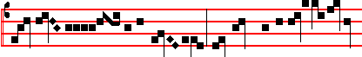
The right hand of the Lord bringeth mighty things to
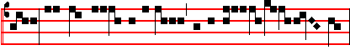
pass, the right hand of the Lord hath exal- ted me:
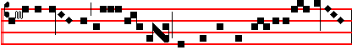
I shall not die, but live, and declare the works
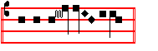
of the Lord .
SECRET
WE beseech thee, O Lord holy, Father almighty, everlasting God: that he may render our sacrifice acceptable unto thee, who on this day commanded and taught his disciples to do this in remembrance of him, even Jesus Christ thy Son our Lord: Who liveth and reigneth with thee.
Solemn Preface of tbe Cross, p. 15.
SANCTUS Cunctipotens Genitor Deus Tone viij
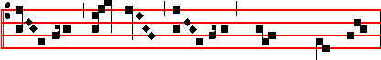
Ho- ly, Ho- ly, Ho- ly, Lord God of
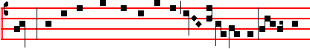
Hosts. Heaven and earth are full of thy glo- ry. Ho- sanna 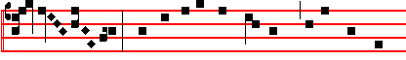
in the high-est. Blessed is he that cometh in the name of
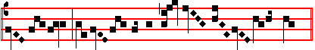
the Lord. Ho- sanna in the high- est.

CANON OF THE MASS
Infra Actionem
JOINING in communion, and celebrating the most sacred day whereon our Lord Jesus Christ was betrayed for us: and venerating moreover tbe memory first, of the glorious ever Virgin Mary, Mother of the same our God and Lord Jesus Christ: as also of thy blessed Apostles and Martyrs, Peter and Paul, Andrew, James, John, Thomas, James, Philip, Bartholomew, Matthew, Simon and Thaddeus: Linus, Cletus, Clement, Xystus, Cornelius, Cyprian, Laurence, Chrysogonus, John and Paul, Cosmas and Damian: and of all thy Saints; by whose prayers grant, that in all things we may be defended with the help of thy protection. He joins his hands. Through the same Christ, our Lord. Amen.

Holding his hands spread out over the Oblations, he says:
THIS oblation therefore of our bounden service, as also of all thy family, which we offer unto thee for the day whereon our Lord Jesus Christ commanded his disciples to celebrate the mysteries of his Body and Blood: we beseech thee, O Lord, graciously to accept: and order our days in thy peace, and bid us to be delivered from eternal damnation, and to be numbered in the flock of thine elect. He joins his hands. Through the same Christ, our Lord. Amen.

WHICH oblation, do thou, O God, we beseech thee, vouchsafe in all things He signs thrice over the Oblations, to make blessed, approved, ratified, reasonable, and acceptable: He signs once over the Host, that unto us it may become the Body and once over the Chalice, and Blood of thy most dearly beloved Son, He joins his hands, our Lord Jesus Christ.

WHO the day before he suffered for our salvation and that of all mankind, that is, on this day, He takes the Host, took bread into his holy and venerable hands, He lifts up his eyes to heaven, and lifting up his eyes to heaven to thee, God, his almighty Father, He bows his head, giving thanks to thee, he signs over the Host did bless, break, and give to his disciples: saying, Take, and eat ye all of this.

FOR THIS IS MY BODY.

LIKEWISE after supper, (he takes the Chalice in both
hands), taking also this excellent chalice into his holy and venerable hands: also (he bows his head), giving thanks to thee, (holding the Chalice in his left hand, he signs over it with his right), he blessed and gave to his disciples, saying : Take and drink ye all of this. (He utters the words of consecration over tbe Chalice, attentivel, continuously and secretly, holding it slightly raised).

FOR THIS IS THE CHALICE OF MY BLOOD,
OF THE NEW AND ETERNAL TESTAMENT:
THE MYSTERY OF FAITH: WHICH SHALL BE SHED FOR YOU AND FOR MANY FOR THE REMISSION OF SINS.

These words being uttered, he sets down the Chalice upon the Corporal, saying secretly : As often as ye do these things, ye shall do them in remembrance of me.
And the rest as in the Canon.

O Lamb of God is said as usual, but tbe Pax is not given.
AGNUS DEI Cunctipotens Genitor Deus Tone vj
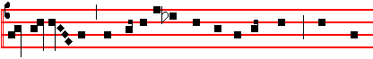
O Lamb of God, that takest away the sins of the world, have mer-
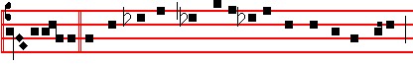
cy upon us. O Lamb of God, that takest away the sins of the world,
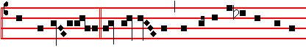
have mercy upon us. O Lamb of God, that takest away the sins of
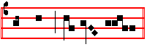
the world, grant us peace. The three customary Prayers, however, are said before Communion.

¶ To-day the Priest consecrates two Hosts, of which he consumes one, and reserves the other for the following day, on which the Sacrament is not consrecrated; he also reserves some consecrated particles, in case of need, for the sick. But (after intincting them) he consumes the whole of the Blood, and before washing his fingers he places the reserved Host in another Chalice, which the Deacon covers with the Pall and the Paten inverted, and spreads a Veil over it, and places it in the midst of the Altar. Then the Communion is said and the Mass finished. The Priest genuflects, however, whenever he approaches or departs from the middle of the A1tar, or crosses before the Sacrament reserved in the Chalice: and when he is to say The Lord be with you, he does not turn to the people in the middle of the Altar, lest he turn his back on the Sacrament, but from the Gospel side: and at the end he gives the blessing from the same place and does not complete the circle.
COMMUNION. John 13. Tone ij
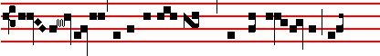
The Lord Jesus, after he had supped with his dis- ciples, washed 32
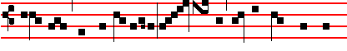
their feet, and said to them: Know ye what I, your Lord and
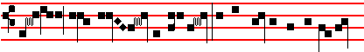
Mas- ter, have done to you? I have given you an ex-am-
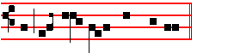
ple, that ye also should so do.

POSTCOMMUNION
O LORD our God, who hast refreshed us with life-
giving sustenance, we beseech thee: that we who observe this institution in the time of our mortal life, may obtain the benefit thereof in thy gift of immortality. Through.

Ite, Missa est is said, and the blessing is given, and the Gospel of St. John is read, at the beginning of which the Priest does not sign the Altar, but himself only.

¶ To-day a suitable place is to be prepared in some Chapel of the Church, or Altar: and adorned as decently as may be, with veils and lights: where the Chalice with the Host, resrerved as above, shall be set. When the Mass is over, torches are lighted, and a Procession is formed in the usual manner, but with another Subdeacon vested carrying the Cross. The Celebrant, vested in a white Cope, standing before the Altar, places incense in two thuribles without a blessing: then kneeling in the middle, with one he censes the Sacrament thrice : and receiving the Chalice with the Sacrament from the hand of the Deacon, who stands, and having it covered with the ends of the Veil with which his shoulders are covered, he proceeds between the same Deacon on his right, and the Subdeacon on his left, under a baldachino with two Acolyles continually censing the Sacrament, to the place prepared, where it is to be kept for the morrow. Meanwhile, during the Procession, the following hymn is sung:

E.H. 326. Pange lingua, gloriosi Corporis mysterium. Mode iij.
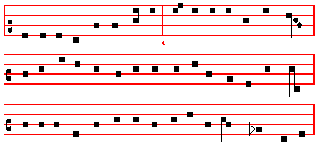

NOW my tongue the mystery telling,
Of the glorious Body sing,
And the Blood, all price excelling,
Which the world's eternal King,
In a noble womb once dwelling
Shed for this world's ransoming.
33
Given for us, for us descending,
Of a Virgin to proceed,
Man with man in converse blending,
Scattered he the Gospel seed,
Till his sojourn drew to ending,
Which he closed in wondrous deed.

At the last great Supper lying
Circled by his brethren's band,
Meekly with the law complying,
First he finished its command,
Then, immortal Food supplying,
Gave himself with his own hand.

Word made Flesh, by word he maketh
Very bread his Flesh to be;
Man in wine Christ's Blood partaketh :
And if senses fail to see,
Faith alone, the true heart waketh
To behold the mystery.

Therefore we, before him bending,
This great Sacrament revere;
Types and shadows have their ending,
For the newer rite is here;
Faith, our outward sense befriending,
Makes the inward vision clear.

Glory let us give, and blessing
To the Father and the Son;
Honour, might, and praise addressing,
While eternal ages run;
Ever too his love confessing,
Who, as God, with both is one. Amen.

When they arrive at the place prepared the Deacon kneels down and receives from the Priest, who stands, the Chalice with the Sacrament and places it first upon the Altar, where it is censed by the Priest kneeling, as above: then he places it in the receptacle. Afterwards Vespers are said in the Choir without singing*.
______________________________________________

ENGLISH BREVIARY - MAUNDY THURSDAY

Vespers, when Our Father and Hail Mary have been said secretly, are begun immediately with the first Antiphon without singing*.
______________________________________________
Antiphon. Tone ij, 4
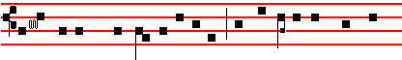
I will receive the cup of salvation, and call upon the Name of
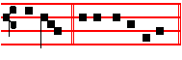
the Lord. E u o u a e.
_______________________________________________________________
*Thus the Missal to 1955, and the Ratisbon Compendium of 1901. But the Liber Usualis of 1951 gives in an Appendix "the melody, formerly in use for these Antiphons and restored by the Vatican edition of the Roman Antiphonary." We print these here in their place to give the option of following the former use.
Psalm 116, v.10 Credidi CXV
I BELIEVED, and therefore will I speak; but I was sore troubled : * I said in my haste, All men are liars.
11 What reward shall I give unto the Lord: * for all the benefits that he hath done unto me ?
12 I will receive the cup of salvation : * and call upon the Name of the Lord.
13 I will pay my vows now in the presence of all his people: * right dear in the sight of the Lord is the death of his saints.
14 Behold, O Lord, how that I am thy servant : * I am thy servant, and the son of thine handmaid; thou hast broken my bonds in sunder.
15 I will offer to thee the sacrifice of thanksgiving : * and will call upon the Name of the Lord,
16 I will pay my vows unto the Lord, in the sight of all his people : * in the courts of the Lord's house, even in the midst of thee, O Jerusalem. Praise the Lord.
Antiphon. I will receive the cup of salvation, and call upon the Name of the Lord.
Antiphon. Tone viij, 7 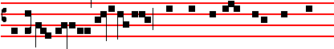
I am for peace , but when I speak unto them there- 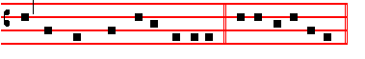
of, they make them ready for battle. E u o u a e.
Psalm 120 Ad Dominum. CXIX
WHEN I was in trouble I called upon the Lord: * and he heard me.
2 Deliver my soul, O Lord, from lying lips: * and from a deceitful tongue.
3 What reward shall be given or done unto thee, thou false tongue: * even mighty and sharp arrrows, with hot burning coals.
4 Wo is me, that I am constrained to dwell with Mesech : * and to have my habitation among the tents of Cedar.
5 My soul hath long dwelt among them : * that are enemies unto peace.
6 I labour for peace, but when I speak unto them thereof: * they make them ready to battle.
Antiphon. I am for for peace, but when I speak unto them thereof, they make them ready for battle.
Antiphon. Tone vij, 7 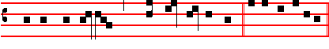
Preserve me, O Lord, f rom the wicked men. E u o u a e
Psalm 140 Eripe me, Domine CXXXIX
DELIVER me, O Lord, from the evil man: * and preserve me from the wicked man.
2 Who imagine mischief in their hearts : * and stir up strife all the day long.
3 They have sharpened their tongues like a serpent : * adders' poison is under their lips.
4 Keep me, O Lord, from the hands of the ungodly : * preserve me from the wicked men, who are purposed to overthrow my goings.
5 The proud have laid a snare for me, and spread a net
abroad with cords : * yea, and set traps in my way.
6 I said unto the Lord, Thou art my God: * hear the voice of my prayers, O Lord.
7 O Lord God, thou strength of my health: * thou hast covered my head in the day of battle.
8 Let not the ungodly have his desire, O Lord: * let not his mischievous imagination prosper, lest they be too proud.
9 Let the mischief of their own lips fall upon the head of them: * that compass me about.
10 Let hot burning coals fall upon them: * let them be cast into the fire, and into the pit, that they never rise up again.
11 A man full of words shall not prosper upon the earth: * evil shall hunt the wicked person to overthrow him.
12 Sure I am that the Lord will avenge the poor: * and maintain the cause of the helpless.
13 The righteous also shall give thanks unto thy Name : * and the just shall continue in thy sight.
Antiphon. Preserve me, O Lord, from the wicked men.
Antiphon. Tone vij, 1 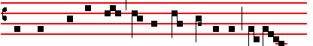
Keep me from the snare that they have laid for me, and from
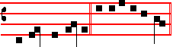
the wicked doers. E u o u a e.
Psalm 141 Domine, clamavi CXL
LORD, I call upon thee, haste thee unto me : * and consider my voice when I cry unto thee.
2 Let my prayer be set forth in thy sight as the incense : * and let the lifting up of my hands be an evening sacrifice.
3 Set a watch, O Lord, before my mouth: * and keep the door of my lips.
4 O let not mine heart be inclined to any evil thing: * let me not be occupied in ungodly works with the men that work wickedness, lest I eat of such thngs as please them.
5 Let the righteous rather smite me friendly : * and reprove me.
6 But let not their precious balms break my head: * yea, I will pray yet against their wickedness.
I7 Let their judges be overthrown in stony places: * that hey may hear my words, for they are sweet.
18 Our bones lie scattered before the pit: * like as when one breaketh and heweth wood upon the earth.
19 But mine eyes look unto thee, O Lord God: * in thee is my trust, O cast not out my soul.
10 Keep me from the snare that they have laid for me: * and from the traps of the wicked doers.
11 Let the ungodly fall into their own nets together : * and let me ever escape them.
Antiphon. Keep me from the snare that they have laid for me, and from the wicked doers
Antiphon. Tone vij, 7 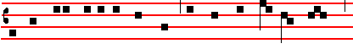
I looked also upon my right hand, and saw there was no man

34
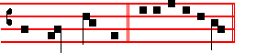
that would know me. E u o u a e.
Psalm 142 Voce mea CXLI
I CRIED unto the Lord with my voice: * yea, even unto the Lord did I make my supplication.
2 I poured out my complaints before him: * and shewed him of my trouble.
3 When my spirit was in heaviness thou knewest my path: * in the way wherein I walked have they privily laid a snare for me.
4 I looked also upon my right hand: * and saw there was no man that would know me.
5 I had no place to flee unto: * and no man cared for my soul.
6 I cried unto thee, O Lord, and said : * Thou art my hope, and my portion in the land of the living.
7 Consider my complaint: * for I am brought very low.
8 O deliver me from my persecutors : * for they are too strong for me.
9 Bring my soul out of prison, that I may give thanks unto thy Name: * which thing if thou wilt grant me, then shall the righteous resort unto my company.
Antiphon. I looked also upon my right hand, and saw there was no man that would know me.

The Chapter, Hymn and  are not said in this triduum.

On Magnificat, Antiphon. Tone j, 6
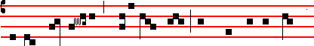
As they were eating, Jesus took bread, and blessed it, and brake
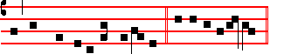
it, and gave it to his disciples. E u o u a e.
On Friday: Tone j, 6
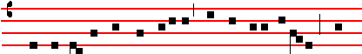
When he had received the vinegar, he said, It is finish-èd: and 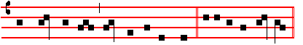
he bowed his head, and gave up the ghost. E u o u a e.
MY  soul doth magnify the Lord * and my spirit hath rejoiced in God my Saviour.
2 For he hath regarded : * the lowliness of his handmaiden.
3 For behold, from henceforth : * all generations shall call me blessed.
4 For he that is mighty hath magnified me : * and holy is his Name.
5 And his mercy is on them that fear him : * throughout all generations.
6 He hath shewed strength with his arm : * he hath scattered the proud in the imagination of their hearts.
7 He hath put down the mighty from their seat : * and hath exalted the humble and meek.
8 He hath filled the hungry with good things : * and the rich he hath sent empty away.
9 He, remembering his mercy, hath holpen his servant Israel : * as he promised to our forefathers, Abraham and his seed for ever.
Antiphon. As they were eating, Jesus took bread, and blessed it, and brake it, and gave it to his disciples.
On Friday, Antiphon on Magnificat. When he had received the vinegar, he said, It is finishèd: and he bowed his head, and gave up the ghost.
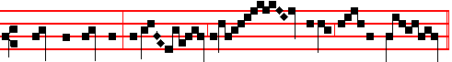
 Christ for our sake became obe- di-ent un- to death.
On Friday is added:
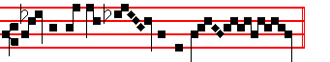
Ev- en the death of the cross.
When the  Christ for our sake is begun, all kneel, and when it is ended, Our Father is said entirely in secret.
Afterwards is said a little louder:
Ps. 51 Miserere meiDeus L
HAVE mercy upon me, O God, after thy great goodness; * according to the multitude of thy mercies do away mine offences.
2 Wash me throughly from my wickedness, * and cleanse me from my sin.
3 For I acknowledge my faults, * and my sin is ever before me.
4 Against thee only have I sinned, * and done this evil in thy sight; * that thou mightest be justified in thy saying, and clear when thou art judged.
5 Behold, I was shapen in wickedness, * and in sin hath my mother conceived me.
6 But lo, thou requirest truth in the inward parts, * and shalt make me to understand wisdom secretly.
7 Thou shalt purge me with hyssop, and I shall be clean; * thou shalt wash me, and I shall be whiter than snow.
8 Thou shalt make me hear of joy and gladness, * that the bones which which thou hast broken may rejoice.
9 Turn thy face from my sins, * and put out all my misdeeds.
10 Make me a clean heart, O God, * and renew a right spirit within me.
11 Cast me not away from thy presence, * and take not thy holy Spirit from me.
12 O give me the comfort of thy help again, * and stablish me with thy free Spirit.
13 Then shall I teach thy ways unto the wicked, * and sinners shall be converted unto thee.
14 Deliver me from blood-guiltiness, O God, thou that art the God of my health; * and my tongue shall sing of thy righteousness.
15 Thou shalt open my lips, O Lord, * and my mouth
shall shew thy praise.
16.For thou desirest no sacrifice, else would I give it thee; * but thou delightest not in burnt-offerings.
17 The sacrifice of God is a troubled spirit: * a broken and contrite heart, O God, shalt thou not despise.
18 O be favourable and gracious unto Sion; * build thou the walls of Jerusalem.

35
19 Then shalt thou be pleased with the sacrifice of righteousness, with the burnt-offerings and oblations; * then shall they offer young bullocks upon thine altar.

Which being ended, without Let us pray, is said in a like voice:
COLLECT
ALMIGHTY God, we beseech thee graciously to behold this thy family, for which our Lord Jesus Christ was contented to be betrayed, and given up into the hands of wicked men, and to suffer death upon the Cross, but Who liveth and reigneth with thee is said in
silence. _____________________________________________

Which being finished, the Priest, vested in an Alb and violet stole, with the Ministers shall lay bare the Altar, reading the following:

ANTIPHON. Psalm 22. They parted my garments among them: and upon my vesture did they cast lots.
Psalm 22 Deus, Deus meus XXI
MY God, my God, look upon me; why hast thou forsaken me: and art so far from my health, and from I the words of my complaint?
O my God, I cry in the day-time, but thou hearest not: and in the night-season also I take no rest.
And thou continuest holy: O thou worship of Israel.
Our fathers hoped in thee: they trusted in thee, and thou didst deliver them.
They called upon thee, and were holpen: they put their trust in thee, and were not confounded.
But as for me, I am a worm, and no man: a very scorn of men, and the outcast of the people.
All they that see me laugh me to scorn : they shoot out their lips, and shake their heads, saying,
He trusted in God, that he would deliver him: let him deliver him if he will have him.
But thou art he that took me out of my mother's womb: thou wast my hope when I hanged yet upon my mother's breasts.
I have been left unto thee ever since I was born: thou art my God even from my mother's womb.
O go not from me, for trouble is hard at hand: and there is none to help me.
Many oxen are come about me: fat bulls of Basan close me in on every side.
They gape upon me with their mouths: as it were a ramping and a roaring lion.
I am poured out like water, and all my bones are out of joint: my heart also in the midst of my body is even like
melting wax.
My strength is dried up like a potsherd, and my tongue cleaveth to my gums: and thou , shalt bring me into the dust of death.
For many dogs are come about me: and the council of the wicked layeth siege against me.
They pierced my hands and my feet; I may tell all my bones: they stand staring and looking upon me.
They part my garments among them: and cast lots upon my vesture.
But be not thou far from me, O Lord: thou art my succour, haste thee to help me.
Deliver my soul from the sword: my darling from the power of the dog.
Save me from the lion's mouth: thou hast heard me also from among the horns of the unicorns.
I will declare thy name unto my brethren: in the midst of the congregation will I praise thee.
O praise the Lord, ye that fear him: magnify him, all ye of the seed of Jacob, and fear him, all ye seed of Israel;
For he hath not despised, nor abhorred, the low estate of the poor: he hath not hid his face from him, but when he called unto him he heard him.
My praise is of thee in the great congregation: my vows will I perform in the sight of them that fear him.
The poor shall eat, and be satisfied: they that seek after the Lord shall praise him; your heart shall live for ever.
All the ends of the world shall remember themselves, and be turned unto the Lord: and all the kindreds of the nations shall worship before him.
For the kingdom is the Lord's: and he is the governor among the people.
All such as be fat upon earth: have eaten, and worshipped.
All they that go down into the dust shall kneel before him: and no man hath quickened his own soul.
My seed shall serve him: they shall be counted unto the Lord for a generation.
They shall come, and the heavens shall declare his righteousness: unto a people that shall be born, whom the Lord hath made.
Repeat Antiphon. They parted my garments among them: and upon my vesture did they cast lots.
______________________________________________

¶ After the stripping of the Altars, at the appointed hour a signal is given with a board, and the Clergy come together to perform the Maundy. The Prelate or Superior is vested with Stole and violet Cope over Amice and Alb, and in the appointed place with the assistance of the Deacon (who with the Subdeacon assists him in white vestments, as at Mass) puts incense in the thurible: then the Deacon holding the book of the Gospels before his breast, kneels before the Superior and asks a blessing: on receiving this, while two Acolytes with lighted candles stand by, and the Subdeacon holds the book, he signs it and censes it, and sings as usual the Gospel, Before the feast of the Passover, as in the Mass, p. 30.

When this is finished, the Subdeacon carries the open book to be kissed by the Superior, and the Deacon censes him as usual. Then the Superior puts off the Cope, and is girded by the Deacon and Subdeacon with a linen cloth, and thus girded, the Deacon and Subdeacon assisting, proceeds to the washing of feet. Those who are to be washed are arranged in order, and while Clerks minister a bason and water, and the Subdeacon holds the right foot of each, the Superior kneels before each, washes his foot, wipes and kisses it, the Deacon giving the towel to wipe them. Meanwhile the following are sung :

36
ANTIPHON. John 13. Mandatum novum Tone iij
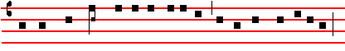
A new commandment I give unto you: that ye love one another,
Psalm 119 Beati omnes CXVIII
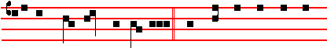
as I have loved you, saith the Lord. BLESSED are those that are
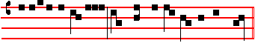
undefiled in the way: and walk in the law of the Lord. And immediately is repeated the Antiphon, A new commandment.

And so with the other Antiphons, which have Psalms or Verses. And of any Psalm only the first verse is said.

ANTIPHON. John 13. Tone iv
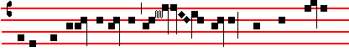
After the Lord had risen from supper, he poured water
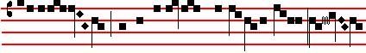
into a ba- son, and began to wash his disciples' feet: this 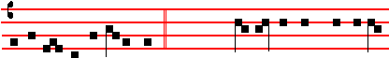
exam-ple left he unto them. Psalm 48. Great is the Lord, and highly
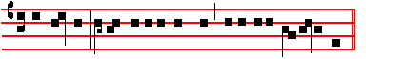
to be praised: in the city of our God, even upon his holy hill. After the Lord had risen.

ANTIPHON. John 13. Tone ij
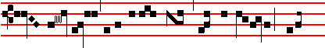
The Lord Jesus, after he had supped with his disciples, washed 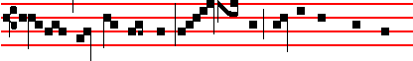
their feet, and said to them: Know ye what I, your Lord and
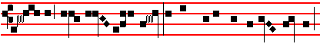
Mas- ter, have done to you? I have given you an ex- ample,
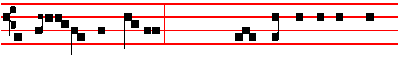
that ye al- so should so do. Psalm 85. Lord, thou art become gra-
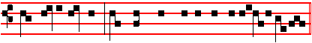
cious unto thy land: thou hast turned away the captivity of Ja- cob.
The Lord Jesus.

ANTIPHON. John 13. Tone v
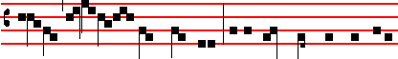
Lord, dost thou wash my feet? Jesus answered, and said unto
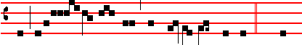 him: If I wash not thy feet, thou hast no part with me.  Then
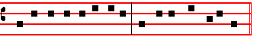
cometh he to Simon Peter, and Peter saith unto him.
And the Antiphon is repeated, Lord, dost thou.
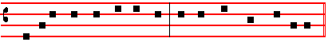
 What I do, thou knowest not now: but thou shalt know hereafter. The Antiphon is repeated for the third time, Lord, dost thou.

ANTIPHON. John 13. Tone iv
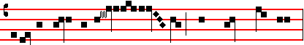
If I, your Lord and Mas- ter, have washed your feet:
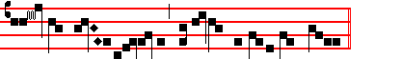
how much more ought ye to wash one another's feet? Psalm 49.
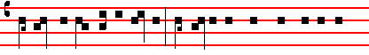
O hear ye this, all ye people: ponder it with your ears, all ye that
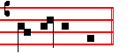
dwell in the world.
If I, your Lord.

ANTIPHON. John 13. Tone vij
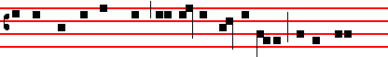
By this shall all men know that ye are my dis- ciples, if ye have
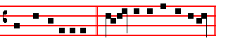
love one to another.  Jesus said to his dis-ciples.
By this shall all men.

ANTIPHON. I Cor.13. Tone vij
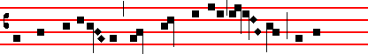
Let there abide in you faith, hope, charity, these three: but the
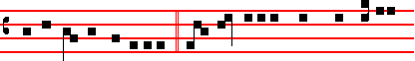 greatest of these is charity.  And now abideth faith, hope, charity,
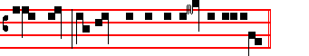
these three, but the greatest of these is chari-ty.
Let there abide in you.

ANTIPHON. Tone ij
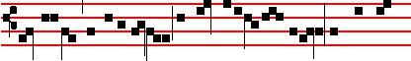
Blessed be the holy Trinity and the undivi-ded Unity: we will give
37
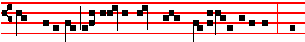
thanks unto him, because he hath shewed his mercy upon us.  Let
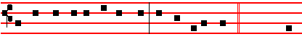
us bless the Father and the Son with the Holy Ghost. Psalm 84. O
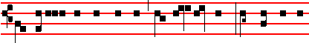
how amiable are thy dwellings, thou Lord of hosts! My soul hath a
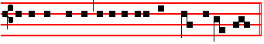
desire and longing to enter into the courts of the Lord.
Blessed be.

ANTIPHON. I John 2, 3, 4. Tone vj 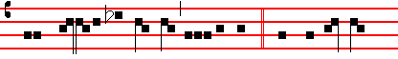
Where charity and love are, there is God.  The love of Christ
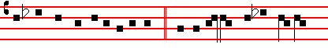
hath gathered us together in one.  Let us rejoice and be glad in
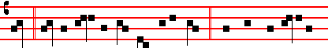
him.  Let us fear and love the living God. And love one another
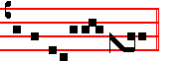
in sincerity of heart.
The Antiphon is repeated, Where charity and love are, there is God.

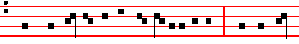
 When therefore we are gathered toge- ther in one:  Take we heed
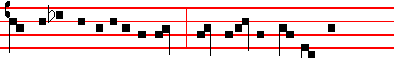
that we be not divided in mind.  Let mali-cious quarrels, let
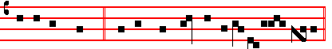
contentions cease.  And let Christ our God be in the midst of us. And the Antiphon is repeated, Where charity and love are, there is God.

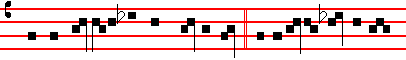
 So may we al-so with the Blessed see  In glory thy countenance,
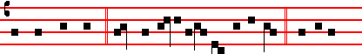
O Christ our God:  Joy, that is infinite and undefiled, For ever
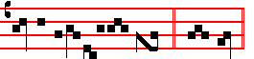
and for evermore. A- men.

38
¶ After the washing, the Superior, or he that hath washed the feet, washes his hands, and wipes them with another towel: then returning to the place where he was at first, he puts on the Cope, and standing with head uncovered says:

Our Father, secretly.
 And lead us not into temptation.
 But deliver us from evil.
 Thou hast charged, O Lord.
 That we shall diligently keep thy commandments.
 Thou didst wash the feet of thy disciples. .
 Despise not thou the works of thine hands.
 O Lord, hear my prayer.
 And let my cry come unto thee.
 The Lord he with you.
 And with thy spirit.

Let us pray. COLLECT
ASSIST us, we beseech thee, O Lord, in this our bounden service: and since thou wast pleased to wash the feet of thy disciples, despise not the works of thine own hands which thou hast bidden us to follow: that as here outward stains by us and from us are washed away; so also the secret sins of us all may be blotted out by thee.* Which do thou vouchsafe to grant, who livest and reignest God: throughout all ages, world without end.
* Amen.
_______________________________________________________________
In the second ferial tone, on one note, but with a flex of a minor third at the *
______________________________________________

GOOD FRIDAY
DOUBLE OF I ST CLASS.
Station at St. Cross in Jerusalem.

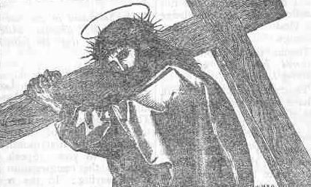

¶ In Choir, None being ended, the Priest and Ministers in black vestments, without lights and incense, proceed to the Altar: and pray awhile prostrate before it. Meanwhile the Acolytes spread one cloth upon the Altar. The Priest with the Ministers, having finished their prayer, go up to the Altar, and he kisses it in the middle: then the Reader proceeds to read the Prophecy in the place where the Epistle is read, and begins it without any announcement; the Priest meanwhile reads the same in a low voice at the Epistle corner.
Hosea vj. I.
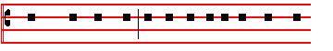
THUS saith the Lord: In their affliction they will seek

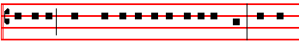
me early: Come, and let us return unto the Lord: for he 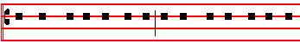hath torn, and he will heal us: he hath smitten, and he will
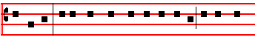
bind us up. After two days will he revive us: in the third
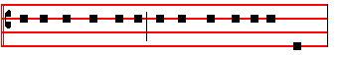
day he will raise us up, and we shall live in his sight.
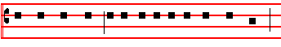
Then shall we know, if we follow on to know the Lord:
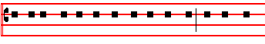 his going forth is prepared as the morning, and he shall
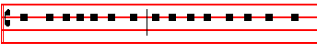
come unto us as the rain, as the latter and former rain
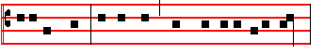
unto the earth. O Ephraim, what shall I do unto thee?
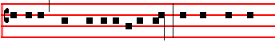
O Judah, what shall I do unto thee? for your goodness
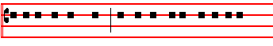
is as a morning cloud: and as the early dew it goeth
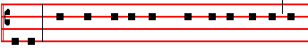
away. Therefore have I hewed them by the prophet, I
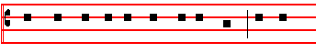
have slain them by the words of my mouth: and thy

39
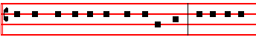
judgments are as the light that goeth forth. For I desired
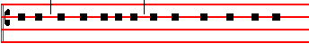
mercy, and not sacrifice, and the knowledge of God
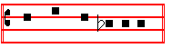
more than burnt offerings.

¶ Thanks be to God is not answered here, nor after the following Lesson.

TRACT. Habak. 3. Tone ij
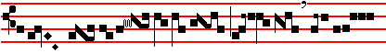
O Lord, I have heard thy speech
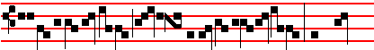
, and was afraid : I have 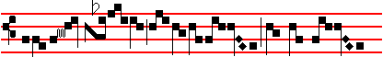
consi- dered thy works, and was con-
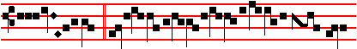
foun- ded. O Lord ,
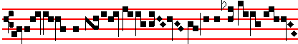
re- vive thy work in the midst
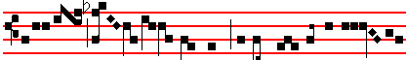
of the years: in the midst
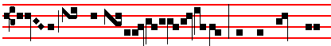 of the years make it known 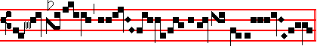
.....................................................................................................

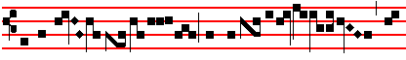
 In the time of confu- sion of
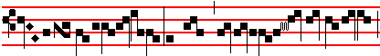
my soul : in wrath, remem- ber
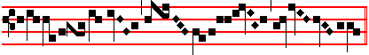
mer- cy.
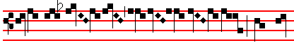
 God came from
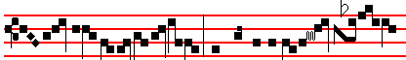
Teman, and his Holy One from
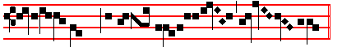
the thick woods of the moun- tains.
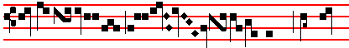
 His glo- ry co- vered the hea-
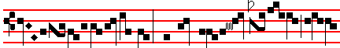
vens: and the earth was full of
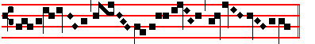
his praise.
¶ The Tract being finished, the Priest at the Epistle corner
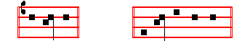
says: Let us pray. The Deacon: Let us bow the knee,
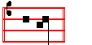
and the Subdeacon: A- rise.

COLLECT*
O GOD, from whom Judas received the punishment of
his guilt, and the thief the reward of his confession, grant unto us the effects of thy propitiation: that as in his passion Jesus Christ, our Lord, gave unto both the divers rewards of their merits; so he may take away the transgressions of our old nature, and bestow upon us the grace of his resurrection: Who liveth and reigneth with thee.
______________________________________________

*This Collect, and all those preceded by Let us bow the knee, are sung in the first ferial tone, that is recto tono, on one note, from beginning to end, with only a slight pause in those places where the metrum and the flex would have been used in the festal tone, and again at the ending. (Liber Usualis, 1951)
_______________________________________________________________

¶ The Subdeacon in the tone of the Epistle, likewise without announcement, sings the following Lesson:

Exod. xij, I.
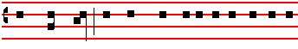
IN those days: The Lord spake unto Moses and Aaron

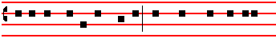 in the land of Egypt, saying: This month shall be unto

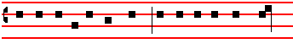
you the beginning of months: it shall be the first month

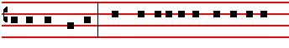
of the year to you. Speak ye unto all the congregation
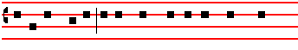
of Israel, saying: In the tenth day of this month they

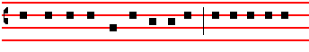
shall take to them every man a lamb, according to the
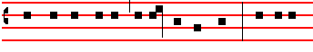
house of their fathers, a lamb for an house. And if the

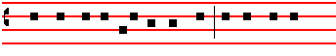
household be too little for the lamb, let him and his
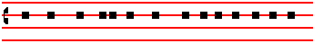
neighbour next unto his house take it according to the
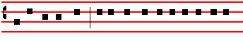
number of the souls, every man according to his eating
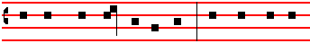
shall make your count for the lamb. Your lamb shall be
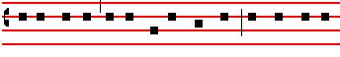
without blemish, a male of the first year: ye shall take it
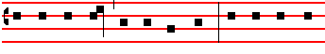
out from the sheep, or from the goats. And ye shall keep
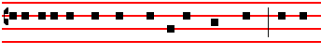
it up until the fourteenth day of the same month: and the
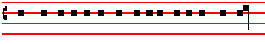
whole assembly of the congregation of Israel shall kill

40
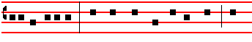 it in the evening. And they shall take of the blood, and
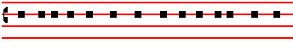
strike it on the two side posts and on the upper door post
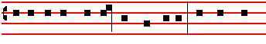 of the houses, wherein they shall eat it. And they shall
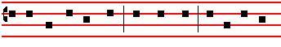 eat the flesh in that night, roast with fire, and unleavened
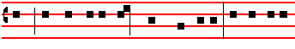
bread, and with bitter herbs they shall eat it. Eat not of it
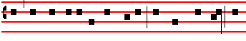
raw, nor sodden at all with water, but roast with fire: his
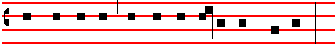
head with his legs, and with the purtenance thereof.
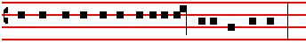
And ye shall let nothing of it remain until the morning.
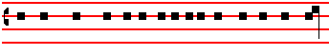 And that which remaineth of it until the morning ye shall
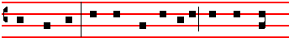
burn with fire. And thus shall ye eat it: with your loins
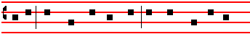
girded, your shoes on your feet, and your staff in your
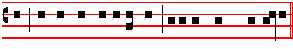
hand, and ye shall eat it in haste: it is the Lord's Passover.
TRACT. Ps. 140. Tone ij
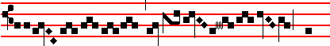
Deliver me, O Lord , from
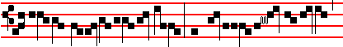
the e- vil man : and preserve me
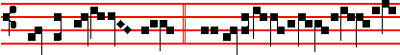
from the wic-ked man. Who ima-
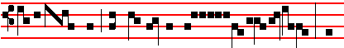 gine mischief in their hearts : and
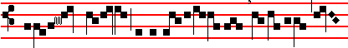
stir up strife all the day long
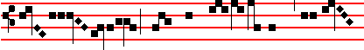
.They have shar- pened their ton-
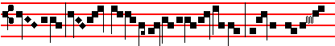
- - - gues like a ser- pent : adders' poi-
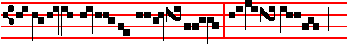
son is un- der their lips.  Keep me,
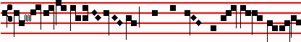
O Lord , from the hands of the un- god-
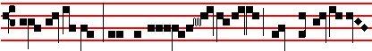
ly: and preserve me from the wic-ked
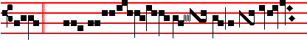
men.  Who are purposed to o- ver-
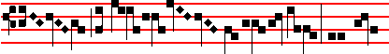
throw my goings : the proud
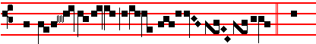
have laid a snare for me.  And
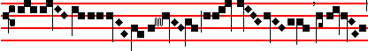
spread a net a- broad
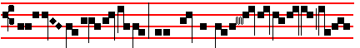
with cords : yea, and set traps in
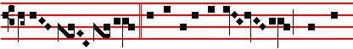
my way.  I said unto the Lord : Thou art
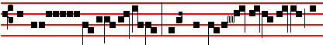 my God : hear the voice of
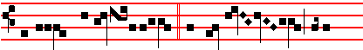
my prayers, O Lord.  O Lord God, thou

41
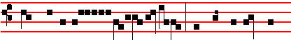
strength of my health : thou hast covered my
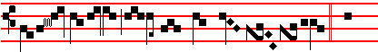
head in the day of batt- le.  Let
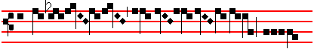
not the ungod- ly have his
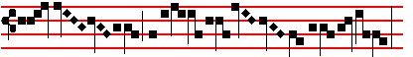
desire , O Lord :
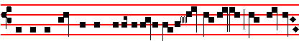
let not his mischievous imagination pros- per, lest they be
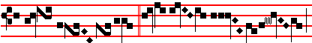
too proud.  Let the mis- chief
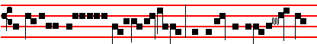
of their own lips fall upon the head of
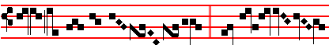
them: that compass me a- bout.  The right- eous also
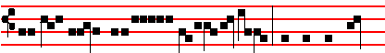
shall give thanks unto thy name : and the just shall
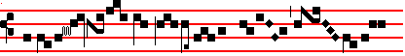
conti- nue in thy sight
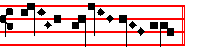
.................................................

¶ The Tract ended, the Passion is read upon a bare pulpit: the Celebrant meanwhile reads it in a low voice at tbe Epistle corner.
.
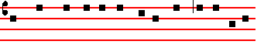
The PASSION of our Lord Jesus Christ according to
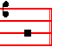
John. (xviii and xix.)
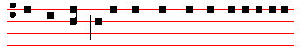
AT that time: Jesus went forth with his disciples over

42
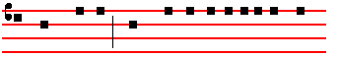
the brook Cedron, where was a garden, into the which
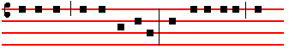
he entered, and his disciples. And Judas also, which
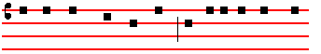
betrayed him, knew the place: for Jesus oft times re-
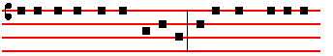
sorted thither with his disciples. Judas then, having re-
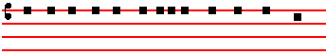
ceived a band of men and officers from the chief priests
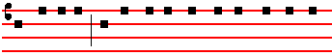
and Pharisees, cometh thither with lanterns and torches
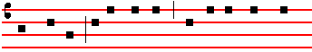
and weapons. Jesus therefore, knowing all things that
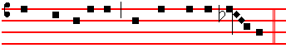
should come upon him, went forth, and said unto them: 
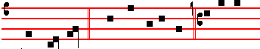 Whom seek ye? C. They answered him: S. Je-sus of
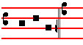
Nazareth. And the rest as noted in the Chant of the Passion of our Lord Jesus Christ.
C. Jesus saith unto them:  I am he. C. And Judas also, which betrayed him, stood with them. As soon then as he had said unto them: I am he: they went backward. and fell to the ground. Then asked he them again:  Whom seek ye? C. And thcy said: S. Jesus of Nazareth. C. Jesus answered:  I have told you that I am he: if therefore ye seek me, let these go their way. C. That the saying might bc fulfilled, which he spake: Of them which thou gavest me have I lost none. Then Simon Peter having a sword drew it : and smote the high priest's servant: and cut off his right ear. The servant's name was Malchus. Then said Jesus unto Peter: Put up thy sword into the sheath. The cup which. my Father hath given me, shall I not drink it? C. Then the band and the captain and officers of the Jews took Jesus, and bound him: and led him away to Annas first, for he was father in law to Caiaphas, which was the high priest that same year. Now Caiaphas was he, which gave counsel to the Jews: That it was expedient that one man should die for the people. And Simon Peter followed Jesus, and so did another disciple. That disciple was known unto the high priest, and went in with Jesus into the palace of the high priest. But Peter stood at the door without. Then went out that other disciple, which was known unto the high priest, and spake unto her that kept the door: and brought in Peter. Then saith the damsel that kept the door unto Peter: S. Art not thou also one of this man's disciples? C. He saith: S. I am not. C. And the servants and officers stood there, who had made a fire of coals, for it was cold, and they warmed themselves: and Peter stood with them, and warmed himself. The high priest then asked Jesus of his disciples, and of his doctrine. Jesus answered him:  I spake openly to the world: I ever taught in the synagogue, and in the temple, whither the Jews always resort: and in secret have I said nothing. Why askest thou me? ask them which heard me, what I have said unto them: behold, they know what I said. C. And when he had thus spoken, one of the officers which stood by struck Jesus with the palm of his hand, saying: S. Answerest thou the high priest so? C. Jesus answered him  If I have spoken evil, bear witness of thc evil: but if well, why smitest thou me? C. Now Annas had sent him bound unto Caiaphas the high priest. And Simon Peter stood and warmed himself. They said therefore unto him: S. Art not thou also one of his disciples? C. He denied it, and said: S. I am not. C. One of the servants of the high priest, being his kinsman whose ear Peter cut off, saith: S. Did not I see thee in the garden with him? C. Peter then denied again: and immediately the cock crew. Then led they Jesus from Caiaphas unto the hall of judgment. And it was early: and they themselves went not into the judgment hall, lest they should be defiled, but that they might eat the passover. Pilate then went out unto them, and said. S. What accusation bring ye against this man? C. They answered and said tmto him: S. If he were not a malefactor, we would not have delivered him up unto thee. C. Then said Pilate unto them: S. Take ye him, and judge him according to your law. C. The Jews therefore said unto him: S. It is not lawful for us to put any man to death. C. That the saying of Jesus might be fulfilled, which he spake, signifying what death he should die. Then Pilate entered into the judgment hall again, and called Jesus, and said unto him: S. Art thou the King of the Jews ? C. Jesus answered him:  Sayest thou this thing of thyself, or did others tell it thee of me? C. Pilate answered: S. Am I a Jew? Thine own nation and the chief priests have delivered thee unto me; what hast thou done? C. Jesus answered:  My kingdom is not of. this world. If my kingdom were of this world, then would my servants fight, that I should not be delivered to the Jews: but now is my kingdom not from hence. C. Pilate therefore said unto him: S. Art thou a King then? C. Jesus answered: Thou sayest that I am a King. To this end was I born, and for this cause came I into the world, that I should bear witness unto the truth: every one that is of the truth heareth my voice. C. Pilate saith unto him: S. What is truth? C. And when he had said this, he went out again unto the Jews, and saith unto them: S. I find in him no fault at. all. But ye have a custom, that I should release unto you one at the Passover: will ye therefore that I release unto you the King of the Jews? C. Then cried they all again, saying: S. Not this man, but Barabbas. C. Now Barabbas was a robber. (xix. I.) Pilate therefore took Jesus, and scourged him. And the soldiers platted a crown of thorns, and put it on his head: and they put on him a purple robe. And said: S. Hail, King of the Jews. C. And they smote him with their hands. Pilate therefore went forth again, and saith unto them: S. Behold, I bring him forth to you, that ye may know that I find no fault in him. C. Then came Jesus forth, wearing the crown of thorns, and the purple robe. And Pilate saith unto them: S. Behold the man. C. When the chief priests therefore and officers saw him, they cried out, saying: S. Crucify him, crucify him. C. Pilate saith unto them: S. Take ye him, and crucify him: for I find no fault in him. C. The Jews answered him: S. We have a law, and by our law he ought to die, because he made himself the Son of God. C. When Pilate therefore heard that saying, he was the more afraid. And went again into the judgment hall: and saith unto Jesus : S. Whence art thou? C. But Jesus gave him no answer. Then saith Pilate unto him: S. Speakest thou not unto me? knowest thou not that I have power to crucify thee, and have power to release thee? C. Jesus answered:  Thou couldest have no power at all against me, except it were given thee from above. Therefore he that delivered me unto thee hath the greater sin. C. And from thenceforth Pilate sought to release him. But the Jews cried out, saying: S. If thou let this man go, thou art not Cæsar's friend. Whosoever maketh himself a king speaketh against Cæsar. C. When Pilate therefore heard that saying, he brought Jesus forth, and sat down in the judgment-seat, in a place that is called the Pavement, but in the Hebrew, Gabbatha. And it was the Preparation of the Passover, and about the sixth hour, and he saith unto the Jews: S. Behold your King. C. But they cried out: S. Away with him, away with him, crucify him. C. Pilate saith unto them: S. Shall I crucify your King? C. The chief priests answered: S. We have no king but Cæsar. C. Then delivered he him therefore unto them to be crucified. And they took Jesus, and led him away. And he, bearing his Cross, went forth into a place called the place of a skull, which is called in the Hebrew, Golgotha: where they crucified him, and two other with him, on either side one, and Jesus in the midst. And Pilate wrote a title: and put it on the cross. And the writing was: Jesus of Nazareth the King of the. Jews. This title then read many of the Jews, for the place where Jesus was crucified was nigh to the city. And it was written in Hebrew, and Greek, and Latin. Then said the chief priests of the. Jews to Pilate: S. Write not, The King of the Jews, but that he said: I am the King of the Jews. C. Pilate answered: S. What I have written, I have written. C. Then the soldiers, when they had crucified Jesus, took his garments, and made four parts: to every soldier a part, and also his coat. Now the coat was without seam, woven from the top throughout. They said therefore among themselves: S.

43
Let us not rend it, but cast lots for it, whose it shall be. C. That the Scripture might be fulfilled which saith: They parted my raiment among them: and for my vesture they did cast lots. These things therefore the soldiers did. Now there stood by the Cross of Jesus, his Mother, and his Mother's sister, Mary the wife of Cleophas, and Mary Magdalene. When Jesus therefore saw his Mother, and the disciple standing by, whom he loved, he saith unto his Mother:  Woman, behold thy son. C. Then saith he to the disciple:  Behold thy mother. C. And from that hour that disciple took her unto his own home. After this, Jesus, knowing that all things were now accomplished, that the Scripture might be fulfilled, saith:  I thirst. C. Now there was set a vessel full of vinegar. And they filled a spunge with vinegar, and put it upon hyssop, and put it to his mouth. When Jesus therefore had received the vinegar, he said:  It is finished. C. And he bowed his head, and gave up the ghost. (Here genuflect, and pause a while) The Jews therefore, because it was the Preparation, that the bodies should not remain upon the cross on the sabbath-day, (for that sabbath-day was an high day,) besought Pilate that their legs might be broken, and that they might be taken away. Then came the soldiers: and brake the legs of the first, and of the other which was crucified with him. But when they came to Jesus, and saw that he was dead already, they brake not his legs, but one of the soldiers with a spear pierced his
side, and forthwith came there out blood and water. And he that saw it bare record: and his record is true. And he knoweth that he saith true: that ye might believe. For these things were done that the Scripture should be fulfilled: A bone of him shall not be broken. And again, another Scripture saith : They shall look on him whom they pierced.

¶ What follows is read in the tone of the Gospel: and Cleanse my heart is said, but a blessing is not asked, nor are lights and incense carried, and the Celebrant does not kiss tbe book at the end.

AND after this Joseph of Arimathea, being a disciple of Jesus, but secretly for fear of the Jews, besought Pilate that he might take away the body of Jesus. And Pilate gave him leave. He came therefore, and took the body of Jesus. And there came also Nicodemus, which at the first came to Jesus by night, and brought a mixture of myrrh and aloes, about an hundred pound weight. Then took they the body of Jesus, and wound it in linen clothes with the spices, as the manner of the Jews is to bury. Now in the place where he was crucified there was a garden: and in the garden a new sepulchre, wherein was never man yet laid. There laid they Jesus therefore because of the Jews' Preparation day, for the sepulchre was nigh at hand.

___________________________________________________________________________________________________

¶ Then the Priest, standing at the Epistle side of the Altar, begins at once with joined hands:
Let us pray dearly beloved, for the holy Church of God: that our God and Lord would vouchsafe to give her
peace and unity, and preserve her throughout all the world: making subject unto her principalities and powers:
and grant that, leading a quiet and peaceful life, we may glorify God the Father almighty. Let us pray.
Deacon: Subdeacon:
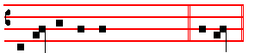
Let us bow the knee.  A- rise. The Collect is sung in tbe ferial tone * of the Collect of the Mass, with hands extended. And the same manner is observed in all that follow.

ALMIGHTY and everlasting God, who in Christ hast revealed thy glory to all nations: * preserve the works of thy mercy; * that thy Church, spread
abroad over the whole world, * may with steadfast faith persevere in the confession of thy name. Through the same.  Amen.

_________________________________________________________________________________________________________________________

* see p. 40: recto tono throughout, with a pause at the * and at the end.
44
Let us pray also for our most blessed Father N.: that our God and Lord, who hath chosen him unto the order
of bishops, may preserve him in health and safety to his holy Church, for the governance of the holy people
Deacon: Subdeacon:
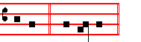
of God. Let us pray. Let us bow the knee.  A- rise.
.

ALMIGHTY and everlasting God, by whose judgment all things are established: mercifully regard our prayers, and in thy goodness preserve him whom thou hast chosen to be our Bishop; that the
christian people who are governed bv thine authority may under so great a Pontiff increase in the merits of their faith. Through.  Amen.

Let us pray also for all Bishops, Priests, and Deacons, for all Subdeacons, Acolytes, Exorcists, Readers,
Doorkeepers, Confessors, Virgins, and Widows: and for all the holy people of God. Let us pray.
Deacon: Subdeacon:
Let us bow the knee.  A- rise.

ALMIGHTY and everlasting God, by whose Spirit the whole body of the Church is governed and sanctified: receive our supplications, which we offer before thee for all orders of the same; that by
the bounty of thy grace they may faithfully serve thee in their several estates. Through. . . in the unity of the same.
 Amen.

Let us pray also for our most Christian * Emperor N.: that our God and Lord would make subject unto him
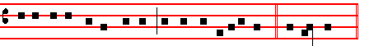
all the nations of the heathen, for our perpe-tu-al peace. Let us pray.
Deacon: Subdeacon:
Let us bow the knee.  A- rise If he has not been crowned say: *Emperor elect. 45

ALMIGHTY and everlasting God, in whose hand. is the dominion of. all things and the government of all kingdoms: graciously look upon
the Roman Empire; that the nations which trust in their own fierceness may be overthrown by the right hand of thy power. Through.  Amen

Let us pray also for our catechumens: that our God and Lord would open the ears of their hearts, and the
gate of mercy: that, receiving in the waters of regeneration the remission of all their sins, they also may be
Deacon: Subdeacon:
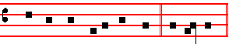
found in Christ Jesus our Lord. Let us pray. Let us bow the knee.  A- rise

ALMIGHTY and everlasting God, who dost continually enrich thy Church with a new offspring: increase the faith and understanding of our
catechumens; that they, being born again in the water of baptism, may be numbered among the sons of thine adoption.Through.  Amen.

Let us pray, dearly beloved, unto God the Father almighty, that he would purge the world from all errors:
would take away diseases: drive away famine: open the prisons: loosen the chains: grant unto pilgrims
a safe return: to the sick, healing: and to them that travel by sea or air a haven of safety . Let us pray.
Deacon: Subdeacon:
Let us bow the knee.  A- rise

ALMIGHTY and everlasting God, the comfort of them that mourn, the strength of them that travail: let the prayers of them that cry out of any
tribulation ascend unto thee; that in their necessities all may rejoice in the succour of thy loving-kindness. Through.  Amen.

Let us pray also for heretics and schismatics: that our God and Lord would deliver them from all their errors;
and vouchsafe to call them back to their holy mother, the Catholic and Apostolic Church. Let us pray.
46
Deacon: Subdeacon:
Let us bow the knee.  A- rise

ALMIGHTY and everlasting God, who savest all men, and wouldest not that any should perish: look upon the souls that are deceived by the craft of the devil; that the hearts of them that are gone astray
being delivered from all perversity of heresy, may turn to wisdom and come again to the unity of thy truth: Through.
 Amen.

Let us pray also for the faithless Jews: that our God and Lord would take away the veil from their hearts; that
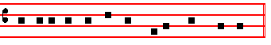
they also may acknowledge Jesus Christ, our Lord.
Amen is not said, nor Let us pray, nor Let us bow the knee, nor Arise, but at once is said:

ALMIGHTY and everlasting God, who deniest not thy mercy even to the faithless Jews: graciously hear our prayers, which we offer for the
blindness of this people; that they acknowledging the light of thy truth, which is Christ, may be delivered from their darkness. Through the same.
 Amen.

Let us pray also for the heathen: that God almighty would take away the iniquity from their hearts; that,
forsaking their idols, they may be turned unto the living and true God, and to his only Son, Jesus Christ, our
Deacon: Subdeacon:
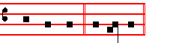
God and Lord. Let us pray. Let us bow the knee.  A- rise

ALMIGHTY and everlasting God, who desirest not the death of sinners but rather that they should live: mercifully receive our prayer, and deliver them from the worship of idols; and gather them unto thy holy Church, to the praise and glory of thy name. Through.  Amen.

¶ Having finished the Prayers, the Priest lays aside his Chasuble and goes to the Epistle side of the Altar, where at the back corner he receives from tbe Deacon the Cross which has previously been made ready on the Altar. With his face to the people, he uncovers the upper portion, beginning alone: Behold the wood of the Cross, and from thence be is helped in singing tbe rest by the Ministers: until O come, let us worship. When the Choir sings O come, let us worship, all prostrate themselves except the Celebrant. He then advances to tbe front corner of the same Epistle side: and uncovering the right arm of the Cross, and raising it a little, he begins in a higher key than at first, Behold the wood of the Cross, the others singing and worshipping as before. Then the Priest proceeds to the middle of the Altar, and uncovering the Cross entirely and raising it, for the third time he begins in a still higher key, Behold the wood of the Cross, the others singing and worshipping as before.
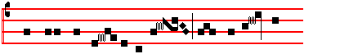
Be- hold the wood of the Cross, where-on was hung
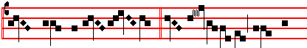
the world's salva- tion.  O come, let us 47
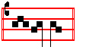
wor- ship.
¶ Then the Priest alone carries the Cross to the place prepared before the Altar, and kneeling there he puts it down: then laying aside his shoes, he proceeds to worship the Cross, kneeling thrice before he kisses it. This done, he returns, and puts on his shoes and the Chasuble. Afterwards the Ministers of the Altar, then the other Clerics and laics, two and two, kneeling thrice, as has been said, worship the Cross. Meantime, while the adoration of the Cross is proceeding, the Reproaches are sung, together with the other things that follow, either all or in part, according as the many or few that worship the Cross require: which also the Priest sitting at the bench reads with the Ministers, as below:

In choir, the Celebrant's part is sung by two cantors in the midst; the Deacon by one choir and the Subdeacon by the second.
Celebrant:
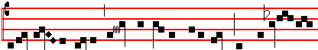
 O my people, what have I done unto thee? or where-in
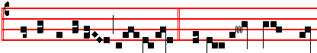
have I wearied thee? Ans- wer me.  Because I brought thee
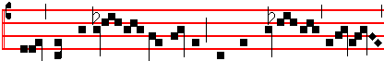
forth from the land of Egypt: thou hast prepared a Cross
Deacon: Subdeacon:
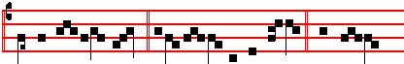
for thy Sav- iour.  Agi-os o The-os.  Ho- ly
Deacon: Subdeacon:
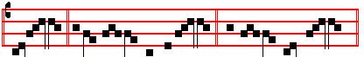
God.  Agi- os ischy-ros. . Holy, migh-ty.
Deacon
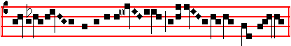 Agi-os athana-tos, ele- i- son i- mas.
Subdeacon: 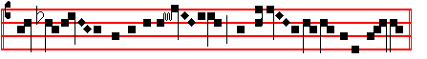
. Ho- ly and immortal, have mer- cy upon us.
Celebrant: (2 cantors of 2nd choir)
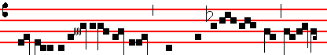
 Because I led thee through the de- sert for-
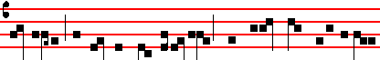
ty years, and fed thee with man- na, and brought thee into a land
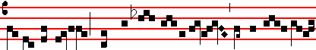
exceeding good: thou hast prepared a Cross for thy Sa- viour.
Deacon:  Agios o Theos. Subdeacon: Holy God.
Deacon:  Agios ischyros. Subdeacon: . Holy, mighty.
Deacon:  Agios athanatos, eleison imas.
Subdeacon.. Holy and immortal, have mercy upon us.
Celebrant: (2 cantors of 1st Choir)
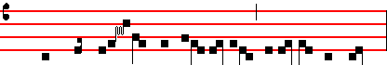
. What more could I have done for thee that I have not done?
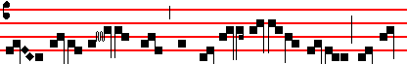
I indeed did plant thee, my vineyard, exceeding fair: and thou
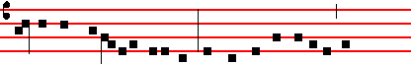
art become very bitter unto me: for thou gavest vinegar to
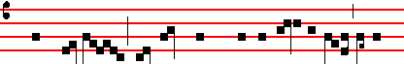
quench my thirst: and hast pierced with a spear the side of thy
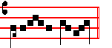
Sa- viour.
Deacon..  Agios o Theos. Subdeacon.. Holy God.
Deacon:  Agios ischyros. Subdeacon: Holy, mighty.
Deacon:  Agios athanatos, eleison imas.
Subdeacon  Holy and immortal, have mercy upon us.
Celebrant: (2 cantors of 2nd choir)
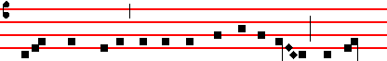
 I did scourge Egypt with her first-born for thy sake: and thou
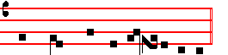
hast scourged me and delivered me up. Deacon and Subdea-con: (both choirs)  O my people, what have I done unto thee; or wherein have I wearied thee? Answer me.
Celebrant: (2 cantors of 1st choir)
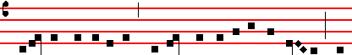  I led thee out of Egypt, drowning Pharaoh in the Red Sea: and
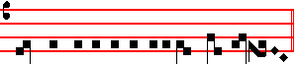
thou hast delivered me unto the chief priests. Deacon and Subdeacon:  (both choirs) O my people, what have I done unto thee, or wherein have I wearied thee? Answer me.
Celebrant: (2 cantors of 2nd choir)
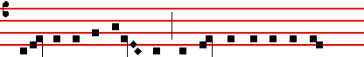
 I opened the sea before thee: and thou hast opened my side
48
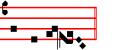
with a spear. Deacon and Subdeacon: (both choirs)  O my people, what have I done unto thee, or wherein have I wearied thee? Answer me.
Celebrant: (2 cantors of 1st choir)
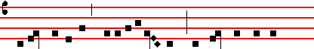  I went before thee in a pillar of cloud; and thou hast led me
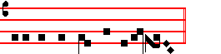
unto the judgment hall of Pilate. Deacon and Subdeacon: (both choirs)  O my people, what have I done unto thee, or wherein have I wearied thee? Answer me.
Celebrant: (2 cantors of 2nd choir)
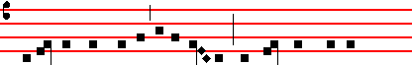
 I fed thee with manna in the desert: and thou hast stricken
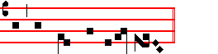
me with blows and scour-ges. Deacon and Subdeacon: (both choirs ) O my people, what have I done unto thee, or wherein have I wearied thee? Answer me.
Celebrant: : (2 cantors of 1st choir)
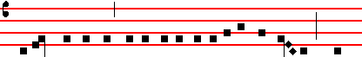
 I gave thee to drink of the water of salvation from the rock: and
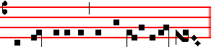
thou hast given me gall and vinegar to drink. Deacon and
Subdeacon: (both choirs ) O my people, what have I done unto thee, or wherein have I wearied thee? Answer me.
Celebrant: (2 cantors of 2nd choir)
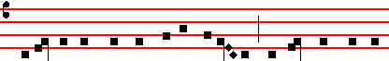 For thee I smote the kings of the Canaanites: and thou hast smittten
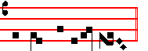
my head with a reed. Deacon and Subdeacon (both choirs ):  O my people, what have I done unto thee, or wherein have I wearied thee? Answer me.
Celebrant: (2 cantors of 1st choir)
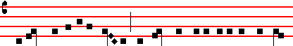  I gave thee a royal sceptre: and thou hast given unto my head a
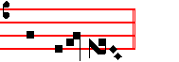
crown of thorns. Deacon and Subdeacon: (both choirs )  O my people, what have I done unto thee, or wherein have I wearied thee? Answer me.

49
Celebrant: (2 cantors of 2nd choir)
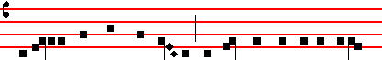 I exalted thee with great power: and thou hast hangèd me upon
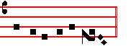
the gibbet of the Cross. Deacon and Subdeacon (both choirs ):
 O my people, what have I done unto thee, or wherein have I wearied thee? Answer me.
Celebrant: (both choirs) Antiphon Tone iv
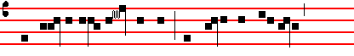
 We wor-ship thy Cross, O Lord: and praise and glori-fy
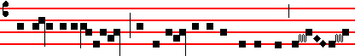
thy holy resurrec- tion: for behold, by virtue of the tree joy
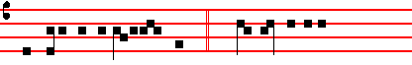
hath come to the whole world. Ps 67. God be merciful
Deacon and Subdeacon: (both choirs)
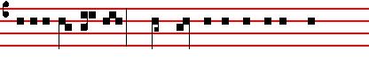
unto us and bless us:  And shew us the light of his coun-
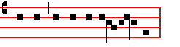
tenance, and be merciful unto us. The Antiphon is repeated. Celebrant: (both choirs)  We worship thy Cross, O Lord: and praise and glorify thy holy resurrection: for behold, by virtue of the tree joy hath come to the whole world.
Hymn Crux fidelis Mode j
Deacon and Subdeacon: (both choirs throughout) 
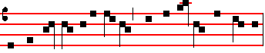
Faithful Cross, above all other, one and only noble tree:
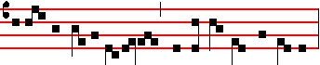
none in foliage, none in blossom, none in fruit thy peer may be.
Sweetest wood and swetest iron, sweetest weight is hung on thee.
Celebrant: (both choirs)
Sing, my tongue, the glorious battle, sing the ending of the fray,
now above the Cross, the trophy, sound thc loud triumphant lay:
tell how Christ, the world's Redeemer, as a victim won the day.
Deacon and Subdeacon:
Faithful Cross, above all other, one and only noble tree:
none in foliage, none in blossom, none in fruit thy peer may be.
Celebrant: 
God in pity saw man fallen, shamed and sunk in misery,
when he fell on death by tasting fruit of the forbidden tree:
then another tree was chosen which the world from death should free.
Deacon and Subdeacon:
Sweetest wood and sweetest iron, sweetest weight is hung on thee.
Celebrant: 
Thus the scheme of our salvation, was of old in order laid:
that the manifold deceiver's art by art might be outweighed:
and the lure the foe put forward into means of healing made.
Deacon and Subdeacon:
Faithful Cross, above all other, one and only noble tree:
none in foliage, none in blossom, none in fruit thy peer may be.
Celebrant: 
Therefore when the appointed fulness of the holy time was come,
he was sent who maketh all things forth from God's eternal home;
thus he came to earth incarnate, offspring of a virgin's womb.
Deacon and Subdeacon:
Sweetest wood and sweetest iron, sweetest weight is hung on thee.
Celebrant: 
Lo! he lies, an Infant weeping, where the narrow manger stands,
while the Mother-Maid his members wraps in mean and lowly bands, and the swaddling clothes is winding round God's helpless feet and hands.
Deacon and Subdeacon:
Faithful Cross, above all other, one and only noble tree:
none in foliage, none in blossom, none in fruit thy peer may be.
Celebrant: 
Thirty years among us dwelling, his appointed time fulfilled,
born for this, he meets his Passion, for that this he freely willed,
on the Cross the Lamb is lifted where his life-blood shall be spilled.
Deacon and Subdeacon:
Sweetest wood and sweetest iron; sweetest weight is hung on thee.
Celebrant: 
He endured the nails, the spitting, vinegar, and spear, and reed;
from that holy body broken blood and water forth proceed :
earth, and stars, and sky, and ocean by that flood from stain are freed.
Deacon and Subdeacon:
Faithful Cross, above all other, one and only noble tree:
none in foliage, none in blossom, none in fruit thy peer may be.
Celebrant: 
Bend thy boughs, O tree of glory! thy relaxing sinews bend;
for awhile the ancient rigour that thy birth bestowed, suspend;
and the King of heavenly beauty on thy bosom gently tend !
Deacon and Subdeacon:
Sweetest wood and sweetest iron, sweetest weight is hung on thee.
Celebrant: 
Thou alone wast counted worthy this world's ransom to uphold; for a
shipwreck'd race preparing harbour, like the ark of old;
with the sacred blood anointed from the smitten Lamb that rolled.
Deacon and Subdeacon:
Faithful Cross, above all other, one and only noble tree:
none in foliage, none in blossom, none in fruit thy peer may be.
Celebrant: 
To the Trinity be glory everlasting, as is meet;
equal to the Father, equal to the Son, and Paraclete
Trinal Unity, whose praises all created things repeat. Amen.
50
Deacon and Subdeacon:
Sweetest wood and sweetest iron, sweetest weigbt is hung on thee.

¶ Towards the end of the adoration of the Cross candles are lighted upon the Altar: and the Deacon, receiving the Burse with the Corporal, spreads the Corporal in the usual way, and puts a Purificator by it; and when the adoration is over, reverently receives the Cross and carries it back to the Altar. Then a Procession is formed to the place where on the previous day the Sacrament had been laid. A Subdeacon goes first with the Cross between two Acolytes bearing candlesticks with lighted candles, and then the Clergy in order, last of all the Priest with the Ministers. When they arrive at the place of the Sacrament, torches are kindled, which art not extinguished till after the consumption of the Sacrament. The Priest genuflects before the Sacrament and prays awhile: the Deacon meanwhile opens the receptacle in which lies hidden the Body of the Lord. Then tbe Priest, rising, puts incense into two thuribles witbout blessing, the Deacon presenting the boat, and then kneeling he censes the Sacrament. The Deacon takes the Chalice with the Sacrament from the receptacle and gives it into the hands of the Priest, covering it with the ends of the Veil which is around his shoulders. Then they proceed in the order in which they came: a baldachino is carried over the Sacrament: and two Acolytes with thuribles continually cense the Sacrament. Meanwhile is sung the following hymn:
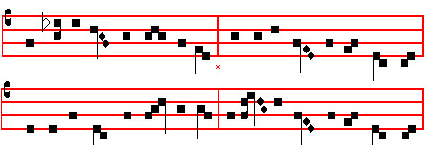
Vexilla regis prodeunt.
THE royal banners forward go;
The Cross shines forth in mystic glow
Where he in flesh, our flesh who made,
Our sentence bore, our ransom paid:

2 Where deep for us the spear was dyed,
Life's torrent rushing from his side,
To wash us in that precious flood,
Where mingled Water flowed, and Blood.

3 Fulfilled is all that David told
In true prophetic song of old
Amidst the nations, God, saith he
Hath reigned and triumphed from the tree

4 O Tree of beauty, Tree of light!
O Tree with royal purple dight!
Elect on whose triumphal breast
Those holy limbs should find their rest:

5 On whose dear arms, so widely flung,
The weight of this world's ransom hung:
The price of humankind to pay,
And spoil the spoiler of his prey.
51
6 O Cross, our one reliance, hail!
So may thy power with us avail
To give new virtue to the saint,
And pardon to the penitent.

7 To thee, eternal Three in One,
Let homage meet by all be done:
Whom by the Cross thou dost restore,
Preserve and govern evermore.

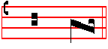
A - men.

¶ When the Priest arrives at the Altar, he places the Chalice upon it, genuflects, and again censes it, and going up takes the Host out of the Chalice and places it upon the Paten which the Deacon holds, and receiving tbe Paten from the hand of the Deacon, he places the sacred Host upon the Corporal, saying nothing. If he touches the Sacrament, he washes his hands in some vessel. Meanwhile tbe Deacon puts wine in the Chalice, and the Subdeacon water, which the Priest does not bless, nor does he say over it the usual Prayer: but receiving the Chalice from the Deacon, he places it upon the Altar, saying nothing, and the Deacon covers it with the Pall. Then he puts incense in the thurible without blessing it, and censes the Oblations, Cross, and Altar in the accustomed manner, genuflecting before and after, and whenever be crosses before the Sacrament. When he censes the Oblations, be says:

MAY this incense, which thou hast blessed, ascend unto thee, O Lord: and let thy mercy descend upon us.
When he censes the Altar, he says:
Ps. 41.
LET my prayer, O Lord, be set forth in thy sight as the incense: and let the lifting up of my hands be an evening sacrifice. Set a watch, O Lord, before my mouth, and keep the door of my lips: O let not mine heart be inclined to any evil thing, let me not be occupied in ungodly works.

When he gives back the thrurible to the Deacon, he says:
THE Lord kindle in us the fire of his love and the flame of everlasting charity. Amen.

And he himself is not censed. Afterwards he washes his hands a little beyond the Altar on the Epistle side, saying nothing: then bowing in the middle of the Altar, with hands joined, he says:

IN a humble spirit and with a contrite heart may we be accepted of thee, O Lord: and so let our sacrifice be offered in thy sight this day, that it may be pleasing unto thee, O Lord God.

Then turning to the people at the Gospel corner, he says as usual:
PRAY, brethren, that my sacrifice and yours may be acceptable to God the Father almighty.
And he turns back by the same way, not completing the circle: and, omitting the rest, proceeds:

LET us pray: Commanded by saving precepts, and taught by divine example, we are bold to say: OUR Father, who art

in heaven: Hallowed be thy name: Thy kingdom come: Thy will be done, in earth as it is in heaven. Give us this day our
daily bread: And forgive us our trespasses, as we forgive them that trespass against us. And lead us not into temptation.

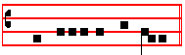
 But deliver us from evil.
The Priest says silently Amen. In the same voice in which he said Our Father, and without Let us pray, he says in the tone of the Collect of the ferial Mass*:

DELIVER us, O Lord, we beseech thee, from all evils, past, present, and to come : and at the intercession of the blessed and glorious ever Virgin Mary Mother of God, with thy blessed Apostles Peter and Paul, and with Andrew, and all the Saints *, (he does not sign himself with the Paten) favourably grant peace in our days: that by the help of thine availing mercy we may ever both be free from sin, and safe from all distress *. Through the same thy Son Jesus Christ our Lord: Who liveth and reigneth with thee, in the unity of the Holy Ghost, God, throughout all ages, world without end *.  Amen.

¶ Then the Celebrant, having made a reverence down to the ground, places the Paten beneath the Sacrament, which he takes in his right hand and elevates so that it can be seen by the people: and immediately he divides it over the Chalice into three parts, the last of which he puts into the Chalice in the usual way, saying nothing. The Peace of the Lord is not said, nor O Lamb of God, nor is the kiss of peace given. Then, omitting the first two Prayers, he says only the following:

LET not the partaking of thy Body, O Lord Jesu Christ, which I, though unworthy, presume to receive, turn to my judgment and condemnation: but of thy goodness let it avail unto me for protection of mind and of body, tbat I may receive thy healing: Who livest and reignest with God the Father in the unity of the Holy Ghost, God, throughout all ages, world without end. Amen.

Then he genuflects and receives the Paten with tbe Body of Christ: and with tbe deepest humility and reverence says:
______________________________________________
* That is recto tono throughout, with only a pause at the * ; see p. 40 above.

I WILL receive the bread of heaven, and call upon the name of the Lord.

He beats his breast, saying thrice:
LORD, I am not worthy that thou shouldest come under my roof: but speak the word only, and my soul shall be healed.
Then he signs himself with the Sacrament, saying:
THE Body of our Lord Jesus Christ preserve my soul unto everlasting life. Amen.
And he reverently consumes the Body.

Then, omitting everything which is wont to be said before the consumption of the Blood, he at once reverently consumes the particle of the Host with the wine from the Chalice. And having made the ablution of his fingers in the usual manner and taken the purification, he says, bowing in the midrt of the Altar, with hands joined:

GRANT, O Lord, that what we have taken with our mouths we may receive with a pure heart: and from a temporal gift may it become to us an everlasting remedy.

May thy Body is not said, nor the Postcommunion, nor Let this my bounden duty, nor is the blessing given, but having made a reverence to the Altar, the Priest retires with the Ministers. Vespers are said without singing*: and the Altar is stripped.


______________________________________________
*Or, as formerly, sung with the Antiphons as given above for Maundy Thursday above, p. 33 , with Proper Antiphon on Magnificat.

52

HOLY SATURDAY
Double of 1st Class
___________________________________________________________________________________________________

Station at St. John Lateran

At a suitable time the Altars are covered with linen cloths, but the candles remain unlit until the beginning of Mass. Meanwhile fire is struck from a flint outside the church, and from it coals are kindled. After None has been said in Choir, the Priest, vested in Amice, Alb, Girdle, Stole, and violet Cope, or without a Chasuble, standing with the Ministers, with the Cross, holy water, and incense, before the door of the Church, if it can conveniently be done, or in the entry of the church itself, blesses the new fire, saying *:

 The Lord be with you.  And with thy spirit.
Let us pray. COLLECT.
O GOD, who through thy Son, the true corner- stone, hast bestowed upon thy faithful people the fire of thy brightness: sanctify this new fire, now struck from the flint-stone, to be profitable to our service: and grant unto us that by this paschal feast we may be so inflamed with heavenly desires; that we may with pure hearts attain unto the feast of thy eternal brightness. Through the same Christ, our Lord.
 Amen.

Let us pray. COLLECT .
O LORD God, Father almighty, who art light unfailing, and the author of all lights: bless this light which hath here been sanctified and blessed by thee, who hast enlightened the whole world: that we may be enkindled by that light, and enlightened with the fire of thy brightness: and like as thou didst enlighten Moses going forth from Egypt, so do thou enlighten our hearts and understandings; that we may be found worthy to attain unto life and light everlasting. Through Christ, our Lord.  Amen.

Let us pray. COLLECT.
O LORD holy, Father almighty; everlasting God: vouchsafe to assist us who bless this fire in thy name, and in the name of thy only-begotten Son, Jesus Christ, our God and Lord, and of the Holy Ghost; and assist us against the fiery darts of the enemy, and enlighten us with thy heavenly grace: Who livest and reignest with the same thy only-begotten Son and the Holy Ghost, God: throughout all ages world without end.  Amen.

He then blesses the five grains of incense, to be placed in the Candle, saying at once this Collect :

WE beseech Thee, almighty God, that the abundance of thy blessing may come down upon this ______________________________________________* These four prayers are said without note. 53

incense; and as thou, thyself unseen, art the regenerator
of all things, so kindle the brightness of this night; that not only may our sacrifice, which is offered on this night, shine with the secret mingling of thy light; but that in all places wheresoever aught shall be carried from this mystery here sanctified, the wickedness of the crafts of the devil may be driven forth, and the power of thy majesty ever be present. Through Christ, our Lord.  Amen.

¶ Whilst he blesses the grains of incense, an Acolyte takes some of the blessed coals, and sets them in the thurible, and the Priest, when he has finished the last Prayer, puts incense from the boat into the thurible, giving the usual blessing. Then he sprinkles the aforesaid grains of incense and the fire, with holy water, saying: Thou shalt purge me, O Lord, without note and without the Psalm, and censes them thrice.

Meanwhile all the lights in the church are extinguished, to be relighted later from the blessed fire.

Then the Deacon, vested in a white Dalmatic, takes the reed upon the top of which are three candles in the shape of a triangle. The Thurifer goes first with an Acolyte blaring the five grains of incense: the Subdeacon follows with the Cross, the Clergy in their order: then the Deacon with the reed, after him the Celebrant.

When the Deacon enters the church, he lowers the reed, and an Acolyte, carrying a candle which has been lighted from the new fire, lights one of the three candles placed upon it, and the Deacon, elevating the reed, genuflects, as do all others with him except the Subdeacon bearing the Cross, and sings alone :

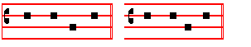
The Light of Christ.  Thanks be to God.

And proceeding to the middle of the church, another candle is lighted: and having again genuflected, he sings in a higher tone: The Light of Christ.  Thanks be to God.
For the third time he proceeds before the Altar, where the third candle is lighted : and again, having genuflected as before, he sings still higher : The Light of Christ.  Thanks be to God.

The Celebrant then ascends to the Epistle corner of the Altar, and the Deacon, handing the reed with the triple candle to an Acolyte, receives the book, and asks a blessing from the Celebrant as at the Gospel, the Priest saying :
The Lord be in thy heart, and on thy lips: that thou mayest worthily and fitly proclaim his paschal praise: In the name of the Father, and of the Son,  and of the Holy Ghost. Amen.

The Deacon then goes to the lectern, and placing the

book upon it, censes it. On the right hand of the Deacon
stand the Subdeacon with the Cross, and the Thurifer : on
his left an Acolyte holding the reed, and another the five grains of blessed incense to be fixed into the Candle. Then, all rising and standing, as at the Gospel, the Deacon sings:

NOW let the Angelic host of heaven rejoice: let the divine mysteries rejoice: and for the victory of the mighty King let

the trumpet of salvation sound forth. Let the earth also be glad, illumined by the rays of this great brightness: and
enlightened by the splendour of the eternal King, let her know that she hath put away the darkness of the whole world.
Let our mother the Church also rejoice, adornèd with the brightness of so great a light: and let this temple resound with
the triumphant voices of the peoples. Wherefore, dearly beloved brethren, who are here present in the wondrous clearness
of this holy light, join with me, I beseech you, in calling upon the mercy of :almighty God.That he who hath been pleased,
for no merit of mine, to admit me into the number of his Levites: may pour on me the brightness of' his light, and make me
meet to proclaim the praises of this Candle. Through Jesus Christ his Son our Lord: Who liveth and reigneth with him in
the unity of the Holy Ghost, God. Throughout all ages, world without end.  . Amen.  The Lord be with you.  And
with thy spirit.  . Lift up your hearts.  We lift them up unto the Lord.  Let us give thanks unto our Lord God.  It
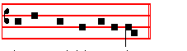
is meet and right so to do.
54
IT is very meet and right that we should, with the whole affection of our heart and mind, and with the service of our lips,

give praise unto the invisible God, the Father almighty, and to his only begotten Son, Jesus Christ, our Lord. Who paid
for us to the eternal Father the debt of Adam's transgression: and with his dear blood wiped away thc reproach of our
former offences. For this is the paschal feast wherein the very Lamb is slain, by whose blood the door-posts of the
faithful are made holy. This is the night, wherein of old thou didst lead forth our fathers, the children of Israel, out of
Egypt, and didst make them to pass as on dry land through the Red Sea. Yea, this is the night, that with the brightness
of the pillar hath purged away the darkness of iniquity. This is the night, which throughout the whole world today doth
separate them that believe in Christ from the wickedness of the age and from the darkness of transgressions, reneweth
them unto grace, restoreth them to holiness. This is the night wherein, breaking the chains of death, Christ ascendeth
from hell in triumph. For nought indeed had it profited us to be born, if it had not profited us to be redeemed. O how
wonderful the condescension of thy loving kindness! O how inestimable the goodness of thy love: who to redeem a slave
didst deliver up thy Son! O truly necessary sin of Adam, which by the death of Christ was done away! O happy fault,
which was counted worthy to have such and so great a Redeemer! O night truly blessed, which alone was worthy to 55
know the time and the hour wherein Christ rose again from hell! This is the night whereof it is written: And the night
is as clear as the day: And, then shall my night be turned into day. The sanctifying power therefore of this night putteth
to flight the deeds of wickedness, washeth away sins: restoreth innocence to the fallen, and joy to them that mourn:
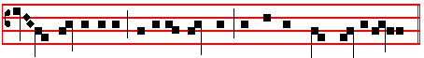
casteth out enmities, prepareth concord, and boweth down principalities.

Here the Deacon fixes the five grains of incense in the Candle, placing them in the form of a cross, in this order:

1
4 2 5
3

Therefore in this night of grace accept, O holy Father, the evening sacrifice of this incense: which, by the hands of thy
ministers, holy Church doth lay before thee, in the solemn offering of this Candle, made from the work of bees. But
we already know the excellency of this pillar, which for the honour of God the sparkling fire doth kindle.

Here the Deacon lights the Candle with one of the three candles on the reed.
Which, though it be divided into parts, suffereth not loss by the borrowing of its light. For it is fed by melting wax,
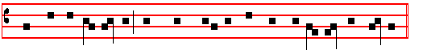
which the bee the mother hath wrought into the substance of this precious candle.

Here the lamps are lighted.
O night truly blessed, which did spoil the Egyptians, and made rich the Hebrews! O night wherein heavenly things are

56
joined unto earthly, things human unto things divine; We therefore pray thee, O Lord: that this Candle, consecrated to the
honour of thy name, may continue without ceasing to vanquish the darkness of this night. That, being accepted for a
savour of sweetness, it may be mingled with the lights of heaven. May the morning star find it burning. That morning
star, I say, which knoweth not his going down. That star, which, rising again from hell, steadfastly giveth light to all
mankind. We therefore pray thee, O Lord: that thou wouldest vouchsafe to rule, govern and preserve with thy continual
protection us thy servants, the whole clergy and thy most faithful people: together with our most blessed Father N. and
our Bishop N., granting us peaceful times in this our paschal joy. Look also upon our most religious Emperor * N.
upon whom, O God, foreknowing the desires of his heart, bestow the quiet of perpetual peace by the gift of thine
unspeakable goodness and mercy: and heavenly victory with all his people. Through the same Jesus Christ thy Son our
Lord: Who liveth and reigneth with thee in the unity of the Holy Ghost God: throughout all ages, world without end.
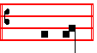
 A- men.
________________________________________________________________________________________________________________________________________
* If he is not crowned, * Emperor-elect is to be said.

¶ The blessing of the Candle ended, the Deacon lays aside his white vestments, and puts on violet, and goes to the Celebrant: who, laying aside his Cope, puts on a Maniple and violet Chasuble.

Then the Prophecies are read without title, and at the end the response Thanks be to God is not made, and the Celebrant reads them in a low voice at the Epistle corner of the Altar.
At the end of the Prophecies are said the Prayers as given below.
Before, or during the reading of the Prophecies, the Priests catechize any Catechumens about to be baptized, and prepare them for Baptism.
57
PROPHECY THE FIRST.
Gen. j and ij.
punctum A 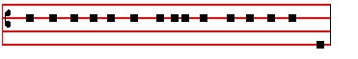
IN the beginning God created the heaven and the earth.

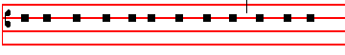
And the earth was without form and void, and darkness
flex
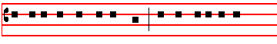
was upon the face of the deep : and the Spirit of God
punctum A flex
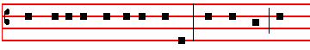
moved upon the face of the waters. And God said: Let
punctum B punctum A
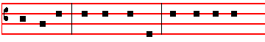
there be light. And there was light. And God saw the
flex
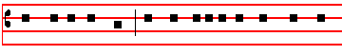
light, that it was good: and God divided the light from the
punctum A
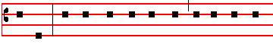
darkness. And God called the light Day, and the darkness
flex
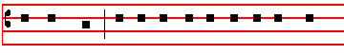
he called Night: and the evening and the morning were
punctum B
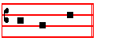
the first day.
And God said: Let there be a firmament in the midst of the waters: and let it divide the waters from the waters. And God made the firmament, and divided the waters which were under the firmament from the waters which were above the firmament. And it was so. And God called the firmament Heaven: and the evening and the morning were the second day. And God said: Let the waters under the heaven be gathered together unto one place: and let the dry land appear. And it was so. And God called the dry land Earth: and the gathering together of the waters called he Seas. And God saw that it was good. And God said: Let the earth bring forth grass, the herb yielding seed, and the fruit tree yielding fruit after his kind, whose seed is in itself, upon the earth. And it was so. And the earth brought forth grass. and herb yielding seed after his kind, and the tree yielding fruit, whose seed was in itself, after his kind. And God saw that it was good. And the evening and the morning were the third day. And God said: Let there be lights in the firmament of the heaven to divide the day from thc night. and let than be for signs, and for seasons. and for days. and years: and let them be for lights in the firmament of the heaven to give light upon the earth. And it was so. And God made two great lights: the greater light to rule the day: and the lesser light to rule the night: he made the stars also. And God set them in the firmament of the heaven to give light upon the earth, and to rule over the day and over the night, and to divide the light from the darkness. And God saw that it was good. And the evening and the morning were the fourth day. And God said: Let thc waters bring forth abundantly the moving creature that hath life, and fowl that may fly above the earth in the open firmament of heaven. And God created great whales, and every living creature that moveth, which the waters brought forth abundantly, after their kind, and every winged fowl after his kind. And God saw that it was good. And God blessed them, saying: Be fruitful, and multiply, and fill the waters in the seas: and let fowl multiply in the earth. And the evening and the morning were thc fifth day. And God said: Let the earth bring forth the living creature after his kind: cattle, and creeping thing, and beast of the earth after his kind. And it was so. And God made the beast of the earth after his kind, and cattle after their kind, and every thing that creepeth upon the earth after his kind. And God saw that it was good, and God said: Let us make man in our image, after our likeness: and let them have dominion over the fish of the sea, and over the fowl of the air, and over the cattle, and over all the earth, and over every creeping thing that creepeth upon the earth. So God created man in his own image: in the image of God created he him, male and female created he them. And God blessed them, and God said unto them: Be fruitful, and multiply, and replenish the earth, and subdue it, and have dominion over the fish of the sea, and over the fowl of the air, and over every living thing that moveth upon the earth. And God said: Behold, I have given you every herb bearing seed, which is upon the face of all the earth, and every tree, in the which is the fruit of a tree yielding seed; to you it shall be for meat: and to every beast of the earth, and to every fowl of the air, and to every thing that creepeth upon the earth, wherein there is life, I have given every green herb for meat. And it was so. And God saw everything that he had made: and, behold, it was very good. And the evening and the morning were the sixth day. Thus the heavens and the earth were finished, and all the host of them. And on the seventh day God ended his work which he had made: and he rested on the seventh
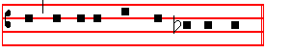
day from all his work which he had made. * Thanks be to God is not said either here or after the other Prophecies.
* All the Prophecies are sung and ended as above, unless otherwise noted.
58
Which being finished, the Priest says:
Let us pray, the Deacon: Let us bow the knee, and
the Subdeacon : A- rise.
COLLECT *
O GOD, who didst wonderfully create man, and hast more wonderfully redeemed him: grant us, we beseech thee, such strength of mind to withstand the enticements of sin; that we may be found worthy to attain to everlasting joys. Through Jesus Christ thy Son our Lord, Who liveth.

PROPHECY THE SECOND
Gen. 5, 6, 7, and 8.
AND Noah was five hundred years old, and Noah begat Shem, Ham, and Japheth. And it came to pass, when men began to multiply on the face of the earth, and daughters were born unto them, that the sons of God saw the daughters of men that they were fair, and they took them wives of all which they chose. And the Lord said: My spirit shall not always strive with man, for that he also is flesh; yet his days shall be an hundred and twenty years. There were giants in the earth in those days. And also after that, when the sons of God came in unto the daughters of men, and they bare children to them, the same became mighty men which were of old, men of renown. And God saw that the wickedness of man was great in the earth, and that every imagination of the thoughts of his heart was only evil continually, and it repented the Lord that he had made man on the earth. And it grieved him at his heart, and the Lord said: I will destroy man whom I have created from the face of the earth, both man, and beast, and the creeping thing, and the fowls of the air; for it repenteth me that I have made them. But Noah found grace in the eyes of the Lord. These are the generations of Noah: Noah was a just man and perfect in his generations, and Noah walked with God. And Noah begat three sons, Shem, Ham, and Japheth. The earth also was corrupt before God, and the earth was filled with violence. And God looked upon the earth, and, behold, it was corrupt, for all flesh had corrupted his way upon the earth, and God said unto Noah: The end of all flesh is come before me: for the earth is filled with violence through them, and, behold, I will destroy them with the earth. Make thee an ark of gopher wood: rooms shalt thou make in the ark, and shalt pitch it within and without with pitch. And this is the fashion which thou shalt make it of: The length of the ark shall be three hundred cubits, the breadth of it fifty cubits, and the height of it thirty cubits. A window shalt thou make to the ark, and in a cubit shalt thou finish it above: and the door of the ark shalt thou set in the side thereof: with lower, second, and third stories shalt thou make it.
_______________________________________________________________
* The Collect is sung to the first ferial tone, i.e, recto tono, on one note, with only pauses at the punctuation and the end.
59
And, behold, I, even I, do bring a flood of waters upon the earth, to destroy all flesh, wherein is the breath of life, from under heaven. And every thing that is in the earth shall die. But with thee will I establish my covenant: and thou shalt come into the ark, thou, and thy sons, and thy wife, and thy sons' wives with thee. And of everv living thing of all flesh, two of every sort shalt thou bring into the ark, to keep them alive with thee : they shall be male and female. Of fowls after their kind, and of cattle after their kind, of every creeping thing of the earth after his kind: two of every sort shall come unto thee, to keep them alive. And take thou with thee of all food that is eaten, and thou shalt gather it to thee: and it shall be for food for thee, and for them. Thus did Noah, according to all that God commanded him, so did he. And Noah was six hundred. years old when the flood of waters was upon the earth. The same day were all the fountains of the great deep broken up, and the windows of heaven were opened: and the rain was upon the earth forty days and forty nights. In the selfsame day entered Noah, and Shem and Ham, and Japheth, the sons of Noah, and Noah's wife, and the three wives of his sons with them, into the ark : they, and every beast after his kind, and all the cattle after their kind, and every creeping thing that creepeth upon the earth after his kind, and every fowl after his kind, every bird of every sort. And the ark went upon the face of the waters. And the waters prevailed exceedingly upon thc earth: and all the high hills, that were under the whole heaven, were covered. Fifteen cubits upward did the waters prevail, and the mountains were covered. And all flesh died that moved upon the earth, both of fowl, and cattle, and of beast, and of every creeping thing that creepeth upon the earth. And Noah only remained alive, and they that were with him in the ark. And the waters prevailed upon the earth an hundred and fifty days. And God remembered Noah, and every living thing, and all the cattle that was with him in the ark, and God made a wind to pass over the earth, and the waters asswaged. The fountains also of the deep and thc windows of heaven were stopped: and thc rain from heaven was restrained. And the waters returned from off the earth continually: and after the end of the hundred and fifty days the waters were abated. And it came to pass at the end of forty days, that Noah opened the window of the ark which he had made, and he sent forth a raven, which went forth to and fro, until the waters were dried up from off the earth. Also he sent forth a dove from him, to see if the waters were abated from off the face of the ground. But the dove found no rest for the sole of her foot, and she returned unto him into the ark, for the waters were on the face of the whole earth: then he put forth his hand, and took her, and pulled her in unto him into the ark. And he stayed yet other seven days, and again he sent forth the dove out of thc ark. And the dove came in to him in the evening, and,
lo, in her mouth was an olive leaf pluckt off. So Noah knew that the waters were abated from off the earth. And he stayed yet other seven days: and sent forth the dove, which returned not again unto him any more. And God spake unto Noah, saying: Go forth of the ark, thou, and thy wife, and thy sons, and thy sons' wives with thee. Bring forth with thee every living thing that is with thee, of all flesh, both of fowl, and of cattle, and of every creeping thing that creepeth upon thc earth, that they may breed abundantly in the earth: and be fruitful, and multiply upon the earth. And Noah went forth, and his sons, and his wife, and his sons' wives with him. Every beast, every creeping thing, and every fowl. and whatsoev~r creepeth upon the earth, after their kinds, went forth out of the ark. And Noah builded an altar unto the Lord: and took of every clean beast, and of every clean fowl, and offered burnt offerings on the altar. And tha Lord smelled a sweet savour.

Let us pray. Let us bow the knee.  Arise.
O GOD, who art strength unchangeable and light eternal: look down in mercy on thc wondrous mystery of thy whole Church, and by the operation of thy continual providence accomplish in tranquillity thc work of man's salvation; and let the whole world perceive and know that things cast down are being raised up, things grown old are being made new, and all things are returning to their perfection, through him from whom they took their beginning: Jesus Christ thy Son our Lord: Who liveth and reigneth with thee.

PROPHECY THE THIRD
Gen. 22.
IN those days: God did tempt Abraham, and said unto him: Abraham. And he said: Behold, here I am. And he said: Take now thy son, thine only son Isaac, whom thou lovest, and get thee into the land of Moriah : and offer him there for a burnt offering upon one of the mountains which I will tell thee of. And Abraham rose up early in the morning, and saddled his ass: and took two of his young men with him, and Isaac his son. And clave the wood for the burnt offering, and rose up, and went unto the place of which God had told him. Then on the third day Abraham lifted up his eyes, and saw the place afar off : and Abraham said unto his young men : Abide ye here with the ass: and I and the lad will go yonder and worship, and come again to you. And Abraham took the wood of the burnt offering, and laid it upon Isaac his son: and he took the fire in his hand, and a knife. And they went both of them together, and Isaac spake unto Abraham his father, and said: My father. And he said: Here am I, my son. And he said: Behold the fire and the wood: but where is the lamb for a burnt offering? And Abraham said: My son, God will provide himself a lamb for a burnt offering. So they went both of them together: and they came to thc place which God had told him of, and Abraham built an altar there, and laid the wood in order: and bound Isaac his son, and laid him on the altar upon the wood. And Abraham stretched forth his hand, and took the knife to slay his son. And the Angel of the Lord called unto him out of heaven, and said: Abraham, Abraham. And he said: Here am I. And he said: Lay not thine hand upon the lad, neither do thou anything unto him: for now I know that thou fearest God, seeing thou hast not withheld thy son, thine only son from me. And Abraham lifted up his eyes, and looked, and behold behind him a ram caught in a thicket by his horns, and Abraham went and took the ram, and offered him up for a burnt offering in the stead of his son. And Abraham called the name of that place Jehovah-jireh. As it is said to this day: In the mount of the Lord it shall be seen. And the Angel of the Lord called unto Abraham out of heaven the second time, and said: By myself have I sworn, saith the Lord: for because thou hast done this thing, and hast not withheld thy son, thine only son: that in blessing I will bless thee, and in multiplying I will multiply thy seed as the stars of the heaven, and as the sand which is upon the sea shore: and thy seed shall possess the gate of his enemies, and in thy seed shall all the nations of the earth be blessed, because thou hast obeyed my voice. So Abraham returned unto his young men, and they rose up and went together to Beer-sheba, and Abraham dwelt at Beer-sheba.

Let us pray. Let us bow the knee.  Arise.
O GOD, the sovereign Father of the faithful, who dost spread abroad throughout all the world the grace of adoption, to the increasing of the sons of thy promise: and, according as thou didst swear unto thy servant Abraham, dost through this paschal sacrament make him the father of all nations; grant that thy peoples may worthily enter upon the grace of thy calling. Through.

PROPHECY THE FOURTH
Exod. 14 and 15.
IN those days: It came to pass, that in the morning watch the Lord looked unto the host of the Egyptians through the pillar of fire and of the cloud, and troubled the host of the Egyptians: and took off their chariot wheels, that they drave them heavily. So that the Egyptians said: Let us flee from the face of Israel; for the Lord fighteth for them against the Egyptians. And the Lord said unto Moses: Stretch out thine hand over the sea, that the waters may come again upon the Egyptians, upon their chariots, and upon their horsemen. And Moses stretched forth his hand over the sea, and the sea returned to his strength when the morning appeared: and the Egyptians fled against it, and the Lord overthrew the Egyptians in the midst of the sea. And the waters returned, and covered the chariots, and the horsemen, and all the host of Pharaoh that came into the sea after them: there remained not so much as one of them. But the children of Israel walked upon dry land in the midst of the sea, and the waters were a wall unto them on their right hand, and on their left: thus the Lord saved Israel that day out of the hand of the Egyptians. And Israel saw the Egyptians dead upon the sea shore, and Israel saw that great work which the Lord did upon the Egyptians: and the people feared the Lord, and believed the Lord, and his servant Moses. Then sang Moses and the children

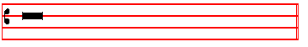
of Israel this song unto the Lord, and spake, saying :

TRACT. Exod. 15. Tone viij
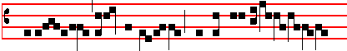
We will sing unto the Lord: for he hath tri-
60
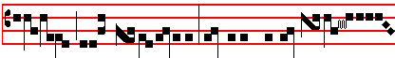
umphed glor- ious- ly: the horse and his ri-
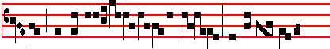
- der hath he thrown into the sea: the Lord is my
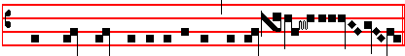
strength and song, and he is become my salva- tion.
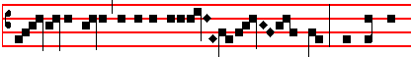
 He is my God, and I will praise him: my father's
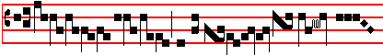
God, and I will ex-alt him
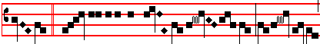
.  The Lord is a man of war: the Lord
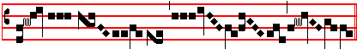
is his name.

Let us pray. Let us bow the knee.  Arise.
O GOD, whose miracles of old we perceive to shine forth even in our times: who by the water of regeneration dost now work for the salvation of the nations, as thou didst deliver one people from the pursuit of the Egyptians by the power of thy right hand: vouchsafe; that the fulness of the whole world may be numbered among the sons of Abraham and made partakers of the dignity of Israel. Through.

PROPHECY THE FIFTH
Is. 54 and 55.
THIS is the heritage of the servants of the Lord: and their righteousness is of me, saith the Lord. Ho, every one that thirsteth, come ye to the waters: and he that hath no money, come ye, buy, and eat : yea, come, buy wine and milk without money and without price. Wherefore do ye spend money for that which is not bread, and your labour for that which satisfieth not? Hearken diligently unto me, and eat ye that which is good, and let your soul delight itself in fatness. Incline your ear, and come unto me: hear, and your soul shall live, and I will make an everlasting covenant with you. even the sure mercies of David. Behold. I have given him for a witness to the people, a leader and commander to the people. Behold, thou shalt call a nation that thou knowest not: and nations that knew not thee shall run unto thee because of the Lord thy God, and for the holy one of Israel, for he hath glorified thee. Seek ye the Lord while he may be found: call ye upon him while he is near. Let the wicked forsake his way, and the unrighteous man his thoughts, and let him return unto the Lord, and he will have mercy upon him, and to our God: for he will abundantly pardon. For my thoughts are not your thoughts: neither are your ways my ways, saith the Lord. For as the heavens are higher than the earth, so are. my ways higher than your ways, and my thoughts than your thoughts. For as the rain cometh down, and the snow from heaven, and returneth not thither, but watereth the earth, and maketh it bring forth and bud, that it may give seed to the sower, and bread to the eater: so shall my word be that goeth forth out of my mouth : it shall not return unto me void, but it shall accomplish that which I please, and it shall prosper in the thing whereto I sent it: saith the Lord almighty.

Let us pray. Let us bow the knee.  Arise.
ALMIGHTY and everlasting God, multiply to the honour of thy name what thou didst swear to the faith of the fathers: and spread abroad the sons of promise by holy adoption; that as the Saints of old doubted not thine oath, so thy Church may now see in abundant measure the fulfilment of' the same. Through.

PROPHECY THE SIXTH
Baruch 3.
HEAR, Israel. the commandments of life: give ear to understand wisdom. How happeneth it, Israel, that thou art in thine enemies' land, that thou art waxen old in a strange country. that thou art defiled with the dead, that thou art counted with them that go down into the grave? Thou hast forsaken the fountain of wisdom. For if thou hadst walked in the way of God, thou shouldest have dwelled in peace for ever. Learn where is wisdom, where is strength, where is understanding: that thou mayest know also where is length of days, and life, where is the light of the eyes, and peace. Who hath found out her place? or who hath come into her treasures? Where are the princes of the heathen become, and such as ruled the beasts upon the earth? they that had their pastime with the fowls of the air, and they that hoarded up silver and gold, wherein men trust, and made no end of thcir getting? For they that wrought in silver, and were so careful, and whose works are unsearchable, they are vanished and gone down to the grave, and othcrs are come up in their steads. Young men have seen light, and dwelt upon the earth: but the way of knowledge have they not known, nor understood the paths thereof, nor laid hold of it, their children were far off from that way: it hath not been heard of in Chanaan, neither hath it been seen in Theman. The Agarenes that seek wisdom upon earth, the merchants of Meran and of Theman, the authors of fables, and searchers out of understanding: none of these have known the way of wisdom, or remember her paths. O Israel, how great is the house of God and how large is the place of his possession! Great, and hath none end: high, and unmeasurable. There were the giants famous from the beginning, that were of so great stature, and so expert in war. Those did not the Lord choose, neither gave he the way of knowledge unto them: but they were destroyed, because they had no wisdom, and perished through their own foolishness. Who hath gone up into heaven, and taken her, and brought her down from the clouds? Who hath gone over the sea, and found her, and will bring her for pure gold? No man knoweth her way, nor thinketh of her path: but he that knoweth all things
61
knoweth her, and hath found her out with his understanding: he that prepared the earth for evermore hath filled it with fourfooted beasts: he that sendeth forth light, and it goeth: calleth it again, and it obeyeth him with fear. The stars shined in their watches, and rejoiced: when he calleth them, they say: Here we be: and so with cheerfulness they shewed light unto him that made them. This is our God, and there shall none other be accounted of in comparison of him. He hath found out all the way of knowledge, and hath given it unto Jacob his servant, and to Israel his beloved. Afterward did he shew himself upon earth, and conversed with men.

Let us pray. Let us bow the knee.  Arise.
O GOD, who by the calling of the nations dost ever multiply thy Church: mercifully grant; that they whom thou dost cleanse by the waters of baptism may be defended by thy continual protection. Through.

PROPHECY THE SEVENTH
Ezek. 37.
IN those days: The hand of the Lord was upon me, and
carried me out in the spirit of the Lord: and set me down in the midst of the valley which was full of bones: and caused me to pass by them round about: and, behold, there were very many in the open valley, and lo, they werc very dry. And he said unto me: Son of man, can these bones live? And I answered: O Lord God, thou knowest. Again he said unto me: Prophesy upon these bones: and say unto them: O ye dry bones, hear the word of the Lord. Thus saith the Lord God unto these bones: Behold, I will cause breath to enter into you, and ye shall live. And I will lay sinews upon you, and will bring up flesh upon you, and cover you with skin: and put breath in you, and ye shall live, and ye shall know that I am the Lord. So I prophesied as I was commanded: and as I prophesied, there was a noise, and behold a shaking: and the bones came together, bone to his bone. And when I beheld, lo, the sinews and the flesh came up upon them: and the skin covered them above, but there was no breath in them. Then said he unto me: Prophesy unto the wind, prophesy. son of man, and say to the wind: Thus saith the Lord God: Come from the four winds. O breath, and breathe upon these slain, that they may live. So I prophesied as he commanded me: and the breath came into them. and they lived: and stood up upon their feet, an exceeding great army. Then he said unto me: Son of man. these bones are the whole house of Israel: behold. they say: Our bones are dried, and our hope is lost, we are cut off for our parts. Therefore prophesy and say unto them: Thus saith the Lord God: Behold, O my people, I will open your graves. and cause you to come up out of your graves: and bring you into the land of Israel. And ye shall know that I am the Lord. when I have opened your graves, O my people, and brought you up out of your graves: and shall put my spirit in you, and ye shall live, and I shall place you in your own land: saith the Lord almighty.

Let us pray. Let us bow the knee.  Arise.
62
O GOD,who dost instruct us in the pages of either Testament in the celebrating of the paschal sacrament: grant unto us so to understand thy mercy; that, through the receiving of these present gifts, we may be established in thc expectation of those which are to come. Through.
PROPHECY THE EIGHTH
Is. 4.
IN that day seven women shall take hold of one man, saying: We will eat our own bread, and wear our own apparel: only let us be called by thy name, to take away our reproach. In that day shall the branch of the Lord be beautiful and glorious, and the fruit of the earth shall be excellent and comely for them that are escaped of Israel. And it shall come to pass: That he that is left in Zion, and he that remaineth in Jerusalem, shall be called holy, even every one that is written among the living in Jerusalem. When the Lord shall have washed away the filth of the daughters of Zion, and shall have purged the blood of Jerusalem from the midst thereof by the spirit of judgment, and by the spirit of burning. And the Lord will create upon every dwelling-place of mount Zion, and upon her assemblies, a cloud and smoke by day, and the shining of a flaming fire by night: for upon all the glory shall be a defence. And there shall be a tabernacle for a shadow in the daytime from the heat, and for a place of refuge, and for a covert from storm and from rain.

TRACT. Is. 5. Tone viij
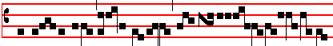
My well- beloved hath a vine- yard
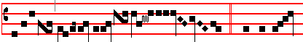
in a very fruitful hill.  And he fenced
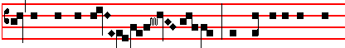
it, and gathered out the stones thereof: and planted it with the
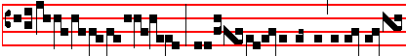
choi- cest vine, and built a tower in the midst
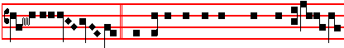
of it.  And also made a wine-press ther-ein:
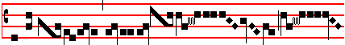
for the vineyard of the Lord of hosts is
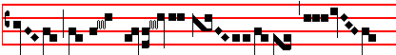
the house of Is- ra- el ..............................................
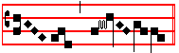
......................................
Let us pray. Let us bow the knee.  Arise.
O GOD, who by the mouth of thy holy prophets hast manifested thyself in all the children of thy Church, to be in all places of thy dominion the sower of good seed and the husbandman of thine elect branches: grant unto thy peoples, who are named thy vineyard and thy harvest field; that being purged from the filthiness of thorns and briars, they, may be made to bring forth worthy fruit in abundance. Through.

PROPHECY THE NINTH
Exod. 12
IN those days: The Lord spake unto Moses and Aaron in the land of Egypt, saying: This month shall be unto you the beginning of months: it shall be the first month of the year to you. Speak ye unto all the congregation of Israel, saying: In the tenth day of this month they shall take to them every man a lamb, according to the house of their fathers, a lamb for an house. And if the household be too little for the lamb let him and his neighbour next unto his house take it according to the number of the souls, every man according to his eating shall make your count for the lamb. Your lamb shall be without blemish, a male of the first year: ye shall take it out from the sheep, or from the goats. And ye shall keep it up until the fourteenth day of the same month: and the whole assembly of the congregation of Israel shall kill it in the evening. And they shall take of the blood, and strike it on the two side posts and on the upper door post of the houses, wherein they shall eat it. And they shall eat the flesh in that night, roast with fire, and unleavened bread, and with bitter herbs they shall eat it. Eat not of it raw, nor sodden at all with water, but roast with fire: his head with his legs, and with the purtenance thereof. And ye shall let nothing of it remain until the morning. And that which remaineth of it until the morning ye shall burn with fire. And thus shall ye eat it : with your loins girded, your shoes on your feet, and your staff in your hand, and ye shall eat it in haste: it is the Lord's Passover.

Let us pray. Let us bow the knee.  Arise.
ALMIGHTY and everlasting God, who art wondrous in the dispensation of all thy works: let thy redeemed understand that thc creation of the world in the beginning was not a work more excellent than the sacrifice, in the end of time, of Christ our Passover: Who liveth and reigneth with thee.

PROPHECY THE TENTH
Jonah 3.
IN those days: The word of the Lord came unto Jonah the Prophet thc second time saying: Arise, go unto Nineveh, that great city: and preach unto it the preaching that I bid thee. So Jonah arose, and went unto Nineveh, according to the word of the Lord. Now Nineveh was an exceeding great city of three days' journey. And Jonah began to enter into the city a day's journey: and he cried, and said: Yet forty days, and Nineveh shall be overthrown. So the people of Nineveh believed God: and proclaimed a fast, and put on sackcloth, from the greatest of them even to thc least of them. For word came unto the king of Nineveh: and he arose from his throne, and he laid his robe from him, and covered him with sackcloth, and sat in ashes. And he caused it to be proclaimed and published through Nineveh by the decree of the king and his nobles, saying: Let neither man nor beast, herd nor flock taste any thing: let them not feed, nor drink water. But let man and beast be covered with sackcloth, and cry mightily unto God, yea, let them turn every one from his evil way, and from the violence that is in their hands. Who can tell if God will turn and repent: and turn away from his fierce anger, that we perish not? And God saw their works, that they turned from their evil way; and he had mercy on his people, even he the Lord, our God.

Let us pray. Let us bow the knee.  Arise.
O GOD, who hast united the diversity of nations in the confession of thy name : grant us both to will, and to have power to do the things which thou commandest; that the people whom thou hast called to everlasting life may agree in unity of faith and in godliness of conversation. Through.

PROPHECY THE ELEVENTH
Deut. 31.
IN those days: Moses wrote this song, and taught it the children of Israel. And he gave Joshua the son of Nun a charge, and said: Be strong and of a good courage: for thou shalt bring the children of Israel into the land which I sware unto them, and I will be with thee. And it came to pass, when Moses had made an end of writing the words of this law in a book, until they were finished: that Moses commanded thc Levites, which bare the ark of the covenant of the Lord, saying: Take this book of the law, and put it in the side of the ark of the covenant of the Lord your God: that it may be there for a witness against thee. For I know thy rebellion, and thy stiff neck. Behold, while I am yet alive with you this day, ye have been rebellious against the Lord: and how much more after my death? Gather unto me all the elders of your tribes, and your officers, that I may speak these words in their ears, and call heaven and earth to record against them. For I know that after my death ye will utterly corrupt yourselves, and turn aside from the way which I have commanded you: and evil will befall you in the latter days, because ye will do evil in the sight of the Lord, to provoke him to anger through the work of your hands. And Moses spake in the ears of all the congregation of
Israel the words of this song, until they were ended.
TRACT. Deut. 32. Tone viij
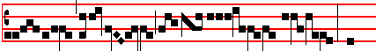
Give ear, O ye heavens, and I will speak: and
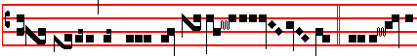
hear, O earth, the words of my mouth. My doctrine
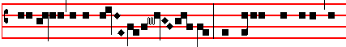
shall drop as the rain: my speech shall distil as
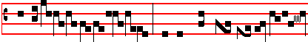
63 the dew.  As the small rain up-on the ten-
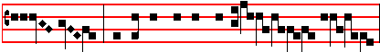
der herb, and as the showers upon the grass:
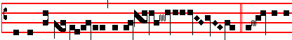
because I will pub- lish the name of the Lord:  Ascribe ye
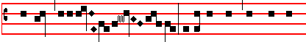
greatness unto our God: he is the rock, his work is
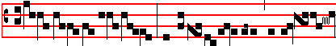
per- fect, for all his ways are judg-
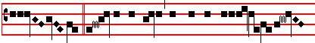
ment.  A God of truth and without iniqui-ty
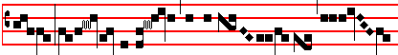
; just and right is the Lord
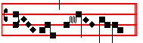
.
Let us pray. Let us bow the knee.  Arise.
O GOD, the exaltation of the humble and the strength of them that do stand, who by thy holy servant Moses didst vouchsafe so to instruct thy people in the chanting of thy sacred song, that the repeating of the law by them might likewise be for our instruction: stir up thy power among all the fulness of the nations whom thou hast justified, and grant us gladness, assuaging fear; that the sins of all may be blotted out by thy forgiveness, and that which was denounced in vengeance may turn to our salvation. Through.

PROPHECY THE TWELFTH
Dan. 3.
IN those days: Nebucadnezzar the king made an image of gold, whose height was threescore cubits, and the breadth thereof six cubits; hc set it up in the plain of Dura, in the province of Babylon. Then Nebuchadnezzar the king sent to gather together the princes, the governors, and the captains, the judges, the treasurers, the counsellors, the sheriffs, and all thc rulers of the provinces, to come to the dedication of the image which Nebuchadnezzar thc king had set up. Then the princes, the governors, and captains, the judges, the treasurers, the counsellors, the sheriffs, and all the rulers of the provinces, were gathered together unto the dedication of the image that Ncbuchadnezzar the king had set up. And they stood before the image that Nebuchadnezzar had set up, then an herald cried aloud: To you it is commanded, O people, nations, and languages: That at what time ye hear the sound of the cornet, flute, harp, sackbut, psaltery, dulcimer, and all kinds of musick, ye fall down and worship the golden image that Nebuchadnezzar the king hath set up. And whoso falleth not down and worshippeth shall the same hour be cast into the midst of a burning fiery furnace. Therefore at that time, when all the people heard the sound of the comet, flute, harp, sackbut, psaltery, and all kinds of musick, all the people, the nations, and the languages, fell down and worshipped the golden image that Nebuchadnezzar the king had set up. Wherefore at that time certain Chaldeans came near, and accused the Jews, they spake and said to the king Nebuchadnezzar: O king, live for ever : thou, O king, hast made a decree, that every man that shall hear the sound of the cornet, flute, harp, sackbut, psaltery, and dulcimer, and all kinds of musick, shall fall down and worship the golden image: and whoso falleth not down and worshippeth, that he should be cast into the midst of a burning fiery furnace. There are certain Jews whom thou hast set over the affairs of the province of Babylon, Sbadrach, Meshach, and Abed-nego : these men, O king, have not regarded thee: they serve not thy gods, nor worship the golden image which thou hast set up. And Nebuchadnezzar in his rage and fury commanded to bring Shadrach, Meshach, and Abed-nego: then they brought these men before the king. Nebuchadnezzar spake and said unto them: Is it true, O Shadrach, Meshach, and Abed-nego, do not ye serve my gods, nor worship the golden image which I have set up? Now if ye be ready that at what time ye hear the sound of the cornet, flute, harp, sackbut, psaltery, and dulcimer, and all kinds of musick, ye fall down and worship the image which I have made, well: but if ye worship not, ye shall be cast the same hour into the midst of a burning fiery furnace; and who is that God that shall deliver you out of my hands? Shadrach, Meshach, and Abed-nego, answered and said to the king: O Nebuchadnezzar, we are not careful to answer thee in this matter. If it be so, our God whom we serve is able to deliver us from the burning fiery furnace, and he will deliver us out of thine hand, O king. But if not, be it known unto thee, O king, that we will not serve thy gods, nor worship the golden image which thou hast set up. Then was Nebuchadnezzar full of fury, and the form of his visage was changed against Shadrach, Meshach, and Abed-nego, therefore he spake, and commanded that they should heat the fumace one seven times more than it was wont to be heated. And he commanded the most mighty men that were in his army to bind Shadrach, Mcshach, and Abed-nego, and to cast them into the burning fiery furnace. Then these men were bound in their coats, their hosen, and their hats, and their other garments, and were cast into the midst of the burning fiery furnace: therefore because the king's commandment was urgent: and the furnace exceeding hot, the flame of the fire slew those men that took up Shadrach, Meshach, and Abed-nego. And these three men, Shadrach, Meshach, and Abed-nego, fell down bound into the midst of the burning fiery furnace. And they walked in the midst of the fire, praising God, and blessing the Lord.

Here is not said Let us bow the knee, but only : Let us pray.
COLLECT
ALMIGHTY and everlasting God, the only hope of the world, who, by the preaching of thy Prophets
64
hast declared the mysteries of these present times: mercifully increase the devotion of thy people; forasmuch as without thine inspiration thy faithful can in no wise advance in virtue. Through.

These things being finished, if the church has a baptismal Font, the Priest who is to bless the Font puts on a violet Cope, and preceded by the Cross with lights and the blessed Candle lighted, descends with the Clergy and Ministers, vested, to the Font: and meanwhile the following is sung :

TRACT. Psalm 42. Tone viij
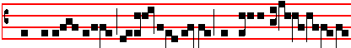
Like as the hart desi- reth the wa- ter-
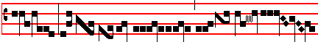
brooks: so long- eth my soul after thee, O God.
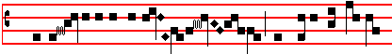
. My soul is athirst for God, yea, even for the liv-
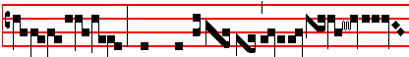
ing God: when shall I come to appear
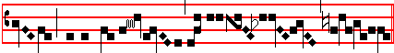
before the presence of God?
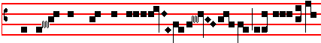
 My tears have been my meat day and night
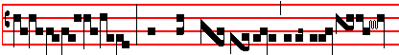
, while they dai- ly say unto me
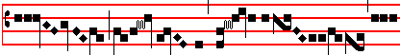
: Where is now thy
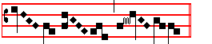
God ?
Then the Priest, before he enters for the blessing of the Font, says this Prayer near by the Font :

. The Lord be with you.
 And with thy spirit. Let us pray.

COLLECT *
ALMIGHTY and everlasting God, mercifully look upon the devotion of this people called to a new birth, who, like the hart, seek thc fountain of thy waters: and mercifully grant; that the thirst of their faith may, by the mystery of Baptism, sanctify them in body and soul. Through.  Amen.
Then he proceeds to the blessing of the Font, saying:
 The Lord be with you.  And with thy spirit.
Let us pray.
COLLECT
ALMIGHTY and everlasting God, be present at the mysteries, be present at the sacraments of thy great goodness: and send forth the spirit of adoption for the regenerating of the new peoples whom the font of baptism doth bring forth unto thee; that what is to be done by our humble mimistry, may be effectually fulfilled by thy power. Through Jesus Christ, thy Son, our Lord: Who liveth and reigneth with thee in the unity of the: Holy Ghost, God.
______________________________________________
* in the first ferial tone, i.e., recto tono, with pauses only at the punctuation.

Then raising his voice to tbe tonle of a Preface, he proceeds with joined hands:

throughout all ages, world without end.  Amen.The Lord be with you.  And with thy spirit.  Lift up your hearts.
. We lift them up unto the Lord.  Let us give thanks unto our Lord God.  It is meet and right so to do.  It is very
meet, right, just and salutary, that we should at all times, and in all places, give thanks unto thee: O Lord holy Father
almighty, everlasting God: Who by thine invisible power dost wondrously give effect to the work of thy sacraments: And

65
though we be unworthy to perform mysteries so great: Yet thou dost not leave us destitute of the gifts of thy grace, but
mercifully inclinest thine ears even unto these our supplications. O God, whose Spirit, in the first beginnings of the world,
moved over the waters: that even then the nature of water might conceive the virtue of sanctification. O God, who didst
wash away in the waters the iniquities of a sinful world, and didst even in the outpouring of the flood shew forth in a figure
our regeneration: that by the mystery of this same element, there should be an end to sin and likewise a beginning of virtue.
Look, O Lord, upon the face of thy Church, and multiply in her the power of thy regeneration, for thou dost by the streams
of thine abundant grace make glad thy city : and openest the fount of baptism throughout the whole world for the renewing
of the nations: that, by the command of thy majesty, she may receive from the Holy Ghost the grace of thine only begotten
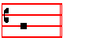
Son.
Here the Priest divides the water in the form of a cross with his extended hand, whicb be wipes at once with a linen cloth, saying:
May he, by the secret mingling of his divine power, make fruitful this water prepared for the regeneration of mankind: that
having received sanctification, and being born again a new creature, there may come forth an offspring of heaven from the
spotless womb of this divine fountain: And that all, whether sex divide them in body, or age in time, may alike be brought
forth into one childhood by grace, their mother. Far hence, O Lord, at thy command let every unclean spirit depart : Far

66
hence be all the wickedness of the craft of the devil. Let no power of the enemy here have place or portion: let it not
ensnare and compass us around: let it not waylay us in secret: let it not taint us with corruption.
He touches the water with his hand.
May this holy and undefiled creature be free from every assault of the enemy, and purified by the deoarture of all iniquity.
May it be a living fountain, water that doth regenerate, a purifying stream: that all who shall be washed in this laver of
salvation may, by the operation of the Holy Ghost within them, obtain the grace of perfect purification.
He makes three crosses over the Font, saying:
Wherefore I bless thee, O creature of water, by the living  God, by the true  God, by the holy  God: by God who in
the beginning through his word divided thee from the dry land: whose spirit moved upon thee.

Here he divides the water with his hand, and scatters it towards the four quarters of the world, saying:
Who made thee to flow from the fountain of paradise, and commanded thee to water the whole earth with thy four
rivers. Who in the desert bestowed upon thee sweetness when thou wast bitter, that men might drink, and brought thee
forth from the rock for the thirsting people. I bless thee also by Jesus Christ his only Son, our Lord: who in Cana of
Galilee by a wondrous miracle did change thee through his power into wine. Who walked upon thee with his feet: and was
baptized in thee by John in Jordan. Who brought thee forth together with blood from his side: and commanded his dis-
ciples, that believing they should be baptized in thee, saying: Go ye, teach all nations, baptizing them in thc name of the 67

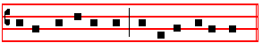
Father, and of the Son, and of the Holy Ghost. He changes his voice, and proceeds in the tone of the Lesson
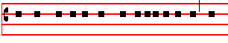
Do thou, almighty God, mercifully assist us, who
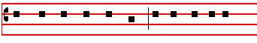
keep these thy commandments: do thou graciously
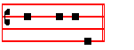
breathe upon us.
He breathes thrice upon the water in the form of a cross, saying:
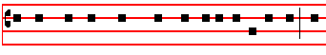 Do thou with thy mouth bless this element of water : that
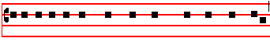
as by nature it hath power to cleanse and wash the body,
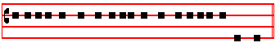
so also it may be effectual for the purifying of the soul..
Here the Priest lowers the Candle into the water a little way: and resuming the tone of the Preface, says:

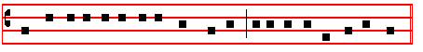
May the power of the Holy Ghost descend upon the fulness of this font.

Then withdrawing the Candle from the water, he again dips it mare deeply, and repeats in a somewhat higher voice, May the power. Then he again withdraws the Candle from the water, and the third time dips it to the bottom, repeating in a still higher voice: May the power, as above.
Then breathing three times over the water in this form Ψ he proceeds:

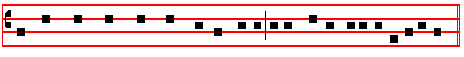
And make the whole substance of this water to be fruitful unto regeneration.
Here the Candle is taken out of the water, and he proceeds:
Here may the stains of every sin be blotted out: here may nature, created in thine image, be restored to the honour of its
first estate, and cleansed from all the defilement of its old condition: that every man who cometh to this sacrament of
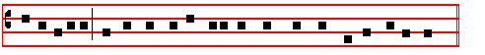
regeneration may be born again unto the new childhood of true innocence.

He says that which follows in the reading voice:
Through Jesus Christ thy Son, our Lord: Who shall come to judge the quick and the dead, and the world by fire.  Amen.
Then some of the water that has been blessed is sprinkled by the assisting Priests over the people. And meantime one of the ministers of the church takes some of the water in a vessel, for sprinkling in houses and other places. Which done, the Priest who is blessing the Font, pours some of the Oil of Catechumens into the water in the form of a cross, saying in an audible voice:
May this font be sanctified and made fruitful bv the Oil of salvation, for such as shall be born again therefrom, unto life everlasting.  Amen.
Then, in tbe same manner, he pours in some of the Chrism, saying:
May this inpouring of the Chrism of our Lord Jesus Christ, and of the Holy Ghost the Paraclete, be wrought in the name of the holy Trinity.  Amen.
Lastly he takes both phials of the said holy Oil and the Chrism and pours in some of both together in tbe form of a cross, saying :
68
May this commingling of the Chrism of sanctification, and of the Oil of unction and of the Water of baptism be likewise wrought in the name of the Father, and of the Son, and of the Holy  Ghost.  Amen.

Then he mingles the Oil itself with the water, and with his hand scatters it over the whole Font. If there be any to be baptized, he baptizes them in the usual manner.

Then as the Priest and Ministers return to the Altar, the Litany is sung by two Cantors, and the Choir repeat it also together, as is directed below.

¶ But where there is no baptismal Font, when the last
Prophecy with its Collect is ended, the Celebrant lays aside his Chasuble, and with the Ministers lies prostrate before the Altar: and all kneeling, the Litany is chanted by two Cantors in the midst of the Choir, and both sides of the Choir respond together.

But when they come to the  We sinners, the Priest and
his Ministers rise, and proceed to the sacristy, where they put on white vestments for the solemn Mass, and meanwhile the candles of the Altar are lighted.

At the end of the Litany, Kyrie eleison is sung solemnly,
and repeated, as is usual at Mass.

___________________________________________________________________________________________________

KYRIE, eleison. Christe, eleison. Kyrie, eleison. O Christ, hear us. O Christ graciously hear us. O God the Father of

heaven, have mercy upon us. O God the Son, Redeemer of the world, have mercy upon us. O God the Holy Ghost, have
mercy upon us. O Holy Trinity, one God, have mercy upon us. Holy Mary, pray for us.
___________________________________________________________________________________________________

Holy Mother of God, pray for us.
Holy Virgin of virgins, pray for us.
Holy Michael, pray for us.
Holy Gabriel, pray for us.
Holy Raphael, pray for us.
O all ye holy Angels and Archangels, pray for us..
O all ye holy orders of blessed Spirits, pray for us..
Holy John Baptist, pray for us..
Holy Joseph, pray for us..
O all ye holy Patriarchs and Prophets, pray for us.
Holy Peter, pray for us.
Holy Paul, pray for us.
Holy Andrew, pray for us.
Holy John, pray for us.
O all ye holy Apostles and Evangelists, pray for us.
O all ye holy Disciples of the Lord, pray for us.
O all ye holy Innocents for us.
Holy Stephen, pray for us.
Holy Laurence, pray for us.
Holy Vincent, pray for us.
O all ye holy Martyrs, pray for us. for us.
Holy Sylvester, pray for us.
Holy Gregory, pray for us.
Holy Augustine, pray for us.
O all ye holy Bishops and Confessors, pray for us.
O all ye holy Doctors, pray for us.
Holy Anthony, pray for us.
Holy Benedict, pray for us.
O all ye holy Priests and Levites, pray for us.
O all ye holy Monks and Hermits, pray for us.
Holy Mary Magdalene, pray for us.
Holy Agnes, pray for us.
Holy Cecilia, pray for us.
Holy Agatha, pray for us.
Holy Anastasia, pray for us.
All ye holy Virgins and Widows, pray for us.
All ye holy men and women, Saints of God,
intercede for us.
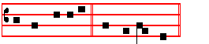
Be thou merciful, spare us, O Lord.
Be thou merciful, graciously hear us, O Lord,
From all evil, deliver us, O Lord.
From all sin, deliver us, O Lord.
From everlasting death, deliver us, O Lord.
Through the mystery of thy holy Incarnation, deliver.
Through thine Advent, deliver us, O Lord.
Through thy Nativity, deliver us, O Lord.
Through thy Baptism and holy Fasting, deliver us, O Lord.
Through thy Cross and Passion, deliver us, O Lord.
Through thy Death and Burial, deliver us, O Lord.
Through thy holy Resurrection, deliver us, O Lord.
Through thy wonderful Ascension, deliver us, O Lord.
Through the coming of the Holy Ghost the Paraclete, deliver us, O Lord.
In the day of judgment, deliver us, O Lord. 69

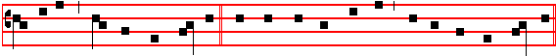
We sinners,   beseech thee, hear us. That thou wouldest spare us,  we beseech thee, hear us.
___________________________________________________________________________________________________

That it may please Thee to govern and preserve thy holy Church, we beseech thee, hear us.
That it may please Thee to preserve our Apostolic lord and all orders of the Church in holy religion, we beseech thee, hear us.
That it may please Thee to humble the enemies of holy Church, we beseech thee, hear us.
That it may please Thee to give unto Christian kings and rulers peace and true concord, we beseech thee, hear us.
That it may please Thee to strengthen and preserve us in

thy holy service, we beseech thee, hear us.
That thou wouldest reward all our benefactors with everlasting blessings, we beseech thee, hear us.
That it may please Thee to give and preserve the fruits of the earth, we beseech thee, hear us.
That it may please Thee to grant unto all the faithful departed rest eternal, we beseech thee, hear us.
That it may please Thee graciously to hear us, we beseech thee, hear us.
Son of God, we beseech thee, hear us.

O Lamb of God who takest away the sins of the world, spare us, O Lord. O Lamb of God, who takest away the sins of
the world, graciously hear us, O Lord. O Lamb of God, who takest away the sins of the wor1d, have mercy upon us.
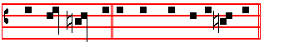
O Christ, hear us. O Christ, graciously hear us. ___________________________________________________________________________________________________

Here the Cantors solemnly intone Kyrie, eleison, Christe, eleison, Kyrie, eleison, repeating each invocation thrice
KYRIE in Eastertide Lux et origo Tone viij
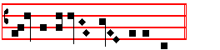
Ky- ri-e e- le-i- son. iij.
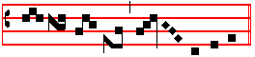
Chri- ste e- le- i- son. iij.

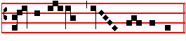
Ky- ri- e e- le- i- son. ij.
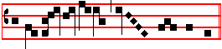
Ky-ri- e e- le- i- son.

Meanwhile the Priest with the Ministers in white vestments approaches the Altar: and having said the Psalm Give sentence with me, O God, with Glory be, he makes the Confession : then going up, he kisses the Altar, and censes it in the usual manner: and after the Choir has
70
finished Kyrie, eleison, he solemnly intones Gloria in excelsis, Tone iv
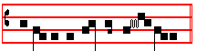
Glory be to God on high , and the bells are rung.
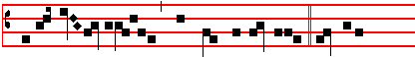
And in earth peace, good will towards men. We praise
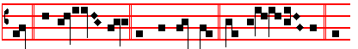
thee. We bless thee.We worship thee. We glorify thee. We
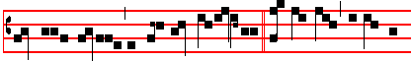give thanks to thee for thy great glo- ry. O Lord God, heavenly
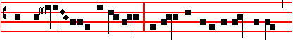King, God the Father almighty. O Lord, the only-begotten Son
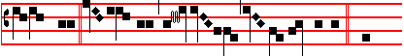
Jesu Christ. O Lord God, Lamb of God, Son of the Father. That
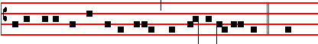
takest away the sins of the world, have mercy upon us. Thou
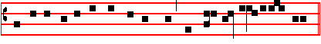
that takest away the sins of the world, re-ceive our pray- er.
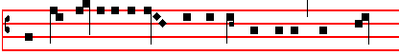
Thou that sit-test at the right hand of God the Father, have mer-
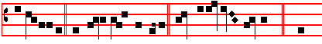
cy upon us. For thou only art holy. Thou only art the Lord. Thou
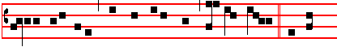
only, O Jesu Christ, with the Holy Ghost, art most high in the
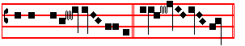
glory  of God the Father. A- men.
Then the Priest says:
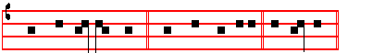
 The Lord be with you.  And with thy spirit. Let us pray.
COLLECT
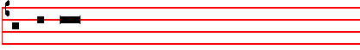
O GOD, who dost enlighten this most sacred night with
flex
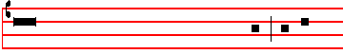
the glory of the Resurrection of the Lord: preserve
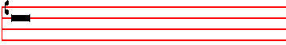
in the new offspring of thy family the spirit of adoption, 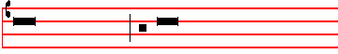
which thou hast given; that they being renewed in body and
punctum
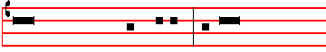
soul may render thee pure service. Through the same Jesus
flex
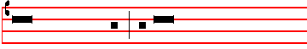
Christ thy Son our Lord: Who liveth and reigneth with thee
metrum
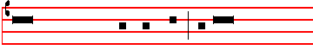
in the unity of the Holy Ghost, God : throughout all ages,
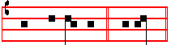
world without end.  A- men..

71
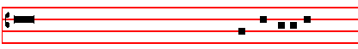
The LESSON from the Epistle of blessed Paul the Apostle
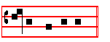
to the Colossians metrum (iij. I)
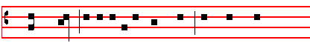
BRETHREN: if ye be risen with Christ, seek those things
metrum punctum
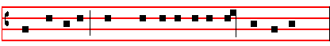
which are above, where Christ sitteth on the right hand of God:
metrum punctum
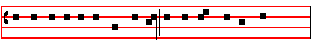
set your affection on things above, not on things on the earth.
metrum punctum
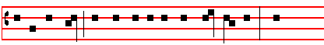
For ye are dead, and your life is hid with Christ in God. When
metrum
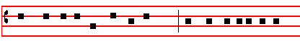
Christ, who is our life, shall appear: then shall ye also appear
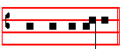
with him in glory.
The Epistle ended, the Celebrant begins: Tone viij
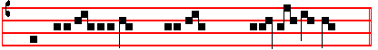 Al- le- lu- ia.
And he sings it through thrice, raising his voice each time: the Choir repeats it each time in the same tone.

Afterwards the Choir continues :  Psalm 118
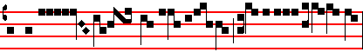 O give thanks un- to the Lord, for he is gra- cious:
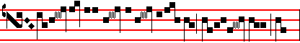
be- cause his mer- cy en- du- reth for
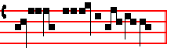
e- ver.
Then is said: TRACT. Psalm 117. Tone viij
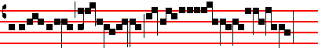
O praise the Lord, all ye hea- then:
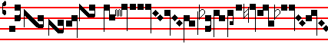
praise him, all ye
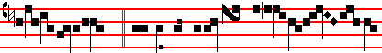
na- tions.  For his merciful kindness is e- ver more
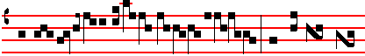
and more towards us: and the truth of
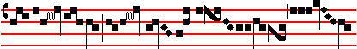
the Lord endur eth for e- ver.
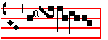At the Gospel lights are not carried, but only incense. A blessing is asked, and other things are done as usual.
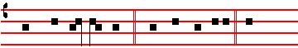
THE Lord be with you.  And with thy spirit. The

metrum punctum
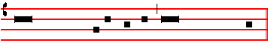
Continuation of the holy GOSPEL according to Matthew.
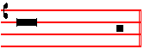
Glory be to thee, O Lord. * (xxviij, 1.)
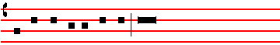
IN the end of the sabbath, as it began to dawn toward

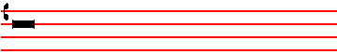
the first day of the week, came Mary Magdalene and the
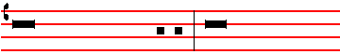
other Mary to see the sepulchre. And, behold, there was
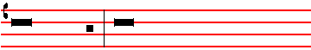
a great earthquake. For the Angel of the Lord descended
from heaven: and came and rolled back the stone from
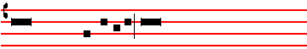
the door, and sat upon it: his countenance was like
______________________________________________
* Third and most ancient tone of the Gospel as given by the Liber Usualis .The Gospels for Easter Day and Easter Monday are noted below to the first and second Tones.
72
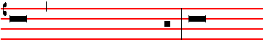
lightning: and his raiment white as snow. And for fear of
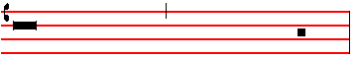
him the keepers did shake, and became as dead men.
And the Angel answered and said unto the women:
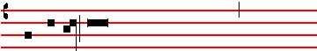
Fear not ye: for I know that ye seek Jesus, which was
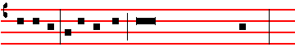
crucified: he is not here: for he is risen, as he said.
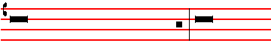
Come, see the place where the Lord lay. And go quickly,
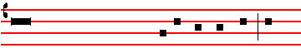
and tell his disciples that he is risen from the dead: and
conclusio
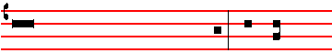
behold, he goeth before you into Galilee : there shall
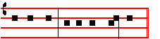
ye see him. Lo, I have told you. The Creed is not said, but, the Gospel ended, the Priest says: The Lord be with you, then: Let us pray. The Offertory is not said. At the Lavabo Gloria Patri is said.

SECRET
RECEIVE, we beseech thee, O Lord, the prayers of thy people together with the offering of these sacrifices: that those things which we have begun in these paschal mysteries may by thine operation be profitable for our healing in eternity. Through.

SOLEMN PREFACE OF EASTER
¶ In the Mass of Holy Saturday is said: chiefly on this night; on Easter Day and until the following Saturday inclusive: chiefly on this day; otherwise: chiefly at this time, as below.

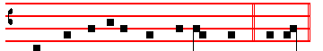
Throughout all ages, world without end.  Amen.

 The Lord be with you.  And with thy spirit.  Lift up your hearts.  We lift them up unto the Lord.
 Let us give thanks unto our Lord. God.  It is meet and right so to do.  It is very meet, right, just and
chiefly on this night,
saluta-ry, that we should indeed at all times glorify thee, O Lord, but chiefly on this day, when Christ our
chiefly at this time,
Passover is sacrificèd, For he is the very Lamb, which hath taken away the sins of the world. Who by his
death hath destroyèd death, and by his rising again hath restorèd to us life. And therefore with Angels
and Archangels, with Thrones and Dominations and with all the host of the heavenly army, we sing the hymn

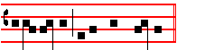
of thy glory, evermore saying:
SANCTUS Lux et origo Tone iv
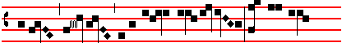
Holy, holy, holy, Lord God of hosts; heaven and
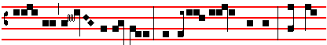
earth are full of thy glory. Hosanna in the highest. Blessèd
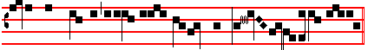
is he that cometh in the name of the Lord . Ho- sanna in the highest.
THE CANON OF THE MASS
Infra Actionem.
JOINING in communion and celebrating the most sacred night of the Resurrection of our Lord Jesus Christ according to the flesh: and venerating moreover the memory, first, of the glorious ever Virgin Mary, Mother of the same our God and Lord Jesus Christ: as also of thy blessed Apostles and Martyrs, Peter and Paul, Andrew, James, John, Thomas, James, Philip, Bartholomew, Matthew, Simon and Thaddeus: Linus, Cletus, Clement, Xystus, Cornelius, Cyprian, Laurence, Chrysogonus, John and Paul, Cosmas and Damian: and of all thy Saints; by whose prayers grant that in all things we may be defended with the help of thy protection. He joins his hands. Through the same Christ, our Lord. Amen.

Holding his hands spread out over the Oblations, he says:
THIS oblation therefore of our bounden service, and of all thy family, which we offer unto thee on behalf also of those whom thou hast vouchsafed to regenerate by water and the Holy Ghost, granting unto them remission of all their sins, we beseech thee, O Lord, graciously to accept: and order our days in thy peace, and bid us to be delivered from etemal damnation, and to be numbered in the flock of thine elect. He joins his hands. Through Christ, our Lord. Amen.

Which oblation, as in the Canon. Pax Domini is said, but the kiss of peace is not given. Agnus Dei is not said, nor the Postcommunion: but the three accustomed Prayers before the Communion are said.

After the receiving of the Sacrament, for Vespers in the choir is sung the Antiphon:
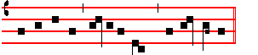
Al- le- lu-ia, al- lelu-ia, al- le- lu- ia.
and Psalm 117:

73
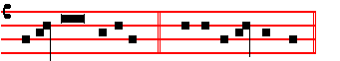
*
O PRAISE the Lord: all ye heathen: *
praise him, all ye nations.
For his merciful kindness is ever
more and more toward us: * and the truth of the Lord
endureth for ever.
Glory be to the Father,
and to the Son, *
and to the Holy Ghost.
As it was in the beginning
is now, and ever shall be, *
world without end. Amen.
ANTIPHON. Alleluia, alleluia, alleluia.
The Chapter, Hymn, and  are not said, but the Cele-brant begins at once to sing the Antiphon to the Magnificat : * Tone viij
And the Choir continues 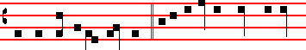
IN the end of the Sabbath. As it began to dawn toward

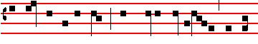
the first day of the week: came Mary Magdalene and the
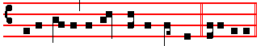
other Ma-ry to see the se- pul-chre, al-le-lu-ia.
Then the Magnificat is sung with Gloria Patri at the end, and the censing is done, as at other times at Vespers. 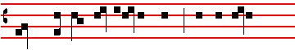
MY  soul doth magnify the Lord: * and my spirit

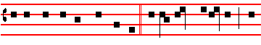 hath rejoiced in God my Saviour. For he hath regarded: * the
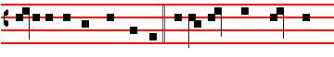 lowliness of his handmaiden. For behold, from henceforth: *
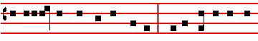
all generations shall call me blessed. For he that is mighty
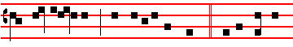
hath magnified me :* and holy is his name. And his mercy
* as noted in the Missal and the Liber Usualis. 74
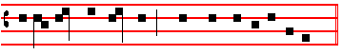
is on them that fear him throughout all gene- rations
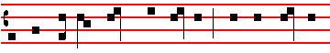
He hath shewed strength with his arm : * he hath scattered
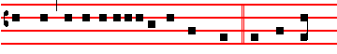 the proud in the imagination of their hearts. He hath put
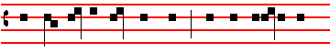
down the mighty from their seat :* and hath exal- ted the
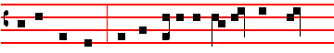 humble and meek. He hath filled the hungry with good
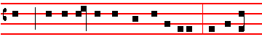 things: * and the rich he hath sent empty away. He remem-
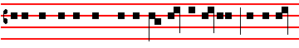
bering his mercy hath holpen his servant Israel: * as he pro-
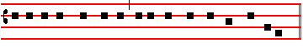
mi-sed to our fore- fathers, Abraham and his seed for ever.
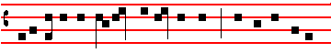
Glory be to the Father, and to the Son :* and to the Holy
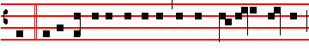
Ghost. As it was in the beginning, is now, and ever shall be:*
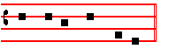-
world without end. Amen. Antiphon * Tone viij
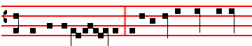
IN the end of the Sab-bath. As it began to dawn toward

the first day of the week: came Mary Magdalene and the
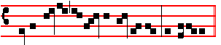
other Ma- ry to see the se- pulchre, al- le-lu-ia.
* following the Ratisbon edition as in the Breviary
The Antiphon having been repeated, the Celebrant says:
 The Lord be with you.  And with thy spirit.
Let us pray.
COLLECT
POUR forth upon us, O Lord, the Spirit of thy charity: that as thou hast fulfilled us with these paschal Sacraments, so of thy goodness thou wouldest make us to be of one heart and mind. Through . . . in the unity of the same.
Then he says: . The Lord be with you.
And the Deacon, turning himself to the people, sings:
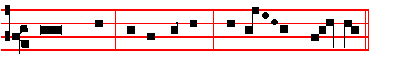
Ite, missa est, al- le- lu- ia, al- le - lu - ia. 
Thanks be to God, al- le- lu- ia, al- le - lu - ia.
And the Priest, having said: Let this my bounden duty : gives the blessing in the usual manner.

___________________________________________________________________________________________________



75

