Antiphon 1. Tone viij, 2.
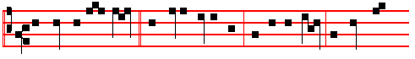
The zeal of thine house hath even eaten me: and the rebukes of them that
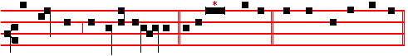
rebuked thee are fallen upon me. Ps. 69 Salvum me fac, p. 142, ending, slower:
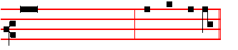
* and they that love his Name shall dwell therein. And the Antiphon is repeated. And the other Psalms in the Psalter on Thursday.
Antiphon 2. Tone viij, 2.
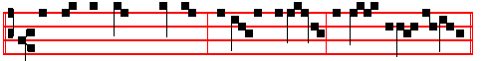
Let them be turned backward and put to confusion that seek to do me evil.
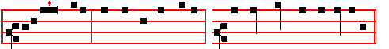
Psalm 70 Deus in adjutorium ending, slower: * O Lord, make no long tarrying.
Antiphon 3. Tone viij, 2.
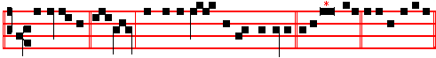
Deliver me, O God., out of the hand of the ungodly. Psalm 71 In te, Domine,
speravi, ending, slower:
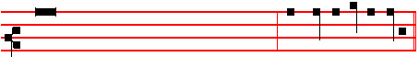
* for they are confounded, and brought unto shame, that seek to do me evil.
__________________________________________________________________

* From this note marked with an asterisk begin verses II and following.

730
Antiphon Tone vj
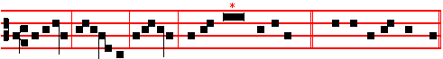
Alleluia, allelu- ia, alle-luia. Ps. 117 Laudate Dominum. E u o u a e.
And the Antiphon is repeated Alleluia, alleluia, alleluia.
The Chapter, Hymn and  are not said.
On Magnificat, Antiphon. * Tone viij.
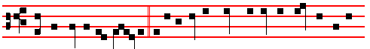
IN the end of the Sabbath, as it began to dawn toward the first day of the
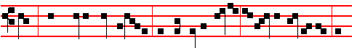
week, came Mary Magdale- ne and the other Mary to see the se-pulchre, al-
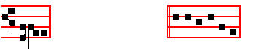
leluia. Cant. Magnificat, p. 211, E u o u a e, with Glory be to the Father.
And the Antiphon is repeated In the end of the Sabbath.
Then the Priest says: The Lord be with you. Let us pray.
COLLECT
POUR forth upon us,O Lord, the spirit of thy charity: that as thou hast fulfilled us with these paschal sacraments, so of thy goodness thou wouldest make us to be of one heart and mind. Through. in the unity of the same Holy Spirit.
Then The Lord be with you.
Afterwards the Deacon, turning himself towards the people, sings:
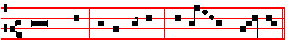
Ite, missa est, al- le- lu- ia, al- le - lu - ia.
 Thanks be to God, al- le- lu- ia, al- le - lu - ia.

787

* Or, as noted in the Missal for the intonation: see below at Compline, p. 784.

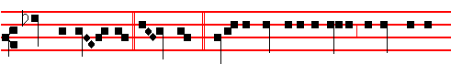
come her en - emies. Ghi - mel. Judah is gone into captivity, because of af-
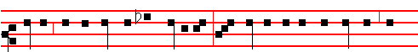
fliction, and because of great servitude: she dwelleth among the heathen, she
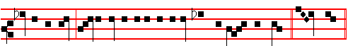
findeth no rest: all her persecutors overtook her between the straits. Daleth.

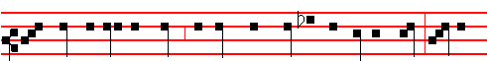
The ways of Sion do mourn, because none come to the solemn feasts: all her
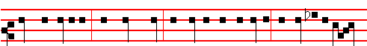
gates are desolate; her priests sigh, her virgins are afflicted, and she is in bit-
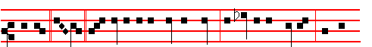
terness. He. Her adversaries are the chief, her enemies prosper; for the
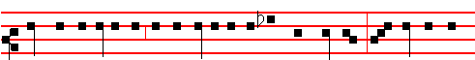
Lord hath afflicted her for the multitude of her transgressions: her children are

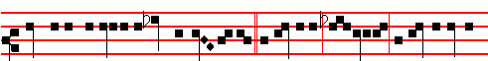
gone into captivity before the en- em-y. Jerusalem, Jer-usalem, return unto the

732
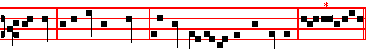
O death, I will be thy plagues: O grave, I will be thy destruction. Psalm 51
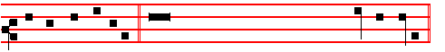
Miserere , p.104, ending * then shall they offer young bullocks upon thine altar.
Antiphon 2. Tone iv, 1.
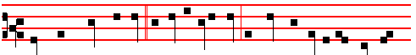
They shall mourn for him as for an only son; because the innocent Lord has
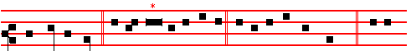
been put to death. Psalm 43 Judica me, Deus, p. 122 , ending slowly: * for I
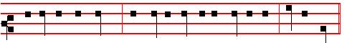
will yet give him thanks, which is the help of my countenance, and my God.
Antiphon 3. Tone vij, 1.
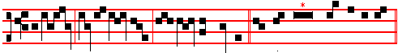
Behold, all ye nat-ions, and see my sorrow. Psalms 63 67 Deus, Deus
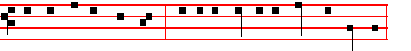
meus, p. 29, ending slowly: * and all the ends of the world shall fear him.
Antiphon 4. Tone ij.
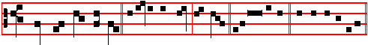
From the gate of hell, deliver my soul, O Lord. Canticle Ego dixi, p. 123,
ending slowly:

785
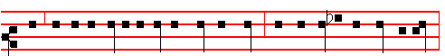
-tion and of her miseries all her pleasant things that she had in the days of old,
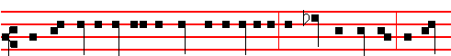
when her people fell into the hand of the enemy, and none did help her: the ad-
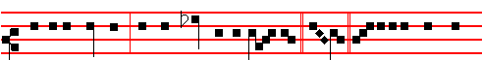
versaries saw her, and did mock at her sabbaths. Heth. Jerusalem hath grie-
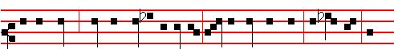
vously sinned; therefore she is removed: all that honoured her despise her, be-
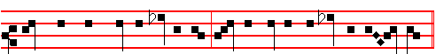
cause they have seen her nakedness; yea, she sigheth, and turneth back- ward.
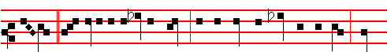
Teth. Her filthiness is in her skirts; she remembereth not her last end; there-
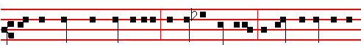
fore she came down wonderfully: she had no comforter. O Lord, behold my af-
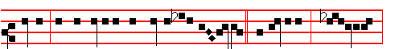
fliction; for the enemy hath magnifi-ed him - self. Je-ru-salem, Je- rusalem,
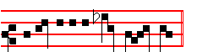
return unto the Lord thy God. 734
conscience from dead works to serve the living God?
 VII Tone viij.
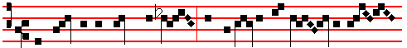
The kings of the earth stand up, and the rulers take coun - sel to-
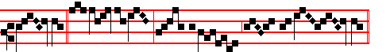
geth - er * Against the Lord, and a-gainst his A-noint- ed.
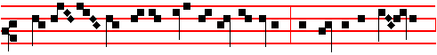
 Why do the heathen so furiously rage together? and why do the peop- le
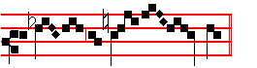
imag- ine a vain thing? Against.

Lesson viij
AND for this cause he is the mediator of the new testament, that by means of death, for the redemption of the transgressions that were under the first testament, they which are called might receive the promise of eternal inheritance. For where a testament is, there must also of necessity be the death of the testator. For a testament is of force after men are dead: otherwise it is of no strength at all while the testator liveth. Whereupon neither the first testament was dedicated without blood.

 VIII Tone iv 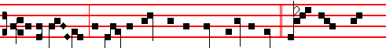
I am counted as one of them that go down into the pit: * And I have
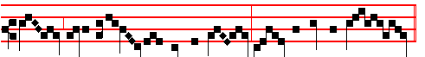
been even as a man that hath no strength, free among the dead.

783
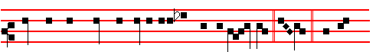
mand that they should not enter into thy congrega - tion. Caph. All her
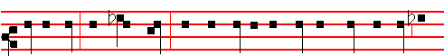
people sigh, they seek bread: they have given their pleasant things for meat to
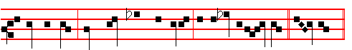
relieve the soul: see, Lord, and con - sid-er; for I am become vile. La-med.

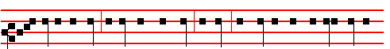
Is it nothing to you, all ye that pass by? behold, and see if there be any sorrow
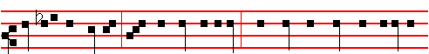
like unto my sorrow, which is done unto me, wherewith the Lord hath afflicted
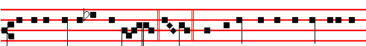
me in the day of his fierce anger. Mem. From above hath he sent fire into my
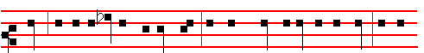
bones, and it prevaileth against them: he hath spread a net for my feet, he hath
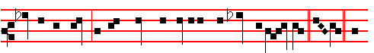
turned me back; he hath made me desolate and faint all the day. Nun. The

736
slept.' Verily, 'the diligent searchers out have failed.' What is this thou sayest, O sterile cunning? Dost thou so far forsake the light of prudence and justice, and plunge thyself so deep in guile, as to speak thus: 'Say ye that his disciples came and stole him away while ye slept.' Thou callest upon sleeping witnesses: surely thou hast fallen asleep thyself, seeing thou hast 'failed in searching out' so notable a matter.

 VI. Tone iv.
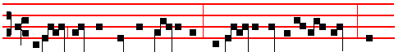
Behold how the righteous perisheth, and no man layeth it to heart: and

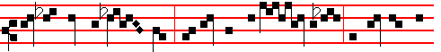
upright men are tak - en, and no man consid - ereth: the righteous is
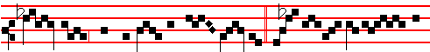
tak - en from the presence of ev - il: * And he shall en-ter in-

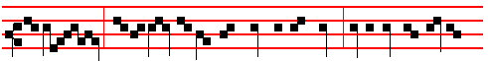
to peace.  As a lamb before her shearers is dumb, so he opened not his

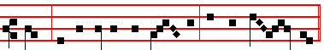
mouth: he was taken from pris - on and from judg - ment. And he. Behold.

IN THE THIRD NOCTURN
Antiphon 1. Tone viij, 1.
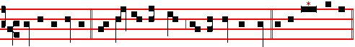
God is my helper, the Lord is with them that uphold my soul. Ps. 54 Deus, in

781
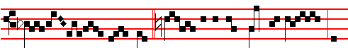
we are healed.  Sure- ly he hath borne our griefs, and
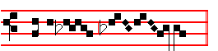
carried our sor- rows. And with.  Behold to the 
Antiphon 1 . IN THE SECOND NOCTURN Tone viij, 2.
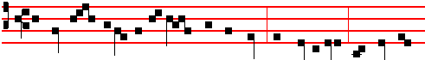
The Lord hath delivered the poor when he cried: the needy also, and him that
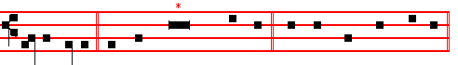
hath no helper. Psalm 72 Deus, judicium tuum. LXXI, ending slowly:
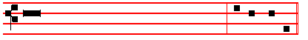
* and all the earth shall be filled with his Majesty. Amen, Amen.
Antiphon 2 Tone viij, 2.
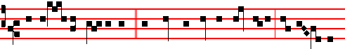
They imag-ine wick-edness, and speak of wicked blas-phemy: their talk - ing
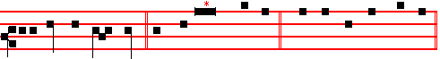
is against the Most High. Psalm 73 Quam bonus Israel. LXXII, ending slowly:
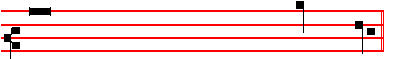
* and to speak of all thy works in the gates of the daughter of Syon.

738
Our Father secretly.

From the Treatise of Saint Augustine, Bishop, on the Psalms.
Lesson iv Ps 64: 6, 7
MAN shall come to a deep mind, and God shall be exalted. (Accedet homo ad cor altum, et exaltabitur Deus.) Tone as above, p. 739-40.
THEY said: 'No man shall see us. The diligent searchers out of evil counsels have failed.' A Man came to these very counsels, and suffered himself to be laid hold upon, as Man. For he could not have been held had he not been Man: neither could he have been seen, had he not been Man: nor been scourged, had he not been Man: nor been crucified, nor died, had he not been Man. As Man therefore, he came to all these sufferings, which would have availed naught against him, had he not been Man. But had he not been Man, man could nowise have been redeemed. He came, as Man, 'to a deep mind', - that is, to a secret mind; shewing the Manhood to the eyes of men, and keeping the Godhead hidden within: concealing the form of God, wherein he is equal to the Father, and presenting the form of a servant, wherein he is inferior to the Father.

 IV. Tone vij
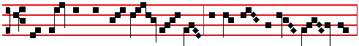
Our Shepherd hath withdrawn him- self , the Fountain of living wat - er,
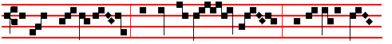
at whose departure the sun was dark- ened: * For he also is
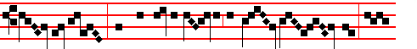
led captive, who had taken captive our first par- ent: to-
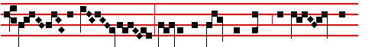
day hath our Sav- iour broken the gates of death, and burst the
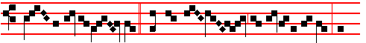
bars thereof asund - er.  He hath destroyed the barriers of hell, and

779
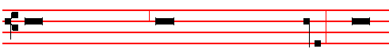
prayeth as one suffering much, and longing to be delivered from evil. It remaineth
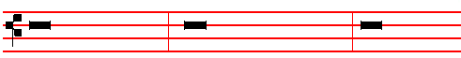
for us to see in what evil he is: and when he beginneth to tell us, to acknowledge
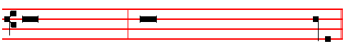
that we also suffer therefrom: that sharing his trouble, we may join in his prayer.
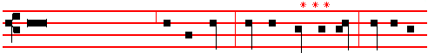
'I mourn,' saith he, 'in my trial, and am vexed,' Wherein mourneth he? Wherein is
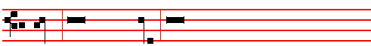
he vexed? He saith, 'In my tri-al,' He remembereth the wicked men whom he
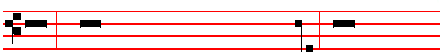
suffereth, and that sufferance of evil men he calleth his trial. Think ye not that the
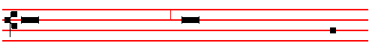
wicked are in this world for naught, and that God nowise doeth good through
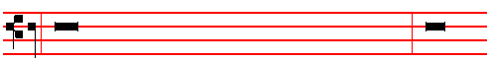
them. Every wicked man either liveth that he may be made righteous; or else he
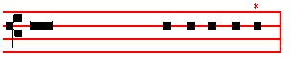
liveth that the righteous may be tried by him.
*** An interrogation is sung thus. 740 * Thus end the Lessons in this Triduum
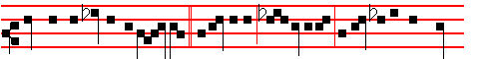 maids in the cities of Jud- ah. Jer-usalem, Jer- usalem, return unto the Lord
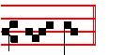
thy God.
 III Tone v.
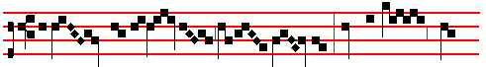
Lament like a vir- gin, O my peo - ple: cry and howl, ye
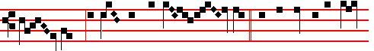
shep- herds, in sackcloth and ash - es: * For the day of the Lord
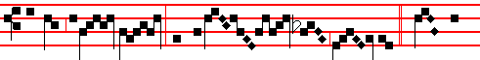
is nigh, a great day and exceed- ing bit - ter.  Gird your-
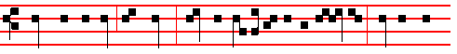
selves and lament, ye priests: howl, ye ministers of the al - tar; wallow your-
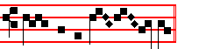
selves in the ash - es. For the day. Lament.

IN THE SECOND NOCTURN
Antiphon 1. Tone v.
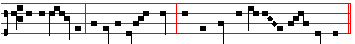
Be ye lift up, ye everlasting doors, and the King of glory shall come in.

777
against powers, against the rulers of the darkness of this world.' He said not, 'the rulers of this world,' lest perchance thou shouldest deem that devils are the lords of heaven and earth: but he said, 'the rulers of the darkness of this world'; when he spake of the world, he meant the lovers of the world: ungodly and unrighteous men, he called the world: of that world he spake, whereof the Gospel saith, 'and the world knew him not'.

 V Tone ij
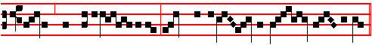
Judas, most evil traf - ficker, sought to betray the Lord with a kiss:
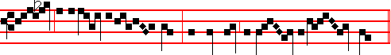
he, as an in - no-cent lamb, refused not the kiss of Jud- as: *
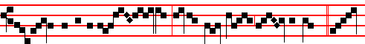
For thir- ty pieces of sil - ver, he be-trayed Christ to the Jews.  Bet-
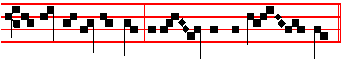
ter were it for that man if he had not been born. For thirty.

Lesson vj Tone as above, pp. 739-740
FOR I have spied unrighteousness and strife in the city.' Give heed unto the glory of the Cross itself. Now upon the brow of kings that Cross firmly resteth, which foes did once revile. Effect hath proven strength: it hath conquered the world not with the sword, but with wood. The wood of the Cross seemed worthy of scorn to his enemies, as they stood before that very wood, wagging their heads, and saying, 'If he be the Son of God, let him come down from the Cross! ' He stretched forth his hands unto a disobedient and gainsaying people. If he is just which liveth by faith, he that hath not faith is unrighteous. What then he calleth unrighteousness, know thou to be unbelief. Therefore the Lord 'spied unrighteousness and strife in the city' and 'stretched forth his hands unto a disobedient and gainsaying people': and yet, looking forth upon these very same,

742
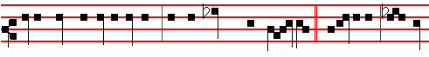
overthrown as in a moment, and no hands stayed on her. Jerusalem, Je- ru-
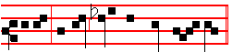
salem, return unto the Lord thy God.

 II Tone v.
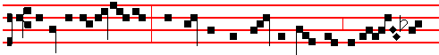
Arise, O Jeru- sal-em, and put off from thee the garments of joy and
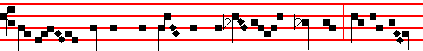
gladness: gird thee with sackcloth, and lie in ash - es: * For the Sav-
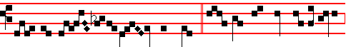
iour of Is - ra-el hath been slain.  Let tears run down like a river
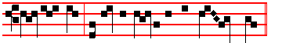
day and night: let not the apple of thine eye cease. For the Saviour.

Lesson iij Chapter 5:1-11
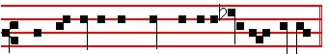
Here beginneth the Prayer of Jeremiah the Prophet.
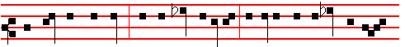
REMEMBER, O Lord, what is come upon us: consider, and behold our re-

775
Antiphon 2. Tone viij, 2.
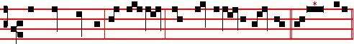
The earth trembled and was still, when God arose to judgment. Psalm 76
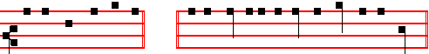
Notus in Judæa ending slowly: * and is wonderful among the kings of the earth.

Antiphon 3. Tone vij, 3.
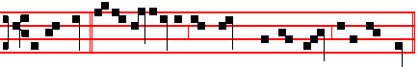
In the time of my tribulation, I stretched out my hands unto the Lord. Psalm
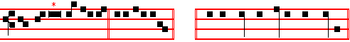
77 Voce mea ad Domimum. ending slowly: * by the hand of Moses and Aaron.
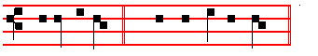
 Arise, O Lord.  And maintain my cause. Our Father secretly.
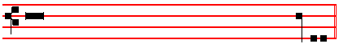
From the First Epistle of Saint Paul the Apostle to the Corinthians.
Lesson vij Ch. 11:17-34
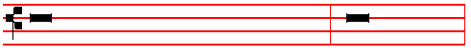
NOW in this that I declare unto you I praise you not, that ye come together,
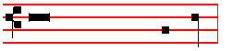
not for the better, but for the worse. Tone as above, p. 739-740

744
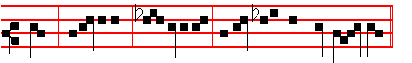
-proach. Jerusalem, Je - rusalem, return unto the Lord thy God.

 I Tone iv
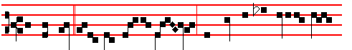
He was led as a lamb to the slaught-er, and while he was evil en- treat-
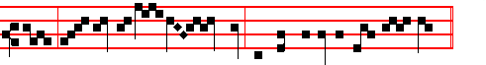
ed, he opened not his mouth: he was delivered un - to death.
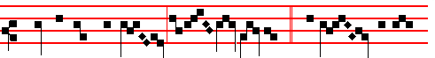
* That he might give life unto his peo-ple.  He poured out his
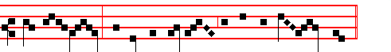
soul unto death, and he was numbered with the transgres- sors.
That he might.

Lesson ij Chapter 4:1-6
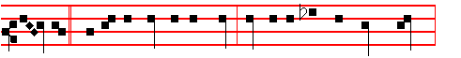
ALEPH. How is the gold become dim! how is the most fine gold changed!

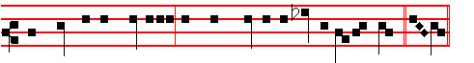
The stones of the sanctuary are poured out in the top of every street. Beth.

773

Lesson viij
FOR I have received of the Lord that which also I delivered unto you, That the Lord Jesus the same night in which he was betrayed took bread: and when he: had given thanks, he brake it, and said, Take, eat: this is my body, which is broken for you: this do in remembrance of me. After the same manner also he took the cup, when he had supped, saying, This cup is the new testament in my blood: this do ye, as oft as ye drink it, in remembrance of me. For as often as ye eat this bread, and drink this cup, ye do shew the Lord's death till he come.

 VIII Tone vij
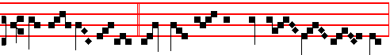
Wherefore sleep ye? What, could ye not watch with me one hour,
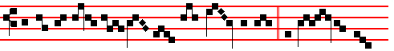
ye that exhorted each oth - er to die for me? * Or see ye not
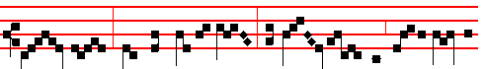
Jud - as, how he sleepeth not, but hast - en - eth to betray me
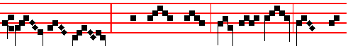
to the Jews? . Why sleep ye? Rise and pray, lest ye
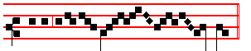
enter into tempta- tion. Or see.

Lesson ix
WHEREFORE whosoever shall eat this bread, and drink this cup of the Lord, unworthily, shall be guilty of the body and blood of the Lord. But let a man examine himself, and so let him eat of that bread, and drink of that cup. For he that eateth and drinketh unworthily, eateth and drinketh damnation to himself, not discerning the Lord's body. For this cause many are weak and sickly among you, and many sleep. For if we would judge ourselves, we should not be judged. But
746
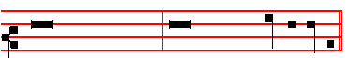
* For it is thou, Lord, only, that makest me dwell in safety.
Antiphon 2. Tone iv, 1.
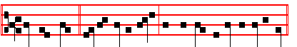
He shall dwell in thy tabernacle: he shall rest upon thy holy hil1.
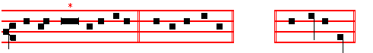
Psalm 15 Domine, quis habitabit ending slowly: * shall never fall.
Antiphon 3. Tone vij, 1.
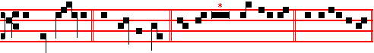
My flesh al - so shall rest in hope. Psalm 16 Conserva me, Domine, p.15
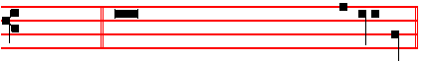
ending slowly: * and at thy right hand there is pleasure for evermore.
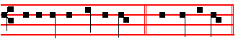
 I will lay me lawn in peace.  And take my rest. Our Father, secretly
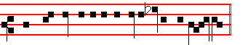
From the Lamentation of Jeremiah the Proph-et.
Lesson j Chapter 3: 22-30
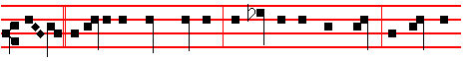
HETH. It is of the Lord's mercies that we are not consumed, because his
771
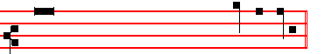
* then shall they offer young bullocks upon thine altar.
Antiphon 2. Tone ij
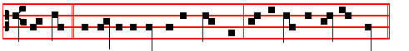
The Lord was led as a lamb to the slaughter: and he opened not his mouth.
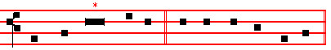
Psalm 90 Domine refugium, p. 158 , ending slowly:
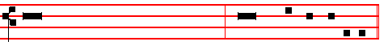
* prosper thou the work of our hands upon us, O prosper thou our handiwork.
Antiphon 3. Tone viij, 1.
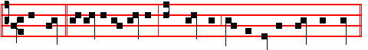
My heart within me is broken: and trembling maketh all my bones to shake.
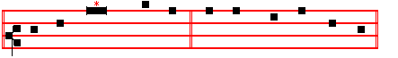
Psalms 63 ,67 Deus, Deus meus, p. 29, ending slowly:
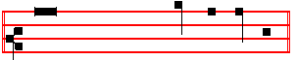
* and all the ends of the world shall fear him.
Antiphon 4. Tone iv, 1.
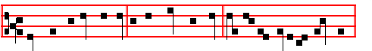
Thou dost encourage us by thy might, O Lord, and by thy holy refreshment.
748
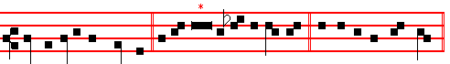
comest into thy kingdom. Psalms 63 67 Deus, Deus meus, p. 29,
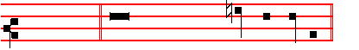
ending slowly: * and all the ends of the world shall fear him.
Antiphon 4. Tone j, 1.
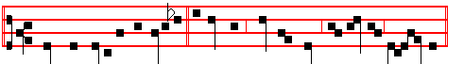
When my spirit is disquieted within me, thou, O Lord, remember merc- y.
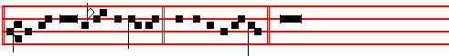
Canticle Domine, audivi, p.177, ending slowly: * and he will make me to walk
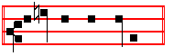
upon mine high places.
Antiphon 5. Tone viij, 1
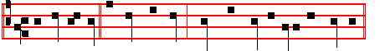
.Remember me, O Lord my God, when thou comest into thy kingdom.
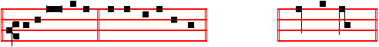
Psalms 148 149 150 Laudate Dominum, p. 33, ending slowly: * praise the Lord.
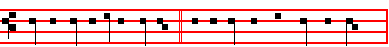
 He hath laid me in the darkness.  As the men that have been long dead.

On Benedictus, Antiphon. Tone j, 2.
769
placed from the beginning upon the Altar are also extinguished one by one so that at the last verse the last candle is put out; the lamps and other lights throughout the
Church are likewise extinguished. As the Antiphon Now he that betrayed is being repeated, the topmost candle is taken from the candelabrum, and hidden under the Altar on the Epistle side. When the Antiphon has been repeated after Benedictus, is said
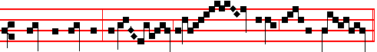
 Christ for our sake became obed - i-ent un- to death.
On the second night is added:
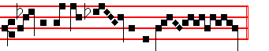
Ev - en the death of the cross. On the third night is added:
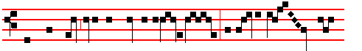
Wherefore God also hath highly exalt-ed him, and given him a
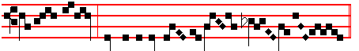
Name which is above eve -ry name.

And so it is said also through all the Hours of the day.

When the  Christ for our sake is begun, all kneel, and when it is ended, Our Father is said entirely in secret. Afterwards is said a little louder: Ps. 51 Miserere mei p.75.Which being ended, without Let us pray, is said in a like voice:

COLLECT
ALMIGHTY God, we beseech thee graciously to behold this thy family, for which our Lord Jesus Christ was contented to be betrayed, and given up into the hands of wicked men, and to suffer death upon the Cross, but Who liveth and reigneth with thee is said in silence.

The Collect being ended, some crack and clatter is made: and soon the lighted candle is brought from under the Altar, and all rise, and depart in silence.

750
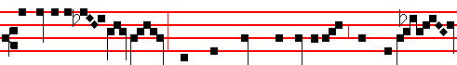
to Caiaphas the high priest, where the scribes and Pharisees were assem -
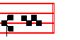
-bled. But Peter.
Lesson ix
AND no man taketh this honour unto himself, but he that is called of God, as was Aaron. So also Christ glorified not himself to be made an high priest; but he that said unto him, Thou art my Son, to-day have I begotten thee. As he saith also in another place, Thou art a priest for ever after the order of Melchisedech. Who in the days of his flesh, when he had offered up prayers and supplications with strong crying and tears unto him that was able to save him from death, and was heard in that he feared; though he were a Son, yet learned he obedience by the things which he suffered; and being made perfect, he became the author of eternal salvation unto all them that obey him; called of God an high priest after the order of Melchisedech.
 IX. Tone vj.
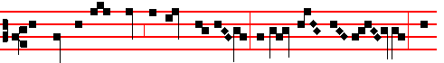
The sight of mine eyes is gone from me, because of my weep- ing: for
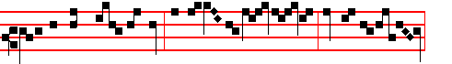
he is removed far from me, that alone did com-fort me: O all ye peo - ple,
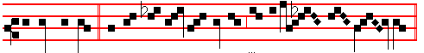
behold and see * If there be an - y sorrow like unto my sor - row.
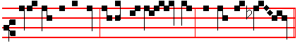
 Is it nothing to you, all ye that pass by? Behold and see. If there.
The sight.
767

__________________________________________________________________

IN THE FIRST NOCTURN
Antiphon 1. Tone viij, 1.
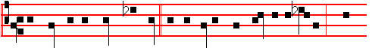
The kings of the earth stand up, and the rulers take counsel together a -
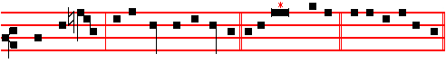
gainst the Lord, and against his Anointed. Psa1m 2 Quare fremuerunt
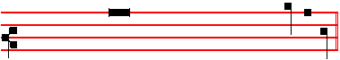
ending slowly: * blessed are all they that put their trust in him.
Antiphon 2. Tone viij, 1.
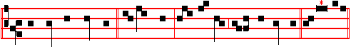
They part my garments among them, and cast lots upon my vesture. Psalm 22 Deus, Deus meus, ending slowly:
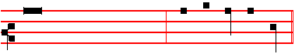
* unto a people that shall be born, whom the Lord hath made.
Antiphon 3. Tone viij, 1.
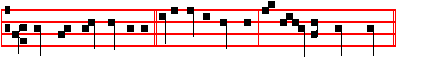
There are false witnesses risen up against me, and such as speak wrong.

752
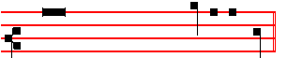
* yea, the Lord our God shall destroy them.

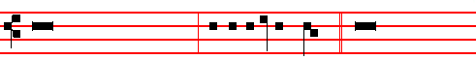
 They have spoken against me with a deceitful tongue.  They compassed
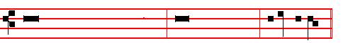
me about also with words of hatred, and fought against me without a cause.

Our Father secretly.

From the Epistle to the Hebrews Tone as above, p. 739-740
Lesson vij Chapter 4: 11-16
LET us labour therefore to enter into that rest, lest any man fall after the same example of unbelief. For the word of God is quick, and powerful, and sharper than any two-edged sword, piercing even to the dividing asunder of soul and spirit, and of the joints and marrow, and is a discerner of the thoughts and intents of the heart. Neither is there any creature that is not manifest in his sight: but all things are naked and opened unto the eyes of him with whom we have to do. Seeing then that we have a great high priest, that is passed into the heavens, Jesus the Son of God, let us hold fast our profession. For we have not an high priest which cannot be touched with the feeling of our infirmities; but was in all points tempted like as we are, yet without sin.

 VII Tone vj.
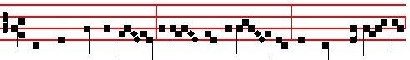
They have cast me out a-mong the un-god- ly, and turned me ov- er
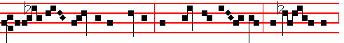
into the hands of the wicked, and spared not my soul: the migh- ty men

765
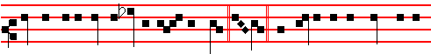
prophets also find no vision from the Lord. Jod. The elders of the daughter of
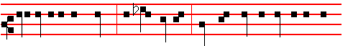
Sion sit upon the ground, and keep silence: they have cast up dust upon their
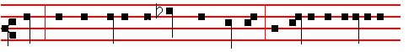
heads; they have girded themselves with sackcloth: the virgins of Jerusalem
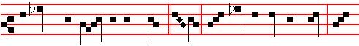
hang down their heads to the ground. Caph. Mine eyes do fail with tears, my
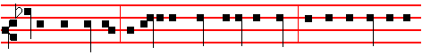
bowels are troubled, my liver is poured upon the earth, for the destruction of
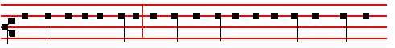
the daughter of my people; because the children and the sucklings swoon in
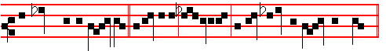
the streets of the ci - ty. Jerusalem, Jerusalem, return unto the Lord thy God.

 I Tone iij 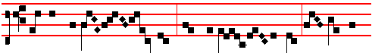
All mine acquaint - ance have forsak - en me, and they that

754
 VI Tone viij
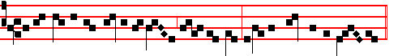
I have given the dearly belov - ed of my soul into the hand of the wick-ed:
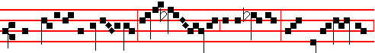
mine heritage is unto me as a li- on in the forest: mine ad-versar - y
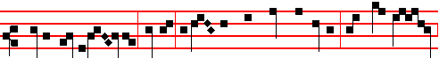
crieth out against me, saying: Assemble yourselves together, and make haste
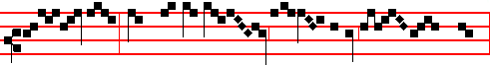
to devour him: they have set me in a des- olate wil - der - ness,
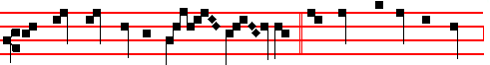 the whole land mourneth un - to me: * Because there is none found
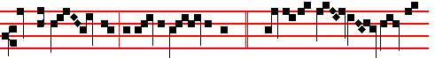
that will know me, or do me an- y good.  Merciless men rose up a-
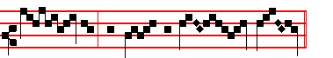
gainst me, and spared not my soul.

Because there. I have given.

IN THE THIRD NOCTURN
Antiphon 1. Tone j, 2.

763
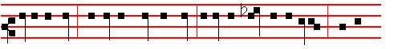
equal to thee, that I may comfort thee, O virgin daughter of Sion? for thy
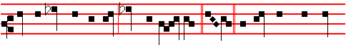
breach is great like the sea; who can heal thee? Nun. Thy prophets have seen
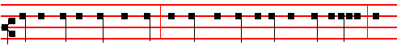
vain and foolish things for thee; and they have not discovered thine iniquity, to
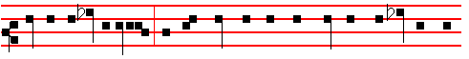
turn away thy captivity; but have seen for thee false burdens and causes of
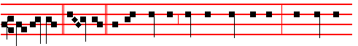 banishment. Samech. All that pass by clap their hands at thee; they hiss and
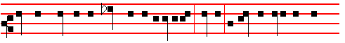
wag their head at the daughter of Jerusalem, saying, Is this the city that men
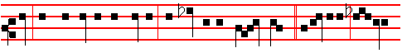
call The perfection of beauty, The joy of the whole earth? Jerusalem, Jerusa-
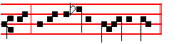
lem, return unto the Lord thy God.

 II Tone ij

756
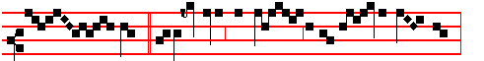
me? * I was daily with you in the tem- ple teach-ing,
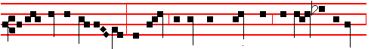
and ye laid no hold on me: and now, behold, ye scourge me, and lead me away
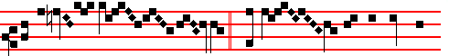
to be cru -ci - fied.  And when they had laid their
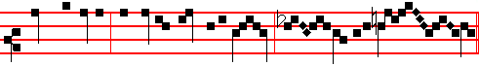
hands on Jesus, and taken hold upon him, he said unto them.
I was daily.

Lesson v
YE know what was 'the gathering together of the froward' Jews, and what was 'the insurrection of the wicked doers', What was their wicked deed? It was that they wished to kill the Lord Jesus Christ, ' Many good works,' saith he, 'have I shewed you; for which of them do you wish to kill me?' He bore all their infirmities, he healed all their sick, he preached unto them the kingdom of heaven; he held not his peace at their iniquities, so that they might rather hate the same, than the Physician who made them whole. Yet being unthankful for all these his remedies, like men frenzied with a great fever, they raved against the Physician who had come to heal them, and took counsel together to destroy him; as though they would therein prove whether he were very man, that could die; or somewhat more than man, and would not suffer himself to die. We perceive the saying of these men in the Wisdom of Solomon: 'Let us condemn him,' they say, 'with a shameful death. Let us examine him: for by his own saying he shall be respected. If he be truly the Son of God, let him deliver him.'
 V Tone vij
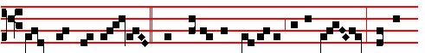
Now there was darkness, when Jesus was crucified by the Jews: and a-

761
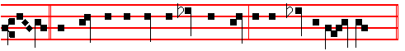
Beth. My flesh and my skin hath he made old; he hath broken my bones.
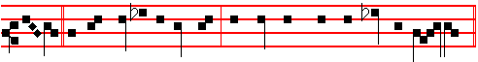
Beth. He hath builded against me, and compassed me with gall and tra-vail.
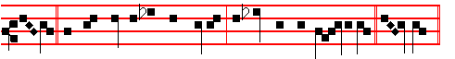
Beth. He hath set me in dark places, as they that be dead of old. Ghi - mel.
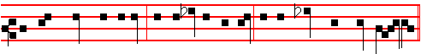
He hath hedged me about, that I cannot get out: he hath made my chain heavy.
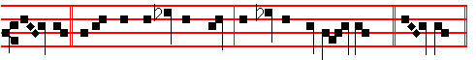
Ghi-mel. Also when I cry and shout, he shutteth out my prayer. Ghi - mel.
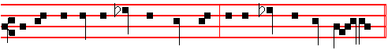
He hath inclosed my ways with hewn stone, he hath made my paths crooked.
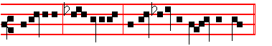
Jerusalem, Je - rusalem, return unto the Lord thy God.

 III Tone viij
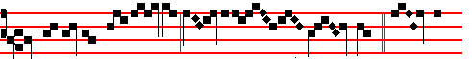
O my vineyard, my chosen, did I not plant thee? * How then

758
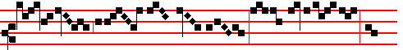
art thou turned into such bit - terness as to crucify me and
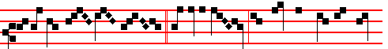
to release Bar- ab- bas?  I fenced thee, and gathered out the stones
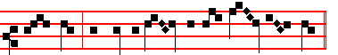
from thee, and built a tower in the midst of thee. How then.
O my vineyard.
IN THE SECOND NOCTURN
Antiphon 1. Tone viij, 1.
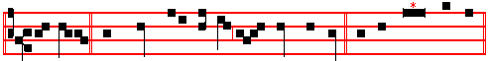
They also that sought after my life laid snares for me. Psalm 38 Domine,
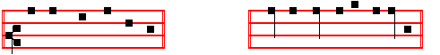
ne in furore p.102, ending slowly: * O Lord God of my salvation.
Antiphon 2. Tone iv, 1.
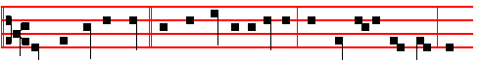
Let them be ashamed and confounded together, that seek after my soul to
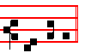
destroy it. Psalm 40 Expectans expectavi p. 112, ending slowly:
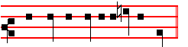
* make no long tarrying, O my God.

759

