Antiphon 4. All mine enemies * have heard of my trouble, O Lord: they are glad that thou hast done it.
Antiphon 5. Bind the nations * of the heathen with chains, O Lord, and their princes with fetters.
Chapter Let us destroy, p. 724.
Hymn E.H. 96 Lustra sex, and  Deliver me, p. 697.
On Benedictus, Antiphon. Simon, sleepest thou? * couldest not thou watch with me one hour? Then the Prayers, p.108.
COLLECT
GRANT, we beseech thee, almighty God: that we, who are continually afflicted by reason of our transgressions, may be delivered by the passion of thine only-begotten Son: Who liveth and reigneth with thee.
At the Hours, Antiphons from Lauds, the rest as in the Psalter. At Vespers, Antiphons and Psalms from the Psa1ter, p.118. Chapter But, O Lord of hosts, p. 724.
Hymn E.H. 94 Vexilla Regis, and  Deliver me, p. 688.
On Magnificat, Antiphon. A maid said unto Peter: * Surely thou art one of them, for thy speech bewrayeth thee. Then the Prayers, p.217.
COLLECT
ALMIGHTY God, we beseech thee graciously to behold this thy family, for which our Lord Jesus Christ was contented to be betrayed, and given up into the hands of wicked men, and to suffer death upon the Cross: Who liveth and reigneth with thee.

¶ On the following three days, having said secretly Our Father, Hail, Mary and at Matins, and at the beginning of Prime I believe, all else being omitted, the Office is begun at once at Matins and Vespers from the Antiphon of the first Psalm: and the Antiphons are doubled, as on a Double Feast.
At the end of the Psalms Glory be to the Father is not said throughout all the Hours, nor in the  and at the end of every Psalm at Matins, one is extin-guished of the fifteen candles placed in & triangular candelabrum before the Altar.
_____________________________________________

 __________________________________________

IN THE FIRST NOCTURN

729
Antiphon 1. Tone viij, 2.
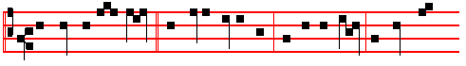
The zeal of thine house hath even eaten me: and the rebukes of them that
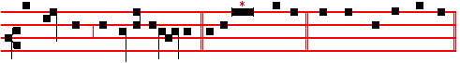
rebuked thee are fallen upon me. Ps. 69 Salvum me fac, p. 142, ending, slower:
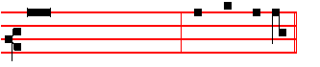
* and they that love his Name shall dwell therein. And the Antiphon is repeated. And the other Psalms in the Psalter on Thursday.
Antiphon 2. Tone viij, 2.
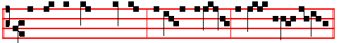
Let them be turned backward and put to confusion that seek to do me evil.
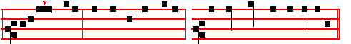
Psalm 70 Deus in adjutorium ending, slower: * O Lord, make no long tarrying.
Antiphon 3. Tone viij, 2.
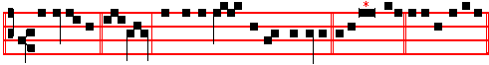
Deliver me, O God., out of the hand of the ungodly. Psalm 71 In te, Domine,
speravi, ending, slower:
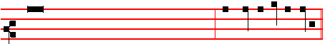
* for they are confounded, and brought unto shame, that seek to do me evil.
__________________________________________________________________

* From this note marked with an asterisk begin verses II and following.

730
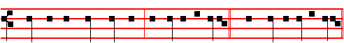
 Let them be turned backward and put to confusion.  That seek to do me evil.

During this triduum after the  of the Nocturn Our Father is said secretly. And lead us is not said aloud, nor is the Absolution said or the Blessings given before the Lessons. After the Lessons But thou is not said, but the first iij Lessons from Jeremiah are ended as below.
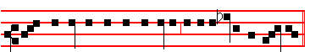
Here beginneth the Lamentation of Jeremiah the Prophet.

Lesson j Ch. 1:1-14
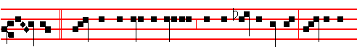
A- LEPH. How doth the city sit solitary, that was full of people! how is she
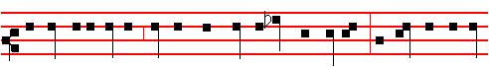
become as a widow! she that was great among the nations, and princess among
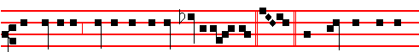
the provinces, how is she become tributa - ry ! Beth. She weepeth sore in
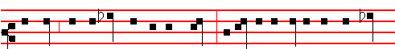
the night, and her tears are on her cheeks; among all her lovers she hath none
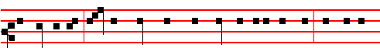
to comfort her: all her friends have dealt treacherously with her, they are be-

731

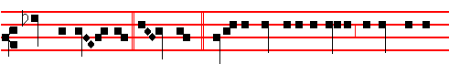
come her en - emies. Ghi - mel. Judah is gone into captivity, because of af-
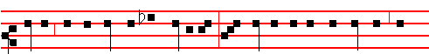
fliction, and because of great servitude: she dwelleth among the heathen, she
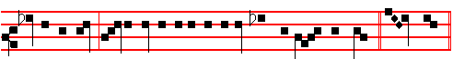
findeth no rest: all her persecutors overtook her between the straits. Daleth.

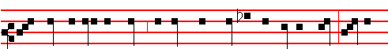
The ways of Sion do mourn, because none come to the solemn feasts: all her
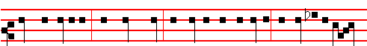
gates are desolate; her priests sigh, her virgins are afflicted, and she is in bit-
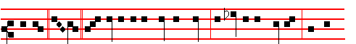
terness. He. Her adversaries are the chief, her enemies prosper; for the
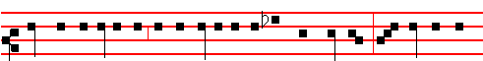
Lord hath afflicted her for the multitude of her transgressions: her children are

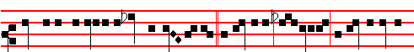
gone into captivity before the en- em-y. Jerusalem, Jer-usalem, return unto the

732
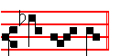
Lord thy God. Thus are ended the Lessons from the Lamentation during this Triduum.
 I . Tone viij.
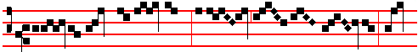
Upon the mount of Ol - ives he prayed to the Fath - er: Fath-
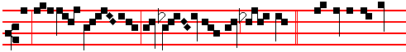
er, if it be pos - sible, let this cup pass from me: * The spirit indeed
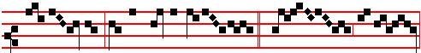
is wil - ling but the flesh is weak.  Watch and pray,
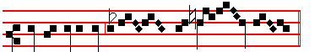
that ye enter not in-to temp- ta - tion. The spirit.

Lesson ij
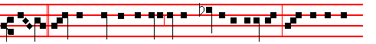
VAU. From the daughter of Sion all her beauty is departed: her princes are
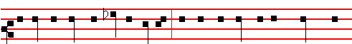
become like harts that find no pasture: and they are gone without strength be-
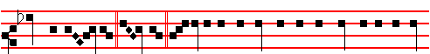
fore the pur-su-er. Za- in. Jer-usalem remembered in the days of her af-flic-

733
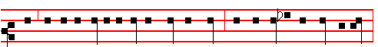
-tion and of her miseries all her pleasant things that she had in the days of old,
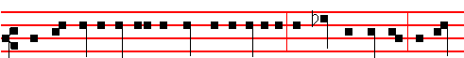
when her people fell into the hand of the enemy, and none did help her: the ad-
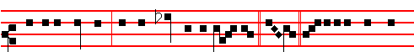
versaries saw her, and did mock at her sabbaths. Heth. Jerusalem hath grie-
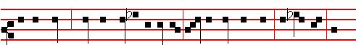
vously sinned; therefore she is removed: all that honoured her despise her, be-
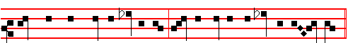
cause they have seen her nakedness; yea, she sigheth, and turneth back- ward.
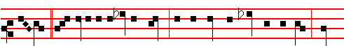
Teth. Her filthiness is in her skirts; she remembereth not her last end; there-
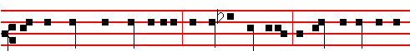
fore she came down wonderfully: she had no comforter. O Lord, behold my af-
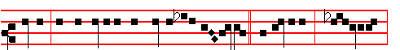
fliction; for the enemy hath magnifi-ed him - self. Je-ru-salem, Je- rusalem,
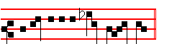
return unto the Lord thy God. 734
 II. Tone viij.
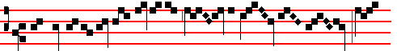
My soul is exceeding sorrowful, ev- en un - to death; tar-
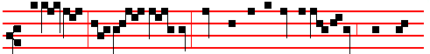
-ry ye here, and watch with me: now shall ye behold a multitude which will
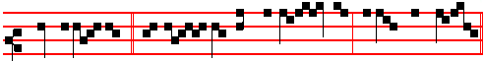
come about me: * Ye will flee and forsake me, and I shall go
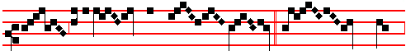
hence to be of - fered for you.  Be - hold,
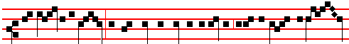
the hour is at hand, and the Son of man is betrayed into the hands of sin-
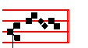
ners. Ye will flee.

Lesson iij
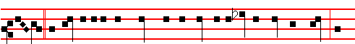
JOD. The adversary hath spread out his hand upon all her pleasant things: for
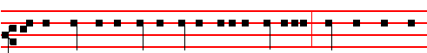
she hath seen that the heathen entered into her sanctuary, whom thou didst com-

735
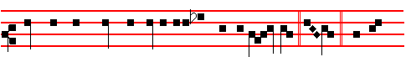
mand that they should not enter into thy congrega - tion. Caph. All her
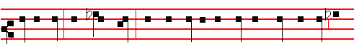
people sigh, they seek bread: they have given their pleasant things for meat to
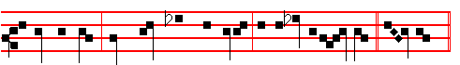
relieve the soul: see, Lord, and con - sid-er; for I am become vile. La-med.

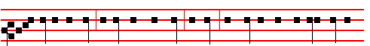
Is it nothing to you, all ye that pass by? behold, and see if there be any sorrow
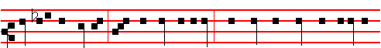
like unto my sorrow, which is done unto me, wherewith the Lord hath afflicted
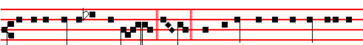
me in the day of his fierce anger. Mem. From above hath he sent fire into my
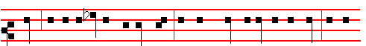
bones, and it prevaileth against them: he hath spread a net for my feet, he hath
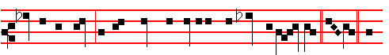
turned me back; he hath made me desolate and faint all the day. Nun. The

736
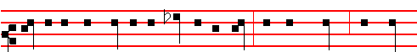
yoke of my transgressions is bound by his hand; they are wreathed, and come
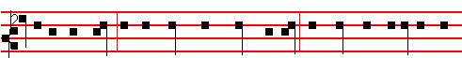
up upon my neck; he hath made my strength to fall, the Lord hath delivered me
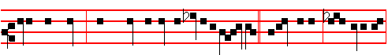
into their hands, from whom I am not able to rise up. Jeru-salem, Je-rusalem,
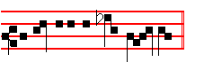
return unto the Lord thy God.

 III Tone v.
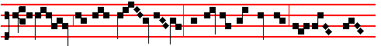
Behold we have seen him, and lo, he hath no form nor come- li-
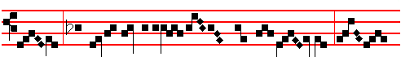
ness; there is no beauty in him, that we should de - sire him: he hath
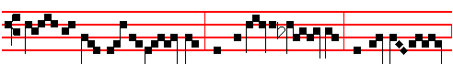
borne our sins and of-fen- ces, and for us he griev- eth: but he was
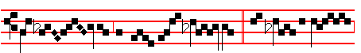
woun - ded for our trans-gres-sions, * And with his stripes

737
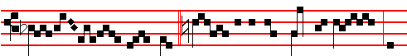
we are healed.  Sure- ly he hath borne our griefs, and
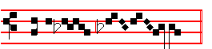
carried our sor- rows. And with.  Behold to the 
Antiphon 1 . IN THE SECOND NOCTURN Tone viij, 2.
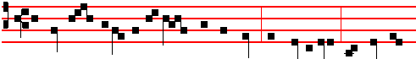
The Lord hath delivered the poor when he cried: the needy also, and him that
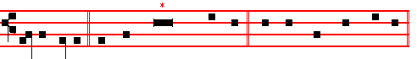
hath no helper. Psalm 72 Deus, judicium tuum. LXXI, ending slowly:
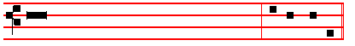
* and all the earth shall be filled with his Majesty. Amen, Amen.
Antiphon 2 Tone viij, 2.
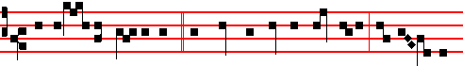
They imag-ine wick-edness, and speak of wicked blas-phemy: their talk - ing
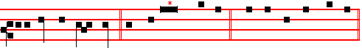
is against the Most High. Psalm 73 Quam bonus Israel. LXXII, ending slowly:
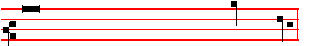
* and to speak of all thy works in the gates of the daughter of Syon.

738
Antiphon 3. Tone j, 1.
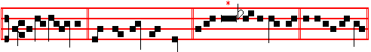
Arise, O Lord, and maintain my cause. Ps. 74 Ut quid, Deus ending slowly:
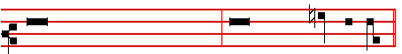
* the presumption of them that hate thee increaseth ever more and more.
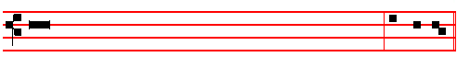
 Deliver me, O my God, out of the hand of the un-god- ly.
 Out of the hand of the unrighteous and cru-el man.

Our Father, secretly.
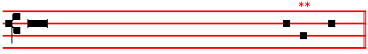
From the Treatise of Saint Augustine the Bishop, on the Psalms.

Lesson iv On Psalm 55:1
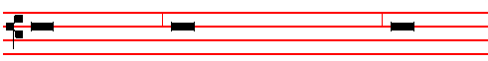
'HEAR my prayer, O God: and hide not thyself from my petition. Take heed unto
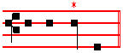
me, and hear me.'

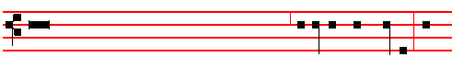
These are the words of an earnest and anxious man, beset by great trouble. He

* The punctum is sung thus. ** A monosyllabic word is sung thus.

739
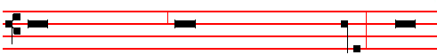
prayeth as one suffering much, and longing to be delivered from evil. It remaineth
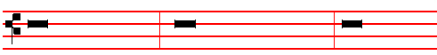
for us to see in what evil he is: and when he beginneth to tell us, to acknowledge
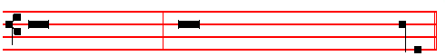
that we also suffer therefrom: that sharing his trouble, we may join in his prayer.
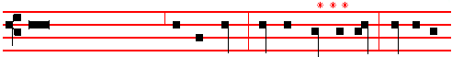
'I mourn,' saith he, 'in my trial, and am vexed,' Wherein mourneth he? Wherein is
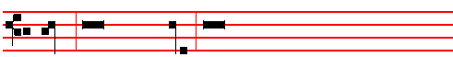
he vexed? He saith, 'In my tri-al,' He remembereth the wicked men whom he
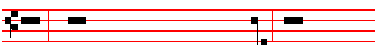
suffereth, and that sufferance of evil men he calleth his trial. Think ye not that the
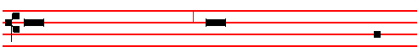
wicked are in this world for naught, and that God nowise doeth good through
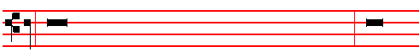
them. Every wicked man either liveth that he may be made righteous; or else he
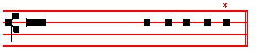
liveth that the righteous may be tried by him.
*** An interrogation is sung thus. 740 * Thus end the Lessons in this Triduum.
 IV Tone viij
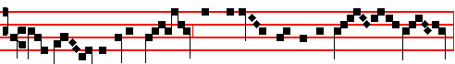
Mine own familiar friend hath betrayed me by the sign of a kiss:
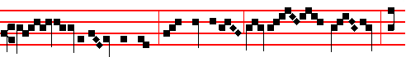
Whom-so-ever I shall kiss, that same is he; hold him fast: he
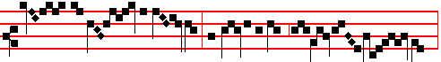
gave this wick- ed sig- nal, and so by a kiss accom-plished murder.
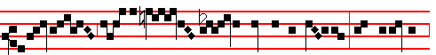
* Unhappy, he cast down the price of blood in the tem-ple, and departed,
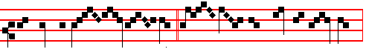
and went and hanged him- self.  It had been good for that man
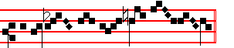
if he had not been born. Unhappy.

Lesson v Tone as above, pp. 739-740.
O WOULD to God, therefore, that they who now try us might be converted, and tried together with us! Nevertheless, as long as they continue to try us, let us not hate them: for we know not whether any one of them will endure to the end in his wickedness. And for the most part, when thou deemest thyself to be hating thine enemy, thou hatest thy brother, and knowest it not. The devil and his angels are pointed out to us in the holy Scriptures as doomed unto fire everlasting. Of their amendment alone need we despair, against whom we wage a hidden strife; to which strife the Apostle armeth us, saying, 'We wrestle not against flesh and blood' (that is, not against men whom ye may see,) 'but against principalities,

741
against powers, against the rulers of the darkness of this world.' He said not, 'the rulers of this world,' lest perchance thou shouldest deem that devils are the lords of heaven and earth: but he said, 'the rulers of the darkness of this world'; when he spake of the world, he meant the lovers of the world: ungodly and unrighteous men, he called the world: of that world he spake, whereof the Gospel saith, 'and the world knew him not'.

 V Tone ij
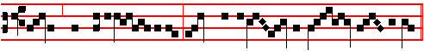
Judas, most evil traf - ficker, sought to betray the Lord with a kiss:
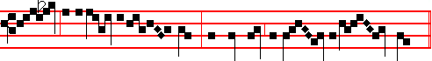
he, as an in - no-cent lamb, refused not the kiss of Jud- as: *
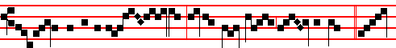
For thir- ty pieces of sil - ver, he be-trayed Christ to the Jews.  Bet-
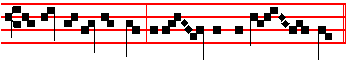
ter were it for that man if he had not been born. For thirty.

Lesson vj Tone as above, pp. 739-740
FOR I have spied unrighteousness and strife in the city.' Give heed unto the glory of the Cross itself. Now upon the brow of kings that Cross firmly resteth, which foes did once revile. Effect hath proven strength: it hath conquered the world not with the sword, but with wood. The wood of the Cross seemed worthy of scorn to his enemies, as they stood before that very wood, wagging their heads, and saying, 'If he be the Son of God, let him come down from the Cross! ' He stretched forth his hands unto a disobedient and gainsaying people. If he is just which liveth by faith, he that hath not faith is unrighteous. What then he calleth unrighteousness, know thou to be unbelief. Therefore the Lord 'spied unrighteousness and strife in the city' and 'stretched forth his hands unto a disobedient and gainsaying people': and yet, looking forth upon these very same,

742
he said; 'Father, forgive them, for they know not what they do.'

 VI Tone viij
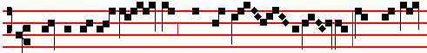
One of my dis- cip- les shall this day betray me: Woe un- to
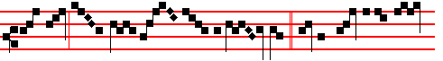
that man by whom I am betray- ed: * Better were it for that
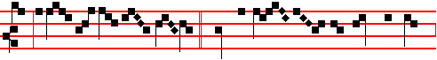
man if he had not been born.  He that dip - peth his hand with me
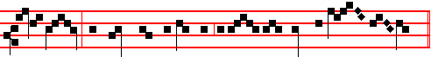
in the dish, the same shall betray me into the hands of sin - ners.

Better. One.
IN THE THIRD NOCTURN
Antiphon 1. Tone vij, 1.
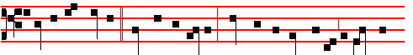
I said to the wicked, Deal not so madly: speak not unrighteously against the
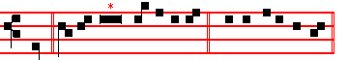
Lord. Psalm 75 Confitebimur E u o u a e. Ending slowly:
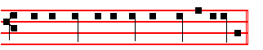
* and the horns of the righteous shall be exalted. 743
Antiphon 2. Tone viij, 2.
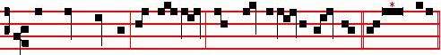
The earth trembled and was still, when God arose to judgment. Psalm 76
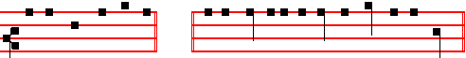
Notus in Judæa ending slowly: * and is wonderful among the kings of the earth.

Antiphon 3. Tone vij, 3.
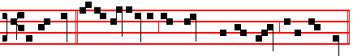
In the time of my tribulation, I stretched out my hands unto the Lord. Psalm
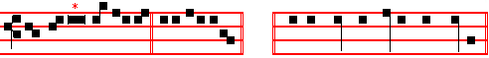
77 Voce mea ad Domimum. ending slowly: * by the hand of Moses and Aaron.
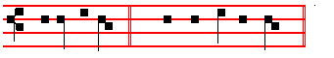
 Arise, O Lord.  And maintain my cause. Our Father secretly.
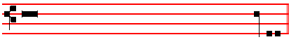
From the First Epistle of Saint Paul the Apostle to the Corinthians.
Lesson vij Ch. 11:17-34
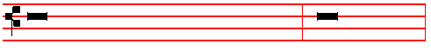
NOW in this that I declare unto you I praise you not, that ye come together,
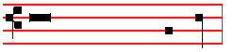
not for the better, but for the worse. Tone as above, p. 739-740

744
For first of all, when ye come together in the church, I hear that there be divisions among you; and I partly believe it. For there must be also heresies among you, that they which are approved may be made manifest among you. When ye come together therefore into one place, this is not to eat the Lord's supper. For in eating, everyone taketh before other his own supper: and one is hungry, and another is drunken. What? have ye not houses to eat and to drink in? or despise ye the church of God, and shame them that have not? : What shall I say to you? shall I praise you in this? I praise you not.

 VII Tone vij.
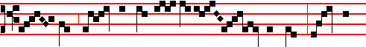
Be - hold, I was like an in- no - cent lamb; I was
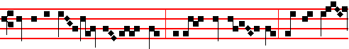
led to the sac- ri - fice, and I knew it not, that mine en-
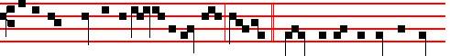
emies took counsel together against me, saying: * Come, let us destroy the tree
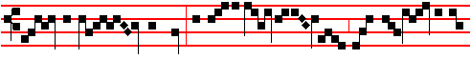
with the fruit thereof, and let us cut him off from the land of the
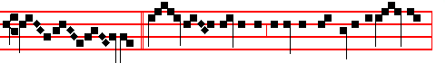
liv- ing.  All mine enemies imagined this evil against me;
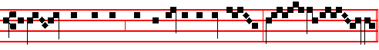
an un - just sentence they delivered against me, say - ing.
Come.

745
Lesson viij
FOR I have received of the Lord that which also I delivered unto you, That the Lord Jesus the same night in which he was betrayed took bread: and when he: had given thanks, he brake it, and said, Take, eat: this is my body, which is broken for you: this do in remembrance of me. After the same manner also he took the cup, when he had supped, saying, This cup is the new testament in my blood: this do ye, as oft as ye drink it, in remembrance of me. For as often as ye eat this bread, and drink this cup, ye do shew the Lord's death till he come.

 VIII Tone vij
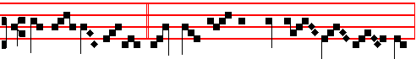
Wherefore sleep ye? What, could ye not watch with me one hour,
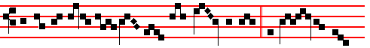
ye that exhorted each oth - er to die for me? * Or see ye not
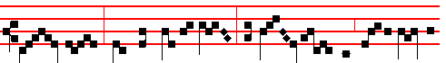
Jud - as, how he sleepeth not, but hast - en - eth to betray me
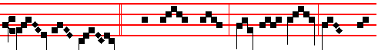
to the Jews? . Why sleep ye? Rise and pray, lest ye
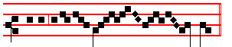
enter into tempta- tion. Or see.

Lesson ix
WHEREFORE whosoever shall eat this bread, and drink this cup of the Lord, unworthily, shall be guilty of the body and blood of the Lord. But let a man examine himself, and so let him eat of that bread, and drink of that cup. For he that eateth and drinketh unworthily, eateth and drinketh damnation to himself, not discerning the Lord's body. For this cause many are weak and sickly among you, and many sleep. For if we would judge ourselves, we should not be judged. But
746
when we are judged, we are chastened of the Lord, that we should not be condemned with the world. Wherefore, my brethren, when ye come together to eat, tarry one for another. And if any man hunger, let him eat at home: that ye come not together unto condemnation. And the rest will I set in order when I come.

 IX. Tone j.
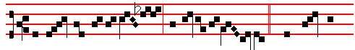
The eld- ers of the peo -ple consulted to-geth- er. * That they might
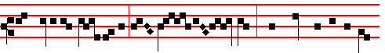
take Jesus by sub- til- ty and kill him: they came out as against
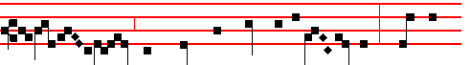
a thief with swords and staves for to take him.  The chief
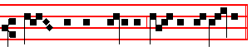
priests and the Pharisees gathered a council. That they. The elders.

AT LAUDS

Antiphon l. Tone viij, 1.
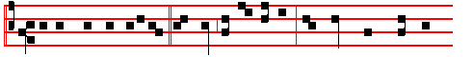
Mayest thou be justified, O Lord, in thy saying, and clear when thou art
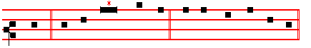
judged. Psalm 51 Miserere mei Deus p. 104, ending slowly:

747
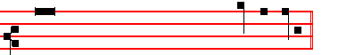
* then shall they offer young bullocks upon thine altar.
Antiphon 2. Tone ij
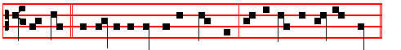
The Lord was led as a lamb to the slaughter: and he opened not his mouth.
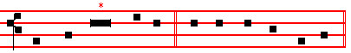
Psalm 90 Domine refugium, p. 158 , ending slowly:
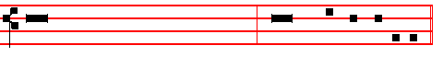
* prosper thou the work of our hands upon us, O prosper thou our handiwork.
Antiphon 3. Tone viij, 1.
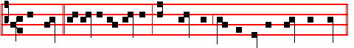
My heart within me is broken: and trembling maketh all my bones to shake.
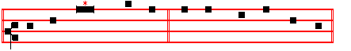
Psalms 63 ,67 Deus, Deus meus, p. 29, ending slowly:
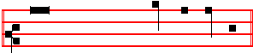
* and all the ends of the world shall fear him.
Antiphon 4. Tone iv, 1.
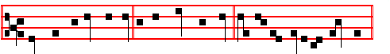
Thou dost encourage us by thy might, O Lord, and by thy holy refreshment.
748
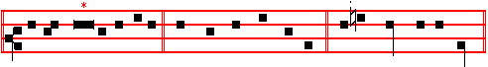
Canticle Cantemus Domino, p. 159, ending slowly: * in the midst of the sea.
Antiphon 5. Tone ij.
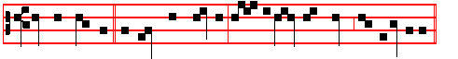
He was offered because he willed it: and himself hath borne our iniquities.
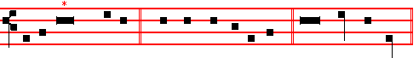
Psalms 148 149 150 Laudate Dominum, p. 33, ending slowly: * praise the Lord.
The Chapter and  are not said.
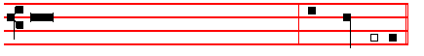
 Mine own familiar friend whom I trust - ed.
 Who did also eat of my bread, hath laid great wait for me.

On Benedictus, Antiphon. Tone j, 2.
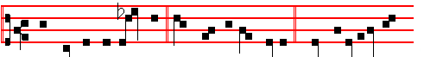
Now he that betrayed him gave them a sign, saying: Whomsoever I shall
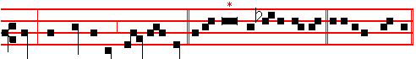
kiss, that same is he; hold him fast. Canticle Benedictus, p. 28, ending slowly:
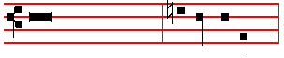
* and to guide our feet into the way of peace.
During the saying of the Canticle Benedictus, all the candles upon the triangular stand having first been put out, except the one placed at the top, the six candles

749
placed from the beginning upon the Altar are also extinguished one by one so that at the last verse the last candle is put out; the lamps and other lights throughout the
Church are likewise extinguished. As the Antiphon Now he that betrayed is being repeated, the topmost candle is taken from the candelabrum, and hidden under the Altar on the Epistle side. When the Antiphon has been repeated after Benedictus, is said
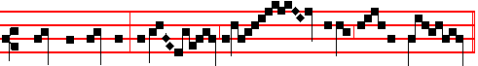
 Christ for our sake became obed - i-ent un- to death.
On the second night is added:
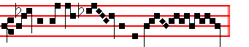
Ev - en the death of the cross. On the third night is added:
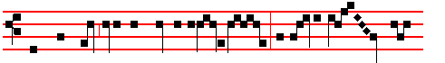
Wherefore God also hath highly exalt-ed him, and given him a
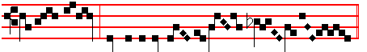
Name which is above eve -ry name.

And so it is said also through all the Hours of the day.

When the  Christ for our sake is begun, all kneel, and when it is ended, Our Father is said entirely in secret. Afterwards is said a little louder: Ps. 51 Miserere mei p.75.Which being ended, without Let us pray, is said in a like voice:

COLLECT
ALMIGHTY God, we beseech thee graciously to behold this thy family, for which our Lord Jesus Christ was contented to be betrayed, and given up into the hands of wicked men, and to suffer death upon the Cross, but Who liveth and reigneth with thee is said in silence.

The Collect being ended, some crack and clatter is made: and soon the lighted candle is brought from under the Altar, and all rise, and depart in silence.

750
AT THE HOURS

At Prime, Terce, Sext, and None, Our Father, Hail Mary, and at Prime I believe having been said secretly, they are begun at once with the usual Psalms, which at Prime are as on Feasts: which being ended, is said  Christ for our sake etc. kneeling: and secretly is said Our Father, the Psalm Miserere p.75, and the Collect, Almighty God, as in Lauds.

In this triduum nothing is read from the Martyrology, nor is Right dear in the sight said.
AT VESPERS

Vespers, when Our Father and Hail Mary have been said secretly, are begun immediately with the first Antiphon without singing.

Antiphon. I will receive the cup of salvation, and call upon the Name of the Lord. Psalm 116, v.10 Credidi.
Antiphon. I am for for peace, but when I speak unto them thereof, they make them ready for battle. Psalm 120 Ad Dominum.
Antiphon. Preserve me, O Lord, from the wicked men. Psalm 140 Eripe me, Domine.
Antiphon. Keep me from the snare that they have laid for me, and from the wicked doers. Psalm 141 Domine, clamavi
Antiphon. I looked also upon my right hand, and saw there was no man that would know me. Psalm 142 Voce mea

The Chapter, Hymn and  are not said in this triduum.

On Magnificat, Antiphon. As they were eating, Jesus took bread, and blessed it, and brake it, and gave it to his disciples.

 Christ for our sake, with the rest as in Lauds, p. 749.

At Compline is not said Bid, Lord, nor the Short Lesson, nor Our help, nor the Lord's Prayer, but the Confession and Absolution having been made, it is begun from the Psalm Hear me.
The Psalms having been said, Nunc Dimittis is said. Then  Christ for our sake, with the rest as at Lauds, p. 749

Thus are ended all Hours in this triduum, until Vespers of Holy Saturday.

751

__________________________________________________________________

IN THE FIRST NOCTURN
Antiphon 1. Tone viij, 1.
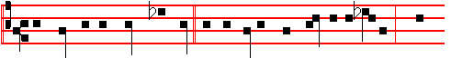
The kings of the earth stand up, and the rulers take counsel together a -
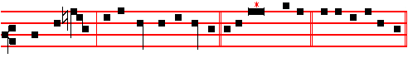
gainst the Lord, and against his Anointed. Psa1m 2 Quare fremuerunt
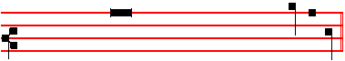
ending slowly: * blessed are all they that put their trust in him.
Antiphon 2. Tone viij, 1.
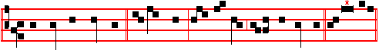
They part my garments among them, and cast lots upon my vesture. Psalm 22 Deus, Deus meus, ending slowly:
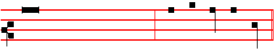
* unto a people that shall be born, whom the Lord hath made.
Antiphon 3. Tone viij, 1.
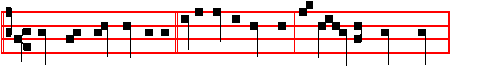
There are false witnesses risen up against me, and such as speak wrong.

752
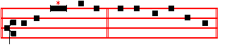
Psalm 27 Deus illuminatio mea , ending slowly:
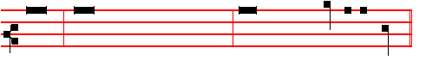
* be strong,and he shall comfort thine heart, and put thou thy trust in the Lord.
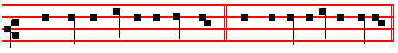
 They part my garments among them.  And cast lots upon my vesture.
Our Father secretly.
From the Lamentation of Jeremiah the Prophet.
Lesson j Chapter 2: 8-15
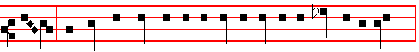
HETH. The Lord hath purposed to destroy the wall of the daughter of Sion;
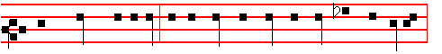
he hath stretched out a line, he hath not withdrawn his hand from destroying:
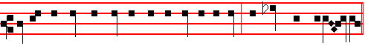
therefore he made the rampart and the wall to lament; they languished togeth-er
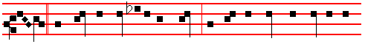
Teth. Her gates are sunk into the ground; he hath destroyed and broken her
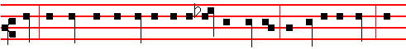
bars: her King and her princes are among the Gentiles: the law is no more; her

753
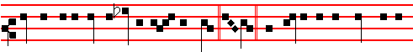
prophets also find no vision from the Lord. Jod. The elders of the daughter of
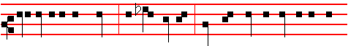
Sion sit upon the ground, and keep silence: they have cast up dust upon their
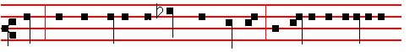
heads; they have girded themselves with sackcloth: the virgins of Jerusalem
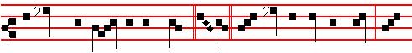
hang down their heads to the ground. Caph. Mine eyes do fail with tears, my
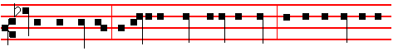
bowels are troubled, my liver is poured upon the earth, for the destruction of
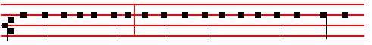
the daughter of my people; because the children and the sucklings swoon in
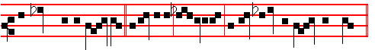
the streets of the ci - ty. Jerusalem, Jerusalem, return unto the Lord thy God.

 I Tone iij 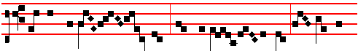
All mine acquaint - ance have forsak - en me, and they that

754
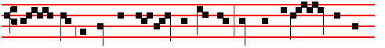
laid wait for me have prevailed against me; he whom I loved hath be-
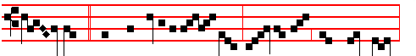
trayed me: * And with fury in their eyes, smit- ing me with cruel blows,
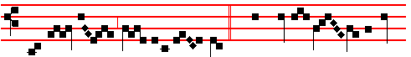
they gave me vin - egar to drink.  They cast me out among
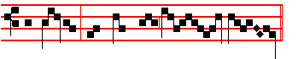
the wicked, and spared not my soul. And with fury.

Lesson ij
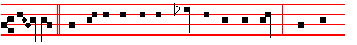
LAMED. They say to their mothers, Where is corn and wine? when they
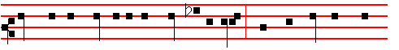
swooned as the wounded in the streets of the city, when their soul was poured
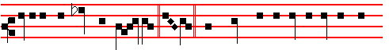
out into their mothers' bos- om. Mem. What thing shall I take to witness for
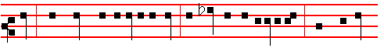
thee? what thing shall I liken to thee, O daughter of Jerusalem? what shall I

755
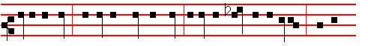
equal to thee, that I may comfort thee, O virgin daughter of Sion? for thy
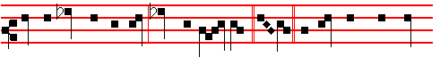
breach is great like the sea; who can heal thee? Nun. Thy prophets have seen
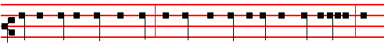
vain and foolish things for thee; and they have not discovered thine iniquity, to
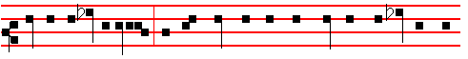
turn away thy captivity; but have seen for thee false burdens and causes of
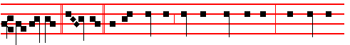 banishment. Samech. All that pass by clap their hands at thee; they hiss and
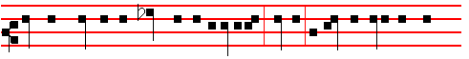
wag their head at the daughter of Jerusalem, saying, Is this the city that men
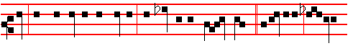
call The perfection of beauty, The joy of the whole earth? Jerusalem, Jerusa-
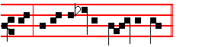
lem, return unto the Lord thy God.

 II Tone ij

756
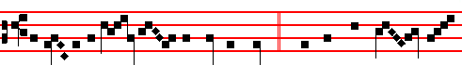
The veil of the tem - ple was rent in twain, * And the whole earth did
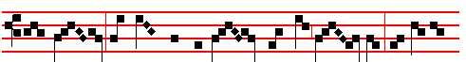
quake: the thief from the cross cried out, say - ing: Remember
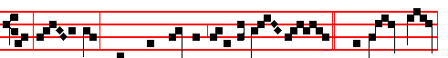
me, O Lord, when thou comest into thy king - dom .  The rocks rent,
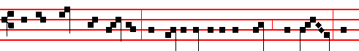
and the graves were opened; and many bodies of the saints which slept a-
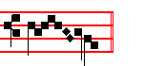
rose. And the whole earth.

Lesson iij Chapter 3: 1-9
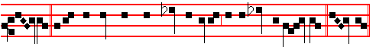
ALEPH. I am the man that hath seen affliction by the rod of his wrath. Aleph.
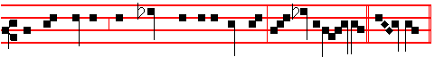
He hath led me, and brought me into darkness, but not into light. A- leph.
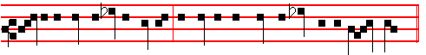
Surely against me is he turned; he turneth his hand against me all the day.

757
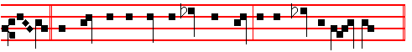
Beth. My flesh and my skin hath he made old; he hath broken my bones.
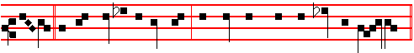
Beth. He hath builded against me, and compassed me with gall and tra-vail.
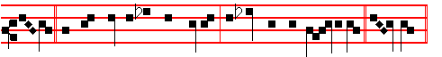
Beth. He hath set me in dark places, as they that be dead of old. Ghi - mel.
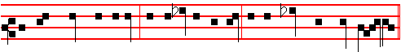
He hath hedged me about, that I cannot get out: he hath made my chain heavy.
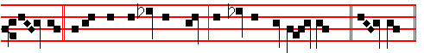
Ghi-mel. Also when I cry and shout, he shutteth out my prayer. Ghi - mel.
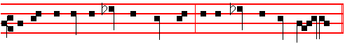
He hath inclosed my ways with hewn stone, he hath made my paths crooked.
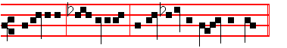
Jerusalem, Je - rusalem, return unto the Lord thy God.

 III Tone viij
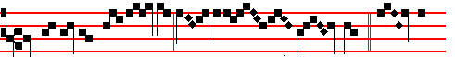
O my vineyard, my chosen, did I not plant thee? * How then

758
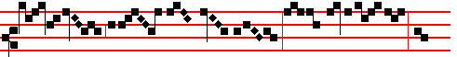
art thou turned into such bit - terness as to crucify me and
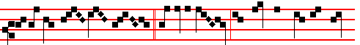
to release Bar- ab- bas?  I fenced thee, and gathered out the stones
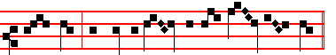
from thee, and built a tower in the midst of thee. How then.
O my vineyard.
IN THE SECOND NOCTURN
Antiphon 1. Tone viij, 1.
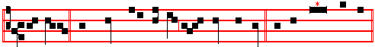
They also that sought after my life laid snares for me. Psalm 38 Domine,
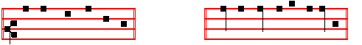
ne in furore p.102, ending slowly: * O Lord God of my salvation.
Antiphon 2. Tone iv, 1.
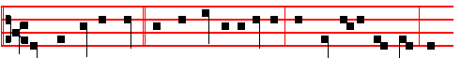
Let them be ashamed and confounded together, that seek after my soul to
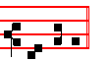
destroy it. Psalm 40 Expectans expectavi p. 112, ending slowly:
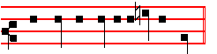
* make no long tarrying, O my God.

759
Antiphon 3. Tone iv, 1.
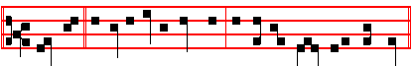
Strangers are risen up against me, and tyrants seek after my soul.
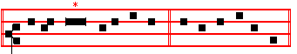
Psalm 54, Deus in nomine p .43, ending slowly:
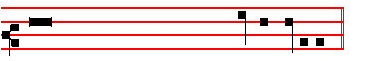
* and mine eye hath seen his desire upon mine enemies.
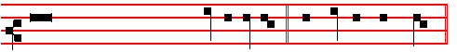
 There are false witnesses risen up against me.  And such as speak wrong.
Our Father secretly.
From the Treatise of Saint Augustine the Bishop, on the Psalms.
Lesson iv Ps. 64: 2
HIDE me from the gathering together of the froward, and from the insurrection of wicked doers. Tone as above, p. 739-740
NOW let us contemplate our Head himself. Many martyrs have suffered like things, but naught shineth out in such wise as the Head of the martyrs: in him we best perceive what they endured. He was hidden from the insurrection of the froward: God protected himself; the Very Son, with the manhood which he took upon him, protected his own flesh. For he is both Son of Man and Son of God: Son of God, being in the form of God; and Son of Man, being in the form of a servant, having power to lay down his life, and to take it again. What could his enemies do against him? They killed the body, the soul they killed not. Give heed: it were not enough for the Lord to encourage martyrs by his word, did he not strengthen them by his example.

 IV Tone viij
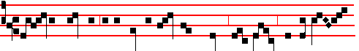
Are ye come out as against a thief with swords and staves, for to take

760
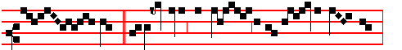
me? * I was daily with you in the tem- ple teach-ing,
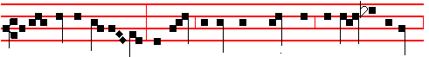
and ye laid no hold on me: and now, behold, ye scourge me, and lead me away
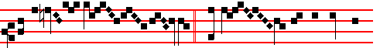
to be cru -ci - fied.  And when they had laid their
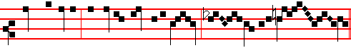
hands on Jesus, and taken hold upon him, he said unto them.
I was daily.

Lesson v
YE know what was 'the gathering together of the froward' Jews, and what was 'the insurrection of the wicked doers', What was their wicked deed? It was that they wished to kill the Lord Jesus Christ, ' Many good works,' saith he, 'have I shewed you; for which of them do you wish to kill me?' He bore all their infirmities, he healed all their sick, he preached unto them the kingdom of heaven; he held not his peace at their iniquities, so that they might rather hate the same, than the Physician who made them whole. Yet being unthankful for all these his remedies, like men frenzied with a great fever, they raved against the Physician who had come to heal them, and took counsel together to destroy him; as though they would therein prove whether he were very man, that could die; or somewhat more than man, and would not suffer himself to die. We perceive the saying of these men in the Wisdom of Solomon: 'Let us condemn him,' they say, 'with a shameful death. Let us examine him: for by his own saying he shall be respected. If he be truly the Son of God, let him deliver him.'
 V Tone vij
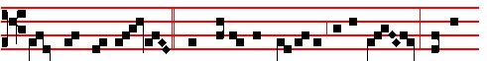
Now there was darkness, when Jesus was crucified by the Jews: and a-

761
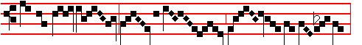
bout the ninth hour, Jes - us cried with a loud voice:
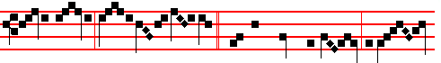
El- i, El- i, la - ma sabachthan-i. * And he bowed his head, and yield-
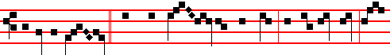
ed up the ghost.  And when Jes - us had cried with a loud voice, he
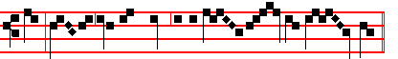
said: Fath-er, into thy hands I commend my spir - it.
And he bowed his head.

Lesson vj
THEY have whet their tongues like a sword.' Let not the Jews say, we did not kill Christ. For they delivered him up to Pilate the judge, to the end that they themselves should seem guiltless of his death. Thus when Pilate had said unto them, 'Take ye him, and crucify him;' they answered him, 'It is not lawful for us to put any man to death,' They desired to cast the injustice of their wicked deed upon a human judge: deceived they anywise God the Judge? What Pilate did, made him somewhat a partaker of their guilt: but in comparison with them he was much more innocent. For he did what he could to deliver him out of their hands, and therefore ordered him to be scourged and brought before them. He scourged not the Lord in persecution, but to satisfy their rage; that, when they saw him scourged, they might be touched with compassion, and cease to desire his death. This then he did. But when they persisted, ye know how he washed his hands, and said that he did it not himself, that he was innocent of his death. Nevertheless he did do it. But if he be guilty that did it against his will, shall they be innocent who compelled him to do it? By no means. He gave sentence upon him, and delivered him to be crucified, and thus in a manner slew him: but ye also, O Jews, have killed him. How did ye kill him? With the sword of the tongue: for ye have whet your tongue. And when smote ye, but when ye cried out, 'Crucify him, crucify him?'

762
 VI Tone viij
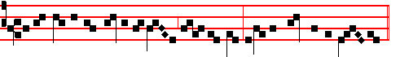
I have given the dearly belov - ed of my soul into the hand of the wick-ed:
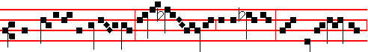
mine heritage is unto me as a li- on in the forest: mine ad-versar - y
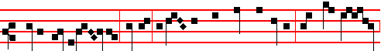
crieth out against me, saying: Assemble yourselves together, and make haste
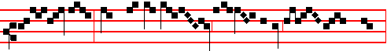
to devour him: they have set me in a des- olate wil - der - ness,
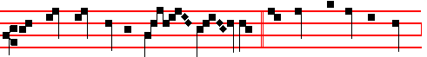 the whole land mourneth un - to me: * Because there is none found
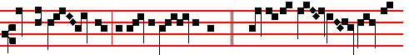
that will know me, or do me an- y good.  Merciless men rose up a-
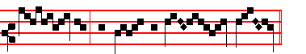
gainst me, and spared not my soul.

Because there. I have given.

IN THE THIRD NOCTURN
Antiphon 1. Tone j, 2.

763
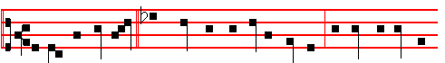
Defend me, O Lord, from them that rise up against me: for they are in pos-
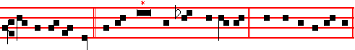
session of my soul. Psalm 59 Eripe me de inimicis ending slowly:
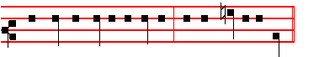
* for thou, O God, art my refuge, and my merciful God.
Antiphon 2. Tone viij, 1.
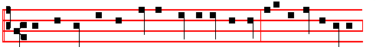
Thou hast put mine acquaintance far away from me: I am so fast in prison
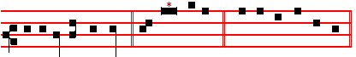
that I cannot get forth. Psalm 88 Domine Deus ending slowly:
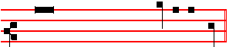
* and hid mine acquaintance out of my sight.
Antiphon 3. Tone viij, 1.
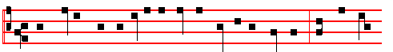
They gather them together against the soul of the righteous, and condemn
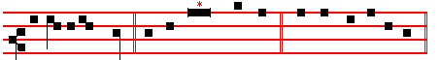
the innocent blood. Psalm 94 Deus ultionum ending slowly:
764
* yea, the Lord our God shall destroy them.

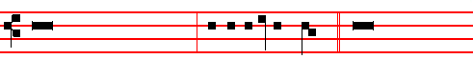
 They have spoken against me with a deceitful tongue.  They compassed
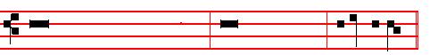
me about also with words of hatred, and fought against me without a cause.

Our Father secretly.

From the Epistle to the Hebrews Tone as above, p. 739-740
Lesson vij Chapter 4: 11-16
LET us labour therefore to enter into that rest, lest any man fall after the same example of unbelief. For the word of God is quick, and powerful, and sharper than any two-edged sword, piercing even to the dividing asunder of soul and spirit, and of the joints and marrow, and is a discerner of the thoughts and intents of the heart. Neither is there any creature that is not manifest in his sight: but all things are naked and opened unto the eyes of him with whom we have to do. Seeing then that we have a great high priest, that is passed into the heavens, Jesus the Son of God, let us hold fast our profession. For we have not an high priest which cannot be touched with the feeling of our infirmities; but was in all points tempted like as we are, yet without sin.

 VII Tone vj.
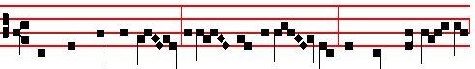
They have cast me out a-mong the un-god- ly, and turned me ov- er
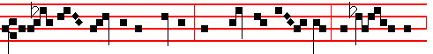
into the hands of the wicked, and spared not my soul: the migh- ty men

765
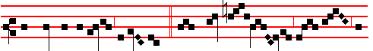
are gathered together against me: * They stood up against me ev- en as
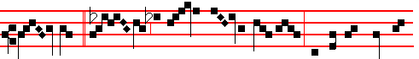
gi- ants.  Strangers are ris- en up against me, and tyrants seek af-
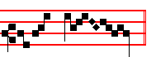
ter my soul. They stood up.

Lesson viij
LET us therefore come boldly unto the throne of grace, that we may obtain mercy, and find grace to help in time of need. For every high priest taken from among men is ordained for men in things pertaining to God, that he may offer both gifts and sacrifices for sins: who can have compassion on the ignorant, and on them that are out of the way; for that he himself also is compassed with infirmity. And by reason hereof he ought, as for the people, so also for himself, to offer for sins.

 VIII Tone vj
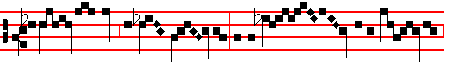
A wic - ked man betrayed Jes- us to the chief priests & the rul - ers,
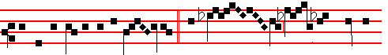
and to the elders of the peo - ple: * But Pet - er foll - owed him a-
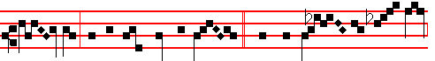
far off, that he might see the end.  And they led him a - way

766
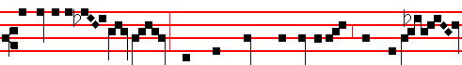
to Caiaphas the high priest, where the scribes and Pharisees were assem -
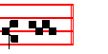
-bled. But Peter.
Lesson ix
AND no man taketh this honour unto himself, but he that is called of God, as was Aaron. So also Christ glorified not himself to be made an high priest; but he that said unto him, Thou art my Son, to-day have I begotten thee. As he saith also in another place, Thou art a priest for ever after the order of Melchisedech. Who in the days of his flesh, when he had offered up prayers and supplications with strong crying and tears unto him that was able to save him from death, and was heard in that he feared; though he were a Son, yet learned he obedience by the things which he suffered; and being made perfect, he became the author of eternal salvation unto all them that obey him; called of God an high priest after the order of Melchisedech.
 IX. Tone vj.
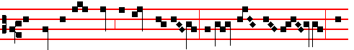
The sight of mine eyes is gone from me, because of my weep- ing: for
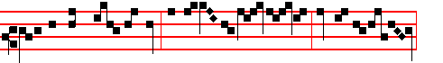
he is removed far from me, that alone did com-fort me: O all ye peo - ple,
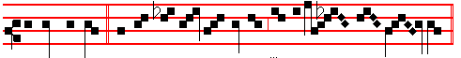
behold and see * If there be an - y sorrow like unto my sor - row.
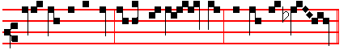
 Is it nothing to you, all ye that pass by? Behold and see. If there.
The sight.
767
AT LAUDS
Antiphon 1. Tone vij, 1.
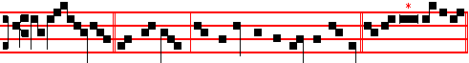
God spared not his own Son, but delivered him up for us all. Psalm 51
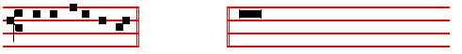
Miserere, p. 104, ending slowly * Then shall they offer young bullocks
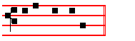
upon thine altar.
Antiphon 2. Tone iv, 1.
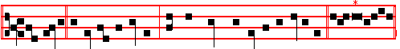
My spirit is vexed within me: and my heart within me is desolate. Psalm
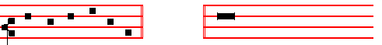
43 Judica me, Deus, p. 123, ending slowly: * for I will yet give him thanks, which
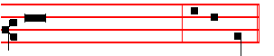
is the help of my countenance, and my God..
Antiphon 3. Tone j, 1.
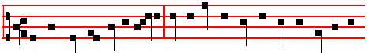
Said the one thief to the other, We indeed receive the due reward of our
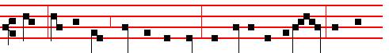
deeds; but this man, what hath he done? Remember me, O Lord, when thou

768
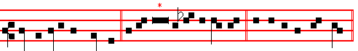
comest into thy kingdom. Psalms 63 67 Deus, Deus meus, p. 29,
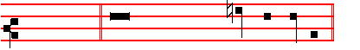
ending slowly: * and all the ends of the world shall fear him.
Antiphon 4. Tone j, 1.
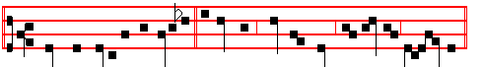
When my spirit is disquieted within me, thou, O Lord, remember merc- y.
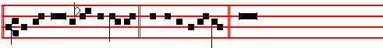
Canticle Domine, audivi, p.177, ending slowly: * and he will make me to walk
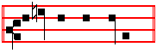
upon mine high places.
Antiphon 5. Tone viij, 1
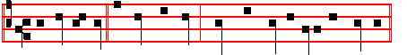
.Remember me, O Lord my God, when thou comest into thy kingdom.
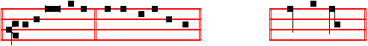
Psalms 148 149 150 Laudate Dominum, p. 33, ending slowly: * praise the Lord.
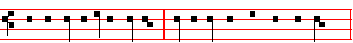
 He hath laid me in the darkness.  As the men that have been long dead.

On Benedictus, Antiphon. Tone j, 2.
769

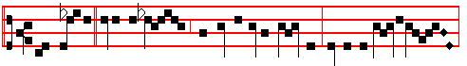 They set up over his head his accusation written: Jesus of Naz-a-reth,
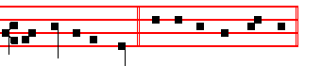
the King of the Jews. Canticle Benedictus, p. 37.

 Christ for our sake became obedient unto death, even the death of the cross. Our Father, secretly. Psalm Miserere, p. 104, and Collect Almighty God, p. 750.

At Vespers, Antiphons and Psalms of the previous day are said without singing, p. 751.
On Magnificat, Antiphon. When he had received the vinegar, he said, It is finished: and he bowed his head, and gave up the ghost.

 Christ for our sake, and the rest as above at Lauds.
__________________________________________________________________


_______________________________________________________________________

IN THE FIRST NOCTURN

Antiphon 1. Tone viij, 1.
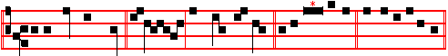
I will lay me down in peace, and take my rest. Psalm 4 Cum invocarem

ending slowly:
770
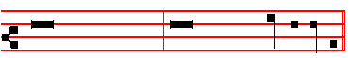
* For it is thou, Lord, only, that makest me dwell in safety.
Antiphon 2. Tone iv, 1.
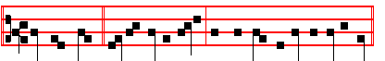
He shall dwell in thy tabernacle: he shall rest upon thy holy hil1.
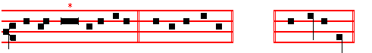
Psalm 15 Domine, quis habitabit ending slowly: * shall never fall.
Antiphon 3. Tone vij, 1.
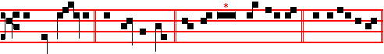
My flesh al - so shall rest in hope. Psalm 16 Conserva me, Domine, p.15
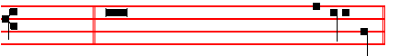
ending slowly: * and at thy right hand there is pleasure for evermore.
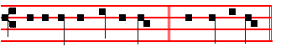
 I will lay me lawn in peace.  And take my rest. Our Father, secretly
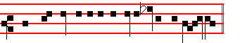
From the Lamentation of Jeremiah the Proph-et.
Lesson j Chapter 3: 22-30
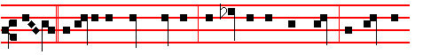
HETH. It is of the Lord's mercies that we are not consumed, because his
771
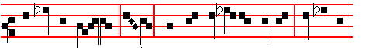
compassions fail not. Heth. They are new every morning: great is thy
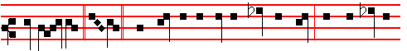
faithful - ness. Heth. The Lord is my portion, saith my soul; therefore will I
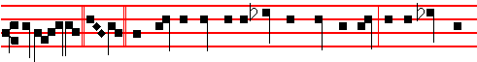
hope in him. Teth. The Lord is good unto them that wait for him, to the soul that
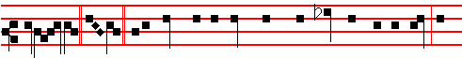
seeketh him. Teth. It is good that a man should both hope and quietly wait for
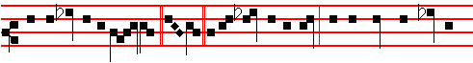
the salvation of the Lord. Teth. It is good for a man that he bear the yoke in
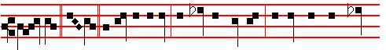
his youth. Jod. He sitteth alone and keepeth silence, because he hath borne
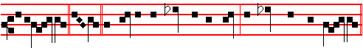
it upon him. Jod. He putteth his mouth in the dust; if so be there may be hope.

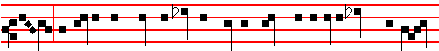

Jod. He giveth his cheek to him that smiteth him: he is filled full with re-

772
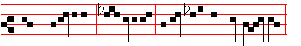
-proach. Jerusalem, Je - rusalem, return unto the Lord thy God.

 I Tone iv
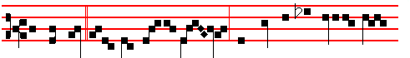
He was led as a lamb to the slaught-er, and while he was evil en- treat-
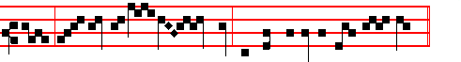
ed, he opened not his mouth: he was delivered un - to death.
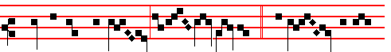
* That he might give life unto his peo-ple.  He poured out his
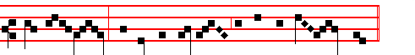
soul unto death, and he was numbered with the transgres- sors.
That he might.

Lesson ij Chapter 4:1-6
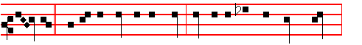
ALEPH. How is the gold become dim! how is the most fine gold changed!

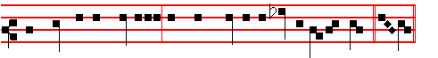
The stones of the sanctuary are poured out in the top of every street. Beth.

773
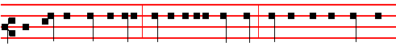
The precious sons of Sion, comparable to fine gold, how are they esteemed as
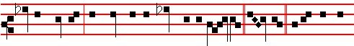
earthen pitchers, the work of the hands of the pot- ter. Ghimel. E-ven the sea
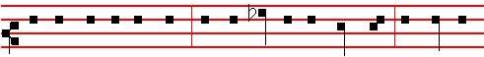
monsters draw out the breast, they give suck to their young ones: the daughter
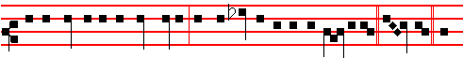
of my people is become cruel, like the ostriches in the wilderness. Daleth. The
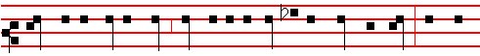
tongue of the sucking child cleaveth to the roof of his mouth for thirst: the young
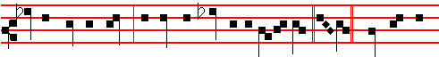
children ask for bread, and no man breaketh it unto them. He. They that did
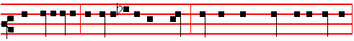
feed delicately are desolate in the streets: they that were brought up in scarlet
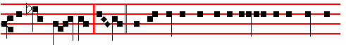
embrace dung- hills. Vau. For the punishment of the iniquity of the daughter
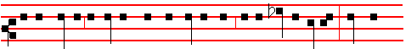
of my people is greater than the punishment of the sin of Sodom, that was

774
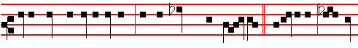
overthrown as in a moment, and no hands stayed on her. Jerusalem, Je- ru-
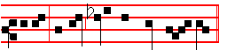
salem, return unto the Lord thy God.

 II Tone v.
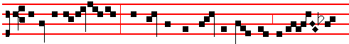
Arise, O Jeru- sal-em, and put off from thee the garments of joy and
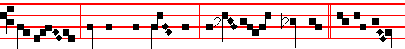
gladness: gird thee with sackcloth, and lie in ash - es: * For the Sav-
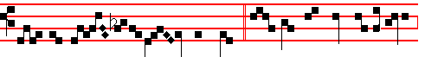
iour of Is - ra-el hath been slain.  Let tears run down like a river
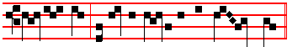
day and night: let not the apple of thine eye cease. For the Saviour.

Lesson iij Chapter 5:1-11
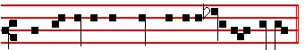
Here beginneth the Prayer of Jeremiah the Prophet.
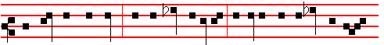
REMEMBER, O Lord, what is come upon us: consider, and behold our re-

775
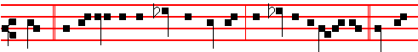
proach. Our inheritance is turned to strangers, our houses to a- li- ens. We are
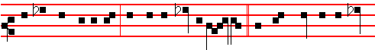
orphans and fatherless, our mothers are as wid-ows. We have drunken our wa-
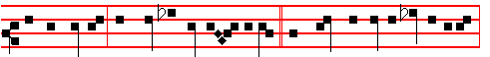
ter for money; our wood is sold un - to us. Our necks are under persecution:
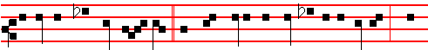 we labour, and have no rest. We have given the hand to the Egyptians, and
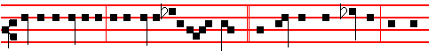
to the Assyrians, to be satisfi-ed with bread. Our fathers have sinned, and are
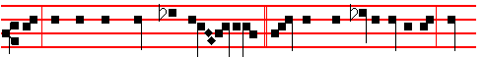
not; and we have borne their ini - quities. Servants have ruled over us: there
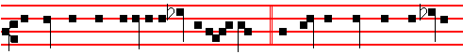
is none that doth deliver us out of their hands. We gat our bread with the peril
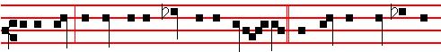
of our lives because of the sword of the wil-derness. Our skin was black like an
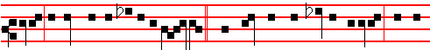
oven because of the terrible fam-ine.They ravished the women in Sion, and the

776
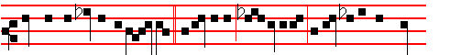 maids in the cities of Jud- ah. Jer-usalem, Jer- usalem, return unto the Lord
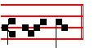
thy God.
 III Tone v.
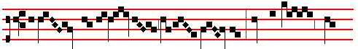
Lament like a vir- gin, O my peo - ple: cry and howl, ye
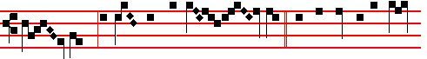
shep- herds, in sackcloth and ash - es: * For the day of the Lord
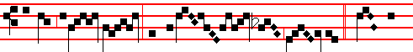
is nigh, a great day and exceed- ing bit - ter.  Gird your-
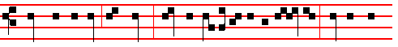
selves and lament, ye priests: howl, ye ministers of the al - tar; wallow your-
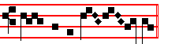
selves in the ash - es. For the day. Lament.

IN THE SECOND NOCTURN
Antiphon 1. Tone v.
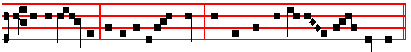
Be ye lift up, ye everlasting doors, and the King of glory shall come in.

777
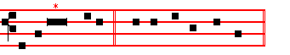
Psalm 24 Domini est terra p. 55, ending slowly:
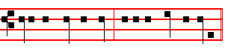
* even the Lord of hosts, he is the King of glory.
Antiphon 2. Tone iv, 1.
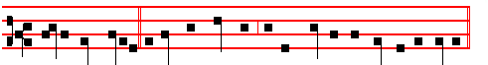
I believe verily to see the goodness of the Lord in the land of the living.
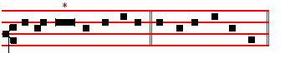
Psalm 27 Dominus iIluminatio p. 90, ending slowly:
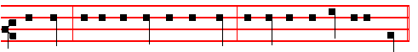
* be strong, and he shall comfort thine heart, and put thou thy trust in the Lord.
Antiphon 3. Tone viij, 1.
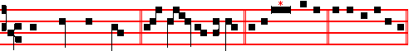
Thou, Lord, hast brought my soul out of hell. Psalm 30 Exaltabo te, Domine
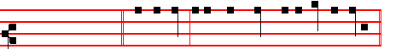
p.92, ending slowly: * O my God, I will give thanks unto thee for ever.
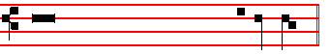
 But thou, O Lord, have mercy upon me.
 Raise thou me up again, and I shall reward them.

778
Our Father secretly.

From the Treatise of Saint Augustine, Bishop, on the Psalms.
Lesson iv Ps 64: 6, 7
MAN shall come to a deep mind, and God shall be exalted. (Accedet homo ad cor altum, et exaltabitur Deus.) Tone as above, p. 739-40.
THEY said: 'No man shall see us. The diligent searchers out of evil counsels have failed.' A Man came to these very counsels, and suffered himself to be laid hold upon, as Man. For he could not have been held had he not been Man: neither could he have been seen, had he not been Man: nor been scourged, had he not been Man: nor been crucified, nor died, had he not been Man. As Man therefore, he came to all these sufferings, which would have availed naught against him, had he not been Man. But had he not been Man, man could nowise have been redeemed. He came, as Man, 'to a deep mind', - that is, to a secret mind; shewing the Manhood to the eyes of men, and keeping the Godhead hidden within: concealing the form of God, wherein he is equal to the Father, and presenting the form of a servant, wherein he is inferior to the Father.

 IV. Tone vij
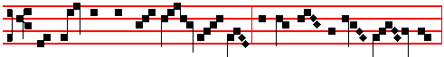
Our Shepherd hath withdrawn him- self , the Fountain of living wat - er,
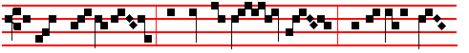
at whose departure the sun was dark- ened: * For he also is
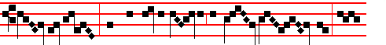
led captive, who had taken captive our first par- ent: to-
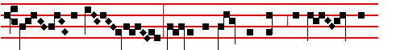
day hath our Sav- iour broken the gates of death, and burst the
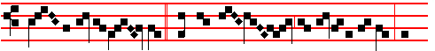
bars thereof asund - er.  He hath destroyed the barriers of hell, and

779
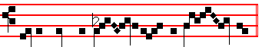
overthrown the pow- er of the dev - il. For he also.

Lesson v
HOW far did they carry those diligent searchings, wherein they failed so much, that even after the Lord was dead and buried, they set a watch over the sepulchre? For they said to Pilate: 'That deceiver' (by the which name the Lord Jesus Christ was called, to the comfort of his servants when they are called deceivers), 'that deceiver', say they to Pilate, 'said, while he was yet alive, After three days I will rise again. Command therefore that the sepulchre be made sure until the third day, lest his disciples come by night, and steal him away, and say unto the people, He is risen from the dead: so the last error shall be worse than the first. Pilate said unto them, Ye have a watch: go your way, make it as sure as ye can. So they went, and made the sepulchre sure, sealing the stone, and setting a watch.'
 V Tone viij.
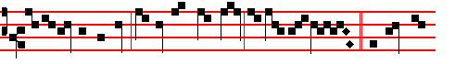
Is it nothing to you, all ye that pass by? Behold and see * If there be
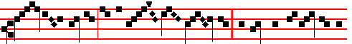
an - y sorrow like unto my sor - row.  Behold, and consider my
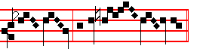
re - proach, O all ye peop - les. If there be.

Lesson vj
THEY set a watch of soldiers over the sepulchre. The earth shook: the Lord rose again. Such wonders were wrought about the sepulchre that the very soldiers who kept watch might be witnesses thereto, would they declare the truth. But the same covetousness that led captive a disciple and fellow of Christ enslaved also the guard set to watch his tomb. We will give you money,' said the chief priests, 'and say ye, that his disciples came and stole him away while ye

780
slept.' Verily, 'the diligent searchers out have failed.' What is this thou sayest, O sterile cunning? Dost thou so far forsake the light of prudence and justice, and plunge thyself so deep in guile, as to speak thus: 'Say ye that his disciples came and stole him away while ye slept.' Thou callest upon sleeping witnesses: surely thou hast fallen asleep thyself, seeing thou hast 'failed in searching out' so notable a matter.

 VI. Tone iv.
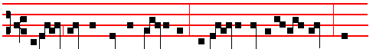
Behold how the righteous perisheth, and no man layeth it to heart: and

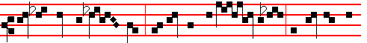
upright men are tak - en, and no man consid - ereth: the righteous is
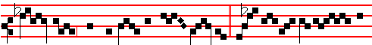
tak - en from the presence of ev - il: * And he shall en-ter in-

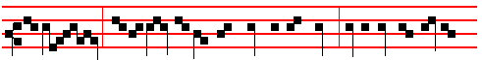
to peace.  As a lamb before her shearers is dumb, so he opened not his

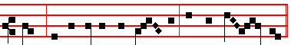
mouth: he was taken from pris - on and from judg - ment. And he. Behold.

IN THE THIRD NOCTURN
Antiphon 1. Tone viij, 1.
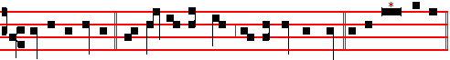
God is my helper, the Lord is with them that uphold my soul. Ps. 54 Deus, in

781
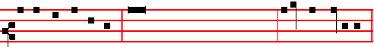
nomine, ending slowly: * and mine eye hath seen his desire upon mine enemies.
Antiphon 2. Tone vij. 3.
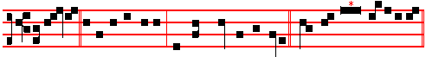
At Salem is his tabernacle, and his dwelling in Sion. Psalm 76 Notus in
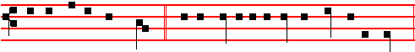
Judæa, p. 150, ending slowly: * and is wonderful among the kings of the earth.
Antiphon 3. Tone iv, 3.
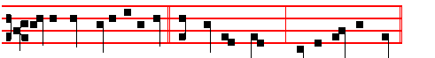
I have been even as a man that hath no strength; free among the dead. Ps.
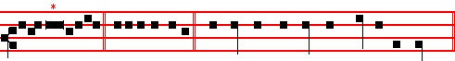
88 Domine Deus p. 169, ending: * and hid mine acquaintance out of my sight.
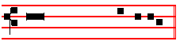
 At Salem is his tabernacle.
 And his dwel - ling in Sion. Our Father secretly.

From the Epistle to the Hebrews Tone as above, p. 739-40.
Lesson vij Chapter 9: 11-22
CHRIST being come an high priest of good things to come, by a greater and more perfect tabernacle, not made with hands, that is to say, not of this building; neither by the blood of goats and calves, but by his own blood he entered in once into the holy place, having obtained eternal redemption for us. For if the blood of bulls and of goats, and the ashes of an heifer sprinkling the unclean, sanctifieth to the purifying of the flesh: how much more shall the blood of Christ, who through the eternal Spirit offered himself without spot to God, purge your

782
conscience from dead works to serve the living God?
 VII Tone viij.
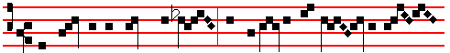
The kings of the earth stand up, and the rulers take coun - sel to-
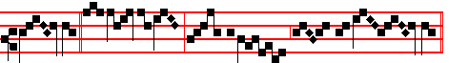
geth - er * Against the Lord, and a-gainst his A-noint- ed.
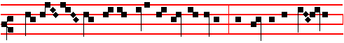
 Why do the heathen so furiously rage together? and why do the peop- le
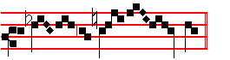
imag- ine a vain thing? Against.

Lesson viij
AND for this cause he is the mediator of the new testament, that by means of death, for the redemption of the transgressions that were under the first testament, they which are called might receive the promise of eternal inheritance. For where a testament is, there must also of necessity be the death of the testator. For a testament is of force after men are dead: otherwise it is of no strength at all while the testator liveth. Whereupon neither the first testament was dedicated without blood.

 VIII Tone iv 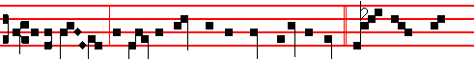
I am counted as one of them that go down into the pit: * And I have
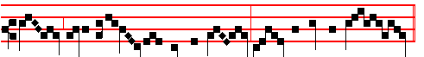
been even as a man that hath no strength, free among the dead.

783
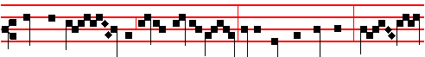
 Thou hast laid me in the lowest pit, in a place of darkness, and in
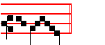
the deep. And I.
Lesson ix
FOR when Moses had spoken every precept to all the people according to the law, he took the blood of calves and of goats, with water, and scarlet wool, and hyssop, and sprinkled both the book, and all the people, saying, This is the blood of the testament which God hath enjoined unto you. Moreover, he sprinkled with blood both the tabernacle and all the vessels of the ministry. And almost all things are by the law purged with blood; and without shedding of blood is no remission.
 IX Tone ij
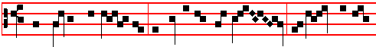
When Jesus was bur - ied, the sepulchre was sealed: and rol - ling a
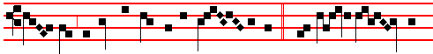
great stone before the door of the sep - ulchre, * They set a band of
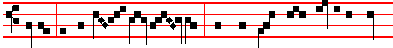
soldiers to keep watch ov - er him.  The chief priests and Pharisees came
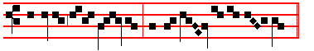
together unto Pi - late, and besought of him a watch. They set.
When Jesus.

AT LAUDS

Antiphon 1. Tone iv, 1.
784
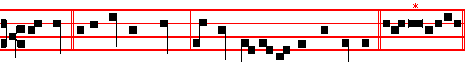
O death, I will be thy plagues: O grave, I will be thy destruction. Psalm 51
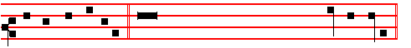
Miserere , p.104, ending * then shall they offer young bullocks upon thine altar.
Antiphon 2. Tone iv, 1.
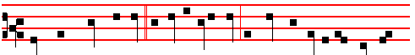
They shall mourn for him as for an only son; because the innocent Lord has
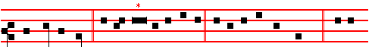
been put to death. Psalm 43 Judica me, Deus, p. 122 , ending slowly: * for I
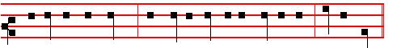
will yet give him thanks, which is the help of my countenance, and my God.
Antiphon 3. Tone vij, 1.
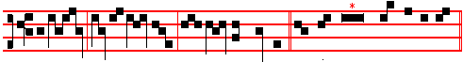
Behold, all ye nat-ions, and see my sorrow. Psalms 63 67 Deus, Deus
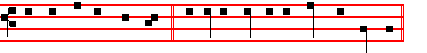
meus, p. 29, ending slowly: * and all the ends of the world shall fear him.
Antiphon 4. Tone ij.
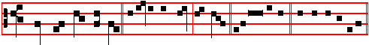
From the gate of hell, deliver my soul, O Lord. Canticle Ego dixi, p. 123,
ending slowly:

785
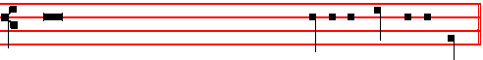
* therefore we will sing my songs to the
stringed instruments all the days of our life in the house of the Lord.
Antiphon 5. Tone viij, 2.
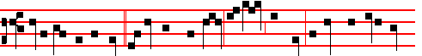
Is it nothing to you, all ye that pass by? behold, and see if there be any sor-
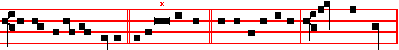
-row like unto my sorrow. Pss 148-150 Laudate , p.33, ending * praise the Lord.
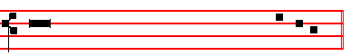
 My flesh shall rest in hope.
 And thou wilt not suffer thy Holy One to see corruption.

On Benedictus, Antiphon. Tone j, 2.
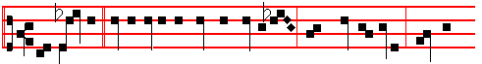
The women, sitting over against the sepulchre, made lamentation, weeping
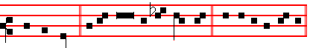
for the Lord. Canticle Benedictus, p. 209.

 Christ for our sake became obedient unto death, even the death of the cross: wherefore God also hath highly exalted him, and given him a Name which is above every name.

Our Father, secretly. Psalm 51 Miserere, p.15, and the Collect Almighty God, p. 733. And thus it is said until None.

786
Antiphon Tone vj
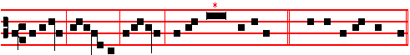
Alleluia, allelu- ia, alle-luia. Ps. 117 Laudate Dominum. E u o u a e.
And the Antiphon is repeated Alleluia, alleluia, alleluia.
The Chapter, Hymn and  are not said.
On Magnificat, Antiphon. * Tone viij.
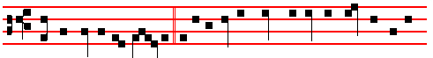
IN the end of the Sabbath, as it began to dawn toward the first day of the
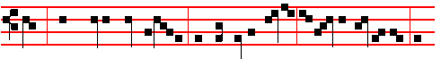
week, came Mary Magdale- ne and the other Mary to see the se-pulchre, al-
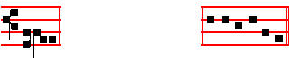
leluia. Cant. Magnificat, p. 211, E u o u a e, with Glory be to the Father.
And the Antiphon is repeated In the end of the Sabbath.
Then the Priest says: The Lord be with you. Let us pray.
COLLECT
POUR forth upon us,O Lord, the spirit of thy charity: that as thou hast fulfilled us with these paschal sacraments, so of thy goodness thou wouldest make us to be of one heart and mind. Through. in the unity of the same Holy Spirit.
Then The Lord be with you.
Afterwards the Deacon, turning himself towards the people, sings:
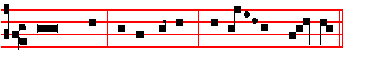
Ite, missa est, al- le- lu- ia, al- le - lu - ia.
 Thanks be to God, al- le- lu- ia, al- le - lu - ia.

787

* Or, as noted in the Missal for the intonation: see below at Compline, p. 784.

¶ Out of choir, after Our Father and Hail Mary have been said, Vespers are begun at once with the Antiphon Alleluia, with the rest as above, and in place of Ite, missa est, alleluia, alleluia, is said  Let us bless the Lord, alleluia, alleluia.
 Thanks be to God, alleluia, alleluia.
Then is added Our Father, and nothing else.

¶ At Compline the  Bid, Lord. The short Lesson Brethren, be sober,  Our help, Our Father, and after the Confession and Absolution, is said  Turn thou us,  O God, make speed, Glory be, and no longer is said Praise be to thee, O Lord, King of eternal glory, but in its place henceforth is said Alleluia.

Then without Antiphon are said the accustomed Tone viij. 1.
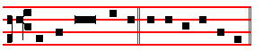
Psalms 4, 31, 1-6, 91, 134, E u o u a e.
The Chapter,  and Hymn are not said.
On Nunc Dimittis, Antiphon. Tone viij, (as above, p.787, or:)
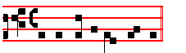
IN the end of the Sabbath * as in the Missal, and the rest as above. p. 787.
 The Lord be with you.  And with thy spirit.
Collect Visit, we beseech thee, p. 131

 The Lord be with you.  And with thy spirit.
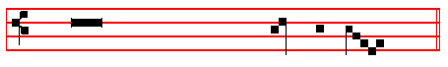
 Let us bless the Lord.
 Thanks be to God.

Blessing. - The Almighty, p.258
Antiphon. Joy to thee, O Queen of heaven, alleluia. p. 261.

¶ And there is no kneeling throughout all of Eastertide.

788

