CONCERNING THE YEAR AND ITS PARTS

THE year has twelve months, fifty-two weeks and one day: and three hundred and sixty-five days, and almost six hours; for in such an imterval of time the Sun shines through the Zodiac. But four times six hours makes a day every four years; hence that year is called the intercalated, leap, or bissextile.

OF THE CORRECTION OF THE YEAR,
and its Necessity and the Gregorian Calendar
AS to what was said, that the year contains three hundred and sixty-five days, and almost six hours, it is to be understood, that the six hours are not complete, since a few minutes are lacking from their total.
By the neglect of which minutes, it has gone on as if the year contained a whole six hours more than 365 days: and it has come to pass, that the minutes, which were ascribed to each year beyond the due quantity, have so grown in the course of time, that added together they amounted to ten days; and they caused the vernal equinox to change its position.
To remedy this evil, Gregory XIII not only restored the vernal equinox to its original place, from which, since the Council of Nicæa, it had already moved forward about ten days by 1582, the year of correction, having been determined by the Council as the 21st of March, and replaced the 14th paschal moon in its position; But also gave a way and method, by which it should be ensured, that henceforth both the vernal equinox and the 14th paschal moon should never move from their proper positions.
For to restore the vernal equinox to the 21st of March, he determined, that the said ten days should ae omitted in the month of October of the same year 1582, so that after the fourth day of October devoted to Saint Francis, the following day should be not the fifth, But the fifteenth of October. And so the error, which in the past had crept in in the cycles of so many years, was corrected in a moment of time.
But so that the same error should be avoided in the future, and the vernal equinox should not move from the 21 st of March, the same Gregory determined, that the leap year every fourth year (as is customary) should be continued, except in every hundredth year: and although they had always previously been bissextile, he wanted also the year 1600 to be such, the next to the year of correction, but the hundredth years which followed after, not all should be bissextile, but in every four hundred years each first three hundredths should pass without a leap year; but each fourth hundredth should be bissextile, so that the years 1700, 1800, 1900 are not bissextile, but in the year 2000 in the usual way the leap day is intercalated, February containing 29 days; and that the same order of omitting and intercalating the leap day in every four hundred years should be kept perpetually.

Ember Days
THE Ember Days are celebrated on Wednesday, Friday and Saturday after the third Sunday of Advent, after the first Sunday of Lent, after Whitsunday, and after the third Sunday of September.
Concerning the Celebration of Marriages
MATRIMONY may ae contracted at any time of the year. - But the solemn benediction of marriages is forbidden from the Ist Sunday of Advent to Christmas Day inclusive, and from Ash Wednesday until Easter Sunday inclusive. - But the Ordinaries of places may, saving the liturgical laws, permit it even at the aforesaid times, admonishing the spouses, that they abstain from excessive solemnity.

Concerning the Nineteen-Year Cycle of the Golden Number
THE nineteen-year cycle of the golden number is a revolution of the number of 19 years from 1 to 19, and when this revolution is gone through, it returns again to one. For example: In the year 1577 the number of the nineteen year cycle, called golden, is 1; in the following year 1578 it is 2; and so on in the following years, always one greater up to 19, which golden number falls in the year 1595, after which it returns again to unity, so that in the year 1596 the golden number is again 1, and in the year 1597 it is 2, etc.
Therefore in order to find the golden number in any given year, the following table of golden numbers has been composed, whose use begins from the year of correction 1582 inclusive, and lasts in perpetuity. For from it the gelden number of any year after the year 1582 is found in this way:
_____________________________________________________________________

6 7 8 9 10 11 12 13 14 15 16 17 18 19 1 2 3 4 5
________________________________________________________________________

To the year 1582 is assigned the first number of the table, which is 6, and the second, which is 7, to the following year 1583, and so on indefinitely, until you come to the year whose golden number you seek, by returning to the beginning of the table as many times as you came to its end. For the number on which a given year falls will give the golden number required.

A short way of finding out the golden number of any year
To the number of the year in question simply add one, 1. For exanple: to 1833 add 1: divide the resulting total by 19; what remains will.be the golden number of the same year; if nothing remains, the golden number will be 19.

Concerning Epacts and New Moons
THE Epact is nothing other than the number by which the common solar year ef 365 days exceeds the common lunar year of 354 days: so that the Epact of the first year is 11, since by this number the common solar year surpasses the common lunar year; and so in the following year new moons occur 11 days earlier than in the first year. From which it follows, that the epact of the foll.wing or second year is 22, since in that year again the solar year exceeds the lunar year by 11 days, which added to the 11 days of the first year make 22: and accordingly, at the end of this year, new moons occur 22 days earlier than in the first year: and the epact ef the third year is 3, for if again 11 days are added to 22, the number 33 is produced; and if 30 days are subtracted from this, which constitute one adjusted lunar cycle, there remain 3, and so forth. For the epacts all progress by the constant increase of 11 days, but subtracting 30, when they can be deducted. Only when yeu come to the last epact corresponding to the golden number 19, which is 29, 12 are added, so that subtracting 30, from the total 41, you have again the epact 11, as in the beginning. And this is done, so that the last adjusted lunar cycle, during the golden number 19, is only 29 days.
For if it contained 30 days, as the other six adjusted lunar cycles, the new moons would not return after 19 solar years to the sane days, but would drift on towards the end of the months, and would occur one day later than 19 years ago. Concerning which you will li.d
mGre in the book of the new method Gf restoring the Ronan Calendar. And there are nineteen epacts, the sane number as golden numbers, and they correspond to the same golden numbers Defore the correction of the Calendar in the manner that they are set out in this taDle.
Table of Epacts
corresponding to the golden numbers before the correction of the Kalendar.
________________________________________________________________________

Golden
Numbers 1 2 3 4 5 6 7 8 9 10 11 12 13 14 15 16 17 18 19
Epacts xi xxii iii xiv xxv vi xvii xxviii ix xx i xii xxiii iv xv xxvi vii xviii xxix
________________________________________________________________________

But as the nineteen-year cycle of golden numbers is imperfect, since the new moons after
19 solar years do not return precisely to the same places, as has been said, this cycle of 19 epacts will also be imperfect. Wherefore it has been so amended, that henceforth instead of the golden number and the said 19 epacts, we use 30 epactal numbers progressing in order from 1 to 30, although the last epact, or that which is thirtieth in order, is noted not by a number, but by this sign *, because no epact can be 30. And at various times out of these 30 epacts there correspond to the nineteen golden numbers the various nineteen epacts, as the equation of the solar and lunar year requires; and indeed these nineteen epacts progress, as before, by the same number 11, and 12 are always added to that epact, which corresponds to the golden number 19, so that the following epact will remain corresponding to the golden number 1, for the reason given just above. Which the following table will make clear, which contains the golden numbers, and the epacts corresponding to each other from the year of correction 1582 after the subtraction of the ten days, up to the year 1700 exclusive. But although the common epacts change in March, here however they are te be changed at the beginning of the year, together with the golden number, and these our epacts succeed into their place.

Table of Epacts corresponding to the Golden numbers
from the 15th of October of the year of correction 1582
(the ten days having first been subtracted) inclusive
until 1700 exclusive
________________________________________________________________________

Golden
Numbers 6 7 8 9 10 11 12 13 14 15 16 17 18 19 1 2 3 4 5
Epacts xxvi vii xviii xxix x xxi ii xiii xxiv v xvi xxvii viii xix i xii xxiii iv xv
________________________________________________________________________

And so if the epact in any given year is to be found, the golden number of thet year is to be sought in the upper line of that table, which agrees with that time, in which the given year is contained. For immediately under the golden number in the lower line of the yable will be found the epact of the given year, or else this sign * . Therefore where that epact or sign * is found in the Calendar, on that day will be the new moon. And the golden number will be found either from the above rule, or from the table of epacts agreeing with a given time, by ascribing the first golden number of that table to that year, from which the use of the table begins, and the second golden number to the following year, etc. In the same way the epact will be found without the golden number, if the first epact of the table is ascribed to that year, from which its use begins, and the second epact to the following year, etc.
Example: In the year of correction 1582 the golden number is 6, namely the first of the first table, whose use begins from the 15th of October of the said year 1582, the ten days having first been subtracted. Therefore the epact will then be xxvi, which is placed under
the golden number 6, and the new moon will be on the 27th of Octeber and the 26th of November and the 25th of December. Likewise in the year 1583 already corrected the golden number is 7, under which in the same table is placed the epact vii, which will indicate the new moons all that year in the calendar: as in January the 24th day, February the 22th, March the 24th, etc.

Another Table of the Epacts corresponding to the golden numbers
from the year 1700 inclusive, until the year 1900 exclusive
________________________________________________________________________

Golden
Numbers 10 11 12 13 14 15 16 17 18 19 1 2 3 4 5 6 7 8 9
Epacts ix xx i xii xxiii iv xv xxvi vii xviii * xi xxii iii xiv xxv vi xvii xxviii
________________________________________________________________________

Another Table of the Epacts corresponding to the golden numbers
from the year 1900 inclusive until the ear 2200 exclusive
________________________________________________________________________

Golden
Numbers 1 2 3 4 5 6 7 8 9 10 11 12 13 14 15 16 17 18 19
Epacts xxix x xxi ii xiii xxiv v xvi xxvii viii xix * xi xxii iii xiv 25 vi xvii
________________________________________________________________________

To remove doubt concerning the use of this new table of epacts, we explain by examples. To the year 1901 is assigned the epact x, which is placed under the golden number 2: and
the new moon will be on the 21st of January, the 19th ef February, the 21st of March. Likewise to the year 1902 is assigned the epact xxi placed under the golden number 3, which will shew the new moons in the calendar all that year: as in January on the 10th, February the 8th, March the 10th. And so forth as the years progress in order, returning to the beginning of the table as often as you reach the end. Again in the year 1911 the epact is designated not by a number, but by this sign *, which is placed under the golden number 12, and will indicate the new moons in the calendar all that year, indeed in January in the 1st and 31st, in March (for at that time there is in February no new moon, for in it the sign * is not found) on the 1st and 31st, in April on the 29th, etc.
Finally: In the year 1916 the golden number is 17, under which in the line of epacts in the
fourth table, which agrees with the given year, is found the epact 25, not in the ancient numerals, as the other epacts, but written in a common numeral. Therefore wherever in the year 1916 in the calendar 25 in ordinary numerals is found written, there is the new moon, as in Jamuary on the 6th, in February on the 4th, in March on the 6th, in April on the 4th, etc. For as often as the epact 25 corresponds to golden numbers greater than 11, as the last
eight from 12 to 19, the epact 25 written in common numerals is to be taken in the calendar; but when the same epact corresponds to numbers less than 12, as the first eleven from 1 to 11 inclusive, the epact XXV written in ancient numerals is to be taken in the calendar: and this happens only in the epact 25, never in the others; and this is done so that the lunar years may correspond more perfectly to the solar years. For which cause also in six places in the calendar two epacts, that is XXV and XXIV, are assigned.

Table of Sunday Letters from the 15th of October of the year of correction 1582
(the ten days having first been subtracted) until the year 1700 exclusive

c | b | Ag | f | e | d | cb | A | g | f | ed | c | b | A | gf | e | d | c | bA | g | f | e | dc | b | A | g | fe | d

The use of this table is as follows. To the year of correction 1582 after the 15th of October (the ten days having first been subtracted) is assigned the letter c in the first box, and to the following year 1583 the letter b in the second, and to the year 1584 the letters A g are given in the third box and so in sequence other boxes are assigned to the other years until you came to the year in question, returning to the beginning of the table as often as you come to the end. For the box in which a given year falls, so long as it is less than the year 1700, will give the Sunday letter of the year in question. And if it occurs alone, it will be an ordinary year; but if double, a leap one; and then the upper letter will show the Sunday letter in the Calendar from the beginning of the year until the feast of S.Matthias the Apostle, and the lower one from that feast until the end of the year.

For example: suppose the Sunday Letter of the year 1587 is to be found. Count from the
year 1582, assigning to it the first letter c, until the year 1587, assigning a year to each box (counting each pair of letters, upper and lower, as one box) and the year 1587 will fall on the letter d, which occupies the sixth place in the table. Therefore the Sunday Letter in all that year is d, and the year is normal, as a single letter occurs. Again suppose that the Sunday Letter of the year 1616 is to be found. Count from the year 1582, as was said, until the year 1616, returning to the beginning of the table, after you run through it, and you will arrive at these two letters c b, in the seventh place. Therefore that is a leap year, since a double letter occurs, and the upper letter c will indicate Sunday from the beginning of that year until the feast of S. Matthias, and the lower b for the rest of the year.

Another Table of Sunday Letters
from the Year 1901 inclusive, until the year 2100 exclusive

f | e | d | cb | A | g | f | ed | c | b | A | gf | e | d | c | bA | g | f | e | dc | b | A | g | fe | d | c | b | Ag

The use of this table is as follows. To the year 1901 is assigned the letter f in the first box, and to the following year 1902 the letter e, and so on in order the other boxes are assigned to the other years, until you come to the year in questio., returning to the eegiaaing of the table, as often as you run through it; for the box, on which a given year falls, will give the Sunday Letter of the year in question; and if it occurs alone, it will be an ordinary year; but if double, a leap year: and then the upper letter will show Sunday in the Calendar from the beginning of the year until the feast of S. Matthias the Apostle, and the lower one from that feast until the end of the year.

Concerning the Indiction

The Indiction is a cycle of 15 years from 1 to 15, and when the cycle is complete, it returns again to one, and any year of this cycle takes its beginning from January in Pontifical bulls. And since frequent use is made of indictions in documents and publications, we shall easily find the current year of indiction in any given year from the following table, whose use is perpetual: and it takes its beginning from the year of indiction 1582.

Table of the Indiction
from the year of correction 1582
___________________________________

10 11 12 13 14 15 1 2 3 4 5 6 7 8 9
___________________________________

For if you assign to the year 1582 the first number, which is 10, and to the following year
1583 the second number, which is 11, and so on until the year in question, returning to the beginning of the table, as often as you run through it, the year in question will fall on the required indiction.
Concerning the Moveable Feasts

Since by the decree of the sacred Council of Nicaea Easter, on which the other moveable
feasts depend, must be celebrated on the Sunday. which next follows the xivth moon of the
first month (and that was called the first month among the Hebrews, whose xivth moon either falls on the day o£ the verbal equinox, which occurs on the 21st day of the month of March, or next follows it) it follows, that if the epact of any year is found, and from where it is noted in the Calendar between the eighth day of March inclusive and the fifth of April inclusive (for the xivth moon of this epact either falls on the day of the vernal equinox, i.e. on the 21st day of March, or next follows it), you count inclusive from there up to fourteen days; the next Sunday following this xivth (lest we coincide with the Jews, if by chance the day of the xivth moon should fall on a Sunday) is Easter Day.

Example: In the year 1605 the epact is x and the Sunday Letter b. And since we find the epact x between the 8th day of March and the 5th of April inclusive to be placed alongside the 21st day of March, if we count from it inclusive fourteen days downwards, we shall
find the xivth moon on the 3rd day of April, which is a Sunday, since alongside it is the Sunday Letter b. Therefore so as not to coincide with the Jews, who celebrate the Passover on the day of the xivth moon, the Sunday Letter b is to be taken which follows the xivth moon, namely the one which is placed alongside the 10th day of April: and in that year
Easter is to be celebrated on the 10th day of April. Likewise in the year 1604 the epact
is xxix and the double Sunday Letter d c, since that is a leap year. If therefore from the epact xxix, which is placed alongside the 1st day of April between the 8th day of March
and the 5th of April inclusive, we count 14 days, the xivth moon will fall on the 14th
day of April. And since at that time the later Sunday Letter is current, namely c, which
is placed after the 14th day of April, i.e. after the xivth moon, alongside the 18th day of April, Easter will be celebrated in that year on the 18th day of April.

Further, for the easier finding of all moveable feasts, the two following paschal tables have been composed, an ancient one, and another new one. From the ancient one the moveable feasts are found like this. Take the current epact on the left side of the table, and in the line of Sunday letters take the current Sunday letter, but below the current epact, so that if the current Sunday letter is found alongside the current epact, the same Sunday letter next below is to be taken. For alongside this Sunday letter all the moveable feasts are contained.

Example: In the year 1606 the epact is xxi, and the Sunday letter A. If therefore in the ancient table we take the Sunday letter A which occurs first below the epact xxi, we find alongside this letter Septuagesima Sunday on the 22nd of January, Ash Wednesday on the 8th of February, Easter on the 26th of March, Ascension Day on the 4th of May, and the feast of Corpus Christi of the 25th of May. And the Sundays between Pentecost and Advent in that year will be 28, and Advent Sunday will be celebrated on the 3rd of December; and so with the rest. Likewise in the year 1605 the epact is x, and the Sunday letter b, which is found in the table alongside the epact x. Therefore the next letter b is to be taken, which is found nearest below the epact, alongside which you will find Septuagesima on the 6th of February, Easter on the 10th of April, etc.

And note, that just as in an ordinary year, when the Sunday letter falls alongside the epact in the ancient table, the same letter is taken next below the epact, as we said; so also in a leap year, if either of the two Sunday letters then current is found alongside the epact, the other two same letters next below are to be taken, to find the moveable feasts.

And from the new paschal table the same moveable feasts are found like this: In the box of the current Sunday letter look for the current epact. For all moveable feasts are perceived straightway. As in the year 1609 in the box of the Sunday letter d, then current, alongside the epact xxiv, which is current in that year, are placed Septuagesima on the 15th of February, Ash Wednesday on the 4th of March, Easter on the 19th of April, etc.

But whether we use the ancient or the new table, all the moveable feasts in leap years are to be found by the second Sunday letter, the one which is current after the feast of Saint Matthias the Apostle, lest there be any doubt, which of the two letters is to be taken for discovering this or that feast; but so, that if Septuagesima and Ash Wednesday are found in January or February, one day is added. And this is done, because before S. Mathias' Day the first Sunday letter is current, which always follows the second one in the Calendar; but after the feast of S. Mathias, in February, indeed the second letter is current, but then the intercalated day is added, so that the 24th of February is called the 25th, and the 25th is called the 26th, etc. And if Ash Wednesday falls in March, nothing is to be added, since then both the second letter is current, and the days of the month correspond to the proper numbers, since the intercalated day was added in February. On the other hand unless they were sought by the second letter, Septuagesima would not be found correctly in a leap year, when the epact xxiv or xxv is current and the Sunday letter d c, as will be clear in the second and third example for the years 4088 and 3784. Fer example: in the year 2096, a leap year, the epact will be v and the Sunday letters A g. If therefore the moveable feasts are sought through the second letter, which is g, Septuagesima will be found on the 11th of February and Ash Wednesday on the 28th of February. And if one day is added, Septuagesima will fall on the 12th of February, which is a Sunday, and Ash Wednesday on the 29th of February, which is a Wednesday; but Easter and the other feasts will fall on those days which are expressed in the table. Likewise in the leap year 4088 the epact will be xxiv and the Sunday letters d and c. If therefore the moveable feasts are sought by the letter c, which is the second, Septuagesima will be found on the 21st of February, and if one day is added, it will fall on the 22nd of February, which is a Sunday. But Ash Wednesday will fall on the 10th of March: therefore nothing is added, etc. Again in the year 3784, a leap year, the epact will be xxv and the Sunday letters d c. Therefore Septuagesima will be found again through the second, c, on the 21st of February, that is, adding one day, 22. For if in either of these two years it had been done by the first letter d, it would not have worked, for below epacts xxiv aad xxv the letter d would indicate Septuagesima on the 15th of February, which would be wrong, since in that year the second letter c gives Easter on the 25th of April, and therefore Septuagesima is to be celebrated on the 22nd of February, as is plain to see, if you count backwards from Easter Sunday to Septuagesima.

Furthermore, in the first, reformed ancient paschal table, we have placed to the left of the epacts the golden numbers in the same order, as they used to be placed before the correction of the calendar, so that the moveable feasts might be found from them. And this was done by us, in order that anyone may be able to find out Easter and the other moveable feasts from the Council of Nicaea up to the year 1582. And from the golden numbers so arranged the moveable feasts are found out in just the same way as from the epacts. Suppose, for example, that it is to be discovered when these feasts were celebrated in the year 1450. Since in that year the golden number was 7, and the Sunday letter d, if the golden number 7 be taken on the left side, and the first letter d occurring below it, there will be found alongside this letter d, Septuagesima on the 1st of February, Ash Wednesday on the 18th of February, Easter on the 5th of April, etc.

The Advent of the Lord is always celebrated on the Sunday which is nearest to the feast of S. Andrew the Apestle, namely from the 27th of November inclusive until the 3rd of December inclusive; so that the current Sunday letter, which is found in the Calendar from the 27th of November until the 3rd of December, will indicate Advent Sunday. For exanple, if the Sunday letter is g, Advent Sunday will fall on the 2nd of December: since that is where the letter 9 is in the Calendar, etc.

Finally, at the end of the paschal tables there is placed a table that runs for many years, alongside which are found all the moveable feasts; and this table is extracted from the paschal tables, from which others without end may be worked out for all years whatsoever.
ANCIENT PASCHAL TABLE REFORMED

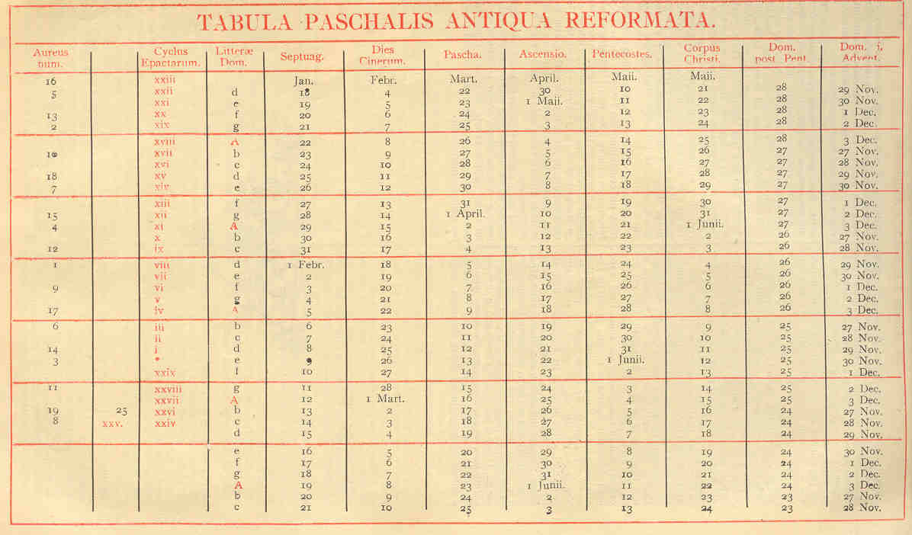

NEW PASCHAL TABLE REFORMED

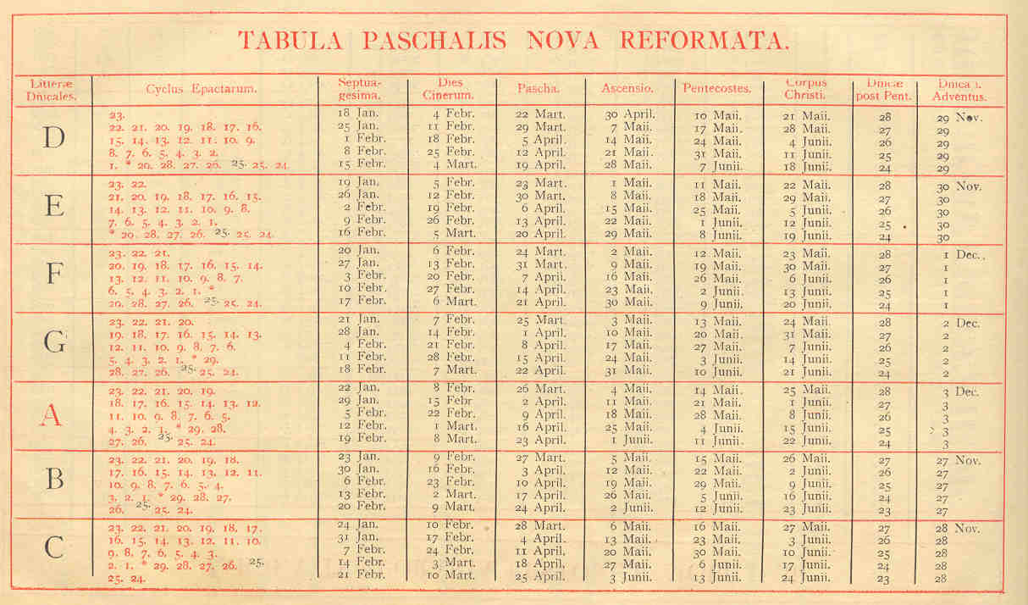

NOTE:

Unlike the other files in this directory, the above material is shown entirely unchanged as in the Breviary or the Missal, and it is not being presented as suitable for Orthodox use. Whatever our opinion as to the wisdom or accuracy of the memasures taken in this document, it is an action by the Latin Church unilaterally without the concurrence at the time of the Greek Church, and without any later accptance to date by any Othodox Churches, at least in regard to the central point, the calculation of Easter according to the Council of Nicæa; although the secular governments of most Orthodox countries have adopted the resulting Kalendar, and some Orthodox Churches have adopted the Kalendar dates, although with one exception not the Easter date.

We must look to future discussions which may reach agreement on the points at issue, as on other matters. Meanwhile I have not reproduced the Table of Moveable Feasts which concludes this section, since in any case, in the original used here, it ends in A.D.1926. In both the secular and monastic offices that I have edited I have constructed a table of similar design but following the Easter dates as currently in use in Eastern Orthodox Churches, but using the fixed dates of the Gregorian Kalendar., running from A.D. 2000 to A.D. 2040.

Fr Jack

