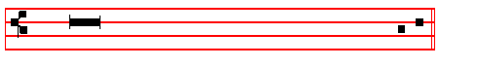 O Lord, make haste to help me.
 Glory be to the Father, and to the Son, and to the Ho - ly Ghost.
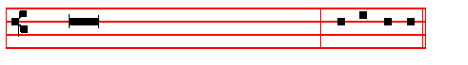
 As it was in the beginning, is now, and ever
shall be, world without end. Amen. Al - le - lu - ia.

Thus alleluia is said at all Hours throughout the year, except from Septuagesima Sunday until Maundy Thursday; for then is said:

Praise be to thee, O Lord, King of eternal glory.

¶ The following Invitatory is said from the Octave of the Epiphany until Septuagesima Sunday, and from the Octave of Pentecost until Advent.
Invitatory. Tone vj.
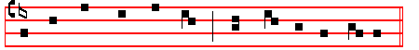
Let us wor - ship the Lord, * for he is our Ma-ker.
It is repeated
Let us wor - ship the Lord, for he is our Ma-ker.

Ps. 95 Venite, exultemus Domino XCIV Tone vj.
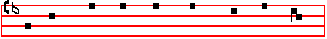 O COME, let us sing un - to the Lord *

2
Tone vij, 1.
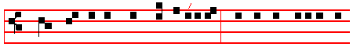
BLESS-ED be the Lord God of Is-ra-el;* for he hath visited and
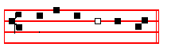
redeemed his peo- ple; Tone viij, 1.
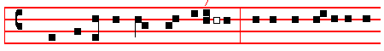
BLESSED be the Lord God of Is-ra-el; * for he hath / vi-sited and
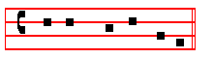
re-deem - ed his peo-ple;
12468 37 5 / / 4
2 And hath raised up a mighty sal - vation for us, * in the house of his
15678 23
ser - vant David;
2468 37 5 / 4
3 As he spake by the mouth of his holy Prophets, * which have been
15678 23
since the world began;
12468 37 5 / / 4
4 That we should be sa - ved from our en-emies, * and from the hands of
15678 23
all that hate us.
12468 37 5 / /
5 To perform the mercy promised to our forefathers, * and to remember
4 15678 23
his ho - ly covenant;
12468 37 5 /
6 To perform the oath which he sware to our fore - fa-ther Abraham, *
4 15678 23
that he would give us;
12468 37 5 /
7 That we being delivered out of the hand of our en-emies * might
4 15678 23
serve him with-out fear;
39
The following hymn is said from the Octave of the Epiphany until the first Sunday of Lent, and from the Sunday nearest to the first of October until Advent.
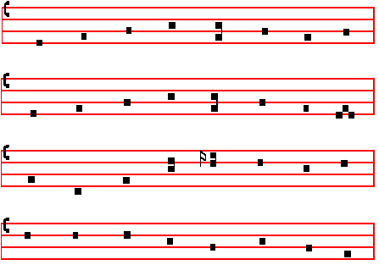
E.H. 50 Primo dierum omnium Mode iv
THIS day the first of days was made, 4 That us, who here this day repair
When God in light the world arrayed; To keep the Apostles' time of prayer,
Or when his Word arose again, And hymn the quiet hours of morn,
And, conquering death, gave life to man With blessèd gifts he may adorn.

2 Slumber and sloth drive far away; 5 For this Redeemer, thee we pray
Earlier arise to greet the day; That thou wilt wash our sins away,
And ere its dawn in heaven unfold And of thy loving-kindness grant
The heart's desire to God be told: Whate'er of good our spirits want

3 Unto our prayer that he attend, 6 O Father, that we ask be done
His all-creating power extend, Through Jesus Christ, thine only Son,
And still renew us, lest we miss Who with the Holy Ghost and thee,
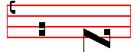 Through earthly stain our heavenly bliss. Doth live and reign eternally.
A - men. The following hymn is said from the Octave of Pentecost until the Sunday nearest to the first of October.

4
3 This he vouchsafe us, God for ever blessed,
Father eternal, Son, and Holy Spirit,
Whose is the glory which through all creation Ever resoundeth.
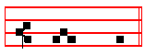
A - men.
Throughout the year,
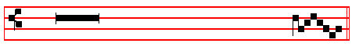
 The Lord is King, and hath put on glorious appar - el.
 The Lord hath put on his apparel, and girded himself with strength.
From Septuagesima to Lent,  Lord, thou hast been our re - fuge.
 From one generation to ano - ther.
In Advent, Lent, Passiontide, and Eastertide, Proper Hymns and 
On Benedictus, Proper Antiphon.
St. Luke i. 68 Benedictus Dominus Deus Israel Tone j, 1. 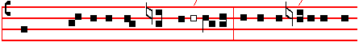
BLES-SED be the Lord God of Is-ra -el; * for he hath vis-ited and

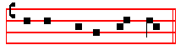
re-deem - ed his peo - ple; Tone ij.
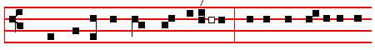
BLESSED be the Lord God of Israel; * for he hath /visit-ed and
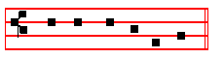
re-deem - ed his peo-ple;

37
5 As for the ungodly, it is not so with them; * but they are like the chaff which the wind scattereth away from the face of the earth.
6 Therefore the ungodly shall not be able to stand in the judgment, * neither the sinners in the congregation of the righteous.
7 But the Lord knoweth the way of the righteous; * and the way of the ungodly shall perish.
Glory be to the Father and to the Son * and to the Holy Ghost;

As it was in the beginning, is now, and ever shall be, * world without end. Amen.

This verse, Glory be to the Father, is always said at the end of all psalms, unless it is otherwise noted.
Psalm 2 Quare fremuerunt gentes? II

WHY do the heathen so furiously rage together? * and why do the people imagine a vain thing?
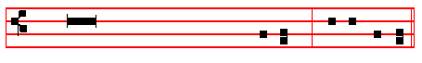
2 The kings of the earth stand up, and the rulers take counsel together * against the Lord, and against his Anointed:
3 Let us break their bonds asunder * and cast away their cords from us.

4 He that dwelleth in heaven shall laugh them to scorn: * the Lord shall have them in derision.
5 Then shall he speak unto them in his wrath * and vex them in his sore displeasure:
6 Yet have I set my King * upon my holy hill of Sion.

7 I will preach the law, whereof the Lord hath said unto me : * Thou art my Son, this day have I begotten thee.
8 Desire of me, and I shall give thee the nations for thine inheritance * and the utmost parts of the earth for thy possession.
9 Thou shalt bruise them with a rod of iron * and break them in pieces like a potter’s vessel.
10 Be wise now therefore, O ye kings; * be instructed, ye that are judges of the earth
11 Serve the Lord in fear * and rejoice unto him with reverence.

12 Kiss the Son, lest he be angry, and so ye perish from the right way * if his wrath be kindled, yea but a little, blessed are all they that put their trust in him.

Psalm 3 Domine, quid multiplicati? III

LORD how are they increased that trouble me! * many are they that rise against me.
6
Throughout the year, Antiphon.
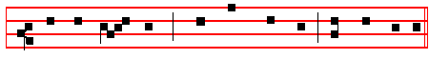
Al - le - lu - ia, al - le - lu - ia, al - le - lu - ia.

In Eastertide, Antiphon.
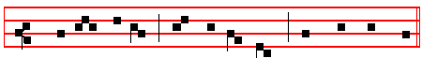
Al - le - lu - ia, al - le - lu - ia, al - le - lu - ia.

The following Chapter is said on Sundays from the second Sunday after the Epiphany until Septuagesima, and from the third Sunday after Pentecost until Advent.
Chapter Rev. 7
Blessing, and glory, and wisdom, and
thanksgiving, and honour, and power,
and might, be unto our God for ever and ever. Amen. R/. Thanks be to God. This response is made at the end of all Chapters.
The following hymn is said from the Octave of the Epiphany until the first Sunday of Lent, and from the Sunday nearest to the first of October until Advent.
Hymn Aeterne Rerum Conditor Mode iv
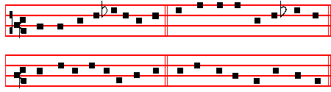
Maker of all, eternal King, 2 Now the shrill cock proclaims the day,
Who day and night about dost bring: And calls the sun's awakening ray,
Who weary mortals to relieve, The wandering pilgrim's guiding light,,
Dost in their times the seasons give: That marks the watches night by night

35
Psalm 7 Domine Deus meus in te speravi VII

O LORD my God, in thee have I put my trust: * save me from all them that persecute me, and deliver me;
2 Lest he devour my soul like a lion, and tear it in pieces, * while there is none to
help.
3 O Lord my God, if I have done any such thing; * or if there be any wickedness in my hands;
4 If I have rewarded evil unto him that dealt friendly with me; * yea, I have
delivered him that without any cause is mine enemy;
5 Then let mine enemy persecute my soul and take me; * yea, let him tread my life down upon the earth, and lay mine honour in the dust.
6 Stand up, O Lord, in thy wrath, and lift up thyself, because of the indignation of mine enemies; * arise up for me in the judgement that thou hast commanded.
7 And so shall the congregation of the peoples come about thee: * for their sakes therefore lift up thyself again.
8 The Lord shall judge the peoples: give sentence with me, O Lord, * according to my righteousness, and according to the innocency that is in me.
9 O let the wickedness of the ungodly come to an end; * but guide thou the just.

10 For the righteous God * trieth the very hearts and reins.

11 My help cometh of God * who preserveth them that are true of heart.

12 God is a righteous Judge, strong and patient; * and God is provoked every day.

13 If a man will not turn, he will whet his sword; * he hath bent his bow, and made it ready.
14 He hath prepared for him the instruments of death; * he ordaineth his arrows against the persecutors.
15 Behold the ungodly travaileth with iniquity; * he hath conceived sorrow, and brought forth ungodliness.
16 He hath graven and digged up a pit, * and is fallen himself into the
destruction that he made for other.
17 For his travail shall come upon his own head, * and his wickedness shall fall on his own pate.
18 I will give thanks unto the Lord, according to his righteousness; * and I will praise the Name of the Lord Most High.

Psalm 8 Domine, Dominus noster VIII

O LORD our Governor, how excellent is thy Name in all the world; * thou

8
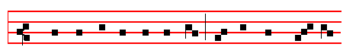
Christ is ri - sen from the grave, who de - li - ver - ed
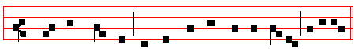
the three children from the burning fier- y furnace, al -le-lu-ia.
Antiphon.
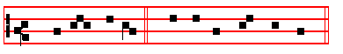
Al - le - lu - ia. E u o u a e.

Psalm 148 Laudate Dominum CXLVIII

O PRAISE the Lord of heaven: * praise him in the height.

2 Praise him, all ye angels of his: * praise him, all his host.

3 Praise him, sun and moon: * praise him, all ye stars and light.

4 Praise him, all ye heavens * and ye waters that be above the heavens.

5 Let them praise the Name of the Lord * for he spake the word, and they were made; he commanded, and they were created.
6 He hath made them fast for ever and ever * he hath given them a law which shall not be broken.
7 Praise the Lord upon earth * ye dragons, and all deeps.

8 Fire and hail, snow and vapours * wind and storm, fulfilling his word.

9 Mountains and all hills * fruitful trees and all cedars.

10 Beasts and all cattle * worms and feathered fowls.

11 Kings of the earth and all people * princes and all judges of the world;

33
forgetteth not the complaint of the poor.
13 Have mercy upon me, O Lord, consider the trouble which I suffer of them that hate me, * thou that liftest me up from the gates of death;
14 That I may show all thy praises within the gates of the daughter of Sion: * I will rejoice in thy salvation.
15 The heathen are sunk down in the pit that they made; * in the same net which they hid privily is their foot taken.
16 The Lord is known to execute judgment; * the ungodly is trapped in the work of his own hands.
17 The wicked shall be turned to destruction, * and all the people that forget God.
18 For the poor shall not alway be forgotten; * the patient abiding of the meek shall not perish for ever.
19 Up, Lord, and let not man have the upper hand; * let the heathen be judged in thy sight.
20 Put them in fear, O Lord * that the heathen may know themselves to be but men.
Continue without Glory be to the Father
Psalm 10 Ut quid, Domine, recessisti longe? IX, 21

WHY standest thou so far off, O Lord * and hidest thy face in,,the needful time of trouble?
2 The ungodly for his own lust doth persecute the poor: * let them be taken in the crafty wiliness that they have imagined.
3 For the ungodly hath made boast of his own heart’s desire * and speaketh good of the covetous, whom God abhorreth.
4 The ungodly is so proud that he careth not for God, * neither is God in all his thoughts.
5 His ways are alway grievous; * thy judgments are far above out of his sight, and therefore defieth he all his enemies.
6 For he hath said in his heart, Tush, I shall never be cast down, * there shall no harm happen unto me.
7 His mouth is full of cursing, deceit, and fraud; * under his tongue is ungodliness and vanity.
8 He sitteth lurking in the thievish corners of the streets, * and privily in his lurking dens doth he murder the innocent; his eyes are set against the poor.
9 For he lieth waiting secretly; even as a lion lurketh he in his den * that he may ravish the poor.
10 He doth ravish the poor * when he getteth him into his net.

11 He falleth down and humbleth himself * that the congregation of the poor may

10

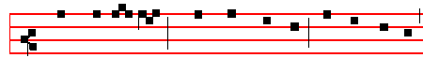
al - le - lu - ia, al - le - lu - ia, al - le - lu - ia;
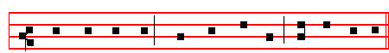
al - le - lu - ia, al - le - lu - ia, al - le - lu - ia.

Antiphon. Tone vj.
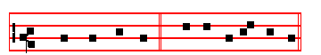
Christ is ri - sen.

The Song of the Three Children Dan. 3
Benedicite, omnia opera

O ALL ye Works of the Lord, bless ye the Lord: * praise him, and magnify him for ever.
2 O ye Angels of the Lord, bless ye the Lord: * O ye Heavens, bless ye the Lord.

3 O ye Waters that be above the firmament bless ye the Lord: * O all ye Powers of the Lord, bless ye the Lord.
4 O ye Sun and Moon, bless ye the Lord: * O ye Stars of heaven, bless ye the Lord.
5 O ye Showers and Dew, bless ye the Lord: * O ye Winds of God, bless ye the Lord.
6 O ye Fire and Heat, bless ye the Lord: * O ye Winter and Summer, bless ye the Lord.
7 O ye Dews and Frosts, bless ye the Lord: * O ye Frost and Cold, bless ye the Lord.
8 O ye Ice and Snow, bless ye the Lord: * O ye Nights and Days, bless ye the Lord.
9 O ye Light and Darkness, bless ye the Lord: * O ye Lightnings and Clouds, bless ye the Lord.
10 O let the earth bless the Lord: * yea, let it praise him and magnify him for ever.

31
Throughout the year, Antiphon. God is a just judge, strong and patient, and God is provoked every day.
Antiphon. Thou, O Lord.

Psalm 12 Salvum me fac, Domine XI

HELP me, Lord, for there is not one godly man left * for the faithful are minished from among the children of men.
2 They talk of vanity every one with his neighbour * they do but flatter with their lips, and dissemble in their double heart.
3 The Lord shall root out all deceitful lips * and the tongue that speaketh proud things;
4 Which have said, With our tongue will we prevail * we are they that ought to speak, who is lord over us?
5 Now for the comfortless troubles’ sake of the needy * and because of the deep sighing of the poor,
6 I will up, saith the Lord; * and will help every one from him that swelleth against him, and will set him at rest.
7 The words of the Lord are pure words; * even as the silver which from the earth is tried, and purified seven times in the fire.
8 Thou shalt keep them O Lord; * thou shalt preserve them from this generation for ever.
9 The ungodly walk on every side: * when they are exalted, the children of men are put to rebuke.

Psalm 13 Usquequo, Domine, oblivisceris me? XII

HOW long wilt thou forget me O Lord, for ever? * how long wilt,thou hide thy face from me?
2 How long shall I seek counsel in my soul, and be so vexed in my heart? * how long shall mine enemy triumph over me?
3 Consider, and hear me, O Lord my God * lighten mine eyes, that I sleep not in death;
4 Lest mine enemy say, I have prevailed against him * for if I be cast down, they that trouble me will rejoice at it.
5 But my trust is in thy mercy * and my heart is joyful in thy salvation.

6 I will sing of the Lord, because he hath dealt so lovingly with me; * yea, I will praise the Name of the Lord Most Highest.

Psalm 14 Dixit insipiens in corde suo XIII

12
2 He hath made the round world so sure, * that it cannot be moved.

3 Ever since the world began hath thy seat been prepared: * thou art from everlasting.
4 The floods are risen, O Lord, the floods have lift up their voice; *
the floods lift up their waves.
5 The waves of the sea are mighty and rage horribly; * but yet the Lord, who dwelleth on high, is mightier.
6 Thy testimonies, O Lord, are very sure: * holiness becometh thine house for ever.

Psalm 100 Jubilate Deo, omnis terra XCIX

O BE joyful in the Lord, all ye lands: * serve the Lord with gladness, and come before his presence with a song.
2 Be ye sure that the Lord he is God; * it is he that hath made us, and not we ourselves; * we are his people, and the sheep of his pasture.
3 O go your way into his gates with thanksgiving, and into his courts with praise; * be thankful unto him and speak good of his Name.
4 For the Lord is gracious, his mercy is everlasting; * and his truth endureth from generation to generation.

Psalm 63 Deus, Deus meus LXII

O GOD, thou art my God; * early will I seek thee.

2 My soul thirsteth for thee, my flesh also longeth after thee * in a barren and dry land where no water is.
3 Thus have I looked for thee in the sanctuary * that I might behold thy power and glory.
4 For thy loving–kindness is better than the life itself: * my lips shall praise thee.

5 As long as I live will I magnify thee in this manner * and lift up my hands in thy Name.
6 My soul shall be satisfied, even as it were with marrow and fatness * when my mouth praiseth thee with joyful lips.
7 Have I not remembered thee in my bed * and thought upon thee when I was waking?
8 Because thou hast been my helper; * therefore under the shadow of thy wings will I rejoice.
9 My soul hangeth upon thee; * thy right hand hath upholden me.

29
vengeance, even God with a recompense: he will come and save you.
 Out of Sion shall God appear in perfect beauty.
 Our God shall come and shall not keep silence.

Throughout the year, Antiphon. Thou, O God, shalt keep them: thou shalt preserve him from this generation for ever.
 I have thought upon thy name, O Lord, in the night-season.
 And have kept thy law.

In Lent,  He shall deliver thee from the snare of the hunter.
 And from the noisome pestilence.

In Passiontide,  Deliver my soul, O God, from the sword.
 My darling from the power of the dog.

In Eastertide, Antiphon. Alleluia, the stone is rolled away, alleluia; from the door of the sepulchre, alleluia, alleluia.
 The Lord is risen from the tomb, alleluia.
 Who for our sakes hung upon the tree, alleluia.

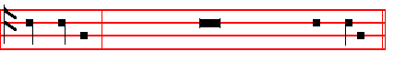
After the  of each Nocturn is said
Our Fa- ther. silently until  And lead us not into temp - ta-tion.
 But deliver us from e - vil.

ABSOLUTION

HEAR, O Lord Jesus Christ, the prayers of thy servants,

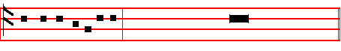
and have mercy upon us: Who livest and reignest with the Father and the

14
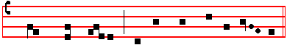
Gov - ern them, and lift them up for ev - er.
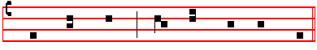
Day by day we mag - ni - fy thee;
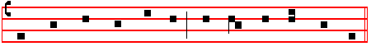
And we wor - ship thy Name ev - er world with - out end.
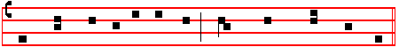
Vouch - safe, O Lord, to keep us this day with - out sin.
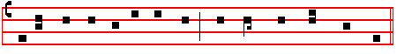
O Lord, have mercy upon us, have mer - cy up - on us.
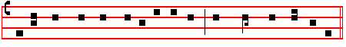
O Lord, let thy mercy lighten up-on us, as our trust is in thee.
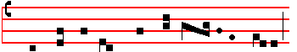
O Lord, in thee have I trust - ed;
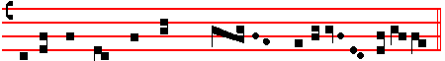
let me nev - er be con - found - ed.

___________________________________________________________________________________________

27
9 I have set the LORD alway before me; * for he is on my right hand, therefore I shall not fall.
10 Wherefore my heart is glad and my glory rejoiceth: * my flesh also shall rest in hope.
11 For why? thou shalt not leave my soul in hell; * neither shalt thou suffer thy Holy One to see corruption.
12 Thou shalt show me the path of life, in thy presence is the fulness of joy, * and at thy right hand there is pleasure for evermore.

In Advent, Antiphon. Rejoice greatly, O daughter of Jerusalem : behold, thy King cometh unto thee; fear not, O Sion, for thy salvation cometh quickly.
Antiphon. Christ our King

Throughout the year, Antiphon. My goods are nothing unto thee; in thee have I hoped; preserve me, O Lord.
Antiphon. Because of the words.

Psalm 17 Exaudi, Domine, justitiam meam XVI

HEAR the right, O Lord, consider my complaint * and hearken unto my prayer, that goeth not out of feigned lips.
2 Let my sentence come forth from thy presence; * and let thine eyes look upon the thing that is equal.
3 Thou hast proved and visited mine heart in the night season; thou hast tried me and shalt find no wickedness in me; * for I am utterly purposed that my mouth shall not offend.
4 Because of men's works, that are done against the words of thy lips * I have kept me from the ways of the destroyer.
5 O hold thou up my goings in thy paths * that my footsteps slip not.

6 I have called upon thee, O God, for thou shalt hear me: * incline thine ear to me, and hearken unto my words.
7 Show thy marvellous loving–kindness, thou that art the Saviour of them which put their trust in thee * from such as resist thy right hand.
8 Keep me as the apple of an eye; * hide me under the shadow of thy wings.

9 From the ungodly that trouble me; * mine enemies compass me round about to take away my soul.
10 They are inclosed in their own fat, * and their mouth speaketh proud things.

11 They lie waiting in our way on every side * turning their eyes down to the ground;

16
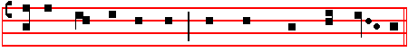
The good-ly fel -low- ship of the Pro- phets praise thee.
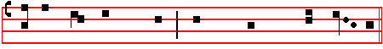
The no - ble ar - my of Mar - tyrs praise thee.
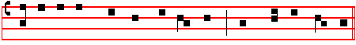
The holy Church through-out all the world doth acknowledge thee;
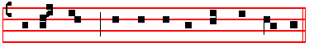
The Fa - ther of an in- fi- nite M a- jes - ty,
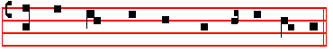
Thine hon - our - a - ble, true, and on - ly Son;
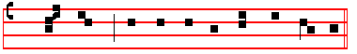
Al - so the Ho - ly Ghost the Com- fort- er.
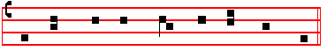
Thou art the King of Glo - ry, O Christ.
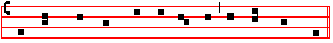
Thou art the ev - er - last - ing Son of the Fa - ther.
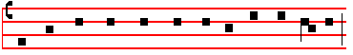
When thou took -est up - on thee to de – liv - er man,

25
9 He bowed the heavens also, and came down, * and it was dark under his feet.

10 He rode upon the Cherubim and did fly; * he came flying upon the wings of the wind.
11 He made darkness his secret place, * his pavilion round about him, with dark water, and thick clouds to cover him.
12 At the brightness of his presence his clouds removed; * hail-stones and coals of fire.
13 The Lord thundered out of heaven, and the Highest gave his thunder; * hail-stones and coals of fire.
14 He sent out his arrows and scattered them; * he cast forth lightnings and destroyed them.
15 The springs of waters were seen, and the foundations of the round world were discovered, at thy chiding, O Lord * at the blasting of the breath of thy displeasure.
16 He sent down from on high to fetch me * and took me out of many waters.

17 He delivered me from my strongest enemy, and from them which hate me * for they were too mighty for me.
18 They came upon me in the day of my trouble * but the Lord was my upholder.
19 He brought me forth also into a place of liberty * he brought me forth, even because he had a favour unto me.
20 The Lord shall reward me after my righteous dealing * according to the cleanness of my hands shall he recompense me.
21 Because I have kept the ways of the Lord * and have not forsaken my God, as the wicked doth.
22 For I have an eye unto all his laws * and will not cast out his commandments from me.
23 I was also uncorrupt before him * and eschewed mine own wickedness.

24 Therefore shall the Lord reward me after my righteous dealing * and according unto the cleanness of my hands in his eyesight.
25 With the holy thou shalt be holy, * and with a perfect man thou shalt be perfect.
26 With the clean thou shalt be clean, * and with the froward thou shalt learn frowardness.
27 For thou shalt save the people that are in adversity * and shalt bring down the high looks of the proud.
28 Thou also shalt light my candle; * the Lord my God shall make my darkness
to be light.
29 For in thee I shall discomfit an host of men, * and with the help of my God I shall leap over the wall.
30 The way of God is an undefiled way: * the word of the Lord also is tried in the
18
children of men.
11 For they intended mischief against thee * and imagined such a device as they are not able to perform.
12 Therefore shalt thou put them to flight, * and the strings of thy bow shalt thou
make ready against the face of them.
13 Be thou exalted Lord in thine own strength; * so will we sing, and praise thy power.

In Advent, Antiphon. In the Advent of the most mighty King the hearts of men shall be cleansed, and we shall walk worthily in his way: for behold, he shall come, and shall not tarry.
 The Lord cometh forth out of his holy place.
 He will come and save his people.

Throughout the year, Antiphon. The King shall rejoice in thy strength, O Lord.
 Be thou exalted, O Lord, in thine own strength.
 So shall we sing and praise thy power.

In Lent,  His truth shall be thy shield and buckler.
 Thou shalt not be afraid for any terror by night.

In Passiontide,  Shut not up my soul with the sinners, O God.
 Nor my life with the blood-thirsty.

In Eastertide, Antiphon. Alleluia, weep not, Mary, alleluia : the Lord is risen, alleluia, alleluia.
 Then were the disciples glad, alleluia.
 When they saw the Lord, alleluia.

Our Father. silently.
 And lead us not into temptation.
 But deliver us from evil.
ABSOLUTION

From the chains of our sins may the almighty and merciful Lord loose us.
 Amen.
 Bid, Lord, a blessing. - May the Gospel Lection be to us salvation and protection.  Amen.
For Lesson viij, Blessing. - May the divine assistance remain with us always.
 Amen.
For Lesson ix, Blessing. - May the King of Angels bring us to the society of the heavenly citizens.  Amen.

23
In Advent, Antiphon. Behold, I come quickly, saith the Lord : and my reward is with me : to give to every man according as his work shall be.
 Send, O Lord, the Lord, the ruler of the land.
 From the Rock of the wilderness unto the mount of the daughter of Sion.

Throughout the year, Antiphon. I will love thee, O Lord my strength.
 Thou also shalt light my candle.
 The Lord my God shall make my darkness to be light.

In Lent,  He shall defend me under his wings.
 And thou shalt be safe under his feathers.

In Passiontide,  Save me, O Lord, from the lion's mouth.
 Thou hast heard me also from among the horns of the unicorns.

In Eastertide, Antiphon. Alleluia, woman, whom seekest thou? Alleluia : seekest thou the living among the dead? Alleluia, alleluia.
 The Lord is risen indeed, alleluia.
 And hath appeared unto Simon, alleluia.

Our Father. silently.  And lead us not into temptation.
 But deliver us from evil.
ABSOLUTION

May his mercy and pity assist us, who liveth and reigneth with the Father and the Holy Ghost, world without end.  Amen.
 Bid, Lord, a blessing. Blessing. - May God the Father Almighty be merciful and gracious unto us.  Amen.
For Lesson v, Blessing.-May Christ grant unto us the joys of eternal life.  Amen.
For Lesson vj, Blessing. -May God kindle the fire of his love in our hearts.
 Amen.
_____________________________________________________________

IN THE THIRD NOCTURN

In Advent, Antiphon. The Angel Gabriel.
Throughout the year, Antiphon. There is no speech.
In Eastertide, Antiphon. Alleluia.
Psalm 19 Coeli enarrant gloriam Dei XVIII

THE heavens declare the glory of God * and the firmament ,showeth his handy–work.
2 One day telleth another; * and one night certifieth another.
20
3 There is neither speech nor language; * but their voices are heard among them.

4 Their sound is gone out into all lands; * and their words into the ends of the world.
5 In them hath he set a tabernacle for the sun * which cometh forth as a bridegroom out of his chamber, and rejoiceth as a giant to run his course.
6 It goeth forth from the uttermost part of the heaven, and runneth about unto the end of it again; * and there is nothing hid from the heat thereof.
7 The law of the Lord is an undefiled law, converting the soul; * the testimony of the Lord is sure, and giveth wisdom unto the simple.
8 The statues of the Lord are right, and rejoice the heart; * the commandment of the Lord is pure, and giveth light unto the eyes.
9 The fear of the Lord is clean, and endureth for ever; * the judgements of the Lord are true, and righteous altogether.
10 More to be desired are they than gold, yea, than much fine gold * sweeter also than honey, and the honey–comb.
11 Moreover by them is thy servant taught * and in keeping of them there is great reward.
12 Who can tell how oft he offendeth? * O cleanse thou me from my secret faults.
13 Keep thy servant also from presumptuous sins, lest they get the dominion over me; * so shall I be undefiled, and innocent from the great offence.
14 Let the words of my mouth, and the meditation of my heart * be alway acceptable in thy sight,
15 O Lord * my strength, and my redeemer.

In Advent, Antiphon. The Angel Gabriel spake unto Mary, and said : Hail, thou that art full of grace, the Lord is with thee : blessed art thou among women. Antiphon. Mary said.

Throughout the year, Antiphon. There is neither speech nor language : but their
voices are heard among them.
Antiphon. The Lord hear.

Psalm 20 Exaudiat te Dominus XIX

THE Lord hear thee in the day of trouble; * the Name of the God of Jacob
defend thee:
2 Send thee help from the sanctuary * and strengthen thee out of Sion:

3 Remember all thy offerings * and accept thy burnt–sacrifice:

21

