THE PSALTER
DIVIDED OVER THE WEEK
with the Ordinary of the Office

ON SUNDAY AT MATINS

Before Matins, and all Hours, except at Compline, is said silently:

OUR FATHER, which art in heaven, hallowed be thy name, thy kingdom come. Thy will be done, on earth as it is in heaven. Give us this day our daily bread. And forgive us our trespasses, as we forgive them that trespass against us. And lead us not into temptation, but deliver us from evil. Amen.

HAIL, MARY, full of grace, the Lord is with thee. Blessed art thou amongst women, and blessed is the fruit of thy womb, Jesus. Holy Mary, Mother of God, pray for us sinners, now and in the hour of our death. Amen.

At the beginning of Matins, and Prime, and at the end of Compline, is also said the Apostles' Creed.
I BELIEVE in God the Father Almighty, Maker of heaven and earth: And in Jesus Christ his only
Son our Lord: Who was conceived by the Holy Ghost, Born of the Virgin Mary: Suffered under Pontius Pilate, Was crucified, dead, and buried: He descended into hell: The third day he rose again from the dead: He ascended into heaven, And sitteth on the right hand of God the Father Almighty: From thence he shall come to judge the quick and the dead.
I believe in the Holy Ghost: The holy Catholic Church: The Communion of Saints: The Forgiveness of sins: The Resurrection of the body: And the Life everlasting. Amen.

Then is said aloud the Verse: 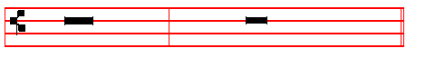
O LORD, open thou  my lips..And my mouth shall shew forth thy praise
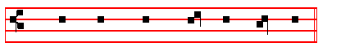
 O God, make speed  to save me.

1
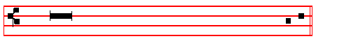. O Lord, make haste to help me.
 Glory be to the Father, and to the Son, and to the Ho - ly Ghost.
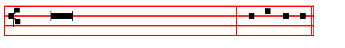. As it was in the beginning, is now, and ever
shall be, world without end. Amen. Al - le - lu - ia.

Thus alleluia is said at all Hours throughout the year, except from Septuagesima Sunday until Maundy Thursday; for then is said:
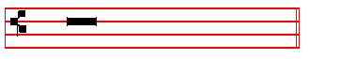
Praise be to thee, O Lord, King of eternal glory.

¶ The following Invitatory is said from the Octave of the Epiphany until Septuagesima Sunday, and from the Octave of Pentecost until Advent.
Invitatory. Tone vj.
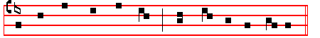
Let us wor - ship the Lord, * for he is our Ma-ker.
It is repeated
Let us wor - ship the Lord, for he is our Ma-ker.

Ps. 95 Venite, exultemus Domino XCIV Tone vj.
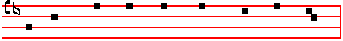
O COME, let us sing un - to the Lord *

2
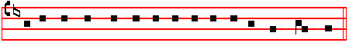
let us heart -i - ly rejoice in the strength of our sal - va - tion.
2 Let us come before his presence with thanksgiving; * and shew ourselves glad in him with psalms.
<Let us worship the Lord, for he is our Maker.>
3 For the Lord is a great God * and a great King above all gods.
4 In his hand are all the corners of the earth * and the strength of the hills is his also.
<For he is our Maker.>
5 The sea is his and he made it * and his hands prepared the dry land.
6 O come let us worship and fall down * and kneel before the Lord our Maker.
7 For he is the Lord our God * and we are the people of his pasture, and the sheep of his hand.
<Let us worship the Lord, for he is our Maker.>
8 Today if ye will hear his voice, harden not your hearts * as in the provocation, and as in the day of temptation in the wilderness;
9 When your fathers tempted me * proved me, and saw my works.
<For he is our Maker.>
10 Forty years long was I grieved with this generation and said * It is a people that do err in their hearts, for they have not known my ways:
11 Unto whom I sware in my wrath * that they should not enter into my rest.
<Let us worship the Lord, for he is our Maker.>
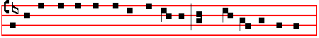
Glo-ry be to the Father, and to the Son * and to the Ho- ly Ghost; 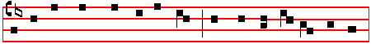
As it was in the be- gin - ning, is now, and e- ver shall be, *
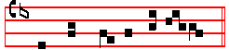
world with - out end. A - men.
<For he is our Maker.>
<Let us worship the Lord, for he is our Maker.>

3
The following hymn is said from the Octave of the Epiphany until the first Sunday of Lent, and from the Sunday nearest to the first of October until Advent.
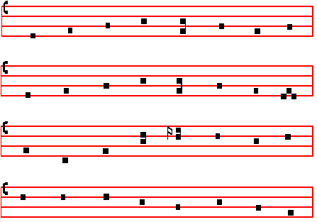
E.H. 50 Primo dierum omnium Mode iv
THIS day the first of days was made, 4 That us, who here this day repair
When God in light the world arrayed; To keep the Apostles' time of prayer,
Or when his Word arose again, And hymn the quiet hours of morn,
And, conquering death, gave life to man With blessèd gifts he may adorn.

2 Slumber and sloth drive far away; 5 For this Redeemer, thee we pray
Earlier arise to greet the day; That thou wilt wash our sins away,
And ere its dawn in heaven unfold And of thy loving-kindness grant
The heart's desire to God be told: Whate'er of good our spirits want.

3 Unto our prayer that he attend, 6 O Father, that we ask be done
His all-creating power extend, Through Jesus Christ, thine only Son,
And still renew us, lest we miss Who with the Holy Ghost and thee,
Through earthly stain our heavenly bliss. Doth live and reign eternally.
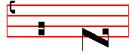
A - men.
The following hymn is said from the Octave of Pentecost until the Sunday nearest to the first of October.
4
E.H 165 Nocte surgentes. Mode vj.
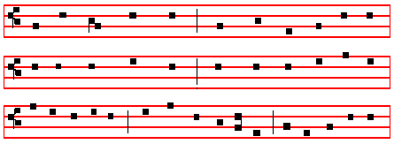

FATHER, we praise thee, now the night is over,
Active and watchful, stand we all before thee;
Singing we offer prayer and meditation: Thus we adore thee.

2 Monarch of all things, fit us for thy mansions;
Banish our weakness, health and wholeness sending;
Bring us to heaven, where thy Saints united Joy without ending.

3 All-holy Father, Son and equal Spirit,
Trinity blessed, send us thy salvation;
Thine is the glory, gleaming and resounding Through all creation.
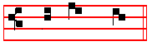
A - men.

IN THE FIRST NOCTURN
In Advent, Antiphon. Behold.
Throughout the year, Antiphon. Serve the Lord in fear.
In Eastertide, Antiphon. Alleluia.

Psalm 1 Beatus vir qui non abiit I

BLESSED is the man that hath not walked in the counsel of the ungodly, nor stood in the way of sinners, * and hath not sat in the seat of the scornful.
2 But his delight is in the law of the Lord; * and in his law will he exercise himself day and night.
3 And he shall be like a tree planted by the water–side * that will bring forth his fruit in due season.
4 His leaf also shall not wither; * and look, whatsoever he doeth, it shall prosper.

5
5 As for the ungodly, it is not so with them; * but they are like the chaff which the wind scattereth away from the face of the earth.
6 Therefore the ungodly shall not be able to stand in the judgment, * neither the sinners in the congregation of the righteous.
7 But the Lord knoweth the way of the righteous; * and the way of the ungodly shall perish.
Glory be to the Father and to the Son * and to the Holy Ghost;

As it was in the beginning, is now, and ever shall be, * world without end. Amen.
This verse, Glory be to the Father, is always said at the end of all psalms, unless it is otherwise noted.
Psalm 2 Quare fremuerunt gentes? II

WHY do the heathen so furiously rage together? * and why do the people
imagine a vain thing?

2 The kings of the earth stand up, and the rulers take counsel together * against the Lord, and against his Anointed:
3 Let us break their bonds asunder * and cast away their cords from us.
4 He that dwelleth in heaven shall laugh them to scorn: * the Lord shall have them in derision.
5 Then shall he speak unto them in his wrath * and vex them in his sore displeasure:
6 Yet have I set my King * upon my holy hill of Sion.

7 I will preach the law, whereof the Lord hath said unto me : * Thou art my Son, this day have I begotten thee.
8 Desire of me, and I shall give thee the nations for thine inheritance * and the utmost parts of the earth for thy possession.
9 Thou shalt bruise them with a rod of iron * and break them in pieces like a potter’s vessel.
10 Be wise now therefore, O ye kings; * be instructed, ye that are judges of the earth
11 Serve the Lord in fear * and rejoice unto him with reverence.

12 Kiss the Son, lest he be angry, and so ye perish from the right way * if his wrath be kindled, yea but a little, blessed are all they that put their trust in him.

Psalm 3 Domine, quid multiplicati? III

LORD how are they increased that trouble me! * many are they that rise against me.

6
2 Many one there be that say of my soul, * There is no help for him in his God.

3 But thou , O Lord, art my defender; * thou art my worship, and the lifter up of my head.
4 I did call upon the Lord with my voice * and he heard me out of his holy hill.

5 I laid me down and slept, and rose up again; * for the Lord sustained me.

6 I will not be afraid for ten thousands of the people * that have set themselves against me round about.
7 Up, Lord, and help me, O my God * for thou smitest all mine enemies upon the cheek–bone; thou hast broken the teeth of the ungodly.
8 Salvation belongeth unto the Lord; * and thy blessing is upon thy people.

(Psalm 4 Cum invocarem exaudivit me at Compline, p.125)
(Psalm 5 Verba mea, at Lauds, Monday, p.76)

Psalm 6 Domine, ne in furore tuo VI

O LORD, rebuke me not in thine indignation, * neither chasten me in thy
displeasure.
2 Have mercy upon me,O Lord, for I am weak; * O Lord, heal me for my bones are vexed.
3 My soul also is sore troubled: * but Lord, how long wilt thou punish me?

4 Turn thee, O Lord, and deliver my soul; * O save me for thy mercy’s sake.

5 For in death no man remembereth thee; * and who will give thee thanks in the pit?
6 I am weary of my groaning; every night wash I my bed: * and water my couch with my tears.
7 My beauty is gone for very trouble * and worn away because of all mine enemies.
8 Away from me, all ye that work iniquity; * for the Lord hath heard the voice of my weeping.
9 The Lord hath heard my petition; * the Lord will receive my prayer.
10 All mine enemies shall be confounded and sore vexed; * they shall be turned back and put to shame suddenly.

In Advent, Antiphon. Behold, the King most high cometh with great power to save the nations, alleluia. Antiphon. Strengthen ye.

Throughout the year, Antiphon. Serve the Lord in fear, and rejoice unto him with reverence. Antiphon. God is a just judge.
7
Psalm 7 Domine Deus meus in te speravi VII

OLORD my God, in thee have I put my trust: * save me from all them that persecute me, and deliver me;
2 Lest he devour my soul like a lion, and tear it in pieces, * while there is none to
help.
3 O Lord my God, if I have done any such thing; * or if there be any wickedness in my hands;
4 If I have rewarded evil unto him that dealt friendly with me; * yea, I have
delivered him that without any cause is mine enemy;
5 Then let mine enemy persecute my soul and take me; * yea, let him tread my life down upon the earth, and lay mine honour in the dust.
6 Stand up, O Lord, in thy wrath, and lift up thyself, because of the indignation of mine enemies; * arise up for me in the judgement that thou hast commanded.
7 And so shall the congregation of the peoples come about thee: * for their sakes therefore lift up thyself again.
8 The Lord shall judge the peoples: give sentence with me, O Lord, * according to my righteousness, and according to the innocency that is in me.
9 O let the wickedness of the ungodly come to an end; * but guide thou the just.

10 For the righteous God * trieth the very hearts and reins.

11 My help cometh of God * who preserveth them that are true of heart.

12 God is a righteous Judge, strong and patient; * and God is provoked every day.

13 If a man will not turn, he will whet his sword; * he hath bent his bow, and made it ready.
14 He hath prepared for him the instruments of death; * he ordaineth his arrows against the persecutors.
15 Behold the ungodly travaileth with iniquity; * he hath conceived sorrow, and brought forth ungodliness.
16 He hath graven and digged up a pit, * and is fallen himself into the
destruction that he made for other.
17 For his travail shall come upon his own head, * and his wickedness shall fall on his own pate.
18 I will give thanks unto the Lord, according to his righteousness; * and I will praise the Name of the Lord Most High.

Psalm 8 Domine, Dominus noster VIII

O Lord our Governor, how excellent is thy Name in all the world; * thou

8
that hast set thy glory above the heavens!
2 Out of the mouth of very babes and sucklings has thou ordained strength, because of thine enemies, * that thou mightest still the enemy and the avenger.
3 When I consider thy heavens, even the work of thy fingers; * the moon and the
stars which thou hast ordained;
4 What is man that thou art mindful of him? * and the Son of Man that thou visitest him?
5 Thou madest him lower than the angels * to crown him with glory and worship.

6 Thou makest him to have dominion of the works of thy hands; * and thou hast put all things in subjection under his feet:
7 All sheep and oxen; * yea, and the beasts of the field;

8 The fowls of the air and the fishes of the sea; * and whatsoever walketh through the paths of the seas.
9 O Lord our Governor * how excellent is thy Name in all the world!

Psalm 9 Confitebor tibi, Domine, in toto corde meo IX

I WILL give thanks unto thee O LORD with my whole heart; * I will...speak of
all thy marvellous works.

2 I will be glad and rejoice in thee; * yea my songs will I make of thy Name, O thou Most Highest.
3 While mine enemies are driven back * they shall fall and perish at thy presence.

4 For thou hast maintained my right and my cause; * thou art set in the throne that judgest right.
5 Thou hast rebuked the heathen, and destroyed the ungodly; * thou hast put out their name for ever and ever.
6 O thou enemy, destructions are come to a perpetual end; * even as the cities which thou has destroyed: their memorial is perished with them.
7 But the Lord shall endure for ever; * he hath also prepared his seat for judgment.
8 For he shall judge the world in righteousness * and minister true judgement unto the people.
9 The Lord also will be a defence for the oppressed, * even a refuge in due time of trouble.
10 And they that know thy Name will put their trust in thee; * for thou, Lord, hast never failed them that seek thee.
11 O praise the Lord which dwelleth in Sion; * show the people of his doings.

12 For when he maketh inquisition for blood he remembereth them, * and

9
forgetteth not the complaint of the poor.
13 Have mercy upon me, O Lord, consider the trouble which I suffer of them that hate me, * thou that liftest me up from the gates of death;
14 That I may show all thy praises within the gates of the daughter of Sion: * I will rejoice in thy salvation.
15 The heathen are sunk down in the pit that they made; * in the same net which they hid privily is their foot taken.
16 The Lord is known to execute judgment; * the ungodly is trapped in the work of his own hands.
17 The wicked shall be turned to destruction, * and all the people that forget God.
18 For the poor shall not alway be forgotten; * the patient abiding of the meek shall not perish for ever.
19 Up, Lord, and let not man have the upper hand; * let the heathen be judged in thy sight.
20 Put them in fear, O Lord * that the heathen may know themselves to be but men.
Continue without Glory be to the Father
Psalm 10 Ut quid, Domine, recessisti longe? IX, 21

WHY standest thou so far off, O Lord * and hidest thy face in,,the needful time of trouble?
2 The ungodly for his own lust doth persecute the poor: * let them be taken in the crafty wiliness that they have imagined.
3 For the ungodly hath made boast of his own heart’s desire * and speaketh good of the covetous, whom God abhorreth.
4 The ungodly is so proud that he careth not for God, * neither is God in all his thoughts.
5 His ways are alway grievous; * thy judgments are far above out of his sight, and therefore defieth he all his enemies.
6 For he hath said in his heart, Tush, I shall never be cast down, * there shall no harm happen unto me.
7 His mouth is full of cursing, deceit, and fraud; * under his tongue is ungodliness and vanity.
8 He sitteth lurking in the thievish corners of the streets, * and privily in his lurking dens doth he murder the innocent; his eyes are set against the poor.
9 For he lieth waiting secretly; even as a lion lurketh he in his den * that he may ravish the poor.
10 He doth ravish the poor * when he getteth him into his net.

11 He falleth down and humbleth himself * that the congregation of the poor may

10
fall into the hands of his captains.
12 He hath said in his heart, Tush, God hath forgotten * he hideth away his face, and he will never see it.
13 Arise, O Lord God, and lift up thine hand * forget not the poor.

14 Wherefore should the wicked blaspheme God * while he doth say in his heart, Tush, thou God carest not for it?
15 Surely thou hast seen it; * for thou beholdest ungodliness and wrong.

16 That thou mayest take the matter into thy hand * the poor committeth
himself unto thee; for thou art the helper of the friendless.
17 Break thou the power of the ungodly and malicious * take away his ungodliness, and thou shalt find none.
18 The Lord is King for ever and ever * and the heathen are perished out of the land.
19 Lord, thou hast heard the desire of the poor * thou preparest their heart, and thine ear hearkeneth thereto;
20 To help the fatherless and poor unto their right * that the man of the earth be no more exalted against them.

Psalm 11 In Domino confido X

IN the Lord put I my trust * how say ye then to my soul, that she.,should flee as a bird unto the hill?
2 For lo, the ungodly bend their bow, and make ready their arrows within the quiver * that they may privily shoot at them which are true of heart.
3 For the foundations will be cast down * and what hath the righteous done?

4 The Lord is in his holy temple; * the Lord’s seat is in heaven.

5 His eyes consider the poor, * and his eyelids try the children of men.

6 The Lord alloweth the righteous: * but the ungodly, and him that delighteth in wickedness, doth his soul abhor.
7 Upon the ungodly he shall rain snares, fire and brimstone, storm and tempest: * this shall be their portion to drink.
8 For the righteous Lord loveth righteousness; * his countenance will behold the thing that is just.

In Advent, Antiphon. Strengthen ye the weak hands: be strong, and say: Behold, your God will come and save you, alleluia.
Antiphon. Be strong.

11
Throughout the year, Antiphon. God is a just judge, strong and patient, and God is provoked every day.
Antiphon. Thou, O Lord.
Psalm 12 Salvum me fac, Domine XI

HELP me, Lord, for there is not one godly man left * for the faithful are minished from among the children of men.

2 They talk of vanity every one with his neighbour * they do but flatter with their lips, and dissemble in their double heart.
3 The Lord shall root out all deceitful lips * and the tongue that speaketh proud things;
4 Which have said, With our tongue will we prevail * we are they that ought to speak, who is lord over us?
5 Now for the comfortless troubles’ sake of the needy * and because of the deep sighing of the poor,
6 I will up, saith the Lord; * and will help every one from him that swelleth against him, and will set him at rest.
7 The words of the Lord are pure words; * even as the silver which from the earth is tried, and purified seven times in the fire.
8 Thou shalt keep them O Lord; * thou shalt preserve them from this generation for ever.
9 The ungodly walk on every side: * when they are exalted, the children of men are put to rebuke.

Psalm 13 Usquequo, Domine, oblivisceris me? XII

HOW long wilt thou forget me O Lord, for ever? * how long wilt,thou hide thy face from me?
2 How long shall I seek counsel in my soul, and be so vexed in my heart? * how long shall mine enemy triumph over me?
3 Consider, and hear me, O Lord my God * lighten mine eyes, that I sleep not in death;
4 Lest mine enemy say, I have prevailed against him * for if I be cast down, they that trouble me will rejoice at it.
5 But my trust is in thy mercy * and my heart is joyful in thy salvation.

6 I will sing of the Lord, because he hath dealt so lovingly with me; * yea, I will praise the Name of the Lord Most Highest.

Psalm 14 Dixit insipiens in corde suo XIII

12
THE fool hath said in his heart, * There is no God.

2 They are corrupt, and become abominable in their doings; * there is none that doeth good, no not one.
3 The Lord looked down from heaven upon the children of men * to see if there were any that would understand, and seek after God.
4 But they are all gone out of the way, they are altogether become abominable; * there is none that doeth good, no, not one.
5 Their throat is an open sepulchre, with their tongues have they deceived * the poison of asps is under their lips.
6 Their mouth is full of cursing and bitterness * their feet are swift to shed blood.

7 Destruction and unhappiness is in their ways, and the way of peace have they not known * there is no fear of God before their eyes.

8 Have they no knowledge, that they are all such workers of mischief * eating up my people as it were bread, and call not upon the Lord?

9 There were they brought in great fear, even where no fear was; * for God is in the generation of the righteous.
10 As for you, ye have made a mock at the counsel of the poor; * because he putteth his trust in the Lord.
11 Who shall give salvation unto Israel out of Sion? When the Lord turneth the captivity of his people * then shall Jacob rejoice, and Israel shall be glad.

Psalm 15 Domine, quis habitabit? XIV

LORD who shall dwell in thy tabernacle? * or who shall rest upon thy holy hill?
2 Even he that leadeth an uncorrupt life * and doeth the thing which is right, and speaketh the truth from his heart.
3 He that hath used no deceit in his tongue, nor done evil to his neighbour * and hath not slandered his neighbour.
4 He that setteth not by himself, but is lowly in his own eyes * and maketh much of them that fear the Lord.
5 He that sweareth unto his neighbour, and disappointeth him not * though it were to his own hindrance.
6 He that hath not given his money upon usury * nor taken reward against the innocent.
7 Whoso doeth these things * shall never fall.

In Advent, Antiphon. Be strong, fear not, behold your God will come with

13
vengeance, even God with a recompense: he will come and save you.

 Out of Sion shall God appear in perfect beauty.
. Our God shall come and shall not keep silence.

Throughout the year, Antiphon. Thou, O God, shalt keep them: thou shalt preserve him from this generation for ever.
 I have thought upon thy name, O Lord, in the night-season.
 And have kept thy law.

In Lent He shall deliver thee from the snare of the hunter.
 And from the noisome pestilence.

In Passiontide,  Deliver my soul, O God, from the sword.
 My darling from the power of the dog.

In Eastertide, Antiphon. Alleluia, the stone is rolled away, alleluia; from the door of the sepulchre, alleluia, alleluia.
. The Lord is risen from the tomb, alleluia.
 Who for our sakes hung upon the tree, alleluia.

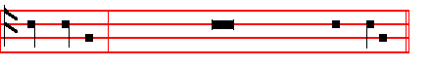
After the . of each Nocturn is said
Our Fa- ther. silently until  And lead us not into temp- ta-tion.
. But deliver us from e -vil.

ABSOLUTION
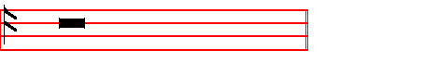
Hear, O Lord Jesus Christ, the prayers of thy servants,
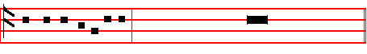
and have mercy upon us: Who livest and reignest with the Father and the

14
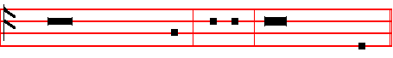
Holy Ghost, world without end. . Amen  Bid, Lord, a bles - sing.
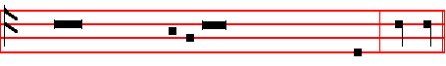
Blessing.
May the blessing of the eternal Father rest upon us al - ways. . A - men.

¶ Then are read the Lessons with the Responsories, as are assigned in the Proper of the Season. [But thou, O Lord as eternal Father; the rest as always]
For the Second Lesson, Blessing.
May the only-begotten Son of God bless us and help us. .A- men.
For the Third Lesson, Blessing.
May the grace of the Holy Spirit enlighten our senses and hearts. . A- men.
________________________________________________________

IN THE SECOND NOCTURN
In Advent, Antiphon. Rejoice greatly.
Throughout the year, Antiphon. My goods.
In Eastertide, Antiphon. Alleluia.

Psalm 16 Conserva me, Domine XV

PRESERVE me, O God; * for in thee have I put my trust.

2 O my soul, thou hast said unto the Lord * Thou art my God, my goods are nothing unto thee.
3 All my delight is upon the saints that are in the earth * and upon such as excel in virtue.
4 But they that run after another god * shall have great trouble.

5 Their drink–offerings of blood will I not offer * neither make mention of their names within my lips.
6 The Lord himself is the portion of mine inheritance and of my cup * thou shalt maintain my lot.
7 The lot is fallen unto me in a fair ground * yea, I have a goodly heritage.

8 I will thank the Lord for giving me warning; * my reins also chasten me in the night-season.
15
9 I have set the Lord alway before me; * for he is on my right hand, therefore I shall not fall.
10 Wherefore my heart is glad and my glory rejoiceth: * my flesh also shall rest in hope.
11 For why? thou shalt not leave my soul in hell; * neither shalt thou suffer thy Holy One to see corruption.
12 Thou shalt show me the path of life, in thy presence is the fulness of joy, * and at thy right hand there is pleasure for evermore.

In Advent, Antiphon. Rejoice greatly, O daughter of Jerusalem : behold, thy King cometh unto thee; fear not, O Sion, for thy salvation cometh quickly.
Antiphon. Christ our King

Throughout the year, Antiphon. My goods are nothing unto thee; in thee have I hoped; preserve me, O Lord.
Antiphon. Because of the words.

Psalm 17 Exaudi, Domine, justitiam meam XVI

HEAR the right, O Lord, consider my complaint * and hearken unto my prayer, that goeth not out of feigned lips.

2 Let my sentence come forth from thy presence; * and let thine eyes look upon the thing that is equal.
3 Thou hast proved and visited mine heart in the night season; thou hast tried me and shalt find no wickedness in me; * for I am utterly purposed that my mouth shall not offend.
4 Because of men's works, that are done against the words of thy lips * I have kept me from the ways of the destroyer.
5 O hold thou up my goings in thy paths * that my footsteps slip not.

6 I have called upon thee, O God, for thou shalt hear me: * incline thine ear to me, and hearken unto my words.
7 Show thy marvellous loving–kindness, thou that art the Saviour of them which put their trust in thee * from such as resist thy right hand.
8 Keep me as the apple of an eye; * hide me under the shadow of thy wings.

9 From the ungodly that trouble me; * mine enemies compass me round about to take away my soul.
10 They are inclosed in their own fat, * and their mouth speaketh proud things.

11 They lie waiting in our way on every side * turning their eyes down to the ground;

16
12 Like as a lion that is greedy of his prey * and as it were a lion’s whelp, lurking in secret places.
13 Up, Lord, disappoint him, and cast him down; * deliver my soul from the ungodly, which is a sword of thine;
14 From the men of thy hand, O Lord; from the men, I say, and from the evil world; * which have their portion in this life, whose bellies thou fillest with thy hid treasure.
15 They have children at their desire * and leave the rest of their substance for their babes.
16 But as for me, I will behold thy presence in righteousness; * and when I awake up after thy likeness, I shall be satisfied with it.

In Advent, Antiphon. Christ our King cometh, whom John preached, saying: Behold the Lamb that should come.
Antiphon. Behold, I come.

Throughout the year, Antiphon. Because of the words of thy lips; I have kept me from the way of the destroyer.
Antiphon.. I will love thee.
And it is not repeated in the Psalm, whch is always done when the Antiphon begins with the first verse of the Psalm, and then the Psalm begins from the same word where the Antiphon finishes, whether it is to be said entire, or only begun, so long as the words are the same, and the Antiphon is to continue with the Psalm.

Psalm 18 Diligam te, Domine, fortitudo mea XVII

I WILL love thee, O Lord my strength; The Lord is my stony rock,,and my defence * my Saviour, my God, and my might, in whom I will trust; my buckler, the horn also of my salvation, and my refuge.
2 I will call upon the Lord, which is worthy to be praised; * so shall I be safe from mine enemies.
3 The sorrows of death compassed me, * and the overflowings of ungodliness made me afraid.
4 The pains of hell came about me; * and the snares of death overtook me.

5 In my trouble I will call upon the Lord * and complain unto my God:

6 So shall he hear my voice out of his holy temple, * and my complaint shall
come before him, it shall enter even into his ears.
7 The earth trembled and quaked, * the very foundations also of the hills shook and were removed, because he was wroth.
8 There went a smoke out in his presence * and a consuming fire out of his mouth, so that coals were kindled at it.

17
9 He bowed the heavens also, and came down, * and it was dark under his feet.

10 He rode upon the Cherubim and did fly; * he came flying upon the wings of the wind.
11 He made darkness his secret place, * his pavilion round about him, with dark water, and thick clouds to cover him.
12 At the brightness of his presence his clouds removed; * hail-stones and coals of fire.
13 The Lord thundered out of heaven, and the Highest gave his thunder; * hail-stones and coals of fire.
14 He sent out his arrows and scattered them; * he cast forth lightnings and destroyed them.
15 The springs of waters were seen, and the foundations of the round world were discovered, at thy chiding, O Lord * at the blasting of the breath of thy displeasure.
16 He sent down from on high to fetch me * and took me out of many waters.

17 He delivered me from my strongest enemy, and from them which hate me * for they were too mighty for me.
18 They came upon me in the day of my trouble * but the Lord was my upholder.
19 He brought me forth also into a place of liberty * he brought me forth, even because he had a favour unto me.
20 The Lord shall reward me after my righteous dealing * according to the cleanness of my hands shall he recompense me.
21 Because I have kept the ways of the Lord * and have not forsaken my God, as the wicked doth.
22 For I have an eye unto all his laws * and will not cast out his commandments from me.
23 I was also uncorrupt before him * and eschewed mine own wickedness.

24 Therefore shall the Lord reward me after my righteous dealing * and according unto the cleanness of my hands in his eyesight.
25 With the holy thou shalt be holy, * and with a perfect man thou shalt be perfect.
26 With the clean thou shalt be clean, * and with the froward thou shalt learn frowardness.
27 For thou shalt save the people that are in adversity * and shalt bring down the high looks of the proud.
28 Thou also shalt light my candle; * the Lord my God shall make my darkness
to be light.
29 For in thee I shall discomfit an host of men, * and with the help of my God I shall leap over the wall.
30 The way of God is an undefiled way: * the word of the Lord also is tried in the
18
fire; he is the defender of all them that put their trust in him.
31 For who is God but the Lord * or who hath any strength except our God?

32 It is God that girdeth me with strength of war * and maketh my way perfect.

33 He maketh my feet like harts’ feet * and setteth me up on high.

34 He teacheth mine hands to fight, * and mine arms shall break even a bow of steel.
35 Thou hast given me the defence of thy salvation; * thy right hand also shall hold me up, and thy loving correction shall make me great.

36 Thou shalt make room enough under me for to go * that my footsteps shall not slide.
37 I will follow upon mine enemies and overtake them; * neither will I turn again till I have destroyed them.
38 I will smite them, that they shall not be able to stand * but fall under my feet.

39 Thou hast girded me with strength unto the battle * thou shalt throw down mine enemies under me.
40 Thou hast made mine enemies also to turn their backs upon me, * and I shall destroy them that hate me.
41 They shall cry, but there shall be none to help them * yea, even unto the Lord shall they cry, but he shall not hear them.
42 I will beat them as small as the dust before the wind * I will cast them out as the clay in the streets.
43 Thou shalt deliver me from the strivings of the people, * and thou shalt make me the head of the heathen.
44 A people whom I have not known * shall serve me.

45 As soon as they hear of me, they shall obey me; * but the strange children
shall dissemble with me.
46 The strange children shall fail * and be afraid out of their prisons.

47 The Lord liveth, and blessed be my strong helper, * and praised be the God of my salvation;
48 Even the God that seeth that I be avenged * and subdueth the people unto me.

49 It is he that delivereth me from my cruel enemies, and setteth me up above
mine adversaries: * thou shalt rid me from the wicked man.
50 For this cause will I give thanks unto thee O Lord among the Gentiles * and
sing praises unto thy Name.
51 Great prosperity giveth he unto his King * and showeth loving–kindness unto David his anointed, and unto his seed for evermore.

19
In Advent, Antiphon. Behold, I come quickly, saith the Lord : and my reward is with me : to give to every man according as his work shall be.
 Send, O Lord, the Lord, the ruler of the land.
 From the Rock of the wilderness unto the mount of the daughter of Sion.

Throughout the year, Antiphon. I will love thee, O Lord my strength.
 Thou also shalt light my candle.
 The Lord my God shall make my darkness to be light.

In Lent,  He shall defend me under his wings.
 And thou shalt be safe under his feathers.

In Passiontide,  Save me, O Lord, from the lion's mouth.
 Thou hast heard me also from among the horns of the unicorns.

In Eastertide, Antiphon. Alleluia, woman, whom seekest thou? Alleluia : seekest thou the living among the dead? Alleluia, alleluia.
 The Lord is risen indeed, alleluia.
 And hath appeared unto Simon, alleluia.

Our Father. silently.  And lead us not into temptation.
 But deliver us from evil.
ABSOLUTION

May his mercy and pity assist us, who liveth and reigneth with the Father and the Holy Ghost, world without end.  Amen.
 Bid, Lord, a blessing. Blessing. - May God the Father Almighty be merciful and gracious unto us.  Amen.
For Lesson v, Blessing.-May Christ grant unto us the joys of eternal life.  Amen.
For Lesson vj, Blessing.-May God kindle the fire of his love in our hearts. .Amen.
_____________________________________________________________

IN THE THIRD NOCTURN

In Advent, Antiphon. The Angel Gabriel.
Throughout the year, Antiphon. There is no speech.
In Eastertide, Antiphon. Alleluia.

Psalm 19 Coeli enarrant gloriam Dei XVIII
THE heavens declare the glory of God * and the firmament ,showeth his handy–work.
2 One day telleth another; * and one night certifieth another.
20
3 There is neither speech nor language; * but their voices are heard among them.

4 Their sound is gone out into all lands; * and their words into the ends of the world.
5 In them hath he set a tabernacle for the sun * which cometh forth as a bridegroom out of his chamber, and rejoiceth as a giant to run his course.
6 It goeth forth from the uttermost part of the heaven, and runneth about unto the end of it again; * and there is nothing hid from the heat thereof.
7 The law of the Lord is an undefiled law, converting the soul; * the testimony of the Lord is sure, and giveth wisdom unto the simple.
8 The statues of the Lord are right, and rejoice the heart; * the commandment of the Lord is pure, and giveth light unto the eyes.
9 The fear of the Lord is clean, and endureth for ever; * the judgements of the Lord are true, and righteous altogether.
10 More to be desired are they than gold, yea, than much fine gold * sweeter also than honey, and the honey–comb.
11 Moreover by them is thy servant taught * and in keeping of them there is great reward.
12 Who can tell how oft he offendeth? * O cleanse thou me from my secret faults.
13 Keep thy servant also from presumptuous sins, lest they get the dominion over me; * so shall I be undefiled, and innocent from the great offence.

14 Let the words of my mouth, and the meditation of my heart * be alway acceptable in thy sight,
15 O Lord * my strength, and my redeemer.

In Advent, Antiphon. The Angel Gabriel spake unto Mary, and said : Hail, thou that art full of grace, the Lord is with thee : blessed art thou among women. Antiphon. Mary said.

Throughout the year, Antiphon. There is neither speech nor language : but their
voices are heard among them.
Antiphon. The Lord hear.

Psalm 20 Exaudiat te Dominus XIX

THE Lord hear thee in the day of trouble; * the Name of the God of Jacob
defend thee:
2 Send thee help from the sanctuary * and strengthen thee out of Sion:

3 Remember all thy offerings * and accept thy burnt–sacrifice:

21
4 Grant thee thy heart’s desire * and fulfil all thy mind.
5 We will rejoice in thy salvation and triumph in the Name of the Lord our God: * the Lord perform all thy petitions.
6 Now know I that the Lord helpeth his Anointed, and will hear him from his holy heaven * even with the wholesome strength of his right hand.

7 Some put their trust in chariots, and some in horses; * but we will remember the Name of the Lord our God.
8 They are brought down, and fallen; * but we are risen, and stand upright.

9 Save, Lord, and hear us, O King of heaven * when we call upon thee.

In Advent, Antiphon. Mary said: Cast in thy mind, what manner of salutation this shall be : for my soul is troubled, and since I shall bring forth the King, who shall not violate the doors of my virginity?
Antiphon. In the Advent.

Throughout the year, Antiphon. The Lord hear thee in the day of trouble.
Antiphon. The King

Psalm 21 Domine, in virtute tua XX

THE King shall rejoice in thy strength, O Lord; * exceeding glad shall he be of thy salvation.
2 Thou hast given him his heart’s desire * and hast not denied him the request of his lips.
3 For thou shalt meet him with the blessing of goodness * and shalt set a crown of pure gold upon his head.
4 He asked life of thee, and thou gavest him a long life * even for ever and ever.

5 His honour is great in thy salvation; * glory and great wor-ship shalt thou lay
upon him.
6 For thou shalt give him everlasting felicity * and make him glad with the joy of thy countenance.
7 And why? because the King putteth his trust in the Lord;* and in the mercy of the Most Highest he shall not miscarry.

8 All thine enemies shall feel thine hand; * thy right hand shall find out them that hate thee.
9 Thou shalt make them like a fiery oven in time of thy wrath * the Lord shall destroy them in his displeasure, and the fire shall consume them.
10 Their fruit shalt thou root out of the earth * and their seed from among the

22
children of men.
11 For they intended mischief against thee * and imagined such a device as they are not able to perform.
12 Therefore shalt thou put them to flight, * and the strings of thy bow shalt thou
make ready against the face of them.
13 Be thou exalted Lord in thine own strength; * so will we sing, and praise thy power.

In Advent, Antiphon. In the Advent of the most mighty King the hearts of men shall be cleansed, and we shall walk worthily in his way: for behold, he shall come, and shall not tarry.
 The Lord cometh forth out of his holy place.
 He will come and save his people.

Throughout the year, Antiphon. The King shall rejoice in thy strength, O Lord.
 Be thou exalted, O Lord, in thine own strength.
 So shall we sing and praise thy power.

In Lent,  His truth shall be thy shield and buckler.
 Thou shalt not be afraid for any terror by night.

In Passiontide, . Shut not up my soul with the sinners, O God.
 Nor my life with the blood-thirsty.

In Eastertide, Antiphon. Alleluia, weep not, Mary, alleluia : the Lord is risen, alleluia, alleluia.
 Then were the disciples glad, alleluia.
. When they saw the Lord, alleluia.

Our Father. silently.
. And lead us not into temptation.
. But deliver us from evil.
ABSOLUTION
From the chains of our sins may the almighty and merciful Lord loose us.
 Amen.

 Bid, Lord, a blessing. - May the Gospel Lection be to us salvation and protection. .Amen

For Lesson viij, Blessing. - May the divine assistance remain with us always.

For Lesson ix, Blessing. - May the King of Angels bring us to the society of the heavenly citizens.  Amen.
23
The following Hymn is said after the ninth Lesson on all Sundays and Feasts only (except on the Feast of the Holy Innocents, when it does not come on a Sunday); on Ferias it is not said. But in Advent, and from Septuagesima until Easter, it is not said except on feasts. But from Easter until Pentecost it is said in the ferial Office also, except on Rogation Monday. When it is not said, in its place is put a ninth or a third Responsory.

THE HYMN OF SS. AMBROSE AND AUGUSTINE
Te Deum Laudamus Tone iij & iv.
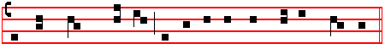
WE praise thee, O God: *we acknowledge thee to be the Lord.
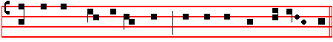
All the earth doth worship thee, the Fath-er e - ver – last -ing.
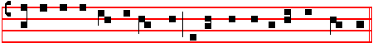
To thee all an -gels cry a- loud, the Heavens, and all the powers therein:
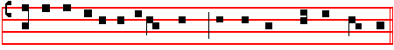
To thee Cherubyn and Sera -phyn con- tin - u - al - ly do cry:
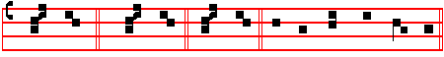
Ho - ly : Ho - ly : Ho - ly : Lord God of Sa - ba - oth.
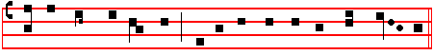
Heaven and earth are full of the maj – es - ty of thy glo - ry.
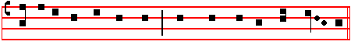
The glo-ri-ous com -pa - ny of the A-pos - tles praise thee.

24
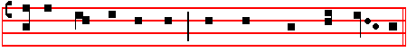 The good-ly fel -low- ship of the Pro- phets praise thee.
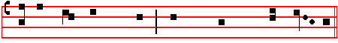
The no - ble ar - my of Mar - tyrs praise thee.
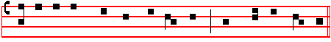
The holy Church through-out all the world doth acknowledge thee;
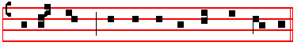
The Fa - ther of an in- fi- nite M a- jes - ty,
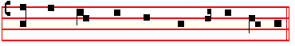
Thine hon - our - a - ble, true, and on - ly Son;
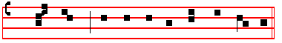
Al - so the Ho - ly Ghost the Com- fort- er.
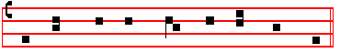
Thou art the King of Glo - ry, O Christ.
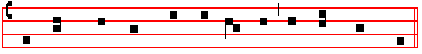 Thou art the ev - er - last - ing Son of the Fa - ther.
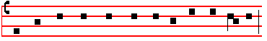
When thou took -est up - on thee to de – liv - er man,

25
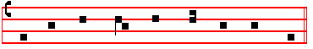
thou didst not ab - hor the Vir - gin's womb.
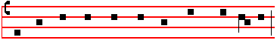
When thou hadst ov - er - come the sharp - ness of death,
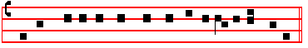
thou didst open the King-dom of heaven to all be–lie-vers.
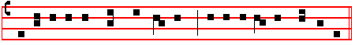
Thou sittest at the right hand of God, in the glo -ry of the Father.
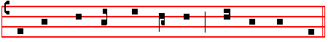
We be - lieve that thou shalt come to be our Judge.
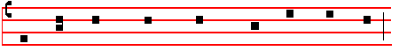
We there - fore pray thee help thy ser - vants
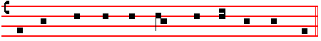
whom thou hast re - deem - ed with thy pre - cious blood.
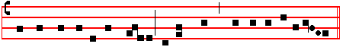
Make them to be number - ed with thy Saints, in glory ever-lasting.
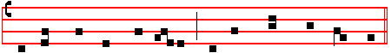
O Lord, save thy peo - ple, and bless thine her - it - age.

26
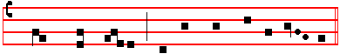
Gov - ern them, and lift them up for ev - er.

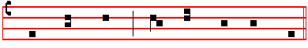
Day by day we mag - ni - fy thee;
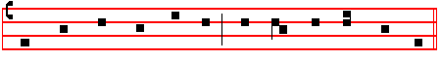 And we wor - ship thy Name ev - er world with - out end.

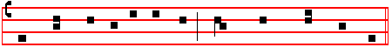
Vouch - safe, O Lord, to keep us this day with - out sin.
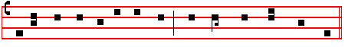
O Lord, have mercy upon us, have mer - cy up - on us.
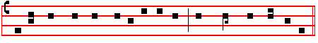
O Lord, let thy mercy lighten up-on us, as our trust is in thee.

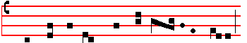
O Lord, in thee have I trust - ed;
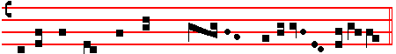
let me nev - er be con - found - ed.

27

AT LAUDS

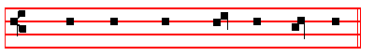
O GOD, make speed to save me.
 O Lord, make haste to help me.

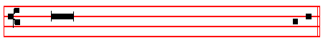
. Glory be to the Father, and to the Son, and to the Ho - ly Ghost. 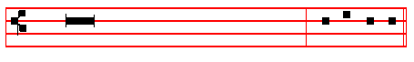
. As it was in the beginning, is now,
and ever shall be, world without end. Amen. Al - le - lu- ia or
Praise be to thee, O Lord, King of eternal glory, according to the season.

From the Sunday after the Octave of the Epiphany until Septuagesima, and
from the Octave of Pentecost until Advent, Antiphon. Tone vj.
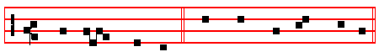
Al - le - lu - ia. E u o u a e.

In Eastertide, Antiphon. Tone viij,1.
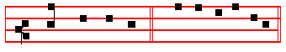
Al - le - lu - ia. E u o u a e.

Psalm 93 Dominus regnavit, decorem indutus est XCII

THE Lord is King, and hath put on glorious apparel; * the Lord

28
,hath put on his apparel, and girded himself with strength.
2 He hath made the round world so sure, * that it cannot be moved.

3 Ever since the world began hath thy seat been prepared: * thou art from everlasting.
4 The floods are risen, O Lord, the floods have lift up their voice; * the floods lift up their waves.
5 The waves of the sea are mighty and rage horribly; * but yet the Lord, who dwelleth on high, is mightier.
6 Thy testimonies, O Lord, are very sure: * holiness becometh thine house for ever.
Psalm 100 Jubilate Deo, omnis terra XCIX

O BE joyful in the Lord, all ye lands: * serve the LORD with gladness, and come before his presence with a song.
2 Be ye sure that the Lord he is God; * it is he that hath made us, and not we ourselves; * we are his people, and the sheep of his pasture.
3 O go your way into his gates with thanksgiving, and into his courts with praise; * be thankful unto him and speak good of his Name.
4 For the Lord is gracious, his mercy is everlasting; * and his truth endureth from generation to generation.

Psalm 63 Deus, Deus meus LXII

O GOD, thou art my God; * early will I seek thee.

2 My soul thirsteth for thee, my flesh also longeth after thee * in a barren and dry land where no water is.
3 Thus have I looked for thee in the sanctuary * that I might behold thy power and glory.
4 For thy loving–kindness is better than the life itself: * my lips shall praise thee.

5 As long as I live will I magnify thee in this manner * and lift up my hands in thy Name.
6 My soul shall be satisfied, even as it were with marrow and fatness * when my mouth praiseth thee with joyful lips.
7 Have I not remembered thee in my bed * and thought upon thee when I was waking?
8 Because thou hast been my helper; * therefore under the shadow of thy wings will I rejoice.
9 My soul hangeth upon thee; * thy right hand hath upholden me.

29
10 These also that seek the hurt of my soul, * they shall go under the earth.

11 Let them fall upon the edge of the sword * that they may be a portion for foxes.

12 But the King shall rejoice in God; all they also that swear by him shall be commended; * for the mouth of them that speak lies shall be stopped.

Here is not said, Glory be to the Father.
Psalm 67 Deus misereatur nostri LXVI

GOD be merciful unto us, and bless us * and show us the light of,,his countenance, and be merciful unto us;
2 That thy ways may be known upon earth, * thy saving health among all nations.

3 Let the people praise thee, O God; * yea, let all the people praise thee.

4 O let the nations rejoice and be glad; * for thou shalt judge the folk righteously, and govern the nations upon earth.
5 Let the people praise thee, O God; * yea, let all the people praise thee.

6 Then shall the earth bring forth her increase; * and God, even our own God, shall give us his blessing.
7 God shall bless us; * and all the ends of the world shall fear him.

Throughout the year, Antiphon.
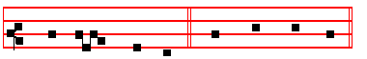
Al - le - lu - ia, al - le - lu - ia.

Antiphon. Tone viij,1
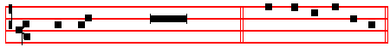
At the King's commandment. E u o u a e.
In Eastertide, Antiphon.
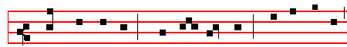
Al - le - lu - ia, al - le - lu - ia , al - le - lu - ia;

30
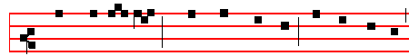
al - le - lu - ia, al - le - lu - ia, al - le - lu - ia;
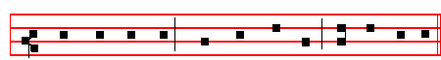
al - le - lu - ia, al - le - lu - ia, al - le - lu - ia.

Antiphon. Tone vj.
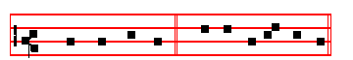
Christ is ri - sen. E u o u a e.

The Song of the Three Children Benedicite, omnia opera Dan. 3

O ALL ye Works of the Lord, bless ye the Lord: * praise him, and magnify him for ever.
2 O ye Angels of the Lord, bless ye the Lord: * O ye Heavens, bless ye the Lord.

3 O ye Waters that be above the firmament bless ye the Lord: * O all ye Powers of the Lord, bless ye the Lord.
4 O ye Sun and Moon, bless ye the Lord: * O ye Stars of heaven, bless ye the Lord.
5 O ye Showers and Dew, bless ye the Lord: * O ye Winds of God, bless ye the Lord.
6 O ye Fire and Heat, bless ye the Lord: * O ye Winter and Summer, bless ye the Lord.
7 O ye Dews and Frosts, bless ye the Lord: * O ye Frost and Cold, bless ye the Lord.
8 O ye Ice and Snow, bless ye the Lord: * O ye Nights and Days, bless ye the Lord.
9 O ye Light and Darkness, bless ye the Lord: * O ye Lightnings and Clouds, bless ye the Lord.
10 O let the earth bless the Lord: * yea, let it praise him and magnify him
for ever.

31
11 O ye Mountains and Hills, bless ye the Lord: * O all ye Green Things upon the earth, bless ye the Lord.
12 O ye Wells, bless ye the Lord: * O ye Seas and Floods, bless ye the Lord.

13 O ye Whales, and all that move in the waters, bless ye the Lord: * O all ye Fowls of the air, bless ye the Lord.
14 O all ye Beasts and Cattle, bless ye the Lord: * O ye Children of Men, bless ye the Lord.
15 O let Israel bless the Lord: * praise him, and magnify him for ever.

16 O ye Priests of the Lord, bless ye the Lord: * O ye Servants of the Lord, bless ye the Lord.
17 O ye Spirits and Souls of the Righteous, bless ye the Lord: * O ye holy and humble Men of heart, bless ye the Lord.
18 O Ananias, Azarias, and Misael, bless ye the Lord: * praise him, and magnify him for ever.
19 Let us bless the Father, and the Son, and the Holy Ghost: * praise him, and magnify him for ever.
20 Blessed art thou, O Lord, in the firmament of heaven: * and to be praised, and glorified, and magnified for ever.
Here is not said Glory be to the Father, nor Amen. In other Canticles they are said.

Throughout the year, Antiphon.
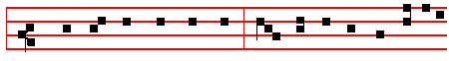 At the king's commandment, the three children were cast into
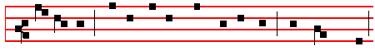
the furnace, fearing not the flames of the fire, but say - ing,
Antiphon. Tone viij,1
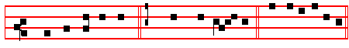
Blessed be our God. Al - le - lu - ia. E u o u a e.

In Eastertide, Antiphon.

32
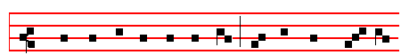
Christ is ri - sen from the grave, who de - li - ver - ed
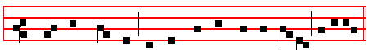
the three children from the burning fier- y furnace, al-le-luia.
Antiphon. 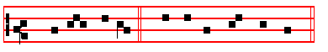
Al - le - lu - ia. E u o u a e..

Psalm 148 Laudate Dominum CXLVIII

O PRAISE the Lord of heaven: * praise him in the height.

2 Praise him, all ye angels of his: * praise him, all his host.

3 Praise him, sun and moon: * praise him, all ye stars and light.

4 Praise him, all ye heavens * and ye waters that be above the heavens.

5 Let them praise the Name of the Lord * for he spake the word, and they were made; he commanded, and they were created.
6 He hath made them fast for ever and ever * he hath given them a law which shall not be broken.
7 Praise the Lord upon earth * ye dragons, and all deeps.

8 Fire and hail, snow and vapours * wind and storm, fulfilling his word.

9 Mountains and all hills * fruitful trees and all cedars.

10 Beasts and all cattle * worms and feathered fowls.

11 Kings of the earth and all people * princes and all judges of the world;

33
12 Young men and maidens, old men and children, praise the Name of the Lord * for his Name only is excellent, and his praise above heaven and earth.
13 He shall exalt the horn of his people; all his saints shall praise him * even the children of Israel, even the people that serveth him.

Here is not said, Glory be to the Father.
Psalm 149 Cantate Domino canticum novum CXLIX

O SING unto the Lord a new song; * let the congregation of saints praise him.

2 Let Israel rejoice in him that made him, * and let the children of Sion be joyful in their King.
3 Let them praise his Name in the dance: * let them sing praises unto him with tabret and harp.
4 For the Lord hath pleasure in his people * and helpeth the meek–hearted.

5 Let the saints be joyful with glory; * let them rejoice in their beds.

6 Let the praises of God be in their mouth; * and a two–edged sword in their hands;
7 To be avenged of the nations * and to rebuke the peoples;

8 To bind their kings in chains * and their nobles with links of iron;

9 That they may be avenged of them, as it is written, * Such honour have all his saints.

Here is not said, Glory be to the Father
Psalm 150 Laudate Dominum CL

O PRAISE God in his holiness * praise him in the firmament of his power.

2 Praise him in his noble acts * praise him according to his excellent greatness.

3 Praise him in the sound of the trumpet * praise him upon the lute and harp.

4 Praise him in the cymbals and dances * praise him upon the strings and pipe.

5 Praise him upon the well-tuned cymbals * praise him upon the loud cymbals.

6 Let everything that hath breath * praise the Lord.

34
Throughout the year, Antiphon.
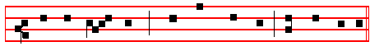
Al - le - lu - ia, al - le - lu - ia, al - le - lu - ia.

In Eastertide, Antiphon.
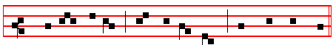
Al - le - lu - ia, al - le - lu - ia, al - le - lu - ia.

The following Chapter is said on Sundays from the second Sunday after the Epiphany until Septuagesima, and from the third Sunday after Pentecost until Advent.
Chapter Rev. 7
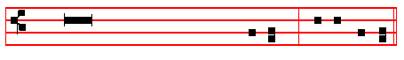
Blessing, and glory, and wisdom, and
thanksgiving, and honour, and power,
and might, be unto our God for ever and ever. Amen. . Thanks be to God. This response is made at the end of all Chapters.
The following hymn is said from the Octave of the Epiphany until the first Sunday of Lent, and from the Sunday nearest to the first of October until Advent.

Hymn Aeterne Rerum Conditor Mode iv
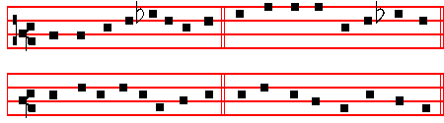

Maker of all, eternal King, 2 Now the shrill cock proclaims the day,
Who day and night about dost bring: And calls the sun's awakening ray,
Who weary mortals to relieve, The wandering pilgrim's guiding light,
Dost in their times the seasons give: That marks the watches night by night.

35
3 Roused at the note, the morning star 6 New hope his clarion note awakes,
Heaven's dusky veil uplifts afar: Sickness the feeble frame forsakes,
Night's vagrant bands no longer roam, The robber sheathes his lawless sword,
But from their dark ways hie them home. Faith to the fallen is restored.

4 The encouraged sailor's fears are o'er, 7 Look on us, Jesus, when we fall,
The foaming billows rage no more: And with thy look our souls recall;
Lo! e'en the very Church's Rock If thou but look, our sins are gone,
Melts at the crowing of the cock And with due tears our pardon won.

5 O let us then like men arise; 8 Shed through our hearts thy piercing ray
The cock rebukes our slumbering eyes , Our souls' dull slumber drive away
Bestirs who still in sleep would lie, Thy name be first on every tongue,
And shames who would their Lord deny. To thee our earliest praises sung.

9 All laud to God the Father be,
All praise, eternal Son, to thee;
All glory, as is ever meet,
To God the Holy Paraclete
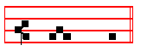
A - men
The following hymn is said from the Octave of Pentecost to the first Sunday of October.
Hymn Ecce jam noctis Mode iv
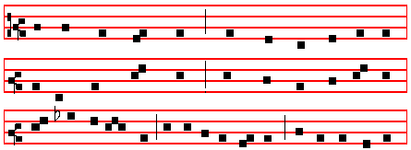

LO! the dim shadows of the night are waning;
Radiantly glowing, dawn of day returneth;
Fervent in spirit, to the mighty Father Pray we devoutly.

2 So shall our maker, of his great compassion,
Banish all sickness, kindly health bestowing;
And may he grant us, of a Father's goodness, Mansions in heaven.
36
3 This he vouchsafe us, God for ever blessed,
Father eternal, Son, and Holy Spirit,
Whose is the glory which through all creation Ever resoundeth.
A - men.
Throughout the year,
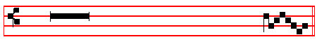
 The Lord is King, and hath put on glorious appar - el.
.The Lord hath put on his apparel, and girded himself with strength.
From Septuagesima to Lent, . Lord, thou hast been our re - fuge.
. From one generation to ano - ther.
In Advent, Lent, Passiontide, and Eastertide, Proper Hymns and .
On Benedictus, Proper Antiphon.
St. Luke i. 68 Benedictus Dominus Deus Israel Tone j, 1.
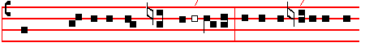
BLES- SED be the Lord God of Is- ra -el; * for he hath visit-ed and
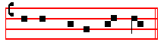
re-deem - ed his peo - ple; Tone ij.
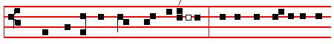 BLESSED be the Lord God of Israel; * for he hath /visit-ed and
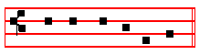
re-deem - ed his peo-ple;

37
Tone iij, 1.
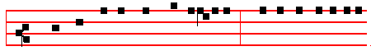
BLESSED be the Lord God of Is-rael; * for he hath visited and
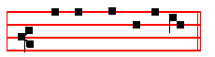
redeem - ed his people; Tone iv, 1
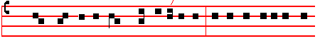
BLESSED be the Lord God of Is -ra-el; * for he hath visited and
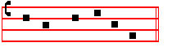
re-deem- ed his peo-ple; Tone v.
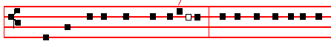
BLESSED be the Lord God of Is-ra-el; * for he hath vis-it-ed and
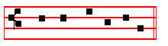
re- deem - ed his peo-ple; Tone vj.
BLESS - ED be the Lord God of Is-ra-el; * for he hath /visited and
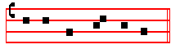
redeem - ed his peo-ple;

38
Tone vij, 1
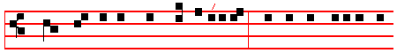
BLESS-ED be the Lord God of Is-ra-el; * for he hath visited and
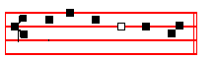
redeemed his peo- ple; Tone viij, 1.
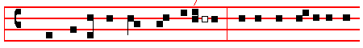
BLESSED be the Lord God of Is-ra-el; * for he hath / vi-sited and
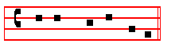
re-deem - ed his peo-ple;

12468 37 5 / / 4
2 And hath raised up a mighty sal - vation for us, * in the house of his
15678 23
ser - vant David;
2468 37 5 / 4
3 As he spake by the mouth of his holy Prophets, * which have been
15678 23
since the world began;
12468 37 5 / / 4
4 That we should be sa - ved from our en-emies, * and from the hands of
15678 23
all that hate us.
12468 37 5 / /
5 To perform the mercy promised to our forefathers, * and to remember
4 15678 23
his ho - ly covenant;
12468 37 5 /
6 To perform the oath which he sware to our fore - fa-ther Abraham, *
4 15678 23
that he would give us;
12468 37 5 /
7 That we being delivered out of the hand of our en-emies * might
4 15678 23
serve him with-out fear;
39
2468 37 5 / 4 15678 23
8 In holiness and righ-teous-ness before him, * all the days of our life.
12468 37 5 /
9 And thou, child, shalt be called the Pro-phet of the Highest: * for thou
/ 4 15678 23
shalt go before the face of the Lord, to pre-pare his ways;
12468 37 5 / 457 168
10 To give knowledge of salvation un - to his people * for the remis-sion
23
of their sins,
16 2478 3 / 5 /
11 Through the tender mer - cy of our God; * whereby the Day–spring from
4 68 157 23
on high hath vi - si- ted us;
12468 37 /
12 To give light to them that sit in darkness, and in the shad-ow of
5 / 4 15678 2 3
death, * and to guide our feet in - to the way of peace.
16 23748 / 5 4 1678 23
13 Glory be to the Fa - ther and to the Son, * and to the Holy Ghost;
12468 37/ 5 4
14 As it was in the beginning, is now and ev- er shall be, * world with-
15678 23
out end. Amen.

Then the Antiphon is said, and the Proper Collect, and after it, if there occur on that day any simple feast, commemoration is made of it.

Finally (if the season require it) the commemorations are made of S. Mary, of the Apostles, and of the Patron of the Church in order among the other commemorations according to its dignity, and in the last place of Peace, as below in Vespers of Saturday.

At the end, if the choir is to be left, is said one of the Antiphons of Blessed Mary, to be found below at the end of Compline.
__________________________________________________________________
(Psalm 22 Deus ,Deus meus,Friday at Prime, p. 43)
(Psalm 23 Dominus regit me, Thursday at Prime, p. 42)
(Psalm 24 Domini est terra, Monday at Prime, p. 38)
(Psalm 25 Ad te,Domine, Tuesday at Prime,p. 39)
(Psalm 26 Judica me, Wednesday at Prime, p. 41)
___________________________________________________________________________________________

40

