Hymn. E.H. 66 Mode ij
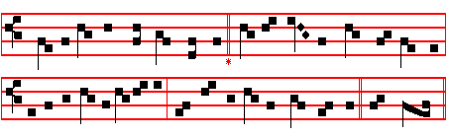
Audi benigne Conditor
O KIND Creator bow thine ear 3 Our sins are many, this we know;
To mark the cry, to know the tear Spare us, good Lord, thy mercy show
Betore thy throne of mercy spent And for tho honour of thy name
In this thy holy fast of Lent Our fainting souls to life reclaim.

2 Our hearts are open, Lord, to thee: 4 Give us the self-control that springs
Thou knowest our infirmity From discipline of outward things,
Pour out on all who seek thy face That fasting inward secretly
Abundance of thy pardoning grace. The soul may purely dwell with thee.
5. We pray thee, Holy Trinity,
One God, unchanging Unity,
That we from this our abstinence
May reap the fruits of penitence. Amen.

 God shall give his Angels charge over thee.  To keep thee in all thy ways.
On Magnificat, Antiphon. Tone vij, 3
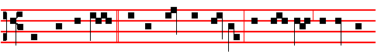
Then shalt thou call, * and the Lord shall answer: thou shalt cry, and he shall
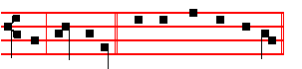
say, Here am I. Canticle Magnificat, p.

COLLECT
O GOD, who year by year dost purify thy Church by this Lenten observance: grant unto thy family; that those things which they strive to obtain from thee by abstinence, they may by good works fulfil. Through.

596
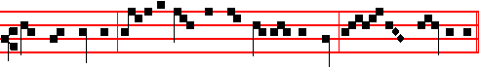
thou shalt not eat: for in the day that thou eatest thereof, thou shalt surely die.
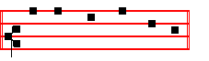
Canticle Magnificat
COLLECT
O LORD, we beseech thee favourably to hear the prayers of thy people:that we, who are justly punished for our offences, may be mercifully delivered by thy goodness, for the glory of thy name. Through.

 Let us bless the Lord. Alleluia, alleluia.
 Thanks be to God. Alleluia, alleluia.
And henceforth Alleluia is not said until Holy Saturday: but after O God, make speed, where Alleluia was said, is said Praise be to thee, O Lord, King of eternal glory.
If on a Sunday from Septuagesima to Low Sunday there occur a Double, or Semidouble Feast, it is transferred to the first day not similarly impeded, as is directed in the Rubric of Translation of Feasts.
__________________________________________________________________

SEPl'UAGESIMA SUNDAY AT MATINS

Invitatory.-Let us come before his presence with thanksgiving, * And shew ourselves glad in him with psalms. Ps.95. In the first verse of the Psalm, Let us come before his presence with thanksgiving etc. is omitted, and in its place the Invitatory is repeated by the Choir.
Hymn.E.H.56 Primo dierum omnium, as in the Psalter.
Antiphons, Psalms, and Versicles of the Nocturms from the Psalter.

IN THE FIRST NOCTURN
Here beginneth the Book of Genesis.
Lesson j Ch. 1, 1-26
IN the beginning God created the heaven and the earth. And the earth was without form, and void; and darkness was upon the face of the deep. And the Spirit of God moved upon the face of the waters. And God said, Let there be light: and there was light. And God saw that it was good: and God divided the light

541
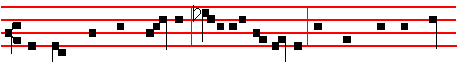
But thou, when thou prayest, * enter into thy closet,and when thou hast shut
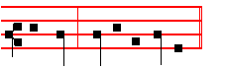
thy door, pray to thy Father. Then the Prayers, p. 108
COLLECT
DEFEND, O Lord, thy people, and mercifully cleanse them from all their sins: that no adversity may harm them, over whom iniquity hath no dominion. Through.
Saturday
The Lesson from the Holy Gospel according to S. Mark.
Lesson j Ch. 6, 47-66
WHEN even was come, the ship was in the midst of the sea, and Jesus alone on the land.
Homily by S. Bede the Venerable, Priest Bk. 2 on S. Mark, Ch. 6
THE toil of the disciples in rowing, and the wind contrary to them, is a figure of the various toils of Holy Church. She, amidst the waves of the contrary world, and the blasts of unclean spirits, strives to reach the harbour of the heavenly fatherland, as the safe shore for her anchorage. It is fittingly said that the ship was in the midst of the sea. and he alone on the dry land: sometimes the Church is not merely afflicted, but is so befouled by the pressure of the Gentiles, that it seems as though, were it possible, her Redeemer had temporarily abandoned her.

 I came this day unto the well, and I besought the Lord, and said: * O Lord God of Abraham, thou hast prospered my way.
 Therefore the virgin to whom I shall say: Give me water of thy pitcher to drink: and she shall say, Drink, my lord, and I will give thy camels to drink also: let the same be she that thou hast appointed for thy servant Isaac. O Lord.

Lesson ij
THENCE arises that cry of hers when she is caught amidst the waves and storms of rushing temptations, as with great anguish she beseeches his saving protection: Why standest thou so far off, O Lord, and hidest thy face in the needful time of trouble. Similarly in the following verses she tells him what her enemy says of her as he persecutes her, crying, He hath said in his heart, Tush,

594
which the waters brought forth abundantly, after their kind, and every winged fowl after his kind: and God saw that it was good. And God blessed them, saying, Be fruitful, and multiply, and fill the waters in the seas, and let fowl multiply in the earth. And the evening and the morning were the fifth day. And God said, Let the earth bring forth the living creature after his kind, tattle, and creeping thing, and beast of the earth after his kind: and it was so. And God made the beast of the earth after his kind, and cattle after their kind, and every thing that creepeth upon the earth after his kind: and God saw that it was good. And God said, Let us make man in our image, after our likeness: and let them have dominion over the fish or the sea, and over the rowl or the air, and over the cattle, and over all the earth, and over every creeping thing that creepeth upon the earth.

 The Lord formed man of the dust or the ground, * And breathed into his nostrils the breath of life, and man became a living soul.
 In the beginning God created the heaven and the earth, and therein formed he man. And breathed. Glory be. And breathed.

IN THE SECOND NOCTURN
From the Book on Faith, Hope, and Charity, by S. Augustine, Bishop
Lesson iv
GOD had threatened man with the punishment of death if he sinned; thus gifting him with free will, as yet to rule him by his control, and affright him with destruction; and placed him in the happiness of paradise as in the shadow of a life, from whence by observing righteousness he might ascend to better things. After his sin he was made an exile, and he bound by the punishment of death and condemnation his own race also, which by sinning he had corrupted in himself as in its root. Therefore whatever offspring would be born of him and his wife, through whom he had sinned and who was condemned together with him through carnal lust, wherein was repaid a punishment fitting the disobedience; this offspring would draw along with it original sin. By original sin it would be drawn through various errors and pains, to that last never-ending punishment, with the apostate angels, its corrupters, masters, and partners.

 The Lord took the man and put him into the garden of Eden, * To dress it and to keep it.
 And the Lord planted a garden eastward in Eden, and there he put the man whom he had formed. To dress.

Lesson v
THUS, By one man sin entered into the world, and by sin death: and so death passed upon all men, in that all sinned. By the world in that place the Apostle

543
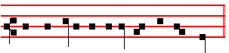
the word only and my servant shall be healed. Then the Prayers, p. 108.
COLLECT
SPARE us, O Lord, spare thy people: that they who are justly chastised by thy scourges, may be relieved by thy tender mercy.Through.
__________________________________________________________________

Friday
The Lesson from the Holy Gospel according to S. Matthew
Lesson j Ch. 5, 43-48; 6, 1-4
JESUS said unto his disciples: Ye have heard that it hath been said, Thou shalt love thy neighbour, and hate thine enemy.
Homily by S. Jerome, Priest Bk. 1 Comm. on Matt. Ch. 5
BUT I say unto you, Love your enemies, bless them that curse you. Many men consider God's commandments in the light of their own feebleness, and not in the strength and virility of the saints; and so they think these commandments impossible to put into practice. They say that not to hate their enemies is the best that they can do, and that to rise to loving them is to command more than human nature can bear. It must be made clear, then, that Christ did not command the impossible, but perfection. This David achieved with Saul and Absalom: so did Stephen the Martyr, in praying for his enemies while they were stoning him: and Paul wished to be accursed from Christ, for the sake of his persecutors. This, Jesus both taught and practised, saying, Father, forgive them, for they know not what they do.

 The angel of the Lord called unto Abraham, and said: * Lay not thine hand upon the lad, for now I know that thou fearest God.
 When he stretched forth his hand to slay his son, behold, the angel of the Lord called unto him out of heaven, and said: Lay not.

Lesson ij
THAT ye may be the children of your Father which is in heaven. If he who keeps the commandments of God becomes a son of God, then he is a son, not by nature, but by his own choice. Therefore when thou doest thine alms, do not sound a trumpet before thee, as the hypocrites do in the synagogues and in the streets, that they may have glory of men. He who sounds a trumpet when he gives alms, is a hypocrite. He who dis- figures his face when he fasts, that the emptiness of his stomach may be revealed by his expression, is a hypocrite too. He who

592
 The Lord God planted a garden eastward in Eden, * And there he put the man whom he had formed.
 And out of the ground made the Lord God to grow every tree that is pleasant to the sight and good for food; the tree of life also in the midst of the garden. And there.

Lesson viij
THIS householder, then, went out early, and at the third, sixth, ninth, and eleventh hours, to hire labourers into his vineyard. For from the beginning of this world even unto its end he unceasingly gathers preachers to teach his faithful people. The early morning of the world was from Adam until Noah: the third hour was from Noah until Abraham: the sixth, from Abraham until Moses: the ninth, from Moses until the coming of the Lord; while the eleventh is from the coming of the Lord until the end of the world.. In this eleventh hour, the holy Apostles were sent as preachers, and they received full hire, although they came at a late hour.
 Behold, the man is become as one of us to know good and evil. * See lest he take of the tree of life and live for ever.
 Unto Adam also did the Lord God make a coat of skins and clothed him and said: See lest.

Lesson ix.
FOR the teaching of his people, the cultivating of his vineyard, the Lord never ceases to send labourers: first by the patriarchs, and soon after by the teachers of the law and the prophets, and lastly by the Apostles, he formed his peoples' way of life, just as he cultivated his vineyard by the hands of his labourers. Whoever, in whatsoever degree or measure, stood forth as a preacher, combining good works with true faith, that man was a preacher; in the Lord's vineyard. The ancient people of the Hebrews is signified by the labourer of the early morning, and of the third, sixth, and ninth hours. These men, from the very beginning of the world, worked zealously to inculcate the true faith into God's chosen people, as though unceasingly working on the cultivation of the vineyard. Then at the eleventh hour the Gentiles were called, and to them it was said, Why stand ye here all the day idle?
 Where is Abel thy brother? said the Lord unto Cain. Lord, I know not; am I my brother's keeper? And he said unto him: What hast thou done? * Behold the voice of thy brother Abel's blood crieth unto me from the ground.
 And now thou art cursed from the earth, which hath opened her mouth to receive thy brother's blood from thy hand. Behold. Glory be. Behold.
The ninth responsory is said on Sundays until Easter instead of the Hymn Te Deum, which is not said in this season, except on Feasts.

545
Jesus went with them. And when he was now not far from the house, the centurion
sent friends to him, saying unto him, Lord, trouble not thyself; for I am not worthy that thou shouldest enter under my roof: wherefore neither thought I myself worthy to come unto thee: but say in a word, and my servant shall be healed.

 Lord, my servant t lieth at home sick of the palsy, grievously tormented. * Jesus saith unto him, I will come and heal him.
 Lord, I am not worthy that thou shouldest come under my roof; but speak the word only, and my servant shall be healed. Jesus.

Lesson ij
FOR if this was the manner in which the incident took place, how can Matthew's statement, that there came to him a certain centurion, be correct, seeing that the man did not come in person, but sent his friends? The apparent discrepancy, however, will disappear if we look carefully into the matter, and observe that Matthew has simply held by a very familiar mode of expression. For not only are we accustomed to speak of one as coming even before he actually reaches the place he is said to have approached; whence, too, we speak of one as making small approach or making great approach to what he is desirous of reaching; but we also not unfrequently speak of that access, for the sake of getting at which the approach is made, as reached even although the person who is said to reach another may not himself see the individual whom he reaches, inasmuch as it may be through a friend that he reaches the person whose favour is necessary to him. This, indeed, is a custom which has so thoroughly established itself, that even in the language of everyday life now those men are said to approach who, in the practice of canvassing, get at the inaccessible ears, as one may say. of any of the men of influence, by the intervention of suitable personages. If, therefore, access itself is thus familiarly said to be gained by the means of other parties, how much more may an approach be said to take place, although it be by means of others, which always remains something short of actual access! For it is surely the case, that a person may be able to do very much in the way of approach, but yet may have failed to succeed in actually reaching what he sought to get at.

Abraham stood by the oak of Mamre, and he saw three men coming towards him. * He saw Three, and worshipped One.
 Behold Sarah thy wife shall bear thee a son, and thou shalt call his name Isaac. He saw.

Lesson iij
CONSEQUENTLY it is nothing out of the way for Matthew, a fact, indeed, which may be understood by any intelligence, when thus dealing with an

590
Antiphon 5. Tone j, 2.
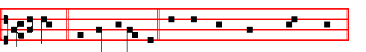
O praise * the Lord of heaven. Psalms 148, 149, 150 Laudate Dominum, as in the Psalter.
The aforesaid Psalms are always said in Lauds of Sunday until Easter.
Chapter I Cor. 9
BRETHREN: Know ye not, that they which run in a race run all, but one receiveth the prize? So run, that ye may obtain.
Hymn. Aeterne rerum Conditor, as in the Psalter.
 Lord, thou hast been our refuge.  From one generation to another.
On Benedictus, Antiphon. Tone j, 1.
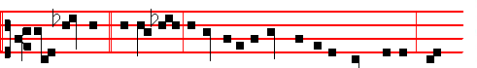
The kingdom * of hea--ven is like unto a man that is an householder, which
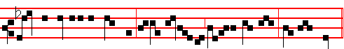
went out early in the morning to hire labourers into his vineyard, saith the Lord.
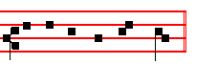
Canticle Benedictus, p. 39.
COLLECT
O LORD, we beseech thee favourably to hear the prayers of thy people:that we, who are justly punished for our offences, may be mercifully delivered by thy goodness, for the glory of thy name. Through.

AT PRIME
Antiphon. Tone j, 1.
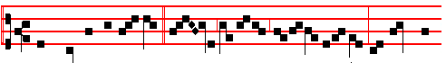
And when he had agreed * with the labourers for a penny a day, he sent them

547
 Therefore the virgin to whom I shall say: Give me water of thy pitcher to drink: and she shall say, Drink, my lord, and I will give thy camels to drink also: let the same be she that thou hast appointed for thy servant Isaac. O Lord God.

Lesson ij
AND therefore he who is very conspicuous by immoderate attention to the body, and by the splendour of his clothing or other things, is easily convicted by the things themselves of being a follower of the pomps of the world, and misleads no one by a cunning semblance of sanctity; but in regard to him who, under a profession of Christianity, fixes the eyes of men upon himself by unusual squalor and filth, when he does it voluntarily, and not under the pressure of necessity, it may be conjectured from the rest of his actings whether he does this from contempt of superfluous attention to the body, or from a certain ambition: for the Lord has enjoined us to beware of wolves under a sheep's skin; but, By their fruits, says he, shall ye know them.

 The word of the Lord came unto Abram, saying: * Fear not, Abram, I am thy shield, and thy exceeding great reward.
 For I am the Lord thy God that brought thee out of Ur of the Chaldees. Fear not.
Lesson iij
FOR when by temptations of any kind those very things begin to be withdrawn from them or refused to them, which under that veil they either have obtained or desire to obtain, then of necessity it appears whether it is a wolf in a sheep's skin or a sheep in its own. For a Christian ought not to delight the eyes of men by superfluous ornament on this account, because pretenders also too often assume that frugal and merely necessary dress, that they may deceive those who are not on their guard: for those sheep also ought not to lay aside their own skins, if at any time wolves cover themselves therewith.

 Abram removed his tent, and came and dwelt in the plain of Mamre. * And built there an altar unto the Lord.
 And the Lord said unto him, Lift up now thine eyes and look: all the land which thou seest, to thee will I give it, and to thy seed for ever. And built. Glory be. And.
At Lauds, and through the Hours, all as in the Psalter.
On Benedictus, Antiphon.
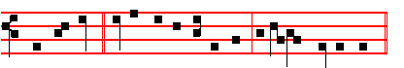
When ye fast, * be not, as the hypocrites, of a sad countenance.

588
 The Lord is my shepherd, therefore can I lack nothing.
 He shall feed me in a green pasture.

AT NONE

Antiphon. Tone viij, 1.
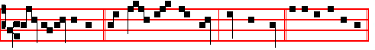
Call the labourers. * and give them their hire, saith the Lord. Psalm 118.
Chapter I Cor.10
FOR they drank of that spiritual Rock which followed them: and that Rock was Christ. But with some of them God was not well pleased.
Short  as on p. 85. I call with my whole heart, * Hear me, O Lord. I call.
 I will keep thy statutes. Hear me. Glory be. I call.
 O cleanse thou me from my secret faults.
 Keep thy servant also from presumptuous sins.

AT VESPERS
Antiphon and Psalm 110 Dixit Dominus with the rest as in the Psalter.
Chapter Brethren: Know ye not, as above.
Hymn. E.H. 51 Lucis Creator optime, as in the Psalter.
 Lord, let my prayer be set forth.  In thy sight as the incense.
On Magnificat, Antiphon. Tone vij, 3.
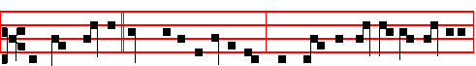
The householder * saith unto the labourers, Why stand ye here all the day idle?
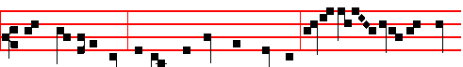
They say unto him, Because no man hath hired us. Go ye also into the vine-
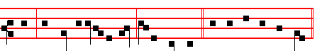
yard, and whatsoever is right, I will give you. Canticle Magnificat, p.

549
and Arioch king of Ellasar; four kings with five. And the vale of Siddim was full of slimepits; and the kings of Sodom and Gomorrah fled, and fell there; and they that remained fled to the mountain. And they took all the goods of Sodom and Gomorrah, and all their victuals, and went their way. And they took Lot, Abram's brother's son, who dwelt in Sodom, and his goods, and departed.

 The Angel of the Lord called unto Abraham, and said: * Lay not thine hand upon the lad, for now I know that thou fearest God.
 When he stretched forth his hand to slay his son, behold, the angel of the Lord called unto him out of heaven, and said: Lay not.

Lesson ij
AND there came one that had escaped, and told Abram the Hebrew; for he dwelt in the plain of Mamre the Amorite, brother of Eshcol, and brother of Aner: and these were confederate with Abram. And when Abram heard that his brother was taken captive, he armed his trained servants, born in his own house, three hundred and eighteen, and pursued them unto Dan. And he divided himself against them, he and his servants, by night, and smote them, and pursued them unto Hobah, which is on the left hand of Damascus. And he brought back all the goods, and also brought again his brother Lot, and his goods, and the women also, and the people.

 The Angel of the Lord called unto Abraham out of heaven the second time, and said: I will bless thee: * And I will multiply thy seed as the stars of heaven.
 Thy seed shall possess the gate of his enemies, and in thy seed shall all the nations of the earth be blessed. And I.

Lesson iij
AND the king of Sodom went out to meet him after his return from the slaughter of Chedorlaomer, and of the kings that were with him, at the valley of Shaveh, which is the king's dale. And Melchizedek king of Salem brought forth bread and wine: and he was the priest of the most high God. And he blessed him, and said, Blessed be Abram of the most high God, possessor of heaven and earth: and blessed be the most high God, which hath delivered thine enemies into thy hand. And he gave him tithes of all.

 O Lord God of my master Abraham, prosper my way which I go: * That I may return again in safety unto the house of my master.
 O Lord, I pray thee, be merciful unto thy servant. That I. Glory be. That I.

On Magnificat, Antiphon.

586
God planted a garden eastward in Eden; and there he put the man whom he had formed. And out of the ground made the Lord God to grow every tree that is pleasant to the sight, and good for food; the tree of life also in the midst of the garden, and the tree of knowledge of good and evil. And a river went out of Eden to water the garden; and from thence it was parted, and became into four heads.

 The Lord formed man of the dust of the ground, * And breathed into his nostrils the breath of life, and man became a living soul.
 In the beginning God created the heaven and the earth, and therein formed he man. And breathed. Glory be. And breathed.

On Magnificat, Antiphon.
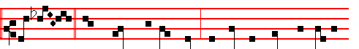
These last * have wrought but one hour, and thou hast made them equal
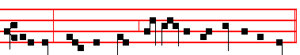
unto us, which have borne the burden and heat of the day.
__________________________________________________________________

Tuesday
From the Book of Genesis
Lesson j Ch. 2, 15-24
AND the Lord God took the man, and put him into the garden of Eden to dress it and to keep it. And the Lord God commanded the man, saying, Of every tree of the garden thou mayest freely eat: but of the tree of the knowledge of good and evil, thou shalt not eat of it: for in the day that thou eatest thereof thou shalt surely die. And the Lord God said, It is not good that the man should be alone; I will make him an help meet for him.

 The Lord took the man and put him into the garden of Eden, * To dress it and to keep it.
 And the Lord planted a garden eastward in Eden, and there he put the man whom he had formed. To dress.

Lesson ij

551
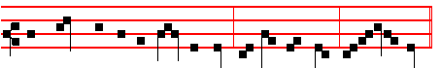
And straightway he received his sight, and followed him, glorifying God.
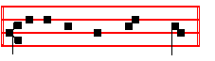
Canticle Magnificat, p.
__________________________________________________________________

Monday
From the Book of Genesis
Lesson j Ch. 13, 1-16
AND Abram went up out of Egypt, he, and his wife, and all that he had, and Lot with him, into the south. And Abram was very rich in cattle, in silver, and in gold. And he went on his journeys from the south even to Beth-el, unto the place where his tent had been at the beginning, between Beth-el and Hai; unto the place of the altar, which he had made there at the first: and there Abram called on the name of the Lord. And Lot also, which went with Abram, had flocks, and herds, and tents. And the land was not able to bear them, that they might dwell together: for their substance was great, so that they could not dwell together.

 Abram removed his tent, and came and dwelt in the plain of Mamre. * And built there an altar unto the Lord.
 And the Lord said unto him, Lift up now thine eyes and look: all the land which thou seest, to thee will I give it, and to thy seed for ever. And built.

Lesson ij
AND there was a strife between the herdmen of Abram's cattle and the herdmen of Lot's cattle: and the Canaanite and the Perizzite dwelled then in the land. And Abram said unto Lot, Let there be no strife, I pray thee, between me and thee, and between my herdmen and thy herdmen; for we be brethren. Is not the whole land before thee? separate thyself, I pray thee, from me: if thou wilt take the left hand, then I will go to the right; or if thou depart to the right hand, then I will go to the left. And Lot lifted up his eyes, and beheld all the plain of Jordan, that it was well watered every where, before the Lord destroyed Sodom and Gomorrah, even as the garden of the Lord, like the land of Egypt, as thou comest unto Zoar. Then Lot chose him all the plain of Jordan; and Lot journeyed East.

584
Lesson j Ch. 3, 1-20
NOW the serpent was more subtil than any beast of the field which the Lord God had made. And he said unto the woman, Yea, hath God said, Ye shall not eat of every tree of the garden? And the woman said unto the serpent, We may eat of the fruit of the trees of the garden: but of the fruit of the tree which is in the midst of the garden, God hath said, Ye shall not eat of it, neither shall ye touch it, lest ye die. And the serpent said unto the woman, Ye shall not surely die: for God doth know that in the day ye eat thereof, then your eyes shall be opened, and ye shall be as gods, knowing good and evil. And when the woman saw that the tree was good for food, and that it was pleasant to the eyes, and a tree to be desired to make one wise, she took of the fruit thereof, and did eat, and gave also unto her husband with her; and he did eat. And the eyes of them both were opened.

 The Lord God planted a garden eastward in Eden, * And there he put the man whom he had formed.
 And out of the ground made the Lord God to grow every tree that is pleasant to the sight and good for food; the tree of life also in the midst of the garden. And there.

Lesson ij
AND they knew that they were naked; and they sewed fig leaves together, and made themselves aprons. And they heard the voice of the Lord God walking in the garden in the cool of the day: and Adam and his wife hid themselves from the presence of the Lord God amongst the trees of the garden. And the Lord God called unto Adam, and said unto him, Where art thou? And he said, I heard thy voice in the garden, and I was afraid, because I was naked; and I hid myself. And he said, Who told thee that thou wast naked? Hast thou eaten of the tree, whereof I commanded thee that thou shouldest not eat? And the man said, The woman whom thou gavest to be with me, she gave me of the tree, and I did eat. And the Lord God said unto the woman, What is this that thou hast done? And the I woman said, The serpent beguiled me, and I did eat.

 Behold, the man is become as one of us to know good and evil. * See lest he take of the tree of life and live for ever.
 Unto Adam also did the Lord God make a coat of skins and clothed him and said: See lest.

Lesson iij
AND the Lord God said unto the serpent, Because thou hast done this, thou art cursed above all cattle, and above every beast of the field; upon thy belly shalt thou go, and dust shalt thou eat all the days of thy life: and I will put enmity

553
At the Close of the Chapter, the Lord direct, p.

AT TERCE
Antiphon. Tone j, 1.
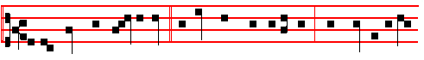
As the Lord was passing by, * a blind man cried unto him, Have mercy upon
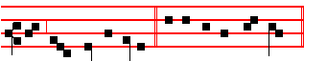
me, thou Son of David. Psalm 119 Legem pone
Chapter Brethren: Though I speak, as above, 581.
Short  as in the Psalter
Incline my heart, O God, * Unto thy testimonies. Incline.
 Turn away mine eyes, lest they behold vanity; and quicken thou me in thy way. Unto thy. Glory be. Incline.
 I said, Lord, be merciful unto me.
 Hea1 my soul, for I have sinned against thee.

AT SEXT
Antiphon. Tone vij, 3.
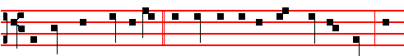
And they which went before * rebuked him that he should hold his peace: but
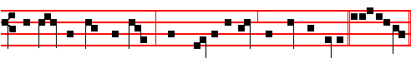
he cried so much the more, Have mercy on me, thou Son of David. Ps. 119
Chapter I Cor. 13
CHARITY never faileth: but whether there be prophecies, they shall fai1; whether there be tongues, they shall cease; whether there be know1edge, it shall vanish away. For we know in part, and we prophesy in part.
Short  as in the Psalter.
O Lord, thy word endureth * For ever in heaven. O Lord.
 Thy truth also remaineth from one generation to another. For ever. Glory be. O Lord.
582
 In the beginning God created the heaven and the earth, and therein formed he man. * After his own image and likeness.
 And the Lord formed man of the dust of the ground. and breathed into his nostrils the breath of life. After his.

Lesson ij
AND Cain talked with Abel his brother: and it came to pass, when they were in the field, that Cain rose up against Abel his brother, and slew him. And the Lord said unto Cain, Where is Abel thy qrother? And he said, I know not: am I my brother's keeper? And he said, What hast thou done? the voice of thy brother's blood crieth unto me from the ground. And now art thou cursed from the earth, which hath opened her mouth to receive thy brother's blood from thy hand; when thou tillest the ground, it shall not henceforth yield unto thee her strength; a fugitive and a vagabond shalt thou be in the earth.

 In the beginning God created the heaven and the earth, and the Spirit of God moved upon the face of the waters. * And God saw everything that he had made, and behold, it was very good.
 Thus the heavens and the earth were finished, and all the host of them. And God.

Lesson iij
AND Cain said unto the Lord, My punishment is greater than I can bear. Behold, thou hast driven me out this day from the face of the earth; and from thy face shall I be hid; and I shall be a fugitive and a vagabond in the earth; and it shall come to pass, that every one that findeth me shall slay me. And the Lord said unto him, Therefore whosoever slayeth Cain, vengeance shall be taken on him sevenfold. And the Lord set a mark upon Cain, lest any finding him should kill him. And Cain went out from the presence of the Lord, and dwelt in the land of Nod, on the east of Eden.

 The Lord formed man of the dust or the ground, * And breathed into his nostrils the breath of life, and man became a living soul.
 In the beginning God created the heaven and the earth, and therein formed he man. And breathed. Glory be. And breathed.

On Magnificat, Antiphon.
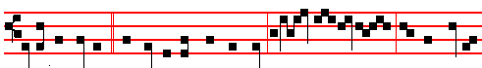
Is it not lawfu1* for me to do what I will? Is thine eye e- vil , because I am

555
 And Jesus stood, and commanded him to be brought unto him, and when he was come near, he asked him, saying: What wilt. Glory be. Lord, that I.
During the week on Wednesday and Saturday, instead of this  is said the  of the following Monday.
AT LAUDS, ANTIPHONS Tone j, 1.
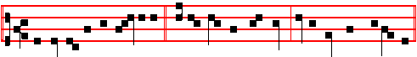
1. According to the multitude * of thy mercies, O Lord, do away mine offences.
Psalm 51 Miserere Tone viij, 2.
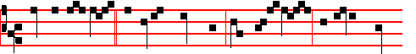
2.Thou art my God, * and I will thank thee: thou art my God, and I will praise
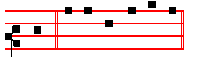
thee. Psalm 118 Confitemini Tone vij, 3.
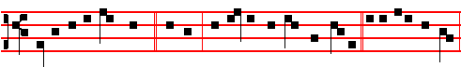
3. Early will I seek thee, * O God, that I may behold thy power. Psalm 63 67
Deus Deus meus Tone iv, 1.
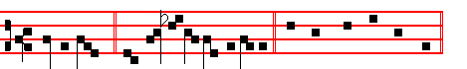
4. Sing a hymn, * and magnify him for ever. Canticle Benedicite Tone v.
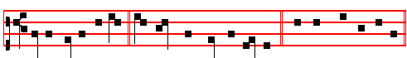
5. All ye Angels of his, * O praise the Lord of heaven. Psalms 148, 149, 150 Laudate Dominum
580
blessed them, and called their name Adam, in the day when they were created. And Adam lived an hundred and thirty years, and begat a son in his own likeness, after his image; and called his name Seth: and the days of Adam after he had begotten Seth were eight hundred years: and he begat sons and daughters: and all the days that Adam lived were nine hundred and thirty years: and he died.

 The Lord caused a deep sleep to fall upon Adam, and he took one of his ribs. * And the rib which the Lord had taken from the man made he a woman, and brought her to Adam to see what he would call her. And he called her name woman because she was taken out of man.
 And when Adam slept, God took one of his ribs and closed up the flesh instead thereof. And the. Glory be. And.

On Magnificat, Antiphon. So the last shall be first, and the first shall be last: for many are called, but few are chosen.
__________________________________________________________________

Saturday
From the Book of Genesis
Lesson j Ch. 5, 15-31
AND Mahalaleel lived sixty and five years, and begat Jared: and Mahalaleel lived after he begat Jared eight hundred and thirty years, and begat sons and daughters: and all the days of Mahalaleel were eight hundred ninety and five years: and he died. And Jared lived an hundred sixty and two years, and he begat Enoch: and Jared lived after he begat Enoch eight hundred years, and begat sons and daughters: and all the days of Jared, were nine hundred sixty and two years: and he died. And Enoch lived sixty and five years, and begat Methuselah.

 The Lord God planted a garden eastward in Eden, * And there he put the man whom he had formed.
 And out of the ground made the Lord God to grow every tree that is pleasant to the sight and good for food; the tree of life also in the midst of the garden. And there.

Lesson ij
AND Enoch walked with God after he begat Methuselah three hundred years, and begat sons and daughters: and all the days of Enoch were three hundred sixty and five years: and Enoch walked with God: and he was not; for God took him. And Methuselah lived an hundred eighty and seven years, and bcgat Lamech: And Methuselah lived after he begat Lamech seven hundred eighty and two years, and begat sons and daughters: and all the days of Methuselah were nine hundred sixty and nine years: and he died.
557
BUT God added the separate behests that he might prove Abraham's affection, lest he should seem to have set out by chance or without forethought, or lest some deception should be prepared against him by the heavenly commands. But precisely as the behests must needs be heaped together lest anything should remain hidden, so also must the rewards be set forth lest perchance he should lose hope. He is tried in fortitude, he is roused in faith, he is provoked in righteousness: And rightly did he set out as the Lord spoke to him. And Lot went with him. Now this saying which is esteemed as great among the sayings of the seven wise men, namely, Follow God, Abraham fully performed, and by his deed he surpassed the
sayings of the wise, and, following God, he set out from his country.

 The Angel of the Lord called unto Abraham the second time, and said, I will bless thee: * And I will multiply thy seed as the stars of heaven.
 Thy seed shall possess the gate of his enemies, and in thy seed shall all the nations of the earth be blessed. And I.

Lesson vj
BUT because he had previously dwelt in another land, namely the land of the Chaldaeans from which Terah, Abraham's father set out and moved to Haran, and because he to whom it was said, Get thee out from thy kindred, took with him his nephew, let us consider whether to set out from one's land may mean to go out from an abiding place of this earth, that is an abiding in our body: from whence Paul went out, for he said, Our conversation is in heaven.

 O Lord God of my master Abraham, prosper my way which I go: * That I may return again in safety unto the house of my master.
. O Lord, I pray thee, be merciful unto thy servant. That I. Glory be. That I.

IN THE THIRD NOCTURN

The Lesson from the Holy Gospel according to S. Luke
Lesson vij Ch. 18
JESUS took unto him the twelve, and said unto them, Behold, we go up to Jerusalem, and all things that are written by the prophets concerning the Son of man shall be accomplished.
Homily by S. Gregory the Great Homily 2 on the Gospels
OUR Redeemer foresaw that his disciples would be troubled in heart by his passion, and so he warned them long beforehand both of the humiliation of his passion, and of the glory of his resurrection, with the intent that when they were to see him dying, they might also believe that he would rise again. But the

578
COLLECT
O GOD, who seest that we put not our trust in any thing that we do: mercifully grant; that by the protection of the Doctor of the Gentiles we may be defended against all adversity. Through.
__________________________________________________________________
SEXAGESIMA SUNDAY AT MATINS.
Invitatory.- Let us come before his presence with thanksgiving, * And shew ourselves glad in him with psalms. Ps.95. In the first verse of the Psalm, Let us come before his presence with thanksgiving, etc. is omitted, and in its place the Invitatory is repeated by the Choir.
E.H.50 Primo dierum omnium, as in the Psalter. Antiphons, Psalms, and Versicles of the Nocturns as in the Psalter.

IN THE FIRST NOCTURN
From the Book of Genesis
Lesson j . Ch. 32, 6 1-15
AND Noah was five hundred years old: and Noah begat Shem, Ham, and Japheth. And it came to pass, when men began to multiply on the face of the earth, and daughters were born unto them, that the sons of God saw the daughters of men that they were fair; and they took them wives of all which they chose. And the Lord said, My spirit shall not always strive with man, for that he also is flesh: yet his days shall be an hundred and twenty years. There were giants in the earth in those days; and also after that, when the sons of God came in unto the daughters of men, and they bare children to them, the same became mighty men which were of old, men of renown.

 The Lord said unto Noah, The end of all flesh is come before me; for the earth is filled with violence through them; * And behold, I will destroy them with the earth.
 Make thee an ark of gopher wood; rooms shalt thou make in it. And behold.

Lesson ij
AND God saw that the wickedness of man was great in the earth, and that every imagination of the thoughts of his heart was only evil continually. And it repented the Lord that he had made man on the earth. And it grieved him at his heart. And the Lord said, I will destroy man whom I have created from the face of the earth; both man, and beast, and the creeping thing, and the fowls of the air; for it repenteth me that I have made them. But Noah found grace in the eyes of the Lord.
 Noah was a just man and perfect, and Noah walked with God; * According to all that God commanded him, so did he.
559
come before his presence with thanksgiving is omitted, and the Invitatory is repeated by the Choir, in its place.
Hymn, E.H.50 Primo dierum as in the Psalter, p.
Antiphons, Psalms,and  of the Nocturn from the Psalter, p.
IN THE FIRST NOCTURN
From the Book of Genesis
Lesson j Ch. 12, 1-19
NOW the Lord had said unto Abram, Get thee out of thy country, and from thy kindred. and from thy father's house, unto a land that I will shew thee: and I will make of thee a great nation, and I will bless thee, and make thy name great; and thou shalt be a blessing: and I will bless them that bless thee, and curse him that curseth thee: and in thee shall all families of the earth be blessed. So Abram departed, as the Lord had spoken unto him; and Lot went with him: and Abram was seventy and five years old when he departed out of Haran. And Abram took Sarai his wife, and Lot his brother's son, and all their substance that they had gathered, and the souls that they had gotten in Haran; and they went forth to go into the land of Canaan. And into the land of Canaan they came. And Abram passed through the land unto the place of Sichem, unto the plain of Moreh. And the Canaanite was then in the land.

 Now the Lord had said unto Abram, Get thee out of thy country and from thy kindred, unto a land that I will shew thee: * And I will make or thee a great nation.
 I will bless thee and make thy name great; and thou shalt be a blessing. And I.

Lesson ij
AND the Lord appeared unto Abram, and said, Unto thy seed will I give this land: and there builded he an altar unto the Lord who appeared unto him. And he removed from thence unto a mountain on thc east of Beth-el, and pitched his tent, having Beth-el on the west, and Hai on the east: and there he builded an altar unto the Lord, and called upon the name of the Lord. And Abram journeyed, going on still toward the south. And there was a Famine in the land: and Abram went down into Egypt to sojourn there; For the Famine was grievous in the land. And it came to pass, when he was come near to enter into Egypt, that he said unto Sarai his wife, Behold now, I know that thou art a fair woman to look upon: therefore it shall come to pass, when the Egyptians shall see thee, that they shall say, This is his wife: and they will kill me, but they will save thee alive. Say, I pray thee, thou art my sister: that it may be well with me for thy sake; and my soul shall live because of thee.

 Abraham stood by the oak of Mamre, and he saw three men coming towards him * He saw Three, and worshipped One.

576
 Behold, I establish my covenant with you, and with your seed after you. Be fruitful.
Lesson v
THEREFORE he threatened to destroy man. I will destroy both man, and beast, and the creeping thing, and the fowls of the air. What had the irrational creatures done? They had been made for man, and now that he for whom they had been made, was going to be destroyed, it followed that they too should be destroyed, because he who was to use them would no longer exist. Yet there is a higher reason: Man has a mind that is capable of reason. Man may be described as a living, mortal, rational animal. When the principal living creature is annihilated, all other living creatures go with it: for nothing remains to be saved when virility, or virtue, the basis of salvation, is no more.

 I do set my bow in the clouds, said the Lord unto Noah: * And I will remember my covenant which is between me and you.
 And it shall come to pass, when I bring a cloud over the heaven, that my bow shall be seen in the cloud. And I will.

Lesson vj
IN condemnation of the rest of mankind, and as an expression of the divine mercy, Noah is said to have found grace with God. At the same time it is revealed that the sin of other men can cast no shadow over the righteous, as he is preserved for the begetting of all his race. He is praised, not for his noble birth, but because he was a just man, and perfect. The stock of a just man yields men of upright character; even as the stock of men begets men, so the stock of just souls begets virtues. Just as some families of men become noble by the splendour of their lineage, so is the grace of souls made glorious by the splendour of their virtues.

 By myself have I sworn, saith the Lord, that I will not bring the waters of the flood again upon the earth; I will remember my covenant. * And the waters shall no more become a flood to destroy all flesh.
 I do set my bow in the cloud, and it shall be for a token of a covenant between me and the earth. And the. Glory be. And the.

IN THE THIRD NOCTURN
The Lesson from the Holy Gospel according to S. Luke
Lesson vij Ch. 8
WHEN much people were gathered together, and were come to Jesus out of every city, he spake by a parable: A sower went out to sow his seed. And the rest.

561
flood again upon the earth; I will remember my covenant. * And the waters shall no more become a flood to destroy all flesh.
 I do set my bow in the cloud, and it shall be for a token of a covenant between me and the earth. And the. Glory be. And the.
On Magnificat, Antiphon. They who keep the word of God * with an honest and perfect heart bring forth fruit with patience.
__________________________________________________________________
Saturday
From the Book of Genesis
Lesson j Ch. 11, 10-30
THESE are the generations of Shem: Shem was an hundred years old, and begat Arphaxad two years after the flood: and Shem lived after he begat Arphaxad five hundred years, and begat sons and daughters. And Arphaxad lived five and thirty years, and begat Salah: and Arphaxad lived after he begat Salah four hundred and three years, and begat sons and daughters. And Salah lived thirty years, and begat Eber: and Salah lived after he begat Eber four hundred and three years, and begat sons and daughters.

 God blessed Noah and his sons, and said unto them: * Be fruitful, and multiply, and replenish the earth.
 Behold, I establish my covenant with you, and with your seed after you. Be fruitful

Lesson ij
AND Eber lived four and thirty years, and begat Peleg: and Eber lived after he begat Peleg four hundred and thirty years. and begat sons and daughters. And Peleg lived thirty years, and begat Reu: and Peleg Jived after he begat Reu two hundred and nine years, and begat sons and daughters. And Reu lived two and thirty years, and begat Serug: and Reu lived after he begat Serug two hundred and seven years, and begat sons and daughters. And Serug lived thirty years, and begat Nahor: and Serug lived after he begat Nahor two hundred years, and begat sons and daughters.

 Behold, I establish my covenant with you, and with your seed after you. * Neither shall there any more be a flood to destroy the earth.
 I do set my bow in the cloud, and it shall be for a token of a covenant between me and the earth. Neither.

Lesson iij
AND Nahor lived nine and twenty years, and begat Terah: and Nahor lived after he begat Terah an hundred and nineteen years, and begat sons and
574
 When much people were gathered together to Jesus, and were come to him out of every city, he spake by a parable: * A sower went out to sow his seed.
 And as he sowed, some fell on good ground, and sprang up, and bare fruit an hundredrold. A sower. Glory be. A sower.

During the week on Wednesday and Saturday, instead of this Responsory is said the first Responsory of the following Monday.

AT LAUDS
Antiphon 1. Tone j, 2
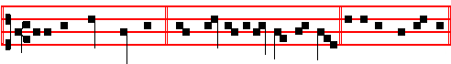
After thy great goodness,* have mercy upon me, O God. Psalm 5l Miserere
Antiphon 2. Tone j, 4
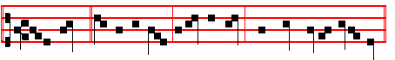
If the Lord * be on my side, I will not fear what man doeth unto me.
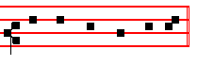
Psalm 118 Confitemini Domino, p.
Antiphon 3. Tone ij
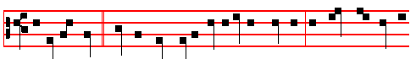
Within the veil * have I called very early in the morning: O God, thou art my
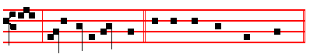
God, early will I seek thee. Psalms 63, 67 Deus, Deus meus,
with the rest in the Psalter.

Antiphon 4. Tone viij, 1

563
the bow shall be seen in the cloud: and 1 will remember my covenant, which is between me and you and every living creature of all flesh; and the waters shall no more become a flood to destroy all flesh.

 The Lord said unto Noah, The end of all flesh is come before me; for the earth is filled with violence through them; * And behold, I will destroy them with the earth.
 Make thee an ark of gopher wood; rooms shalt thou make in it. And behold.

Lesson ij Ibid. 20-28
AND Noah began to be an husbandman, and he planted a vineyard: and he drank of the wine, and was drunken; and he was uncovered within his tent. And Ham, the father of Canaan, saw the nakedness of his father, and told his two brethren without. And Shem and Japheth took a garment, and laid it upon both their shoulders, and went backward, and covered the nakedness of their father; and their faces were backward, and they saw not their father's nakedness.

 Noah was a just man and perfect, and Noah walked with God; * According to all that God commanded him, so did he.
 He made him an ark to keep seed alive upon the face of all the earth. According.

Lesson iij
AND Noah awoke from his wine. and knew what his younger son had done unto him. And he said, Cursed be Canaan; a servant of servants shall he be unto his brethren. And he said. Blessed be the Lord God of Shem; and Canaan shall be his servant. God shall enlarge Japheth, and he shall dwell in the tents of Shem; and Canaan shall be his servant. And Noah lived after the flood three hundred and fifty years. And all the days of Noah were nine hundred and fifty years: and he died.

 Forty days and forty nights were the heavens opened, and they went in into the ark, two and two of all flesh wherein is the breath of life. * And the Lord shut them in.
 In the selfsame day entered Noah into the ark, and his sons, and his wife, and his sons' wives with him. And the Lord. Glory be. And the.

On Magnificat, Antiphon. Some seed * fell on good ground, and brought forth fruit; some an hundredfold and some sixtyfold.
__________________________________________________________________

Friday
572
defended against all adversity. Through.
AT PRIME
Antiphon. Tone ij.
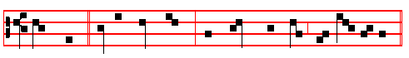
Some seed * fell on good ground, and brought forth fruit with pat- i -ence.
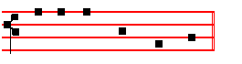
Psalm 54 Deus in nomine, p.
At the Close of the Chapter, the Lord direct, p. 31.

AT TERCE
Antiphon. Tone j, 1
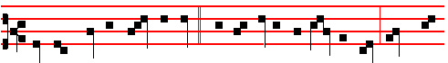
They who keep the word of God * with an honest and perfect heart bring forth
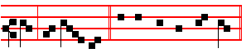
fruit with patience. Psalm 119 Legem pone.
Chapter Ye suffer fools, as above, p. 564.
Short , as in the Psalter.
Incline my heart, O God, * Unto thy testimonies. Incline.
 Turn away mine eyes, lest they behold vanity: and quicken thou me in thy way. Unto thy testimonies. Glory be. Incline.
 I said, Lord, be merciful unto me.
 Heal my soul, for I have sinned against thee.

AT SEXT
Antiphon. Tone viij, 2.
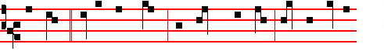
Some seed fell on good ground, and brought forth fruit; some an humdred-
565
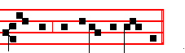
eth him shall abide for ev - er.
__________________________________________________________________

Wednesday
From the Book of Genesis
Lesson j Ch. 15-22
AND God spake unto Noah, saying, Go forth of the ark, thou, and thy wife, and thy sons, and thy sons' wives with thee. Bring forth with thee every living thing that is with thee, of all flesh, both of fowl, and of cattle, and of every creeping thing that creepeth upon the earth; that they may breed abundantly in the earth, and be fruitful, and multiply upon the earth. And Noah went forth, and his sons, and his wife, and his sons' wives with him: every beast, every creeping thing, and every fowl, and whatsoever creepeth upon the earth, after their kinds, went forth out of the ark.

 God blessed Noah and his sons, and said unto them: * Be fruitful, and multiply, and replenish the earth.
 Behold, I establish my covenant with you, and with your seed after you. Be fruitful.

Lesson ij
AND Noah builded an altar unto the Lord; and took of every clean beast, and of every clean fowl, and offered burnt offerings on the altar. And the Lord smelled a sweet savour; and the Lord said in his heart, I will not again curse the ground any more for man's sake; for the imagination of man's heart is evil from his youth; neither will I again smite any more every thing living, as I have done. While the earth remaineth, seedtime and harvest, and cold and heat, and summer and winter, and day and night shall not cease.

 Behold, I establish my covenant with you, and with your seed after you. * Neither shall there any more be a flood to destroy the earth.
 I do set my bow in the cloud, and it shall be for a token of a covenant between me and the earth. Neither.

Lesson iij Ch. 9, 1-6
AND God blessed Noah and his sons, and said unto them, Be fruitful, and multiply, and replenish the earth. And the fear of you and the dread of you

570
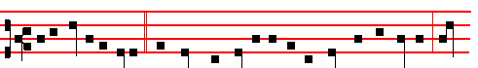
Unto you it is given * to know the mysteries of the kingdom of heaven: but
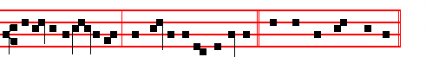
to others in parables, said Jesus to his disciples. Canticle Magnificat, p.
Collect O God, who seest, 564.
__________________________________________________________________

Monday
From the Book of Genesis
Lesson j Ch.7. 1-5, 10-14, 11
AND the Lord said unto Noah, Come thou and all thy house into the ark; for thee have I seen righteous before me in this generation. Of every clean beast thou shalt take to thee by sevens, the male and his female; and of beasts that are not clean by two, the male and his female. Of fowls also of the air by sevens, the male and the female; to keep seed alive upon the face of all the earth. For yet seven days, and I will cause it to rain upon the earth forty days and forty nights; and every living substance that I have made will I destroy from off the face of the earth.

 In the selfsame day Noah went in, and his sons, into the ark, * And his wife and his sons' wives with him.
 And every living substance was destroyed which was upon the face of the ground, and only Noah remained alive, and they that were with him in the ark. And his wife.

Lesson ij
AND Noah did accordIng unto all that the Lord commanded him. And it came to pass after seven days, that the waters of the flood were upon the earth. In the six hundredth year of Noah's life, in the second month, the seventeenth day of the month, the same day were all the fountains of the great deep broken up, and the windows of heaven were opened. And the rain was upon the earth forty days and forty nights.

 And God remembered Noah, and made a wind to pass over the earth, and the waters asswaged; * And the rain from heaven was restrained.

567

