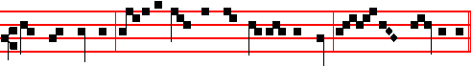
thou shalt not eat: for in the day that thou eatest thereof, thou shalt surely die.
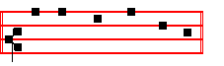
Canticle Magnificat, p.
COLLECT
O LORD, we beseech thee favourably to hear the prayers of thy people:that we, who are justly punished for our offences, may be mercifully delivered by thy goodness, for the glory of thy name. Through.

 Let us bless the Lord. Alleluia, alleluia.
 Thanks be to God. Alleluia, alleluia.
And henceforth Alleluia is not said until Holy Saturday: but after O God, make speed, where Alleluia was said, is said Praise be to thee, O Lord, King of eternal glory.
If on a Sunday from Septuagesima to Low Sunday there occur a Double, or Semidouble Feast, it is transferred to the first day not similarly impeded, as is directed in the Rubric of Translation of Feasts.
__________________________________________________________________

SEPl'UAGESIMA SUNDAY AT MATINS

Invitatory.-Let us come before his presence with thanksgiving, * And shew ourselves glad in him with psalms. Ps.95. In the first verse of the Psalm, Let us come before his presence with thanksgiving etc. is omitted, and in its place the Invitatory is repeated by the Choir.
Hymn.E.H.56 Primo dierum omnium, as in the Psalter.
Antiphons, Psalms, and Versicles of the Nocturms from the Psalter.

IN THE FIRST NOCTURN
Here beginneth the Book of Genesis.
Lesson j Ch. 1, 1-26
IN the beginning God created the heaven and the earth. And the earth was without form, and void; and darkness was upon the face of the deep. And the Spirit of God moved upon the face of the waters. And God said, Let there be light: and there was light. And God saw that it was good: and God divided the light

541
from the darkness. And God called the light Day, and the darkness he called Night. And the evening and the morning were the first day. And God said, Let there be a firmament in the midst of the waters, and let it divide the waters from the waters. And God made the firmament, and divided the waters which were under the firmament from the waters which were above the firmament: and it was so. And God called the firmament Heaven. And the evening and the morning were the second day.

 In the beginning God created the heaven and the earth, and therein formed he man. * After his own image and likeness.
 And the Lord formed man of the dust of the ground. and breathed into his nostrils the breath of life. After his.

Lesson ij
A ND God said, Let the waters under the heaven be gathered together unto one place, and let the dry land appear: and it was so. And God called the dry land Earth; and the gathering together of the waters called he Seas: and God saw that it was good. And God said, Let the earth bring forth grass, the herb yielding seed, and the fruit tree yielding fruit after his kind, whose seed is in itself, upon the earth: and it was so. And the earth brought forth grass, and herb yielding seed after his kind, and the tree yielding fruit, whose seed was in itself, after his kind: and God saw that it was good. And God said, Let there be lights in the firmament of the heaven to divide the day from the night; and let them be for signs, and for seasons, and for days, and years: and let them be for lights in the firmament of the heaven to give light upon the earth: and it was so. And God made two great lights; the greater light to rule the day, and the lesser light to rule the night: he made the stars also. And God set them in the firmament of the heaven to give light upon the earth, and to rule over the day and over the night, and to divide the light from the darkness: and God saw that it was good. And the evening and the morning were the fourth day.

 In the beginning God created the heaven and the earth, and the Spirit of God moved upon the face of the waters. * And God saw every thing that he had made, and behold, it was very good.
 Thus the heavens and the earth were finished, and all the host of them. And God.

Lesson iij
A ND God said, Let the waters bring forth abundantly the moving creature that hath life, and fowl that may fly above the earth in the open firmament of heaven; And God created great whales, and every living creature that moveth

542
which the waters brought forth abundantly, after their kind, and every winged fowl after his kind: and God saw that it was good. And God blessed them, saying, Be fruitful, and multiply, and fill the waters in the seas, and let fowl multiply in the earth. And the evening and the morning were the fifth day. And God said, Let the earth bring forth the living creature after his kind, tattle, and creeping thing, and beast of the earth after his kind: and it was so. And God made the beast of the earth after his kind, and cattle after their kind, and every thing that creepeth upon the earth after his kind: and God saw that it was good. And God said, Let us make man in our image, after our likeness: and let them have dominion over the fish or the sea, and over the rowl or the air, and over the cattle, and over all the earth, and over every creeping thing that creepeth upon the earth.

 The Lord formed man of the dust or the ground, * And breathed into his nostrils the breath of life, and man became a living soul.
 In the beginning God created the heaven and the earth, and therein formed he man. And breathed. Glory be. And breathed.

IN THE SECOND NOCTURN
From the Book on Faith, Hope, and Charity, by S. Augustine, Bishop
Lesson iv
GOD had threatened man with the punishment of death if he sinned; thus gifting him with free will, as yet to rule him by his control, and affright him with destruction; and placed him in the happiness of paradise as in the shadow of a life, from whence by observing righteousness he might ascend to better things. After his sin he was made an exile, and he bound by the punishment of death and condemnation his own race also, which by sinning he had corrupted in himself as in its root. Therefore whatever offspring would be born of him and his wife, through whom he had sinned and who was condemned together with him through carnal lust, wherein was repaid a punishment fitting the disobedience; this offspring would draw along with it original sin. By original sin it would be drawn through various errors and pains, to that last never-ending punishment, with the apostate angels, its corrupters, masters, and partners.

 The Lord took the man and put him into the garden of Eden, * To dress it and to keep it.
 And the Lord planted a garden eastward in Eden, and there he put the man whom he had formed. To dress.

Lesson v
THUS, By one man sin entered into the world, and by sin death: and so death passed upon all men, in that all sinned. By the world in that place the Apostle

543
means the whole human race. This therefore was the case; the mass of the whole human race under condemnation was lying in evils, or even was rolling on and going headlong from evils into evils; and joined to the side of those angels who had sinned, was paying the deserved penalty of impious apostacy.

 The Lord God said: It is not good that man should be alone; * I will make
him an help meet for him.
. But for Adam there was not found an help meet for him, and God said, I will.

Lesson vj
EVEN as it pertaineth to the just anger of God, whatsoever the wicked willingly commit through blind and unsubdued lust, and whatsoever they unwillingly suffer by manifest and secret punishments: even so the goodness of the Creator ceaseth not to minister even to evil angels life and vital power, which ministration being withdrawn, they would straightway perish; and as for men. although they be born from a corrupted and condemned stock, the Creator ceaseth not to give form and life to their seeds, to dispose their members, through periods of time and distances of place to quicken their senses, to bestow on them nutriment. For he judged it better to work good out of evil things, than to allow no evil things to exist.
 The Lord caused a deep sleep to fall upon Adam, and he took one of his ribs. * And the rib which the Lord had taken from the man made he a woman, and brought her to Adam to see what he would call her. And he called her name woman because she was taken out of man.
 And when Adam slept, God took one of his ribs and closed up the flesh instead thereof. And the. Glory be. And.

IN THE THIRD NOCTURN

The Lesson from the Holy Gospel according to S. Matthew
Lesson vij Ch. 20
JESUS spake this parable unto his disciples: The kingdom of heaven is like unto a man that is an householder. which went out early in the morning to hire labourers into his vineyard. And the rest.
Homily by S. Gregory the Great Homily 19 on the Gospels
THE kingdom of heaven is said to be like unto a man that is an householder which went out to hire labourers into his vineyard. Who has more right to the title of an householder than our Maker, who rules those whom he has made, and is Master of his elect in this world as though they were his household servants? He has his vineyard too, the Catholic Church, that. from righteous Abel unto the last of the elect to be born into the world. is ever bringing forth her holy ones, as so many new shoots.
544
 The Lord God planted a garden eastward in Eden, * And there he put the man whom he had formed.
 And out of the ground made the Lord God to grow every tree that is pleasant to the sight and good for food; the tree of life also in the midst of the garden. And there.

Lesson viij
THIS householder, then, went out early, and at the third, sixth, ninth, and eleventh hours, to hire labourers into his vineyard. For from the beginning of this world even unto its end he unceasingly gathers preachers to teach his faithful people. The early morning of the world was from Adam until Noah: the third hour was from Noah until Abraham: the sixth, from Abraham until Moses: the ninth, from Moses until the coming of the Lord; while the eleventh is from the coming of the Lord until the end of the world.. In this eleventh hour, the holy Apostles were sent as preachers, and they received full hire, although they came at a late hour.
 Behold, the man is become as one of us to know good and evil. * See lest he take of the tree of life and live for ever.
 Unto Adam also did the Lord God make a coat of skins and clothed him and said: See lest.

Lesson ix.
FOR the teaching of his people, the cultivating of his vineyard, the Lord never ceases to send labourers: first by the patriarchs, and soon after by the teachers of the law and the prophets, and lastly by the Apostles, he formed his peoples' way of life, just as he cultivated his vineyard by the hands of his labourers. Whoever, in whatsoever degree or measure, stood forth as a preacher, combining good works with true faith, that man was a preacher; in the Lord's vineyard. The ancient people of the Hebrews is signified by the labourer of the early morning, and of the third, sixth, and ninth hours. These men, from the very beginning of the world, worked zealously to inculcate the true faith into God's chosen people, as though unceasingly working on the cultivation of the vineyard. Then at the eleventh hour the Gentiles were called, and to them it was said, Why stand ye here all the day idle?
 Where is Abel thy brother? said the Lord unto Cain. Lord, I know not; am I my brother's keeper? And he said unto him: What hast thou done? * Behold the voice of thy brother Abel's blood crieth unto me from the ground.
 And now thou art cursed from the earth, which hath opened her mouth to receive thy brother's blood from thy hand. Behold. Glory be. Behold.
The ninth responsory is said on Sundays until Easter instead of the Hymn Te Deum, which is not said in this season, except on Feasts.

545
AT LAUDS
Antiphon 1. Tone j, 2.
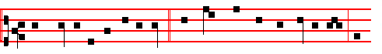
Have mercy, O God, upon me, * and cleanse me from my wickedness; for
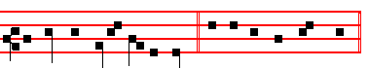
against thee only have I sinned. Psalm 51 Miserere L, p.
Antiphon 2 . Tone viij, 1.
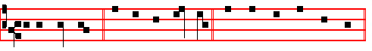
I will thank thee, * for thou hast heard me. Psalm 118 Confitemini Domino,
as in the Psalter for Sunday at Prime, p..
Antiphon 3. Tone ij.
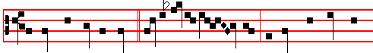
O God, thou art my God, * early will I seek thee, because thou hast been
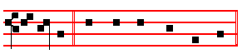
my helper. Psalms 63, 67 Deus, Deus meus as in the Psalter for Sunday Lauds.
Antiphon 4. Tone ij
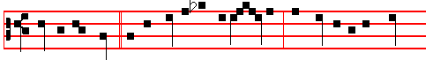
Blessed art thou * in the firmament of hea - ven: and worthy to be praised
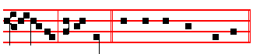
for ever, O our God. Canticle Benedicite, p..

546
Antiphon 5. Tone j, 2.
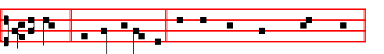
O praise * the Lord of heaven. Psalms 148, 149, 150 Laudate Dominum, as in the Psalter., p.
The aforesaid Psalms are always said in Lauds of Sunday until Easter.
Chapter I Cor. 9
BRETHREN: Know ye not, that they which run in a race run all, but one receiveth the prize? So run, that ye may obtain.
Hymn. Aeterne rerum Conditor, as in the Psalter.
 Lord, thou hast been our refuge.  From one generation to another.
On Benedictus, Antiphon. Tone j, 1.
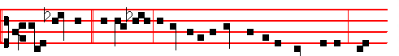
The kingdom * of hea--ven is like unto a man that is an householder, which
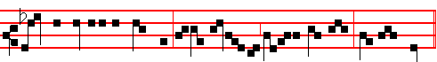
went out early in the morning to hire labourers into his vineyard, saith the Lord.
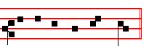
Canticle Benedictus, p. 39.
COLLECT
O LORD, we beseech thee favourably to hear the prayers of thy people:that we, who are justly punished for our offences, may be mercifully delivered by thy goodness, for the glory of thy name. Through.

AT PRIME
Antiphon. Tone j, 1.
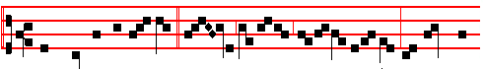
And when he had agreed * with the labourers for a penny a day, he sent them

547
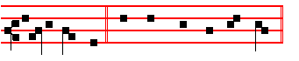
into his vineyard. Psalm 54 Deus in nomine, p. , with the rest as in the Psalter.
At the Close of the Chapter, short Lesson The Lord direct.

AT TERCE
Antiphon. Tone viij, 2.
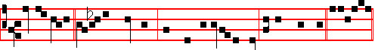
Go ye also * into the vineyard. and whatsoever is right I will give you. Psalm
118, Legem pone.
Chapter Brethren: Know ye not, as above, p.547.
Short  , as on p. 66. Incline my heart, O God, * Unto thy testimonies. Incline.
 Turn away mine eyes, lest they behold vanity: and quicken thou me in thy way. Unto thy testimonies. Glory be. Incline.
 I said, Lord, be merciful unto me.
 Heal my soul, for I have sinned against thee.

AT SEXT
Antiphon. Tone ij
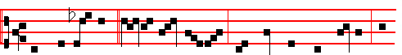
Why stand ye here * all the day id - le? They answered him, saying; Be-
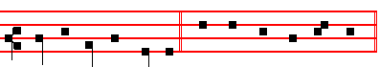
cause no man hath hired us. Psalm 118 Defecit.
Chapter I Cor.9
AND every man that striveth for the mastery is temperate in all things. Now they do it to obtain a corruptible crown; but we an incorruptible.
Short  as on p. 75.
O Lord, thy word endureth, * For ever in heaven. O Lord.
 Thy truth also remaineth from one generation to another. For ever. Glory be. O Lord.

548
 The Lord is my shepherd, therefore can I lack nothing.
 He shall feed me in a green pasture.

AT NONE

Antiphon. Tone viij, 1.
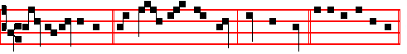
Call the labourers. * and give them their hire, saith the Lord. Psalm 118.
Chapter I Cor.10
FOR they drank of that spiritual Rock which followed them: and that Rock was Christ. But with some of them God was not well pleased.
Short  as on p. 85. I call with my whole heart, * Hear me, O Lord. I call.
 I will keep thy statutes. Hear me. Glory be. I call.
 O cleanse thou me from my secret faults.
 Keep thy servant also from presumptuous sins.

AT VESPERS
Antiphon and Psalm 110 Dixit Dominus with the rest as in the Psalter.
Chapter Brethren: Know ye not, as above.
Hymn. E.H. 51 Lucis Creator optime, as in the Psalter.
 Lord, let my prayer be set forth.  In thy sight as the incense.
On Magnificat, Antiphon. Tone vij, 3.
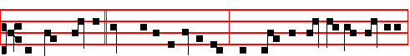
The householder * saith unto the labourers, Why stand ye here all the day idle?
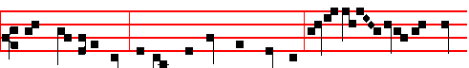
They say unto him, Because no man hath hired us. Go ye also into the vine-
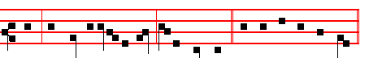
yard, and whatsoever is right, I will give you. Canticle Magnificat, p.

549
Monday
From the Book of Genesis
Lesson j Ch. 1, 27-31
SO God created man in his own image, in the image of God created he him; male and female created he them. And God blessed them, and God said unto them, Be fruitful, and multiply, and replenish the earth, and subdue it: and have dominion over the fish of the sea, and over the fowl of the air, and over every living thing that moveth upon the earth. And God said, Behold, I have given you every herb bearing seed, which is upon the face of all the earth, and every tree, in the which is the fruit of a tree yielding seed; to you it shall be for meat. And to every beast of the earth, and to every fowl of the air, and to every thing that creepeth upon the earth, wherein there is life, I have given every green herb for meat: and it was so. And God saw every thing that he had made, and, behold, it was very good. And the evening and the morning were the sixth day.

 When the Lord God walked in the garden in the cool of the day, he called and said: Adam, where art thou? Lord, I heard thy voice, * And I hid myself.
 I heard thy voice in the garden, and I was afraid because I was naked. And I.

Lesson ij Ch. 2, 1-10
THUS the heavens and the earth were finished, and all the host of them. And on the seventh day God ended his work which he had made; and he rested on the seventh day from all his work which he : had made. And God blessed the seventh day, and sanctified it: because that in it he had rested from all his work which God created and made. These are the generations of the heavens and of the earth when they were created, in the day that the Lord God made the earth and the heavens, and every plant of the field before it was in the earth. and every herb of the field before it grew: for the Lord God had not caused it to rain upon the earth, and there was not a man to till the ground. But there went up a mist from the earth, and watered the whole face of the ground.

 In the sweat of thy face shalt thou eat bread, said the Lord unto Adam; when thou tillest the ground it shall not yield its fruit. * Thorns also and thistles shall it bring forth to thee.
 Because thou hast hearkened unto the voice of thy wife, and hast eaten of the tree of which I commanded thee, saying, Thou shalt not eat of it: cursed is the ground for thy sake. Thorns also.

Lesson iij
AND the Lord God formed man of the dust of the ground, and breathed into his nostrils the breath of life; and man became a living soul. And the Lord

550
God planted a garden eastward in Eden; and there he put the man whom he had formed. And out of the ground made the Lord God to grow every tree that is pleasant to the sight, and good for food; the tree of life also in the midst of the garden, and the tree of knowledge of good and evil. And a river went out of Eden to water the garden; and from thence it was parted, and became into four heads.

 The Lord formed man of the dust of the ground, * And breathed into his nostrils the breath of life, and man became a living soul.
 In the beginning God created the heaven and the earth, and therein formed he man. And breathed. Glory be. And breathed.

On Magnificat, Antiphon.
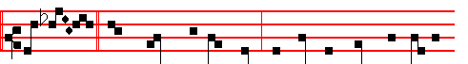
These last * have wrought but one hour, and thou hast made them equal
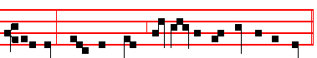
unto us, which have borne the burden and heat of the day.
__________________________________________________________________

Tuesday
From the Book of Genesis
Lesson j Ch. 2, 15-24
AND the Lord God took the man, and put him into the garden of Eden to dress it and to keep it. And the Lord God commanded the man, saying, Of every tree of the garden thou mayest freely eat: but of the tree of the knowledge of good and evil, thou shalt not eat of it: for in the day that thou eatest thereof thou shalt surely die. And the Lord God said, It is not good that the man should be alone; I will make him an help meet for him.

 The Lord took the man and put him into the garden of Eden, * To dress it and to keep it.
 And the Lord planted a garden eastward in Eden, and there he put the man whom he had formed. To dress.

Lesson ij

551
AND out of the ground the Lord God formed every beast of the field, and every fowl of the air; and brought them unto Adam to see what he would call them: and whatsoever Adam called every living creature, that was the name thereof. And Adam gave names to all cattle, and to the fowl of the air, and to every beast of the field, but for Adam there was not found an help meet for him.

 The Lord God said: It is not good that man should be alone; * I will make him an help meet for him.
. But for Adam there was not found an help meet for him, and God said, I will.

Lesson iij
AND the Lord God caused a deep sleep to fall upon Adam, and he slept: and he took one of his ribs, and closed up the flesh instead thereof; and the rib, which the Lord God had taken from man, made he a woman, and brought her unto the man. And Adam said, This is now bone of my bones, and flesh of my flesh: she shall be called Woman, because she was taken out of Man. Therefore shall a man leave his father and his mother, and shall cleave unto his wife: and they shall be one flesh.

 The Lord caused a deep sleep to fall upon Adam, and he took one of his ribs. * And the rib which the Lord had taken from the man made he a woman, and brought her to Adam to see what he would call her. And he called her name woman because she was taken out of man.
 And when Adam slept, God took one of his ribs and closed up the flesh instead thereof. And the. Glory be. And the.

On Magnificat, Antiphon. 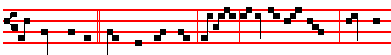
The householder * answered and said, Friend, I do thee no wrong: didst thou
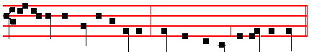
not agree with me for a penny? Take that thine is, and go thy way.
__________________________________________________________________

Wednesday
From the Book of Genesis
552
Lesson j Ch. 3, 1-20
NOW the serpent was more subtil than any beast of the field which the Lord God had made. And he said unto the woman, Yea, hath God said, Ye shall not eat of every tree of the garden? And the woman said unto the serpent, We may eat of the fruit of the trees of the garden: but of the fruit of the tree which is in the midst of the garden, God hath said, Ye shall not eat of it, neither shall ye touch it, lest ye die. And the serpent said unto the woman, Ye shall not surely die: for God doth know that in the day ye eat thereof, then your eyes shall be opened, and ye shall be as gods, knowing good and evil. And when the woman saw that the tree was good for food, and that it was pleasant to the eyes, and a tree to be desired to make one wise, she took of the fruit thereof, and did eat, and gave also unto her husband with her; and he did eat. And the eyes of them both were opened.

 The Lord God planted a garden eastward in Eden, * And there he put the man whom he had formed.
 And out of the ground made the Lord God to grow every tree that is pleasant to the sight and good for food; the tree of life also in the midst of the garden. And there.

Lesson ij
AND they knew that they were naked; and they sewed fig leaves together, and made themselves aprons. And they heard the voice of the Lord God walking in the garden in the cool of the day: and Adam and his wife hid themselves from the presence of the Lord God amongst the trees of the garden. And the Lord God called unto Adam, and said unto him, Where art thou? And he said, I heard thy voice in the garden, and I was afraid, because I was naked; and I hid myself. And he said, Who told thee that thou wast naked? Hast thou eaten of the tree, whereof I commanded thee that thou shouldest not eat? And the man said, The woman whom thou gavest to be with me, she gave me of the tree, and I did eat. And the Lord God said unto the woman, What is this that thou hast done? And the I woman said, The serpent beguiled me, and I did eat.

 Behold, the man is become as one of us to know good and evil. * See lest he take of the tree of life and live for ever.
 Unto Adam also did the Lord God make a coat of skins and clothed him and said: See lest.

Lesson iij
AND the Lord God said unto the serpent, Because thou hast done this, thou art cursed above all cattle, and above every beast of the field; upon thy belly shalt thou go, and dust shalt thou eat all the days of thy life: and I will put enmity

553
between thee and the woman, and between thy seed and her seed; it shall bruise thy head, and thou shalt bruise his heel. Unto the woman he said, I will greatly multiply thy sorrow and thy conception; in sorrow thou shalt bring forth children; and thy desire shall be to thy husband, and he shall rule over thee. And unto Adam he said, Because thou hast hearkened unto the voice or thy wife, and hast eaten of the tree, of which I commanded thee, saying, Thou shalt not eat of it: cursed is the ground for thy sake; in sorrow shalt thou eat of it all the days of thy life. Thorns also and thistles shall it bring forth to thee; and thou shalt eat the herb of the field; in the sweat of thy face shalt thou eat bread, till thou return unto the ground; for out of it wast thou taken: for dust thou art, and unto dust shalt thou return. And Adam called his wife's name Eve; because she was the mother of all living.

 Where is Abel thy brother? said the Lord unto Cain. Lord, I know not; am I my brother's keeper? And he said unto him: What halt thou done? * Behold the voice of thy brother Abel's blood crieth unto me from the ground.
 And now thou art cursed from the earth, which hath opened her mouth to receive thy brother's blood from thy hand. Behold. Glory be. Behold.

On Magnificat, Antiphon.
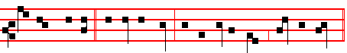
Take that thine is * and go thy way: because I am good, saith the Lord.
__________________________________________________________________

Thursday
From the Book of Genesis
Lesson j Ch. 4, 1-16
AND Adam knew Eve his wife: and she conceived, and bare Cain, and said, I have gotten a man from the Lord. And she again bare his brother Abel. And Abel was a keeper of sheep, but Cain was a tiller of the ground. And in process of time it came to pass, that Cain brought of the fruit of the ground an offering unto the Lord. And Abel, he also brought of the firstlings of his flock and of the fat thereof, And the Lord had respect unto Abel and to his offering: but unto Cain and to his offering he had not respect. And Cain was very wroth, and his countenance fell. And the Lord said unto Cain, Why art thou wroth? and why is thy countenance fallen? If thou doest well, shalt thou not be accepted? and if thou doest not well, sin lieth at the door. And unto thee shall be his desire, and thou shalt rule over him.

554
 In the beginning God created the heaven and the earth, and therein formed he man. * After his own image and likeness.
 And the Lord formed man of the dust of the ground. and breathed into his nostrils the breath of life. After his.

Lesson ij
AND Cain talked with Abel his brother: and it came to pass, when they were in the field, that Cain rose up against Abel his brother, and slew him. And the Lord said unto Cain, Where is Abel thy qrother? And he said, I know not: am I my brother's keeper? And he said, What hast thou done? the voice of thy brother's blood crieth unto me from the ground. And now art thou cursed from the earth, which hath opened her mouth to receive thy brother's blood from thy hand; when thou tillest the ground, it shall not henceforth yield unto thee her strength; a fugitive and a vagabond shalt thou be in the earth.

 In the beginning God created the heaven and the earth, and the Spirit of God moved upon the face of the waters. * And God saw everything that he had made, and behold, it was very good.
 Thus the heavens and the earth were finished, and all the host of them. And God.

Lesson iij
AND Cain said unto the Lord, My punishment is greater than I can bear. Behold, thou hast driven me out this day from the face of the earth; and from thy face shall I be hid; and I shall be a fugitive and a vagabond in the earth; and it shall come to pass, that every one that findeth me shall slay me. And the Lord said unto him, Therefore whosoever slayeth Cain, vengeance shall be taken on him sevenfold. And the Lord set a mark upon Cain, lest any finding him should kill him. And Cain went out from the presence of the Lord, and dwelt in the land of Nod, on the east of Eden.

 The Lord formed man of the dust or the ground, * And breathed into his nostrils the breath of life, and man became a living soul.
 In the beginning God created the heaven and the earth, and therein formed he man. And breathed. Glory be. And breathed.

On Magnificat, Antiphon.
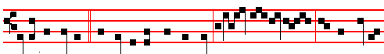
Is it not lawfu1* for me to do what I will? Is thine eye e- vil , because I am

555
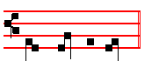
good, saith the Lord.
__________________________________________________________________

Friday
From the Book of Genesis
Lesson j Ch. 4, 17-26
AND Cain knew his wife; and she conceived, and bare Enoch; and he builded a city, and called the name of the city, after the name of his son, Enoch, And unto Enoch was born Irad: and lrad begat Mehujael: and Mehujael begat Methusael: and Methusael begat Lamech. And Lamech took unto him two wives: the name of the one was Adah, and the name of the other Zillah. And Adah bare Jabal: he was the father of such as dwell in tents, and of such as have cattle, And his brother's name was Jubal: he was the father of all such as handle the harp and organ. And Zillah, she also bare Tubal-cain, an instructer of every artificer in brass and iron: and the sister of Tubal-cain was Naamah.

 The Lord took the man and put him into the garden of Eden, * To dress it and to keep it.
 And the Lord planted a garden eastward in Eden, and there he put the man whom he had formed. To dress.

Lesson ij
AND Lamech said unto his wives, Adah and Zillah, Hear my voice; ye wives of Lamech, hearken unto my speech: for I have slain a man to my wounding, and a young man to my hurt. If Cain shall be avenged sevenfold, truly Lamech seventy and sevenfold. And Adam knew his wife again; and she bare a son, and called his name Seth: For God, said she, hath appointed me another seed instead of Abel, whom Cain slew. And to Seth, to him also there was born a son; and he called his name Enos: then began men to call upon the name of the Lord.

 The Lord God said: It is not good that man should be alone; * I will make
him an help meet for him.
. But for Adam there was not found an help meet for him, and God said, I will.

Lesson iij Ch. 5, 1-5
THIS is the book of the generations of Adam. In the day that God created man, in the likeness of God made he him; male and female created he them; and

556
blessed them, and called their name Adam, in the day when they were created. And Adam lived an hundred and thirty years, and begat a son in his own likeness, after his image; and called his name Seth: and the days of Adam after he had begotten Seth were eight hundred years: and he begat sons and daughters: and all the days that Adam lived were nine hundred and thirty years: and he died.

 The Lord caused a deep sleep to fall upon Adam, and he took one of his ribs. * And the rib which the Lord had taken from the man made he a woman, and brought her to Adam to see what he would call her. And he called her name woman because she was taken out of man.
 And when Adam slept, God took one of his ribs and closed up the flesh instead thereof. And the. Glory be. And.

On Magnificat, Antiphon. So the last shall be first, and the first shall be last: for many are called, but few are chosen.
__________________________________________________________________

Saturday
From the Book of Genesis
Lesson j Ch. 5, 15-31
AND Mahalaleel lived sixty and five years, and begat Jared: and Mahalaleel lived after he begat Jared eight hundred and thirty years, and begat sons and daughters: and all the days of Mahalaleel were eight hundred ninety and five years: and he died. And Jared lived an hundred sixty and two years, and he begat Enoch: and Jared lived after he begat Enoch eight hundred years, and begat sons and daughters: and all the days of Jared, were nine hundred sixty and two years: and he died. And Enoch lived sixty and five years, and begat Methuselah.

 The Lord God planted a garden eastward in Eden, * And there he put the man whom he had formed.
 And out of the ground made the Lord God to grow every tree that is pleasant to the sight and good for food; the tree of life also in the midst of the garden. And there.

Lesson ij
AND Enoch walked with God after he begat Methuselah three hundred years, and begat sons and daughters: and all the days of Enoch were three hundred sixty and five years: and Enoch walked with God: and he was not; for God took him. And Methuselah lived an hundred eighty and seven years, and bcgat Lamech: And Methuselah lived after he begat Lamech seven hundred eighty and two years, and begat sons and daughters: and all the days of Methuselah were nine hundred sixty and nine years: and he died.
557
 Behold, the man is become as one of us to know good and evil. * See lest he take of the tree of life and live for ever.
 Unto Adam also did the Lord God make a coat of skins and clothed him and said: See lest.

Lesson iij
AND Lamech lived an hundred eighty and two years, and begat a son: and he called his name Noah, saying, This same shall comfort us, concerning our work and toll of our hands, because of the ground which the Lord hath cursed. And Lamech lived after he begat Noah five and hundred ninety and five years, and begat sons and daughters: and all the days of Lamcch were seven hundred seventy and seven years: and he died.

 Where is Abel thy brother? said the Lord unto Cain. Lord, I know not; am I my brother's keeper? And he said unto him: What halt thou done? * Behold the voice of thy brother Abel's blood crieth unto me from the ground.
 And now thou art cursed from the earth, which hath opened her mouth to receive thy brother's blood from thy hand. Behold. Glory be. Behold.
__________________________________________________________________

AT VESPERS
Chapter 2 Cor. 11
BRETHREN:Ye suffer fools gladly, seeing ye yourselves are wise. For ye suffer, if a man bring you into bondage, if a man devour you, if a man take of you, if a man exalt himself, if a man smite you on the face.
Hymn and  from the Psalter.
On Magnificat, Antiphon. Tone viij, 1
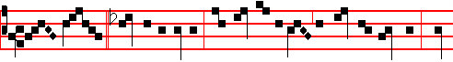
The Lord * said unto Noah: The end of all flesh is come before me: make
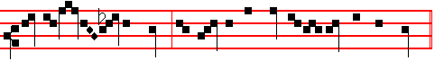
thee an ark of gopher wood, that therein the seed of all flesh may be saved.
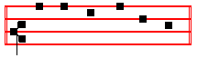
Canticle. Magnificat, p..
558
COLLECT
O GOD, who seest that we put not our trust in any thing that we do: mercifully grant; that by the protection of the Doctor of the Gentiles we may be defended against all adversity. Through.
__________________________________________________________________
SEXAGESIMA SUNDAY AT MATINS.
Invitatory.- Let us come before his presence with thanksgiving, * And shew ourselves glad in him with psalms. Ps.95. In the first verse of the Psalm, Let us come before his presence with thanksgiving, etc. is omitted, and in its place the Invitatory is repeated by the Choir.
E.H.50 Primo dierum omnium, as in the Psalter. Antiphons, Psalms, and Versicles of the Nocturns as in the Psalter.

IN THE FIRST NOCTURN
From the Book of Genesis
Lesson j . Ch. 32, 6 1-15
AND Noah was five hundred years old: and Noah begat Shem, Ham, and Japheth. And it came to pass, when men began to multiply on the face of the earth, and daughters were born unto them, that the sons of God saw the daughters of men that they were fair; and they took them wives of all which they chose. And the Lord said, My spirit shall not always strive with man, for that he also is flesh: yet his days shall be an hundred and twenty years. There were giants in the earth in those days; and also after that, when the sons of God came in unto the daughters of men, and they bare children to them, the same became mighty men which were of old, men of renown.

 The Lord said unto Noah, The end of all flesh is come before me; for the earth is filled with violence through them; * And behold, I will destroy them with the earth.
 Make thee an ark of gopher wood; rooms shalt thou make in it. And behold.

Lesson ij
AND God saw that the wickedness of man was great in the earth, and that every imagination of the thoughts of his heart was only evil continually. And it repented the Lord that he had made man on the earth. And it grieved him at his heart. And the Lord said, I will destroy man whom I have created from the face of the earth; both man, and beast, and the creeping thing, and the fowls of the air; for it repenteth me that I have made them. But Noah found grace in the eyes of the Lord.
 Noah was a just man and perfect, and Noah walked with God; * According to all that God commanded him, so did he.
559
 He made him an ark to keep seed alive upon the face of all the earth. According.

Lesson iij
THESE are the generations of Noah: Noah was a just man and perfect in his generations, and Noah walked with God. And Noah begat three sons, Shem, Ham, and Japheth. The earth also was corrupt before God, and the earth was filled with violence. And God looked upon the earth, and, behold, it was corrupt: for all flesh had corrupted his way upon the earth. And God said unto Noah. The end of all flesh is come before me; for the earth is filled with violence through them; and, behold, I will destroy them with the earth. Make thee an ark of gopher wood; rooms shalt thou make in the ark, and shalt pitch it within and without with pitch. And this is the fashion which thou shalt make it of: The length of the ark shall be three hundred cubits, the breadth of it fifty cubits, and the height of it thirty cubits.

 Forty days and forty nights were the heavens opened, and they went in into the ark, two and two of all flesh wherein is the breath of life.* And the Lord shut them in.
 In the selfsame day entered Noah into the ark, and his sons, and his wife, and his sons' wives with him. And the Lord. Glory be. And the.

IN THE SECOND NOCTURN

From the Book by S. Ambrose, Bishop On Noah and the Ark
Lesson iv Ch. 4
WE read that God was angry. Although he was well aware, that is, he knew, that man, placed in this worldly domain, bearing flesh, could not be without sin, (the world is, as it were, a ground for sin, and the flesh is a decoy for seduction), yet men were rushing heedlessly into moral error from which they had no desire to recall themselves, although they had minds capable of reasoning, and their bodies were infused with power of soul. Neither are God's thoughts as men's, with one idea ever giving place to anothcr, nor is his anger inconsistent; but what we read here is so written to express to us the bitterness of our sins, and how greatly they called down the divine displeasure: such was the growth of our guilt, that it even seemed to make God angry, he who is not naturally moved either to wrath, or to hatred, or to any other passion.

 Noah builded an altar unto the Lord, and offered burnt offerings thereon; and the Lord smelled a sweet savour, and blessed him, saying: * Be fruitful, and multiply, and replenish the earth.

560
 Behold, I establish my covenant with you, and with your seed after you. Be fruitful.
Lesson v
THEREFORE he threatened to destroy man. I will destroy both man, and beast, and the creeping thing, and the fowls of the air. What had the irrational creatures done? They had been made for man, and now that he for whom they had been made, was going to be destroyed, it followed that they too should be destroyed, because he who was to use them would no longer exist. Yet there is a higher reason: Man has a mind that is capable of reason. Man may be described as a living, mortal, rational animal. When the principal living creature is annihilated, all other living creatures go with it: for nothing remains to be saved when virility, or virtue, the basis of salvation, is no more.

 I do set my bow in the clouds, said the Lord unto Noah: * And I will remember my covenant which is between me and you.
 And it shall come to pass, when I bring a cloud over the heaven, that my bow shall be seen in the cloud. And I will.

Lesson vj
IN condemnation of the rest of mankind, and as an expression of the divine mercy, Noah is said to have found grace with God. At the same time it is revealed that the sin of other men can cast no shadow over the righteous, as he is preserved for the begetting of all his race. He is praised, not for his noble birth, but because he was a just man, and perfect. The stock of a just man yields men of upright character; even as the stock of men begets men, so the stock of just souls begets virtues. Just as some families of men become noble by the splendour of their lineage, so is the grace of souls made glorious by the splendour of their virtues.

 By myself have I sworn, saith the Lord, that I will not bring the waters of the flood again upon the earth; I will remember my covenant. * And the waters shall no more become a flood to destroy all flesh.
 I do set my bow in the cloud, and it shall be for a token of a covenant between me and the earth. And the. Glory be. And the.

IN THE THIRD NOCTURN
The Lesson from the Holy Gospel according to S. Luke
Lesson vij Ch. 8
WHEN much people were gathered together, and were come to Jesus out of every city, he spake by a parable: A sower went out to sow his seed. And the rest.

561
Homily by S. Gregory the Great Homily 15 on the Gospels
THIS lesson that you have heard from the Holy Gospel, beloved brethren, needs no explanation; but take heed of its warning. What Truth himself has expounded, human frailty does not presume to discuss. Yet there is matter for careful consideration in this explanation given by the Lord: if we ourselves were to tell you that the seed is the word; the field, the world; the birds, the devil; the thorns, riches; you might perhaps entertain doubts as to whether you should believe us. The Lord himself has vouchsafed to expound what he was saying, that you might learn to discover the meaning of those other things that he did not choose to explain personally.

 God blessed Noah and his sons, and said unto them: * Be fruitful, and multiply, and replenish the earth.
 Behold, I establish my covenant with you, and with your seed after you. Be fruitful.

Lesson viij
IN expounding his words, he states that he speaks in parables. Thus he hands on to us his authority, when we, in our frailty, reveal the meaning of his parables to you. Who would ever believe me if I had chosen to say that thorns mean riches? As extreme as is the prick of thorns. so is the delight of riches. Yet riches are thorns: they pierce the mind with the stabs of all the anxiety they bring; and when they drag men into sin, then they wound, as though they were drawing blood. According to another Evangelist, in this passage the Lord most aptly called the thorns, not riches, but the deceitfulness of riches.

 Behold, I establish my covenant with you, and with your seed after you. * Neither shall there any more be a flood to destroy the earth.
 I do set my bow in the cloud, and it shall be for a token of a covenant between me and the earth. Neither.

Lesson ix
THOSE riches are deceitful that cannot last for ever: those riches are deceitful that do not dispel our poverty of mind. Those alone are the true riches that make us rich in virtues. Therefore, beloved brethren, if you would be rich, love the true riches. If you seek the highest honour, strive for the kingdom of heaven. If you love glorious rank, make haste to be numbered among the legions of angels. When the word of God sounds in your ear, retain it in your mind. God's word is food for the mind: if you do not retain the word you hear in the stomach of your memory, it is as though a weak stomach were rejecting food. When anyone cannot retain his nourishment, his life is in danger.

562
 When much people were gathered together to Jesus, and were come to him out of every city, he spake by a parable: * A sower went out to sow his seed.
 And as he sowed, some fell on good ground, and sprang up, and bare fruit an hundredrold. A sower. Glory be. A sower.

During the week on Wednesday and Saturday, instead of this Responsory is said the first Responsory of the following Monday.

AT LAUDS
Antiphon 1. Tone j, 2
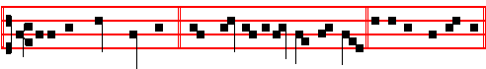
After thy great goodness,* have mercy upon me, O God. Psalm 5l Miserere
Antiphon 2. Tone j, 4
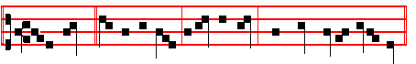
If the Lord * be on my side, I will not fear what man doeth unto me.
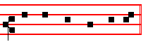
Psalm 118 Confitemini Domino, p.
Antiphon 3. Tone ij
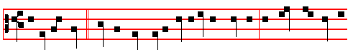
Within the veil * have I called very early in the morning: O God, thou art my
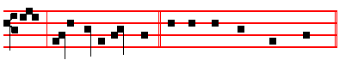
God, early will I seek thee. Psalms 63, 67 Deus, Deus meus,
with the rest in the Psalter.
Antiphon 4. Tone viij, 1

563

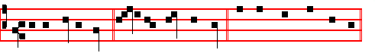
Let us sing a hymn * unto the Lord our God. Canticle Benedicite, p.
Antiphon 5. Tone j, 1
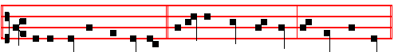
In the cymbals and dances, * upon the strings and pipe, O praise the Lord.
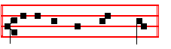
Psalms 148-150. pp.

Chapter 2 Cor. 11
BRETHREN: Ye suffer fools gladly, seeing ye yourselves are wise. For ye suffer, if a man bring you into bondage, if a man devour you, if a man take of you, if a man exalt himself, if a man smite you on the face.
Hymn and  as in the Psalter, p. 18.
On Benedictus, Antiphon. Tone viij, 1.
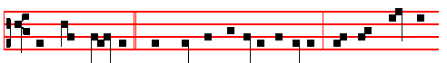
When much people * were gathered together to Jesus, and were come to
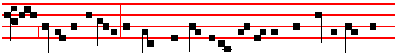
him out of every city, he spake a pa-ra-ble: A sower went out to sow his
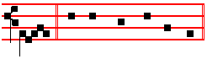
seed. Canticle Benedictus, p. 39.
COLLECT
O GOD, who seest that we put not our trust in anything that we do: mercifully grant; that by the protection of the Doctor of the Gentiles we may be

564
defended against all adversity. Through.
AT PRIME
Antiphon. Tone ij.
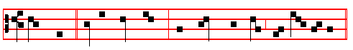
Some seed * fell on good ground, and brought forth fruit with pat- i -ence.
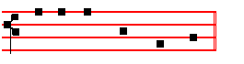
Psalm 54 Deus in nomine, p.
At the Close of the Chapter, the Lord direct, p. 31.

AT TERCE
Antiphon. Tone j, 1
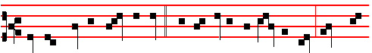
They who keep the word of God * with an honest and perfect heart bring forth
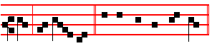
fruit with patience. Psalm 119 Legem pone.
Chapter Ye suffer fools, as above, p. 564.
Short , as in the Psalter.
Incline my heart, O God, * Unto thy testimonies. Incline.
 Turn away mine eyes, lest they behold vanity: and quicken thou me in thy way. Unto thy testimonies. Glory be. Incline.
 I said, Lord, be merciful unto me.
 Heal my soul, for I have sinned against thee.

AT SEXT
Antiphon. Tone viij, 2.
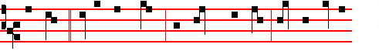
Some seed fell on good ground, and brought forth fruit; some an humdred-
565
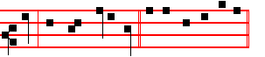
fold, and some sixtyfold. Psalm 119 Defecit
Chapter 2 Cor. 11
THRICE was I beaten with rods, once was I stoned, thrice I suffered shipwreck, a night and a day I have been in the deep.
Short  , as in the Psalter.
O Lord, thy word endureth * For ever in heaven. O Lord.
 Thy truth also remaineth from one generation to another. For ever. Glory be. O Lord.
 The Lord is my shepherd, therefore can I lack nothing.  He shall feed me in a green pasture.
AT NONE
Antiphon. Tone vij, 1
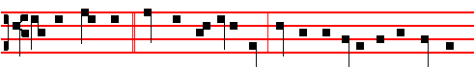
If then, brethren, * ye would be truly rich, set your affection on the true rich-
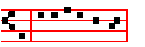
-es. Psalm 119 Mirabilia
Chapter 2 Cor. 12
MOST gladly therefore will I rather glory in my infirmities, that the power of Christ may rest upon me.
Short , as in the Psalter.
I call with my whole heart, * Hear me, O Lord. I call.
 I will keep thy statutes. Hear me. Glory be. I call.
 O cleanse thou me from my secret faults.
 Keep thy servant also from presumptuous sins.

AT VESPERS
Antiphons and Psalms of Sunday, p.
Chapter Brethren: ye suffer, as above at Lauds, p. 564.
Hymn Lucis Creator E.H. 5l, p. 112.
 Let my prayer, p. 113
On Magnificat, Antiphon. Tone vj

566
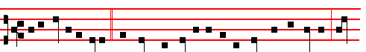
Unto you it is given * to know the mysteries of the kingdom of heaven: but
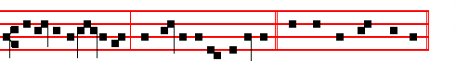
to others in parables, said Jesus to his disciples. Canticle Magnificat, p.
Collect O God, who seest, 564.
__________________________________________________________________

Monday
From the Book of Genesis
Lesson j Ch.7. 1-5, 10-14, 11
AND the Lord said unto Noah, Come thou and all thy house into the ark; for thee have I seen righteous before me in this generation. Of every clean beast thou shalt take to thee by sevens, the male and his female; and of beasts that are not clean by two, the male and his female. Of fowls also of the air by sevens, the male and the female; to keep seed alive upon the face of all the earth. For yet seven days, and I will cause it to rain upon the earth forty days and forty nights; and every living substance that I have made will I destroy from off the face of the earth.

 In the selfsame day Noah went in, and his sons, into the ark, * And his wife and his sons' wives with him.
 And every living substance was destroyed which was upon the face of the ground, and only Noah remained alive, and they that were with him in the ark. And his wife.

Lesson ij
AND Noah did accordIng unto all that the Lord commanded him. And it came to pass after seven days, that the waters of the flood were upon the earth. In the six hundredth year of Noah's life, in the second month, the seventeenth day of the month, the same day were all the fountains of the great deep broken up, and the windows of heaven were opened. And the rain was upon the earth forty days and forty nights.

 And God remembered Noah, and made a wind to pass over the earth, and the waters asswaged; * And the rain from heaven was restrained.

567
 And the waters returned from off the earth continually, and after the end of the hundred and fifty days the waters were abated. And the rain.

Lesson iij
IN the selfsame day entered Noah, and Shem, and Ham, and Japheth, the sons of Noah, and Noah's wife, and the three wives of his sons with them, into the ark; they, and every beast after his kind, and all the cattle after their kind, and every creeping thing that creepeth upon the earth after his kind, and every fowl after his kind, every bird of every sort. And the flood was forty days upon the earth; and the waters increased, and bare up the ark, and it was lift up above the earth.

 Forty days and forty nights were the heavens opened, and they went in into the ark, two and two of all flesh wherein is the breath of life. * And the Lord shut them in.
 In the selfsame day entered Noah into the ark, and his sons, and his wife, and his sons' wives with him. And the Lord. Glory be. And the Lord.

On Magnificat, Antiphon.
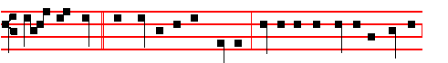
If ye seek * the summit of true honour, hasten to yon heavenly country
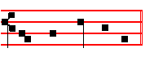
with what speed ye may.
__________________________________________________________________

Tuesday
From the Book of Genesis
Lesson j Ch. 8, 1-13
AND God remembered Noah, and every living thing, and all the cattle that was with him in the ark: and God made a wind to pass over the earth, and the waters asswaged; the fountains also of the deep and the windows of heaven were stopped, and the rain from heaven was restrained. And the waters returned from off the earth continually: and after the end of the hundred and fifty days the waters were abated. And the ark rested in the seventh month, on the seventeenth day of the month, upon the mountains of Ararat.

568
 Noah builded an altar unto the Lord, and offered burnt offerings thereon; and the Lord smelled a sweet savour, and blessed him, saying: * Be fruitful, and multiply, and replenish the earth.
 Behold, I establish my covenant with you, and with your seed after you. Be fruitful.

Lesson ij
AND the waters decreased continually until the tenth month: in the tenth month, on the first day of the month, were the tops of the mountains seen. And it came to pass at the end of forty days, that Noah opened the window of the ark which he had made: and he sent forth a raven, which went forth to and fro, until the waters were dried up from off the earth. Also he sent forth a dove from him, to see if the waters were abated from off the face of the ground: but the dove found no rest for the sole of her foot, and she returned unto him into the ark.

 I do set my bow in the clouds, said the Lord unto Noah: * And I will remember my covenant which is between me and you.
 And it shall come to pass, when I bring a cloud over the heaven, that my bow shall be seen in the cloud. And I will.

Lesson iij
AND he stayed yet other seven days; and again he sent forth the dove out of the ark; and the dove came in to him in the evening; and, lo, in her mouth was an olive leaf pluckt off: so Noah knew that the waters were abated from off the earth. And he stayed yet other seven days; and sent forth the dove, which returned not again unto him any more, and it came to pass in the six hundredth and first year, in the first month, the first day of the month, the waters were dried up from off the earth.

 By myself have I sworn, saith the Lord, that I will not bring the waters of the flood again upon the earth; I will remember my covenant. * And the waters shall no more become a flood to destroy all flesh.
 I do set my bow in the cloud, and it shall be for a token of a covenant between me and the earth. And the. Glory be. And the.

On Magnificat, Antiphon.
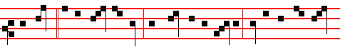
The seed * is the word of God, but Christ is the Sower: every one that hear-

569
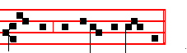
eth him shall abide for ev - er.
__________________________________________________________________

Wednesday
From the Book of Genesis
Lesson j Ch. 15-22
AND God spake unto Noah, saying, Go forth of the ark, thou, and thy wife, and thy sons, and thy sons' wives with thee. Bring forth with thee every living thing that is with thee, of all flesh, both of fowl, and of cattle, and of every creeping thing that creepeth upon the earth; that they may breed abundantly in the earth, and be fruitful, and multiply upon the earth. And Noah went forth, and his sons, and his wife, and his sons' wives with him: every beast, every creeping thing, and every fowl, and whatsoever creepeth upon the earth, after their kinds, went forth out of the ark.

 God blessed Noah and his sons, and said unto them: * Be fruitful, and multiply, and replenish the earth.
 Behold, I establish my covenant with you, and with your seed after you. Be fruitful.

Lesson ij
AND Noah builded an altar unto the Lord; and took of every clean beast, and of every clean fowl, and offered burnt offerings on the altar. And the Lord smelled a sweet savour; and the Lord said in his heart, I will not again curse the ground any more for man's sake; for the imagination of man's heart is evil from his youth; neither will I again smite any more every thing living, as I have done. While the earth remaineth, seedtime and harvest, and cold and heat, and summer and winter, and day and night shall not cease.

 Behold, I establish my covenant with you, and with your seed after you. * Neither shall there any more be a flood to destroy the earth.
 I do set my bow in the cloud, and it shall be for a token of a covenant between me and the earth. Neither.

Lesson iij Ch. 9, 1-6
AND God blessed Noah and his sons, and said unto them, Be fruitful, and multiply, and replenish the earth. And the fear of you and the dread of you

570
shall be upon every beast of the earth, and upon every fowl of the air, upon all that
moveth upon the earth, and upon all the fishes of the sea; into your hand are they delivered. Every moving thing that liveth shall be meat for you; even as the green herb have I given you all things. But flesh with the life thereof, which is the blood thereof, shall ye not eat. And surely your blood of your lives will I require; at the hand of every beast will I require it, and at the hand of man; at the hand of every man's brother will I require the life of man. Whoso sheddeth man's blood, by man shall his blood be shed: for in the image of God made he man.

 In the selfsame day Noah went in, and his sons, into the ark, * And his wife and his sons' wives with him.
 And every living substance was destroyed which was upon the face of the ground, and only Noah remained alive, and they that were with him in the ark. And his wife. Glory be. And his wife.

On Magnificat, Antiphon.
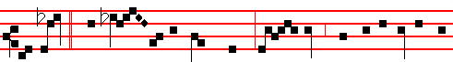
But that * which fell on the good ground are they which in an honest and
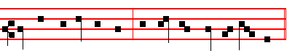
good heart receive the word; and bring forth fruit with patience.

[If the aforesaid Antiphons on Magnificat shall not have been able to be said on the preceding Ferias, and on the following Thursday it happen to be the Office of the Feria, there shall be said the last of them which was omitted; or else, if they were all used, they shall be taken from the Psalter, which is always done, when there are none proper.- Ratisbon Compendium, 1901]
__________________________________________________________________

Thursday
From the Book of Genesis
Lesson j Ch. 9, 12-15
AND God said, This is the token of the covenant which I make between me and you and every living creature that is with you, for perpetual generations: I do set my bow in the cloud, and it shall be for a token of a covenant between me and the earth. And it shall come to pass, when I bring a cloud over the earth, that

571
the bow shall be seen in the cloud: and 1 will remember my covenant, which is between me and you and every living creature of all flesh; and the waters shall no more become a flood to destroy all flesh.

 The Lord said unto Noah, The end of all flesh is come before me; for the earth is filled with violence through them; * And behold, I will destroy them with the earth.
 Make thee an ark of gopher wood; rooms shalt thou make in it. And behold.

Lesson ij Ibid. 20-28
AND Noah began to be an husbandman, and he planted a vineyard: and he drank of the wine, and was drunken; and he was uncovered within his tent. And Ham, the father of Canaan, saw the nakedness of his father, and told his two brethren without. And Shem and Japheth took a garment, and laid it upon both their shoulders, and went backward, and covered the nakedness of their father; and their faces were backward, and they saw not their father's nakedness.

 Noah was a just man and perfect, and Noah walked with God; * According to all that God commanded him, so did he.
 He made him an ark to keep seed alive upon the face of all the earth. According.

Lesson iij
AND Noah awoke from his wine. and knew what his younger son had done unto him. And he said, Cursed be Canaan; a servant of servants shall he be unto his brethren. And he said. Blessed be the Lord God of Shem; and Canaan shall be his servant. God shall enlarge Japheth, and he shall dwell in the tents of Shem; and Canaan shall be his servant. And Noah lived after the flood three hundred and fifty years. And all the days of Noah were nine hundred and fifty years: and he died.

 Forty days and forty nights were the heavens opened, and they went in into the ark, two and two of all flesh wherein is the breath of life. * And the Lord shut them in.
 In the selfsame day entered Noah into the ark, and his sons, and his wife, and his sons' wives with him. And the Lord. Glory be. And the.

On Magnificat, Antiphon. Some seed * fell on good ground, and brought forth fruit; some an hundredfold and some sixtyfold.
__________________________________________________________________

Friday
572
From the Book of Genesis
Lesson j Ch. 10, 1-6
NOW these are the generations of the sons of Noah, Shem, Ham, and Japheth: and unto them were sons born after the flood. The sons of Japheth; Gomer, and Magog, and Madai, and Javan, and Tubal, and Meshech and Tiras. And the sons of Gomer; Ashkenaz, and Riphath, and Togarmah. And the sons of Javan; Elishah, and Tarshish, Kittim, and Dodanim. By these were the isles of the Gentiles divided in their lands; every one after his tongue, after their families, in their nations. And the sons of Ham; Cush, and Mizraim, and Phut, and Canaan.

 Noah builded an altar unto the Lord, and offered burnt offerings thereon; and the Lord smelled a sweet savour, and blessed him, saying: * Be fruitful, and multiply, and replenish the earth.
 Behold, I establish my covenant with you, and with your seed after you. Be fruitful

Lesson ij Ch. 11, 1-8
AND the whole earth was of one language, and of one speech. And it came to pass, as they journeyed from the east, that they found a plain in the land of Shinar; and they dwelt there. And they said one to another, Go to, let us make brick, and bum them throughly. And they had brick for stone, and slime had they for morter. And they said, Go to, let us build a city and a tower, whose top may reach unto heaven; and let us make us a name, lest we be scattered abroad upon the face of the whole earth.

 I do set my bow in the clouds, said the Lord unto Noah: * And I will remember my covenant which is between me and you.
 And it shall come to pass, when I bring a cloud over the heaven, that my bow shall be seen in the cloud. And I will.

Lesson iij
AND the Lord came down to see the city and the tower, which the children of men builded. And the Lord said, Behold, the people is one, and they have all one language; and this they begin to do: and now nothing will be restrained from them, which they have imagined to do. Go to, let us go down, and there confound their language, that they may not understand one another's speech. So the Lord scattered them abroad from thence upon the face of all the earth: and they left off to build the city.

 By myself have I sworn, saith the Lord, that I will not bring the waters of the

573
flood again upon the earth; I will remember my covenant. * And the waters shall no more become a flood to destroy all flesh.
 I do set my bow in the cloud, and it shall be for a token of a covenant between me and the earth. And the. Glory be. And the.
On Magnificat, Antiphon. They who keep the word of God * with an honest and perfect heart bring forth fruit with patience.
__________________________________________________________________
Saturday
From the Book of Genesis
Lesson j Ch. 11, 10-30
THESE are the generations of Shem: Shem was an hundred years old, and begat Arphaxad two years after the flood: and Shem lived after he begat Arphaxad five hundred years, and begat sons and daughters. And Arphaxad lived five and thirty years, and begat Salah: and Arphaxad lived after he begat Salah four hundred and three years, and begat sons and daughters. And Salah lived thirty years, and begat Eber: and Salah lived after he begat Eber four hundred and three years, and begat sons and daughters.

 God blessed Noah and his sons, and said unto them: * Be fruitful, and multiply, and replenish the earth.
 Behold, I establish my covenant with you, and with your seed after you. Be fruitful

Lesson ij
AND Eber lived four and thirty years, and begat Peleg: and Eber lived after he begat Peleg four hundred and thirty years. and begat sons and daughters. And Peleg lived thirty years, and begat Reu: and Peleg Jived after he begat Reu two hundred and nine years, and begat sons and daughters. And Reu lived two and thirty years, and begat Serug: and Reu lived after he begat Serug two hundred and seven years, and begat sons and daughters. And Serug lived thirty years, and begat Nahor: and Serug lived after he begat Nahor two hundred years, and begat sons and daughters.

 Behold, I establish my covenant with you, and with your seed after you. * Neither shall there any more be a flood to destroy the earth.
 I do set my bow in the cloud, and it shall be for a token of a covenant between me and the earth. Neither.

Lesson iij
AND Nahor lived nine and twenty years, and begat Terah: and Nahor lived after he begat Terah an hundred and nineteen years, and begat sons and
574
daughters. And Terah lived seventy years, and begat Abram, Nahor, and Haran. Now these are the generations of Terah: Terah begat Abram, Nahor, and Haran; and Haran begat Lot. And Haran died before his father Terah in the land of his nativity, in Ur of the Chaldees. And Abram and Nahor took them wives: the name of Abram's wife was Sarai; and the name of Nahor's wife, Milcah, the daughter of Haran, the father of Milcah, and the father of Iscah. But Sarai was barren; she had no child.

 In the selfsame day Noah went in, and his sons, into the ark, * And his wife and his sons' wives with him.
 And every living substance was destroyed which was upon the face of the ground, and only Noah remained alive, and they that were with him in the ark. And his wife. Glory be. And his wife.

SATURDAY BEFORE QUINQUAGESIMA
At Vespers
Chapter 1 Cor. 13
BRETHREN: Though I speak with the tongues of men and of angels, and have not charity, I am become as sounding brass, or a tinkling cymbal.
Hymn. E.H. 164 O Lux and  Let our evening, from the Psalter, p.
On Magnificat, Antiphon. Tone vj
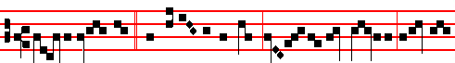
Mighty Abraham, * the father of our faith, offered a burnt offering upon the
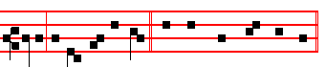
altar, instead of his son. Canticle Magnificat, p.

COLLECT
WE beseech thee, O Lord, graciously hear our prayers; that we, being loosed from the bonds of our sins, may be defended against all adversity. Through.
__________________________________________________________________

QUINQUAGESIMA SUNDAY.
At Matins, Invitatory.- Let us come before his presence with thanksgiving, * And shew ourselves glad in him with psalms. In the first verse of the psalm, Let us

575
come before his presence with thanksgiving is omitted, and the Invitatory is repeated by the Choir, in its place.
Hymn, E.H.50 Primo dierum as in the Psalter, p. Antiphons, Psalms,and  of the Nocturn from the Psalter, p.
IN THE FIRST NOCTURN
From the Book of Genesis
Lesson j Ch. 12, 1-19
NOW the Lord had said unto Abram, Get thee out of thy country, and from thy kindred. and from thy father's house, unto a land that I will shew thee: and I will make of thee a great nation, and I will bless thee, and make thy name great; and thou shalt be a blessing: and I will bless them that bless thee, and curse him that curseth thee: and in thee shall all families of the earth be blessed. So Abram departed, as the Lord had spoken unto him; and Lot went with him: and Abram was seventy and five years old when he departed out of Haran. And Abram took Sarai his wife, and Lot his brother's son, and all their substance that they had gathered, and the souls that they had gotten in Haran; and they went forth to go into the land of Canaan. And into the land of Canaan they came. And Abram
passed through the land unto the place of Sichem, unto the plain of Moreh. And the Canaanite was then in the land.

 Now the Lord had said t unto Abram, Get thee out of thy country and from thy kindred, unto a land that I will shew thee: * And I will make or thee a great nation.
 I will bless thee and make thy name great; and thou shalt be a blessing. And I.

Lesson ij
AND the Lord appeared unto Abram, and said, Unto thy seed will I give this land: and there builded he an altar unto the Lord who appeared unto him. And he removed from thence unto a mountain on thc east of Beth-el, and pitched his tent, having Beth-el on the west, and Hai on the east: and there he builded an altar unto the Lord, and called upon the name of the Lord. And Abram journeyed, going on still toward the south. And there was a Famine in the land: and Abram went down into Egypt to sojourn there; For the Famine was grievous in the land. And it came to pass, when he was come near to enter into Egypt, that he said unto Sarai his wife, Behold now, I know that thou art a fair woman to look upon: therefore it shall come to pass, when the Egyptians shall see thee, that they shall say, This is his wife: and they will kill me, but they will save thee alive. Say, I pray thee, thou art my sister: that it may be well with me for thy sake; and my soul shall live because of thee.

 Abraham stood by the oak of Mamre, and he saw three men coming towards him * He saw Three, and worshipped One.

576
 Behold, Sarah thy wife shall bear thee a son, and thou I shalt call his name Isaac. He saw.

Lesson iij
AND it came to pass, that, when Abram was come into Egypt, the Egyptians beheld the woman that she was very fair. The princes also of Pharaoh saw her, and commended her before Pharaoh: and the woman was taken into Pharaoh's house. And he entreated Abram well for her sake: and he had sheep, and oxen, and he asses, and menservants, and maidservants, and she asses, and camels. And the Lord plagued Pharaoh and his house with great plagues because of Sarai Abram's wife. And Pharaoh called Abram, and said, What is this that thou hast done unto me? why didst thou not tell me that she was thy wife? why saidst thou, She is my sister? so I might have taken her to me to wife: now therefore behold thy wife, take her, and go thy way.

 God did tempt Abra- ham, and said unto him: * Take now thy son Isaac, whom thou lovest, and offer him for a burnt offering upon one of the mountains which I will tell thee of.
 When he was called by the Lord, he answered, Behold, here I am, and the Lord said unto him: Take now. Glory be. Take now.

IN THE SECOND NOCTURN

Sermon by S. Ambrose, Bishop On the Patriarch Abraham
Lesson iv Bk. 1. Ch. 2
AGREAT man indeed was Abraham, distinguished by the marks of many virtues. Philosophy could not by its prayers equal him. Indeed what philosophy conceived is less than he actually achieved: and simple faith in the truth is greater than the boastful lying of eloquence. Therefore let us consider what was the nature of the devotion in that man. For that virtue is first in order which is the foundation of all the rest. Rightly did God demand it from him, saying, Get thee out of thy country, and from thy kindred, and from thy father's house. It would have been enough to say, From thy country. For in that lay the going forth from kindred and the going forth from his father's house.

 The Angel called unto Abraham, and said, * Lay not thine hand upon the lad, for now I know that thou fearest God.
 When he stretched forth his hand to slay his son, behold, the angel of the Lord called unto him out of heaven and said: Lay not.

Lesson v

577
BUT God added the separate behests that he might prove Abraham's affection, lest he should seem to have set out by chance or without forethought, or lest some deception should be prepared against him by the heavenly commands. But precisely as the behests must needs be heaped together lest anything should remain hidden, so also must the rewards be set forth lest perchance he should lose hope. He is tried in fortitude, he is roused in faith, he is provoked in righteousness: And rightly did he set out as the Lord spoke to him. And Lot went with him. Now this saying which is esteemed as great among the sayings of the seven wise men, namely, Follow God, Abraham fully performed, and by his deed he surpassed the
sayings of the wise, and, following God, he set out from his country.

 The Angel of the Lord called unto Abraham the second time, and said, I will bless thee: * And I will multiply thy seed as the stars of heaven.
 Thy seed shall possess the gate of his enemies, and in thy seed shall all the nations of the earth be blessed. And I.

Lesson vj
BUT because he had previously dwelt in another land, namely the land of the Chaldaeans from which Terah, Abraham's father set out and moved to Haran, and because he to whom it was said, Get thee out from thy kindred, took with him his nephew, let us consider whether to set out from one's land may mean to go out from an abiding place of this earth, that is an abiding in our body: from whence Paul went out, for he said, Our conversation is in heaven.

 O Lord God of my master Abraham, prosper my way which I go: * That I may return again in safety unto the house of my master.
. O Lord, I pray thee, be merciful unto thy servant. That I. Glory be. That I.

IN THE THIRD NOCTURN

The Lesson from the Holy Gospel according to S. Luke
Lesson vij Ch. 18
JESUS took unto him the twelve, and said unto them, Behold, we go up to Jerusalem, and all things that are written by the prophets concerning the Son of man shall be accomplished.
Homily by S. Gregory the Great Homily 2 on the Gospels
OUR Redeemer foresaw that his disciples would be troubled in heart by his passion, and so he warned them long beforehand both of the humiliation of his passion, and of the glory of his resurrection, with the intent that when they were to see him dying, they might also believe that he would rise again. But the

578
disciples were still worldly-minded and incapable of understanding the implication of his words, and so he resorted to a miracle. Before their eyes a blind man received his sight: thus, while they could not comprehend the mystery of his words, by his divine act, they were confirmed in the faith.

 I came this day unto the well, and I besought the Lord, and said: * O Lord God of Abraham, thou hast prospered my way.
 Therefore the virgin to whom I shall say, give me water of thy pitcher to drink; and she shall say to me, Drink, my lord, and I will give thy camels to drink also; let the same be she that thou hast appointed for thy servant Isaac. O Lord.

Lesson viij
NOW the miracles of our Lord and Saviour, beloved brethren, must be so received, that they are both taken to be true, and believed to have some special meaning for us as well, In the former case, they manifest his acts and his power; in the latter, they possess a mystical meaning. While we do not know who this blind man was historically, we do know what he stands for in the mystical sense. The blind man is the race of mankind, expelled in the person of our first parent from the joys of paradise, unaware of the brightness of the heavenly radiance, enduring the darkness of his condemnation. Then he is enlightened by the presence of his Redeemer: this enables him to see, through hope, the gladness of inward light, and directs his steps along the way of a life of good works.

 The word of the Lord came unto Abram, saying: * Fear not, Abram, I am thy shield and thy exceeding great reward.
 For I am the Lord thy God, that brought thee out of Ur of the Chaldees. Fear.

Lesson ix.
NOTE here that it was when Jesus is said to have come nigh unto Jericho that the blind man received his sight. For Jericho means Moon, and in Holy Scripture the moon denotes the failing of the flesh: in its monthly waning it symbolises the decline of our mortal nature. As our Creator comes nigh unto Jericho a blind man receives his sight: while the Divinity receives the infirmity of our flesh, the human race receives once more the light that it had lost. Where God suffered as human, there man is raised up as divine. How rightly then, is the blind man described as both sitting by the wayside, and begging. For Truth himself says, I am the way.

 As the Lord passed by, a certain blind man sat by the way side, and cried unto him; and the Lord asked him, saying: * What wilt thou that I shall do unto thee? * Lord, that I may receive my sight.

579
 And Jesus stood, and commanded him to be brought unto him, and when he was come near, he asked him, saying: What wilt. Glory be. Lord, that I.
During the week on Wednesday and Saturday, instead of this  is said the  of the following Monday.
AT LAUDS, ANTIPHONS Tone j, 1.
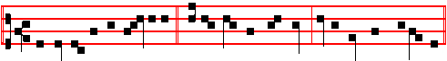
1. According to the multitude * of thy mercies, O Lord, do away mine offences.
Psalm 51 Miserere Tone viij, 2.
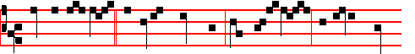
2.Thou art my God, * and I will thank thee: thou art my God, and I will praise
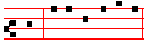
thee. Psalm 118 Confitemini Tone vij, 3.
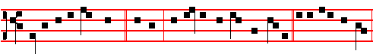
3. Early will I seek thee, * O God, that I may behold thy power. Psalm 63 67
Deus Deus meus Tone iv, 1.
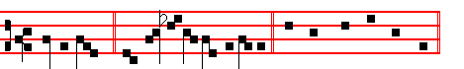
4. Sing a hymn, * and magnify him for ever. Canticle Benedicite Tone v.
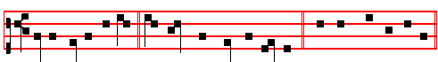
5. All ye Angels of his, * O praise the Lord of heaven. Psalms 148, 149, 150 Laudate Dominum
580
Chapter I Cor. 13
BRETHREN: Though I speak with the tongues of men and of angels, and have not charity, I am become as sounding brass, or a tinkling cymbal.
Hymn Æterne rerum Conditor, p.
 Lord, thou hast been our refuge.  From one generation to another.
On Benedictus, Antiphon. Tone iv, 1.
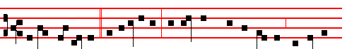
Behold, we go up * to Jerasalem, and all things that are written concerning
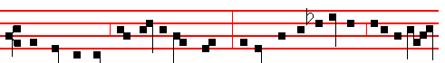
the Son of Man shall be accomplished: for he shall be delivered unto the Gen-
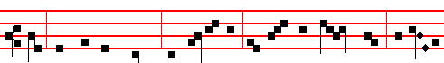
tiles, and shall be mocked, and spitted on; and they shall scourge him, and put
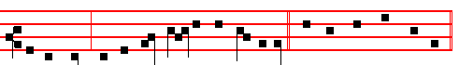 him to death; and the third day he shall rise again. Canticle Benedictus
COLLECT
WE beseech thee,O Lord, graciously hear our prayers; that we, being loosed from the bonds of our sins, may be defended against all adversity. Through.
Antiphon. AT PRIME Tone j, 3.
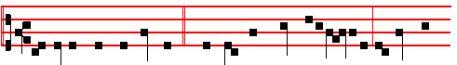
As Jesus made his journey, * when he was come unto Jericho, a blind man
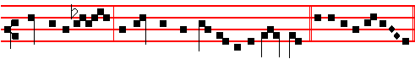
cried unto him, that he might be worthy to receive light. Psalm Deus in
581
At the Close of the Chapter, the Lord direct, p.

AT TERCE
Antiphon. Tone j, 1.
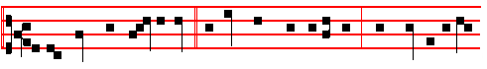
As the Lord was passing by, * a blind man cried unto him, Have mercy upon
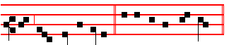
me, thou Son of David. Psalm 119 Legem pone
Chapter Brethren: Though I speak, as above, 581.
Short  as in the Psalter
Incline my heart, O God, * Unto thy testimonies. Incline.
 Turn away mine eyes, lest they behold vanity; and quicken thou me in thy way. Unto thy. Glory be. Incline.
 I said, Lord, be merciful unto me.
 Hea1 my soul, for I have sinned against thee.

AT SEXT
Antiphon. Tone vij, 3.
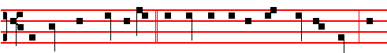
And they which went before * rebuked him that he should hold his peace: but
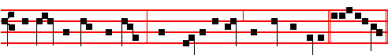
he cried so much the more, Have mercy on me, thou Son of David. Ps. 119
Chapter I Cor. 13
CHARITY never faileth: but whether there be prophecies, they shall fai1; whether there be tongues, they shall cease; whether there be know1edge, it shall vanish away. For we know in part, and we prophesy in part.
Short  as in the Psalter.
O Lord, thy word endureth * For ever in heaven. O Lord.
 Thy truth also remaineth from one generation to another. For ever. Glory be. O Lord.
582
 The Lord is my shepherd, therefore can I lack nothing.
 He shall feed me in a green pasture.
AT NONE
Antiphon. Tone j, 1.
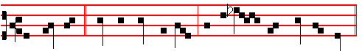
The blind man * cried out more and more, that the Lord would give him light.
Psalm 119 Mirabilia
Chapter I Cor. 13
AND now abideth faith, hope, charity, these three; but the greatest of these is charity.
Short  as in the Psalter. I call with my whole heart, * Hear me, O Lord. I call.
 I will keep thy statutes. Hear me. Glory be. I call.
 O cleanse thou me from my secret faults.
 Keep thy servant also from presumptuous sins.
AT VESPERS
Antiphons and Psalms of Sunday, p.
Chapter Brethren: Though I speak, 381.
Hymn E.H. 51 Lucis Creator p. , and  Let my prayer, 113.
On Magnificat, Antiphon. Tone j, 1.
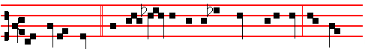
And Jesus stood, * and commanded him to be brought unto him, and asked
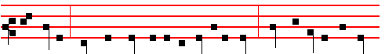
him, saying, What wilt thou that I shall do unto thee? Lord, that I may receive
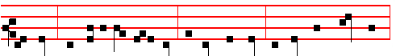
my sight. And Jesus said unto him, Receive thy sight, thy faith hath saved thee.

583
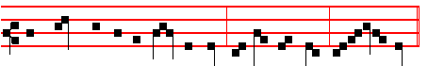
And straightway he received his sight, and followed him, glorifying God.
Canticle Magnificat, p.
__________________________________________________________________

Monday
From the Book of Genesis
Lesson j Ch. 13, 1-16
AND Abram went up out of Egypt, he, and his wife, and all that he had, and Lot with him, into the south. And Abram was very rich in cattle, in silver, and in gold. And he went on his journeys from the south even to Beth-el, unto the place where his tent had been at the beginning, between Beth-el and Hai; unto the place of the altar, which he had made there at the first: and there Abram called on the name of the Lord. And Lot also, which went with Abram, had flocks, and herds, and tents. And the land was not able to bear them, that they might dwell together: for their substance was great, so that they could not dwell together.

 Abram removed his tent, and came and dwelt in the plain of Mamre. * And built there an altar unto the Lord.
 And the Lord said unto him, Lift up now thine eyes and look: all the land which thou seest, to thee will I give it, and to thy seed for ever. And built.

Lesson ij
AND there was a strife between the herdmen of Abram's cattle and the herdmen of Lot's cattle: and the Canaanite and the Perizzite dwelled then in the land. And Abram said unto Lot, Let there be no strife, I pray thee, between me and thee, and between my herdmen and thy herdmen; for we be brethren. Is not the whole land before thee? separate thyself, I pray thee, from me: if thou wilt take the left hand, then I will go to the right; or if thou depart to the right hand, then I will go to the left. And Lot lifted up his eyes, and beheld all the plain of Jordan, that it was well watered every where, before the Lord destroyed Sodom and Gomorrah, even as the garden of the Lord, like the land of Egypt, as thou comest unto Zoar. Then Lot chose him all the plain of Jordan; and Lot journeyed East.

584
 Abram believed God, and it was imputed unto him for righteousness. * And therefore he became the friend of God.
 He was also righteous in the sight of God, and walked in his way. And therefore.

Lesson iij
AND they separated themselves the one from the other. Abram dwelled in the land of Canaan, and Lot dwelled in the cities of the plain, and pitched his tent toward Sodom. But the men of Sodom were wicked and sinners before the Lord exceedingly. And the Lord said unto Abram, after that Lot was separated from him, Lift up now thine eyes, and look from the place where thou art northward, and southward, and eastward, and westward: for all the land which thou seest, to thee will I give it, and to thy seed for ever. And I will make thy seed as the dust of the earth.

 God did tempt Abraham, and said unto him: * Take now thy son Isaac, whom thou lovest, and offer him for a burnt offering upon one of the mountains which I will tell thee of.
 When he was called by the Lord, he answered: Behold, here I am; and the Lord said unto him: Take. Glory be. Take.
On Magnificat, Antiphon.
Antiphon. Tone vij, 3.
And they which went before * rebuked him that he should hold his peace: but
he cried so much the more, Have mercy on me, thou Son of David. C. Magn.
__________________________________________________________________

Tuesday
From the Book of Genesis
Lesson j Ch. 14. 8-20
AND there went out the king of Sodom, and the king of Gomorrah, and the king of Admah, and the king of Zeboiim, and the king of Bela (the same is Zoar;) and they joined battle with them in the vale of Siddim; with Chedorlaomer the king ofElam, and with Tidal king of nations, and Amraphel king of Shinar,

585
and Arioch king of Ellasar; four kings with five. And the vale of Siddim was full of slimepits; and the kings of Sodom and Gomorrah fled, and fell there; and they that remained fled to the mountain. And they took all the goods of Sodom and Gomorrah, and all their victuals, and went their way. And they took Lot, Abram's brother's son, who dwelt in Sodom, and his goods, and departed.

 The Angel of the Lord called unto Abraham, and said: * Lay not thine hand upon the lad, for now I know that thou fearest God.
 When he stretched forth his hand to slay his son, behold, the angel of the Lord called unto him out of heaven, and said: Lay not.

Lesson ij
AND there came one that had escaped, and told Abram the Hebrew; for he dwelt in the plain of Mamre the Amorite, brother of Eshcol, and brother of Aner: and these were confederate with Abram. And when Abram heard that his brother was taken captive, he armed his trained servants, born in his own house, three hundred and eighteen, and pursued them unto Dan. And he divided himself against them, he and his servants, by night, and smote them, and pursued them unto Hobah, which is on the left hand of Damascus. And he brought back all the goods, and also brought again his brother Lot, and his goods, and the women also, and the people.

 The Angel of the Lord called unto Abraham out of heaven the second time, and said: I will bless thee: * And I will multiply thy seed as the stars of heaven.
 Thy seed shall possess the gate of his enemies, and in thy seed shall all the nations of the earth be blessed. And I.

Lesson iij
AND the king of Sodom went out to meet him after his return from the slaughter of Chedorlaomer, and of the kings that were with him, at the valley of Shaveh, which is the king's dale. And Melchizedek king of Salem brought forth bread and wine: and he was the priest of the most high God. And he blessed him, and said, Blessed be Abram of the most high God, possessor of heaven and earth: and blessed be the most high God, which hath delivered thine enemies into thy hand. And he gave him tithes of all.

 O Lord God of my master Abraham, prosper my way which I go: * That I may return again in safety unto the house of my master.
 O Lord, I pray thee, be merciful unto thy servant. That I. Glory be. That I.

On Magnificat, Antiphon.

586
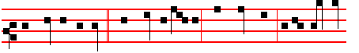
Have mercy on me, * thou Son of David. What wilt thou that I shall do
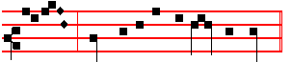
unto thee? Lord, that I may receive my sight.
__________________________________________________________________

ASH WEDNESDAY

If on this day there occur a Double Feast, it is transferred to the next day not similarly impeded, as is said in the Rubiric of the Translation of Feasts. On other days if a Double Feast occur, or a Semidouble, the Office is of it, with
commemoration, and ninth Lesson from the Homily, of the Feria. Of Simples a commemoration only is made.
On this and the following Ferias until Vespers of Saturday, the Hymns, Chapters, and all else are said as in the Psalter throughout the year, except the Antiphons on Benedictus and Magnificat: and after Lauds, the Hours, Vespers and Compline are said the Prayers kneeling, as likewise in the Psalter.
Today before Matins in Choir are said the Gradual Psalms.

The Lesson from the Holy Gospel according to S. Matthew
Lesson j Ch. 6, 16-21
JESUS said unto his disciples: when ye fast, be not as the hypocrites, of a sad countenance.
Homily by S. Augustine, Bishop On the Sermon On the Mount. Bk. 2. Ch. 12
IT is manifest from these precepts that all our effort is to be directed towards inward joys, lest, seeking a reward from without, we should be conformed to this world, and should lose the promise of a blessedness so much the more -solid and firm, as it is inward, in which God has chosen that we should become conformed to the image of his Son. But in this section it is chiefly to be noticed that there may be ostentatious display not merely in the splendour and pomp of things pertaining to the body, but also in doleful filth itself; and the more dangerous on this account, that it deceives under the name of serving God.

 I came this day unto the well, and I besought the Lord, and said: * O Lord God of Abraham, thou hast prospered my way.

587
 Therefore the virgin to whom I shall say: Give me water of thy pitcher to drink: and she shall say, Drink, my lord, and I will give thy camels to drink also: let the same be she that thou hast appointed for thy servant Isaac. O Lord God.

Lesson ij
AND therefore he who is very conspicuous by immoderate attention to the body, and by the splendour of his clothing or other things, is easily convicted by the things themselves of being a follower of the pomps of the world, and misleads no one by a cunning semblance of sanctity; but in regard to him who, under a profession of Christianity, fixes the eyes of men upon himself by unusual squalor and filth, when he does it voluntarily, and not under the pressure of necessity, it may be conjectured from the rest of his actings whether he does this from contempt of superfluous attention to the body, or from a certain ambition: for the Lord has enjoined us to beware of wolves under a sheep's skin; but, By their fruits, says he, shall ye know them.

 The word of the Lord came unto Abram, saying: * Fear not, Abram, I am thy shield, and thy exceeding great reward.
 For I am the Lord thy God that brought thee out of Ur of the Chaldees. Fear not.
Lesson iij
FOR when by temptations of any kind those very things begin to be withdrawn from them or refused to them, which under that veil they either have obtained or desire to obtain, then of necessity it appears whether it is a wolf in a sheep's skin or a sheep in its own. For a Christian ought not to delight the eyes of men by superfluous ornament on this account, because pretenders also too often assume that frugal and merely necessary dress, that they may deceive those who are not on their guard: for those sheep also ought not to lay aside their own skins, if at any time wolves cover themselves therewith.

 Abram removed his tent, and came and dwelt in the plain of Mamre. * And built there an altar unto the Lord.
 And the Lord said unto him, Lift up now thine eyes and look: all the land which thou seest, to thee will I give it, and to thy seed for ever. And built. Glory be. And.
At Lauds, and through the Hours, all as in the Psalter.
On Benedictus, Antiphon.
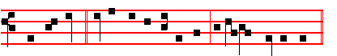
When ye fast, * be not, as the hypocrites, of a sad countenance.

588
Then are said the Prayers, 19, kneeling. And likewise at all the Hours, as in the Psalter.
COLLECT
GRANT, O Lord. unto thy faithful people: that they may enter upon the venerable solemnity of the fast with fitting piety, and may pass through the same with undisturbed devotion. Through.

Today, and on the following two days, Vespers are said at the accustomed time. But on Saturday they are said before eating.
On Magnificat, Antiphon.
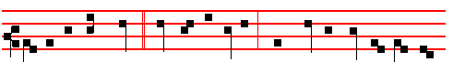
Lay up for yourselves * treasures in heaven, where neither moth nor rust doth
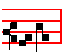
corrupt. Then the Prayers, p.
COLLECT
LOOK down in mercy, O Lord, upon those who bow before thy majesty: that they who have been refreshed by the divine gift, may evermore be nourished by thy heavenly succour. Through.
__________________________________________________________________

Thursday
The Lesson from the Holy Gospel according to S. Matthew
Lesson j Ch. 8, 5-13
WHEN Jesus was entered into Capernaum, there came unto him a centurion. beseeching him, and saying, Lord, my servant lieth at home sick of the palsy, grievously tormented.
Homily by S. Augustine, Bishop Harmony of the Gospels Bk. 2, Ch. 20
LET us proceed to consider whether Matthew and Luke are at one in the
account of this servant. Matthew's words, then, are these: There came unto him a centurion, beseeching him, and saying, My servant lieth at home sick of the palsy. Now this seems to be inconsistent with the version presented by Luke, which runs thus: And when he heard of Jesus, he sent unto him the elders of the Jews, beseeching him that he would come and heal his servant. And when they came to Jesus, they besought him instantly, saying, That he was worthy for whom he should do this: for he loveth our nation, and he hath built us a synagogue. Then

589
Jesus went with them. And when he was now not far from the house, the centurion
sent friends to him, saying unto him, Lord, trouble not thyself; for I am not worthy that thou shouldest enter under my roof: wherefore neither thought I myself worthy to come unto thee: but say in a word, and my servant shall be healed.

 Lord, my servant t lieth at home sick of the palsy, grievously tormented. * Jesus saith unto him, I will come and heal him.
 Lord, I am not worthy that thou shouldest come under my roof; but speak the word only, and my servant shall be healed. Jesus.

Lesson ij
FOR if this was the manner in which the incident took place, how can Matthew's statement, that there came to him a certain centurion, be correct, seeing that the man did not come in person, but sent his friends? The apparent discrepancy, however, will disappear if we look carefully into the matter, and observe that Matthew has simply held by a very familiar mode of expression. For not only are we accustomed to speak of one as coming even before he actually reaches the place he is said to have approached; whence, too, we speak of one as making small approach or making great approach to what he is desirous of reaching; but we also not unfrequently speak of that access, for the sake of getting at which the approach is made, as reached even although the person who is said to reach another may not himself see the individual whom he reaches, inasmuch as it may be through a friend that he reaches the person whose favour is necessary to him. This, indeed, is a custom which has so thoroughly established itself, that even in the language of everyday life now those men are said to approach who, in the practice of canvassing, get at the inaccessible ears, as one may say. of any of the men of influence, by the intervention of suitable personages. If, therefore, access itself is thus familiarly said to be gained by the means of other parties, how much more may an approach be said to take place, although it be by means of others, which always remains something short of actual access! For it is surely the case, that a person may be able to do very much in the way of approach, but yet may have failed to succeed in actually reaching what he sought to get at.

Abraham stood by the oak of Mamre, and he saw three men coming towards him. * He saw Three, and worshipped One.
 Behold Sarah thy wife shall bear thee a son, and thou shalt call his name Isaac. He saw.

Lesson iij
CONSEQUENTLY it is nothing out of the way for Matthew, a fact, indeed, which may be understood by any intelligence, when thus dealing with an

590
approach on the part of the centurion to the Lord, which was effected in the person of others, to have chosen to express the matter in this compendious method, There came a centurion to him. At the same time, however, we must be careful enough to discern a certain mystical depth in the phraseology adopted by the evangelist, which is in accordance with these words of the psalm, Come ye to him, and be ye lightened. For in this way, inasmuch as the Lord himself commended the faith of the centurion, in which indeed his approach was really made to Jesus, in such terms that he declared, I have not found so great faith in Israel, the evangelist wisely chose to speak of the man himself as coming to Jesus, rather than to bring in the persons through whom he had conveyed his words.

 God did tempt Abraham, and said unto him: * Take now thy son Isaac, whom thou lovest and offer him for a burnt offering upon one of the mountains which I will tell thee of.
 When he was called by the Lord, he answered: Behold, here I am; and the Lord said unto him: Take. Glory be. Take.

On Benedictus, Antiphon.
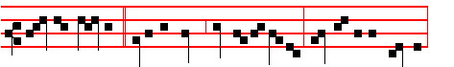
Lord, my servant * lieth at home sick of the palsy, grievously tormented.
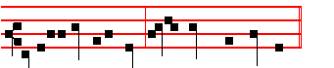
Verily I say unto thee, I will come and heal him.
Then the Prayers, p.
COLLECT

O GOD, who art offended by sin, and reconciled by penitence: mercifully regard the prayers of thy suppliant people, and turn away the scourge of thy wrath, which for our sins we have justly deserved. Through.

On Magnificat, Antiphon.
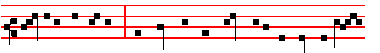
Lord, I am not worthy * that thou shouldest enter under my roof: but speak

591
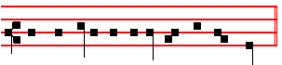
the word only and my servant shall be healed. Then the Prayers, p.
COLLECT
SPARE us, O Lord, spare thy people: that they who are justly chastised by thy scourges, may be relieved by thy tender mercy.Through.
__________________________________________________________________

Friday
The Lesson from the Holy Gospel according to S. Matthew
Lesson j Ch. 5, 43-48; 6, 1-4
JESUS said unto his disciples: Ye have heard that it hath been said, Thou shalt love thy neighbour, and hate thine enemy.
Homily by S. Jerome, Priest Bk. 1 Comm. on Matt. Ch. 5
BUT I say unto you, Love your enemies, bless them that curse you. Many men consider God's commandments in the light of their own feebleness, and not in the strength and virility of the saints; and so they think these commandments impossible to put into practice. They say that not to hate their enemies is the best that they can do, and that to rise to loving them is to command more than human nature can bear. It must be made clear, then, that Christ did not command the impossible, but perfection. This David achieved with Saul and Absalom: so did Stephen the Martyr, in praying for his enemies while they were stoning him: and Paul wished to be accursed from Christ, for the sake of his persecutors. This, Jesus both taught and practised, saying, Father, forgive them, for they know not what they do.

 The angel of the Lord called unto Abraham, and said: * Lay not thine hand upon the lad, for now I know that thou fearest God.
 When he stretched forth his hand to slay his son, behold, the angel of the Lord called unto him out of heaven, and said: Lay not.

Lesson ij
THAT ye may be the children of your Father which is in heaven. If he who keeps the commandments of God becomes a son of God, then he is a son, not by nature, but by his own choice. Therefore when thou doest thine alms, do not sound a trumpet before thee, as the hypocrites do in the synagogues and in the streets, that they may have glory of men. He who sounds a trumpet when he gives alms, is a hypocrite. He who dis- figures his face when he fasts, that the emptiness of his stomach may be revealed by his expression, is a hypocrite too. He who

592
prays in the synagogue and in the corners of the streets, to be seen of men, is a hypocrite.

 The angel of the Lord called unto Abraham out of heaven the second time, and said: I will bless thee: * And I will multiply thy seed as the stars of heaven.
 Thy seed shall possess the gate of his enemies, and in thy seed shall all the nations of the earth be blessed. And I.

Lesson iij
FROM all this, we may gather that hypocrites are those who do everything for the sake of being praised by men. It seems to me that he too is a hypocrite who says to his brother, Let me pull out the mote out of thine eye; for he seems to do this for vain glory, that he may appear righteous. Therefore the Lord says to him, Thou hypocrite, first cast out the beam out of thine own eye. Therefore it is not the good deed, but the motive for the good deed, that is rewarded by God. If you turn aside from the straight path, be it only a little, it makes no difference whether you turn to the left or to the right, you still lose your way.

 O Lord God of my master Abraham, prosper my way which I go: * That I may return again in safety unto the house of my master.
 O Lord, I pray thee, be merciful unto thy servant. That I. Glory be. That I.

On Benedictus, Antiphon.
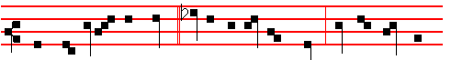
When thou doest thine alms, * let not thy left hand know what thy right hand
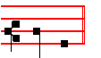
doeth.
Then the Prayers, p.
COLLECT
WE beseech thee, O Lord, to accompany with thy bounteous favour the fast upon which we have entered: that the observance which we show forth in our bodies, we may be able also to practise with sincerity of heart. Through.

Today after Lauds are said the Penitential Psalms.

On Magnificat, Antiphon.
593
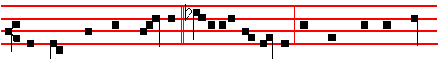
But thou, when thou prayest, * enter into thy closet,and when thou hast shut
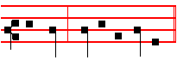
thy door, pray to thy Father. Then the Prayers, p.
COLLECT
DEFEND, O Lord, thy people, and mercifully cleanse them from all their sins: that no adversity may harm them, over whom iniquity hath no dominion. Through.
Saturday
The Lesson from the Holy Gospel according to S. Mark.
Lesson j Ch. 6, 47-66
WHEN even was come, the ship was in the midst of the sea, and Jesus alone on the land.
Homily by S. Bede the Venerable, Priest Bk. 2 on S. Mark, Ch. 6
THE toil of the disciples in rowing, and the wind contrary to them, is a figure of the various toils of Holy Church. She, amidst the waves of the contrary world, and the blasts of unclean spirits, strives to reach the harbour of the heavenly fatherland, as the safe shore for her anchorage. It is fittingly said that the ship was in the midst of the sea. and he alone on the dry land: sometimes the Church is not merely afflicted, but is so befouled by the pressure of the Gentiles, that it seems as though, were it possible, her Redeemer had temporarily abandoned her.

 I came this day unto the well, and I besought the Lord, and said: * O Lord God of Abraham, thou hast prospered my way.
 Therefore the virgin to whom I shall say: Give me water of thy pitcher to drink: and she shall say, Drink, my lord, and I will give thy camels to drink also: let the same be she that thou hast appointed for thy servant Isaac. O Lord.

Lesson ij
THENCE arises that cry of hers when she is caught amidst the waves and storms of rushing temptations, as with great anguish she beseeches his saving protection: Why standest thou so far off, O Lord, and hidest thy face in the needful time of trouble. Similarly in the following verses she tells him what her enemy says of her as he persecutes her, crying, He hath said in his heart, Tush,

594
God hath forgotten: he hideth away his face, and he will never see it.

. The word of the Lord came unto Abram, saying: * Fear not, Abram, I am thy shield, and thy exceeding great reward.
 For I am the Lord thy God that brought thee out of Ur of the Chaldees. Fear not.

Lesson iij
TRULY he forgetteth not the prayer of the poor, neither turneth he away his face from any that putteth his trust in him: on the contrary, he helps those that are striving with an enemy to win the victory, and he crowns them as conquerors for ever. Whence it is said plainly here, He saw them toiling in rowing. He saw them toiling in the sea, although he was standing on the dry land: though he seems to delay for a time in giving help to those who are threatened and in peril, nevertheless he strengthens them with his merciful glance, lest they should fail in their distress; and sometimes he openly helps those who are overcome by their adversities, as when he delivered them by walking on the swelling waves, and calming them.

 Abram removed his tent, and came and dwelt in the plain of Mamre. * And built there an altar unto the Lord.
 And the Lord said unto him, Lift up now thine eyes and look: all the land which thou seest, to thee will I give it, and to thy seed for ever. And built. Glory be. And.
On Benedictus, Antiphon.
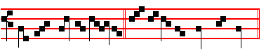
Yet they seek me dai- ly, * and delight to know my ways. Then the Prayers.
COLLECT
ASSIST us, Lord, in these our supplications: and grant that we may keep with devout service this solemn fast, ordained for the healing of both soul and body. Through.
__________________________________________________________________

FIRST SATURDAY IN LENT
Today and henceforth until Easter Vespers are said before eating, both on Feasts and on Ferias, except on Sundays, on which they are said at the accustomed hour.
At Vespers, Chapter 2 Cor. 6
BRETHREN:We beseech you also that ye receive not the grace of Gol in vain. For he saith, I have heard thee in a time accepted, and in the day of salvation have I succoured thee.
595
Hymn. E.H. 66 Mode ij
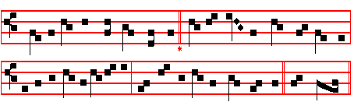
Audi benigne Conditor
O KIND Creator bow thine ear 3 Our sins are many, this we know;
To mark the cry, to know the tear Spare us, good Lord, thy mercy show
Betore thy throne of mercy spent And for tho honour of thy name
In this thy holy fast of Lent Our fainting souls to life reclaim.

2 Our hearts are open, Lord, to thee: 4 Give us the self-control that springs
Thou knowest our infirmity From discipline of outward things,
Pour out on all who seek thy face That fasting inward secretly
Abundance of thy pardoning grace. The soul may purely dwell with thee.
5. We pray thee, Holy Trinity,
One God, unchanging Unity,
That we from this our abstinence
May reap the fruits of penitence. Amen.

 God shall give his Angels charge over thee.  To keep thee in all thy ways.
On Magnificat, Antiphon. Tone vij, 3
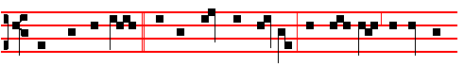
Then shalt thou call, * and the Lord shall answer: thou shalt cry, and he shall
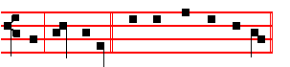
say, Here am I. Canticle Magnificat, p.

COLLECT
O GOD, who year by year dost purify thy Church by this Lenten observance: grant unto thy family; that those things which they strive to obtain from thee by abstinence, they may by good works fulfil. Through.

596

