Christ as by medical knowledge. When the Prefect Lysias learnt what their religion was, he ordered them to be brought before him, and questioned them concerning their rule of life and profession of faith. When they freely declared that they were Christians, and that the Christian faith was necessary for salvation, he ordered them to worship the gods; and if they refused to do so, threatened torture and a painful death.

 Thy Saints, O Lord, have passed a wonderful way, serving thy peculiar commandments that were given unto them, that thy children might be found without hurt. * Dry land appeared, and out of the Red Sea a way without impediment.
 For he smote the stony rock indeed, that the waters gushed out, and the streams flowed withal. Dry land.

Lesson v
BUT, perceiving that he was putting this to them to no purpose: Bind, he said, their hands and feet ,and torture them with exquisite torments. His commands were carried out; nevertheless, Cosmas and Damian remained of the same mind. So, bound as they were, they were cast into the depths of the sea; from which they emerged safe and loosed from their bonds.The Prefect attributed this to magic arts, and put them in prison, and the next day ordered them brought out and thrown on a burning pyre: when its flames receded from them, he comnanded them to be variously and cruelly tortured and beheaded with the axe. And so, confessing Jesus Christ, they received the palm of martyrdom.

 The Saints of God, p. lij.

Lesson vj Whenever we celebrate, p. lij,  As gold, p. liij.

In the third Nocturn, Homily by Saint Ambrose, Bishop, on the Gospel, Jesus came down, from the Common in the ij place, p. lxiij.

 viij. Theirs was a brotherhood indeed, p. liv.

Vespers from the Chapter of the following, commemoration of the preceding.
__________________________________________________________________

The Twenty-eighth of September
On the Feast of Saint Wenceslas, Duke and Martyr
Semidouble

1969
All from the Common of one Martyr, p. xxix, except the following.

COLLECT
O GOD, who through the victory of martyrdom didst translate blessed Wenceslas from an earthly principality to the glory of heaven: defend us through his prayers from all adversity, and grant us likewise to rejoice in his fellowship. Through.

In the first Nocturn Lessons from the occurrent Scripture.

IN THE SECOND NOCTURN
Lesson iv
WENCESLAS, Duke of Bohemia, was the son of a Christian father, Wratislaus, and a pagan mother, Drahamira. He was brought up piously by his grandmother, Ludmilla, a very holy woman, and was noted for every virtue; he preserved his virginity unstained throughout his life with the greatest zeal. His mother, through the brutal murder of Ludmilla, seized the government of the kingdom and lived a wicked life together with her younger son, Boleslaus. This stirred up against her the indignation of the nobility, who, wearied of their wicked rule, threw off the yoke of both mother and son and proclaimed Wenceslas as king in the city of Prague.

 The Lord made him honourable, defended him from his enemies, and kept him safe from those that lay in wait. * And gave him perpetual glory.
 He went down with him into the pit, and left him not in bonds. And gave him.

Lesson v
HE ruled the kingdom by piety rather than by power, relieving the orphans, widows and needy with so great charity that sometimes he bore firewood by night to the indigent on his own shoulders, frequently carrying paupers to burial, liberating captives, visiting those detained in prison at all hours of the night, consoling then with money and wisest counsel. In tenderness of heart the Prince mourned deeply anyone condemned to death, even if guilty. He had the most pious respect for priests, and with his own hands sowed the wheat and pressed the wine which they used in the sacrifice of the Mass. By night he went around the Churches on snow and ice with bare feet, leaving behind him bloodstained footprints that warmed the earth.

 O Lord,thou hast given him his heart's desire, * And hast not denied him the request of his lips.
 For thou hast prevented bim with the blessings o£ goodness, thou hast set upon

1970
his head a crown of pure gold. And hast not.

Lesson vj
HE had Angels for his bodyguard: for as he went to single combat against Radislaus, Duke of the Curimenses, in order to ensure the safety of his people, Angels appeared offering him weapons, and saying to his opponents: Do not strike. The terrified enemy cane forward with reverence and asked pardon. When he went to Germany, the Emperor saw two Angels adorning him as he approached with a golden cross, and coming forward £ran his throne received him in his arms, adorned him with royal insignia,and gave him the arm of Saint Vitus. Nevertheless his wicked brother, at his mother's urging, when he had left a feast and was then praying in a Church, foreseeing the death that was prepared for him; brought some wicked companions and killed him. His blood was spattered over the wall and may still be seen: and in diivine vengeance his inhuman mother was swallowed up by the earth: and those who had killed him perished miserably in various ways.

 The Lord clothed him with a robe of glory. * And set upon his head a crown of pure gold.
.With the bread of life and understanding shall the Lord feed him, and give him the water of wisdom to drink. And set . Glory be. And set.

In the third Nocturn, Homily on the Gospel, If any man will come, from the Common in the second place, p. xliij.

Vespers of Saint Michael, without commemoration of Saint Wenceslas.
__________________________________________________________________

THE TWENTY-NINTH OF SEPTEMBER
ON THE DEDICATION OF SAINT MICHAEL THE ARCHANGEL DOUBLE
AT VESPERS

Antiphons of Lauds below, p. 1271. Psalms 110, 111, 112, 113 of Sunday, and 117 Laudate Dominum, p. iij.
Chapter Rev. 1
GOD shewed things which must shortly come to pass, speaking by his Angel unto his servant John, who bare record of the word of God, and of the testimony of Jesus Christ, and of all things that he saw.

Hymn . E.H. 241 Tibi, Christe, splendor Patris Mode j

1971
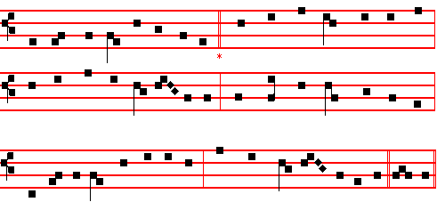

Thee, O Christ, the Father's splendour, 3 By whose watchful care repelling -
Life and virtue of the heart, King of everlasting grace -
In the presence of the Angels Every ghostly adversary,
Sing we now with tuneful art, All things evil, all things base,
Meetly in alternate chorus Grant us of thine only goodness
Bearing our responsive part. In thy Paradise a place.

2 Thus we praise with veneration 4 Laud and honour to the Father,
All the armies of the sky; Laud and honour to the Son,
Chiefly him, the warrior Primate, Laud and honour to the Spirit
Of celestial chivalry, Ever Three, and ever One,
Michael, who in princely virtue Consubstantial, co-eternal,
Cast Abaddon from on high. While unending ages run. Amen.

 An Angel stood at the altar of the temple.
 Having in his hand a golden censer.

On Magnificat, Antiphon. Tone viij, 1
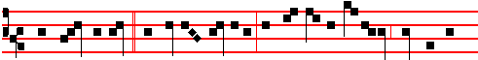
While John beheld * the sacred mystery, the Archangel Michael sounded the
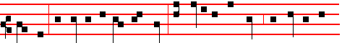
trumpet: Forgive us, O Lord our God, that openest the book, and loosest the

1972
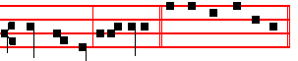
seals thereof, alle- luia. Canticle Magnificat

COLLECT
O GOD, who dost constitute the services of Angels and men in a wonderful order: mercifully grant; that they ,who ever stand before thee and serve thee in heaven, may likewise defend our life on earth. Through.
And no commemoration is made of the preceding.

AT MATINS
Invitatory.- The Lord, the King of the Archangels, * O come, let us worship. Psalm 95 Venite, p. 2 Hymn E.H. 241 above.

IN THE FIRST NOCTURN
Antiphon. The sea was moved, * and the earth quaked, when the Archangel Michael descended from heaven. Psalm 8 Domine Deus noster.
Antiphon. Let us praise the Lord * whom Angels praise, unto whom Cherubim and Seraphim do cry: Holy, holy, holy. Psalm 11 In Domino confido
Antiphon.The smoke of the incense * ascended up before the Lord out of the Angel's hand. Psalm 15 Domine, quis habitabit
 An Angel stood at the altar of the temple.
 Having in his hand a golden censer.

From the Prophet Daniel
Lesson j Ch. 7
I BEHELD till the thrones were cast down, and the Ancient of days did sit, whose garment was white as snow, and the hair of his bead like the pure wool: his throne was like the fiery flame. and his wheels as burning fire. A fiery stream issued and came forth from before him: thousand thousands ministered unto him. and ten thousand times ten thousand stood before him: the judgment was set, and the books were opened. I beheld then because of the voice of the great words which the horn spake: I beheld even till the beast was slain, and his body destroyed, and given to the burning flame.

 There was silence in heaven while the dragon fought against Michael the Archangel: * I heard the voice of thousands of thousands saying: Salvation. and honour, and power, unto God the Almighty.
 Thousand thousands ministered unto him, and ten thousand times ten thousand stood before him. I heard.
1973
Lesson ij Ch. 10, 4-14
IN the four and twentieth day of the first month, as I was by the side of the great river, which is Hiddekel; then I lifted up mine eyes, and looked, and behold a certain man clothed in linen, whose loins are girded with fine gold of Uphaz: his body also was like the beryl, and his face as the appearance of lightning, and his eyes as lamps of fire, and his arms and his feet like in colour to polished brass, and the voice of his words like the voice of a multitude. And I Daniel alone saw the vision: for the men that were with me saw not the vision; but a great quaking fell upon them, so that they fled to hide themselves. Therefore I was left alone, and saw this great vision, and there remained no strength in me: for my comeliness was turned in me into corruption, and I retained no strength.

 An Angel stood at the altar of the temple, having a golden tenser in his hand, and was given unto him much incense: * And the smoke of the incense ascended up before the Lord out of the Angel's hand.
 Before the Angels will I sing praise unto thee; I will worship toward thy holy temple, and praise thy Name, O Lord. And the.

Lesson iij
YET heard I the voice of his words: and when I heard the voice of his words, then was I in a deep sleep, and my face toward the ground. And, behold, an hand touched me, which set me upon my knees and upon the palms of my hands. And he said unto me, O Daniel, a man greatly beloved, understand the words that I speak unto thee, and stand upright : for unto thee am I now sent. And when he had spoken this word unto me, I stood trembling. Then said he unto me, Fear not, Daniel: for from the first day that thou didst set thine heart to understand, and to chasten thyself before thy God, thy words were heard, and I am come for thy words. But the prince of the kingdom of Persia withstood me one and twenty days: but, lo, Michael, one of the chief princes, came to help me; and I remained there with the kings of Persia. Now I am come to make thee understand what shall befall thy people in the latter days: for yet the vision is for many days.

 In the presence of the Angels will I sing praise unto thee. I will worship toward thy holy temple. * And praise thy Name, O my God.
 Because of thy loving-kindness and truth; for thou hast magnified thy Name and thy Word above all things. And praise. Glory be. And praise.

IN THE SECOND NOCTURN

Antiphon. Archangel Michael, * come to the help of God's people. Psalm 19 Cæli enarrant

1974
Antiphon. Michael, * Prince of Paradise, whom hosts of Angels honour. Psalm 24 Domini est terra
Antiphon. Glorious didst thou appear * in the sight of the Lord, because the Lord hath clothed thee with majesty. Psalm 34 Benedicam Domino
 The smoke of the incense ascended up before the Lord.
 Out of the Angel's hand.

Sermon by S. Gregory the Great.
Lesson iv Homily 34 on the Gospels
WE declare that there are nine orders of Angels, for by the witness of holy Scripture wc know that there are: Angels, Archangels, Virtues, Powers, Principalities, Dominions, Thrones, Cherubim and Seraphim. Nearly all the pages of holy Scripture bear witness to the existence of Angels and Archangels. Then, as is well known, the Books of the Prophets often speak of Cherubim and Seraphim. The Apostle Paul enumerates four more orders in his Epistle to the Ephesians, saying: Far above all Principality and Power and Virtue and Dominion. Again, writing to the Colossians, he says: Whether they be Thrones, or Dominions, or Principalities, or Powers. Therefore when Thrones are added to the four mentioned to the Ephesians, then there are five orders. When Angels and Archangels, Cherubim and Seraphim are added to these, then, without a doubt, nine orders of Angels are found.

 This is Michael the Archangel, Leader of the Angel hosts: * Whose privilege it is to benefit the people, and whose prayer leads them to the kingdom of heaven.
 Archangel Michael, Prince of Paradise, whom hosts of Angels honour. Whose.

Lesson v
NOW it must be realized that the name, Angel, is the title of their office; not of their nature. For these holy spirits in the heavenly fatherland are indeed always spirits, but by no means can they always be called Angels; for they are Angels only when messages are announced through them. Whence also it is said by mcans of the Psalmist: He made the spirits his Angels; as though he were to say openly: When he so wills, he makes messengers, or Angels, of those who have
always been spirits. Those who announce lesser matters are called Angels; but those who announce momentous ones are called Archangels. For thus it is not simply an Angel, but Gabriel the Archangel who is sent to the Virgin Mary: for in the performance of this service it is fitting that the greatest of all Angels should come to announce the greatest of all messages. For this reason they are given individual names. so that these names may indicate the particular scope of their ministry. For Michael means, Who is like unto God? while Gabriel means, God's Fortitude, and Raphael means God's Healing.

1975
 The Archangel Michael, to whom God had committed the souls of the righteous, came with a multitude of Angels, * To lead them to the joys of Paradise.
 O Lord, send forth thy Holy Spirit from heaven, the Spirit of wisdom and understanding.

Lesson vj
AND whenever anything mighty is to be done, Michael is called, to be sent; so that by his very name and deed we are to understand that none is able to do what pertains unto God to do. Whence also that ancient enemy who through pride desired to be like God, saying: I will ascend into heaven, I will exalt my throne above the stars of God; I will be like the most High; when at the end of the world he is left with nothing but his own strength, to perish in his final punishment; then he is called to combat with Michael the Archangel, as it is said by means of John: There was war in heaven: Michael and his Angels fought against the dragon. Gabriel, too, was sent to Mary, he who was called God's Fortitude; for he came to announce him who vouchsafed to appear in lowliness in order to overcome the powers of the air. And again, Raphael means, as we have said, God's Healing; for clearly, when he touched Tobit's eyes in his capacity of healing, he wiped away the shades of blindness.

 At that time shall Michael stand up, the great Prince which standeth for the children of thy people: * And there shall be a time of trouble, such as never was since there was a nation even to that same time.
 And at that time thy people shall be delivered, every one that shall be found written in the book of life. And there. Glory be. And there.

IN THE THIRD NOCTURN
Antiphon.. Angel Archangel * Michael, God's messenger for the souls of the righteous, alleluia, alleluia. Psalm 96 Cantate Domino
Antiphon. There was given unto him * much incense, that he should offer it upon the golden altar which is before the eyes of the Lord. Psalm 97 Dominus regnavit
Antiphon. Many were the glorious * deeds of Michael the Archangel, who, valiant in warfare, won the victory. Psalm 103 Benedic, anima mea

 In the presence of the Angels will I sing praise unto thee, O my God.
 I will worship toward thy holy temple, and praise thy Name.

The Lesson from the Holy Gospel according to S. Matthew
Lesson vij Ch. 18
THE disciples came unto Jesus, saying: Who is the greatest in the kingdom of heaven? And the rest.
1976
Homily by S. Jerome, Priest Bk.3 Comm. on Matt. 18, v. 1
AFTER the finding of the piece of money, after the paying of the tribute, what means the sudden question of the ADostles: Who is the greatest in the kingdom of heaven? Because they had seen the same tribute paid for Peter and the Lord, they thought from the equality of the sum, that Peter was preferred to all the Apostles, for he had been made equal to the Lord in the payment of the tribute: therefore they ask, Who is the greatest in the kingdom of heaven? Jesus, perceiving their thoughts and understanding the reason for their error, chose to heal the desire for glory by the contrast of humility.

 Be not afraid of the Gentiles, but say in your hearts: O Lord, we must worship thee: * For his Angel is with you.
 An Angel stood at the altar of the temple, baving in his hand a golden censer.
For his.

Blessing May they whose.
Lesson viij
WHEREFORE if thy hand or thy foot offend thee, cut them off, and cast them
from thee. For it must needs be that offences come, but woe to that man, who, because it must needs be that it happen in the world, by his own fault makes it happen. Therefore let every affection be cut off, every tie of kinship be cut away, lest any single believer be exposed to offences through occasion offered by affection. If, he says, there is anyone as close to thee as hand or foot or eye, and is anxious for thee and quick of perception, yet causes thee offence, and through dissimilarity of character is dragging thee to hell: it is better that thou be deprived of his company and of his worldly service; lest, while thou wishest to enrich thy kinsfolk and acquaintance, thou holdest the source of ruin.

 Michael the Archangel came to thc help of God's people: * He stood to succour the souls of the righteous.
 An Angel stood at the altar of the temple, having in his hand a golden censer.
He stood. Glory be. He stood.

Lesson ix
FOR I say unto you, That in heaven their angels do always behold the face of my Father. He had said above that hand and foot and eye, all kinship and acquaintance which might cause offence should be cut off. Then he tempers the sternness of his words by adding a precept, saying: Take heed that ye despise not one of these little ones. While I enjoin sternness, he saith, yet I teach that mercy be mingled with it. For in heaven their angels do always behold the face of my Father. Great is the worth of souls, that each of them has from birth an Angel

1977
appointed as guardian. Hence we read in the Revelation of S. John: Unto the angel of the church of Ephesus write. The Apostle also enjoins that the heads of women be veiled in the churches because of the Angels.
Te Deum Laudamus, p. 24.

AT LAUDS, AND THROUGH THE HOURS
Antiphon 1. Tone iv, 1
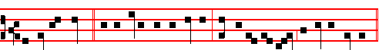
An Angel stood * at the altar of the temple, having in his hand a golden censer.

Psalm 93 and the rest, p. 28.

Antiphon 2. Tone vij, 3
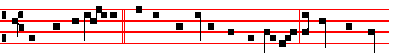
While the Archangel * Michael contended with the dragon, a voice was heard

of them that said: Salvation to our God. E u o u a e.

Antiphon 3. Tone viij, 1
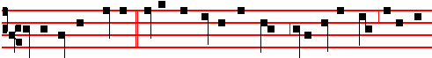
O Archangel Michael,* I have appointed thee prince over all the souls about to

be received. E u o u a e.

Antiphon 4. Tone viij, 1

1978
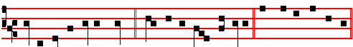
O ye Angels of the Lord, * bless ye the Lord for ever. E u o u a e
Antiphon 5. Tone vij, 1
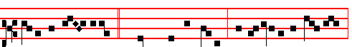
Angels and Archangels, * Thrones and Dominions, Principalities and Pow-ers,
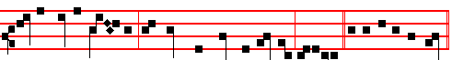
Virtues of the heavens, O praise the Lord of heaven, alleluia. E u o u a e.

Chapter Rev. 1
GOD shewed things which must shortly come to pass, speaking by his Angel unto his servant John, who bare record of the word of God, and of the testimony of Jesus Christ, and of all things that he saw.

Hymn E.H. 242 Christe, Sanctorum decus Angelorum Mode j

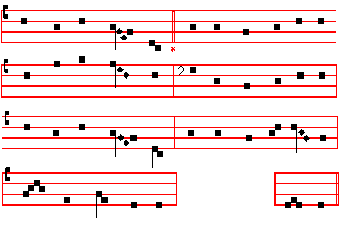
1979
CHRIST, the fair glory of the holy Angels,
Thou who hast made us, thou who o'er us rulest,
Grant of thy mercy unto us thy servants
Steps up to heaven.

2 Send thy Archangel, Michael, to our succour;
Peacemaker blessed, may he banish from us
Striving and hatred, so that for the peaceful
All things may prosper.

3 Send thy Archangel, Gabriel, the mighty;
Herald of heaven, may he from us mortals
Spurn the old serpent, watching o'er the temples
Where thou art worshipped.

4 Send thy Archangel, Raphael, the restorer
Of the misguided ways of men who wander,
Who at thy bidding strengthens soul and body
With thine anointing.

5 May the blest Mother of our God and Saviour,
May the assembly of the Saints in glory,
May the celestial companies of Angels
Ever assist us.

6 Father almighty, Son and Holy Spirit,
God ever blessed, be thou our preserver;
Thine is the glory which the Angels worship,
Veiling their faces. Amen.

 An Angel stood at the altar of the temple, alleluia.
 Having in his hand a golden censer, alleluia.
On Benedictus, Antiphon. Tone viij, 1
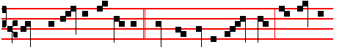
There was silence in heaven * while the dragon waged war: and Michael
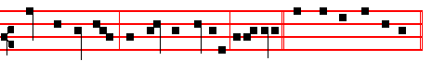
fought against him, and had the victory, alle-luia Canticle Benedictus

1980
COLLECT
O GOD, who dost constitute the services of Angels and men in a wonderful order: mercifully grant; that they, who ever stand before thee and serve thee in heaven, may likewise defend our life on earth. Through.

AT TERCE
Antiphon. While the Archangel, p. 1978.
Chapter God shewed, as above, p. 1979.
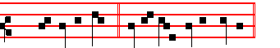
Short  An Angel stood * At the altar of the temple. An Angel.
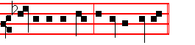
 Having in his hand a golden censer. At the.
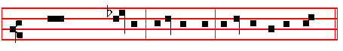
Glory be to the Father, and to the Son, and to the Holy Ghost.
An Angel.
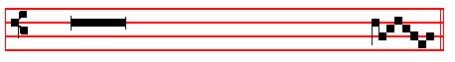
 The smoke of the incense ascended up before God.
 Out of the Angel's hand.

AT SEXT
Antiphon. O Archangel Michael, p. 1978.
Chapter Rev. 5
I HEARD the voice of many Angels round about the throne and the beasts and the elders: and the number of them was ten thousand times ten thousand, and thousands of thousands; saying with a loud voice, Salvation to our God.
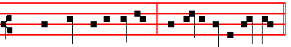
Short  The smoke of the incense * Ascended up before God. The smoke.

1981
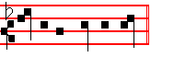
 Out of the Angel's hand. Ascended up. Glory be. The smoke.
 In the presence of the Angels I will sing praise unto thee, O my God.
 I will worship toward thy holy temple, and praise thy Name.

AT NONE
Antiphon. Angels and Archangels, p. 1979.
Chapter Rev. 12
THERE was war in heaven: Michael and his Angels fought against the dragon; and the dragon fought and his angels, and prevailed not; neither was their place found any more in heaven.
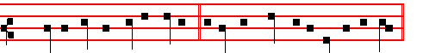
Short  In the presence of the Angels * I will sing praise unto thee, O my God.
In the.
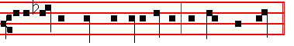
 I will worship toward thy holy temple, and praise thy Name. I will sing.
Glory be. In the.  O praise God.  All ye Angels of his.

AT II VESPERS
Antiphons and Chapter from Lauds. Psalms 110, 111, 112, 113 of Sunday, and in the last place, psalm 138 Confitebor tibi Hymn E.H. 241 Tibi Christe, p. 1972.
 In the presence of the Angels I will sing praise unto thee, O my God.
 I will worship toward thy holy temple, and praise thy Name.
On Magnificat, Antiphon. Tone j, 3
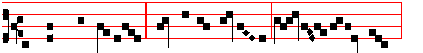
O Prince most glorious, * Michael the Archangel, keep us in remembrance:
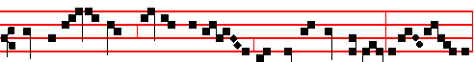
here and everywhere, always, en-treat the Son of God for us, al-le lu- ia,

1982
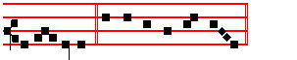
al-le- lu-ia. Canticle Magnificat
Then commemoration is made of the following.
__________________________________________________________________

THE THIRTIETH OF SEPTEMBER
ON THE FEAST OF S. JEROME
PRIEST, CONFESSOR AND DOCTOR OF THE CHURCH
DOUBLE
All from the Common of a Confessor not a Bishop, p. xcvij, except the following.
On Magnificat in both Vespers, Antiphon, p. lxxv. O Teacher right excellent, O light of Holy Church, O blessed Jerome, lover of the divine law: intercede for us unto the Son of God.
 The Lord loved him, and adorned him.  He clothed him with a robe of glory.

COLLECT
O GOD, who for the exposition of the sacred Scriptures didst bestow upon thy Church blessed Jerome, thy Confessor and most illustrious Doctor: grant, we beseech thee; that by his intercession, we may through thine assistance be enabled to perform those things which he taught both in word and deed. Through.
In the first Nocturn, Lessons He will seek out, from the Common of Doctors, p. xcj.
IN THE SECOND NOCTURN
Lesson iv
JEROME, son of Eusebius, was born at Stridonium in Dalmatia during the reign of the Emperor Constantius. He was baptized while still young at Rome, and was educated in the liberal arts by Donatus and other learned men. Then, zealous for learning, he travelled through Gaul, where he cultivated some pious men, who were learned in divine letters, and copied many sacred books with his own hand. Then he went to Greece, was instructed in philosophy and rhetoric, and flourished in the company of the greatest theologians: especially he resorted to Gregory Nazianzen in Constantinople, whom he proclaims as the teacher from whom he learned sacred letters. Drawn by religious motives, he visited the crib of the Lord Christ and all of Palestine: in which wandering he testifies that he profited much in his understanding of the sacred Scripture by frequenting the most learned of the Hebrews.

 The Lord made him honourable, defended him £rom his enemies, and kept him safe from those that lay in wait. * And gave him perpetual glory.

1983
 The Lord guided the righteous in right paths, and shewed him the kingdom of God. And gave.

Lesson v
THEN he withdrew into the vast Syrian desert, where he spent four years in reading divine books and comtemplating heavenly blessedness, tormenting himself with unremitting abstinence, many tears, and affliction of the body. He was ordained priest by Paulinus, Bishop of Antioch, and went to Pope Damasus in Rome with Paulinus and Epiphanius in connection with controversies of some bishops, and assisted him in writing ecclesiastical epistles. But overcome by desire for his former solitude, he returned to Palestine, to the crib of Christ the Lord in Bethlehem, and in the monastery which had been erected by Paula the Roman, he formed a certain heavenly rule of life; and though much afflicted with various diseases and sufferings, yet he overcane his bodily discomforts by works of piety and ceaseless study and writing.

,.The Lord loved him,and adorned him: he clothed him wiyh a robe of glory. * And at the gates of paradise he crowned him.
The Lord put on him the breastplate of faith,and adorned him. And at.

Lesson vj
FROM all parts of the world he was referred to as an oracle on questions of expounding the divine Scriptures. Pope Damasus and Saint Augustine often consulted him on most difficult passages of Scripture, on account of his remarkable learning, and of his knowledge, not only of Latin and Greek, but also of Hebrew and Chaldaic, and because he had read almost all the Scriptures, as testified by the same Augustine. He attacked the heretics with very fierce writings, and always took up the defence of the godly and catholic. He translated the Old Testament from the Hebrew, and at the order of Damasus rendered the New faithfully from the Greek, and also expounded the greater part. He also rendered into Latin many writings of learned men: and himself illuminated the Christian rule with other monuments of his own genius. Having reached extreme old age, and being renowned for learning and holiness, he passed to heaven in the reign of the Emperor Honorius. His body was buried at Bethlehem, but was afterwards translated to the Basilica of S. Mary at the Crib, in Rome.

 This man did according to all that God commanded him: and God said unto him: Enter thou into my rest: * For thee have I seen righteous before me among all people.
.This is he which hated his life in this world, and is come unto life eternal. For thee. Glory be. For thee.

1984
IN THE THIRD NOCTURN
The Lesson from the Holy Gospel according to S. Matthew
Lesson vij Ch. 5
JESUS said unto his disciples: Ye are the salt of the earth: but if the salt have lost his savour, wherewith shall it be salted? And the rest.
Homily by S. Jerome, Priest Bk. 1. Comm. on Matt. Ch. 5
SALT is what the Apostles and Doctors are called; for with them is the whole
human race seasoned. But if the salt have lost his savour, wherewith shall it be seasoned? If a doctor shall err, by what other doctor shall he be corrected? He is thenceforth good for nothing, but to be cast out, and to be trodden under foot of men. The example is taken from farm work. For although salt is necessary for seasoning food and preserving meat, it yet is of no use for anything else. We read in Scripture that certain cities were sown with salt, by avenging conquerors, so that nothing would grow in them.

 This is he which wrought great wonders before God, and praised the Lord with all his heart. * May he pray for all people that their sins may be forgiven.
 Behold a man without blame, a worshipper of God in truth, keeping himself from every evil deed and abiding still in his innocency. May he.

Lesson viij
THEN let doctors and bishops beware, and let them see that the powerful are powerfully tormented; and that there is no remedy, but that the ruin of the great leads to hell. Ye are the light of the world. A city that is set on an hill cannot be hid; neither do men light a candle, and put it under a bushel, but on a candlestick, and it giveth light unto all that are in the house. He teaches boldness in preaching, lest the Apostles should shrink back through timidity, and be like candles under a bushel: but let them come forth freely, and let them proclaim upon the housetops what they have heard in closets.

 Let your loins be girded about, and your lights burning m your hands. * And ye yourselves like unto men that wait for their lord, when he will return from the wedding.
 Watch, therefore, for ye know not what hour your Lord doth come. And ye.
Glory be. And ye.

Lesson ix
THINK not that I am come to destroy the law, or the prophets: I am not come to destroy, but to fulfil. Either that he would fulfil what had been prophesied of him by others; or else that he would fulfil by his preaching those things that had been incomplete and imperfect on account of the weakness of the hearers, taking

1985
away wrath, forbidding the tooth for a tooth. and condemning the hidden lust of the heart. Till heaven and earth pass. A new heaven and a new earth are promised unto us, which the Lord God will make. Then if the new ones are to be created, then it follows that the old ones will pass away. But from what follows: One jot or one tittle shall in no wise pass from the law, till all be fulfilled: it is shown from the example of a letter, that even that which seems least in the law is full of spiritual mysteries, and that all is gathered up in the Gospels.
Te Deum Laudamus, p. 24.
In II Vespers commemoration is made of Saint Remigius.
__________________________________________________________________

FEASTS OF OCTOBER

On the first unimpeded day is said the Office of the Dead.
__________________________________________________________________

The First of October
Saint Remigius, Bishop and Confessor

Antiphon. O thou Priest and Bishop, thou worker of mighty works, thou good shepherd of the people, pray unto the Lord for us.
 The Lord loved him and adorned him.  He clothed him with a robe of glory.

COLLECT
GRANT, we beseech thee, almighty God: that the venerable solemnity of blessed Remigius, thy Confessor and Bishop, may increase our devotion and set forward our salvation. Through.

Lesson iij
REMIGIUS, Bishop of Rheims, flourished in the time of Clovis, king of the Franks, whom he also baptized, and he was the first of all to lead the Franks to the faith of Christ the Lord by his teaching and miracles. By his prayers he raised a dead girl to life. He expounded many of the books of Holy Scripture. For more than seventy years he ruled the Church of Rheims in the most exemplary manner. The sanctity of his life and death were proved by the many miracles which followed after them.
Te Deum Laudamus, p. 24.
__________________________________________________________________

THE SECOND OF OCTOBER
ON THE FEAST OF THE HOLY GUARDIAN ANGELS
DOUBLE

1986
AT VESPERS
Antiphons from Lauds below. Psalms 110, 111, 112 ,113, of Sunday, and 117 Laudate Dominum, p. iij.
Chapter Ex. 23
BEHOLD, I send an Angel before thee, to keep thee in the way, and to bring thee into the place which I have prepared. Beware of him, and obey his voice.

Hymn Custodes hominum Mode iij
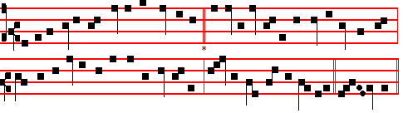
The Guardians of our race, our Angel Guides we hail;
Our Father sendeth forth to aid our nature frail
These heavenly friends, lest we should suffer overthrow
Through cunning of our subtle foe.

2 For he, who justly lost the honour once his own,
The traitor angel, rues his lost and vacant throne,
With burning envy strives to make them fall away
Whom God doth call to heavenly day.

3 Then, watchful Guardian, spread thy wings and cleave the air,
Haste hither to our home committed to thy care;
Drive thence each anxious ill that might the soul infest,
Nor suffer danger here to rest.

4 Now to the holy Three your praise devoutly pour;
His glorious Godhead guides and governs evermore
This triple frame: to him ascribe we all our praise
Who reigns through everlasting days. Amen.

 In the presence of the Angels I will sing praise unto thee, O my God.
 I will worship toward thy holy temple, and praise thy Name.

On Magnificat, Antiphon. Tone vij, 3

1987
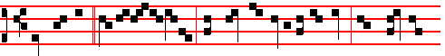
They are all * ministering spirits, sent forth to minister to them who shall be

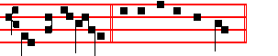
heirs of salvation. Canticle Magnificat

COLLECT
O GOD, who of thy ineffable providence dost vouchsafe to send thy holy Angels to be our guardians: grant unto us thy humble servants; that we may ever both be defended by their protection, and rejoice in their everlasting fellowship. Through.
AT MATINS
Invitatory.- The Lord, the King of the Angels, * O come, let us worship. Psalm 95 Venite, p. 2
Hymn Custodes hominum, as above in Vespers.

IN THE FIRST NOCTURN
Antiphon. The Lord God * of heaven and earth shall send his Angel before thee. Psalm 8 Domine, Dominus noster
Antiphon. My God * hath sent his Angel, and hath shut the lions' mouths, that they have not hurt me. Psalm 11 In Domino confido
Antiphon. Go prosperously, * and the Lord be with you in your journey, and his Angel keep you company. Psalm 15 Domine, quis
 An Angel stood at the altar of the temple.
 Having in his hand a golden censer.
¶ The Lessons of the first Nocturn which follow are omitted in a year in which the beginning of the book of Esther cannot be read on the preceding days, for then it must be read on this Feast.

From the Book of Exodus
Lesson j Ch. 23, 20-23
BEHOLD, I send an Angel before thee, to keep thee in the way, and to bring thee into the place which I have prepared. Beware of him, and obey his voice, provoke him not; for he will not pardon your transgressions: for my name is in him. But if thou shalt indeed obey his voice, and do all that I speak; then I will be an enemy unto thine enemies, and an adversary unto thine adversaries. For mine Angel shall go before thee.
1988
 God shall give his Angels charge over thee, to keep thee in all thy ways. * They shall bear thee in their hands, that thou hurt not thy foot against a stone.
 Thousand thousands ministered unto him, and ten thousand times ten thousand stood before him. They shall.

From the Book of Zechariah
Lesson ij Ch. 1, 7-11
THE word of the Lord came unto Zechariah, the son of Berechiah, the son of Iddo the prophet, saying, I saw by night, and behold a man riding upon a red horse, and he stood among the myrtle trees that were in the bottom; and behind him were there red horses. speckled and white. Then said I, O my Lord, what are these? And the angel that talked with me said unto me, I will shew thee what these be. And the man that stood among the myrtle trees answered and said, These are they whom the Lord hath sent to walk to and fro through the earth. And they answered the angel of the Lord that stood among the myrtle trees, and said, We have walked to and fro through the earth, and, behold, all the earth sitteth still, and is at rest.

 Then the Angel of the Lord answered and said: O Lord of hosts, * How long wilt thou not have mercy on Jerusalem, and on the cities of Judah, against which thou hast had indignation.
 These threescore and ten years? How long.

Lesson iij
I LIFTED up mine eyes again, and looked, and behold a man with a measuring line in his hand. Then said I, Whither goest thou? And he said unto me, To measure Jerusalem, to see what is the breadth thereof, and what is the length thereof. And, behold, the angel that talked with me went forth, and another angel went out to meet him, and said unto him, Run, speak to this young man, saying, Jerusalem shall be inhabited as towns without walls for the multitude of men and cattle therein; For I, saith the Lord, will be unto her a wall of fire round about, and will be the glory in the midst of her.

 Be not afraid of the Gentiles, but say in your hearts : O Lord, we must worship thee: * For his Angel is with you.
 An Angel stood at the altar of the temple, having in his hand a golden censer. For his. Glory be. For his.

Antiphon. When I came * unto you. by the will of God I came; bless him, and give him thanks. Psalm 19. Cæli enarrant
Antiphon. The Angel of the Lord, * which went before the camp of Israel,

1989
removed, and went behind them. Psalm 21. Domini est terra
Antiphon. The Angel of the Lord * tarrieth round about them that fear him, and delivereth them. Psalm 34 Benedicam Domino
 The smoke of the incense ascended up before the Lord.
 Out of the Angel's hand.

¶ In place of the Sermon by Bernard of Clairvaux, not given here, may be read the Lessons for S. Michael, above, p. 1975, with the  as below.

 iv. As the Lord liveth, * His Angel hath kept me in my way that I went thither, and in my sojourning there, and in mine home-coming again hither.
 And the Lord hath not suffered me that am his hand- maid to be defiled. His.

 v. The Angel of the Lord came down into the furnace together with Azarias and his fellows, and smote the flame of the fire out of the furnace, * So that the fire touched them not at all, neither hurt them.
 Blessed be their God, who sent his Angel, and delivered his servants that trusted him. So that.

 vj. In all their affliction he was afflicted, * And the Angel of his presence saved them.
 In his love and pity he redeemed them; and he bare them, and carried them all the days of old. And the. Glory be. And the.

IN THE THIRD NOCTURN
Antiphon. 'The Lord sent * an Angel, which cut off all the mighty men of valour. and the leaders and captains in the camp of the king of Assyria. Psalm 96 Cantate Domino
Antiphon. Worship the Lord, * all ye Angels: Sion heard of it, and rejoiced. Psalm 97 Dominus regnavit
Antiphon. O praise the Lord, * ye Angels of his, ye that excel in strength, ye that fulfil his commandment, and hearken unto the voice of his words. Psalm 103
Benedic, anima mea
 In the presence of the Angels will I sing praise unto thee, O my God.
 I will worship toward thy holy temple, and praise thy Name

The Lesson from the Holy Gospel according to S. Matthew
Lesson vij Ch. 18
THE disciples carne unto Jesus saying: Who is the greatest in the kingdom of heaven? And the rest.
Homily by S. Hilary, Bishop Comm. On Matt. 18

1990
THE Lord teaches: Except ye become as little children, ye shall not enter into the kingdom of heaven. That is, through returning to the simplicity of children we are to do away with the sins of our body and soul. He calls all those, Children, who believe by means of the faith that cometh by hearing. For these obey their father, love their mother, wish no evil to their neighbour, care nothing for riches; are not haughty, not despiteful, they lie not, they believe what they are told, and what they hear they hold as troth. We are to return, then, to the simplicity of babes; for if we be established therein, we shall bear within us the image of the Lord's humility.

 When Maccabeus and they that were with him heard that Lysias besieged the holds, they and all the people with lamentation and tears besought the Lord that he would send * A good Angel to deliver Israel.
 So they went forth together with a willing mind, and as they were at Jerusalem, there appeared before them on horseback one in white clothing.

Blessing May they whose.
Lesson viij
WOE unto the world because of offences! The humiliation of the Passion is an offence to the world. Herein lies the greatest stupidity of mankind: that, because of the shame of the cross, it would not accept the Lord of eternal glory. And what is more perilous to the world, than not to accept Christ? For it must needs be, he says, that offences come; because for the accomplishment of the mystery of the giving us back of eternal life, all the humiliation of the Passion had to be fulfilled in him.

 O Lord, thou didst send thine Angel in the time of Hezekiah, king of Judah, and didst slay in the host of Sennacherib an hundred, four score and five thousand. * Now also, O Lord of heaven, send thy good Angel before us for a fear and dread unto them.
 And through the might of thine arm let those be stricken with terror that come against thy holy people to blaspheme. Now also. Glory be.

Lesson ix
TAKE heed that ye despise not one of these little ones that believe in me. He made a fitting bond of mutual love, and set it especially on those who truly believed in the Lord. For I say unto you that in heaven their angels do always behold the face of my Father which is in heaven. For the Son of man is come to save that which was lost. Therefore the Son of man saves, and the Angels see God, and the Angels of the little ones have wardship over the prayers of the faithful. And in wardship the Angels have absolute authority. The Angels daily

1991
present to God the prayers of those who are saved through Christ. It is a dangerous thing, therefore, for a man to despise one whose desires and petitions are brought unto the eternal and invisible God by the zealous service and ministry of the Angels.
Te Deum Laudamus, p. 24.

AT LAUDS, AND THROUGH THE HOURS

Antiphon 1. Tone viij, 1
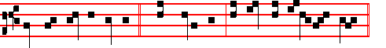
God shall give his Angels * charge over thee, to keep thee in all thy ways.
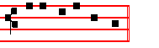
Psalm 93 Dominus regnavit and the rest, p. 28.
Antiphon 2. Tone j, 2
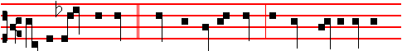
Let us praise the Lord * whom the Angels praise, to whom Cherubim and
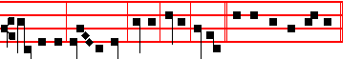
Seraphim cry aloud, Holy, holy, holy. E u o u a e.
Antiphon 3. Tone iij, 1
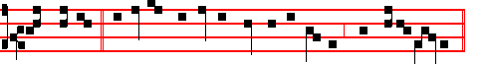
Their Angels * do always behold the face of my Father which is in heaven.
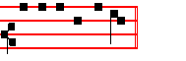
E u o u a e.

Antiphon 4. Tone viij, 1

1992
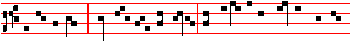
Blessed be God, * who hath sent his Angel, and delivered his servants who put
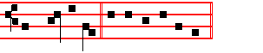
their trust in him. E u o u a e.
Antiphon 5. Tone vij, 3
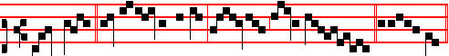
Praise God, * all ye Angels of his: praise him, all his host. E u o u a e.
Chapter Ex. 23
BEHOLD, I send an Angel before thee, to keep thee in the way, and to bring thee into the place which I have prepared. Beware of him, and obey his voice.

Hymn Orbis patrator optime Mode viij 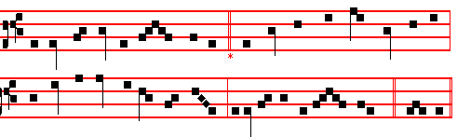
Creator of the circling sky, 4 Let him destroy that hidden snare
Who madest all by power most high, The eager serpent doth prepare,
Thy Providence will never cease Lest we be taken in the net
To rule thy works in might and peace. Before our heedless bosoms set.

2 Be present when we cry to thee, 5 At his command let every fear
A sinful people though we be; Of hostile foemen disappear;
And as the day-dawn grows apace Let civil strife give way to peace,
Illume our minds with light of grace. And pestilence and famine cease.

3 O send thine Angel thitherward 6 To God the Father glory be;
Assigned by thee to be our guard, For those the Saviour setteth free,
That now his presence may begin Anointed by the Holy Ghost
To keep us from all stain of sin. Are guarded by the Angel host. Amen.

1993
 In the presence of the Angels I will sing praise unto thee, O my God.
 I will worship toward thy holy temple, and praise thy Name.

On Benedictus, Antiphon. Tone j, 1
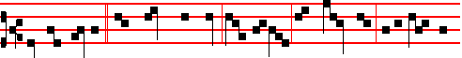
And the Angel * that talked with me came again, and waked me, as a man that
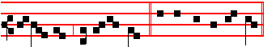
is wakened out of his sleep. Canticle Benedictus

COLLECT
O GOD , who of thy ineffable providence dost vouchsafe to send thy holy Angels to be our guardians: grant unto us thy humble servants; that we may ever both be defended by their protection, and rejoice in their everlasting fellowship. Through.
AT TERCE
Antiphon. Let us praise the Lord, p. 1992.
Chapter Behold, I send, as above, p. 1993.
Short  as p. 1981
An Angel stood * At the altar of the temple. An Angel.
 Having in his hand a golden censer. At the. Glory be. An Angel.
 The smoke of the incense ascended up before God. Out of the Angel's hand.

AT SEXT
Antiphon. Their Angels, p. 1992.
Chapter Ex. 23
PROVOKE him not; for he will not pardon your transgressions: for my Name is in him.
Short  as p. 1981
The smoke of the incense * Ascended up before God. The smoke.
 Out of the Angel's hand. Ascended up. Glory be. The smoke.
 In the presence of the Angels I will sing praise unto thee, O my God.
 I will worship toward thy holy temple, and praise thy Name.

AT NONE
Antiphon. Praise God, p. 1993.
Chapter Ex. 23

1994
BUT if thou shalt indeed obey his voice, and do all that I speak; then I will be an enemy unto thine enemies, and an adversary unto thine adversaries. For mine Angel shall go before thee.
Short as p. 1982
In the presence of the Angels * I will sing praise unto thee, O my God. In the.
 I will worship toward thy holy temple, and praise thy Name. I will sing. Glory be. In the.
 O praise God.  All ye Angels of his.

IN II VESPERS
Antiphon God shall give, with the rest from Lauds, p. 1279. Psalms 110, 111, 112, 113 of Sunday, and in the last place Psalm 138 Confitebor tibi
Chapter, Hymn and Versicle as above in I Vespers, p. 1987.
On Magnificat, Antiphon. Tone vj
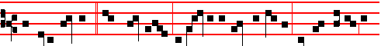
Ye holy Angels, * our Guardians, defend us in time of battle, lest we perish in
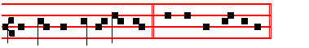
the dreaded day of judgment. Canticle Magnificat
Collect as above, p. 1994.
__________________________________________________________________

The Fifth of October
SS. Placidus and his Companions, Martyrs.

COLLECT
O GOD, who vouchsafest unto us to celebrate the birthday of thy holy Martyrs Placidus and his Companions: grant that we may rejoice in the everlasting felicity of their fellowship. Through.

Lesson iij
PLACIDUS, born at Rome the son of Tertullus a high nobleman, was as a child consecrated to God and entrusted to Saint Benedict. He became so proficient in the discipline and institutions of the monastic life, that he was numbered among his distinguished disciples. Sent by him into Sicily, he built a monastery and Church in honour of Saint John the Baptist near the gate of Messana, where he lived with his monks in admirable sanctity. When Eutychius and Victorinus, his

1995
brothers, and his sister, the virgin Flavia, came to visit him, there landed at the same time a certain cruel pirate called Manucha; who, after taking the monastery, when he could not by any means bring Placidus and the others to deny Christ, ordered him and his brothers and sister to be cruelly put to death. With them also Donatus, the Deacon Firmatus, Faustus and thirty other monks brought the contest of martyrdom to a happy end on the fifth of October, in the year of salvation five hundred and thirty-nine.
Te Deum Laudamus, p. 24.
__________________________________________________________________

The Seventh of October
Saint Mark, Pope and Confessor

COLLECT
HEAR, O Lord, our prayers, and at the intercession of blessed Mark, thy Confessor and Bishop, graciously grant us pardon and peace. Through.
And commemoration is made of SS. Sergius, Bacchus, Marcellus and Apuleius, Martyrs.
Antiphon, p. xlviij. For theirs is the kingdom of heaven, who despised worldly living: who have won the rewards of the kingdom, and have washed their robes in the blood of the Lamb.

 Be glad, O ye righteous, and rejoice in the Lord.
 And be joyful,all ye that are true of heart.

COLLECT
MAY the blessed example of thy holy Martyrs, Sergius, Bacchus, Marcellus and Apuleius be ever with us, O Lord: and make us alway fervent in thy love. Through.

Lesson iij
MARK of Rome, Pope during the reign of the Emperor Constantine the Great, decreed that the Bishop of Ostia, by whom the Bishop of Rome is consecrated, should use the pallium. He built two Churches at Rome, one in the City, and the other on the via Ardeatina: which Constantine enlarged and adorned with generous gifts. He lived in his Pontificate for eight months, and was buried in the cemetery of Balbina.
Te Deum Laudamus, p. 24.

In Lauds commemoration is made of the holy Martyrs Sergius and his Companions.
Antiphon, p. lvij.
1996
The very hairs of your head are all numbered: fear ye not, therefore, ye are of more value than many sparrows.
 Let the Saints be joyful with glory.  Let them rejoice in their beds.
Collect Mav the blessed example, as above.
__________________________________________________________________

The Ninth of October
On the Feast of SS. Dionysius (Denys), Rusticus, and Eleutherius, Martyrs Semidouble
All from the Common of many Martyrs, p. xlvij, except the following.

COLLECT
O GOD, who on this day didst strengthen blessed Dionysius, thy Martyr and Bishop, with the virtue of constancy in his passion, and didst vouchsafe to join unto him Rusticus and Eleutherius for the preaching of thy glory to the Gentiles: grant us, we beseech thee; by their example, to despise for love of thee the prosperity of the world, and to fear none of its adversities.

IN THE SECOND NOCTURN

Lesson iv
DIONYSIUS of Athens, one of the Areopagite judges, was a man instructed in all kinds of learning. He had been wandering in the errors of paganisn until, on the day when Christ the Lord was nailed to the Cross, noticing that the sun was unnaturally weak, he is reported to have exclaimed: Either the God of nature is suffering, or the fabric of the world is breaking up. But when the Apostle Paul, coming to Athens, and being brought into the Areopagus, gave the reason for the doctrine which he preached, affirming that Christ the Lord had risen, and would restore all the dead to life; both many others, and Dionysius himself believed in Christ.

 Thy Saints,O Lord, have passed a wonderful way, serving thy peculiar commandments that were given unto them, that thy children might be found without hurt.* Dry land appeared,and out of the Red Sea a way without impediment.
 For he smote the stony rock indeed, that the waters gushed out, and the streams flowed withal. Dry land.

Lesson v
AND so by the Apostle he was both baptized and set over the Church of Athens. Later he came to Rome, and was sent into Gaul by Pope Clement to

1997
preach the Gospel. Rusticus, a priest, and Eleutherius, a deacon, accompanied him as far as Paris: where he converted many to the Christian religion, and for this reason the prefect Fescennius had him and his companions beaten with rods; since he still steaifastly continued to preach the Christian faith, he was thrown upon a gridiron over a lighted fire, and suffered many other torments together with his companions.

 The Saints of God feared not the blows of the executioners, but died for the Name of Christ. * That they might dwell in the house of the Lord for ever.
 They delivered up their bodies to be punished for God's sake. That they.

Lesson vj
BUT since they all boldly and valiantly endured these various torments, Dionysius, being over a hundred years old, was beheaded with his companions on the ninth of October. And this memory is handed down about him, that he picked up his severed head, and carried it forward in his hands, up to two miles. He wrote some admirable and truly heavenly books, on the divine names, on the celestial and ecclesiastical hierarchy, on mystical theology, and some others.

 As gold in the furnace hath the Lord tried them, and received them as a burnt offering : and he hath care for Gis elect. * For grace and mercy is to his Saints.
 They that put their trust in him shall understand the truth, and such as be faithful in love shall abide with him. For grace. Glory be. For grace.

In the third Nocturn, Homily on the Gospel, Beware ye of the leaven, from the Common of many Martyrs in the third place, p. lxiv.
__________________________________________________________________

Allowed for certain places on the Second Sunday of October
(THE ELEVENTH OF OCTOBER)
FEAST OF THE MATERNITY OF THE BLESSED
VIRGIN MARY
GREATER DOUBLE
(DOUBLE OF THE SECOND CLASS)

At Vespers, Antiphon Blessed art thou, O Virgin Mary, with the rest from Lauds, as below.
Psalms as on Feasts of Virgins, cxvij.
Chapter Ecclus 24, 12-13
HE that made me caused my tabernacle to rest, and said, Let thy dwelling be in Jacob, and thine inheritance in Israel.

1998
Hymn Ave, Maris Stella, p. ccv.

 Blessed art thou among women.  And blessed is the fruit of thy womb.
On Magnificat, Antiphon. Tone vij, 1
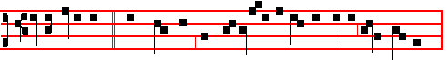
Let us celebrate * with gladness the Maternity of blessed Mary ever Virgin.
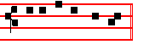
Canticle Magnificat
COLLECT
O GOD, who wast pleased that thy Word should take flesh of the womb of the blessed Virgin Mary at the message of an Angel: grant to thy humble servants; that we, who believe her to be truly the Mother of God, may be aided by her intercession in thy sight. Through the same.

The Hymns of Compline and the Hours are sung to the Mode of Matins or Lauds in the Common, and conclude as follows:
All honour, laud, and glory be
O Jesu, Virgin-born, to thee;

AT MATINS
Invitatory:- Let us celebrate the Maternity of the blessed Virgin Mary, * Let us worship Christ the Lord her Son.
Hymn Cælo Redemptor prætulit
From heaven of old the Redeemer chose 3 May joyous hope drive from our hearts
The blessed Virgin's holy womb Anxiety and all our fears,
From whence, assuming mortal flesh, For she indeed brings to her Son
As future victim he would come. Our supplications and our tears.

2 And him the Virgin bore for us 4 The Son receives his parent's words
As Saviour of all human life: And hears her when she intercedes:
He bought us with his precious Blood, O let us ever love her more
Endured the Cross and mortal strife. And call to her in all our needs.

5 Be glory to the Trinity
Who in the Mother's womb most pure
Bestowed the precious Offspring blessed:
Be praise while ages ere endure. Amen.

1999
IN THE FIRST NOCTURN

From the Book of Ecclesiasticus
Lesson j Ch. 24, 5-17
I ALONE compassed the circuit of heaven, and walked in the bottom of the deep. In the waves of the sea and in all the earth, and In every people and nation, I got a possession. With all these I sought rest: and in whose inheritance shall I abide?

 Happy art thou, O holy Virgin Mary, and worthy of all praise: * For from thee hath arisen the Sun of Righteousness, Christ our God, by whom we are saved and set free.
 Let us joyfully celebrate the Maternity of thc blessed Virgin Mary. For from.

Lesson ij
SO the Creator of all things gave me a commandment, and he that made me caused my tabernacle to rest, and said, Let thy dwelling be in Jacob, and thine inheritance in Israel. He created me from the beginning before the world, and I shall never fail. In the holy tabernacle I served before him. So was I established in Sion. Likewise in the beloved city he gave me rest, and in Jerusalem was my power. And I took root in all honourable people, even in the portion of the Lord's inheritance.

 Thou art found without spot of sin, O Mother of the Saviour: * He who reigneth over hcaven and earth, being made man, lay hid in thy womb.
 Blessed art thou among women, and blessed is the fruit of thy womb. He who.

Lesson iij
AND I was exalted like a cedar in Libanus, and as a cyprus tree upon the mountains of Hermon. I was exalted like a palm tree in En-gaddi, and as a rose plant in Jericho, as a fair olive tree in a pleasant field, and grew up as a plane tree by the water. I gave a sweet smell likc cinnamon and aspalathus, and I yielded a pleasant odour like the best myrrh, as galbanum, and onyx, and sweet storax, and as the fume of frankincense in the tabernacle. As the turpentine tree I stretched out my branches, and my branches are the branches of honour and grace. As the vine brought I forth plcasant savour.

 Many daughters have done virtuously, but thou excellest them all: * Thou art bcautiful and pleasant, O holy Mother of God, in thy felicity.
 May all acknowledge thy help, who celebrate thy holy Maternity. Thou art. Glory be. Thou art.

2000
IN THE SECOND NOCTURN

Sermon by S. Leo the Great
Lesson iv Sermon 1 on the Lord's Nativity
A ROYAL Virgin of the stem of Jesse is chosen, who in order to become pregnant with the holy Child, was to conceive the divine and human Offspring in mind before conceiving in body. And lest, being unaware of the heavenly counsel, she should be troubled at the strange tidings, she learned from her conversation with the Angel what was to be performed in her through the operation of thc Holy Ghost, nor did she think it a loss to her maiden honour that she would soon be the Mother of God. For why should she be without hope in the novelty of her conception, when the operation of divine power had been promised to her? The faith of her belief is confirmed by the testimony of a foregoing miracle. Unhoped-for fruitfulness is given to Elisabeth, that there might be no doubt that he who had given conception to the barren would also give it to the Virgin. Therefore the Word, the Son of God, who was in the beginning with God, by whom all things were made and without whom was nothing made, in order to set man free from eternal death, was made man.

 Let us celebrate worthily the Maternity of the glorious Virgin Mary: * whose lowliness the Lord regarded, when at the message of. the Angel she conceived the Saviour of the world.
 Let us sing glory unto Christ on this holy festlval of the wondrous Mother of God. Whose.

Lesson v Sermon 2 On the Lord's Nativity
JESUS Christ entered this lower realm, descending from his heavenly throne and leaving not his Father's glory, and is begotten in accordance with a new order, a new birth. A new order, because invisible in his own nature he is made visible in ours: incomprehensible, he willed to be comprehended: remaining before time, he began to be in time. He is begotten in accordance with a new nativity: conceived by the Virgin he is born of the Virgin, without concupiscense of paternal flesh, without injury to his Mother's integrity: such a birth befits the future Saviour of men, who would have the nature of human substance in himsclf, and yet know not the stain of human flesh. Unlike in origin, yet like in nature, his was a birth without the use and custom of mankind: for it was contingent on divine power that the Virgin conceived, the Virgin bore, and Virgin she remained.

 Blessed art thou, O Daughter of the Lord, for through thee we have received the fruit of life: * For thou alone without compare wast pleasing to our Lord Jesus Christ.

2001
 Despise not our supplications in our needs, but deliver us from all dangers, O
holy Mother of God. For thou.

Lesson vj
IT was fitting that His purity who was born should preserve the first integrity of His Mother, and that the well-pleasing gate of modesty and sanctity should be kept by the indwelling power of the Divine Spirit, which had determined to raise up the fallen, to restore the broken, and to bestow the manifold power of chastity on overcoming the snares of the flesh; that Virginity, which in others could not be preserved in birth, might be accessible to others through rebirth. And does not
this very thing, that Christ chose to be born of a Virgin, seem to have been the highest wisoom? namely that the devil should be unaware that salvation had come by a human birth: and, the spiritual conception being hidden, he should think
him no otherwise born than others, who seemed no different from others. And that this might come to pass, Christ came forth from a Virgin, whom the Holy Spirit had made fruitful: and as in all mothers conception comes not to pass without
the defilement of sin, she drew purification from him by whom she conceived.

((In 1931 this lesson was replaced by a lesson concerning the action of Pius XI in making this feast universal on the 11th of October, not given here))

 Blessed art thou among women, and blessed is the fruit of thy womb: * And whence is this to me, that the Mother of my Lord should come to me?
 For he hath regarded the lowliness of his handmaiden for he that is mighty hath done to me great things. And whence. Glory be. And whence.

IN THE THIRD NOCTURN

 For he that is mighty hath done to me great things.
 And his mercy is on them that fear him from generation to generation.
The Lesson from the Holy Gospel according to Luke.
Lesson vij Ch. 2
AS they returned, the child Jesus tarried behind in Jerusalem; and Joseph and his mother knew not of it. And the rest.

In place of the homily by Bernard of Clairvaux, not given here, may be read that of S. Ambrose for the first Sunday after the Epiphany, p. 476. with these :

 vij. Blessed art thou, O Virgin Mary, Mother of God, for thou hast believed the Lord: there hath been a performance in thee of those things which were told thee: * Therefore God hath blessed thee for ever.

2002
 Full of grace are thy lips: intercede for us to the Lord our God. Therefore.

 viij. Rejoice with me, all ye that love the Lord, for athough I was lowly I pleased the Most High. * And from my womb I have brought forth God and man.
 All generations shall call me blessed, for the Lord hath rewarded the lowliness of his handmaiden. And from. Glory be. And from.

Lesson ix from the Homily of the occurrent Sunday (Lesson ix, p. 476-7).

Te Deum Laudamus, p. 24.

AT LAUDS, and through the Hours
Antiphon 1. Tone j, 1
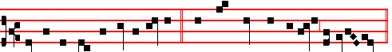
Blessed art thou, O Virgin Mary, * who hast borne the Creator of all things.
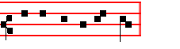
Psalm 93 Dominus regnavit, and the rest, p. 28.

Antiphon 2. Tone iij, 1
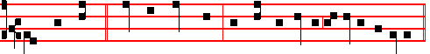
Thou hast borne * him who made thee, and thou remainest a Virgin for ever.
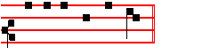
E u o u a e.

Antiphon 3. Tone v
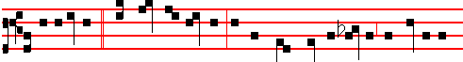
All generations * shall call me blessed, for the Lord hath regarded the lowliness

2003
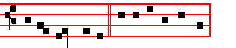
of his handmaiden. E u o u a e.
Antiphon 4. Tone vj
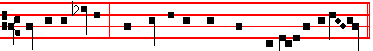
He that is mighty * hath cbne to me great things, and holy is his name.
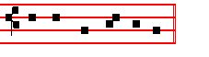
E u o u a e.

Antiph on 5. Tone viij, 1
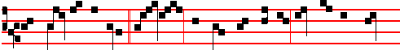
The daughters of Sion * saw her, and called her blessed; yea, and the queens
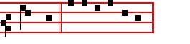
praised her. E u o u a e.
Chapter Ecclus 24, 12-13
HE that made me caused my tabernacle to rest, and said, Let thy dwelling be in Jacob, and thine inheritance in Israel.

Hymn Te Mater alma Numinis Mode ij as in the Common

Sweet Mother of the Lord most High, 3 So, Mother, unto thee we pray;
To thee we bow in humble prayer, Thou seest our need; thy Son entreat
To thee from evil powers we fly; That He, His anger turned away,
O shield and keep us in thy care. May raise our souls in mercy sweet.

2 It was to lift our fallen race 4 All honour, laud, and glory be,
Above the curse of Adam's crime O Jesu, Virgin-born, to thee;
The King bestowed on thee all grace All glory, as is ever meet,
And shaoed thy Motherhood sublime. To Father and to Paraclete. Amen.

2004
 The root of Jesse hath budded, a star is arisen from Jacob.
 The Virgin hath brought forth a Saviour, we praise thee, O our God.
On Benedictus, Antiphon. Tone j, 3
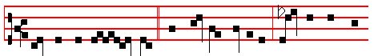
O ho- ly Ma- ry, * help thou the suffering, strengthen the faint-
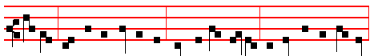
hearted, comfort the sorrowful; pray for the people, entreat for the clergy,
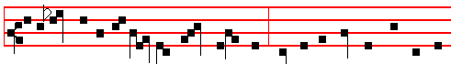
intercede for all womankind vowed unto God: may all acknowledge the help of 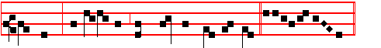
thy prayer, who celebrate thy wondrous Motherhood. Canticle Benedictus

COLLECT
O GOD, who wast pleased that thy Word should take flesh of the womb of the blessed Virgin Mary at the message of an Angel: grant to thy humble servants; that we, who believe her to be truly the Mother of God, may be aided by her intercession in thy sight. Through the same.

At Prime in the Short  is said.  Who wast born of the Virgin Mary.
At the Hours, the Antiphons and Collect are taken from Lauds, the rest from the Common of blessed Mary, p. ccxv
(At Terce, the Chapter from Lauds above).
In second Vespers, all as in first.
On Magnificat, Antiphon. Tone j, 4
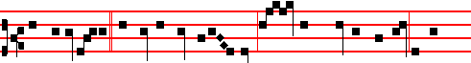
Thy Maternity, * O Virgin Mother of God, hath brought tidings of joy to the

2005
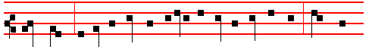
whole world: for out of thee hath arisen the Sun of righteousness, Christ our
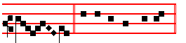
God. Canticle Magnificat
__________________________________________________________________

THE FOURTEENTH OF OCTOBER
ON THE FEAST OF S. CALLISTUS, POPE AND MARTYR
DOUBLE
All from the Common of one Martyr, xxi, except the following.

COLLECT
O GOD, who seest that we fail by reason of our infirmity: through the example of thy Saints mercifully restore us to the love of thee. Through.

In the first Nocturn Lessons from the occurrent Scripture.

IN THE SEOOND NOCTURN
Lesson iv
CALLISTUS, a Roman, presided over the Church when Antoninus Heliogabalus was Emperor. He instituted the four Ember seasons of the year, on which fasting, received by apostolic tradition, was to be observed. He built the Basilica of Saint Mary across the Tiber ,and enlarged the old cemetery on the Appian Way, in which many holy priests and Martyrs were buried:whence it is called, after him,the cemetery of Callistus.

 The Lord made him honourable, defended him £rom his enenies, and kept him safe from those that lay in wait.* And gave him perpetual glory.
 He went down with him into the pit, and left him not in bonds. And gave.

Lesson v
IT was characteristic of his piety that he had a search made with diligence for the body of blessed Calepodius, presbyter and Martyr, which had been thrown into the Tiber, and buried it honourably when found. For having washed in baptism Palmatius, of consular rank, and Simplicius of senatorial dignity, Felix, and Blanda, who all afterwards suffered martyrdom, he was sent to prison, where he

2006
wonderfully restored to health the soldier Privatus, who was full of ulcers, and united him to Christ:for which the latter, having only just received the faith, was beaten to death with leaden whips.

 O Lord,thou hast given him his heart's desire, * And hast not denied him the request of his lips.
 For thou hast prevented him with the blessings of goodness, thou hast set upon his head a crown of pure gold. And hast not.

Lesson vj
CALLISTUS was in his See for five years, one month, and twelve days. In five ordinations, in the month of December, he made sixteen priests, four deacons, and eight bishops. After long starvation and repeated scourgings he was thrown head-first into a well, and having thus been crowned with martyrdom under the Emperor Alexander, he was placed in the cemetery of Calepodius on the Via Aurelia, three miles from the City, on the fourteenth of October. Afterwards his body was taken into the Basilica of Saint Mary across the Tiber, which had been built by him, and is honoured with the greatest veneration beneath the high altar.

 The Lord clothed him with a robe of glory. * And set upon his head a crown of pure gold.
 With the bread of life and understanding shall the Lord feed him, and give him the water of wisdom to drink. And set.Glory be. And set.
In the third Nocturn, Homily on the Gospel, There is nothing covered, from the Common in the fourth place, p. xxxiv.
__________________________________________________________________

THE EIGHTEENTH OF OCTOBER
ON THE FEAST OF SAINT LUKE, EVANGELIST
DOUBLE OF THE SECOND CLASS

All from the Common of Apostles, p. ij, except the following.

COLLECT
WE beseech thee, O Lord, that the holy Evangelist Luke may intercede for us: who for the honour of thy name continually bare in his own body the mortification of the cross. Through.

In the first Nocturn Lessons from the Prophet Ezekiel placed in the Common of Evangelists, p. xix.
IN THE SECOND NOCTURN

2007
From the Book by Saint Jerome, Priest, on Ecclesiastical Writers.
Lesson iv Ch. 7
LUKE, a physician of San Antioch, as his writings indicate, was not unskilled in the Greek language. An adherent of the Apostle Paul, and companion of all his journeying, he wrote a Gospel, concerning which the same Paul says: We have sent with him the brother, whose praise is in the Gospel throughout all the churches. And to the Colossians: Luke the beloved physician salutes you. And to Timothy: Luke only is with me. He also wrote another excellent volume to which he prefixed the title, Acts of the Apostles; a history which extends to the second year of Paul's sojourn at Rome, that is, to the fourth year of Nero, from which we learn that the fbook was composed in that same city.

 I saw a great people who had received glorious garments of the Lord. and the Angel of the Lord spake in me, saying: * These men are holy, for they are the friends of God.
 I saw a strong Angel of God flying through .the midst of heaven, crying with a loud voice and saying: These men are.

Lesson v
THEREFORE the Acts of Paul and Thecla, and all the fable about the lion baptized by him, we reckon among the tt apocryphal writings, for how is it possible that the inseparable companion of the Apostle in his other affairs, alone should have been ignorant of this thing? Moreover Tertullian, who lived near those times, mentions a certain presbyter in Asia, an adherent of the Apostle Paul, who was convicted by John of having been the author of this book, and who, confessing that he did this for love of Paul. resigned his office of presbyter. Some think,that whenever in his Epistles Paul says: According to my Gospel, he means the book by Luke.

 Blessed.are ye when men shall revile you and persecute you, and shall say all manner of evil against you falsely for my sake. * Rejoice and be exceeding glad, for great is your reward in heaven.
 When men shall hate you, and when they shall separate you from their company, and shall reproach you, and cast out your name as evil, for the Son of Man's sake. Rejoice.

Lesson vj
LUKE had learned the Gospel not only from Paul, who had not been with the Lord in the flesh, but from the other Apostles as well. This he too at the beginning of the work declares, saying, Even as they delivered unto us, which

2008
from the beginning were eyewitnesses and ministers of the word. So he wrote the Gospel as he had heard it, but composed the Acts of the Apostles as he himself had seen. He lived tor eighty-four years, and had no wife. He is buried
at Constantinople, to which city, in the twentieth year of Constantine, his bones were transferred from Achaia, together with the remains of Andrew the Apostle.

 These men are conquerors and friends of God, who despised the orders of governors, and earned the everlasting reward: * Now are they crowned and receive palms.
 These are they which came out of great tribulation, and have washed their robes in the blood of the Lamb. Now are they. Glory be. Now are they.

In the third Nocturn Homily by Saint Ambrose, Bishop, on the Gospel, The Lord appointed, from the Common of Evangelists, p. xxj.

__________________________________________________________________

The Twenty-first of October
Saint Hilarion, Abbot
COLLECT
O LORD,we beseech thee, let the intercession of the blessed Abbot Hilarion canmend us unto thee: that those things which for our own merits we cannot ask, we may through his advocacy obtain. Through.
And commemoration is made of SS. Ursula and her Companions.
In Vespers and Lauds, Antiphon.
O ye wise Virgins, arise, and trim your lamps:for behold the Bridegroom cometh; go ye out to meet him.
 The Virgins that be her fellows shall bear her company.
 And shall be brought unto thee.

COLLECT
GRANT, we beseech thee, O Lord our God, that we may at all times so devoutly honour the triumphs of thy holy Virgins and Martyrs Ursula and her Companions: that, although we cannot worthily shew forth their praise, yet we may continually honour them with lowly service. Through.

Lesson ij
HILARION, from Tabatha in Palestine, of pagan parents, was sent to Alexandria to study, and there flourished to the praise of his life and intelligence: and adopting the religion of Jesus Christ, he advanced wonderfully in faith and charity. For he was often in Church, zealous in fasting and prayer: he

2009
despised all lures of pleasures and desire for earthly things. And as the name of Antony was very famous in Egypt, he set forth into the desert in a desire to see him, and spent two months with him learning all his way of life. He returned home, and when his parents had died, distributed all his goods to the poor: and being no more than fifteen years old, returned into the desert: where he raised a very small house which would barely hold him, in which he lay on the ground. But the sack he wore, once he had put it on, he never washed or changed, since he said it was superfluous to seek cleanliness in a hairshirt.

Lesson iij
HE was much occupied in reading and meditation of holy Scripture. For food he took a few figs and the juice of herbs, and these he did not eat until sunset. His continence and humility were beyond belief. And with these and other virtues he overcame various horrible temptations of the devil, and cast out innumerable demons from the bodies of people in many parts of the world. And when he was eighty years old, and had built many monasteries, and was renowned for miracles, he fell sick: and as his spirit struggled with extreme pain against the force of that disease, he said: Go forth, why dost thou fear? go forth, my soul, why dost thou hesitate ? nigh seventy years thou hast served Christ, and dost thou fear death? With these words he breathed his last.
Te Deum Laudamus, p. 24.
__________________________________________________________________

(THE TWENTY-FOURTH OF OCTOBER
S. RAPHAEL, ARCHANGEL
GREATER DOUBLE

IN I VESPERS
Antiphons from Lauds below. Psalms 110, 111, 112, 113 of Sunday, and in the last place is said Psalm 117 Laudate Dominum, p.ij, or, if II Vespers of this Feast are not to be said, Psalm 138 Confitebor tibi , p. 231.
Chapter Tob. 12
NOW therefore, when thou didst pray, and Sara thy daughter in law, I did bring the remembrance of your prayers before the Holy One: and when thou didst bury the dead, I was with thee likewise.
Hymn: E.H. 242, vv.1, 4, 5, 6. Christe, sanctorum decus Angelorum Mode j
The hymns at Compline and the Hours are sung to this Mode.

CHRIST, the fair glory of the holy Angels,
Thou who hast made us, thou who o'er us rulest,
Grant of thy mercy unto us thy servants
Steps up to heaven.

2010
4 Send thy Archangel, Raphael, the restorer. A- men.
Of the misguided ways of men who wander,
Who at thy bidding strengthens soul and body
With thine anointing. .

5 May the blest Mother of our God and Saviour,
May the assembly of the Saints in glory,
May the celestial companies of Angels
Ever assist us.

6 Father almighty, Son and Holy Spirit,
God ever blessed, be thou our preserver;
Thine is the glory which the Angels worship
Veiling their faces. Amen

 An Angel stood at the altar of the temple.
 Having in his hand a golden censer.

On Magnificat, Antiphon. Tone j, 1
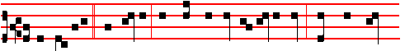
I am Raphael * the Angel, that stand before the Holy One: wherefore bless

2011
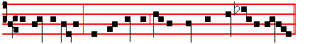
ye God for ever, and confess ye all his great and wonderful doings.
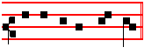
Canticle Magnificat
COLLECT
O GOD, who didst give blessed Raphael the Archangel unto thy servant Tobias for a companion on his way: grant to us thy servants; that we may ever be guarded by his protection and strengthened by his help. Through.

AT MATINS
Invitatory.- The Lord, the King of the Archangels, * O come, let us worship. Psalm 95 Venite
Hymn E.H. 242, vv,1, 4 ,5, 6 Christe, sanctorum, as above, p. 2010.

IN THE FIRST NOCTURN

Antiphon. Tobias went forth * and found a young man girded and ready to journey, and not knowing that he was an Angel, he saluted him. Psalm 8 Domine, Dominus noster
Antiphon. The Angel Raphael * hid himself, and said: I am Azarias, the son of Ananias the great. Psalm 11 In Domino confido
Antiphon. I will bring * thy son safely into the land of Media, and bring him back safely to thee again. Psalm 15 Domine, quis habitabit?

 There was given unto the Angel much incense.  That he should offer it upon the golden altar, which is before the eyes of the Lord.

From the Book of Tobit
Lesson j Ch. 12, 1-22
THEN Tobit called his son Tobias, and said unto him, My son, see that the man have his wages, which went with thee: and thou must give him more. And Tobias said unto him, O father, it is no harm to me to give him the half of those things whicj I have brought: for he hath brought me again to thee in safety, and made whole my wife, and brought me the money, and likewise healed thee. Then the old man said, It is due unto him. So he called the angel, and he said unto him, Take half of all that ye have brought, and go away in safety.

2012

