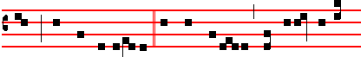
world : have mercy upon us. O Lamb of God, that takest away
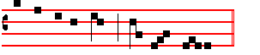
the sins of the world : grant us peace.

COMMUNION Matthew 26. Tone viij
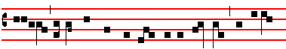
Fa- ther, if this cup may not pass away from me, except I
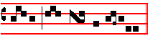
drink it: thy will be done.

POSTCOMMUNION.
MAY the operation of this mystery, O Lord: avail for the cleansing of our sins, and for the fulfilment of our godly desires, Through.

¶ In private Masses there is read at tbe end the Gospel, When Jesus drew nigh, as above in the blessing of the Palms, p. 4.

S.Peter Orthodox Truth Service, April 2007

32

PALM SUNDAY
IST CLASS. SEMIDOUBLE

¶ In Choir, Terce having been said, the sprinkling of water is performed in the usual manner. Then the Priest, vested in a violet Cope, or without the Chasuble, with the Ministers vested in like manner, proceeds to bless branches of palm or olive or other trees placed in the midst before the Altar, or at the Epistle corner. And first the Choir sings the Antiphon:

Matthew 21. Tone vij
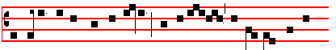
Hosanna to the Son of David: blessed is he that cometh in the
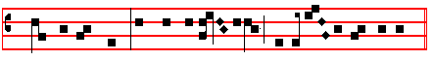
name of the Lord. O King of Is- rael: Hosanna in the Highest.
¶ Then the Priest, standing at the Epistle corner, without turning toward the people, sings with joined hands in the tone of the ferial Collect:
 The Lord be with you.
 And with thy spirit. Let us pray.
COLLECT
O GOD, whose love and service is our justice, multiply upon us the gifts of thy unspeakable grace: and like as by the death of thy Son thou hast given unto us the hope of our faith; so grant: that by his resurrection we may he brought unto the country which we seek: Who liveth and reigneth with thee.

¶ Then the Subdeacon in the accustomed place sings the following Lesson in the tone of the Epistle, and at the end kisses the hand of the Priest.
The LESSON from the book Exodus (xv, 27.)
IN those days: The children of Israel came to Elim, where were twelve wells or water, and threescore and ten palm trees: and they encamped there by the waters. And they took their journey from Elim, and all the congregation of the children of Israel came unto the wilderness of Sin, which is between Elim and Sinai: on the fifteenth day of the second month after their departing out of the land

1
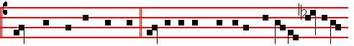
Who spake by the Prophets. And I believe one holy, catholick and apo-
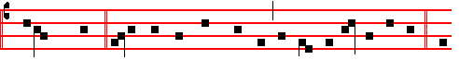
stolick Church. I acknowledge one Baptism for the remis-sion of sins. And
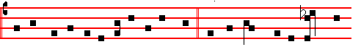
I look for the resur-rection of the dead, and the life  of the world to
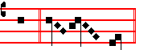
come. A- men.
OFFERTORY. Psalm 69. Tone viij
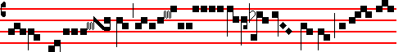
Thy re- buke hath bro- ken my heart; I am full
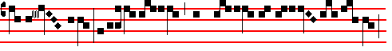
of hea- viness: I looked for some to have pi- ty on me,
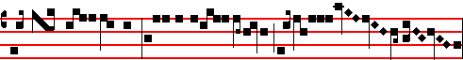
but there was no man, neither found I an-y to com- fort me:
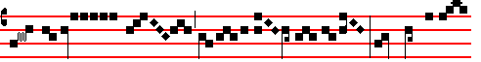
they gave me gall to eat: and when I was

30
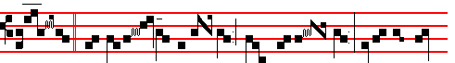
tion  And one of them named Caia- phas, being the high
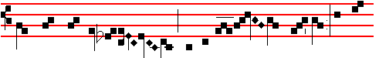
priest that same year, prophesied say-ing: It is 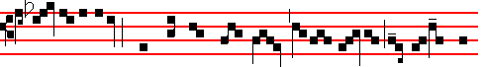
expedient for us, that one man should die for the people, and that the
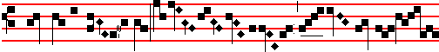
whole nation per-ish not. Then from that day forth
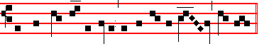
they took counsel together to put him to death, say- ing. * And the Romans.

Or another  Matthew 26. Tone viij
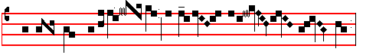  On the Mount of Ol- ives he prayed to his Fath- er:
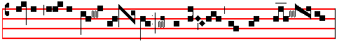 Father, if it be pos- sib- le, let this cup pass from me. *
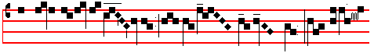 The spirit indeed is wil- ling, but the flesh is weak: thy will
3
Here Cleanse my heart is said, a blessing is asked, incense is carried without lights, and the book is censed. The Lord be with you is not said, and the Celebrant or Deacon does not sign the book nor himself: and what follows is sung in the tone of the Gospel: at the conclusion of which the Celebrant kisses the book and is censed. All of which is observed in the other Passions except on Good Friday.
NOW the next day, that followed the day of the Preparation, the chief priests and Pharisees came together unto Pilate, saying: Sir, we remember that that deceiver said, while he was yet alive: After three days I will rise again. Command therefore that the sepulchre be made sure until the third day: lest his disciples come by night, and steal him away, and say unto the people: He is risen from the dead; so the last error shall be worse than the first. Pilate said unto them: Ye have a watch, go your way, make it as sure as you can. So they went, and made the sepulchre sure, sealing the stone, and setting a watch. Creed. Authentic Tone iv
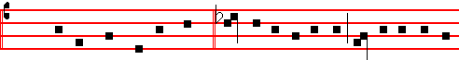
 I be- lieve in one God  The Father al-mighty, maker of heaven
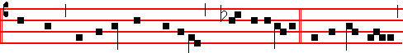
and earth, and of all thngs vi-si-ble and i nvi-sib-le. And in one Lord
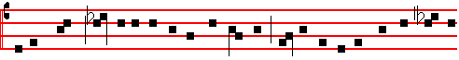
Jesus Christ , the only-be-got-ten Son of God, Begot- ten of his Father before
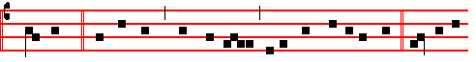
all worlds, God of God, Light of Light , very God of very God, Be-gotten,
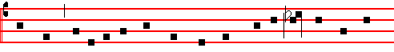
not made, Being of one substance with the Father: by whom all things
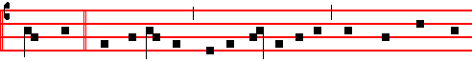
were made. Who for us men, and for our salvation, came down from hea-
28
us: and let these branches of pahn or olive be blessed: and, as in a figure of the Church thou didst multiply Noah going forth from the ark, and Moses when he weat out of Egypt with the children of Israel: so may we, bearing pahns and branches of olive, go forth. with good works to meet Christ: and through him enter into everlasting joy: Who liveth and reigneth with thee in the unity of the Holy Ghost, God:
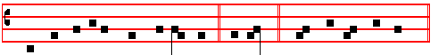
Throughout all ages, world without end.  A-men.  The Lord be with you.
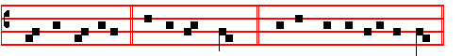
 And with thy spirit.  Lift up your hearts. . We lift them up unto the Lord
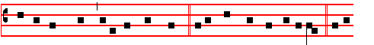
 Let us give thanks unto our Lord God.  It is meet and right so to do.  It is
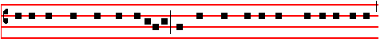
very meet, right, just and salutary, that we should at all times, and in all places,
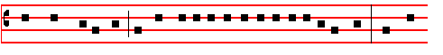
give thanks unto thee: O Lord holy Father almighty, everlasting God: Who art
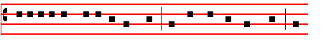
glorified in the council of thy Saints. For thee thy creatures serve: and
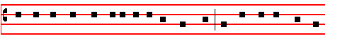
acknowledge thee their only maker and their God, and thee all thy works do
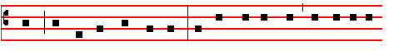
5 praise, and thee thy Saints do bless. For with fearless voice, before the kings
he cast down the pieces of silver in the temple, and departed: and went and hanged himself. And the chief priests took the silver pieces. and said: S. It is not lawful for to put them into the treasury: because it is the price of blood. C. And they took counsel, and bought with them the potter's field, to bury strangers in. Wherefore that field was called: The field of blood, unto this day. (Then was fulfilled that which was spoken by Jeremy the prophet, saying: And they took the thirty pieces of silver, the price of him that was valued, whom they of the children of Israel did value: and gave them for the potter's fidd, as the Lord appointed me.) And Jesus stood before the governor, and the governor asked him, saying: S. Art thou thc King of the Jews? C. And Jesus said unto him:  Thou Sayest. C. And when he was accused of the chief priests and elders, he answered nothing. Then saith Pilate unto him: S. Hearest thou not how many things they witness against thee? C. And he answered him to never a word, insomuch that the governor marvelled greatly. Now at that feast the governor was wont to release unto the people a prisoner, whom they would. And they had then a notable prisoner, called Barabbas. Therefore when they were gathered together, Pilate said unto them: S. Whom will ye that I release unto you: Barabbas, or Jesus which is called Christ? C. For he knew that for envy they had delivered him. When he was let down on the judgment-seat, his wife sent unto him, saying: S. Have thou nothing to do with that just man: for I have suffered many things this day in a dream because of him. C. But the chief priests and elders persuaded the multitude that they should ask Barabbas, and destroy Jesus. The governor answered and said unto them: S. Whether of the twain will ye that I release unto you? C. They said: S. Barabbas. C. Pilate saith unto them: S. What shall I do then with Jesus, which is called Christ? C. They all say unto him: S. Let him be crucified. C. And the governor said: S. Why, what evil hath he done? C. But they cried out the more, saying: S. Let him be crucified. C. When Pilate saw that he could prevail nothing, but that rather a tumult was made: he took: water, and washed his hands before the multitude, saying: S. I am innocent of the blood of this just person: see ye to it. C. Then answered all the people, and said: S. His blood be on us, and on our children. C. Then released he Barabbas unto them: and when he had scourged Jesus he delivered him to be crucified. Then the soldiers of the governor took Jesus into the common hall, and gathered unto him the whole band of soldiers: and they stripped him, and put on him a scarlet robe: and when they had platted a crown of thorns they put it upon his head, and a reed in his right hand. And they bowed the knee before him, and mocked him, saying: Hail, King of the Jews. C. And they spit upon him, and took the reed, and smote him on the head. And after that they had mocked him they took the robe off from him, and put his own raiment on him, and led him away to crucify him. And as they came out they found a man of Cyrene, Simon by name: him they compelled to bear his cross. And when they were come unto a place called Golgotha, that is to say, a place of a skull, they gave him

26
palm and olive which thy servants receive with faith to the honour of thy name; that into whatsoever place they shall be brought, the dwellers in that place may obtain thy blessing: that all adversity being put to flight, thy right hand may protect those who are redeemed by Jesus Christ thy Son our Lord: Who liveth and reigneth with thee.

Let us pray. COLLECT
O GOD. who by a wonderful order of thy providence wast pleased, even by means of things insensible, to shew forth the dispensation of our salvation: grant, we beseech thee; that the devout hearts of thy faithful people may profitably understand what is mystically signified by that deed when. on this day, the multitude, inspired by the heavenly light, went forth to meet the Redeemer, and strawed branches of palm and olivc beneath his feet. The branches. then, of palm foreshadow his triumph over the prince of death; and the boughs of olive in a manner proclaim that the anointing of the Spirit is come. For the multitude rejoiced to know that even then it was prefigured: that our Redeemer, having compassion on the misery of mankind, was about to battle with the prince of death, and by his death to triumph. And therefore obediently they laid before him such things as should signify in him both the triumphs of his victory and the abundance of his mercy. Wherefore we likewise with sure faith, having in memory both the deed and the signification of the same, humbly beseech thee, O Lord holy Father almighty, everlasting God, through the same Jesus Christ our Lord: that in him and through him, whose members thou hast been pleased to make us, we may win the victory over thc empire of death, and be found worthy to be partakers of his glorious resurrection: Who liveth and reigneth with thee.

Let us pray. COLLECT
O GOD, who by an olive-branch didst command the. dove to proclaim peace on earth : vouchsafe, we beseech thee; to sanctify with thy heavenly blessing these branches of olive and other trees: that for all thy people they may be profitable unto salvation. Through Christ, our Lord.  Amen.

Let us pray. COLLECT
BLESS, we beseech thee, O Lord, these branches of palm or olive and grant;
that as thy people on this day do outwardly perform thcse things to thy honour, so they, spiritually fulfilling the same with pure devotion, may win the victory over the enemy, and cleave steadfastly to every work of mercy. Through.

¶ Then the Celebrant, after putting incense into the thurible, thrice sprinkles the boughs with holy water. saying the Antiphon, Thou shalt purge me, without note and without the Psalm: and then thrice incenses them. Then he says:
 The Lord be with you.  And with thy spirit.

7
Master, is it I? C. He said unto him:  Thou hast said. C. And as they were eating, Jesus took bread, and blessed it, and brake it, and gave it to the disciples, and said:  Take, eat: this is my body. C. And he took the cup, and gave thanks: and gave it to them, saying:  Drink ye all of it; for this is my blood of the new Testament, which is shed for many for the remission of sins. But I say unto you: I will not drink henceforth of this fruit of the vine, until that day when I drink it new with you in my Father's kingdom. C. And : when they had sung an hymn, they went out into the mount of Olives. Then saith Jesus unto them:  All ye shall be offended because of me this night. For it is written: I will smite the shepherd, and thc sheep of the flock shall be scattered abroad. But after I am risen again, I will go beforc you into Galilee. C. Peter answered and said unto him: S. Though all men shall be offended because of thee, yet will I never be offended. C. Jesus said unto him:  Verily I say unto thee, That this night, before the cock crow, thou shalt denv me thrice. C. Peter said unto him: S. Though I should die with thee, yet will I not deny thee. C. Likewise also said all the disciples. Then cometh Jesus with them unto a place called Gethsemane, and saith unto the disciplcs:  Sit ye here, while I go and pray yonder. C. And he took with him Peter and the two sons of Zebedee, and began to be sorrowful and very heavy. Then saith he unto them:  My soul is exceeding sorrowful, even unto death: tarry ye here, and watch with me. C. And he went a little farther, and fell on his face, and prayed, saying:  O my Father, if it be possible, let this cup pass from me. Nevertheless not as I will, but as thou wilt. C. And he cometh unto the disciples, and findeth them asleep: and saith unto Peter:  What, could ye not watch with me one hour? Watch and prny, that ye enter not into temptation. The spirit indeed is willing, but the flesh is weak. C. He went away again the second time, and prayed, saying:  O my Father, if this cup may not pass away from me, except I drink it, thy will be done. C. And he came and found them asleep again : for their eyes were heavy. And he left them, and went away again, and payed the third time, saying the same words. Then cometh he to his disciples, and saith unto them :  Sleep on now, and take your rest: behold the hour is at hand, and the Son of man is betrayed into the hands of sinners. Rise, let us be going: behold, he is at hand that doth betray me. C. And while he yet spake, lo, Judas, one of the twelve, came and with him a great multitude with swords and staves, from the chief priests and elders of the people. Now he that betrayed him gave them a sign, saying: S. Whomsoever I shall kiss, that same is he, hold him fast. C. And forthwith he came to Jesus, and said S. Hail, Master. C. And kissed him. And Jesus said unto him :  Friend, wherefore art thou come? C. Then came they, and laid hands on Jesus, and took him. And, behold, one of them which were with Jesus. stretched out his hand, and drew his sword, and struck a servant of the high priest's, and smote off his ear. Then said Jesus unto him:  Put up again thy sword into his place. For all they that take the

24
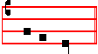
of the Lord.
¶ If these are not sufficient, they are repeated until the distribution is finished.

Then the Priest says:
 The Lord be with you.  And with thy spirit.
Let us pray. COLLECT.
ALMIGHTY and everlasting God, who didst ordain that our Lord Jesus Christ should ride upon the foal of an ass, and didst teach the multitudes of the people to straw in his way their raiment and branches of trees, and likewise to sing Hosanna in his praise: grant, we beseech thee; that we may by thee be enabled to follow their innocency, and be partakers of their merit. Through the same Christ, our Lord.  Amen.

¶ Then the Procession is made. And first the Celebrant puts incense in the censer : and the Deacon, turning to the people, says
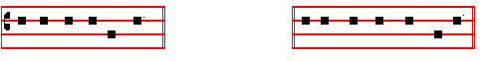
Let us proceed in peace; and the Choir respond: In the name of Christ. Amen.

The Thurifer goes first with the smoking censer: then the Subdeacon vested, carrying the Cross, between two Acolytes with lighted candles : the Clergy follow in order, and last of all the Celebrant with the Deacon on his left, all with branches in their hands : and the following Antiphons are sung, either all, or some, so long as the Procession lasts.

Antiphon. Matthew 21 Tone vij 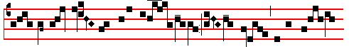 When the Lord drew nigh unto Jeru- salem, he sent two of his discip-les,
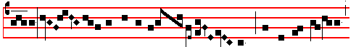 saying: Go in- to the village over a- gainst you: and ye shall find

9
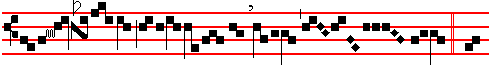
clare his right- eous- ness.  Un-
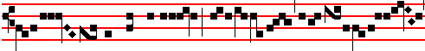
to a peo- ple that shall be born, whom the Lord
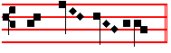
hath made .

The Passion begins at once: Cleanse my heart is not said, nor is a blessing asked, and lights and incense are not carried, neither is The Lord be with you said, nor the response, Glory be to Thee, O Lord, and the Celebrant or Deacon, while he announces The Passion of our Lord, does not sign the book nor himself . Which is observed likewise on other days, when the Passion is read.

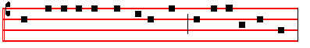
The Passion of our Lord Jesus Christ according to Matthew. (xxvj and xxvij)

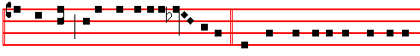
AT that time: Jesus said unto his dis-ciples:  Ye know that after two days is the
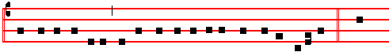
feast of the passover, and the Son of man is betrayed to be crucified. C. Then
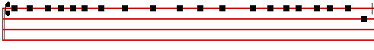
assembled together the chief priests, and the scribes, and the elders of the people,

22
Another Antiphon. John 12. Tone v
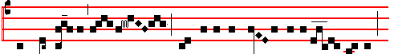
When the people heard that Jesus was coming to Jeru- salem,
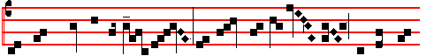
they took branches of palm-trees: and went forth to meet him, and the child-
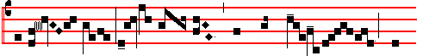
ren cried saying: This is he that should come for 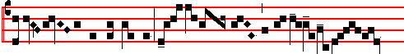
the salvat- ion of the people. This is our salva- tion

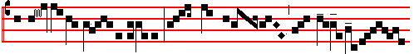
and the redemption of Isra-el. How great is he, whom Thrones
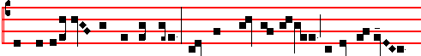
and Dominations go forth to meet! Fear not, daughter of Sion: behold thy King
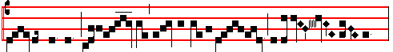
cometh to thee, sit- ting upon an ass's colt, as it is written.
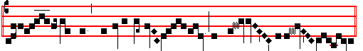
Hail, O King, Creator of the world, who art come to re- deem us.

11
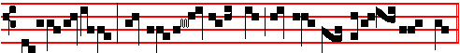
: they trust- ed in thee, and thou didst deli- ver them.
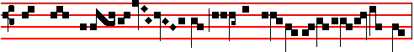
 They called upon thee, and were holp- en:
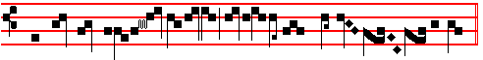
they put their trust in thee, and were not confound- ed.
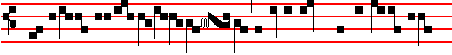
 But as for me, I am a worm, and no man
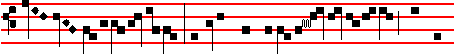
: a very scorn of men, and the
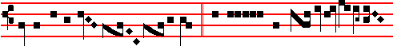 outcast of the peo- ple.  All they that see me
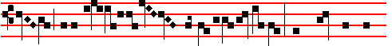
laugh me to scorn: they shoot out their
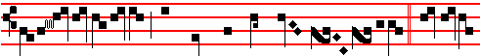
lips, and shake their head, say- ing:  He trusted
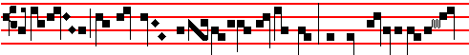
in God that he would deli- ver him: let him deliver him

20
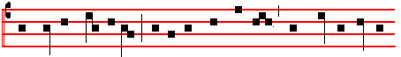
proclaim the Son of God: and in the praise of Christ their voices thunder
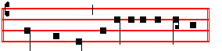
through the skies: Hosanna in the highest.

Another Antiphon. Tone vij
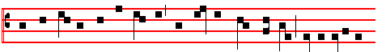
With the Angels and the children may we be found faithful, crying unto the
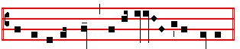
vanquisher of death: Hosanna in the highest.

Another Antiphon. Tone iv
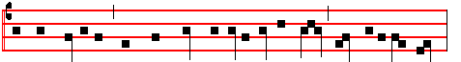
A great multitude, that were come together to the feast, cried unto the Lord:
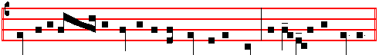
Blessed is he that cometh in the name of the Lord: Hosanna in the highest.

¶ As the Procession turns back, two or four Cantors enter the church, and the door being shut, with their faces toward the Procession, sing the first verse of the following hymn, Gloria laus, etc. which verse is repeated by the Priest and others outside the church. Then those within sing the other verses which follow, either all or a part, as shall seem good: and those who are without respond to each verse: Gloria laus, as at the  at the beginning.

13
Psalm 73. Tone viij
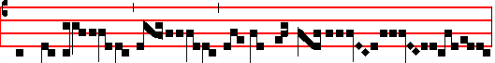
Thou hast hold- en me by my right hand;
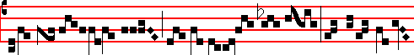
thou shalt guide me with thy coun- sel: and after that re-
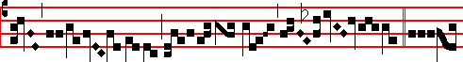
ceive me with glo- ry. . Tru-
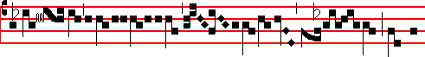
ly God is lov- ing unto Isra- el, ev-en 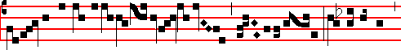
unto such as are of a clean heart; nevertheless,
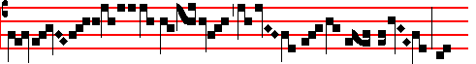
my feet were almost gone; my
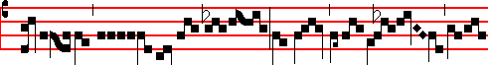
treadings had well nigh slipt: and why? I was grieved at the
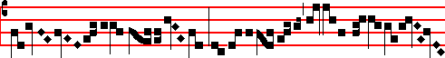
wick- ed, I do also see the un- god-

18
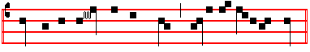
We to the King on his throne ut-ter the jubi-lant hymn.
 Glory and honour.
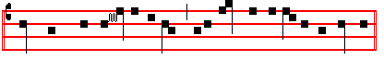
They were then pleas- ing to thee, unto thee our de-votion be pleasing;
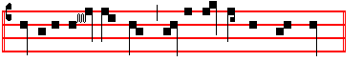
Merciful King, kind King, who in all goodness art pleased.  Glory and honour.
__________________________________________________________________

Or this version:
ALL glo- ry, laud, and hon-our , To thee, Redeem-er, King,
To whom the lips of children Made sweet hosannas ring.  All glory, laud.
Thou art the King of Is- rael, Thou David's royal Son,
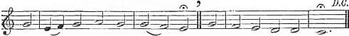
Who in the Lord's name comest, The King and blessed One. . All glory, laud.

The company of Angels. Are praising thee on high,
And mortal men and all things Created make reply. .All glory, laud.

The people of the Hebrews With palms before thee went;
Our praise and prayer and anthems Before thee we present.  All glory, laud.

To thee before thy passion They sang their hymns of praise;
To thee now high exalted Our melody we raise.  All glory, laud.

Thou didst accept their praises, Accept the prayers we bring,
Who in all good delightest, Thou good and gracious King.  All glory, laud.
__________________________________________________________________

Then the Subdeacon with the foot of the Cross knocks at the door, which being

15
straightway opened, the Procession enters the Church singing : Tone ij
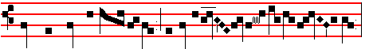
 When the Lord entered the holy ci- ty,
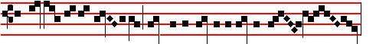
the children of the Heb- rews, foretelling the resurrection of life, *
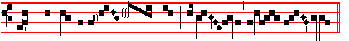
With branches of palm cried: Hosan- na in the high- est.
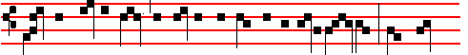
 When the people heard that Jesus was coming to Jerusa- lem, they went
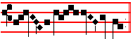
forth to meet him. With branches. And Glory be is not said.
¶ Then Mass is celebrated, and branches are held in the hands, while the Passion and Gospel are sung only.
Station at St. John Lateran.
INTROIT. Psalm 22. Domine, ne longe Tone viij
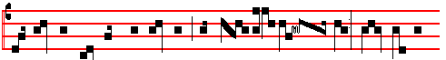
BE not thou far from me, O Lord, thou art my suc- cour, haste thee to
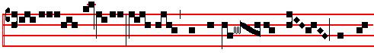
help me: save me from the lion's mouth, thou hast
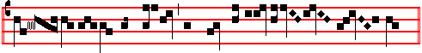
heard me al- so from a-mong the horns of the u- ni- corns.
16
Psalm ibid.
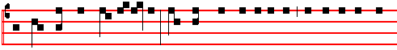
My God, my God, look upon me, why hast thou forsaken me: and art so far from
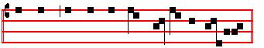
my health, and from the words of my com-plaint? Be not.
KYRIE Salve Tone x, 3
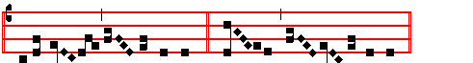
Kyri e *e- le- i- son iij Chri- ste e- le- i- son iij
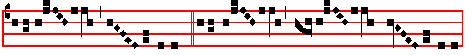
Kyri-e e- e- le-i- son ij Kyrie e- * ** e- le-ison.

COLLECT
ALMIGHTY and everlasting God, who didst cause our Saviour to take upon him our flesh, and to suffer on the cross, that mankind might follow the example of his humility: mercifully grant; that we may both keep in mind the lessons of his patience, and be made partakers of his resurrection. Through the same.
And this Collect only is said, even if a Commemoration has been made in the Office.
The LESSON from the Epistle of blessed Paul the Apostle to the Philippians
(ij, 5.)
BRETHREN: Let this mind be in you, which was also in Christ Jesus: who, being in the form of God, tbought it not robbery to be equal with God: but made himself of no reputation, and took upon him the form of a servant, and was made in tbe. likeness of men. And being found in fashion as a man, he humbled himself, and became obedient unto death, even the death of the cross. Wherefore God also hath highly exalted him, and given him a name which is above every name: (here genuflect) that at the name of Jesus every knee should bow, of things in heaven, and things in earth, and things under the earth: and that every tongue should confess that Jesus Christ is Lord, to the glory of God the Father.

GRADUAL
17
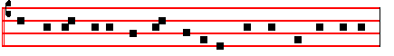
GLORY and honour and praise be to thee, our King and Redeemer,
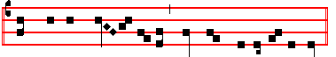
Christ, to whom children of old loved their Hosannas to raise. . Glory and honour.
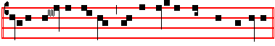
Israel's Monarch art thou, and the glorious Offspring of David,
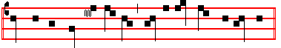
Thou that approachest, a King, blest in the Name of the Lord.  Glory and honour.
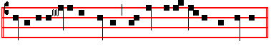
Glory to thee in the highest, the heaven-ly armies are singing;
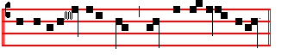
Glo-ry to thee upon earth, man and crea- tion reply.  Glory and honour.
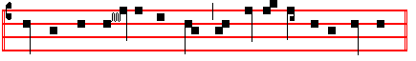
Met thee with palms in their hands that day the folk of the Heb- rews.
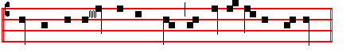
We with our prayers and our hymns now to thy presence approach.
 Glory and honour.
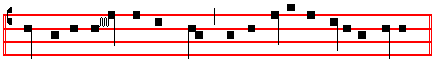
They to thee prof- fered their praise for to herald thy dolorous Passion;

14
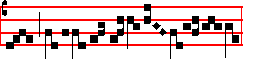
ly in such prosper- i- ty.
TRACT. Psalm 22. Tone ij
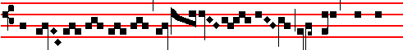
My God, my God, look up-
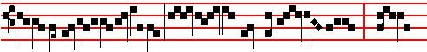
on me: why hast thou forsa- ken me? . And 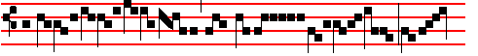
art so far from my health, and
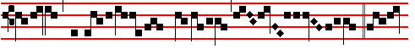
from the words of my com-plaint?  O my
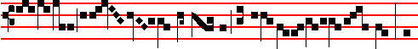
God, I cry in the daytime, but thou hear- est not: and
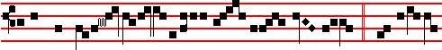
in the night sea- son al-so I take no rest.  And thou
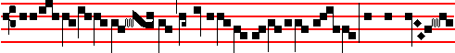
continuest ho-ly, O thou worship 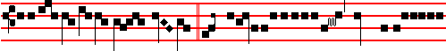
of Is- ra- el.  Our fath- ers hoped in thee
19
Another Antiphon. Tone viij
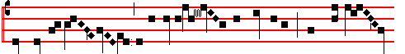
Six days before the solemnity of the Passover, when the Lord
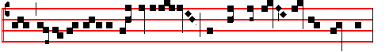
came in- to the city of Je- rusalem, the children went forth to meet him:
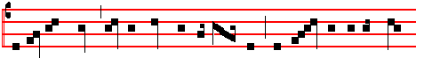
and in their hands carried branches of palm trees, and cried with a loud voice,
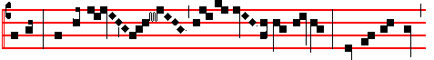
saying: Hosanna in the highest: blessed art thou,
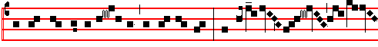
that art come in the multitude of thy mercies: Hosan- na
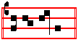
in the highest.

Another Antiphon. Tone viij
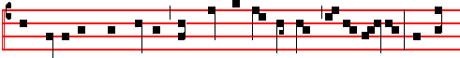
The multitudes with flowers and palms go forth to meet the Redeemer: and ren-
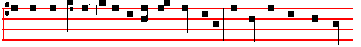
der worthy homage to the triumphant conqueror: the Gentiles with their lips

12
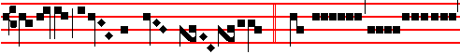
, if he will have him.  They stand star- ing
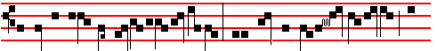
and looking up- on me: they part my gar- ments a-
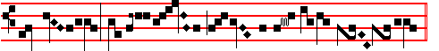
mong them, and cast lots up- on my ves- ture.
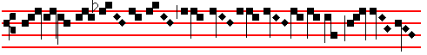
 Save me from the
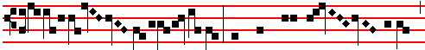
li-on's mouth: thou hast heard me al-so
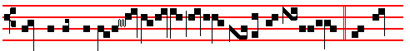
from among the horns of the u- ni-corns.  O praise
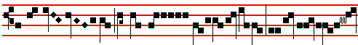
the Lord, ye that fear him: magni-fy him
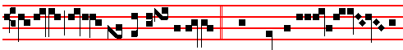
, all ye of the seed of Jacob.  They shall be counted unto the
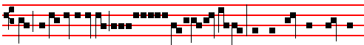
Lord for a generation: they shall come, and the heavens shall de-

21
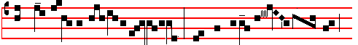 the colt of an ass tied, whereon never man sat: 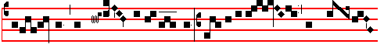
loose him, and bring him un-to me. If any man say ought un- 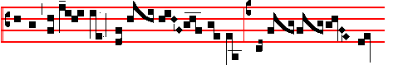
to you, ye shall say: The Lord hath need of him. They loose him and bring 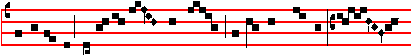
him to Jesus: and put on him their clothes, and set him thereon: some 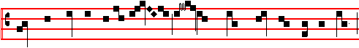
spread their garments in the way: oth- ers strawed branches from the trees:
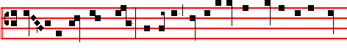
and they that followed, cried: Hosanna, blessed is he that cometh in the name
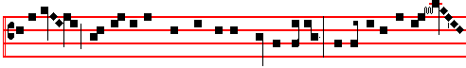
of the Lord: blessed is the kingdom of our father David: Hosanna in the high-
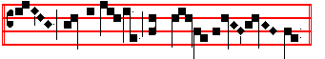
est: Son of David, have mercy upon us.

10
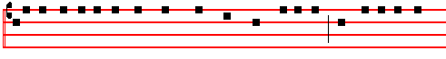
unto the palace of the high priest, who was called Caiaphas: and consulted that
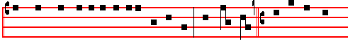
they might take Jesus by subtilty, and kill him. But they said: S. Not on the feast
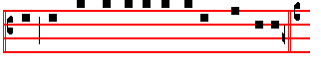
day, lest there be an uproar among the people. And the rest, as fully noted in
the Chant of the Passion of Our Lord. C. Now when Jesus was in Bethany, in the ouse of Simon the leper, there came unto him a woman having an alabaster box of very precious ointment, and poured it on his head, as he sat at meat. But when his disciples saw it, they had indignation, saying: S. To what purpose is this waste? For this ointment might have been sold for much, and given to the poor. C. When Jesus understood it, he said unto them :  Why trouble ye the woman? for she hath wrought a good work upon me. For ye have the poor always with you: but me ye have not always. For in that she hath poured this ointment on my body, she did it for my burial. Verily I say unto you, Wheresoever this Gospel shall be preached in the whole world, there shall also this, that this woman hath done, be told for a memorial of her. C. Then one of the twelve, called Judas Iscariot, went unto the chief Priests, and said unto them; S. What will ye give me, and I will deliver him unto you? C. And they covenanted with him for thirty pieces of silver. And from that time he sought opportunity to betray him. Now the first day of the feast of unleavened bread the disciples came to Jesus, saying unto him: S. Where wilt thou that we prepare for thee to eat the passover? C. And he said:  Go into the city to such a man, and say unto him: The Master saith: My time is at hand, I will keep the passover at thy house with my disciples. C. And the disciples did as Jesus had appointed them, and they made ready the passover. Now when the even was come, he sat down with the twelve. And as they did eat, he said:  Verily I say unto you, that one of you shall betray me. C. And they were exceeding sorrowful, and began every one of them to say unto him: S. Lord, is it I? C. And he answered and said:  He that dippeth his hand with me in the dish, the same shall betray me. The Son of man goeth as it is written of him: but woe unto that man by whom the Son of man is betrayed: it had a been good for that man if he had not been born. C. Then Judas, which betrayed him, answered and said, S.

23
Let us pray. COLLECT
O GOD, who didst send forth thy Son, Jesus Christ our Lord, into the world for our salvation, thar he might humble himself to be made like unto us, and call us back to thee: before whom, at his coming to Jerusalem for the fulfilling of the Scriptures, the multitude of the people that believed with faithful devotion strawed their raiment and palm branches in the way: grant, we beseech thee : that we may so prepare for him the. way of faith, that, every stone of stumbling and rock of offence being done away, our works may blossom before thee with branches of righteousness: and that we may be found worthy to follow in his footsteps: Who liveth and reigneth with thee.

¶ The blessing being completed, the senior of the Clergy goes up to the Altar and presents a blessed branch to the Celebrant, who does not genuflect; nor kiss the hand of him who gives it. Then the Celebrant, standing before the Altar, turns to the people and distributes the branches, first to the senior from whom he received his, then to the Deacon and Subdeacon vested, and to the other clergy severally in order, last of all to the laity, all genuftecting and kissing the branch and the hand of the Celebrant, except Prelates, if they are present. And when he begins to distribute, the Choir sings. the following Antiphons:
Tone j, 6
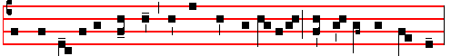
The children of the Hebrews bearing branches of olive, went out to meet the Lord,
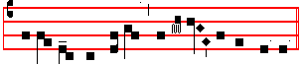
crying out and saying: Hosanna in the highest.

Another Antiphon. Tone j, 6
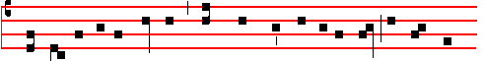 The children of the Hebrews spread their garments in the way and cried out, 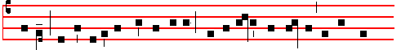 saying: Hosanna to the Son of David: blessed is he that cometh in the name

8
sword shall perish with the sword. Thinkest thou that I cannot now pray to my Father, and he shall presently give me more than twelve legions of Angels ? But how then shall the Scriptures be fulfilled, that thus it must be? C. In that same hour said Jesus to the multitudes:  Are ye come out as against a thief with swords and staves for to take me? I sat daily with you teaching in the temple, and ye laid no hold on me. C. But all this was done, that the Scriptures of the. Prophets might be fulfilled. Then all the disciples forsook him, and fled. And they that had laid hold on Jesus led him away to Caiaphas the high priest, where the scribes and the elders were assembled. But Peter followed him afar off unto the high priest's palace. And went in, and sat with the servants to see the end. Now the chief priests, and elders, and all the council; sought false witness against Jesus, to put him to death: but found none, yea, though many false witnesses came, yet found they none. At the last came two false witnesses, and said: S. This fellow said: I am able to destroy the temple of God, and to build it in three days. C. And the high priest arose, and said unto him: S. Answerest thou nothing? what is it which these witness against thee? C. But Jesus held his peace. And the high priest I answered and said unto him: S. I adjure thee by the living God, that thou tell us whether thou be the Christ, the Son of God. C. Jesus saith unto him:  Thou hast said. Nevertheless I say unto you: Hereafter shall ye see the Son of man sitting on the right hand of power, and coming in the clouds of heaven. C. Then the high priest rent his clothes, saying: S. He hath spoken blasphemy: what further need have we of witnesses? Behold, now ye have heard his blasphemy: what think ye? C. They answered and said: S. He is guilty of death. C. Then did they spit in his face, and buffeted him, and others smote him with the palms of their hands, saying: S. Prophesy unto us, thou Christ, who is he that smote thee? C. Now Peter sat without in the palace: and a damsel came unto him, saying: S. Thou also wast with Jesus of Galilee. C. But he denied before them all, saying: S. I know not what thou sayest. C. And when he was gone out into the porch, another maid saw him, and said unto them that were there: S. This fellow was also with Jesus of Nazareth. C. And again he denied with an oath: I do not know the man. And after a while came unto him they that stood by, and said to Peter: S. Surely thou also art one of them: for thy speech bewrayeth thee. C. Then began he to curse and to swear, saying: S. I know not the man. C. And immediately the cock crew. And Peter remembered the word of Jesus, which said unto him: Before the cock crow, thou shalt deny me thrice. And he went out, and wept bitterly. When the morning was come, all the chief priests and elders of the people took counsel against Jesus, to put him to death. And when they had bound him, they led him away, and delivered him to Pontius Pilate the governor. Then Judas who had betrayed him, when he saw that he was condemned, repented himself, and brought again the thirty pieces of silver to the chief priests and elders, saying: S. I have sinned, in that I have betrayed the innocent blood. C. And they said: S. What is that to us? See thou to that. C. And

25
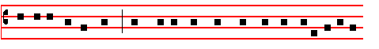
and rulers of this world, they confess the great name of thine only begotten
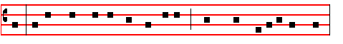
Son. Before whom Angels and Archangels, Thrones and Dominations stand:
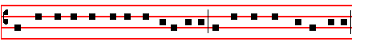
and with all the host of the heavenly army, do sing the hymn of thy glory,
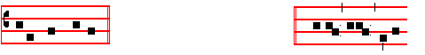
evermore saying: And the Sanctus is sung by the Choir. HOLY, Holy, Holy
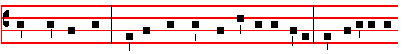
Lord, God of Hosts. Heaven and earth are full of thy glory Hosanna in the
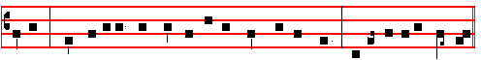
highest. Blessed is he that cometh in the name of the Lord. Hosanna in the highest.
 The Lord be with you.  And with thy spirit.
Let us pray COLLECT
WE beseech thee, O Lord holy Father almighty, everlasting God: that thou wouldest vouchsafe to bless and sanctify this creature of olive, which thou hast bidden to spring from the wood of the tree, which likewise the dove, returning to the ark, did bear in her mouth: that all who shall receive thereof, may obtain for themselves protection both in body and soul: and let it be, a Lord, a remedy for our salvation, a sacrament of thy grace. Through.

Let us pray. COLLECT
O GOD, who dost gather together the things which: are dispersed abroad, and dost preserve that which thou dost gather: who didst bless the people when they went forth bearing branches to meet Jesus: bless also these branches of

6
vinegar to drink mingled with gall. And when he had tasted thereof, he would not drink. And they crucified him, and parted his garments, casting lots: that it might be fulfilled, which was spoken by the Prophet: They parted my garments among them, and upon my vesture did they cast lots. And sitting down they watched him there. And set up over his head his accusation written: This is Jesus the King of the Jews. Then were there two thieves crucified with him: one on the right hand, and another on the left. And I they that passed by reviled him, wagging their heads, and saying: S. Thou that destroyest the temple, and buildest it in three days: save thyself. If thou be the Son of God, come down from the cross. C. Likewise also the chief priests mocking him, with the scribes and elders, said; S. He saved others, himself he cannot save; if he be the King of Israel, let him now come down from the cross, and we will believe him; he trusted in God; let him deliver him now, if he will have him; for he said: I am the Son of God. C. The thieves also, which were crucified with him, cast the same in his teeth. Now from the sixth hour there was darkness over all the land unto the ninth hour. And about the ninth hour Jesus cried with a loud voice, saying:  Eli, Eli, lama sabachtbani? C. That is to say:  My God, my God, why hast thou forsaken me? C. Some of them that stood there, when they heard that, said: S. This man calleth for Elias. C. And straightway one of them ran, and took a spunge, and tilled it with vinegar, and put it on a reed, and gave him to drink. The rest said: S. Let be, let us see whether Elias will come to save him. C. Jesus, when he cried again with a loud voice, yielded up the ghost.

(Here genuflect, and pause awhile)

And behold, the vail of the temple was rent in twain from the top to the bottom: and the earth did quake; and the rocks rent, and the graves were opened: and many bodies of saints which slept arose, and came out of the graves after his resurrection, and went into the holy city, and appeared unto many. Now when the centurion, and they that were with him, watching Jesus, saw the earthquake, and those things that were done, they feared greatly, saying: S. Truly this was the Son of God. C. And many women were there beholding afar off, which followed Jesus from Galilee, ministering unto him: among which was Mary Magdalene, and Mary the mother of James and Joses, and the mother of Zebedee's children. When the even was come, there came a rich man of Arimathea, named Joseph, who also himself was Jesus' disciple. He went to Pilate, and begged the body of Jesus. Then Pilate commanded the body to be delivered. And when Joseph had taken the body, he wrapped it in a clean linen cloth, and laid it in his own new tomb, which he had hewn out in the rock. And he rolled a great stone to the door of the sepulchre, and departed. And there was Mary Magdalene, and the other Mary, sitting over against the sepulchre.

27
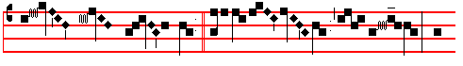 be done.  Watch and pray, that
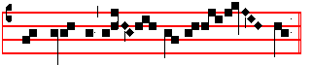
ye enter not into temp-ta- tion. The spirit indeed.

¶ During the singing of the , the Deacon places the book of the Gospels on the Altar, and the Priest, the Deacon ministering the incense-boat, places incense in the censer. Then the Deacon says: Cleanse my heart, takes the book from the Altar, and asks a blessing from the Priest: then, while the Subdeacon holds the book, he stands between two Acolytes holding lighted candles, signs the book, and censes it, and sings the Gospel, as below, in the usual way: after which the Subdeacon carries the book to be kissed by the Priest, who is censed by the Deacon.
 The Continuation of the holy GOSPEL according to Matthew (xxj, 1)
AT that time: When Jesus drew nigh unto Jerusalem, and was come to Bethphage unto the mount of Olives: then sent he two disciples, saying unto them: Go into the village over against you, and straightway ye shall find an ass tied, and a colt with her: loose them and bring them unto me: and if any man say ought unto you, ye shall say, The Lord hath need of them, and straightway he will send them. All this was done, that it might be fulfilled which was spoken by the Prophet, saying: Tell ye the daughter of Sion: Behold thy King cometh unto thee, meek and sitting upon an ass, and a colt the foal of an ass. And the disciples went, and did as Jesus commanded them. And brought the ass, and the colt, and put on them their clothes, and they set him thereon. And a very great multitude spread their garments in the way: others cut down branches from thc trces, and strawed them in the way: and the multitudes that went before, and that followed, cried, saying: Hosanna to the Son of David: blessed is he that cometh in the name of the Lord.
After this the branches are blessed. The Priest, standing at the Epistle corner, says in the tone of the ferial Collect:
 The Lord be with you.  And with thy spirit. Let us pray.

COLLECT
INCREASE, O God, the faith of them that put their trust in thee, and graciously hear the prayers of thy humble servants: let thy manifold mercies descend upon

4
here all kneel
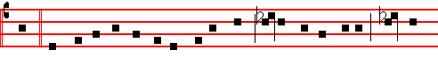
ven, and was in-carnate by the Holy Ghost of the Virgin Mary: and was
and rise
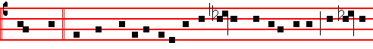
made man. And was crucified al-so for us under Pon-ti-us Pilate: he suf-fer
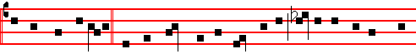
-ed, and was buri-ed. And the third day he rose again, according to the scrip-
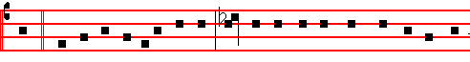
tures. And ascend-ed into heaven: And sitteth on the right hand of the Fa-
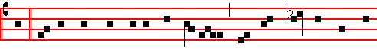
ther. And he shall come again with glo- ry, to judge both the quick and
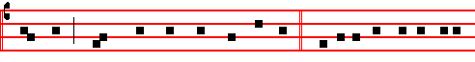
the dead : Whose kingdom shall have no end. And I believe in the Holy
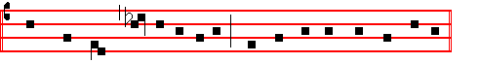
Ghost, the Lord, and Giver of life: Who procee- deth from the Father :
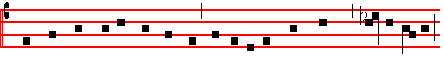 Who with the Father and the Son to-ge-ther is worshipped and glori-fied:

29
of Egypt. And the whole congregation of the children of Israel murmured against
Moses and Aaron in the wilderness. And the children of Israel said unto them: Would to God we had died bv the hand of the Lord in the land of Egypt, when we sat by the flesh pots, and when we did eat bread to the full: for ye have brought us forth into this wilderness, to kill this whole assembly with hunger. Then said the' Lord unto Moses: Behold, I will rain bread from heaven for you: and the people shall go out and gather a certain rate every day: that I may prove them, whether they will walk in my law or no. And it shall come to pass, that on the sixth day they shall prepare that which they bring in: and it shall be twice as much as they gather daily. And Moses and Aaron said unto all the children of Israel: At even, then ye shall know that the Lord hath brought you out from the land of Egypt: and in the morning, then ye shall see the glory of the Lord.

¶ Then is sung for the Gradual
 John 11. Tone ij
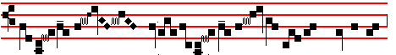
The chief priests and the Pharisees
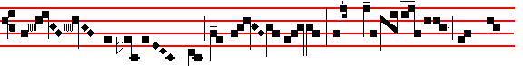
gath- ered a coun- cil, and said: What do we, for this
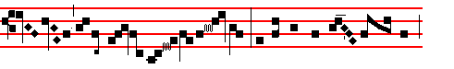 man doeth many mir- ac- les? If we let him thus a- lone, 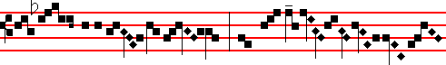
all men will believe on him: * And the Ro- mans

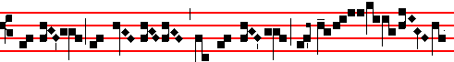
shall come. and take a- way both our place and na-

2
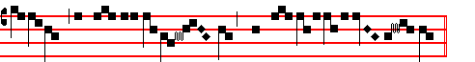
thirs- ty they gave me vi-ne- gar to drink.
SECRET
GRANT, we beseech thee, O God: that the gift which we offer in the sight of thy majesty may obtain for us grace to serve thee with devotion, and bring us in the end to everlasting felicity. Through.
Solemn Preface of the Cross. Sanctus on Sundays in Lent 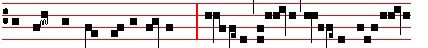
with suppliant thanksgiving saying:  Ho- ly, Ho- ly, Ho- ly, Lord God
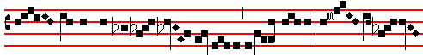
of Hosts. Heaven and earth are full of thy glory. Ho- sanna
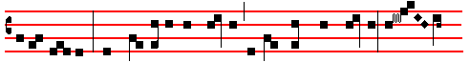
in the highest. Blessed is he that cometh in the name of the Lord. Ho- san-
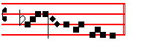
na in the highest.

Agnus Dei on Sundays in Lent Tone v
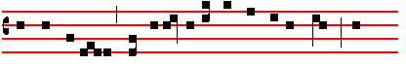
O Lamb of God, that takest away the sins of the world: have

31

