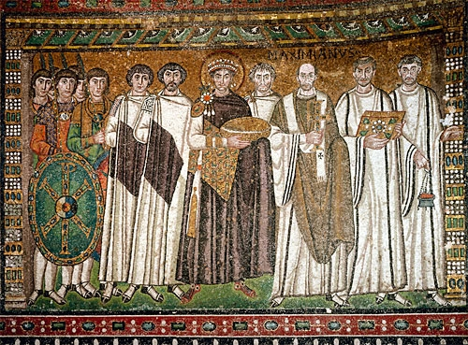

S.Peter Orthodox Truth Service
February, 2007

ENGLISH ORTHODOX
MISSAL

THE HOLY MASS

OF S. GREGORY THE GREAT

Merbecke musical setting

ASPERGES ME
On all Sundays of the year except in Eastertide
Mode vij
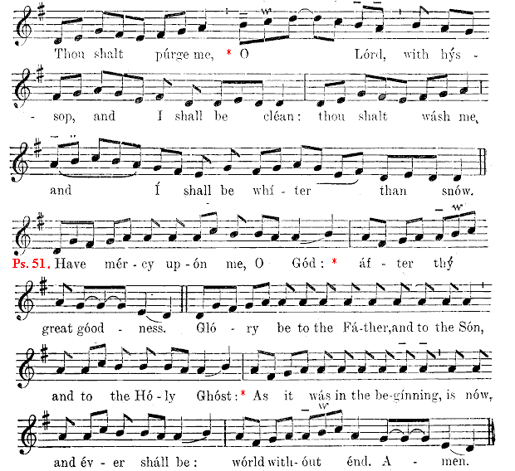
repeat Antiphon Thou shalt purge me.

¶ On Passion Sunday and Palm Sunday Glory be is not sung, but the Psalm Have mercy is followed immediately by the Antiphon Thou shalt purge me.
 O Lord, shew thy mercy up- on us.
 And grant us thy salva- tion.
 O Lord, hear my prayer.
 And let my cry come un- to thee
 The Lord be with you.
 And with thy spi- rit.  Let us pray.

GRACIOUSLY hear us, O Lord holy, Father almighty, everlasting God: and vouchsafe to send thy holy Angel from heaven; to guard and cherish, to protect and visit, and to defend all who dwell in this thy holy habitation. Through Christ our Lord.  Amen.

