THE ORDER OF THE MASS

Mass is normally said after one of the Hours: after Prime for a requiem, after Terce and Asperges me on Sundays, after Terce on Feasts, after Sext on weekdays and after None on fasts.
________________________________________________________________________

The Prayers at the Foot of the Altar may be said by the Ministers while a Hymn is sung:

Priest: In the Name of the Father, and of the  Son, and of the Holy  Ghost.
 Amen.
Priest: I will go unto the altar of God
 Even unto the God of my joy and gladness.
Ps.43.
(Omitted in Passiontide, and in requiems).

Priest. Give sentence with me, O God, and defend my cause against the ungodly people :
O deliver me from the deceitful and wicked man.
 For thou art the God of my strength, why hast thou put me from thee : and why go I so heavily, while the enemy oppresseth me?
Priest. O send out thy light and thy truth, that they may lead me : and bring me to thy holy
hill, and to thy dwelling.
 And that I may go unto the altar of God, even unto the God of my joy and gladness: and upon the harp will I give thanks unto thee, O God, my God.
Priest. Why art thou so heavy, O my soul : and why art thou so disquieted within me?
 O put thy trust in God : for I will yet give him thanks, which is the help of my countenance, and my God.
Priest. Glory be to the Father, and to the Son, and to the Holy Ghost.
 As it was in the beginning, is now, and ever shall be : world without end. Amen.
Priest.I will go unto the altar of God.
 Even unto the God of my joy and gladness.
Priest. Our  help is in the name of the Lord.
 Who hath made heaven and earth.

Priest. I confess ...... you, brethren.........to the Lord our God.
 Almighty God have mercy upon thee, forgive thee thy sins, and bring thee to everlasting life. Priest: Amen.

.I confess to almighty God, to blessed Mary ever Virgin, to blessed Michael the Archangel, to blessed John Baptist, to the holy Apostles Peter and Paul, to all the Saints, and to thee, father : that I have sinned exceedingly in thought, word and deed: through my fault, through my fault, through my most grievous fault. Therefore I pray blessed Mary ever Virgin, blessed Michael the Archangel, blessed John

1
Baptist, the holy Apostles Peter and Paul, all the Saints, and thee, father, to pray for me to the Lord our God.
Priest: Almighty God have mercy upon you, forgive you your sins, and bring
you to everlasting life. .Amen.
Priest: The almighty and merciful Lord grant unto us pardon, + absolution and remission
of our sins.  Amen.
Priest: Wilt thou not turn again, and quicken us, O God?
. That thy people may rejoice in thee.
Priest: O Lord, shew thy mercy upon us.
. And grant us thy salvation.
Priest: O Lord, hear my prayer.
. And let my cry come unto thee.
Priest: The Lord be with you.
. And with thy spirit.
Priest: Let us pray.
TAKE away from us, we beseech thee, O Lord, our iniquities: that we may be worthy to enter with pure minds into the Holy of holies. Through Christ, our Lord. Amen.
WE pray thee, O Lord, by the prayers of thy Saints, whose relics are here, and of all the Saints: that thou wouldest vouchsafe to pardon all my sins. Amen.

THE INTROIT of the day is sung or said. Then:
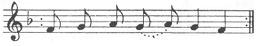
Ky- ri- e e- lei- son
Ky- ri- e e- lei- son
Ky- ri- e e- lei- son
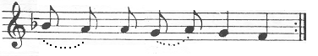
Chris- te e- lei- son
Chris- te e- lei- son
Chris- te e- lei- son
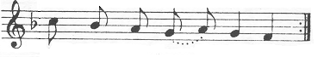
Ky- ri- e e- lei- son
Ky- ri- e e- lei- son
Ky- ri- e e- lei- son

2
The following hymn is said only on Sundays and Feasts:

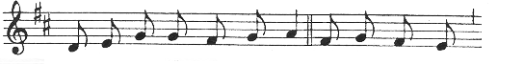 GLORY be to God on high, And in earth peace, 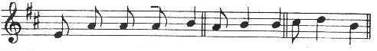 good will towards men. We praise thee. We bless thee.
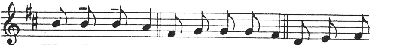
We wor- ship thee. We glo- ri- fy thee. We give thanks 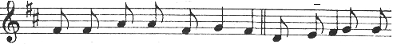 to thee for thy great glo- ry. O Lord God, heaven- 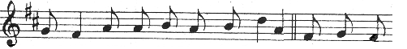
ly King, God the Fa- ther al- migh-ty. O Lord, the
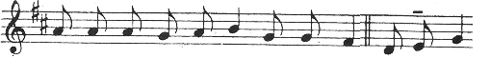
on- ly- -be- got- ten Son Je- su Christ. O Lord God,
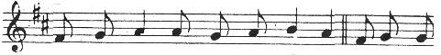
Lamb of God, Son of the Fa- ther. That tak- est
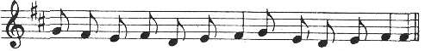
a- way the sins of the world, have mer- cy up- on us.

3

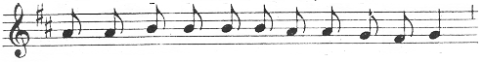
Thou that tak- est a- way the sins of the world,
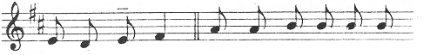
re- ceive our prayer. Thou that sit- test at the
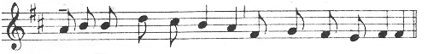 right hand of God the Fa- ther, have mer- cy up- on us.
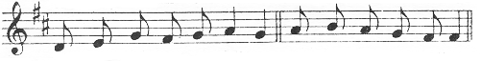
For thou on- ly art ho- ly. Thou on- ly art the Lord
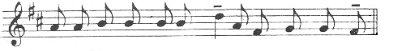
Thou on- ly, O Je- su Christ, with the Ho- ly Ghost,
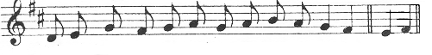
art most high in the glo- ry + of God the Fa-ther. A-men.
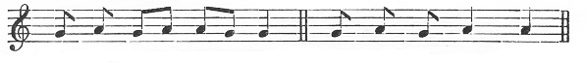
Priest: The Lord be with you. . And with thy spi- rit.
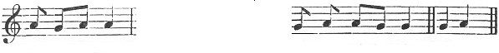 Let us pray. The Collect(s), ending: world with- out end.  Amen.

The EPISTLE, GRADUAL, and TRACT or ALLELUIA,
with the VERSE, or SEQUENCE.

4
Deacon or Priest, silently:
CLEANSE my heart and my lips, O almighty God, who didst cleanse the lips of the prophet Isaiah with a live coal; so of thy gracious mercy vouchsafe to cleanse me, that I may worthily proclaim thy holy Gospel. Through Christ, our Lord. Amen.
Bid, Lord a blessing.
Priest: The Lord be in thy or my heart and on thy or my lips, that thou mayest or I may worthily proclaim his holy Gospel. (and if blessing the Deacon: In the name of the Father, and of the Son,  and of the Holy Ghost.) Amen.

Deacon or Priest:
The Lord be with you  And with thy spi- rit
The Continuation or the Beginning of the
holy  Gospel ac- cord-ing to N.  Glo- ry + be + to + thee, O Lord.
The HOLY GOSPEL is sung or read.
.Praise be to thee, O Christ.
Priest, silently: Through the words of the Gospel may our sins be blotted out.

(Notices and sermon, if any)
THE NICENE CREED
( on Sundays and some Feasts)
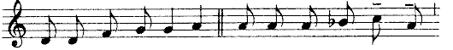
Priest: I BELIEVE in one God,  the Fa- ther al- migh- ty,
ma- ker of hea- ven and earth, and of all things
vis- ib- le and in- vis- ib- le. And in one Lord
Jes- us Christ, the on- ly- be- got- ten Son of God,

5
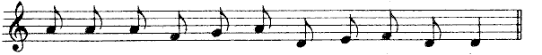
Be- got- ten of his Fa- ther be- fore all worlds.
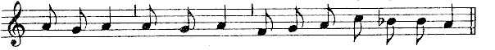
God of God, Light of Light, ve- ry God of ve- ry God,
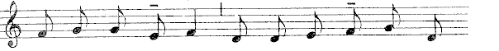
Be- got- ten, not made, Be- ing of one sub- stance
with the Fa- ther: by whom all things were made.
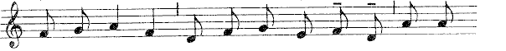
Who for us men, and for our sal- va- tion, came down

Here all kneel
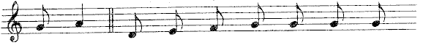
from heaven, and was in- carn- ate by the
Ho- ly Ghost of the Vir- gin Ma- ry: and was made man.

and rise
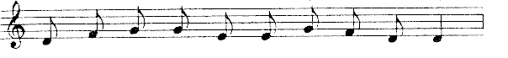
And was cru- ci- fi- ed al- so for us
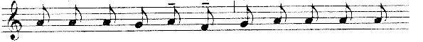
un- der Pon- tius Pi- late: he suf- fer- ed, and

6
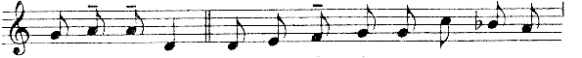
was bu- ri- ed. And the third day he rose a- gain,
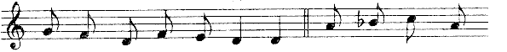
ac- cord- ing to the scriptures. And as- cend- ed
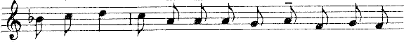
in- to heaven: And sit- teth on the right hand of the
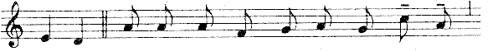
Fa- ther. And he shall come a- gain with glo- ry,
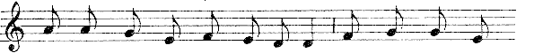
to judge both the quick and the dead: Whose kingdom shall
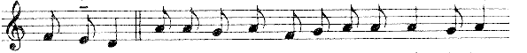
have no end. And I be- lieve in the Ho- ly Ghost, the Lord, 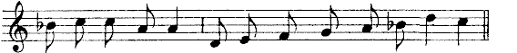
and Giv-er of life: Who pro- ceed- eth from the Fa- ther :
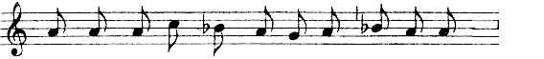
Who with the Fa- ther and the Son to- ge- ther
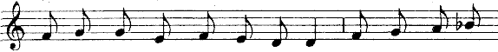
is wor- ship- ped and glo- ri- fied: Who spake by the
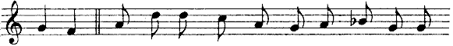
Pro- phets. And I be- lieve one ho- ly, ca- tho- lick

7
and a- pos- to- lick Church I ack- now- ledge
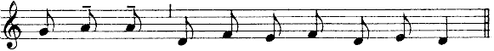
one Bap- tism for the re- mis- sion of sins.
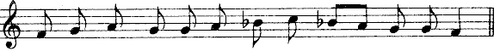
And I look for the re- sur- rec- ti-on of the dead,

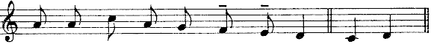
and the life  of the world to come. A- men.
Priest: The Lord be with you.  And with thy spi- rit.
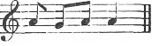
Priest: Let us pray.
The OFFERTORY is sung or said. A Hymn may follow.
Priest, silently:
RECEIVE, O holy Father, almighty, everlasting God, this spotless host, which I, thine unworthy servant, offer unto thee, my living and true God, for my numberless sins, offences and negligences, and for all who stand around, as also for all faithful christians, both living and departed: that to me and to them it may avail for salvation unto life eternal. Amen.
O GOD, who didst wonderfully create, and yet more wonderfully renew the dignity of man's nature: grant that by the mystery of this + water and wine we may be made partakers of his divinity, who vouchsafed to share our humanity, Jesus Christ thy Son our Lord: Who liveth and reigneth with thee in the unity of the Holy Ghost, God: throughout all ages, world without end. Amen.
WE offer unto thee, O Lord, the chalice of salvation, humbly beseeching thy mercy: that in the sight of thy divine majesty it may ascend as a sweet-smelling savour for our salvation, and that of the whole world. Amen.
IN a humble spirit, and with a contrite heart may we be accepted of thee, O Lord: and so let our sacrifice be offered in thy sight this day, that it may be pleasing unto thee, O Lord God.
8
COME, O sanctifier almighty, everlasting God: and bless this sacrifice, prepared for thy holy name.
(If incense is offered:
THROUGH the intercession of blessed Michael the Archangel, standing at the right hand of the altar of incense, and all his elect. may the Lord vouchsafe to bl+ess this incense, and to receive it for a sweet-smelling savour. Through Christ, our Lord. Amen.
MAY this incense, which thou has blessed, ascend unto thee, O Lord: and let thy mercy descend upon us.
Ps.141
LET my prayer, O Lord, be set forth in thy sight as the incense: and let the lifting up of my hands be an evening sacrifice. Set a watch, O Lord, before my mouth, and keep the door of my lips: O let my heart not be inclined to any evil thing, let me not be occupied in ungodly works.
The Lord kindle in us the fire of his love, and the flame of everlasting charity. Amen
Ps. 26
I WILL wash my hands in innocency, O Lord: and so will I go to thine altar: That I may shew the voice of thanksgiving, and tell of all thy wonderous works. Lord, I have loved the habitation of thy house and the place where thine honour dwelleth. O shut not up my soul with the sinners, nor my life with the blood-thirsty. In whose hands is wickedness: and their right hand is full of gifts. But as for me, I will walk innocently: O deliver me, and be merciful unto me. My foot standeth right: I will praise the Lord in the congregations.
(and, except in passiontide and in requiems:
Glory be to the Father, and to the Son, and to the Holy Ghost.
As it was in the beginning, is now, and ever shall be: world without end. Amen.)

RECEIVE, O holy Trinity, this oblation which we offer unto thee in memory of the passion, resurrection, and ascention of Jesus Christ, our Lord: and in honour of blessed Mary ever Virgin, of blessed John Baptist, of the holyApostles Peter and Paul, of these, and of all the saints: that it may avail for their honour,and for our salvation: and may they, whose memory we celebrate on earth, vouchsafe to intercede for us in heaven. Through the same Christ, our Lord. Amen.

PRAY, brethren: that my sacrifice and yours may be acceptable to God the Father almighty.
THE Lord receive the sacrifice at thy hands, to the praise and glory of his name, and to our benefit, and that of all his holy Church.

Priest, silently: Amen. and the SECRET prayer(s), ending:
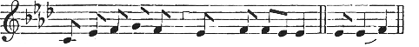
Throughout all ag- es, world with- out end.  A- men.

9
Priest: The Lord be with you.  And with thy spi- rit.  Lift up
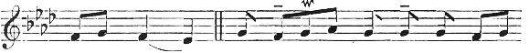
your hearts . .We lift them up un- to
the Lord.  Let us give thanks un- to our
Lord God  It is meet and right so to do.
THE PREFACE
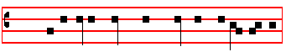
Priest: It is very meet, right, just and sa- lu- ta- ry, and the rest as noted in the Missal, and if there is no Proper Preface, he continues as follows:
that we should at all times and in all places give thanks unto thee: O Lord holy Father almighty, everlasting God. Through Christ our Lord. Through whom the Angels praise, the Dominations adore, the powers fear thy majesty. The Heavens and the heavenly Virtues and the blessed Seraphim together sing thy praise with exultation. With whom, we beseech thee, bid that our voices also be admitted, with suppliant thanksgiving saying:

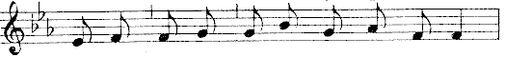
 Ho- ly, Ho- ly, Ho- ly, Lord God of Hosts.
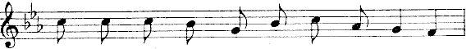
Hea- ven and earth are full of thy glo- ry.
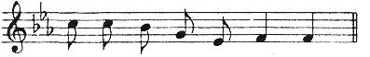
Ho- san- na in the high- est.

10
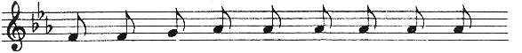
Bles + sed is he that com- eth in the
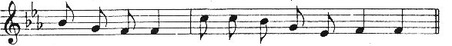
name of the Lord. Ho- san- na in the high- est.

The music may be prolonged while the Priest says the canon quietly

CANON OF THE MASS

THEREFORE, most merciful Father, through Jesus Christ thy Son our Lord, we humbly pray and beseech thee, He kisses the Altar and with hands joined before his breast, says: that thou accept and bless He signs thrice over the Host and Chalice together, saying : these  gifts, these  offerings, these  holy and unspotted sacrifices, With extended hands he proceeds: which, first, we offer unto thee for thy holy catholic Church: that thou vouchsafe to keep her in peace, to guard, unite, and govern her throughout the whole world : together with thy servant our Patriarch Ignatius, our Metropolitan Paul, and all the orthodox, and those who profess the catholic and apostolic faith.

Commemoration for the living.

REMEMBER, O Lord, thy servants and handmaids N. and N., He joins his hands, and prays a while for those for whom he intends to pray : then with extended hands proceeds : and all who stand around, whose faith and devotion unto thee are known and manifest, for whom we offer unto thee : or who themselves offer unto thee this sacrifice of praise, for and all who stand around, whose faith and devotion unto thee are known and manifest, for whom we offer unto thee : or who themselves offer unto thee this sacrifice of praise, for themselves, and for all to whom they are bound : for the redemption of their souls, for the hope of their salvation and safety : and who render their vows unto thee, the eternal, living and true God.
Infra Actionem

JOINING in communion and venerating the memory, first of the glorious ever Virgin Mary, Mother of our God and Lord Jesus Christ:
(the above section varies with the seasons)
as also of the blessed Apostles and Martyrs, Peter and Paul, Andrew, James, John, Thomas, James, Philip, Bartholomew, Matthew, Simon, and Thaddeus : Linus, Cletus, Clement, Xystus, Cornelius, Cyprian, Laurence, Chrysogonus, John and Paul, Cosmas and Damian : and of all thy saints; by whose prayers grant, that in all things we may be defended with with the help of thy protection. He joins his hands. Through the same Christ, our Lord. Amen.

11
Holding his hands spread out over the Oblations, he says:

THIS oblation, therefore, of our bounden service, as also of all thy family, we beseech thee, O Lord, graciously to accept : and order our days in thy peace, and bid us to be delivered from eternal damnation, and to be numbered in the flock of thine elect. He joins his hands. Through Christ, our Lord. Amen.

(the above section varies with the seasons)

WHICH oblation do thou, O God, we beseech thee, vouchsafe in all things He signs thrice over the oblations, to make blessed, approved, ratified, reasonable, and acceptable : He signs once over the Host, that unto us it may become the Body and once over the Chalice, and Blood of thy most dearly beloved Son, He joins his hands, our Lord Jesus Christ.

WHO the day before he suffered, He takes the Host, took bread into His holy and venerable hands, He lifts up his eyes to heaven, and lifting up His eyes to heaven to thee, God, his almighty Father, He bows his head, giving thanks to thee, He signs over the Host, He blessed, brake and gave to His disciples, saying : Take and eat ye all of this.

Holding the Host with both hands between the thumbs and forefingers, he utters the words of consecration secretly, distinctly, and attentively over the Host and at the same time over all, if more are to be consecrated.

For this is my Body.

Having uttered these words, he immediately genuflects and adores the consecrated Host: rises, shews it to the people, replaces it upon the Corporal, and again genuflects and adores: and does not disjoin his forefingers and thumbs henceforth, except when the Host is to be handled, till after the ablution of his fingers. Then, having uncovered the Chalice, he says:

LIKEWISE after supper, He takes the Chalice in both hands, taking also this excellent Chalice into his holy and venerable hands: also He bows his head, giving thanks to thee, Holding the Chalice in his left hand, he signs over it with his right, he blessed, and gave to his disciples, saying: take and drink ye all of it.

He utters the words of consecration over the Chalice, attentively, continuously and secretly, holding it slightly raised.

For this is the Chalice of my Blood, of the new and eternal testament: the mystery of faith: which shall be shed for you and for many for the remission of sins.

Having uttered these words, he sets down the Chalice upon the Corporal, saying secretly:

12
As oft as ye do these things, ye shall do them in remembrance of me.

He genuflects and adores: rises, shews it to the people, sets it down,covers it, and genuflecting again adores. Then with hands extended he says:

WHEREFORE,O Lord, we also thy servants, together with thy holy people, mindful of the blessed passion of the same Christ thy Son our Lord, as also his resurrection from hell and glorious ascension into heaven: do offer unto thine excellent majesty of thine own gifts and bounty, He joins his hands and signs thrice over the Host and Chalice together, saying: a pure  victim, a holy  victim, a spotless  victim, He signs once over the Host, saying: the holy + Bread of eternal life, and once over the Chalice, saying: and the Chalice  of everlasting salvation.

With extended hands he proceeds:

UPON which vouchsafe to look with a favourable and gracious countenance: and to accept them, even as thou didst vouchsafe to accept the gifts of thy just servant Abel, and the sacrifice of our Patriarch Abraham: and the holy sacrifice, the spotless victim, which thy high priest Melchisedech offered unto thee.

Bowing profoundly, he says with hands joined and placed upon the Altar:

AND we beseech thee, O Lord, to send down thy Holy Spirit upon these offerings, that he would make this bread the precious Body of thy Christ, and that which is in this cup the precious Blood of thy son our Lord Jesus Christ, transmuting them by thy Holy Spirit. Amen. Amen. Amen.

WE humbly beseech thee, almighty God: command thou these to be brought by the hands of thy holy Angel to thine Altar on high, in the presence of thy divine majesty: that, as many of us He kisses the Altar, as by this partaking of the altar shall receive the most sacred He joins his hands, and signs once over the Host, and once over the Chalice, Body and Blood of thy Son, He signs himself, saying: may be fulfilled + with all heavenly benediction and grace. He joins his hands. Through the same Christ, our Lord. Amen.
Commemoration for the Departed

REMEMBER also, O Lord, thy servants and handmaids N. and N., who have gone before us with the sign of faith, and rest in the sleep of peace.

He joins his hands, and prays awhile for those departed for whom he intends to pray, then with extended hands proceeds:

To them, O Lord, and to all that rest in Christ, we beseech thee to grant a place of refreshing, light and peace. He joins his hands and bows his head, saying: Through the same Christ, our Lord. Amen.

13
He strikes his breast with his right hand, saying in a slightly louder voice:

TO us sinners also, With hands extended as before, he proceeds secretly: thy servants, trusting in the multitude of thy mercies, vouchsafe to grant some part and fellowship with thy holy Apostles and Martyrs: with John, Stephen, Matthias, Barnabas, Ignatius, Alexander, Marcellinus, Peter, Felicity, Perpetua, Agatha, Lucy, Agnes, Cecilia, Anastasia, and with all thy Saints: within whose fellowship we beseech thee admit us, not weighing our merit, but granting us forgiveness. He joins his hands. Through Christ,our Lord.

BY whom. O Lord, all these good things thou dost ever create, He signs over the Host and Chalice together, saying: dost sanc+tify, quick+en, ble+ss, and bestow upon us.

He uncovers the Chalice, genuflects, and takes the Host between the thumb and first finger of his right hand: and holding the Chalice with his left, he signs with the Host thrice from lip to lip of the Chalice, saying:

THROUGH  him, and with  him, and in  him, He signs with the Host itself between himself and the Chalice, saying: is unto thee, God the Father  almighty, in the unity of the Holy  Ghost, Elevating the Chalice a little with the Host, he says: all honour and glory.

He replaces the Host, covers the Chalice with the Pall, genuflects, rises and says in an audible voice, or sings:
He joins his hands 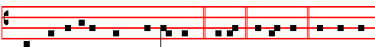 Throughout all ages, world without end.  Amen. Let us pray: Commanded
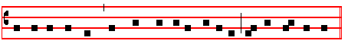
by saving precepts, and taught by divine example, we are bold to say:

He extends his hands, singing or saying:.
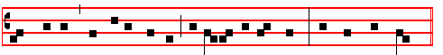
OUR Father, who art in heaven: Hallowed be thy name: Thy Kingdom come:

14
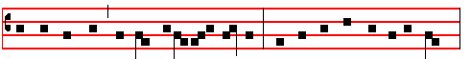
Thy will be done, in earth as it is in heaven .Give us this day our daily bread:
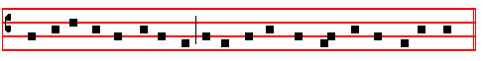 and for-give us our trespasses, as we forgive them that trespass against us.
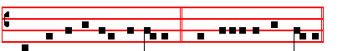
And lead us not into temptation.  But deliver us from evil.

The Priest says secretly: Amen.
Then he takes the Paten between the fore and middle fingers of his right hand, and holding it upright upon the Altar, says secretly:

DELIVER us, O Lord, we beseech thee, from all evils, past, present, and to come: and at the intercession of the blessed and glorious ever Virgin Mary, Mother of God, with thy blessed Apostles Peter and Paul, and with Andrew, and all the saints, He signs himself with the Paten from forehead to breast, favourably grant peace in our days: He kisses the Paten, that by the help of thine availing mercy we may ever both be free from sin and safe
from all distress.
He puts the Paten under the Host, uncovers the Chalice, genuflects, rises, takes the Host, and holding it with both hands over the Chalice, breaks it in the middle, saying:
Through the same Jesus Christ thy Son our Lord. He places the half which he holds in his right hand on the Paten. Then from the part which remains in his left hand, he breaks a particle, saying:
Who liveth and reigneth with thee in the unity of the Holy Ghost, God. He joins the other half, which he holds in his left hand, to the half laid upon the Paten, and retaining the small particle in his right hand over the Chalice, which he holds with his left by the knob below the cup, he says in an audible voice, or sings:

Throughout all a- ges, world without end. . A- men.
With the particle itself he signs thrice over the Chalice, saying:
The peaceof the Lord bealway withyou. And with thy spirit.

15
He puts the particle into the Chalice, saying secretly:
MAY this commixture and consecration of the Body and Blood of our Lord Jesus Christ be to us who receive it unto everlasting life. Amen.
He covers the Chalice, genuflects, rises, and bowing to the Sacrament, joins his hands, and beating his breast thrice, says in an audible voice:
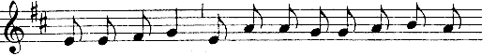
O LAMB of God, that tak- est a- way the sins of
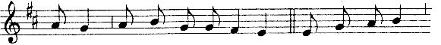
the world: have mer- cy up- on us. O Lamb of God,
that tak- est a- way the sins of the world:
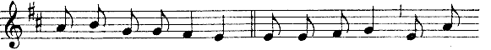
have mer- cy up- on us. O Lamb of God, that tak-
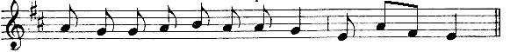
est a- way the sins of the world: grant us peace.
In Masses of the Dead have mercy upon us is not said; but in its place grant them rest, and the third time is added everlasting.

Priest, silently:
O LORD Jesu Christ, who saidst to thine Apostles: Peace I leave with you, my peace I give unto you: regard not my sins but the faith of thy Church; and vouchsafe to grant her peace and unity according to thy will: Who livest and reignest God, throughout all ages, world without end.

If the Pax is to be given, he kisses the Altar, and giving the pax, says:
Peace be with thee.  And with thy spirit.
In Masses of the Dead the pax is not given, nor is the preceding Prayer said.

O LORD Jesu Christ, Son of the living God, who by the will of the Father, and the co-operation of the Holy Ghost, hast through thy death given life unto the world; deliver me by this thy most sacred Body and Blood from all mine iniquities, and from every evil; and make me ever to cleave unto thy commandments, and suffer me never to be separated

16
from thee: Who with the same God the Father and the Holy Ghost livest and reignest God, world without end. Amen.

LET the partaking of thy Body, O Lord Jesu Christ, which I unworthy, presume to receive, turn not to my judgment and condemnation:but of thy goodness let it avail unto me for protection of mind and of body, that I may receive thy healing: Who livest and reignest with God the Father in the unity of the Holy Ghost, God, throughout all ages, world without end. Amen.

I WILL receive the bread of heaven, and call upon the name of the Lord.

He says thrice, raising his voice a little:
LORD, I am not worthy, And he proceeds secretly: that thou shouldest come
under my roof: but speak the word only, and my soul shall be healed.

THE Body of our Lord Jesus Christ preserve my soul unto everlasting life. Amen.

WHAT reward shall I give unto the Lord for all the benefits that he hath done unto me? I will receive the cup of salvation, and call upon the name of the Lord. I will call upon the Lord which is worthy to be praised, so shall I be safe from mine enemies.

THE Blood of our Lord Jesus Christ preserve my soul unto everlasting life. Amen.

(Meanwhile, if there are other communicants, they make the Confession, as above, pp. 2-3, and the Priest gives absolution likewise, then:

BEHOLD the Lamb of God, behold him who taketh away the sins of the world. Then: Lord, I am not worthy, as above.

THE Body and Blood of our Lord Jesus Christ preserve thy soul unto everlasting life. Amen.)

Priest, silently:
GRANT, O Lord, that what we have taken with our mouths we may receive with a pure heart; and from a temporal gift may it become to us an everlasting remedy.

LET thy Body, O Lord, which I have taken, and thy Blood which I have drunk, cleave to my members: and grant; that no stain of sin may remain in me, whom thou hast refreshed with pure and holy sacraments: who livest and reignest world without end. Amen.

The COMMUNION is sung or said.

17
Priest: The Lord be with you. . And with thy spi- rit.
Let us pray. The Postcommunion(s)....world with- out end.  Amen.
Priest: The Lord be with you.  And with thy spi- rit.
Deacon or Priest:
1. On a solemn Feast. (Double of the I Class)
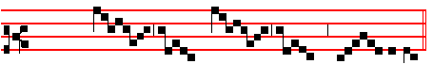
 I- te, mis- sa est.
Go ye, mass is done.
 Thanks be to God.
2. Of the Blessed Virgin and throughout the whole Octave of Corpus Christi and of her Nativity. 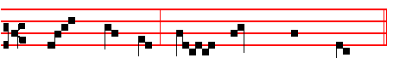
 I- te, mis- sa est.
. Thanks be to God.
3. Of Apostles, and on Double Feasts.
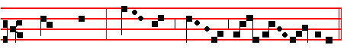
. I- te mis- sa est.
. Thanks be to God.

4. Of Sunday throughout the whole year, on semidouble Feasts, and within Octaves, which are not of the Blessed Virgin Mary.

18
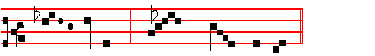
 I- te. mis- sa est.
. Thanks be to God.

4a On Septuagesima, Sexagesima and Quinquagesima.
 Let us bless the Lord.
 Thanks be to God.

5. In Eastertide, beginning from Vespers of Holy Saturday until Vespers of the following Saturday exclusively.
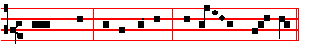
 Let us bless the Lord, al- le – lu - ia, al- le - - lu - ia.
. Thanks be to God, al- le - lu – ia, al- le - - lu - ia.

6. On simple Feasts at Matins, Lauds, and Vespers.
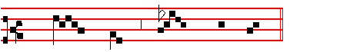
. I- te, mis- sa est.
. Thanks be to God.

7. In the ferial Mass throughout the whole year. 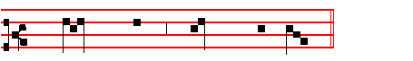
 Let us bless the Lord.
. Thanks be to God.

19
Priest, silently:
LET this my bounden duty and service be pleasing unto thee, O holy Trinity: and grant; that the sacrifice, which I unworthy have offered before the eyes of thy majesty, may be acceptable to thee, and through thy mercy obtain thy gracious favour for me and all for whom I have offered it. Through Christ our Lord. Amen.

Priest: May almighty God bless you, the Father, the Son,  and the Holy Ghost. . Amen

Priest: The Lord be with you. R/. And with thy spirit.
 The beginning of the holy Gospel according to John. or: The Continuation.
R/. Glory be to thee, O Lord.

IN the beginning was the Word, and the Word was with God, and the Word was God. The same was in the beginning with God. All things were made by him: and without him was not any thing made that was made: in him was life, and the life was the light of men: and the light shineth in darkness, and the darkness comprehended it not. There was a man sent from God, whose name was John. The same came for a witness, to bear witness of the light, that all men through him might believe. He was not that light, but was sent to bear witness of that light. That was the true light, which lighteth every man that cometh into the world,. He was in the world and the world was made by him, and the world knew him not. He came unto his own, and his own received him not. But as many as received him, to them gave he power to become the sons of God, even to them that believe on his name: which were born, not of blood, nor of the will of the flesh, nor of the will of man, but of God. All kneel And the Word was made flesh, and rise and dwelt among us: and we beheld his glory, the glory as of the only-begotten of the Father, full of grace and truth.

 Thanks be to God.



20

