152
than all gods.
5 As for all the gods of the heathen, they are but idols; * but it is the Lord that made the heavens.
6 Glory and worship are before him; * power and honour are in his sanctuary.

7 Ascribe unto the Lord, O ye kindreds of the people, * ascribe unto the Lord worship and power.
8 Ascribe unto the Lord the honour due unto his Name; * bring presents, and come into his courts.
9 O worship the Lord in the beauty of holiness; * let the whole earth stand in awe of him.
10 Tell it out among the heathen that the Lord is King, and that it is he who hath
made the round world so fast that it cannot be moved; * and how that he shall judge the people righteously.
11 Let the heavens rejoice, and let the earth be glad; * let the sea make a noise, and all that therein is.
12 Let the field be joyful, and all that is in it; * then shall all the trees of the wood
rejoice before the Lord.
13 For he cometh, for he cometh to judge the earth; * and with righteousness to judge the world, and the people with his truth.

Psalm 97 Dominus regnavit XCVI

THE Lord is King, the earth may be glad thereof; * yea, the multitude of the isles may be glad thereof.
2 Clouds and darkness are round about him: * righteousness and judgment are the
habitation of his seat.
3 There shall go a fire before him, * and burn up his enemies on every side.

4 His lightnings gave shine unto the world: * the earth saw it, and was afraid.

5 The hills melted like wax at the presence of the Lord; * at the presence of the Lord of the whole earth.
6 The heavens have declared his righteousness, * and all the people have seen his glory.
7 Confounded be all they that worship carved images, and that delight in vain gods: * worship him, all ye gods.
8 Sion heard of it, and rejoiced; and the daughters of Judah were glad, * because
of thy judgments, O Lord.
9 For thou, Lord, art higher than all that are in the earth: * thou art exalted far above all gods.

121

S.Peter Orthodox Truth Service, December, 2006

150
Psalm 99 Dominus regnavit XCVIII
THE Lord is King, be the people never so impatient; * he sitteth between the cherubims, be the earth never so unquiet.
2 The Lord is great in Sion, * and high above all people.

3 They shall give thanks unto thy Name, * which is great, wonderful, and holy.

4 The King's power loveth judgment; thou hast prepared equity, * thou hast executed judgment and righteousness in Jacob.
5 O magnify the Lord our God, and fall down before his footstool; * for he is holy.
6 Moses and Aaron among his priests, and Samuel among such as call upon his Name: * these called upon the Lord, and he heard them.
7 He spake unto them out of the cloudy pillar; * for they kept his testimonies, and the law that he gave them.
8 Thou heardest them, O Lord our God; * thou forgavest them, O God, and punishedst their own inventions.
9 O magnify the Lord our God, and worship him upon his holy hill; * for the Lord
our God is holy.

From Septuagesima, Antiphon.
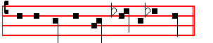
For the Lord hath done marvellous things.
__________________________________________________________________

The following Antiphon and Psalm O be joyful is omitted here when it is said at Lauds, and in its place Antiphon and Psalm it is a good thing is said as below.

Antiphon. Tone iv, 5

O be joyful * in the Lord, all ye lands. E u o u a e. The Antiphon is not repeated in the Psalm.
Psalm 100 Jubilate Deo XCIX

O BE joyful in the Lord, all ye lands: * serve the Lord with gladness, and come
before his presence with a song.

123
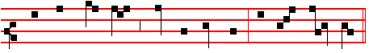
As he pro-mised, hath a - ri - sen. al - le - lu - ia.

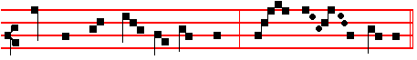
Pour for us to him thy prayer. al - le - lu - ia.
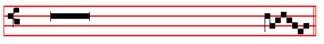
 Rejoice and be glad, O Virgin Mary. Allelu - ia.
 For the Lord is risen indeed. Allelu - ia.
Let us pray COLLECT
O God, who by the resurrection of thy Son, Jesus Christ, didst vouchsafe to give gladness unto the world; grant, we beseech thee, that we, being holpen by the Virgin Mary, his Mother, may attain unto the joys of everlasting life. Through the same Christ our Lord.  Amen.

From first Vespers of the Feast of the Most Holy Trinity until None of the Saturday before Advent, Antiphon.
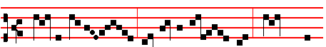
HAIL, ho-ly Queen, mo-ther of mer - cy, hail , our
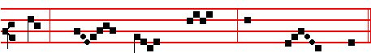
life, our sweet - ness, and our hope.
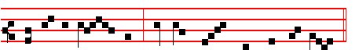
To thee do we cry, poor ba - nished chil - dren of Eve;

148
12 Such as are planted in the house of the Lord, * shall flourish in the courts of the house of our God.
13 They also shall bring forth more fruit in their age, * and shall be fat and well-liking.
14 That they may shew how true the Lord my strength is, *and that there is no unrighteousness in him.
__________________________________________________________________

Psalm 101 Misericordiam et judicium C

MY song shall be of mercy and judgment; * unto thee, O Lord, will I sing.

2 O let me have understanding * in the way of godliness.

3 When wilt thou come unto me? * 1 will walk in my house with a perfect heart.

4 I will take no wicked thing in hand; I hate the sins of unfaithfulness; * there shall no such cleave unto me.
5 A froward heart shall depart from me; * I will not know a wicked person.

6 Whoso privily slandereth his neighbour, * him will I destroy.

7 Whoso hath also a proud look and high stomach, * I will not suffer him.

8 Mine eyes look upon such as are faithful in the land, * that they may dwell with me.
9 Whoso leadeth a godly life, * he shall be my servant.

10 There shall no deceitful person dwell in my house; * he that telleth lies shall not tarry in my sight.
11 I shall soon destroy all the ungodly that are in the land; * that 1 may root out all wicked doers from the city of the Lord.
Antiphon
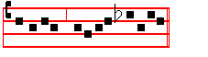
. Alleluia, alleluia, alleluia.
From Septuagesima, Antiphon
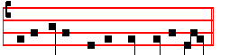
. O be joyful in the Lord, all ye lands.

125
Let us pray COLLECT
WE beseech thee, O Lord, to pour thy grace into our hearts; that as we have known the incarnation of thy Son Jesus Christ by the message of an angel, so by his Cross and Passion we may be brought unto the glory of His resurrection. Through the same Christ our Lord. Amen.

From first Vespers of the Nativity and thenceforth,
 After childbearing, O Virgin, thou didst remain invio- late.
 Mother of God, intercede for us.
Let us pray COLLECT
O God, who by the virgin child-bearing of blessed Mary hast bestowed upon mankind the rewards of eternal salvation: grant, we beseech thee, that we may perceive her intercession for us, through whom we have been counted worthy to receive the author of life, Jesus Christ, thy Son, our Lord.  Amen.

After the Purification, that is from the end of Compline of that day the second of February inclusive, even when the Feast of the Purification of the Blessed Virgin
Mary is transferred, until Maundy Thursday exclusive, Antiphon. xij.
 HAIL, O Queen of hea - ven en- throned!
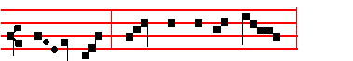
Hail, by an - gels Mis-tress owned!

Root of Jes-se, Gate of morn,

Whence the world's true Light was born;

146
3 Our reins and hearts in pity heal, 4 And as we now the hours of night
And with thy chastening fires anneal: With songs united put to flight,
Gird thou our loins, each passion quell Bestow, with thine abundant hand,
And every harmful lust expel. The gifts of our blest fatherland.

5 O Father, that we ask be done,
Through Jesus Christ, thine only Son,
Who, with the Holy Ghost and thee
Doth live and reign eternally. Amen.

(Or else the Hymn: O God, Creator of the world, p.39, may be said.)

IN THE FIRST NOCTURN

Throughout the year, Antiphon. Irregular Tone
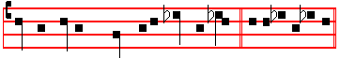
Let my crying * come unto thee, O Lord. E u o u a e.
In Eastertide, Antiphon. Tone v, 1
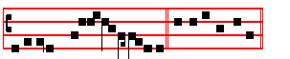
Alleluia, * alleluia, alle-luia. E u o u a e.

Psalm 102 Domine, exaudi CI

HEAR my prayer, O Lord, * and let my crying come unto thee.

2 Hide not thy face from me in the time of my trouble; * incline thine ear unto me when I call; O hear me, and that right soon.
3 For my days are consumed away like smoke, * and my bones are burnt up as it were a fire-brand.
4 My heart is smitten down, and withered like grass; * so that I forget to eat my bread.
5 For the voice of my groaning, * my bones will scarce cleave to my flesh.

6 I am become like a pelican in the wilderness, * and like an owl that is in the desert.
7 I have watched, and am even as it were a sparrow, * that sitteth alone upon the
house-top.

127
28 Let mine adversaries be clothed with shame; * and let them cover themselves with their own confusion, as with a cloke.
29 As for me, I will give great thanks unto the Lord with my mouth, * and praise him among the multitude;
30 For he shall stand at the right hand of the poor, * to save his soul from unrighteous judges.

Throughout the Year and in Eastertide, Antiphon.
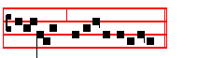
Alleluia, alleluia, alleluia.
From Septuagesima to Easter, Antiphon.
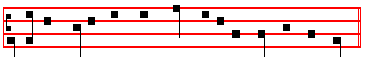
As for me , I will give great thanks unto the Lord with my mouth.

Chapter and the rest as on Monday, p. 59 for the Ferial Office, p. 61 for the Festal Office.
In the Office of' S. Mary on Saturday
Chapter Ecclus. 24, 19-20
COME unto me, all ye that be desirous of me, and fill yourselves with my fruits. For my memorial is sweeter than honey, and mine inheritance than the honey-comb.
 Thou art beautiful and pleasant.
 O holy Mother of God, in thy felicity.
__________________________________________________________________

And one of the Antiphons below, according to the season.
__________________________________________________________________

From Vespers of Saturday before the first Sunday of Advent until the second day of February inclusive, Antiphon. xj.
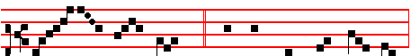

MOTH- ER be - nign of our re - deem- ing Lord,

144
Psalm 103 Benedic, anima mea CII

PRAISE the Lord, O my soul; * and all that is within me praise his holy Name.

2 Praise the Lord, O my soul, * and forget not all his benefits;

3 Who forgiveth all thy sin, * and healeth all thine infirmities;

4 Who saveth thy life from destruction, * and crowneth thee with mercy and lovingkindness;
5 Who satisfieth thy mouth with good things, * making thee young and lusty as an eagle.
6 The Lord executeth righteousness and judgment * for all them that are oppressed with wrong.
7 He shewed his ways unto Moses, * his works unto the children of Israel.

8 The Lord is full of compassion and mercy, * long-suffering, and of great goodness.
9 He will not alway be chiding; * neither keepeth he his anger for ever.

10 He hath not dealt with us after our sins; * nor rewarded us according to our
wickednesses.
11 For look how high the heaven is in comparison of the earth; * so great is his mercy also toward them that fear him.
12 Look how wide also the east is from the west; * so far hath he set our sins from us.
13 Yea, like as a father pitieth his own children; * even so is the Lord merciful unto them that fear him.
14 For he knoweth whereof we are made; * he remembereth that we are but dust.

15 The days of man are but as grass; * for he flourisheth as a flower of the field.

16 For as soon as the wind goeth over it, it is gone; * and the place thereof shall know it no more.
17 But the merciful goodness of the Lord endureth for ever and ever upon them that fear him; * and his righteousness upon children's children;
18 Even upon such as keep his covenant, * and think upon his commandments to do them.
19 The Lord hath prepared his seat in heaven, * and his kingdom ruleth over all.

20 O praise the Lord, ye angels of his, ye that excel in strength; * ye that fulfil his
commandment, and hearken unto the voice of his words.

129
Psalm 108 Paratum cor meum CVII

O GOD, my heart is ready, my heart is ready; * I will sing and give praise with the best member that I have.
2 Awake, thou lute and harp; * 1 myself will awake right early.

3 I will give thanks unto thee, O Lord, among the people; * 1 will sing praises unto thee among the nations.
4 For thy mercy is greater than the heavens, * and thy truth reacheth unto the clouds.
5 Set up thyself, O God, above the heavens, * and thy glory above all the earth.

6 That thy beloved may be delivered: * let thy right hand save them, and hear thou me.
7 God hath spoken in his holiness; * 1 will rejoice therefore, and divide Sichem, and mete out the valley of Succoth.
8 Gilead is mine, and Manasses is mine; * Ephraiin also is the strength of my head.
9 Judah is my law-giver, Moab is my washpot; * over Edom will 1 cast out my shoe; upon Philistia will I triumph.
10 Who will lead me into the strong city? * and who will bring me into Edom?

11 Hast not thou forsaken us, O God? * and wilt not thou, O God, go forth with
our hosts?
12 O help us against the enemy: * for vain is the help of man.

13 Through God we shall do great acts; * and it is he that shall tread down our enemies.
Psalm 109 Desu, laudem CVIII

HOLD not thy tongue, O God of my praise; * for the mouth of the ungodly, yea, the mouth of the deceitful is opened upon me.
2 And they have spoken against me with false tongues; * they compassed me about also with words of hatred, and fought against me without a cause.
3 For the love that I had unto them, lo, they take now my contrary part; * but I give myself unto prayer.
4 Thus have they rewarded me evil for good, * and hatred for my good will.

5 Set thou an ungodly man to be ruler over him, * and let Satan stand at his right hand.
6 When sentence is given upon him, let him be condemned; * and let his prayer be turned into sin.
142
13 He watereth the hills from above; * the earth is filled with the fruit of thy works.
14 He bringeth forth grass for the cattle, * and green herb for the service of men;

15 That he may bring food out of the earth, and wine that rnaketh glad the heart of man; * and oil to make him a cheerful countenance, and bread to strengthen man's heart.
16 The trees of the Lord also are full of sap; * even the cedars of Libanus which he hath planted;
17 Wherein the birds make their nests; * and the fir-trees are a dwelling for the stork.
18 The high hills are a refuge for the wild goats; * and so are the stony rocks for
the conies.
19 He appointed the moon for certain seasons, * and the sun knoweth his going down.
20 Thou makest darkness that it may be night; * wherein all the beasts of the forest do move.
21 The lions roaring after their prey, * do seek their meat from God.

22 The sun ariseth, and they get them away together, * and lay them down in their dens.
23 Man goeth forth to his work, and to his labour, * until the evening.

24 O Lord, how manifold are thy works! * in wisdom hast thou made them all; the
earth is full of thy riches.
Division

SO is the great and wide sea also; * wherein are things creeping innumerable, both small and great beasts.
26 There go the ships, and there is that Leviathan, * whom thou hast made to take his pastime therein.
27 These wait all upon thee, * that thou mayest give them meat in due season.
28 When thou givest it them they gather it; * and when thou openest thy hand they are filled with good.
29 When thou hidest thy face they are troubled: * when thou takest away their breath they die, and are turned again to their dust.
30 When thou lettest thy breath go forth they shall be made; * and thou shalt renew the face of the earth.
31 The glorious Majesty of the Lord shall endure for ever; * the Lord shall rejoice in his works.
32 The earth shall tremble at the look of him; * if he do but touch the hills, they shall smoke.

131
8 O that men would therefore praise the Lord for his goodness; * and declare the wonders that he doeth for the children of men!
9 For he satisfieth the empty soul, * and filleth the hungry soul with goodness.

10 Such as sit in darkness, and in the shadow of death, * being fast bound in misery and iron;
11 Because they rebelled against the words of the Lord, * and lightly regarded the
counsel of the most Highest;
12 He also brought down their heart through heaviness: * they fell down, and there was none to help them.
13 So when they cried unto the Lord in their trouble, * he delivered them out of their distress.
14 For he brought them out of darkness, and out of the shadow of death, * and brake their bonds in sunder.
15 O that men would therefore praise the Lord for his goodness; * and declare the
wonders that he doeth for the children of men!
16 For he hath broken the gates of brass, * and smitten the bars of iron in sunder.

17 Foolish men are plagued for their offence, * and because of their wickedness.

18 Their soul abhorred all manner of meat, * and they were even hard at death's door.
19 So when they cried unto the Lord in their trouble, * he delivered them out of their distress.
20 He sent his word, and healed them; * and they were saved from their destruction.
21 O that men would therefore praise the Lord for his goodness; * and declare the
wonders that he doeth for the children of men!
22 That they would offer unto him the sacrifice of thanksgiving, * and tell out his
works with gladness!
23 They that go down to the sea in ships, and occupy their business in great waters;
24 These men see the works of the Lord, * and his wonders in the deep.

Division

FOR at his word the stormy wind ariseth, * which lifteth up the waves thereof.

26 They are carried up to the heaven, and down again to the deep; * their soul
melteth away because of the trouble.
27 They reel to and fro, and stagger like a drunken man, * and are at their wit's end.
28 So when they cry unto the Lord in their trouble, * he delivereth them out of

140
12 When there were yet but a few of them, * and they strangers in the land;

13 What time as they went from one nation to another, * from one kingdom to another people;
14 He suffered no man to do them wrong, * but reproved even kings for their sakes;
15 Touch not mine Anointed, * and do my prophets no harm.

16 Moreover, he called for a dearth upon the land, * and destroyed all the provision of bread.
17 But he had sent a man before them, * even Joseph, who was sold to be a bond-
servant;
18 Whose feet they hurt in the stocks; * the iron entered into his soul;

19 Until the time came that his cause was known: * the word of the Lord tried him.
20 The king sent, and delivered him; * the prince of the people let him go free.

21 He irnade him lord also of his house, * and ruler of all his substance;

22 That he might inform his princes after his will, * and teach his senators wisdom.
Division

ISRAEL also came into Egypt, * and Jacob was a stranger in the land of Ham.

24 And he increased his people exceedingly, * and made them stronger than their enemies;
25 Whose heart turned so, that they hated his people, * and dealt untruly with his
servants.
26 Then sent he Moses his servant, * and Aaron whom he had chosen.

27 And these shewed his tokens among them, * and wonders in the land of Ham.

28 He sent darkness, and it was dark; * and they were not obedient unto his word.

29 He turned their waters into blood, * and slew their fish.

30 Their land brought forth frogs; * yea, even in their kings' chambers.

31 He spake the word, and there came all manner of flies, * and lice in all their quarters.
133
21 And they forgat God their Saviour, * who had done so great things in Egypt;

22 Wondrous works in the land of Ham; * and fearful things by the Red sea.

23 So he said, he would have destroyed them, had not Moses his chosen stood before him in the gap, * to turn away his wrathful indignation, lest he should destroy them.
24 Yea, they thought scorn of that pleasant land, * and gave no credence unto his word.
25 But murmured in their tents, * and hearkened not unto the voice of the Lord.

26 Then lift he up his hand against them, * to overthrow them in the wilderness;

27 To cast out their seed among the nations, * and to scatter them in the lands.

28 They joined themselves unto Baal-peor, * and ate the offerings of the dead.

29 Thus they provoked him to anger with their own inventions; * and the plague was great among them.
30 Then stood up Phinees and prayed; * and so the plague ceased.

31 And that was counted unto him for righteousness, * among all posterities for evermore.
Division

THEY angered him also at the waters of strife, * so that he punished Moses for
their sakes;
33 Because they provoked his spirit, * so that he spake unadvisedly with his lips.

34 Neither destroyed they the heathen, * as the Lord commanded them;

35 But were mingled among the heathen, * and learned their works.

36 Insomuch that they worshipped their idols, which turned to their own decay; *
yea, they offered their sons and their daughters unto devils;
37 And shed innocent blood, even the blood of their sons and of their daughters, * whom they offered unto the idols of Canaan; and the land was defiled with blood.
38 Thus were they stained with their own works, * and went a whoring with their own inventions.
39 Therefore was the wrath of the Lord kindled against his people, * insomuch that he abhorred his own inheritance.
40 And he gave them over into the hand of the heathen; * and they that hated them

138
In Passiontide,  Shut not up my soul with the sinners, O God.
 Nor my life with the bloodthirsty.
In Eastertide, Antiphon.
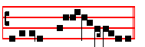
Alleluia, alleluia, alle-luia.
 Then were the disciples glad, alleluia.
. When they saw the Lord, alleluia.

Within the Octave of the Ascension,
 I ascend unto my Father and your Father, alleluia.
And to my God and your God, alleluia.

Our Father secretly until And lead us not into temptation.
 But deliver us from evil.
ABSOLUTION

ROM the chains of our sins may the almighty and merciful Lord loose us.

F
 Amen.

Then 3 Lessons with 3  are read, or in summer a single Lesson with its  as noted on Monday.

The following Blessings are said before Scripture Lessons:

1 May he bless us, who liveth and reigneth for ever and ever.  Amen.
2 May the divine assistance remain with us always.  Amen.
3 May the King of Angels bring us to the society of the heavenly citizens.
 Amen.

If the 3 Lessons are not from Scripture, or if the Office is not of the Feria, then the Blessings are said as noted on Monday.

In summer before the Single or Short Lesson:
Blessing: May the King of Angels bring us to the Society of the heavenly citizens.  Amen.
Short Lesson Ecclus. 12, 2-3
DO good to the godly man, and thou shalt find a recompense; and if not from him, yet from the Most High. There can no good come to him that is always

135
occupied in evil, nor to him that giveth no alms. For the Most High hateth sinners, and is merciful to the penitent. But thou, O Lord.

Short  Tone vj
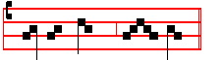
Hear my prayer, * O Lord. Hear.
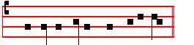
 And let my crying come unto thee. O Lord.
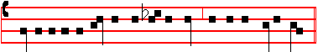
Glory be to the Father, and to the Son, and to the Holy Ghost. . Hear.

In the Office of S. Mary on Saturday:
Throughout the year, . Hear my prayer, O Lord.
 And let my crying come unto thee.

In Eastertide,  Then were the disciples glad, alleluia.
 When they saw the Lord, alleluia.

Absolution and the rest as in the Office of S. Mary on Saturday, after the Common of Saints.
IN THE SECOND NOCTURN

Throughout the year, and in Eastertide, for all Psalms,
Antiphon. Tone viij, 7
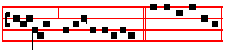
Alleluia, * alleluia, alleluia. E u o u a e.
From Septuagesima until Easter,
Antiphon. Tone iv, 5

O visit me * with thy salvation. E u o u a e.
136
Psalm 106 Confitemini Domino CV

O GIVE thanks unto the Lord, for he is gracious, * and his mercy endureth for ever.
2 Who can express the noble acts of the Lord, * or shew forth all his praise?

3 Blessed are they that alway keep judgment, * and do righteousness.

4 Remember me, O Lord, according to the favour that thou bearest unto thy people; * O visit me with thy salvation;
5 That I may see the felicity of thy chosen, * and rejoice in the gladness of thy people, and give thanks with thine inheritance.
6 We have sinned with our fathers; * we have done amiss, and dealt wickedly.

7 Our fathers regarded not thy wonders in Egypt, neither kept they thy great goodness in remembrance; * but were disobedient at the sea, even at the Red sea.
8 Nevertheless he helped them for his Name's sake, * that he might make his power to be known.
9 He rebuked the Red sea also, and it was dried up; * so he led them through the
deep, as through a wilderness.
10 And he saved them from the adversary's hand, * and delivered them from the hand of the enemy.
11 As for those that troubled them, the waters overwhelmed them; * there was not one of them left.
12 Then believed they his words, * and sang praise unto him.

13 But within a while they forgat his works, * and would not abide his counsel.

14 But lust came upon them in the wilderness, * and they tempted God in the desert.
15 And he gave them their desire, * and sent leanness withal into their soul.

16 They angered Moses also in the tents, * and Aaron the saint of the Lord.

17 So the earth opened, and swallowed up Dathan, * and covered the congregation of Abiram.
18 And the fire was kindled in their company; * the flame burnt up the ungodly.

19 They made a calf in Horeb, * and worshipped the molten image.

20 Thus they turned their glory * into the similitude of a calf that eateth hay.

137
32 He gave them hail-stones for rain; * and flames of fire in their land.

33 He smote their vines also and fig-trees; * and destroyed the trees that were in their coasts.
34 He spake the word, and the grasshoppers came, and caterpillars innumerable, * and did eat up all the grass in their land, and devoured the fruit of their ground.
35 He smote all the first-born in their land; * even the chief of all their strength.

36 He brought them forth also with silver and gold; * there was not one feeble person among their tribes.
37 Egypt was glad at their departing; * for they were afraid of them.

38 He spread out a cloud to be a covering, * and fire to give light in the night-season.
39 At their desire he brought quails; * and he filled them with the bread of heaven.

40 He opened the rock of stone, and the waters flowed out: * so that rivers ran in the dry places.
41 For why? he remembered his holy promise; * and Abraham his servant.

42 And he brought forth his people with joy, * and his chosen with gladness;

43 And gave them the land of the heathen; * and they took the labours of the people in possession;
44 That they might keep his statutes, * and observe his laws.

Antiphon.
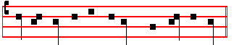
Let the heart of them rejoice that seek the Lord.
Throughout the year,
 Hear my prayer, O Lord.  And let my crying come unto thee.

In Advent, in the Ferial Office only,
 The Lord cometh forth out of his holy place.
 He will come and save his people.

In the 3 Lesson Office of Saints, the  is as above throughout the year.

In Lent,  His faithfulness and truth shall be thy shield and buckler.
 Thou shalt not be afraid for any terror by night.

134
were lords over them.
41 Their enemies oppressed them, * and had them in subjection.

42 Many a time did he deliver them; * but they rebelled against him with their own inventions, and were brought down in their wickedness.
43 Nevertheless, when he saw their adversity, * he heard their complaint.

44 He thought upon his covenant, and pitied them, according unto the multitude of his mercies; * yea, he made all those that led them away captive to pity them.
45 Deliver us, O Lord our God, and gather us from among the heathen; * that we may give thanks unto thy Holy Name, and make our boast of thy praise.
46 Blessed be the Lord God of Israel from everlasting, and world without end; * and let all the people say, Amen.

Antiphon.
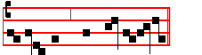
O visit me with thy salvation.
From Septuagesima to Easter, Antiphon. Tone v, 1
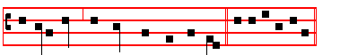
Deliver me, * O Lord, from my distress. E u o u a e.

Psalm 107 Confitemini Domino CVI

O GIVE thanks unto the Lord, for he is gracious, * and his mercy endureth for ever.
2 Let them give thanks whom the Lord bath redeemed, * and delivered from the hand of the enemy;
3 And gathered them out of the lands, from the east, and from the west; * from the north, and from the south.
4 They went astray in the wilderness out of the way, * and found no city to dwell in;
5 Hungry and thirsty, * their soul fainted in them.

6 So they cried unto the Lord in their trouble, * and he delivered them from their distress.
7 He led them forth by the right way, * that they might go to the city where they dwelt.
139
33 1 will sing unto the Lord as long as I live; * I will praise my God while I have my being.
34 And so shall my words please him: * my joy shall be in the Lord.

35 As for sinners, they shall be consumed out of the earth, and the ungodly shall come to an end * praise thou the Lord, O my soul, praise the Lord.

Antiphon.
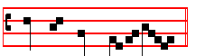
Praise the Lord, O my soul.
Throughout the Year, Antiphon. Tone viij, 7
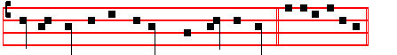
Let the heart of them rejoice * that seek the Lord. E u o u a e.

Psalm 105 Confitemini Domino CIV

O GIVE thanks unto the Lord, and call upon his Name; * tell the people what things he hath done.
2 O let your songs be of him, and praise him; * and let your talking be of all his
wondrous works.
3 Rejoice in his holy Name; * let the heart of them rejoice that seek the Lord.

4 Seek the Lord and his strength; * seek his face evermore.

5 Remember the marvellous works that he hath done; * his wonders, and the judgments of his mouth,
6 O ye seed of Abraham his servant, * ye children of Jacob his chosen.

7 He is the Lord our God; * his judgments are in all the world.

8 He hath been alway mindful of his covenant and promise, * that he made to a thousand generations;
9 Even the covenant that he made with Abraham; * and the oath that he sware unto Isaac;
10 And appointed the same unto Jacob for a law, * and to Israel for an everlasting testament;
11 Saying. Unto thee will I give the land of Canaan, * the lot of your inheritance;

132
their distress.
29 For he maketh the storm to cease, * so that the waves thereof are still.

30 Then are they glad, because they are at rest; * and so he bringeth them unto the haven where they would be.
31 O that men would therefore praise the Lord for his goodness; * and declare the
wonders that he doeth for the children of men!
32 That they would exalt him also in the congregation of the people, * and praise him in the seat of the elders!
33 Who turneth the floods into a wilderness, * and drieth up the water-springs.

34 A fruitful land maketh he barren * for the wickedness of them that dwell therein.
35 Again, he maketh the wilderness a standing water, * and water-springs of a dry
ground.
36 And there he setteth the hungry, * that they may build them a city to dwell in;

37 That they may sow their land, and plant vineyards, * to yield them fruits of increase.
38 He blesseth them, so that they multiply exceedingly * and suffereth not their cattle to decrease.
39 And again, when they are minished, and brought low * through oppression,
through any plague, or trouble;
40 Though he suffer them to be evil intreated through tyrants, * and let them wander out of the way in the wilderness;
41 Yet helpeth he the poor out of misery, * and maketh him households like a flock of sheep.
42 The righteous will consider this, and rejoice; * and the mouth of all wickedness
shall be stopped.
43 Whoso is wise will ponder these things; * and they shall understand the loving-kindness of the Lord.

Antiphon.
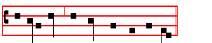
Deliver me, O Lord, from my distress.
Out of Eastertide, Antiphon. Tone vij, 4
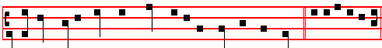
As for me, * I will give great thanks unto the Lord with my mouth. E u o u a e.
141
21 O praise the Lord, all ye his hosts; * ye servants of his that do his pleasure.

22 O speak good of the Lord, all ye works of his, in all places of his dominion: * praise thou the Lord, O my soul.

Antiphon.

Let my crying come unto thee, O Lord.
Throughout the Year, Antiphon. Tone viij, 7
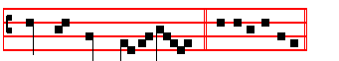
Praise the Lord, * O my soul. E u o u a e. It is not repeated in the Psalm.

Psalm 104 Benedic, anima mea CIII

PRAISE the Lord, O my soul: * O Lord my God, thou art become exceeding glorious; thou art clothed with majesty and honour.
2 Thou deckest thyself with light as it were with a garment, * and spreadest out the heavens like a curtain.
3 Who layeth the beams of his chambers in the waters, * and maketh the clouds his chariot, and walketh upon the wings of the wind.
4 He rnaketh his angels spirits, * and his ministers a flaming fire.

5 He laid the foundations of the earth, * that it never should move at any time.

6 Thou coveredst it with the deep like as with a garment, * the waters stand in the hills.
7 At thy rebuke they flee; * at the voice of thy thunder they are afraid.
8 They go up as high as the hills, and down to the valleys beneath; * even unto
the place which thou hast appointed for them.
9 Thou hast set them their bounds which they shall not pass, * neither turn again to cover the earth.
10 He sendeth the springs into the rivers, * which run among the hills.

11 All beasts of the field drink thereof, * and the wild asses quench their thirst.

12 Beside them shall the fowls of the air have their habitation, * and sing among
the branches
. 130
7 Let his days be few; * and let another take his office.

8 Let his children be fatherless, * and his wife a widow.

9 Let his children be vagabonds, and beg their bread; * let them seek it also out of
desolate places.
10 Let the extortioner consume all that he hath; * and let the stranger spoil his labour.
11 Let there be no man to pity him, * nor to have compassion upon his fatherless children.
12 Let his posterity be destroyed; * and in the next generation let his name be clean put out.
13 Let the wickedness of his fathers be had in remembrance in the sight of the Lord; * and let not the sin of his mother be done away.
14 Let them alway be before the Lord, * that he may root out the memorial of them from off the earth;
15 And that, because his mind was not to do good; * but persecuted the poor helpless man, that he might slay him that was vexed at the heart.
16 His delight was in cursing, and it shall happen unto him; * he loved not blessing, therefore shall it be far from him.
17 He clothed himself with cursing, like as with a raiment, * and it shall come into his bowels like water, and like oil into his bones.
18 Let it be unto him as the cloke that he hath upon him. * and as the girdle that he is alway girded withal.
19 Let it thus happen from the Lord unto mine enemies, * and to those that speak evil against my soul.
20 But deal thou with me, O Lord God, according unto thy Name; * for sweet is thy mercy.
21 O deliver me, for I am helpless and poor, * and my heart is wounded within me.
22 I go hence like the shadow that departeth, * and am driven away as the grasshopper.
23 My knees are weak through fasting; * my flesh is dried up for want of fatness.

24 I became also a reproach unto them: * they that looked upon me shaked their heads.
25 Help me, O Lord my God; * O save me according to thy mercy;

26 And they shall know, how that this is thy hand, * and that thou, Lord, hast done
it.
27 Though they curse, yet bless thou; * and let them be confounded that rise up against me; but let thy servant rejoice.
143
8 Mine enemies revile me all the day long; * and they that are mad upon me are sworn together against me.
9 For 1 have eaten ashes as it were bread, * and mingled my drink with weeping;

10 And that because of thine indignation and wrath; * for thou hast taken me up, and cast me down.
11 My days are gone like a shadow, * and I am withered like grass.

12 But, thou, O Lord, shalt endure for ever, * and thy remembrance throughout all
generations.
13 Thou shalt arise, and have mercy upon Sion; * for it is time that thou have mercy upon her, yea, the time is come.
14 And why? thy servants think upon her stones, * and it pitieth them to see her in the dust.
15 The heathen shall fear thy Name, O Lord; * and all the kings of the earth thy
Majesty;
16 When the Lord shall build up Sion, * and when his glory shall appear;

17 When he turneth him unto the prayer of the poor destitute, * and despiseth not
their desire.
18 This shall be written for those that come after, * and the people which shall be born shall praise the Lord.
19 For he hath looked down from his sanctuary; * out of the heaven did the Lord behold the earth;
20 That he might hear the rnournings of such as are in captivity, * and deliver the
children appointed unto death;
21 That they may declare the Name of the Lord in Sion, and his worship at Jerusalem;
22 When the people are gathered together, * and the kingdoms also, to serve the
Lord.
23 He brought down my strength in my journey, * and shortened my days.

24 But I said, O my God, take me not away in the midst of mine age; * as for thy years, they endure throughout all generations.
25 Thou, Lord, in the beginning hast laid the foundation of the earth, * and the heavens are the work of thy hands.
26 They shall perish, but thou shalt endure: * they all shall wax old as doth a garment;
27 And as a vesture shalt thou change them, and they shall be changed; * but thou
art the same, and thy years shall not fail.
28 The children of thy servants shall continue, * and their seed shall stand fast in thy sight.
128
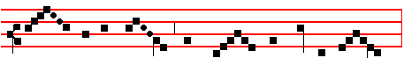
Star of the sea and por - tal of the skies,
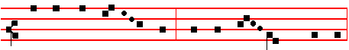
Un - to thy fal - len peo - ple help af - ford,
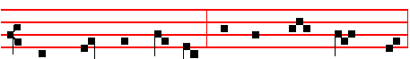
Fal - len, but stri - ving still a - new to rise.
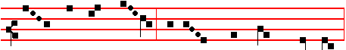
Thou who didst once, while won - d'ring worlds a - dored,
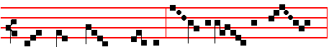
Bear thy Cre - a - tor, Vir - gin then as now,
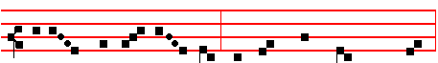
O, by the ho - ly joy at Ga - bri - el's word,
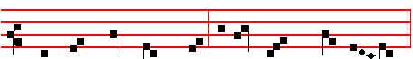
Pi - ty the sin - ners who be - fore thee bow.
In Advent,
 The angel of the Lord announced unto Ma - ry.
 And she conceived of the Holy Ghost.

145
or Antiphon.

It is a good thing to give thanks unto the Lord.

Chapter and the rest as on Monday, p. 59 for the Ferial Office, p. 61 for the Festal Office.
__________________________________________________________________

Saturday at Matins

Our Father, Hail, Mary, I believe, p. 1.
Invitatory Tone vj
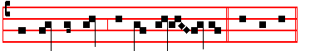
The Lord our God * O come, let us worship. Psalm 95, p. 3.
Hymn Summe Deus Tone j
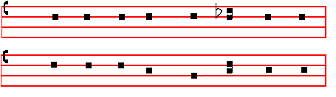
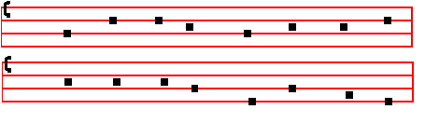

O GOD of mercy passing thought, 2 Do thou in love accept our lays
Who hast the world contrived and wrought: Of mingled penitence and praise
In Power, essential Unity, And set our hearts from error free
In Person, blessed Trinity: More fully to rejoice in thee.

126

Glor-ious Vir - gin, joy to thee,
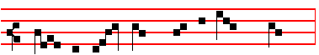
Love- liest whom in heav-en they see;
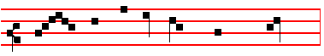
Fair - est thou where all are fair,
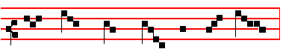
Plead with Christ our sins to spare.
 . Vouchsafe that I may praise thee, O holy Vir - gin.
 Give me strength against thine enem - ies.
Let us pray COLLECT
O most merciful God, grant succour unto our frailty, that as we celebrate the memory of the holy Mother of God, so by the help of her intercessions we may
rise again from our transgressions.Through the same Christ, our Lord. R/. Amen.

From Compline of Holy Saturday until None of Saturday after Pentecost inclusive, Antiphon. xij.
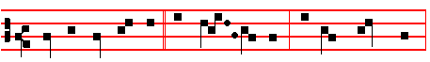 JOY to thee, O Queen of hea - ven. al - le - lu - ia.
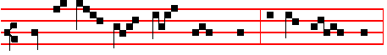
He whom thou wast meet to bear. al - le - lu - ia.
147
2 Be ye sure that the Lord he is God; it is he that hath made us, and not we ourselves; * we are his people, and the sheep of his pasture.
3 O go your way into his gates with thanksgiving, and into his courts with praise; * be thankful unto him, and speak good of his Name.
4 For the Lord is gracious, his mercy is everlasting; * and his truth endureth from generation to generation.
__________________________________________________________________

When the above Psalm is said, the following is omitted.

Antiphon. Tone viij, 7
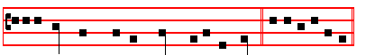
It is a good thing * to give thanks unto the Lord. E u o u a e.
The Antiphon is not repeated in the psalm.

Psalm 92 Bonum est confiteri XCI

IT is a good thing to give thanks unto the Lord, * and to sing praises unto thy Name, O most Highest;
2 To tell of thy loving-kindness early in the morning, * and of thy truth in the night-season.
3 Upon an instrument of ten strings, and upon the lute; * upon a loud instrument, and upon the harp.
4 For thou, Lord, hast made me glad through thy.works.; * and I will rejoice in giving praise for the operations of thy hands.
5 O Lord, how glorious are thy works! * thy thoughts are very deep.

6 An unwise man doth not well consider this, * and a fool doth not understand it.

7 When the ungodly are green as the grass, and when all the workers of wickedness do flourish, * then shall they be destroyed for ever; but thou,
Lord, art the most Highest for evermore.
8 For lo, thine enemies, O Lord, lo, thine enemies shall perish; * and all the workers of wickedness shall be destroyed.
9 But mine horn shall be exalted like the horn of an unicorn; * for I am anointed
with fresh oil.
10 Mine eye also shall see his lust of mine enemies, * and mine ear shall hear his desire of the wicked that arise up against me.
11 The righteous shall flourish like a palm-tree, * and shall spread abroad like a cedar in Libanus.
124
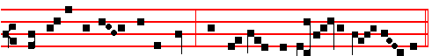
to thee do we send up our sighs, mourning and weeping in this vale of tears.
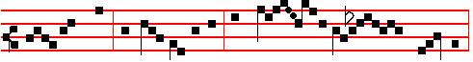 Turn, then, most gracious Advocate, thine eyes of mer - cy to-
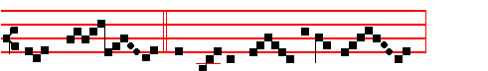 -wards us; and af - ter this our ex- ile
 show un-to us the blessed fruit of thy womb, Je- sus. 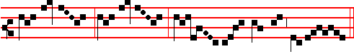 O cle- ment, O lo - ving, O sweet Vir - gin Ma- ry.
 Pray for us, O holy Mother of God.
 That we may be made worthy of the promises of Christ.

Let us pray COLLECT
Almighty and everlasting God, who by the cooperation of the holy Ghost didst prepare the body and soul of the glorious Virgin Mary to become an habitation meet for thy Son; grant that as we rejoice in her commemoration, we may be delivered by her loving intercession from our present evils and from eternal death. Through the same Christ our Lord.  Amen.
__________________________________________________________________

 May the divine assistance remain with us always.  Amen.

149
10 O ye that love the Lord, see that ye hate the thing which is evil: * the Lord preserveth the souls of his saints; he shall deliver them from the hand of the ungodly.
11 There is sprung up a light for the righteous, * and joyful gladness for such as are true-hearted.
12 Rejoice in the Lord, ye righteous; * and give thanks for a remembrance of his holiness.

From Septuagesima, Antiphon.
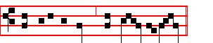
Sing unto the Lord, and praise his Name.
Antiphon IrregularTone
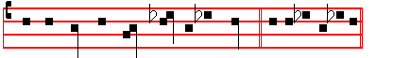
For the Lord hath done * marvellous things. E u o u a e.

Psalm 98 Cantate Domino XCVII

O SING unto the Lord a new song; * for he hath done marvellous things.

2 With his own right hand, and with his holy arm, * hath he gotten himself the victory.
3 The Lord declared his salvation; * his righteousness hath he openly shewed in the sight of the heathen.
4 He hath remembered his mercy and truth toward the house of Israel; * and all the ends of the world have seen the salvation of our God.
5 Shew yourselves joyful unto the Lord, all ye lands; * sing, rejoice, and give thanks.
6 Praise the Lord upon the harp; * sing to the harp with a psalm of thanksgiving.

7 With trumpets also, and shawms, * O shew yourselves joyful before the Lord the King.
8 Let the sea make a noise, and all that therein is; * the round world, and they that
dwell therein.
9 Let the floods clap their hands, and let the hills be joyful together before the Lord; * for he is come to judge the earth.
10 With righteousness shall he judge the world, * and the people with equity.

122

151

