FEASTS OF MARCH

Before Lent, on the first unimpeded day is said the Office of the Dead

The fourth of March
Commemoration of S. Lucius, Pope and Martyr

COLLECT
O GOD, who makest us glad with the yearly solemnity of blessed Lucius, thy Martyr and Bishop: mercifully grant; that, as we now celebrate his birthday, so we may likewise rejoice in his protection. Through.
__________________________________________________________________

THE SEVENTH OF MARCH
ON THE FEAST OF SS. PERPETUA AND FELICITY, MARTYRS
DOUBLE

In first and second Vespers and at Lauds,
 Thou hast crowned them with glory and honour, O Lord..
 Thou hast made them to have dominion of the works of thy hands .
On Magnificat and Benedictus, Antiphon, as in the Common of many Martyrs, p. xlviij. For theirs is the the kingdom of heaven, * Who despised worldly living: who have won the rewards of the kingdom, and have washed their robes in the Blood of the Lamb.
COLLECT
GRANT, we beseech thee, O Lord our God, that we may at all times so devoutly honour the triumphs of thy holy martyrs Perpetua and Felicity: that although we cannot worthily shew forth their praises, yet we may continually honour them with lowly service. Through.

And in Lent commemoration is made of the Feria.

AT MATINS
Invitatory.- Let us praise our God * In the confession of blessed Perpetua and Felicity. Psalm 95 Venite
In the first Nocturn, if they are to be taken from the Common, Lessons I will thank thee, as in the Common of Virgins in the second place.

IN THE SECOND NOCTURN
Lesson iv
PERPETUA and Felicity, during the persecution of the Emperor Severus, were arrested in Africa together with Revocatus, Saturninus, and Secundulus and

1529
thrown into a dungeon, where Satyrus was imprisoned with them. They were still
catechumens, but were soon baptised. A few days later, they were taken with their companions from prison to the forum, and having made a glorious confession, were condemned to the wild beasts. From there they went down joyfu1ly to the prison, where they were refreshed by several visions, and burned for the martyr's crown. Perpetua could never be deterred from her faith in Christ either by the repeatel entreaties and tears of her aged father or by motherly love for the infant son whom she was suckling.

 Because of the word of truth, of meekness, and righteousness: * And thy right hand. shall teach thee terrible things.
 In thy grace, and in thy beauty, go forth, ride prosperously, and. reign. And thy right.

Lesson v
BUT Fe1icity, as the day of the spectacle approached, was in great grief, lest she be put off, being eight months pregnant: for the laws forbade the torturing of pregnant women. But by the prayers of her fellow-martyrs her delivery was hastened and she brought forth a daughter. And as she was in pain as she laboured to give birth, one of the guards said to her: If you are in pain with only this, what will you do, when you are thrown to the wild beasts? But she answered him: Now it is only I who suffer, but there Another shall be in me, who shall suffer for me, because it is for him that I am to suffer.

 Thou hast loved righteousness, and hated. iniquity: * Wherefore God, even thy God, hath anointed thee with the oil of gladness.
 Because of the word of truth, of meekness,and righteousness. Wherefore. Lesson vj
IN the amphitheatre in front of all the people the devout women were led forth at length, on the seventh of March, and first they were beaten with whips. Then they were tossed for some time by a wild cow, lashed, and thrown to the ground. Finally, with their oompanions,who had been attacked by various wild beasts, they were killed by sword-blows.

 Favour is deceitful and beauty is vain: * But a woman that feareth the Lord, she shall be praised.
 Give her of the fruit of her hands, and let her own works praise her in the gates. But a woman. Glory be. But a woman.
In the third Nocturn, Homily on the Gospel, The kingdom of heaven is like unto treasure, as in the Common of holy Women not Virgins.
In Lent, ninth Lesson from the Homily of the Feria and of it oommemoration is made in Lauds.
1530
The tenth of March
On the Feast of the Forty Holy Martyrs
Semidouble

All as in the Common of Many Martyrs, except the following.
COLLECT
GRANT, we beseech thee, almighty God: that as we have known thy glorious Martyrs to be constant in tleir confession, so we may perceive their loving intercession for us with thee. Through.
Then in Lent commemoration is made of the Feria.
In the first Nocturn, Lessons from the Epistle to the Romans, Brethren, we are debtors, from the Common of many Martyrs, p. l.

IN THE SECOND NOCTURN
WHEN Licinius was Emperor, and Agricola Ruler, near Sebaste, a city in Armenia, forty soldiers shewed forth their faith in Christ, and bravery in bearing torments. Having been thrown many times into a horrinle prison, and confined in bonds, and their faces having been pounded with stones, they were commanded to pass the night, naked, in the coldest time in winter, on a frozen lake under the open sky, to be frozen to death by the cold. They all had one prayer: We came forty into the stadium, O Lord; let forty also receive the crown, lest any one be lacking from this number. This number is honourable, which thou didst adorn with the forty days' fast, through which the divine law came into the world. Elijah sought God in a forty days' fast, and obtained his vision. And this was the prayer of them all.

 Thy Saints, O Lord, have passed a wonderful way, serving thy peculiar commandments that were given unto them, that thy children might be found without hurt. * Dry land appeared, and out of the Red Sea a way without impediment.
 For he smote the stony rock indeed, that the waters gushed out, and the streams flowed withal. Dry land.

Lesson v
BUT when the other guards had fallen asleep and only the door- keeper was awake, he, seeing them praying, and surrounded by light, and some Angels descending from heaven as if sent by the King, and distributing thirty-nine crowns to the soldiers, said to himself: They are forty: where is the crown of the fortieth? And while he thought this, one of that number, whose spirit was unequa1 to bearing the cold, departed to a warm bath that was nearby, grealy grieving those saints. But God did not suffer their prayers to be in vain: for the doorkeeper, amazed at this event ,quickly wakened the guards, nd taking off his clothes, and

1531
proclaiming in a loud voice that he was a Christian, joined the Martyrs. But when the ruler's attendants knew that the doorkeeper also was a Christian, they broke all their legs with their staves.

 The Saints of God feared not the blows of the executioners, but died for the name of Christ. * That they might dwell in the house of the Lord for ever.
 They delivered up their bodies to be punished for God's sake. That they.

Lesson vj
IN that torment all died, except Melithon the youngest. His mother was present, and seeing him, with his legs broken, still alive, she enoouraged him thus: O son, hold on a litt1e; behold, Christ standeth at the door, helping thee. But when she saw the bodies of the others being loaded on carts, to be laid on a pyre, and her son left, as the unbelieving crowd of youths hoped that if he 1ived, they might bring him back to the worship of idols; the holy mother lifted him on her shoulders, and strenuuusly pursued the vehicle laden with the bodies of the Martyrs. And in her embrace Melithon gave up his spirit to God, and his mother laid his body devoutly on the same pyre as the other Martyrs, so that they who had been most closely united in faith and courage, and united in their funeral, might come to heaven together. And when they were burned, and their relics cast into the river, they were cast up miraculously in one spot, and found safe and whole, and placed in an honourable tomb.

 As gold in the furnace hath the Lord tried them, and recieved them as a burnt offering: and he hath care for his elect.* For grace and mercy is to his Saints.
 They that put their trust in him shall understand the truth, and such as be faithful in love shall abide with him. For grace. Glory be. For grace.

In the third Nocturn, Homily of S. Ambrose, Bishop, on the Gospel Jesus came down with them, from the Common of many Martyrs in the second place, p. lxiij.
The ninth Lesson is said of the Homily of the occurring Feria, and commemoration is made of it.
__________________________________________________________________

THE TWELFTH OF MARCH
ON THE FEAST OF S. GREGORY
POPE, CONFESSOR, AND DOCTOR OF THE CHURCH
DOUBLE

All from the Common of a Confessor and Bishop, except the following.
On Magnificat in both Vespers, Antiphon. as in the Common, p. xxv.
O Teacher right excellent, * O light of Holy Church, O blessed Gregory, lover of the divine law: intercede for us unto the Son of God.

1532
COLLECT
O GOD, who on the soul of thy servant Gregory hast bestowed the rewards of everlasting bliss: mercifully grant; that we, who are oppressed by the burden of our sins, may by his prayers before thee be relieved. Through.

In the first Nocturn, Lessons He will seek out the Wisdom from the Common of Doctors.
IN THE SECOND NOCTURN
Lesson iv
GREGORY the Great was a Roman, the son of the Senator Gordian; he
studied philosophy in his youth, and held the office of Prætor. After the death of his father he founded six monasteries in Sicily. He founded a seventh, dedicated to S. Andrew, in his own house at Rome, near the Church of SS. John and Paul on the hill of Scaurus, where, together with his masters Hilary and Maximian, he made his profession as a monk, and later became Abbot. Soon after that he was made Cardinal Deacon, and was sent to Constantinople as Legate from Pope Pelagius to the emperor Tiberius Constantine: he did such outstanding work there, by refuting the Patriarch Eutychius, who had written a book against the true and palpable resurrection of the body, that the emperor threw the book into the fire. Moreover, not long after this Eutychius, who had fallen ill and was on his death-bed, took hold of the skin of his hand, and in the presence of many witnesses, exclaimed, I declare that we shall all rise again in this flesh.

  I have found David my servant, with my holy oil have I anointed him: * My hand shall hold him fast.
 The enemy shall not be able to do him violence, the son of wickedness shall not hurt him. My hand.

Lesson v
WHEN he returned to Rome Pelagius had died of plague, and Gregory was unanimously elected Pope. As long as he could, he refused to accept the honour, for he disguised himself and hid in a cave. But his hiding-place was revealed by the sign of a column of fire, and he was consecrated as S. Peter's successor. He left his successors in the pontificate many examples of doctrine and sanctity. Every day he invited pilgrims to his table; among them he received in the guise of pilgrims both Angels and the Lord of Angels. He cared for the poor with great kindness; not only those of the city, but in the country beyond as well, and kept a list of them. He restored the Catholic Faith in many places where it had been overthrown, for he repressed the Donatists in Africa, and the Arians in Spain; he cast out the Agnoites from Alexandria. He refused to give the Pall to Syragrius, Bishop of Autun, unless he would expel the Neophite heretics from

1533
Gaul. He forced the Goths to abandon the Arian heresy. He sent to Britain those learned and holy men, Augustine and his monks. and so converted the island to the faith of Jesus Christ; indeed, S. Bede the Venerable calls Gregory the Apostle of the English. He opposed the boldness of John, Patriarch of Constantinople, who was adopting the title of Ecumenica1 Patriarch. He prevailed upon the emperor Maurice to alter his decision of prohibiting his soldiers from becoming monks.

  I have laid help upon one that is mighty: I have exalted one chosen out of the people: * My hand shall hold him fast.
 I have found David my servant, with my holy oil have I anointed him: My hand.

Lesson vj
HE adorned the Church with holy statutes and laws. He called a synod at S. Peter's, at which he formed many ordinances: among them, that at Mass the Kyrie Eleison should be repeated nine times: that, apart from the season between Septuagesima and Easter, Alleluia should be said: that, And order our days in thy peace, should be added to the Canon of the Mass. He augmented the Litanies, Stations and Offices of the Church. He wished the four councils of Nicea, Constantinople, Ephesus and Chalcedon to be honoured like the four Gospels. He allowed the Bishops of Sicily to come to Rome once every five years, instead of coming, according to an ancient church custom, every three ycars. Hc wrote many books, and Peter the Deacon bears witness that he had often seen the Holy Spirit in the likeness of a dove over Gregory's head while he was dictating them. It is marvellous how much he accomplished in word, deed, writing and ordinance, when it is considered that he was always weak through ill health. He performed many miracles, and at length, in the thirteenth year of his pontificate, he was called to celestial blessedness on the twelfth of March. The Greeks also keep this festival with solemn rite on this day, because or his great wisdom and sanctity. His body is entombed in the Basilica of S. Peter, near the Secretarium.

 This is he which wrought great wonders before God, and the whole earth is full of his teaching: * May he pray for all people, that their sins may be forgiven unto them.
 This is he which hated his life in this world, and is come unto life eternal. May he. Glory be. May he.

IN THE THIRD NOCTURN
The Lesson from the Holy Gospel according to S. Matthew
Lesson vij Ch. 5
JESUS said unto his disciples: Ye are the salt of the earth: but if the salt have lost his savour, wherewith shall it be salted ? And the rest.

1534
Homily by S. Gregory the Great Homily 17 on Luke
WE ought to consider, that since a teacher cannot at one time admonish all with one and the same word of exhortation, he should strive to instruct men one by one, in so far as he is able, and to edify them with conferences in private. For we ought constantly to ponder what is said to the holy Apostles and through the Apostles to us, Ye are the salt of the earth. If, therefore, we are salt, we ought to season the minds of the faithful. You, therefore, who are pastors, reflect that you feed the flock of God. Concerning which flock it is said to God through the Psalmist, Thy congregation shall dwell therein. And often we see that a piece of rock salt is set before brute beasts, that they may lick it and be healed. As the rock salt among brute beasts, so must the priest be among his people. For the priest must take care what he says to each one, and how he admonishes each; that whosoever has contact with the priest may be seasoned with the flavour of eternal life, as with the touch of salt.

 The Lord loved him and adorned him: he clothed him with a robe of glory. *
And at the gates of paradise he crowned him.
 The Lord put on him the breastplate of faith, and adorned him. And at.

Lesson viij
WE are not the salt of the earth if we season not the hearts of our hearers. For he truly applies salt to his neighbour who does not withhold the word of preaching. And we do indeed preach what is right to others if we illustrate our words by our deeds and example. Beloved brethren, I believe that God suffers no greater damage from men than he does from priests: when he sees those whom he has set for the correction of others setting examples of wickedness: when we ourselves sin, who ought to correct sin. Seeking to gain no souls, every day we have leisure for our own pursuits: we lust after earthly things: with eager mind we snatch at worldly glory. And for the very reason that we have been set over others we have the greater licence to do whatever we will: we turn the ministry of blessing that we have received to the ends of self-secking. We desert the cause of God, and we are free to engage in worldly affairs. We accept the position of holiness, and we are involved in the business of the world.

  In the midst of the Church he opened his mouth. * And the Lord filled him with the spirit of wisdom and understanding.
 He shall find joy and a crown of gladness. And the. Glory be. And the.

The ninth Lesson is said from the Homily of the occurrent Feria, and commemoration is made of it in Lauds.

1535
THE SEVENTEENTH OF MARCH
ON THE FEAST OF S.PATRICK, BISHOP AND CONFESSOR
DOUBLE

All from the Common of a Confessor and Bishop, p. lxxiij, except the following.

COLLECT
O GOD, who for the preaching of thy glory unto the Gentiles wast pleased to send forth blessed Patrick, thy Confessor and Bishop: grant by his intercession, that we may through thy mercy be enabled to accomplish those things which thou commandest us to do. Through.

In Lent commemoration is made of the Feria.

In the first Nocturn, Lessons in Lent This is a true saying, from the Common. Otherwise from the occurring Scripture.

IN THE SECOND NOCTURN
Lesson iv
PATRICK, called the Apostle of Ireland, born in Great Britain to Calphurnius, and to Conchessa, said to be the sister of Saint Martin, Bishop of Tours, as a boy fell several times into bariarian captivity. In this state he was put in charge of grazing flocks, and already at that time showed signs of his future sanctity; for filled with faith, divine fear and the spirit of love, he rose untiringly before dawn in snow, frost, and rain, to pour forth prayers to God: being accustomed to pray to God a hundred times by day, and a hundred times by night. When he was released from slavery the third time, and admitted to the Clergy, he occupied himself for a long time in divine reading. He laboured much throughout both Gauls, Italy, and the isles of the western Mediterrean, and at lencth was divinely called to work for the salvation of the Irish: and being empowered by blessed Pope Celestine to preach the Gospel, and having been consecrated Bishop, he went to Ireland.

  I have found David my servant, with my holy oil have I anointed him: * My hand shall hold him fast.
 The enemy shall not be able to do him violence, the son of wickedness shall not hurt him. My hand.

Lesson v
IN this task it is wonderful how many evils, how many troubles and labours, how many adversaries the apostolic worker endured. But with the inspiration of God's favour that land, formerly a worshipper of idols, soon bore such fruit from Patrick's preaching that henceforth it was to be called the isle of saints. Many from that nation were reborn in holy baptism: many bishops and clergy were ordained:

1536
virgins and widows were enrolled in the laws of continence. By the authority of the Roman Pontiff he made the See of Armagh the Metropolitan See over the whole island, and adorned it with relics of saints which had been brought from Rome. He so shone with heavenly vision, the gift of prophecy, and great signs and wonders bestowed by God, that Patrick's increasing fame spread far and wide.

  I have laid help upon one that is mighty: I have exalted one chosen out of the
people: * My hand shall hold him fast.
 I have found David my servant, with my holy oil have I anointed him: My hand.

Lesson vj
BESIDES the daily care for the Churches, his unconquerable spirit never relaxed from prayer. For it is said that he used to recite the whole Psalter daily, together with Canticles and Hymns, and two hundred prayers, to bow the knee in worship to God three hundred times each day, and to fortify himself with the sign of the Cross a hundred times in each canonical Hour of the day. He divided the night into three parts, and spent the first in going through a hundred Psalms, and genuflecting two hundred times, the second in finishing the remaining fifty Psalms, immersed in cold waters, and raising his heart, eyes and hands to heaven: and the third he spent in a short rest stretched out on a bare rock. He observed the utmost humility, and like the Apostles, did not refrain from working with his own hands. At last, worn out by his diligent care of the Church, being famous in word and deed, in extreme old age, he fell asleep in the Lord, and was buried at Down in Ulster, in the fifth century of the Christian era.

 This is he which wrought great wonders before God, and the whole earth is full of his teaching: * May he pray for all people, that their sins may be forgiven unto them.
 This is he which hated his life in this world, and is come unto life eternal. May he. Glory be. May he.

In the third Nocturn, Homily on the Gospel, a man travelling into a far country, from the Common, p. lxxix.

Lesson ix from the Homily of the occurrent Feria, if it is celebrated in Lent, and commemoration in Lauds.

(Vespers from the Chapter of the following, with commemoration of the preceding and of the Feria.

1537
THE EIGHTEENTH OF MARCH
ON THE FEAST OF S. CYRIL, BISHOP OF JERUSALEM,
CONFESSOR AND DOCTOR OF THE CHURCH
DOUBLE.
 The Lord loved him and adorned him.
 He clothed him with a robe of glory.
On Magnificat, Antiphon, as p. xxv. O Teacher right excellent, O light of Holy Church, O blessed Cyri1, lover of the divine law: intercede for us unto the Son of God.
COLLECT
GRANT to us, we beseech thee, almighty God, at the intercession of the blessed bishop Cyril: so to know thee, the only true God, and Jesus Christ whom thou hast sent; that we may be found worthy to be numbered for evermore among the sheep who hear his voice.Through the same.

And commemoration is made of the preceding. Antiphon, p. lxxxvij.
The Lord loved him * and adorned him; he clothed him with a robe of glory, and at the gates of Paradise he crowned him.
 The Lord guided the righteous in right paths.
 And shewed him the kingdom of God.
Collect O God, who for the preaching, as above. Then commemoration of the Feria.
IN THE SECOND NOCTURN
Lesson iv
CYRIL of Jerusalem, being intensely devoted from tender years to the study of the divine Scriptures, became so expert in that knowledge that he proved a tireless defender or the Orthodox Faith. Being admitted to the monastic discipline he willingly devoted himself to perpetual continence and all severity of 1iving. After being ordained presbyter by Saint Maximus, Bishop of Jerusalem, he fulfilled the task of preaching the divine word to the faithful and training the catechumens with high praise, and composed those truly wonderful Catechetical Sermons, in which he covered all the Church doctrine clearly and fully, and firmly defended each dogma against the enemies of the faith. And so clearly and distinctly did he teach in these, that he destroyed not only heresies already arisen, but also, as if foreseeing them, those to come as well, in that he made an excellent statement of the real presence of the Body and Blood of Christ in the mystery of the Eucharist. And when Saint Maximus died, he was chosen in his place by the Bishops of the province.

  I have found David my servant, with my holy oil have I anointed him: * My hand shall hold him fast.

1538
 The enemy shall not be able to do him violence, the son of wickedness shall not hurt him. My hand.

Lesson v
AS Bishop, he endured many insults and troubles, just as blessed Athanasius did, who was of the same age, from the sects of the Arians because of the Faith. For they were angry that Cyril was strongly resisting the heresies, and attacked him with calumnies, and in a false council deposed and expelled him from his see. In order to escape their fury, he fled to Tarsus in Cilicia, and as long as Constantius lived, he bore the rigours of exile. After his death, when Julian the Apostate had iecome Emperor, he was able to return to Jerusalem, where with burning zeal he succeeded in recalling his flock from errors and vices. But again, when Valens was Emperor, he was driven into exile, until, when peace was returned to the Church through Theodosius the Great, and the cruelty and arrogance of the Arians suppressed, he was received with honour by the same Emperor as a brave athlete of Christ and restored to his see. With what energy and holiness he accomplished the task of his high office, appears clearly from the flourishing state of the Church of Jerusalem at that time, as described by Saint Basil, who stayed there for some time to venerate the holy places.

  I have laid help upon one that is mighty: I have exalted one chosen out of the people: * My hand shall hold him fast.
 I have found David my servant, with my holy oil have I anointed him: My hand.

Lesson vj
WE have received by tradition the memory of heavenly signs by which God shewed the sanctity of this venerable ruler. Among these is reckoned the appearance of the cross, shining brighter than the rays of the sun, which adorned the beginning of his episcopate. Both heathen and christians were eyewitnesses with Cyril of this great wonder, and he first gave thanks in Church to God, and then narrated it in a letter to the Emperor Constantius. It is no less worthy of admiration, what happened to the Jews who, at the command of the Emperor Julian the unbeliever, tried to restore the temple destroyed by Titus. For a violent earthquake arose, and huge fireballs burst forth from the earth and consumed the whole work in flames, so that the Jews and Julian were afraid and gave up what they had begun: just as Cyril had unhesitatingly predicted. Finally, a little before his death, he was present at the ecumenical Council of Constantinople, in which the heresy of Macedonius was condemned, and the Arian heresy once again. And returning from there to Jerusalem, being almost seventy years old, in the thirty-fifth year of his episcopate, he had a holy and peaceful end. ((The celebration of his Office and Mass became universal under Leo XIII)).

1539
 This is he which wrought great wonders before God, and the whole earth is full of his teaching: * May he pray for all people, that their sins may be forgiven unto them.
 This is he which hated his life in this world, and is come unto life eternal. May he. Glory be. May he.

IN THE THIRD NOCTURN
The Lesson from the Holy Gospel according to Matthew.
Lesson vij Ch. 10
AT that time: Jesus said unto his disciples: When they persecute you in this city, flee ye into another. And the rest.
Homily by S. Athanasius, Bishop. Apology for his flight.
IT was commanded in the law, that there should be cities of refuge, so that they who in any way were pursued unto death, might be saved. And aftwrwards, in the fullness of time, when that very Word of the Father had come, who had spoken before to Moses, again he gave this commandment: saying, When ye are persecuted in this city, flee ye into another.And a little later he adds: When ye shall see the abomination of desolation, spoken of by Daniel the prophet, stand in the holy place, (whoso readeth, let him understand): then let them which be in Judaea flee into the mountains: let him which is on the housetop not come down to take anything out of his house: neither let him which is in the field return back to take his clothes.

 The Lord loved him and adorned him: he clothed him with a robe of glory. * And at the gates of paradise he crowned him.
 The Lord put on him the breastplate of faith, and adorned him. And at.

Lesson viij
SINCE the saints knew this, they kept a like rule for their own behaviour. For those things which the Lord has now commanded, the same things before his coming in the flesh he declared in the saints: and this rule leads men to perfection. For what God has commaned, must certainly be done. And so the Word Himself, being made man for us, did not think it unworthy, when he was pursued, like us also, to hide: and when he suffered persecution, to flee and avoid snares: but when he himself had reached the time determined by himself, in which he willed to suffer in the body for all, he gave himself of his own accord to them that lay in wait.

  In the midst of the Church he opened his mouth. * And the Lord filled him with the spirit of wisdom and understanding.
 He shall find joy and a crown of gladness. And the. Glory be. And the.

1540
Lesson ix from the Homily of the Feria, and commemoration of it is made in Lauds.
Vespers of the following, commemoration of the preceding, and in Lent of the Feria.)
__________________________________________________________________

THE NINTEENTH OF MARCH
ON THE FEAST OF S. JOSEPH, SPOUSE OF THE B. V. MARY,
CONFESSOR
DOUBLE OF THE SECOND CLASS

¶ If this Feast come in Holy Week, or in the Octave of Easter, it is transferred after the Octave, according to the Rubric on the Translation of Feasts, and then at the end of the Antiphons,Versicles,and Responses is added Alleluia, and the three Psalms of each Nocturn are said under the first Antiphon of that Nocturn, which also is done in all Feasts which are celebrated in Eastertide.

AT VESPERS

Antiphon 1. Tone j, 1
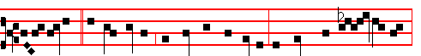
And Jacob * begat Joseph, the husband of Mary, of whom was born Jesus,
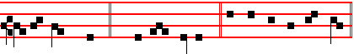
who is called Christ. (E.T. Al-le- lu-ia .) Psalms 110, 111, 112, 113 of Sunday, and 117 as in the Common of Apostles.
Antiphon 2. Tone ij
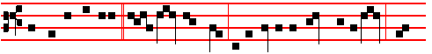
The Angel Gabriel * was sent from God to a virgin espoused to a man whose
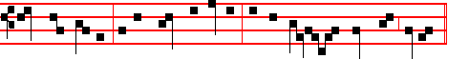
name was Joseph, of the house of David: and the virgin's name was Mary.

1541
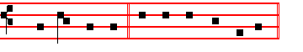
(E.T. Al- le - lu- ia. ) E u o u a e.
Antiphon 3. Tone iij, 1
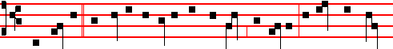
When Mary * the mother of Jesus was espoused to Joseph, before they came
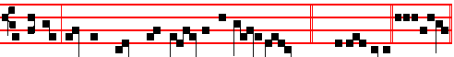
together, she was found with child of the Holy Ghost. (E.T. Alle- lu-ia.) Euouae.
Antiphon 4. Tone iv, 1
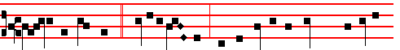
Joseph her husband, * being a just man, and not willing to make her a public
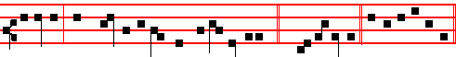
example, was minded to put her away privily. (E.T.Al-le-lu-ia.) E u o u a e.
Antiphon 5. Tone v
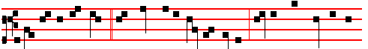
The Angel of the Lord * appeared unto Joseph, saying: Joseph, thou son of Da-
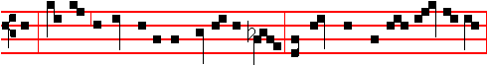
-vid, fear not to take unto thee Mary thy wife: for that which is conceived in her
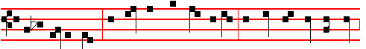
is of the Holy Ghost: and she shall bring forth a son, and thou shalt call his name

1542
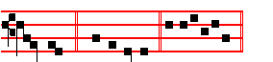
Jes- us. (E.T. Al-le-lu-ia.) E u o u a e.

Chapter Prov. 28 and 21
A FAITHFUL man shall abound with blessings; and he that waiteth on his master shall be honoured.

Hymn. Te, Joseph, celebrent Mode iij
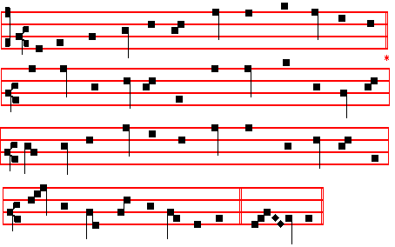

O Joseph, heavenly hosts thy worthiness proclaim,
And Christendom conspires to celebrate thy fame,
Thou who in purest bonds wert to the Virgin bound;
How glorious is thy name renowned.

2 Thou, when thou didst behold thy Spouse about to bear,
Wert sore oppressed with doubt, wert filled with wondering care;
At length the Angel's word thy anxious heart relieved:
She by the Spirit hath conceived.

3 Thou with thy new-born Lord didst seek far Egypt's land,
As wandering pilgrims, ye fled o'er the desert sand;
That Lord, when lost, by thee is in the temple found,
While tears are shed, and joys abound.

1543
4 Not till death' s hour is past do other men obtain
The meed of holiness, and glorious rest attain;
Thou, like to Angels made, in life completely blest,
Dost clasp thy God unto thy breast.

5 O Holy Trinity, thy suppliant servants spare;
Grant us to rise to heaven, for Joseph's sake and prayer,
And so our grateful hearts to thee shall ever raise
Exulting canticles of praise. Amen.

 He made him lord of his house.  And ruler of all his substance.
On Magnificat, Antiphon.
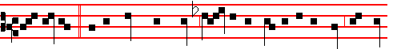
Then Joseph, * being raised from sleep, did as the Angel of the Lord had bid-
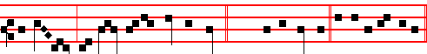
den him, and took unto him his wife. (E.T. Al- le- lu- ia) Cant. Magnificat

COLLECT
WE beseech thee, O Lord, that we may be aided by the prayers of the Spouse of thy most holy Mother: that those things which by our own power we cannot obtain, may through his intercession be granted unto us: Who livest.

(And commemoration is made of the preceding. Antiphon, as in the Common, p. xxv. O Teacher right excellent, * O light of Holy Church, O blessed Cyril, lover of the divine law: intercede for us unto the Son of God.
 The Lord guided the righteous in right paths.
 And shewed him the kingdom of God.
COLLECT
GRANT to us, we beseech thee, almighty God, at the intercession of the blessed bishop Cyril: so to know thee, the only true God, and Jesus Christ whom thou hast sent; that we may be found worthy to be numbered for evermore among the sheep who hear his voice.Through the same.)

Then commemoration of the Feria in Lent.

At Matins, Invitatory.- Christ the Son of God, who deigned to be thought the son of Joseph, * O come, let us worship.

1544
Hymn. Cælitum Joseph decus Mode j, as E.H.188
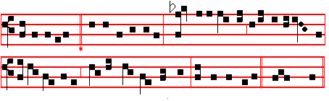
JOSEPH, whose glory fills the Church with praises,
Spouse of the Virgin, Jesus' foster-father,
From the Almighty came thy high vocation,
Best of protectors.

2 When the Redeemer, whom the prophets' chorus
Long had predicted, lay within the manger,
Glad was thy spirit, while in adoration
Lowly thou kneeledst.

3 He, who as monarch reigns over all creation,
Feared in the deepest, worshipped in the highest,
Veiling his Godhead, rendered meek subjection
Unto thy bidding.

4 Praise to the Godhead, Three in One for ever,
Who with such honour wondrously hath blessed thee;
O may he grant us, hearing thy petition,
Joys everlasting. Amen.

IN THE FIRST NOCTURN
Antiphon. Joseph went up * from Galilee, out of the city of Nazareth, into Judea, unto the city of David, which is called Bethlehem, to be taxed with Mary. Psalms from the Common of a Confessor not a Bishop, l Beatus vir
Antiphon.The shepherds * came with haste; and they found Mary and Joseph, and the Babe lying in a manger. Psalm 2 Quare fremuerunt
Antiphon. Behold ,the Angel of the Lord * appeared to Joseph in a dream, saying: Arise, and take the young Child and his Mother, and flee into Egypt. Psalm 3 Domine, quid multiplicati
 He made him lord of his house.  And ruler of all his substance.
From the Book of Genesis
Lesson j Ch.19. 1-5

1545
AND Joseph was brought down to Egypt; and Potiphar, an officer of Pharaoh, captain of the guard, an Egyptian, bought him of the hands of the Ishmeelites, which had brought him down thither. And the Lord was with Joseph, and he was a prosperous man; and he was in the house of his master the Egyptian. And. his master saw that the Lord was with him, and that. the Lord made all that he did to prosper in his hand. And Joseph found grace in his sight, and he served him: and he made him overseer over his house, and all that he had he put into his hand. And it came to pass from the time that he had made him overseer in his house, and over all that he had, that the Lord blessed the Egyptian's house for Joseph's sake.

 The Lord was with Joseph, and gave him favour in the sight of the keeper of the prison: * And the keeper committed to Joseph's hand all the prisoners.
 And whatsoever they did there, he was the doer of it; because the Lord was with him, and that which he did, the Lord made it to prosper. And the keeper.

Lesson ij
AND Joseph's counsel was good in the eyes of Pharaoh, and in the eyes of all his servants. And Pharaoh said unto his servants. Can we find such a one as this is, a man in whom the Spirit of God is? And Pharaoh said unto Joseph, Forasmuch as God hath shewed thee all this, there is none so discreet and wise as thou art; thou shalt be over my house, and according unto thy word shall all my people be ruled: only in the throne will I be greater than thou.

 And when all the land of Egypt was famished, the people cried unto the king for bread, and he said unto them: * Go unto Joseph, what he saith to you, do.
 And the famine was over all thc face of the earth, and Joseph opened the storehouses and sold unto the Egyptians. Go unto.

Lesson iij Ch. 41, 37-44
AND Pharaoh said unto Joseph, See, I have set thee over all the land of Egypt. And Pharaoh took off his ring from his hand, and put it upon Joseph's hand, and arrayed him in vestures of fine linen, and put a gold chain about his neck; and he made him to ride in the second chariot which he had; and they cried before him, Bow the knee: and he made him ruler over all the land of Egypt. And Pharaoh said unto Joseph, I am Pharaoh, and without thee shall no man lift up his hand or foot in all the land of Egypt.

 The Lord hath made me as a father to the king, and lord of all his house; fear not; * For God hath sent me before you into Egypt to save your lives.
 Come unto me, and I will give you the good of the land of Egypt, and ye shall eat the fat of the land. For God. Glory be. For God.

1546
IN THE SECOND NOCTURN
Antiphon. Joseph arose, * and took the young Child and his Mother by night, and departed into Egypt, and was there until the death of Herod. Psalm 4 Cum invocarem
Antiphon. When Herod * was dead, behold, an Angel of the Lord appeared in a dream to Joseph in Esypt, saying, Arise, and take the young Child and his Mother, and go into the land of Israel, for they are dead which sought the young Child's life. Psalm 5 Verba mea
Antiphon. And Joseph took * the young Child and his Mother, and came into the land of Israel. Psalm 8 Domine Dominus noster
 His honour is great in thy salvation.
 Glory and great worship shalt thou lay upon him.

The homily of Bernard of Clairvaux is not given here, but in its place may be read the lessons from S. Gregory The simplicity of the just, from the Common of a Confessor not a Bishop in the second place.

 iv. Joseph went up from Galilee, out of the city of Nazareth, into Judaea, unto the city of David, which is called Bethlehem: * Because he was of the house and lineage of David.
 To be taxed with Mary, his espoused wife. Because.

 v. Arise, and take the young Child and his Mother,and flee into Egpt: * And be thou there until I bring thee word.
 That it might be fulfilled which was spoken of the Lord by the prophet, saying, Out of Egypt have I called my Son. And be.

 vj. When the parents brought the child Jesus into the temple to do for him arger the custom of the law, * Simeon took him up in his arms, and blessed God.
 And Joseph and his mother marvelled at those things which were spoken of him. Simeon. Glory be. Simeon.

IN THE THIRD NOCTURN
Antiphon. When Joseph * heard that Archelaus did reign in Judaea in the room of his father Herod, he was afraid to go thither. Psalm 15 Domine, quis
Antiphon. Joseph being warned in a dream * turned aside into the parts of Galilee: and he came and dwelt in a city called Nazareth, that it might be fulfilled which was spoken by the prophet: He shall be called a Nazarene. Psalm 21 Domine, in virtute tua
Antiphon. Joseph and his mother * marvelled at those things which were spoken of Jesus, and Simeon blessed them. Psalm 24 Domini est terra.

1547
 The righteous shall grow as the lily.
 And he shall flourish in the house of the Lord for ever.
The Lesson from the Holy Gospel according to S. Matthew
Lesson vij Ch. 1, 18-20
WHEN as his mother Mary was espoused to Joseph, before they came together, she was found with child of the Holy Ghost. And the rest.
Homily by S. Jerome, Priest Comm. on Matt. Ch. 1
WHY was he not born simply of a virgin, instead of an espoused one? Firstly, to reveal Mary's lineage by means of Joseph's: secondly, to prevent her being stoned by the Jews as an adulteress: thirdly, to provide a protector for the flight into Egypt. Ignatius the Martyr adds a fourth reason for his being born of an espoused maiden: to hide her child-bearing from the devil, who would expect him to be born of a married woman.

 The Mother of Jesus said unto him: Son, why hast thou thus dealt with us? * Behold, thy father and I have sought thee sorrowing.
 And he said unto them: How is it that ye sought me? Wist ye not that I must be about my Father's business? Behold.

Lesson viij
BEFORE they came together, she was found with Child of the Holy Ghost. By Joseph alone was she found; he had the bridegroom's privilege of knowing all about his bride. In the words, Before they came together, there is no indication that they did come together afterwards; but Scripture shows that they had not done so then.

 Jesus went down with them, and came to Nazareth: * And was subject unto them.
 He increased in wisdom and stature, and in favour with God and man. And was.
Glory be. And was.

In Lent, Lesson ix is said from the Homily of the ocurrent Feria. Otherwise
Lesson ix
T HEN Joseph her husband, being a just man, and not willing to make her a publick example, was minded to put her away privily. If anyone is married to an adulteress, they become one body. and it is laid down in the law that, in addition to the culprit, anyone who is privy to the crime is also guilty: how can Joseph be described as a just man, if he hid his wife's sin? This is the very testimony of Mary's purity, for Joseph knew that she was chaste, and marvelled at what was happening, and so he hid in silence the mystery that he did not understand.
1548
AT LAUDS, AND THROUGH THE HOURS

Antiphon 1. Tone vij, 3
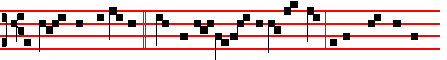
The parents of Jesus * went to Je- ru- salem eve-ry year at the feast of the
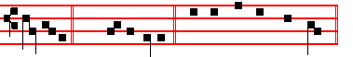
Passover. (E.T. Al-le-lu-ia.) Psalm 93 Dominus regnavit and the rest.

Antiphon 2. Tone viij, 1
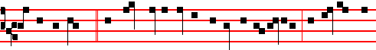
As they returned, * the Child Jesus tarried behind in Je-ru-salem; and Joseph &
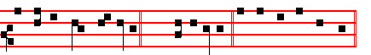
his mother knew not of it. (E.T. Al-le-lu-ia.) E u o u a e.

Antiphon 3. Tone j, 1
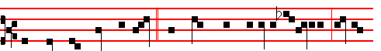
And when they found him not, * they turned back again to Jerusalem, seeking
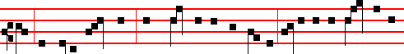
him: and after three days, they found him in the temple, sitting in the midst of the
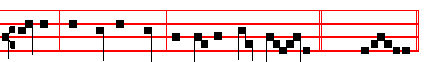
doctors, both hearing them, and asking them questions. (E.T. Al-le-luia.)

1549
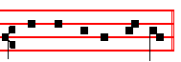
E u o u a e.

Antiphon 4. Tone ij
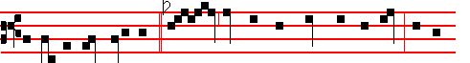
His mother said unto him,* Son, why hast thou thus dealt with us? Behold,
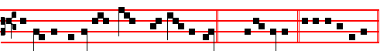
thy father and I have sought thee sorrowing. (E.T. Alle-lu-ia.) E u o u a e.

Antiphon 5. Tone iij, 1
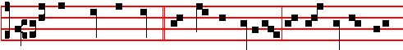
Jesus went down with them,* and came to Nazar-eth, and was subject unto
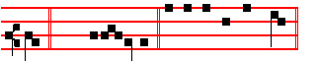
them. (E.T. Al-le-lu-ia.) E u o u a e.

Chapter Prov. 28 and 21
AFAITHFUL man shall abound with blessedness; and he that waiteth on his Master shall be honoured.

Hymn Iste, quem læti. Mode ij

Tune: E.H. 188, p. 1546, or:

1550
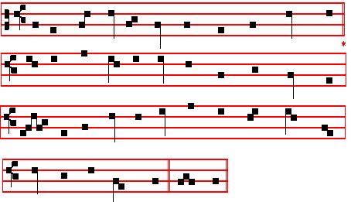
HE, whom the faithful joyously do honour,
Singing his praises with devout affection,
Won, on this feast day, in eternal glory
Life everlasting.

2 Blest beyond others, and exceeding blissful,
For, when the moment of his death was nearing,
Jesus and Mary at his side were standing
Soothing his spirit.

3 Death doth he conquer, laying down his burden,
Calmly he slumbers, rest he gains eternal;
Lo, round his forehead, bright with rays of splendour,
Shineth a garland.

4 Then, as he reigneth, earnestly beseech we
That he may utter fervent intercessions,
Praying that pardon and the peace of heaven
May be our portion.

5 Glory we give thee, hymns of praise and blessing,
One in Three Persons, who above art reigning,
God, who hast honoured with thy crown for ever
This thy true servant. Amen.
 The mouth of the righteous is exercised in wisdom.
 And his tongue will be talking of judgment.

1551
On Benedictus, Antiphon. Tone v
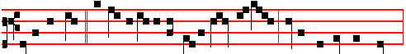
Jesus himself * began to be about thirty years of age, being, as was supposed,
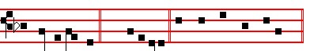
the son of Joseph. (E.T.Alleluia.) Canticle Benedictus, p. 39.

COLLECT
WE beseech thee, O Lord, that we may be aided by the prayers of the Spouse of thy most holy Mother: that those things which by our own power we cannot obtain, may through his intercession be granted unto us: Who livest.

In Lent, commemoration of the Feria.

AT TERCE
Antiphon. As they returned., p. 1549.
Chapter A faithful man, as above, p. 1550.

Short 
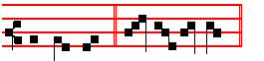
He made him. * Lord of his house. He made him.
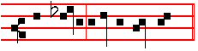
 And ruler of all his substance.
Lord.
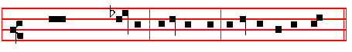
Glory be to the Father, and to the Son, and to the Ho- ly Ghost.
He made him.

1552

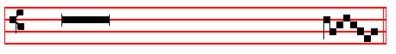
 His honour is great in thy salva- tion.
 Glory and great worship shalt thou lay upon him.

In Eastertide:
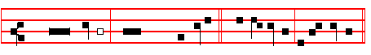
 He made him. Lord of his house. * Al-le- lu-ia, al-le- lu-ia.
He made him.
 And ruler of all his substance. Al-le- lu-ia, al-le- lu-ia.
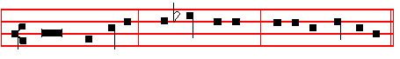
Glory be to the Father, and to the Son, and to the Holy Ghost
He made him.
 His honour is great in thy salva- tion.
 Glory and great worship shalt thou lay upon him.

AT SEXT
Antiphon. And when they found him not, p. 1549.
Chapter Ecclus. 45
BELOVED of God and men, whose memorial is blessed. He sanctified him in his faithfulness and meekness, and chose him out of all men.
Short 
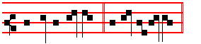
His honour is great * In thy salvation.
His honour.
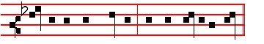
 G1ory and great worship shalt thou lay upon him.
In thy.
1553
Glory be to the Father, and to the Son, and to the Ho- ly Ghost.
His honour.
 The righteous shall blossom as the lily.
 He shall flourish for ever before the Lord.

In Eastertide, tone as above, p. 1553.
 His honour is great in thy salvation * Alleluia, alleluia. His honour.
 Glory and great worship shalt thou lay upon him. Alleluia, alleluia. Glory be.
 The righteous shall blossom as the lily, alleluia.
 He shall flourish for ever before the Lord, alleluia.

AT NONE
Antiphon. Jesus went down with them, p. 1550.
Chapter Wisdom 10
WHEN the righteous fled, Wisdom guided him in right paths, shewed him the kingdom of God, and gave him knowledge of holy things, made him rich in his travels, and mu1tiplied the fruit of his labours.
Short 
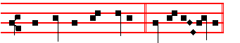
The righteous shall blossom * As the li- ly.
The righteous.
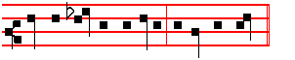
 He shall flourish for ever before the Lord.
As the lily. Glory be. The righteous.
 Planted in the house of the Lord.  In the courts of the house of our God.

In Eastertide, tone as above, p. 1550.
 The righteous shall blossom As the lily * Alleluia, alleluia The righteous.
 He shall flourish for ever before the Lord. * Alleluia, alleluia. Glory be.
 Planted in the house of the Lord, alleluia.
 In the courts of the house of our God, alleluia.

1554
AT VESPERS
Antiphons and Chapter from Lauds. Psalms and Hymn as in first Vespers.
 Riches and plenteousness shall be in his house.
 And his righteousness endureth for ever.
On Magnificat, Antiphon. Tone iv, 1
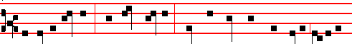
Behold a faithfu1 * and wise servant, whom his Lord hath made ruler over his
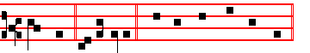
household. Al-le-lu-ia. Canticle Magnificat, p. 209.

COLLECT
WE beseech thee, O Lord, that we may be aided by the prayers of the Spouse of thy most holy Mother: that those things which by our own power we cannot obtain, may through his intercession be granted unto us: Who livest.

In Lent commemoration of the Feria.

__________________________________________________________________

THE TWENTY-FIRST OF MARCH
ON THE FEAST OF S. BENEDICT, ABBOT
DOUBLE.
All from the Common of a Confessor not a Bishop, xcvij, except the following.

COLLECT
O LORD, we beseech thee, let the intercession of the blessed Abbot Benedict commend us unto thee: that those things which for our own merits we cannot ask, we may through his advocacy obtain. Through.
And commemoration is made of the Feria if it is celebrated in Lent.

IN THE FIRST NOCTURN
Lessons Let us now praise famous men, for many Bishops and Confessors, p. lxxxvij, with  for a Confessor not a Bishop, pp. xcix, c.

IN THE SECOND NOCTURN
Lesson iv

1555
BENEDICT was born of a noble family in Nursia, and was given a liberal education at Rome. For the purpose of giving himself wholly to Jesus Christ he sought out a deep cave in a place called Subiaco. For three years he lived there in concealment, his hiding-place being known only to a monk named Romanus, who used to bring him the necessities of life. One day he was subjected to a violent temptation to impurity, so he rolled himself in brambles until the desire of the flesh was extinguished by the pain of his torn body. The fame of his holiness spread abroad beyond his hiding place, and some monks came to him to be taught; but their loose way of living was such that they could not bear his chidings, and they decided to poison his drink. However, when the cup was given him, at the sign of the cross the vessel broke. He left the monastery an returned to his solitude.

 The Lord made him honourable, defended him from his enemies, and kept him. safe from those that lay in wait. * And gave him perpetual glory.
 The Lord guided the righteous in right paths, and shewed him the kingdom of God. And gave.

Lesson v
BUT since many disciples came to him daily, he built twelve monasteries, and
established them with holy laws. Later he went to Cassino, where he destroyed an image of Apollo that was still worshipped there, threw down the altar. and burned the groves. There he huilt the shrine of S. Martin and the chapel of S. John, and instructed the townsfolk and local inhabitants in Christianity. Benedict grew in the grace of God day by day, so that, being prevented with the spirit of prophecy, he foretold things to come. When Totila, king of the Goths, heard this, he wished to find out if it were really true, so he sent his sword bearer with his royal insignia and retinue, who was to pretend to be the king. When Benedict saw him, he said: Put off, my son, put off those things you wear; for they are not yours. He prophesied that Totila would reach Rome, cross the sea, and die in nine years' time.

 The Lord loved him and adorned him: he clothed him with a robe of glory. * And at the gates of paradise he crowned him
  The Lord put on him the breastplate of faith, and adorned him. And at.

Lesson vj
SEVERAL months before he passed from this life, Benedict forewarned his disciples of the day on which he was to die; and he ordered them to open the tomb in which he wished his body to be buried, six days before he was carried thither. On the sixth day he asked to be carried to the church; there, after receiving

1556
the Eucharist, in prayer, with eyes uplifted to heaven, in the arms of his disciples, he breathed forth his soul. Two monks saw it going up into heaven, adorned in a costly mantle, surrounded with shining lights, and a man of illustrious and stately aspect, standing above his head; and they heard him say: This is the way by which Benedict, beloved of the Lord, went up into heaven.

 This man did according unto all that God commanded him: and God said unto him: Enter thou into my rest: * For thee have I seen righteous before me among all people.
 This is he which hated his life In this world, and is come unto life eternal. For thee. Glory be. For thee.

In the Third Nocturn, Homily on the Gospel, Behold, we have forsaken all, as in the Common of Abbots, p. cxiij.
The ninth Lesson from the Homily of the occurrent Feria, if it is celebrated in Lent.
__________________________________________________________________

(THE TWENTY-FOURTH OF MARCH
S. GABRIEL, ARCHANGEL
Greater Double
AT VESPERS
Antiphons from Lauds below. Psalms 110, 111, 112, 113, of Sunday, p. , and finally 138 Confitebor tibi. But if ever II Vespers of this Feast are to be said entire, instead is said 117, p. .
Chapter Dan. 9
BEHOLD the man Gabrie1, whom I had seen in the vision at the beginning, being caused to fly swiftly, touched me about the time of the evening oblation. And he informed me, and talked with me, and said, O Daniel, I am now come forth to give thee skill and understanding.

Hymn. E.H. 242 vv.l, 3,5, 6. Christe, sanctorum decus Angelorum Mode j.
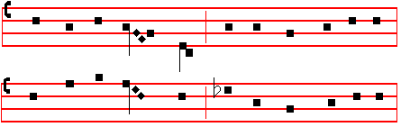

1557
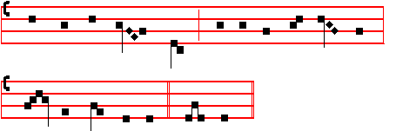
CHRIST, the fair glory of the holy Angels,
Thou who hast made us, thou who o'er us rulest,
Grant of thy mercy unto us thy servants
Steps up to heaven.

3 Send thy Archangel, Gabriel, the mighty; ,
Herald of heaven, may he from us mortals
Spurn the old serpent, watching o'er the temples
Where thou art worshipped.

5 May the blest Mother of our God and Saviour,
May the assembly of the Saints in glory,
May the celestial companies of Angewls
Ever assist us.

6 Father almighty, Son and Holy Spirit,
God ever blessed, be thou our preserver;
Thine is the glory which the Angels worship,
Veiling their faces. Amen.

 An Angel stood at the altar of the temple.
 Having in his hand a golden censer.
On Magnificat, Antiphon. The Angel Gabriel * came in unto Mary and said, Hail, thou that art full of grace, the Lord is with thee; blessed art thou among women.

COLLECT
O GOD, who from the company of Angels didst choose the Archangel Gabriel to proclaim the mystery of thine Incarnation: mercifully grant; that we who celebrate his festival on earth, may perceive his advocacy in heaven: Who livest.
And commemoration is made of the Feria.

AT MATINS

1558
Invitatory.- The Lord, the King of the Angels, * O come, let us worship.
Hymn Christe, sanctorum Angelorum, as above.

IN THE FIRST NOCTURN

Antiphon 1. The Angel Gabriel * said unto Daniel: Understand, O son of man, for at the time of the end shall be the vision. Psalm 8
Antiphon 2. Behold the man Gabriel, * whom I had seen in the vision, being caused to fly swiftly, touched me about the time of the evening oblation, and he informed me. Psalm 11
Antiphon 3.. When Gabriel * talked with me, I fell on my face toward the ground: but he touched me, and set me upright. Psalm 15
 An Angel stood at the altar of the temple.
 Having in his hand a golden censer.

From the Book of Daniel
Lesson j Ch. II, 20-27
I DANIEL, whiles I was speaking, and praying, and confessing my sin and the sin of my people Israel, and presenting my supplication before the Lord my God for the holy mountain of my God; Yea, whiles I was speaking in prayer, even the man Gabriel, whom I had seen in the vision at the beginning, being caused to fly swiftly, touched me about the time of the evening oblation. And he informed. me, and talked with me, and said, O Daniel, I am now come forth to give thee skill and understanding. At the beginning of thy supplications the commandment came forth, and I am come to shew thee; for thou art greatly beloved: therefore understand the matter, and consider the vision.

 While Daniel was praying, and confessing his sin and the sin of his people, * Behold, the Archangel Gabriel, being caused to fly swiftly, touched him about the time of the evening oblation.
 And while he was presenting his supplication before the Lord his God. Behold, the Archangel.

Lesson ij
SEVENTY weeks are determined upon thy people and upon thy holy city, to finish the transgression, and to make an end of sins, and to make reconciliation for iniquity, and to bring in everlasting righteousness, and to seal up the vision and prophecy, and to anoint the most Holy. Know therefore and understand, that from the going forth of the commandment to restore and build Jerusalem unto the Messiah the Prince shall be seven weeks, and threescore and two weeks: the street shall be built again, and the wall, even in troublous times.

1559
 Gabriel talked with Daniel, and said: At the beginning of thy supplications the commandment came forth: * I am come to shew thee, for thou art greatly beloved.
 Therefore understand the matter, and consider the vision. I am come.

Lesson iij
AND after threescore and two weeks shall Messiah be cut off, but not for himself: and the people of the prince that shall come shall destroy the city and the sanctuary; and the end thereof shall be with a flood, and unto the end of the war desolations are determined. AND he shall confirm the covenant with many for one week: and in the midst of the week he shall cause the sacrifice and the oblation to cease, and for the overspreading of abominations he shall make it desolate, even until the consummation, and that determined shall be poured upon the desolate.

 Behold the man Gabriel, whom I had seen, being caused to fly swiftly, touched me about the time of the evening oblation, and he informed me, and said: * Daniel, I am come forth to give thee skill and understanding.
 Gabriel, make me to understand this vision: and he came and stood by me where I was standing, and he said unto me. Daniel. Glory be. Daniel.

IN THE SECOND NOCTURN
Antiphon. The Angel Gabriel * appeared unto Zacharias, and said: Thy wife Elisabeth shall bear thee a son, and thou shalt call his name John. Psalm 19
Antiphon. And Zacharias said * unto the Angel: Whereby shalll know this? For I am an old man, and my wife well-stricken in years. Psalm 24.
Antiphon. And the Angel answering * said unto him: I am Gabriel, that stand in the presence of God; and am sent to speak unto thee, and to shew thee these glad tidings. Psalm 34.
 The smoke of the incense ascended up before God.  Out of the Angel's hand.

Sermon by S.Bede the Venerable, Priest.
Lesson iv
THE Angel appeared to Zacharias, standing at the right hand of the altar of incense. It is well that the Angel appeared in the temple, and by the altar, and at the right; for clearly he prophesies the coming of the true priest, and the mystery of a universal sacrifice, and the joy of a heavenly gift. For, as bythe left present goods, so by the right often eternal goods are foretold. In connection with which it is sung in praise of wisdom: Length of days in her right hand: in her left riches and glory.The Angel comforts the trembling Zacharias, for, just as it is proper to human frailty to be disturbed at the sight of a spiritual creature, so also it is proper to angelic kindness to soothe and solace mortals frightened by their

1560
sight. But on the other hand, it is proper to demonic ferocity, to pursue those who seem affrighted at their presence with ever greater horrors, which are defeated by nothing better than by intrepid faith.

 It came to pass, that while Zacharias executed the priest's office before God in the order of his course, * There appeared unto him the Angel Gabriel, standing at the right site of the altar of incense.
 And when he went into the temple of the Lord to burn incense according to the custom of the priest's office. There appeared.

Lesson v
THE Angel said that his prayer had been heard and immediately promised that his wife would bear a child. Not that he, who had entered in to offer for the people, could have neglected public prayers and prayed for sons, especially as nobody prays for what he despairs of receiving. But he so despaired of sons being born to him, being mindful that he was now old and his wife barren, that he did not believe the Angel when he promised it. But what he says: Thy prayer is heard, is meant for the redemption of the people; And thy wife shall bear thee a son, unfolds the order of the same redemption, for clearly the son born to Zacharias will by preaching prepare the way for the Redeemer of that people. For by saying that the prayer of Zaoharias for the people had been heard, he shows how the same people was to be saved and perfected, that is by repenting and believing in Christ at John's preaching.

 The Angel Gabriel came down to Zacharias and said unto him: * Fear not, for thy prayer is heard; and thy wife Elisabeth shall bear thee a son, and thou shalt call his name John.
 And when Zacharias saw him, he was troubled, and fear fell upon him: But the Angel said unto him. Fear not.

Lesson vj
ZACHARIAS, hesitating at the greatness of the promises, asks a sign by which he may believe, when the sight alone of the Angel or his message should have sufficed him for a sign. So deservedly he paid the penalty of his diffidence, by silence, and the same silence was to him both the sign of faith, which he sought, and the penalty of unbelief, which he deserved. It is to be understood, that if a man were to promise such things, one might with impunity demand a sign; but, when an Angel promises, it is no longer proper to doubt. And he gives the sign asked for, so that he who spoke in unbelief, may in silence learn belief. In which place it is to be noted that the Angel testifies that he both stands before God, and is sent to bring news to Zacharias: for even when the Angels come to us, they so

1561
fulfil their outward service, that they nevertheless never cease from inward contemplation. Therefore they b0th are sent, ani stand in the presence, for, even if the angelic spirit is circumscribed, yet that greatest spirit, who is God, is not circumscribed. And so Angels are both sent, and before Him, for, whithersoever they are sent and go, they run within Him. ((The Feast of Saint Gabriel the Archangel was made universal by Pope Benedict XV )).

 I am Gabriel, that stand in the presence of God; and am sent to speak unto thee, and to shew thee these glad tidings.* Behold, thou shalt be dumb, and not able to speak, until the day that these things shall be performed.
 Because thou believest not my words, which shall be fulfilled in their season. Beholt, thou. Glory be. Behold, thou.

IN THE THIRD NOCTURN

Antiphon. The Angel Gabriel * was sent to Mary, a Virgin espoused to Joseph. Psalm 96.
Antiphon. The Angel Gabriel * said unto Mary: Behold, thy cousin Elisabeth, she hath also conceived a son in her old age. Psalm 97.
Antiphon. Receive the Word, * O Virgin Mary, which is brought thee from the Lord by the Angel Psalm 103.
 In the presence of the Angels will I sing praise unto thee, O my God.
 I will worship toward thy holy temple, and praise thy name.

The Lesson from the Holy Gospel according to S. Luke
Lesson vij Ch. 1

THE Angel Gabriel was sent from God unto a city of Galilee, named Nazareth, to a Virgin espoused to a man whose name was Joseph, of the house of David; and the Virgin's name was Mary. And the rest.
** Homily by S. Julian, Archbishop of Toledo Bk. 2 against the Jews
IT was through an Angel that Daniel learned the mystery of the seventy weeks referring to the birth of Christ; and similarly Zacharias, when an Angel appeared to him, heard that his son John was to be begotten by him; and Mary, when an Angel foretold that Christ was to be born of her, both believed and con- sented. We see that these three things were announced and fulfilled through an Angel. We must now, therefore, carefully consider whether this Angel who appeared to Zacharias and Mary was the same one that loretold those things to Daniel.
1562
_______________________________________________________________
**From the Monastic Breviary, instead of the Homily of Bernard of Clairvaux, not given here.
 The Angel Gabriel was sent to Mary, a Virgin espoused to Joseph, to bring unto her the Word: and when the Virgin saw the light, she was afraid. * Fear not, Mary, for thou hast round favour with the Lord; and, behold, thou shalt conceive and bring forth a Son, and he shall be called the Son of the Highest.
 And when she saw him, she was troubled at his saying, and cast in her mind what manner of salutation this should be. Fear not.

Lesson viij
DANIEL himself, in his prophetical book, when he learns through the Angel of
that mystery of the weeks rererring to the birth of Christ, clearlv makes mention or that Angel's name. For he says: The man Gabriel, whom I had seen at the beginning, being caused to fly swiftly, touched me, and said: Daniel, understand the matter; and so on, as there recorded. Similarly, when those times drew near, it is found. according to the Evangelist, that the wonderful name of that Angel is uttered again. For the same Angel said to Zacharias: I am Gabriel, that stand in the presence of God; and am sent to speak unto thee, and to shew thee these glad tidings.

 Rejoice, O Virgin Mary; thou hast mightily destroyed all heresies; * Because thou didst believe the words of thc Archangel Gabriel, when thou, a Virgin, didst give birth to God and man, and thou remainest a Virgin for ever.
 Blessed art thou among women, and blessed is the fruit of thy womb. Because the. Glory be. Because the.

In Lent the ninth Lesson from the Homily of the occurrent Feria; otherwise, if the ninth Lesson of any commemorated Office is not to be said, it will be the following
Lesson ix
AGAIN, in the same Gospel, where we read of the childbearing of the blessed Virgin Mary: The Angel Gabriel, says the Evangelist, was sent from God unto a city of Galilee, named Nazareth, To a Virgin espoused to a man whose name was Joseph, of the house of David; and the Virgin's name was Mary. Therefore it is now clear that it was one and the same Angel who both shewed the foreordained time or the birth of Christ to Daniel, and revealed the childbearing of the Virgin when the time came. He comes, therefore, at the appointed time, and proves by the actual events that what he had formerly foretold has now been fulfilled, faithful in that prophecy of the weeks, and faithful in the revelation of the mystery.
Te Deum Laudamus, p. 24.

AT LAUDS AND THE HOURS

1563
Antiphon 1.When Zacharias * went into the temple, there appeared unto him the Angel Gabriel, standing at the right hand of the altar of incense. Psalm 93 Dominus regnavit and the rest, p.
Antiphon 2. But the Angel said unto him, * Fear not, Zacharias, for thy prayer is heard.
Antiphon 3. I am the Angel Gabriel, * that stand in the presence of God; and am sent to speak unto thee.
Antiphon 4. The Angel Gabriel * spake unto Mary, saying: Behold, thou shalt conceive in thy womb, and bring forth a Son, and shall call his Name Jesus.
Antiphon 5. Then said Mary * unto the Angel, How shall this be, seeing I know not a man? And the Angel Gabriel answered and said unto her, The Holy Ghost shall come upon thee, and the power of the Hignest shall overshadow thee.

Chapter Dan. 9
BEHOLD the man Gabriel, whom I had seen in the vision at the beginning, being caused to fly swiftly, touched me about the time of the evening oblation. And he informed me, and talked with me, and said, O Daniel ,I am now come forth to give thee skill and understanding.
Hymn. Christe, Redemptor omnium (Tune E.H.17) Mode j
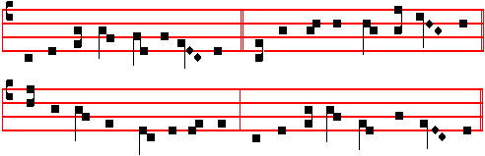
O CHRIST, Redeemer of us all, 3 And ye, O ever blissful throng
Protect thy servants when they call, Of heavenly Spirits, guardians strong,
And hear with reconciling care Our past and present ills dispel,
The Blessed Virgin's holy prayer. From future peril shield us well.

2 Be ever present, Angel high 4 From lands wherein thy faithful dwell
Whose name 'God's might' doth signify: Drive far away the infIdel;
To all the weak new strength impart, So we to Christ new hymns of praise
And solace to the sad of heart. Henceforth with eager hearts may raise.

5 To thee, O Father, born of none,
And thee, O sole-begotten Son,
One with the Holy Paraclete,
Be glory ever, as is meet.

1564
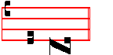
A - men.

 An Angel stood at the altar of the temple.
 Having in his hand a golden censer.
On Benedictus, Antiphon. The Angel Gabriel * descended to Zacharias, and said unto him: Thy wife shall bear thee a son, and thou shalt call his name John; and many shall rejoice at his birth; for he shall go before the face of the Lord, to prepare his ways.
COLLECT
O GOD, who from the company of Angels didst choose the Archangel Gabriel to proclaim the mystery of thine Incarnation: mercifully grant; that we who celebrate his festival on earth, may perceive his advocacy in heaven: Who livest.
And commemoration is made of the Feria.

AT TERCE
Antiphon. But the Angel said. unto him.
Chapter: Behold the man Gabriel, as above.
Short  An Angel stood * At the altar of the temple. An Angel.
 Having in his hand a golden censer. At the. Glory be. An Angel.
The smoke of the incense ascended up to God.  Out of the Angel's hand.

AT SEXT
Antiphon. I am the Angel Gabriel.
Chapter Dan. 9
AND I am come to shew thee; for thou art greatly beloved: seventy weeks are determined to make an end of sins, and to seal up the vision and prophecy, and to anoint the most Holy.
Short  The smoke of the incense * Ascended up before God. The smoke.
 Out of the Angel's hand. Ascended up. Glory be. The smoke.
 In the presence of the Angels I will sing praise unto thee, O God.
 I will worship toward thy holy temple, and praise thy Name.

AT NONE
Antiphon. Then said Mary.
Chapter Dan. 9
KNOW therefore and understand, that from the going forth of the commandment to restore and to build Jerusalem unto the Messiah the Prince

1565
shall be seven weeks, and threescore and two weeks.
Short  In the presence of the Angels * I will sing praise unto thee, O my God.
In the presence.
 I will worship toward thy holy temple, and praise thy Name. I will sing. Glory be. In the presence.
 O worship God.  All ye Angels of his.

Vespers of the following. Commemoration of the Feria only.
¶ If ever II Vespers of this Feast are to be said entire:

AT II VESPERS
Antiphons, Chapter and Hymn as in I Vespers above; Psalms of Sunday, but in the last place is said Psalm 138 Confitebor tibi.
 In the presence of the Angels I will sing praise unto thee, O my God.
 I will worship toward thy holy temple, and praise thy Name.
On Magnificat, Antiphon. The Archangel Gabriel * said unto Mary: With God nothing shall be impossible. And Mary said, Behold the handmaid of the Lord: be it unto me according to thy word. And the Angel departed from her.)
__________________________________________________________________

THE TWENTY -FIFTH OF MARCH
ON THE FEAST OF THE ANNUNCIATION
OF THE BLESSED VIRGIN MARY
DOUBLE OF THE SECOND CLASS

If this Feast shall come on a privileged Sunday, it shall be transferred to the Monday immediately following, even if a Feast of equal, but not of higher rank, falls upon it. But if it shall occur in Holy Week, or Easter Week, it shall be transferred (with equal privilege) to the Monday after Low Sunday, observing the rite for Eastertide.
AT VESPERS

Antiphons from Lauds. Psalms 111, 113, 122, 127, 147 (vv.12-20) as in Feasts of the B. V. Mary.
Chapter Isaiah 7
BEHOLD, a virgin shall conceive, and bear a son, and shall call his name Immanuel. Butter and honey shall he eat, that he may know to refuse the evil, and choose the good.
Hymn E.H. 213 Ave, maris stella, as on Feasts of the B.V. Mary.
 Hail, Mary, full of grace.  The Lord is with thee.
On Magnificat, Antiphon. Tone viij, 1

1566
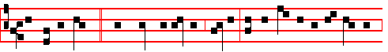
The Holy Ghost * shall come upon thee, Mary: and the power of the Highest
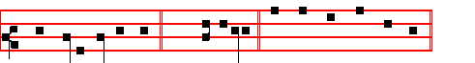
shall overshadow thee. (E.T. Al-leluia.) Canticle Magnificat, p. 210.

COLLECT
OGOD, who wast pleased that thy Word should take flesh of the womb of the blessed Virgin Mary at the message of an Angel: grant to thy humble servants; that we who believe her to be truly the Mother of God may be aided by her intercession in thy sight. Through the same.
In Lent, commemoration is made of the Feria.
At Compline, and through the Hours, (even if it be in Eastertide) at the end of the Hymns is said:
All honour, laud, and glory be
O Jesu, Virgin-born, to thee.

AT MATINS
Invitatory.- Hail, Mary, full of grace: * The Lord is with thee.
Psalm 95 Venite, p. 2.
Hymn, Antiphons, Psalms, and  of the Nocturns, as on Feasts of the B. V. Mary, with the ninth Antiphon The Angel of the Lord, as in the same place.

IN THE FIRST NOCTURN
From the Book of the Prophet Isaiah
Lesson j Ch. 7, 10-15
THE Lord spake again unto Ahaz, saying, Ask thee a sign of the Lord thy God: ask it either in the depth, or in the height above. But Ahaz said, I will not ask, neither will I tempt the Lord. And he said, Hear ye now, O house of David: Is it a small thing for you to weary men, but will ye weary my God also? Therefore the Lord himself shall give you a sign; Behold, a virgin shall conceive, and bear a son, and shall call his name Emmanuel. Butter and honey shall he eat, that he may know to refuse the evil, and choose the good.

 The Angel Gabriel was sent to Mary, a virgin espoused to Joseph, to bring unto her the Word; and when the virgin saw the light she was afraid: Fear not. Mary, for thou hast found favour with the Lord: * Behold, thou shalt conceive and bring

1567
forth a Son, und he shall bc called the Son of the Highest.
 The Lord God shall give unto him the throne of his father David; and he shall reign over the house of Jacob for ever. Behold.

Lesson ij Ch.11, 1-5
AND there shall come forth a rod out or the stem of Jesse, und a Branch shall grow out of his roots: and the spirit of the Lord shall rest upon him, the spirit of wisdom and understanding. the spirit of counsel und might, the spirit of knowledge and of the fear of the Lord; and shall make him of quick understanding in the fear or the Lord: and he shall not judge after the sight of his eyes, neither reprove after the hearing of his ears: but with righteousness shall he judge the poor, and reprove with equity for the meek of the earth: and he shall smite the earth with the rod of his mouth, and with the breath of his lips shall he slay the wicked. And righteousness shall be the girdle of his loins, and faithfulness the girdle of his reins.

 Hail, Mary, full of grace, the Lord is with thee: * The Holy Ghost shall come upon thee, and the power of the Highest shall overshadow thee: therefore also that holy thing which shall be born of thee shall be called the Son of God.
 How shall this be, seeing I know not a man? And the Angel answered, and said unto her. The Holy Ghost.

Lesson iij Ch. 35, 1-7
THE wilderness and the solitary place shall be glad for them; and the desert shall rejoice, and blossom as the rose. It shall blossom abundantly, and rejoice even with joy and singing: the glory of Lebanon shall be given unto it, the excellency of Carmel and Sharon, they shall see the glory of the Lord, and the excellency of our God. Strengthen ye the weak hands, and confirm the feeble knees. Say to them that are of a fearful heart, Be strong, fear not: behold, your God will come with vengeance, even God with a recompence; he will come and save you. Then the eyes of the blind shall be opened, and the ears of the deaf shall be unstopped. Then shall the lame man leap as an hart, and the tongue of the dumb sing: for in the wilderness shall waters break out, and streams in the desert. And the parched ground shall become a pool, and the thirsty land springs of water.

 Receive the Word, O Virgin Mary, which is brought thee from the Lord by the Angel: conceive and bear him who is both God and man: * That thou mayest be callcd blessed among all women.
 For thou shalt bear a Son, yet shalt thou remain unspotted in thy virginity: thou shalt bring to pass great things, and shalt be a Mother ever Virgin. That thou.
Glory be. That thou.

1568
IN THE SECOND NOCTURN
Sermon by S. Leo the Great
Lesson iv Sermon 2 On the Birth of Our Lord
THE Almighty and most merciful God, whose nature is goodness, whose
will is power, whose work is mercy, as soon as the devil in his malice had done us to death with the poison of his envy, at the very beginning of the world foretold those remedies which in his loving- kindness he had predestined for our salvation; he proclaimed to the serpent that the seed of the woman would prevail to bruise his proud and evil head, that is, Christ who was to come in the flesh; signifying that he who was born of a Virgin would, by his undefiled birth, condemn the seducer of the human race.

 Behold a virgin shall conceive and bear a son, saith the Lord: * And his Name shall be called Wonderful, Counsellor, the Mighty God.
 He shall sit upon the throne of David, and of his kingdom there shall be no end. And his.

Lesson v
NOW the devil was rejoicing because by his guile he had so deceived man as to deprive him of his divine gifts and to rob him of his dowry of immortality, thus making him suffer the hard sentence of death; and because in his misery he had found a certain consolation in having a comrade in his guilt; he also thought that God, by reason of righteous severity, would now change his former attitude towards man whom he had created in such high dignity: there was need, dearly beloved, that the unchangeable God, whose will cannot be separated from his loving-kindness, should fulfil his original purpose of goodness by the dispensation of his secret counsel, by the hidden mystery of his plan; and that man, led into sin by the cunning craft of the devil's wickedness, should not perish in opposition to God's idea.

 There shall come forth a rod out of the stem of Jesse, and a branch shall grow out of his roots: * And righteousness shall be the girdle of his loins, and faithfulness the girdle of his reins.
 And the spirit of the Lord shall rest upon him, the spirit of wisdom and understanding. And.

Lesson vj
THEREFORE, dearly beloved, when the time appointed for the redemption of mankind had come, our Lord Jesus Christ entered this lower world, descended from his heavenly throne, and, without receding from the glory that he had with the Father, took flesh by a new means, by a new birth: invisible in his own nature,

1569
he became visible in ours; being incomprehensible, he willed to be comprehended; remaining before time, he began to exist in time; the Lord or the universe veiled the glory of his majesty and took the form of a servant; impassible God did not disdain to becomc a suffering man, and immortal God subjected himself to the laws of death.

 O holy and spotless virginity! I know not how to praise thee; * For thou hast borne in thy breast him whom the heavens cannot contain.
 Blessed art thou among women, and blessed is thc fruit of thy womb. For thou hast. Glory be. For thou hast.

IN THE THIRD NOCTURN

The Lesson from the Holy Gospel according to S. Luke
Lesson vij Ch. 1
THE angel Gabriel was sent from God unto a city of Galilee, named Nazareth, to a virgin espoused to a man whose name was Joseph, of the house of David; and the virgin's name was Mary. And the rest.
Homily by S. Ambrose, Bishop Bk. 2 on Luke Ch. 1, v. 26
THE divine mysteries are well hidden, and their meanings are not easy to grasp. For, as the prophet says: What man is he that can know the counsel of God? And yet we can gather from other sayings of our Lord and Saviour, that there was some prevalent reason for singling out for the Childbearing of our Lord one who was espoused to a man. Why was her time not fulfilled before her espousal? To give the devil no chance of saying that she had conceived in adultery.

 Rejoice with me, all ye that love the Lord, for although I was lowly I pleased the Most High. * And from my womb I have brought forth God and man.
 All generations shall call me blessed, for the Lord hath regarded the lowliness of his handmaiden. And from.

Blessing May the Virgin of virgins whose Feast we are keeping intercede for us to the Lord.
Lesson viij
AND the Angel came in unto her. Mark the virtue of a virgin in her behaviour, mark it in her hesitancy, mark it in her words, in the mystery itself. It is natural for a virgin to be timid, perturbed at the approach of men, and troubled at their salutation. Here is an example of modesty for women to study. She was alone in her chamber, she who would not be seen by men, and an Angel alone discovers her there. She was alone with neither companion nor witness, when the

1570
Angel saluted her, so that their converse could not be basely interpreted.

 Rejoice, O Virgin Mary, thou hast mightily destroyed all heresies, because thou didst believe the words of the Archangel Gabriel. * When thou, a Virgin, didst give birth to God and Man. thou remainest a Virgjn forever.
 Blessed art thou, who didst believe; for there shall be a performance of those things which were told thee from the Lord. When thou. Glory be. When thou.

In Lent, Lesson ix from the Homily of the occurrent Feria. Otherwise
Lesson ix
NOW this mystery was not to be entrusted to men, but was to issue from the mouth of an Angel. To-day is heard for the first time: The Holy Ghost shall come upon thee. It is both heard and believed. Then she says: Behold the handmaid of the Lord: let it happen to me according to thy word. How humblc she is! How she consecrates herself! She who is chosen to be the Mother of the Lord calls herself his handmaid, instead of exalting herself at the unexpected promise.
Te Deum Laudamus, p. 24.

AT LAUDS, AND THE HOURS,
Antiphon 1. Tone viij, 1
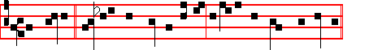
The Angel * Gabriel was sent to Mary, a Virgin espoused to Joseph. (E.T.
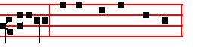
Alleluia) Psalm 93 Dominus regnavit and the rest, .p.
Antiphon 2. Tone j, 2
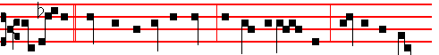
Hail Mary * thou that art full of grace, the Lord is with thee: blessed art thou
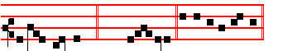
among women. (E.T. Al-le-luia.) E u o u a e.

Antiphon 3. Tone viij, 1
1571
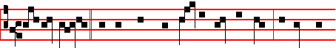
Fear not, Mary, * for thou hast found favour with the Lord: behold, thou
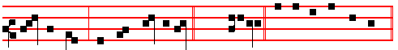
shalt conceive, and bring forth a Son.(E.T. Alleluia) E u o u a e.
Antiphon 4. Tone j, 1
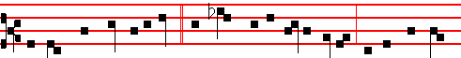
The Lord shall give unto him * the throne of his father David, and he shall reign
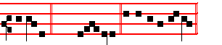
for ever. (E.T. Alle-luia.) E u o u a e.
Antiphon 5. Tone viij, 2
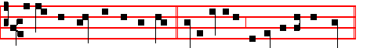
Behold the handmaid of the Lord * be it unto me according to thy word.
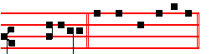
(E.T. Alleluia.) E u o u a e. Chapter Isaiah 1
BEHOLD, a virgin shall conceive, and bear a son, and shall call his name Immanuel. Butter and honey shall he eat, that he may know to refuse the evil, and choose the good.
Hymn E.H. 215 O gloriosa, as on Feasts of the B.V. Mary.
 Hail, Mary, full of grace.  The Lord is with thee.
On Benedictus, Antiphon. Tone vij, 3
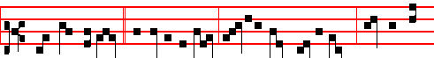
How shall this be, * O Angel of God, seeing I know not a man? Hearken, O

1572
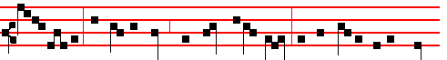
Virgin Mary; The Holy Ghost shall come upon thee, and the power of the High-
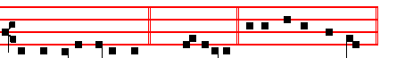
est shall overshadow thee. (E.T. Alleluia. ) Canticle Benedictus, p. 39.
COLLECT
O GOD, who wast pleased that thy Word should take flesh of the womb of the blessed Virgin Mary at the message of an Angel: grant to thy humble servants; that we who believe her to be truly the Mother of God may be aided by her intercession in thy sight. Through the same.
In Lent, commemoration of the Feria.
At Prime in the Short , even in Eastertide,  Who wast torn of the Virgin Mary.

AT TERCE
Antiphon. Hail, Mary, p. 1571.
Chapter Behold, a virgin, as above, p. 1572.
Short  as in the Common.
In thy grace, * And in thy beauty. In thy.
 Go forth, ride prosperously, and reign. And in. Glory be. In thy.
 God shall help her with his countenance.
 God is in the midst of her, therefore shall she not be removed.

AT SEXT
Antiphon. Fear not, Mary, p. 1572.
Chapter Luke 1
THE Lord God shall give unto him the throne of his father David: and he shall reign over the house of Jacob for ever; and of his kingdom there shall be no end.
Short  as in the Common.
God shall help her * With his countenance. God shall.
 God is in the midst of her, therefore shall she not be removed. With his. Glory be. God shall.
 God hath chosen her, and preferred her.
 He hath made her to dwell in his tabernacle.

AT NONE

1573
Antiphon. Behold the handmaid of the Lord, p. 1572..
Chapter Isaiah 11
THERE shall come forth a rod out of the stem of Jesse, and a Branch shall grow out of his roots: and the Spirit of the Lord shall rest upon him.
Short  as in the Common.
God hath chosen her * And preferred her. God hath.
 He hath made her to dwell in his tabernacle. And preferred. Glory be. God hath.
 Full of grace are thy lips.
 Because God hath blessed thee for ever.

AT VESPERS
All as in I Vespers above, p. 1566.
 Hail Mary, full of grace.  The Lord is with thee.
On Magnificat, Antiphon. Tone vij, 2
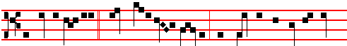
The Angel Gabriel * spake unto Mary, saying: Hail, thou that art full of grace,
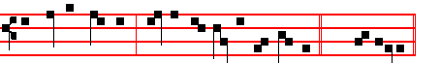
the Lord is with thee; blessed art thou among women. (E.T. Alleluia.)
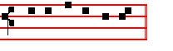
Canticle Magnificat.
In Lent commemoration is made of the Feria.
__________________________________________________________________

(THE TWENTY-SEVENTH OF MARCH
S. JOHN DAMASCENE CONFESSOR AND DOCTOR OF THE CHURCH
DOUBLE

In the Hymn E.H. 188 Iste Confessor, the third line is changed.
 The Lord loved him, and adorned him.
 He clothed him with a robe of glory.
On Magnificat, Antiphon as for Doctors, p. lxxv. O Teacher right excellent, * O light of Holy Church, O blessed John, lover of the divine law; intercede for us unto the Son of God.
1574
COLLECT
ALMIGHTY and everlasting God, who, for the defence of the veneration of sacred images, didst endue blessed John with heavenly doctrine and wondrous strength of spirit: grant unto us by his intercession and example; that we may imitate the virtues and perceive the advocacy of those whose images we venerate. Through.
And in Lent commemoration is made of the Feria.
In the first Nocturn, Lessons He will seek out, from the Common of Doctors, p. xcj.
IN THE SECOND NOCTURN
Lesson iv
JOHN, called Damascene from his native city, was of noble birth, and educated in human and divine writing in Constantinople by Cosmas the monk; and when with such violence the emperor Leo She Isaurian waged a wicked war on the cult
of images, John, encouraged by the Pope of Rome Gregory III, defended the sanctity of that cult firmly in words and writings. By this he aroused such envy by Leo against himself, that he wrote letters to the Caliph of Damascus accusing him as a traitor, since he used John as a counsellor and administrator. John denied the calumny in vain, and the prince, believing the lie, ordered his right hand to be cut off. But the most holy Virgin ,whose help he had earnestly implored in prayers, was present to vindicate the innocence of her servant, and by her help the severed hand, restored to the arm, so adhered, as if it had never been separated. Greatly moved by this miracle John decided to carry out what he had conceived long ago in his mind. And so, having obtained the Caliph's reluctant permission to depart, he distributed all his means to the poor, and gave liberty to his slaves; then he went as a pilgrim round the holy places of Palestine, and finally together with his teacher Cosmas withdrew into the monastery of Saint Sabbas near Jerusalem, and there was ordained presbyter.

 The Lord made him honourable, defended him from his enemies, and kept him safe from those that lay in wait.* And gave him perpetual glory.
 The Lord guided the righteous in right paths, and shewed him the kingdom of God. And gave.

Lesson v
IN the exercise of the religious life he gave a splendid example to the monks of virtues, especially of humility and obeidience. He demanded all the lowest tasks of the monastery as his own, ani zealously performed them. When he was commanded to go selling in Damascus the baskets that he had woven, in that city indeed, where once he had discharged his office with great honours, he eagerly sought the mockery and derision of the multitude. He so practised obedience, that

1575
not only was he prompt to every nod of the rulers; but never even thought he should ask the reason for what was commanded, however hard and unusual. Among this exercise of virtues, he never ceased to guard zealously the catholic dogma of the cult of the holy icons. For this reason he provoked later the hatred and persecution of Constantine Copronymus against him, as previously of Leo the Isaurian; all the more because he freely attacked the arrogance of emperors who presumed to deal with matters of faith and to give judgment on them by their own will.

 The Lord loved him and adorned him: he clothed him with a robe of glory. * And at the gates of paradise he crowned him.
 The Lord put on him the breastplate of faith, and adorned him. And at.

Lesson vj
IT is truly wonderful, how much John composed both in poetry and prose, for the safeguarding of the faith, and the fostering of piety; and was indeed worthy to be celebrated by the Second Council of Nicæa with fulsome praises, and to be called Chrysorrhoas because of the golden flow of his speech. Nor did he defend the orthodox faith only against the enemies of icons; but strenuously assailed almost all heretics, especially the Acephali, the Monothelites, and the Theopaschites. He excellently defended the power and rights of the Church. He asserted the primacy of the prince of the apostles in many arguments; calling him pillar of the Church, unbroken rock, and master and moderator of the whole world, in many places.And all his writings are notable not only for learning and doctrine, but also show a certain sense of natural piety, especially when he proclaims the praises of the Mother of God, to whom he had a singular devotion and love. But the highest praise of John is that he was the first to compose a systematic theology and showed the way to others **. At last the holy man, full of merit and in declining age, slept in peace in Christ, about the year 754. ((His Office and Mass were made universal by Pope Leo XIII))

 This man did according unto all that God commanded him: and God said unto him: Enter thou into my rest: * For thee have I seen righteous before me among all people.
 This is he which hated his life in this world, and is come unto life eternal. For thee. Glory be. For thee.

IN THE THIRD NOCTURN
The Lesson from the holy Gospel according to Luke.
Lesson vij Ch. 6

1576
AT that time: It came to pass on another Sabbath, that Jesus entered into the synagogue and taught: and there was a man whose right hand was withered. And the rest.
Homily by S. Peter Chrysologus. Sermon 32
IN this man is pictured the image of all men, in him the cure of all is performed, in him the long-awaited health of all is restored. For the man's hand had withered more through paralysis of faith than through dryness of nerves, and more by guilt of conscience than by weakness of flesh. For that sickness was exceeding old, and contracted in the very beginning of the world; nor could it be cured by the art or help of man, which had been incurred from the wrath of God. It had touched forbidden things, presumed things not permitted, when it stretched out to the tree of the knowledge of good and evil:it longed for its creator, not to put a bandage on it, but to be able to loose the sentence he had imposed, and to free by forgiveness what he had bound by wrath.

 This is he which wrought great wonders before God, and praised the Lord with all his heart. * May he pray for all people that their sins may be forgiven.
 Behold a man without blame, a worshipper of God in truth, keeping himself from every evil deed and abiding still in his innocency. May he.

Lesson viij
IN this man only the shadow of our healing is performed; but our complete salvation is kept for us in Christ: for then the miserable withering of our hand shall be loosed, when it is washed in the blood of the Lord's passion, when it is stretched out on the life-giving wood of the Cross, when it plucks fruitful virtue from suffering, when it embraces the whole tree of salvation, when the body of the
Lord is affixed with nails, that it may never return to the tree of desire and withered pleasure. Ani he saith to the man with the withered hand: Arise in the midst, O confessor of thine own weakness, O object of heavenly compassion, O witness of divine goodness, O proof of the unbelief of the Jews: arise in the midst; that they who do not repent at so great signs of power, nor change at the works of so great a salvation, may perhaps be constrained and mitigated by the pity of so great weakness.

 In the midst of the Church he opened his mouth, * And the Lord filled him with the spirit of wisdom and understanding.
 He shall find joy and a crown of gladness. And the. Glory be. And the.
Lesson ix
HE said to the man: Stretch forth thy hand; and he did so: and his hand was restored. Stretch forth thy hand: by a command it is loosed, which was bound

1577
by a command. Stretch forth thy hand: the penalty acknowledged the Judge, the work the God, the forgiveness betrayed the Creator. Pray, Brethren, that only the synagogue be darkened by such weakness, that no one's hand in the Church be withered by desire, shrivelled by avarice, weakened by grasping, sickened by clutching; But if this shall have happened to him, let him hear the Lord and straightway stretch it out it the work of piety, relax it in mercy, hold it out in alms. He knows not how to be healed, who knows not how to give to the poor.
Te Deum Laudamus, p. 24.
AT LAUDS
 The Lord guided the righteous in right paths.
 And shewed him the kingdom of God.
On Benedictus, Antiphon. Well done, good and faithful servant, * thou hast been faithful over a few things, I will make thee ruler over many things: enter thou into the joy of thy Lord.
COLLECT
ALMIGHTY and everlasting God, who, for the defence of the veneration of sacred images, didst endue blessed John with heavenly doctrine and wondrous strength of spirit: grant unto us, by his intercession and example; that we may imitate the virtues and perceive the advocacy of those whose images we venerate. Through.
And commemoration is made of the Feria in Lent.

AT II VESPERS
 The Lord guided the righteous in right paths.
 And shewed him the kingdom of God.
On Magnificat, Antiphon. O Teacher right excellent, * O light of Holy Church, O blessed John, lover of the divine law: intercede for us unto the Son of God.

And in Lent commemoration is made of the Feria.
__________________________________________________________________

FRIDAY AFTER PASSION SUNDAY
THE FEAST OF THE SEVEN SORROWS
OF THE BLESSED VIRGIN MARY
GREATER DOUBLE

¶ If on this feria there occur a feast of higher rite or dignity, then the feast of the Seven Sorrows is to be transferred to the Saturday immediately following, notwithstanding that on the said day there occur some Office of another Saint, so long as it be not of higher rank: for then nothing will be said that year of the Seven Sorrows.

1578
¶ Note that if for any cause the first Vespers of this Feast are to be omitted, then the following hymn Stabat Mater Dolorosa shall be placed at Matins, and after the line By his death within my heart is added the Hymn May his wounds, until the end. Otherwise, as follows.
AT VESPERS
Antiphon I will get me, with the rest from Lauds below. Psalm 116, vv.10-16, 120, 140, 141, 142 as on Maundy Thursday.
Chapter Isaiah 53
WHO hath believed our report? and to whom is the arm of the Lord revealed? For he shall grow up before him as a tender plant, and as a root out of a dry ground.
Hymn. E.H. 1l5 Stabat mater dolorosa Mode j
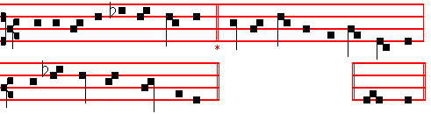
At the Cross her station keeping, 3 Who on Christ's dear Mother gazing,
Stood the mournful Mother weeping, In her trouble so amazing,
Close to Jesus at the last, Born of woman. would not weep?
Through her soul, of joy bereaved, Who on Christ's dear Mother thinking,
Bowed with anguish, deeply grieved, Such a cup of sorrow drinking,
Now at length the sword hath passed. Would not share her sorrow deep?

2 O, that blessed one, grief-laden, 4 For his people's sins, in anguish,
Blessed Mother, blessed Maiden, There she saw the victim languish,
Mother of the all-holy One; Bleed in torments, bleed and die.
O that silent, ceaseless mourning, Saw the Lord's Anointed taken;
O those dim eyes, never turning Saw her Child in death forsaken;
From that wondrous, suffering Son. Heard his last expiring cry.

5 In the Passion of my Maker,
Be my sinful soul parlaker,
May I bear with her my part;
Of his Passion bear the token,
In a spirit bowed and broken
Bear his death within my heart. Amen.

 Pray for us, O sorrowful Virgin.
 That we may be made worthy of the promises of Christ.

1579
On Magnificat, Antiphon. Tone vj
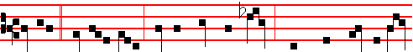
Simeon * said unto Mary, Yea, a sword shall pierce through thine own soul al-
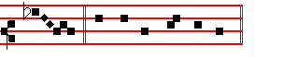
so. Canticle Magnificat

COLLECT
O GOD, in whose passion, according to the prophecy of Simeon, a sword of sorrow did pierce the most sweet soul of the glorious Virgin Mother Mary: mercifully grant; that we, who devoutly call to mind the suffering whereby she was pierced, may by the glorious example and prayers of all the Saints who have faithfully stood beneath the Cross, obtain with gladness the blessed effects of thy passion. Who livest.
And commemoration is made of the Feria.
At the end of the Hymn at Compline and the Hours is said,
All honour, laud, and glory be,
O Jesu,Virgin-born, to thee.

At Matins, Invitatory.- As we remember the sorrows of the glorious Virgin: * O come, let us worship the Lord who suffered for us.

Hymn E. H. 115 Sancta Mater Mode j, as above.
6 May his wounds both wound and heal me, 7 Jesu, may thy Cross defend me,
He enkindle, cleanse, anneal me, And thy saving death befriend me,
Be his Cross my hope and stay. Cherished by thy deathless grace;
May he, when the mountains quiver, When to dust my dust returneth,
From that flame which burns for ever Grant a soul that to thee yearneth
Shield me on the judgement day. In thy Paradise a place. Amen.

IN THE FIRST NOCTURN
Antiphon. The kings of the earth * stand up and the rulers take counsel together, against the Lord and against his Anointed. Psalm 2 Quare fremuerunt
Antiphon. I did call * upon the Lord with my voice, and he heard me out of his holy hill. Psalm 3 Domine, quid.
Antiphon. My heart * also in the midst of my body is even like melting wax. Psalm 13 Usquequo

1580
 He hath made me desolate.  And faint all the day.
From the Book of the Prophet Isaiah
Lesson j Ch. 63, 1-12
WHO hath believed our report? and to whom is the arm of the Lord revealed? For he shall grow up before him as a tender plant, and as a root out of a dry ground: he hath no form nor comeliness; and when we shall see him, there is no beauty that we should desire him. He is despised and rejected of men; a man of sorrows, and acquainted with grief: and we hid as it were our faces from him; he was despised, and we esteemed him not. Surely he hath borne our griefs, and carried our sorrows: yet we did esteem him stricken, smitten of God, and afflicted.

But he was wounded for our transgressions, he was bruised for our iniquities: the
chastisement of our peace was upon him; and with his stripes we are healed.

 My beloved is white and ruddy. He is altogether lovely. * All his appearance speaks of love, and provokes love in return: his head is inclined, his hands are stretched out, and his side is opened.
 O Virgin, who didst look on him tenderly, and didst see, not only his wounds, but also that the world was saved. All his.

Lesson ij
ALL we like sheep havc gone astray; we have turned every one to his own way; and the Lord hath laid on him the iniquity of us all. He was oppressed, and he was afflicted, yea, he opened not his mouth: he is brought as a lamb to the slaughter, and as a sheep hefore her shearers is dumb, so he openeth not his mouth. He was taken from prison and from judgment: and who shall declare his generation? for he was cut off out of the land of the living: for the transgression of my peoplc was he stricken. And he madc his grave with the wickcd, and with the rich in his death; because he had done no violence, neither was any deceit in his mouth.

 His hands are like rings, pierced with the points of the nails, * Set with the price of man's salvation, as it were with jacinths.
 He had horns coming out of his hand, and there was the hiding of his power. For his hands are. Set with.

Lesson iij
YET it pleased the Lord to bruise him; he hath put him to grief: when thou shalt make his soul an offering for sin, he shall see his seed, he shall prolong his days, and the pleasure of the Lord shall prosper in his hand. He shall see of the travail of his soul, and shall be satisfied: by his knowledge shall my righteous

1581
servant justify many; for he shall bear their iniquities. Therefore will I divide him a portion with the great, and he shall divide the spoil with the strong; because he hath poured out his soul unto death: and he was numbered with the transgressors; and he bare the sin of many, and madc intercession for the transgressors.

 Jesus loved John, * For his special mark of chastity made him worthy of greater love. * He chose him for a virgin unto himself, and he remaineth a virgin for ever.
 At the end, when he was dying upun the cross, he committed his Mother to him as virgin to virgin. For his. Glory be. He chose.

IN THE SECOND NOCTURN

Antiphon. Mine enemies * speak evil of me; when shall he die and his name perish? Psalm 41 Beatus qui
Antiphon. O God, * thou tellest my flittings, put my tears into thy bottle. Psalm 56 Miserere mei Deus
Antiphon. I lie * among the children of men, whose teeth are spears and arrows, and their tongue a sharp sword. Psalm 57 Miserere mei Deus, miserere mei.
 My face is swollen with weeping.
 And on my eyelids is the shadow of death.

In place of the Sermon by Bernard of Clairvaux, which is not given here, may be read the Sermon by S.John Chrysostom,The Son of God, from the Common of Feasts of the B.V. Mary.

 iv. There was darkness when the Jews crucified Jesus, and about the ninth hour Jesus cried with a loud voice: My God, why hast thou forsaken me? * And he bowed his head and gave up the ghost.
 What feeling is now thine, O Virgin, on beholding such things? And he.

 v. The Lord's passion * Grieved with exceeding sorrow his Mother who was deeply moved by her mortal bereavement.
 The blade of the soldier's spear pierced both the side of the Saviour and the soul of the Virgin Mother. Grieved.

 vj. O that thou wert as my brother that sucked the breasts of my mother! and that, by cleaving unto thy side, thy blood might touch and cleanse my blood: * That thy well of water which floweth from the fountain of the True of Heart, through the veins of good works, may at the last spring up into everlasting life.
 Thy sons shall come from far, and thy daughters shall be nursed at thy side.

1582
That thy. Glory be. That thy.

IN THE THIRD NOCTURN
Antiphon.They shoot out * their arrows, even bitter words, that they may privily shoot at him that is perfect. Psalm 64 Exaudi Deus
Antiphon. I have been * even as a man that hath no strength, free among the dead. Psalm 88 Domine Deus salutis
Antiphon. He hath filled * me with bitterness, and made me drunken with wormwood. Psalm 109 Deus laudem meam
 O God, my life have I declared unto thee.
 Thou hast put my tears in thy sight.

The Lesson from the Holy Gospel according to John

Lesson vij Ch. 19
THERE stood by the cross of Jesus his mother, and his mother's sister, Mary
the wife of Cleophas, and Mary Magdalene. And the rest.
Homily by S. Augustine, Bishop Homily 119 on John
THIS surely is the hour of which Jesus, when about to turn water into wine, had said to his Mother: Woman, what have I to do with thee? Mine hour is not yet come. This was then the hour, at that time not yet come, the hour in which it would be right for him, being at the point to die, to acknowledge her of whom he was in mortal manner born. At that time therefore, being about to work as God, her who was the Mother not of his Godhead but of his infirmity, he repulsed as one unknown: but now already suffering as man, with man's affections he commended her of whom he was made man. For at that time, he that created Mary was making himself known by power; but now, that to which Mary had given birth was hanging upon the cross. Here then a subjcct of morals comes in. He is doing that which he admonishes to be done, and by his own example hath, as the Good Teacher, instructed his own, that it is the duty of pious sons to have a care of their parents: as though the wood on which were fixed the members of him that was dying, were even the chair of the master that was teaching.

 I am distressed for thee, my son Jesus, very pleasant hast thou been unto me; thy love to me was wonderful, passing the love of women: * For even as a mother loveth her only son, so loved I thee.
 My life is waxen old with heaviness, and my years with mourning. For even.

Blessing May the Virgin of virgins whose Feast we are keeping intercede for us to the Lord.

Lesson viij
1583
OUT of this sound doctrine had Paul the Apostle learned that which he taught, when he said: But if any provide not for his own, and chiefly for them of his own household, he hath denied the faith, and is worse than an infidel. And what so pertains to one's own household, as parents to sons, or sons to parents? Of this most wholesome precept, I say, the Master of the Saints was setting an example in his own practice, when, not as God for the servant whom he had created and was ruling, but as man for the mother of whom he was born and whom he was leaving, he provided another to be, in some sort, a son to her in his stead.

 Mother, fount of love, O teach me, how thy sorrows deep may reach me, that with thee I may lament: * That we nlay perceive the fruit of the Lord's Passion.
 That as thy Son Jesus died and rose again for us, so we also who have died with
him, may rise again with him. That we. Glory be. That we.
The ninth Lesson from the Homily of the Feria.

AT LAUDS, AND THROUGH THE HOURS,

Antiphon 1. Tone j, 4
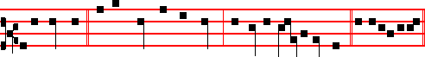
I will get me * to the mountain of myrrh, and to the hill of incense. Psalm 93 Dominus regnavit, and the rest, p.

Antiphon 2. Tone ij
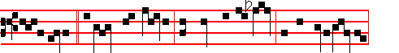
My beloved * is white and ruddy: the looks or his head are as royal purple,
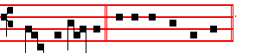
bound in tresses. E u o u a e.
Antiphon 3. Tone iij, 3.
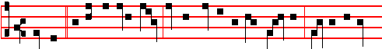
Whither * is thy beloved gone, O thou fairest among women? whither is thy

1584
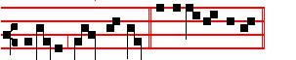
beloved turned aside? E u o u a e.
Antiphon 4. Tone iv, 1
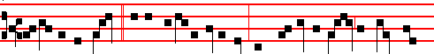
A bundle of myrrh * is my beloved unto me; he shall lie all night between my
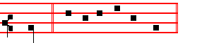
breasts. E u o u a e.
Antiphon 5. Tone v
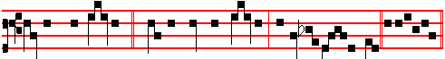
Stay me with flagons, * comfort me with apples; for I am sick of love. Euo u a e.
Chapter Isaiah 53
WHO hath believed our report? and to whom is the arm of the Lord revealed? For he shall grow up before him as a tender plant, and as a root out of a dry ground.
Hymn. Virgo virginum præclara Mode j, as above at Vespers

8 Virgin, virgins all excelling, 9 Let thy Son's wounds penetrate me:
Spurn me not, my prayer repelling: Let the Cross inebriate me
Make me weep and mourn with thee And his own most precious blood
So Christ's death within me bearing, Lest in flames I burn and perish,
Let me, in his Passion sharing, On the judgment day, O cherish
Keep his wounds in memory. And defend me, Virgin good.

10 Christ, whene'er this world shall leave me,
Through thy Mother then receive me
To the palm of victory.
When the bonds of flesh are riven,
Glory to my soul be given
In thy paradise with thee. Amen.

 Pray for us, O sorrowful Virgin.
 That we may be made worthy of the promises of Christ.

1585
On Benedictus, Antiphon. Tone vij, 3
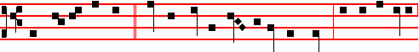
When Jesus therefore * saw his Mother standing by the cross, and the disciple
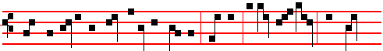
whom he loved, he saith unto his Mother, Woman, behold thy son! Then saith
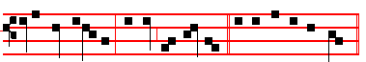
he to the disciple, Behold thy mother. Canticle Benedictus

COLLECT
O GOD, in whose passion, according to the prophecy of Simeon, a sword of sorrow did pierce the most sweet soul of the glorious Virgin Mother Mary: mercifully grant; that we, who devoutly call to mind the suffering whereby she was pierced, may by the glorious example and prayers of all the Saints who have faithfully stood beneath the Cross, obtain with gladness the blessed effects or thy passion. Who livest.
And commemoration is made of the Feria.

AT PRIME
in the Short 
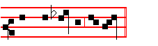
Who didst suffer for man.
AT TERCE

Antiphon. My beloved, p. 1584, Chapter Who hath believed, as above, p. 1585.
Short 
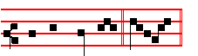
He hath made me * Desolate. He hath.

1586
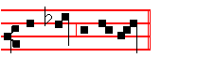
 And faint all the day. Desolate.
Glory be to the Father, and to the Son, and to the Holy Ghost. He hath.
 My face is swollen with weep -ing.
 And on my eyelids is the shadow of death.

AT SEXT
Antiphon. Whither, p. 1584.
Chapter Isaiah 53
HE was wounded for our transgressions, he was bruised for our iniquities: the chastisement of our peace was upon him; and with his stripes we are healed.
Short 
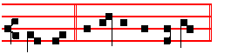
My face * Is swollen with weeping. My face.
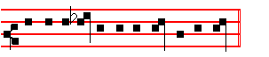
 And on my eyelids is the shadow of death. Is swollen. Glory be. My face.
 O God, my life I have declared unto thee.
 Thou hast put my tears in thy sight.

AT NONE
Antiphon. Stay me with flagons, p. 1585.
Chapter Isaiah 53
WHO shall declare his generation? for he was cut off out of the land of the living: for the transgression of my people was he stricken.
Short 

1587
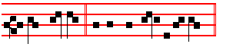
O God, my life * I have declared unto thee. O God.
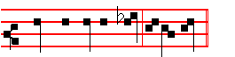
 Thou hast put my tears in thy sight. I have. Glory be. O God.
 Pray for us, O sorrowful Virgin.
 That we may be made worthy of the promises of Christ.

AT VESPERS
All as in I Vespers as above.
 Pray for us, O sorrowful Virgin.
 That we may be made worthy of the promises of Christ.

On Magnificat, Antiphon. Tone j, 3
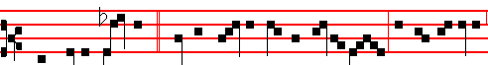
When Jesus therefore * saw his Mother standing by the cross, and the disciple
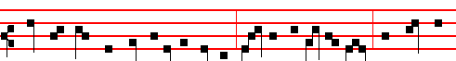
whom he loved, he saith unto his Mother,Woman, behold thy son! Then saith he
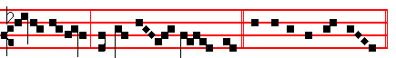
to the disciple, Behold thy mo- ther. Canticle Magnificat

And commemoration is made of the Feria.

__________________________________________________________________

1588

