JESUS said unto the Pharisees: Ye will surely say unto me this proverb, Physician, heal thyself: whatsoever we have heard done in Capernaum, do also here in thy country. And the rest.
Homily by S. Ambrose, Bishop Bk. 4 on Luke Ch. 4
NO little envy was shown, when, heedless of the charity due to a fellow- citizen, they turned what should have been an opportunity for grateful love into bitter hatred. Likewise it is here made plain, both by word and example, that it is in vain to hope for mercy from heaven if you are envious of the fruits of virtue in other men. For the Lord despises the envious, and will not show the miracles of his power to those, who persecute others for their heavenly blessings. For indeed, the Lord's deeds in the flesh are examples of his Divinity. And his hidden works are revealed to us by means of those which are seen.

 Take hence presents with you, and go unto the lord of the land, and when ye be come into his presence, bow yourselves to him to the earth: * And may God Almighty give you mercy before the man, that he may send away again this your brother, and him which he keepeth in ward.
 Take of the best fruits of the land in your vessels and carry down the man a present. And may.

Lesson ij
IT was not without a purpose that the Lord explained that he could do no miracle in his own country, for some may think that we should have a mean opinion of our own country. Nor was it possible for him not to love his fellow- countrymen, he who loved all men: but they deprived themselves of this love, by their envying. But I tell you of a truth. many widows were in Israel in the days of Elias. Not that those days belonged to Elijah. but they were the days in which Elijah worked; or else, Elijah brought daylight to those who saw the light of spiritual grace in his works and were converted to the Lord. And therefore heaven lay open to those who saw eternal and divine mysteries, and it was shut, and there was a famine, when there was no fruit of divine knowledge. But we have spoken of this at greater length in our book on widows.

 Is this your younger brother of whom you spake unto me? God be gracious unto thee; my son. * And Joseph made haste, and he entered into his chamber and wept there: for his tears brake forth and he might not refrain himself.
 He lifted up his eyes and saw his brother Benjamin, and his bowels did yearn upon his brother. And Joseph.

Lesson iij
AND many lepers were in Israel in the time of Eliseus the prophet; and none of them was cleansed, saving Naaman the Syrian. Clearly these words of the

653
Lord and Saviour urge us to zeal in holy worship: for we are shown that none is healed or cleansed from contaminating bodily disease who has not sought the healing remedy of religious observance. The Divine remedies are given, not to the sleeping, but to the watchful. We have read in another book, in that on widows, that she to whom Elijah was sent was a type of the Church. First came the people of the Church, so that the people of other nations might follow them later. That people had previously been leprous, that people had previously been covered with contaminating disease, before it was baptized in the mystic stream: that same people. after the sacrament of baptism, is cleansed from contamination both of mind and body; now, leprous no longer, it begins to be a glorious virgin Church without wrinkle or blemish.

 Joseph said unto his eleven brethren: I am Joseph whom ye sold into Egypt; is our father yet alive, the old man of whom ye spake? * Haste ye, and bring him hither, that he may live.
 For these two years hath the famine been in the land; and yet there are five years in which there shall be neither earing nor harvest. Haste ye. Glory be. Haste ye.
At Lauds, Antiphon and Psalm Miserere, with the rest from the Psalter, p. 104.
Chapter Cry aloud, p. 609.
Hymn O sol salutis, p. 603 and.  God. shall give, p. 604
On Benedictus, Antiphon.
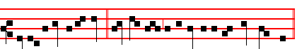
Verily I say unto you,* No prophet is accepted. in his own country.
Today the Prayers are said., p. 108.
COLLECT
WE beseech thee,O Lord, mercifully to pour thy grace into our hearts: that we who abstain from carnal feastings; may also restrain our senses from all wantonness that may hurt us. Through.
Today the Office of the Dead.
At the Hours, all as in the Psalter.
AT VESPERS

Antiphon The Lord hath inclined, Psalm 116, 1-9, Dilexi, with the rest from the Psalter, p.
Chapter Let the priests, p. 610.
Hymn E.H.66 Audi benigne and  God shall give, p. 596.
On Magnificat, Antiphon.

654
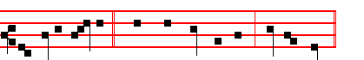
But Jesus, passing * through the midst of them, went his way.

Then the Prayers, p. 217.
COLLECT
LET thy merciful kindness, O Lord, be upon us: that through thy protection we may be found worthy to be set free from the perils of our sins which beset us and preserved by thy deliverance. Through.
__________________________________________________________________

Tuesday

The Lesson from the Holy Gospel according to S. Matthew
Lesson j Ch. 18, 15-22
JESUS said unto his disciples: If thy brother shall trespass against thee, go and tell him his fault between thee and him alone. And the rest.
Homily by S. Augustine, Bishop Sermon 82 on the Words of the Gospel
WHY tell him his fault? Because he has hurt you by sinning against you? Far from it. If you do so for motives of self-love, your action is worthless: if you do so for his sake, then you do great good. In short, learn from these very words, for love of whom you should act: for yourself or for him. If he shall hear thee, says the Lord, Thou hast gained thy brother. Act, therefore, for his sake, that you may gain him. If you do so, you will gain him; should you not do so, he would be lost. How is it, then, that so many men make light of their trespasses, and say, I have done nothing very wrong: I have sinned only against my fellow man. Do not make light of it. You have sinned against man.

 They told Jacob, saying Joseph is yet alive, and he is governour over all the land of Egypt. And when he heard it his spirit revived, and he said: * It is enough, I will go and see him before I die.
 And when Jacob heard that Joseph, his son, was yet alive, his heart fainted, and he said. It is.

Lesson ij
WOULD you know, how by sinning against man, you will be lost? If he, against whom you have sinned, tells you of your fault between you and him alone, he has gained you. Now what does, He has gained you, mean, except that you would be lost, had he not gained you? Therefore let no man think lightly of

655
trespassing against his brother. For the Apostle says in another place. But when ye so sin against the brethren, and wound their weak conscience, ye sin against Christ. This is because we have all been made members of Christ. How can you not sin against Christ, when you sin against a member of Christ?

 When Joseph carne into the land of Egypt, he heard a strange language; his hands were delivered from making the pots: * That he might teach his princes wisdom.
 Whose feet they hurt in the stocks; the iron entered into his soul, until the time came that his cause was known. That he.

Lesson iij
THEN let no-one say. I have not sinned against God, but I have sinned against my brother: I have sinned against man, but that is a slight thing, it is nothing. Perhaps you may then say, It is slight because it is soon mended. You have sinned against your brother: make satisfaction and you will be healed. You did this deadly thing hastily, but hastily have you found the remedy. Which of us, my brethren, can hope for the kingdom of heaven, when the Gospel says, Whosoever shall say to his brother, Thou fool, shall be in danger of hell fire? A terrible thing indeed: but lo, there is a remedy. If thou bring thy gift to the altar, and there remember that thy brother hath ought against thee: leave there thy gift before the altar. God will not be angry, because you delay in bringing your gift, God seeks you more than your gift.

 Think on me when it shall be well with thee: * And make mention of me unto Pharaoh and bring me out of this house. * For indeed I was stolen away: and here also have I done nothing that they should put me into the dungeon.
 Yet within three days shall Pharaoh remember thy service and restore thee unto thy place: then think on me. And make. Glory be. For

On Benedictus, Antiphon.
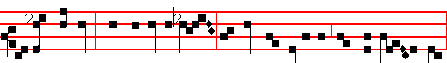
If two of you * shall agree on earth as touching anything that they shall ask,
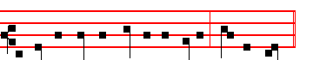
it shall be done for them of my Father, saith the Lord.

Then the Prayers, p. 108
656
COLLECT
GRACIOUSLY hear us, almighty and merciful God: and of thy goodness grant us the gift of continence unto salvati on. Through.

On Magnificat, Antiphon.
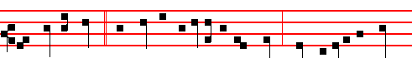
Where two or three * are gathered together in my Name, there am I in the midst
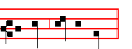
of them, saith the Lord. Then the Prayers, 217

COLLECT
DEFEND us, O Lord, with thy protection: and keep us evermore from all iniquities. Through.
__________________________________________________________________

Wednesday
Today the Gradual Psalms.
The Lesson from the Holy Gospel according to S. Matthew
Lesson j Ch. 15, 1-20
THERE came to Jesus scribes and Pharisees which were of Jerusalem, saying, Why do thy disciples transgress the tradition of the elders? And the rest.
Homily by S. Jerome. Priest Bk. 2 Comm. on Matt. Ch. 15
THE stupidity of the scribes and Pharisees is amazing. They rebuke the Son of God for not observing the laws and traditions of men: For they wash not their hands when they eat bread. The hands, that is the works, not indeed of the body but of the soul, must be washed before the Word of God becomes effective in them. But he answered and said unto them, Why do ye also transgress the commandment of God by your tradition? He refuted their false accusation by a true answer. Since, he says, You neglect the laws of God for the sake of the traditions of men, why do you think my disciples should be rebuked for considering the laws of the elders to be of little weight in comparison with keeping close to the ordinances of God?

 We are verily guilty concerning our brother, in that we saw the anguish of his soul, when he besought us, and we would not hear: * Therefore is this distress come upon us.
657
 And Reuben answered his brethren, saying: Spake I not unto you, saying: Do not sin against the child; and ye would not hear? Therefore.

Lesson ij
FOR God commanded, saying, Honour thy father and mother: and, He that curseth father or mother, let him die the death. But ye say, Whosoever shall say to his father or mother, It is a gift, by whatsoever thou mightest be profited by me; and honour not his father or his mother, he shall be free. Honour in the Scriptures means not so much giving greetings and paying respect, as almsgiving and offering gifts. Honour widows, says the Apostle, that are widows indeed. Honour is here to be understood as a gift. And in another place, Let the elders that rule well be counted worthy of double honour, especially they who labour in the word and doctrine. For the Scripture saith, Thou shalt not muzzle the ox that treadeth out the corn. And, The labourer is worthy of his reward.

 And Reuben answered his brethren, saying: Spake I not unto you, saying: Do not sin against the child; and ye would not hear? * Therefore, behold also his blood is required.
 We are verily guilty concerning our brother, in that we saw the anguish of his soul, when he besought us, and we would not hear. Therefore.

Lesson iij
THE Lord, remembering the weakness, age and penury of parents, commanded sons to honour their parents even in the providing of the necessities of life for them. But the scribes and Pharisees chose to overrule this most provident law of God, and introduced wickedness under the name of goodness: for they taught undutiful sons that if anyone wished to make an offering to God who is the true Father, and yet owed anything to his parents, then that man could give preference to his offering to God instead of giving it to his parents. So those parents, refusing to accept gifts intended for God, for fear of committing sacrilege, are brought to suffer want. So it came to pass that offerings brought by the children for the temple and for God went to the gain of the priests.

 Jacob mourned for his two sons, saying: Woe is me, I am bereaved of Joseph, for he is not; and Benjamin is taken away for bread. * I pray the King of heaven in my distress that he may make me to see him yet again.
 And Jacob cast him down upon his face upon the ground and wept sore, and he prayed, saying. I pray. Glory be. I pray.

On Benedictus, Antiphon
658
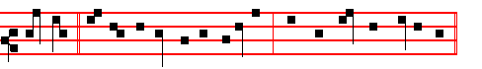
Hearken, * and understand ye the traditions which the Lord hath given you.
Then the Prayers, 108
COLLECT
GRANT to us, we beseech thee, O Lord: that we, being taught by saving
fasts, and likewise abstaining from hurtful vices, may more readily obtain thy mercy. Through.
On Magnificat, Antiphon.
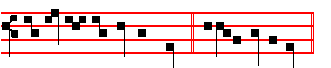
To eat with unwashen hands * defileth not a man.
Then the Prayers, 217.
COLLECT
GRANT, we beseech thee, almighty God: that we, who seek the grace of thy protection, may by thee be delivered from all evils and serve thee with a quiet mind. Through.
__________________________________________________________________

Thursday

The Lesson from the Holy Gospel according to S. Luke
Lesson j Ch. 4, 38-44
JESUS arose out of the synagogue, and entered into Simon's house. And Simon's wife's mother was taken with a great fever. And the rest.

Homily by S. Ambrose, Bishop Bk. 4 on Luke Ch. 4.
BEHOLD the compassion of our Lord and Saviour: he is not angry with the Jews, nor offended with their evil doings, nor even when they are violently malicious does he leave them; on the contrary, heedless of the wrongs they do him, and regarding only his compassion towards them, by teaching one, freeing another, healing a third, he softens the heart of this unbelieving people. And rightly has Luke recounted the freeing of the man from an unclean spirit, and then gone on to speak of the healing of this woman. The Lord came to work his cure on both sexes, yet it was but fitting that he should heal first the one who was created first; afterwards he was not to overlook the one who had sinned more through levity of mind than through actual malice.

659
 And when his brethren saw Joseph afar off, they said one to another: Behold, this dreamer cometh: * Come, let us slay him, and we shall see what will become of his dreams.
 And when his brethren saw that their father loved Joseph more than all his brethren, they hated him, and could not speak peaceably unto him, therefore they
said. Come

Lesson ij
THE Lord began his healing on the Sabbath, and this reveals to us that the New
Creation begins there, where the old creation left off. It also makes plain that the Son of God was not under the law, but above the law, not come to destroy the law, but to fulfil it. Nor was it through the law that the world was made, but it was made by the Word: as we read, By the Word of the Lord were the heavens made. Therefore the law was not destroyed but fulfilled in the restoration of fallen man. As the Apostle says, Put off the old man, and put on the new man, which after God is created.

 Judah said unto his brethren: Behold, the Ishmeelites pass by: come, let us sell
him, let not our hands be upon him: * For he is our brother and our flesh.
 What profit is it if we slay our brother and conceal his blood? It is better to sell him. For he.

Lesson iij
AND rightly did the Lord begin on the Sabbath, that he might show himself to be the very Creator, interweaving all his works together, and that he might continue the work that he had already begun; just as a builder, when he knocks down a house in order to rebuild it, begins not with the foundations, but with the roof. So in this case God begins again where he had left off, on the Sabbath: and he begins again with lesser works, that he may go on to greater ones. Even men are able to deliver others from demons, as agents themselves of the Word of God, but by the power of the Divine Majesty alone can the raising of the dead be commanded. Perhaps in this woman, the mother-in-law of Simon and Andrew, we are to see a figure of our fleshly nature, languishing under the numerous fevers of sin, and burning with uncontrolled enticements of unlawful desires. Indeed, I would not call the fever of desire a lesser malady than a physical fever: one rages in the soul, the other in the body. Avarice is our fever lust is our fever; luxury is our fever; ambition is our fever; wrath is our fever.

 They drew and lifted up Joseph out of the pit, and sold Joseph to the lshmeelites for twenty pieces of silver. * And Reuben returned unto the pit, and when he found him not, he rent his clothes and wept, and said: The child is not,

660
and I, whither shall I go?
 And they took Joseph's coat, and dipped it into the blood of.a kid of the goats: and they sent the coat of many colours, and they brought it to their father, and said: Know now whether it be thy son's coat or no. And Reuben. Glory be. And Reuben.
On Benedictus, Antiphon.
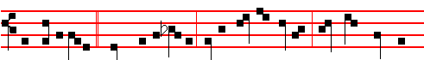
And devils also * came out of many, crying out and saying: Thou art Christ the
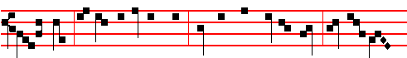
Son of God. And he, rebuking them, suffered them not to speak: for they knew
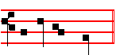
that he was Christ. Then the Prayers, p. 108.
COLLECT
LET the blessed solemnity of thy Saints Cosmas and Damian magnify thee, O Lord: wherein by thy unspeakable providence thou hast both bestowed upon them everlasting glory, and upon us thy succour.Through.
On Magnificat, Antiphon.
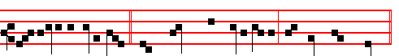
Whosoever had any sick, * they brought them unto Jesus; and they were healed.
Then the Prayers, 217.
COLLECT
WE beseech thee, O Lord, that the heavenly propitiation may strengthen and increase thy humble people: and make them ever to walk obediently after thy commandments. Through.
__________________________________________________________________

Friday
The Lesson from the Holy Gospel according to S. John

661
Lesson j Ch. 4, 5-42
JESUS cometh to a city of Samaria, which is called Sychar, near to the parcel of ground that Jacob gave to his son Joseph. And the rest.
Homily by S. Augustine, Bishop Homily 15 on John
JESUS therefore, being wearied with his journey, sat thus on the well: and it was about the sixth hour. Already the mysteries begin. For it is not without a meaning that Jesus is weary: not surely without a meaning that he is weary, who is the power of God: not surely without a meaning that he is weary, by whom the wearied are refreshed: not surely without a meaning that he is weary, by whose absence from us we are made weary, by whose presence we are made strong. Yet Jesus is weary; and weary from his journey; and sitteth; and it is beside a well that he sitteth; and it is at the sixth hour, that, wearied, he sitteth. All these things hint something, they would point to something, they put us upon the stretch of expectation, they bid us to knock. May he then open to us and you, who deigned so to exhort that he said, Knock, and it shall be opened unto you.

 When Jacob saw Joseph's coat, he rent his clothes, and mourned, and said: * An evil beast hath devoured my son Joseph.
 And his brethren took his coat, and sent it to his father: and he knew it, and said. An evil

Lesson ij
FOR thee is Jesus wearied from his journey. We find a Jesus who is a Power, we find also a Jesus who is weak: a strong and a weak Jesus: strong, because, in the beginning was the Word, and the Word was with God, and the Word was God: the came was in the beginning witn God. Wouldest thou see how this Son of God is strong? All things were made by him, and without him was nothing made: and made too without labour. Then what stronger than he, by whom without labour were all things made? Wouldest thou know him weak? The Word was made flesh, and dwelt in us. The strength of Christ created thee: the weakness of Christ created thee anew. The strength of Christ wrought that what was not, should be: the weakness of Christ wrought that what was, should not perish. He made us by his strength, he sought us by his weakness.

 When Joseph carne into the land of Egypt, he heard a strange language; his hands were delivered from making the pots: * That he might teach his princes wisdom.
 Whose feet they hurt in the stocks; the iron entered into his soul, until the time came that his cause was known. That he.

Lesson iij

662
HE then, as weak, nourisheth the weak as a hen her chickens; for to this hath he likened himself. How often, saith he to Jerusalem, would I have gathered thy children under my wings, even as a hen gathereth her chickens together, and ye would not! Now ye see, brethren, how a hen becometh weak with her young ones. No other bird, being a mother, is known to be such at sight. We see sparrows of every sort building their nests before our eyes; swallows, storks, doves, every day we see them building their nests; yet unless we see them in their nests, we do not know them at sight to be parent-birds. But the hen doth in such wise become enfeebled over her brood, that even if the chickens be not following her, though thou see not the young ones, yet thou knowest her at once to be a mother.

 Think on me when it shall be well with thee: * And make mention of me unto Pharaoh and bring me out of this house. For indeed I was stolen away: and here
also have I done nothing that they should put me into the dungeon.
 Yet within three days shall Pharaoh remember thy service and restore thee unto thy place: then think on me. And make. Glory be. For

On Benedictus, Antiphon.
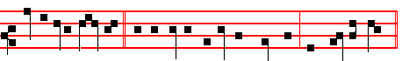
Whosoever drinketh * of the water that I shall give him shall never thirst.
Then the Prayers, p. 108.
COLLECT
ASSIST, we beseech thee, O Lord, these our fasts with thy gracious favour: that like as we do abstain from food in our bodies; so in our souls we may fast from sin. Through.
Today the Penitential Psalms.

On Magnificat, Antiphon.
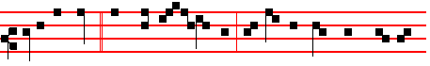
Sir, I perceive * that thou art a Prophet. Our fathers worshipped on this
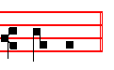
mountain. Then the prayers, p. 217.

663
COLLECT
GRANT, we beseech thee, almighty God: that we who put our trust in thy protection, may by thy help overcome all things that may hurt us. Through.
__________________________________________________________________

Saturday

The Lesson from the Holy Gospel according to S. John
Lesson j Ch. 8, 1-11
JESUS went unto the mount of Olives. And early in the morning he came again into the temple. And the rest.
Homily by S. Augustine, Bishop Homily 33 on John
JESUS went unto the mount of Olives, the mount, to wit, of Olivet, to the mount which was full of fruits, to the mount of unguent, to the mount of chrism. And indeed where did it become Christ to teach, if not in the mount of Olivet? Christ hath his name from Chrism, in Greek meaning what we call unction, anointing; and the reason why he hath anointed us, is, because he hath made us wrestlers against the devil. And at daybreak he came again into the temple, and all the people came to him, and he sat and taught them. And he was not laid hold upon, because he did not yet deign to suffer. Now then mark, where the Lord's enemies tempted his gentleness.

 We are verily guilty concerning our brother, in that we saw the anguish of his soul, when he besought us, and we would not hear: * Therefore is this distress come upon us.
 And Reuben answered his brethren, saying: Spake I not unto you, saying: Do not sin against the child; and ye would not hear? Therefore.

Lesson ij
AND the scribes and Pharisees bring unto him a woman taken in adultery; and they set her in the midst, and said unto him, Master, this woman has been even now taken in adultery. Now Moses in the Law commanded us to stone such: but what sayest thou? This they said, tempting him, that they might have to accuse him. To accuse him of what? Had they caught him in the commission of any crime, or was that woman alleged to have been in some way concerned with him?

 And Reuben answered his brethren, saying: Spake I not unto you, saying: Do not sin against the child; and ye would not hear? * Therefore, behold also his blood is required.
 We are verily guilty concerning our brother, in that we saw the anguish of his soul, when he besought us, and we would not hear. Therefore.

664
Lesson iij
WE understand, my brethren, the marvellous gentleness that was pre-eminently conspicuous in the Lord. They perceived him to be exceeding meek, exceeding gentle. For of him it had been foretold of old, Gird thee with thy sword upon thy thigh, O thou most mighty; with thy comeliness and thy beauty, go thy way, march prosperously on, and reign, because of truth, and gentleness, and righteousness, So he brought with him truth as Teacher, gentleness as Deliverer, righteousness as Judge. That for these things sake he should reign, this the Prophet had in the Holy Ghost foretold. When he spake, men felt his truth: when he stirred not against his enemies, men praised his gentleness. Since therefore by reason of these two, that is, his truth and gentleness, his enemies were tormented with rankling malice and envy, they must needs make of the third, that is, righteousness, a means of his falling.

On Benedictus, Antiphon.
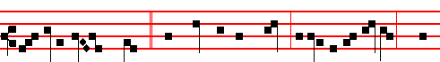
But Jesus stooped, down, * and wrote on the ground: If any is without sin, let
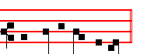
him cast a stone at her. Then the Prayers, p. 108.

COLLECT
GRANT, we beseech thee, almighty God: that they who do abstain from food to the mortifying of the flesh; may likewise fast from sin, to the following after justice. Through.
__________________________________________________________________

AT VESPERS
Chapter Gal. 4
BRETHREN: It is written, that Abraham had two sons; the one by a bondmaid, the other by a freewoman. But he who was of the bondwoman was born after the flesh: But he of the freewoman was by promise. Which things are an allegory.

Hymn. E.H. 66 Audi benigne, and  God shall give, p. 596.

On Magnificat, Antiphon. Tone iij, 1.

665
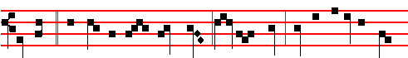
Woman, * hath no man condemned thee? No man, Lord. Neither do I condemn
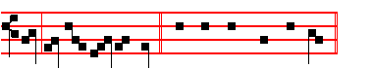
thee; go and sin no more. Canticle Magnificat, p.
COLLECT
GRANT, we beseech thee, almighty God: that we, who for our evil deeds do worthily deserve to be punished, by the comfort of thy grace may mercifully be relieved. Through.
__________________________________________________________________

THE FOURTH SUNDAY OF LENT

At Matins, Invitatory It shall not be lost, and Hymn Ex more docti, p. 597
The rest, apart from the Lessons, as in the Psa1ter, p. 4
IN THE FIRST NOCTURN
From the Book of Exodus
Lesson j Ch. 3, 1-15
NOW Moses kept the flock of Jethro his father in law the priest of Midian: and he led the flock to the backside of the desert, and came to the mountain of God, even to Horeb. And the angel of the Lord appeared unto him in a flame of fire out of the midst of a bush: and he looked, and, behold, the bush burned with fire, and the bush was not consumed. And Moses said, I will now turn aside, and see this great sight, why the bush is not burnt. And when the Lord saw that he turned aside to see, God called unto him out of the midst of the bush, and said, Moses, Moses. And he said. Here am I. And he said, Draw not nigh hither: put off thy shoes from off thy feet, for the place whereon thou standest is holy ground. Moreover he said, I am the God of thy father, the God of Abraham, the God of Isaac, and the God of Jacob. And Moses hid his face; for he was afraid to look upon God.

 The Lord spake unto Moses, saying, Go down now into Egypt, and say unto Pharaoh, * Let my people go. And the heart of Pharaoh shall be hardened, that he will not let my people go, no, not by a mighty hand.
 Behold the cry of the children of Israel is come unto me and I have seen the oppression. Come now therefore, and I will send thee to Pharaoh, saying. Let my.

666
Lesson ij
AND the Lord said, I have surely seen the affiiction of my people which are in Egypt, and have heard their cry by reason of their taskmasters ; for I know their sorrows; and I am come down to deliver them out of the hand of the Egyptians, and to bring them up out of that land unto a good land and a large, unto a land flowing with milk and honey; unto the place of the Canaanites, and the Hittites, and the Amorites, and the Perizzites, and the Hivites, and the Jebusites. Now therefore, behold, the cry of the children of Israel is come unto me: and I have also seen the oppression wherewith the Egyptians oppress them. Come now therefore, and I will send thee unto Pharaoh, that thou mayest bring forth my people the children of Israel out of Egypt.

 Moses went in and told Pharaoh, Thus saith the Lord, * Let my people go, that they may hold a feast unto me in the wilderness.
 The Lord God of the Hebrews hath sent me unto thce. saying. Let my.
Lesson iij
AND Moses said unto God, Who am I, that I should go unto Pharaoh, and that I should bring forth the children of Israel out of Egypt? And he said, Certainly I will be with thee; and this shall be a token unto thee, that I have sent thee: When thou hast brought forth the people out of Egypt, ye shall serve God upon this mountain. And Moses said unto God, Behold, when I come unto the children of Israel, and shall say unto them, The God of your fathers hath sent me unto you; and they shall say to me, What is his name? what shall I say unto them? And God said unto Moses, I AM THAT I AM: and he said, Thus shalt thou say unto the children of Israel, I AM hath sent me unto you. And God said moreover unto Moses, Thus shalt thou say unto the children of Israel, The Lord God of your fathers, the God of Abraham, the God of Isaac, and the God of Jacob, hath sent me unto you: this is my name for ever, and this is my memorial unto all generations.

 I will sing unto the Lord, for he hath triumphed gloriously; the horse and his rider hath he thrown into the sea. * The Lord is my strength and song, and he is become my salvation.
 The Lord is a man of war. The Lord is his Name. The Lord is my. Glory be. The Lord.
IN THE SECOND NOCTURN
Sermon by S. Basil the Great Lesson iv Homily. 1 on Fasting
WE know that it was through fasting that Moses went up into the mountain: nor would he have dared to approach that smoking summit and enter into the darkness, unless he were first strengthened by fasting. Through fasting he received the commandments written by the finger of God on tables of stone. Likewise upon the mountain fasting was the promoter of the giving of the law: but

667
down below gluttony led the people to idolatry, and contaminated them. And the people sat down to eat and drink. and rose up to play. One bout of drunkenness rendered null and void forty days' toil and perseverance in fasting and prayer. For this drunkenness broke those tables written by the finger of God, which fasting had received: that most holy prophet considered a wine-soaked people unworthy to receive the law from God.

 Thy way is in the sea and thy paths in the great waters. * Thou leddest thy people like sheep by the hand of Moses and Aaron.
 Thou broughtest them through the Red Sea, and led them through much water. Thou leddest.

Lesson v
IN one moment of time, through gluttony, that people, trained to the worship of God by such great wonders, fell headlong and shamelessly into Egyptian idolatry. From these facts, if you consider both sides, you will observe that fasting leads to God, while luxury causes loss of salvation. What polluted Esau, and made him his brother's servant? Was it not one mess of pottage, for which he sold his birthright? Was it not prayer and fasting that bestowed Samuel on his mother? What made Samson invincible? Was it not the fasting through which he was conceived in his mother's womb? Fasting conceived him, fasting nourished him, fasting made him so mighty a man. For indeed the angel gave orders concerning his mother, saying, She may not touch anything that cometh of the vine, neither let her drink wine nor strong drink. Fasting begat the prophets, and strengthens and confirms the mighty.

 O Lord, thou hast overwhelmed in the deep of the sea them which persecuted
thy people. * Even the people which thou leddest by the pillar of cloud.
 Thou leddest thy people like sheep by the hand of Moses and Aaron. Even the.

Lesson vj
FASTING gives wisdom to law-makers: it is the best guardian of the soul, the safest companion for the body, it is the armour and weapon of valiant men, the training for athletes and wrestlers. Moreover it drives away temptations, equips men for good works, dwells with sobriety, and is the maker of temperance. It produces courage in time of war, teaches tranquillity in time of peace: it sanctifies the Nazarene, and brings the priest to perfection: it is not lawful to approach the sacrifice without fasting, not only this our mystic and true worship of God, but also that sacrifice which was offered figuratively under the law. Fasting made Elijah the witness of a great vision: for when he had purified his soul by means of forty days of fasting, while in his cave, he was found worthy to see God, which is

668
not lawful for man. Moses betook himself to fasting again when he received the law for the second time. The Ninevites would never have escaped the threat of ruin, had they not fasted together with their beasts, herds and flocks. And in the wilderness, whose were the bodies slain? Were they not those of them who had sought flesh-meat?

 Moses the servant of God, fasted forty days and forty nights, * To make him worthy to receive the law of God.
 Moses gat him up unto the Lord into Mount Sinai, and he was in the mount forty days and forty nights. To make. Glory be. To make.

IN THE THIRD NOCTURN

The Lesson from the Holy Gospel according to S. John
Lesson vij Ch. 6
JESUS went over the sea of Galilee, which is the sea of Tiberias. And a great multitude followed him, because they saw his miracles which he did on them that were diseased. And the rest.
Homily by S. Augustine, Bishop Homily 24 on John
THE miracles wrought by our Lord Jesus Christ are indeed divine works, and admonitions of God to the human mind, that it should rise to the understanding of him by the things that are seen. For because he is not such a substance as can be seen with eyes, and his miracles, or marvellous works, in his governing the whole world and administering the universal creation, have by their very constancy become cheap in our regard, so that almost no man deigns to mark the marvellous and stupendous works of God exhibited in any grain of seed; in his mercy he hath reserved to himself certain works, which he should do at suitable time, beside the usual course and order of nature, that so they in whose regard his daily works have become cheap, might be amazed at the sight of works, not greater indeed, but unwonted.

 After that the Lord had looked upon him, the face of Moses shone, * And when the elders saw that his face shone, they marvelled and were sore afraid.
 And when he came down from Mount Sinai with the two tables of testimony in his hand, he wist not that his face shone because God had spoken with him. And when.

Lesson viij
TRULY the government of the whole world is a greater miracle than the satisfying of five thousand men with five loaves, and yet no man marvels at the one; the other, men marvel at, not because it is greater, but because it is rare.

669
For who is he that doth even now feed the whole world, but he that of a few grains creates whole harvests? He wrought therefore as God worketh. For whence he multiplieth a few grains into harvests, thence in his hands he multiplied the five loaves. The power was in the hands of Christ; but those five loaves were as seed, not indeed committed to the earth, but multiplied by him that made the earth.

 Behold, I send an Angel before thee to keep thee always. * Beware, and obey my voice: then I will be an enemy unto thine enemies, and an adversary unto thine adversaries, for mine Angel shall go before thee.
 O Israel, if thou wilt hearken unto me, there shall no strange God be in thee, neither shalt thou worship any other God: I am the Lord. Beware.

Lesson ix
HERE then was something brought near to the senses, that by it the mind should be lifted up; and exhibited to the eyes, that upon it the understanding should be exercised: that the invisible God might through visible works be admired by us, and we, being lifted up to faith and purged by faith, might desire to have vision invisibly of him, even of whom, invisible, we by visible things had knowledge. Yet it is not enough that we fix our regard upon these points in the miracles of Christ. Let us interrogate the miracles themselves, what they speak to us concerning Christ: for they have their tongue, if they be understood. Since Christ is the Word of God, every deed of that Word is to us a word.

 Hear, O my people, my law, * Incline your ears unto the words of my mouth.
 I will open my mouth in a parable: I will declare hard sentenccs of old. Incline.
Glory be. Incline.
AT LAUDS
Antiphon 1. Tone vij, 3
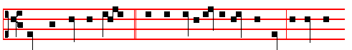
Then shalt thou be pleased * with the sacrifice of righteousness, if thou wilt

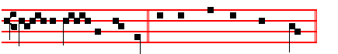
turn thy face from my sins. Psalm 51 Miserere, p. 104

Antiphon 2. Tone viij, 1.

670
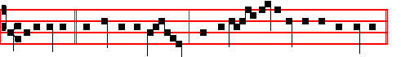
It is better * to trust in the Lord, than to put any confidence in princes.
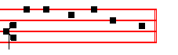
Psalm 118 Confitemini, p. 43.
Antiphon 3. Tone ij.
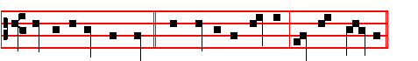
God, even our own God, * shall give us his blessing: God shall bless us.
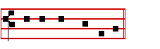
Psalms 63, 67, p. 29. Antiphon 4. Tone viij, 1.
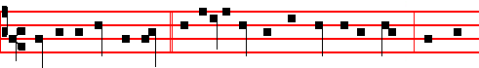
Mighty art thou,O Lord, * to deliver us from the hand of the strong: save and
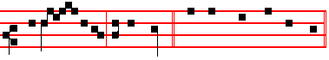
deli - ver us, O our God. Canticle Benedicite, p. 31.
Antiphon 5. Tone j, 4.
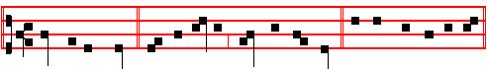
Kings of the earth * and all people, praise ye the Lord. Psalms 148 149 150.
Chapter Gal. 4
BRETHREN: It is written, that Abraham had two sons; the one by a bondmaid, the other by a freewoman. But he who was of the bondwoman was born after

671
the flesh: But he of the free-woman was by promise. Which things are an allegory.
Hymn O sol, p. 603, and  God shall give, p. 604.
On Benedictus, Antiphon. Tone 1, 3.
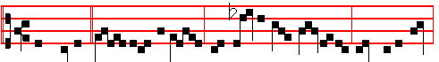
When Jesus * lift -ed up his eyes, and saw a great compa-ny come unto him,
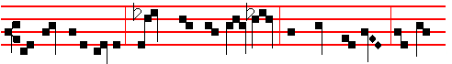
he saith unto Philip: Whence shall we buy bread that these may eat? And this
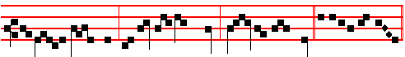
he said to prove him; for he himself knew what he would do. Cant. Benedictus
COLLECT
GRANT, we beseech thee, almighty God: that we, who for our evil deeds do worthily deserve to be punished, by the comfort of thy grace may mercifully be relieved. Through.
Antiphon. AT PRIME Tone j, 1.
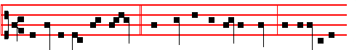
And Jesus took the loaves, * and when he had given thanks, he distributed
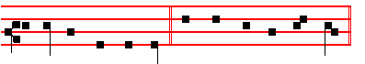
to them that were set down. Psalm 54 Deus in nomine, p. 43
AT TERCE
Antiphon. Tone j, 1.
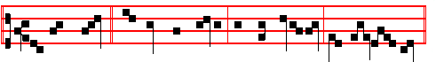
With five loaves * and two small fishes, the Lord satisfied five thousand men.

672
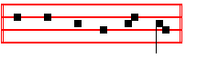
Psalm 119 Legem pone, p. 63.
Chapter Brethren: It is written, as above, p. 671.
Short  as above, p. 605.
He shall deliver thee * From the snare of the hunter. He shall.
 And from the noisome pestilence. From the snare. Glory be. He shall.
 He shall hide thee under his wings.
 And thou shalt be safe under his feathers.
AT SEXT
Antiphon. Tone iv, 1.
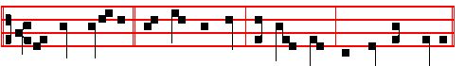
The Lord satisfied * five thousand men with five loaves and two small fishes.
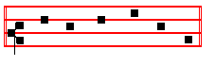
Psalm 119 Defecit, p. 72.
Chapter Gal. 4
REJOICE, thou barren that bearest not; break forth and cry, thou that travailest not; for the desolate hath many more children than she which hath an husband.
Short  as above, p. 606.
He shall defend thee * Under his wings. He shall.
 And thou shalt be safe unier his feathers. Under his. Glory be. He shall.
 His faithfulness and truth shall be thy shield and buckler.
 Thou shalt not be afraid for any terror by night.

AT NONE
Antiphon. Tone j, 2. 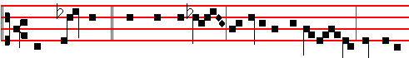
Then those men, * when they had seen the miracle that Jesus did, said unto

673
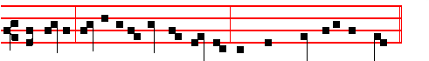
each other: This is of a truth that prophet that should come into the world.

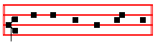
Psalm 119 Mirabilia, p. 82.
Chapter Gal. 4
SO then, brethren, we are not children of the bondwoman, but of the free. Stand fast, therefore, in the liberty wherewith Christ hath made us free.
Short  as above, p. 607.
His faithfulness and truth * Shall be thy shield and buckler. His faithfulness.
 Thou shalt not be afraid for any terror by night. Shall be. Glory Be. His faithfulness..
 He shall give his Angels charge over thee.  To keep thee in all thy ways.

AT VESPERS

Antiphons and Psalms of Sunday, p. 202.
Chapter: Brethren: It is written, as above, p. 671.
Hymn E.H.66 Audi benigne and  God shall give, p. 596.

On Magnificat, Antiphon. Tone j, 2.
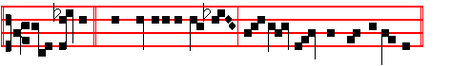
And Jesus * went up into a mountain, and there sat with his disciples.
Canticle Magnificat, p. 209

Collect Grant,we beseech thee, as above, p. 672.

Then Vespers of the Dead.
674
Monday

At Matins, Invitatory as in the Psa1ter, p. 89.
Hymn E.H.65 Ex more docti, p. 596. Antiphons and Psalms of the Nocturn, as in the Psa1ter, p.
And thus it is said on the other Ferias following.
The Lesson from the Holy Gospel according to S. John
Lesson j Ch. 2, 13-25
THE Jews' passover was at hand, and Jesus went up to Jerusalem, and found in the temple those that sold oxen and sheep and doves. And the rest.
Homily by S. Augustine, Bishop Homily 10 on John
WHAT have we heard, brethren? Lo, that temple was yet but a figure, yet from it doth the Lord cast out all that sought their own, who had come to market. And what were those men selling there? Things which people had need of in the sacrifices of that time. For ye know, beloved, that there were sacrifices given to that people, according to its carnal temper and the heart of stone which was still in them, such as might keep them from abandoning themselves to idols; and they immolated there as sacrifices, oxen, sheep, and doves: this ye know, because ye have read it.

 When ye be gone over Jordan, thou shalt build an altar unto the Lord, * An altar of stones; thou shalt not lift up any iron tool upon them; and thou shalt offer burnt offerings thereon unto thy God, and thou shalt offer peace offerings.
 When ye shall pass over unto the land which the Lord giveth thee, thou shalt build an altar unto the Lord. An altar.
Lesson ij
SURELY then, it was no great sin, if they sold in the temple just what people had to buy to offer in the temple; and yet he cast them out thence. What, if he should find drunkards there, what would the Lord do? if, though these people were selling what is lawful and not contrary to justice, (for what things it is honest to buy, it is not unlawful to sell,) he nevertheless expelled them, and suffered not the house of prayer to be made an house of buying and selling.

 Hear O Israel, the commandments of the Lord, and write them upon thine heart, as in a book: * I will give you a land flowing with milk and honey.
 Take heed, therefore, and hearken unto my voice: and then I will be an enemy unto thine enemies. I will.

Lesson iij
IF it be wrong to make a house of buying and selling of the house of God, can it be right to make it a house of wine-bibbing? When we, indeed, say this, they

675
gnash upon us with their teeth; and for our comfort, the psalm which ye have heard, saith, They gnashed upon me with their teeth. We know that we hear therein the means whereby we too may be cured, albeit again and again, the scourges fall upon Christ, whose own word men are scourging now. Against me, saith he, were the scourges gathered together, and they knew it not. Scourged he was, with the scourges of the Jews; scourged he is, with the blasphemies of false Christians: they multiply scourges to their Lord, and know it not. Let us do, as he shall aid us, what he there saith, But as for me, when they were troublesome to me, I put on sackcloth, and humbled my soul with fasting.

 As I was with Moses, so I will be with you, saith the Lord. * Be strong and of a good courage, and thou shalt bring my people into a land flowing with milk and honey.
 Fear not, for I am with thee: whithersoever thou goest, I will not fail thee, nor forsake thee. Be strong. Glory be. Be strong.

AT LAUDS
Antiphon and Psalm 51 Miserere, with the rest from the Psalter, p.104.
Chapter Cry aloud, p. Hymn O sol salutis, p. 603, and  God shall give, p. 604.
On Benedictus, Antiphon.
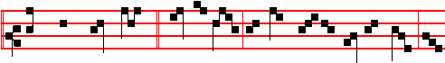
Take these things hence, * saith the Lord, and make not my Father's house an
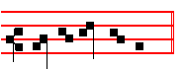
house of merchandise. Then the Prayers, p. 108.
COLLECT
GRANT, we beseech thee, almighty God: that we who year by year devoutly keep this holy observance may be acceptable unto thee both in body and in soul. Through.
Today the Office of the Dead.
At the Hours all as in the Psalter.
AT VESPERS

Antiphon.The Lord. Psalm Dilexi, with the rest from the Psalter, 114.
Hymn E.H. 66 Audi benigne and  God shall give, p. 596.

On Magnificat, Antiphon.
676
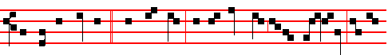
Destroy this temple, * saith the Lord, and in three days I will raise it up: but he
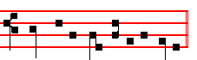
spake of the temple of his body. Then the Prayers, p. 217.

COLLECT
O LORD, we beseech thee graciously to hear our prayers: and. grant that we, to whom thou hast given an hearty desire to pray, may be defended by thy succour. Through.
__________________________________________________________________

Tuesday

The Lesson from the Holy Gospel according to S. John
Lesson j Ch. 7, 14-31
ABOUT the midst of the feast Jesus went up into the temple, and taught. And the rest.
Homily by S. Augustine, Bishop Homily 29 on John
HE who kept himself secret, now taught: he openly spake, and was not laid hold upon. For that keeping himself secret was for the sake of the example: this openness was for the betokening of power. But when he taught, the Jews marvelled. All indeed, I suppose, marvelled, but not all were converted. And whence this marvelling? Because many knew where he was born, how brought up; they had never seen him learning letters, they heard him indeed reasoning of the law, producing testimonies of the law which no man could produce unless he had read, none could read unless he had learned letters; and that was why they marvelled. But their wonder served the Master for an occasion of more deeply winding the Truth into their minds. By reason, namely, of their wonder and their words, the Lord uttered a profound saying, worthy to be looked into and discussed with more than common diligence. On behalf of which I would have you, my beloved, to bend your minds not only to hear for yourselves, but to pray for us.

 Why go ye about to kill me, a man that hath told you the truth? * If I have spoken evil, bear witness of the evil; but if well, why smitest thou me?
 Many good works have I wrought among you; for which of those works go ye about to kill me. If I have.
677
Lesson ij
WHAT then said the Lord in answer to them when they were marvelling how he knew letters, which he had never learned? My doctrine, saith he, is not mine, but his that sent me. This is the first profundity: he seems, namely, In a few words to have spoken contraries. He saith not, This doctrine is not mine; but, My doctrine is not mine. If not thine, how thine? if thine, how not thine? For thou sayest both, My doctrine, and, Not mine. If he had said. This doctrine is not mine, there had been no mistake.

 I the Lord have led you forty years in the wilderness, and your clothes are not waxen old upon you. * I rained down manna upon you from heaven, and ye have forgotten me, saith the Lord.
 I led you forth out of the land of Egypt. and delivered you from the house of bondage. I rained.

Lesson iij
BUT now, my brethren, in the first place mark well the question, and so in due order expect the solution. For when one sees not the question which is propounded, how should he expect to understand what is expounded? Well; the matter in question is this, that he saith, Mine, not mine: this seemeth to be contrary: how mine, how not mine? Now, if we look diligently into what the holy Evangelist himself saith in his opening, In the beginning was the Word, and the Word was with God, and the Word was God, thereby hangs the solution of this question. What, in fact. is the doctrine of the Father, but the Word of the Father? Consequently. Christ himself is the doctrine of the Father, if the Word of the Father. But because, Word, cannot be of none, but must be the word of some speaker, therefore he both said, His doctrine, meaning of his own self, and, Not his, because he is the Word of the Father. For what is so much thine as thyself. and what so much not thine as thyself, if it be of some one that thou art?

 Moses the servant of God, fasted forty days and forty nights, * To make him worthy to receive the law of God.
 Moses gat him up unto the Lord into Mount Sinai, and he was in the mount forty days and forty nights. To make. Glory be. To make.

On Benedictus, Antiphon.
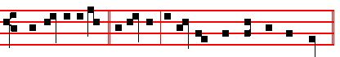
Why go ye about * to kill me, a man that hath told you the truth?

678
Then the Prayers, p. 108.
COLLECT
WE beseech thee, O Lord, that these sacret fasts which we devoutly observe: may obtain for us both an increase in godly conversation, and the continual succour of thy loving-kindness.Through.
On Magnificat, Antiphon.
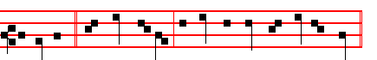
But no man * laid hands on him, because his hour was not yet come.
Then the Prayers, p. 217.
COLLECT
HAVE mercy, O Lord, upon thy people: and grant that they who are sore vexed by continual tribulations may of thy goodness be relieved. Through.
__________________________________________________________________

Wednesday
Today the Gradual Psalms.
The Lesson from the Holy Gospel according to S. John
Lesson j Ch. 9, 1-38
AS Jesus passed by, he saw a man which was blind from his birth. And his disciples asked him, saying, Master, who did sin, this man, or his parents, that he was born blind? And the rest.
Homily by S. Augustine, Bishop Homily 44 on John
THOSE acts of our Lord Jesus which are astonishing and marvellous are both works and words: works, because they are things done: words, because they are signs. If then we consider what is signified by this thing done, the blind man is mankind in general: for this blindness took place in the first man through sin, of whom we have all derived the origin not only of death, but also of iniquity. For if blindness is unbelief, and enlightenment faith, whom will Christ find a believer at his coming? Since indeed the Apostle, born as he was in the nation of the prophets, saith, We too were sometime by nature children of wrath, even as the rest. If children of wrath, children of vengeance, children of punishment, children of hell. How, by nature, unless as by the sin of the first man, the taint has grown into us to be as nature? If the taint has grown into us to be as nature, then, in respect of the mind, every man is born blind.

 After that the Lord had looked upon him, the face of Moses shone, * And when the elders saw that his face shone, they marvelled and were sore afraid.
 And when he came down from Mount Sinai with the two tables of testimony in

679
his hand, he wist not that his face shone because God had spoken with him. And when.

Lesson ij
THE Lord came: what did he? A great mystery hath he intimated. He spat upon the ground; of his spittle he made clay - because the Word was made flesh - and anointed the eyes of the blind man. He was anointed, and still did not yet see. He sent him to the pool which is called Siloe. It concerned the Evangelist, however, to call our attention to the name of this pool; and he saith, Which is by interpretation, Sent. Who was the Sent, of course ye know: had he not been sent with that mission. none of us should have had thc remission of our iniquity. Well, he washed his eyes in that pool which is by interpretation, Sent; he was baptized in Christ. If therefore when Christ in some sort baptized the man in himself, he then enlightened him; when he anointed him, belike he made him a catechumen.

 Behold, I send an Angel before thee to keep thee always. * Beware, and obey my voice: then I will be an enemy unto thine enemies, and an adversary unto thine adversaries, for mine Angel shall go before thee.
 O Israel, if thou wilt hearken unto me, there shall no strange God be in thee, neither shalt thou worship any other God: I am the Lord. Beware.

Lesson iij
YE have heard a great mystery. Ask a man, Art thou Christian? He answereth, I am not, if he be Pagan or Jew. But should he say, I am; thou goest on to question him, Catechumen, or believer? Should he reply, Catechumen, he is anointed, not yet washed. But wherewith anointed? Ask, and he answereth; ask him, in whom he bclieveth? in the very fact of his being a catechumen, he saith, In Christ. Lo, I am now speaking both to believers and to catechumens. What said I of the spittle and the clay? That the Word was made flesh. This the catechumens do also hear; but that is not enough for them whereunto they are anointed: let them haste to the laver, if they seek light.

 Hear, O my people, my law, * Incline your ears unto the words of my mouth.
 I will open my mouth in a parable: I will declare hard sentenccs of old. Incline.
Glory be. Incline.

On Benedictus, Antiphon.
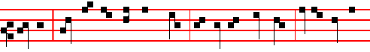
Master, * wherein hath this man sinned, that he was born blind? Jesus answered

680
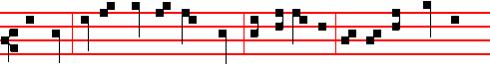
and said: Neither hath this man sinned, nor his parents; but that the works of God

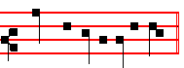
should be manifest in him. Then the Prayers, p. 108.

COLLECT
O GOD, who through fasting dost grant to the just the reward of their merits, and to sinners thy pardon: have mercy upon thy humble servants; that by confession of our guilt we may obtain forgiveness of our iniquities. Through.
On Magnificat, Antiphon.
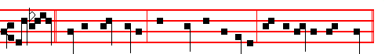
A man * that is called Jesus made clay out of spittle and anointed mine eyes,
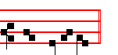
and now I see. Then the Prayers, p. 108
COLLECT
LET thy merciful ears, O Lord, be open to the prayers of thy humble servants: and that they may obtain their petitions; make them to ask such things as shall please thee.Through.
__________________________________________________________________

Thursday
The Lesson from the Holy Gospel according to S. Luke
Lesson j Ch. 7, 11-16
JESUS went into a city called Nain; and many of his disciples went with him, and much people. And the rest.
Homily by S. Ambrose, Bishop Bk. 5 on Luke Ch. 7
THIS Gospel lesson flows with a twofold grace: first, we are to believe how readily the divine mercy stoops to the distress of a widow-mother especially

681
to one who is broken by the sickness or death of an only son; and it was a funeral of considerable importance, as befitted her position, for much people of the city was with her. Secondly, it would appear that this widow, surrounded by a crowd of people, stands for more than a woman who by her tears deservedly obtained the resurrection of her young and only son: for holy Church calls her younger people
back to life as they think on her tears at the time of a solemn funeral and last rites of burial: she may not weep for those who are due to rise again.

 The Lord spake unto Moses, saying, Go down now into Egypt, and say unto Pharaoh, * Let my people go. And the heart of Pharaoh shall be hardened, that he will not let my people go, no, not by a mighty hand.
 Behold the cry of the children of Israel is come unto me and I have seen the oppression. Come now therefore, and I will send thee to Pharaoh, saying. Let my.

Lesson ij
AND the dead man was carried to the grave in a bier by bearers representing the four elements of the material world, but he had hope of rising again, for he was carried on wood. Wood was of no avail to us in former days, but since Jesus touched it, it began to be conducive to life: it was a sign that salvation would be restored to the people through the gibbet of the cross. On hearing the word of God, those grim funeral bearers stood still, they who were carrying the human body along the deadly way of material nature. For how else is it, but that we are lying lifeless on a kind of bier, that is, on the instrument of funeral rites; when the flame of inordinate desires burns us, or cold-heartedness freezes us, or when our vigour of soul is deadened by some slothful habit of our earthly body, or when our spirit, blocked by sin, is void of that pure light that nourishes the mind? These are our funeral bearers.

 Moses went in and told Pharaoh, Thus saith the Lord, * Let my people go, that they may hold a feast unto me in the wilderness.
 The Lord God of the Hebrews hath sent me unto thce. saying. Let my.

Lesson iij
BUT although the last rites at the moment of death banish all hope of life, and the bodies lie close to the grave; yet by the word of God those bodies rise again: speech returns, the son is given back to his mother, he is called back from the tomb, he is delivered from the grave. What is this your tomb, but evil habits? Your tomb is unbelief: your sepulchre is your throat. Their throat is an open sepulchre, whence deadly words are produced. From this sepulchre Christ sets you free: from this tomb you will arise, if you will listen to the word of God. And if your sin is grievous, so that you cannot wash yourself clean with tears of penitence; then Mother Church will weep for you, for she intercedes for each of

682
her children as a widow-mother for her only son. She grieves with a spiritual sorrow that is like a mother's natural sorrow, when she sees her children being carried on to death by deadly sins.

 I will sing unto the Lord, for he hath triumphed gloriously; the horse and his
rider hath he thrown into the sea. * The Lord is my strength and song, and he is become my salvation.
 The Lord is a man of war. The Lord is his Name. The Lord is my. Glory be. The Lord.

On Benedictus, Antiphon.
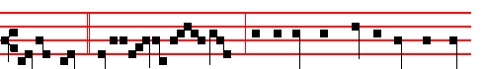
Jesus went * into a ci- ty called Nain: and behold there was a dead man car-
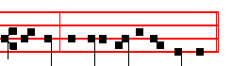
ried out, the only son of his mother. Then the Prayers, p. 108.

COLLECT
GRANT, we beseech thee, almighty God; that we, being chastened by these sacred fasts, may likewise rejoice in holiness of spirit; that, our earthly desires being subdued, we may more readily lay hold on things heavenly. Through.
On Magnificat, Antiphon.
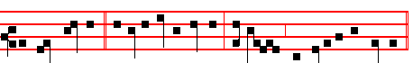
A great prophet * is risen up among us, and God hath visited his people.
Then the Prayers, p. 217.
COLLECT
O GOD, the creator and ruler of thy people, drive far the sins which do beset them: that they, being ever pleasing to thee, may also be safe under thy protection. Through.
__________________________________________________________________

Friday
683
The Lesson from the Holy Gospel according to S. John
Lesson j Ch. 11, 1-45
ACERTAIN man was sick, named Lazarus, of Bethany, the town of Mary and her sister Martha. And the rest.
Homily by S. Augustine, Bishop Homily 49 on John
IN the former lesson, ye remember, the Lord escaped from the hands of them who wished to stone him: and went away beyond Jordan, where John was once baptizing. Well, the Lord being there, Lazarus was taken sick at Bethany which was a town very near Jerusalem. It was that Mary which anointed the Lord with ointment and wiped his feet with her hair, whose brother Lazarus was sick. Therefore the sisters sent unto him, saying - We already understand to what place they sent, the place where the Lord was: because he was absent, beyond Jordan, to wit. They sent to the Lord, to announce the illness of their brother: in order that, if he should vouchsafe, he should come and release him of his sickness. The Lord delayed to heal, that he might raise to life again.

 Thy way is in the sea and thy paths in the great waters. * Thou leddest thy people like sheep by the hand of Moses and Aaron.
 Thou broughtest them through the Red Sea, and led them through much water. Thou leddest.

Lesson ij
WELL, what was the message the sisters sent? Lord, behold he whom thou lovest is sick. They said not, Come: to one that loved, it needed but to send tidings. They durst not say, Command there, and it shall be done here. For why should not these women have said this, if the faith of that centurion is praised on this very account? For he said, I am not worthy that thou shouldest come under my roof, but only say the word, and my servant shall be healed. Nothing of the sort did these women say, but only, Lord, behold, he whom thou lovest is sick. Enough that thou know it: for thou dost not love and forsake.

 O Lord, thou hast overwhelmed in the deep of the sea them which persecuted thy people. * Even the people which thou leddest by the pillar of cloud.
 Thou leddest thy people like sheep by the hand of Moses and Aaron. Even the.

Lesson iij
SOME man will say, How should it be that by Lazarus a sinner was denoted, and yet was so loved by the Lord? Let him hear him saying, I am not come to call the just, but sinners. For if God loved not sinners, he had not descended from heaven to earth. When Jesus heard that, he said, This sickness is not unto death, but for the glory of God, that the Son of God might be glorified thereby. That he should be thus glorified was no gain to him, but only for our good. That he saith

684
then, Is not unto death, is this, that the death itself was not for death, but rather for a miracle, which being wrought, men should believe in Christ, and avoid the true death. See, withal, how, by a kind of side hint, the Lord hath intimated that he is God: because of certain who deny the Son to be God.

 Moses the servant of God, fasted forty days and forty nights, * To make him worthy to receive the law of God.
 Moses gat him up unto the Lord into Mount Sinai, and he was in the mount forty days and forty nights. To make. Glory be. To make.

On Benedictus, Antiphon.
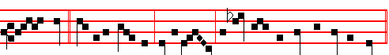
Our friend * Lazarus sleepeth: let us go, that we may awake him out of sleep.
Then the Prayers, p. 108.
COLLECT
O GOD, who by ineffable sacraments dost renew the world: grant, we beseech thee; that thy Church, being profited by thine eternal ordinances, may likewise fail not of thy succour in things temporal. Through.

Today the Penitential Psalms.

On Magnificat, Antiphon.
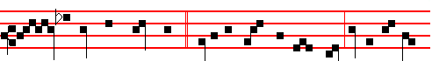
Lord, if thou hadst been here,* Lazarus would not have died: lo, by this time
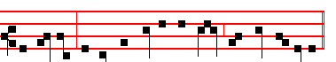
he stinketh; for he hath lain in the grave four days already.

Then the Prayers, p. 217.
COLLECT
GRANT, we beseech thee, almighty God: that we, who, knowing our own infirmity, do put our confidence in thy power, may evermore rejoice beneath thy loving-kindness. Through.

685
Saturday

The Lesson from the Holy Gospel according to S. John
Lesson j Ch. 8, 12-20
JESUS spake unto the multitudes of the Jews, saying: I am the light of the world: he that followeth me shall not walk in darkness, but shall have the light of life. And the rest.
Homily by S. Augustine, Bishop Homily 34 on John
WHAT the Lord saith, I am the light of the world, I suppose is clear to them that have eyes wherewith to be made partakers of this light: but they who have not eyes, save in the flesh alone, marvel that it is said by the Lord Jesus Christ, I am the light of the world. And perchance there may not lack one to say in himself, May not the Lord Christ be this sun, which by its rising and setting maketh the day? For there have not been wanting heretics that thought this. The Manicheans have accounted this sun, which is visible to the eyes, exposed and public, not only for men, but even for beasts to see it, to be Christ the Lord!

 After that the Lord had looked upon him, the face of Moses shone, * And when the elders saw that his face shone, they marvelled and were sore afraid.
 And when he came down from Mount Sinai with the two tables of testimony in his hand, he wist not that his face shone because God had spoken with him. And when.

Lesson ij
BUT the right faith of the Catholic Church refuseth to listen to such an imagination, and holdeth it to be a devilish doctrine: and not only in believing adjudgeth it to be such, but also by reasoning proveth the same to the conviction of whom it may. Then let us refuse to listen to this error, which the Holy Church from the beginning hath anathematized. Let us not imagine the Lord Jesus Christ to be this sun which we see rising from the east, setting in the west; to whose course night succeedeth; whose rays are overshadowed by a cloud; which goeth on its way by a set motion from place to place: the Lord Christ is none of this! The Lord Christ is not the created sun, but he by whom the sun was created. For all things were made by him, and without him was nothing made.

 Behold, I send an Angel before thee to keep thee always. * Beware, and obey my voice: then I will be an enemy unto thine enemies, and an adversary unto thine adversaries, for mine Angel shall go before thee.
 O Israel, if thou wilt hearken unto me, there shall no strange God be in thee, neither shalt thou worship any other God: I am the Lord. Beware.

Lesson iij
686
THERE is then a Light which made this visible light: this let us love, this let us desire to understand, even this let us thirst after; that to It, by Its own guidance we may sooner or later come, and therein so live, that we may never die at all. For this is the Light, of which the prophecy which of old time went before, hath thus sung in the Psalm: Thou, Lord, shalt save both man and beast; how excellent is thy mercy, O God.

 Hear, O my people, my law, * Incline your ears unto the words of my mouth.
 I will open my mouth in a parable: I will declare hard sentences of old. Incline.
Glory be. Incline.

On Benedictus, Antiphon. Tone iij, 1.
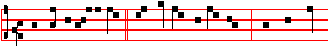
He that followeth me * shall not walk in darkness, but shall have
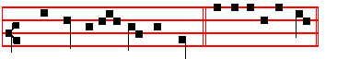
the light of life, saith the Lord. Canticle Benedictus, p. 28.
Then the Prayers, p. 108.
COLLECT
O LORD, forasmuch as these our fasts will be unprofitable unto us unless they be acceptable unto thy loving-kindness: we beseech thee that the devout affection of our hearts may be made fruitful by thy grace. Through.
__________________________________________________________________

SATURDAY BEFORE PASSION SUNDAY

AT VESPERS

Chapter Heb. 9
BRETHREN: Christ being come an high priest of good things to come, by a greater and more perfect tabernacle, not made with hands, that is to say, not of this building; neither by the blood of goats and calves, but by his own blood he entered in once into the holy place, having obtained eternal redemption for us.

Hymn. E.H. 94 Vexilla Regis Mode j
¶ Or the Ratisbon version given below at Compline.

687
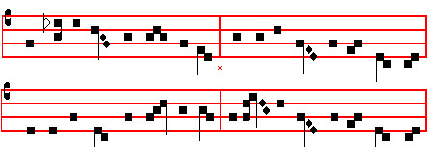
THE royal banners forward go; 4 O Tree of beauty, Tree of light!
The Cross shines forth in mystic glow O Tree with royal purple dight!
Where he in flesh, our flesh who made, Elect on whose triumphal breast
Our sentence bore, our ransom paid: Those holy limbs should find their rest:

2 Where deep for us the spear was dyed, 5 On whose dear arms, so widely flung,
Life's torrent rushing from his side, The weight of this world's ransom hung:
To wash us in that precious flood, The price of humankind to pay,
Where mingled Water flowed, and Blood. And spoil the spoiler of his prey.

3 Fulfilled is all that David told 6 O Cross, our one reliance, hail!
In true prophetic song of old So may thy power with us avail
Amidst the nations, God, saith he, To give new virtue to the saint,
Hath reigned and triumphed from the tree. And pardon to the penitent.

7 To thee, eternal Three in One,
Let homage meet by all be done:
Whom by the Cross thou dost restore,
Preserve and govern evermore.
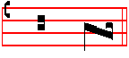
A - men.
 Deliver me, O Lord, from the evil man.
 And preserve me from the wicked man.

On Magnificat, Antiphon. Tone viij, 1.
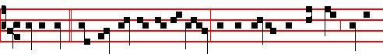
I am one * that bear witness of myself, and the Father that sent me beareth

688
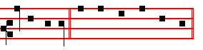
witness of me. Canticle Magnificat, p.211.
COLLECT
WE beseech thee, almighty God, mercifully to look upon thy family: that by thy great goodness they may be governed and preserved evermore, both in body and soul. Through.
From this Saturday until Monday after the Octave of Pentecost the accustomed commemorations of the Cross, of Saint Mary, and the others in the Psalter, are not said.
At Compline, and through the Hours
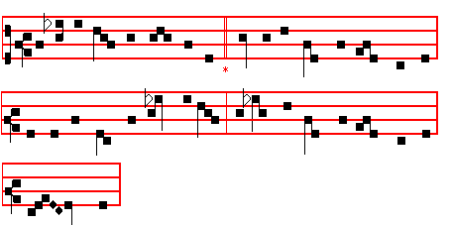
¶ In the Short  Glory be to the Father is not said in the Ferial Office until Maundy Thursday.
__________________________________________________________________

PASSION SUNDAY AT MATINS

Invitatory.- Today if ye will hear the voice of the Lord, * Harden not your hearts. Psalm 95 Venite, p. 2.
This Invitatory is said until Maundy Thursday, in the Ferial Office also. In the Psalm,Today if ye will hear his voice is omitted, and the Invitatory is repeated by the Choir: then follows as in the provocation.
At the end of this Psalm Glory be to the Father is not said in this Passiontide Season, except on Feasts; but the Invitatory is repeated, as at other times, at the end. Which is observed also in the Responsories at Matins, and in the Short Responsories of the Hours, where likewise the Responsory is repeated.

689
Hymn. E.H. 95 Pange lingua gloriosi proelium certaminis. Mode iij
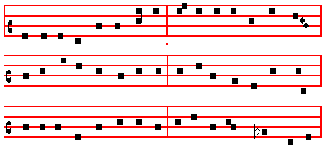
¶ Or the Ratisbon version below at Lauds.
SING, my tongue, the glorious battle, 2 God in pity saw man fallen,
Sing the ending of the fray; Shamed and sunk in misery,
Now above the Cross, the trophy, When he fell on death by tasting
Sound the loud triumphal lay: Fruit of the forbidden tree;
Tell how Christ, the world's Redeemer, Then another tree was chosen
As a victim won the day. Which the world from death should free.

3 Thus the scheme of our salvation 4 Therefore, when the appointed fullness
Was of old in order laid, Of the holy time was come,
That the manifold deceiver's He was sent who maketh all things
Art by art might be outweighed, Forth from God's eternal home;
And the lure the foe put forward Thus he came to earth, incarnate,
Into means of healing made. Offspring of a maiden's womb.

5 To the Trinity be glory
Everlasting, as is meet;
Equal to the Father, equal
To the Son and Paraclete :
Trinal Unity, whose praises
All created things repeat.
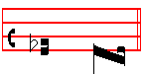
A - men
At the Nocturns, all as in the Psalter, with the  as in Passiontide.

IN THE FIRST NOCTURN

690
Here beginneth the book of the Prophet Jeremiah.
Lesson j
THE words of Jeremiah the son of Hilkiah, of the priests that were in Anathoth in the land of Benjamin: to whom the word of the Lord came in the days of Josiah the son of Amon king of Judah, in the thirteenth year of his reign. It came also in the days of Jehoiakim the son of Josiah king of Judah, unto the end of the eleventh year of Zedekiah the son of Josiah king of Judah, unto the carrying away of Jerusalem captive in the fifth month. Then the word of the Lord came unto me, saying, Before I formed thee in the belly I knew thee; and before thou camest forth out of the womb I sanctified thee, and I ordained thee a prophet unto the nations. Then said I, Ah, Lord God! behold, I cannot speak: for I am a child.

 These are the days which ye shall proclaim in their seasons: * In the fourteenth day at even is the Lord's passover, and on the fifteenth day ye shall keep the feast unto the Lord Most High..
 The Lord spake unto Moses, saying, Speak unto the children of Israel, and say unto them. In the.
This  is not said during the week.

Lesson ij
BUT the Lord said unto me, Say not, I am a child: for thou shalt go to all that I shall send thee, and whatsoever I command thee thou shalt speak. Be not afraid of their faces: for I am with thee to deliver thee, saith the Lord. Then the Lord put forth his hand, and touched my mouth. And the Lord said unto me, Behold, I have put my words in thy mouth. See, I have this day set thee over the nations and over the kingdoms, to root out, and to pull down, and to destroy, and to throw down, to build, and to plant. Moreover the word of the Lord came unto me, saying, Jeremiah, what seest thou? And I said, I see a rod of an almond tree. Then said the Lord unto me, Thou hast well seen: for I will hasten my word to perform it. And the word of the Lord came unto me the second time, saying, What seest thou? And I said, I see a seething pot; and the face thereof is toward the north.

 How are they increased that trouble me, that say of my soul, There is no help for him in his God. * Arise, O Lord: save me, O my God.
 Lest mine enemy say: I have prevailed against him. Arise.

Lesson iij
THEN the Lord said unto me, Out of the north an evil shall break forth upon all the inhabitants of the land. For, lo, I will call all the families of the kingdoms of the north, saith the Lord; and they shall come, and they shall set every one his

691
throne at the entering of the gates of Jerusalem, and against all the walls thereof round about, and against all the cities of Judah. And I will utter my judgments against them touching all their wickedness, who have forsaken me, and have burned incense unto other gods, and worshipped the works of their own hands. Thou therefore gird up thy loins, and arise, and speak unto them all that I command thee: be not dismayed at their faces, lest I confound thee before them. For, behold, I have made thee this day a defenced city, and an iron pillar, and brasen walls against the whole land, against the kings of Judah, against the princes thereof, against the priests thereof, and against the people of the land. And they shall fight against thee; but they shall not prevail against thee; for I am with thee, saith the Lord, to deliver thee.

 How long shall mine enemies triumph over me? * Consider and hear me, O Lord my God.
 For if I be cast down, they that trouble me will rejoice at it, but my trust is in thy mercy. Consider. How long.

IN THE SECOND NOCTURN

Sermon by S. Leo the Great
Lesson iv Sermon 9 on Lent
WE know, dearly beloved, that the Paschal mystery is pre-eminent among all the great Christian festivals: indeed all the other seasons form a preparation for a reverent and worthy approach to this one: but these days of Passiontide demand our greatest devotion, for we know that they immediately precede that supreme sacrament of the Divine mercy. The Apostles, through the teaching of the Holy Spirit, fittingly ordered a strict fast to be observed during these days: that. by sharing in the. sufferings of the cross of Christ, we also might participate in some way in that which he suffered for us, as the Apostle says, If so be that we suffer with him, we may be also glorified together. Sure and steadfast is the hope of promised blessedness for one who is a partaker of the sufferings of the Lord.

 Thou art my God, go not far from me, * For trouble is hard at hand, and there is none to help me.
 But be not thou far from me, O Lord: thou art my succour, haste thee to help me. For trouble.
Lesson v
NO-ONE, dearly beloved, is debarred from a share in this glory by reason of the time and circumstances in which he lives, as though periods of tranquillity were lacking in opportunities for proving one's strength. The Apostle teaches us, saying, All that will live godly in Christ Jesus shall suffer persecution.

692
And therefore the trial of persecution will never be lacking so long as there be no lack of observance of piety. For the Lord, while urging on his disciples, said, He that taketh not his cross and followeth after me, is not worthy of me. Unmistakeably this announcement concerns not only Christ's disciples, but all the faithful as well, the whole Church. For in those words spoken to those who were there present, the Church heard, in a universal sense, the message of her own salvation.

 I have been left unto thee ever since I was born: thou art my God even from my mother's womb. O go not from me, * For trouble is hard at hand, and there is none to help me.
 Save me from the lion's mouth, thou hast heard me also from among the horns of the unicorns. For trouble.

Lesson vj
NOW just as the whole body of the Church is to live godly, so likewise is the cross to be carried at all times: fittingly is each member of the Church urged to carry it, for it is borne by each one differently according to his means and capacity. There is one name, persecution, but there is more than one kind of battle; and there is far more danger from a hidden ambush than from an open enemy. Blessed Job, who had known both the good and the evil of this world, said truly and rightly, Is there not a warfare to man upon earth? For the faithful soul is attacked not only with bodily pains and afflictions, but also, when the body is sound and healthy, it is goaded on to grievous sin if it is weakened by fleshly desire. But since the flesh lusteth against the Spirit, and the Spirit against the flesh, the rational mind is fortified by the deFence of the Cross of Christ, nor does it consent to the enticements of harmful desires for it is pierced by the nails of continence and by the fear of God.

 Trouble is hard at hand, O Lord, and there is none to help me; they pierced my hands and my feet; save me from the lion's mouth, * And I will declare thy Name unto my brethren.
 Deliver my soul, 0 God, from the sword: my darling from the power of the dog.
And I. Trouble is.
IN THE THIRD NOCTURN

The Lesson from the Holy Gospel according to S. John
Lesson vij Ch. 8
JESUS said unto the multi- tudes of the Jews, Which of you convinceth me of
sin? And if I say the truth, why do ye not believe me? And the rest.

693
Homily by S. Gregory the Great Homily 18 on the Gospels
THINK of the gentleness of God, beloved brethren. He had come to remit sins, and he said, Which of you convinceth me of sin? He did not disdain to show by reasoning that he was without sin, he who by virtue of his divinity was able to justify sinners. But terrible indeed is the saying that follows: He that is of God heareth God's words: ye therefore hear them not, because ye are not of God. For if he who is of God hears God's words, and whoever is not of him cannot hear his words: let each one ask himself whether the words of God sound in the ears of his heart: and let him thus know whose he is. Truth commands us to long for our heavenly fatherland, to do away with carnal desires, to turn away from earthly glory, not to covet another man's goods, and to give away our own.

 I go mourning all the day long, O Lord: for my soul is filled with a sore disease: * They also that sought after my life laid snares for me.
 My lovers and my neighbours did stand looking upon my trouble, and my kinsmen stood afar off. They.

Lesson viij
LET each one, then, examine himself, as to whether this voice of God has sounded in the ears of his heart, and so let him acknowledge that he is of God. For there are some who will not deign to hear God's commandments even with their bodily ears. And there are others who will indeed hear them with their bodily ears, but will not cleave to them with the loving desire of their minds. And there are yet others, who receive God's word with a good will, even to the point of shedding tears. of compunction, but when this time of weeping is over, they return again to their evil doings. Truly they hear not God's words, those who scorn to put them into effect. Therefore, beloved brethren, call up your life before your mind's eye, and in the spirit of holy fear ponder deeply this saying that rings out from the lips of Truth: Ye therefore hear them not, because ye are not of God.

 Hide not thy face from thy servant, O Lord: * For I am in trouble: O haste thee and hear me.
 Draw nigh unto my soul, and save it: O deliver me because of mine enemies. For I.

Lesson ix
BUT Truth says this concerning the reprobate, and the reprobate prove it themselves by their own wickedness, for it follows: Say we not well that thou art a Samaritan, and hast a devil? Let us hear the Lord's answer, when he received such an insult. I have not a devil; but I honour my Father, and ye do dishonour me. For since Samaritan means watchman, and he was indeed the watchman of whom the Psalmist says, Except the Lord keep the city, the watchman waketh but in

694
vain; and to whom it is said by Isaiah, Watchman, what of the night? watchman, what of the night? because of this, the Lord did not choose to say, I am not a Samaritan, but he said, I have not a devil. Two charges were brought against him: he denied one, and, by his silence, he agreed to the other.

 O that my head were waters, and mine eyes a fount of tears, that; I might weep day and night: for my nearest brother hath supplanted me, * And every neighbour hath gone about with slanders against me.
 Let their way be dark and slippery, and let the Angel of the Lord persecute them. And every. O that my head.

AT LAUDS

Antiphon 1. Tone viij, 1.
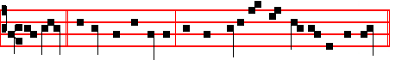
O Lord, * behold my affliction: for mine enemy hath magnified himself.
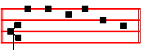
Psalm 51 Miserere and the rest.
Antiphon 2. Tone vij, 1.
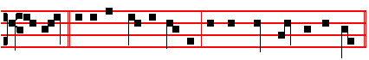
I called * upon the Lord in trouble; and the Lord heard me at large.
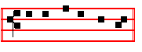
Psalm 118 Confiremini, p. 43.
Antiphon 3. Tone iv, 1.
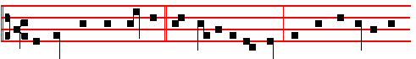
O Lord, thou hast pleaded * the causes of my soul: thou hast defended my

695
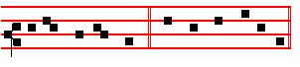
life, O Lord my God. Psalms 63, 67, p. 29.

Antiphon 4. Tone iv, 1.
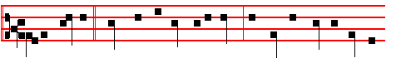
O my people, * what have I done unto thee? and wherein have I wearied
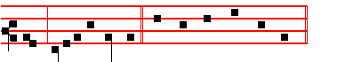
thee? testify against me. Canticle Benedicite, p. 31.

Antiphon 5. Tone iv, 1.
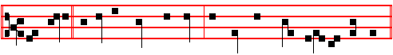
Shall evil * be recompensed for good? for they have digged a pit for my soul.
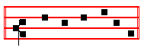
Psalms 148 149 150, p. 33.

Chapter Heb. 9
BRETHREN: Christ being come an high priest of good things to come, by a greater and more perfect tabernacle, not made with hands, that is to say, not of this building; neither by the blood of goats and calves, but by his own blood he entered in once into the holy place, having obtained eternal redemption for us.

Hymn Lustra sex qui jam peregit Mode j.

¶ Or as E.H. 95 above at Matins, p. 690.

696
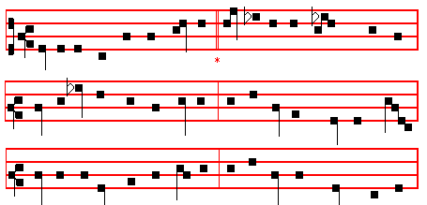

E.H. 96 Lustra sex qui jam peracta
THIRTY years among us dwelling, 2 He endured the nails, the spitting,
His appointed time fulfilled, Vinegar, and spear, and reed;
Born for this, he meets his Passion, From that holy Body broken
For that this he freely willed, Blood and water forth proceed:
On the Cross the Lamb is lifted Earth, and stars, and sky, and ocean
Where his life-blood shall be spilled. By that flood from stain are freed.

3 Faithful Cross! Above all other, 4 Bend thy boughs, O Tree of Glory!
One and only noble tree! Thy relaxing sinews bend;
None in foliage, none in blossom, For awhile the ancient rigour
None in fruit thy peer may be; That thy birth bestowed, suspend.
Sweetest wood and sweetest iron! And the King of heavenly beauty
Sweetest weight is hung on thee. On thy bosom gently tend!

5 Thou alone wast counted worthy 6 To the Trinity be glory
This world's ransom to uphold; Everlasting, as is meet;
For a shipwreck'd race preparing Equal to the Father, equal
Harbour, like the Ark of old; To the Son, and Paraclete:
With the sacred Blood anointed Trinal Unity, whose praises
From the smitten Lamb that rolled. All created things repeat.
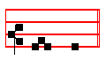
A - men.

 Deliver me from mine enemies, O God.
 Defend me from them that rise up against me.

697
On Benedictus, Antiphon. Tone iij, 1.
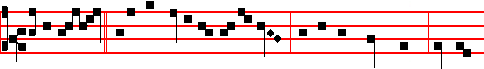
Jesus said * unto the multitude of the Jews, and to the chief priests: He that
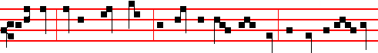
is of God heareth God's words; ye therefore hear them not, because ye are not
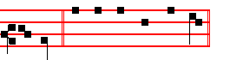
of God. Canticle Benedictus, p. 28

COLLECT

WE beseech thee, almighty God, mercifully to look upon thy family: that by thy great goodness they may be governed and preserved evermore, both in body and soul. Through.
AT PRIME
Antiphon. Tone viij, 2
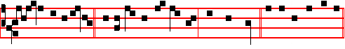
I have not a devil,* but I honour my Father, saith the Lord. Psalm 54, p. 43.

Chapter Now unto the King, p. 32.
Short  as in the Psalter, p. 32.
O Christ, Son of the living God, * Have mercy upon us. O Christ.
 Who sittest at the right hand of the Father.  Have. It is repeated O Christ, Son of the living God, have mercy upon us.
 Arise, O Christ, and help us.  And deliver us for thy name's sake.
Thus it is said on Sundays and Ferias until Maundy Thursday exclusively.
At the Close of the Chapter, Short Lesson I hid not my face, as in the Psalter.

AT TERCE
Antiphon. Tone viij, 2.

698
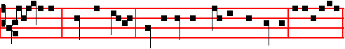
I seek not * mine own glory: there is one that seeketh and judgeth. Psalm 119
Chapter Brethren: Christ, as above, p. 696.
Short 
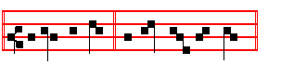
Deliver my soul, * O God, from the sword. Deliver.
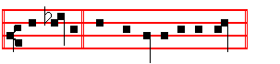
 My darling from the power of the dog. O God. Deliver.
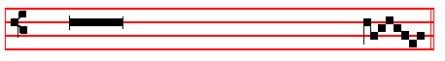
 Save me, O Lord, from the lion's mouth.
 Thou hast heard me also from among the horns of the uni - corns.

AT SEXT
Antiphon. Tone j, 1.
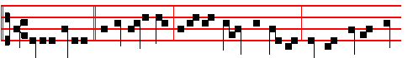
Verily, verily,* I say unto you, If a man keep my saying, he shall never taste
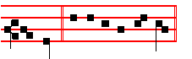
of death. Psalm 119 Defecit.
Chapter Heb. 9
FOR if the blood of bulls and of goats, and the ashes of an heifer sprinkling the unclean, sanctifieth to the purifying of the flesh; how much more shall the blood of Christ, who through the eternal Spirit offered himself without spot to God, purge your conscience from dead works to serve the living God?

699
Short 
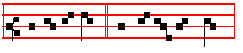
Save me, O Lord, * From the li - on's mouth. Save me.
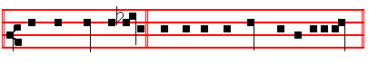
 Thou hast heard me also from among the horns of the unicorns.
From the. Save me.
 O shut not up my soul with the sinners.  Nor my life with the bloodthirsty.

AT NONE
Antiphon. Tone j, 3.
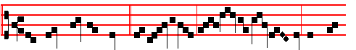
The Jews took up stones * to cast at him: but Jes-us hid him-self, and went
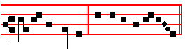
out of the temple. Psalm 119 Mirabilia.
Chapter Heb. 9
AND for this cause he is the mediator of the new testament, that by means of death, for the redemption of the transgressions that were under the first testament, they which are called might receive the promise of eternal inheritance, in Christ Jesus our Lord.
Short 
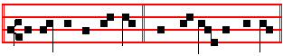
O shut not up my soul * With the sinners, O God. O shut.
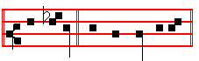
 Nor my life with the bloodthirsty. With the. O shut.
700
 Deliver me, O Lord, from the evil man.
 And preserve me from the wicked man.

AT VESPERS

Antiphon and Psalms The Lord said, with the rest of Sunday, p. 2O2. Chapter Brethren: Christ being come, as above, p. 696. Hymn E.H. 94 Vexilla Regis,  Deliver me, p. 688.
On Magnificat, Antiphon. Tone ij.
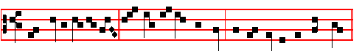
Your father Abraham * rejoiced to see my day: and he saw it and was glad.
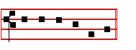
Canticle Magnificat, p. 209.
Collect We beseech thee, p. 698.
The Hymns,  and short  above are said also on Palm Sunday, and in the Ferial Office until Wednesday in Holy Week.
After Vespers of the Day are said Vespers ef the Dead.
__________________________________________________________________

Monday

Invitatory Today if ye wIll hear, as above, p. 689.
Hymn E.H. 95 Pange lingua, p. 690. Antiphons and Psalms of this Feria, p. 89.  Deliver my soul, p. 103, for Passiontide.
The Lesson from the Holy Gospel according to S. John
Lesson j Ch. 7, 32-39
THE Pharisees and the chief priests sent officers to take Jesus. And the rest.

Homily by S. Augustine, Bishop Homily 31 on John
TO apprehend whom? Him while as yet he would not? Because therefore they could not apprehend him while he would not, they were sent to hear him teaching. Teaching what? Then said Jesus, Yet a little while I am with you. What ye wish to do now, ye shall do, but not now, because now I am not willing. Why am I now as yet not willing? Because yet a little while I am with you, and then I go to him that sent me. It behoveth me to fulfil my Dispensation, and so to come to my Passion.
701

 Deliver me O my God, out of the hand of the ungodly: out of the hand of the unrighteous and cruel man. * For thou art my hope.
 Go not far from me, O God: my God, haste thee to help me. For thou.

Lesson ij
YE shall seek me, and shall not find me: and where I am, thither ye cannot come. Here hath he now foretold his resurrection: for they would not acknowledge him when present, and afterwards they sought him, when they saw the multitude now believing in him. For great signs were wrought also when the Lord was risen, and ascended into heaven. Then, by the disciples were wrought great signs; yea, he wrought by them, as he wrought by himself: for he it was that had said to them, Without me ye can do nothing. When the lame man who sat at the gate, at the voice of Peter arose, and walked on his own feet, so that men marvelled, Peter told them that not by his own power had he done this, but in virtue of him whom they had killed. Many, pricked in heart, said, What shall we do?

 They that lay wait for my soul take their counsel together, saying, God hath forsaken him: * Persecute him and take him, for there is none to deliver him. Go not far from me, O God: haste thee to help me.
 All mine enemies whisper together against me: even against me do they imagine this evil. Persecute.

Lesson iij
FOR they saw themselves bound by a huge crime of impiety, when they killed him whom they ought to have venerated and adored: and this they thought inexpiable. For it was a great wickedness, the consideration of which might make them despair: howbeit they behoved not to despair, for whom the Lord, as he hung upon the cross, had deigned to pray. For he said, Father forgive them; for they know not what they do. He saw some that were his among many aliens; for those he even then asked pardon, from whom he was then still receiving wrong. For he regarded not that he was dying by their hands, but only that he was dying for them.

 Mine enemies' communing is not for peace, but in mine adversity they rejoiced. * This thou hast seen, O Lord: hold not thy tongue, then, go not far from me, O Lord.
 Nevertheless, when they were sick, I put on sackcloth, and humbled my soul with fasting. This thou. Mine enemies. This thou.

AT LAUDS

702
Antiphon and Psalm 51 Miserere with the rest in the Psalter, p. 104.
Chapter Jer. 11
LET us destroy the tree with the fruit thereof, and let us cut him off in the land of the living, that his name may be no more remembered.
Hymn E.H. 96 Lustra sex,  Deliver me, p. 697.
On Benedictus, Antiphon.
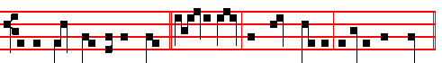
In the great day of the feast, * Jesus stood and cried, saying: If any man thirst,
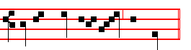
let him come unto me and drink. Then the Prayers, 108.

COLLECT
SANCTIFY, we beseech thee, O Lord, our fasts: and mercifully bestow upon us
the remssion of all our offences.Through.
Today the Office of the Dead.
At the Hours, all as in the ferial Office in Passiontide, in the Psalter.

AT VESPERS
Antiphons and Psalms of the Psalter, p. 114.
Chapter Jer.11
BUT,O Lord of hosts, that judgest righteously, that triest the reins and the heart, let me see thy vengeance on them; for unto thee have I revealed my cause, O Lord my God.
Hymn E.H. 94 Vexilla and  Deliver me, p. 688.
On Magnificat, Antiphon
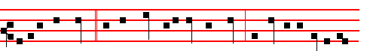
If any man thirst, * let him come unto me and drink: and out of his belly shall
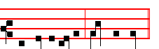
flow living water, saith the Lord. Then the Prayers, p. 217.

703
COLLECT
GRANT, we beseech thee, O Lord, to thy people health both of mind and body: that they, cleaving steadfastly to all good works, may ever be found worthy to be defended by thy protection. Through.
The above Chapters are said in the ferial Office until Wednesday in Holy Week. But the Antiphons through the Hours until Palm Sunday.
__________________________________________________________________

Tuesday
The Lesson from the Holy Gospel according to S. John
Lesson j Ch. 7, 1-13
JESUS walked in Galilee: for he would not walk in Jewry. because the Jews sought to kill him. And the rest.
Homily by S. Augustine, Bishop Homily 28 on John
IN this section of the Gospel, my brethren, our Lord Jesus Christ hath, as man, very much commended himself unto our faith. Indeed he ever aimeth at this, in his words and deeds, that he should be believed to be God and Man: God that made us; Man that sought us; God with the Father, always; Man with us, from time. For he should not have sought man whom he had made, were not himself made the thing he had made. But remember this, and do not let it go from your hearts, that Christ was in such sort made Man, that he ceased not to be God. Remaining God, he took unto him Man; he that made man.

 Thou art my defence and shield, and my trust is in thy word. * Away from me, ye wicked: I will keep the commandments of my God.
. I hate them that imagine evil things, but thy law do I love. Away.

Lesson ij
WHEN therefore, as Man, he hid himself, he must not be supposed to have lost his power, but only to have afforded an example to infirmity. For when he would, he was laid hold upon, when he would, he was slain. But because there would be members of him, that is, believers in him who would not have the power which he, even our God, had; therefore, in that he kept secret, in that he made as though to conceal himself that he might not be put to death, he indicated that this thing would be done by his members, in which his members he himself of course was.

 Then shall teach thy ways unto the wicked, and sinners shall be converted unto thee. * Deliver me from blood-guiltiness, O God, thou that art the God of my health.
 Thou shalt open my lips, O Lord, and my mouth shall shew thy praise. Deliver me.
704
Lesson iij
FOR Christ is not so in the head that he is not in the body, but Christ whole is in the head and in the body. What therefore his members are, that is he: but what he is, it does not follow that his members are. Were his members not himself, he would not have said, Saul, Saul, why persecutest thou me? Now Saul was persecuting on earth, not him, but his members, that is, his believers. Yet he was pleased to say, not, My saints, my servants, or more honourable still, my brethren: but, Me, that is, My members, to which I am the Head.

 O shut not up my soul with the sinners, nor my life with the bloodthirsty. * Deliver me, O Lord.
 Deliver me, O Lord, from the evil man, and preserve me from the wicked man. Deliver. O shut not. Deliver.
On Benedictus, Antiphon.
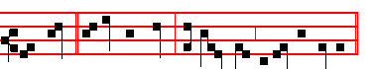
My time * is not yet come, but your time is alway ready .
Then the Prayers, p. 108.
COLLECT
WE beseech thee, O Lord, let these our fasts be acceptable unto thee: that by their atoning power they may make us worthy of thy grace; and lead us unto everlasing healing. Through.
On Magnificat, Antiphon.
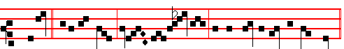
Go ye up * unto this feast: I go not up yet, for my time is not yet full come.
Then the Prayers, 217.
COLLECT
GRANT, to us, Lord, we beseech thee: so to continue steadfastly in obedience to thy will; that in our time the number of thy faithful may be multiplied and the worthiness of their service increased. Through.
__________________________________________________________________

Wednesday
Today the Gradual Psalms.
The Lesson from the Holy Gospel according to S. John
Lesson j Ch. 10, 22-38

705
IT was at Jerusalem the feast of the dedication, and it was winter. And Jesus walked in the temple in Solomon's porch. And the rest.
Homily by S. Augustine, Bishop Homily 48 on John
THE Encænia was the feast of the dedication of the temple. For cænon is Greek for new. Whenever anything new is dedicated, they call it encænia. In fact, the word is now in common use: when a man puts on a new coat he is said to encæniare (to handsel) it. The day, namely, on which the temple was dedicated, the Jews kept as an annual solemnity: this same holy-day they were keeping at the time when the Lord spake what has been read.

 I go mourning all the day long, O Lord: for my soul is filled with a sore disease: * They also that sought after my life laid snares for me.
 My lovers and my neighbours did stand looking upon my trouble, and my kinsmen stood afar off. They.

Lesson ij
IT was winter, and Jesus walked in the temple in Solomon's porch. Then came the Jews round about him, and said unto him, How long dost thou make us to doubt? If thou be the Christ, tell us plainly. Not that they desired the truth; they wanted only to get matter of accusation. Winter it was, and cold they were: for they had no mind to come to that divine fire. But to come is to believe: he that believes draws near and comes; he that denies, turns his back. The soul moves not with its feet but with its affections.

 Hide not thy face from thy servant, O Lord: * For I am in trouble: O haste thee and hear me.
 Draw nigh unto my soul, and save it: O deliver me because of mine enemies. For I.

Lesson iij
THEY were chilled from the charity of loving, and were burning with the lust of doing harm. They were far away, and yet they were there: they did not draw near by believing, and yet they pressed close by persecuting. They wanted to hear the Lord say, I am Christ: and belike they conceived of Christ only as man. The prophets preached Christ: but the Godhead of Christ both in the prophets and in the Gospel itself not even heretics believe, how much less Jews, so long as the veil is upon their hearts!

 O that my head were waters, and mine eyes a fount of tears, that; I might weep day and night: for my nearest brother hath supplanted me, * And every neighbour hath gone about with slanders against me.

706
 Let their way be dark and slippery, and let the Angel of the Lord persecute them. And every. O that my head.

On Benedictus, Antiphon.
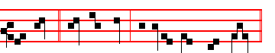
My sheep * hear my voice, and I the Lord know them. Then the Prayers, p. 108.

COLLECT
O MERCIFUL God, sanctify this our fast to the enlightenment of the hearts of thy faithful people: that we, to whom thou lost give an hearty desire to pray, may obtain of thy loving-kindness the f'ulfilment of all our petitions. Through.

On Magnificat, Antiphon.
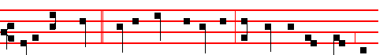
Many good works * have I wrought among you: for which of these works do
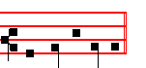
ye wish to kill me? Then the prayers, 217.
COLLECT
ASSIST us almighty God, in these our supplications: that as thou dost suffer us to put our trust and confidence in thy mercy; so thou wouldest graciously vouchsafe unto us the wonted effects of thy compassion. Through.
__________________________________________________________________

Thursday
The Lesson from the Holy Gospel according to S. Luke
Lesson j Ch. 7, 36-50
ONE of the Pharisees desired Jesus that he would eat with him. And he went into the Pharisee's house, and sat down to meat. And the rest.
Homily by S. Gregory the Great Homily 33 on the Gospels
WHEN I think of Mary Magdalene and her penitence, I feel more inclined to weep than to discourse upon it. For would not the tears of this repentant sinner soften even a heart of stone, and move it to penitence by her example? For

707
she knew what she was doing, and would not do it by half measures. She came into a banquet, she came unbidden; she shed tears at a feast. You may learn how poignant was her grief, when you see that she was not ashamed to weep at a feast.

 Deliver me, O God, out of the hand of the ungodly: out of the hand of the uunrighteous and cruel man. * For thou art my hope.
 Go not far from me, O God: O God, haste thee to help me. For thou.

Lesson ij
NOW this penitent, whom Luke calls a woman which was a sinner, John calls Mary, and we believe her to be that Mary out of whom, as Mark declares, seven devils were cast And what is meant by seven devils, but all sin? For since all time is represented by seven days, universality is aptly expressed by the number seven. Therefore Mary had seven devils, because she was full of sin.

 How are they increased that trouble me, that say of my soul, There is no help for him in his God. * Arise, O Lord: save me, O my God.
 Lest mine enemy say: I have prevailed against him. Arise.

Lesson iij
BUT behold, when she saw the stains of her infamy, she ran to the fountain of mercy to wash them out, not ashamed to do so in the presence of the guests. For since she was deeply ashamed of the sin within her, she thought nothing of the outward disgrace. But what should surprise us, brethren? Mary's entering, or the Lord's receiving her? Receiving her, or should I say, drawing her? It is best to say both drawing and receiving her: for truly, he drew her inwardly through his mercy, and received her outwardly.

 How long shall mine enemies triumph over me? * Consider and hear me, O Lord my God.
 For if I be cast down, they that trouble me will rejoice at it, but my trust is in thy mercy. Consider. How long.
On Benedictus, Antiphon.
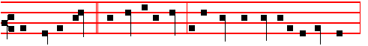
The Master saith, * My time is at hand; I will keep the Passover at thy house
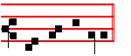
with my disciples. Then the Prayers, p. 108.

708
COLLECT
GRANT, we beseech thee, almighty God: that we, who by our incontinence have corrupted the dignity of man's condition, may by devout abstinence heal and restore the same. Through.
On Magnificat, Antiphon.
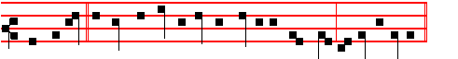
With desire * I have desired to eat this Passover with you before I suffer.
Then the Prayers, p. 217.
COLLECT
BE merciful, we beseech thee, O Lord, unto thy people: that they, eschewing those things which are displeasing unto thee, may be fulfilled the more with the delights of thy commandments.Through.
__________________________________________________________________

Friday
The Lesson from the Holy Gospel according to S. John
Lesson j Ch. 11, 47-54
THE chief priests and the Pharisees gathered a council against Jesus, and said, What do we? For this man doeth many miracles. And the rest.
Homily by S, Augustine, Bishop Homily 49 on John
THE chief priests and Pharisees gathered a council, and said, What do we? And yet they said not, Let us believe. For these lost undone men thought more how they might do him hurt to his undoing, than how they might consult their own interests, that they might not themselves be undone: and yet they feared, and did in a sort consult. For they said, What do we? For this man doeth many miracles, If we let him thus alone, all men will believe on him: and the Romans will come and take away both our place and our nation. They feared to lose their temporal things; eternal life they thought not of, and so lost both.

 Thou art my God, go not far from me, * For trouble is hard at hand, and there is none to help me.
 But be not thou far from me, O Lord: thou art my succour, haste thee to help me. For trouble.

Lesson ij
FOR the Romans, after the Lord's passion and glorifying, did take away from them both place and nation, by conquering the city, and carrying away the people: and that follows then which is elsewhere said, But the children of this kingdom shall go into outer darkness. What they feared, however, was this, that, if all should believe in Christ, there would remain none to defend against the
709
Romans the city and temple of God; because they felt the doctrine of Christ to be against that same temple, and against their laws inherited.

 I have been left unto thee ever since I was born: thou art my God even from my mother's womb. O go not from me, * For trouble is hard at hand, and there is none to help me.
 Save me from the lion's mouth, thou hast heard me also from among the horns of the unicorns. For trouble.

Lesson iij
AND one of them, named Caiaphas, being the high priest of that year, said unto them, Ye know nothing at all, nor consider that it is expedient for us, that one man should die for the people, and that the whole nation perish not. And this spake he not of himself: but being high priest of that year, he prophesied. Here we are taught, that even by bad men the spirit of prophecy predicts things to come: which thing, however, the Evangelist attributes to a divine sacrament, in that he was pontiff, that is, high priest.

 Trouble is hard at hand, O Lord, and there is none to help me; they pierced my hands and my feet; save me from the lion's mouth, * And I will declare thy Name unto my brethren.
 Deliver my soul, O God, from the sword: my darling from the power of the dog.
And I. Trouble is.
On Benedictus, Antiphon.
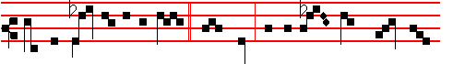
Now the feast day of the Jews * drew nigh; and the chief priests soughtt how
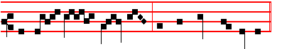
they might kill Jes- us, but they feared the people.
Then the Prayers, p. 108.
COLLECT
WE beseech thee, O Lord, mercifully to pour thy grace into our hearts: that we, who by willing chastisement do restrain our sins, may in such wise
mortify ourselves in this life, that we be not delivered unto everlasting punishments. Through.
Today the Penitential Psalms. On Magnificat, Antiphon.
710
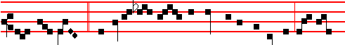
The chief priests * consulted how they might take Jesus and kill him; but they
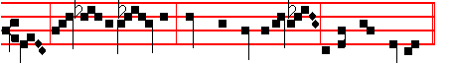
said, Not on the feast day, lest there be an uproar among the people.
Then the Prayers, p. 217. COLLECT
GRANT, we beseech thee, almighty God: that we, who seek the grace of thy protection, may be delivered from all evils and serve thee with a quiet mind. Through.
________________________________________________________________

Saturday
The Lesson from the Holy Gospel according to S. John
Lesson j Ch. 12, 10-36
THE chief priests consulted that they might put Lazarus also to death: because that by reason of him many of the Jews went away, and believed on Jesus. And the rest.
Homily by S. Augustine, Bishop Homily 50 on John
AT sight of Lazarus, the raised from the dead; because so great a miracle of the Lord was with so great evidence noised abroad, with so great manifestation declared, that it was impossible for them either to conceal that it was wrought, or to deny it: see what they devised. But the chief priests thought how they might put Lazarus also to death: because that by reason of him many of the Jews went away, and believed on Jesus. O foolish thought, and blind rage! If the Lord Christ had power to raise him being dead, had he not power to raise him being put to death? In putting Lazarus to death, could ye put away the Lord's power? If it seems to you that a dead man is one thing, a man put to death another: behold, the Lord did both: both Lazarus who was dead, and himself who was put to death, he raised to life again.
 I go mourning all the day long, O Lord: for my soul is filled with a sore disease: * They also that sought after my life laid snares for me.
 My lovers and my neighbours did stand looking upon my trouble, and my kinsmen stood afar off. They.

Lesson ij Homily 51
ON the next day much people that were come to the Feast, when they heard that Jesus was coming to Jerusalem, took branches of palm trees, and went

711
forth to meet him and cried, Hosanna, Blessed is he that cometh in the name of the Lord, the King of Israel. Palm branches are praises, signifying victory, in token that the Lord was by dying to overcome death, and with the trophy of the Cross to triumph over the devil, the prince of death.

 Hide not thy face from thy servant, O Lord: * For I am in trouble: O haste thee and hear me.
 Draw nigh unto my soul, and save it: O deliver me because of mine enemies. For I.

Lesson iij
THUS lauded him the multtude: Hosanna, Blessed is he that cometh in the name of the Lord, the King or Israel! Well might it be a mental crucifying for the envy of the rulers of the Jews to endure, when so great a multitude was shouting out Christ their King! But what was it for the Lord to be King of Israel? what great matter for the King of all worlds to become King of men? For Christ was not King of Israel, for exacting of tribute, or arming a host with the sword, and visibly subduing enemies; but King of Israel, that he should rule minds, that he should counsel for eternity, that he should bring unto the kingdom of heaven them that believe, hope, and love.
 O that my head were waters, and mine eyes a fount of tears, that; I might weep day and night: for my nearest brother hath supplanted me, * And every neighbour hath gone about with slanders against me.
 Let their way be dark and slippery, and let the Angel of the Lord persecute them. And every. O that my head.
On Benedictus, Antiphon.
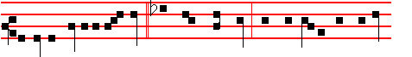
O Father, glorify thou me * with thine own self with the glory which I had
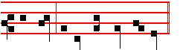
with thee before the world began. Then the prayers, p. 108
COLLECT
WE beseech thee, O Lord, that thy people who are dedicated to thee may increase in all godly and devout affection: that, being instructed by these holy exercises, they may both be made the more acceptable unto thy majesty, and prospered more abundantly with thy gifts.Through.

712

