THE FIRST SUNDAY IN LENT

If on this day and on the other Sundays in Lent there occur a Double Feast, it is transferred to the next day not similarly impeded, as is said in the Rubric of Translation of Feasts. On the other days of Lent until Holy Week if there occur a Double or Semidouble Feast, the Office is of it, with Commemoration, and ninth Lesson from the Homily, of the Feria. Of Simples only a commemoration is made.
Throughout Lent in the Ferial Office, on Monday is said the Office of the Dead, on Wednesday are said the Gradual Psalms, and on Friday the Seven Penitential Psalms with the Litanies, except on the Ferias of Holy Week; which are all to be found at the end of the Breviary.
AT MATINS
Invitatory.- It shall not be lost labour that ye haste to rise up early: * For the Lord hath promised a crown unto them that watch. Ps. 95 Venite, p.2.
The following is said on Sundays and Ferias until Passion Sunday exclusively.
Hymn. E.H. 65 Mode j
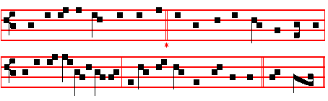
Ex more docti mystico.
THE fast, as taught by holy lore, 5 Thy grace have we offended sore,
We keep in solemn course once more: By sins, O God, which we deplore;
The fast to all men kno\vn, and bound But pour upon us from on high,
In forty days of yearly round. O pardoning One, thy clemency.

2 The law and seers that were of old 6 Remember thou, though frail we be,
In divers ways this Lcnt foretold, That yet thine handiwork are we;
Which Christ, all seasons' King and guide, Nor let the honour of thy name
In after ages sanctified. Be by another put to shame.

3 More sparing therefore let us make 7 Forgive the sin that we have wrought;
The words we speak, the.food we take, lncrease the good that we have sought
Our aleep and mirth, and closer barred That we at length, our wanderings o'er,
Be every sense in holy guard. May please thee here and evermore.

4 In prayer together let us fall, We pray thee, Holy Trinity,
And cry for mercy, one and all, One God, unchanging Unity,
And weep before the Judge's feet That we from this our abstinence
And his avenging wrath entreat. May reap the fruits of penitenoe. Amen.
597
IN THE FIRST NOCTURN

Antiphon. Serve the Lord in fear. Psalm 1 Beatus vir, with the rest as in the Psalter, p. 5.
From S. Paul's Second Epistle to the Corinthians
Lesson j Ch. 6, 16
WE then, as workers together with him, beseech you also that ye receive not the grace of God in vain. (For he saith, I have heard. thee in a time accepted, and in the day of salvation have I succoured thee: behold, now is the accepted time. behold, now is the day of salvation.) Giving no offence in any thing, that the mnistry be not blamed: but in all things approving ourselves as the ministers of God, in much patience, in afflictions, in necessities, in distresses, in stripes, in imprisonments, in tumults, in labours, in watchings, in fastings; by pureness, by knowledge, by longsuffering, by kindness, by the Holy Ghost, by love unfeigned, by the word of truth, by the power of God, by the armour of righteousness on the right hand and on the left, by honour and dishonour, by evil report and good report: as deceivers, and yet true; as unknown, and yet well known; as dying, and, behold, we live; as chastened, and not killed; as sorrowful, yet alway rejoicing; as poor, yet making many rich; as having nothing and yet possessing all things.

 Behold now is the acceptable time, behold now is the day of salvation: let us approve ourselves in much patience, in many fastings: * By the power of God, by the armour of righteousness.
 In all things let us approve ourselves as the ministers of God in much patience, in many fastings. By the power.

Lesson ij
O YE Corinthians, our mouth is open unto you, our heart is enlarged. Ye are not straitened in us, but ye are straitened in your own bowels. Now for a recompence in the same (I speak as unto my children,) be ye also enlarged. Be ye not unequally yoked together with unbelievers: for what fellowship hath righteousness with unrighteousness? and what communion hath light with darkness? and what concord hath Christ with Belial? or what part hath he that believeth with an infidel? and what agreement hath the temple of God with idols? for ye are the temple of the living God; as God hath said, I will dwell in them, and walk in them; and I will be their God, and they shall be my people.

 In all things let us approve ourselves as the ministers of God in much patience. * That the ministry be not blamed.
 Behold now is the acceptable time, behold now is the day of salvation: let us approve ourselves in much patience. That the.

598
Lesson iij Ch. 7, 4b-9a
I AM filled with comfort, I am exceeding joyful in all our tribulation. For, when we were come into Macedonia, our flesh had no rest, but we were troubled on every side; without were fightings, within were fears. Nevertheless God, that comforteth those that are cast down, comforted us by the coming of Titus. And not by his coming only, but by the consolation wherewith he was comforted in you, when he told us your earnest desire, your mourning, your fervent mind toward me; so that I rejoiced the more. For though I made you sorry with a letter, I do not repent, though 1 did repent: for I perceive that the same epistle hath made you sorry, though it were but for a season. Now I rejoice, not that ye were made sorry, but that ye sorrowed to repentance.

 The priests shall pray with fasting and with weeping, crying: * Spare, O Lord. spare thy people, and give not thine heritage to reproach.
 The priests shall weep betweeen the porch and the altar, crying: Spare. Glory be. Spare.

IN THE SECOND NOCTURN

Sermon by S. Leo the Great
Lesson iv Sermon 42
I AM going to preach on that holiest and greatest of fasts, and with what more appropriate words can I begin, than with those that have just been read from the Apostle, in whom Christ was speaking, Behold now is the acceptable time, behold now is the day of salvation. Although there is no time that is not laden with the gifts of God, and though we have free access to his mercy through his grace at all times: yet now more especially should our minds be roused in faith, and moved to greater zeal in things spiritual. as the day of our Redemption comes round again, urging us to every work of piety: thus purified in body and soul, may we celebrate that greatest of all mysteries, the Passion of the Lord.

 Let us amend ourselves in that wherein we have sinned through ignorance: lest suddenly overtaken by the day of death, we seek space for repentance, and can in no wise find it: * Give ear, O Lord, and have mercy upon us, for we have sinned against thee.
 Help us, O God of our salvation, for the glory of thy Name: O deliver us, and be merciful unto our sins, for thy Name's sake. Give ear.

Lesson v
SUCH devotion and ceaseless reverence is due to these unfathomable mysteries, that we should ever abide in the sight of God in such a manner that

599
he may find us worthy of the Paschal Feast. But because this strength belongs to but a few, and because this sterner observance is slackened by the weakness of the flesh, and moreover, because this earnest zeal meets with distractions through the diverse activities of this life, it is inevitable that even the hearts of the religious become soiled by. the dust of the world: therefore this great boon of the holy institution provides for the restoration of our purity of heart, in giving us this healing exercise of forty days; in which holy fastings may purge, and good works redeem our faults of other seasons.

 Let the wicked forsake his way, and the unrighteous man his thoughts: and let him return unto the Lord, and he will have mercy upon him: * For the Lord our God is gracious and merciful, and repenteth him of the evil.
 The Lord hath no pleasure in the death of the wicked, but that the wicked turn from his way and live. For he.

Lesson vj
AS we enter upon these mystic days, beloved, these days instituted both for the purifying of our minds and the sanctifying of our bodies, let us take care to obey the apostolic commandment, and cleanse ourselves from all defilement of spirit and of flesh. Let us so put down all strife between these two substances, that the soul, ordained by God as the governor of the other, may be found worthy of its domination: giving no offence to anyone, that we be not guilty of those things that our accusers bring against us. WE will indeed be worthy of the derision of the unbelievers, and the tongues of the unbelievers will be armed by our sins to the harm of the religious, if the manner of our fasting is not in accordance with the purity of perfect continence. Mere abstinence from food does not fulfil the purpose of our fast; nor is it profitable to deny food to the body, unless the mind be recalled from wrong-doing.

 The season of the fast has opened to us the gates of paradise; let us enter therein with prayer and supplication: * That we may rejoice with our Lord on the day of his Resurrection.
 In all things let us approve ourselves as the ministers of God in much patience. That we. Glory be. That we.

IN THE THIRD NOCTURN

The Lesson from the Holy Gospel according to S. Matthew
Lesson vij Ch. 4
THEN was Jesus led up of the spirit into the wilderness to be tempted of the devil. And when he had fasted forty days and forty nights he was afterward an

600
hungred. And the rest.
Homily by S. Gregory the Great Homily 16 on the Gospels
SOME people are wont to ask by what spirit Jesus was led up into the wilderness, because of the following words, The devil taketh him up into the holy city, and again, The devil taketh him up into an exceeding high mountain But truly and without a doubt, we may believe that he was led up into the wilderness by the Holy Spirit, and that his own Spirit led him where the evil spirit might find him and tempt him. But when it is stated that God-made-Man was led up to a high mountain or into the holy city by the devil, the mind recoils from believing it, and the ears of man shrink from hearing it. But yet we are not to take this as incredible, when we consider the other facts concerning him.

 Rend your heart and not your garments, and turn unto the Lord your God: * For he is gracious and merciful.
 Let the wicked forsake his way, and the unrighteous man his thoughts, and let him return unto the Lord, and he will have mercy upon him. For he.

Lesson viij
THE devil is indeed the head of all the wicked: and all wicked men are members of this head. Was not Pilate a member of the devil? Were not the Jews who persecuted Christ, and the soldiers who crucified him, members of the devil? What wonder is it then, that he allowed himself to be led by him up into the moun- tain, if he also allowed himself to be crucified by the members? There is nothing unworthy in our Redeemer willing to be tempted, when he came to be slain. Indeed it is fitting that he should overcome our temptations by his own temptations, just as he came to conquer our death by his own death.

 Deal thy bread to the hungry, and bring the poor that are cast out to thy house. * Then shall thy light break forth as the morning, and thy righteousness shall go before thee.
 When thou seest the naked, cover thou him, and hide not thyself from thine own flesh. Then shall.

Lesson ix
WE must recognize that there are three degrees of temptation; suggestion, delight and consent, because we are begotten of sinful flesh, and bear within ourselves that which we fight against. But God, who took flesh from the Virgin's womb, came into the world without sin, and bore within himself nothing of this inward contradiction. Therefore though he was able to be tempted by suggestion, the delight of sin could lay no hold on his mind. Therefore all that temptation from the devil was from without, and not from within.

601
 God shall give his angels charge over thee to keep thee in all thy ways: * They shall bear thee in their hands, that thou hurt not thy foot against a stone.
 Thou shalt go upon the lion and adder: the young lion and the dragon shalt thou tread under thy feet. They shall. Glory be. They shall.
Through the week is said instead:
 Shut up alms in the breast of the poor, and it shall pray for you to the Lord. * Water will quench a flaming fire, and alms maketh an atonement for sin.
 Give alms, and bchold, all things are clean unto you. Water will. Glory be. Water will.
AT LAUDS
Antiphon 1 Tone j, 2.
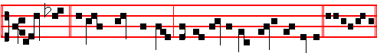
Make me * a clean heart, O God, and renew a right spirit within me. Ps. 51 Miserere, p. 104.
Antiphon 2 Tone ij
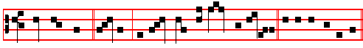
Help me now, * O Lord: O Lord, send us now prosperity. Psalm 118
Confitemini Domino p. 43.
Antiphon 3 Tone vij, 3.
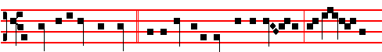
As long as I live, O Lord, * will I magnify thee on this manner, and lift up my
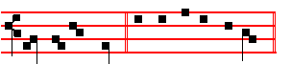
hands in thy Name. Psalms 63 67 Deus Deus meus, p. 29, 30.
Antiphon 4 Tone ij
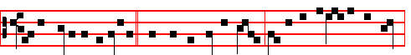
In the spirit of humility * and with a contrite heart, let us be accepted by thee,

602
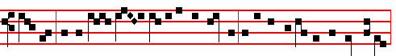
O Lord: and so let our sacrifice be offered as to be accepted by thee today,
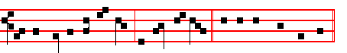
and be p1easing in thy sight, O Lord our God. Canticle Benedicite, p. 31.
Antiphon 5 Tone viij, 1.
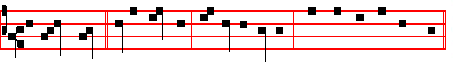
O praise God, * all ye heavens, and all ye waters. Psalms 148 149 150
Laudate Dominum, p. 33.
Chapter 2 Cor. 6
BRETHREN: We beseech you that ye receive not the grace of God in vain. For he saith, I have heard thee in a time accepted, and in the day of salvation have I succoured thee.
Hymn Mode viij
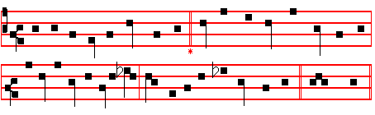
The Hymns of the Hours and Compline are sung in the same tone.

O sol salutis, intimis
Now Christ, thou Sun of righteousness, 3 Spare not, we pray, to send us here
Let dawn our iarkene' spirits bless: Some penance kindly but severe,
The light of grace to us restore So let thy gift of pardoning grace
While day to earth returns once more. Our grievous sinfulness efface

2 Thou who dost give the accepted time, 4 Soon will that day, thy day, appear
Give, too, a heart that mourns for crime, And all things with its brghtness cheer;
Let those by mercy now be cured We will rejoice in it, as we
Whom loving-kindness long endured. Return thereby to grace, and thee.

603
5 Let all the world from shore to shore
Thee, gracious Trinity, adore;
Right soon thy loving pardon grant,
That we our new-made song may chant. A - men.

 God shall give his Angels charge over thee.  To keep thee in all thy ways.
On Benedictus, Antiphon. Tone j, 1.
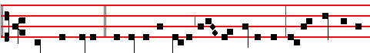
Then was Jesus * led up of the Spirit into the wilderness to be tempted of
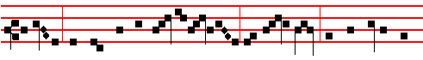
the devil: and when he had fasted forty days and forty nights, he was afterwards
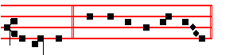
an hungred. Canticle Benedictus, p. 28.
COLLECT
O GOD,who year by year dost purify thy Church by this Lenten observance: grant unto thy family; that those things which they strive to obtain from thee by abstinence, they may by good works fulfil. Through.

AT PRIME
Antiphon Tone j, 1.
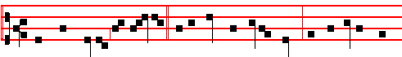
.And when Jesus had fasted * forty days and forty nights, he was afterwards
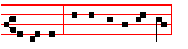
an hungred. Psalm 54 Deus, in nomine, with the rest as in the Psalter, p. 43.
At the Close of the Chapter, Short Lesson Seek ye the Lord, as in the Psalter, p. 54. And it is said on Sundays and Ferias until Passion Sunday exclusively.

604
AT TERCE
Antiphon. Tone ij
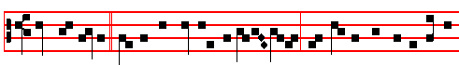
Then the devil * taketh him up into the holy city, and setteth him on a pinna-
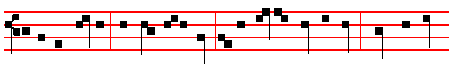
cle of the temple, and saith unto him., If thou be the Son of God, cast thyself
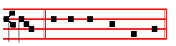
down. Psalm 119 Legem pone, p. 63.
Chapter Brethren: we beseech you, p. 603.

Short 
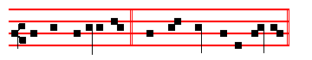
He shall deliver me * From the snare of the hunter. He shall
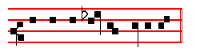
 And from the noisome pestilence. From the snare.
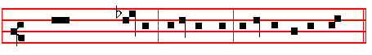
Glory be to the Father, and to the Son, and to the Holy Ghost. He shall.
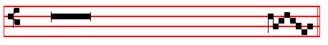
 He shall hide thee under his wings.
 And thou shalt be safe under his feath- ers.

605
AT SEXT
Antiphon. Tone v
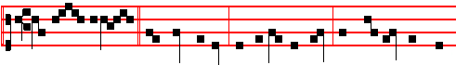
Man shall not live * by bread alone, but by every word that proceedeth out
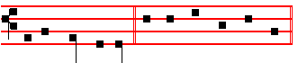
of the mouth of God. Psalm 119, Defecit, p. 72
Chapter 2 Cor. 6
BEHOLD, now is the accepted time; behold, now is the day of salvation. Giving no offence in anything, that the mnistry be not blamed.
Short 
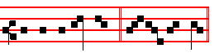
He shall defend thee * Un- der his wings. He shall.
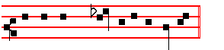
 And thou shalt be safe under his feathers. Under his. Glory be. He shall.
 His faithfulness and truth shall ae thy shield and buckler.
 Thou shalt not be afraid for any terror by night.

AT NONE
Arrtiphon. Tone vj
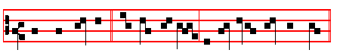
Thou shalt worship * the Lord thy God, and him only shalt thou serve.
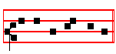
Psalm 119 Mirabilia, p. 82.

606
Chapter 2 Cor.6
AS chastened, and not killed; as sorrowful, yet alway rejoicing; as poor, yet making many rich; as having nothing, and yet possessing all things.
Short 
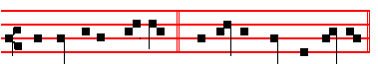
His faithfulness and truth * Shall be thy shield and buckler. His faithfulness.
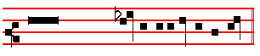
 Thou shalt not be afraid for any terror by night. Shall be.
Glory be to the Father, and to the Son, and to the Holy Ghost.
His faithfulness.
 He shall give his angels over over thee.
 To keep thee in all thy ways.

AT VESPERS
Psalms and Antiphons of Sunday, p. 201 ff.
Chapter Brethren: we beseeoh you, p. 603. Hymn. E.H.66 Audi benigne, p. 596.
 .God shall give his Angels charge over thee.  To keep thee in all thy ways.
On Magnificat, Antiphon. Tone viij, 1.
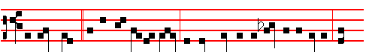
Beho1d, now * is the accepted time; beho1d, now is the day of salvation: let
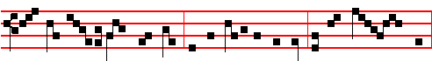
us therefore approve ourselves as the ministers of God, in much pati- ence,
607
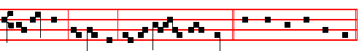
in watchings, in fastings, and by love un-feigned. Canticle Magnificat, p .211
Collect as above, p. 604.
The Hymns,  and Short . above are said on Sundays and Ferias until Passion Suniay exclusive.
After Vespers of the day are said Vespers of the Dead.
__________________________________________________________________

Monday
At Matins, Invitatory from the Psalter, 89. Hymn E.H 65 Ex more docti mystico, p. 596. Antiphons and Psalms of the Psalter, p.73.
And thus it is said also on the other following Ferias until Passion Sunday.
Blessing May the Gospel.
The Lesson from the Holy Gospel according to S. Matthew
Lesson j Ch. 26, 31-46
JESUS said unto his disciples: When the Son of man shall come in his glory, and all the holy Angels with him, then shall he sit upon the throne of his glory: and before him shall be gathered all nations. And the rest.
Homily by S. Augustine, Bishop On Faith and Works Ch. 16
IF without keeping the commandments it is possible to come unto life by faith alone which without works is dead, how then can that be true which he shall say to those who are to be on his left hand: Depart from me into everlasting fire prepared for the devil an4 his angels: not chiding them for not believing in him, but for omitting to do good works? For, lest anyone should promise himself eternal life by reason of his faith, which without works is dead, for this reason he said that all nations would be separated which had hitherto been mingled together sharing the same pasture: that it might be plain that those who would say to him, Lord, when saw we thee suffering such and such a thing and did not minister unto thee; those were the ones who believed in him, but did not take pains to do good works, trusting that they could attain unto life eternal by means of that same dead faith.

 Behold now is the acceptable time, behold now is the day of salvation: let us approve ourselves in much patience, in many fastings: * By the power of God, by the armour of righteousness.
 In all things let us approve ourselves as the ministers of God in much patience, in many fastings. By the power.
Blessing May the divine.
Lesson ij
608
WHAT? and will they haply, who have omitted to do works of mercy, go into everlasting fire, and will they not go who have taken away other men's goods, and by corrupting the temple of God within them, have been unmerciful towards themselves? As if works of mercy were of any profit without love, whereas the Apostle says, If I distribute all my goods to the poor, and have not love, it profiteth me nothing; or as if any man love his neighbour as himself, who loves not himself? For whoso loveth unrighteousness hateth his own soul.

 In all things let us approve ourselves as the ministers of God in much patience. * That the ministry be not blamed.
 Behold now is the acceptable time, behold now is the day of salvation: let us approve ourselves in much patience. That the.

Blessing May the King of . . .
Lesson iij
NOR will that allow of being said here, wherein some deceive themselves, saying that the fire is said to be everlasting, not the punishment itself everlasting: insomuch as they judge that through fire, which is everlasting, those will pass, who have been promised salvation through fire on account of a dead faith; evidently, that the fire itself be everlasting, but that their burning, that the
operation of the fire upon them, be not everlasting; whereas the Lord, foreseeing this also, as the Lord, thus ended his sentence saying, Thus they shall go into everlasting burning, but the righteous into life everlasting. Therefore the burning will be everlasting, in like manner as the fire; and the Truth hath said that into it they will go, not whose faith, but whose good works, he hath declared to have been wanting.

 The priests shall pray with fasting and with weeping, crying: * Spare, O Lord, spare thy people, and give not thine heritage to reproach.
 The priests shall weep between the porch and the altar, crying: Spare. Glory be.
Spare.
At Lauds, Antiphons and Psalms of the Psalter, p.
Chapter Isaiah 58
CRY aloud, spare not; lift up thy voice like a trumpet, and shew my people their transgression, and the house of Jacob their sins.
Hymn O Sol salutis, p. 603.  God shall give, p. 604.
On Benedictus, Antiphon.
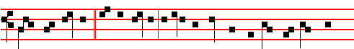
Come, ye blessed * of my Father, inherit the kingdom prepared for you from
609
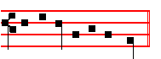
the foundation of the world.
In the ferial Office throughout Lent are said the Prayers, 108.
COLLECT
TURN thou us, O God our Saviour: and that the Lenten fast may profit us, do thou instruct our minds with heavenly teaching. Through.
After Lauds is said the Office of the Dead.
At the Hours,all is said as in the ferial Office in Lent in the Psalter.
And the Prayers are said. At Vespers, Antiphons and Psalms from the Psalter. Chapter Joel 2
LET the priests, the ministers of the Lord, weep between the porch and the altar, and let them say, Spare thy people, O Lord, and give not thine heritage to reproach, that the heathen should rule over them.
Hymn. E.H.66 Audi benigne and  God shall give, p. 596.
The above Antiphons and Chapter are said in the feria1 Office in Lent until Passion Sunday.
On Magnificat, Antiphon.
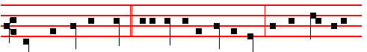
That which ye have done * unto one of the least of mine, ye have done unto
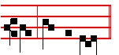
me, saith the Lord. Then the Prayers, p. 108.

COLLECT

WE beseech thee, O Lord, loose the chains of our sins: and mercifully turn aside the punishment which for the same we deserve.Through.
__________________________________________________________________

Tuesday
The Lesson from the Holy Gospel according to S. Matthew
Lesson j Ch. 21, 10-17
WHEN Jesus was come into Jerusalem, all the city was moved, saying, Who is this? And the rest.
610
Homily by S. Bede the Venerable, Priest Homily 63
BY cursing the barren fig tree, the Lord performed in type what he was soon after to reveal more plainly in the casting out of the wicked traders from the temple. The tree did no sin in that it bore no fruit, for the season of its harvest had not come: but the priests sinned, because they were conducting worldly trade in the house of the Lord, and they failed to yield the fruit of piety, which they owed the Lord, and for which he hungered. The Lord withered up the cursed fig tree, that men might see it, or at least hear about it, and so realize that they stand in so much the greater condemnation under the divine iudgment, insomuch as they flatter themselves with high sounding declamations of their religion, without the fruit of good works, like the empty rustlings of profuse foliage.

 Let us amend ourselves in that wherein we have sinned through ignorance: lest suddenly overtaken by the day of death, we seek space for repentance, and can in no wise find it: * Give ear, O Lord, and have mercy upon us, for we have sinned against thee.
 Help us, O God of our salvation, for the glory of thy Name: O deliver us, and be merciful unto our sins, for thy Name's sake. Give ear.

Lesson ij
NOW because they did not understand this, the Lord brought upon them the stroke of punishment that they deserved: and he cast out the commerce of worldly goods from that house in which it had been commanded that holy things alone be done, prayer and sacrifice be offered, the word of God read, heard, and sung. We may believe that he found only those things being bought and sold in the temple that were needful for the holy services, according to the words of another Evangelist, that he went up to Jerusalem, and found in the temple those that sold oxen and sheep and doves; and we may well believe these to have been provided by the inhabitants only to be offered in the house of the Lord by those who came from afar.

 Let the wicked forsake his way, and the unrighteous man his thoughts: and let him return unto the Lord, and he will have mercy upon him: * For the Lord our God is gracious and merciful, and repenteth him of the evil.
 The Lord hath no pleasure in the death of the wicked, but that the wicked turn from his way and live. For the.

Lesson iij
IF the Lord did not wish those things to be sold in the temple that he did wish to be offered there (for the reason that motives of greed and dishonesty are apt to poison such transactions), consider how much more severe would be his

611
punishment were he to find any occupied there in idle laughter or gossip, or giving themselves up to any other wrong-doing? If the Lord would not suffer those worldly transactions which could freely be done elsewhere to take place in his house, how much more would those actions that are in no place lawful call down wrath from heaven, if they were to be done in the holy temples of God? The Holy Spirit was seen descending upon the Lord like a dove. Who are those who sell doves in the temple of God to-day? Are they not those in the Church who take money for the laying on of hands, by which the Holy Spirit is received from heaven?

 The season of the fast has opened to us the gates of paradise; let us enter therein with prayer and supplication: * That we may rejoice with our Lord on the day of his Resurrection.
 In all things let us approve ourselves as the ministers of God in much patience. That we. Glory be. That we.

On Benedictus, Antiphon.
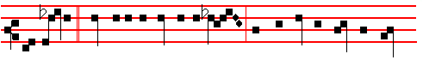
And Jesus * went into the temple of God, and cast out all them that sold
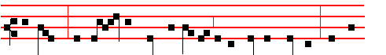
and bought: and o - verthrew the tables of the money-changers, and the
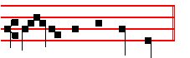
seats of them that sold doves. Then the Prayers, p. 108.

COLLECT

O LORD, look down upon thy family: and vouchsafe; that whereas our minds are now chastened by the mortifying of the flesh, they may shine in thy sight with longing after thee. Through.

On Magnificat, Antiphon.

612
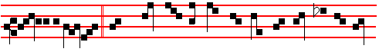
Truly it is written, * Mine house shall be called an house of prayer for all na-
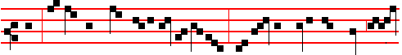
tions: but ye have made it a den of robbers. And he was daily with them, tea-
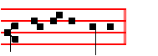
-ching in the temple. Then the Prayers, p. 217.
COLLECT
O LORD, let our prayers ascend unto thee: and drive far from thy Church all wickedness. Through.
__________________________________________________________________

Ember Wednesday
Today the Gradual Psalms.
The Lesson from the Holy Gospel according to S. Matthew
Lesson j Ch. 12, 38-50
CERTAIN of the scribes and Pharisees answered Jesus, saying, Master, we would see a sign from thee. And the rest.
Homily by S. Ambrose, Bishop Bk. 7 on Luke, Ch. 11
FOLLOWING after the condemnation of the Jews, a mystery of the Church is clearly revealed, in the men of Nineveh with their repentance, and in the queen of the south with her zeal for wisdom. For she comes from the uttermost parts of the earth to hear the words of Solomon the Prince of Peace. Clearly, the Church is a queen, and her realm is undivided, as she rises up and gathers the people from every kindred and nation into one body.

 Rend your heart and not your garments, and turn unto the Lord your God: * For he is gracious and merciful.
 Let the wicked forsake his way, and the unrighteous man his thoughts, and let him return unto the Lord, and he will have mercy upon him. For he.

Lesson ij
THAT is a great mystery of Christ and his Church. But how much greater is this mystery than the figure which preceded it, now that it is truly fulfilled.
613
Formerly, Solomon was the type, but here is Christ in his Body. The Church is built up of two sorts of people: there are those who know not sin, and those who have ceased to sin. Penitence does away with sin, wisdom debars it.

 Deal thy bread to the hungry, and bring them that are cast out to thy house. * Then shall thy light break forth as the morning, and thy righteousness shall go before thee.
 When thou seest the naked, cover thou him, and hide not thyself from thine own flesh. Then shall.

Lesson iij
MOREOVER, the sign of Jonah is a type of the Lord's Passion, and it is also a testimony of the gravity of the sins that the Jews committed. It is also to be taken as a proclamation both of majesty and of mercy. By the example of the men of Nineveh both the judgment is declared and the way of escape is revealed. Even the Jews need not give way to despair, if only they will do penance.

 Shut up alms in the breast of the poor, and it shall pray for you to the Lord. * Water will quench a flaming fire and alms maketh an atonement for sin.
 Give alms, and behold, all things are clean unto you. Water will. Glory be. Water will.
On Benedictus, Antiphon.
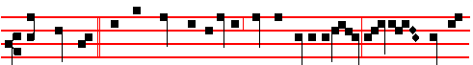
This crooked * and perverse generation seeketh after a sign: and there shall no
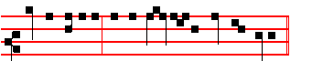
sign be given it, but the sign of the prophet Jonas. Then the Prayers, p. 108.
COLLECT
WE beseech thee,O Lord, mercifully hear our prayers: and stretch forth the right hand of thy majesty to be our defence against all things that may hurt
us. Through.
On Magnificat, Antiphon.
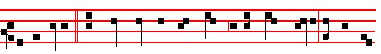
For as Jonas * was three days and three nights in the whale' s belly, so shall the
614
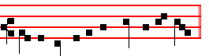
Son of Man be in the heart of the earth. Then the Prayers, p. 217
COLLECT
O LORD, we beseech thee, illumine our minds with the light of thy brightness: that we may be ale to perceive those things which we ought to do: and have strength to do those things which be right. Through.
____________________________________________________________

Thursday
The Lesson from the Holy Gospel according to S. Matthew.
Lesson j Ch. 15, 21-28
JESUS went thence, and departed into the coasts of Tyre and Sidon. And the rest.
Homily by S. Jerome, Priest Bk. 2 Comm. on Matt. Ch. 15
HE turned away from his false accusers, the scribes and pharisees, and passed over into the coasts of Tyre and Sidon. And a woman of Canaan came out of the same coasts, to call on him and beseech him to heal her daughter. Note that the daughter of Canaan was the fifteenth person to be healed. Have mercy upon me, O Lord, thou Son of David. Hence she knew to call him Son of David, because she had already come out of those coasts; she had changed her home and her faith, and had put away the errors of Tyre and Sidon.

 I had been troubled, had I not known thy mercy, O Lord: thou hast said: I have no pleasure in the death of the wicked, but that the wicked turn from his way and live: * O thou who didst call the Canaanite woman and the publican to repentance.
 In the multitude of the sorrows that I had in my heart, thy comforts have refreshed my soul. O thou.

Lesson ij
MY daughter is grievously vexed with a devil. The daughter of Canaan, in my opinion, represented the souls of those who would believe, who were then grievously vexed with a devil, in that they were ignorant of the Creator, and worshipping stones. But he answered her not a word: not from pride like the pharisees, nor from haughtiness like the scribes: but lest he should seem to contradict his own order: Go not into the way of the Gentiles, and into any city of the Samaritans enter ye not. For he did not want to give an opportunity to his slanderers: he postponed the full salvation of the Gentiles to the time of his passion and resurrection.

615
 In all things let us approve ourselves as the ministers of God in much patience. * That the ministry be not blamed.
 Behold now is the acceptable time, behold now is the day of salvation: let us approve ourselves in much patience. That the.

Lesson iij
AND his disciples came and besought him, saying, Send her away, for she crieth after us. The disciples, either because they were then still ignorant of the Lord's mysteries, or else because they were moved with compassion, pleaded for the Canaanite woman, whom another Evangelist calls the Syro-Phoenecian: or else they wanted to be free from her importunity. for she went on crying out, as though he were a hard physician and not a merciful one. But he answered and said: I am not sent but unto the lolt sheep of the house of Israel. Not that he had not been sent to the Gentiles, but that his first mission was to Israel: so that by their not receiving the Gospel, going over to the Gentiles would be justified.

 The priests shall pray with fasting and with weeping, crying: * Spare, O Lord, spare thy people, and give not thine heritage to reproach.
 The priests shall weep between the porch and the altar, crying: Spare. Glory be. Spare.

On Benedictus, Antiphon.
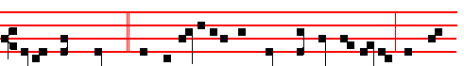
Jesus went thence, * and departed into the coasts of Tyre and Sidon: and be-
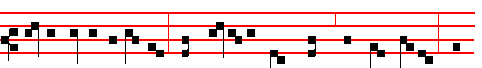
hold, a woman of Canaan came out of the same coasts and cried, saying, Have
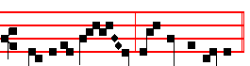
mercy on me, thou Son of David. Then the Prayers, p. 108.
COLLECT
WE beseech thee, O Lord, graciously to regard the devout prayers of thy people: that they who by abstinence do mortify the body, may in their minds be refreshed by the fruit of good works. Through.

616
On Magnificat, Antiphon.
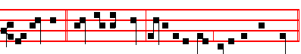
O Woman, * great is thy faith: be it unto thee even as thou wilt.
Then the Prayers, p. 217.
COLLECT
GRANT, O Lord, we beseech thee, unto the Christian peoples: that they may both acknowledge those things which they profess, and likewise love the heavenly gift to which they continually draw near. Through.
__________________________________________________________________

Ember Friday
The Lesson from the Holy Gospel according to S. John
Lesson j Ch. 5, 1-15
THERE was a feast of the Jews; and Jesus went up to Jerusalem. And the rest.

Homily by S. Augustine, Bishop Homily 17 on John
LET us see then what he willed to signify in the person of that one individual whom he, himself also preserving the mystery of unity, as I said before, vouchsafed to heal, the only one of so many impotent folk. He found in the years of this man the number, as one may say, of impotence: he had thirty-eight years in his infirmity. How this number pertains more to impotence than to wholeness must be somewhat more diligently expounded. I wish you to be very attentive; the Lord will be with us to aid, that I may meetly speak and ye sufficiently hear. The number forty is commended to our notice as having a sacred reference to a kind of perfection. I suppose this is well known to you, my beloved; the holy Scriptures do very often bear witness to the fact. Fasting hath its sacred designation in this number: thus Moses fasted forty days, and Elias as many: and our Lord and Saviour Jesus Christ himself fulfilled this number of fasting. By Moses is signified the Law, by Elias are signified the Prophets, by the Lord is signified the Gospel. For this reason it was, that on the mountain these three appeared, where he showed himself to his disciples in the brightness of his countenance and raiment. For he appeared in the midst between Moses and Elias, so that the Gospel should have testimony from the Law and the Prophets.

 Let us amend ourselves in that wherein we have sinned through ignorance: lest suddenly overtaken by the day of death, we seek space for repentance, and can in no wise find it: * Give ear, O Lord, and have mercy upon us, for we have sinned against thee.

617
 Help us, O God of our salvation, for the glory of thy Name: O deliver us, and be merciful unto our sins, for thy Name's sake. Give ear.

Lesson ij
WHETHER in the Law, whether in the Prophets, whether in the Gospel, still the number forty is put to our notice in lhe matter of fasting. Now fasting, in its large and general import, is, to abstain from the iniquities and unlawful pleasures of the world; this is perfect fasting, That denying ungodliness and worldly lusts, we live temperately, and righteously, and godly in this present world. To this fast, what reward doth the Apostle annex? He goes on and says, Looking for that blessed hope, and the manifestion of the glory of the blessed God and our Saviour Jesus Christ. In this present world, therefore, we are keeping as it were a lenten forty days of abstinence, while we live good lives, while we abstain from iniquities and from unlawful pleasures. But to shew that this abstinence will not be without its reward, we look for that blessed hope, and the revelation of the glory of the great God, and our Saviour Jesus Christ. In that hope, when of the hope shall have come the reality, we are to receive our wages, the denarius (the penny). For that is the wages paid to the labourers working in the vineyard, according to the Gospel, which I suppose you remember: for one must not rehearse everything as if to mere beginners who have everything to learn. Well then, the denarius, which has its name from the number ten, is paid, and conjoined with forty makes fifty: whence it is that we with labour keep the lenten forty days before Easter, but with joy, as having received our wages, the pentecostal fifty days after Easter.

 Let the wicked forsake his way, and the unrighteous man his thoughts: and let him return unto the Lord, and he wil1 have mercy upon him: * For the Lord our God is gracious and merciful, and repenteth him of the evil.
 The Lord hath no pleasure in the death or the wicked, but that the wicked turn from his way and live. For the.

Lesson iij
REMEMBER what I propounded: the number thirty-eight, or the years of this impotent man, it is this I wish to expound, why that number thirty-eight is a number of impotence rather than of soundness. Well then, as I was saying, Love filleth up the Law. To the fulness or completing of the Law, in all works, belongeth the number forty; but in love there be two commandments set forth for special regard. Look to it, I beseech you, and find in your memory what I am saying, be not despisers of the word, let not your soul become a wayside where the seed cast cannot sprout, and, the birds or the air, saith he, will come and pick them up. Take it in, and lay it up, in your hearts. Of love, there be two precepts

618
specially set forth by the Lord, Thou shalt love the Lord thy God with all thy heart, with all thy soul, and with all thy mind, and, Thou shalt love thy neighbour as thyself. On these two commandments hang all the Law and the Prophets. It is well seen, why also that widow cast into the offerings or God the two mites, even all her living: well seen, why for that poor sufferer, who was wounded by the thieves, the innkeeper received two pieces or money for his making whole; well seen, why among the Samaritans Jesus spent two days, to make them strong in charity. By this number two, then, while in general something good is signified; love especially, in its two parts, is thereby betokened. Then if the number forty hath the perfecting of the Law, and the Law is fulfilled but in the twin precepts of charity, why marvellest thou that he was weak, who, to make forty, had lack of two?

 The season of the fast has opened to us the gates of paradise; let us enter therein with prayer and supplication. * That we may rejoice with our Lord on the day of his Resurrection.
 In all things let us approve ourselves as the ministers of God, in much patience. That we. Glory be. That we.
On Benedictus, Antiphon.
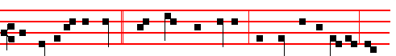
An Angel of the Lord * went down from heaven, and troubled the water, and
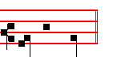
one was healed. Then the Prayers, p. 108.

COLLECT
BE favourable, O Lord, to thy people: and mercifully comfort with thy gracious help those whom thou dost make to do thee godly service. Through.
Today the Penitential Psalms.

On Magnificat, Antiphon.
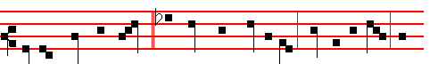
He that made me whole, * the same commanded me: Take up thy bed, and

619
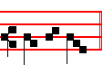
walk in peace. Then the Prayers, p. 217.
COLLECT
GRACIOUSLY hear us, O merciful God: and shew forth in our hearts the light of thy grace. Through.
__________________________________________________________________

Ember Saturday

The Lesson from the Holy Gospel according to S. Matthew
Lesson j Ch. 17, 1-9
JESUS taketh Peter, James, and John his brother, and bringeth them up into an high mountain apart, and was transfigured before them. And the rest.
Homily by S, Leo the Great Sermon 61: Homily on the Transfiguration
THE Gospel, dearly beloved, entering through our bodily ears, has knocked at the inner door of our mental hearing, and summons us to the understanding of
this great mystery. And we may the more easily understand it, by the grace of God, if we turn our minds back to those things that have been told us a little earlier. Jesus Christ, the Saviour of the human race, when founding that faith which would recall both the wicked to righteousness and the dead to life, imbued into his disciples by words of doctrine and by working of miracles, the belief that he was both the Only-Begotten Son of God, and also the Son of man. Belief in one of these facts without the other does not lead to salvation: it is as dangerous to believe that the Lord Jesus Christ was God only and not man, as it is to believe that he was man only and not God: we must confess our belief in both facts; just as God was truly in the Manhood, so also was man truly in the Divinity.

 Rend your heart and not your garments, and turn unto the Lord your God: * For he is gracious and merciful.
 Let the wicked forsake his way, and the unrighteous man his thoughts, and let him return unto the Lord, and he will have mercy upon him. For he.

Lesson ij
TO strengthen his disciples' salutary knowledge of the faith, therefore, the Lord had been asking them what, amidst the various opinions men held, they themselves believed concerning him, and what they thought about it all. Then Peter the Apostle, by a revelation from the Father Almighty, rising above bodily vision and transcending human perception, saw with his mind's eye the Son of the

620
Living God, and confessed the glory of the Godhead; for he saw beyond the substance of flesh and blood. So pleasing was he to God by the sublimity of his faith that he was given the great joy of being blessed by God; and he was confirmed and endowed with the holy strength of an impregnable rock, upon which the Church was to be founded, and the gates of hell and the jaws of death would not prevail against it: moreover no case of binding or loosing of any man would be ratified in heaven unless it had been judged by Peter.

 Deal thy bread to the hungry, and bring the poor that are cast out to thy house, * Then shall thy light break forth as the morning, and thy righteousness shall go before thee.
 When thou seest the naked, cover thou him, and hide not thyself from thine own flesh. Then shall.

Lesson iij
BUT this sublime knowledge of Peter, dearly beloved, had to be built on the holy mystery of the lower nature: lest the faith of the Apostle, carried away by the confession of the glory of Christ's divinity, should deem the reception of our weakness to be unfitting and unworthy of the impassible God; and lest he should believe that the human nature of Christ was so glorified that it could be neither hurt by pain nor dissolved by death. For when the Lord said that he must go unto Jerusalem, and suffer many things of the elders and chief priests and scribes, and be killed, and be raised again on the third day: blessed Peter, illuminated by heavenly light, burned with his ardent confession of the Son of God: with a natural, and, as he thought, a holy abhorrence, he rejected the idea of mockery and insults and shame of a cruel death; on being corrected by Jesus with a kindly rebuke, he was moved with longing to participate in his sufferings.

 Shut up alms in the breast of the poor, and it shall pray for you to the Lord. * Water will quench a flaming fire, and alms maketh an atonement for sin.
 Give alms, and behold, all things are clean unto you. Water will. Glory be.
Water will.

On Benedictus, Antiphon. as below on Sunday, p. 628. And Jesus taketh his disciples, * and goeth up into a mountain, and was transfigured before them.
Then the Prayers, p. 108.
COLLECT
WE beseech thee, O Lord, graciously to look upon thy people: and mercifully turn away from them the scourges of thy wrath. Through.

AT VESPERS

621
Chapter I Thess. 4
WE beseech you, brethren, and exhort you by the Lord Jesus, that as ye have received of us how ye ought to walk, and to please God, so ye would abound more and more.
Hymn. E.H. 66 Audi benigne and  God shall give, p. 596.
On Magnificat, Antiphon as below at II Vespers, p. 630.
Tell the vision which ye have seen to no man, until the Son of Man be risen again from the dead.
COLLECT
O GOD, who seest that we are wholly without power of ourselves: keep us both outwardly and inwardly; that we may be defended against all adversities in the body, and cleansed from evil thoughts in the mind. Through.
__________________________________________________________________

THE SECOND SUNDAY OF LENT

At Matins, Invitatory It shall not be lost, Hymn. E.H. 65 Ex more docti p. 597.

IN THE FIRST NOCTURN
Antiphon Serve the Lord. Psalm l Beatus vir, with the rest as in the Psalter, p. 5.
From the Book of Genesis
Lesson j Ch. 27, 1-29
AND it came to pass, that when Isaac was old, and his eyes were dim, so that he could not see, he called Esau his eldest son, and said unto him, My son: and he said unto him, Behold, here am I. And he said, Behold now, I am old, I know not the day of my death: now therefore take, I pray thee, thy weapons, thy quiver and thy bow, and go out to the field, and take me some venison; and make me savoury meat, such as I love, and bring it to me, that I may eat; that my soul may bless thee before I die. And Rebekah heard when Isaac spake to Esau his son. And Esau went to the field to hunt for venison, and to bring it. And Rebekah spake unto Jacob her son, saying, Behold, I heard thy father speak unto Esau thy brother, saying, Bring me venison, and make me savoury meat, that I may eat, and bless thee before the Lord before my death. Now therefore, my son, obey my voice according to that which 1 command thee. Go now to the flock, and fetch me from thence two good kids of the goats; and I will make them savoury meat for thy father, such as he loveth: and thou shalt bring it to thy father, that he may eat, and that he may bless thee before his death.

 Take thy weapons, thy quiver and thy bow, and bring me venison, that I may eat. * That my soul may bless thee.
 And take me some venison, and make me savoury meat, that I may eat. That my soul.
622
Lesson ij
AND Jacob said to Rebekah his mother, Behold, Esau, my brother is a hairy man, and I am a smooth man: my father peradventure will feel me, and I shall seem to him as a deceiver; and I shall bring a curse upon me, and not a blessing. And his mother said unto him, Upon me be thy curse, my son: only obey my voice, and go fetch me them. And he went, and fetched, and brought them to his mother: and his mother made savoury meat, such as his father loved. And Rebekah took goodly raiment of her eldest son Esau, which were with her in the house, and put them upon Jacob her younger son: and she put the skins of the kids of the goats upon his hands, and upon the smooth of his neck: and she gave the savoury meat and the bread, which she had prepared into the hand of her son Jacob. And he came unto his father, and said, My father: and he said, Here am I; who art thou, my son? And Jacob said unto his father, I am Esau thy firstborn; I have done according as thou badest me: arise, I pray thee, sit and eat of my venison, that thy soul may bless me. And Isaac said unto his son, How is it that thou hast found it so quickly, my son? And he said, Because the Lord thy God brought it to me.

 See the smell of my son is as the smell of a field which the Lord hath blessed; may my God multiply thee as the sand of the sea. * And give thee a blessing of the dew of heaven.
 And God Almighty bless thee and multiply thee. And give.

Lesson iij
AND Isaac said unto Jacob, Come near, I pray thee, that I may feel thee, my son, whether thou be my very son Esau or not. And Jacob went near unto Isaac his father; and he felt him, and said, The voice is Jacob's voice, but the hands are the hands of Esau, And he discerned him not, because his hands were hairy, as his brother Esau's hands: so he blessed him. And he said, Art thou my very son Esau? And he said, I am. And he said, Bring it near to me, and I will eat of my son's venison, that my soul may bless thee. And he brought it near to him, and he did eat: and he brought him wine, and he drank. And his father Isaac said unto him, Come near now, and kiss me, my son. And he came near, and kissed him: and he smelled the smell of his raiment, and blessed him, and said, See, the smell of my son is as the smell of a field which the Lord hath blessed: therefore God give thee of the dew of heaven, and the fatness of the earth, and plenty of com and wine: Let people serve thee, and nations bow down to thee: be lord over thy brethren, and let thy mother's sons bow down to thee: cursed be everyone that curseth thee, and blessed be he that blesseth thee.

 God give thee of the dew of heaven, and the fatness of the earth. Let people and nations serve thee. * Be lord over thy brethren.

623
 And let thy mother's sons bow down to thee. Be lord. Glory be. Be lord.

IN THE SECOND NOCTURN

Antiphon. My goods. Psalm 16 Conserva me, with the rest as in the Psalter, p. 15.
From the Book by S. Augustine, Bishop, Against Lying
Lesson iv Ch 10.
TOUCHING Jacob, that which he did at his mother's bidding, so as to seem to deceive his father, if with diligence and faith it be attended to, is no lie, but a mystery. The which if we shall call lies, all parables also, and figures designed for the signifying of all things soever, which are not to be taken according to their proper meaning, but in them is one thing to be understood from another, shall be said to be lies; which be far from us altogether. For he who thinks this, may also in regard of figurative expressions of which there are so many, bring in upon all of them this calumny; so that even metaphor, as it is called, that is, the usurped transferring of any word from its proper object to an object not proper, may at this rate be called a lie.

 Jacob went out from his own land, and saw the glory of God, and said: How dreadful is this place. * This is none other but the house of God, and this is the gate of heaven.
 Surely God is in this place and I knew it not. This is

Lesson v
FOR the things that are signified are the things that are spoken: they are accounted lies only because people do not understand that the true things which are signified are the things said, but believe that false things are said. To make this plainer by examples, attend to this very thing that Jacob did. With skins of the kids, no doubt, he did cover his limbs; if we seek the immediate cause, we shall account him to have lied; for he did this, that he might be thought to be the man he was not: but if this deed be referred to that for the signifying of which it was really done, by skins or the kids are signified sins; by him who covered himself therewith, he who bare not his own, but others' sins.

 If the Lord my God will be with me and will keep me in this way that I go, and will give me bread to eat, and raiment to put on, so that I come again to my father's house in peace: * The Lord shall be my refuge, and this stone shall be the sign.
 And Jacob rose up early in the morning, and took the stone that he had put for his pillows, and set it up for a pillar, and poured oil upon the top of it, and said. The Lord.

624
Lesson vj
THE truthful signification, therefore, can in no wise rightly be called a lie. And as in deed, so also in word. Namely, when his father said unto him, Who art thou, my son? he answered, I am Esau, thy firstborn. This, if it be referred to those two twins, will seem a lie; but for the signifying of which those deeds and words were written, he is here to be understood, in his body, which is his Church, who, speaking of this thing, saith, When ye shall see Abraham, and Isaac, and Jacob, and all the prophets in the kingdom of God, and yourselves cast out. And they shall come from the east and from the west and from the north and from the south, and shall sit down in the kingdom of God; and behold, there are last which shall be first, and there are first which shall be last. For so in a certain sense the younger brother did bear off the primacy of the elder brother, and transfer it to himself.

 The Lord shall be my God, and this stone, which I have set up for a pillar, shall be God's house: and of all that thou shalt give me, * I will surely give the tenth and peace offerings unto thee.
 If I come again to my famer's house in peace. I will. Glory be. I will.

IN THE THIRD NOCTURN

Antiphon. There is neither speech, Psalm 19 Caeli enarrant, with the rest as in the Psa1ter, p. 20.
The Lesson from the Holy Gospel according to S. Matthew
Lesson vij Ch. 17
JESUS taketh Peter, James and John his brother, and bringeth them up into an high mountain apart, and was transfigured before them. And the rest.
Homily by S. Leo the Great Sermon 51. Homily on the Lord's Transfiguration.
JESUS took Peter, and James, and John his brother, and went up into an high
mountain with them, and showed them the splendourof his glory. For although they had realized the majesty of God within him, they did not know the power of the body that hid the divinity. For this reason expressly and definitely he promised that some of them standing there should not taste of death, till they should see the Son of man coming in his kingdom; that is, in royal splendour, which pertained spiritually to the nature that he had assumed as man and which he wished to manifest to thcse three men. For that ineffable and inacccssible sight of his Godhead, which was reserved for the pure in heart in eternal life, could in no wise be contemplated and seen by those still clothed in mortal flesh.

 The Angel said unto Jacob * Let me go, for the day breaketh. And he said, I will not let thee go, except thou bless me. And he blessed him there.

625
 And when Jacob arose, there wrestled a man with him until the breaking of the day: and when he saw that he prevailed not against him, he said unto him, Let me go.

Lesson viij
IN the Father's saying, this is my beloved Son, in whom I am well pleased, hear ye him: should it not be understood as, This is my Son, who is from me and with me throughout all ages? For neither is the begetter before the begotten, nor does he who is begotten come before the begetter. This is my Son, and Divinity does not separate him from me, nor power divide, nor eternity sever. This is my Son, not adopted, but my own: not created from another source, but begotten of me: not made like unto me from another nature, but of my essence, born equal to me.

 I have seen God face to face, * And my life is preserved.
 And he said unto me, Thy name shall be called no more Jacob, but Israel. And my.

Lesson ix
THIS is my Son, by whom all things were made, and without whom nothing was made: who makes all things like as I have made them; and whatever I do, he does with me, inseparably and without distinction. This is my Son, who sought
not by robbery that equality which he has with me, nor did he usurp it unlawfully: but remaining in the form of my glory in order that our common purpose, the restoration of the human race, might be accomplished, he bowed down the unchangeable Divinity even unto the form of a servant. Him, therefore, in whom in all things I am well pleased, and by whose preaching I am made known, by whose humility I am glorified hear ye him unhesitatingly: for he is truth and life, he is my strength and my wisdom.

 When Jacob heard that Esau came to meet him, he divided his sons and his wives, saying: If Esau smite the one company, then the other shall escape. * Deliver me, O Lord, which saidst unto me: I will multiply thy seed as the stars of heaven and as the sand of the sea which cannot be numbered for multitude.
 O Lord, which saidst unto me: Return unto thy country, O Lord which feedest me from my youth up. Deliver. Glory be. Deliver.
Antiphon 1. AT LAUDS Tone vij, 1.
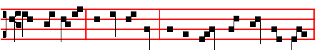
Thou shalt open * my lips, O Lord, and my mouth shall shew thy praise.

626
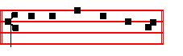
Psalm 51 Miserere, p. 104.
Antiphon 2. Tone viij, 2.
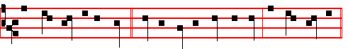
The right hand of the Lord * bringeth mighty things to pass: the right hand of
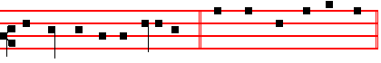
the Lord hath the pre-eminence. Psalm 118 Confitemini Domino, p. 43.
Antiphon 3. Tone j, 2.
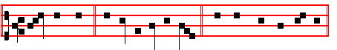
Thou hast been * my helper, O my God. Psalms 63 67. Deus, Deus meus, and the rest, p. 29.
Antiphon 4. Tone viij, 1.
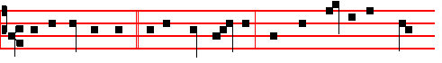
Let us sing the song * of the three children, which they sang as they blessed
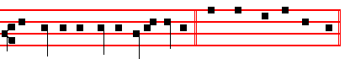
the Lord in the burning fiery furnace. Canticle Benedicite, p. 31.
Antiphon 5. Tone vij, 3.
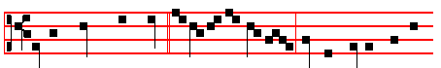
He hath made them fast * for ever and ev-er: he hath given them a

627
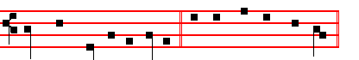
law which shall not be broken. Psalms 148 149 150, p. 33.
Chapter I Thess. 4
WE beseech you, brethren, and exhort you by the Lord Jesus, that as ye have received of us how ye ought to walk and to please God, so ye would abound more and more.
Hymn. O sol salutis, p .603 and .God shall give, p. 604.
On Benedictus, Antiphon. Tone vij, 3.
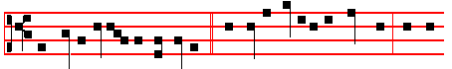
And Jesus taketh his disciples, * and goeth up imto a mountain, and was
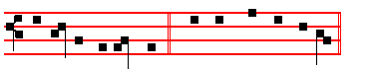
transfigured before them. Canticle Benedictus, p. 29.
COLLECT
O GOD, who seest that we are wholly without power of ourselves keep us both outwardly and inwardly; that we may be defended against all adversities in the body, and cleansed from evil thoughts in the mind. Through.
At Prime and Terce, .Antiphon. Tone j, 2. 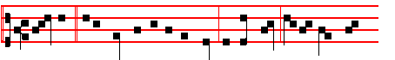
Master, * it is good for us to be here: if thou wilt, let us make here
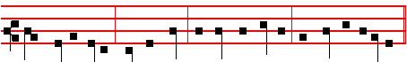
three tabernacles; one for thee, and one for Mcses, and one for E-li-as.
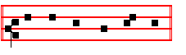
Psalm 54 Deus in nomine p. 43 / Ps. 119 Legem pone, p. 63.

628
At Prime, Chapter and the rest, p. 49.

AT TERCE

Antiphon Master, as at Prime above, p. 628.
Chapter We beseech you, brethren, as above in Lauds, p. 628.
Short  as above, p. 605
He shall deliver me * From the snare of the hunter. He shall.
 And from the noisome pestilence. From the snare. Glory be. He shall.
 He shall hide thee under his wings.
 And thou shalt be safe under his feathers.

AT SEXT
Antiphon. Tone iv, 1.
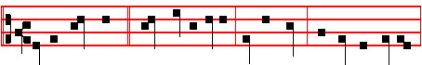
Let us make here * three tabernacles: one for thee, and one for Moses,
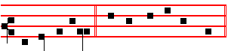
and one for Elias. Psalm 119, Defecit, p. 72.
Chapter I Thess. 4
FOR this is the will of God, even your sanctification,that ye should abstain from fornication: that every one of you should know how to possess his vessel in sanctification and honour.
Short  as above, p.606
He shall defend thee * Under his wings. He shall.
 And thou shalt be safe under his feathers. Under his. Glory be. He shall.
 His faithfulness and truth shall be thy shield and buckler.
 Thou shalt not be afraid for any terror by night.

AT NONE

Antiphon as below at II Vespers, p. 630. Tell the vision * which ye have seen to no man, until the Son of Man be risen again from the dead.
Chapter I Thess. 4
FOR God hath not called us unto uncleanness, but unto holiness in Christ Jesus our Lord.
629
Short  as above, p. 607
His faithfulness and truth * Shall be thy shield and buckler. His faithfulness.
 Thou shalt not be afraid for any terror by night. Shall be. Glory be. His faithfulness.
 He shall give his angels charge over thee.  To keep thee in all thy ways.

AT VESPERS

Antiphons and Psalms of Sunday, p. 201.
Chapter We beseech you, brethren, as above, p. 628.
Hymn. E.H.66 Audi benigne.  God shall give, p. 596.

On Magnificat. Antiphon. Tone j, 1.
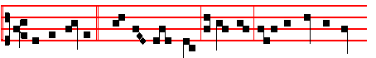
Tell the vision * which ye have seen to no man, until the Son of Man
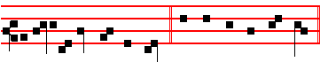
be risen again from the dead. Canticle Magnificat, p. 209.
Collect O God, who seest, as above, p. 628.
Vespers of the Dead.
__________________________________________________________________

Monday

At Matins, Invitatory p. 89 in the Psalter.
Hymn. E.H.65 Ex more docti, p. 597. Antiphons and Psalms of the Nocturn, as in the Psalter, p. 89.
And thus it is said on the other Ferias following.

The Lesson from the Holy Gospel according to S. John
Lesson j Ch. 8, 21-29
JESUS said unto the multitude of the Jews: I go my way, and ye shall seek me,
and shall die in your sins. And the rest.
Homily by S. Augustine, Bishop Homily 38 on John
IN the present Lesson, it was of his Passion, which rested not in a necessity for him, but in his own power, that he spoke to the Jews, saying, I go. For to Christ

630
the Lord, death was a going to that place whieh he came from, and yet never quitted. I, saith he, go, and ye shall seek me: not of desire, but of hatred. For in fact, when he had withdrawn from the eyes of men, he was sought both by them which hated, and by them which loved him; those sought him by perscuting, these by desiring to have him. In the Psalms the Lord himself saith by the Prophet, Flight hath failed me, and there is none that seeketh after my soul: and again he saith in another place in a Psalm, Let them be ashamed, and confounded, that seek
after my soul:

 When Jacob , went out uom Beersheba, and went towards Haran, the Lord spake to him and said, * The land whereon thou liest, to thee will I give it and to thy seed.
 He built an altar of stones unto the Lord, and poured oil upon the top of it, and God blessed him and said. The land.

Lesson jj
HE hath blamed some for not seeking, condemned some for seeking. For it is a good thing to seek the soul of Christ, as the disciples sought; and evil, to seek the soul of Christ, as the Jews sought: for those sought in order to have, these, in order to destroy. Well, because these so sought, in evil manner, with a perverse heart, what added he next? Ye shall seek me, and, lest ye should think to get good by seeking, In your sin shall ye die. This it is to seek Christ in an evil way, to die in one's sin: this it is for one to hate him, through whom alone he might be saved.

 God appeared unto Jacob and blessed him, and said unto him: I am the God of Bethel where thou anointedst the pillar, and where thou vowedst a vow unto me: * I will make thee fruitful, and multiply thee.
 Surely the Lord is in this place, and I knew it not. I will.

Lesson iii
FOR whereas men whose hope is in God ought not to render evil, no, not even for evil, these rendered evil for good. Therefore the Lord fore-announced to them, and spake their sentence in his foreknowledge, that they should die in their sin. Then he adds, Whither I go ye cannot come. This same he said to the disciples too in another place, and yet he said not to them, Ye shall die in your sin. But what said he? The same as to these, Whither I go, ye cannot come. He took not away hope, but only foretold the deferring thereof. For at the time when the Lord was speaking this to the disciples, they were not able to come whither he was going, but should come afterwards: these, never, because by his foreknowledge he said to them, In your sin ye shall die.

 God give thee of the dew of heaven, and the fatness of the earth. Let people and nations serve thee. * Be lord over thy brethren.
631
 And let thy mother's sons bow down to thee. Be lord. Glory be. Be lord.

At Lauds, Antiphons and Psalms Miserere with the rest from the Psa1ter, p. 104.
Chapter Cry aloud, p. 609. Hymn O sol salutis, p. 603, and  God shall give, p. 604.
On Benedictus, Antiphon.
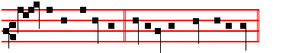
I am the Beginning, * even I that speak unto you.
Then the Prayers, p. 108.
COLLECT
GRANT, we \eseech thee, a1mighty God: that like as thy family do abstain from food to the mortifying of the flesh; so they may likewise fast from sin to the following after justice. Through.
Then the Office of the Dead.
At the Hours all as in the Psalter.
At Vespers, Antiphon The Lord, Psalm Dilexi, with the rest from the Psalter. Hymn. E.H.66 Audi benigne, and  God shall give, p. 596.
On Magnificat, Antiphon.
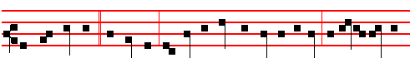
He that sent me * is with me; the Father hath not left me alone; for I do always
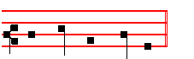
those things that please him. Then the Prayers, p. 217.
COLLECT
ASSIST us, almighty God, in these our supplications: that as thou dost suffer us to put our trust ani confidence in thy mercy; so thou wouldest graciously vouchsafe unto us the wonted effects of thy compassion. Through.
__________________________________________________________________

Tuesday

The Lesson from the Holy Gospel according to S. Matthew

632
Lesson j Ch. 23, 1-12
JESUS spake to the multitude, and to his disciples, saying: The scribes and the Pharisees sit in Moses' seat: all therefore whatsoever they bid you observe, that observe and do; but do not ye after their works. And the rest.
Homily by S. Jerome, Priest Comm. on Matt. Bk. 4. Ch. 23
WHO is gentler, who is kinder, than the Lord? He is tempted by the Pharisees, they are destroyed by their own craftiness, and according to the Psalmist, God shall suddenly shoot at them with a swift arrow, that they shall be wounded: and nevertheless, because of the honour of their name and priesthood, he urges the people to be subject unto them, and to take heed, not of their works, but of their teaching.

 Jacob went out from his own land, and saw the glory of God, and said: How dreadful is this place. * This is none other but the house of God, and this is the gate of heaven.
 Surely God is in this place and I knew it not. This is

Lesson ij
FOR they bind heavy burdens and grievous to be borne, and lay them on men's shoulders; but they themselves will not move them with their fingers. This is a general condemnation of all the masters who command hard things and yet do not practise slight ones. But notice that the shoulders and fingers and burdens and binding are to be understood in their spiritual meaning. But all their works they do to be seen of men. Therefore whoever does anything to be seen of men is a scribe and a Pharisee.

 If the Lord my God will be with me and will keep me in this way that I go, and will give me bread to eat, and raiment to put on, so that I come again to my father's house in peace: * The Lord shall be my refuge, and this stone shall be the sign.
 And Jacob rose up early in the morning, and took the stone that he had put for his pillows, and set it up for a pillar, and poured oil upon the top of it, and said. The Lord

Lesson iij
THEY make broad their phylacteries, and enlarge the borders of their garments, and love the uppermost rooms at feasts, and the chief seats in the synagogues, and greetings in the markets, and to be called of men, Rabbi. Woe unto us, unhappy sinners, who have inherited the sins of the Pharisees! When the Lord gave the commandments of the Law through Moses, he added at the end of them, And thou shalt bind them as a sign upon thine hand, and they sha1l be as frontlets

633
between thine eyes: this means, My commandments are to be in thine hand, so that they sha1l be fulfi1led in thy work; they are to be before thine eyes, so that you may meditate on them day and night. The Pharisees misinterpreted this, and so they used to write out on pieces of parchment the Decalogue of Moses, that is, the ten commandments of the Law, bind them together, and tie them on their foreheads, making a kind of crown on their heads: and so they were always in front of their eyes.

 The Lord shall be my God, and this stone, which I have set up for a pillar, shall be God's house: and of all that thou shalt give me, * I will surely give the tenth and peace offerings unto thee.
 If I come again to my famer's house in peace. I will. Glory be. I will.

On Benedictus, Antiphon.
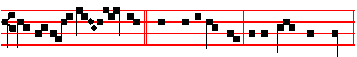
One is your mas - ter, * which is in heaven, even Christ the Lord.

Then the Prayers, p. 108.
COLLECT
WE beseech thee, O Lord, graciously perfect in us the work of this holy observance: that we, who, through thine inspiration, know those things which we ought to do, may by thy power fulfil the same. Through.
On Magnificat, Antiphon.
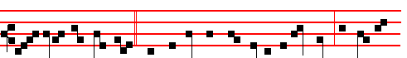
But all ye are brethren; * and call no man your father upon earth; for one is
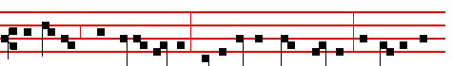
your Father, which is in heaven: neither be ye called masters; for one is your
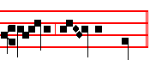
Mas-ter, e- ven Christ. Then the Prayers, p. 217.

634
COLLEC'T
BE favourable, O Lord, to our supplications, and heal the infirmities of our souls: that we obtaining forgiveness, may ever rejoice in thy blessing. Through.
__________________________________________________________________

Wednesday
Today are said the Gradual Psalms.
The Lesson from the Holy Gospel according to S. Matthew
Lesson j Ch. 20, 17-28
JESUS going up to Jerusalem took the twelve disciples apart in the way, and said unto them, Behold, we go up to Jerusalem; and the Son of man shall be betrayed unto the chief priests and unto the scribes. and they shall condemn him to death. And the rest.
Homily by S. Ambrose, Bishop On the Faith. Bk. 5. To Gratian
CONSIDER what it was that the mother of Zebedee's children was asking with and for her sons: for she is a mother indeed, so excessively anxious for the honour of her sons, but then she is totally unaware of the measure of her requests. And remember that she is a mother advanced in years, fervent in piety, and deprived of the comfort which at this time she would normally receive from the help and support of her grown children: she endures their absence from her, and prefers, rather than her own desires, her sons' reward for following Christ. For it was these sons, who, at the Lord's first call (as we read) left their nets and their father, and followed him.

 The Angel said unto Jacob * Let me go, for the day breaketh. And he said, I will not let thee go, except thou bless me. And he blessed him there.
 And when Jacob arose, there wrestled a man with him until the breaking of the day: and when he saw that he prevailed not against him, he said unto him, Let me go.

Lesson ij
SHE then, giving vent to her maternal zeal, besought the Saviour, saying, Grant that these my two sons may sit, the one on thy right hand, and the other on the left, in thy king dom. If this be an error, then it is an error of piety. For the mother's heart knows no bounds: if it be a grasping request, then it is pardonable greed, for she would grasp, not money, but grace. Nor is it a shameless demand, for she was acting, not for herself, but for her children. Think of the mother, consider well the mother.

 I have seen God face to face, * And my life is preserved.

635
 And he said unto me, Thy name shall be called no more Jacob, but Israel. And my.

Lesson iij
CHRIST was mindful of the love of the mother, of her who would be consoled in her old age by her sons' great reward: and who, although worn down by maternal yearning, still endured the absence of her beloved ones. And then remember that she was a woman, that is, one of the weaker sex, whom the Lord had not yet strengthened by his own suffering. Remember, I say, that she was a daughter of that first woman, Eve, and had the inherent failing of immoderate desire which was transmitted to all women: the Lord had not yet redeemed her by his own blood, Christ had not yet washed away in that tide from his own wounds that ever-growing craving for immoderate and unlawful honour with which all are stained. Therefore through inherited error was the woman at fault.

 When Jacob heard that Eau came to meet him, he divided his sons and his wives, saying: If Esau smite the one company, then the other shall escape. * Deliver me, O Lord, which saidst unto me: I will multiply thy seed as the stars of heaven and as the sand of the sea which cannot be numbered for multitude.
 O Lord, which saidst unto me: Return unto thy country, O Lord which feedest me from my youth up. Deliver. Glory be. Deliver.

On Benedictus, Antiphon
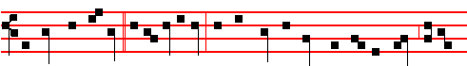 Behold, we go up * to Jerusalem: and the Son of Man shall be betrayed to be
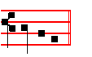
crucified. Then the Prayers, p. 108.

COLLECT

WE beseech tkee, O Lord, mercifully look upon thy peopIe: that they whom thou dost command. to:. abstain. from carnal food, may likewise by thy bounty eschew all hurtful vices .Through.

On Magnificat, Antiphon.

636
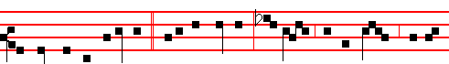
For he shall be delivered * unto the Gentiles, to mock, and to scourge, and to
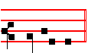
crucify him. Then the Prayers, p. 217.

COLLECT
O GOD, the restorer and lover of innocency, direct to thyself the hearts of thy servants: that being kind1ed with the fire of thy spirit, they may be found steadfast in faith, and abounding in works. Through..

__________________________________________________________________

Thursday

The Lesson from the Holy Gospel according to S. Luke
Lesson j Ch. 16. 19-31
JESUS said unto the Pharsees: There was a certain rich man, which was clothed in purple and fine linen, and fared sumptuously every day. And the rest.
Homily by S. Gregory the Great Homily 40 on the Gospels
WHO, beloved brethren, who is meant by this rich man, which was clothed in purple and fine linen, and fared sumptuously every day, but the Jewish people, who kept the outward observances of religion, and who used the privileges of the law that they had received for their own consolation, and not for the common good? Whom, again, does Lazarus, full of sores, figuratively represent, but the Gentile nations? For when they were converted to God they were not ashamed to confess their sins, and so these were the sores in their skin. Indeed,' it is through sores in the skin that poison is drawn from within the body, and breaks out.

 Take thy weapons, thy quiver and thy bow, and bring me venison, that I may eat. * That my soul may bless thee.
 And take me some venison, and make me savoury meat, that I may eat. That my soul.

Lesson ij

637
THEN what is confession of sin, but a certain breaking out of wounds? For the poison of sin is salubriously laid open in confession, whereas. it had been poisonously hidden in the mind. Through skin wounds, festering matter is drawn forth. And what else do we do, in confessing our sins, but to bring to the surface the evil that was lurking within us? But wounded Lazarus desired to be fed with the crumbs which fell from the rich man's table, and no one gave them to him: because that proud people disdained to admit the Gentiles to knowledge of the law.

 See the smell of my son is as the smell of a field which the Lord hath blessed; may my God multiply thee as the sand of the sea. * And give thee a blessing of the dew of heaven.
 And God Almighty bless thee and multiply thee. And give.

Lesson iij
THE teaching of the law made them proud instead of loving, as though they were puffed up with the riches that they had received: and the words that they let fall from their knowledge were like crumbs which fell from the table. And, on the other hand, the dogs licked the sores of the poor man lying there. Often, in holy Scripture, preachers are designated by dogs. For a dog's tongue, when it licks a wound, heals it. And so when we confess our sins, the holy teachers instruct us, as though touching the wounds of our minds with their tongues.

 God give thee of the dew of heaven, and the fatness of the earth. Let people and nations serve thee. * Be lord over thy brethren.
 And let thy mother's sons bow down to thee. Be lord. Glory be. Be lord.
On Benedictus, Antiphon.
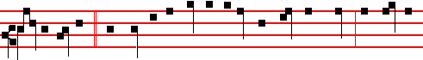
Son, remember * that thou in thy lifetime receivedst thy good things, and likewise
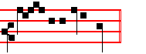
Laz- arus evil things. Then the Prayers, p. 108.
COLLECT
GRANT us, Lord,we beseeeh thee, the help of thy graoe: that we, being meetly
given to fastings and prayers, may be delivered from the enemies of mind

638
and body. Through.
On Magnificat, Antiphon.
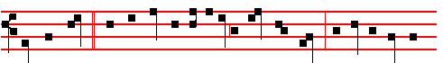
That rich man * who refused to Lazarus a crumb of bread, desired a drop of
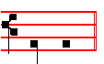
wa - ter. Then the Prayers, p. 217.

COLLECT
ASSIST, O Lord, thy servants, and grant thy oontinual favour to them that call upon thee: that in those who glory in thee their author and governor thou mayest restore what thou hast gathered, and preserve what thou hast restored. Through.
__________________________________________________________________

Friday

The Lesson from the Holy Gospel according to S. Matthew
Lesson j Ch. 21, 33-46
JESUS spake this parable unto the multitudes of the Jews: There was a certain householder, which planted a vineyard. And the rest.
Homily by S. Ambrose, Bishop Bk. 9 On Luke Ch. 20
MANY and various are the meanings derived from the term, Vineyard: but Isaiah recorded clearly that the vineyard of the Lord of hosts is the house of Israel. Who but God planted this vineyard? He it is who let it out to husbandmen and went into a far country: not that God went from place to place, he who is always present everywhere. But he is more readily present to the careful, and absent from the careless. He was away for a long time, lest he should seem too insistent in his demands. For the more generous the liberality, the more inexcusable is perversity.

 Jacob went out from his own land, and saw the glory of God, and said: How dreadful is this place. * This is none other but the house of God, and this is the gate of heaven.
 Surely God is in this place and I knew it not. This is

Lesson ij
639
MATTHEW says well that he hedged it round about: that is, he walled it in with the protection of divine defence, lest it should be an easy prey to the inrush of spiritual wild beasts. And he digged a winepress in it. How are we to interpret this reference to the winepress? Is it not connected with those psalms that are entitled, For the winepress. in which, through the Holy Spirit, the mysteries of the Lord's Passion seethe over with foam- ing new wine? Whence those men who were filled with the Holy Ghost were thought to be drunken. Therefore in this parable the man digged a winepress in which the inward fruit of the clusters of reason should pour forth its spiritual juice.

 If the Lord my God will be with me and will keep me in this way that I go, and will give me bread to eat, and raiment to put on, so that I come again to my father's house in peace: * The Lord shall be my refuge, and this stone shall be the sign.
 And Jacob rose up early in the morning, and took the stone that he had put for his pillows, and set it up for a pillar, and poured oil upon the top of it, and said. The Lord

Lesson iij
HE built a tower, raising, as it were, the spire of the law: and this vineyard thus fenced, prepared and equipped, he let out to the Jews. And at the time of the fruit he sent his servants. It is well said, Time of the fruit, and not harvest, for there was no fruit from the Jews, no harvest from this vineyard, of which the Lord said, When I looked that it should bring forth grapes, it ' brought forth wild grapes. Therefore, not with the wine of gladness, not with the new wine of the Spirit did this vineyard overflow, but with the blood of the murdered prophets.

 The Lord shall be my God, and this stone, which I have set up for a pillar, shall be God's house: and of all that thou shalt give me, * I will surely give the tenth and peace offerings unto thee.
 If I come again to my famer's house in peace. I will. Glory be. I will.
On B enedictus, Antiphon.
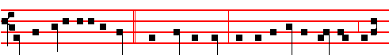
He will miserably destroy * these wicked. men: and will let out his vineyard unto
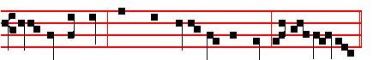
other husbandmen, which shall render him the fruit in their seas-ons.

640
Then the Prayers, p. 108.
COLLECT
GRANT, we .beseech thee, almighty God: that we may in such wise be purified by this sacred fast, that with sinoere minds we may be brought by thee to the holy things which are to come. Through.
Today are said thePenitential Psalms.

On Magnificat, Antiphon.
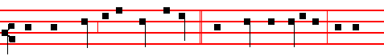
When they sought to lay hands on him, * they feared the multitude, because
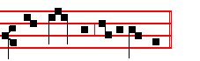
they took him for a prophet. Then the Prayers, p. 217.

COLLECT
GRANT, we beseech thee, O Lord, unto thy people health of mind and of body: that cleaving steadfastly to good works, they may ever be found worthy to be defended by the protection of thy power.Through.
__________________________________________________________________

Saturday
The Lesson from the Holy Gospel according to S. Luke
Lesson j Ch. 15, 11-32
JESUS spake this parable unto the scribes and Pharsees: A certain man had two sons: and the younger of them said to his father, Father, give me the portion of goods that falleth to me. And the rest.
Homily by S. Ambrose, Bishop Bk. 7 on Luke Ch. 16
NOTICE that the divine patrimony is given to those that ask it. Neither think the father to blame in giving it to his younger son. For there is no weakness of age in the kingdom of God, nor does faith decline with years. And he who asked considered himself worthy to receive. Would that he had never gone away from his father, then had he never known the drawback of his age. Then leaving his father's house, he took his journey into a far country, and began to be in want. It is well said that he wasted his patrimony, he who withdrew from the Church.

 Father, I have sinned against heaven, and before thee, and am no more worthy to be called thy son: * Make me as one of thy hired servants

641
 How many hired servants of my father's house have bread enough and to spare. and I perish with hunger! I will arise and go to my father, and will say unto him. Make me.

Lesson ij
HE took his journey into a far country. How much further can one go, than from oneself: to be separated, not by territories, but by behaviour: to be cut off, not by frontiers, but by desires; and, as though consumed with the heat of riotous living, to be severed from the company of the Saints? Truly he who separates himself from Christ is an exile from his fatherland, for he is a citizen of the world. But we are no more strangers and foreigners, but fellow-citizens with the saints, and of the household of God. For we who were far off are made nigh by the blood of Christ. Let us not be angry with those who are returning from a far country; for we too have been in a far country, as Isaiah teaches, as it is written, They that dwell in the land of the shadow of death, upon them hath the light shined. Therefore the far country is the shadow of death.

 I have seen God face to face, * And my life is preserved.
 And he said unto me, Thy name shall be called no more Jacob, but Israel. And my.
Lesson iij
BUT as for us, unto whom Christ is the Lord and breath of life, we live under the shadow of Christ. Therefore does the Church say, I sat down under his shadow with great delight. Yet that man wasted all his natural gifts by his riotous living. But thou that hast received the image of God, who hast been given his likeness, waste it not in living like ail animal. Thou art God's handiwork: Say not to a stock: Thou art my father, lest thou become like a stock, as it is written, They that make them are like unto them.

 When Jacob heard that Eau came to meet him, he divided his sons and his wives, saying: If Esau smite the one company, then the other shall escape. * Deliver me, O Lord, which saidst unto me: I will multiply thy seed as the stars of heaven and as the sand of the sea which cannot be numbered for multitude.
 O Lord, which saidst unto me: Return unto thy country, O Lord which feedest me from my youth up. Deliver. Glory be. Deliver.

On Benedictus, Antiphon.
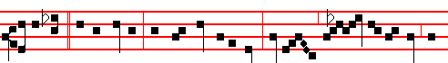
I will go * to my father, and will say unto him, Father, make me as one of

642
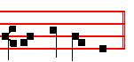
thy hired servants. Then the Prayers, p. 108.

COLLECT
GRANT, we beseech thee, O Lord, that our fasts may so work to good effect: that we who submit to the chastening of the flesh may be profited thereby to the quickening of our souls. Through.

AT VESPERS
Chapter Eph. 5
BRETHREN: Be ye therefore followers of God, as dear children; and walk in love, as Christ also hath loved us, and hath given himself for us, an offering and a sacrifice to God for a sweet-smelling savour.
Hymn Audi benigne, and  God. shall give, p. 596.
On Magnificat, Antiphon. Tone viij, 1.
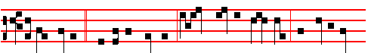
But the father * said to his servants, Bring forth the best robe and put it on
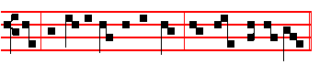
him; and put a ring on his hand, and shoes on his feet.
COLLECT
WE beseech thee, almighty God, look upon the hearty desires of thy servants: and stretch forth the right hand of thy majesty, to be our defence against all our enemies. Through.
THIRD SUNDAY IN LENT
At Matins, Invitatory It shall not be lost, and Hymn Ex more docti, p. 597.
The rest, apart from the Lessons, as in the Psalter, p. 5.

IN THE FIRST NOCTURN
From the Book of Genesis
Lesson j Ch. 37, 2-28
JOSEPH, being seventeen years old, was feeding the flock with his brethren; and the lad was with the sons of Bilhah, and with the sons of Zilpah, his father's

643
wives: and Joseph brought unto his father their evil report. Now Israel loved Joseph more than all his children, because he was the son of his old age: and he made him a coat of many colours. And when his brethren saw that their father loved him more than all his brethren, they hated him, and could not speak peaceably unto him. And Joseph dreamed a dream, and he told it his brethren: and they hated him yet the more. And he said unto them, Hear, I pray you, this dream which I have dreamed: for, behold, we were binding sheaves in the field, and, lo, my sheaf arose, and also stood upright; and, behold, your sheaves stood round about, and made obeisance to my sheaf. And his brethren said to him, Shalt thou indeed reign over us? or shalt thou indeed have dominion over us? And they hated him yet the more for his dreams, and for his words. And he dreamed yet another dream, and told it his brethren, and said, Behold, I have dreamed a dream more; and, behold, the sun and the moon and the eleven stars made obeisance to me. And he told it to his father, and to his brethren: and his father rebuked him, and said unto him, What is this dream that thou hast dreamed? Shall I and thy mother and thy brethren indeed come to bow down ourselves to thee to the earth?

 And when his brethren saw Joseph afar off, they said one to another: Behold, this dreamer cometh: * Come, let us slay him, and we shall see what will become of his dreams.
 And when his brethren saw that their father loved Joseph more than all his brethren, they hated him, and could not speak peaceably unto him, therefore they said. Come.

Lesson ij
AND his brethren envied him; but his father observed the saying. And his brethren went to feed their father's flock in Shechem. And Israel said unto Joseph, Do not thy brethren feed the flock in Shechem? come, and I will send thee unto them. And he said to him, Here am I. And he said to him. Go, I pray thee, see whether it be well with thy brethren, and well with the flocks; and bring me word again. So he sent him out of the vale of Hebron, and he came to Shechem. And a certain man found him, and, behold, he was wandering in the field: and the man asked him, saying, What seekest thou? And he said, I seek my brethren: tell me, I pray thee, where they feed their flocks. And the man said, They are departed hence; for I heard them say, Let us go to Dothan. And Joseph went after his brethren, and found them in Dothan. And when they saw him afar off, even before he came near unto them, they conspired against him to slay him. And they said one to another, Behold, this dreamer cometh. Come now therefore, and let us slay him, and cast him into some pit, and we will say, Some evil beast hath devoured him: and we shall see what will become of his dreams.

 Judah said unto his brethren: Behold, the Ishmeelites pass by: come, let us sell

644
him, let not our hands be upon him: * For he is our brother and our flesh.
 What profit is it if we slay our brother and conceal his blood? It is better to sell him. For he.

Lesson iij
AND Reuben heard it, and he delivered him out of their hands; and said, Let us not kill him. And Reuben said unto them, Shed no blood, but cast him into this pit that is in the wilderness, and lay no hand upon him; that he might rid him out of their hands, to deliver him to his father again. And it came to pass, when Joseph was come unto his brethren, that they stript Joseph out of his coat, his coat of many colours that was on him; and they took him, and cast him into a pit: and the pit was empty, there was no water in it. And they sat down to eat bread: and they lifted up their eyes and looked, and, behold, a company of Ishmeelites came from Gilead with their camels bearing spicery and balm and myrrh, going to carry it down to Egypt. And Judah said unto his brethren, What profit is it if we slay our brother, and conceal his blood? Come, and let us sell him to the Ishmeelites, and let not our hand be upon him; for he is our brother and our flesh. And his brethren were content. Then there passed by Midianites merchantmen; and they drew. and lifted up Joseph out of the pit, and sold Joseph to the lshmeelites for twenty pieces of silver: and they brought Joseph into Egypt.

 They drew and lifted up Joseph out of the pit, and sold Joseph to the lshmeelites for twenty pieces of silver. * And Reuben returned unto the pit, and when he found him not, he rent his clothes and wept, and said: The child is not, and I, whither shall I go?
 And they took Joseph's coat, and dipped it into the blood of.a kid of the goats: and they sent the coat of many colours, and they brought it to their father, and said: Know now whether it be thy son's coat or no. And Reuben. Glory be. And Reuben.

IN THE SECOND NOCTURN

Sermon by S. Ambrose, Bishop On Joseph the Patriarch. Ch. 1
Lesson iv
THE way that the Saints lIved provides a pattern to be copied in the lives of other men. And therefore have we received a full and ordered series in the Scriptures: as in our reading we make the acquaintance of Abraham, Isaac and Jacob, and of other righteous men, it is as though a certain path of innocence were revealed to us by their virtues. which we may follow by treading in their footsteps. As these have often been my subjects, we come to-day to the story of holy Joseph: very many were the virtues he possessed, yet above all did he wondrously excel in chastity. As you have discovered in Abraham the unflagging constancy of faith, in

645
Isaac the purity of an upright mind, in Jacob singleheartedness and patience in toil; it is right that you should bend your minds to the particular kinds of discipline that their virtues reveal.

 When Jacob saw Joseph's coat, he rent his clothes, and mourned, and said: * An evil beast hath devoured my son Joseph.
 And his brethren took his coat, and sent it to his father: and he knew it, and said. An evil.

Lesson v
LET us, then, make a study of holy Joseph, as a mirror of chastity. For modesty shines forth in all his deeds and behaviour, and attendant on his chastity is a splendid graciousness. And indeed on this account he was loved by his parents more dearly than his other brethren. But this gave rise to envy: which matter was not to be passed over in silence; for the whole story hangs upon it. And from this we may learn that the perfect man is not moved by the wicked desire of avenging wrongs, nor does he repay evil with evil. Whence David also said, If I have rewarded evil unto him that dealt me evil.

 When Joseph carne into the land of Egypt, he heard a strange language; his hands were delivered from making the pots: * That he might teach his princes wisdom.
 Whose feet they hurt in the stocks; the iron entered into his soul, until the time came that his cause was known. That he.

Lesson vj
FOR how should Joseph deserve to be preferred to the others, had he injured those which injured him, and loved those that loved him? For most men do this. But the admirable thing is to love your enemy: as the Saviour teaches.
Rightly is he to be admired, who so acted before the Gospel came, that when injured he was merciful, when seized upon he forgave, when sold he rendered no evil in return, but paid off the wrong with favour: which things we have all learned from the Gospel, and are yet unable to carry them out. Let us take note, then, that the Saints were hated, that we may imitate their patience; let us recognize that they were not naturally better than other men, but that they were more vigilant: it was not that they had never known sin, but that they amended. themselves. Moreover, if envy has scorched even the Saints, how much more careful must sinners be, lest it set them alight?

 Think on me when it shall be well with thee: * And make mention of me unto Pharaoh and bring me out of this house. For indeed I was stolen away: and here

646
also have I done nothing that they should put me into the dungeon.
 Yet within three days shall Pharaoh remember thy service and restore thee unto thy place: then think on me. And make. Glory be. For

IN THE THIRD NOCTURN

The Lesson from the Holy Gospel according to Luke
Lesson j. Ch. 11
JESUS was casting out a devil, and it was dumb. And it came to pass, when the devil was gone out, the dumb spake; and the people wondered. And the rest.
Homily by S. Bede the Venerable, Priest Bk. 4. Ch. 48 on Luke Ch. 11
THIS demoniac, according to Matthew, was not only dumb, but it was also blind; and so it is said, He healed him, insomuch that the blind and dumb both spake and saw. Therefore three miracles were worked on the one man: blind, he saw: dumb, he spoke: possessed with a devil, he was freed. Now what was then done in the flesh is also fulfilled every day in the conversion of believers: for first, when the devil has been cast out, they see the light of faith, and then the mouths that were hitherto silent are loosed for the praise of God. But some of them said, He casteth out devils through Beelzebub the chief of devils. It was not any of the people, but the scribes and Pharisees who were thus maligning him, as the other Evangelists testify.

 We are verily guilty concerning our brother, in that we saw the anguish of his soul, when he besought us, and we would not hear: * Therefore is this distress come upon us.
 And Reuben answered his brethren, saying: Spake I not unto you, saying: Do not sin against the child; and ye would not hear? Therefore.

Lesson viij
INDEED the people, who were presumably less learned, always marvelled at the Lord's doings: but the others either denied them, or, if they could not deny them, did their best to put an evil interpretation on them; as though they had been done, not through his Divinity, but by an unclean spirit. And others, tempting him, sought of him a sign from heaven. Either they wanted fire, like that of Elijah, to come down from on high; or else, as with Samuel, peals of thunder in summer time with flashing lightning and torrential rain: as though they would not have interpreted this despite- fully also, saying that it had happened by reason of various hidden disturbances of the sky. And you, who would explain away those things that you see with your eyes, hold in your hands, experience with your- senses: what would you do if those things should come from heaven? Doubtless you will answer that the magicians in Egypt worked many sighs from heaven.

647
 And Reuben answered his brethren, saying: Spake I not unto you, saying: Do not sin against the child; and ye would not hear? * Therefore, behold also his blood is required.
 We are verily guilty concerning our brother, in that we saw the anguish of his soul, when he besought us, and we would not hear..Therefore.

Lesson ix
BUT he, knowing their thoughts, said unto them, Every kingdom divided against itself is brought to desolation; and a house divided against a house falleth. He answered, not their sayings, but their thoughts: that thus they might be com- pelled to believe in his power, since he saw the hidden things of the heart. But if every kingdom divided against itself is brought to desolation, then is the kingdom of the Father and of the Son and of the Holy Ghost not divided; for without any contradiction, it cannot be brought to desolation by any attack, but remains for ever in eternal stability. If Satan also be divided against himself, how shall his kingdom stand? because ye say that I cast out devils through Beelzebub. In saying this, he wished it to be understood by their own confession, that by not believing in him they had chosen for themselves the kingdom of the devil, which indeed, if it be divided against itself, cannot stand.

 Jacob mourned for his two sons, saying: Woe is me, I am bereaved of Joseph, for he is not; and Benjamin is taken away for bread. * I pray the King of heaven in my distress that he may make me to see him yet again.
 And Jacob cast him down upon his face upon the ground and wept sore, and he prayed, saying. I pray. Glory be. I pray.
Antiphon 1 AT LAUDS Tone iij, 1.
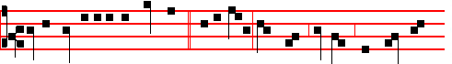
O be favourable and gracious * unto Sion: Build thou, O Lord, the walls of
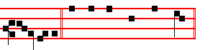
Jeru-salem. Psalm 51 Miserere and the rest.
Antiphon 2. Tone viij, 1.
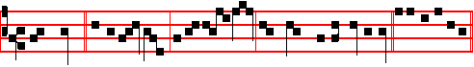
The Lord * is on my side: I will not fear what man doeth unto me. Psalm 118
648
Antiphon 3 Tone viij, 1.
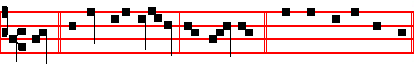
God * be merciful unto us, and bless us. Psalms 63 67 Deus, Deus meus
Antiphon 4. Tone j, 4.
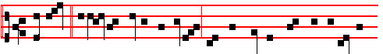
The fire * forgat his power and virtue, that thy children might be delivered
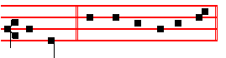
unharmed. Canticle Benedicite.
Antiphon 5 Tone j, 2.
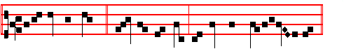
O ye sun and moon,* praise ye the Lord: for his Name only is excellent.
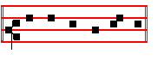
Psalm 148 149 150 Laudate.
Chapter Eph..5
BRETHREN: Be ye therefore followers of God, as dear children; and walk in love, as Christ also hath loved us, and hath given himself for us, an offering and a sacrifice to God for a sweet-smelling savour.

Hymn O sol p.603, and  God shall give, p.604.
On Benedictus, Antiphon. Tone iij, 1.
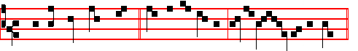
When a strong man armed * keepeth his palace, all his goods are in peace.

649
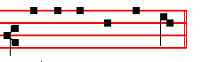
Canticle Benedictus, p. 28.
COLLECT
WE beseech thee, almighty God, look upon the hearty desires of thy humble servants: and stretch forth the right hand of thy majesty, to be our defence against all our enemies. Through.
AT PRIME
Antiphon. Tone j, 2.
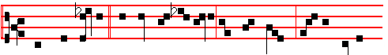
And when Jesus * had cast out the devil, the dumb spake, and the people
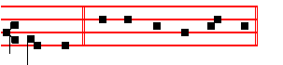
wondered. Psalm 54 Deus in Nomine, p. 43.

AT TERCE
Antiphon. Tone iij, 1.
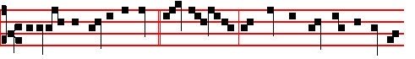
If I with the finger of God * cast out devils, no doubt the kingdom of God is
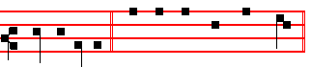
come upon you. Psalm 119, Legem pone, p. 63.
Chapter Brethren: Be ye therefore followers, as above, p. 649.
Short  as above, p. 605.
He shall deliver thee * From the snare of the hunter. He shall. And from the noisome pestilence. From the snare. Glory be. He shall.
 He shall hide thee under his wings.
 And thou shalt be safe under his feathers.

650
AT SEXT
Antiphon. Tone j, 1.
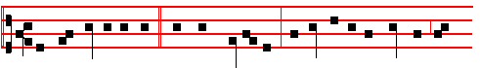
He that gathereth not * with me scattereth: and he that is not with me is
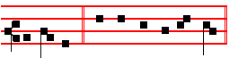
against me. Psalm 119 Defecit, p. 72.
Chapter Eph.5
FOR this ye know, that no whoremonger, nor unclean person, nor covetous man, who is an idolater, hath any inheritance in the kingdom of Christ and of God.
Short  as above, p. 606. He shall defend thee * Under his wings. He shall.
 And thou shalt be safe under his feathers. Under his. Glory be. He shall.
 His faithfulness and truth shall be thy shield and buckler.
 Thou shalt not be afraid for any terror by night.

AT NONE
Antiphon. Tone j, 1.
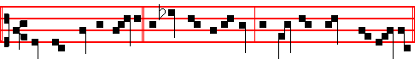
When the unclean spirit * is gone out of a man, he walketh through dry places,
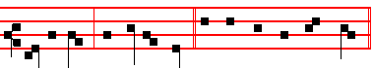
seeking rest, and findeth none. Psalm 119 Mirabilia, p. 82.
Chapter Eph. 5
FOR ye were sometimes darkness, but now are ye light in the Lord: walk as children of light; for the fruit of the Spirit is in all goodness and righteousness and truth.
Short  as above, p. 607.
His faithfulness and truth * Shall be thy shield and buckler. His faithfulness.
 Thou shalt not be afraid for any terror by night. Shall be. Glory be.
His faithfulness.

651
 He shall give his Angels charge over thee.  To keep thee in all thy ways.

AT VESPERS

Antiphons and Psalms of Sunday, p. 201.
Chapter Brethren: Be ye, as above, p. 649.
Hymn. E.H.66 Audi benigne and  God shall give, p. 596.
On Magnificat, Antiphon. Tone viij, 1.
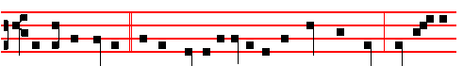
A certain woman * of the company lifted up her voice and cried, Blessed is
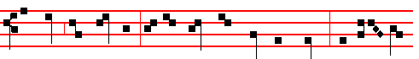
the womb that bare thee, and the paps which thou hast sucked. But Je-sus an-
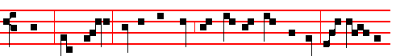
swered, Yea, rather, blessed are they that hear the word of God, and keep it.
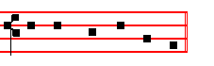
Canticle Magnificat, p. 211.
Collect We beseech thee, p. 650.
After Vespers of the Day are said Vespers of the Dead.
__________________________________________________________________

Monday

At Matins, Invitatory, p. in the Psalter.
Hymn. E.H.65 Ex more docti, p. Antiphons and Psalms of the Nocturn, as in the Psalter, p.
And thus it is said on the other Ferias following.

The Lesson from the Holy Gospel according to S. Luke
Lesson j Ch. 4, 23-30

652

