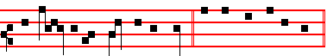
his hands in the name of the Lord. E u o u a e.
Antiphon 5. Tone viij, 1
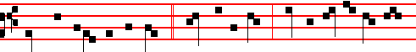
Thrice was I beaten with rods, * once was I stoned, thrice I suffered shipwreck
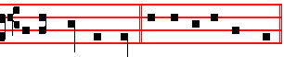
for the name of Christ. E u o u a e.
Chapter 2 Tim.4
I HAVE fought a good fight,I have finished my course,I have kept the faith: henceforth there is laid up for me a crown of righteousness, which the Lord, the righteous judge, shall give me at that day.
Hymn E.H.176 Exultet caelum laudibus, p. iv.
 Thou art a chosen vessel, holy Apostle Paul.
 A preacher of the truth throughout all the world.
On Benedictus, Antiphon. as in the Common, xj.
Ye which have followed me * shall sit upon twelve thrones, judging the twelve tribes of Israel, saith the Lord.
COLLECT
O GOD, who by the preaching of the blessed Apostle Paul didst teach the multitude of the Gentiles: grant to us, we beseech thee; that we who celebrate his birthday may know him to be our advocate with thee. Through.
And commemoration is made of S. Peter. Antiphon. as on p. 1717.
Thou art the shepherd of the sheep, O chief of the Apostles: unto thee were given the keys of the kingdom of heaven.
 Thou art Peter.  And upon this rock I will build my Church.

COLLECT
O GOD, who didst bestow upon thy blessed Apostle Peter the keys of the kingdom of heaven, and didst appoint unto him the high priesthood of binding and loosing: vouchsafe; that by the help of his intercession we may be delivered from the bonds of our iniquities. Who livest and reignest.

And commemoration is made of S. John, as in Lauds of the Feast, above.

1732
Augustine wrote, become from the richest of men willingly the poorest, but most rich in holiness, he was captured by the barbarians, and thus prayed to God: Lord, let me not be tortured for gold and silver: for where all my goods are, thou knowest. But later, when the Vandals invaded those parts, when a widow asked him to redeem her son, as he had used up all his means in the work of charity, he gave himself into slavery in his stead.

Lesson iij
SO he went to Africa, and began to till the garden of his master, who was the king's son-in-law. But by a prophetic gift he predicted the king's death to his master, and the king, in a dream, saw Paulinus, sitting in the midst between two judges, and taking a whip from his royal hands. So, being recognised for a man of such importance, he was given a most honourable discharge, and all his fellow-citizens, who had been slaves, were set free with him. He returned to Nola, to his episcopal duties, and incited all by word and example to christian devotion, until he was laid low with pleurisy. After a while, the bed in which he lay was shaken by an earthquake, and shortly afterwards he gave up his soul to God.
Te Deum Laudamus, p. 24.
__________________________________________________________________

The Twenty-third of June
On the Vigil of S. John the Baptist

The Lesson from the Holy Gospel according to S. Luke
Lesson j Ch. 1, 5-17
THERE was in the days of Herod, the king of Judrea, a certain priest named Zacharias, of the course of Abia: and his wife was of the daughters of Aaron, and her name was Elisabeth. And the rest.

Homily by S. Ambrose, Bishop Bk. 1 on Luke Ch. 1, v. 15
HOLY Scripture teaches us to praise not only those who are worthy of honour, but their parents as well; in order. as it were, that the inheritance of spotless purity which is passed on to those whom we desire to praise might shine the brighter. For what other intention had the holy Evangelist in this place but to make S. John the Baptist noble in his parentage as well as in his miracles, way of life, office, and passion? So, likewise, is Hannah the mother of Samuel praised; so did Isaac receive from his parents that nobility of godliness which he bequeathed to his descendants. Therefore Zacharias the priest was not only a priest, but was of thc course of Abia, that is, noble even among noble families.

 of the occurrent Feria.

1689
exposed to wolves; I might have rendered you more formidable than lions; but it is expedient that so it should be. This makes you all the more glorious; this proclaims also my power. (This he said also unto Paul: My grace is sufficient for thee, for my strength is made perfect in weakness.) It is I, now mark it, who have caused you so to be.

 O holy Apostle Paul, thou preacher of the truth, and Doctor of the Gentiles, * Intercede for us to God who hath chosen thee, that we may be made worthy of the grace of God.
 Thou art a chosen vessel, O holy Apostle Paul, a preacher of the truth. Intercede.

Lesson viij
BUT let us see what manner of wisdom he here requires. That of the serpent, he says. For even as that animal gives up everything, and if its very body must be cut off: doth not very earnestly defend it, so that it may save its head; in like manner do thou also, he saith, give up everything but the Faith; though goods, body, life itself must be yielded. For that is the head and the root; and if that be preserved, though thou lose all, thou wilt recover all with so much the more splendour. On this account, then, he neither commanded to be merely a simple and single hearted sort of person, nor merely wise; but hath mixed up both of these, so that they may become virtue.

 In Damascus the governor under Aretas the king would have apprehended me, * But I was let down the wall by the brethren in a basket, and so escaped out of his hands, in the Name of the Lord.
 The God and Father of our Lord Jesus Christ knoweth that I lie not. But I.
Glory be. But I.

AND if in men's actual deeds thou wouldst see this result, read the book of the Acts of the Apostles, and thou wilt see how often, when the people of the Jews had risen up against them and were sharpening their teeth, these men, imitating the dove and answering with suitable meekness, did away with their wrath, quenched their madness, broke their impetuosity. As when they said: Did we not straitly command you that ye should not speak in this name? although able to work any number of miracles, they neither said nor did anything harsh, but answered for themselves with all meekness, saying: Whether it be right to hearken unto you more than unto God judge ye. Hast thou seen the harmlessness of the dove? Behold the wisdom of the serpent: For we cannot but speak the things which we know and have heard.
Te Deum Laudamus, p. 24.

1730
THE TWENTY-FOURTH OF JUNE
ON THE NATIVITY OF SAINT JOHN THE BAPTIST
DOUBLE OF THE FIRST CLASS WITH OCTAVE

AT VESPERS
Antiphon 1. Tone vij, 3
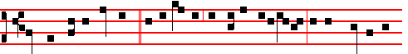
He shall go before him * in the spirit and power of E-li-as, to make ready a
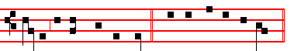
people prepared for the Lord. Psalms 110, 111, 112, 113, 117, as in I Vespers of Apostles. Antiphon 2. Tone viij, 1
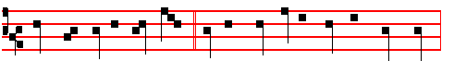
Thou shalt call his name John: * he shall drink neither wine nor strong drink:
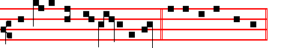
and many shall rejoice at his birth. E u o u a e.
Antiphon 3. Tone j. 1
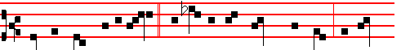
From the womb of the aged * and barren was brought forth John, the Lord's
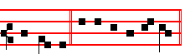
Forerunner. E u o u a e. Antiphon 4. Tone vij, 3
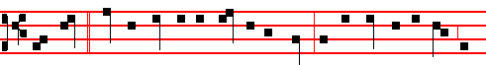
This child * shall be great in the sight of the Lord: for the hand of the Lord is

1691
IN THE SECOND NOCTURN

Antiphon. Thou art a chosen vessel, O holy Apostle Paul, a preacher of the truth throughout all the world. Psalm 47 Omnes gentes
Antiphon. The great and holy Paul is a chosen vessel, verily he is worthy to be glorified, for he was worthy to sit upon the twelfth throne. Psalm 61Exaudi, Deus
Antiphon. I have fought the good fight, I have finished my course, 1 have kept the faith. Psalm 64. Nonne Deo?
 Thou shalt make them princes in all lands.
 They shall remember thy Name, O Lord.

From the Book by S. Augustine, Bishop, On Grace and Free Will
Lesson iv Bk. 1, Ch. 6
PAUL the Apostle had no merits of his own: indeed, he had many demerits. But after he had received the grace of God who renders good for evil, let us see what he said in a letter to Timothy when his passion was at hand: For I am now ready to be offered, and the time of my departure is at hand. I have fought a good fight, I have finished my course, I have kept the faith. He is here recalling his merits, as his crown is to follow upon them, just as grace had followed upon his demerit. Then listen to what follows: Henceforth there is laid up for me a crown of righteousness. Which the Lord, the righteous judge, shall give me at that day. To whom would he give a crown, as the righteous Judge, had he not given grace, as the merciful Father? And how should it be a crown of righteousness, bad not grace
come first, which makes the ungodly righteous? How should it be given as a reward, unless grace had first been given freely?

 Thou art a chosen vessel, O holy Apostle Paul, a preacher of the truth throughout all the world. * Through whom all nations have known the grace of God.
 Intercede for us to God who hath chosen thee. Through whom.
Lesson v
ACCORDINGLY, consider those merits of Paul the Apostle, on account of which he said the righteous Judge would give him a crown, and let us see whether these merits were really his own, that is, sprung from himself, or whether they were gifts of God. I have fought a good fight, I have finished my course, I have kept the faith. To begin with, those good works would have been worth nothing, had not good thoughts come first. Listen, therefore, to what Paul says of these thoughts. For when writing to the Corinthians he said: Not that we are sufficient of ourselves to think any thing as of ourselves; but our sufficiency is of God. Now let us examine these points separately

1728.
4 Oh! what a splendour and a revelation
Came to each mother, at thy joyful leaping,
Greeting thy Monarch, King of every nation, In the womb sleeping.

5 Angels in orders everlasting praise thee,
God, in thy triune Majesty tremendous;
Hark to the prayers we, penitents, upraise thee: Save and defend us. Amen.
 There was a man sent from God.  Whose name was John.
On Magnificat, Antiphon Tone viij, 1 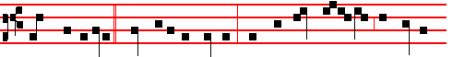
When Zacharias * went into the temple, there appeared unto him the Angel
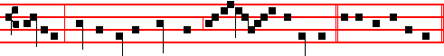
Gabriel, standing on the right hand of the al- tar of incense. Cant. Magnificat

COLLECT
O GOD, who hast made this day honourable to us by the nativity of blessed John: grant unto thy people the grace of spiritual joys; and direct the minds of all the faithful into the way of everlasting salvation. Through.

AT MATINS

Invitatory.- The Lord, the King of the Forerunner, * O come, let us worship. Psalm 95 Venite

Hymn E. H. 224, Antra deserti but with v. 3 as below.

E'EN in thy childhood, 'mid the desert places,
Thou hadst a refuge from the city gainèd,
Far from all slander and its bitter traces Living unstainèd

2 Often had prophets in the distant ages
Sung to announce the Daystar and to name him;
But as the Saviour, last of all the sages, Thou didst proclaim him.

3 Camel's hair raiment clothed thy saintly members,
Leathern the girdle which thy loins encircled.
Locusts and honey, with the fountain-water, Daily sustained thee.

1693
Thou art the shepherd of the sheep, * O chief of the Apostles: unto thee were
given the keys of the kingdom of heaven.
 Thou art Peter.  And upon this rock I will build my Church.

COLLECT
O GOD, who didst bestow upon thy blessed Apostle Peter the keys of the kingdom of heaven, and didst appoint unto him the high priesthood of binding and loosing: vouchsafe; that by the help of his intercession we may be delivered from the bonds of our iniquities. Who livest and reignest.
And commemoration is not made of S. John, nor in Lauds.
If the commemoration of S. Paul shall come on the Octave Day of Corpus Christi, outside of a Church of his name, it is transferred to the first day within the Octave not impeded by a Sunday or Feast; and the whole Office is said as in a Church of his name.
__________________________________________________________________

THE THIRTIETH OF JUNE
COMMEMORATION OF S. PAUL, APOSTLE
GREATER DOUBLE
AT MATINS
Invitatory.- The Lord,the King of the Apostles, * O come, let us worship. Psalm 95 Venite, p. .2
Hymn E.H.226, vv. 4, 6. Egregie Doctor Paule, as above in Lauds of the preceding day.
IN THE FIRST NOCTURN
Antiphon. He that wrought effectually in Peter to the Apostleship, the same was mighty in me towards the Gentiles: and they perceived the grace that was given me of Christ the Lord. Psalms of the Common of Apostles Ps. 19 Cæli enarrant
Antiphon. I know whom I have believed, and am persuaded, that he is able to keep that which I have committed unto him against that day, the just judge. Psalm 34 Benedicam Domino
Antiphon. For me to live is Christ, and to die is gain: it behoveth me to glory in the Cross of our Lord Jesus Christ. Psalm 45 Eructavit cor meum.
 Their sound is gone out into all the world.
 And their words unto the end of the earth.
From the Acts of the Apostles.
Lesson j Ch. 13, 1-13
NOW there were in the church that was at Antioch certain prophets and teachers; as Barnabas, and Simeon that was called Niger, and Lucius of Cyrene, and Manaen, which had been brought up with Herod the tetrarch, and Saul. As they ministered to the Lord, and fasted, the Holy Ghost said, Separate me

1726
his hand, and touched my mouth. And the Lord said unto me, Behold, I have put my words in thy mouth. See, I have this day set thee over the nations and over the kingdoms, to root out, and to pull down, and to destroy, and to throw down, to build, and and to plant.

 Elizabeth, the wife of Zachariah, brought forth a mighty son, John the Baptist, the Lord's forerunner: * Who made straight in the desert a highway for our God.
 There was a man sent from God whose name was John. Who made.

Lesson iij
THOU therefore gird up thy loins, and arise, and speak unto them all that I command thee: be not dismayed at their faces, lest I confound thee before them. For, behold, I have made thee this day a defenced city, and an iron pillar, and brasen walls against the whole land, against the kings of Judah, against the princes thereof, against the priests thereof, and against the people of the land. And they shall fight against thee; but they shall not prevail against thee; for I am with thee, saith the Lord, to deliver thee.

 Before I formed thee in the belly I knew thee; and before thou camest forth out of the womb I sanctified thee: * And I ordained thee a prophet unto the nations.
 Beloved of God and men, whose memorial is blessed. And I. Glory be. And I.

IN THE SECOND NOCTURN
Antiphon. The Lord * put forth his hand, and touched my mouth; and the Lord ordained me a prophet unto the nations. Psalm 4 Cum invocarem
Antiphon. Behold, * I have put my words into thy mouth. See, I have this day set thee over the nations and over the kingdoms. Psalm 5 Verba mea
Antiphon. The Lord hath called me * from the womb: from the bowels of my mother hath he made mention of my name. Psalm 8 Domine Dominus noster
 Among them that are born of women there hath not risen a greater.
 Than John the Baptist.
Sermon of Saint Augustine, Bishop.
Lesson iv Sermon 20 on the Saints.
AFTER that most holy birthday of the Lord, we do not read of the birthday of any man being celebrated, except that of blessed John the Baptist. In the case of other saints and elect of God, we know that that day is honoured on which, when their works were accomplished and the world conquered and completely subdued, they were born from this present life into the everlasting life of eternity. In others we honour the completed merits of their last day; in this present case, the first day, and the very beginning, of this man is holy; doubtless for this reason, that the Lord wished his coming to be attested, lest if he came suddenly and

1695
Short  as in the Common, p. xj.
Their sound is gone out.* Into all lands. Their sound.
 And their words into the ends of the world. Into all. Glory be. Their sound.
 Thou shalt make them princes in all lands.
 They shall remember thy Name, O Lord.

AT SEXT
Antiphon. The Angel said unto Peter.
Chapter Acts 12
PETER therefore was kept in prison: but prayer was made without ceasing of the Church unto God for him.
Short  as in the Common, p. xij.
Thou shalt make them princes.* In all lands. Thou shalt.
 They shall remember thy name, O Lord. In all. Glory be. Thou shalt.
 Exceedingly honourable are thy friends, O God.
 Firmly established is their princedom.

AT NONE
Antiphon.Thou art Peter.
Chapter Acts 12
AND when Peter was come to himself, he said, Now I know of a surety, that the Lord hath sent his Angel, and hath delivered me out of the hand of Herod, and from all the expectation of the people of the Jews.
Short  as in the Common, p. xij.
Exceedingly honourable * Are thy friends, O God. Exceedingly honourable.
 Firmly established is their princedom. Are thy friends, O God. Glory be. Exceedingly honourable.
.They declared the work of God.  And wisely considered of his doing.

AT VESPERS
When the Office is not to be said of S. Paul in a Church of his name, the Antiphons and Psalms are said from the Common of Apostles, p.xiij.
Chapter from Lauds, Hymn as in I Vespers.
 They declared the work of God.  And wisely considered of his doing.

On Magnificat, Antiphon. Tone j, 3
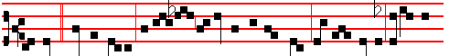
Today * Simon Peter as-cended the gibbet of the cross, alle- luia: today the

1724
his hand hath he hid me. Psalm 15 Domine, quis
Antiphon. And now, saith the Lord * that formed me from the womb to be his servant, I will also give thee for a light to the Gentiles, that thou mayest be my salvation unto t he end of the earth. Psalm 21 Domine, in virtute tua
Antiphon. Kings shall see * and arise, princes also shall worship the Lord thy God who hath chosen thee. Psalm 34 Benedicam Dominum.

 Elisabeth,the wife of Zacharias, brought forth a mighty son.
 John the Baptist, the Lord's forerunner.

The Lesson from the Holy Gospel according to S. Luke
Lesson vij Ch. 1
ELISABETH'S full time came that she should be delivered; and she brought forth a son. And her neighbours and her cousins heard how the Lord had shewed great mercy upon her; and they rejoiced with her. And the rest.
Homily by S. Ambrose, Bishop Bk. 2 on Luke Ch. 1
ELISABETH brought forth a son, and her neighbours rejoiced with her. The birth of the Saints is a source of joy to many, for it is a benefit to all; for righteousness is a communal virtue. And therefore in the birth of the righteous man a token of his future life is foreshown, and the grace of the virtue-to-be is indicated by the neighbours' prophetic joy. Now it is fitting that mention should be made of the time that the prophet was in the womb, lest the presence of Mary should be passed over; but nothing is said of his childhood, for he knew not the limitations of childhood. And thereefore in the Gospel we read of nothing more than his origin, the announcement, the leaping in the womb, the voice in the wilderness. .

 The Lord's Fore-runner cometh, of whom the Lord himself bore witness, saying: . * Among them that are born of women there hath not risena greater than John the Baptist.
 This is that prophet, and more than a prophet, of whom the Saviour said. Among.

Lesson viij
FOR he knew not the age of childhood, who transcending nature, transcending age, when still in his mother's womb, began with the measure of the age of the fulness of Christ. It is noteworthy that the Evangelist considered that it should be reported that many considered that the child should be called by the name of his father, Zacharias; so that you might notice that his mother would have none of the names of his kinsmen, but that one given him by the Holy Ghost which had been

1697
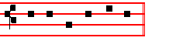
E u o u a e. Antiphon 4. Tone vij, 3
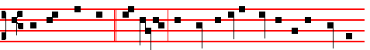
The Lord hath sent * his Angel, and hath delivered me out of the hand of
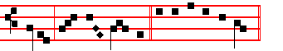
Herod, al- le- lu- ia. E u o u a e.
Antiphon 5. Tone vij, 1
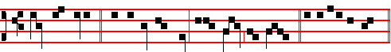
Thou art Peter, * and upon this rock I will build my Church. E u o u a e.
Chapter Acts 12
HEROD the king stretched forth his hands to vex certain of the church. And he killed James the brother of John with the sword. And because he saw it pleased the Jews, he proceeded further to take Peter also.
Hymn. E.H .226, vv. 3, 4, 6. Melody as above at Vespers, or: Mode iv
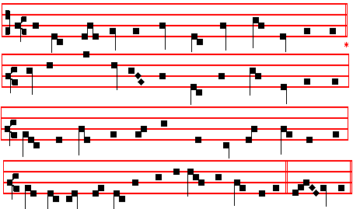

1722
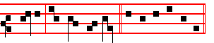
saying, His name is John. E u o u a e. Antiphon 3. Tone j, 1
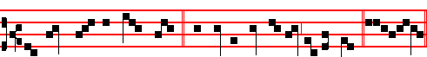
His name shall be called John: * and many shall rejoice at his birth. Eu o u a e.
Antiphon 4. Tone iij, 1
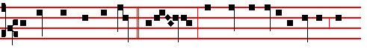
Among them that are born * of wom- en, there hath not risen a greater than
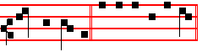
John the Baptist E u o u a e. Antiphon 5. Tone iij, 1
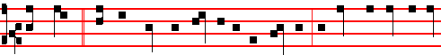
Thou, child, * shalt be called the prophet of the Highest; for thou shalt go before
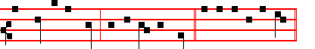
the face of the Lord, to prepare his ways. E u o u a e.
Chapter Isaiah 49
LISTEN, O isles, unto me; and hearken, ye people, from far; The Lord hath called me from the womb; from the bowels of my mother hath he made mention of my name.
Hymn O nimis felix Mode ij
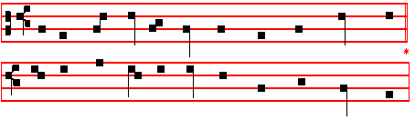
1699
time when she was ruling nearly every nation, was herself preserving all their errors; and in her own eyes she seemed to be most religious, because she rejected no false god. Hence, the more firmly she was held in the devil's bondage, so much the greater was the miracle of Christ's setting her free.

 Thou art the shepherd of the sheep; the Prince of the Apostles, and unto thee hath God given all the kingdoms of the world: * And therefore unto thee hath he given the keys of the kingdom of heaven.
 Whatsoever thou shalt bind on earth shall be bound in heaven: and whatsoever thou shalt loose on earth shall be loosed in heaven. And therefore. Glory be. And therefore.

IN THE THIRD NOCTURN
The Lesson from the holy Gospel according to S. Matthew
Lesson vij Ch. 16
WHEN Jesus came into the coasts of Cæsarea Philippi, he asked his disciples, saying, Whom do men say that I the Son of man am? And the rest.
Homily by S. Jerome, Priest Bk. 3 Comm. on Matt. 16, v. 13
WELL did he ask, Whom do men say that I the Son of man am? because those who speak of the Son of man are men; while those that discern his Divinity are called, not men, but gods. And they said: Some say that thou art John the Baptist, some Elias. I am sure that certain commentators seek the cause of each of these mistakes, and weave a lengthy argument as to why some should have thought our Lord Jesus Christ to have been John; some Elias; and others Jeremias, or one of the prophets; since they could have made the same mistake that Herod made concerning John, saying: It is John, whom I beheaded: he is risen from the dead: and therefore mighty works do shew forth themselves in him.

 Peter, I have prayed for thee, that thy faith fail not; * And when thou art converted, strengthen thy brethren.
 Flesh and blood hath not revealed it unto thee, but my Father which is in heaven. And when.

Lesson viij
BUT whom say ye that I am. Notice, careful reader, that according to the wording and context the Apostles arc called, not men, but gods. For when he said: Whom do men say that I the Son of man am? he added: But whom say ye that I am? They, because they are men hold a human opinion; ye, who are gods, who do ye think I am? Peter, in the name of all the Apostles, proclaims: Thou art the Christ. the Son of the living God. He calls him the living God to differentiate him from those other gods who are thought to be gods, but are dead.

1720
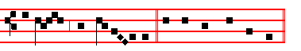
the God of Is- ra- el. Canticle Benedictus
COLLECT
O GOD, who hast made this day honourable to us by the nativity of blessed John: grant unto thy people the grace of spiritual joys; and direct the minds of all the faithful into the way of everlasting salvation. Through.

AT TERCE
Antiphon. They made signs, as above, p. 1698 .
Chapter Listen, O isles, as above.
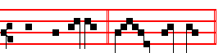
Short  There was a man. * Sent from God.
There was.
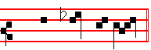
 Whose name was John. Sent from God.
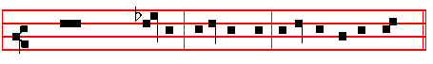
Glory be to the Father, and to the Son, and to the Holy Ghost.
There was.
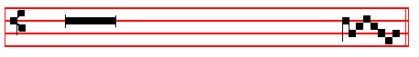
 Among them that are born of women there hath not risen a great-er.
 Than John the Bap- tist.

AT SEXT
Antiphon. His name shall be called John, as above, p. 1699
Chapter Isaiah 49
AND now, saith the Lord that formed me from the womb to be his servant: I will give thee for a light to the Gentiles, that thou mayest be my salvation

1701
captain over my people; * And I have given unto thee the keys of the kingdom of
heaven.
 Whatsoever thou shalt bind on earth shall be bound in heaven: and whatsoever thou shalt loose on earth shall be loosed in heaven. And I.

Lesson ij
THEN Peter said, Silver and gold have I none; but such as I have give I thee: In the name of Jesus Christ or Nazareth rise up and walk. And he took him by the right hand, and lifted him up: and immediately his feet and ankle bones received strength. And he leaping up stood, and walked, and entered with them into the temple, walking, and leaping, and praising God. And all the people saw him walking and praising God: and they knew that it was he which sat for alms at the Beautiful gate of the temple: and they were filled with wonder and amazement at that which had happened unto him.

 If thou lovest me, Simon Peter, feed my sheep. Lord; thou knowest that I love thee, * I will lay down my life for thy sake.
 If I should die with thee, I will not deny thee. I will.

Lesson ij
AND as the lame man which was healed held Peter and John, all the people ran together unto them in the porch that is called Solomon's, greatly wondering. And when Peter saw it, he answered unto the people, Ye men of Israel, why marvel ye at this? or why look ye so earnestly on us, as though by our own power or holiness we had made this man to walk? The God of Abraham, and of Isaac, and of Jacob, the God of our fathers, hath glorified his Son Jesus; whom ye delivered up, and denied him in the presence of Pilate, when he was determined to let him go. But ye denied the Holy One and the Just, and desired a murderer to be granted unto you; and killed the Prince of life, whom God hath raised from the dead; whereof we are witnesses. And his name through faith in his name hath made this man strong, whom ye see and know: yea, the faith which is by him hath given him this perfect soundness in the presence of you all.

 Thou art Peter, and upon this rock I will build my church; and the gates of hell shall not prevail against it. * And I will give unto thee the keys of the kingdom of heaven.
 Whatsoever thou shalt bind on earth shall be bound in heaven, and whatsoever thou shalt loose on earth shall be loosed in hcaven. And I. Glory be. And I.

IN THE SECOND NOCTURN
Sermon by S. Leo the Great

1718
On Magnificat, Antiphon. Tone vij, 2
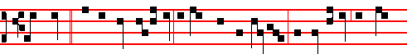
The child * that is born unto us is more than a prophet; for this is he of whom
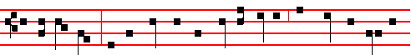
the Saviour saith: Among them that are born of women, there hath not risen a
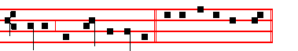
greater than John the Baptist. CAnticle Magnificat
__________________________________________________________________

The Twenty-fifth of June
Second Day within the Octave of the Nativity of Saint John.

In the first Nocturn Lessons from the occurrent Scripture.

IN THE SECOND NOCTURN
** Sermon bt Saint Maximus, Bishop.
Lesson iv Homily 66; 2 on the Nativity of S. John Baptist
THE memory of all the prophets, dearest brethren, is indeed to be venerated. Blessed John the Baptist, whose Nativity is honoured to-day, surpasses them all in glory so far that by the truth of his testimony being present he reveals not only that our Lord Jesus the Saviour was to come, but that he had come already and was dwelling with men; and when he had seen him draw near among the crowds to be baptized, he said, as if pointing him out with his finger: Behold the Lamb of God, which taketh away the sin of the world. How innocent his life, and with what devotion can we meetly praise his merit, who was the first to recognize the coming of the heavenly Lamb, and the only one to point him out. How wonderful is the heralding to all of him from whose lips the pure One first heard his own sinlessness proclaimed.

1703

**Lessons in the second and third Nocturns today taken from the Nocturns for today and tomorrow in the Monastic Breviary. Alternatively, those of the Octave Day, July 1, below, if for any reason they are not to be read on that day.
At Vespers, Antiphons of Lauds below. Psalms 110, 111, 112, 113, of Sunday,
and 117, as in I Vespers of Apostles.

Chapter Acts 12
HEROD the king stretched forth his hands to vex certain of the church. And he killed James the brother of John with the sword. And because he saw it pleased the Jews, he proceeded further to take Peter also.

Hymn Aurea luce et decore roseo Melody E.H. 226 / 174 or as below at Lauds.
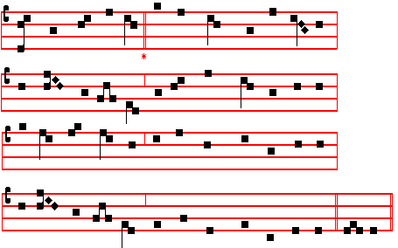

WITH golden splendour, and with roseate loveliness,
Thou didst illumine, Light of Light, the universe;
The heavens adorning with a glorious martyrdom
This day, which brtngeth pardon to the penitent.

2 Celestial Warder! earth's instructor eloquent!
The world's dread judges, lights mankind enlightening,
By cross triumphant, by the sword victorious,
Now are ye laurelled, Life's immortal senators.

3 O Rome, thrice happy, that so great a martyrdom
Thy walls empurpled with rich life-blood, halloweth:
Not thine the merit; by thy Princes' excellence
Thou shinest fairer than the world's magnificence.

1716
The Lesson from the Holy Gospel according to S. Luke Ch. 1, 57-80
ELISABETH'S full time came that she should be delivered; and she brought forth a son. And her neighbours and her cousins heard how the Lord had shewed great mercy upon her; they rejoiced with her. And the rest.
Sermon by S. Augustine, Bishop Hom. 291; On the Nativity of S. John Baptist
Lesson vij
I NEED not tell you what day we are celebrating to-day, for you all heard, when
the Gospel was read. To-day we receive S. John the Lord's Forerunner, the son of the childless, anouncing the son of the Virgin, and also the servant announcing his Lord. Because the God-man was to come by means of a virgin, a wondrous man, born of a barren woman, preceded him. lAnd when this wondrous man said that he was unworthy to unloose the latchet of his shoes, he was recognizing the God-man. Admire, then, John, as much as thou canst. It glorifies Christ that thou shouldest admire him. It glorifies Christ, I say, not that thou addest anything to Christ, but that thou art proficient in him.

 The Lord's Fore-runner cometh, of whom the Lord himself bore witness, saying: . * Among them that are born of women there hath not risena greater than John the Baptist.
 This is that prophet, and more than a prophet, of whom the Saviour said. Among.

Lesson viij
ADMIRE, then, John, as much as thou canst. Ye have heard at what it is that thou dost wonder; he was foretold by an Angel to his falher the priest: the Angel took away speech from the incredulous father; he remains dumb, waiting for speech at the birth of his son. The sterile conceives, the old woman conceives, there is double infecundity: barrenness and age. The Angel says what manner of child it shall be; what was said is accomplished in him; and, most marvellous of all, he is filled with the Holy Spirit even from his mother's womb. For when holy Mary comes he exults in the womb, and salutes by his movement, him whom he could not salute by words. At his birth he gives a voice to his father; his father, speaking, gives a name to his son; all wonder at so much grace. For what else is it but grace? For where was John when he merited God? Where did he merit God before he who was merited was born? O grace given to graces!

 The Angel Gabriel appeared unto Zacharias, and said to him: Thy wife Elisabeth shall bear thee a son, and thou shalt call his name John. * And many shall rejoice at his birth.
 He shall be great in the sight of the Lord, and shall drink neither wine nor strong drink. And many. Glory be. And many.

1705
COLLECT
O GOD, who hast counted the blessed Bishop Leo worthy to be among thy Saints: mercifully grant; that we, who keep feast in his memory, may also follow the example of his life. Through.
Then commemoration is made of the Octave of S. John.

In the first Nocturn Lessons from the occurrent Scripture.

IN THE SECOND NOCTURN
Lesson iv
POPE Leo the Second, a Sicilian, was educated in human and divine literature in Greek and Latin, and also learned in music: for he restored the sacred Hymns and Psalms in the Church to a better musical order. He confirmed the acts of the Sixth Council, which was held at Constantinople, under the legates of the Apostolic See, in the presence also of the Emperor Constantine, and two Patriarchs, of Constantinople and of Antioch, and a hundred and seventy Bishops: and he also translated it into Latin.

 I have found David my servant, with my holy oil have I anointed him: * My hand shall hold him fast.
 The enemy shall not be able to do him violence, the son of wickedness shall not hurt him. My hand.

Lesson v
IN THAT Council Cyrus, Sergius, and Pyrrhus were condemned for preaching only one will and operation in Christ. He curbed the pride of the Bishops of Ravenna who, relying on the power of Exarchs, did mot submit to the apostolic See. Therefore he decreed that the election by the clergy of Ravenna would be invalid unless it were confirmed by the authority of the Roman Bishop.

 I have laid help upon one that is mighty: I have exalted one chosen out of the
people: * My hand shall hold him fast.
 I have found David my servant, with my holy oil have I anointed him: My hand.

Lesson vj
HE was a true father of the poor: for he relieved the poverty and solitude of poor widows and orphans not only with money, but by deeds, labour, and counsel. And as he exhorted each one as much by his life as by preaching to devout and holy living, he fell asleep in the Lord, in the tenth month, and seventeenth day, of his Pontificate: and was buried in the Basilica of Saint Peter,

1714
WE beseech thee, almighty God: that, as their faith and passion did cause blessed John and Paul to be brothers indeed; so this day's festival may bestow upon us a twofold gladness in their glory. Through.
Then commemoration of the Octave of S. John. Antiphon.The child. p. 1783  This child, p. 1782, Collect O God, who hast made., p. 1781

AT MATINS
All from the Common of many Martyrs , p. xlvij, except the following.
In the first Nocturn, Lessons Brethren, we are debtors, p. l.

 j. These are two men of mercy, who stand before the Lord. * The Ruler of the whole earth.
 These are two olive-trees, and two candle-sticks giving light before the Lord. The Ruler.

 ij. I saw men joined together, having splendid garments, and the Angel of the Lord spake to me, saying: * These are holy men, who have become the friends of God.
 I saw a mighty Angel of God, flying through the midst of heaven, crying with a loud voice, and saying. These are.

 iij. They gave up their bodies to be punished for God's sake, * And gained everlasting crowns.
 These are they which came out of great tribulation, and have washed their
robes in the blood of the Lamb. And gained. Glory be. And gained.

IN THE SECOND NOC'IURN
Lesson iv
JOHN and Paul, brothers of Rome, gave to the poor of Christ the riches left to them by Constantia, Constantine's daughter, whom they had piously and faithfully served. Being invited by Julian the Apostate to enter his household, they boldly said that they had no wish to be with one who had forsaken Jesus Christ. And he appointed them ten days to deliberate, knowing that unless they gave him their allegiance on that day, and decided to sacrifice to Jupiter, they would certainly have to die.

 Thy Saints, O Lord, have passed a wonderful way, serving thy peculiar commandments that were given unto them, that thy children might be found without hurt. * Dry land appeared, and out of the Red Sea a way without impediment.
 For he smote the stony rock indeed, that the waters gushed out and the streams flowed withal. Dry land.
1707
repentance, in it baptizing unto repentance in water. The voice is mighty in operation, saying: Repent ye, for the kingdom of heaven is at hand; and, Bring. forth fruits worthy of repentance.

 This is the beloved Forerunner, a burning and shining light before the Lord: * For verily this is John who made straight in the desert a highway for our God, and, moreover, bore witness unto the Lamb of God, and enlightened the minds of men.
 He shall go before him in the spirit and power of Elias. For verily.

Lesson vj
THE voice of the Lord breaketh the cedar-trees. This may be interpreted, that by preparing a people ready for the Lord, and breaking the wickednesses that had risen up and exalted themselves against the knowledge of God, he made the crooked things straight. For he who laid every mountain and hill low, he it was who broke the cedar-trees, and prepared the way of the Lord, in that he led the high, and lofty, and proud heart to repentance. Hence the Lord, taking up his preparation, by his coming broke the opposing powers, the cedars of Lebanon, figuratively speaking. For the Lord must reign, until he hath put all enemies under his feet, and crushed those cedar-trees.

 They made signs to his father, how he would have him called. And he asked for a writing table, and wrote, saying: * His name is John.
 The mouth of Zacharias was opened, and he prophesied, saying. His name. Glory be. His name.

IN THE THIRD NOCTURN
The Lesson from the holy Gospel according to Luke.
Lesson vij Ch. 1
ELISABETH'S full time came that she should be delivered; and she brought forth a son. And her neighbours and her cousins heard how the Lord had shewed great mercy upon her; and they rejoiced with her. And the rest.
From the Homily of S. Ambrose, Bishop. Bk. 2 on Luke, Ch 1, end
AND Zacharias his father was filled with the Holy Ghost, and prophesied. See how good God is, and ready to forgive sins. He not only restores what was taken away, but also gives what was not hoped for. He prophesies while still dumb. For this is the very great grace of God, that he confesses him whom he had denied. Therefore let no one be diffident, let no one, conscious of old offences, despair of the divine rewards. The Lord knows now to change his sentence, if thou know how to amend thine offence.

 The Lord's Fore-runner cometh, of whom the Lord himself bore witness,

1712
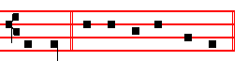
and earth. Psalm 93 Dominus regnavit, and the rest, p. 28.
Antiphon 2. Tone viij, 2
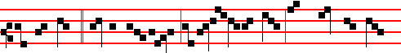
Paul and John * said to Terentianus: If Julian be thy Lord, have peace with him:
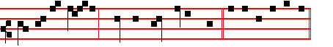
ours is none other, than the Lord Jesus Christ. E u o u a e.
Antiphon 3. Tone j, 1 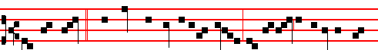
John and Paul * perceived the tyranny of Juli-an, and began to distribute their
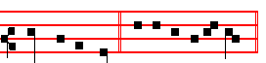
goods to the poor. E u o u a e. Antiphon 4. Tone j, 4
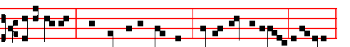 O ye spirits * and souls of the righteous, sing a hymn unto God, alle-luia.
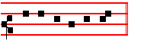
E u o u a e. Antiphon 5. Tone j, 1
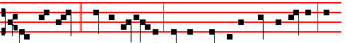
John and Paul * said to Gallicanus; Pay thy vows to the Lord of heaven, and thou

1709

