Augustine wrote, become from the richest of men willingly the poorest, but most rich in holiness, he was captured by the barbarians, and thus prayed to God: Lord, let me not be tortured for gold and silver: for where all my goods are, thou knowest. But later, when the Vandals invaded those parts, when a widow asked him to redeem her son, as he had used up all his means in the work of charity, he gave himself into slavery in his stead.

Lesson iij
SO he went to Africa, and began to till the garden of his master, who was the king's son-in-law. But by a prophetic gift he predicted the king's death to his master, and the king, in a dream, saw Paulinus, sitting in the midst between two judges, and taking a whip from his royal hands. So, being recognised for a man of such importance, he was given a most honourable discharge, and all his fellow-citizens, who had been slaves, were set free with him. He returned to Nola, to his episcopal duties, and incited all by word and example to christian devotion, until he was laid low with pleurisy. After a while, the bed in which he lay was shaken by an earthquake, and shortly afterwards he gave up his soul to God.
Te Deum Laudamus, p. 24.
__________________________________________________________________

The Twenty-third of June
On the Vigil of S. John the Baptist

The Lesson from the Holy Gospel according to S. Luke
Lesson j Ch. 1, 5-17
THERE was in the days of Herod, the king of Judrea, a certain priest named Zacharias, of the course of Abia: and his wife was of the daughters of Aaron, and her name was Elisabeth. And the rest.

Homily by S. Ambrose, Bishop Bk. 1 on Luke Ch. 1, v. 15
HOLY Scripture teaches us to praise not only those who are worthy of honour, but their parents as well; in order. as it were, that the inheritance of spotless purity which is passed on to those whom we desire to praise might shine the brighter. For what other intention had the holy Evangelist in this place but to make S. John the Baptist noble in his parentage as well as in his miracles, way of life, office, and passion? So, likewise, is Hannah the mother of Samuel praised; so did Isaac receive from his parents that nobility of godliness which he bequeathed to his descendants. Therefore Zacharias the priest was not only a priest, but was of thc course of Abia, that is, noble even among noble families.

 of the occurrent Feria.

1689
Lesson ij
AND his wife, says the Evangelist, was of the daughters of Aaron. Therefore the nobility of S. John was derived not only from his parents, but from his ancestors as well, who were not distinguished as regards worldly power, but who were venerable in their religious succession. For it behoved the Forerunner of Christ to have such ancestors; that it might be seen that his preaching the faith of the Lord's coming was not a sudden conception, but had been received and infused into him by the law of nature. And, says the Evangelist, They were both righteous before God, walking in all the commandments and ordinances of the Lord blameless. What do they make of this, who, to console themselves for their own sins, consider it impossible for man to be without frequent sin, and who make use of that sentence in the Book of Job: Not one is clean, even though his life on earth be but one day?

Lesson iij
WE must answer them first, What do they mean by a man without sin: whether they mean one who has never sinned at all, or one who has ceased to sin. For if they consider that to be without sin is never to havc sinned at all, then I agree with them. For all have sinned, and come short of the glory of God. But if they deny that a man can avoid wrong-doing who has corrected his former fault and transformed the quality of his life in such a way that he can refrain from sin; I cannot agree with their opinion, since we read: Christ so loved the church, that he might present it to himself a glorious church, not having spot, or wrinkle, or any such thing: but that it should be holy and without blemish.

Antiphon on Benedictus, as in the Psalter, and the ferial prayers, kneeling.

COLLECT

GRANT, we beseech thee, almighty God: that thy family may walk in the way of salvation; and, following the teachings of blessed John the Forerunner, may attain in safety unto him whom he foretold, Jesus Christ thy Son, our Lord: Who liveth.

¶ Note that if on the following day, the 24th, there occur the solemnity of the Most Holy Body of Christ ,the Office is to be of the said Solemnity. And then the Feast of S. John Baptist is to be observed on the 25th, as if on its own day, and any other Double Feast, if it ever occurs, is to be transferred after the Octave: but if it be of the I or II Class, it is transferred to the first day not impeded by a double Office, even within the Octave of the SS. Corpus Christi.

1690
THE TWENTY-FOURTH OF JUNE
THE NATIVITY OF SAINT JOHN THE BAPTIST
DOUBLE OF THE FIRST CLASS WITH OCTAVE

AT VESPERS
Antiphon 1. Tone vij, 3
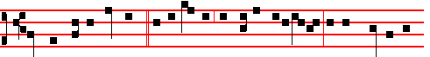
He shall go before him * in the spirit and power of E-li-as, to make ready a
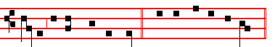
people prepared for the Lord. Psalms 110, 111, 112, 113, 117, as in I Vespers of Apostles. Antiphon 2. Tone viij, 1
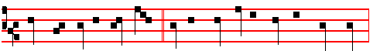
Thou shalt call his name John: * he shall drink neither wine nor strong drink:
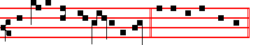
and many shall rejoice at his birth. E u o u a e.
Antiphon 3. Tone j. 1
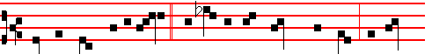
From the womb of the aged * and barren was brought forth John, the Lord's
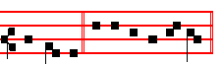
Forerunner. E u o u a e. Antiphon 4. Tone vij, 3
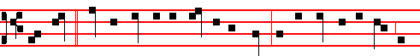
This child * shall be great in the sight of the Lord: for the hand of the Lord is

1691
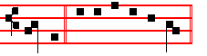
with him. E u o u a e. Antiphon 5. Tone v
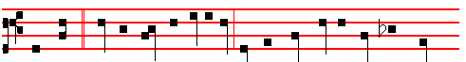 This child * shall be called a Nazarite, he shall drink neither wine nor strong
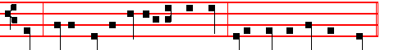
drink;. neither shall he eat any unclean thing, even from his mother's womb.
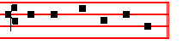
E u o u a e.
Chapter Is. 49
LISTEN, O isles, unto me; and hearken, ye people, from far; The Lord hath called me from the womb; from the bowels of my mother hath he made mention of my name.
The following melody, or that given below at Lauds, serves for the three Hymns.
Hymn E.H. 223 Ut queant laxis Mode j
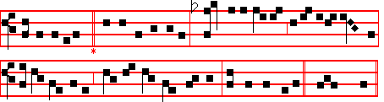
Let thine example, holy John, remind us,
Ere we can meetly sing thy deeds of wonder,
Hearts must be chastened, and the bonds that bind us, Broken asunder!

2 Lo! a swift Angel, from the skies' descending,
Tells to thy father, what shall be thy naming;
All thy life's greatness to its bitter ending Duly proclaiming.

3 But when hc doubted what the Angel told him
Came to him dumbness to confirm the story;
At thine appearing, healed again behold him, Chanting thy glory!
1692

4 Oh! what a splendour and a revelation
Came to each mother, at thy joyful leaping,
Greeting thy Monarch, King of every nation, In the womb sleeping.

5 Angels in orders everlasting praise thee,
God, in thy triune Majesty tremendous;
Hark to the prayers we, penitents, upraise thee: Save and defend us. Amen.
 There was a man sent from God.  Whose name was John.
On Magnificat, Antiphon Tone viij, 1 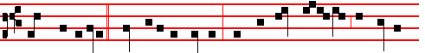
When Zacharias * went into the temple, there appeared unto him the Angel
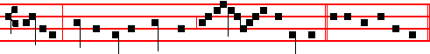
Gabriel, standing on the right hand of the al- tar of incense. Cant. Magnificat

COLLECT
O GOD, who hast made this day honourable to us by the nativity of blessed John: grant unto thy people the grace of spiritual joys; and direct the minds of all the faithful into the way of everlasting salvation. Through.

AT MATINS

Invitatory.- The Lord, the King of the Forerunner, * O come, let us worship. Psalm 95 Venite
Hymn E. H. 224, Antra deserti but with v. 3 as below.

E'EN in thy childhood, 'mid the desert places,
Thou hadst a refuge from the city gainèd,
Far from all slander and its bitter traces Living unstainèd

2 Often had prophets in the distant ages
Sung to announce the Daystar and to name him;
But as the Saviour, last of all the sages, Thou didst proclaim him.

3 Camel's hair raiment clothed thy saintly members,
Leathern the girdle which thy loins encircled.
Locusts and honey, with the fountain-water, Daily sustained thee.

1693
4 Than John the Baptist, none of all Eve's daughters
E'er bore a greater, whether high or lowly:
He was thought worthy, washing in the waters Jesus the holy.

5 Angels in orders everlasting praise thee,
God, in thy triune Majesty tremendous;
Hark to the prayers we, penitents, upraise thee: Save and defend us. Amen.

IN THE FIRST NOCTURN

Antiphon. Before I formed thee in the belly * I knew thee; and before thou camest forth out of the womb I sanctified thee. Psalms from the Common of a Confessor Bishop, except the last, as below. Psalm 1 Beatus Vir
Antiphon. Thou shalt go to all * that I shall send thee, saith the Lord: Be not afraid, and whatsoever I command thee thou shalt speak. Psalm 2 Quare fremuerunt
Antiphon. Be not afraid * of their faces: for I am with thee, saith the Lord. Psalm 3 Domine, quid.

 There was a man sent from God.  Whose name was John.
The Beginning of the Book of the Prophet Jeremiah
Lesson j Ch. 1, 1-10
THE words of Jeremiah the son of Hilkiah, of the priests that were in Anathoth in the land of Benjamin: to whom the word of the Lord came, in the days of Josiah the son of Amon king of Judah, in the thirteenth year of his reign. It came also in the days of Jehoiakim the son of Josiah king of Judah, unto the end of the eleventh year of Zedekiah the son of Josiah king of Judah, unto the carrying away of Jerusalem captive in the fifth month. Then the word of the Lord came unto me, saying. Before I formed thee in the belly I knew thee; and before thou camest forth out of the womb I sanctified thee, and I ordained thee a prophet unto the nations.

 There was a man sent from God whose name was John: * The same came for a witness to bear witness of the light, and to make ready a people prepared for the Lord.
 John was in the wilderness preaching the baptism of repentance. The same.

Lesson ij
THEN said I, Ah; Lord God!I behold, I cannot speak: for I am a child. But the Lord said unto me, Say not, I am a child: for thou shalt go to all that I shall send thee, and whatsoever I command thee thou shalt speak. Be not afraid of their faces: for I am with thee to deliver thee, saith the Lord. Then the Lord put forth

1694
his hand, and touched my mouth. And the Lord said unto me, Behold, I have put my words in thy mouth. See, I have this day set thee over the nations and over the kingdoms, to root out, and to pull down, and to destroy, and to throw down, to build, and and to plant.

 Elizabeth, the wife of Zachariah, brought forth a mighty son, John the Baptist, the Lord's forerunner: * Who made straight in the desert a highway for our God.
 There was a man sent from God whose name was John. Who made.

Lesson iij
THOU therefore gird up thy loins, and arise, and speak unto them all that I command thee: be not dismayed at their faces, lest I confound thee before them. For, behold, I have made thee this day a defenced city, and an iron pillar, and brasen walls against the whole land, against the kings of Judah, against the princes thereof, against the priests thereof, and against the people of the land. And they shall fight against thee; but they shall not prevail against thee; for I am with thee, saith the Lord, to deliver thee.

 Before I formed thee in the belly I knew thee; and before thou camest forth out of the womb I sanctified thee: * And I ordained thee a prophet unto the nations.
 Beloved of God and men, whose memorial is blessed. And I. Glory be. And I.

IN THE SECOND NOCTURN
Antiphon. The Lord * put forth his hand, and touched my mouth; and the Lord ordained me a prophet unto the nations. Psalm 4 Cum invocarem
Antiphon. Behold, * I have put my words into thy mouth. See, I have this day set thee over the nations and over the kingdoms. Psalm 5 Verba mea
Antiphon. The Lord hath called me * from the womb: from the bowels of my mother hath he made mention of my name. Psalm 8 Domine Dominus noster
 Among them that are born of women there hath not risen a greater.
 Than John the Baptist.
Sermon of Saint Augustine, Bishop.
Lesson iv Sermon 20 on the Saints.
AFTER that most holy birthday of the Lord, we do not read of the birthday of any man being celebrated, except that of blessed John the Baptist. In the case of other saints and elect of God, we know that that day is honoured on which, when their works were accomplished and the world conquered and completely subdued, they were born from this present life into the everlasting life of eternity. In others we honour the completed merits of their last day; in this present case, the first day, and the very beginning, of this man is holy; doubtless for this reason, that the Lord wished his coming to be attested, lest if he came suddenly and

1695
unexpectedly, men might not recognize him. But John was a figure of the old Testament, and typified the law in himself; and therefore John foretold the Saviour, just as the law preceded grace.

 The Angel of the Lord came down to Zacharias, saying: Receive a son in thine old age: * And his name shall be called John the Baptist.
 This child shall be great in the sight of the Lord, for his hand is with him. And his.

Lesson v
WHEN not yet born, he prophesied from the hiding-place of his mother's womb, and already bore witness to the truth though himself being without light. This is to be understood, that, hidden under the veil and flesh of the letter, by the spirit he preached the Redeemer to the world, and proclaimed our Lord to us as from the womb of the Law. Therefore, because the Jews went astray from the womb, that is, from the Law which was pregnant with Christ, they went astray from the womb, speaking lies; and so John came for a witness, to bear witness of the light.

 This is the beloved Forerunner, a burning and shining light before the Lord: * For verily this is John who made straight in the desert a highway for our God, and, moreover, bore witness unto the Lamb of God, and enlightened the minds of men.
 He shall go before him in the spirit and power of Elias. For verily.

Lesson vj
JOHN, from prison, directs his disciples to Christ. So the Law points on to the Gospel. The same Law is typified by John, enclosed as it were in the prison of ignorance, lying in the dark in a hidden place, and held captive in the letter by Jewish blindness. Of him the blessed Evangelist proclaims: He was a shining light, that is, he was enkindled by the fire of the Holy Spirit, that to a world held in the night of ignorance he might show forth the light of salvation, and amid the thickest darkness of sin might by his ray point out the most resplendent Sun of righteousness, saying of himself: I am the voice of one crying in the wilderness.

 They made signs to his father, how he would have him called. And he asked for a writing table, and wrote, saying: * His name is John.
 The mouth of Zacharias was opened, and he prophesied, saying. His name. Glory be. His name.

IN THE THIRD NOCTURN
Antiphon. The Lord * hath made my mouth like a sharp sword: in the shadow of

1696
his hand hath he hid me. Psalm 15 Domine, quis
Antiphon. And now, saith the Lord * that formed me from the womb to be his servant, I will also give thee for a light to the Gentiles, that thou mayest be my salvation unto t he end of the earth. Psalm 21 Domine, in virtute tua
Antiphon. Kings shall see * and arise, princes also shall worship the Lord thy God who hath chosen thee. Psalm 34 Benedicam Dominum.

 Elisabeth,the wife of Zacharias, brought forth a mighty son.
 John the Baptist, the Lord's forerunner.

The Lesson from the Holy Gospel according to S. Luke
Lesson vij Ch. 1
ELISABETH'S full time came that she should be delivered; and she brought forth a son. And her neighbours and her cousins heard how the Lord had shewed great mercy upon her; and they rejoiced with her. And the rest.
Homily by S. Ambrose, Bishop Bk. 2 on Luke Ch. 1
ELISABETH brought forth a son, and her neighbours rejoiced with her. The birth of the Saints is a source of joy to many, for it is a benefit to all; for righteousness is a communal virtue. And therefore in the birth of the righteous man a token of his future life is foreshown, and the grace of the virtue-to-be is indicated by the neighbours' prophetic joy. Now it is fitting that mention should be made of the time that the prophet was in the womb, lest the presence of Mary should be passed over; but nothing is said of his childhood, for he knew not the limitations of childhood. And thereefore in the Gospel we read of nothing more than his origin, the announcement, the leaping in the womb, the voice in the wilderness. .

 The Lord's Fore-runner cometh, of whom the Lord himself bore witness, saying: . * Among them that are born of women there hath not risena greater than John the Baptist.
 This is that prophet, and more than a prophet, of whom the Saviour said. Among.

Lesson viij
FOR he knew not the age of childhood, who transcending nature, transcending age, when still in his mother's womb, began with the measure of the age of the fulness of Christ. It is noteworthy that the Evangelist considered that it should be reported that many considered that the child should be called by the name of his father, Zacharias; so that you might notice that his mother would have none of the names of his kinsmen, but that one given him by the Holy Ghost which had been

1697
foretold to Zacharias by the Angel. And, being dumb, he could not tell his wife his son's name; but Elisabeth learned through prophecy what she had not learned from her husband.

 The Angel Gabriel appeared unto Zacharias, and said to him: Thy wife Elisabeth shall bear thee a son, and thou shalt call his name John. * And many shall rejoice at his birth.
 He shall be great in the sight of the Lord, and shall drink neither wine nor strong drink. And many. Glory be. And many.

Lesson ix
JOHN, she said, is his name; that is, it is not for us to give a name to him who has already received a name from God. For he has his name, which we have acknowledged, but which we have not chosen. To receive a name from God is one of the merits of the Saints. Thus Jacob was called Israel, because he saw God face to face. Thus our Lord Jesus was named before he was born; not the Angel, but the Father gave him his Name. Notice that the Angels declare what they hear, and not what they take upon themselves. And be not surprised that the woman declared what she did not hear, when the Holy Spirit revealed what he had told the Angel.
Te Deum Laudamus, p. 24.

AT LAUDS, AND THROUGH THE HOURS

Antiphon 1. Tone iij, 1
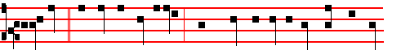
Elisabeth, * the wife of Zacharias , brought forth a mighty son, John the Bap-
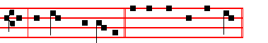
tist, the Lord's Forerunner. Psalm 93 Dominus regnavit, and the rest, p. 28.
Antiphon 2. Tone iv, 1
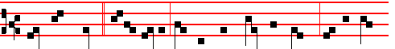
They made signs * to his father, how he would have him called: and he wrote,

1698
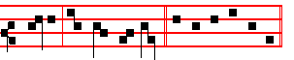
saying, His name is John. E u o u a e. Antiphon 3. Tone j, 1
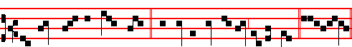
His name shall be called John: * and many shall rejoice at his birth. Eu o u a e.
Antiphon 4. Tone iij, 1
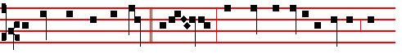
Among them that are born * of wom- en, there hath not risen a greater than
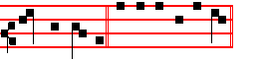
John the Baptist E u o u a e. Antiphon 5. Tone iij, 1
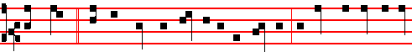
Thou, child, * shalt be called the prophet of the Highest; for thou shalt go before
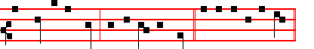
the face of the Lord, to prepare his ways. E u o u a e.
Chapter Isaiah 49
LISTEN, O isles, unto me; and hearken, ye people, from far; The Lord hath called me from the womb; from the bowels of my mother hath he made mention of my name.
Hymn O nimis felix Mode ij
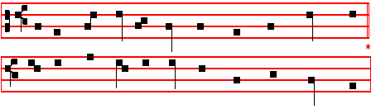
1699
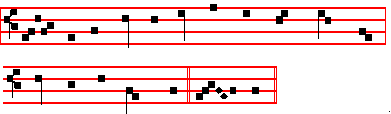
(or as at Vespers above)
O MORE than blessed, merit high attaining,
Pure as the snow-drift, innocent of evil,
Child of the desert, mightiest of martyrs,
Greatest of prophets.

Thirty-fold increase some with glory crowneth;
Sixty-fold fruitage prize for others winneth;
Hundred-fold measure, thrice repeated, decks thee,
Blest one, for guerdon.

O may the virtue of thine intercession,
All stony hardness from our hearts expelling,
Smooth the rough places, and the crooked straighten
Here in the desert.

Thus may our gracious Maker and Redeemer,
Seeking a station for his hallow'd footsteps,
Find, when he cometh, temples undefiled,
Meet to receive him.

Angels in orders everlasting praise thee,
God, in thy triune Majesty tremendous;
Hark to the prayers we, penitents, upraise thee:
Save and defend us. Amen.

 This child shall be great in the sight of the Lord.
 For the hand of the Lord is with him.
On Benedictus, Antiphon. Tone viij, 1
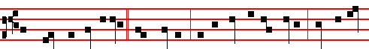
The mouth of Zacharias * was opened, and he prophesied, saying: Blessed be

1700
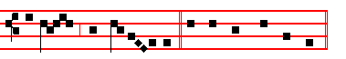
the God of Is- ra- el. Canticle Benedictus
COLLECT
O GOD, who hast made this day honourable to us by the nativity of blessed John: grant unto thy people the grace of spiritual joys; and direct the minds of all the faithful into the way of everlasting salvation. Through.

AT TERCE
Antiphon. They made signs, as above, p. 1698 .
Chapter Listen, O isles, as above.
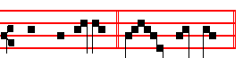
Short  There was a man. * Sent from God.
There was.
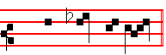
 Whose name was John. Sent from God.
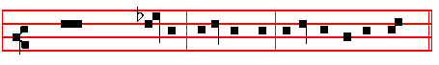
Glory be to the Father, and to the Son, and to the Holy Ghost.
There was.
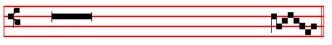
 Among them that are born of women there hath not risen a great-er.
 Than John the Bap- tist.

AT SEXT
Antiphon. His name shall be called John, as above, p. 1699
Chapter Isaiah 49
AND now, saith the Lord that formed me from the womb to be his servant: I will give thee for a light to the Gentiles, that thou mayest be my salvation

1701
unto the end of the earth.
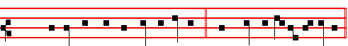
Short  Among them that are born of women. * There hath not ris-en a greater.
Among them.
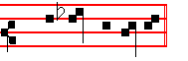
 Than John the Baptist. There hath not. Glory be.
Among them.
 Elisabeth, the wife of Zacharias, brought forth a mighty son.
 John the Baptist, the Lord's forerunner.

AT NONE
Antiphon. Thou, child, p. 1699..
Chapter Isaiah 49
KINGS shall see and arise, princes also shall worship the Lord thy God, and the Holy One of Israel,who hath chosen thee.
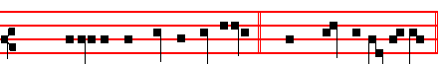
Short  Elisabeth, the wife of Zacharias. * Brought forth a migh-ty son.
Elisabeth.
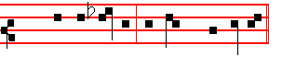
 John the Baptist, the Lord's Fore-runner.
Brought forth. Glory be.
Elisabeth.
 This child shall be great in the sight of the Lord.
 For the hand of the Lord is with him.

AT VESPERS
Antiphons and Chapter of Lauds. Psalms and Hymn as in I Vespers.
 This child sha.ll be great in the sight of the Lord.
 For the hand of the Lord is with him.

1702
On Magnificat, Antiphon. Tone vij, 2
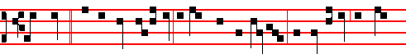
The child * that is born unto us is more than a prophet; for this is he of whom
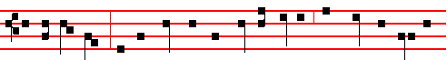
the Saviour saith: Among them that are born of women, there hath not risen a
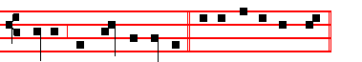
greater than John the Baptist. CAnticle Magnificat
__________________________________________________________________

The Twenty-fifth of June
Second Day within the Octave of the Nativity of Saint John.

In the first Nocturn Lessons from the occurrent Scripture.

IN THE SECOND NOCTURN
** Sermon bt Saint Maximus, Bishop.
Lesson iv Homily 66; 2 on the Nativity of S. John Baptist
THE memory of all the prophets, dearest brethren, is indeed to be venerated. Blessed John the Baptist, whose Nativity is honoured to-day, surpasses them all in glory so far that by the truth of his testimony being present he reveals not only that our Lord Jesus the Saviour was to come, but that he had come already and was dwelling with men; and when he had seen him draw near among the crowds to be baptized, he said, as if pointing him out with his finger: Behold the Lamb of God, which taketh away the sin of the world. How innocent his life, and with what devotion can we meetly praise his merit, who was the first to recognize the coming of the heavenly Lamb, and the only one to point him out. How wonderful is the heralding to all of him from whose lips the pure One first heard his own sinlessness proclaimed.

1703

**Lessons in the second and third Nocturns today taken from the Nocturns for today and tomorrow in the Monastic Breviary. Alternatively, those of the Octave Day, July 1, below, if for any reason they are not to be read on that day.
 The Angel of the Lord came down to Zacharias, saying: Receive a son in thine old age: * And his name shall be called John the Baptist.
 This child shall be great in the sight of the Lord, for his hand is with him. And his.

Lesson v
THIS is he, beloved, of whom it was foretold by prophetic revelation: The voice of one crying in the wilderness, Prepare ye the way of the Lord, make straight a highway for our God. For he was to cry, even as he did cry, that by the loud heralding of salvation the heavenly preaching should open the long-closed ears of mortal men: Who therefore would not receive such a prophet with all wonder whom he recognizes to have obtained from God so great favour that his merits were praised even before his birth took place?

 This is the beloved Forerunner, a burning and shining light before the Lord: * For verily this is John who made straight in the desert a highway for our God, and, moreover, bore witness unto the Lamb of God, and enlightened the minds of men.
 He shall go before him in the spirit and power of Elias. For verily.

Lesson vj
THIS man, therefore, through the care of God and by an Angel, was promised in future birth to the most righteous priest, Zacharias, who had reached a great age, and who had despaired, because of the barrenness of his aged consort, that the promised offspring should come forth. And well it was that the new-born son should be given to very old parents, for he was to show the only-begotten Son of God, the hope of future generations, to a world growing old in sin. With how much wonder are we to behold the fact that Zacharias himself, when he could hardly believe that the Forerunner of the Word of Salvation was to be conceived in an aged womb, was struck dumb with sudden silence, and did not receive back the power of speech until, on being asked by what name the child should be called, the bonds of his closed mouth were relaxed. So it happened, that the priest's mouth, which the trembling doubt had fast closed, was set free by the merit of the new-born son, so that, the speech restored to the father might testify to the glory of the babe.

 They made signs to his father, how he would have him called. And he asked for a writing table, and wrote, saying: * His name is John.
 The mouth of Zacharias was opened, and he prophesied, saying. His name. Glory be. His name.

IN THE THIRD NOCTURN

1704
The Lesson from the Holy Gospel according to S. Luke Ch. 1, 57-80
ELISABETH'S full time came that she should be delivered; and she brought forth a son. And her neighbours and her cousins heard how the Lord had shewed great mercy upon her; they rejoiced with her. And the rest.
Sermon by S. Augustine, Bishop Hom. 291; On the Nativity of S. John Baptist
Lesson vij
I NEED not tell you what day we are celebrating to-day, for you all heard, when
the Gospel was read. To-day we receive S. John the Lord's Forerunner, the son of the childless, anouncing the son of the Virgin, and also the servant announcing his Lord. Because the God-man was to come by means of a virgin, a wondrous man, born of a barren woman, preceded him. lAnd when this wondrous man said that he was unworthy to unloose the latchet of his shoes, he was recognizing the God-man. Admire, then, John, as much as thou canst. It glorifies Christ that thou shouldest admire him. It glorifies Christ, I say, not that thou addest anything to Christ, but that thou art proficient in him.

 The Lord's Fore-runner cometh, of whom the Lord himself bore witness, saying: . * Among them that are born of women there hath not risena greater than John the Baptist.
 This is that prophet, and more than a prophet, of whom the Saviour said. Among.

Lesson viij
ADMIRE, then, John, as much as thou canst. Ye have heard at what it is that thou dost wonder; he was foretold by an Angel to his falher the priest: the Angel took away speech from the incredulous father; he remains dumb, waiting for speech at the birth of his son. The sterile conceives, the old woman conceives, there is double infecundity: barrenness and age. The Angel says what manner of child it shall be; what was said is accomplished in him; and, most marvellous of all, he is filled with the Holy Spirit even from his mother's womb. For when holy Mary comes he exults in the womb, and salutes by his movement, him whom he could not salute by words. At his birth he gives a voice to his father; his father, speaking, gives a name to his son; all wonder at so much grace. For what else is it but grace? For where was John when he merited God? Where did he merit God before he who was merited was born? O grace given to graces!

 The Angel Gabriel appeared unto Zacharias, and said to him: Thy wife Elisabeth shall bear thee a son, and thou shalt call his name John. * And many shall rejoice at his birth.
 He shall be great in the sight of the Lord, and shall drink neither wine nor strong drink. And many. Glory be. And many.

1705
Lesson ix
ALL wonder, and are filled with amazement, and say in the movements of their hearts that which has been read, that it may be written for us: What manner of child shall this be? And the hand of the Lord is with him. He exceeds the measure of human nature. Children we know; but what manner of child shall this be? The hand of the Lord is with him. That the hand of the Lord is with him we know already, but what he shall be we know not. He shall be great indeed, who as so great began. What shall he be who, while yet so tiny, was so much? Human weakness is dumb, the hearts of those who consider these things are awestruck. What manner or child shall this be? He shall be great, but what shall he be, who is greater yet? John is great, but what shall he be who is greater than the great one? If he, who only began to be, shall be so great, what shall he be, who had been already?
Te Deum Laudamus, p. 24.
Vespers of the following, with commemoration of the Octave.
__________________________________________________________________

THE TWENTY-SIXTH OF JUNE
ON THE FEAST OF SS. JOHN AND PAUL, MARTYRS
DOUBLE

All from the Common of Many Martyrs, xlvij, except the following.
Antiphons from Lauds below. Psalms 110, 111, 112, 113 of Sunday and 117, as in the I Vespers of Apostles.
Chapter, Hymn and  from the Common of Many Martyrs, pp. xlvij, xlviij.
On Magnificat, Antiphon. Tone j, 2
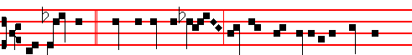
The righteous * stood before the Lord, and were not separated one from
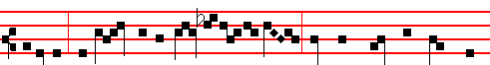
another: they drank of the chalice of the Lord, and were called the friends of
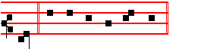
God. Canticle Magnificat
COLLECT

1706
WE beseech thee, almighty God: that, as their faith and passion did cause blessed John and Paul to be brothers indeed; so this day's festival may bestow upon us a twofold gladness in their glory. Through.
Then commemoration of the Octave of S. John. Antiphon.The child. p. 1783  This child, p. 1782, Collect O God, who hast made., p. 1781

AT MATINS
All from the Common of many Martyrs , p. xlvij, except the following.
In the first Nocturn, Lessons Brethren, we are debtors, p. l.

 j. These are two men of mercy, who stand before the Lord. * The Ruler of the whole earth.
 These are two olive-trees, and two candle-sticks giving light before the Lord. The Ruler.

 ij. I saw men joined together, having splendid garments, and the Angel of the Lord spake to me, saying: * These are holy men, who have become the friends of God.
 I saw a mighty Angel of God, flying through the midst of heaven, crying with a loud voice, and saying. These are.

 iij. They gave up their bodies to be punished for God's sake, * And gained everlasting crowns.
 These are they which came out of great tribulation, and have washed their
robes in the blood of the Lamb. And gained. Glory be. And gained.

IN THE SECOND NOC'IURN
Lesson iv
JOHN and Paul, brothers of Rome, gave to the poor of Christ the riches left to them by Constantia, Constantine's daughter, whom they had piously and faithfully served. Being invited by Julian the Apostate to enter his household, they boldly said that they had no wish to be with one who had forsaken Jesus Christ. And he appointed them ten days to deliberate, knowing that unless they gave him their allegiance on that day, and decided to sacrifice to Jupiter, they would certainly have to die.

 Thy Saints, O Lord, have passed a wonderful way, serving thy peculiar commandments that were given unto them, that thy children might be found without hurt. * Dry land appeared, and out of the Red Sea a way without impediment.
 For he smote the stony rock indeed, that the waters gushed out and the streams flowed withal. Dry land.
1707
Lesson v
DURING that time they distributed the rest of their goods to the poor, that they might the more easily depart to the Lord, and that there might be more helped by them, to receive them into everlasting habitations. On the tenth day Terentianus, head of the Prætorian Guard, was sent to them, the image of Jupiter was brought for them to worship, and the Emperor's command explained to them, that unless they accepted the worship of Jupiter, they would die. They, continuing at their prayers, replied that for the faith of Christ, whom they worshipped as God with mind and mouth, they would unhesitatingly submit to death.

 The Saints of God feared not the blows or the, executioners, but died for the name of Christ. * That they might dwell in the house of the Lord for ever.
 They delivered up their bodies to be punished for God's sake. That they.

Lesson vj
BUT Terentianus was afraid that if they were killed publicly there would be an uppoar of the people, had them beheaded there, where they were, on the twenty-sixth of June, and buried secretly; and he spread the rumour that John and Paul had been sent into exile. But their death was made public by the unclean spirits who were vexing the bodies of many, among whom the son of Terentianus,
himself also being troubled by a demon, was brought to the tomb of the Martyrs and set free. At this miracle both he believed in Christ, and his father Terentianus, by whom the life of these blessed Martyrs is said to have been written.

 As gold in the furnace hath the Lord tried them, and received them as a burnt offering: and he hath care for his elect. * For grace and mercy is to his Saints.
 They that put their trust in him shall understand the truth, and such as be faithful in love shall abide with him. For grace. Glory be. For grace.

In the third Nocturn, Homily on the Gospel, Beware ye of the leaven, from the Common in the iij place, p.lxiv, with  viij Theirs was a brotherhood, p. liv.

AT LAUDS, AND THROUGH THE HOURS

Antiphon 1. Tone viij, 1
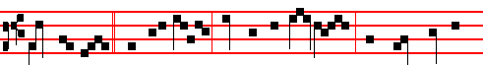
Paul and John * said unto Julian: We worship one God, who made heaven

1708
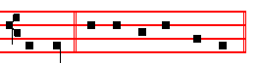
and earth. Psalm 93 Dominus regnavit, and the rest, p. 28.
Antiphon 2. Tone viij, 2
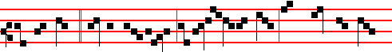
Paul and John * said to Terentianus: If Julian be thy Lord, have peace with him:
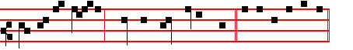
ours is none other, than the Lord Jesus Christ. E u o u a e.
Antiphon 3. Tone j, 1 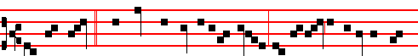
John and Paul * perceived the tyranny of Juli-an, and began to distribute their
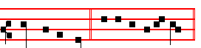
goods to the poor. E u o u a e. Antiphon 4. Tone j, 4
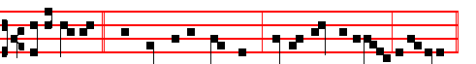 O ye spirits * and souls of the righteous, sing a hymn unto God, alle-luia.
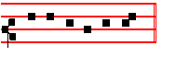
E u o u a e. Antiphon 5. Tone j, 1
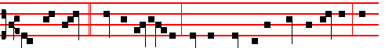
John and Paul * said to Gallicanus; Pay thy vows to the Lord of heaven, and thou

1709
shalt be conqueror more than before.
Chapter, Hymn and  of the Common, xli-xliii.
On Benedictus, Antiphon. Tone j, 2
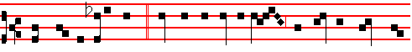
These are the holy ones, * who for the love of Christ despised the threats of
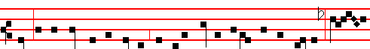
men: in the kingdom of heaven, the holy Martyrs exult with the Angels: O
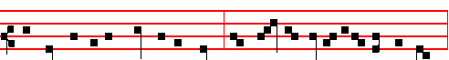
how precious is the death of the Saints, who stand unceasingly before the Lord,
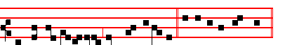
and are not separated one from another. Canticle Benedictus

COLLECT
WE beseech thee, almighty God: that, as their faith and passion did cause blessed John and Paul to be brothers indeed: so this day's festival may bestow upon us a twofold gladness in their glory. Through.
Then commemoration is made of the Octave of S. John, as above on the Feast.

At the Hours, Antiphons of Lauds, Chapters and Short .of the Common, p. lviij.
In II Vespers, Antiphons of Lauds above. Psalms 110, 111, 112, 113 of Sunday, and in the last place, Psalm 116, vv.10-16 Credidi
Chapter and Hymn of the Common, p. xlvij.
 Let the Saints be joyful with glory.  Let them rejoice in their beds.
On Magnificat, Antiphon. Tone j, 1
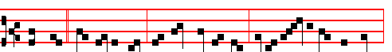
These are * two olive trees, and two candlesticks giving light before the Lord:

1710
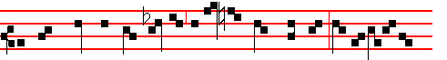
they have power to close heaven so that the clouds rain not, and to op-en its
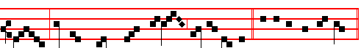
gates: for their tongues have become keys of heaven. Canticle Magnificat
And commemoration is made of the Octave of S. John.
__________________________________________________________________

The Twenty-seventh of June.
Fourth day within the Octave of the Nativity of S.John

In the first Nocturn Lessons from the occurrent Scripture.

IN THE SECOND NOCTURN
Sermon of S. Basil the Great
Lesson iv Homily 2 on Psalm 29 (XXVIII)
THE VOICE of the Lord over the waters. What voice? over what waters? We take what was said as a prophecy. Rememberest thou John, who when he was asked by the Jews, Who art thou? what answer shall we give to them that sent us? replied: I am the voice of one crying in the desert. So the voice of the Lord is John, an Angel sent by God before the face of the Lord, to prepare for the Lord a people ready for him.Therefore this voice over the waters was over Jordan, in which he baptized preaching the baptism of repentance. And not only in Jordan, but also in Aenon near Salem, for there was much water there.

 The Angel of the Lord came down to Zacharias, saying: Receive a son in thine old age: * And his name shall be called John the Baptist.
 This child shall be great in the sight of the Lord, for his hand is with him. And his.

Lesson v
SO the voice of the Lord commanding the waters is John commanding baptism. There also the glorious God made the thunder. For a voice came from heaven, saying: This is my beloved Son, in whom I am well pleased. Then also the Lord, ruling the sea ,vouchsafed to come down in the baptism of John, that he might fulfil all righteousness that is in the Law. The voice of the Lord is mighty in operation. For it takes away the weakness of the people through the baptism of

1711
repentance, in it baptizing unto repentance in water. The voice is mighty in operation, saying: Repent ye, for the kingdom of heaven is at hand; and, Bring. forth fruits worthy of repentance.

 This is the beloved Forerunner, a burning and shining light before the Lord: * For verily this is John who made straight in the desert a highway for our God, and, moreover, bore witness unto the Lamb of God, and enlightened the minds of men.
 He shall go before him in the spirit and power of Elias. For verily.

Lesson vj
THE voice of the Lord breaketh the cedar-trees. This may be interpreted, that by preparing a people ready for the Lord, and breaking the wickednesses that had risen up and exalted themselves against the knowledge of God, he made the crooked things straight. For he who laid every mountain and hill low, he it was who broke the cedar-trees, and prepared the way of the Lord, in that he led the high, and lofty, and proud heart to repentance. Hence the Lord, taking up his preparation, by his coming broke the opposing powers, the cedars of Lebanon, figuratively speaking. For the Lord must reign, until he hath put all enemies under his feet, and crushed those cedar-trees.

 They made signs to his father, how he would have him called. And he asked for a writing table, and wrote, saying: * His name is John.
 The mouth of Zacharias was opened, and he prophesied, saying. His name. Glory be. His name.

IN THE THIRD NOCTURN
The Lesson from the holy Gospel according to Luke.
Lesson vij Ch. 1
ELISABETH'S full time came that she should be delivered; and she brought forth a son. And her neighbours and her cousins heard how the Lord had shewed great mercy upon her; and they rejoiced with her. And the rest.
From the Homily of S. Ambrose, Bishop. Bk. 2 on Luke, Ch 1, end
AND Zacharias his father was filled with the Holy Ghost, and prophesied. See how good God is, and ready to forgive sins. He not only restores what was taken away, but also gives what was not hoped for. He prophesies while still dumb. For this is the very great grace of God, that he confesses him whom he had denied. Therefore let no one be diffident, let no one, conscious of old offences, despair of the divine rewards. The Lord knows now to change his sentence, if thou know how to amend thine offence.

 The Lord's Fore-runner cometh, of whom the Lord himself bore witness,

1712

saying: . * Among them that are born of women there hath not risena greater than John the Baptist.
 This is that prophet, and more than a prophet, of whom the Saviour said. Among.

Lesson viij
AND thou, child, shalt be called the Prophet of the Highest. Well did he turn his words to Prophet, as he was prophesying from the Lord; that he might shew that this benefit also was from tne Lord: and lest, as he publicly recounted his benefits, he might seem ungratefully to have passed over those that he perceived in his son. But perhaps some may think it an irrational excess of mind, that he addressed an eight-day-old infant. But if we refrain we shall soon understand that he who heard Mary's salutation before he was born could hear his father's voice when he was born.

 The Angel Gabriel appeared unto Zacharias, and said to him: Thy wife Elisabeth shall bear thee a son, and thou shalt call his name John. * And many shall rejoice at his birth.
 He shall be great in the sight of the Lord, and shall drink neither wine nor strong drink. And many. Glory be. And many.

Lesson ix
HE knew immediately that the Prophet had other ears, opened by the Spirit of God, not by bodily age. He had the sense to understand, as he had the feeling to exult. At the same time, notice this: how few Elisabeth prophesies to,and how many Zacharias: and both spoke, filled with the Holy Spirit: but the discipline is observed, that the woman should study rather to learn divine matters than to teach them.
Te Deum Laudamus, p. 24.
Vespers from the Chapter of the following, with commemoration of the Octave. (Vespers entire of S. Irenaeus, comm. Oct.)
__________________________________________________________________

The Twenty eighth of June
(S. IRENAEUS, below, p. )
On the Feast of S.Leo, Pope and Confessor.
Semidouble
If this Feast shall come on a Sunday, it is transferred after the Octave of the Apostles, and on the Saturday on which the Office is of the Octave of S. John, the ninth Lesson is read from the Homily of the Vigil of the Apostles, with commemoration of the same at Lauds only.

1713
COLLECT
O GOD, who hast counted the blessed Bishop Leo worthy to be among thy Saints: mercifully grant; that we, who keep feast in his memory, may also follow the example of his life. Through.
Then commemoration is made of the Octave of S. John.

In the first Nocturn Lessons from the occurrent Scripture.

IN THE SECOND NOCTURN
Lesson iv
POPE Leo the Second, a Sicilian, was educated in human and divine literature in Greek and Latin, and also learned in music: for he restored the sacred Hymns and Psalms in the Church to a better musical order. He confirmed the acts of the Sixth Council, which was held at Constantinople, under the legates of the Apostolic See, in the presence also of the Emperor Constantine, and two Patriarchs, of Constantinople and of Antioch, and a hundred and seventy Bishops: and he also translated it into Latin.

 I have found David my servant, with my holy oil have I anointed him: * My hand shall hold him fast.
 The enemy shall not be able to do him violence, the son of wickedness shall not hurt him. My hand.

Lesson v
IN THAT Council Cyrus, Sergius, and Pyrrhus were condemned for preaching only one will and operation in Christ. He curbed the pride of the Bishops of Ravenna who, relying on the power of Exarchs, did mot submit to the apostolic See. Therefore he decreed that the election by the clergy of Ravenna would be invalid unless it were confirmed by the authority of the Roman Bishop.

 I have laid help upon one that is mighty: I have exalted one chosen out of the
people: * My hand shall hold him fast.
 I have found David my servant, with my holy oil have I anointed him: My hand.

Lesson vj
HE was a true father of the poor: for he relieved the poverty and solitude of poor widows and orphans not only with money, but by deeds, labour, and counsel. And as he exhorted each one as much by his life as by preaching to devout and holy living, he fell asleep in the Lord, in the tenth month, and seventeenth day, of his Pontificate: and was buried in the Basilica of Saint Peter,

1714
on the twenty-eighth of June. In one ordination in the month of June he made nine Priests, three Deacons, and twenty-three Bishops for various places.

 This is he which wrought great wonders before God, and the whole earth is full of his teaching: * May he pray for all people, that their sins may be forgiven unto them.
 This is he which hated his life in this world, and is come unto life eternal. May he. Glory be. May he.

IN THE THIRD NOCTURN

Homily on the Gospel, a man travelling into a far country, lxxix.

Lesson ix of the Vigil of SS. Peter and Paul, Apostles.
The Lesson from the holy Gospel according to S. John
Lesson ix Ch. 2, 15-29
JESUS saith to Simon Peter: Simon, son of Jonas, lovest thou me more than these? And the rest.
Homily by S. Augustine, Bishop Homily 23 on John
FOR the thrice denying there is rendered a thrice confessing, that the tongue be not less servant unto love than it hath been servant unto fear, nor death imminent seem to have elicited more of speech than life present shall elicit now. Be it the office of love to feed the Lord's flock, if it was the token of fear to deny the Shepherd. They who with this mind feed the sheep of Christ, that they will needs have them to be theirs, not Christ's, are convicted of loving themselves, not Christ: through lust of getting either glory, or dominion, or gain; not through charity, of obeying, and succouring, and pleasing God.
Te Deum Laudamus, p. 24.
In Lauds, commemoration of the Octave of S. John.
Then, for commemoration of the Vigil, Antiphon and  of the occurrent Feria, as in the Psalter.
COLLECT
GRANT, we beseech thee, almighty God: that as thou hast stablished us on the rock of the apostolic confession; so thou wouldest not suffer us to be troubled by any adversities. Through.
Vespers of the following without any commemoration.
__________________________________________________________________

THE TWENTY-NINTH OF JUNE
ON THE FEAST OF THE HOLY APOSTLES PETER AND PAUL
DOUBLE OF THE FIRST CLASS WITH OCTAVE

1715
At Vespers, Antiphons of Lauds below. Psalms 110, 111, 112, 113, of Sunday,
and 117, as in I Vespers of Apostles.

Chapter Acts 12
HEROD the king stretched forth his hands to vex certain of the church. And he killed James the brother of John with the sword. And because he saw it pleased the Jews, he proceeded further to take Peter also.

Hymn Aurea luce et decore roseo Melody E.H. 226 / 174 or as below at Lauds.
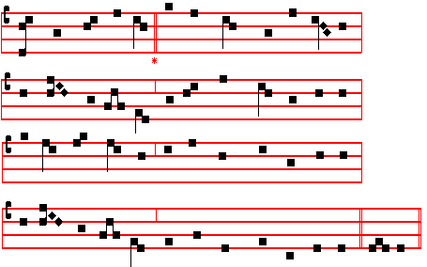

WITH golden splendour, and with roseate loveliness,
Thou didst illumine, Light of Light, the universe;
The heavens adorning with a glorious martyrdom
This day, which brtngeth pardon to the penitent.

2 Celestial Warder! earth's instructor eloquent!
The world's dread judges, lights mankind enlightening,
By cross triumphant, by the sword victorious,
Now are ye laurelled, Life's immortal senators.

3 O Rome, thrice happy, that so great a martyrdom
Thy walls empurpled with rich life-blood, halloweth:
Not thine the merit; by thy Princes' excellence
Thou shinest fairer than the world's magnificence.

1716
4 Glory eternal to the blessed Trinity,
With laud and honour, virtue and supremacy,
Trinal yet Onely, reigning in his majesty
Both now and ever, through the ages infinite. Amen.

 Their sound is gone out into all lands.
 And their words into the ends of the world.
On Magnificat, Antiphon. Tone j, 1
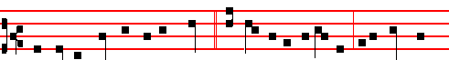
Thou art the shepherd of the sheep, * a chief of the Apostles: unto thee were
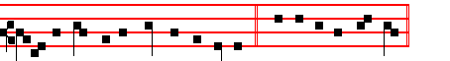
given the keys of the kingdom of heaven. Canticle Magnificat

COLLECT
O GOD who hast hallowed this day by the martyrdom of thine Apostles Peter and Paul: grant unto thy Church in all things to follow the commandment of those: through whom she received the beginning of religion. Through.
And commemoration is not made of S. Paul, since the Collect is common, nor of the Octave of S. John.
AT MATINS

All from the Common of Apostles, v, except the Lessons and 

IN THE FIRST NOCTURN
From the Acts of the Apostles
Lesson j Ch. 3, 1-16
NOW Peter and John went up together into the temple at the hour of prayer, being the ninth hour, and a certain man lame from his mother's womb was carried, whom they laid daily at the gate or the temple which is called Beautiful, to ask alms of them that entered into the temple; who seeing Peter and John about to go into the temple asked an alms. And Peter, fastening his eyes upon him with John, said, Look on us. And he gave heed unto them, expecting to receive something of them.

 Simon Peter, before I called thee out of the ship I knew thee, and made thee a

1717
captain over my people; * And I have given unto thee the keys of the kingdom of
heaven.
 Whatsoever thou shalt bind on earth shall be bound in heaven: and whatsoever thou shalt loose on earth shall be loosed in heaven. And I.

Lesson ij
THEN Peter said, Silver and gold have I none; but such as I have give I thee: In the name of Jesus Christ or Nazareth rise up and walk. And he took him by the right hand, and lifted him up: and immediately his feet and ankle bones received strength. And he leaping up stood, and walked, and entered with them into the temple, walking, and leaping, and praising God. And all the people saw him walking and praising God: and they knew that it was he which sat for alms at the Beautiful gate of the temple: and they were filled with wonder and amazement at that which had happened unto him.

 If thou lovest me, Simon Peter, feed my sheep. Lord; thou knowest that I love thee, * I will lay down my life for thy sake.
 If I should die with thee, I will not deny thee. I will.

Lesson ij
AND as the lame man which was healed held Peter and John, all the people ran together unto them in the porch that is called Solomon's, greatly wondering. And when Peter saw it, he answered unto the people, Ye men of Israel, why marvel ye at this? or why look ye so earnestly on us, as though by our own power or holiness we had made this man to walk? The God of Abraham, and of Isaac, and of Jacob, the God of our fathers, hath glorified his Son Jesus; whom ye delivered up, and denied him in the presence of Pilate, when he was determined to let him go. But ye denied the Holy One and the Just, and desired a murderer to be granted unto you; and killed the Prince of life, whom God hath raised from the dead; whereof we are witnesses. And his name through faith in his name hath made this man strong, whom ye see and know: yea, the faith which is by him hath given him this perfect soundness in the presence of you all.

 Thou art Peter, and upon this rock I will build my church; and the gates of hell shall not prevail against it. * And I will give unto thee the keys of the kingdom of heaven.
 Whatsoever thou shalt bind on earth shall be bound in heaven, and whatsoever thou shalt loose on earth shall be loosed in hcaven. And I. Glory be. And I.

IN THE SECOND NOCTURN
Sermon by S. Leo the Great

1718
Lesson iv Sermon 82 On the Birthday of the
Holy Apostles Peter and Paul
THE whole world, dearly beloved, shares in the festivals of all the Saints; and the piety of the one Faith demands that whatever act is commemorated that pertains to the salvation of all, should also be celebrated with joy by all. Nevertheless, to-day's festival is to be reverenced with special and singular rejoicing in this our city, over and above that reverence which it merits from the whole world: for where the glorious departure of the foremost of the Apostles took place, there, on the day of their martyrdom, should be thc greatest gladness. For these are thc men through whom the Gospel of Christ shone upon you, O Rome; and you who were the teacher of error have become thc disciple of truth.

 Lord, if it be thou, bid me come unto thee on the water. * And Jesus stretched forth his hand, and caught him, and said unto him: O thou of little faith, wherefore didst thou doubt?
 But when he saw the wind boisterous, he was afraid, and beginning to sink, he cried, saying, Lord, save me. And Jesus.

Lesson v
THESE are your fathers and your true shepherds, who, as touching the kingdom of heaven, founded you in a much better and happier way than did they by whose efforts your first bulwarks were laid; from among whom he who gave you your namc defiled you with his brother's blood. These are the men who raised you to this glory, that you have bccome a holy nation, a chosen people, a priestly and royal city, made the head of the world through the holy chair of blessed Peter, that your rule should extend further by the divine bounds of religion than by the earthly bounds of domination. For although, made great by many victories, you extended your imperial rule over land and sea; yet warlike toil subdued less to you than was subjected by Christian peace.

 Arise, O Peter, cast thy garment about thee, and receive strength for the saving of the nations. * The chains are fallen from off thy hands,
 The Angel of the Lord came upon him, and a light shined in the prison: and he smote Peter on the side, and raised him up, saying: Arise up quickly. The chains are fallen.

Lesson vj
FOR it was well-pleasing to the operation of the Divine dispensation that many kingdoms should be gathered together under one empire, so that the world-wide preaching might have a swift passage to the nations who were ruled by the one city. But this city, not knowing the Author of that power of hers, at the very

1719
time when she was ruling nearly every nation, was herself preserving all their errors; and in her own eyes she seemed to be most religious, because she rejected no false god. Hence, the more firmly she was held in the devil's bondage, so much the greater was the miracle of Christ's setting her free.

 Thou art the shepherd of the sheep; the Prince of the Apostles, and unto thee hath God given all the kingdoms of the world: * And therefore unto thee hath he given the keys of the kingdom of heaven.
 Whatsoever thou shalt bind on earth shall be bound in heaven: and whatsoever thou shalt loose on earth shall be loosed in heaven. And therefore. Glory be. And therefore.

IN THE THIRD NOCTURN
The Lesson from the holy Gospel according to S. Matthew
Lesson vij Ch. 16
WHEN Jesus came into the coasts of Cæsarea Philippi, he asked his disciples, saying, Whom do men say that I the Son of man am? And the rest.
Homily by S. Jerome, Priest Bk. 3 Comm. on Matt. 16, v. 13
WELL did he ask, Whom do men say that I the Son of man am? because those who speak of the Son of man are men; while those that discern his Divinity are called, not men, but gods. And they said: Some say that thou art John the Baptist, some Elias. I am sure that certain commentators seek the cause of each of these mistakes, and weave a lengthy argument as to why some should have thought our Lord Jesus Christ to have been John; some Elias; and others Jeremias, or one of the prophets; since they could have made the same mistake that Herod made concerning John, saying: It is John, whom I beheaded: he is risen from the dead: and therefore mighty works do shew forth themselves in him.

 Peter, I have prayed for thee, that thy faith fail not; * And when thou art converted, strengthen thy brethren.
 Flesh and blood hath not revealed it unto thee, but my Father which is in heaven. And when.

Lesson viij
BUT whom say ye that I am. Notice, careful reader, that according to the wording and context the Apostles arc called, not men, but gods. For when he said: Whom do men say that I the Son of man am? he added: But whom say ye that I am? They, because they are men hold a human opinion; ye, who are gods, who do ye think I am? Peter, in the name of all the Apostles, proclaims: Thou art the Christ. the Son of the living God. He calls him the living God to differentiate him from those other gods who are thought to be gods, but are dead.

1720
 Jesus asked his disciples, saying: Whom do men say that I the Son of man am? Peter answered and said, Thou art the Christ, the Son of the living God. * And I say also unto thee, That thou art Peter, and upon this rock I will build my church.  Blessed art thou, Simon Bar-Jona: for flesh and blood hath not revealed it unto thee, but my Father which is in heaven. And I. Glory be. And I.

Lesson ix
AND Jesus answered and said unto him, Blessed art thou, Simon Bar-Jona. The Apostle testified of him, and he in turn testifies of the Apostle. Peter had said: Thou art the Christ, the Son of the living God; his true confession received the reward: Blessed art thou, Simon Bar-Jona. Why? For flesh and blood hath not revealed it unto thee. but my Father.What flesh and blood could not reveal, the grace of the Holy Spirit did reveal. Therefore his name was in keeping with his confession, be:cause he received a revelation from the Holy Spirit, whose son he should also be called. For Bar-Jona in our language means, Son of a dove.
Te Deum Laudamus, p. 24.

AT LAUDS, AND THROUGH THE HOURS

Antiphon 1. Tone viij, 1
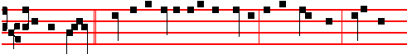
Peter and John * went up together into the temple at the ninth hour, being the
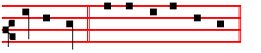
hour of prayer. Psalm 93 Dominus regnavit and the rest, p. 28.
Antiphon 2. Tone vij, 3
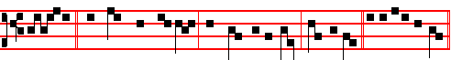
Silver * and gold have I none; but such as I have, give I thee. E u o u a e.
Antiphon 3. Tone viij, 2
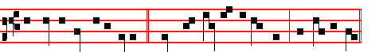
The Angel said unto Peter, * Cast thy garment about thee, and follow me.

1721
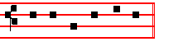
E u o u a e. Antiphon 4. Tone vij, 3
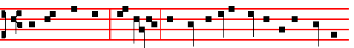
The Lord hath sent * his Angel, and hath delivered me out of the hand of
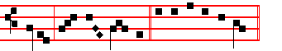
Herod, al- le- lu- ia. E u o u a e.
Antiphon 5. Tone vij, 1
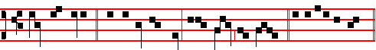
Thou art Peter, * and upon this rock I will build my Church. E u o u a e.
Chapter Acts 12
HEROD the king stretched forth his hands to vex certain of the church. And he killed James the brother of John with the sword. And because he saw it pleased the Jews, he proceeded further to take Peter also.
Hymn. E.H .226, vv. 3, 4, 6. Melody as above at Vespers, or: Mode iv
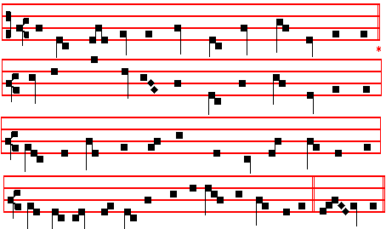

1722
Jam, bone pastor, Petre
3 Good shepherd, Peter, unto whom the charge was given
To close or open ways of pilgrimage to heaven,
In sin's hard bondage held may we have grace to know
The full remission thou wast granted to bestow.

4 O noble Teacher, Paul, we trust to learn of thee
Both earthly converse and the flight of ecstasy;
Till from the fading truths that now we know in part
We pass to fulness of delight for mind and heart.

6 Now to the glorious Trinity be duly paid
Worship and honour, praise and service unafraid,
Who in unchanging Unity, one Lord sublime,
Hath ever lived as now and to unending time. Amen.

 They declared the work of God.  And wisely considered of his doing.
On Benedictus, Antiphon. Tone viij, 1
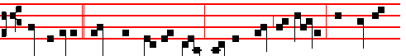
Whatsoever * thou shalt bind on earth shall be bound in heaven: and whatso-
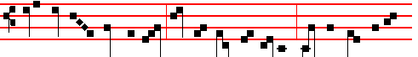 ever thou shalt loose on earth shall be loosed in heaven: saith the Lord un- to
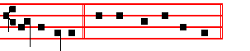
Simon Peter. Canticle Benedictus

COLLECT
OGOD who hast hallowed this day by the martyrdom of thine Apostles Peter and Paul: grant unto thy Churcn in all things to follow the commandment of those: through whom she received the beginning of religion. Through.

AT TERCE
Antiphon. Silver.
Chapter Herod the king, as above.
1723
Short  as in the Common, p. xj.
Their sound is gone out.* Into all lands. Their sound.
 And their words into the ends of the world. Into all. Glory be. Their sound.
 Thou shalt make them princes in all lands.
 They shall remember thy Name, O Lord.

AT SEXT
Antiphon. The Angel said unto Peter.
Chapter Acts 12
PETER therefore was kept in prison: but prayer was made without ceasing of the Church unto God for him.
Short  as in the Common, p. xij.
Thou shalt make them princes.* In all lands. Thou shalt.
 They shall remember thy name, O Lord. In all. Glory be. Thou shalt.
 Exceedingly honourable are thy friends, O God.
 Firmly established is their princedom.

AT NONE
Antiphon.Thou art Peter.
Chapter Acts 12
AND when Peter was come to himself, he said, Now I know of a surety, that the Lord hath sent his Angel, and hath delivered me out of the hand of Herod, and from all the expectation of the people of the Jews.
Short  as in the Common, p. xij.
Exceedingly honourable * Are thy friends, O God. Exceedingly honourable.
 Firmly established is their princedom. Are thy friends, O God. Glory be. Exceedingly honourable.
.They declared the work of God.  And wisely considered of his doing.

AT VESPERS
When the Office is not to be said of S. Paul in a Church of his name, the Antiphons and Psalms are said from the Common of Apostles, p.xiij.
Chapter from Lauds, Hymn as in I Vespers.
 They declared the work of God.  And wisely considered of his doing.

On Magnificat, Antiphon. Tone j, 3
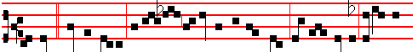
Today * Simon Peter as-cended the gibbet of the cross, alle- luia: today the

1724
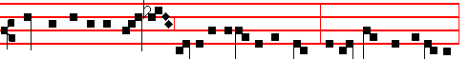
Key-bearer of the Kingdom joyfully departed to Christ: today Paul the Apostle,
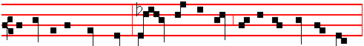
the light of the whole world, bowed down his head; and for the Name of Christ,
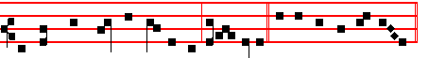
received the crown of martyrdom, alle- luia. Canticle Magnificat
Collect O God who hast hallowed.
And commemoration is not made of S. Paul, nor of the Octave of S. John.

BUT WHEN IT IS
the Office of S. Paul in a Church of his name,
At Vespers, Antiphons of Lauds, Psalms 110, 111, 112, 113, 117 as in I Vespers of Apostles.
Chapter 2 Tim. 4
I HAVE fought a good fight, I have finished my course, I have kept the faith: henceforth there is laid up for me a crown of righteousness, which the Lord, the righteous judge, shall give me at that day.
Hymn E.H. 226 vv. 4, 6 Egregie Doctor Paule, as above at Lauds, p. 1723.
 Thou art a chosen vessel, holy Apostle Paul.
 A preacher of the truth throughout all the world.
On Magnificat, Antiphon. Tone viij,1
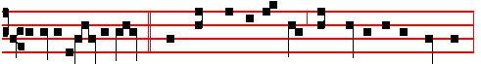
O holy Apostle Paul, * thou preacher of the truth and Doctor of the Gentiles,
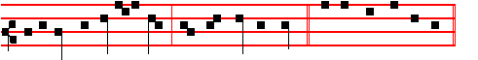
intercede for us unto God, who hath chosen thee. Canticle Magnificat
Collect as below at Lauds.

Then commemoration is made of S. Peter. Antiphon as on p. 1717.

1725
Thou art the shepherd of the sheep, * O chief of the Apostles: unto thee were
given the keys of the kingdom of heaven.
 Thou art Peter.  And upon this rock I will build my Church.

COLLECT
O GOD, who didst bestow upon thy blessed Apostle Peter the keys of the kingdom of heaven, and didst appoint unto him the high priesthood of binding and loosing: vouchsafe; that by the help of his intercession we may be delivered from the bonds of our iniquities. Who livest and reignest.
And commemoration is not made of S. John, nor in Lauds.
If the commemoration of S. Paul shall come on the Octave Day of Corpus Christi, outside of a Church of his name, it is transferred to the first day within the Octave not impeded by a Sunday or Feast; and the whole Office is said as in a Church of his name.
__________________________________________________________________

THE THIRTIETH OF JUNE
COMMEMORATION OF S. PAUL, APOSTLE
GREATER DOUBLE
AT MATINS
Invitatory.- The Lord,the King of the Apostles, * O come, let us worship. Psalm 95 Venite, p. .2
Hymn E.H.226, vv. 4, 6. Egregie Doctor Paule, as above in Lauds of the preceding day.
IN THE FIRST NOCTURN
Antiphon. He that wrought effectually in Peter to the Apostleship, the same was mighty in me towards the Gentiles: and they perceived the grace that was given me of Christ the Lord. Psalms of the Common of Apostles Ps. 19 Cæli enarrant
Antiphon. I know whom I have believed, and am persuaded, that he is able to keep that which I have committed unto him against that day, the just judge. Psalm 34 Benedicam Domino
Antiphon. For me to live is Christ, and to die is gain: it behoveth me to glory in the Cross of our Lord Jesus Christ. Psalm 45 Eructavit cor meum.
 Their sound is gone out into all the world.
 And their words unto the end of the earth.
From the Acts of the Apostles.
Lesson j Ch. 13, 1-13
NOW there were in the church that was at Antioch certain prophets and teachers; as Barnabas, and Simeon that was called Niger, and Lucius of Cyrene, and Manaen, which had been brought up with Herod the tetrarch, and Saul. As they ministered to the Lord, and fasted, the Holy Ghost said, Separate me

1726
Barnabas and Saul for the work whereunto I have called them. And when they had fasted and prayed, and laid their hands on them, they sent them away. So they, being sent forth by the Holy Ghost, departed unto Seleucia; and from thence they sailed to Cyprus.

 He that wrought t effectually in Peter to the Apostleship, the same was mighty in me toward the Gentiles, * And they perceived the grace that was given unto me of the Lord Christ.
 The grace which was bestowed upon me was not in vain, but his grace abideth with me always. And they.

Lesson ij
AND when they were at Salamis, they preached the word of God in the synagogues of the Jews: and they had also John to their minister. And when they had gone through the isle unto Paphos, they found a certain sorcerer, a false prophet, a Jew. whose name was Bar-jesus: which was with the deputy of the country, Sergius Paulus, a prudent man; who called for Barnabas and Saul, and desired to hear the word of God. But Elymas the sorcerer (for so is his name by interpretation) withstood them, seeking to turn away the deputy from the faith.

 I have fought a good fight, I have finished my course, I have kept the faith: * Henceforth there is laid up for me a crown of righteousness.
 I know whom I have believed, and am persuaded that he is able to keep that which I have committed unto him against that day. Henceforth.

Lesson iij
THEN Saul, (who also is called Paul,) filled with the Holy Ghost, set his eyes on him, and said, O full of all subtilty and all mischief, thou child of the devil, thou enemy of all righteousness, wilt thou not cease to pervert the right ways of the Lord? And now, behold, the hand of the Lord is upon thee, and thou shalt be blind, not seeing the sun for a season. And immediately there fell on him a mist and a darkness; and he went about seeking some to lead him by the hand. Then the deputy, when he saw what was done believed, being astonished at the doctrine of the Lord. Now when Paul and his company loosed from Paphos, they came to Perga in Pumphylia: and John departing. from them returned to Jerusalem.

 There is laid up for me a crown of righteousness, * Which the Lord, the righteous Judge, shall give me all that day.
 I know whom I have believed, and am persuaded that he is able to keep that which I have committed unto him against that day. Which. Glory be. Which.

1727
IN THE SECOND NOCTURN

Antiphon. Thou art a chosen vessel, O holy Apostle Paul, a preacher of the truth throughout all the world. Psalm 47 Omnes gentes
Antiphon. The great and holy Paul is a chosen vessel, verily he is worthy to be glorified, for he was worthy to sit upon the twelfth throne. Psalm 61.Exaudi, Deus
Antiphon. I have fought the good fight, I have finished my course, 1 have kept the faith. Psalm 64. Nonne Deo?
 Thou shalt make them princes in all lands.
 They shall remember thy Name, O Lord.

From the Book by S. Augustine, Bishop, On Grace and Free Will
Lesson iv Bk. 1, Ch. 6
PAUL the Apostle had no merits of his own: indeed, he had many demerits. But after he had received the grace of God who renders good for evil, let us see what he said in a letter to Timothy when his passion was at hand: For I am now ready to be offered, and the time of my departure is at hand. I have fought a good fight, I have finished my course, I have kept the faith. He is here recalling his merits, as his crown is to follow upon them, just as grace had followed upon his demerit. Then listen to what follows: Henceforth there is laid up for me a crown of righteousness. Which the Lord, the righteous judge, shall give me at that day. To whom would he give a crown, as the righteous Judge, had he not given grace, as the merciful Father? And how should it be a crown of righteousness, bad not grace
come first, which makes the ungodly righteous? How should it be given as a reward, unless grace had first been given freely?

 Thou art a chosen vessel, O holy Apostle Paul, a preacher of the truth throughout all the world. * Through whom all nations have known the grace of God.
 Intercede for us to God who hath chosen thee. Through whom.
Lesson v
ACCORDINGLY, consider those merits of Paul the Apostle, on account of which he said the righteous Judge would give him a crown, and let us see whether these merits were really his own, that is, sprung from himself, or whether they were gifts of God. I have fought a good fight, I have finished my course, I have kept the faith. To begin with, those good works would have been worth nothing, had not good thoughts come first. Listen, therefore, to what Paul says of these thoughts. For when writing to the Corinthians he said: Not that we are sufficient of ourselves to think any thing as of ourselves; but our sufficiency is of God. Now let us examine these points separately

1728.
 By the grace of God I am what I am: * And his grace which was bestowed upon me was not in vain, but his grace abideth with me always.
 He that wrought effectually in Peter to the Apostleship, the same was mighty in me toward the Gentiles. And his.

Lesson vj
I HAVE fought a good fight, he said. And I ask in whose strength he fought, whether it was his own, or was given him from on high? But it is impossible that so great a teacher of the law should not know the law of God, as it is written in Deuteronomy: And thou say in thine heart, My power and the might of mine hand hath gotten me this wealth. But thou shalt remember the Lord thy God: for it is he that giveth thee power to get wealth. And again, what is the use of a fight, except to gain the victory? And who gives the victory, except he of whom Paul himself says: Thanks be to God, which giveth us the victory through our Lord Jesus Christ.

 Saul, who also is called Paul, a great preacher, * Was by God increased the more in strength, and confounded the Jews.
 Proving that this is very Christ, the Son of God. Was by. Glory be. Was by.

IN THE THIRD NOCTURN
Antiphon. Saul, * who also is called Paul, a great preacher, was by God increased the more in strength, and confounded the Jews. Psalm 15. Confitebimur tibi
Antiphon. Lest I should be exalted * above measure through the abundance of the revelations, there was given to me a thorn in the flesh, the messenger of Satan. to buffet me; for this thing I besought the Lord thrice, that it might depart from me; and the Lord said unto me: Paul, my grace is sufficient for thee. Psalm 97 Dominus regnavit
Antiphon. There is laid up * for me a crown of righteousness, which the Lord, the righteous Judge, shall give me at that day. Psalm 99. Dominus regnavit
 Exceedinaly honoured are thy friends, O God.
 Firmly stablished is their princedom.
The Lesson from the Holy Gospel according to S. Matthew
Lesson vij Ch. 10
JESUS said unto his disciples: Behold, I send you forth as sheep in the midst of wolves.
Homily by S. John Chrysostom Homily 33 on Matt.
BE not thou troubled, (so he speaks,) that sending you among wolves, I command you to be like sheep and like doves. For I might indeed have done the contrary, and have suffered you to undergo nothing terrible, nor as sheep to be

1729
exposed to wolves; I might have rendered you more formidable than lions; but it is expedient that so it should be. This makes you all the more glorious; this proclaims also my power. (This he said also unto Paul: My grace is sufficient for thee, for my strength is made perfect in weakness.) It is I, now mark it, who have caused you so to be.

 O holy Apostle Paul, thou preacher of the truth, and Doctor of the Gentiles, * Intercede for us to God who hath chosen thee, that we may be made worthy of the grace of God.
 Thou art a chosen vessel, O holy Apostle Paul, a preacher of the truth. Intercede.

Lesson viij
BUT let us see what manner of wisdom he here requires. That of the serpent, he says. For even as that animal gives up everything, and if its very body must be cut off: doth not very earnestly defend it, so that it may save its head; in like manner do thou also, he saith, give up everything but the Faith; though goods, body, life itself must be yielded. For that is the head and the root; and if that be preserved, though thou lose all, thou wilt recover all with so much the more splendour. On this account, then, he neither commanded to be merely a simple and single hearted sort of person, nor merely wise; but hath mixed up both of these, so that they may become virtue.

 In Damascus the governor under Aretas the king would have apprehended me, * But I was let down the wall by the brethren in a basket, and so escaped out of his hands, in the Name of the Lord.
 The God and Father of our Lord Jesus Christ knoweth that I lie not. But I.
Glory be. But I.

AND if in men's actual deeds thou wouldst see this result, read the book of the Acts of the Apostles, and thou wilt see how often, when the people of the Jews had risen up against them and were sharpening their teeth, these men, imitating the dove and answering with suitable meekness, did away with their wrath, quenched their madness, broke their impetuosity. As when they said: Did we not straitly command you that ye should not speak in this name? although able to work any number of miracles, they neither said nor did anything harsh, but answered for themselves with all meekness, saying: Whether it be right to hearken unto you more than unto God judge ye. Hast thou seen the harmlessness of the dove? Behold the wisdom of the serpent: For we cannot but speak the things which we know and have heard.
Te Deum Laudamus, p. 24.

1730
AT LAUDS
And through the Hours
Antiphon 1. Tone viij, 1
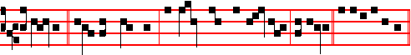
I planted, * Apollos watered, but God gave the increase, alleluia. Psalm 93
etc., as on Sundays. Antiphon 2. Tone viij, 1
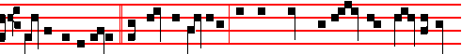
Gladly will I glory * in mine infirmities, that the power of Christ may rest upon
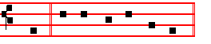
me. E u o u a e.
Antiphon 3. Tone iv, 1
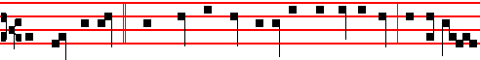
The grace of God * which was bestowed upon me was not in vain, but his grace
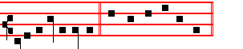
ever abideth in me. E u o u a e.

Antiphon 4. Tone viij, 1
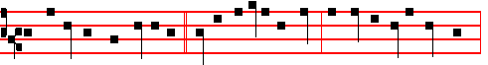
In Damascus, the governor * under Aretas the king desired to apprehend me:
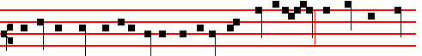
and by the brethren in a basket was I let down by the wall, and thus escaped

1731
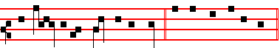
his hands in the name of the Lord. E u o u a e.
Antiphon 5. Tone viij, 1
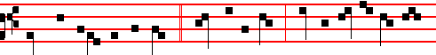
Thrice was I beaten with rods, * once was I stoned, thrice I suffered shipwreck
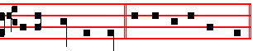
for the name of Christ. E u o u a e.
Chapter 2 Tim.4
I HAVE fought a good fight,I have finished my course,I have kept the faith: henceforth there is laid up for me a crown of righteousness, which the Lord, the righteous judge, shall give me at that day.
Hymn E.H.176 Exultet caelum laudibus, p. iv.
 Thou art a chosen vessel, holy Apostle Paul.
 A preacher of the truth throughout all the world.
On Benedictus, Antiphon as in the Common, xj.
Ye which have followed me * shall sit upon twelve thrones, judging the twelve tribes of Israel, saith the Lord.
COLLECT
O GOD, who by the preaching of the blessed Apostle Paul didst teach the multitude of the Gentiles: grant to us, we beseech thee; that we who celebrate his birthday may know him to be our advocate with thee. Through.
And commemoration is made of S. Peter. Antiphon. as on p. 1717.
Thou art the shepherd of the sheep, O chief of the Apostles: unto thee were given the keys of the kingdom of heaven.
 Thou art Peter.  And upon this rock I will build my Church.

COLLECT
O GOD, who didst bestow upon thy blessed Apostle Peter the keys of the kingdom of heaven, and didst appoint unto him the high priesthood of binding and loosing: vouchsafe; that by the help of his intercession we may be delivered from the bonds of our iniquities. Who livest and reignest.

And commemoration is made of S. John, as in Lauds of the Feast, above.

1732

