Pharisees who criticized the Lord for receiving sinners; in dryness of heart they rebuked the very fountain of mercy. But they were sick, so sick that they were unaware of it. To make them realize that they were sick, the heavenly physician tends them with a gentle remedy, laying before them this gracious parable, and reduces the swelling of the wound in their hearts.
Te Deum Laudamus, p. 24.
On Benedictus, Antiphon. Tone iij, 4.
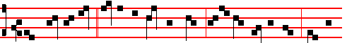
What man of you,* having an hundred sheep, if he lose one of them, doth not
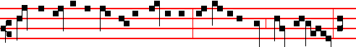
leave the ninety and nine in the wilderness, and go after that which is lost, un-
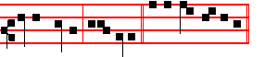
til he find it? alle- luia. Canticle Benedictus, p..29
On Magnificat, Antiphon. Tone vj
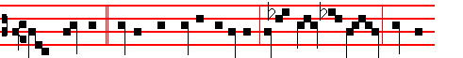
What woman,* having ten pieces of silver, if she lose one piece, doth not

light a cand-le, and sweep the house, and seek diligently until she find it?
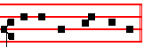
Canticle Magnificat, p. 210.
__________________________________________________________________

THE FOURTH SUNDAY AFTER PENTECOST

COLLECT

1318
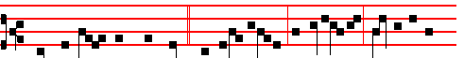
When ye, therefore, shall see * the abomination of desolation, spoken of by
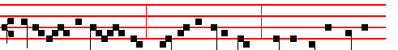
Dani-el the proph- et, stand in the holy place; whoso readeth, let him

understand. Canticle Benedictus, p. 39.

On Magnificat, Antiphon. Tone j, 3.
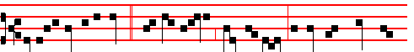
Verily I say unto you, * This generation shall not pass, till all these things be
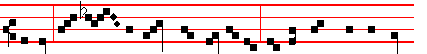
fulfilled, Hea- ven and earth shall pass away, but my words shall not pass
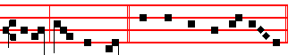
away, saith the Lord. Canticle Magnifiicat, p. 209.

__________________________________________________________________

1363
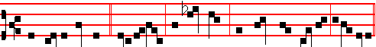
And Jesus entered * into a ship, and sat down, and taught the people, alle-luia.


Canticle Benedictus , p. 39.
On Magnificat, Antiphon. Tone j, 2.
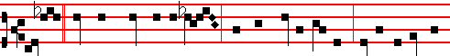
Master,* we have toiled all the night, and have taken nothing: nevertheless, at

thy word I will let down the net. Canticle Magnificat, p. 209.
__________________________________________________________________

THE FIFTH SUNDAY AFTER PENTECOST

COLLECT
O GOD,who hast prepared for them that love thee such good things as pass man's understanding: pour into our hearts such love toward thee; that we, loving thee in all and above all things, may obtain thy promises, which exceed all that we can desire. Through.

The Lesson from the Holy Gospel according to S. Matthew
Lesson vij Ch. 5
JESUS said unto his disciples: Except your righteousness shall exceed the righteousness of the scribes and Pharisees, ye shall in no case enter into the kingdom of heaven. And the rest.
Homily by S. Augustine, Bishop On the Sermon on the Mount Bk. 1, Ch. 9
THE righteousness of the Pharisees is, that they shall not kill; the righteousness of those who are destined to enter into the kingdom of God, that they shall not be angry without a cause. The least commandment, therefore, is not to kill; and whosoever shall break that, shall be called least in the kingdom of heaven; but whosoever shall fulfil that commandment not to kill, will not, as a necessary

1320
On Benedictus, Antiphon. Tone vij, 3.
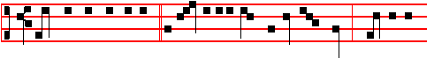
The kingdom of heaven * is like unto a grain of mustard seed, which is the
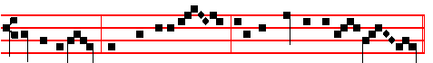
least of all seeds, but when it is grown, it is the greatest among herbs.

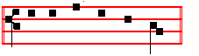
Canticle Benedictus, p. 39.

On Magnificat, Antiphon. Tone j, 3.
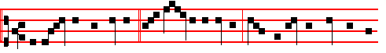
The kingdom of heaven * is like unto leaven,which a woman took and hid
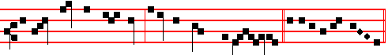
in three measures of meal, until the whole was leavened. Canticle Magnificat.
__________________________________________________________________

THE TWENTY-FOURTH AND LAST SUNDAY AFTER PENTECOST

COLLECT
STIR up, we beseech thee, O Lord, the wills of thy faithful: that they plenteously bringing forth the fruit of good works, may of thy loving- kindness receive more abundant rewards. Through.

The Lesson from the Holy Gospel according to S. Matthew
Lesson vij Ch. 24
JESUS said unto his disciples: When ye shall see the abomination of desolation, spoken of by Daniel the prophet, stand in the holy place, (whoso readeth, let him understand). And the rest.
1361
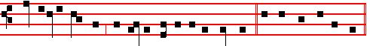
whosoever shall kill, shall be in danger of the judgment. Canticle Benedictus
On Magnificat, Antiphon. Tone j, 3.
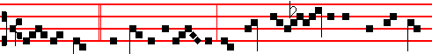
If thou bring * thy gift to the al- tar, and there remem- berest that thy bro-
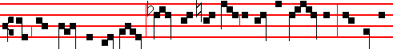
ther hath ought against thee; leave there thy gift before the al- tar, and go thy
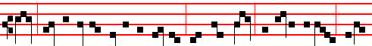
way; first be reconciled to thy brother, and then come and offer thy gift, al-le-
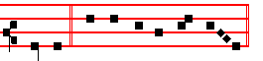
lu- ia. Canticle Magnificat, p. 209.
__________________________________________________________________

THE SIXTH SUNDAY AFTER PENTECOST

COLLECT

O GOD of hosts, who art the author of all good things: graft in our hearts the
love of thy name, increase in us true religion; nourish us with all goodness, and of thy great mercy keep us in the same. Through.

The Lesson from the Holy Gospel according to S. Mark
Lesson vij Ch. 8
THE multitude being very great, and having nothing to eat, Jesus called his disciples unto him, and saith unto them, I have compassion on the multitude, because they have now been with me three days, and have nothing to eat. And the rest.
Homily by S. Ambrose, Bishop Bk. 6 on Luke Ch. 9

1322
yet evil, are considered straw rather than tares: because straw has the very same
foundation as the wheat and a common root.

Lesson ix.
CLEARLY, not without reason are bad Catholics understood to be in that net in which are enclosed fish both bad and good. For the sea which betokens that world is one thing; quite another is the straw, which seems to point to the communion of the one faith or the one Church. Between heretics and bad Catholics there is this difference, that heretics believe that is false, but bad Catholics, while believing what is true, do not live in accordance with their belief.
Te Deum Laudamus, p. 24.

On Benedictus, Antiphon. Tone j, 2.
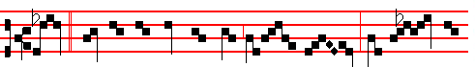
Sir, * didst not thou sow good seed in thy field? from whence then
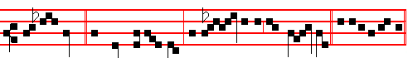
hath it tares? He said unto them, an en- emy hath done this.C. Benedictus

On Magnificat, Antiphon. Tone j, 1.
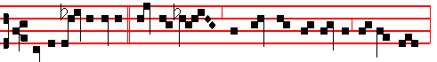
Gather ye together * first the tares, and bind them in bundles to burn them:
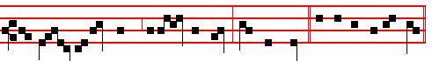
but gath- er the wheat into my barn, saith the Lord. Canticle Magnificat.
__________________________________________________________________

THE SIXTH SUNDAY THAT REMAINED OVER
AFTER THE EPIPHANY

COLLECT

1359
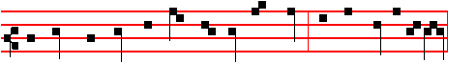
because they have now been with me three days, and have nothing to eat,
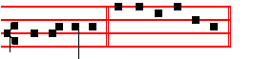
al- le- luia. Canticle Benedictus, p. 39.
On Magnificat, Antiphon. Tone vij, 1.
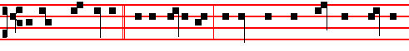
I have compassion * on the multitude, because they have now been with me

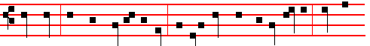
three days, and have nothing to eat: and if I send them away fasting, they will
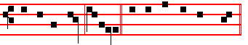
faint by the way, alleluia. Canticle Magnificat, p. 211.
__________________________________________________________________

THE SEVENTH SUNDAY AFTER PENTECOST

COLLECT
O GOD, whose providence never faileth in its disposition: we humbly beseech thee; to put away from us all hurtful things, and to give us all things which be profitable for us. Through.

The Lesson from the Holy Gospel according to S. Matthew
Lesson vij Ch. 7
JESUS said unto his disciples: Beware of false prophets, which come to you in sheep's clothing, but inwardly they are ravening wolves. And the rest.
Homily by S. Hilary, Bishop Comm. on Matt. 7
THE Lord warns us that soft words and apparent meekness should be estimated by the fruit of the accompanying works: so we should have regard rather for

1324
allowed demons to enter the swine. The seventh, when entering his own city, he healed a second paralytic lying on a bed. For the first paralytic was the Centurion’s servant.

Lesson viij
BUT he himself was asleep: and they came to him and awoke him, saying, Lord save us. We read in Jonah a type of this sign, when, while the rest were in danger, he himself was carefree and slept, and was awakened. And by his command and by the sacrament of his passion, he sets free those who awake him. Then he arose and rebuked the winds and the sea. From this we understand that all creatures perceive their Creator. For those whom he chided and commanded perceive him who so commanded: not according to the false belief of heretics who
think all things endued with life: but through the majesty of the Author of their being, things that we cannot perceive by the senses are to him objects of knowledge.

Lesson ix.
BUT the men marvelled, saying, What manner of man is this that even the winds and the sea obey him? It was not the disciples, but sailors and others who were in the ship who marvelled. But if anyone wishes to argue that those who marvelled were the disciples, we shall answer that rightly were they called men, inasmuch as not yet did they know the Saviour's power.
Te Deum Laudamus, p. 24.

On Benedictus, Antiphon. Tone vj
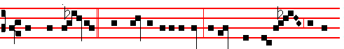
And when Jes- us * was entered into a ship, behold, there a- rose a great
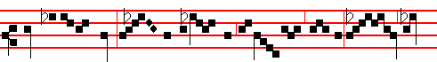
tempest in the sea: and his disci- ples awoke him, saying: Lord, save
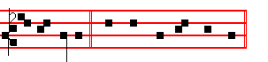
us, we perish. Canticle Benedictus, p. 39.

1357

Canticle Benedictus, p. 39.
On Magnificat, Antiphon. Tone j, 3.
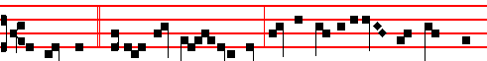
A good tree * cannot bring forth evil fruit, neither can a corrupt tree bring forth
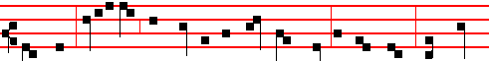
good fruit: every tree that bringeth not forth good fruit is hewn down, and cast
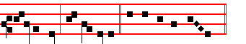
into the fire, alleluia. Canticle Magnificat, p. 209.
__________________________________________________________________

THE EIGHTH SUNDAY AFTER PENTECOST

COLLECT
GRANT to us, Lord, we beseech thee, the spirit to think and do always such things as be rightful: that we who without thee cannot exist, may be enabled to live according to thy will. Through.

The Lesson from the Holy Gospel according to S. Luke
Lesson vij Ch. 16
JESUS spake this parable unto his disciples: There was a certain rich man, which had a steward; and the same was accused unto him that he had wasted his goods. And the rest.
Homily by S. Jerome, Priest Ep. 121 to Algasia Ch. 6
IF the steward of the mammon of unrighteousness is commended by his lord for
preparing his judgment by an unrighteous deed: and if his lord, in spite of suffering loss, commends his steward for his prudence, because though he does deal fraudulently against his lord, yet he acts prudently in his own interests: how much more shall Christ, who can suffer no loss from our hands and is always ready to shew mercy, commend his disciples if they are merciful to those who believe in him?

1326
troubled by an evil spirit, their spirits he cast out with a word: and also he healed
all that were sick.

Lesson viij
AND behold, a leper, coming to him worshipped him, saying. It is right that after the preaching and teaching there should be offered occasion for a sign, that by virtue of a miracle the sermon now over may be confirmed among the hearers. Lord, if thou wilt, thou canst make me clean. He who asks the will, doubts not the power. Ad Jesus put forth his hand and touched him, saying, I will;
be thou clean. As the Lord put forth his hand, immediately the leprosy fled. Consider also how lowly and without arrogance is the reply. He (the leper) had said, If thou wilt. The Lord replied, I will. He had first said, Thou canst make me clean; the Lord continues and says, Be thou clean. We must not therefore, as many of the Latinists think, join the words together and read, I will make thee clean; but take them separately, so that first he says I will; then he commands, Be thou clean.

Lesson ix
AND Jesus saith unto him, see thou tell no man. And truly what need was there to boast in speech of that which he plainly showed in his body? But go thy way, show thyself to the priest. For divers reasons he sends him to the priests. For it was enjoined in the law that those who had been cleansed of leprosy should offer gifts to the priests. Secondly, that those who say that the leper was cleansed should either believe on the Saviour, or not believe. If they believed, they would be saved: if they did not believe, they would be without excuse: and also, lest he should seem to be breaking the law, a charge often brought against him.
Te Deum Laudamus, p. 24.

On Benedictus, Antiphon. Tone j, 1.
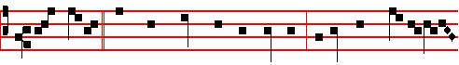
When Jesus * was come down from the mountain, behold there came a leper

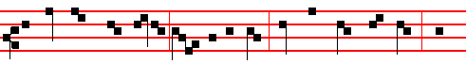
and worshipped him, saying, Lord,if thou wilt, thou canst make me clean. And

1355
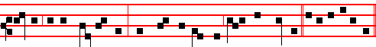
put out of the stewardship, they may receive me into their houses. Cant. Magn.
__________________________________________________________________

THE NINTH SUNDAY AFTER PENTECOST

COLLECT
LET thy merciful ears, O Lord, be open to the prayers of thy humble servants: and that they may obtain their petitions; make them to ask such things as shall please thee. Through.

The Lesson from the Holy Gospel according to S. Luke
Lesson vij Ch. 19
WHEN Jesus was come near Jerusalem, he beheld the city, and wept over it, saying, If thou hadst known, even thou, at least in this thy day, the things which belong unto thy peace! And the rest.
Homily by S. Gregory the Great Homily 39 on the Gospels
NO one who has read of the destruction of Jerusalem by the Roman rulers Vespasian and Titus can be unaware that the Lord, when he wept over
Jerusalem, was describing this overthrow. For the Roman rulers are referred to when it is said, For the days shall come upon thee, that thine enemies shall cast a trench about thee. And then what follows, And they shall not leave in thee one stone upon another, is even now witnessed to in the changed site of that city, which is now built in the place outside the gates where the Lord was crucified; whereas the ancient city was razed to the ground.

Lesson viij
WE are then told what that sin of hers was, which brought upon her the punishment of destruction: Because thou knewest not the time of thy visitation. For the very Creator of men vouchsafed to visit her through the mystery of his Incarnation. But she was in no mind to fear and love him. Whence also the Prophet, rebuking the hardness of the human heart, brings the birds of the air to bear witness, saying, The stork in the heaven knoweth her appointed times; and the turtle and the crane and swallow observe the time of their coming; but my people know not the judgment of the Lord.

Lesson ix
OUR Redeemer wept over the ruin of the unfaithful city before that city was herself aware that it was coming. Rightly does the Lord tell her, as he weeps,

1328
raised to life. But the woman with an issue of blood made her way in, and her cure takes the eighth place. Thus, the ruler's daughter, prevented from being the eighth, becomes the ninth, in accordance with the words of the psalm: Ethiopia shall soon stretch out her hands unto God. And again, When the fulness of the Gentiles be come in. then shall all Israel be saved.

Lesson viij
AND, behold, a woman which was diseased with an issue of blood twelve years, came behind him, and touched the hem of his garment. In the Gospel according to Luke it is written that the ruler's daughter was twelve years old. Observe, therefore, that the time since the disease first came upon this woman, that is, the Gentile people, corresponds with the time that the Jewish nation had been living in faith. For sin is not apparent unless it is compared with virtue.

Lesson ix
NOW this woman with the issue of blood did not come to the Lord when he was in a house or in a city, because according to the law she was not allowed in the cities; but she came up to him in the road, when he was walking along; thus one was healed while he was on his way to another. Whence the Apostles also say: It was necessary that the word of God should have been spoken to you: but seeing ye judge yourselves unworthy of everlasting life, lo, we turn to the Gentiles.
Te Deum Laudamus, p. 24.

On Benedictus, Antiphon. Tone ij
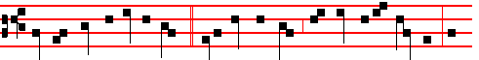
For she said within herself, * If I may but touch the hem of his garment, I

shall be whole. Canticle Benedictus, p. 39.

On Magnificat, Antiphon. Tone ij

But Jesus turned him about, * and when he saw her, he said, Daughter, be

1353

ing in the temple. Canticle Magnificat, p. 211.,
__________________________________________________________________

THE TENTH SUNDAY AFTER PENTECOST

COLLECT
OGOD, who declarest thy almighty power most chiefly in shewing mercy and pity: multiply upon us thy loving- kindness; that we, running toward thy promises, may by thee be made partakers of thy heavenly gifts. Through.

The Lesson from the Holy Gospel according to S. Luke
Lesson vij Ch. 18
JESUS spake this parable unto certain which trusted in themselves that they were righteous, and despised others: Two men went up into the temple to pray; the one a Pharisee, and the other a publican. And the rest.
Homily by S. Augustine, Bishop Sermon 115 on the Words of the Lord, Ch. 11
THE Pharisee might at least have said, I am not as many men are. What does he mean by other men, except everyone save himself? I, says he, am righteous,
the others are sinners. I am not as other men are, extortioners, unjust, adulterers. And lo, he makes the occasion of the publican standing there into a subject for even greater pride, adding, Or even this publican. I, says he, am singular. He is like the rest. I am not, says he, such a man as he is, by reason of my righteous deeds, by means of which I am not unrighteous.

Lesson viij
I FAST twice in the week, I give tithes of all that I possess. If you look into his words to find what he is asking of God, you will find nothing. He went up to pray, but instead he praised himself; moreover, he was scornful of the one who was praying. Now the publican stood afar off, and yet he was near to God. His conscience kept him away, but his piety brought him near. Now the publican stood afar off, and yet the Lord was nigh at hand.

Lesson ix
FOR though the Lord be high, yet hath he respect unto the lowly: as for the proud, (for such men as the Pharisee,) he beholdeth them afar off. Though God beholds them, he does not pardon them. Hear yet more of the publican's lowliness. It was a comparatively small thing that he stood afar off, and would not

1330
OGOD, our refuge and strength, who art the author of all godliness: hear the devout prayers of thy Church, and grant; that those things which we ask faithfully we may obtain effectually. Through.

The Lesson from the Holy Gospel according to S. Matthew
Lesson vij Ch. 22
THE Pharisees went, and took counsel how they might entangle Jesus in his talk. And the rest.

Homily by S. Hilary, Bishop Comm. on Matt. Ch. 23
THE Pharisees were often put to confusion, and they could not find anything to charge him with from the things that he had done. There was no fault to be found in his words and deeds, yet , out of sheer malice they busied themselves, seeking in everything grounds of accusation. Now he was calling all men away from worldly crimes and the superstitions set up by men, calling them to hope in the kingdom of God. Therefore they tried him, by means of a craftily worded question, to see whether he would violate the law; namely, they asked whether it was right to give tribute to Cæsar.

Lesson viij
BUT he, knowing the hidden depths of their reasoning, (for there is nothing of man's to which God is not a witness of all those things that are hidden to man) ordered them to bring him a penny, and asked them whose was the image and superscription. The Pharisees answered, It was Cæsar's. He said to them, They were to render unto Cæsar the things which were Cæsar's; and unto God the things that were God's. What a wonderful answer and perfect fulfilment of the divine commandment! He adjusts the balance between contempt of the world and the affront of offending Cæsar; he frees souls devoted to God from all worldly cares and burdens, in decreeing that the things which are Cæsar’s are to be given to Cæsar.

Lesson ix
FOR if nothing of his remains with us, then we are no longer in the position of having to render unto him the things which are his. But we are concerned with those things which are his, if we are busied with things under his control, and subject ourselves like mercenaries to the administration of the inheritance of foreigners; then undoubtedly those things must be given to Cæsar which are Cæsar's, while we must render to God the things that belong to him: body, soul and will. For we receive these from him, and he is their Author and Maker: hence it is fitting that they should return wholly to him, as they should recall that their origin and development is from him.
Te Deum Laudamus, p. 24.

1351
COLLECT
ALMIGHTY and everlasting God, who in the abundance of thy loving-kindness dost give more than thy suppliants either desire or deserve: pour down upon us thy mercy; forgiving us those things whereof our conscience is afraid, and giving us that which our prayer doth not presume to ask. Through.

The Lesson from the Holy Gospel according to S. Mark
Lesson vij Ch. 7
JESUS departed from the coasts of Tyre and Sidon, and came unto the sea of Galilee, through the midst of the coasts of Decapolis. And the rest.
Homily by S. Gregory the Great Homily on Ezekiel. Bk. 1. Ch10
WHY is it, that when God the Creator of all things wished to heal the deaf and dumb man, he put his fingers into his ears. and he spit, and touched his tongue? What is meant by the fingers of the Redeemer, except the gift of the Holy Spirit? Whence it is that he said in another place, after he had cast out a devil, If I with the finger of God cast out devils, no doubt the kingdom of God is come upon you. And this same thing is expressed by another Evangelist in the words If I cast out devils by the spirit of God, then the kingdom of God is come unto you. When these two passages are compared it may be seen that the Spirit is called the finger.
Therefore to put his fingers into his ears was to lay open the way of obedience in the mind of the deaf man, through the sift of the Holy Spirit.

Lesson viij
BUT why did he spit and touch his tongue? Spittle from the mouth of the Redeemer is given us when we receive wisdom in speaking of divine mysteries. Spittle flows into the mouth from the head. So that when our tongue is touched by that wisdom, which is he himself, it is straightway enabled to preach the word. And looking up to heaven, he sighed; not that he had any need to sigh, when he was bestowing what he prayed for, but he taught us to beseech him with sighs, since he reigns in heaven: to beseech him both that our ears may be opened through the gift of the Holy Spirit, and that our tongue may be loosed through his spittle, that is, through knowledge of the divine word, so that we may go forth to preach it to others.

Lesson ix
AND saith unto him, Ephphatha, that is, Be opened. And straightway his ears were opened and the string of his tongue was loosed. It must be noticed here, that when his ears were closed it was said, Be openeded. But when the ears of a man's heart have been opened by obedience, it undoubtedly follows that the string of his tongue is also loosed, so that he may tell others that they also should do the good deeds which he has done. Whence it is fittingly added, And he spake plain. For he speaks plainly, when by his speaking he urges othen to the performance of

1232
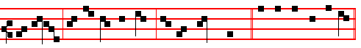
son liveth: and himself believed, and his whole house. Canticle Magnificat
__________________________________________________________________

THE TWENTY-FIRST SUNDAY AFTER PENTECOST

COLLECT
LORD,we beseech thee to keep thy household in continual godliness: that through thy protection it may be free from all adversities; and in good works be devoted to thy name. Through.

The Lesson from the Holy Gospel according to S. Matthew
Lesson vij Ch. 18
PETER said unto Jesus: Lord, how oft shall my brother sin against me, and I forgive him? And the rest.
Homily by S. Jerome, Priest Comm. on Matt. Ch. 18
THE Syrians, and more especially the Palestinians, are wont to illustrate every discourse with a parable; so that the listeners may grasp by means of comparison and example what they are not able to grasp by means of bare precept. Therefore the Lord instructs Peter under the figure of a lord and king, and his servant who owed his lord ten thousand talents and who sought and obtained pardon; thus teaching Peter that he also should forgive his fellow-servants their lesser offences. For if that lord and king so readily forgave his debtor-servant the ten thousand talents, how much more readily should servants forgive their fellow-servants their lesser tresspasses?

Lesson viij
TO make this plainer, we will give an example: if any of us were to commit adultery, or murder, or sacrilege; then these greater crimes, signified by the ten thousand talents, would be forgiven us if we sought pardon, provided that we also forgave lesser tresspasses. But if we refuse to be pacified after receiving a slight, and keep up an endless quarrel because of an unkind word; would it not seem right to send us back to prison, and, according to the example that we have here set forward, to give us no pardon for our greater sins?

Lesson ix
SO likewise shall my heavenly Father do also unto you if ye from your hearts forgive not every one his brother their trespasses. A terrible sentence, if the judgment of God may be turned and changed according to our mental attitude: if

1349
eyes of the little ones, to whom the Son has vouchsafed to reveal both himself and his Father. Abraham rejoiced to see Christ's day. He saw it and was glad. Isaiah too, and Micah, and many other prophets, saw the glory of the Lord, and for that reason they were called seers. But all these, looking from afar, and hailing from a distance, saw through a glass darkly.

Lesson viij
THE Apostles, however, who had the Lord present with them, and ate and drank with him, and learned from him by asking him whatever they wished, had no need to be taught by means of Angels or different kinds of visions. Those whom Luke terms, Many prophets and kings, Matthew openly calls, Prophets and righteous men. For these are great kings, since they do not succumb by consenting to the stirrings of their temptations, but know how to subdue them by over-ruling them.

Lesson ix
AND, behold, a certain lawyer stood up, and tempted him, saying, Master, what shall I do, to inherit eternal life? The lawyer who tempted the Lord, asking about eternal life, took his occasion of tempting, it seems to me, from
those words of the Lord, where he said: Rejoice, because your names are written in heaven. But by his very tempting he declared how true was that confession which the Lord had just made to the Father: Thou hast hid these things from the wise and prudent, and hast revealed them unto babes.
Te Deum Laudamus, p. 24.

On Benedictus, Antiphon. Tone viij, 1.

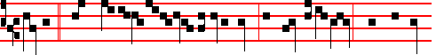
Master,* what shall I do to inherit eternal life? He said unto him, What is writ-
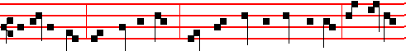
ten in the law? how readest thou? Thou shalt love the Lord thy God with all thy
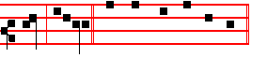
heart, alleluia. Canticle Benedictus, p. 39.

1334
On Magnificat, Antiphon. Tone iij, 1.

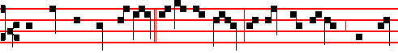
And when the king came in * to see the guests, he saw there a man which had
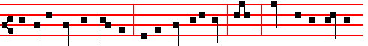
not on a wedding garment: and he said unto him, Friend, how camest thou in
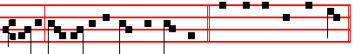
hither not having a wedding garment? Canticle Magnificat, p. 209.
__________________________________________________________________

THE TWENTIETH SUNDAY AFTER PENTECOST

COLLECT
GRANT, we beseech thee, merciful Lord, to thy faitnful people pardon and peace: that they may be cleansed from all their sins and serve thee with a quiet mind. Through.

The Lesson from the Holy Gospel according to S. Matthew
Lesson vij Ch. 18
THERE was a certain nobleman, whose son was sick at Capernaum. When he heard that Jesus was come out of Judæa into Galilee, he went unto his and besought him that he would come down, and heal his son: for he was at the point of death. And the rest.
Homily by S. Gregory the Great Homily 28 on the Gospels.
THE Lesson from the holy Gospel, brethren, that you have just heard, needs no explanation: but lest by no mention being made of it, it should seem to be passed by, we shall say a few words by way of exhortation rather than of exposition. This point alone seems to require explanation: why did the man who came to seek health for his son hear the words: Except ye see signs and wonders, ye will not believe? For without a doubt he who was seeking health for his son did believe; for anyone who did not believe the Saviour would not have sought healing from him. Why, then, was it said: Except ye see signs and wonders, ye will not believe: when he believed before seeing the signs?

1347
Lesson viij
THEREFORE it is not unreasonable to understand by lepers those men who have not the knowledge of the true faith, and so put forth various erroneous doctrines. For they do not hide their ignorance, but bring it forth to the light as the greatest knowledge, and proclaim it with high-sounding phrases. Moreover there is no false doctrine that is not intermingled with some form of truth. Therefore when, in a man's discourse or argument, truth is unequally mixed with falsehood, then the different colours in one body are like leprosy, which causes different coloured spots to appear on the human body like the mingling of truth and falsehood.

Lesson ix
SUCH men as these are so shunned by the Church, that, if it can be done, she banishes them far from her, so that they cry out to Christ with a loud voice, as did those ten which stood afar off, and lifted up their voices, and said: Jesus, Master, have mercy upon us. The fact that they called him Master, by which name I know not whether any others who besought the lord for bodily healing, so called him, is, I think, sufficient to show that false doctrine was the leprosy which the good Master removed from them.
Te Deum Laudamus, p. 24.
On Benedictus, Antiphon. Tone j, 3.
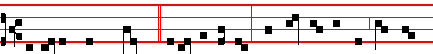
As Jesus passed through * a certain village, there met him ten men that were
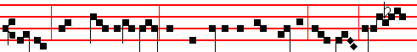
lepers, which stood afar off: and they lifted up their voices, and said, Jesus,
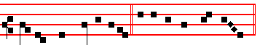
Master, have mercy on us. Canticle Benedictus, p. 39.

On Magnificat, Antiphon. Tone ij.
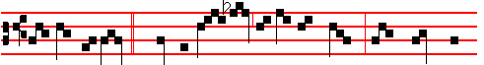
And one of them, * When he saw that he was healed, turned back, and

1336
and Creator of the universe, when for our sakes he confined himself within the narrow limits of our flesh, began to have an earthly fatherland, began to be a citizen of a Jewish city, and he, the parent of all parents, began to have parents; that love might invite, charity attract, affection win, and kindness persuade, those whom tyranny had dispelled, fear had scattered, and force had banished.
Te Deum Laudamus, p. 24.
On Benedictus, Antiphon. Tone j, 4.
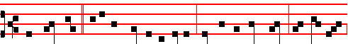
The Lord said * unto the sick of the palsy, Son, be of good cheer, thy sins be
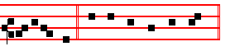
forgiven thee. Canticle Benedictus, p. 39.
On Magnificat, Antiphon. Tone iv, 1.
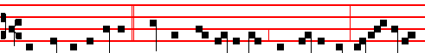
The sick of the palsy * therefore took up his bed whereon he lay, glori- fy-ing
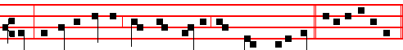
God: and all the people, when they saw it, gave praise unto God. C. Magnificat.
__________________________________________________________________

THE NINETEENTH SUNDAY AFTER PENTECOST

COLLECT
ALMIGHTY and merciful God, of thy bountiful goodness keep us from all things that may hurt us: that we, being ready both in body and soul, may cheerfully accomplish those things that thou wouldest have done. Through.

The Lesson from the Holy Gospel according to S. Matthew
Lesson vij Ch. 22
JESUS spake unto the chief priests and Pharisees in parables, saying: The kingdom of heaven is like unto a certain king which made a marriage for his son. And the rest.
Homily by S. Gregory the Great Homily 38 on the Gospels
1345
double by reason of necessities themselves, and the aim should be wrenched aside to seek after those things of our own, when we are doing something as it were from compassion; that is, so that when we wish to appear to be consulting for someone's good, we are in that matter looking after our own profit rather than his advantage: and we do not seem to be sinning, for this reason, that it is not superfluities, but necessities, which we wish to obtain.
Te Deum Laudamus, p. 24.
On Benedictus, Antiphon. Tone viij, 1.
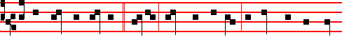
Be not therefore anxious, * saying, What shall we eat? or What shall we drink?
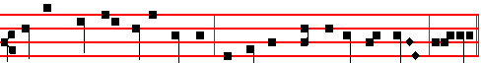
for your heavenly Father knoweth that ye have need of all these things, alleluia.
Canticle Benedictus, p. 39.

On Magnificat, Antiphon. Tone j, 2.
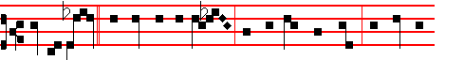
Seek ye first * the kingdom of God, and his righteousness; and all these
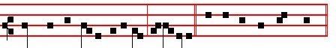
things shall be added unto you, al-le- luia. Canticle Magnificat, p. 209.
__________________________________________________________________

THE FIFTEENTH SUNDAY AFTER PENTECOST

COLLECT
O LORD, we beseech thee, let thy continual pity cleanse and defend thy Church: and, because it cannot continue in safety without thee: govern it evermore by thy goodness. Through.
1338
Lesson viij
WHY is the second like unto it? Because the first leads to the second, and is, moreover, confirmed by it. For every one that doeth evil hateth the light, neither cometh to the light. And again: The foolish body hath said in his heart: There is no God. Then it continues: Corrupt are they, and become abominable in their wickedness. And again: The love of money is the root of all evil; which while some coveted after, they have erred from the faith. And, if ye love me, keep my commandments: of which commandments the head and root is: Thou shalt love the Lord thy God, and thy neighbour as thyself.

Lesson ix
IF therefore, to love God is to love our neighbour (For, If ye love me, O Peter, he said, feed my sheep): if the love of our neighbour makes us keep his commandments; then rightly, does he say that on these hang all the law and the prophets. And just as before this, when he was questioned about the resurrection, he taught more than his tempters asked him; so in this place, when questioned , about the first commandment, he immediately adds that the second is hardly less important than the first; for the second is like unto the first. Therefore He suggests in a veiled way that hatred is their motive for questioning him. For charity, he said, envieth not. Te Deum Laudamus, p. 24.
On Benedictus, Antiphon. Tone viij, 1.
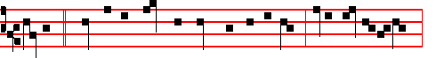
Master, * which is the great commandment in the law? Jesus said unto him,
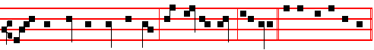
Thou shalt love the Lord thy God with all thy heart, alleluia. Canticle Benedictus
On Magnificat, Antiphon. Tone iv, 1.
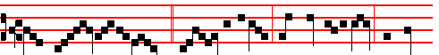
What think ye of Christ? * whose son is he? They say unto him, The son
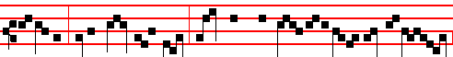
of David. Jesus saith unto them, How then doth Dav-id in spirit call him Lord,

1343
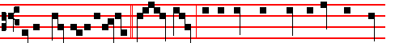
Jesus went into a city * called Nain; and behold, there was a dead man car-

ried out, the only son of his mother. Canticle Benedictus, p. 39.
On Magnificat, Antiphon. Tone iv, 1.
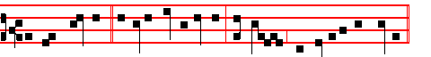
A great prophet * is risen up anong us: and God hath visited his people.
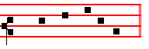
Canticle Magnificat, p. 210.
__________________________________________________________________

THE SIXTEENTH SUNDAY AFTER PENTECOST

COLLECT
LORD, we pray thee that thy grace may always prevent and follow us: and make us continually to be given to good works. Through.

The Lesson from the Holy Gospel according to S. Luke
Lesson vij Ch. 14
AS Jesus went into the house of one of the chief Pharisees to eat bread on the sabbath day, they watched him. And, behold there was a certain man before him which had the dropsy. And the rest.
Homily by S. Ambrose, Bishop Bk. 7 on Luke Ch. 14
THE man with the dropsy is cured, in whom an excessive bodily fluid was hampering the work of the soul: and extinguishing the flame of the spirit. Then, while it is forbidden to take the highest places at a wedding feast, humility
is taught, but it is taught gently, so that persuasion may take the place of harsh compulsion, reason may follow the effects of persuasion, correction emend the disposition. Kindliness is joined to humility as its neighbour, as it were. In the Lord's words, it is that which is to be given to the poor and infirm: for it is a form of avarice to show hospitality to those who are going to reward it.

1340
Lesson viij
FINALLY, as a soldier who has served his time is given a reward as compensation for the good things that he has forgone: so he alone can attain unto the kingdom of heaven who has not been consumed with zeal for lower things and purchased for himself earthly possessions, since the Lord says: Sell that thou hast, and come and follow me. Neither can he attain unto it who buys oxen, since Elijah slew those he had and gave them to the people: neither can he who marries a wife, for he is mindful of the things that are of the world, and not of those of God. Not that we disapprove of marriage, but virginity is a more honourable state; since the unmarried woman and the widow careth for the things of the Lord, that she may be holy both in body and in spirit.

Lesson ix
BUT now that we are once more in agreement with the married, as we have already agreed with the widows, we are not afraid to hold that opinion, prevalent among many: we believe that there are three kinds of men shut out from partaking of that great supper: Gentiles, Jews and heretics. And therefore doth the Apostle tell us to flee from avarice, lest hindered after the manner of the Gentiles by wickedness, malice, and all uncleanness, we should be unable to attain unto the kingdom of heaven.

Te Deum Laudamus, 39.

On Benedictus, Antiphon. Tone vij, 3.
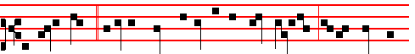
As Jesus went * into the house of one of the chief Pharisees to eat bread on
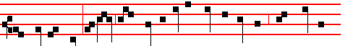
the sabbath day, behold there was a certain man before him which had the dropsy;
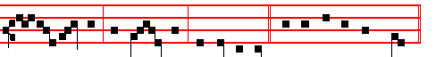
and he took him, and healed him, and let him go. Canticle Benedictus, p. 39.

On Magnificat, Antiphon. Tone vij, 3.

1341

