CORPUS CHRISTI AT II VESPERS

Simple Mode (see p. 997-998 above)

On Magnificat, Antiphon. Tone v.
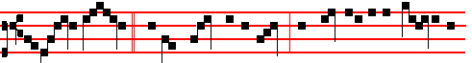
O sacred banquet, * wherein Christ is received, the memory of his passion is
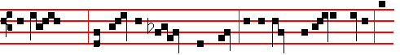
renewed; the soul with grace is filled, and a pledge of future glory is
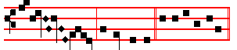
bestowed, al- le- lu- ia. E u o u a e.

__________________________________________________________________



1364
THE HOMILIES AND COLLECTS
ON SUNDAYS
arranged in order, from the third to the last
after Pentecost
________________________________________________________________________

THE THIRD SUNDAY AFTER PENTECOST

COLLECT
O GOD, the protector of them that trust in thee, without whom nothing is strong, nothing is holy: multiply upon us thy mercy; that, thou being our ruler and guide, we may so pass through things temporal, that we lose not the things eternal. Through.

The Lesson from the Holy Gospel according to S. Luke
Lesson vij Ch. l5
THEN drew near unto Jesus all the publicans and sinners for to hear him. And the rest.
Homily by S. Gregory the Great Homily 35 on the Gospels
YOU have heard in the Gospel lesson, my brethren, that the publicans and sinners drew near unto the Redeemer; and they were received, so that they not only spoke with him, they even ate with him. And when the Pharisees saw this, they were scornful. You may gather from this that true righteousness is compassionate, whereas false righteousness is scornful. However, the righteous also are wont to he scornful towards sinners. But one kind of scorn springs from a form of pride, whereas the othcr comes from zeal for discipline.

Lesson viij
THEY are scornful, indeed, but not as scorners; they are disappointed, but not without hope; they are moved to inflict punishment, but they do not cease to love: for though they outwardly pour forth reproaches for the sake of discipline, yet do they inwardly maintain the gentlencss of charity. They often have a higher opinion of those they correct than they have of themselves; they think that those whom they judge are better than than they are. Clearly, in such a case, they both guard those under their care through discipline, and themselves through humility.

Lesson ix
ON the other hand, those who are wont to be haughty through false righteousness, despise everyone else and show no mercy to the weak; and, since they will not believe that they are sinners themselves, for that very reason they become worsc sinners. Clearly, to be numbered among these are those

1317
Homily by S. Jerome, Priest Bk.4. Comm. on Matt. Ch.24
WHEN we are called upon to understand what we read, it is shown that there is a mystery in these words. Now we read in Daniel as follows: In the midst of the week he shall cause the sacrifice and the oblation to cease, and for the overspreading of abominations he shall make it desolate, even until the consummation, and that determined shall be poured upon the desolate. The Apostle is also speaking of this when he says: There shall come that man of sin, who opposeth and exalteth himself above all that is called God, or that is worshipped; so that he as God sitteth in the temple of God, shewing himself that he is God: even he whose coming is after the working of Satan, and he shall destroy them. and banish from God all who shall receive him.

 BIeased is the people * Whom the Lord of hosts hath blessed, saying: O Israel, thou art the work of mine own hands, thou art mine own inheritance.
 Blessed is the nation whose God is the Lord, and the people whom he hath chosen for his own inheritance. Whom the.

Lesson viij
BUT this prophecy may also be understood to mean simply Antichrist, or else the statue of Cæsar which Pilate erected in the temple, or the equestrian statue of Hadrian which stands even to this present day on the site of the Holy of holies. The word, Abomination, in the Old Testament also means, Idol; and, Desolation is added because the idol was placed in the temple that was desolated and destroyed.

 One Seraph cried unto another, and said, * Holy, holy, holy, is the Lord of hosts. * The whole earth is full of his glory.
 There are Three that bear record in heaven, the Father, the Word. and the Holy Ghost, and these Three are One. Holy, holy. Glory be. The whole.

Lesson ix
ABOMINATION of desolation may also be understood as all perverse dogma: and when we see it stand in the holy place, that is, in the Church, we must flee from Judæa to the mountains, that is, we must leave the letter that killeth and Jewish perversity, and make our way to the everlasting hills, from which God sheds his light ineffably: we must be on the housetop where the fiery darts of the devil cannot reach us, nor must we come down to take anything out of the house of our former conversation, nor seek the things that we left behind; but instead we must labour in the spiritual field of the Scriptures, so that we may reap fruit from it; nor must we have two coats, for that was forbidden to the Apostles.
Te Deum Laudamus, p.24.
On Benedictus, Antiphon. Tone j, 3.

1362
GRANT to us, O Lord, we beseech thee: that the course of this world may be peaceably ordered by thy governance; and thy Church may rejoice in godly quietness. Through.

The Lesson from the Holy Gospel according to S. Luke
Lesson vij Ch. 5
AS the people pressed upon Jesus to hear the word of God, he stood by the lake of Gennesaret. And the rest.
Homily by S. Ambrose, Bishop Bk. 4 on Luke Ch. 7
WHEN the Lord bestowed his manifold healing on so many people, neither time nor place could keep back the crowds that pressed upon him, seeking to be healed. Evening fell; they still followed him: he came to the shore of the lake; they still surged on: and thererore he entered into Peter's ship. This is that ship, which, according to Matthew, was yet tossed about. but according to Luke, it was full of fishes: thus we may learn that at first the Church suffered storms, but was afterwards filled with souls. For the fishes are the men who swim through this life. In Matthew's account Christ sleeps in the midst of his disciples: in Luke's he gives commands. For in the hearts of the lukewarm he sleeps: in the perfect he watches.

Lesson viij
THAT ship is not tossed which is steered by wisdom; unfaithfulness is not on board, the wind of faith fills its sails. How could it be tossed, when he on whom the Church is founded is in command? A storm arises where there is littleness of faith: here there is safety, where there is perfect love. And if others are told to let down their nets, yet to Peter alone is it said, Launch out into the deep: that is, into the depths of doctrine. For what is more profound than to discern thc depths of the riches of God, to know the Son of God, and to make profession of the Divine generation? Although the human mind cannot comprehend this by reasoning, yet it can be grasped by profound faith.

Lesson ix
FOR although I am not to know how he was born, yet am I not to be in ignorance of the fact that he was born. I know not the manner of his generation, but I acknowledge the Author of that generation. We were not present when he was born Son of God the Father, but we were present when he was declared Son of God the Father. If we believe not God, whom shall we believe? For all that we believe, we believe either through sight or through hearing: sight often fails, but faith cometh by hearing.
Te Deum Laudamus, p. 24.

On Benedictus, Antiphon. Tone j, 3.
1319
GRANT, we beseech thee, almighty God: that we, ever meditating those things that be reasonable and pleasing unto thee, may both in word and deed fulfil the same.Through.

The Lesson from the Holy Gospel according to S. Matthew
Lesson vij Ch. 13
JESUS said unto his disciples; The kingdom of heaven is like to a grain of
mustard seed, which a man took and sowed in his field. And the rest.
Homily by S. Jerome, Priest Bk. 2 Comm. on Matt. Ch. 13, v. 32
THE Kingdom of heaven is the preaching of the Gospel and the knowledge of the Scriptures which leads to life and concerning which it was said to the
Jews, The Kingdom of God will be taken from you and given to a nation bringing forth the fruit of it. This Kingdom therefore is like to a grain of mustard seed, which a man took, and sowed in his field. The man who sows in his field is understood by many to be the Saviour, because he sows in the minds of them that believe: by others, a man himself is the one who sows in his own field, that is in himself and in his heart.

Lesson viij
WHO is the sower but our perception and our mind? And it, receiving the grain of preaching and tending the young shoot, with the water of faith makes it burgeon in the soil of his own breast The preaching of the Gospel is the least of all systems of knowledge. For at the first instruction the preaching is hardly believed that God became Man, that Christ died, and the scandal of the Cross. Compare teaching of this kind with the dogmas of the philosophers, with their books, the splendour of their eloquence, the careful arrangement of their discourses, and you will see how much less than the other seeds is the sowing of the Gospel.

Lesson ix
BUT when they, the seeds of the philosophers, are fully grown, they reveal nothing that is pungent, nothing lively, nothing vital. But the whole body of their teaching is feeble, rotten, soft; springs up abundantly into herbs and grasses, which swiftly become parched and perish. But this preaching of the Gospel, which in the beginning seemed but small, when it has been sown in the heart of the believer, or in the whole world, does not grow up into herbs but into a tree, so that the birds of the air, which we must takc to mean the souls of the believers, or celestial spirits devoted to the service of God come and dwell in its branches. I think the branches of the Gospel tree which grew from the grain of mustard are the varieties of dogma in which each one of the aforesaid birds takes its rest.
Te Deum Laudamus, p. 24.

1360
consequence, be great and meet for the kingdom of heaven, but yet he ascends a certain step. He will be perfected, however, if he be not angry without a cause; and if he shall do this he will be much further removed from murder. Therefore he who teaches that we should not be angry does not break the law that we should not kill, but fulfils it; so that we preserve our innocence both outwardly while we do not kill, and in our heart when we are not angry.

Lesson viij
THERE is therefore a gradation in the sins referred to, so that first one is angry, and keeps that feeling unexpressed in his heart; but if now that emotion shall draw forth an exclamation of anger not having any definite meaning, but giving evidence of that feeling of the mind by the very fact of the outbreak wherewith he is assailed with whom one is angry, this is certainly more than if the rising anger were restrained by silence. But if there is heard not merely an exclamation of anger, but also a word by which the party using it now indicates and signifies a distinct censure of him against whom it is directed, who doubts but that it is something more than if merely an exclamation were uttered?

Lesson ix
LOOK now also at the three degrees of liability: to the judgment, to the council, to the gehenna of fire. For in the judgment an opportunity is still given for defence. In the council, however, although there is wont to be a judgment, yet because the very fact of a distinction being made compels us to acknowledge that there is a certain difference in this passage: the pronouncing of the sentence seems to belong to the council, inasmuch as it is not now the case of the accused himself that is in question, whether he is to be condemned or not, but a conferring with one another on the part of those who judge to what punishment they ought to condemn him, who, it is clear, is to be condemned, Thc gehenna of fire, though, does not treat as a doubtful matter either the condemnation, like the judgment, or the punishment of him who is condemned, like the council; for in the gehenna of fire both the condemnation and the punishment of him who is
condemned are certain.

Te Deum Laudamus, p. 24.

On Benedictus, Antiphon. Tone viij, 1.
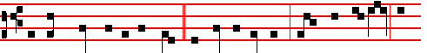
Ye have heard that it was said * to them of old time,Thou shalt not kill; and

1321
On Magnificat, Antiphon. Tone j, 2.
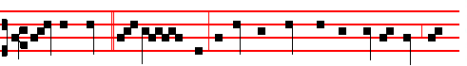
Save us, Lord, * we per- ish: rebuke the winds and the sea, O God, and
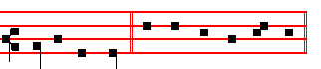
make a great calm. Canticle Magnificat, p.209.
__________________________________________________________________

THE FIFTH SUNDAY THAT REMAINED OVER
AFTER THE EPIPHANY

COLLECT
O LORD, we beseech thee to keep thy household in continual godliness: that they who do lean only upon the hope of thy heavenly grace may evermore be defended by thy protection. Through.

The Lesson from the Holy Gospel according to S. Matthew
Lesson vij Ch. 13
JESUS spake this parable unto the multitudes: The kingdom of heaven is likened unto a man which sowed good seed in his field. And the rest.
Homily by S. Augustine, Bishop 17 on S. Matthew
WHEN those who had been set over the Church behaved in careless fashion or when the Apostles received the sleep of death, the devil came and sowed his seed upon those whom the Lord called the evil sons. But the question is asked, Were they heretics, or Catholics living evil lives? For even heretics can be called evil sons, because they have been begotten from the same seed of the Gospel and in the Name of Christ, though they are turned by their crooked beliefs to false doctrines.

Lesson viij
BUT this he says, that they were sown in the midst of the wheat as though those men seem to be meant who are of the one communion. Yet since the Lord interpreted the field itself not as the Church, but as this world, they are rightly understood as the heretics, because not in the fellowship of the one Church, or of the one faith, but in the fellowship of the name Christian only are they mingled in this world with the good. But they who, holding the same faith are

1358
AFTER that woman, who may be taken as a type of the Church, has been cured of an issue of blood, after the Apostles have been sent out to prcach the
Gospel of the kingdom of God, the food of divine grace is bestowed. But note on whom it is bestowed. Not on the leisured, not on those in cities, such as those who occupy high places in the synagogues or in the state: but on those who are seekin~ Christ in desert places. Men who are not haughty, it is they who are received by Christ; and the Word of God converses with them, not of worldly matters, but of the kingdom of God. And if any of them are suffering from the sores of fleshly passions, then he gladly grants them healing.

Lesson viij
CONSEQUENTLY, those whom he healed from the pain of their wounds, those he also freed from fasting by giving them spiritual food. Therefore no
one receives the bread of Christ who has not first been healed; and those who have
been called to his feast are first healed through his call. If there were a lame man, he would receive the power to walk, so that he could come; if one were deprived of his eyesight, he could not enter the house of the Lord, unless his sight were restored.

Lesson ix
IN all cases the order of the mystery is retained, so that first the wounds are healed through remission of sins, and afterwards the food of the heavenly table abounds: however, this multitude is not yet refreshed with stronger meat, nor is it fed with the body and blood of Christ, as are the fasting hearts of those of stronger faith. I have fed you, says the Apostle, with milk, and not with meat: for hitherto you were not able to bear it, neither yet now are ye able. The five loaves are, as it were, milk; but the stronger meat is the Body of Christ; the stronger drink is the Blood of the Lord.
Te Deum Laudamus, p. 24.

On Benedictus, Antiphon. Tone viij, 1.
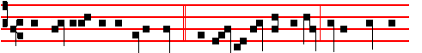
The multitude being very great,* and having nothing to eat, Jesus called his
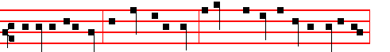
disciples unto him, and saith unto them, I have compassion on the multitude,

1323
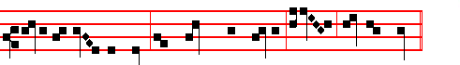 Jesus put forth his hand and touched him, saying I will; be thou clean. 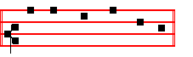
Canticle Benedictus, p.39. On Magnificat, Antiphon. Tone j, 2.
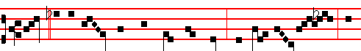
Lord, * if thou wilt, thou canst make me clean: then saith Je- sus, I
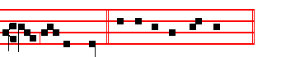
will; be thou clean. Canticle Magnificat, p. 209.
__________________________________________________________________

THE FOURTH SUNDAY WHICH REMAINED OVER
AFTER THE EPIPHANY

COLLECT
O GOD,who knowest us to be set in the midst of so great dangers that through our human frailty we cannot stand upright: grant to us health of mind and body; that those things which we suffer for our sins, by thy help we may overcome. Through.

The Lesson from the Holy Gospel according to S. Matthew
Lesson vij Ch. 8
JESUS entereed into a ship, and his disciples followed him. And, behold, there arose a great tempest in the sea, insomuch that the ship was covered with the waves: but he was asleep. And the rest.
Homily by S. Jerome, Priest Bk. I, Ch. 8 on Matt.
WE wrought the fifth sign when, taking ship from Capernaum, he commanded the winds and the sea. The sixth, when, in the country of the Gergesenes, he

1356
the nature of man's deeds than for the way he speaks; for in many a man a ravening wolf hides under sheep's clothing. Therefore, as thorns do not bear grapes, nor thistles figs, and as a corrupt tree does not bring forth good fruit; even so, as the Lord teaches, evil men do not bring forth good works. For the mere speaking of words does not gain us the kingdom of heaven, nor shall he inherit it who says, Lord, Lord.

Lesson viij
FOR what is the use of saying, Lord, to our Lord? Would he not still be the Lord, even if we did not call him so? What has the declaiming of a name to do with holiness, when the way to the kingdom of heaven is to be found in obedience to the will of God rather than merely calling on his name? Many shall say to me in that day, Lord, Lord, have we not prophesied in thy name? He here condemns both the deceit of the false prophets and the guile of the hypocrites, who presume to take to themselves that glory which lies in the power of the Word, in their teaching of doctrine, in putting demons to flight, and in other mighty deeds of this kind.

Lesson ix
THUS they promise themselves the kingdom of heaven, as though there were something of their own in what they say or do, as though all were not done by invocation of God; since reading brings knowledge of doctrine and the name of Christ puts demons to flight. Therefore, if we would gain that blessed eternity, it is for us to do our part in willing what is good and in shunning all evil; we must obey the heavenly commands with our whole heart, and by such work will God know us. We must do his will, instead of glorying in power. And we must put away and cast off from us those who through their evil works are estranged from him.
Te Deum Laudamus, p. 24.

On Benedictus, Antiphon. Tone viij, 1.
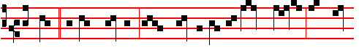
Beware * of false prophets, which come to you in sheep's clothing, but in-
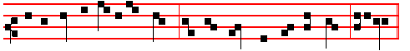
wardly they are ravening wolves.Ye shall know them by their fruits, alleluia.

1325
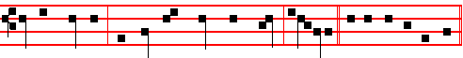
of good comfort; thy faith hath made thee whole, alle-lu-ia. Canticle Magnificat.

¶ The Sundays after Pentecost cannot be fewer than 23, nor more than 28. When there are more than 24, then after the 23rd Sunday there are taken those which were over in that year after the Epiphany, as concerns the Collect, Homily, and Antiphons on Benedictus and Magnificat in this order.

If the Sundays after Pentecost be XXV, the XXIV Sunday after Pentecost will be the VI after the Epiphany.

If they be XXVI, the XXIV Sunday will be the V after the Epiphany and the XXV will be the VI.

If they be XXVII, the XXIV Sunday will be the IV after Epiphany, the XXV will be the V, and the XXVI will be the VI.

If they be XXVIII, the XXIV Sunday will be the III after Epiphany, the XXV will be the IV and the XXV will be the V, and the XXVII will be the VI, and always in the last place is placed the one which follows in order as the XXIV below, p. 1361.
__________________________________________________________________

THE THIRD SUNDAY WHICH REMAINED OVER AFTER THE EPIPHANY

COLLECT
ALMIGHTY and everlasting God, mercifully look upon our infirmities: and stretch forth the right hand of thy majesty to defend us. Through.

The Lesson from the Holy Gospel according to S. Matthew
Lesson vij Ch. 8
WHEN Jesus was come down from the mountain, great multitudes followed him. And, behold, there came a leper and worshipped him. And the rest.
Homily by S. Jerome, Priest Comm. on Matt. 8, Ch. 1
WHEN the Lord came down from the mountain, multitudes met him, for they were not able to climb to the heights. And the first to meet him was a leper, for he could not yet, with his leprosy, hear upon the mountain the Saviour's manifold discourse. And note: he was the first person specially mentioned as healed. The second was the centurion's servant: the third Peter's mother-in-law

1354
Lesson viij
AT the end of the parable he says, And I say unto you, Make to yourselves friends of the mammon of unrighteousness. Now Mammon is not a Hebrew but a Syriac word, meaning ill-gotten gains. Therefore if unrighteousness is changed into righteousness when these gains are put to a good use, how much more will the divine word, in which there is no unrighteousness, and which is entrusted to the Apostles, raise its stewards to heaven, if it has been well stewarded?

Lesson ix
FOR this reason it is added, He that is faithful in that which is least, (that is, in material things,) is faithful also in much, (that is, in spiritual things.) He that is unjust in the least in that he will not allow his brother to use that which has been created by God for every man's use; that man will be unrighteous in dealing out spiritual riches, in that he will bestow the Lord's teaching without regard to where it is most needed, but with respect of persons. If, therefore, you have not done wisely concerning material riches that pass away, who will commit to your trust the true and eternal riches of God's teaching? And if you have not been faithful in those riches which belong to others, (for nothing in this world is truly our own) who will be able to commit to your trust those riches which are especially destined for men?
Te Deum Laudamus, p. 24.
On Benedictus, Antiphon. Tone j, 3.
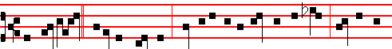
The lord said * unto the steward, How is it that I hear this of thee? Give an ac-
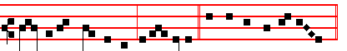
count of thy stewardship, alleluia. Canticle Benedictus, p. 39.
On Magnificat, Antiphon. Tone iv, 1.
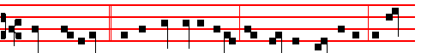
What shall I do? * for my lord taketh away from me the stewardship: I can-
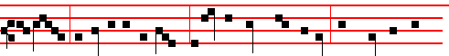
not dig; to beg I am ashamed: I am resolved what to do, that, when I am
1327
On Benedictus, Antiphon. Tone viij, 1.
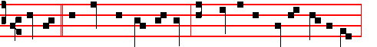
Master, * we know that thou art true, and teachest the way of God in truth,
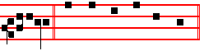
alleluia. Canticle Benedictus, p. 39.
On Magnificat, Antiphon. Tone j, 2.
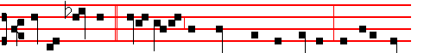
Render therefore * unto Cæsar the things which are Cæsar's: and unto God
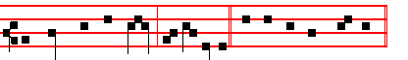
the things that are God's, al-le- luia. Canticle Magnificat, p.209.
¶ If the following Sunday be the last after Pentecost, in its place is put the 24th, as below, p. , and the Office of this Sunday is put on the Saturday preceding, not being impeded by a Feast of ix Lessons, or else on Friday or another day not similarly impeded.
__________________________________________________________________

THE TWENTY-THIRD SUNDAY AFTER PENTECOST

COLLECT
O LORD, we beseech thee, absolve thy people from their offences: that through thy bountiful goodness we may be delivered from the bonds of those sins, which by our frailty we have committed. Through.

The Lesson from the Holy Gospel according to S. Matthew
Lesson vij Ch. 9
WHILE Jesus spake these things unto John's disciples, behold, there came a certain ruler, and worshipped him, saying, My daughter is even now dead. And the rest.
Homily by S. Jerome, Priest Bk, 1, Comm. on Matt. 9
THE eighth miracle took place when the ruler, who did not wish to be excluded from the mystery of the true circumcision, asked that his daughter might be

1352
If thou hadst known, even thou; meaning, Thou too wouldest weep, instead of rejoicing in ignorance of your approaching fate. Whence it follows, At least in this thy day, the things which belong unto thy peace. For, while she was giving herself up to the pleasures of the flesh, she did have in her day those things which should have been for her peace.
Te Deum Laudamus, p. 24.
On Benedictus, Antiphon. Tone j, 1.
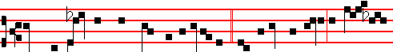
When the Lord was come near to Jerusalem, * he beheld the city, and wept
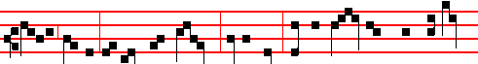
over it, saying: If thou hadst known, even thou: For the days snaIl come upon
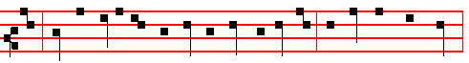
thee, that thine enemies shall cast a trench about thee, and compass thee round,
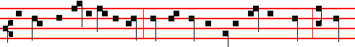
and keep thee in on every side, and shall lay thee even with the ground; because
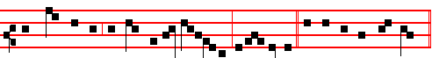
thou knewest not the time of thy visitation, alle- lu-ia. Canticle Benedictus.
On Magnificat, Antiphon. Tone viij, 1.
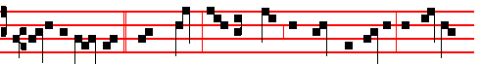
Is it not written, * Mine house shall be called an house of prayer for all peo-
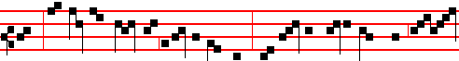
ple? But ye have made it a den of robbers. And he was daily with them, teach-
1329
we will not forgive little things to our brethren, we shall not be forgiven grievous things by God. And because some one might say: I have nothing against him, he knows what he has done and God will judge him, what he chooses to do is not my business, I myself have forgiven him: because of this, the Lord confirms his sentence, and removes the likelihood of any such false peace, saying: If ye from your hearts forgive not every one his brother their trespasses.
Te Deum Laudamus, p. 24.
On Benedictus, Antiphon. Tone viij, 1.
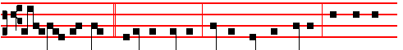
Then said the Lord * unto the servant, Pay me that thou owest. The servant
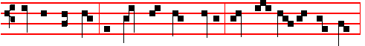
therefore fell down and worshipped him, saying, Lord, have patience with me,
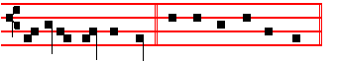
and I will pay thee all. Canticle Benedictus, p. 39.
On Magnificat, Antiphon. Tone vj.
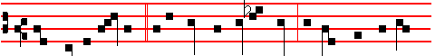
Thou wicked servant, * I forgave thee all that debt, because thou desiredst
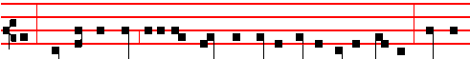
me: shouldest not thou also have had compassion on thy fellow-servant, even
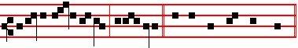
as I had pity on thee, alle- luia. Canticle Magnificat, p. 209.
__________________________________________________________________

THE TWENTY-SECOND SUNDAY AFTER PENTECOST

COLLECT
1350
lift up his eyes to heaven: that he might be seen, not that he might see; he did not
dare to look up: his conscience weighed him down, hope lifted him up. But hear this further thing. He smote upon his breast. He punished himself. Therefore the Lord forgave him as he confessed. He smote upon his breast, saying, God, be merciful to me a sinner. Lo, he is the one who prays. Is it surprising that the Lord pardons him, when he acknowledges his fault?
Te Deum Laudamus, p. 24.
On Benedictus, Antiphon. Tone ij.
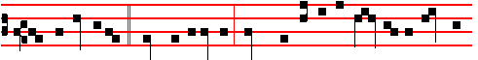
And the publican, * standing afar off, would not lift up so much as his eyes un-
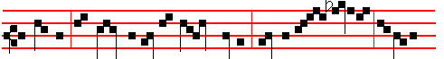
to heaven, but smote upon his breast, saying, God be mer- ciful to me a
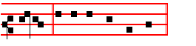
sin-ner. Canticle Benedictus, p. 39.
On Magnificat, Antiphon.. Tone viij, 1.

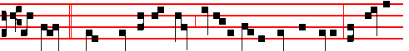
This man * went down to his house justified rather than the other: for every-
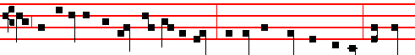
one that exalteth himself shall be abased; and he that humbleth himself shall be
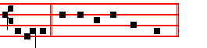
ex-alted. Canticle Magnificat, p. 211.
__________________________________________________________________

THE ELEVENTH SUNDAY AFTER PENTECOST

1331

Lesson viij
BUT call to mind what he asked; and you will see clearly that his faith was unsound. For he requested him to come down and heal his son. He besought

the Lord's bodily presence, and the Lord is never absent in spirit. Therefore his faith in the Lord was inadequate, because he thought he could not bestow health unless he were present in body. For if his faith had been whole and perfect he would doubtless have known that there is no place where God is not present.

Lesson ix
THEREFORE his faith was bereft of the greater part, for he attributed the Lord's power to his bodily presence, and not to his divine majesty. He sought health for his son, then, and yet his faith was unsound; for although he believed that he to whom he had come was able to heal, yet he thought that he was absent from his dying son. But the Lord, who is asked to go, shows that he is not absent from the place whither he is called: he who created all things restored health by a single command.
Te Deum Laudamus, p. 24.

On Benedictus, Antiphon. Tone j, 1.
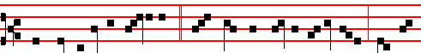
There was a certain nobleman, * whose son was sick at Ca- pernaum: when he
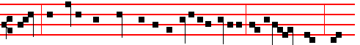
heard that Jesus was came out of Judaea into Galilee, he besought him that
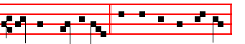
he would heal his son. Canticle Benedictus, p. 39.
On Magnificat, Antiphon. Tone iij, 1.
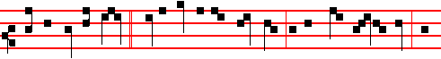
So the father knew * that it was at the same hour in the which Jesus said, Thy

1348
those good works which he, through obedience, has already done.
Te Deum Laudamus, p. 24.
On Benedictus, Antiphon. Tone v.
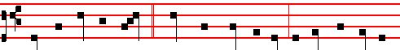
When the Lord had passed * through the coasts of Tyre, he made the deaf to
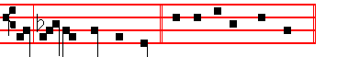
hear and the dumb to speak. Canticle Benedictus, p. 39.
On Magnificat, Antiphon. Tone v.
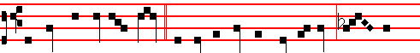
He hath done all things well * he maketh both the deaf to hear, and the
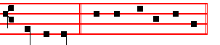
dumb to speak. Canticle Magnificat, p. 210.
__________________________________________________________________

THE TWELFTH SUNDAY AFTER PENTECOST

COLLECT
ALMIGHIY and merciful God, of whose gift it cometh, that thy faithful people
do unto thee worthy and laudable service: grant, we beseech thee; that we may so faithfully serve thee in this life, that we may without stumbling run the way of thy promises. Through.

The Lesson from the Holy Gospel according to S. Luke
Lesson vij Ch. 10
JESUS said unto his disciples, Blessed are the eyes which see the things that ye see: for I tell you, that many prophets and kings have desired to see those things which ye see, and have not seen them. And the rest.
Homily by S. Bede the Venerable Bk. 3 on Luke Ch. 10
BLESSED are the eyes, not of the scribes and pharisees, which can see only the bodily presence of the Lord, but those eyes which can recognize his mysteries, of whom it is said: And hast revealed them unto babes. Blessed are the

1333
I REMEMBER having often said that the Church is frequently mentioned in the Gospels as the kingdom of heaven. The Lord says through his prophet: The heaven is my throne; and Solomon says: The soul of the righteous is the throne of wisdom; Paul also says: Christ the power of God and the wisdom of God. We may clearly gather that if God is wisdom, and the soul of the righteous is the throne of wisdom, while heaven is the throne of God, then heaven is the soul of the righteous. For the Lord says through the Psalmist concerning his holy preachers: The heavens declare the glory of God.

Lesson viij
THEREFORE the kingdom of heaven is the throne of the righteous: for their heart's desire is by no means set upon earth, but yearns for the heavenly country, and through this very fact the Lord is already reigning in them as though in heaven. Therefore is it said: The kingdom of heaven is like unto a certain king which made a marriage for his son. Now of your charity learn who is this King, the father of the King's son. Indeed it is he to whom the Psalmist says: Give the King thy judgments, O God: and thy righteousness unto the King's son. Which made a marriage for his son. For God the Father made a marriage for his son, when he united him to human nature in the Virgin's womb, when he willed that he who was God before time was should become man in the latter days.

Lesson ix
BUT since the marriage union is wont to be made from two persons, be it far from us that we should believe the one Person of God and of the man Christ Jesus to be of two persons. We do indeed say that he is of two and in two natures; but we abhor as wicked the belief that he is made up of two separate persons. Therefore all the more openly and safely may it be said that the Father made a marriage for the King his Son; in that by the mystery of the Incarnation he united holy Church to him. Now the womb of the Virgin was the marriage chamber of this espousal. Whence also the Psalmist says: In the sun hath he set his tabernacle, and he cometh forth as a bridegroom out of his chamber.
Te Deum Laudamus, p. 24.
On Benedictus, Antiphon. Tone viij, 1.
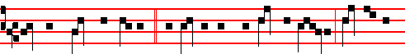
Tell them which are bidden, * Behold, I have prepared my dinner; come to the
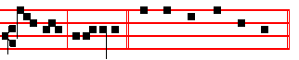
marriage, alle- luia. Canticle Benedictus, p. 39.
1346
On Magnificat, Antiphon. Tone viij, 1.
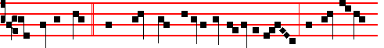
A certain man * went down from Jerusalem to Jericho, and fell among
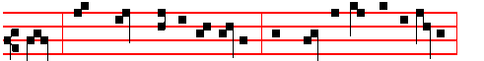
thieves, which stripped him of his raiment, and wounded him, and departed,
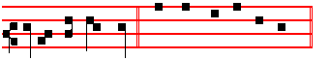
leaving him half dead. Canticle Magnificat, p. 211.
__________________________________________________________________

THE THIRTEENTH SUNDAY AFTER PENTECOST

COLLECT

ALMIGHTY and everlasting God, give unto us the increase of faith, hope, and charity:and, that we may be worthy to obtain that which thou dost promise, make us to love that which thou dost command. Through.

The Lesson from the Holy Gospel according to S. Luke
Lesson vij Ch. 17
AS Jesus went to Jerusalem, he passed through the midst of Samaria and Galilee. And as he entered a certain village, there met him ten men that were lepers. And the rest.

Homily by S. Augustine, Bishop Book of Questions. 2, Ch. 40
CONCERNING those ten lepers whom the Lord cleansed when he said: Go, shew yourselves to the priests: we may ask why it was that he sent them to the priests, so that, as they went, they were cleansed. For with none of the others on whom he bestowed bodily blessings is it found that they were sent to the priests, except the lepers. For that man was also cleansed from leprosy, to whom he said: Go, and show thyself to the priest, and offer for thy cleansing, according as Moses commanded, for a testimony unto them. Therefore it is to be asked what this leprosy signifies: for the men whom he delivered from it were said to be cleansed, not healed. Now it discolours the skin before it destroys health and the use of the members.

1335
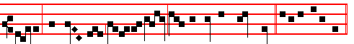
saying, The Lord said unto my Lord, Sit thou on my right hand? C. Magnificat.
__________________________________________________________________

THE EIGHTEENTH SUNDAY AFTER PENTECOST

COLLECT
LET the operation of thy mercy, O Lord, direct our hearts: forasmuch as without thee we are not able to please thee. Through.

The Lesson from the Holy Gospel according to S. Matthew
Lesson vij Ch. 9
JESUS entered into a ship, and passed over, and came into his own city. And the rest.
Homily by S. Peter Chrysologus Sermon 50
TODAY'S lesson shows that in his actions as man Christ worked divine mysteries, and that in the things that could be seen he performed invisible deeds. He entered into a ship, says the Evangelist, and passed over, and came into his own city. Yet is not this he who put the waves to flight and laid bare the depths of the sea, so that the people of Israel passed dry-shod between the petrified waves, as though through a mountain pass? Is not this he who moulded the swirling waves beneath Peter's feet, so that the liquid path became firm and offered itself to human footsteps?

Lesson viij
WHY, then, does he deny himself this service of the sea, and cross that narrow lake by means of a borrowed ship? He entered into a ship, says the Evangelist, and passed over. Why do you marvel, brethren? Christ came to take our weakness, and to give us his strength; to seek out the ways of man and to open up the ways of God; to receive injuries and to bestow honours in return; to bear weariness and to restore health, for a physician with no experience of weakness knows not how to cure it, and he who is not weak among the weak knows not how to make them strong.

Lesson ix
THEREFORE had Christ remained in his own strength, he would have had nothing in common with men; and had he not fulfilled the conditions of the flesh, there would have been no point in his taking of flesh. He ascended into a ship, says the Evangelist, and passed over, and came into his own city. The Lord

1344

with a loud voice glorified God, alleluia. Canticle Magnificat, p. 209.
__________________________________________________________________

THE FOURTEENTH SUNDAY AFTER PENTECOST

COLLECT
KEEP, we beseech thee, O Lord, thy Church with thy perpetual mercy: and, because the frailty of man without thee cannot but fall; keep us ever by thy help from things hurtful, and lead us to those things profitable to our salvation. Through.

The Lesson from the Holy Gospel according to S. Matthew
Lesson vij Ch. 6
JESUS said unto his disciples: No man can serve two masters. And the rest.
Homily by S. Augustine, Bishop On the Sermon on the Mount Chaper 14
NO man can serve two masters; is to be referred to this very intention, as he goes on to explain, saying: For either he will hate the one, and love the other; or else he will submit to the one, and despise the other. And these words are to be carefully considered; for who the two masters are he forthwith shows, when he says: Ye cannot serve God and mammon. Riches are said to be called mammon among the Hebrews. The Punic name also corresponds; for gain is called mammon in Punic.

Lesson viij
BUT he who serves mammon certainly serves him who, as being set over those earthly things in virtue of his perversity, is called by the Lord the prince of this world. A man will therefore either hate this one, and love the other, that is, God; or he will submit to the one, and despise the other. For whoever serves mammon submits to a hard and ruinous master: (or, being entangled by his own
lust, he becomes a subject of the devil, and he does not love him; for who is there that loves the devil? and yet he serves him.

Lesson ix
THEREFORE, says he, I say unto you, be not anxious for your life, what ye shall eat; nor yet for your body, what ye shall put on. Lest perchance, although it is not now superfluities that are sought after, the heart should be made

1337
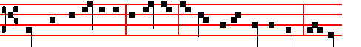
When thou art bidden to * a wedding, sit down in the lowest place; that he
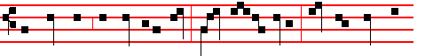
that bade thee may say unto thee, Friend, go up higher; then shalt thou have
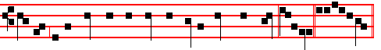
worship in the presence of them that sit at meat with thee, alleluia. Canticle Magnificat, p. 210.
__________________________________________________________________

THE SEVENTEENTH SUNDAY AFTER PENTECOST

COLLECT
LORD, we beseech thee, grant thy people grace to avoid the infections of the devil: and with pure minds to follow thee, the only God. Through.

The Lesson from the Holy Gospel according to S. Matthew
Lesson vij Ch. 22
WHEN the Pharisees heard that Jesus had put the Sadducees to silence, they were gathered together. Then one of them, which was a lawyer, asked him a question. And the rest.
Homily by S. John Chrysostom Homily 72 on Matt.
WHEN the Sadducees are put to silence the Pharisees return to the attack, and when they ought to keep silence they take upon themselves to contend. They put forward one who professes to be learned in the law, who is eager, not to learn, but to tempt him, and he questions the Lord in this manner: Which is the first commandment in the law? Now since the first is, Thou shalt love the Lord thy God; they question him in this manner, because they think that he will add some alteration, by way of correction, to the commandment, for his own purposes, since he made himself God. What, then, does Christ do? To show that they had descended to this behaviour because there was not a vestige of love in them and because they were consumed with envy: Thou shalt love the lord thy God, he says; this is the first and great commandment. And the second is like unto it. Thou shalt love thy neighbour as thyself.

1342
The Lesson from the Holy Gospel according to S. Luke
Lesson vij Ch. 7
JESUS went into a city called Nain; and many of his disciples went with him, and much people. And the rest.
Homily by S. Augustine. Bishop Sermon on theWords of the Lord Ch.2
THE widowed mother rejoiced when her young son was raised to life: Mother Church rejoices daily when men are raised to life in the spirit. He indeed was dead in body. but they in mind. His visible death was visibly mourned; their invisible death is neither seen nor searched into. He sought for them whom he knew to be dead, he who was able to make them live. For had he not come to raise men from the dead. the Apostle would not have said: Awake. thou that sleepest. and arise from the dead, and Christ shall give thee light.

Lesson viij
WE are told of three dead persons who were visibly raised from the dead by the Lord, and thousands invisibly. But who knows how many he visibly raised from the dead? For not all the things that he did are recorded. John says on this subject: And there are also many other things which Jesus did, the which, if they should be written every one, I suppose that even the world itself could not contain the books that should be written. Therefore without a doubt many others were raised, but it is not without reason that these three are mentioned. For our Lord Jesus Christ wished the things that he did to be understood according to their spiritual as well as their material meaning. Neither did he work such a miracle merely for the miracle's sake; but so that his wondrous acts should be marvelled at by those who saw them, and truly understood by those who comprehended them.

Lesson ix
IT is as though a man who could not read were to see a beautifully written manuscript. He would praise the ancient scribe, admiring the beauty of the characters; yet, not knowing what those characters represented nor what meaning lay hid in them, he would praise them with his eye, but not comprehend with hismind. But another man would both praise the craftsmanship and grasp the meaning: he indeed who could not only see what was manifest to all, but could also read the words; which a man who had not learned would not be able to do. So, likewise those who saw Christ's miracles and did not understand what meaning lay hid in them, nor what they revealed to those who, to a certain measure, did understand them, only marvelled at what was done, while others both marvelled at what was done and grasped the meaning. And we also should be like these last in the school of Christ.
Te Deum Laudamus, p. 24.
On Benedictus, Antiphon. Tone ij

1339

