THE HOMILIES AND COLLECTS
ON SUNDAYS
arranged in order, from the third to the last
after Pentecost
________________________________________________________________________

THE THIRD SUNDAY AFTER PENTECOST

COLLECT
O GOD, the protector of them that trust in thee, without whom nothing is strong, nothing is holy: multiply upon us thy mercy; that, thou being our ruler and guide, we may so pass through things temporal, that we lose not the things eternal. Through.

The Lesson from the Holy Gospel according to S. Luke
Lesson vij Ch. l5
THEN drew near unto Jesus all the publicans and sinners for to hear him. And the rest.
Homily by S. Gregory the Great Homily 35 on the Gospels
YOU have heard in the Gospel lesson, my brethren, that the publicans and sinners drew near unto the Redeemer; and they were received, so that they not only spoke with him, they even ate with him. And when the Pharisees saw this, they were scornful. You may gather from this that true righteousness is compassionate, whereas false righteousness is scornful. However, the righteous also are wont to he scornful towards sinners. But one kind of scorn springs from a form of pride, whereas the othcr comes from zeal for discipline.

Lesson viij
THEY are scornful, indeed, but not as scorners; they are disappointed, but not without hope; they are moved to inflict punishment, but they do not cease to love: for though they outwardly pour forth reproaches for the sake of discipline, yet do they inwardly maintain the gentlencss of charity. They often have a higher opinion of those they correct than they have of themselves; they think that those whom they judge are better than than they are. Clearly, in such a case, they both guard those under their care through discipline, and themselves through humility.

Lesson ix
ON the other hand, those who are wont to be haughty through false righteousness, despise everyone else and show no mercy to the weak; and, since they will not believe that they are sinners themselves, for that very reason they become worsc sinners. Clearly, to be numbered among these are those

1317
Pharisees who criticized the Lord for receiving sinners; in dryness of heart they rebuked the very fountain of mercy. But they were sick, so sick that they were unaware of it. To make them realize that they were sick, the heavenly physician tends them with a gentle remedy, laying before them this gracious parable, and reduces the swelling of the wound in their hearts.
Te Deum Laudamus, p. 24.
On Benedictus, Antiphon. Tone iij, 4.
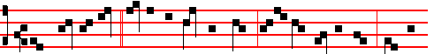
What man of you,* having an hundred sheep, if he lose one of them, doth not
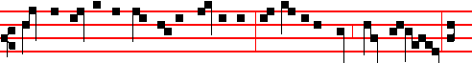
leave the ninety and nine in the wilderness, and go after that which is lost, un-
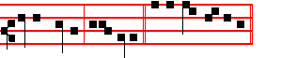
til he find it? alle- luia. Canticle Benedictus, p..29
On Magnificat, Antiphon. Tone vj
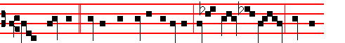
What woman,* having ten pieces of silver, if she lose one piece, doth not
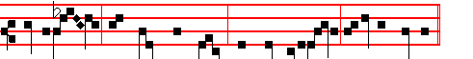
light a cand-le, and sweep the house, and seek diligently until she find it?
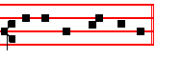
Canticle Magnificat, p. 210.
__________________________________________________________________

THE FOURTH SUNDAY AFTER PENTECOST

COLLECT

1218
GRANT to us, O Lord, we beseech thee: that the course of this world may be peaceably ordered by thy governance; and thy Church may rejoice in godly quietness. Through.

The Lesson from the Holy Gospel according to S. Luke
Lesson vij Ch. 5
AS the people pressed upon Jesus to hear the word of God, he stood by the lake of Gennesaret. And the rest.
Homily by S. Ambrose, Bishop Bk. 4 on Luke Ch. 7
WHEN the Lord bestowed his manifold healing on so many people, neither time nor place could keep back the crowds that pressed upon him, seeking to be healed. Evening fell; they still followed him: he came to the shore of the lake; they still surged on: and thererore he entered into Peter's ship. This is that ship, which, according to Matthew, was yet tossed about. but according to Luke, it was full of fishes: thus we may learn that at first the Church suffered storms, but was afterwards filled with souls. For the fishes are the men who swim through this life. In Matthew's account Christ sleeps in the midst of his disciples: in Luke's he gives commands. For in the hearts of the lukewarm he sleeps: in the perfect he watches.

Lesson viij
THAT ship is not tossed which is steered by wisdom; unfaithfulness is not on board, the wind of faith fills its sails. How could it be tossed, when he on whom the Church is founded is in command? A storm arises where there is littleness of faith: here there is safety, where there is perfect love. And if others are told to let down their nets, yet to Peter alone is it said, Launch out into the deep: that is, into the depths of doctrine. For what is more profound than to discern thc depths of the riches of God, to know the Son of God, and to make profession of the Divine generation? Although the human mind cannot comprehend this by reasoning, yet it can be grasped by profound faith.

Lesson ix
FOR although I am not to know how he was born, yet am I not to be in ignorance of the fact that he was born. I know not the manner of his generation, but I acknowledge the Author of that generation. We were not present when he was born Son of God the Father, but we were present when he was declared Son of God the Father. If we believe not God, whom shall we believe? For all that we believe, we believe either through sight or through hearing: sight often fails, but faith cometh by hearing.
Te Deum Laudamus, p. 24.

On Benedictus, Antiphon. Tone j, 3.
1319
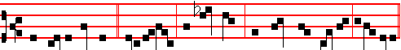
And Jesus entered * into a ship, and sat down, and taught the people, alle-luia.


Canticle Benedictus , p. 39.
On Magnificat, Antiphon. Tone j, 2.
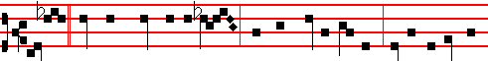
Master,* we have toiled all the night, and have taken nothing: nevertheless, at

thy word I will let down the net. Canticle Magnificat, p. 209.
__________________________________________________________________

THE FIFTH SUNDAY AFTER PENTECOST

COLLECT
O GOD,who hast prepared for them that love thee such good things as pass man's understanding: pour into our hearts such love toward thee; that we, loving thee in all and above all things, may obtain thy promises, which exceed all that we can desire. Through.

The Lesson from the Holy Gospel according to S. Matthew
Lesson vij Ch. 5
JESUS said unto his disciples: Except your righteousness shall exceed the righteousness of the scribes and Pharisees, ye shall in no case enter into the kingdom of heaven. And the rest.
Homily by S. Augustine, Bishop On the Sermon on the Mount Bk. 1, Ch. 9
THE righteousness of the Pharisees is, that they shall not kill; the righteousness of those who are destined to enter into the kingdom of God, that they shall not be angry without a cause. The least commandment, therefore, is not to kill; and whosoever shall break that, shall be called least in the kingdom of heaven; but whosoever shall fulfil that commandment not to kill, will not, as a necessary

1320
consequence, be great and meet for the kingdom of heaven, but yet he ascends a certain step. He will be perfected, however, if he be not angry without a cause; and if he shall do this he will be much further removed from murder. Therefore he who teaches that we should not be angry does not break the law that we should not kill, but fulfils it; so that we preserve our innocence both outwardly while we do not kill, and in our heart when we are not angry.

Lesson viij
THERE is therefore a gradation in the sins referred to, so that first one is angry, and keeps that feeling unexpressed in his heart; but if now that emotion shall draw forth an exclamation of anger not having any definite meaning, but giving evidence of that feeling of the mind by the very fact of the outbreak wherewith he is assailed with whom one is angry, this is certainly more than if the rising anger were restrained by silence. But if there is heard not merely an exclamation of anger, but also a word by which the party using it now indicates and signifies a distinct censure of him against whom it is directed, who doubts but that it is something more than if merely an exclamation were uttered?

Lesson ix
LOOK now also at the three degrees of liability: to the judgment, to the council, to the gehenna of fire. For in the judgment an opportunity is still given for defence. In the council, however, although there is wont to be a judgment, yet because the very fact of a distinction being made compels us to acknowledge that there is a certain difference in this passage: the pronouncing of the sentence seems to belong to the council, inasmuch as it is not now the case of the accused himself that is in question, whether he is to be condemned or not, but a conferring with one another on the part of those who judge to what punishment they ought to condemn him, who, it is clear, is to be condemned, Thc gehenna of fire, though, does not treat as a doubtful matter either the condemnation, like the judgment, or the punishment of him who is condemned, like the council; for in the gehenna of fire both the condemnation and the punishment of him who is
condemned are certain.

Te Deum Laudamus, p. 24.

On Benedictus, Antiphon. Tone viij, 1.
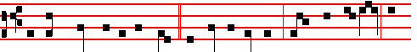
Ye have heard that it was said * to them of old time,Thou shalt not kill; and

1321
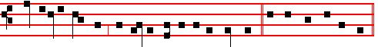
whosoever shall kill, shall be in danger of the judgment. Canticle Benedictus
On Magnificat, Antiphon. Tone j, 3.
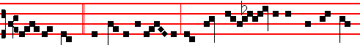
If thou bring * thy gift to the al- tar, and there remem- berest that thy bro-
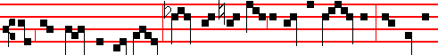
ther hath ought against thee; leave there thy gift before the al- tar, and go thy
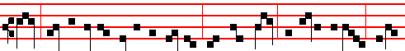
way; first be reconciled to thy brother, and then come and offer thy gift, al-le-
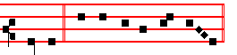
lu- ia. Canticle Magnificat, p. 209.
__________________________________________________________________

THE SIXTH SUNDAY AFTER PENTECOST

COLLECT

O GOD of hosts, who art the author of all good things: graft in our hearts the
love of thy name, increase in us true religion; nourish us with all goodness, and of thy great mercy keep us in the same. Through.

The Lesson from the Holy Gospel according to S. Mark
Lesson vij Ch. 8
THE multitude being very great, and having nothing to eat, Jesus called his disciples unto him, and saith unto them, I have compassion on the multitude, because they have now been with me three days, and have nothing to eat. And the rest.
Homily by S. Ambrose, Bishop Bk. 6 on Luke Ch. 9

1322
AFTER that woman, who may be taken as a type of the Church, has been cured of an issue of blood, after the Apostles have been sent out to prcach the
Gospel of the kingdom of God, the food of divine grace is bestowed. But note on whom it is bestowed. Not on the leisured, not on those in cities, such as those who occupy high places in the synagogues or in the state: but on those who are seekin~ Christ in desert places. Men who are not haughty, it is they who are received by Christ; and the Word of God converses with them, not of worldly matters, but of the kingdom of God. And if any of them are suffering from the sores of fleshly passions, then he gladly grants them healing.

Lesson viij
CONSEQUENTLY, those whom he healed from the pain of their wounds, those he also freed from fasting by giving them spiritual food. Therefore no
one receives the bread of Christ who has not first been healed; and those who have
been called to his feast are first healed through his call. If there were a lame man, he would receive the power to walk, so that he could come; if one were deprived of his eyesight, he could not enter the house of the Lord, unless his sight were restored.

Lesson ix
IN all cases the order of the mystery is retained, so that first the wounds are healed through remission of sins, and afterwards the food of the heavenly table abounds: however, this multitude is not yet refreshed with stronger meat, nor is it fed with the body and blood of Christ, as are the fasting hearts of those of stronger faith. I have fed you, says the Apostle, with milk, and not with meat: for hitherto you were not able to bear it, neither yet now are ye able. The five loaves are, as it were, milk; but the stronger meat is the Body of Christ; the stronger drink is the Blood of the Lord.
Te Deum Laudamus, p. 24.

On Benedictus, Antiphon. Tone viij, 1.
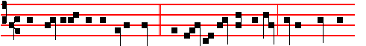
The multitude being very great,* and having nothing to eat, Jesus called his
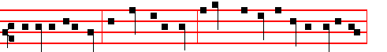
disciples unto him, and saith unto them, I have compassion on the multitude,

1323
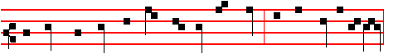
because they have now been with me three days, and have nothing to eat,
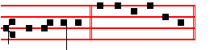
al- le- luia. Canticle Benedictus, p. 39.
On Magnificat, Antiphon. Tone vij, 1.
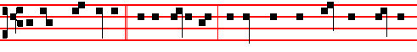
I have compassion * on the multitude, because they have now been with me

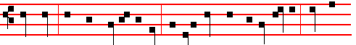
three days, and have nothing to eat: and if I send them away fasting, they will
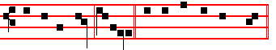
faint by the way, alleluia. Canticle Magnificat, p. 211.
__________________________________________________________________

THE SEVENTH SUNDAY AFTER PENTECOST

COLLECT
O GOD, whose providence never faileth in its disposition: we humbly beseech thee; to put away from us all hurtful things, and to give us all things which be profitable for us. Through.

The Lesson from the Holy Gospel according to S. Matthew
Lesson vij Ch. 7
JESUS said unto his disciples: Beware of false prophets, which come to you in sheep's clothing, but inwardly they are ravening wolves. And the rest.
Homily by S. Hilary, Bishop Comm. on Matt. 7
THE Lord warns us that soft words and apparent meekness should be estimated by the fruit of the accompanying works: so we should have regard rather for

1324
the nature of man's deeds than for the way he speaks; for in many a man a ravening wolf hides under sheep's clothing. Therefore, as thorns do not bear grapes, nor thistles figs, and as a corrupt tree does not bring forth good fruit; even so, as the Lord teaches, evil men do not bring forth good works. For the mere speaking of words does not gain us the kingdom of heaven, nor shall he inherit it who says, Lord, Lord.

Lesson viij
FOR what is the use of saying, Lord, to our Lord? Would he not still be the Lord, even if we did not call him so? What has the declaiming of a name to do with holiness, when the way to the kingdom of heaven is to be found in obedience to the will of God rather than merely calling on his name? Many shall say to me in that day, Lord, Lord, have we not prophesied in thy name? He here condemns both the deceit of the false prophets and the guile of the hypocrites, who presume to take to themselves that glory which lies in the power of the Word, in their teaching of doctrine, in putting demons to flight, and in other mighty deeds of this kind.

Lesson ix
THUS they promise themselves the kingdom of heaven, as though there were something of their own in what they say or do, as though all were not done by invocation of God; since reading brings knowledge of doctrine and the name of Christ puts demons to flight. Therefore, if we would gain that blessed eternity, it is for us to do our part in willing what is good and in shunning all evil; we must obey the heavenly commands with our whole heart, and by such work will God know us. We must do his will, instead of glorying in power. And we must put away and cast off from us those who through their evil works are estranged from him.
Te Deum Laudamus, p. 24.

On Benedictus, Antiphon. Tone viij, 1.
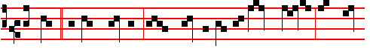
Beware * of false prophets, which come to you in sheep's clothing, but in-
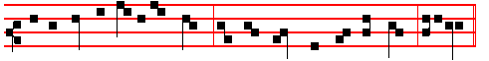
wardly they are ravening wolves.Ye shall know them by their fruits, alleluia.

1325

Canticle Benedictus, p. 39.
On Magnificat, Antiphon. Tone j, 3.
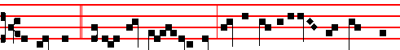
A good tree * cannot bring forth evil fruit, neither can a corrupt tree bring forth
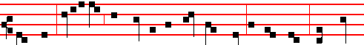
good fruit: every tree that bringeth not forth good fruit is hewn down, and cast
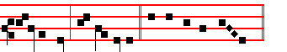
into the fire, alleluia. Canticle Magnificat, p. 209.
__________________________________________________________________

THE EIGHTH SUNDAY AFTER PENTECOST

COLLECT
GRANT to us, Lord, we beseech thee, the spirit to think and do always such things as be rightful: that we who without thee cannot exist, may be enabled to live according to thy will. Through.

The Lesson from the Holy Gospel according to S. Luke
Lesson vij Ch. 16
JESUS spake this parable unto his disciples: There was a certain rich man, which had a steward; and the same was accused unto him that he had wasted his goods. And the rest.
Homily by S. Jerome, Priest Ep. 121 to Algasia Ch. 6
IF the steward of the mammon of unrighteousness is commended by his lord for
preparing his judgment by an unrighteous deed: and if his lord, in spite of suffering loss, commends his steward for his prudence, because though he does deal fraudulently against his lord, yet he acts prudently in his own interests: how much more shall Christ, who can suffer no loss from our hands and is always ready to shew mercy, commend his disciples if they are merciful to those who believe in him?

1326
Lesson viij
AT the end of the parable he says, And I say unto you, Make to yourselves friends of the mammon of unrighteousness. Now Mammon is not a Hebrew but a Syriac word, meaning ill-gotten gains. Therefore if unrighteousness is changed into righteousness when these gains are put to a good use, how much more will the divine word, in which there is no unrighteousness, and which is entrusted to the Apostles, raise its stewards to heaven, if it has been well stewarded?

Lesson ix
FOR this reason it is added, He that is faithful in that which is least, (that is, in material things,) is faithful also in much, (that is, in spiritual things.) He that is unjust in the least in that he will not allow his brother to use that which has been created by God for every man's use; that man will be unrighteous in dealing out spiritual riches, in that he will bestow the Lord's teaching without regard to where it is most needed, but with respect of persons. If, therefore, you have not done wisely concerning material riches that pass away, who will commit to your trust the true and eternal riches of God's teaching? And if you have not been faithful in those riches which belong to others, (for nothing in this world is truly our own) who will be able to commit to your trust those riches which are especially destined for men?
Te Deum Laudamus, p. 24.
On Benedictus, Antiphon. Tone j, 3.
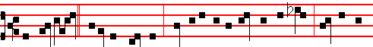
The lord said * unto the steward, How is it that I hear this of thee? Give an ac-
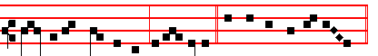
count of thy stewardship, alleluia. Canticle Benedictus, p. 39.
On Magnificat, Antiphon. Tone iv, 1.
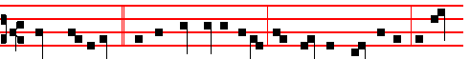
What shall I do? * for my lord taketh away from me the stewardship: I can-
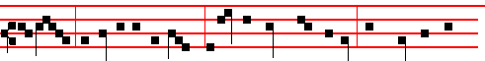
not dig; to beg I am ashamed: I am resolved what to do, that, when I am
1327
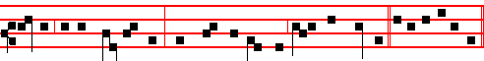
put out of the stewardship, they may receive me into their houses. Cant. Magn.
__________________________________________________________________

THE NINTH SUNDAY AFTER PENTECOST

COLLECT
LET thy merciful ears, O Lord, be open to the prayers of thy humble servants: and that they may obtain their petitions; make them to ask such things as shall please thee. Through.

The Lesson from the Holy Gospel according to S. Luke
Lesson vij Ch. 19
WHEN Jesus was come near Jerusalem, he beheld the city, and wept over it, saying, If thou hadst known, even thou, at least in this thy day, the things which belong unto thy peace! And the rest.
Homily by S. Gregory the Great Homily 39 on the Gospels
NO one who has read of the destruction of Jerusalem by the Roman rulers Vespasian and Titus can be unaware that the Lord, when he wept over
Jerusalem, was describing this overthrow. For the Roman rulers are referred to when it is said, For the days shall come upon thee, that thine enemies shall cast a trench about thee. And then what follows, And they shall not leave in thee one stone upon another, is even now witnessed to in the changed site of that city, which is now built in the place outside the gates where the Lord was crucified; whereas the ancient city was razed to the ground.

Lesson viij
WE are then told what that sin of hers was, which brought upon her the punishment of destruction: Because thou knewest not the time of thy visitation. For the very Creator of men vouchsafed to visit her through the mystery of his Incarnation. But she was in no mind to fear and love him. Whence also the Prophet, rebuking the hardness of the human heart, brings the birds of the air to bear witness, saying, The stork in the heaven knoweth her appointed times; and the turtle and the crane and swallow observe the time of their coming; but my people know not the judgment of the Lord.

Lesson ix
OUR Redeemer wept over the ruin of the unfaithful city before that city was herself aware that it was coming. Rightly does the Lord tell her, as he weeps,

1328
If thou hadst known, even thou; meaning, Thou too wouldest weep, instead of rejoicing in ignorance of your approaching fate. Whence it follows, At least in this thy day, the things which belong unto thy peace. For, while she was giving herself up to the pleasures of the flesh, she did have in her day those things which should have been for her peace.
Te Deum Laudamus, p. 24.
On Benedictus, Antiphon. Tone j, 1.
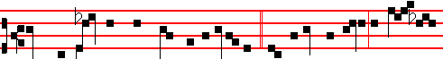
When the Lord was come near to Jerusalem, * he beheld the city, and wept
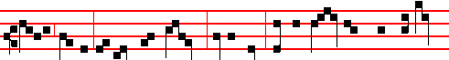
over it, saying: If thou hadst known, even thou: For the days snaIl come upon
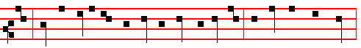
thee, that thine enemies shall cast a trench about thee, and compass thee round,
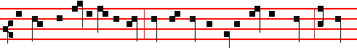
and keep thee in on every side, and shall lay thee even with the ground; because
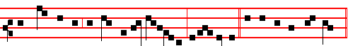
thou knewest not the time of thy visitation, alle- lu-ia. Canticle Benedictus.
On Magnificat, Antiphon. Tone viij, 1.
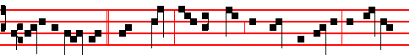
Is it not written, * Mine house shall be called an house of prayer for all peo-
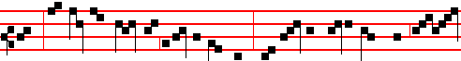
ple? But ye have made it a den of robbers. And he was daily with them, teach-
1329

ing in the temple. Canticle Magnificat, p. 211.,
__________________________________________________________________

THE TENTH SUNDAY AFTER PENTECOST

COLLECT
OGOD, who declarest thy almighty power most chiefly in shewing mercy and pity: multiply upon us thy loving- kindness; that we, running toward thy promises, may by thee be made partakers of thy heavenly gifts. Through.

The Lesson from the Holy Gospel according to S. Luke
Lesson vij Ch. 18
JESUS spake this parable unto certain which trusted in themselves that they were righteous, and despised others: Two men went up into the temple to pray; the one a Pharisee, and the other a publican. And the rest.
Homily by S. Augustine, Bishop Sermon 115 on the Words of the Lord, Ch. 11
THE Pharisee might at least have said, I am not as many men are. What does he mean by other men, except everyone save himself? I, says he, am righteous,
the others are sinners. I am not as other men are, extortioners, unjust, adulterers. And lo, he makes the occasion of the publican standing there into a subject for even greater pride, adding, Or even this publican. I, says he, am singular. He is like the rest. I am not, says he, such a man as he is, by reason of my righteous deeds, by means of which I am not unrighteous.

Lesson viij
I FAST twice in the week, I give tithes of all that I possess. If you look into his words to find what he is asking of God, you will find nothing. He went up to pray, but instead he praised himself; moreover, he was scornful of the one who was praying. Now the publican stood afar off, and yet he was near to God. His conscience kept him away, but his piety brought him near. Now the publican stood afar off, and yet the Lord was nigh at hand.

Lesson ix
FOR though the Lord be high, yet hath he respect unto the lowly: as for the proud, (for such men as the Pharisee,) he beholdeth them afar off. Though God beholds them, he does not pardon them. Hear yet more of the publican's lowliness. It was a comparatively small thing that he stood afar off, and would not

1330
lift up his eyes to heaven: that he might be seen, not that he might see; he did not
dare to look up: his conscience weighed him down, hope lifted him up. But hear this further thing. He smote upon his breast. He punished himself. Therefore the Lord forgave him as he confessed. He smote upon his breast, saying, God, be merciful to me a sinner. Lo, he is the one who prays. Is it surprising that the Lord pardons him, when he acknowledges his fault?
Te Deum Laudamus, p. 24.
On Benedictus, Antiphon. Tone ij.
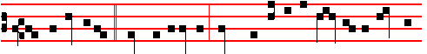
And the publican, * standing afar off, would not lift up so much as his eyes un-
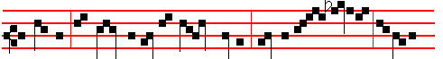
to heaven, but smote upon his breast, saying, God be mer- ciful to me a

sin-ner. Canticle Benedictus, p. 39.
On Magnificat, Antiphon.. Tone viij, 1.

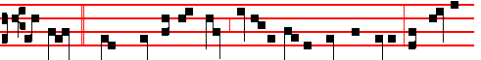
This man * went down to his house justified rather than the other: for every-
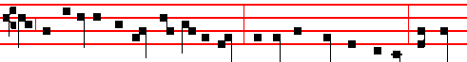
one that exalteth himself shall be abased; and he that humbleth himself shall be
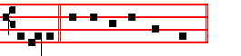
ex-alted. Canticle Magnificat, p. 211.
__________________________________________________________________

THE ELEVENTH SUNDAY AFTER PENTECOST

1331
COLLECT
ALMIGHTY and everlasting God, who in the abundance of thy loving-kindness dost give more than thy suppliants either desire or deserve: pour down upon us thy mercy; forgiving us those things whereof our conscience is afraid, and giving us that which our prayer doth not presume to ask. Through.

The Lesson from the Holy Gospel according to S. Mark
Lesson vij Ch. 7
JESUS departed from the coasts of Tyre and Sidon, and came unto the sea of Galilee, through the midst of the coasts of Decapolis. And the rest.
Homily by S. Gregory the Great Homily on Ezekiel. Bk. 1. Ch10
WHY is it, that when God the Creator of all things wished to heal the deaf and dumb man, he put his fingers into his ears. and he spit, and touched his tongue? What is meant by the fingers of the Redeemer, except the gift of the Holy Spirit? Whence it is that he said in another place, after he had cast out a devil, If I with the finger of God cast out devils, no doubt the kingdom of God is come upon you. And this same thing is expressed by another Evangelist in the words If I cast out devils by the spirit of God, then the kingdom of God is come unto you. When these two passages are compared it may be seen that the Spirit is called the finger.
Therefore to put his fingers into his ears was to lay open the way of obedience in the mind of the deaf man, through the sift of the Holy Spirit.

Lesson viij
BUT why did he spit and touch his tongue? Spittle from the mouth of the Redeemer is given us when we receive wisdom in speaking of divine mysteries. Spittle flows into the mouth from the head. So that when our tongue is touched by that wisdom, which is he himself, it is straightway enabled to preach the word. And looking up to heaven, he sighed; not that he had any need to sigh, when he was bestowing what he prayed for, but he taught us to beseech him with sighs, since he reigns in heaven: to beseech him both that our ears may be opened through the gift of the Holy Spirit, and that our tongue may be loosed through his spittle, that is, through knowledge of the divine word, so that we may go forth to preach it to others.

Lesson ix
AND saith unto him, Ephphatha, that is, Be opened. And straightway his ears were opened and the string of his tongue was loosed. It must be noticed here, that when his ears were closed it was said, Be openeded. But when the ears of a man's heart have been opened by obedience, it undoubtedly follows that the string of his tongue is also loosed, so that he may tell others that they also should do the good deeds which he has done. Whence it is fittingly added, And he spake plain. For he speaks plainly, when by his speaking he urges othen to the performance of

1232
those good works which he, through obedience, has already done.
Te Deum Laudamus, p. 24.
On Benedictus, Antiphon. Tone v.
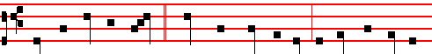
When the Lord had passed * through the coasts of Tyre, he made the deaf to

hear and the dumb to speak. Canticle Benedictus, p. 39.
On Magnificat, Antiphon. Tone v.
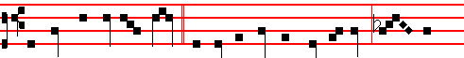
He hath done all things well * he maketh both the deaf to hear, and the
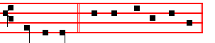
dumb to speak. Canticle Magnificat, p. 210.
__________________________________________________________________

THE TWELFTH SUNDAY AFTER PENTECOST

COLLECT
ALMIGHIY and merciful God, of whose gift it cometh, that thy faithful people
do unto thee worthy and laudable service: grant, we beseech thee; that we may so faithfully serve thee in this life, that we may without stumbling run the way of thy promises. Through.

The Lesson from the Holy Gospel according to S. Luke
Lesson vij Ch. 10
JESUS said unto his disciples, Blessed are the eyes which see the things that ye see: for I tell you, that many prophets and kings have desired to see those things which ye see, and have not seen them. And the rest.
Homily by S. Bede the Venerable Bk. 3 on Luke Ch. 10
BLESSED are the eyes, not of the scribes and pharisees, which can see only the bodily presence of the Lord, but those eyes which can recognize his mysteries, of whom it is said: And hast revealed them unto babes. Blessed are the

1333
eyes of the little ones, to whom the Son has vouchsafed to reveal both himself and his Father. Abraham rejoiced to see Christ's day. He saw it and was glad. Isaiah too, and Micah, and many other prophets, saw the glory of the Lord, and for that reason they were called seers. But all these, looking from afar, and hailing from a distance, saw through a glass darkly.

Lesson viij
THE Apostles, however, who had the Lord present with them, and ate and drank with him, and learned from him by asking him whatever they wished, had no need to be taught by means of Angels or different kinds of visions. Those whom Luke terms, Many prophets and kings, Matthew openly calls, Prophets and righteous men. For these are great kings, since they do not succumb by consenting to the stirrings of their temptations, but know how to subdue them by over-ruling them.

Lesson ix
AND, behold, a certain lawyer stood up, and tempted him, saying, Master, what shall I do, to inherit eternal life? The lawyer who tempted the Lord, asking about eternal life, took his occasion of tempting, it seems to me, from
those words of the Lord, where he said: Rejoice, because your names are written in heaven. But by his very tempting he declared how true was that confession which the Lord had just made to the Father: Thou hast hid these things from the wise and prudent, and hast revealed them unto babes.
Te Deum Laudamus, p. 24.

On Benedictus, Antiphon. Tone viij, 1.

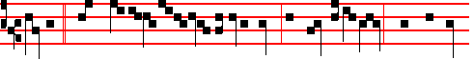
Master,* what shall I do to inherit eternal life? He said unto him, What is writ-
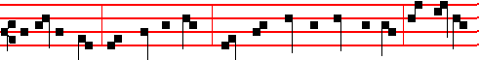
ten in the law? how readest thou? Thou shalt love the Lord thy God with all thy
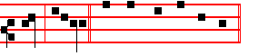
heart, alleluia. Canticle Benedictus, p. 39.

1334
On Magnificat, Antiphon. Tone viij, 1.
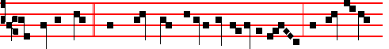
A certain man * went down from Jerusalem to Jericho, and fell among
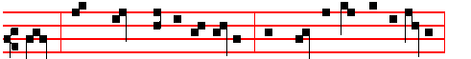
thieves, which stripped him of his raiment, and wounded him, and departed,

leaving him half dead. Canticle Magnificat, p. 211.
__________________________________________________________________

THE THIRTEENTH SUNDAY AFTER PENTECOST

COLLECT

ALMIGHTY and everlasting God, give unto us the increase of faith, hope, and charity:and, that we may be worthy to obtain that which thou dost promise, make us to love that which thou dost command. Through.

The Lesson from the Holy Gospel according to S. Luke
Lesson vij Ch. 17
AS Jesus went to Jerusalem, he passed through the midst of Samaria and Galilee. And as he entered a certain village, there met him ten men that were lepers. And the rest.

Homily by S. Augustine, Bishop Book of Questions. 2, Ch. 40
CONCERNING those ten lepers whom the Lord cleansed when he said: Go, shew yourselves to the priests: we may ask why it was that he sent them to the priests, so that, as they went, they were cleansed. For with none of the others on whom he bestowed bodily blessings is it found that they were sent to the priests, except the lepers. For that man was also cleansed from leprosy, to whom he said: Go, and show thyself to the priest, and offer for thy cleansing, according as Moses commanded, for a testimony unto them. Therefore it is to be asked what this leprosy signifies: for the men whom he delivered from it were said to be cleansed, not healed. Now it discolours the skin before it destroys health and the use of the members.

1335
Lesson viij
THEREFORE it is not unreasonable to understand by lepers those men who have not the knowledge of the true faith, and so put forth various erroneous doctrines. For they do not hide their ignorance, but bring it forth to the light as the greatest knowledge, and proclaim it with high-sounding phrases. Moreover there is no false doctrine that is not intermingled with some form of truth. Therefore when, in a man's discourse or argument, truth is unequally mixed with falsehood, then the different colours in one body are like leprosy, which causes different coloured spots to appear on the human body like the mingling of truth and falsehood.

Lesson ix
SUCH men as these are so shunned by the Church, that, if it can be done, she banishes them far from her, so that they cry out to Christ with a loud voice, as did those ten which stood afar off, and lifted up their voices, and said: Jesus, Master, have mercy upon us. The fact that they called him Master, by which name I know not whether any others who besought the lord for bodily healing, so called him, is, I think, sufficient to show that false doctrine was the leprosy which the good Master removed from them.
Te Deum Laudamus, p. 24.
On Benedictus, Antiphon. Tone j, 3.
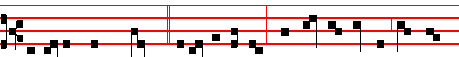
As Jesus passed through * a certain village, there met him ten men that were
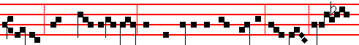
lepers, which stood afar off: and they lifted up their voices, and said, Jesus,
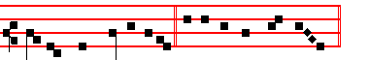
Master, have mercy on us. Canticle Benedictus, p. 39.

On Magnificat, Antiphon. Tone ij.
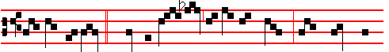
And one of them, * When he saw that he was healed, turned back, and

1336


with a loud voice glorified God, alleluia. Canticle Magnificat, p. 209.
__________________________________________________________________

THE FOURTEENTH SUNDAY AFTER PENTECOST

COLLECT
KEEP, we beseech thee, O Lord, thy Church with thy perpetual mercy: and, because the frailty of man without thee cannot but fall; keep us ever by thy help from things hurtful, and lead us to those things profitable to our salvation. Through.

The Lesson from the Holy Gospel according to S. Matthew
Lesson vij Ch. 6
JESUS said unto his disciples: No man can serve two masters. And the rest.
Homily by S. Augustine, Bishop On the Sermon on the Mount Chaper 14
NO man can serve two masters; is to be referred to this very intention, as he goes on to explain, saying: For either he will hate the one, and love the other; or else he will submit to the one, and despise the other. And these words are to be carefully considered; for who the two masters are he forthwith shows, when he says: Ye cannot serve God and mammon. Riches are said to be called mammon among the Hebrews. The Punic name also corresponds; for gain is called mammon in Punic.

Lesson viij
BUT he who serves mammon certainly serves him who, as being set over those earthly things in virtue of his perversity, is called by the Lord the prince of this world. A man will therefore either hate this one, and love the other, that is, God; or he will submit to the one, and despise the other. For whoever serves mammon submits to a hard and ruinous master: (or, being entangled by his own
lust, he becomes a subject of the devil, and he does not love him; for who is there that loves the devil? and yet he serves him.

Lesson ix
THEREFORE, says he, I say unto you, be not anxious for your life, what ye shall eat; nor yet for your body, what ye shall put on. Lest perchance, although it is not now superfluities that are sought after, the heart should be made

1337
double by reason of necessities themselves, and the aim should be wrenched aside to seek after those things of our own, when we are doing something as it were from compassion; that is, so that when we wish to appear to be consulting for someone's good, we are in that matter looking after our own profit rather than his advantage: and we do not seem to be sinning, for this reason, that it is not superfluities, but necessities, which we wish to obtain.
Te Deum Laudamus, p. 24.
On Benedictus, Antiphon. Tone viij, 1.
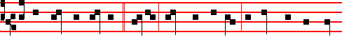
Be not therefore anxious, * saying, What shall we eat? or What shall we drink?
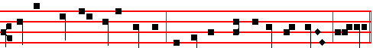
for your heavenly Father knoweth that ye have need of all these things, alleluia.
Canticle Benedictus, p. 39.

On Magnificat, Antiphon. Tone j, 2.
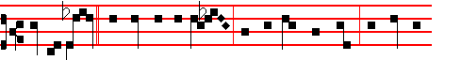
Seek ye first * the kingdom of God, and his righteousness; and all these
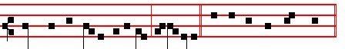
things shall be added unto you, al-le- luia. Canticle Magnificat, p. 209.
__________________________________________________________________

THE FIFTEENTH SUNDAY AFTER PENTECOST

COLLECT
O LORD, we beseech thee, let thy continual pity cleanse and defend thy Church: and, because it cannot continue in safety without thee: govern it evermore by thy goodness. Through.
1338
The Lesson from the Holy Gospel according to S. Luke
Lesson vij Ch. 7
JESUS went into a city called Nain; and many of his disciples went with him, and much people. And the rest.
Homily by S. Augustine. Bishop Sermon on theWords of the Lord Ch.2
THE widowed mother rejoiced when her young son was raised to life: Mother Church rejoices daily when men are raised to life in the spirit. He indeed was dead in body. but they in mind. His visible death was visibly mourned; their invisible death is neither seen nor searched into. He sought for them whom he knew to be dead, he who was able to make them live. For had he not come to raise men from the dead. the Apostle would not have said: Awake. thou that sleepest. and arise from the dead, and Christ shall give thee light.

Lesson viij
WE are told of three dead persons who were visibly raised from the dead by the Lord, and thousands invisibly. But who knows how many he visibly raised from the dead? For not all the things that he did are recorded. John says on this subject: And there are also many other things which Jesus did, the which, if they should be written every one, I suppose that even the world itself could not contain the books that should be written. Therefore without a doubt many others were raised, but it is not without reason that these three are mentioned. For our Lord Jesus Christ wished the things that he did to be understood according to their spiritual as well as their material meaning. Neither did he work such a miracle merely for the miracle's sake; but so that his wondrous acts should be marvelled at by those who saw them, and truly understood by those who comprehended them.

Lesson ix
IT is as though a man who could not read were to see a beautifully written manuscript. He would praise the ancient scribe, admiring the beauty of the characters; yet, not knowing what those characters represented nor what meaning lay hid in them, he would praise them with his eye, but not comprehend with hismind. But another man would both praise the craftsmanship and grasp the meaning: he indeed who could not only see what was manifest to all, but could also read the words; which a man who had not learned would not be able to do. So, likewise those who saw Christ's miracles and did not understand what meaning lay hid in them, nor what they revealed to those who, to a certain measure, did understand them, only marvelled at what was done, while others both marvelled at what was done and grasped the meaning. And we also should be like these last in the school of Christ.
Te Deum Laudamus, p. 24.
On Benedictus, Antiphon. Tone ij

1339
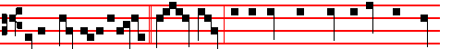
Jesus went into a city * called Nain; and behold, there was a dead man car-
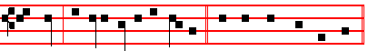
ried out, the only son of his mother. Canticle Benedictus, p. 39.
On Magnificat, Antiphon. Tone iv, 1.
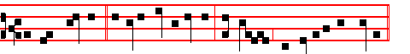
A great prophet * is risen up anong us: and God hath visited his people.
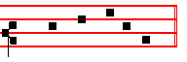
Canticle Magnificat, p. 210.
__________________________________________________________________

THE SIXTEENTH SUNDAY AFTER PENTECOST

COLLECT
LORD, we pray thee that thy grace may always prevent and follow us: and make us continually to be given to good works. Through.

The Lesson from the Holy Gospel according to S. Luke
Lesson vij Ch. 14
AS Jesus went into the house of one of the chief Pharisees to eat bread on the sabbath day, they watched him. And, behold there was a certain man before him which had the dropsy. And the rest.
Homily by S. Ambrose, Bishop Bk. 7 on Luke Ch. 14
THE man with the dropsy is cured, in whom an excessive bodily fluid was hampering the work of the soul: and extinguishing the flame of the spirit. Then, while it is forbidden to take the highest places at a wedding feast, humility
is taught, but it is taught gently, so that persuasion may take the place of harsh compulsion, reason may follow the effects of persuasion, correction emend the disposition. Kindliness is joined to humility as its neighbour, as it were. In the Lord's words, it is that which is to be given to the poor and infirm: for it is a form of avarice to show hospitality to those who are going to reward it.

1340
Lesson viij
FINALLY, as a soldier who has served his time is given a reward as compensation for the good things that he has forgone: so he alone can attain unto the kingdom of heaven who has not been consumed with zeal for lower things and purchased for himself earthly possessions, since the Lord says: Sell that thou hast, and come and follow me. Neither can he attain unto it who buys oxen, since Elijah slew those he had and gave them to the people: neither can he who marries a wife, for he is mindful of the things that are of the world, and not of those of God. Not that we disapprove of marriage, but virginity is a more honourable state; since the unmarried woman and the widow careth for the things of the Lord, that she may be holy both in body and in spirit.

Lesson ix
BUT now that we are once more in agreement with the married, as we have already agreed with the widows, we are not afraid to hold that opinion, prevalent among many: we believe that there are three kinds of men shut out from partaking of that great supper: Gentiles, Jews and heretics. And therefore doth the Apostle tell us to flee from avarice, lest hindered after the manner of the Gentiles by wickedness, malice, and all uncleanness, we should be unable to attain unto the kingdom of heaven.

Te Deum Laudamus, 39.

On Benedictus, Antiphon. Tone vij, 3.
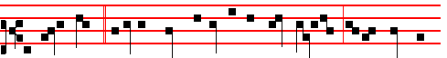
As Jesus went * into the house of one of the chief Pharisees to eat bread on
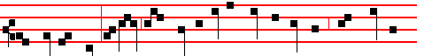
the sabbath day, behold there was a certain man before him which had the dropsy;
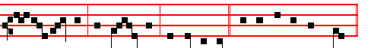
and he took him, and healed him, and let him go. Canticle Benedictus, p. 39.

On Magnificat, Antiphon. Tone vij, 3.

1341
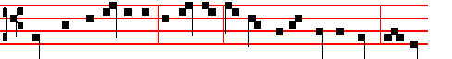
When thou art bidden to * a wedding, sit down in the lowest place; that he
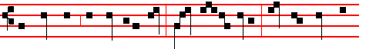
that bade thee may say unto thee, Friend, go up higher; then shalt thou have
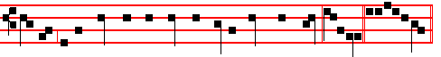
worship in the presence of them that sit at meat with thee, alleluia. Canticle Magnificat, p. 210.
__________________________________________________________________

THE SEVENTEENTH SUNDAY AFTER PENTECOST

COLLECT
LORD, we beseech thee, grant thy people grace to avoid the infections of the devil: and with pure minds to follow thee, the only God. Through.

The Lesson from the Holy Gospel according to S. Matthew
Lesson vij Ch. 22
WHEN the Pharisees heard that Jesus had put the Sadducees to silence, they were gathered together. Then one of them, which was a lawyer, asked him a question. And the rest.
Homily by S. John Chrysostom Homily 72 on Matt.
WHEN the Sadducees are put to silence the Pharisees return to the attack, and when they ought to keep silence they take upon themselves to contend. They put forward one who professes to be learned in the law, who is eager, not to learn, but to tempt him, and he questions the Lord in this manner: Which is the first commandment in the law? Now since the first is, Thou shalt love the Lord thy God; they question him in this manner, because they think that he will add some alteration, by way of correction, to the commandment, for his own purposes, since he made himself God. What, then, does Christ do? To show that they had descended to this behaviour because there was not a vestige of love in them and because they were consumed with envy: Thou shalt love the lord thy God, he says; this is the first and great commandment. And the second is like unto it. Thou shalt love thy neighbour as thyself.

1342
Lesson viij
WHY is the second like unto it? Because the first leads to the second, and is, moreover, confirmed by it. For every one that doeth evil hateth the light, neither cometh to the light. And again: The foolish body hath said in his heart: There is no God. Then it continues: Corrupt are they, and become abominable in their wickedness. And again: The love of money is the root of all evil; which while some coveted after, they have erred from the faith. And, if ye love me, keep my commandments: of which commandments the head and root is: Thou shalt love the Lord thy God, and thy neighbour as thyself.

Lesson ix
IF therefore, to love God is to love our neighbour (For, If ye love me, O Peter, he said, feed my sheep): if the love of our neighbour makes us keep his commandments; then rightly, does he say that on these hang all the law and the prophets. And just as before this, when he was questioned about the resurrection, he taught more than his tempters asked him; so in this place, when questioned , about the first commandment, he immediately adds that the second is hardly less important than the first; for the second is like unto the first. Therefore He suggests in a veiled way that hatred is their motive for questioning him. For charity, he said, envieth not. Te Deum Laudamus, p. 24.
On Benedictus, Antiphon. Tone viij, 1.
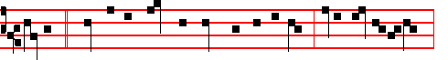
Master, * which is the great commandment in the law? Jesus said unto him,
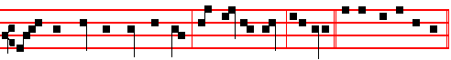
Thou shalt love the Lord thy God with all thy heart, alleluia. Canticle Benedictus
On Magnificat, Antiphon. Tone iv, 1.
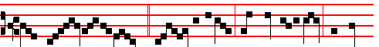
What think ye of Christ? * whose son is he? They say unto him, The son
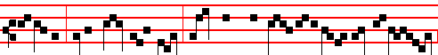
of David. Jesus saith unto them, How then doth Dav-id in spirit call him Lord,

1343
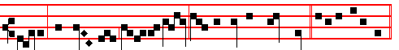
saying, The Lord said unto my Lord, Sit thou on my right hand? C. Magnificat.
__________________________________________________________________

THE EIGHTEENTH SUNDAY AFTER PENTECOST

COLLECT
LET the operation of thy mercy, O Lord, direct our hearts: forasmuch as without thee we are not able to please thee. Through.

The Lesson from the Holy Gospel according to S. Matthew
Lesson vij Ch. 9
JESUS entered into a ship, and passed over, and came into his own city. And the rest.
Homily by S. Peter Chrysologus Sermon 50
TODAY'S lesson shows that in his actions as man Christ worked divine mysteries, and that in the things that could be seen he performed invisible deeds. He entered into a ship, says the Evangelist, and passed over, and came into his own city. Yet is not this he who put the waves to flight and laid bare the depths of the sea, so that the people of Israel passed dry-shod between the petrified waves, as though through a mountain pass? Is not this he who moulded the swirling waves beneath Peter's feet, so that the liquid path became firm and offered itself to human footsteps?

Lesson viij
WHY, then, does he deny himself this service of the sea, and cross that narrow lake by means of a borrowed ship? He entered into a ship, says the Evangelist, and passed over. Why do you marvel, brethren? Christ came to take our weakness, and to give us his strength; to seek out the ways of man and to open up the ways of God; to receive injuries and to bestow honours in return; to bear weariness and to restore health, for a physician with no experience of weakness knows not how to cure it, and he who is not weak among the weak knows not how to make them strong.

Lesson ix
THEREFORE had Christ remained in his own strength, he would have had nothing in common with men; and had he not fulfilled the conditions of the flesh, there would have been no point in his taking of flesh. He ascended into a ship, says the Evangelist, and passed over, and came into his own city. The Lord

1344
and Creator of the universe, when for our sakes he confined himself within the narrow limits of our flesh, began to have an earthly fatherland, began to be a citizen of a Jewish city, and he, the parent of all parents, began to have parents; that love might invite, charity attract, affection win, and kindness persuade, those whom tyranny had dispelled, fear had scattered, and force had banished.
Te Deum Laudamus, p. 24.
On Benedictus, Antiphon. Tone j, 4.
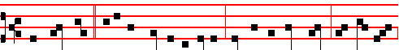
The Lord said * unto the sick of the palsy, Son, be of good cheer, thy sins be
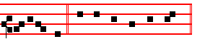
forgiven thee. Canticle Benedictus, p. 39.
On Magnificat, Antiphon. Tone iv, 1.
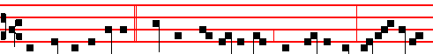
The sick of the palsy * therefore took up his bed whereon he lay, glori- fy-ing
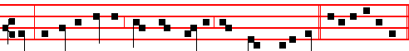
God: and all the people, when they saw it, gave praise unto God. C. Magnificat.
__________________________________________________________________

THE NINETEENTH SUNDAY AFTER PENTECOST

COLLECT
ALMIGHTY and merciful God, of thy bountiful goodness keep us from all things that may hurt us: that we, being ready both in body and soul, may cheerfully accomplish those things that thou wouldest have done. Through.

The Lesson from the Holy Gospel according to S. Matthew
Lesson vij Ch. 22
JESUS spake unto the chief priests and Pharisees in parables, saying: The kingdom of heaven is like unto a certain king which made a marriage for his son. And the rest.
Homily by S. Gregory the Great Homily 38 on the Gospels
1345
I REMEMBER having often said that the Church is frequently mentioned in the Gospels as the kingdom of heaven. The Lord says through his prophet: The heaven is my throne; and Solomon says: The soul of the righteous is the throne of wisdom; Paul also says: Christ the power of God and the wisdom of God. We may clearly gather that if God is wisdom, and the soul of the righteous is the throne of wisdom, while heaven is the throne of God, then heaven is the soul of the righteous. For the Lord says through the Psalmist concerning his holy preachers: The heavens declare the glory of God.

Lesson viij
THEREFORE the kingdom of heaven is the throne of the righteous: for their heart's desire is by no means set upon earth, but yearns for the heavenly country, and through this very fact the Lord is already reigning in them as though in heaven. Therefore is it said: The kingdom of heaven is like unto a certain king which made a marriage for his son. Now of your charity learn who is this King, the father of the King's son. Indeed it is he to whom the Psalmist says: Give the King thy judgments, O God: and thy righteousness unto the King's son. Which made a marriage for his son. For God the Father made a marriage for his son, when he united him to human nature in the Virgin's womb, when he willed that he who was God before time was should become man in the latter days.

Lesson ix
BUT since the marriage union is wont to be made from two persons, be it far from us that we should believe the one Person of God and of the man Christ Jesus to be of two persons. We do indeed say that he is of two and in two natures; but we abhor as wicked the belief that he is made up of two separate persons. Therefore all the more openly and safely may it be said that the Father made a marriage for the King his Son; in that by the mystery of the Incarnation he united holy Church to him. Now the womb of the Virgin was the marriage chamber of this espousal. Whence also the Psalmist says: In the sun hath he set his tabernacle, and he cometh forth as a bridegroom out of his chamber.
Te Deum Laudamus, p. 24.
On Benedictus, Antiphon. Tone viij, 1.
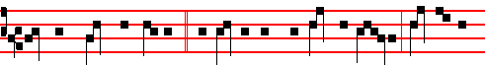
Tell them which are bidden, * Behold, I have prepared my dinner; come to the
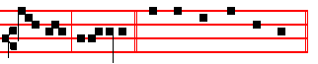
marriage, alle- luia. Canticle Benedictus, p. 39.
1346
On Magnificat, Antiphon. Tone iij, 1.

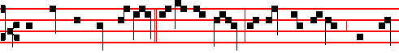
And when the king came in * to see the guests, he saw there a man which had
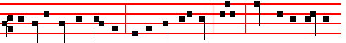
not on a wedding garment: and he said unto him, Friend, how camest thou in
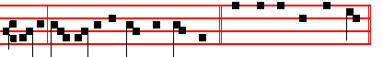
hither not having a wedding garment? Canticle Magnificat, p. 209.
__________________________________________________________________

THE TWENTIETH SUNDAY AFTER PENTECOST

COLLECT
GRANT, we beseech thee, merciful Lord, to thy faitnful people pardon and peace: that they may be cleansed from all their sins and serve thee with a quiet mind. Through.

The Lesson from the Holy Gospel according to S. Matthew
Lesson vij Ch. 18
THERE was a certain nobleman, whose son was sick at Capernaum. When he heard that Jesus was come out of Judæa into Galilee, he went unto his and besought him that he would come down, and heal his son: for he was at the point of death. And the rest.
Homily by S. Gregory the Great Homily 28 on the Gospels.
THE Lesson from the holy Gospel, brethren, that you have just heard, needs no explanation: but lest by no mention being made of it, it should seem to be passed by, we shall say a few words by way of exhortation rather than of exposition. This point alone seems to require explanation: why did the man who came to seek health for his son hear the words: Except ye see signs and wonders, ye will not believe? For without a doubt he who was seeking health for his son did believe; for anyone who did not believe the Saviour would not have sought healing from him. Why, then, was it said: Except ye see signs and wonders, ye will not believe: when he believed before seeing the signs?

1347

Lesson viij
BUT call to mind what he asked; and you will see clearly that his faith was unsound. For he requested him to come down and heal his son. He besought

the Lord's bodily presence, and the Lord is never absent in spirit. Therefore his faith in the Lord was inadequate, because he thought he could not bestow health unless he were present in body. For if his faith had been whole and perfect he would doubtless have known that there is no place where God is not present.

Lesson ix
THEREFORE his faith was bereft of the greater part, for he attributed the Lord's power to his bodily presence, and not to his divine majesty. He sought health for his son, then, and yet his faith was unsound; for although he believed that he to whom he had come was able to heal, yet he thought that he was absent from his dying son. But the Lord, who is asked to go, shows that he is not absent from the place whither he is called: he who created all things restored health by a single command.
Te Deum Laudamus, p. 24.

On Benedictus, Antiphon. Tone j, 1.
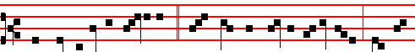
There was a certain nobleman, * whose son was sick at Ca- pernaum: when he
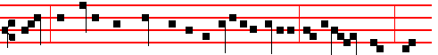
heard that Jesus was came out of Judaea into Galilee, he besought him that
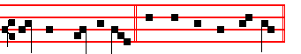
he would heal his son. Canticle Benedictus, p. 39.
On Magnificat, Antiphon. Tone iij, 1.
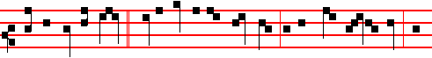
So the father knew * that it was at the same hour in the which Jesus said, Thy

1348
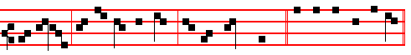
son liveth: and himself believed, and his whole house. Canticle Magnificat
__________________________________________________________________

THE TWENTY-FIRST SUNDAY AFTER PENTECOST

COLLECT
LORD,we beseech thee to keep thy household in continual godliness: that through thy protection it may be free from all adversities; and in good works be devoted to thy name. Through.

The Lesson from the Holy Gospel according to S. Matthew
Lesson vij Ch. 18
PETER said unto Jesus: Lord, how oft shall my brother sin against me, and I forgive him? And the rest.
Homily by S. Jerome, Priest Comm. on Matt. Ch. 18
THE Syrians, and more especially the Palestinians, are wont to illustrate every discourse with a parable; so that the listeners may grasp by means of comparison and example what they are not able to grasp by means of bare precept. Therefore the Lord instructs Peter under the figure of a lord and king, and his servant who owed his lord ten thousand talents and who sought and obtained pardon; thus teaching Peter that he also should forgive his fellow-servants their lesser offences. For if that lord and king so readily forgave his debtor-servant the ten thousand talents, how much more readily should servants forgive their fellow-servants their lesser tresspasses?

Lesson viij
TO make this plainer, we will give an example: if any of us were to commit adultery, or murder, or sacrilege; then these greater crimes, signified by the ten thousand talents, would be forgiven us if we sought pardon, provided that we also forgave lesser tresspasses. But if we refuse to be pacified after receiving a slight, and keep up an endless quarrel because of an unkind word; would it not seem right to send us back to prison, and, according to the example that we have here set forward, to give us no pardon for our greater sins?

Lesson ix
SO likewise shall my heavenly Father do also unto you if ye from your hearts forgive not every one his brother their trespasses. A terrible sentence, if the judgment of God may be turned and changed according to our mental attitude: if

1349
we will not forgive little things to our brethren, we shall not be forgiven grievous things by God. And because some one might say: I have nothing against him, he knows what he has done and God will judge him, what he chooses to do is not my business, I myself have forgiven him: because of this, the Lord confirms his sentence, and removes the likelihood of any such false peace, saying: If ye from your hearts forgive not every one his brother their trespasses.
Te Deum Laudamus, p. 24.
On Benedictus, Antiphon. Tone viij, 1.
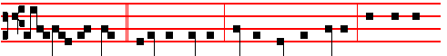
Then said the Lord * unto the servant, Pay me that thou owest. The servant
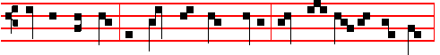
therefore fell down and worshipped him, saying, Lord, have patience with me,
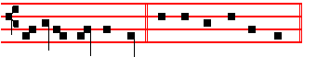
and I will pay thee all. Canticle Benedictus, p. 39.
On Magnificat, Antiphon. Tone vj.
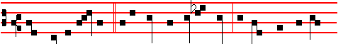
Thou wicked servant, * I forgave thee all that debt, because thou desiredst
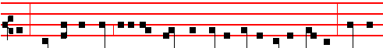
me: shouldest not thou also have had compassion on thy fellow-servant, even
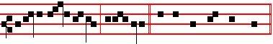
as I had pity on thee, alle- luia. Canticle Magnificat, p. 209.
__________________________________________________________________

THE TWENTY-SECOND SUNDAY AFTER PENTECOST

COLLECT
1350
OGOD, our refuge and strength, who art the author of all godliness: hear the devout prayers of thy Church, and grant; that those things which we ask faithfully we may obtain effectually. Through.

The Lesson from the Holy Gospel according to S. Matthew
Lesson vij Ch. 22
THE Pharisees went, and took counsel how they might entangle Jesus in his talk. And the rest.

Homily by S. Hilary, Bishop Comm. on Matt. Ch. 23
THE Pharisees were often put to confusion, and they could not find anything to charge him with from the things that he had done. There was no fault to be found in his words and deeds, yet , out of sheer malice they busied themselves, seeking in everything grounds of accusation. Now he was calling all men away from worldly crimes and the superstitions set up by men, calling them to hope in the kingdom of God. Therefore they tried him, by means of a craftily worded question, to see whether he would violate the law; namely, they asked whether it was right to give tribute to Cæsar.

Lesson viij
BUT he, knowing the hidden depths of their reasoning, (for there is nothing of man's to which God is not a witness of all those things that are hidden to man) ordered them to bring him a penny, and asked them whose was the image and superscription. The Pharisees answered, It was Cæsar's. He said to them, They were to render unto Cæsar the things which were Cæsar's; and unto God the things that were God's. What a wonderful answer and perfect fulfilment of the divine commandment! He adjusts the balance between contempt of the world and the affront of offending Cæsar; he frees souls devoted to God from all worldly cares and burdens, in decreeing that the things which are Cæsar’s are to be given to Cæsar.

Lesson ix
FOR if nothing of his remains with us, then we are no longer in the position of having to render unto him the things which are his. But we are concerned with those things which are his, if we are busied with things under his control, and subject ourselves like mercenaries to the administration of the inheritance of foreigners; then undoubtedly those things must be given to Cæsar which are Cæsar's, while we must render to God the things that belong to him: body, soul and will. For we receive these from him, and he is their Author and Maker: hence it is fitting that they should return wholly to him, as they should recall that their origin and development is from him.
Te Deum Laudamus, p. 24.

1351
On Benedictus, Antiphon. Tone viij, 1.
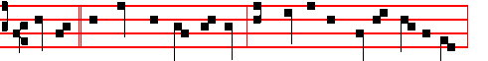
Master, * we know that thou art true, and teachest the way of God in truth,

alleluia. Canticle Benedictus, p. 39.
On Magnificat, Antiphon. Tone j, 2.
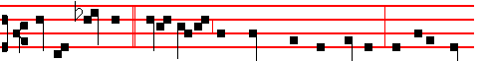
Render therefore * unto Cæsar the things which are Cæsar's: and unto God
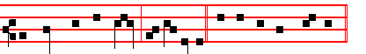
the things that are God's, al-le- luia. Canticle Magnificat, p.209.
¶ If the following Sunday be the last after Pentecost, in its place is put the 24th, as below, p. , and the Office of this Sunday is put on the Saturday preceding, not being impeded by a Feast of ix Lessons, or else on Friday or another day not similarly impeded.
__________________________________________________________________

THE TWENTY-THIRD SUNDAY AFTER PENTECOST

COLLECT
O LORD, we beseech thee, absolve thy people from their offences: that through thy bountiful goodness we may be delivered from the bonds of those sins, which by our frailty we have committed. Through.

The Lesson from the Holy Gospel according to S. Matthew
Lesson vij Ch. 9
WHILE Jesus spake these things unto John's disciples, behold, there came a certain ruler, and worshipped him, saying, My daughter is even now dead. And the rest.
Homily by S. Jerome, Priest Bk, 1, Comm. on Matt. 9
THE eighth miracle took place when the ruler, who did not wish to be excluded from the mystery of the true circumcision, asked that his daughter might be

1352
raised to life. But the woman with an issue of blood made her way in, and her cure takes the eighth place. Thus, the ruler's daughter, prevented from being the eighth, becomes the ninth, in accordance with the words of the psalm: Ethiopia shall soon stretch out her hands unto God. And again, When the fulness of the Gentiles be come in. then shall all Israel be saved.

Lesson viij
AND, behold, a woman which was diseased with an issue of blood twelve years, came behind him, and touched the hem of his garment. In the Gospel according to Luke it is written that the ruler's daughter was twelve years old. Observe, therefore, that the time since the disease first came upon this woman, that is, the Gentile people, corresponds with the time that the Jewish nation had been living in faith. For sin is not apparent unless it is compared with virtue.

Lesson ix
NOW this woman with the issue of blood did not come to the Lord when he was in a house or in a city, because according to the law she was not allowed in the cities; but she came up to him in the road, when he was walking along; thus one was healed while he was on his way to another. Whence the Apostles also say: It was necessary that the word of God should have been spoken to you: but seeing ye judge yourselves unworthy of everlasting life, lo, we turn to the Gentiles.
Te Deum Laudamus, p. 24.

On Benedictus, Antiphon. Tone ij
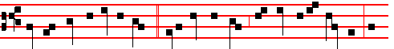
For she said within herself, * If I may but touch the hem of his garment, I

shall be whole. Canticle Benedictus, p. 39.

On Magnificat, Antiphon. Tone ij
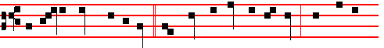
But Jesus turned him about, * and when he saw her, he said, Daughter, be

1353
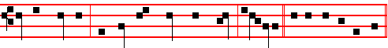
of good comfort; thy faith hath made thee whole, alle-lu-ia. Canticle Magnificat.

¶ The Sundays after Pentecost cannot be fewer than 23, nor more than 28. When there are more than 24, then after the 23rd Sunday there are taken those which were over in that year after the Epiphany, as concerns the Collect, Homily, and Antiphons on Benedictus and Magnificat in this order.

If the Sundays after Pentecost be XXV, the XXIV Sunday after Pentecost will be the VI after the Epiphany.

If they be XXVI, the XXIV Sunday will be the V after the Epiphany and the XXV will be the VI.

If they be XXVII, the XXIV Sunday will be the IV after Epiphany, the XXV will be the V, and the XXVI will be the VI.

If they be XXVIII, the XXIV Sunday will be the III after Epiphany, the XXV will be the IV and the XXV will be the V, and the XXVII will be the VI, and always in the last place is placed the one which follows in order as the XXIV below, p. .
__________________________________________________________________

THE THIRD SUNDAY WHICH REMAINED OVER AFTER THE EPIPHANY

COLLECT
ALMIGHTY and everlasting God, mercifully look upon our infirmities: and stretch forth the right hand of thy majesty to defend us. Through.

The Lesson from the Holy Gospel according to S. Matthew
Lesson vij Ch. 8
WHEN Jesus was come down from the mountain, great multitudes followed him. And, behold, there came a leper and worshipped him. And the rest.
Homily by S. Jerome, Priest Comm. on Matt. 8, Ch. 1
WHEN the Lord came down from the mountain, multitudes met him, for they were not able to climb to the heights. And the first to meet him was a leper, for he could not yet, with his leprosy, hear upon the mountain the Saviour's manifold discourse. And note: he was the first person specially mentioned as healed. The second was the centurion's servant: the third Peter's mother-in-law suffering from fever, in Capernaum: in the fourth place those who met him

1354
troubled by an evil spirit, their spirits he cast out with a word: and also he healed
all that were sick.

Lesson viij
AND behold, a leper, coming to him worshipped him, saying. It is right that after the preaching and teaching there should be offered occasion for a sign, that by virtue of a miracle the sermon now over may be confirmed among the hearers. Lord, if thou wilt, thou canst make me clean. He who asks the will, doubts not the power. Ad Jesus put forth his hand and touched him, saying, I will;
be thou clean. As the Lord put forth his hand, immediately the leprosy fled. Consider also how lowly and without arrogance is the reply. He (the leper) had said, If thou wilt. The Lord replied, I will. He had first said, Thou canst make me clean; the Lord continues and says, Be thou clean. We must not therefore, as many of the Latinists think, join the words together and read, I will make thee clean; but take them separately, so that first he says I will; then he commands, Be thou clean.

Lesson ix
AND Jesus saith unto him, see thou tell no man. And truly what need was there to boast in speech of that which he plainly showed in his body? But go thy way, show thyself to the priest. For divers reasons he sends him to the priests. For it was enjoined in the law that those who had been cleansed of leprosy should offer gifts to the priests. Secondly, that those who say that the leper was cleansed should either believe on the Saviour, or not believe. If they believed, they would be saved: if they did not believe, they would be without excuse: and also, lest he should seem to be breaking the law, a charge often brought against him.
Te Deum Laudamus, p. 24.

On Benedictus, Antiphon. Tone j, 1.
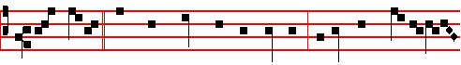
When Jesus * was come down from the mountain, behold there came a leper

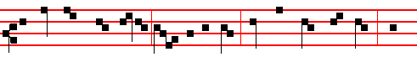
and worshipped him, saying, Lord,if thou wilt, thou canst make me clean. And

1355
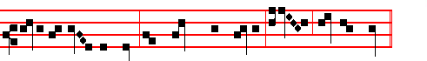 Jesus put forth his hand and touched him, saying I will; be thou clean. 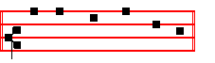
Canticle Benedictus, p.39. On Magnificat, Antiphon. Tone j, 2.
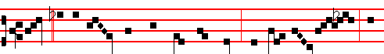
Lord, * if thou wilt, thou canst make me clean: then saith Je- sus, I

will; be thou clean. Canticle Magnificat, p. 209.
__________________________________________________________________

THE FOURTH SUNDAY WHICH REMAINED OVER
AFTER THE EPIPHANY

COLLECT
O GOD,who knowest us to be set in the midst of so great dangers that through our human frailty we cannot stand upright: grant to us health of mind and body; that those things which we suffer for our sins, by thy help we may overcome. Through.

The Lesson from the Holy Gospel according to S. Matthew
Lesson vij Ch. 8
JESUS entereed into a ship, and his disciples followed him. And, behold, there arose a great tempest in the sea, insomuch that the ship was covered with the waves: but he was asleep. And the rest.
Homily by S. Jerome, Priest Bk. I, Ch. 8 on Matt.
WE wrought the fifth sign when, taking ship from Capernaum, he commanded the winds and the sea. The sixth, when, in the country of the Gergesenes, he

1356
allowed demons to enter the swine. The seventh, when entering his own city, he healed a second paralytic lying on a bed. For the first paralytic was the Centurion’s servant.

Lesson viij
BUT he himself was asleep: and they came to him and awoke him, saying, Lord save us. We read in Jonah a type of this sign, when, while the rest were in danger, he himself was carefree and slept, and was awakened. And by his command and by the sacrament of his passion, he sets free those who awake him. Then he arose and rebuked the winds and the sea. From this we understand that all creatures perceive their Creator. For those whom he chided and commanded perceive him who so commanded: not according to the false belief of heretics who
think all things endued with life: but through the majesty of the Author of their being, things that we cannot perceive by the senses are to him objects of knowledge.

Lesson ix.
BUT the men marvelled, saying, What manner of man is this that even the winds and the sea obey him? It was not the disciples, but sailors and others who were in the ship who marvelled. But if anyone wishes to argue that those who marvelled were the disciples, we shall answer that rightly were they called men, inasmuch as not yet did they know the Saviour's power.
Te Deum Laudamus, p. 24.

On Benedictus, Antiphon. Tone vj
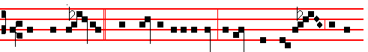
And when Jes- us * was entered into a ship, behold, there a- rose a great
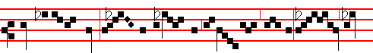
tempest in the sea: and his disci- ples awoke him, saying: Lord, save
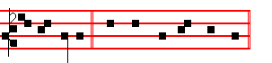
us, we perish. Canticle Benedictus, p. 39.

1357
On Magnificat, Antiphon. Tone j, 2.
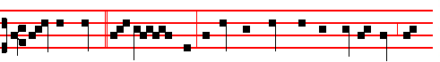
Save us, Lord, * we per- ish: rebuke the winds and the sea, O God, and
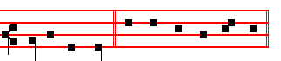
make a great calm. Canticle Magnificat, p.209.
__________________________________________________________________

THE FIFTH SUNDAY THAT REMAINED OVER
AFTER THE EPIPHANY

COLLECT
O LORD, we beseech thee to keep thy household in continual godliness: that they who do lean only upon the hope of thy heavenly grace may evermore be defended by thy protection. Through.

The Lesson from the Holy Gospel according to S. Matthew
Lesson vij Ch. 13
JESUS spake this parable unto the multitudes: The kingdom of heaven is likened unto a man which sowed good seed in his field. And the rest.
Homily by S. Augustine, Bishop 17 on S. Matthew
WHEN those who had been set over the Church behaved in careless fashion or when the Apostles received the sleep of death, the devil came and sowed his seed upon those whom the Lord called the evil sons. But the question is asked, Were they heretics, or Catholics living evil lives? For even heretics can be called evil sons, because they have been begotten from the same seed of the Gospel and in the Name of Christ, though they are turned by their crooked beliefs to false doctrines.

Lesson viij
BUT this he says, that they were sown in the midst of the wheat as though those men seem to be meant who are of the one communion. Yet since the Lord interpreted the field itself not as the Church, but as this world, they are rightly understood as the heretics, because not in the fellowship of the one Church, or of the one faith, but in the fellowship of the name Christian only are they mingled in this world with the good. But they who, holding the same faith are

1358
yet evil, are considered straw rather than tares: because straw has the very same
foundation as the wheat and a common root.

Lesson ix.
CLEARLY, not without reason are bad Catholics understood to be in that net in which are enclosed fish both bad and good. For the sea which betokens that world is one thing; quite another is the straw, which seems to point to the communion of the one faith or the one Church. Between heretics and bad Catholics there is this difference, that heretics believe that is false, but bad Catholics, while believing what is true, do not live in accordance with their belief.
Te Deum Laudamus, p. 24.

On Benedictus, Antiphon. Tone j, 2.
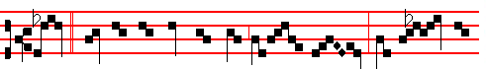
Sir, * didst not thou sow good seed in thy field? from whence then
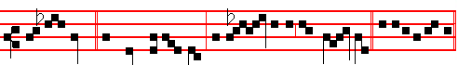
hath it tares? He said unto them, an en- emy hath done this.C. Benedictus

On Magnificat, Antiphon. Tone j, 1.
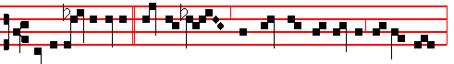
Gather ye together * first the tares, and bind them in bundles to burn them:
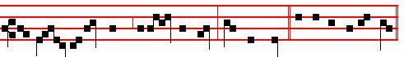
but gath- er the wheat into my barn, saith the Lord. Canticle Magnificat.
__________________________________________________________________

THE SIXTH SUNDAY THAT REMAINED OVER
AFTER THE EPIPHANY

COLLECT
1359
GRANT, we beseech thee, almighty God: that we, ever meditating those things that be reasonable and pleasing unto thee, may both in word and deed fulfil the same.Through.

The Lesson from the Holy Gospel according to S. Matthew
Lesson vij Ch. 13
JESUS said unto his disciples; The kingdom of heaven is like to a grain of
mustard seed, which a man took and sowed in his field. And the rest.
Homily by S. Jerome, Priest Bk. 2 Comm. on Matt. Ch. 13, v. 32
THE Kingdom of heaven is the preaching of the Gospel and the knowledge of the Scriptures which leads to life and concerning which it was said to the
Jews, The Kingdom of God will be taken from you and given to a nation bringing forth the fruit of it. This Kingdom therefore is like to a grain of mustard seed, which a man took, and sowed in his field. The man who sows in his field is understood by many to be the Saviour, because he sows in the minds of them that believe: by others, a man himself is the one who sows in his own field, that is in himself and in his heart.

Lesson viij
WHO is the sower but our perception and our mind? And it, receiving the grain of preaching and tending the young shoot, with the water of faith makes it burgeon in the soil of his own breast The preaching of the Gospel is the least of all systems of knowledge. For at the first instruction the preaching is hardly believed that God became Man, that Christ died, and the scandal of the Cross. Compare teaching of this kind with the dogmas of the philosophers, with their books, the splendour of their eloquence, the careful arrangement of their discourses, and you will see how much less than the other seeds is the sowing of the Gospel.

Lesson ix
BUT when they, the seeds of the philosophers, are fully grown, they reveal nothing that is pungent, nothing lively, nothing vital. But the whole body of their teaching is feeble, rotten, soft; springs up abundantly into herbs and grasses, which swiftly become parched and perish. But this preaching of the Gospel, which in the beginning seemed but small, when it has been sown in the heart of the believer, or in the whole world, does not grow up into herbs but into a tree, so that the birds of the air, which we must takc to mean the souls of the believers, or celestial spirits devoted to the service of God come and dwell in its branches. I think the branches of the Gospel tree which grew from the grain of mustard are the varieties of dogma in which each one of the aforesaid birds takes its rest.
Te Deum Laudamus, p. 24.

1360
On Benedictus, Antiphon. Tone vij, 3.
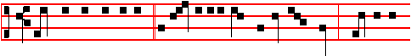
The kingdom of heaven * is like unto a grain of mustard seed, which is the
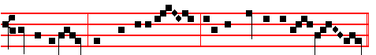
least of all seeds, but when it is grown, it is the greatest among herbs.

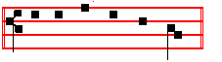
Canticle Benedictus, p. 39.

On Magnificat, Antiphon. Tone j, 3.
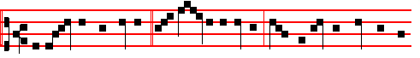
The kingdom of heaven * is like unto leaven,which a woman took and hid
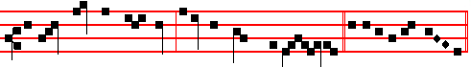
in three measures of meal, until the whole was leavened. Canticle Magnificat.
__________________________________________________________________

THE TWENTY-FOURTH AND LAST SUNDAY AFTER PENTECOST

COLLECT
STIR up, we beseech thee, O Lord, the wills of thy faithful: that they plenteously bringing forth the fruit of good works, may of thy loving- kindness receive more abundant rewards. Through.

The Lesson from the Holy Gospel according to S. Matthew
Lesson vij Ch. 24
JESUS said unto his disciples: When ye shall see the abomination of desolation, spoken of by Daniel the prophet, stand in the holy place, (whoso readeth, let him understand). And the rest.
1361
Homily by S. Jerome, Priest Bk.4. Comm. on Matt. Ch.24
WHEN we are called upon to understand what we read, it is shown that there is a mystery in these words. Now we read in Daniel as follows: In the midst of the week he shall cause the sacrifice and the oblation to cease, and for the overspreading of abominations he shall make it desolate, even until the consummation, and that determined shall be poured upon the desolate. The Apostle is also speaking of this when he says: There shall come that man of sin, who opposeth and exalteth himself above all that is called God, or that is worshipped; so that he as God sitteth in the temple of God, shewing himself that he is God: even he whose coming is after the working of Satan, and he shall destroy them. and banish from God all who shall receive him.

 BIeased is the people * Whom the Lord of hosts hath blessed, saying: O Israel, thou art the work of mine own hands, thou art mine own inheritance.
 Blessed is the nation whose God is the Lord, and the people whom he hath chosen for his own inheritance. Whom the.

Lesson viij
BUT this prophecy may also be understood to mean simply Antichrist, or else the statue of Cæsar which Pilate erected in the temple, or the equestrian statue of Hadrian which stands even to this present day on the site of the Holy of holies. The word, Abomination, in the Old Testament also means, Idol; and, Desolation is added because the idol was placed in the temple that was desolated and destroyed.

 One Seraph cried unto another, and said, * Holy, holy, holy, is the Lord of hosts. * The whole earth is full of his glory.
 There are Three that bear record in heaven, the Father, the Word. and the Holy Ghost, and these Three are One. Holy, holy. Glory be. The whole.

Lesson ix
ABOMINATION of desolation may also be understood as all perverse dogma: and when we see it stand in the holy place, that is, in the Church, we must flee from Judæa to the mountains, that is, we must leave the letter that killeth and Jewish perversity, and make our way to the everlasting hills, from which God sheds his light ineffably: we must be on the housetop where the fiery darts of the devil cannot reach us, nor must we come down to take anything out of the house of our former conversation, nor seek the things that we left behind; but instead we must labour in the spiritual field of the Scriptures, so that we may reap fruit from it; nor must we have two coats, for that was forbidden to the Apostles.
Te Deum Laudamus, p.24.
On Benedictus, Antiphon. Tone j, 3.

1362
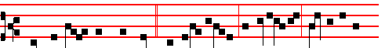
When ye, therefore, shall see * the abomination of desolation, spoken of by
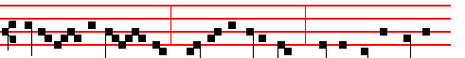
Dani-el the proph- et, stand in the holy place; whoso readeth, let him
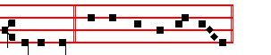
understand. Canticle Benedictus, p. 39.

On Magnificat, Antiphon. Tone j, 3.
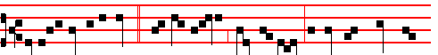
Verily I say unto you, * This generation shall not pass, till all these things be
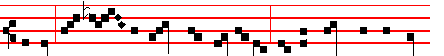
fulfilled, Hea- ven and earth shall pass away, but my words shall not pass
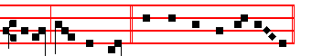
away, saith the Lord. Canticle Magnifiicat, p. 209.

__________________________________________________________________

1363
CORPUS CHRISTI AT II VESPERS

Simple Mode (see p. 997-998 above)

On Magnificat, Antiphon. Tone v.
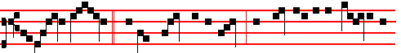
O sacred banquet, * wherein Christ is received, the memory of his passion is
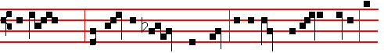
renewed; the soul with grace is filled, and a pledge of future glory is
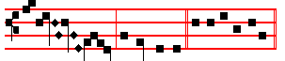
bestowed, al- le- lu- ia. E u o u a e.

___________________________________________________________________________________________



1364

