AT VESPERS
Chapter Phil. 2
BRETHREN: Let this mind be in you, which was also in Christ Jesus: who, being in the form of God, thought it not robbery to be equal with God; but made himself of no reputation, and took upon him the form of a servant, and was made in the likeness of men: and was found in fashion as a man.
Hymn E.H. 94 Vexilla Regis and  Deliver me, p. 688.
On Magnificat, Antiphon. Tone iv, 1.
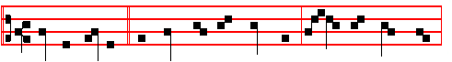
Righteous Father,* the world hath not known thee: but I have known thee,
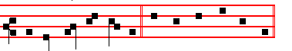
because thou hast sent me. Canticle Magnificat, p. 209
COLLECT
ALMIGHTY and everlasting God, who didst cause our Saviour to take upon him our flesh, and to suffer on the cross, that mankind might follow the example of his humility: mercifully grant; that we may both keep in mind the lessons of his patience, and be worthy to be partakers of his resurrection. Through the same.
__________________________________________________________________

PALM SUNDAY
AT MATINS

Invitatory. Today if ye will hear, p. 689.
Hymn. E.H. 95 Pange lingua, p. 690.
At the Nocturns all as in the Psalter with  as in Passiontide.

IN THE FIRST NOCTURN
From the Prophet Jeremiah
Lesson j Ch. 2, 12-22
BE astonished, O ye heavens, at this, and be horribly afraid, be ye very desolate, saith the Lord. For my people have committed two evils; they have forsaken me the fountain of living waters, and hewed them out cisterns, broken cisterns, that can hold no water. Is Israel a servant? is he a homeborn slave? why is he spoiled? The young lions roared upon him, and yelled, and they made his

713
land waste: his cities are burned without inhabitant.Also the children of Noph and Tahapanes have broken the crown of thy head. Hast thou not procured this unto thyself, in that thou hast forsaken the Lord thy God, when he led thee by the way?

 In the day that I called upon thee, thou saidst, Fear not. * O Lord, thou hast pleaded the causes of my soul, thou hast redeemed my life.
 In the time of my trouble I will call upon thee: for thou hearest me. O Lord.

Lesson ij
AND now what hast thou to do in the way of Egypt, to drink the waters of Sihor? or what hast thou to do in the way of Assyria, to drink the waters of the river? Thine own wickedness shall correct thee, and thy backslidings shall reprove thee: know therefore and see that it is an evil thing and bitter, that thou hast forsaken the Lord thy God, and that my fear is not in thee, saith the Lord God of hosts. For of old time I have broken thy yoke, and burst thy bands; and thou saidst, I will not transgress; when upon every high hill and under every green tree thou wanderest, playing the harlot. Yet I planted thee a noble vine, wholly a right seed: how then art thou turned into the degenerate plant of a strange vine unto me? For though thou wash thee with nitre, and take thee much soap, yet thine iniquity is marked before me, saith the Lord God.

 My lovers and my friends hast thou put away from me: * And hid mine acquaintance out of my sight.
 And my kinsmen stood afar off. And hid.
Lesson iij
WHEREFORE will ye plead with me? ye all have transgressed against me, saith the Lord. In vain have I smitten your children; they received no correction: your own sword hath devoured your prophets, like a destroying lion. O generation, see ye the word or the Lord. Have I been a wilderness unto Israel? a land of darkness? wherefore say my people, We are lords; we will come no more unto thee? Can a maid forget her ornaments, or a bride her attire? yet my people have forgotten me days without number.

 Give heed to me, O Lord, and hearken to the voice of them that contend with me: * Shall evil be recompensed for good? for they have digged a pit for my soul.
 Remember that I stood before thee to speak good for them, and to turn away thy wrath from them. Shall. Give heed.

IN THE SECOND NOCTURN
Sermon by S. Leo the Great
Lesson iv Sermon 11 on the Lord's Passion

714
THE festival that we had so greatly desired, that the whole world is awaiting
the festival of the Lord's Passion, is now upon us: amidst our great spiritual rejoicing we cannot keep silence. Hard as it is to discourse so often on the subject of the same festival fittingly and worthily: yet the priest is not at liberty to deny to his faithful people his bounden duty of a sermon on so great a mystery of the Divine mercy: the very fact that the subject is an ineffable mystery makes it easier to speak of it; for when something can never be adequately expressed, there must needs ever be room for further words. Then let human weakness fall prostrate before the glory of God, and find itself ever unequal to the task of expounding the workings of God's mercy. Let us strive with our perception, wrestle with our intellect, outstrip our expression: it is good for us to fall short, to see aright the
majesty of God.

 The enemy hath closed my ways, he was unto me like a lion lying in wait in secret places, he hath filled me and made me drunk with bitterness: they have cut off my life in a dungeon and cast a stone upon me. * O Lord behold their wrong: and plead the cause of my soul, thou who art the defender of my life.
 I was a derision to all my people, and their song all the day. O Lord behold.

Lesson v
AS the Prophet says, Seek the Lord and his strength, seek his face evermore. No-one should be so presumptuous as to think that he can find all that he seeks, lest he should fail to draw near by the very fact that he no longer strives after it. But among all the works of God that hold and absorb man's marvelling gaze, what so delights and ravishes our soul's contemplation as the Saviour's Passion? For the purpose of freeing mankind from the chains of his fatal transgression, he both hid the power of his majesty from the raging devil, and opposed him with the weakness of our low estate. For if the proud and cruel enemy had been able to know the counsel of God's mercy, he would have tried to soften the hearts of the Jews to gentleness, rather than kindle them to unrighteous hatred; lest by pursuing the freedom of one who owed him nothing he should lose the servitude of those who were his captives.

 Save me, O God, for the waters are come in, even unto my soul: hide not thy face from thy servant: * For I am in trouble: O haste thee, and hear me.
 Draw nigh unto my soul, and save it: O deliver me, because of mine enemies.
For I.

Lesson vj
THEREFORE his own wickedness foiled him: he punished the Son of God, and this punishment was turned into the remedy for all the sons of men. He

715
shed righteous blood, which became both the price and the healing draught for the restoration of the world. The Lord underwent that which he had chosen in accordance with the proposition of his own will. He allowed himself to be taken by the wicked hands of cruel men: who in performing their own wickedness ministered to the Redeemer. His merciful love even towards his murderers was so great that he besought his Father from the cross, not asking to be avenged, but
seeking their forgiveness.

 O Lord, be not a terror unto me: thou art my hope in the day of evil. * Let them be confounded that persecute me, but let not me be confounded.
 Let them be confounded, and put to shame, that seek after my soul. Let them be. O Lord.

IN THE THIRD NOCTURN

The Lesson from the Holy Gospel according to S. Matthew.
Lesson ix Ch. 21
WHEN Jesus drew nigh unto Jerusalem, and was come to Bethphage unto the mount of Olives, then sent he two disciples, saying unto them. And the rest.
Homily by S. Ambrose, Bishop Bk. 9 on Luke Ch. 19, v. 29.
IT is fitting that the Lord, when he had left the Jews and was about to dwell in
!he Gentiles' hearts, went up into the temple. For the true temple is that one which is built upon courses of stone. Therefore the men who hated him were abandoned, and those who loved him were chosen. For this reason did he come to the mount of Olives: to plant the olive branches on the heights of virtue, those olive branches whose mother is the heavenly Jerusalem. He is the divine husbandman on that mountain: so that each one of all those that are planted in the house of God may be able to say, As for me, I am like a green olive-tree in the house of God.

 The Lord is with me as a mighty terrible one: therefore my persecutors shall stumble and shall not prevail. But, O Lord of hosts, that triest the righteous and seest the reins of the heart, * Unto thee have I revealed my cause.
 O Lord, thou hast seen my wrong: judge thou my cause.
Lesson viij
AND perhaps the mountain is Christ himse1f. For who else bears such fruitful olive- trees, not laden with profuse olives indeed, but with the spiritual fruit of the fulness of the Gentiles. He it is through whom we go up, and into whom we go. He is the door he is the way, it is he who is opened and who opens: he is knocked upon by those who enter, and is worshipped by those who find entrance. For this reason was there a village, and an ass tied, and a colt with her: nor could

716
she be loosed without the Lord's command. She was loosed by the hand of an apostle. Such was the act, such the life, such the grace. Be ye also such an one, that ye may loose that which is bound.

 The ungodly said, reasoning with themselves, but not aright: Let us lie in wait for the righteous, because he is clean contrary to our doings. He professeth to have knowledge of God: he calleth himself the Child of the Lord, and maketh his boast that God is his Father. * Let us see if his words be true; if he be verily the Son of God, let him deliver him out of our hands. Let us condemn him with a shameful death.
 We are esteemed of him as counterfeits: he abstaineth from our ways as from filthness; he pronounceth the end of the just to be blessed. Let us see.

Lesson ix
NOW let us consider who they were that were discovered in sin, and were cast out of paradise and bound in this village. See how Life recalled those whom death had expelled. Thus in Matthew we read both of an ass and of a colt; for as both sexes were represented in the two cast out of paradise, so were both sexes in the two animals recalled. Therefore by the mother-ass, Eve, as the mother of sin, is denoted: while the colt represents the multitude of the Gentiles. It is well said, Whereon yet never man sat, for before Christ no-one had called the Gentiles into the Church. And Mark also says this, Whereon never man sat.

 Liars are come round about: they have fallen upon me with scourges without a cause. * But thou, O Lord, art my succour, haste thee to help me.
 For trouble is hard at hand, and there is none to help me. But thou. Liars are come.
AT LAUDS

Antiphon 1 Tone ij
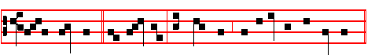 For the Lord God * will help me: and therefore shall I not be confounded.
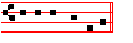
Psalm 51 Miserere
Antiphon 2. Tone j, 4.

717
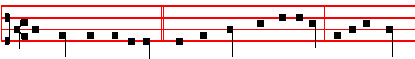
They compassed me about, * yea, they compassed me about: but in the Name
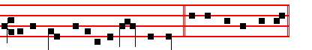
of the Lord will I be avenged on them. Ps. 118 Confitemini.
Antiphon 3.
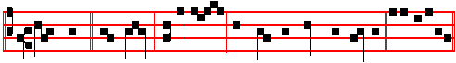
Judge thou * my cause: defend me, for thou, O Lord, art mighty. Pss 63 ,67
Antiphon 4. Tone vij
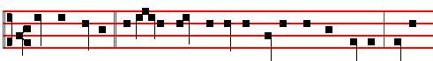
May the faithful * today be found among the Angels and the children, crying
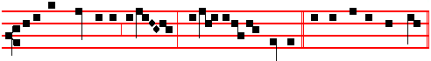
unto the Conqueror of death, Ho- san-na in the highest.Canticle Benedicite.
Antiphon 5. Tone iv, 1.
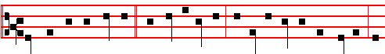
Let them be confounded * that persecute me, but let not me be confounded, O
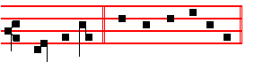
Lord my God. Psalms 148, 149, 150.
Chapter Phil. 2
BRETHREN: Let this mind be in you, which was also in Christ Jesus: who, being in the form of God, thought it not robbery to be equal with God; but

718
made himself of no reputation, and took upon him the form of a servant, and was made in the likeness of men: and was found in fashion as a man.
Hymn E.H. 96 Lustra sex, and  Deliver me, p.697.
On Benedictus, Antiphon. Tone iv, 1.
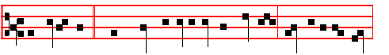
The multitudes * which came together for the feast day cried unto the Lord:
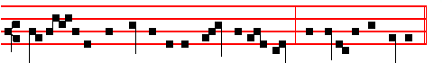
Blessed is he that cometh in the Name of the Lord. Hosan-na in the highest.
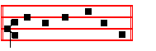
Canticle Benedictus.
COLLECT

ALMIGHTY and everlasting God, who didst cause our Saviour to take upon him our flesh, and to suffer on the cross, that mankind might follow the example of his humility: mercifully grant; that we may both keep in mind the lessons of his patience, and be worthy to be partakers of his resurrection. Through the same.
AT PRIME

Antiphon Tone j, 1.
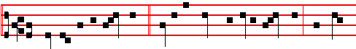
The children of the Hebrews, * carrying palms and olive branches, went forth
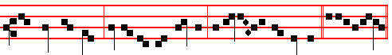
to meet the Lord, crying out and saying: Hosanna in the highest. Psalm 54

AT TERCE

719
Antiphon. Tone j, 1.
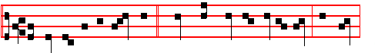
The children of the Hebrews * spread their garments in the way, and cried,
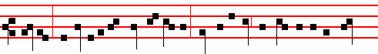
saying: Hosanna to the Son of David; blessed is he that cometh in the Name
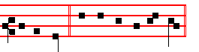
of the Lord. Psalm 119 Legem pone
Chapter Brethren: Let this mind, p. 718.
Short  as above, p. 699.
Deliver my soul, * O God, from the sword. Deliver.
 My darling from the power ef the dog. O God. Deliver.
 Save me, O Lord, from the lion's mouth.
 Thou hast heart me also from among the horns of the unicorns.

AT SEXT
Antiphon. Tone iv, 1.
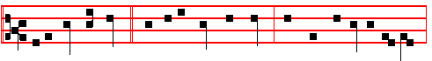
Unto thee, O Lord, * have I revealed my cause: thou hast defended my life,
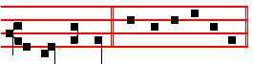
O Lord my God. Psalm 119 Defecit
Chapter Phil. 2
HE humbled himself, and became obedient unto death, even the death of the Cross. Wherefore God also hath highly exalted him, and given him a Name which is above every name.

Short  as above, p. 700.
720
Save me, O Lord, * From the lion's mouth. Save me.
 Thou hast heard me also from among the horns of the unicorns. From the.
Save me.
 O shut not up my soul with the sinners.  Nor my life with the bloodthirsty.

AT NONE
Antiphon. Tone iv, 1.
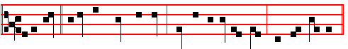
I will call * upon thy Name, O Lord: turn not away thy face from my calling.
Psalm 119 Mirabilia
Chapter Phil. 2
AT the Name of Jesus every knee should bow, of things in heaven, and things in earth, and things under the earth; and every tongue should confess that Jesus Christ is Lord, to the glory of God the Father.
Short  as above, p. 700.
O shut not up my soul * With the sinners, O God. O shut.
 Nor my life with the bloodthirsty. With the. O shut.
 Deliver me, O Lord, from the evil man.  And preserve me from the wicked man.
AT VESPERS
Antiphons and Psalms of Sunday, p. 202.
Chapter: Brethren: Let this mind, p. 718.
Hymn: E.H. 94 Vexilla regis and  Deliver me, p. 688.
On Magnificat, Antiphon. Tone viij, 1.
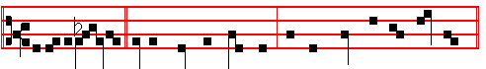
For it is writ-ten, * I will smite the shepherd, and the sheep shall be scattered.
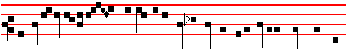
But after I am ri-sen again, I will go before you into Galilee: there shall ye

721
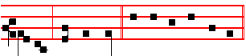
see me, saith the Lord. Canticle Magnificat

COLLECT
Almighty and everlasting God, p. 719.
From this day until the Octave of Easter, if there occur a Feast of ix Lessons, it is transferred after the Octave. Of one of iij Lessons however, from Maundy Thursday until Easter Tuesday, no commemoration is made.
__________________________________________________________________

Monday
Invitatory.- Today, p. 689.
Hymn E.H .95 Pange, lingua, p. 690.
Antiphons and Psalms of Monday, p. 89, with  as in Passiontiie.
The Lesson from the Holy Gospel according to S. John
Lesson j Ch. 12, 1-9
SIX days before the passover Jesus came to Bethany, where Lazarus was which had been dead, whom he raised from the dead. And the rest.
Homily by S. Augustine, Bishop Homily 50 on John
LEST men should think that he had become a phantom because he had risen from the dead, Lazarus was one of those who reclined at table. He lived, he spoke, he feasted; the truth was made manifest, and the disbelief of the Jews brought to confusion. Jesus then, sat down to table with Lazarus and the rest; Martha, one of the sisters of Lazarus, served. But Mary, the other sister of Lazarus, took a pound of ointment of genuine nard of great value, and anointed the feet of Jesus, and wiped his feet with her hair; and the house was filled with the fragrance of the ointment. We have heard what was done: let us seek out the mystery.

 The ungodly said, Let us oppress the righteous man without cause, and swallow him up alive as the grave: let us make his memory to perish from the earth: and let us cast lots for his spoils: and those murderers laid up stores for themselves of evil. * Fools and evil men hate wisdom: and are guilty in their thoughts.
 Such things they imagined and were deceived: and their wickedness blinded them. Fools.

Lesson ij

722
OTHOU, whosoever wouldest be a faithful soul, with Mary anoint thou the Lord's feet with precious ointment! that ointment was righteousness, therefore was it a pound: moreover it was ointment of costly spikenard. That he calls it pisticum, we ought to take it to mean some place from which this costly ointment came: yet neither is this expression idle, but chimes in excellently with the inward and spiritual meaning. Pistis is Greek for Faith. Thou wast seeking to work righteousness: the righteous liveth by faith. Anoint the feet of Jesus: by good living follow the Lord's footsteps. Wipe his feet with thine hair: if thou hast super- fluities, give to the poor, and thou has wiped the feet of the Lord: for the hair seems to be the superfluity of the body. Thou hast what thou mayest do with thy superfluity: to thee it is superfluous, but to the Lord's feet necessary. Perchance on earth the Lord's feet suffer need.

 I became also a reproach unto them: they that looked upon me shaked their heads. * Hear me, O Lord my God.
 They have spoken against me with false tongues: they compassed me about also with words of hatred. Hear me.

Lesson iij
FOR of whom but his members will he say in the end of the world, While ye did it to one of the least of mine, ye did it unto me? Your superfluities ye bestowed, but it was to my feet that ye showed the kindness. But, The house was filled with the odour; the world was filled with the good fame: for good odour is good fame. They that live ill, and are called Christians, do wrong to Christ: such are they of whom it is said, that through them the name of the Lord is blasphemed. If through such the Name of God is blasphemed through the good the Name of the Lord is praised. Hear the Apostle: We are a good odour of Christ, saith he, in every place.

 False witnesses tare risen up against me, and such as speak wrong. They have gone about to kill me, and spared not to spit in my face; their spears have wounded me, and all my bones are out of joint. * But as for me, I am like to one that is dead upon the earth.
 They poured forth their fury upon me, they gnashed upon me with their teeth. But as. False witnesses. But as.

AT LAUDS, AND THE HOURS
Antiphon 1. I hid not * my face from shame and spitting. Psalms of Monday.
Antiphon 2. Awake, O sword, * against them that scatter my flock.
Antiphon 3. So they weighed * for my price thirty pieces of silver, the price that I was prised at of them.
723
Antiphon 4. Water flowed over * mine head: then I said, I am cut off: I will call upon thy Name, O Lord God.
Antiphon 5. Behold, O Lord, * the lips of them that rise up against me, and their devices.
Chapter Jer. 11
LET us destroy the tree with the fruit thereof, and let us cut him off from the land of the living, that his name may be no more remembered.
Hymn E.H. 96 Lustra sex, and  Deliver me, p. 697.
On Benedictus, Antiphon.
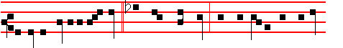
O Father, glorify thou me * with thine own self, with the glory which I had
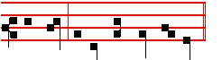
with thee before the world began.
Then the Prayers, p. 108.
COLLECT
GRANT, we beseech thee, almighty God: that we who amidst so many adversities do fail by reason of our weakness, may be renewed through the pleading of the Passion of thy only-begotten Son: Who liveth and reigneth with thee.
At the Hours, Antiphons from Lauds, the rest as in the Psalter.
At Vespers, Antiphons and Psalms from the Psalter, p .
Chapter Jer. 11
BUT, O Lord of hosts, that judgest righteously, that triest the reins and the heart, let me see thy vengeance on them: for unto thee have I revealed my cause,O Lord my God.
Hymn E.H. 94 Vexilla Regis, and  Deliver me, p. 688.
On Magnificat, Antiphon.Thou couldest have no power * at all ever me, except it were given thee from above. Then the Prayers, p. 217.

COLLECT
HELP us, O God of our salvation: and grant, that we may come with joy to the celebration of those benefits by which thou hast vouchsafed to redeem us. Through.
__________________________________________________________________

Tuesday
724
Blessing May God the Father almighty.
From the Prophet Jeremiah
Lesson j Ch. 11, 15-20
WHAT hath my beloved to do in mine house, seeing she hath wrought lewdness with many, and the holy flesh is passed from thee? when thou doest evil, then thou rejoicest. The Lord called thy name, A green olive tree, fair, and of goodly fruit: with the noise of a great tumult he hath kindled fire upon it, and the branches of it are broken. For the Lord of hosts, that planted thee, hath pronounced evil against thee, for the evil of the house of Israel and of the house of Judah, which they have done against themselves to provoke me to anger in offering incense unto Baal. And the Lord hath given me knowledge of it, and I know it: then thou shewedst me their doings. But I was like a lamb or an ox that is brought to the slaughter; and I knew not that they had devised devices against me, saying, Let us destroy the tree with the fruit thereof, and let us cut him off from the land of the living, that his name may be no more remembered. But, O Lord of hosts, that judgest righteously, that triest the reins and the heart, let me see thy vengeance on them: for unto thee have I revealed my cause.

 For I heard the defaming of many, fear on every side. All my familiars watched for my hasting, saying: Peradventure he will be enticed and we shall prevail against him, and we shall take our revenge on him. But the Lord is with me as a mighty terrible one: therefore my persecutors shall stumble and they shall not prevail. * Let me see thy vengeance on them, for unto thee have I revealed my cause.
 O Lord, thou hast pleaded the causes of my soul, thou hast redeemed my life. Let me.

Blessing May Christ grant.
Lesson ij Ch. 12. 1-4
RIGHTEOUS art thou, O Lord, when I plead with thee: yet let me talk with thee of thy judgments: Wherefore doth the way of the wicked prosper? Wherefore are all they happy that deal very treacherously.? Thou hast planted them, yea, they have taken root: they grow, yea, they bring forth fruit: thou art near in their mouth, and far from their reins. But thou, O Lord, knowest me: thou hast seen me, and tried mine heart toward thee: pull them out like sheep for the slaughter, and prepare them for the day of slaughter. How long shall the land mourn, and the herbs of every field wither, for the wickedness of them that dwell therein? the beasts are consumed, and the birds; because they said, He shall not see our last end.

 O Lord God of Israel for thy sake have I suffered reproof; shame hath covered my face. I am become a stranger unto my brethren; even an alien unto my

725
mother's children. * For the zeal of thine house hath even eaten me.
 Draw nigh unto my soul, and save it; O deliver me because of mine enemies. For the zeal.

Blessing May God enkindle.
Lesson iij Ibid. 7-11
I HAVE forsaken mine house, I have left mine heritage; I have given the dearly beloved of my soul into the hand of her enemies. Mine heritage is unto me as a lion in the forest; it crieth out against me: therefore have I hated it. Mine heritage is unto me as a speckled bird, the birds round about are against her; come ye, assemble all the beasts of the field, come to devour. Many pastors have destroyed my vineyard, they have trodden my portion under foot, they have made my pleasant portion a desolate wilderness. They have made it desolate, and being desolate it mourneth unto me; the whole land is made desolate, because no man layeth it to heart.

 The congregation of the people came about me, but I rewarded not evil unto him that dealt wickedly with me. * Let the wickedness of the ungodly come to an end; but guide thou the just.
 The Lord shall judge me; give sentence with me, O Lord, according to my righteousness, and according to the innocency that is in me. Let the.
The congregation. Let the.

AT LAUDS, AND THROUGH THE HOURS,
Antiphon 1. See, O Lord, * and consider, for I am in trouble: O haste thee and hear me. Psalms of Tuesday, p. 81
Antiphon 2. Defend thou * my cause, O Lord: O deliver me from the deceitful and wicked man.
Antiphon 3. When I was in trouble * I cried unto the Lord out of the belly of hell, and he heard me.
Antiphon 4. Lodi, I am oppressed, * undertake for me: for I know not what I shall say unto mine enemies.
Antiphon 5. The ungodly said, * Let us oppress the righteous man, because he is clean contrary to our doings.
Chapter Let us destroy, p. 724.
Hymn E.H. 96 Lustra sex, and  Deliver me, p. 697.
On Benedictus, Antiphon. Now before the feast * of the Passover, when Jesus knew that his hour was come, having loved his own, he loved them unto the end.
Then the Prayers, p. 108.
COLLECT
ALMIGHTY an everlasting God: grant unto us so to celebrate the mysteries of the passion of the Lord; that we may be worthy to obtain thy pardon. Through the same.
726
At the Hours,Antiphons from Lauds, the rest as in the Psalter. At Vespers, Antiphons and Psalms of the Psalter, p.117. Chapter But, O Lord of hosts, p.724.
Hymn E.H. 94 Vexilla Regis, and  Deliver me, p. 688.
On Magnificat, Antiphon. I have power * to lay down my life, and I have power to take it again. Then the Prayers, p.217.

C OLLECT
LET thy merciful kindness, O God, cleanse us throughly from all the corruption of our former nature, and make us to be effectually renewed unto holiness of life. Through.
__________________________________________________________________

Wednesday
Blessing May he bless us .
From the Prophet Jeremiah
Lesson j Ch. 17, 13-18
O LORD, the hope of Israel, all that forsake thee shall be ashamed, and they that depart from me shall be written in the earth, because they have forsaken the Lord, the fountain of living waters. Heal me, O Lord, and I shall be healed; save me, and I shall be saved: for thou art my praise. Behold, they say unto me, Where is the word of the Lord? let it come now. As for me, I have not hastened from being a pastor to follow thee: neither have I desired the woeful day; thou knowest: that which came out of my lips was right before thee. Be not a terror unto me: thou art my hope in the day of evil. Let them be confounded that persecute me, but let not me be confounded: let them be dismayed, but let not me be dismayed: bring upon them the day of evil, and destroy them with double destruction.

 They have spoken against me with false tongues; they compassed me about also with words of hatred. For the love that I had unto them, lo, they take now my contrary part: * But I give myself unto prayer, and thou hast heard me ,O Lord my God.
 Thus have they rewarded me evil for good, and hatred for my good will. But I give.
Blessing May the divine.
Lesson ij Ch. 18, 13-23
WHO hath heard such things: the virgin of Israel hath done a very horrible thing; Will a man leave the snow of Lebanon which cometh from the rock of the field? or shall the cold flowing waters that come from another place be forsaken? Because my people hath forgotten me, they have burned incense to vanity, and they have caused them to stumble in their ways from the ancient paths, to walk in paths, in a way not cast up; to make their land desolate, and a perpetual

727
hissing; every one that passeth thereby shall be astonished, and wag his head. I will scatter them as with an east wind before the enemy; I will shew them the back, and not the face, in the day of their calamity. Then said they, Come, and let us devise devices against Jeremiah; for the law shall not perish from the priest, nor counsel from the wise, nor the word from the prophet. Come, and let us smite him with the tongue, and let us not give heed to any of his words.

 The ungodly said, reasoning with themselves, but not aright: Let us lie in wait for the righteous, because he is clean contrary to our doings. He professeth to have knowledge of God: he calleth himself the Child of the Lord, and maketh his boast that God is his Father. * Let us see if his words be true; if he be verily the Son of God, let him deliver him out of our hands. Let us condemn him with a shameful death.
 We are esteemed of him as counterfeits: he abstaineth from our ways as from filthiness: he pronounceth the end of the just to be blessed. Let us see.

Blessing May the King of.
Lesson iij
GIVE heed to me, O Lord, and hearken to the voice of them that contend with me. Shall evil be recompensed for good? for they have digged a pit for my soul. Remember that I stood before thee to speak good for them, and to turn away thy wrath from them. Therefore deliver up their children to the famine, and pour out their blood by the force of the sword; and let their wives be bereaved of their children, and be widows; and let their men be put to death; let their young men be slain by the sword in battle. Let a cry be heard from their houses, when thou shalt bring a troop suddenly upon them: for they have digged a pit to take me, and hid snares for my feet. Yet, Lord, thou knowest all their counsel against me to slay me; forgive not their iniquity, neither blot out their sin from thy sight, but let them be overthrown before thee; deal thus with them in the time of thine anger.

 Liars are come round about: they have fallen upon me with scourges without a cause. * But thou, O Lord, art my succour, haste thee to help me.
 For trouble is hard at hand, and there is none to help me. But thou.
Liars are. But thou.

AT LAUDS, AND THROUGH THE HOURS,
Antiphon 1. Deliver me * from blood-guiltiness, O God my God: and my tongue shall sing of thy righteousness. Psalms of Wednesday, p. 85.
Antiphon 2. Reproaches * and terrors have I suffered of them: and the Lord is with me as a mighty terrible one.
Antiphon 3. These also * that seek the hurt of my soul, they shall go under the earth.
728

