THE ORDINARY OF THE MASS

Mass is normally said after one of the Hours: after Prime for a daily requiem,
after Terce on Sundays and Feasts,
after Sext on weekdays and after None on fasts.
_________________________________________________________________________________________________________________________

When the Priest, having vested, approaches the Altar, he makes the due reverence, and signs himself with the sign of the cross from forehead to breast, and says in a loud voice:
IN the Name of the Father, and of the Son, and of the Holy Ghost. Amen.

Then with hands joined before his breast he begins the Antiphon:
I will go unto the altar of God.

The Ministers respond:
Even unto the God of my joy and gladness.
Then alternately with the Ministers he says the following:

Ps. 43.
GIVE sentence with me, O God, and defend my cause against the ungodly people : O deliver me from the deceitful and wicked man.
Ministers For thou art the God of my strength, why hast thou put me from thee : and why go I so heavily, while the enemy oppresseth me?
Priest. O send out thy light and thy truth, that they may lead me : and bring me to thy holy
hill, and to thy dwelling.
Ministers. And that I may go unto the altar of God, even unto the God of my joy and gladness: and upon the harp will I give thanks unto thee, O God, my God.
Priest. Why art thou so heavy, O my soul : and why art thou so disquieted within me?
Ministers.O put thy trust in God : for I will yet give him thanks, which is the help of my countenance, and my God.
Priest. Glory be to the Father, and to the Son, and to the Holy Ghost.
Ministers.As it was in the beginning, is now, and ever shall be : world without end. Amen.
The Priest repeats the Antiphon:
I will go unto the altar of God.
.Even unto the God of my joy and gladness.
He signs himself, saying:
 Our help is in the name of the Lord.
 Who hath made heaven and earth.
Then with hands joined, bowing profoundly, he makes the Confession.
¶ In Masses of the Dead, and in Masses of the Season from Passion Sunday to Holy Saturday, exclusive, the Psalm Give Sentence is omitted, with Glory be to the Father, and the repetition of the Antiphon: but In the name of the Father, I will go, and Our help having been said, the Confession is made as follows:
I CONFESS almighty God, to blessed Mary ever Virgin, to blessed Michael the Archangel, to blessed John Baptist, to the holy Apostles Peter and Paul, to all the Saints, and to you, brethren: that I have sinned exceedingly in thought, word and deed: (He strikes his breast thrice, saying:) through my fault, through my fault, through my most grievous fault. Therefore I beg blessed Mary ever Virgin, blessed Michael the Archangel, blessed John Baptist, the holy Apostles Peter and Paul, all the Saints, and you, brethren, to pray for me to the Lord our God.

The Ministers respond: Almighty God have mercy upon thee, forgive thee thy sins, and bring thee to everlasting life.
Priest: Amen.
He stands erect, and the Mnisters repeat the Confession; and where the Priest said, you brethren, the Ministers say, thee, father.
Then the Priest, with joined hands, makes the absolution, saying: Almighty God have mercy upon you, forgive you your sins, and bring you to everlasting life. .Amen.
He signs himself with the sign of the cross, saying:
Priest: The almighty and merciful Lord grant unto us pardon, absolution and remission of our sins.  Amen.
Bowing he proceeds:
 Wilt thou not turn again, and quicken us, O God?
 That thy people may rejoice in thee.
 O Lord, shew thy mercy upon us.
 And grant us thy salvation.
 O Lord, hear my prayer.
 And let my cry come unto thee.
 The Lord be with you.
. And with thy spirit.
And extending and joining his hands, he says in a loud voice:
: Let us pray. And ascending to the Altar, he says, bowing:
TAKE away from us, we beseech thee, O Lord, our iniquities: that we may be worthy to enter with pure minds into the Holy of holies. Through Christ, our Lord. Amen.
Then with hands joined upon the Altar, he says, bowing:
WE pray thee, O Lord, by the prayers of thy Saints, (he kisses the Altar in the middle) whose relics are here, and of all the Saints: that thou wouldest vouchsafe to pardon all my sins. Amen.
¶ At a solemn Mass the Celebrant, before he reads the Introit, blesses incense, saying:
Be thou blessed by him in whose honour thou shalt be burnt. Amen. And receiving the thurible from the Deacon, he censes the Altar, saying nothing. Then the eacon takes the thurible from the Celebrant, and censes him only. 76
Then the Celebrant, signing himself with the sign of the cross, begins the Introit: which finished, with joined hands he says alternately with the Ministers:

KYRIE eleison Kyrie eleison Kyrie eleison

Christe eleison Christe eleison Christe eleison

Kyrie eleison Kyrie eleison Kyrie eleison
Then in the middle of the Altar he extends and joins his hands, and bosing his head a little,says, if it is to be said, Glory be to God on high, and continues with joined hands. When he says We worship thee, We give thanks to thee, Jesu Christ, and Receive our prayer, he bows his head; and at the end, saying With the Holy Ghost, he signs himself from forehead to breast.

I. On Doubles and solemn days
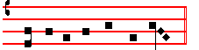
Glo- ry be to God on high,

II. On Feasts of the blessed Virgin Mary
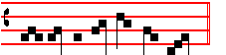
Glo- ry be to God on high

III. On Sundays, Semidoubles, and within Octaves not of the blessed Virgin Mary

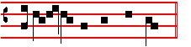
Glo-ry be to God on high

IV. On Simple Feasts
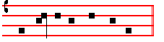
Glo- ry be to God on high

And in earth peace, good will towards men. We praise thee. We bless thee. We worship thee. We glorify thee. We give thanks to thee for thy great glory. O Lord God, heavenly King, God the Father almighty. O Lord, the only-begotten Son Jesu Christ. O Lord God, Lamb of God, Son of the Father. That takest away the sins of the world, have mercy upon us. Thou that takest away the sins of the world, receive our prayer. Thou that sittest at the right hand of God the Father, have mercy upon us. For thou only art holy. Thou only art the Lord. Thou only, O Jesu Christ, with the Holy Ghost, art most high in the glory of God the Father. Amen.

Then he kisses the Altar in the midst, and turning to the people, says:  The Lord be with you. . And with thy spirit. Then he says: Let us pray, and the Collects, one or more, as the order of the Mass requires. 77
Then follow the Epistle, Gradual and Tract, or Alleluia, with the Verse, or Sequence,as the Season or quality of the mass requires.
When these are finished, if it be a solemn Mass, the Deacon places the book of the Gospels on the Altar in the middle, and the Celebrant blesses incense as above: then the Deacon, kneeling before the Altar, says with joined hands:
CLEANSE my heart and my lips, O almighty God, who didst cleanse the lips of the prophet Isaiah with a live coal; so of thy gracious mercy vouchsafe to cleanse me, that I may worthily proclaim thy holy Gospel. Through Christ, our Lord. Amen.
Then he takes the book from the Altar, and again kneeling, asks a blessing from the Priest, saying: Bid, Sir, a blessing.
The Priest answers: The Lord be in thy heart and on thy lips, that thou mayest worthily and fitly proclaim his Gospel. In the name of the Father, and of the Son,  and of the Holy Ghost. Amen.
And having received the blessing, he kisses the hand of the Celebrant: and going with the other Ministers, the incense and the lights, to the place of the Gospel, he stands with joined hands and says:
 The Lord be with you  And with thy spirit. And announcing: The Continuation of the holy Gospel according to N., or The Beginning, he signs the book with the thumb of his right hand at the beginning of the Gospel which he is to read, then himself on the forehead, the mouth, and the breast: and while the Ministers respond, Glory be to thee, O Lord, he censes the book thrice, then reads the Gospel with joined hands. Which being finished, the Subdeacon carries the book to the Priest, who kisses the Gospel, saying: Through the words of the Gospel may our sins be blotted out.
Then the Priest is censed by the Deacon.
If, however, the Priest celebrates without Deacon and Subdeacon,when the book has been carried to the other corner of the Altar, he bows in the midst, and with joined hands says: Cleanse my heart, as above, and Bid, Lord, a blessing. The Lord be in my heart and on thy lips: that I may worthily and fitly proclaim his Gospel. Amen.
Then turning to the book, he says, with joined hands:  The Lord be with you. .And with thy spirit. And announcing: the Beginning, or the Continuation of the Holy Gospel, he signs the book, and himself on forehead, mouth, and breast, and reads the Gospel, as said before. At the end of which the Minister responds: Praise be to thee, O Christ, and the Priest kisses the Gospel, saying: Through the words, as above.

¶ In Masses of the Dead, Cleanse my heart is said, but a blessing is not asked, neither are lights carried, and the Celebrant does not kiss the book.

Then at the middle of the Altar, extending, raising and joining his hands, he says, if it is to be said, I believe in one God, and proceeds with joined hands. When he says God he bows his head to the Cross: which he does likewise when he says Jesus Christ, and together is worshipped. But at the the words. And was incarnate he genuflects until and was made man has been said. At the end of the words And the life of the world to come he signs himself with the sign of the from forehead to breast.
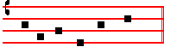
I believe in one God,

the Father almighty, maker of heaven and earth, and of all things visible and invisible.
And in one Lord Jesus Christ, the only-begotten Son of God, Begotten of his Father before all worlds. God of God, Light of Light, very God of very God, Begotten, not made, Being of one substance with the Father: by whom all things were made. Who for us men, and for our salvation, came down from heaven, (here genuflect) and was incarnate by the Holy Ghost of the Virgin Mary: and was made man. And was crucified also for us under Pontius Pilate:he suffered, and was buried. And the third day he rose again, according to the scriptures. And ascended into heaven: And sitteth on the right hand of the Father. And he shall come again with glory, to judge both the quick and the dead: Whose kingdom shall have no end.
And I believe in the Holy Ghost, the Lord, and Giver of life: Who proceedeth from the Father : Who with the Father and the Son together is worshipped and glorified: Who spake by the Prophets. And I believe one holy, catholick and apostolick Church. I acknowledge one Baptism for the remission of sins. And I look for the resurrection of the dead, and the life of the world to come. Amen.
Then he kisses the Altar, and turning to the people, says:  The Lord be with you. .And with thy spirit. Then he says: Let us pray, and the Offertory.
Which having been said, if the Mass be solemn the Deacon presents the Paten with the Host to the Celebrant: if it be private, the Priest himself takes the Paten with the Host, which he offers, saying:

RECEIVE, O holy Father, almighty, everlasting God, this spotless host, which I, thine unworthy servant, offer unto thee, my living and true God, for my numberless sins, offences and negligences, and for all who stand around, as also for all faithful christians, both living and departed: that to me and to them it may avail for salvation unto life eternal. Amen.

Then making a cross with the Paten itself, he places the Host upon the Corporal. The Deacon ministers the wine, the Subdeacon the water, in the Chalice: or if it be a private Mass, the Priest pours both, and blesses with the sign of the Cross, the water to be mixed in the Chalice, saying:

O GOD, who didst wonderfully create, and yet more wonderfully renew the dignity of man's nature: grant that by the mistery of this water and wine we may be made partakers of his divinity, who vouchsafed to share our humanity, Jesus Christ thy Son our Lord: Who liveth

78
and reigneth with thee in the unity of the Holy Ghost, God: throughout all ages, world without end. Amen.

¶ In Masses of the Dead the foregoing Prayer is said: but the water is not blessed.

Then he receives the Chalice, and offers it, saying:

WE offer unto thee, O Lord, the chalice of salvation, humbly beseeching thy mercy: that in the sight of thy divine majesty it may ascend as a sweet-smelling savour for our salvation, and that of the whole world. Amen.

Then he makes the sign of the Cross with the Chalice, and places it upon the Corporal, and covers it ewith the Pall: then with hands joined upon the Altar, he says, bowing slightly:

IN a humble spirit, and with a contrite heart may we be accepted of thee, O Lord: and so let our sacrifice be offered in thy sight this day, that it may be pleasing unto thee, O Lord God.

Standing erect, he extends his hands, raises them and joins them, and lifting his eyes to heaven and straightway lowering them, he says:

COME, O sanctifier almighty, everlasting God: and bless this sacrifice, prepared for thy holy name.

Then, if he is celebrating solemnly, he blesses incense, saying:

THROUGH the intercession of blessed Michael the Archangel, standing at the right hand of the altar of incense, and all his elect. may the Lord vouchsafe to bless this incense, and to receive it for a sweet-smelling savour. Through Christ, our Lord. Amen.

And receiving the thurible from the Deacon, he censes the oblations, in the manner prescribed in the general Rubrics, saying:

MAY this incense, which thou has blessed, ascend unto thee, O Lord: and let thy mercy descend upon us.
Then he censes the Altar, saying:
Ps. 141
LET my prayer, O Lord, be set forth in thy sight as the incense: and let the lifting up of my hands be an evening sacrifice. Set a watch, O Lord, before my mouth, and keep the door of my lips: O let my heart not be inclined to any evil thing, let me not be occupied in ungodly works.

While he returns the thurible to the Deacon, he says:
THE Lord kindle in us the fire of his love, and the flame of everlasting charity. Amen

Then the Priest is censed by the Deacon, and afterwards the others in order. Meanwhile the Priest washes his hands , saying:
Ps. 26

I WILL wash my hands in innocency, O Lord: and so will I go to thine altar: That I may shew the voice of thanksgiving, and tell of all thy wonderous works. Lord, I have loved the habitation of thy house and the place where thine honour dwelleth. O shut not up my soul with the sinners, nor my life with the blood-thirsty. In whose hands is wickedness: and their right hand is full of gifts. But as for me, I will walk innocently: O deliver me, and be merciful unto me. My foot standeth right: I will praise the Lord in the congregations.
Glory be to the Father, and to the son, and to the holy Ghost.
As it was in the beginning, is now, and ever shall be: world without end. Amen.

¶ In Masses of the Dead, and during Passion Tide in Masses of the Season, Glory be is omitted.
Then bowing slightly in the middle of the Altar, with hands joined upon it,he says:

RECEIVE, O holy Trinity, this oblation which we offer unto thee in memory of the passion, resurrection, and ascention of Jesus Christ, our Lord: and in honour of blessed Mary ever Virgin, of blessed John Baptist, of the holyApostles Peter and Paul, of these, and of all the saints: that it may avail for their honour,and for our salvation: and may they, whose memory we celebrate on earth, vouchsafe to intercede for us in heaven. Through the same Christ, our Lord. Amen.
Then he kisses the Altar, and turning to the people, he extends and joins his hands, and says, raising his voice a little:
PRAY, brethren: that my sacrifice and yours may be acceptable to God the Father almighty.
The Minister, or those standing around, respond: other-wise the Priest himself:
THE Lord receive the sacrifice at thy hands, to the praise and glory of his name, and to our benefit, and that of all his holy Church.

The Priest in a low voice says: Amen.
Then with hands extended, immediately without Let us pray, he adds the secret Prayers, which ended, when he comes to the conclusion, he says in a loud voice: Throughout all ages, world without end, with the Preface as below:
He begins the Preface with both hands placed apart on the altar. The Priest raises them a little when he says Lift up your hearts, and joins them before his breast and bows his head when he says Let us give thanks.
Then he separates his hands, and holds them separated until the end of the Preface; which being finished, he again joins them and says, bowing his head, Holy holy, holy. And when he says Blessed is he that cometh, he makes the sign of the cross on himself from forehead to breast.

___________________________________________________________________________________________________

PREFACES

THE PREFACES WITH SOLEMN CHANT

are to be used in all Masses of any double or semidouble office, and in Votive masses for a grave and at the same time public cause. They are never used in Masses of simple rite, or in Votive Masses which are not for a grave and for a same time public cause. A Commemoraion, however, or Octave, enjoying its own Preface, although according to the Rubrics, it retains its right to it as regards the text, does not retain it as regards the solemn chant, unless such chant agrees with the mass which is being celebrated.
____________________________________

THE PREFACES WITH FERIAL CHANT

are to be used in all Masses of simple rite, and in Votive masses, which are not for a grave and at the same time public cause. A Commemoraion, however, or Octave, enjoying its own Preface, although according to the Rubrics, it retains its right to it as regards the text, does not retain it as regards the solemn chant, unless such chant agrees with the mass which is being celebrated. But if the ferial chant is to be used within the Octaves of the Nativity, Easter, and Ascension, the prayers
joining in communion and This oblation (as below in the Canon), are said in all Masses, in which Commemoration of the Octave or Sunday within the Octave is not to be omitted.
___________________________________________________________________________________________________

PREFACES WITH SOLEMN CHANT

PREFACE OF THE HOLY CROSS
As noted on p. 15

79
PREFACE OF EASTER
as noted on p. 72
___________________________________________________________________________________________________

PREFACES WITH FERIAL CHANT

PREFACE OF THE HOLY CROSS
As noted on p. 18
___________________________________________________________________________________________________

COMMON PREFACE WITHOUT NOTE

Throughout all ages, world without end. Amen.  The Lord be with you.  And with thy spirit.  Lift up your hearts .  We lift them up unto the Lord.  Let us give thanks unto our Lord God  It is meet and right so to do.

IT is very meet, right, just and salutary, that we should at all times and in all places give thanks unto thee: O Lord holy Father almighty, everlasting God. Through Christ our Lord. Through whom the Angels praise, the Dominations adore, the powers fear thy majesty. The Heavens and the heavenly Virtues and the blessed Seraphim together sing thy praise with exultation. With whom, we beseech thee, bid that our voices also be admitted, with suppliant thanksgiving saying:

 Holy, Holy, Holy, Lord God of Hosts. Heaven and earth are full of thy glory. Hosanna in the highest. Blessed is he that cometh in the name of the Lord. Hosanna in the highest.
___________________________________________________________________________________________________

THE CANON OF THE MASS

___________________________________________________________________________________________________

The Preface ended, the Priest extending, slightly raising and joining his hands, raising his eyes to heaven, and at once lowering them, bowing profoundly before the Altar, with his hands placed upon it, says:

THEREFORE, most merciful Father, through Jesus Christ thy Son our Lord, we humbly pray and beseech thee, He kisses the Altar and with hands joined before his breast, says: that thou accept and bless He signs thrice over the Host and Chalice together, saying : these  gifts, these  offerings, these  holy and unspotted sacrifices, With extended hands he proceeds: which, first, we offer unto thee for thy holy catholic Church: that thou vouchsafe to keep her in peace, to guard, unite, and govern her throughout the whole world : together with thy servant our Patriarch Ignatius, our Metropolitan Paul, and all the orthodox, and those who profess the catholic and apostolic faith.

Commemoration for the living.

REMEMBER, O Lord, thy servants and handmaids N. and N., He joins his hands, and prays a while for those for whom he intends to pray : then with extended hands proceeds : and all who stand around, whose faith and devotion unto thee are known and manifest, for whom we offer unto thee: or who themselves offer unto thee this sacrifice of praise, for themselves, and for all to whom they are bound : for the redemption of their souls, for the hope of their salvation and safety : and who render their vows unto thee, the eternal, living and true God.
Infra Actionem
______________________________________________
throughout the year:
JOINING in communion and venerating the memory, first of the glorious ever Virgin Mary, Mother of our God and Lord Jesus Christ: *
______________________________________________
On Maundy Thursday is said:
JOINING in communion, and celebrating the most sacred day whereon our Lord Jesus Christ was betrayed for us: and venerating moreover tbe memory first, of the glorious ever Virgin Mary, Mother of the same our God and Lord Jesus Christ. *
______________________________________________
From Holy Saturday to the following Saturday is said:
JOINING in communion and celebrating the most sacred night of the Resurrection of our Lord Jesus Christ according to the flesh: and venerating moreover the memory, first, of the glorious ever Virgin Mary, Mother of the same our God and Lord Jesus Christ: *
______________________________________________

* as also of thy blessed Apostles and Martyrs, Peter and Paul, Andrew, James, John, Thomas, James, Philip, Bartholomew, Matthew, Simon, and Thaddeus : Linus, Cletus, Clement, Xystus, Cornelius, Cyprian, Laurence, Chrysogonus, John and Paul, Cosmas and Damian : and of all thy saints; by whose prayers grant, that in all things we may be defended with with the help of thy protection. 80
He joins his hands. Through the same Christ, our Lord. Amen.
Holding his hands spread out over the Oblations, he says:
______________________________________________
throughout the year:
THIS oblation, therefore, of our bounden service, as also of all thy family, we beseech thee, O Lord, graciously to accept : and order our days in thy peace, and bid us to be delivered from eternal damnation, and to be numbered in the flock of thine elect. He joins his hands. Through Christ, our Lord. Amen. *
______________________________________________
On Maundy Thursday
THIS oblation therefore of our bounden service, as also of all thy family, which we offer unto thee for the day whereon our Lord Jesus Christ commanded his disciples to celebrate the mysteries of his Body and Blood: we beseech thee, O Lord, graciously to accept: and order our days in thy peace, and bid us to be delivered from eternal damnation, and to be numbered in the flock of thine elect. He joins his hands. Through the same Christ, our Lord. Amen. *
______________________________________________
From Holy Saturday until Saturday in Easter Week inclusive and from the Vigil of Pentecost until the following Saturday inclusive is said::
THIS oblation therefore of our bounden service, and of all thy family, which we offer unto thee on behalf also of those whom thou hast vouchsafed to regenerate by water and the Holy Ghost, granting unto them remission of all their sins, we beseech thee, O Lord, graciously to accept: and order our days in thy peace, and bid us to be delivered from etemal damnation, and to be numbered in the flock of thine elect. He joins his hands. Through Christ, our Lord. Amen. *
______________________________________________
*
WHICH oblation do thou, O God, we beseech thee, vouchsafe in all things He signs thrice over the oblations, to make blessed, approved, ratified, reasonable, and acceptable : He signs once over the Host, that unto us it may become the Body and once over the Chalice, and Blood of thy most dearly beloved Son, He joins his hands, our Lord Jesus Christ.
___________________________________________________
Throughout the year
WHO the day before he suffered, He takes the Host, took bread into His holy and venerable hands, He lifts up his eyes to heaven, and lifting up His eyes to heaven to thee, God, his almighty Father, He bows his head, giving thanks to thee, He signs over the Host, He blessed, brake and gave to His disciples, saying : Take and eat ye all of this. *
______________________________________________
On Maundy Thursday
WHO the day before he suffered for our salvation and that of all mankind, that is, on this day, He takes the Host, took bread into his holy and venerable hands, He lifts up his eyes to heaven, and lifting up his eyes to heaven to thee, God, his almighty Father, He bows his head, giving thanks to thee, he signs over the
81
Host did bless, break, and give to his disciples: saying, Take, and eat ye all of this. *
______________________________________________

* Holding the Host with both hands between the thumbs and forefingers, he utters the words of consecration secretly, distinctly, and attentively over the Host and at the same time over all, if more are to be consecrated.
For this is my Body.
Having uttered these words, he immediately genuflects and adores the consecrated Host: rises, shews it to the people, replaces it upon the Corporal, and again genuflects and adores: and does not disjoin his forefingers and thumbs henceforth, except when the Host is to be handled, till after the ablution of his fingers. Then, having uncovered the Chalice, he says:

LIKEWISE after supper, He takes the Chalice in both hands, taking also this excellent Chalice into his holy and venerable hands: also He bows his head, giving thanks to thee, Holding the Chalice in his left hand, he signs over it with his right, he blessed, and gave to his disciples, saying: take and drink ye all of it.

He utters the words of consecration over the Chalice, attentively, continuously and secretly, holding it slightly raised.

For this is the Chalice of my Blood, of the new and eternal testament: the mystery of faith: which shall be shed for you and for many for the remission of sins.

Having uttered these words, he sets down the Chalice upon the Corporal, saying secretly:

As oft as ye do these things, ye shall do them in remembrance of me.

He genuflects and adores: rises, shews it to the people, sets it down,covers it, and genuflecting again adores. Then with hands extended he says:

WHEREFORE, O Lord, we also thy servants, together with thy holy people, mindful of the blessed passion of the same Christ thy Son our Lord, as also his resurrection from hell and glorious ascension into heaven: do offer unto thine excellent majesty of thine own gifts and bounty, He joins his hands and signs thrice over the Host and Chalice together, saying: a pure victim, a holy  victim, a spotless  victim, He signs once over the Host, saying: the holy Bread of eternal life, and once over the Chalice, saying: and the Chalice  of everlasting salvation.

With extended hands he proceeds:

UPON which vouchsafe to look with a favourable and gracious countenance: and to accept them, even as thou didst vouchsafe to accept the gifts of thy just servant Abel, and the sacrifice of our Patriarch Abraham: and the holy sacrifice, the spotless victim, which thy high priest Melchisedech offered unto thee.
Bowing profoundly, he says with hands joined and placed upon the Altar:
AND we beseech thee, O Lord, to send down thy Holy Spirit upon these offerings, that he would make this bread the precious Body of thy Christ, and that which is in this cup the precious Blood of thy son our Lord Jesus Christ, transmuting them by thy Holy Spirit. Amen. Amen. Amen.
WE humbly beseech thee, almighty God: command thou these to be brought by the hands of thy holy Angel to thine Altar on high, in the presence of thy divine majesty: that, as many of us He kisses the Altar, as by this partaking of the altar shall receive the most sacred He joins his hands, and signs once over the Host, and once over the Chalice, Body and Blood of thy Son, He signs himself, saying: may be fulfilled with all heavenly benediction and grace. He joins his hands. Through the same Christ, our Lord. Amen.

Commemoration for the Departed

REMEMBER also, O Lord, thy servants and handmaids N. and N., who have gone before us with the sign of faith, and rest in the sleep of peace.
He joins his hands, and prays awhile for those departed for whom he intends to pray, then with extended hands proceeds:
To them, O Lord, and to all that rest in Christ, we beseech thee to grant a place of refreshing, light and peace. He joins his hands and bows his head, saying: Through the same Christ, our Lord. Amen.
He strikes his breast with his right hand, saying in a slightly louder voice:
TO us sinners also, With hands extended as before, he proceeds secretly: thy servants, trusting in the multitude of thy mercies, vouchsafe to grant some part and fellowship with thy holy Apostles and Martyrs: with John, Stephen, Matthias, Barnabas, Ignatius, Alexander, Marcellinus, Peter, Felicity, Perpetua, Agatha, Lucy, Agnes, Cecilia, Anastasia, and with all thy Saints: within whose fellowship we beseech thee admit us, not weighing our merit, but granting us forgiveness. He joins his hands. Through Christ,our Lord.

BY whom. O Lord, all these good things thou dost ever create, He signs over the Host and Chalice together, saying: dost sanctify, quicken, bless, and bestow upon us.
He uncovers the Chalice, genuflects, and takes the Host between the thumb and first finger of his right hand: and holding the Chalice with his left, he signs with the Host thrice from lip to lip of the Chalice, saying:
Through  him, and with  him, and in  him, He signs with the Host itself between himself and the Chalice, saying: is unto thee, God the Father  almighty, in the unity of the Holy  Ghost, Elevating the Chalice a little with the Host, he says: all honour and glory.
He replaces the Host, covers the Chalice with the Pall, genuflects, rises and says in an audible voice, or sings:
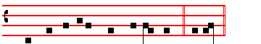 Throughout all ages, world without end.  Amen

He joins his hands:

___________________________________________________________________________________________________
Let us pray : Commanded by saving precepts, and taught by divine example, we are bold to say : Our Father, who art in
heaven, Hallowed be thy Name: Thy kingdom come. Thy will be done, in earth as it is in heaven.Give us this day our daily
bread : And forgive us our trespasses, as we forgive them that trespass against us. And lead us not into temptation.

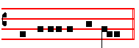
 But deliver us from e-vil. The Priest says secretly: Amen.
¶ The following chant is used on simple Feasts, on Ferial
days, in Votive Masses which are not for a grave and at the same time public cause, and in Masses of the Dead.
82
Throughout all ages, world without end.  Amen.
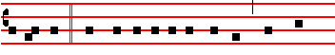
Let us pray: Commanded by saving precepts, and taught
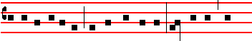
by divine example, we are bold to say: Our Father, who
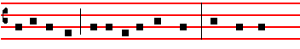
art in heaven, Hallowed be thy Name: Thy kingdom
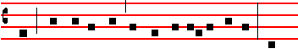
come. Thy will be done, in earth as it is in heaven. Give
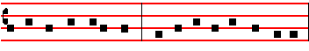
us this day our daily bread: And forgive us our trespasses,
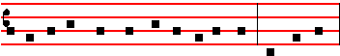
as we forgive them that trespass against us. And lead us
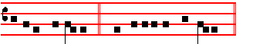
not into temptation.  But deliver us from evil.
The Priest says secretly: Amen.
Then he takes the Paten between the fore and middle fingers of his right hand, and holding it upright upon the Altar, says secretly:
DELIVER us, O Lord, we beseech thee, from all evils, past, present, and to come: and at the intercession of the blessed and glorious ever Virgin Mary, Mother of God, with thy blessed Apostles Peter and Paul, and with Andrew, and all the saints, He signs himself with the Paten from forehead to breast, favourably grant peace in our days: He kisses the Paten, that by the help of thine availing mercy we may ever both be free from sin and safe from all distress.
He puts the Paten under the Host, uncovers the Chalice, genuflects, rises, takes the Host, and holding it with both hands over the Chalice, breaks it in the middle, saying:
Through the same Jesus Christ thy Son our Lord. He places the half which he holds in his right hand on the Paten. Then from the part which remains in his left hand, he breaks a particle, saying:
Who liveth and reigneth with thee in the unity of the Holy Ghost, God. He joins the other half, which he holds in his left hand, to the half laid upon the Paten, and retaining the small particle in his right hand over the Chalice, which he holds with his left by the knob below the cup, he says in an audible voice, or sings:

Throughout all ages, world without end.  Amen.

With the particle itself he signs thrice over the Chalice, saying:
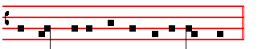
The peace  of the Lord be  alway with  you.
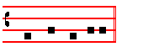
 And with thy spirit.
He puts the particle into the Chalice, saying secretly:
MAY this commixture and consecration of the Body and Blood of our Lord Jesus Christ be to us who receive it unto everlasting life. Amen.

He covers the Chalice, genuflects, rises, and bowing to the Sacrament, joins his hands, and beating his breast thrice, says in an audible voice:
O LAMB of God, that takest away the sins of the world: have mercy upon us.
O Lamb of God, that takest away the sins of the world: have mercy upon us.
O Lamb of God, that takest away the sins of the world: grant us peace.
In Masses of the Dead have mercy upon us is not said; but in its place grant them rest, and the third time is added everlasting.

Then bowing, with hands joined upon the Altar, he says secretly the following prayers:
O LORD Jesu Christ, who saidst to thine Apostles: Peace I leave with you, my peace I give unto you: regard not my sins but the faith of thy Church; and vouchsafe to grant her peace and unity according to thy will: Who livest and reignest God, throughout all ages, world without end.

If the Pax is to be given, he kisses the Altar, and giving the pax, says: Peace be with thee.  And with thy spirit.

In Masses of the Dead the pax is not given, nor is the preceding Prayer said.

O LORD Jesu Christ, Son of the living God, who by the will of the Father, and the co-operation of the Holy Ghost, hast through thy death given life unto the world; deliver me by this thy most sacred Body and Blood from all mine iniquities, and from every evil; and make me ever to cleave unto thy commandments, and suffer me never to be separated from thee: Who with the same God the Father and the Holy Ghost livest and reignest God, world without end. Amen.

LET the partaking of thy Body, O Lord Jesu Christ, which I unworthy, presume to receive, turn not to my judgment and condemnation:but of thy goodness let it avail unto me for protection of mind and of body, that I may receive thy healing: Who livest and reignest with God the Father in the unity of the Holy Ghost, God, throughout all ages, world without end. Amen.

83
I WILL receive the bread of heaven, and call upon the name of the Lord.
Then bowing slightly, he takes both parts of the Host between the thumb and forefinger of his left hand, and places the Paten between the same forefinger and the middle finger, and beating his breast three times with his right hand, devoutly and humbly, raising his voice a little:

LORD, I am not worthy, And he proceeds secretly: that thou shouldest come under my roof: but speak the word only, and my soul shall be healed.

Afterward signing himself with his right hand with the Host over the Paten, he says:
THE Body of our Lord Jesus Christ preserve my soul unto everlasting life. Amen.
And bowing himself, he reverently takes both parts of the Host: which having beeen consumed, hw pus the Paten down upon the Corporal, and raising himself, joins his hands, and is still fopr a little space in meditation on the Most Holy Sacrament.Then he uncovers the Chalice, cleanses the Paten over the Chalice, saying meanwhile:

WHAT reward shall I give unto the Lord for all the benefits that he hath done unto me? I will receive the cup of salvation, and call upon the name of the Lord. I will call upon the Lord which is worthy to be praised, so shall I be safe from mine enemies.

He takes the Chalice in his right hand and signing himself with it, says:
THE Blood of our Lord Jesus Christ preserve my soul unto everlasting life. Amen.

Holding the Paten under the Chalice with his left hand, he reverently receives the Host with the particle. Having received It, if there be any to be communicated, let him communicate them, before he purify himself.
_____________________________________________

The Priest places the consecrated particles in the ciborium, or if there are few to be communicated, upon the paten, unless at the beginning they were placed in the ciborium, and genuflects. Meanwhile the Minister makes the general Confession in the name of the people, kneeling at the Epistle side. Then the Priest genuflects again, and with hands joined before his breast, turns himself toward the people, taking care not to turn his back on the Sacrament, and at the Gospel side says the Absolution Almighty God, etc., signing the communicants with the right hand in the form of a cross at the word pardon.

Then he turns to the Altar, genuflects, holds the ciborium with his left hand, and taking the Sacrament between his thumb and forefinger, he raises It, and turning to the people in the midst of the Altar, he says in a clear voice:

Behold the Lamb of God, behold him who taketh away the sins of the world. Then he adds: Lord, I am not worthy, that thou shouldest come under my roof: but
84
speak the word only, and my soul shall be healed; which he repeats a second and a third time.

Then he proceeds to communicate them, beginning from those who are opn the Epistle side; but first, if Communion is to be given to Priests, or others of the clergy, it shall be administered to them kneeling at the steps of the Altar. Priests and Deacons moreover shall communicate wearing the stole.

Afterwards he says::
GRANT, O Lord, that what we have taken with our mouths we may receive with a pure heart; and from a temporal gift may it become to us an everlasting remedy.

Meanwhile he presents the Chalice to the minister, who pours into it a little wine, wherewith he putifies hinself: then he continues:

LET thy Body, O Lord, which I have taken, and thy Blood which I have drunk, cleave to my members: and grant; that no stain of sin may remain in me, whom thou hast refreshed with pure and holy sacraments: who livest and reignest world without end. Amen.

He washes and wipes is fingers, and takes the ablution: he wipes his mouth and ther Chalice, which, having folded the Corporal, he ovcers and places on the Altar as before: then he proceeds with the Mass.

Having said after the last Prayer:  The Lord be with you. .And with thy spirit, He says, according to the quality of the Mass, either Ite, Missa est. (Go ye, Mass is done) or: Let us bless the Lord.  Thanks be to God.
In Masses of the Dead he says:  May they rest in peace.  Amen.
I. In Easter Tide, that is from the Mass of Holy Saturday to the Saturday before Low Sunday inclusive, in Masses of the Season. 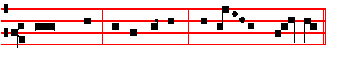
Ite missa est, al- le- lu-ia, al- le- lu- ia.
Thanks be
to God, al- le - lu-ia, al- le - lu- ia.
II. On Solemn Feasts.
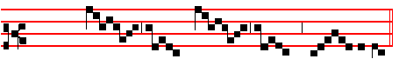
I- te mis- sa est.
Thanks be to God
VII. On Sundays in Advent, Lent, and Passion Tide.
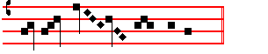
Let us bless the Lord.
Thanks be to God
VIII. On all Ferias outside Easter Tide, on the greater and lesser Litanies, on Common Vigils outside Easter Tide, and, if Gloria in excelsis has been omitted, in Votive Masses, which are not for a grave and at the same time public cause. 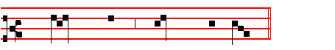
Let us bless the Lord.
Thanks be to God.

Having said Ite, Missa est, or Let us bless the Lord, the Priest bows himself before the midst of the Altar, and with hands joined thereon, says secretly:
LET this my bounden duty and service be pleasing unto thee, O holy Trinity: and grant; that the sacrifice, which I unworthy have offered before the eyes of thy majesty, may be acceptable to thee, and through thy mercy obtain thy gracious favour for me and all for whom I have offered it. Through Christ our Lord. Amen.
Then he kisses the Altar: and raising his eyes, extending, raaising, and joining his hands, and bowing his head to the Cross, he says: May almighty God bless you, and turning to the people, blessing them once only, even in solemn Masses, he proceeds: the Father, the Son,  and the Holy Ghost.  Amen.

In Pontifical Mass the blessing is threefold, as is ordered in the Pontifical.
The the Priest at the Gospel corner says with hands joined:  The Lord be with you. . And with my spirit.

And signing with the sign of the Cross first on the Altar or book then himself on forehead, mouth and breast, he says:

The beginning of the holy Gospel according to John. Or if another Gospel is to be read: The Continuation of the holy Gospel, etc..
 Glory be to thee, O Lord.
He proceeds with joined hands:
John 1, 1-14.
IN the beginning was the Word, and the Word was with God, and the Word was God. The same was in the beginning with God. All things were made by him: and without him was not any thing made that was made: in him was life, and the life was the light of men: and the light shineth in darkness, and the darkness comprehended it not. There was a man sent from God, whose name was John. The same came for a witness, to bear witness of the light, that all men through him might believe. He was not that light, but was sent to bear witness of that light. That was the true light, which lighteth every man that cometh into the world,. He was in the world and the world was made by him, and the world knew him not. He came unto his own, and his own received him not. But as many as received him, to them gave he power to become the sons of God, even to them that believe on his name: which were born, not of blood, nor of the will of the flesh, nor of the will of man, but of God. He genuflects, saying: And the Word was made flesh, And rising proceeds: and dwelt among us: and we beheld his glory, the glory as of the only-begotten of the Father, full of grace and truth.

. Thanks be to God.

In Masses of the Dead the Blessing is not given, but having said May they rest in peace and Let this my bounden duty, he kisses the Altar, and reads rthe Gospel of Saint John.

The Gospel of Saint John being ended, he says for thanksgiving as he goes from the Altar the Antiphon Let us sing, with the rest, as is set out at the beginning of the Missal.

_______________________________________________________________

85
THE SUNDAY OF THE RESURRECTION

DOUBLE OF IST. CLASS
WITH PRIVILEGED OCTAVE OF THE FIRST ORDER
Station at St. Mary Major
___________________________________________________

INTROIT. Psalm 139. Resurrexi Tone iv
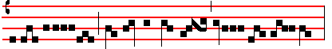
I AM ris- en, and am still with thee, al- le- lu- ia,

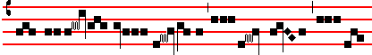
thou hast laid thine hand up- on me, al- le-
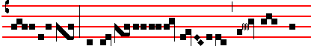
lu- ia: thy know- ledge is too won-
Ps. ibid.
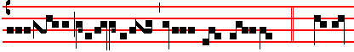
der- ful, alle- lu-ia, al- le- lu- ia. O Lord,
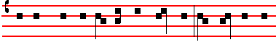
thou hast searched me out, and known me: thou knowest my
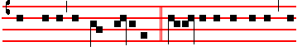 down-sitting and mine uprising.  Glory be to the Father, and 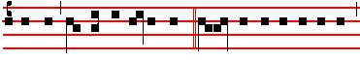
to the Son, and to the Holy Ghost. As it was in the beginning,
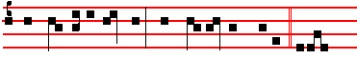
is now, and ever shall be: world without end. Amen. I am etc.

KYRIE and GLORIA as noted in the Vigil Mass, pp. 70-71.

COLLECT
O GOD, who through thine only-begotten Son hast this day overcome death, and opened unto us the gate of eternity: prosper by thine assistance our desires, which by thy preventing grace thou dost put into our minds. Through the same.

The LESSON from the Epistle of blessed Paul the Apostle to the Corinthians (I. v. 6.)
BRETHREN: Purge out the old leaven, that ye may be a new lump, as ye are unleavened. For even Christ our passover is sacrificed for us. Therefore let us keep the feast: not with old leaven, neither with the leaven of malice and wickedness: but with the unleavened bread of sincerity and truth.

86
GRADUAL. Psalm 118. Tone ij
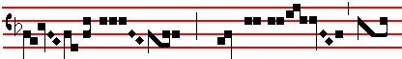 This is the day which the Lord hath
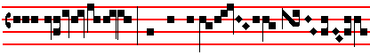
made: we will rejoice
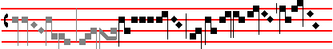
and be glad in it
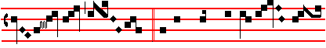 . O give thanks unto the
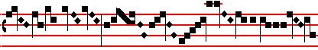
Lord. for he is gra-
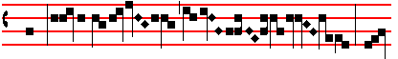
cious: and his mer- cy en-
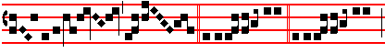
dur- eth forever . Allelu- ia. allelu- ia
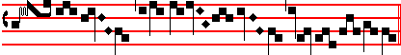
...........................................................................................
 I. Cor. 5.
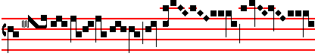
Christ our Pass-
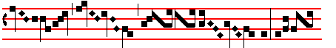
o- ver is sacri-
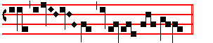
ficed for us . Alleluia is not repeated,
but the Sequence is then said:.
SEQUENCE Victimæ Paschali Mode j
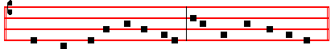
CHRISTIANS, to the paschal victim offer your thankful praises.
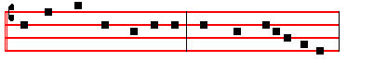
A Lamb the sheep redeemeth: Christ, who only is sinless,
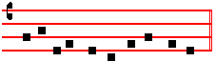
reconcileth sinners to the Father.
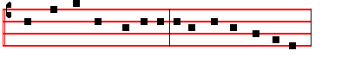
Death and life have contended in that combat stupendous:
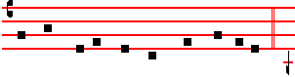
the prince of life, who died, reigns immortal.
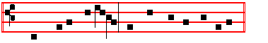
Speak, Mary, declaring what thou sawest wayfaring.
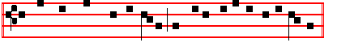 The tomb of Christ, who is living: the glory of Jesu's resur-rection. 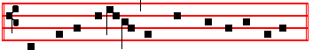
Bright Angels attesting, the shroud and napkin resting.
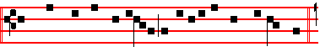
Yea, Christ my hope is aris-en: to Galilee he goes before you.*
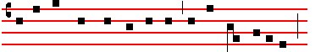
Happy they who hear the witness Mary's word believing
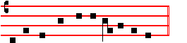
Above the tales of Jew-ry deceiving. *
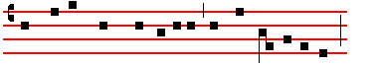
Christ indeed from eath is risen, our new life obtaining:
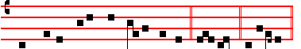
have mercy, victor King, ever reigning. A- men. Allelu-ia.
¶ The Sequence is said until Saturday before Low Sunday, inclusive.
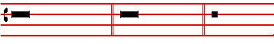
The Lord be with you.  And with thy spirit. The *
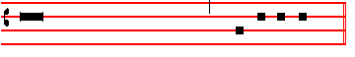 Continuation of the holy GOSPEL according to Mark.
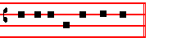
 Glory be to thee, O Lord. (xij. 1.)
* Liber Usualis., first Gospel tone ad lib. This has only the full stop (punctum) which is made by lowering the voice on the fourth syllable before the end of the sentence. The interrogation is made in the usual way, unless it occurs at the ending. The modulation of the final ending or conclusio begins on the second last accent.
87
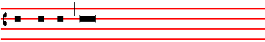
AT that time: Mary Magdalene, and Mary the mother

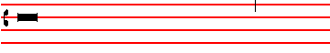
of James, and Salome, brought sweet spices, that they
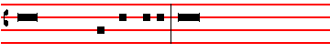 might come and anoint Jesus. And very early in the
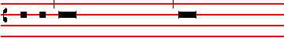 morning, the first day of the week, they came unto the 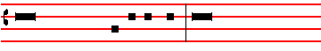
sepulchre at the rising of the sun. And they said among
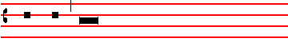
themselves: Who shall roll us away the stone from the
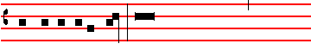
door of the sepulchre? And when they looked, they saw
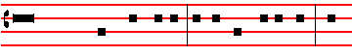
that the stone was rolled away. For it was very great. And
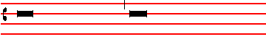
entering into the sepulchre, they saw a young man sitting
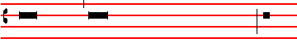
on the right side, clothed in a long white garment, and
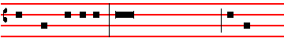
they were affrighted. And he saith unto them: Be not
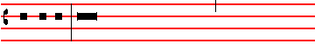
affrighted: Ye seek Jesus of Nazareth, which was
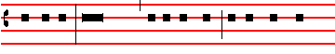
crucified: he is risen, he is not here, behold the place
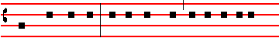
where they laid him. But go your way, tell his disciples
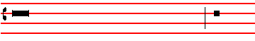
and Peter that he goeth before you into Galilee: there
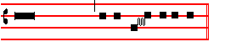
shall ye see him, as he said unto you. Creed, p. 14.

OFFERTORY. Psalm 76. Tone iv
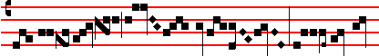
The earth trembled and was still, when God a-
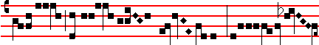
rose to judg- ment, al-
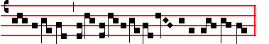
le- lu- ia.
SECRET
RECEIVE, we beseech thee, O Lord, the prayers of thy people together with the offering of these sacrifices: that those things which we have begun in these paschal mysteries may, by thine operation, be profitable for our healing in eternity. Through.

¶ Easter Preface, Thee, O Lord, but chiefly on this day, p. 72-73.
SANCTUS as noted in the Vigil mass, p. 73.
Infra Actionem Joining in communion, and This oblation proper, p. 73.
And so it is said until the Saturday before Low Sunday,
inclusive.

AGNUS DEI for Eastertide Tone j 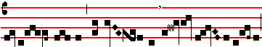
O Lamb of God, that takest away the sins of the world:
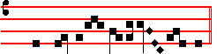
have mercy up-on us.
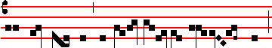
O Lamb of God, that takest away the sins of the world:
have mercy upon us.
O Lamb of God, that takest away the sins of the world:
88
grant us peace.
COMMUNION. I. Cor. 5. Tone vj
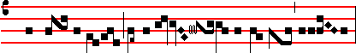 Christ our Passover is sacrificed for us, alleluia:
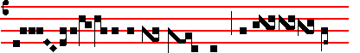
there fore let us keep the feast with the unleavened
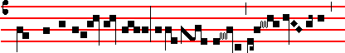
bread of sincerity and truth, alle- luia, alle- luia,

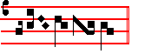
alle- lu- ia.
POSTCOMMUNION
POUR forth upon us, O Lord, the Spirit of thy charity: that as thou hast fulfilled us with these paschal sacraments, so of thy goodness thou wouldest make us to be of one heart and mind. Through. . . in the unity of the same Holy Spirit.
After The Lord be with you is said:
Ite, missa est, al- le- lu- ia, al- le - lu - ia. 
Thanks be to God, al- le- lu- ia, al- le - lu - ia.
And so it is said until Saturday inclusive.
______________________________________________

Monday in Octave of Easter

DOUBLE OF 1ST CLASS.
Station at St. Peter.

INTROIT. Exod. 13. Introduxit. Tone viij
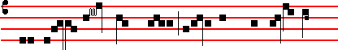 THE Lord hath brought you into a land flowing with
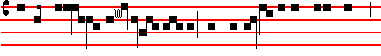
milk and honey, al- le- luia: that the law of the Lord may
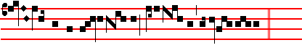
al- way be in your mouth, allelu-ia, allelu- ia. Ps. 105.
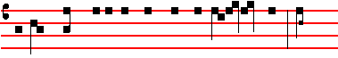
O give thanks unto the Lord, and call upon his name: tell
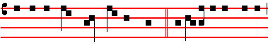
the people what things he hath done.Glory be to the Father,
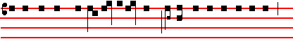
& to the Son: and to the holy Ghost. As it was in the beginning,
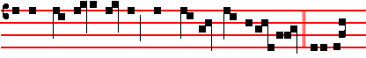
is now, and ever shall be: world without end. Amen. The Lord

COLLECT
O GOD, who by the paschal solemnity hast bestowed healing upon the world: prosper, we beseech thee, thy people with thy heavenly gift; that they may be worthy to attain unto perfect freedom, and may likewise be profited unto everlasting life. Through.

The LESSON from the Acts of the Apostles (x. 37.)
IN those days: Peter standing in the midst of the people, said: Men and brethren, ye know the word which was published throughout all Judæa: and began from Galilee, after the baptism which John preached: how God anointed Jesus of Nazareth with the Holy Ghost, and with power, who went about doing good, and healing all that were oppressed of the devil, for God was with him. And we are witnesses of all things, which he did both in the land of the Jews and in Jerusalem, whom they slew and hanged on a tree. Him God raised up the third day and shewed him openly, not to all the people, but unto witnesses chosen before of God: even to us, who did eat and drink with him, after he rose from the dead. And he commanded us to preach unto the people, and to testify, that it is he who was ordained of God to be the judge of quick and dead. To him give all the Prophets witness, that through his name whosoever believeth in him shall receive remission of sins.

GRADUAL. Ps. 118. Tone ij, as noted, p. 86
This is the day which the Lord hath made: we will rejoice and be glad in it.
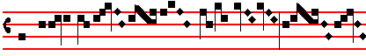
 Let Isra- el now con-fess, that he
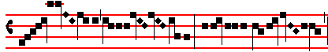
is gra- cious: and that his mer- cy
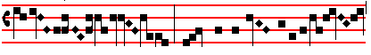
endu- reth: for e-
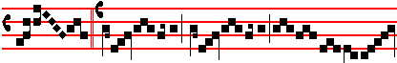
-ver. Alle- luia, alle- luia
89
Matt. 28 Tone viij
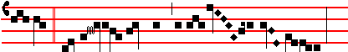
 The Angel of the Lord descend- ed from heaven:
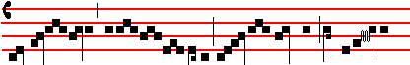
and came and rolled back the stone and sat
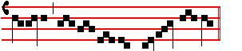
upon it .
SEQUENCE, p. 86.
CHRISTIANS, to thc paschal victim offer your thankfu1 praises.
A Lamb the sheep redeemeth: Christ, who only is sinless, reconcileth sinners to the Father.
Death and life have contended in that combat stupendous: the prince of life, who died, reigns immortal.
Speak. Mary, declaring what thou sawest wayfaring.
The tomb of Christ, who is living: the glory of Jesu's resurrection.
Bright Angels attesting, the shroud and napkin resting.
Yea, Christ my hope is arisen: to Galilee he goes before you.
Happy they who hear the witness: Mary's word believing : above the tales of Jewry deceiving.
Christ indeed from death is risen, our new life obtaining: have mercy, victor King, ever reigning. Amen. Alleluia. 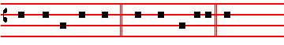
The Lord be with you.  And with thy spirit.The *
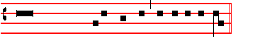 Continuation of the holy GOSPEL according to Luke.
 Glory be to thee, O Lord. (x-xiv. 13.)
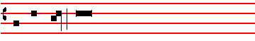
AT that time: Behold two of Jesus' disciples went that
metrum

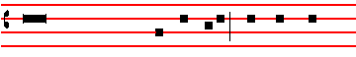
same day to a village called Emmaus, which was from
punctum
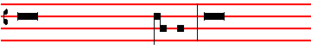
Jerusalem about threescore furlongs. And they talked
______________________________________________
* Liber Usualis, second tone ad lib.
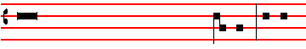
together of all these things which had happened. And it
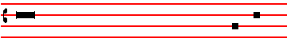
came to pass. that while they communed together, and
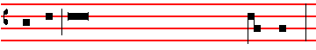
reasoned: Jesus himself drew near and went with them:
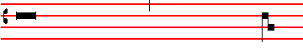
but their eyes were holden, that they should not know
interrogatio
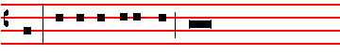
him. And he said unto them: What manner of commu-

nications are these that ye have one to another, as ye
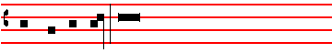
walk, and are sad? And the one of them, whose name
interrogatio
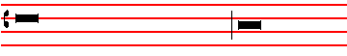
was Cleopas, answering, said unto him: Art thou only a
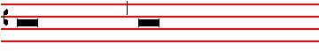
stranger in Jerusalem, and hast not known the things
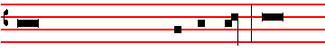
which are come to pass there in these days? And he said
interrogatio metrum
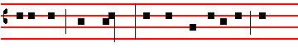
unto them: What things? And they said unto him: Con-
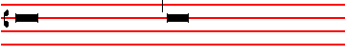
cerning Jesus of Nazareth, who was a Prophet mighty in
metrum
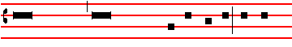
deed and word, before God and all the people: and how

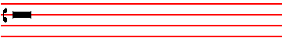
the chief priests and our rulers delivered him to be
punctum
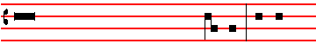
condemned to death, and have crucified him. But we
metrum
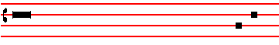
trusted that it had been he which should have redeemèd
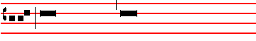
Israel: and besides all this, to-day is the third day since
punctum
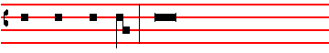
these things were done. Yea, and certain women also of
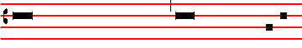
our company made us astonished, which were early at the
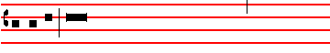sepulchre, and when they found not his body, they came,
saying, that they had also seen a vision of Angels, which
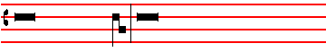
said that he was alive. And certain of them which were
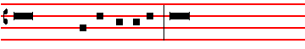
with us went to the sepulchre: and found it even so as
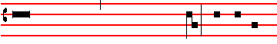
the women had said, but him they saw not. Then he said
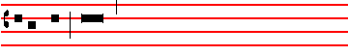
unto them: O fools, and slow of heart to believe all that
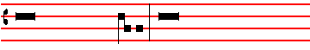
the Prophets have spoken. Ought not Christ to have

90
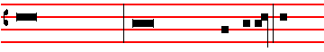
suffered these things, and to enter into his glory? And
beginning at Moses, and all the Prophets, he expounded
unto them in all the Scriptures the things concerning
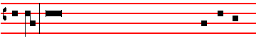
himself. And they drew nigh unto the village whither they
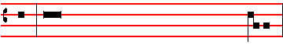
went: and he made as though he would have gone further.
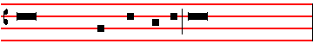
But they constrained him, saying: Abide with us, for it is
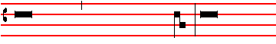 towards evening, and the day is far spent. And he went in
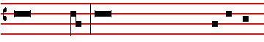
to tarry with them. And it came to pass, as he sat at meat
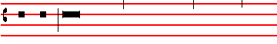
with them, he took bread, and blessed it, and brake, and
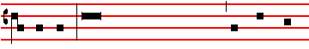
gave to them. And their eyes were opened, and they knew
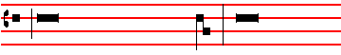
him: and he vanished out of their sight. And they said
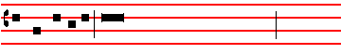
one to another: Did not our heart burn within us, while
interrogatio
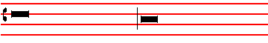
he talked with us in the way, and while he opened to us
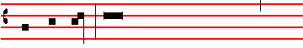
the Scriptures? And they rose up the same hour, and
metrum
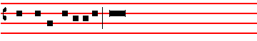
returned to Jerusalem: and found the eleven gathered
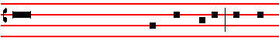
together, and them that were with them, saying: The Lord
punctum
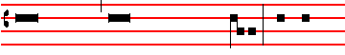
is risen indeed, and hath appeared to Simon. And they
metrum
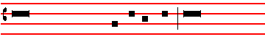
told what things were done in the way: and how he was
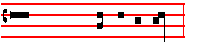
known of them in breaking of bread. Creed, p. 14.

OFFERTORY. Matt. 28. Tone viij
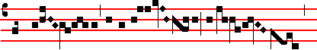
The An- gel of the Lord descen-
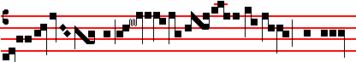
ded from heav- en, and said
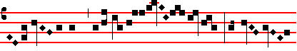
unto the wo- men: He whom
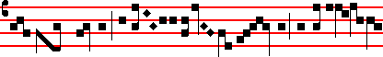
ye seek is ri- sen as he
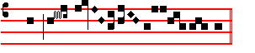
said, al- le- lu- ia.
SECRET
RECEIVE, we beseech thee, O Lord, the prayers of thy people together with the offering of these sacrifices; that those things which we have begun in these paschal mysteries may, by thine operation, be profitable for our healing in eternity. Through.
Preface and Joining in communion and This oblation, as on Easter Day, pp.72-73.
COMMUNION. Luke 24. Tone vj
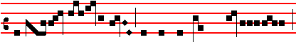 The Lord is ri- sen, and hath ap-peared to Pe- ter,

91
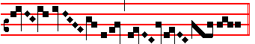
al- le- lu- ia.
POSTCOMMUNION.
POUR forth upon us, O Lord, the Spirit of thy charity: that as thou hast fulfilled us with these paschal sacraments, so of thy goodness thou wouldest make us to be of one heart and mind. Through. in the unity of the same. ______________________________________________

Tuesday in the Octave of Easter.
DOUBLE OF IST CLASS
Station at St. Paul.
INTROIT. Ecclus. 15. Aqua sapientiæ. Tone vij
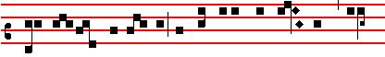
THE water of wisdom hath he given them to drink, al-

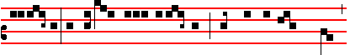 le- lu- ia: he shall be stayed upon them, and shall not be moved,
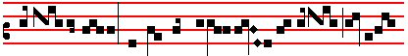
alle- lu-ia: and he shall exalt them for ever, al- le-
Psalm 105, 2
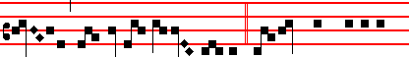
lu- ia, al- le- lu-ia.  O give thanks unto the
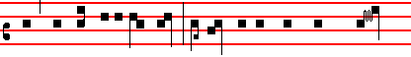
Lord, and call upon his name: tell the people what things he
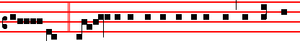
hath done.  Glory be to the Father, and to the Son, and to the
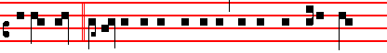
Holy Ghost. As it was in the beginning, is now, and ever shall
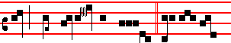
be: world without end. A-men. The wa- ter.

COLLECT.
O GOD, who dost ever . multiply thy Church with new offspring: grant unto thy servants; that they may hold fast in their lives the sacrament which by faith they have received. Through.

The LESSON from the Acts of the Apostles (xiii. 26.)
IN those days: Paul standing up, and beckoning with his hand to keep silence, said: Men and brethren. children of the stock of Abraham, and whosoever among you

92
feareth God, to you is the word of this salvation sent. For they that dwell at Jerusalem, and their rulers, because they knew not Jesus, nor yet the voices of the Prophets which are read every sabbath-day, they have fulfilled them in condemning him: and though they found no cause of death in him, yet desired they Pilate that he should be slain. And when they had fulfilled all that was written of him, they took him down from the tree, and laid him in a sepulchre. But God raised him from the dead: and he was seen many days of them which came up with him from Galilee to Jerusalem, who are his witnesses unto the people. And we declare unto you glad tidings, how that the promise which was made unto the fathers; God hath fulfilled the same unto us their children, in that he hath raised up Jesus Christ, our Lord.

GRADUAL. Ps. 118. Tone ij, as noted p. 86
This is the day which the Lord hath made: we will rejoice and be. glad in it. Psalm 107.
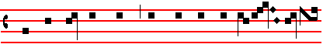
 Let them now give thanks whom the Lord hath re-deemed
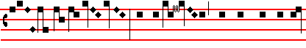
: and deli- vered from the hand of the
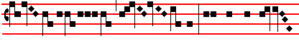 en- em- y, and gathered them
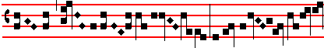
out of the lands
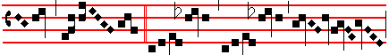 . Allelu- ia, allelu- ia
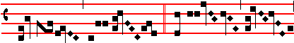
.  The Lord
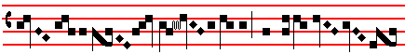
is ri- sen from the tomb
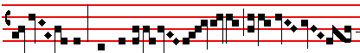
, who for us hung
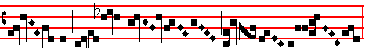
upon the tree .
SEQUENCE, p. 86.
CHRISTIANS, to thc paschal victim offer your thankfu1 praises.
A Lamb the sheep redeemeth: Christ, who only is sinless, reconcileth sinners to the Father.
Death and life have contended in that combat stupendous: the prince of life, who died, reigns immortal.
Speak. Mary, declaring what thou sawest wayfaring.
The tomb of Christ, who is living: the glory of Jesu's resurrection.
Bright Angels attesting, the shroud and napkin resting.
Yea, Christ my hope is arisen: to Galilee he goes before you.
Happy they who hear the witness: Mary's word believing: above the tales of Jewry deceiving.
Christ indeed from death is risen, our new life obtaining: have mercy, victor King, ever reigning. Amen. Alleluia.

 The Continuation of the holy GOSPEL according to Luke (xxiv. 36.)
AT that time: Jesus stood in the midst of his disciples, and saith unto them: Peace be unto you: it is I, be not afraid. But they were terrified and affrighted, and supposed that they had seen a spirit. And he said unto them: Why are ye troubled, and why do thoughts arise in your hearts? Behold my hands and my feet that it is I myself: handle me, and see: for a spirit hath not flesh and
bones, as ye see me have. And when he had thus spoken, he shewed them his hands and his feet. And while they yet believed not for joy, and wondered, he said unto them: Have ye here any meat? And they gave him a piece of a broiled fish, and of an honeycomb. And when he had eaten before them, he took that which was left, and gave it to them. And he said unto them: These are the words which I spake unto you, while I was yet with you, that all things must be fulfilled which were written in the law of Moses, and in the Prophets and in the Psalms concerning me Then opened he their understanding, that they might understand the Scriptures. And said unto them: Thus it is written, and thus it behoved Christ to suffer, and to rise from the dead the third day: and that repentance and remission of sins should be preached in his name among all nations. Creed, p. 14

OFFERTORY. Psalm 18. Tone iv
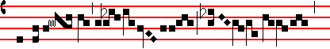
The Lord thun- dered out of
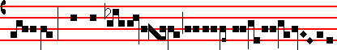
hea-ven: and the High- est gave his
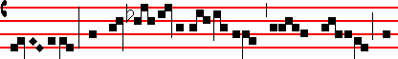
thun- der: and the springs of wa- ters were seen, al-
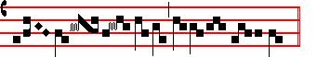
le- lu- ia.
SECRET.
RECEIVE, O Lord, the prayers of thy faithful people, together with the offering of these sacrifices: that through these observances of our bounden devotion we may attain unto heavenly glory. Through.

Preface, Joining in communion and This oblation, as on Easter Day.
93
COMMUNION Col. 3. Tone vij
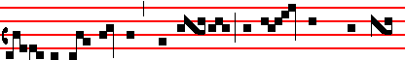
If ye be risen with Christ, seek those things which are
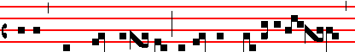
above, where Christ sit- teth on the right hand of God,
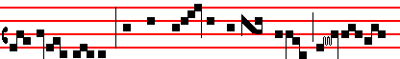
al- le- lu- ia: set your affection on things above, al- le-
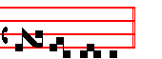
lu- ia.
POSTCOMMUNION
GRANT, we beseech thee, almighty God: that the paschal sacrament, which we have received, may continually abide in our hearts, Through.

______________________________________________

Wednesday in Octave of Easter
SEMIDOUBLE
Station at St. Lawrence without the walls.

INTROIT. Matt. 25. Venite Tone vij
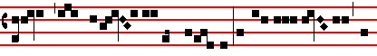
COME, ye blessed of my Fa- ther, inherit the kingdom, al-

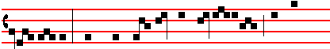
le- lu- ia: which hath been prepared for you from the
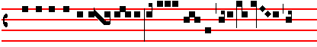
foundation of the world, al-le- lu- ia, alle-lu- ia, al-
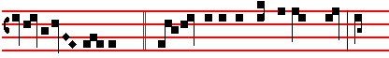
le- lu- ia. Ps. 96. O sing unto the Lord a new song: sing
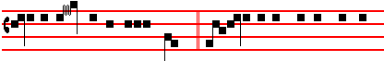
unto the Lord, all the whole earth.  Glo- ry be to the Father, and to
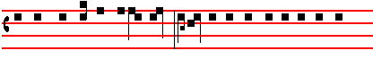
the Son, and to the Holy Ghost: as it was in the beginning, is now,
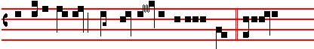
and ever shall be: world with-out end. A- men. Come
COLLECT
O GOD, who dost gladden us with the yearly solemnity of the Resurrection of the Lord: mercifully grant ; that through this temporal feast which we observe, we may be found worthy to attain unto everlasting joys. Through the same.

2nd. against the persecutors of the Church.
COLLECT
WE beseech thee, O Lord, mercifully to hear the prayers of thy Church: that all adversities and errors being done away, she may serve thee in freedom and quietness. Through.

Or 2nd. for the Bishop.
COLLECT.
O GOD, the pastor and rulcr of all the faithful, mercifully look upon thy servant N., whom thou hast been pleased to set as pastor over thy Church: grant him, we beseech thee, to be in word and conversation a wholesome example to the people committed to his charge; that he with them may attain unto everlasting life. Through.

The LESSON from the Acts of the Apostles (iij. 12.)
IN those days: Peter opened his mouth and said: Ye men of Israel, and ye that fear God, hearken. The God of Abraham. and of Isaac, and of Jacob, the God of our fathers, hath glorified his Son Jesus, whom ye delivered up, and denied him in the presence of Pilate, when he was determined to let him go. But ye denied the holy one and the just, and desired a murderer to be granted unto you: and killed the prince of life, whom God hath raised from the dead, whereof we are witnesses. And now, brethren, I wot that through ignorance ye did it, as did also your rulers. But those things, which God bcfore had shewed by the mouth of all his Prophets, that Christ should suffer, he hath so fulfilled. Repent ye therefore, and be converted, that your sins may be blotted out.

GRADUAL. Psalm 118. Tone ij, as noted, p. 86
This is the day which the Lord hath made: we will rejoice and be glad in it.
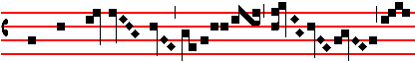
 The right hand of the Lord
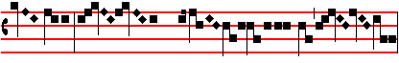
bring- eth migh- ty things to pass,
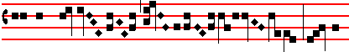
the right hand of the Lord hath ex-
Tone viij
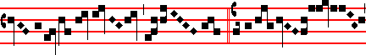
al- ted me . Alle- lu- ia,
Luke 24
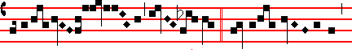 alle- lu- ia.  The Lord is
94
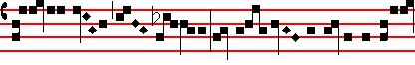 ri- sen in- deed : and hath appearèd to Pe-
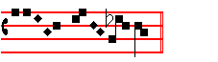
ter.
SEQUENCE, as noted above, p. 86.
CHRISTIANS, to thc paschal victim offer your thankfu1 praises.
A Lamb the sheep redeemeth: Christ, who only is sinless, reconcileth sinners to the Father.
Death and life have contended in that combat stupendous: the prince of life, who died, reigns immortal.
Speak, Mary, declaring what thou sawest wayfaring.
The tomb of Christ, who is living: the glory of Jesu's resurrection.
Bright Angels attesting, the shroud and napkin resting.
Yea, Christ my hope is arisen: to Galilee he goes before you.
Happy they who hear the witness: Mary's word believing: above the tales of Jewry deceiving.
Christ indeed from death is risen, our new life obtaining: have mercy, victor King, ever reigning. Amen. Alleluia.

The Continuation of the holy GOSPEL according to John
(xij. I.)
AT that time: Jesus shewed himself again to the disciples at the sea of Tiberias. And on this wise shewed he himself. There were together Simon Peter, and Thomas called Didymus, and Nathanael of Cana in Galilee, and the sons of Zebedee, and two other of his disciples. Simon Peter saith unto them: I go a fishing. They say unto him: We also go with thee. They went forth, and entered into a ship immediately: and that night they caught nothing. But when the morning was now come, Jesus stood on the shore: but the disciples knew not that it was Jesus. Then Jesus saith unto them: Children, have ye any meat? They answered him: No. And he said unto them: Cast the net on the right side of the ship, and ye shall find. They cast therefore: and now they were not able to draw it for the multitude of fishes. Therefore that disciple whom Jesus loved saith unto Peter; It is the Lord. Now when Simon Peter heard that it was the Lord, he girt his fisher's coat unto him, (for he was naked,) and did cast himself into the sea. And the other disciples came in a little ship, (for they were not far from land, but as it werc two hundred cubits,) dragging the net with fishes. As soon then as they were come to land, they saw a fire of coals there, and fish laid thereon, and bread. Jesus saith unto them; Bring of the fish which ye have now caught. Simon Peter went up, and drew the net to land full of great fishes, an hundred and fifty and three. And for all thcre were so many, yet was not the net broken. Jesus saith unto them; Corne and dine. And none of the disciples durst ask him: Who art thou? knowing that it was the Lord. Jesus then cometh, and taketh bread, and giveth them, and fish likewise. This is now the third time that Jesus shewed himself to his disciples, after that he was risen from thc dead.
Creed, p. 14.
OFFERTORY. Psalm 78. Tone viij 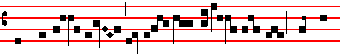
The Lord o- pened the doors of' hea- ven : and rai-
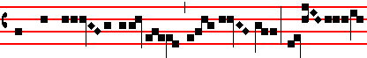
ned down man-na upon them for to eat: he gave
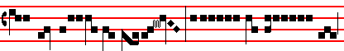
them food from hea-ven: so man did eat
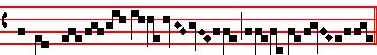
Angels' food, alle- lu- ia.
SECRET
WE offer unto thee, O Lord, the sacrifices of our paschal gladness: whereby thou dost wondrously both feed and sustain thy Church. Through.

2nd. against the persecutors of the Church.
SECRET.
DEFEND us, O Lord, who wait upon thy mysteries: that we, cleaving fast to things heavenly, may serve thee both in body and soul. Through.

Or, 2nd. for the Bishop.
SECRET
LOOK favourably, we beseech thee, O Lord, upon the gifts which we offer: and guide with thy continual protection thy servant N., whom thou hast been pleased to set as pastor over thy Church. Through.
Preface, Joining in communion and This oblation, as on Easter Day.
COMMUNION. Rom. 6. Tone viij
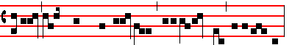 Christ being raised from the dead, dieth no more, alle-lu- ia:
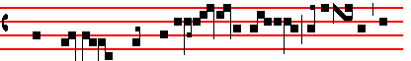
death hath no more domin- ion over him, allelu- ia, al-
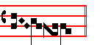
le- lu- ia.
POSTCOMMUNION
WE beseech thee, O Lord, that we, being cleansed from all our former nature: may by the devout receiving of thy sacrament be transformed into a new creature: Who livest.

2nd. against the persecutors of the Church.
POSTCOMMUNION.
WE beseech thee, O Lord our God: that we whom thou makest to rejoice in the partaking of heavenly things may by thee be defended against all earthly perils. Through.
95
Or, 2nd. for the Bishop.
POSTCOMMUNION
WE beseech thee, O Lord, that the divine sacrament which we have here received may be our protection: and together with the flock entrusted to his charge ever save and defend thy servant N. ; whom thou hast been pleased to set as pastor over thy Church. Through.
______________________________________________

Thursday in Octave of Easter
SEMlDOUBLE
Station at the twelve holy Apostles.

INTROIT. Wisd.10 Victricem. Tone viij
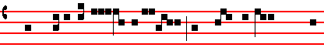
THY victorious hand, O Lord, have they magnified, with

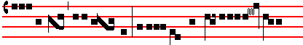
one accord, alle-lu- ia: for wisdom hath o- pened the
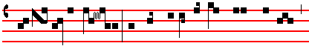
mouth of the dumb, and made eloquent the tongues of them
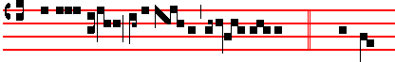
that cannot speak, alle-lu- ia, alle- lu- ia. Ps. 98. O sing
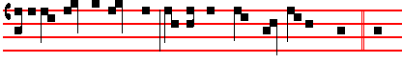
unto the Lord a new song: for he hath done marvellous things. Glo-
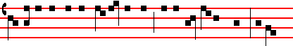
ry be to the Father, and to the Son, and to the Holy Ghost. As it
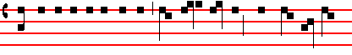
was in the beginning, is now, and ever shall be: world without end.
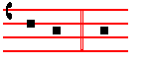
A- men. Thy.
COLLECT
O GOD, who hast united the diversity of nations in the confession of thy name: grant that they who are born again in the font of baptism may agree in unity of faith and in godliness of conversation. Through.

2nd Collect against the persecutors of the Church or for the Bishop, as above, p. 94.
The LESSON from the Acts of the Apostles (viij. 26.)
IN those days: The Angel of the Lord spake unto Philip, saying: Arise, and go toward the south unto the way that goeth down from Jerusa1em unto Gaza: which is desert. And he arose, and went. And, behold, a man of Ethiopia, an eunuch of great authority under Candace queen of the Ethiopians, who had the charge of all her treasure, and had come to Jerusalem for to worship: was returning, and sitting in his chariot read Esaias the prophet. The the Spirit said unto Philip: Go near, and join thyself to this chariot. And Philip ran thither to him, and heard him read the prophet Esaias, and said: Understandest thou what thou readest? And he said: How can I, except some man should guide me? And he desired Philip that be would come up and sit with him. The place of the Scripture which he read was this: He was led as a sheep to the slaughter: and like a lamb dumb before his shearer, so opened he not his mouth. In his humiliation his judgment was taken away. And who shall declare his generation, for his life is taken from the earth? And the eunuch answered Philip, and said: I pray thee, of whom speaketh the Prophet this? of himself, or of some other man? Then Philip opened his mouth, and began at the same Scripture, and preached unto him Jesus. And as they went on their way, they came unto a certain water: and the eunuch said: See, here is water, what doth hinder me to be baptized? And Philip said: If thou believest with all thine heart, thou mayest. And he answered and said: I believe that Jesus Christ is the Son of God. And he commanded thc chariot to stand still: and they went down both into the water, both Philip and the eunuch, and he baptized him. And when they were come up out of the water, the Spirit of the Lord caught away Philip, that the eunuch saw him no more. And he went on his way rejoicing. But Philip was found at Azotus, and passing through he preached in all the cities, till he came to Cæsarea, the name of the Lord Jesus Christ.
GRADUAL Ps.118. Tone ij, as noted above, p. 86
This is the day which the Lord hath made: we will rejoice and be glad in it.
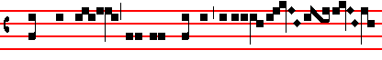
 The same stone, which the builders refused
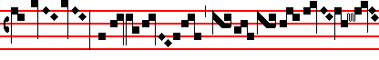
, is become
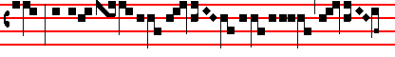
the head- stone in the cor-
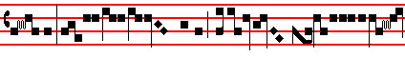
ner: this is the Lord's doing, and it is marvel- lous
Tone ij
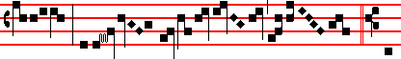
in our eyes . Al-
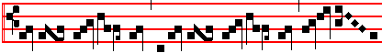
le- lu- ia, al-le- lu- ia
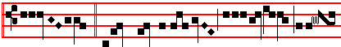
 Christ, who crea- ted all things, is ri- 96
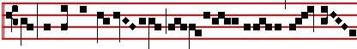
sen: and he hath had com- pas- sion on man-
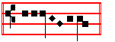
kind.
SEQUENCE, p. 86.
CHRISTIANS, to thc paschal victim offer your thankfu1 praises.
A Lamb the sheep redeemeth: Christ, who only is sinless, reconcileth sinners to the Father.
Death and life have contended in that combat stupendous: the prince of life, who died, reigns immortal.
Speak. Mary, declaring what thou sawest wayfaring.
The tomb of Christ, who is living: the glory of Jesu's resurrection.
Bright Angels attesting, the shroud and napkin resting.
Yea, Christ my hope is arisen: to Galilee he goes before you.
Happy they who hear the witness: Mary's word believing: above the tales of Jewry deceiving.
Christ indeed from death is risen, our new life obtaining: have mercy, victor King, ever reigning. Amen. Alleluia.

The Continuation of the holy GOSPEL according to John
(xx. II.)
AT that time: Mary stood without at the sepulchre weeping. And as she wept, she stooped down, and looked into thc sepulchre: and seeth two Angels in white sitting, the one at the head, and the other at the feet, where the body of Jesus had lain. And they say unto her: Woman, why weepest thou? She saith unto them: Because they have taken away my Lord: and I know not where they have laid him. And when she had thus said, she turned herself back, and saw Jesus standing: and knew not that it was Jesus. Jesus saith unto her: Woman, why weepest thou? whom seekest thou? She, supposing him to be the gardener, saith unto him: Sir, if thou have borne him hence, tell me where thou hast laid him: and I will take him away. Jesus saith unto her: Mary. She turned herself, and saith unto him: Rabboni, which is to say, Master. Jesus saith unto her: Touch me not, for I am not yet ascended to my Father: but go to my brethren, and say unto them : I ascend unto my Father, and your Father, and to my God, and your God. Mary Magdalene came and told the disciples that she had seen the Lord, and that he had spoken these things unto her. Creed.
OFFERTORY. Exod. 13. Tone j
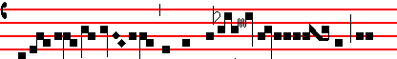
In the day of your solem-ni- ty, saith
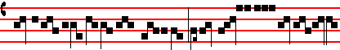
the Lord , I will bring
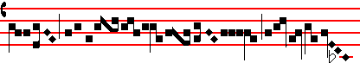 you into a land flow-
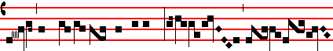
ing with milk and honey, alle-
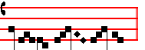
luia.
SECRET
WE beseech thee, O Lord, mercifully to accept the oblations of thy people: that being made regenerate by the confession of thy name, and by baptism, they may attain to everlasting blessedness. Through.

2nd Secret against the persecutors of the Church, or for the Bishop, as above, p. 95.
Preface, Joining in communion and T'his oblation, as on Easter Day.
COMMUNION. I. Pet. 2. Tone vij
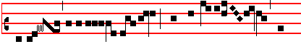
Ye are a peculiar people, shew ye forth the
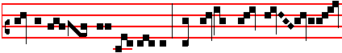
praises of him, alle- lu- ia: who hath called you out
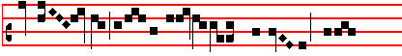
of dark- ness into his mar- vellous light, alle-
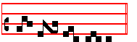
lu- ia.
POSTCOMMUNION
GRACIOUSLY hear our prayers, O Lord: that this holy communion of our redemption may both bestow on us thy succour in this present lifc, and obtain for us everlasting joys. Through.
2nd Postcommunion against the persecutors of the Church or for the Bishop, as above, p. 95.
______________________________________________

Friday in Octave of Easter
SEMIDOUBLE
Station at St. Mary of the Martyrs.
INTROIT. Ps 78. Eduxit eos. Tone iv
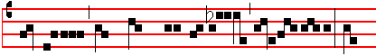
THE Lord hath brought them out safely, alle- luia: and

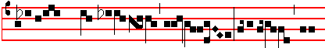
overwhelmed their enemies with the sea, allelu- ia, alle-
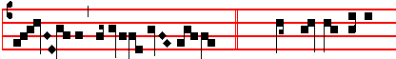
lu- ia, alle- lu- ia. Ps. Hear my law, O my

97
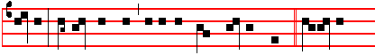
people: incline your ears unto the words of my mouth. Glory be
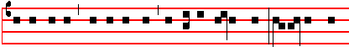 to the Father, and to the Son: and.to the Holy Ghost: as it was in
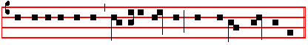
the beginning, is now, and ever shall be: world without end. Amen.
The Lord.
COLLECT
ALMIGHTY and everlasting God, who hast bestowed
the paschal sacrament for a pledge of man's reconciliation: grant unto our hearts; that what we celebrate in outward profession we may effectually fulfil. Through.
2nd Collect against the persecutors of the Cburch or for the Bishop, as above, p. 94.

The LESSON from the Epistle of blessed Peter the Apostle (1. iij. 18.)
DEARL Y beloved: Christ hath once suffered for sins, the just for the unjust, that he might bring us to God, being put to death in the flesh, but quickened by the Spirit. By which also he went and preached unto the spirits in prison: which sometime were disobedient, when once the longsuffering of God waited in the days of Noah, while the ark was a preparing, wherein few, that is, eight souls ,were saved by water. The like figure whereunto even baptism doth also now save us: (not the putting away of the filth of the flesh, but the answer of a good conscience toward God), by the resurrection of Jesus Christ, who is gone into heaven, and is on the right hand of God.
GRADUAL. Ps. 118. Tone ij, as noted above, p. 86
This is the day which the Lord hath made: we will rejoice and be glad in it.
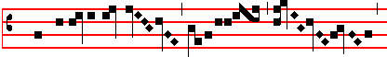
 Blessed is he that co- 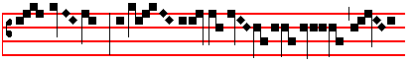 meth in the name of the Lord
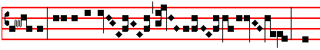
: God is the Lord who
Tone viij
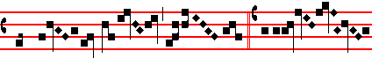
hath shewed us light. Allelu- ia,
Psalm 96.
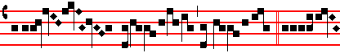
allelu- ia .  Tell it out
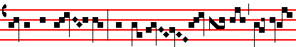
among the hea- then: that the Lord hath reig-
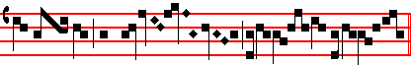
ned from the tree
.
SEQUENCE, p. 86.
CHRISTIANS, to the paschal victim offer your thankfu1 praises.
A Lamb the sheep redeemeth: Christ, who only is sinless, reconcileth sinners to the Father.
Death and life have contended in that combat stupendous: the prince of life, who died, reigns immortal.
Speak, Mary, declaring what thou sawest wayfaring.
The tomb of Christ, who is living: the glory of Jesu's resurrection.
Bright Angels attesting, the shroud and napkin resting.
Yea, Christ my hope is arisen: to Galilee he goes before you.
Happy they who hear the witness: Mary's word believing: above the tales of Jewry deceiving.
Christ indeed from death is risen, our new life obtaining: have mercy, victor King, ever reigning. Amen. Alleluia.

The Continuation of the holy GOSPEL according to Matthew (xxviij. 16.)
AT that time: The eleven disciples went away into Galilee, into a mountain where Jesus had appointed them. And when they saw him, they worshipped him: but some doubted. And Jesus came and spake unto them, saying: All power is given unto me in heaven and in earth. Go ye therefore, and teach all nations, baptizing them in the name of the Father, and of the Son, and of the Holy Ghost: teaching them to observe all things whatsoever I have commanded you. And, lo, I am with you alway, even unto the end of the world. Creed, p. 14.

OFFERTORY. Exod.12. Tone vj
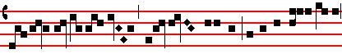
This day shall be unto you for a memo- rial,
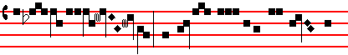
alle- lu- ia: and ye shall keep it a feast to the
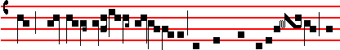
Lord throughout your generations: ye shall keep it a feast by
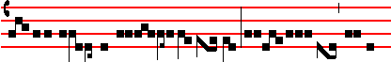
an ordinance for e- ver, al-le- lu- ia, al-le-
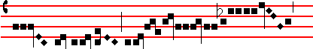
lu- ia, alle-
98
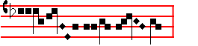
lu- ia.
SECRET
WE beseech thee, O Lord, mercifully to accept our oblations: which we offer unto thee for the expiation of the sins of them that are born again. and for the speedy attaining of thy heavenly succour. Through.

2nd Secret against the persecutors of the Church or for the Bishop, as above, p. 95.
Preface, Joining in communion and This oblation as on Easter Day.
COMMUNION. Matt. 28. Tone j
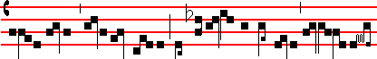
All power is given to me in heaven and in earth, al-le- lu-
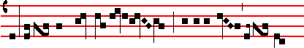
ia: go ye, and teach all na- tions, baptizing them in the name
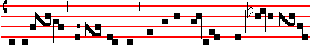 of the Father, and of the Son, and of the Holy Ghost, alle- lu- ia,
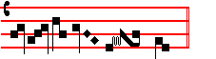
al- le- lu- ia.

POSTCOMMUNION
WE beseech thee, O Lord, look upon thy people:
and as thou hast vouchsafed to renew them with thine eternal mysteries, so of thy goodness deliver them from temporal guilt. Through.

2nd Postcommunion against the persecutors of the Church or for the Bishop, as above, p. 95.
______________________________________________

Saturday in Octave of Easter
SEMIDOUDLE
Station at St. John Lateran.

INTROIT. Ps. 105. Eduxit Dominus. Tone vij
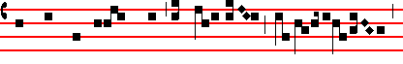
THE Lord hath brought forth his peo- ple with joy ,
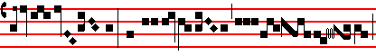
alle- lu- ia: and his cho- sen with glad- ness,
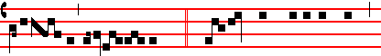
allelu- ia, alle luia. Ps. ibid. O give thanks unto the Lord,
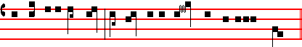
and call upon his name: tell the people what things he hath done.
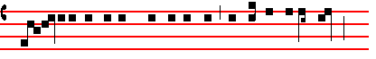
 Glory be to the Father, and to the Son: and to the Holy Ghost:
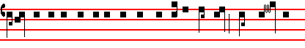
as it was in the beginning, is now, and ever shall be: world with-out
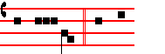
end. A- men. The Lord.
COLLECT
GRANT, we beseech thee, almighty God: that we who have devoutly kept this paschal festival may thereby be found worthy to attain to everlasting joys. Through.
2nd Collect against the persecutors of the Church or for the Bishop, as above, p. 86.

The LESSON from the Epistle of blessed Peter the Apostle: (1. ii. I.)
DEARLY beloved: Laying aside therefore all malice,
and all guile, and hypocrisies, and envies, and all evil speakings, as newborn babes, desire the sincere milk of the word: that ye may grow thereby: if so be ye have tasted that the Lord is gracious. To whom coming, as unto a living stone, disallowed indeed of men, but chosen of God, and precious : ye also, as lively stones, are built up a spiritual house, an holy priesthood, to offer up spiritual sacrifices, acceptable to God by Jesus Christ. Wherefore also it is contained in the Scripture: Behold, I lay in Sion a chief corner stone, elect, precious: and he that believeth on him shall not be confounded. Unto you therefore whlich believe he is precious: but unto them which be disobedient, the stone which the builders disallowed, the same is made the head of the corner, and a stone of stumbling, and a rock of offence, even to them which stumble at the word, being disobedient, whereunto also they were appointcd. But ye are a chosen generation, a royal priesthood, an holy nation, a peculiar people: that ye should shew forth the praises of him who hath called you out of darkness into his marvellous light. Which in time past were not a people, but are now the people of God: which had not obtained mercy, but now have obtained mercy.

¶ From this day until Ember Saturday in Whitsun Week inclusive, in all Masses, the Gradual is not said, but four Alleluias with two Verses are said in the order given below; but in the Mass of tbe Rogations, on the Vigil of Pentecost, and after each Lesson on Ember Saturday, one Alleluia is said with one Verse.
Tone viij
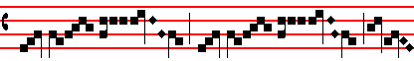
ALLE- LU- IA, al- le lu- ia
Psalm 118.
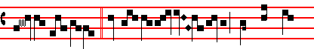
 This is the day which the Lord
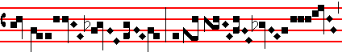 hath made : we will re- joice
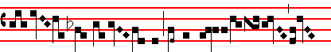 and be glad in it
. Tone iv
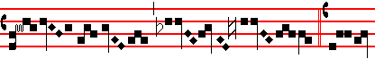
. Al- le-
Psalm 113
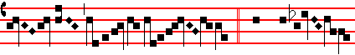
lu- ia.  Praise the Lord
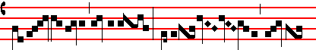
, ye servants, O praise the name
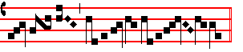
of the Lord .
SEQUENCE, p. 86.
CHRISTIANS, to the paschal victim offer your thankfu1 praises.
A Lamb the sheep redeemeth: Christ, who only is sinless, reconcileth sinners to the Father.
Death and life have contended in that combat stupendous: the prince of life, who died, reigns immortal.
Speak. Mary, declaring what thou sawest wayfaring.
The tomb of Christ, who is living: the glory of Jesu's resurrection.
Bright Angels attesting, the shroud and napkin resting.
Yea, Christ my hope is arisen: to Galilee he goes before you.
Happy they who hear the witness: Mary's word believing: above the tales of Jewry deceiving.
Christ indeed from death is risen, our new life obtaining: have mercy, victor King, ever reigning. Amen. Alleluia.

The Continuation of the holy GOSPEL according to John. (xx. I)
AT that time: On the first day of the week cometh Mary Magdalene early, when it was yet dark, unto the sepulchre, and seeth the stone taken away from the sepulchre. Then she runneth, and cometh to Simon Peter, and to the other disciple, whom Jesus loved, and saith unto them: Thcy have taken away the Lord out of the sepulchre, and we know not where they have laid him. Peter therefore went forth, and that other disciple, and came to thc sepulchre. So they ran both together, and the other disciple did outrun Peter, and came first to the sepulchre. And he stooping down, and looking in, saw the linen clothes lying, yet went he not in. Then cometh Simon Peter following him, and went into the sepulchre, and seeth the linen clothes lie, and the napkin, that was about his head, not lying with the linen clothes, but

99
wrapped together in a place by itself. Then went in also that other disciple, which came first to the sepulchre: and he saw, and believed: for as yet they knew not the Scripture, that he must rise again from the dead.
Creed.

OFFERTORY. Ps. 118. Tone viij 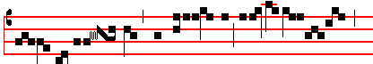
Bles- sed is he that co- meth in the name
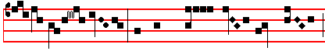
of the Lord : we have wished you good luck,
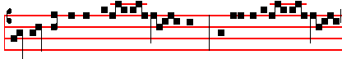
ye that are of the house of the Lord: God
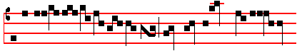
is the Lord who hath shewed us light
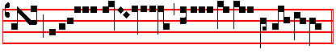
, allelu- ia , alle- lu- ia
.
SECRET
GRANT us, we beseech thee, O Lord, alway to rejoice in these paschal mysteries: that the continual working of our redemption may be to us the cause of everlasting gladness. Through.

2nd Secret against the persecutors of the Church, or for the Bishop, as above, p. 95.

Preface, Joining in communion and This oblation as on Easter Day.

COMMUNION. Gal. 3. Tone ij
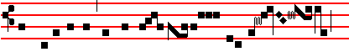
As many of you as have been bap- tized into Christ ,
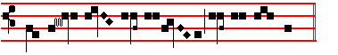
have put on Christ , al- le- lu- ia.

POSTCOMMUNION
O LORD, who hast quickened us with the gift of our redemption, we beseech thee: that this aid to everlasting salvation may avail for our advancement in the true faith. Through.

2nd Postcommunion against the persecutors of the Church, or for the Bishop, as above, p. 95.

100
Dominica in Albis

The Octave of Easter
GREATER DOUBLE
Station at St. Pancras

INTROIT. I. Pet. 2. Quasimodo Tone vj
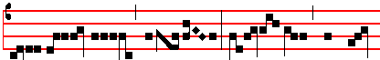
AS new-born babes, alle- lu- ia: desire ye the guile-

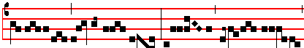
less milk of the spi- rit, alle- lu- ia, alle- lu- ia,
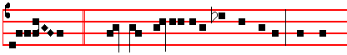
alle- lu- ia. Ps. 81. Sing we merrily unto God our helper: make a
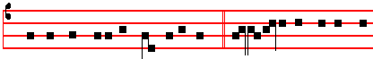
cheerful noise unto the God of Jacob.  Glory be to the Father, and
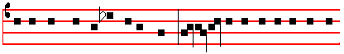
to the Son: and to the Holy Ghost: as it was in the beginning, is now,
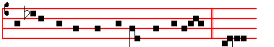
and ever shall be: world without end. A- men. As.

¶ Gloria in excelsis is said on this and the following Sundays after Easter, even when on week-days the Mass of the preceding Sunday is resumed.

COLLECT
GRANT, we beseech thee, almighty God: that we who have celebrated the paschal feasts may, through thy bounty, ever keep them in our life and conversation. Through.

The LESSON from the Epistle of blessed John the Apostle (I. v. 4.)
DEARLY beloved: Whatsoever is born of God overcometh the world: and this is the victory that overcometh the world, even our faith. Who is he that over cometh the world, but he that believeth that Jesus is the Son of God? This is he that came by water and blood, even Jesus Christ: not by water only, but by water and blood. And it is the Spirit that beareth witness, because the Spirit is truth. For there are three that bear record in heaven: the Father, the Word, and the Holy Ghost: and these three are one. And there are three that bear witness in earth: the Spirit, and the water, and the blood: and these three agree in one. If we receive the witness of men, the witness of God is greater: for this is the witness of God which he hath testified of his Son. He that believeth on the Son of God hath the witness in himself.

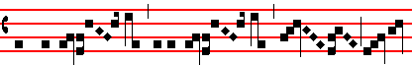
ALLELU- IA, alle lu- ia
Matt. 28.
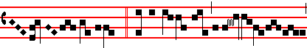
.  In the day of my resur-rec-tion,
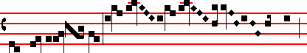
saith the Lord, I will go be- fore you
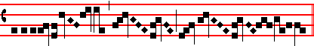
into Ga- li- lee .
Tone vij
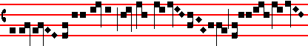
Alle- lu- ia
John 20
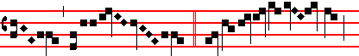
.  After eight days,
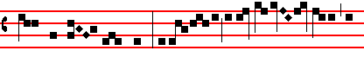
when the doors were shut, Jesus stood in the midst of
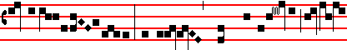 his discip- les, and said: Peace be unto you
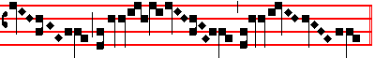

.
Alleluia. as above.

The Continuation of the holy GOSPEL according to John
(xx. 19.)
AT that time: The same day at evening, being the first day of the week, when the doors were shut, where the disciples were assembled for fear of the Jews: came Jesus and stood in the midst, and saith unto them: Peace be unto you. And when he had so said, he shewed unto them his hands and his side. Then were the disciples glad when they saw the Lord. Then said Jesus to them again: Peace be unto you, As my Father hath sent me, even so send I you. And when he had said this, he breathed on dIem: and saith unto them: Receive ye the Holy Ghost: whosesoever sins ye remit, they are remitted unto them: and whosesoever sins ye retain, they are retained. Now, Thomas, one of the twelve, called Didymus, was not with them when Jesus came. The other disciples therefore said unto him: We have seen the Lord. But he said unto them: Except I shall see in his hands the print of the nails and put my finger into the print of the nails, and thrust my
101
hand into his side, I will not believe. And after eight days again his disciples were within, and Thomas with them. Then came Jesus, the doors being shut, and stood in the midst, and said: Peace be unto you. Then saith he to Thomas: Reach hither thy finger, and behold my hands and reach hither thy hand and thrust it into my side: and be not faithless, but believing. And Thomas answered and said unto him: My Lord, and my God. Jesus saith unto him: Thomas, because thou hast seen me, thou hast believed: blessed are they that have not seen. and yet have believed. And many other signs truly did Jesus in the presence of his disciples. which are not written in this book. But these are written, that ye might believe that Jesus is the Christ, the Son of God: and that believing ye might have life through his name. Creed.

OFFERTORY. Matt. 28. Tone viij
The An- gel of the Lord descen-
ded from heav- en, and said
unto the wo- men: He whom
ye seek is ri- sen as he
said, al- le- lu- ia.

SECRET
RECEIVE, we beseech thee, O Lord, the offerings of thy Church exultant : and grant unto her, on whom thou hast bestowed cause for so great joy, the fruit of perpetual gladness. Through.
Preface of Easter, in which is said but chiefly.

COMMUNION. John 20. Tone vj
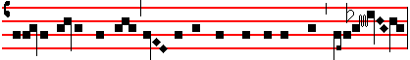 Reach hither thy hand, and behold the print of the nails, allelu- ia:
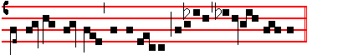
and be not faithless, but believing, alleluia, alle- lu- ia.

POSTCOMMUNION
WE beseech thee, O Lord our God: that these holy mysteries which thou hast given us for the assurance of our redemption; may avail for our healing both in this life and in that which is to come. Through.

