
AT MATINS
__________________________________________________________________

Our Father. Hail, Mary. I believe. O Lord, open thou our lips.
 O God, make speed. Glory be. Alleluia.

Invitatory Tone vj
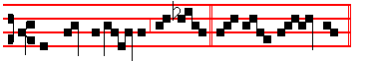
The Lord is ris - en in- deed, * Al- le - lu - ia. It is repeated:
The Lord is ris - en in- deed, * Al- le - lu - ia.

Psalm 95 Venite XCIV
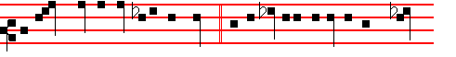
O COME, let us sing unto the Lord let us heartily rejoice in the strength
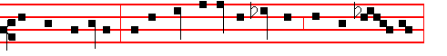
of our salvation. Let us come before his presence with thanksgiv- ing;
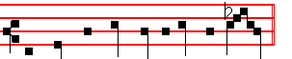
and shew ourselves glad in him with psalms.  The Lord, as above.

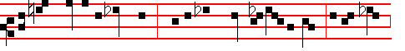
For the Lord is a great God, and a great King above all gods. In his hand

789
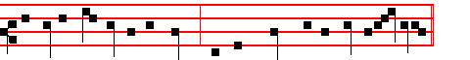
are all the corners of the earth and the strength of the hills is his al-so.
 Alleluia, as above.

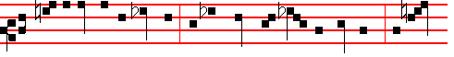
The sea is his and he made it, and his hands prepared the dry land. O come
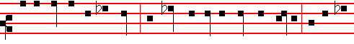
let us worship and fall down, and kneel before the Lord our Maker. For he is
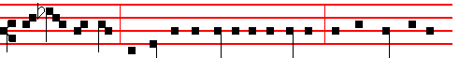
the Lord our God, and we are the people of his pasture, and the sheep of his
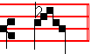
hand.  The Lord, as above.

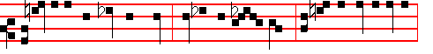
Today if ye will hear his voice, harden not your hearts, as in the provocation,
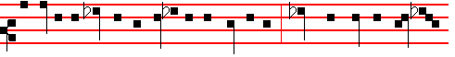
and as in the day of temptation in the wilderness; When your fathers temp-ted

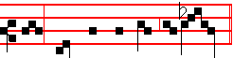
me, proved me, and saw my works.  Alleluia, as above.

790
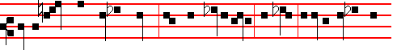
Forty years long was I grieved with this generation and said, It is a people that
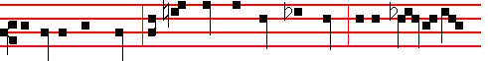
do err in their hearts, for they have not known my ways: Unto whom I sware
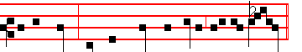
in my wrath, that they should not enter into my rest.  The Lord, as above.

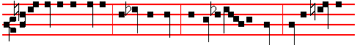
Glory be to the Father, and to the Son , and to the Holy Ghost; As it was in
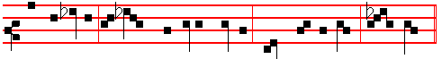
the beginning, is now, and ever shall be, world without end. A - men.
 Alleluia, as above.  The Lord, as above.

The Hymns and Chapters are not said in any of the Hours, until Vespers of Saturday before Low Sunday, nor the Versicles, except in the Nocturn.

AT THE NOCTURN
Antiphon 1. Tone ij
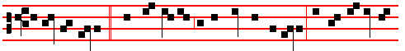 I am that I am, * and my counsel is not with the ungodly, but my delight is
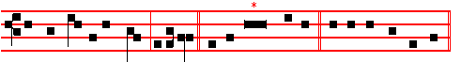
in the law of the Lord, alleluia. Psalm 1 Beatus vir E u o u a e.
Antiphon 2. Tone ij
791
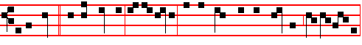
I desired * of my Father, al-le-lu-ia: and he gave me the heathen, al- le- lu-ia,
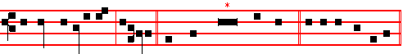
for mine inheritance, alleluia. Psalm 2 Quare fremuerunt E u o u a e.
Antiphon 3. Tone viij, 2.
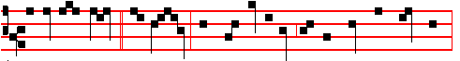
I laid me down, * and slept: and rose up again, for the Lord sustained me,
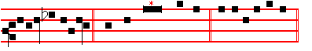
allelu-ia, alleluia. Psalm 3 Domine, quia E u o u a e.
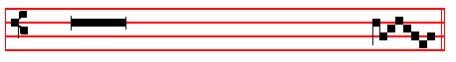
 The Lord is risen from the tomb, allelu - ia.
 Who for our sakes hung upon the tree, allelu - ia.
Our Father. Absolution. Hear. Bid, Lord, p. 14. Blessing May the Gospel.

The Lesson from the Holy Gospel according to S. Mark
Lesson j Ch. 16
MARY Magdalene, and Mary the mother of James, and Salome, had bought sweet spices, that they might come and anoint Jesus. And the rest.
Homily by S. Gregory the Great Homily 2 on the Gospel.
YOU have heard, beloved brethren. how the holy women who had followed the Lord. came to the sepulchre with sweet spices, that they might zealously care for him even in death, whom they had loved when he was living. But these things signify something in holy Church which we must do. And so it is nccessary for us to hear what was done then, so that as we ponder over it we see what we have to do by way of imitation. Therefore if we, who believe in him who died, seek the Lord, bearing the good odour of virtues together with the repute of good works, then we do come to his sepulchre bringing sweet spices. Those women saw

792
the Angels, when they came with sweet spices: for truly they who go forth to seek the Lord with holy desire in the odour or virtue do mentally behold the heavenly citizens.
 I. Tone iij.
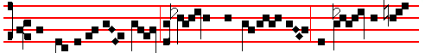
The Angel of the Lord descended from heav - en, and came and rolled
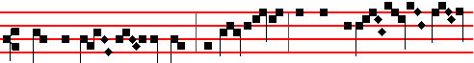 back the stone from the door, and sat upon it, and said unto the wom-
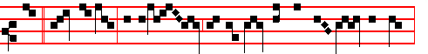
en: * Fear not ye: for I know that ye seek him that was cru - ci- fied:
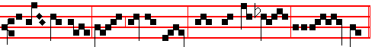
he is ris- en: come, see the place where the Lord lay, alle-lu- ia.
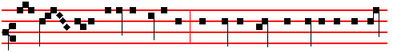
 And ent- - ering into the sepulchre, they saw a young man sitting on the right
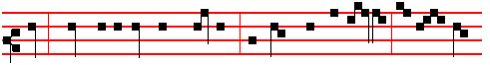
side, clothed in a long white garment; and they were affrighted, and he saith
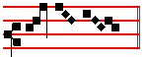
un - to them, Fear not, as above.
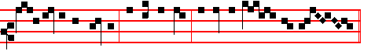
Glory be to the Father, and to the Son, and to the Ho- ly Ghost.
793
And the  is repeated The Angel of the Lord up to the 
Blessing May the Divine.
Lesson ij
WE must consider why it was that the Angel was seen sitting on the right side. For what is meant hy the left, but this present life: what by the right, but life eternal? Whence it is written in the Song of Songs: His left hand is under my head, and his right hand doth embrace me. Therefore since our Redeemer had gone forth from the corruption of this present life, rightly was the Angel, who had come to announce his eternal life, sitting on the right side. He appeared clothed in a white garment, because he announced the joys of our festival. For white garments declare the splendour of our solemnity. Shall we say ours, or his? To speak more accurately. we should say, both his and ours. For the Resurrection of our Redeemer was both our festival, because it brought us back to immortality and yet it was even more the Angels' festival, because our being brought back to heaven filled up their number.

 II. Tone iv.
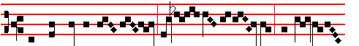
When the sabbath was passed, Ma-ry Magda-le - ne and Ma-ry the
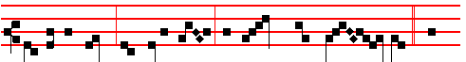
mother of James, and Salome, had bought sweet spic- es, * That
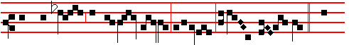
they might come and anoint Jes-us, allelu-ia, alle - lu - ia.  And
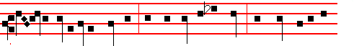
ver - y early in the morning, the first day of the week, they came unto the
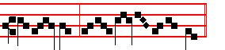
sepul - chre at the ris - ing of the sun. That they, as above.

794
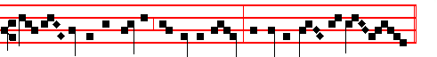
Glor-y be to the Father, and to the Son, and to the Ho- ly Ghost.
That they, as above.

Blessing May the King.

Lesson iij
THEREFORE at this, both his festival and ours, the Angel appeared in white garments: for while we are led back to the supernal kingdom by the Lord's Resurrection, the losses in the heavenly country are repaired. But let us hear what the Angel said to the women as they arrived. Be not affrighted. As though he were to say openly, Let those fear, who do not love the approach of heavenly citizens; let them be greatly afraid, who, oppressed by carnal desires, despair of attaining to the company of Angels. But you, what need have you to fear when you behold your fellow-citizens? Whence also Matthew, describing the appearance of the Angel, says: His countenance was like lightning, and his raiment white as snow. For in lightning there is the terror of fear, while in snow there is the pleasure of whiteness.

After the third Lesson is said Te Deum Laudamus, p. 24.

AT LAUDS
Antiphon 1. Tone viij, 1.
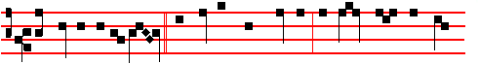
The Angel of the Lord * descended from heaven, and rolled back the stone
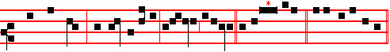
from the door, and sat upon it, alleluia, alleluia. Psalm. 93 Dominus regnavit, with the rest, p. 28 ff.
Antiphon 2. Tone vij, 1.
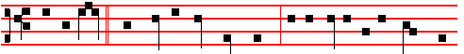
And behold, * there was a great earthquake: for the Angel of the Lord de-

795
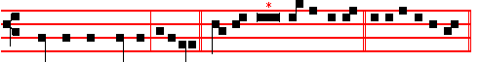
scended from heaven, alleluia. Psalm 100 Jubilate Deo E u o u a e.
Antiphon 3. Tone viij, 2.
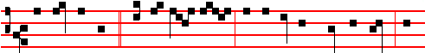
His countenance * was like light- ning, and his raiment white as snow, al-
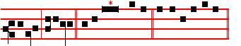
leluia, alleluia. Psalms 63, 67 E u o u a e.
Antiphon 4. Tone vij, 3.
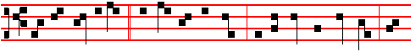
And for fear of him * the keepers did shake, and became as dead men, al-
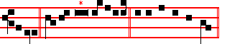
leluia. Canticle Benedicite E u o u a e.
Antiphon 5. Tone viij, 1.
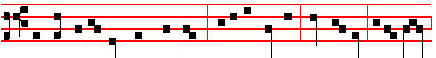
And the Angel answered and said * unto the women, Fear not ye, for I know
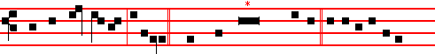
that ye seek Jes-us, alleluia. Psalms 148 149 150 Laudate E u o u a e.

The Chapter, Hymn, and  are not said: but in their place is said the Antiphon

Hæc dies. Tone X.

796
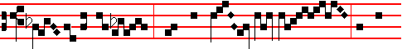
This is the day which the Lord hath made: we will
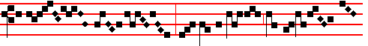
be joy - ful and will be glad in it . . . . . . . . . . .
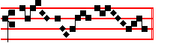
. . . . . . . . . . . . . . . . . . . . . . . (or Mode ij, as E.H.738, first part)

On Benedictus, Antiphon. Tone viij, 1.
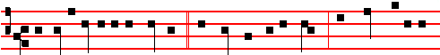
And very early in the morning the first day of the week, they came unto the
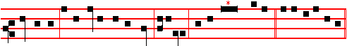
sepulchre at the rising of the sun, alleluia. Canticle Benedictus E u o u a e.

COLLECT
O GOD, who through thine only-begotten Son hast this day overcome death, and opened unto us the gate of eternity: prosper by thine assistance our desires, which by thy preventing grace thou dost put into our minds. Through the same.

 The Lord be with you.  And with thy spirit.
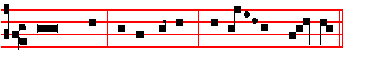
 Let us bless the Lord, al- le – lu - ia, al- le - - lu - ia.
 Thanks be to God, al- le - lu – ia, al- le - - lu - ia.

Thus it is said in Vespers and Lauds only until Vespers on Saturday before Low Sunday exclusive.
797
At Prime, Terce, Sext, and None, after O God, make speed, and Glory be to the Father, are said the usual Psalms: but at Prime as on Feasts, that is,
Tone viij, 1.
Psalm 54 Deus in nomine tuo, Ps.119 Beati immaculati and Retribue,
which being ended, is said the Antiphon This is the day. Then the Collect, which at Prime is said as in the Psalter, O Lord God almighty, p. 52. Right dear, with the rest, and at the Close of the Chapter, Short Lesson If ye then, as in the Psalter, p. 54. But at the other Hours, after the Antiphon, is said the Collect placed in Lauds.

AT TERCE
Tone vij, 1.
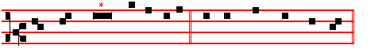
Psalm 119 Legem pone E u o u a e.

AT SEXT
Tone viij, 2.
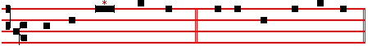
Psalm 119 Defecit E u o u a e.

AT NONE
Psalm 119 Miribilia etc; Tone viij, 1 as above at Prime.

AT VESPERS
Antiphon The Angel of the Lord, with the rest from Lauds, and the Psalm 110 Dixit Dominus, with the rest from Sunday, p. 202.
And thus it is said until Vespers of Saturday.
Then the Antiphon This is the day, p. 797.
On Magnificat, Antiphon. Tone iij, 1.
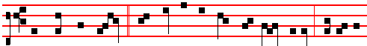
And when they looked, they saw that the stone was rolled away: for it was

798
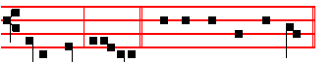
very great, alle- luia. Canticle Magnificat, p. 209.
Collect O God, who, p. 797.

At Compline, having said Bid, Lord, Brethren, be sober, Our help, Our Father, and made the Confession and Absolution, after O God, make speed, Glory be to the Father, and Alleluia, are said the usual Psalms, which being ended, is said:
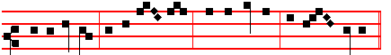
Al-le-lu- ia, al- le- lu- ia, al- le- lu- ia, al- le- lu- ia.

Then the Canticle of Simeon Nunc dimittis, p. 130.Then the Antiphon This is the day, the Collect Visit, as above, p.13l.
The above manner of the Hours is observed until Vespers of Saturday before Low Sunday.
__________________________________________________________________

MONDAY
At Matins, Invitatory, Antiphons and Psalms at the Nocturn, and Lauds, are said as above on Easter Day, through the whole Octave.
 The Lord is risen from the tomb, alleluia.
 Who for our sakes hung upon the tree, alleluia.
Our Father. Absolution Hear.Blessing May the Gospel.

The Lesson from the Holy Gospel according to S. Luke
Lesson j Ch. 24
TWO of Jesus' disciples went that same day to a village called Emmaus, which was from Jerusalem about threescore furlongs. And the rest.
Homily by S. Gregory the Great Homily 23 on the Gospels
YOU have heard, beloved brethren: that as two of the disciples were going along the way, not indeed believing in him, but yet talking about him, the Lord appeared: but he did not reveal himself in his familiar form which they would have recognized. Therefore the Lord was effecting outwardly to the eyes of the body the same thing that was taking place inwardly before the eyes of the heart. For in their inmost heart they both loved and doubted; while outwardly though the Lord was indeed present with them yet he did not show them who he was. While they were talking about him he presented himself to them; but while they were entertaining doubts about him he hid his recognizable form.

799
 As it began to dawn, came Mary Magdalene and the other Mary to the sepulchre. * Ye seek Jesus; he is not here; for he is risen, as he said, he goeth before you into Galilee; there shall ye see him, alleluia, alleluia.
 And very early in the morning, the first day of the week, they came unto the sepulchre at the rising of the sun: and entering into the sepulchre they saw a young man sitting on the right side: and he saith unto them. Ye seek.

Lesson ij
HE took up the thread of their conversation, he rebuked their dulness of understanding, and revealed to them the mysteries written in holy Scripture concerning himself: nevertheless, since he was as yet a stranger to them in their hearts, as their faith held him not, he made as though he would have gone further. Now we say, He made, and this can also mean, He fashioned. Whence those who fashion things out of clay are called craftsmen. Now he who is Very Truth does nothing by guile or craft: but he revealed himself to them in bodily form in a fashion that corresponded to the idea that they had 'of him in their minds. They had to be tested, to see whether, even though they did not love him as God, they would yet care for him as a stranger.

 The good Shepherd is risen, who hath laid down his life for the sheep, and hath vouchsafed to die for his flock, * Alleluia, alleluia, alleluia.
 For Christ our Passover is sacrificed for us. Alleluia. Glory be. Alleluia.

Lesson iij
BUT since those who were walking with the Truth could not be without charity; they asked him to abide with them, as though he were a stranger. But why do we say, Asked, when it is written in the Gospel, They constrained him? We may gather from this example that strangers are not merely to be invited to abide with us, but are even to be pressed to do so. Therefore they set the table and brought bread and other food: and God, whom they did not know when he was expounding the holy Scriptures to them, they did know in the breaking of bread. They were not enlightened by hearing the commandments of God, but they were enlightened by carrying them out: it is written, For not the hearers of the law are just before God, but the doers of the law shall be justified. If anyone would apprehend what he has heard, let him hasten to fulfil what he has been enabled to hear. Lo, God was not known while he was speaking, and he vouchsafed to be known when food was set before him.
Te Deum Laudamus, p.

On Benedictus, Antiphon. Tone viij, 1.

800
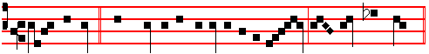
Jesus himself * drew near to his disciples in the way, and went with them:
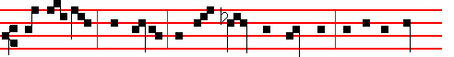
but their eyes were holden that they should not know him: and he rebuked
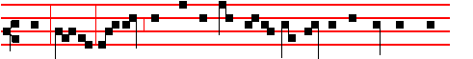
them, saying, O fools and slow of heart to believe all that the prophets have
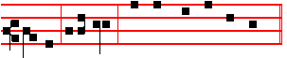
spoken, al-le-luia. Canticle Benedictus, p.
COLLECT
O GOD, who by the paschal solemnity hast bestowed healing upon the world: prosper, we beseech thee, thy people with thy heavenly gift; that they may be worthy to attain unto perfect freedom, and may likewise be profited unto everlasting life. Through.
On Magnificat, Antiphon. Tone viij, 1.
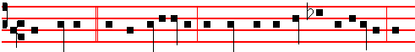
What manner of communications are these that ye have one to another, as
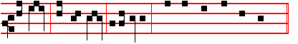
ye walk, and are sad? al-le-luia. Canticle Magnificat, p. 210.
__________________________________________________________________

TUESDAY
 The Lord is risen indeed, alleluia.
 And hath appeared to Simon, alleluia.
Our Father. Abso1ution May his mercy. B1essing May the Gospel.
The Lesson from the Holy Gospel according to S. Luke

801
Lesson j. Ch. 24
JESUS stood in the midst of his disciples, and saith unto them, Peace be unto you. And the rest.
Homily by S. Ambrose, Bishop Bk. 10 on Luke Ch. 24. v. 37
IT is extraordinary how the Lord's natural body could pass through an impenetrable substance, being invisible in its entrance and yet visible to human eyes; it could easily be touched, and yet it is hard to think of it. Therefore the disciples were terrified and supposed that they had seen a spirit. And so the Lord, that he might show us the proof of his resurrection, said, Handle me, and see; for a spirit hath not flesh and bones, as ye see me have. It was not by a bodiless nature, then, but by the quality of his risen body, that he passed through closed and imrenetrable matter. For that which can be touched is body; that which can be handled is body.

 With great power gavc the Apostles * Witness of the resurrection of our Lord Jcsus Christ, alleluia, alleluia.
 They were all filled with the Holy Ghost, and they spake the word of God with boldness. Witness.

Lesson ij
WE shall rise again in the body. It is sown a natural body; it is raised a spiritual body. But that body will be finer, while this is thicker, since it still bears the density of its earthly stain. How should that not be a body which still bore the marks of the wounds and the scars of the nails, which the Lord offered to be handled? In so doing he not only strengthens our faith, but he also sharpens our devotion, for, rather than doing away with the wounds that he had received on our account, he preferred to bring them into heaven with him, so that he might show God the Father the price of our freedom. Thus does God the Father place him at his right hand, bearing the trophy of our salvation. Thus does he show us those Martyrs bearing the crown of their scars.

 From the mouth of the wise proceedeth honey, alleluia, the sweetness of honey is under his tongue, alleluia. * His lips drop as the honeycomb, alleluia, alleluia.
 Wisdom doth abide in his heart, and. out of his mouth cometh understanding. His lips. Glory be. His lips.

Lesson iij
NOW that our discourse has led up to this point, let us consider how it is that according to John, the Apostles believed and were glad; according to Luke they were upbraided for their unbelief: in John, they received the Holy Spirit; in Luke, they were told to remain in the city until they were indued with power from

802
on high. It seems to me that John as an Apostle touches on greater and higher things, while Luke relates the events in their natural aspect: the latter is wont to trace the narrative, the former summarizes. For on the one hand we cannot doubt the one who testifies of these things, who saw and bare record, and whose testimony is true: while on the other, all suspicion of carelessness or untruthfulness must be banished from one who was found worthy to be an evangelist. And therefore we must take both accounts to be true, not looking for discrepancies in the statements, nor finding differences in the characters. For while Luke says first that they did not believe, he later reveals that they did: and if we consider his first statement there is a contradiction; if we examine the later one, there is full agreement.
Te Deum Laudamus, 9.
On Benedictus, Antiphon. Tone viij, 1. 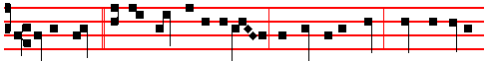
Jesus stood * in the midst of his disciples and said unto them, Peace be unto
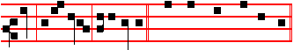
you, al-le-lu-ia, al-le-lu-ia. Canticle Benedictus, p.
COLLECT
O GOD, who dost ever multiply thy Church with new offspring: grant unto thy servants; that they may hold fast in their lives the sacraments which by faith they have received. Through.
On Magnificat, Antiphon. Tone viij, 1.
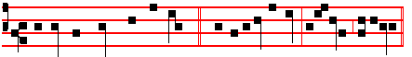
Behold my hands and my feet * that it is I myself, alle-luia, alleluia. Canticle
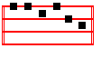
Magnificat, p. 210.
__________________________________________________________________

WEDNESDAY
 Then were the disciples glad, alleluia.  When they saw the Lord, alleluia.
Absolution From the chains. Blessing May the Gospel.

803
The Lesson from the Holy Gospel according to S. John
Lesson j Ch. 21, 1-14
JESUS shewed himself again to the disciples at the sea of Tiberias: and on this wise shewed he himself. There were together Simon Peter, and Thomas called Didymus. And the rest.
Homily by S. Gregory the Great Homily 24 on the Gospels
THE Gospel Lesson that has been sounding in your ears, my brethren, is knocking at the door of your heart with a question. But by that knocking it is indicating the power of discrimination. It is to be asked why Peter, who was a fisherman before his conversion, returned again to his fishing afterwards: and since the Truth says, No man, having put his hand to the plough, and looking back, is fit for the kingdom of God, why does he take up what he laid aside? But by virtue of discrimination it is readily seen that if the trade he followed before his conversion had no sin in it, then he could take it up again after his conversion without blame.

 Behold, the lion of the tribe of Judah, the root of David, hath prevailed to open the book and to loose the seven seals thereof. * Alleluia, alleluia, alleluia.
 Worthy is the Lamb that was slain to receive power. and riches, and wisdom. and strength, and honour, and glory, and blessing. Alleluia.

Blessing May the divine.
Lesson ij
WE know that Peter was a fisherman, while Matthew was a tax-collector; and while Peter returned to his fishing arter his conversion, Matthew did not go back to his seat or custom: for it is one thing to earn a living by fishing, and quite another to lay up riches by tax-collecting. There are many trades that can scarcely or never be followed without sin. Of necessity, then. where sin is involvcd, a man may not return to such a trade after his conversion.

 I am the true vine, ye are the branches: * He that abideth in me and I in him, the same bringeth forth much fruit, alleluia, alleluia.
 As the Father hath loved me, so have I loved you. He that. Glory be. He that.

Blessing May the King of Angels.
Lesson iij
IT may also be asked, why, when the disciples were toiling in the sea, after his resurrection the Lord stood on the shore, whereas before his resurrection he walked on the waves of the sea in the sight or them all. The reason for this may soon he known if we look at the inner meaning. For what is meant by the sea, except this present fleeting world, in tumult with the surge of fortune and with the

804
rolling waves of corruptible life? What does the safe shore denote, but the eternity of everlasting rest? Therefore, since the disciples were still tossed by the waves of this mortal life, they were toiling in the sea; but since our Redeemer had passed beyond the corruption of the flesh, after his resurrection he was standing on the shore.
Te Deum Laudamus, 9
On Benedictus, Antiphon. Tone vij, 1.
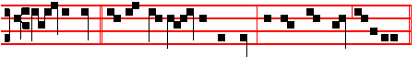
Cast the net * on the right side of the ship, and ye shall find, alleluia.
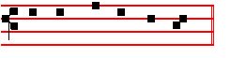
Canticle Benedictus, p.
COLLECT
O GOD, who dost gladden us with the yearly solemnity of the resurrection of the Lord: mercifully grant; that through this temporal feast which we observe, we may be found worthy to attain unto everlasting joys.Through the same.
On Magnificat, Antiphon. Tone viij, 1.
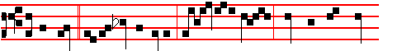
Jesus saith * unto his dis-ciples, Bring of the fish which ye have now
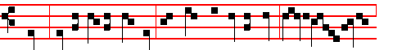
caught. Simon Peter went up, and drew the net to land, full of great fishes,
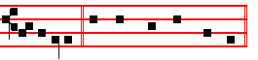
al-le-luia. Canticle Magnificat, p. 210.
__________________________________________________________________

THURSDAY
 The Lord is risen from the tomb, alleluia.
 Who for our sakes hung upon the tree, alleluia.

805
The Lesson from the Holy Gospel according to S. John
Lesson j Ch. 20, 11-18
MARY stood without at the sepulchre weeping: and as she wept, she stooped down, and looked into the sepulchre, and seeth two angels in white, sitting. And the rest.
Homily by S. Gregory the Great Homily 25 on the Gospel.
MARY Magdalene, a woman of the city, which was a sinner, washed out the stains of her sins with her tears, by her love of the Truth; and the Word of Truth is fulfilled which says, Her sins are forgiven, for she loved much. She who had previously been cold through sin was afterwards aflame with love, For when she came to the sepulchre and found that the Lord's body was not there, she believed that it had been taken away, and told thc disciples so: they came to the sepulchre, and saw, and believed that it was as the woman had said. It is written, Then he disciples went away again into their own home; and then it is added, But Mary stood without at the sepulchre, weeping.

 They have taken away my Lord, and I know not where they have laid him. The Angels said unto her, Woman, why weepest thou? He is risen as he said: * He goeth before you into Galilee: there shall ye see him, alleluia, alleluia.
 As she wept, she stooped down. and looked into the sepulchre: and seeth two Angels in white sitting, and they say unto her. He

Lesson ij
THERE is something that we should ponder here, how great a name of love was burning the mind of the woman for she would not leave the Lord's sepulchre even when the disciples had left. She was seeking him and could not find him. As she sought, she wept, and enkindled with the fire of his love, she was aflame with longing for him whom she believed had been taken away. Whence it happened that she alone saw him, as she alone had stayed behind to seek him: for the power of good works lies in perseverance, as the voice of the Truth declares, He that perseveres to the end shall be saved.

 Rejoice with me, all ye that love the Lord, for I sought him and he hath appeared unto me: * And while I was weeping at the sepulchre, I saw the Lord, alleluia, alleluia.
 I would not leave, even when the disciples had left; enkindled with the fire of his love, I was aflame with longing. And whle. Glory be. And while.

Lesson iij
AS Mary wept, she stooped down: and looked into the sepulchre. Surely she had already seen that the sepulchre was empty, had already declared that the

806
Lord had been taken away: what is the reason. then, for stooping down again, for trying to see again? But for those that love, it is not enough to look once: the power of love increases the vehemence of the search. The first time that she sought him she could in no wise find him: she persevered in seeking, and so it came about that she found him. And this happened, because longing increases when unsatisfied, and thus increased, can retain what it finds.
Te Deum Laudamus, 9
On Benedictus, Antiphon. Tone vij, 1.
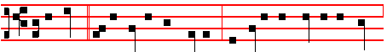
Mary stood * at the sepulchre weeping, and seeth two Angels in white,
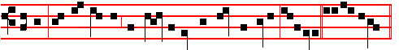
sitting, and the napkin that was about the head of Jesus, alleluia. Canticle
Benedictus, p.
COLLECT
O GOD, who hast united the diversity of nations in the confession of thy name: grant that they who are born again in the font of Baptism may agree in unity of faith and in godliness of conversation. Through.

On Magnificat, Antiphon. Tone vij, 1.
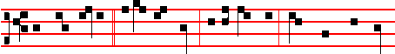
They have taken * away my Lord, and I know not where they have laid
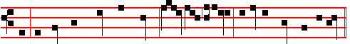
him. If thou have borne him hence, tell me, alleluia: and I will take him away,
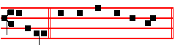
al-leluia. Canticle Magnificat, p. 210.
__________________________________________________________________

FRIDAY

807
 The Lord is risen indeed, alleluia.  And hath appeared to Simon, alleluia.
The Lesson from the Holy Gospel according to S. Matthew
Lesson j Ch. 28, 16-20
THE eleven disciples went away into Galilee, into a mountain where Jesus had
appointed them. And the rest.
Homily by S. Jerome, Priest Comm. on Matt. Ch. 28, v. 16
AFTER his resurrection, Jesus is seen on a mountain: in Galilee, and he is worshipped there. Though the disciples doubt, yet their doubting increases our faith. He is revealed more plainly to Thomas, and shows him the spear-wound in his side and the prints of the nails in his hands. And Jesus came and spake unto them, saying, All power is given unto me in heaven and in earth. Power is given unto him who but a little while ago was crucified, who was buried in the tomb, who lay there dead, and who afterwards rose again. Power is given unto him both in heaven and in earth: for he who has been reigning in heaven is to reign in earth as well, through the faith of the believers.

 After that our Lord Jesus was risen, he came and stood in the midst of his disciples, and said: * Peace be unto you, alleluia: then were the disciples glad, when they saw the Lord, alleluia.
 The first day of the week, when the doors were shut where the disciples were assembled, came Jesus, and stood in thc midst of them, and saith unto them. Peace.

Lesson ij
GO ye thercfore, and teach all nations, baptizing them in the name of the Father, and of the Son, and of the Holy Ghost. First they teach all nations, then they wash with water those whom they have taught. For it cannot be that the bodv receives the sacrament of baptism, unless the mind has first received the truth of faith. Now, they baptize in the Name of the Father, and of the Son, and of the Holy Ghost: for as these Three are one Godhead, so there may be but one gift: and the Name of the Trinity is the Name of the One God.

 Purge out therefore the old leaven, that ye may be a new lump: for even Christ our Passover is sacrificed for us: * Therefore let us keep the Feast in the Lord, alleluia.
 He died for our sins, and rose again for our justification. * Therefore. Glory be. Therefore.

Lesson iij
TEACHING them to observe all things whatsoever I have commanded you. A noteworthy order: he tells the Apostles, first to teach all nations, then to

808
initiate them by the sacrament of faith, and then, after they have received faith and baptism, to instruct them in the ways of observance. And lest we should think that the things they were told to do were few and easy, he added, All things whatsoever I have commanded you. So that all who have believed and have been baptized in the Trinity are to do all the things that have been commanded. And lo, I am with you alway, even unto the end of the world. He promises that he will be with his disciples even unto the end of the world, and makes plain to them that they will always be conquerors, and that he will never leave those who believe in him.
Te Deum Laudamus, 9
On Benedictus, Antiphon. Tone vij, 1.
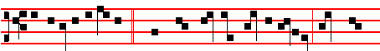
The eleven disciples, * when they saw the Lord in Galilee, worshipped
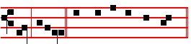
him, alleluia. Canticle Benedictus, p.

COLLECT
ALMIGHTY and everlasting God, who hast bestowed the paschal sacrament for a pledge of man's reconciliation: grant unto our hearts; that what we celebrate in outward profession we may effectually fulfil. Through.

On Magnificat, Antiphon. Tone viij, 1.
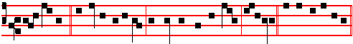
All power * is given unto me in heaven and in earth, alleluia. Canticle
Magnificat, p. 210.
__________________________________________________________________

SATURDAY BEFORE LOW SUNDAY
 Then were the disciples glad, alleluia.  When they saw the Lord, alleluia.
The Lesson from the Holy Gospel according to S. John
Lesson j Ch. 20, 1-9
ON the first day of the week cometh Mary Magdalene early, when it was yet dark, unto the sepulchre. And the rest.
Homily by S. Gregory the Great Homily 22 on the Gospels
809
THE Gospel lesson that you have just heard, brethren, is quite clear as to the historical sense: but under these brief facts there are mysteries which we must
investigate. Mary Magdalene, when it was yet dark, came unto the sepulchre. According to the historical sense, the hour is recorded: but according to the mystical interpretation, the mind of the woman who was seeking is denoted. For Mary was seeking for the Author of all things at the sepulchre, he whom she had seen dead in the flesh; and she could in no wise find him. She believed that he had been stolen away. So it was yet dark, when she came to the sepulchre. She ran quickly and told the disciples: and those disciples ran quicker than the others, who loved more than the others, namely Peter and John.

 Christ being risen from the dead dieth no more, death hath no more dominion over him: for in that he died, he died unto sin once, * But in that he liveth, he liveth unto God, alleluia, alleluia.
 He died once for our sins, and was raised again for our justification. But in.

Lesson ij
NOW, the two ran both together: but John did outrun Peter. He came first to the sepulchre, but did not dare go in. Then came Peter following him, and he did go in. What, brethren, what is the meaning of this race? Surely we are not to believe that in so subtle an account by the Evangelist there is no mystery? Far from it. For John would not have said that he arrived first and yet did not go in, had he not believed that there was a mystery in his own constemation. What is meant by John, if not the synagogue: what by Peter, if not the Church?

 These are the new-born Iambs who have proclaimed, alleluia. They came but just now to the well. * They are all filled with light, alleluia, alleluia.
 They stand before the Lamb, clothed in white robes, with palms in their hands. They are.

Lesson iij
NEITHER should it seem strange that the synagogue is represented by the younger man, while the Church is represented by the elder. For though the synagogue did come to worship God before the congregation of the Gentiles, yet the multitude of the Gentiles was an older congregation than the synagogue, as Paul bears witness, where he says, That was not first which is spiritual, but that which is natural. Therefore the Church of the Gentiles is represented by Peter. the elder man, and the synagogue of the Jews by John, the younger. They ran both together: because from the sunrise to the sunset of her day the Gentile Church did run along a way that was parallel and in common with that of the synagogue,

810
although their perception was not parallel and in common. The synagogue came first to the sepulchre, but she did not go in: for she received the commandments of the law, and heard the prophecies of the Lord's Incarnation and Passion, but would not believe in his Death.
Te Deum Laudamus, p.
On Benedictus, Antiphon. Tone j, 1.
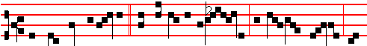
They ran both together, * and the other disci- ple did outrun Pet-er, and
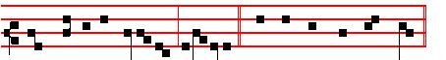
came first to the sepulchre, al-le-luia. Canticle Benedictus, p.

COLLECT
GRANT, we beseech thee, almighty God: that we who have devoutly kept this paschal fectiva1 may thereby be found worthy to attain to everlasting joys. Through.
AT VESPERS THE OFFICE IS DOUBLE

Antiphon. Alleluia, alleluia, alleluia, p. 207. Psa1ms 144 Benedictus and the rest from the Psa1ter, p. 202-206.
Chapter I John 5
DEARLY be1oved: Whatsoever is born of God overcometh the world: and this is the victory that overcometh the world, even our faith.

Hymn: E.H. 125 Ad cenam Agni providi Mode viij.
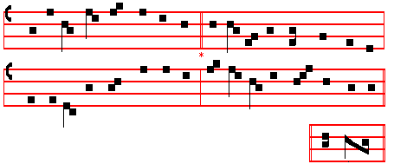
(Or tune as below at Matins) A - men.
811
THE Lamb's high banquet we await 5 O thou from whom hell's monarch flies,
In snow-white robes of royal state; O great, O very Sacrifice,
And now, the Red Sea's channel past, Thy captive people are set free,
To Christ, our Prince, we sing at last. And endless life restored in thee.

2 Upon the altar of the Cross 6 For Christ, arising from the dead,
His Body hath redeemed our loss; From conquered hell victorious sped;
And tasting of his roseate Blood He thrusts the tyrant down to chains.
Our life is hid with him in God. And Paradise for man regains.

3 That Paschal eve God's arm was bared; 7 Maker of all, to thee we pray,
The devastatlng Angel spared: Fulfil in us thy joy today ;
By strength of hand our hosts went free When death assails, grant, Lord, that we
From Pharaoh's ruthless tyranny. May share thy Paschal victory.

4 Now Christ our Paschal Lamb is slain, 8 To thee who, dead, again dost live,
The Lamb of God that knows no stain; All glory Lord, thy people give;
The true Oblation offered here, All glory, as is ever meet,
Our own unleavened Bread sincere. To Father and to Paraclete. Amen.

Thus are ended all the hymns of the same metre until the Ascension, except in the
Office of the B. V. M. and in the Hymn of the Holy Cross at Vespers.
 Abide with us, Lord, alleluia.  For it is toward evening, alleluia.
On Magnificat, Antiphon. Tone j, 3.
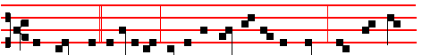
The same day at evening, being the first day of the week, when the doors
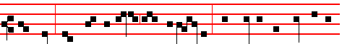
were shut where the disciples were assembled, came Jesus, and stood in the
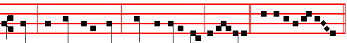
midst, and saith unto them, Peace be unto you, al-le- luia. Canticle Magnificat,
p. 209.
COLLECT
GRANT, we beseech thee, almighty God: that we, who have celebrated the paschal feasts may, through thy bounty, ever keep them in our life and conversation.Through.
812
LOW SUNDAY
THE OCTAVE OF EASTER
DOUBLE
At Matins, Invitatory. The Lord is risen indeed. * Alleluia, & Psalm 95, p. 789.

HYMN Rex sempiterne Mode viij
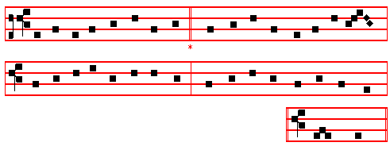
(or Mode as above at Vespers) A - men
O CHRIST, the heavens' eternal King, 4 Once of a virgin born to save,
Creator, unto thee we sing, And now new-born from death's dark grave,
With God the Father ever One, O Christ, thou bidst us rise with thee
Co-equal, co-eternal Son. From death to immortality.

2 Thy hand, when first the world began, 5 Eternal Shepherd, thou art wont
Made in thine own pure image man, To cleanse thy chosen at the font,
And linked to fleshly form of earth That mystic bath. that grave of sin,
A living soul of heavenly birth. Where ransomed souls new life begin.

3 And when the envious crafty foe 6 Divine Redeemer, thou didst deign
Had marred thy noblest work below, To bear for us the cross of pain,
Thou didst our ruined state repair And gavest there thy blood to be
By deigning flesh thyself to wear. Thc price of our eternity.

7 To thee who, dead, again dost live,
All glory, Lord. thy people give;
All glory, as is ever meet
To Father and to Paracete. Amen.

IN THE FIRST NOCTURN
Antiphon. Alleluia, the stone is rolled away, alleluia; from the door of the sepulchre, alleluia, alleluia. Psalms of Sunday as in the Psalter, p.5, which are said in each Nocturn under one Antiphon.

813
 The Lord is risen from the tomb, alleluia.
 Who for our sakes hung upon the tree, alleluia.
From S. Paul's Epistle to the Colossians
Lesson j Ch. 3, 1-17
IF ye then he risen with Christ, seek those things which are above, where Christ sitteth on the right hand of God. Set your affection on things above, not on things on the carth. For ye are dead, and your life is hid with Christ in God. Whcn Christ, who is our life, shall appear, then shall ye also appear with him in glory. Mortify therefore your members which are upon the earth; fornication, uncleanness, inordinate affection, evil concupiscence, and covetousness, which is idolatry: for which things' sake the wrath of God cometh on the children of disobedience: in the which ye also walked some time, when ye lived in them.

 The Angel of the Lord descended from heaven, and came and rolled back the stone from the door. and sat upon it, and said unto the women, * Fear not ye: for I know that ye seek him that was crucified: he is risen: come, see the place where the Lord lay, alleluia.
 And entering into the sepulchre, they saw a young man sitting on the right side, clothed in a long white garment; and they were affrighted, and he saith unto them. Fear not.

Lesson ij
BUT now ye also put off all these; anger, wrath, malice, blasphemy, filthy communications out of your mouth. Lie not one to another, seeing that ye have put off the old man with his deeds; and have put on the new man, which is renewed in knowledge after the image of him that created him: where there is neither Greek nor Jew, circumcision nor uncircumcision, Barbarian, Scythian, bond nor free: but Christ is all, and in all. Put on therefore, as the elect of God, holy and beloved, bowels of mercies, kindness, humbleness of mind, meekness, longsuffering; forbearing one another, and forgiving one another, if any man have a quarrel against any: even as Christ forgave you, so also do ye.

 The Angel of the Lord spake unto the women, saying: Whom seek ye? Do ye seek Jesus? He is risen: * Come and see. Alleluia, alleluia.
 Do ye seek Jesus of Nazareth which was crucified? He is risen, he is not here. Come.
Lesson iij
AND above all these things put on charity, which is the bond of perfectness. And let the peace of God rule in your hearts, to the which also ye are called in one body; and be ye thankful. Let the word of Christ dwell in you richly in all wisdom; teaching and admonishing one another in psalms and hymns and spiritual

814
songs, singing with grace in your hearts to the Lord. And whatsoever ye do in word or deed, do all in the name of the Lord Jesus, giving thanks to God and the Father through him.

 When the sabbath was passed, Mary Magdalene and Mary the mother of James, and Salome, had brought sweet spices, * That they might come and anoint Jesus, alleluia, alleluia.
 And very early in the morning, the first day of the week, they came unto the sepulchre at the rising of the sun. That they. Glory be. That they.

IN THE SECOND NOCTURN
Antiphon. Alleluia, woman, whom seekest thou? alleluia; seekest thou the living among the dead? alleluia, alleluia. Psalms of the Psalter, 1.
 The Lord is risen indeed, alleluia.
 And hath appeared to Simon, alleluia.
Sermon by S. Augustine, Bishop Sermon for the Octave of Easter
Lesson iv
THE Paschal Solemnity ends with to-day's festival, and therefore to-day the neophytes change their festal garments: in such a way, however, that the whiteness that they lay aside in their garments is retained for ever in their hearts. Bearing this in mind, let us make it our first concern, since these are the days of the Passover, that is, of pardon and remission of sins, that we celebrate these holy days in such a way that the purity of our souls is not tarnished while we relax in body. But rather let us abstain from all luxury, uncleanness and drunkenness: in short, let our relaxation be sober, and in holy sincerity, so that whatever we have not yet acquired by bodily abstinence, we may seek to obtain by purity of mind.

 As it began to dawn, came Mary Magdalene and the other Mary to the sepulchre. * Ye seek Jesus; he is not here; for he is risen, as he said, he goeth before you into Galilee; there shall ye see him, alleluia, alleluia.
 And very early in the morning, the first day of the week, they came unto the sepulchre at the rising of the sun: and entering into the sepulchre they saw a young man sitting on the right side: and he saith unto them. Ye seek.

Lesson v
MY discourse concerns all who are under our care; and yet on this day which ends the festival of the mysteries, we are especially addressing you, the new shoots of holiness, born anew by water and the Holy Ghost: our goodly shoot, our new crop, our flower of honour, and fruit of our labour, my joy and my crown, all you who stand in the Lord. I address you in the apostolic words, Behold, the night is far spent, the day is at hand: let us therefore cast off the works of darkness, and

815
let us put on the armour of light. Let us walk honestly, as in the day: not in rioting and drunkenness, not in chambering and wantonness, not in strife and envying. But put ye on the Lord Jesus Christ.

 The good Shepherd is risen, who hath laid down his life for the sheep, and hath vouchsafed to die for his flock. * Alleluia, alleluia, alleluia.
 For Christ our Passover is sacrificed for us. Alleluia.

Lesson vj
WE have, it says, also a more sure word of prophecy; whereunto you do well to take heed, as unto a light that shineth in a dark place, until the day dawn, and the day star arise in your hearts. Let your loins be girded about, and your lights burning; and ye yourselves like unto men that wait for their lord when he will return from the wedding. Behold, the days come, whereof the Lord says, A little while, and ye shall not see me: and again, a little while, and ye shall see me. This is the hour of which he said, Ye shall weep and lament, but the world shall rejoice: that is, this life, in which we journey separated from him, is full of temptations. But I will see you again, he says, and your heart shall rejoice, and your joy no man taketh from you.

 With great power gave the Apostles * Witness of the resurrection of our Lord Jesus Christ, alleluia, alleluia.
 They were all filled with the Holy Ghost, and they spake the word of God with boldness. Witness. Glory be. Witness.

IN THE THIRD NOCTURN

Antiphon. Alleluia, weep not, Mary, alleluia: the Lord is risen indeed, alleluia.
Psalms as in the Psalter, p. 8.
 Then were the disciples glad, alleluia.  When they saw the Lord, alleluia.
The Lesson from the Holy Gospel according to S. John
Lesson vij Ch. 20
THE same day at evening, being the first day of the week, when the doors were shut where the disciples were assembled for fear of the Jews, came Jesus and stood in the midst, and saith unto them, Peace be unto you. And the rest.
Homily by S. Gregory the Great Homily 26 on the Gospels
THE first question that knocks on the door of our mind is this: How could the body of the Lord be a true one, if it could pass through closed doors? But we must realize that God's action, when grasped by reason, is no longer marvellous: neither is there any merit in faith that can be proved by human reason. But those works of our Redeemer which in themselves can never be understood must be

816
considered in the light of his other works; so that faith in his miraculous doings may be confirmed by yet more wonderful works. This body of the Lord, then, came into the midst of the disciples when the doors were shut, and it was the same body that was seen by human eyes when, through his Nativity, the Lord came forth from the Virgin's closed womb. Why do you marvel, then, if after his resurrection when he was to live for ever he passed through the closed doors, since when he came to die he came forth without opening the Virgin's womb?

 From the mouth of the wise proceedeth honey, alleluia, the sweetness of honey is under his tongue, alleluia.
* His lips drop as the honey-comb, alleluia, alleluia.
 Wisdom doth abide in his heart, and out of his mouth cometh understanding. His lips.

Lesson viij
HE showed them two marvels, which, according to human reason, are directly opposed to one another. He revealed that his body, after his resurrection, was incorruptible, and yet palpable. Now, that which can be touched must needs be corruptible; and that which is incorruptible cannot be touched. But in a marvellous and incomprehensible way, our Redeemer proved his body, after his resurrection, to be both incorruptible, and palpable: thus, by showing it to be incorrruptible, he urges us on to our reward; and by proving that it could be touched, he strengthens our faith. He revealed himself, therefore, as both incorruptible and palpable, that thus he might plainly show that his body after the resurrection was the same in nature, yet different in glory. But because the faith or the onlookers was doubtful as to the verity of that body before their eyes: he straightway showed unto them his hands and his side: he proved to them that the flesh which entered through closed doors could be touched.

 After that our Lord Jesus was risen, he came and stood in the midst of his disciples, and said: * Peace be unto you, alleluia: then were the disciples glad, when they saw the Lord, alleluia.
 The first day of the week, when the doors were shut where the disciples were assembled, came Jesus, and stood in the midst of them, and saith unto them. Peace. Glory be. Peace.

Lesson ix
HE saith unto them, Peace be unto you. As my Father hath sent me, even so send I you. That is, As the Father. who is God, hath sent me, who am God, even so do I, who am Man, send you, who are men. The Father sent the Son, and ordaine that he should be incarnate for the redemption of mankind. He willed

817
that he should come into the world to suffer: but yet he loved his Son, whom he sent to suffer. The Lord sends his chosen Apostles. not to rejoice in the world, but to suffer in the world. Therefore, just as the Son is loved by the Father, and is yet sent to suffer; so likewise are the disciples loved by the Lord, and yet they are sent into the world to suffer. So it is rightly said, As my Father hath sent me, even so send I you: that is, When I send you forth into all the terrors of persecution, I love you with that love with which my Father loved me, when he caused me to come into the world to undergo my Passion.
Te Deum Laudamus, 9.
AT LAUDS
Antiphon. Alleluia, alleluia, alleluia; alleluia, alleluia, alleluia; alleluia, alleluia, alleluia, pp. 30-31. Psalms 93 Dominus regnavit, 100 Jubilate, 63 67 Deus, Deus meus, pp. 28 ff.
Antiphon. Christ is risen from the grave, who delivered the three children from the burning fiery furnace, alleluia, p. 33. Canticle Benedicite, p. 31.
Antiphon. Alleluia, alleluia, alleluia. p. 35. Psalms 148 149 150, p. 133-34.
Chapter I John 5
DEARLY be1oved: Whatsoever is born of God overcometh the world: and this is the victory that overcometh the world, even our faith.

Hymn. E.H. 123 (Part I) Aurora lucis rutilat. Mode v.
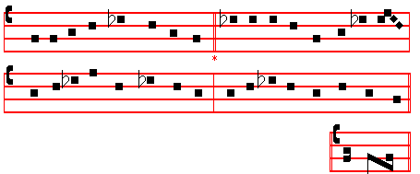
(or as above at Matins) A - men.
THE day draws on with golden light, 3 Enclosed he lay in rocky cell,
Glad songs go echoing throngh the height, With guard of armed sentinel;
The broad earth lifts an answering cheer, But thence returning, strong and free,
The deep makes moan with wailing fear. He comes with pomp of jubilee.

2 For lo, he comes, the mighty King, 4 Hell's pains are loosed, and tears are fled;
To take from death his power and sting, , Captivity is captive led;
When death assails, grant, Lord, that we For by the grave, with flashing eyes,
May share thy Paschal victory. 'Your Lord is risen,' the Angel cries.
818
5 Maker of all, to thee we pray, 6 To thee who, dead, again dost live,
Fulfil in us thy joy today; All glory, Lord, thy people give; .
To trample down his gloomy reign All glory, as is ever meet,
And break the weary prisoner's chain To Father and to Paraclete. Amen.

 In thy resurrection, O Christ, alleluia.  Let heaven and earth rejoice, alleluia.
On Benedictus, Antiphon. Tone j, 3, as above at Vespers, p. 812.
The same day at evening, being the first day of the week, when the doors were shut where the disciples were assembled, came Jesus and stood in the midst, and saith unto them, Peace be unto you, alleluia.

COLLECT
GRANT, we beseech thee, almighty God: that we, who have celebrated the paschal feasts may, through thy bounty, ever keep them in our life and conversation. Through.
AT PRIME
Hymn Iam lucis, p. 42. Antiphon. Alleluia,* alleluia, alleluia, alleluia, p. 49. Psalms 54, 119, vv.1-16, 17-32, and Quicumque.
The above Psalms are said on Sundays until the Ascension.
Chapter Now unto the King.
Short  as p. 50.
O Christ, Son of the living God, have mercy upon us. *Alleluia, alleluia.
O Christ.
 Who art risen from the dead. Alleluia, alleluia. Glory be. O Christ.
 Arise, O Christ, and help us, alleluia.
 And deliver us for thy name's sake, alleluia.
And thus the Short  is said until the Ascension.
And when it is not a Double or within Octaves, the Prayers of Sunday are said, as in the Psalter.
At the Close of the Chapter, Short Lesson If ye then., p. 54.

AT TERCE
and the other Hours, Antiphon. Alleluia, alleluia, alleluia, alleluia, p. 69.
Chapter Dearly beloved, as above, 818.
Short  as p. 70.
The Lord is risen from the tomb. * Alleluia, alleluia. The Lord.
 Who for our sakes hung upon the tree. Alleluia, alleluia. Glory be. The Lord.
 The Lord is risen indeed, alleluia.
 And hath appeared unto Simon, alleluia.

AT SEXT

819
Chapter I John 5
WHO is he that overcometh the world, but he that believeth that Jesus is the Son of God? This is he that came by water and blood, even Jesus Christ; not by water only, But by water and blood.
Short  as p. 79.
The Lord is risen indeed, * Alleluia,alleluia. The Lord.
 And hath appeared to Simon. Alleluia, alleluia. Glory be. The Lord.
 Then were the disciples glad, alleluia.
 When they saw the Lord, alleluia.

AT NONE
Chapter I John 5
IF we receive the witness of men, the witness of God is greater: for this is the witness of God which he hath testified of his Son. He that believeth on the Son of God hath the witness in himself.
Short  as p. 88.
Then were the disciples glad, * Alleluia, alleluia. Then.
 When they saw the Lord. Alleluia, alleluia. Glory be. Then were.
 Abide with us, Lord, alleluia.
 For it is toward evening, alleluia.

AT VESPERS
Antiphon. Alleluia, alleluia, alleluia, p. 207.
Psalms of Sunday, p. 202 ff., which are said under the one Antiphon only.
Chapter Dearly beloved, 463.
Hymn E.H. l25 Ad cenam and  Abide, pp. 811-812.

On Magnificat, Antiphon. Tone viij, 2.
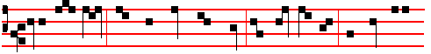
After eight days, when the doors were shut, the Lord entered, and said unto
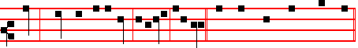
them, Peace be unto you, alleluia, alleluia. Canticle Magnificat, p. 210.
Collect Grant, we beseech thee, as above, p. 819.

The Hymns, , and Short  of this Sunday are said until the Ascension, even in the ferial Office.
820
MONDAY

AT MATINS
Invitatory. Alleluia, alleluia, * Alleluia.
Hymn Rex sempiterne, p. 813.
Antiphon, Psalms and  as in the Psalter for Eastertide.
Here beginneth the Book of the Acts of the Apostles.
Lesson j Ch. l
THE former treatise have I made, O Theophilus, of all that Jesus began both to do and teach, until the day in which he was taken up, after that he through the Holy Ghost had given commandments unto the apostles whom he had chosen: To whom also he shewed himself alive after his passion by many infallible proofs, being seen of them forty days, and speaking of the things pertaining to the kingdom of God: And being assembled together with them, commanded them that they should not depart from Jerusalem, but wait for the promise of the Father, which, saith he, ye have heard of me. For John truly baptized with water; but ye shall be baptized with the Holy Ghost not many days hence. When they therefore were come together, they asked of him, saying, Lord, wilt thou at this time restore again the kingdom to Israel? And he said unto them. It is not for you to know the times or the seasons, which the Father hath put in his own power. But ye shall receive power, after that the Holy Ghost is come upon you: and ye shall be witnesses unto me both in Jerusalem, and in all Judæa, and in Samaria, and unto the uttermost part of the earth.

 With great power gave the Apostles * Witness of the resurrection of our Lord Jesus Christ, alleluia, alleluia.
 They were all filled with the Holy Ghost, and they spake the word of God with boldness. Witness.

Lesson ij
AND when he had spoken these things, while they beheld, he was taken up; and a cloud received him out of their sight. And while they looked stedfastly toward heaven as he went up, behold, two men stood by them in white apparel; which also said, Ye men of Galilee, why stand ye gazing up into heaven? this same Jesus, which is taken up from you into heaven, shall so come in like manner as ye have seen him go into heaven. Then returned they unto Jerusalem from the mount called Olivet, which is from Jerusalem a sabbath day's journey. And when they were come in, they went up into an upper room, where abode both Peter, and James, and John, and Andrew, Philip and Thomas, Bartholomew, and Matthew, James the son of Alphæus, and Simon Zelotes, and Judas the brother of James. These all continued with one accord in prayer and supplication, with the women, and Mary the mother of Jesus, and with his brethren.

821

 From the mouth of the wise proceedeth honey, alleluia, the sweetness of honey is under his tongue, alleluia. * His lips drop as the honeycomb, alleluia, alleluia.  Wisdom doth abide in his heart, and out of his mouth cometh understanding. His lips. Glory be. His lips.

Lesson iij
AND in those days Peter stood up in the midst of the disciples, and said, (the number of names together were about an hundred and twenty.) Men and brethren, this scripture must needs have been fulfilled, which the Holy Ghost by the mouth of David, spake before concerning Judas, which was guide to them that took Jesus. For he was numbered with us,and had obtained part of this ministry.
Now this man purchased a field with the reward of iniquity; and falling headlong, he burst asunder in the midst, and all his bowels gushed out. And it was known unto all the dwellers at Jerusalem; insomuch as that field is called in their proper tongue. Acel-dama, that is to say, The field of blood. For it is written in the book of Psalms, Let his habitation be desolate, and let no man dwell therein: and his bishoprick let another take. Wherefore of these men which have companied with us all the time that the Lord Jesns went in and out among us, beginning from the baptism of John, unto that same day that he was taken up from us, must one be ordained to be a witness with us of his resurrection. And they appointed two, Joseph called Barsabas, who was surnamed Justus, and Matthias. And they prayed, and said, Thou, Lord, which knowest the hearts of all men, shew whether of these two thou hast chosen, That he may take part of this ministry and apostleship, from which Judas by transgression fell, that he might go to his own place. And they gave forth their lots; and the lot fell upon Matthias; and he was numbered with the eleven apostles.

In this Eastertide a third  is not said in the ferlal Office, but the hymn Te Deum Laudamus, p. 24.
At Lauds, Antiphons and Psalms as on Sundays in Eastertide, from the Psalter, p. 28 ff.
Chapter Rom. 6
CHRIST being raised from the dead dieth no more; death hath no more dominion over him. For in that he died, he died unto sin once: but in that he liveth, he liveth unto God.

Hymn E.H. 123 Aurora 1ucis rutilat, p. 818.
 In thy resurrection, O Christ, alleluia.
 Let heaven and earth rejoice, alleluia.

On Benedictus, Antiphon.
822
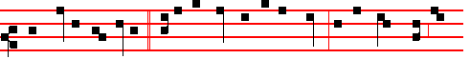
When Jesus was risen * early the first day of the week, he appeared first to
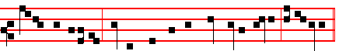
Mary Magdalene, out of whom he had cast seven devils, al-le-lu-ia.
Collect of the preceding Sunday, p. 819.
Afterwards commemoration is made of the Cross, as below, or as in the Psalter, p. 247, which is made daily in Lauds and Vespers until the Ascension, both in the Office of the Season, and of the Saints; unless it be a Double, or within Octaves. The other commemorations of S. Mary, of the Apostles, and of Peace, are not said in Eastertide.
In Lauds, Antiphon of the Cross, as in the Psalter, p. 247.
He that was crucified is risen from the dead; and hath redeemed us, alleluia, alleluia.
 Tell it out among the nations, alleluia.
 That the Lord reigneth from the Tree, alleluia. Let us pray.
COLLECT
O GOD, who didst will that thy Son should for us undergo the burden of the Cross, that he might deliver us from the power of the enemy: grant unto us thy servants that we may attain unto the joy of his resurrection. Through the same.
In Vespers, Antiphon as in the Psalter, 247.
He the holy Cross endured, Burst the gates of hell in twain: Begirt with might and majesty, On Easter morn he rose again, alleluia.
 and Collect as above.

At the Hours, all as in the Psalter in Eastertide. In the ferial Office Prime is said as on Simple Feasts, in all Eastertide. At the other Hours, the Antiphons, Chapters and  are found in the Psalter in the proper places.
At Vespers, Antiphon and Psalms as in the Psalter, in Eastertide, 202.
Chapter Christ being raised, p. 822. Hymn E.H. l25 Ad cenam and  Abide, p. 811-812.
On Magnificat, Antiphon.
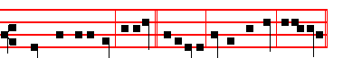
Peace be unto you, it is I, * alleluia, be not afraid, alleluia.

823
The Invitatory, Hymns, Chapters, and Short  given above are said in the ferial Office until the Ascension.
__________________________________________________________________

TUESDAY

From the Acts of the Apostles.
Lesson j Ch.2
AND when the day of Pentecost was fully come, they were all with one accord in one place. And suddenly there came a sound from heaven as of a rustling mighty wind, and it filled all the house where they were sitting. And there appeared unto them cloven tongues like as of fire, and it sat upon each of them. And they were all filled with the Holy Ghost, and began to speak with other tongues, as the Spirit gave them utterance. And there were dwelling at Jerusalem Jews, devout men, out of every nation under heaven. Now when this was noised abroad. the multitude came together, and were confounded, because that every man heard them speak in his own language. And they were all amazed and marvelled. saying one to another, Behold, are not all these which speak Galilæans? And how hear we every man in our own tongue, wherein we were born?

 Behold, the lion of the tribe of Judah, thc root of David, hath prevailed to open the book and to loose the seven seals thereof. * Alleluia, alleluia, alleluia.
 Worthy is the lamb that was slain to receive power. and riches. and wisdom. and strength, and honour, and glory, and blessing. Alleluia.

Lesson ij
BUT Peter, standing up with the eleven, lifted up his voice, and said unto them, Ye men of Judæa, and all ye that dwell at Jerusalem, be this known unto you, and hearken to my words: For these are not drunken, as ye suppose, seeing it is but the third hour of the day. But this is that which was spoken by the prophet Joel: And it shall come to pass in the last days, saith God, I will pour out of my Spirit upon all flesh: and your sons and your daughters shall prophesy, and your young men shall see visions, and your old men shall dream dreams: and on my servants and on my handmaidens 1 will pour out in those days of my Spirit; and they shall prophesy: and I will shew wonders in heaven above, and signs in the earth beneath; blood, and fire, and vapour of smoke: the sun shall be turned into darkness, and the moon into blood, before that great and notable day of the Lord come: and it shall come to pass, that whosoever shall call on the name of the Lord shall be saved.

 I am the true vine, ye are the branches: * He that abideth in me and I in him,

824
the same bringeth forth much fruit, alleluia, alleluia.
 As the Father hath loved me, so have I loved you. He that. Glory be. He that.

Lesson iij
YE men of Israel, hear these words; Jesus of Nazareth, a man approved of God among you by miracles and wonders and signs, which God did by him in the midst of you, as ye yourselves also know: him, being delivered by the determinate counsel and foreknowledge of God, ye have taken, and by wicked hands have crucified and slain: whom God hath raised up, having loosed the pains of death: because it was not possible that he should bc holden of it. For David speaketh concerning him, I foresaw the Lord always before my face, for he is on my right hand, that I should not be moved: Therefore did my heart rejoice, and my tongue was glad; moreover also my flesh shall rest in hope: because thou wilt not leave my soul in hell, neither wilt thou suffer thine Holy One to see corruption.
Te Deum Laudamus, 9.

On Benedictus, Antiphon.
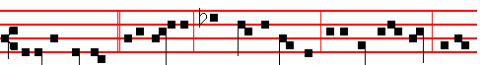
I go before you * into Galilee: there shall ye see me, as I said unto you, al-le-
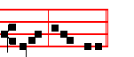
-luia, alle- luia.
On Magnificat, Antiphon.
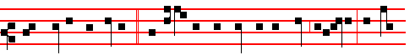
Reach hither thy finger, * and examine the print of the nails, alleluia: and be
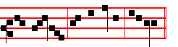
not faithless, but believing, alleluia.
__________________________________________________________________

WEDNESDAY
Frem the Acts of the Apostles.

825
Lesson j Ch.3
NOW Peter and John went up together into the temple at the hour of prayer, being the ninth hour. And a certain man lame from his mother's womb was carried, whom they laid daily at the gate of the temple which is called beautiful, to ask alms of them that entered into the temple; who seeing Peter and John about to go into the temple asked an alms. And Peter, fastening his eyes upon him with John, said, Look on us. And he gave heed unto them, expecting to receive something of them. Then Peter said, Silver and gold have I none; but such as I have give I thee: In the name of Jesus Christ of Nazareth rise up and walk.

 After that our Lord Jesus was risen, he came and stood in the midst of his disciples, and said: * Peace be unto you, alleluia: then were the disciples glad, when they saw the Lord, alleluia.
 The first day of the week, when the doors were shut where the disciples were assembled came Jesus, and stood in the midst of them, and saith unto them. Peace.

Lesson ij
AND he took him by the right hand, and lifted him up: and immediately his feet and ancle bones received strength. And he leaping up stood, and walked, and entered with them into the temple, walking, and leaping, and praising God. And all the people saw him walking and praising God: And they knew that it was he which sat for alms at the beautiful gate of the temple: and they were filled with wonder and amazement at that which had happened unto him. And as the lame man which was healed held Peter and John, all the people ran together unto them in the porch that is called Solomon's, greatly wondering.

 Purge out thercfore the old leaven, that ye may be a new lump: for even Christ our Passover is sacrificed for us: * Therefore let us keep the Feast in the Lord, alleluia.
 He died for our sins, and rose again for our justification. Therefore. Glory be. Therefore.

Lesson iij
AND when Peter saw it, he answered unto the people, Ye men of Israel, why marvel ye at this? or why look ye so earnestly on us, as though by our own power or holiness we had made this man to walk? The God of Abraham, and of Isaac, and of Jacob, the God of our fathers, hath glorified his Son Jesus; whom ye delivered up, and denied him in the presence of Pilate, when he was determined to let him go. But ye denied the Holy One and the Just, and desired a murderer to be granted unto you; and killed the Prince of life, whom God hath raised from the dead; whereof we are witnesses. And his name through faith in his name hath

826
made this man strong, whom ye see and know: yea, the faith which is by him hath given him this perfect in the presence of you all.
Te Deum Laudamus, 9.
On Benedictus, Antiphon.
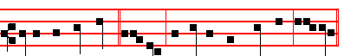
I am the true vine, * alleluia: and ye are the branches, alle-luia.
On Magnificat, Antiphon.
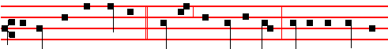
Because thou hast seen me, * Thomas, thou hast believed: blessed are they that
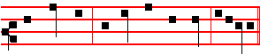
have not seen, and yet have believed, alleluia.
__________________________________________________________________

THURSDAY
From the Acts of the Apostles.
Lesson j Ch. 5
BUT a certain man named Ananias, with Sapphira his wife, sold a possession. And kept back part of the price, his wife also being privy to it, and brought a certain part, and laid it at the apostles' feet. But Peter said. Ananias, why hath Satan filled thine heart to lie to the Holy Ghost, and to keep back part of the price of the land? Whiles it remained, was it not thine own? and after it was sold, was it not in thine own power? why hast thou conceived this thing in thine heart? thou hast not lied unto men but unto God. And Ananias hearing these words fell down, and gave up the ghost: and great fear came on all them that heard these things. And the young men arose, wound him up, and carried him out, and buried him.

 Christ being risen from the dead dieth no more, death hath no more dominion over him: for in that he died. he died unto sin once: * But in that he liveth, he liveth unto God, alleluia, alleluia.
 He died once for our sins and was raised agaIn for our justification. But in.

Lesson ij
AND it was about the space of three hours after, when his wife, not knowing what was done, came in. And Peter answered unto her, Tell me whether ye

827

sold the land for so much? And she said, Yea, for so much. Then Peter said unto her, How is it that ye have agreed together to tempt the Spirit of the Lord? behold, the feet of them which have buried thy husband are at the door, and shall carry thee out. Then fell she down straightway at his feet, and yielded up the ghost: and the young men came in, and found her dead, and carrying her forth, buried her by her husband. And great fear came upon all the church, and upon as many as heard these things.

 The good Shepherd is risen, who hath laid down his life for the sheep, and hath vouchsafed to die for his flock. * Alleluia, alleluia, alleluia.
 For Christ our Passover is sacrificed for us. Alleluia. Glory be. Alleluia.

Lesson iij
AND by the hands of the apostles were many signs and wonders wrought among the people; (and they were all with one accord in Solomon's Porch. And of the rest durst no man join himself to them: but the people magnified them.
And believers were the more added to the Lord, multitudes both of men and women, insomuch that they brought forth the sick into the streets, and laid them on beds and couches, that at the least the shadow of Peter passing by might overshadow some of them. There came also a multitude out of the cities round about unto Jerusalem, bringing sick folks, and them which were vexed with unclean spirits: and they were healed every one.
Te Deum Laudamus, 9
On Benedictus, Antiphon.
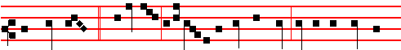
My heart burns * within me; I desire to behold my Lord: I seek, and find not
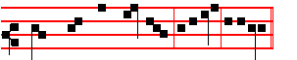
where they have laid him, alleluia, alleluia.

On Magnificat, Antiphon.
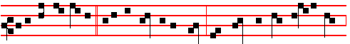
I did put my finger * into the print of the nails, and thrust my hand into his side,

828
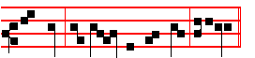
and said, My Lord and my God, alleluia.
__________________________________________________________________

FRIDAY
From the Acts of the Apostles.
Lesson j Ch. 8
BUT there was a certain man, called Simon, which beforetime in the same city used sorcery, and bewitched the people of Samaria, giving out that himself was some great one: to whom they all gave heed; from the least to the greatest, saying, This man is the great power of God. And to him they had regard, because that of long time he had bewitched them with sorceries. But when they believed Philip preaching the things concerning the kingdom of God, and the name of Jesus Christ, they were baptized, both men and women. Then Simon himself believed also: and when he was baptized, he continued with Philip, and wondered,
beholding the miracles and signs which were done.

 With great power gave the Apostles * Witness of the resurrection of our Lord Jesus Christ, alleluia, alleluia.
 They were all filled with the Holy Ghost, and they spake the word of God with boldness. Witness.

Lesson ij
NOW when the apostles which were at Jerusalem heard that Samaria had received the word of God, they sent unto them Peter and John: who, when they were come down, prayed for them, that they might receive the Holy Ghost: (For as yet he was fallen on none of them: only they were baptized in the name of the Lord Jesus.) Then laid they their hands on them, and they received the Holy Ghost. And when Simon saw that through laying on of the apostles' hands the Holy Ghost was given, he offered them money, saying, Give me also this power, that on whomsoever I lay hands, he may receive the Holy Ghost.

 From the mouth of the wise proceedeth honey, alleluia, the sweetness of honey is under his tongue, alleluia. * His lips drop as the honeycomb, alleluia, alleluia.
 Wisdom doth abide in his heart, and out of his mouth cometh understanding. His lips. Glory be. His lips.

Lesson iij
BUT Peter said unto him, Thy money perish with thee, because thou hast thought that the gift of God may be purchased with money. Thou hast neither

829

part nor lot in this matter: for thy heart is not right In the sight of God. Repent therefore of this thy wickedness, and pray God, if perhaps the thought of thine heart may be forgiven thee. For I perceive that thou art in the gall of bitterness, and in the bond of iniquity. Then answered Simon, and said, Pray ye to the Lord for me, that none of these things which ye have spoken come upon me.
Te Deum Laudamus, 9.
On Benedictus, Antiphon. Tone j, 1.
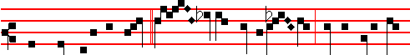
There came unto the tomb * Mar- y Magdale- ne and the other Ma-
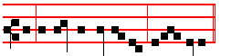
-ry, to see the sepulchre, al-le- luia.
At Vespers, unless there occur a Feast of ix Lessons, the Office from the Chapter is of S. Mary.
__________________________________________________________________

SATURDAY
From the Acts of the Apostles.
Lesson j Ch. 10
THERE was a certain man in Cæsarea called Cornelius, a centurion of the band called the Italian band, A devout man, and one that feared God with all his house, which gave much alms to the people, and prayed to God alway. He saw in a vision evidently about the ninth hour of the day an angel of God coming in to him, and saying unto him, Cornelius. And when he looked on him, he was afraid, and said, What is it, Lord? And he said unto him. Thy prayers and thine alms are come up for a memorial before God. And now send men to Joppa, and call for one Simon, whose surname is Peter: He lodgeth with one Simon a tanner, whose house is by the sea side: he shall tell thee what thou oughtest to do. And when the angel which spake unto Cornelius was departed, he called two of his household servants, and a devout soldier of them that waited on him continually; and when he had declared all these things unto them, he sent them to Joppa.

Lesson ij
ON the morrow, as they went on their journey, and drew nigh unto the city, Peter went up upon the housetop to pray about the sixth hour: and he became very hungry, and would have eaten: but while they made ready, he fell into a

830
trance, and saw heaven opened, and a certain vessel descending unto him, as it had been a great sheet knit at the four corners, and let down to the earth: wherein were all manner of four-footed beasts of the earth, and wild beasts, and creeping things, and fowls of the air. And there carne a voice to him, Rise, Peter; kill, and eat. But Peter said, Not so, Lord: for I have never eaten any thing that is common or unclean. And the voice spake unto him again the second time, What God hath cleansed, that call not thou common. This was done thrice: and the vision was received up again into heaven. Now while Peter doubted in himself what this vision which he had seen should mean, behold, the men which were sent from Cornelius had made inquiry for Simon's house, and stood before the gate, and called, and asked whether Simon, which was surnamed Peter, were lodged there.

Lesson iij
THEN Peter opened his mouth, and said, Of a truth I perceive that God is no respecter of persons: but in every nation he that feareth him, and worketh righteousness, is accepted with him. The word which God sent unto the children of Israel, preaching peace by Jesus Christ: (he is Lord of all:) that word, I say, ye know, which was published throughout all Judæa, and, began from Galilee, after the baptism which John preached; how God anointed Jesus of Nazareth with the Holy Ghost and with power: who went about doing good, and healing all that were oppressed of the devil; for God was with him. And we are witnesses of all things which he did both in the land of the Jews, and in Jerusalem; whom they slew and hanged on a tree: him God raised up the third day, and shewed him openly; not to all the people, but unto witnesses chosen before of God, then to us, who did eat and drink with him after he rose from the dead.
Te Deum Laudamus, 9.

At Vespers, Antiphon. Alleluia. Psa1m 144 Benedictus, with the rest, p. 236.
Chapter I Peter 2
DEARLY beloved: Christ also suffered for us,leaving us an example, that ye should follow his steps: who did no sin, neither was guile found in his mouth.
Hymn E.H. l25 Ad cenam, and  Abide, p. 812.
On Magnificat, Antiphon. Tone viij, 1.
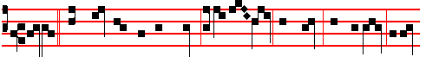
I am * the Shepherd of the sheep: I am the way, the truth, and the life: I am
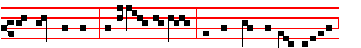
the good Shepherd; and I know my sheep, and am known of mine, alleluia,
831
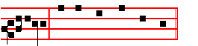
alleluia. Canticle Magnificat, p. 211.
COLLECT
O GOD, who in the humility of thy Son hast raised up a fallen world: grant unto thy faithful abiding gladness: that they whom thou hast delivered from the peril of eternal death, may be brought to the fruition of everlasting joys.Through the same.
Then of the Cross, as on p. 247.

THE SECOND SUNDAY AFTER EASTER
At Matins, Invitatory, p. 789ff, Hymn Rex sempiterne, p.813. Antiphons, Psalms and  as in the Psalter in Eastertide, p. 5.

IN THE FIRST NOCTURN
From the Acts of the Apostles.
Lesson j Ch. 13
NOW when Paul and his company loosed from Paphos, they came to Perga in Pamphylia: and John departing from them returned to Jerusalem. But when they departed from Perga, they came to Antioch in Pisidia, and went into the synagogue on the sabbath day, and sat down. And after the reading of the law and the prophets the rulers of the synagogue sent unto them, saying, Ye men and brethren, if ye have any word of exhortation for the people, say on. Then Paul stood up, and beckoning with his hand said, Men of Israel, and ye that fear God, give audience. The God of this people of Israel chose our fathers, and exalted the people when they dwelt as strangers in the land of Egypt, and with an high arm brought he them out of it. And about the time of forty years suffered he their manners in the wilderness. And when he had destroyed seven nations in the land of Chanaan, he divided their land to them by lot. And after that he gave unto them judges about the space of four hundred and fifty years, until Samuel the prophet.

 With great power gave the Apostles * Witness of the resurrection of our Lord Jesus Christ, alleluia, alleluia.
 They were all filled with the Holy Ghost. and they spake the word of God with boldness. Witness.

Lesson ij
AND afterward they desired a king; and God gave unto them Saul the son of Cis, a man of the tribe of Benjamin, by the space of forty years. And when he had removed him, he raised up unto them David to be their king; to whom also he

832
gave testimony, and said, I have found David the son of Jesse, a man after mine own heart, which shall fulfil all my will. Of this man's seed hath God according to his promise raised unto Israel a Saviour, Jesus: when John had first preached before his coming the baptism of repentance to all the people of Israel. And as John fulfilled his course, he said, Whom think ye that I am? I am not he. But, behold, there cometh one after me, whose shoes of his feet I am
not worthy to loose.

 From the mouth of the wise proceedeth honey, alleluia, the sweetness of honey is under his tongue, alleluia. * His lips drop as the honeycomb, alleluia, alleluia.
 Wisdom doth abide in his heart. and out of his mouth cometh understanding. His lips.

Lesson iij
MEN and brethren, children of the stock of Abraham, and whosoever among you feareth God, to you is the word of this salvation sent. For they that dwell at Jerusalem, and their rulers, because they knew him not, nor yet the voices of the prophets which are read every sabbath day, they have fulfilled them in condemning him. And though they found no cause of death in him, yet desired they Pilate that he should he slain. And when they had fulfilled all that is written of him, they took him down from the tree, and laid him in a sepulchre. But God raised him from the dead; and he was seen many days of them which came up with him from Galilee to Jerusalem, who are his witnesses unto the people. And we declare unto you glad tidings, how that the promise which was made unto the fathers, God hath fulfilled the same unto us their children, in that he hath raised up Jesus again; as it is also written in the second psalm, Thou art my Son, this day have I begotten thee.

 Behold, the lion or the tribe of Judah, the root of David, hath prevailed to open the book and to loose the seven seals thereof. * Alleluia, alleluia, alleluia.
 Worthy is the Lamb that was slain to receive power, and riches, and wisdom, and strength, and honour, and glory, and blessing. Alleluia. Glory be. Alleluia.

IN THE SECOND NOCTURN

Sermon by S. Leo the Great
Lesson iv Sermon 73 on theAscension of Our Lord
THESE days, dearly beloved, which flowed between the Lord's Resurrection and Ascension, pursued no idle course, but great mysteries were established in them, great wonders were revealed. In them the fear of dreadful death is taken away, and the immortality, not only of the soul, but of the body too, is declared. In

833
them, through the Lord's breathing, the Holy Spirit is poured out upon the Apostles. And to the blessed Apostle Peter, above the others, is entrusted, in addition to the keys of the kingdom, the care of the Lord's flock.

 I am the true vine, ye are the branches: * He that abideth in me and I in him, the same bringeth forth much fruit, alleluia, alleluia.
 As the Father hath loved me, so have I loved you. He.

Lesson v
IN these days, the Lord joins two, disciples as a third companion on the road, and in order to dispel all the darkness of our doubt, he rebukes the slowness of their timorous, wavering hearts: then their hearts are enlightened, and conceive the flame of faith: lukewarm no longer, they blaze up as the Lord expounds the scriptures. In the breaking of bread also, the eyes of them that sat at meat are opened: far more blessed is this revelation, showing them the glory of their nature, than was the opening of the eyes of our first parents, bringing them the realization of their guilt.

 After that our Lord Jesus was risen, he came and stood in the midst of his dis- ciples, and said: * Peace be unto you, alleluia: then were the disciples glad. when they saw the Lord. alleluia.
 The first day of the week. when the doors were shut where the disciples were assembled came Jesus, and stood in the midst of them, and saith unto them. Peace.

Lesson vj
BUT among these and other miracles, when the disciples were harassed with timorous and troubled thoughts, the Lord appeared in their midst, and said unto them, Peace be unto you. Lest the thought that they were pondering in their hearts should remain (for they thought that he was a spirit, and not a real body), he rebuked these thoughts that were opposed to the truth: he presented to the eyes of these doubting men the marks of the cross that still remained in his hands and feet; and he invited them to examine them. For the prints of the nails and spear had been retained to heal the wounds of their doubting hearts: so that with no wavering faith, but with the most steadfast certainty, it should be held that the same nature which had lain in the sepulchre was to sit on the throne of God the Father.

 Purge out therefore the old leaven, that ye may be a new lump: for even Christ our Passover is sacrificed for us: * Therefore let us keep the Feast in the Lord, alleluia.
834
 He died for our sins, and rose again for our justification. Therefore. Glory be. Therefore.
IN THE THIRD NOCTURN

The Lesson from the Holy Gospel according to S. John
Lesson vij Ch. 10
JESUS said unto the Pharisees: I am the good shepherd: the good shepherd giveth his life for the sheep. And the rest.
Homily by S. Gregory the Great Homily 14 on the Gospels
FROM this Gospel Lesson, beloved brethren, you have heard what pertains to your instruction and to our peril. Bchold, he who is good not through any chance gift but by his essential goodness, says, I am the good shepherd. And he gives us the pattern of his goodness that we are to imitate, The good shepherd giveth his life for the sheep. He did what he counselled. He enacted what he ordered. The good shepherd gave his life for the sheep, so that he might change his body and blood into our sacrament and satisfy the sheep he had redeemed with the food of his flesh.

 Christ being risen from the dead dieth no more, death hath no more dominion over him: for in that he died, he died unto sin once, * But in that he liveth, he liveth unto God, alleluia, alleluia.
 He died once for our sins, and was raised again for our justification. But in.

Lesson viij
WE have been shown the way of despising death, which we are to follow: the pattern is set out, to which we are to be shaped. The first thing we must do, is to expend our external goods in loving care for his sheep: but then afterwards, if needs be, we must tender even our mortality for these same sheep. Now, from this small beginning the subsequent great sacrifice is reached. But since our life, our very being, is an incomparably greater thing than our earthly goods which we possess in an external fashion: if a man will not give his substance for his sheep, when will he ever give his life for them?

 The good Shepherd is risen, who hath laid down his life for the sheep, and hath vouchsafed to die for his flock * Alleluia, alleluia, alleluia.
 For Christ our Passover is sacrificed for us. Alleluia. Glory be. Alleluia.

Lesson ix
AND there are some, who, while they love their posses- sions more than their sheep, deservedly lose the name of shepherd: of whom it goes on to say, But he that is an hireling and no t the shepherd, whose own the sheep are not, seeth

835
the wolf coming, and leaveth the sheep, and fleeth. The man who feeds the sheep, not because he loves them deeply, but for an earthly reward, is not called a shepherd, but an hireling. That man is truly an hireling who holds the position of shepherd, but does not seek the good of souls: he delights in episcopal honours, thrives on temporal rewards, and rejoices in the deference of men.
Te Deum Laudamus, 9.

At Lauds, Antiphons and Psalms of the Psalter, p. 28.
Chapter I Peter 2
DEARLY beloved: Christ also suffered for us, leaving us an example, that ye should follow his steps: who did no sin, neither was guile found in his mouth.
Hymn E.H. 123 Aurora lucis, p. 818, and  In thy resurrection, p. 819.
On Benedictus, Antiphon. Tone viij, 1 as above at Vespers, p. 831.
I am * the Shepherd of the sheep: I am the way, the truth, and the life: I am the Good Shepherd; and I know my sheep, and am known of mine, alleluia, alleluia.

COLLECT
O GOD,who in the humility of thy Son hast raised up a fallen world.: grant unto thy faithful abiding gladness: that they whom thou hast delivered from the peril of eternal death, may be brought to the fruition of everlasting joys. Through the same.
Commemoration of the Cross, as on p. 247.

AT TERCE
Chapter Dearly beloved, as above at Lauds.
Short  as in the Psalter, p. 70
The Lord is risen from the tomb, * Alleluia, alleluia. The Lord.
 Who for our sakes hung upon the tree. Alleluia, alleluia. Glory be. The Lord.
 The Lord is risen indeed, alleluia.
 And hath appeared to Simon, alleluia.
AT SEXT
Chapter I Peter 2
BUT he committed himself to him that judgeth righteously: who his own self bare our sins in his own body on the tree, that we, being dead to sins, should live unto righteousness: by whose stripes ye were healed.
Short  as in the Psalter, p.79.
The Lord is risen indeed. * Alleluia, alleluia. The Lord.
 And hath appeared to Simon. Alleluia, alleluia. Glory be. The Lord.
 Then were the disciples glad, alleluia.  When they saw the Lord, alleluia.

AT NONE

836
Chapter I Peter 2
FOR ye were as sheep going astray; but are now returned unto the Shepherd and Bishop of your souls.
Short  as in the Psalter, p. 88.
Then were the disciples glad. * Alleluia, alleluia. Then were.
 When they saw the Lord. Alleluia, alleluia. Glory be. Then were.
 Abide with us, Lord, alleluia.  For it is toward evening, alleluia.

AT VESPERS
Antiphons and Psalms of Sunday, p. 202ff.
Chapter Dearly beloved, p. 836, above.
Hymn E.H. 125 Ad cenam, p. 811 and  Abide, p. 812.
On Magnificat, Antiphon . Tone iij, 1.
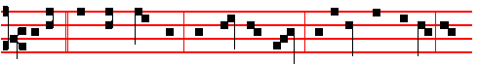
I am * the Good shepherd, who feed my sheep: and I lay down my life for
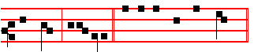
the sheep , al-le-luia. Canticle Magnificat, p. 209.
Collect O God, who, as above, p. 836. Then of the Cross, p. 274.
__________________________________________________________________________________________

MONDAY
Invitatory Alleluia, alleluia * Alleluia. Hymn Rex sempiterne, p. 813, Antiphon, Psalms and  as in the Psalter in Eastertide, p. 90.
From the Acts of the Apostles.
Lesson j Ch. 15
BUT there rose up certain of the sect of the Pharisees which believed, saying, That it was needful to circumcise them and to command them to keep the law of Moses. And the apostles and elders came together for to consider of this matter.
And when there had been much disputing, Peter rose up, and said unto them, Men and brethren, ye know how that a good while ago God made choice among us, that the Gentiles by my mouth should hear the word of the gospel, and believe. And God, which knoweth the hearts, bare them witness, giving them the Holy Ghost, even as he did unto us; and put no difference between us and them, purifying their hearts by faith. Now therefore why tempt ye God. to put a yoke upon the neck of the disciples, which neither our fathers nor we were able to bear?
But we believe that through the grace of the Lord Jesus Christ we shall be saved,

837
even as they. Then all the multitude kept silence, and gave audience to Barnabas and Paul, declaring what miracles and wonders God had wrought among the Gentiles by them.

 With great power gave the Apostles * Witness of the resurrection of our Lord Jesus Christ, alleluia, alleluia.
 They were all filled with the Holy Ghost, and they spake the word of God with boldness. Witness.

Lesson ij
AND after they had held their peace, James answered, saying, Men and brethren, hearken unto me. Simeon hath declared how God at the first did visit the Gentiles, to take out of them a people for his name. And to this agree the words of the prophets; as it is written, After this 1 will return, and will build again the tabernacle of David, which is fallen down; and I will build again the ruins thereof, and I will set it up, that the residue of men might seek after the Lord, and all the Gentiles, upon whom my name is called, saith the Lord, who doeth all these things. Known unto God are all his works from the beginning of the world. Wherefore my sentence is, that we trouble not them, which from among the Gentiles are turned to God: but that we write unto them, that they abstain from pollutions of idols, and from fornication, and from things strangled, and from blood. For Moses of old time hath in every city them that preach him, being read
in the synagogues every sabbath day.

 From the mouth of the wise proceedeth honey, alleluia, the sweetness of honey is under his tongue, alleluia. * His lips drop as the honeycomb, alleluia, alleluia.
 Wisdom doth abide in his heart, and out of his mouth cometh understanding. His lips. Glory be. His lips.

Lesson iij
THEN pleased it the apostles and elders, with the whole church, to send chosen men of their own company to Antioch with Paul and Barnabas; namely, Judas surnamed Barsabas, and Silas, chief men among the brethren: and they wrote letters by them after this manner: The apostles and elders and brethren send greeting unto the brethren which are of the Gentiles in Antioch and Syria and Cilicia: Forasmuch as we have heard, that certain which went out from us have troubled you with words, subverting your souls, saying, ye must be circumcised, and keep the law: to whom we gave no such commandment: it seemed good unto us, being assembled with one accord, to send chosen men unto you with our beloved Barnabas and Paul, men that have hazarded their lives for the name of our Lord Jesus Christ. We have sent therefore Judas and Silas, who shall also tell you

838
the same things by mouth. For it seemed good to the Holy Ghost, and to us, to lay upon you no greater burden than these necessary things; That ye abstain from meats offered to idols, and from blood, and from things strangled, and from fornication: from which if ye keep yourselves, ye shall do well. Fare ye well.
Te Deum Laudamus, 24.
At Lauds, Antiphons and Psalms as on Sundays in Eastertide, from the Psalter, p. 28.
Chapter Christ being raised, p. 822.
Hymn E.H. 123 Aurora, p. 818, and  In thy, p. 819.
On Benedictus, Antiphon.
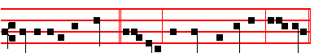
Go ye into the world, * alleluia, and teach all nations, alleluia.
On Magnificat,Antiphon.
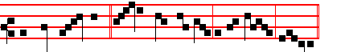
The Good Shepherd * layeth down his life for the sheep, alleluia.
__________________________________________________________________

TUESDAY
From the Acts of the Apostles.
Lesson j Ch. 17 and 18
THEN Paul stood in the midst of Mars' hill, and said, Ye men of Athens, I perceive that in all things ye are too superstitious. For as I passed by, and beheld your devotions, I found an altar with this inscription, TO THE UNKNOWN GOD. Whom therefore ye ignorantly worship, him declare I unto you. God that made the world and all things therein, seeing that he is Lord of heaven and earth, dwelleth not in temples made with hands; neither is worshipped with men's hands, as though hc needed any thing, seeing he giveth to all life, and breath, and all things; and hath made of one blood all nations of men for to dwell on all the face of the earth, and hath determined the times before appointed, and the bounds of their habitation: that they should seek the Lord, if haply they might feel after him, and find him, though he be not far from everyone of us:

 Behold, the lion of the tribe of Judah, the root of David, hath prevailed to open the book and to loose the seven seals thereof, * Alleluia, alleluia, alleluia,
 Worthy is the Lamb that was slain to receive power, and riches, and wisdom, and strength, and honour, and glory, and blessing. Alleluia.

839
Lesson ij
FOR in him we live, and move, and have our being; as certain also of your own poets have said, For we are also his offspring. Forasmuch then as we are the offspring of God, we ought not to think that the Godhead is like unto gold, or silver, or stone, graven by art and man's device. And the times of this ignorance God winked at; but now commandeth all men every where to repent: because he hath appointed a day, in the which he will judge the world in righteousness by that man whom he hath ordained; whereof he hath given assurance unto all men, in that he hath raised him from the dead. And when they heard of the resurrection of the dead, some mocked; and others said, We will hear thee again of this matter. So Paul departed from among them.

 I am the vine, ye are the branches: * Hc that abideth in me and I in him, the same bringeth forth much fruit, alleluia, alleluia.
 As the Father hath loved me, so have I loved you. He that. Glory be. He that.

Lesson iij
HOWBEIT certain men clave unto him, and believed: among the which was Dionysius the Areopagite, and a woman named Damaris, and others with them. After these things Paul departed from Athens, and came to Corinth; and found a certain Jew named Aquila, born in Pontus, lately come from Italy, with his wife Priscilla; (because that Claudius had commanded all Jews to depart from Rome:) and came unto them. And because he was of the same craft, he abode with them, and wrought: for by their occupation they were tentmakers. And he reasoned in the synagogue every sabbath, and persuaded the Jews and the Greeks.
Te Deum Laudamus, 24.
On Benedictus, Antiphon.
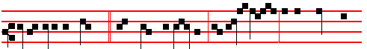
Go ye into the world. * and teach all nations, baptizing them in the Name of
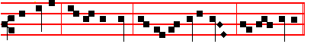
the Father, and of the Son, and of the Holy Ghost, al- le- lu- ia.
On Magnificat, Antiphon.
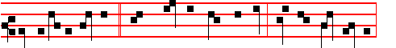
He that is an hireling, * whose own the sheep are not, seeth the wolf coming,

840
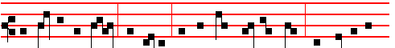 and leaveth the sheep, and fleeth: and the wolf catcheth them, and scat- tereth
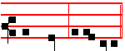
the sheep, al-le- lu-ia.
__________________________________________________________________

WEDNESDAY
From the Acts of the Apostles.
Lesson j Ch. 20
AND from Miletus Paul sent to Ephesus, and called the elders of the church. And when they were come to him, he said unto them. Ye know, from the first day that I came into Asia, after what manner I have been with you at all seasons, serving the Lord with all humility of mind, and with many tears, and temptations, which befell me by the lying in wait of the Jews: and how I kept back nothing that was profitable unto you, but have shewed you, and have taught you publickly, and from house to house, testifying both to the Jews, and also to the Greeks, repentance toward God, and faith toward our Lord Jesus Christ. And now, behold, I go bound in the spirit unto Jerusalem, not knowing the things that shall befall me there: save that the Holy Ghost witnesseth in every city, saying that bonds and affiictions abide me. But none of these things move me, neither count I my life dear unto myself, so that I might finish my course with joy, and the ministry, which I have received of the Lord Jesus, to testify the gospel of the grace of God.

 After that our Lord Jesus was risen, he came and stood in the midst of his disciples, and said: * Peace be unto you, alleluia: then were the disciples glad, when they saw the Lord, alleluia.
 The first day of the week, when the doors were shut where the disciples were assembled, came Jesus. and stood in the midst of them, and saith unto them. Peace.

Lesson ij
AND now, behold, I know that ye all, among whom I have gone preaching the kingdom of God, shall see my face no more. Wherefore I take you to record this day, that I am pure from the blood of all men. For I have not shunned to declare unto you all the counsel of God. Take heed therefore unto yourselves, and to all the ftock, over the which the Holy Ghost hath made you overseers, to feed

841
the church of God., which he hath purchased with his own blood. For I know this, that after my departing shall grievous wolves enter in among you, not sparing the ftock. Also of your own selves shall men arise, speaking perverse things, to draw away disciples after them. Therefore watch, and remember, that by the space of three years I did ceased not to warn everyone night and day with tears.

 Purge out, therefore, the old leaven, that ye may be a new lump: for even Christ our Passover is sacrificed for us: * Therefore let us keep the Feast in the Lord, alleluia.
 He died for our sins, and rose again for our justification. Therefore. Glory be. Therefore.

Lesson iij
AND now, brethren, I commend you to God, and to the word of his grace, which is able to build you up, and to give you an inheritance among all them which are sanctified. I have coveted no man's silver, or gold, or apparel. Yea, ye yourselves know, that these hands have ministered unto my necessities, and to them that were with me. I have shewed you all things, how that so labouring ye ought to support the weak, and to remember the words of the Lord Jesus, how he said, It is more blessed to give than to receive. And when he had thus spoken, he kneeled down, and prayed with them all. And they all wept sore, and fell on Paul's neck, and kissed him, sorrowing most of all for the words which he spake, that they should see his face no more. And they accompanied him unto the ship.
Te Deum Laudamus, p. 24.

On Benedictus, Antiphon.
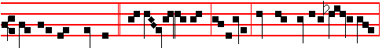
Go unto my brethren * and say unto them, alleluia: that they go into Gallilee,
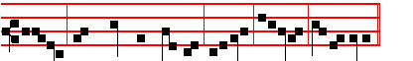
alleluia: there shall they see me, alleluia, alleluia, al-le-lu-ia.
On Magnificat, Antiphon.
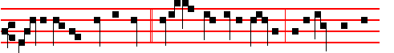
As the Father knoweth me, * even so know I the Fath-er: and I lay down my

842
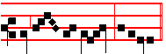
life for the sheep, alleluia.
__________________________________________________________________

THURSDAY
From the Acts of the Apostles.
Lesson j Ch. 24
THEN Paul, after that the governor had beckoned unto him to speak, answered, Forasmuch as I know that thou hast been of many years a judge unto this nation, I do the more cheerfully answer for myself: because that thou mayest understand, that there are yet but twelve days since I went up to Jerusalem for to worship. And they neither found me in the temple disputing with any man, neither raising up the people, neither in the synagogues, nor in the city: neither can they prove the things whereof they now accuse me. but this I confess unto thee, that after the way which they call heresy, so worship I the God of my fathers, believing all things which are written in the law and in the prophets: and have hope toward God, which they themselves also allow, that there shall be a resurrection of the dead, both of the just and unjust. And herein do I exercise myself, to have always a conscience void of offence toward God, and toward men.

 Christ being risen from the dead dieth no more, death hath no more dominion over him: for in that he died, he died unto sin once, * But in that he liveth, he liveth unto God, alleluia, alleluia.
 He died once for our sins, and was raised again for our justification. But in.

Lesson ij
NOW after many years I came to bring alms to my nation, and offerings. Whereupon certain Jews from Asia found me purified in the temple, neither with multitude, nor with tumult, who ought to have been here before thee, and object, if they had ought against me. Or else let these same here say, if they have found any evil doing in me, while I stood before the council, except it be for this one voice, that I cried standing among them, Touching the resurrection of the dead I am called in question by you this day.

 The good Shepherd is risen, who hath laid down his life for the sheep, and hath vouchsafed to die for his flock * Alleluia, alleluia, alleluia.
 For Christ our Passover is sacrificed for us. Alleluia. Glory be. Alleluia.

Lesson iij
843
AND when Felix heard these things, having more perfect knowledge of that way, he deferred them, and said, When Lysias the chief captain shall come down, I will know the uttermost of your matter. And he commanded a centurion to keep Paul, and to let him have liberty, and that he should forbid none of his acquaintance to minister or come unto him. And after certain days, when Felix came with his wife Drusilla, which was a Jewess, he sent for Paul, and heard him concerning the faith in Christ. And as he reasoned of righteousness, temperance, and judgment to come, Felix trembled, and answered, Go thy way for this time; when 1 have a convenient season, I will call for thee. He hoped also that money should have been given him of Paul, that he might loose him, wherefore he sent for him the oftener, and communed with him. But after two years Porcius Festus came into Felix' room: and Felix, willing to shew the Jews a pleasure, left Paul bound.
Te Deum Laudamus, p. 24.

On Benedictus, Antiphon.
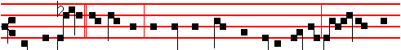 Art thou only * a stranger, and hast not heard concerning Jesus, how they de-
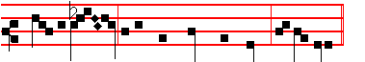
-livered him to be condemned to death? al-le -lu-ia.

On Magnificat, Antiphon.
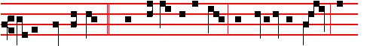
Other sheep I have, * which are not of this fold: them also I must bring, and
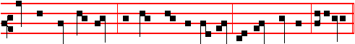
they shall hear my voice; and there shall be one fold and one Shepherd, alleluia.
__________________________________________________________________

FRIDAY
From the Acts of the Apostles.
Lesson j Ch. 25
844
NOW when Festus was come into the province, after three days he ascended from Cæsarea to Jerusalem. Then the high priest and the chief of the Jews informed him against Paul, and besought him, and desired favour against him, that he would send for him to Jerusalem. laying wait in the way to kill him. But Festus answered, that Paul should be kept at Cæsarea, and that he hilnself would depart shortly thither.Let them therefore, said he, which among you are able, go down with me, and accuse this man, if there be any wickedness in him.

 With great power gave the Apostles * Witness of the resurrection of our Lord Jesus Christ, alleluia, alleluia.
 They were all filled with the Holy Ghost, and they spake the word of God with boldness. Witness.

Lesson ij
AND when he had tarried among them more than ten days, he went down unto Cæsarea; and the next day sitting on the judgment seat commanded Paul to be brought. And when he was come, the Jews which came down from Jerusalem stood round about, and laid many and grievous complaints against Paul, which they could not prove. While he answered for himself, Neither against the law of the Jews, neither against the temple, nor yet against Cæsar, have I offended any thing at all.

 From the mouth of the wise proceedeth honey, alleluia, the sweetness of honey is under his tongue, alleluia. * His lips drop as the honeycomb, alleluia, alleluia.
 Wisdom doth abide in his heart, and out of his mouth cometh understanding. His lips.

Lesson iij
BUT Festus, willing to do the Jews a pleasure, answered Paul, and said, Wilt thou go up to Jerusalem, and there be judged of these things before me? Then said Paul, I stand at Cæsar's judgment seat, where I ought to be judged: to the Jews have I done no wrong, as thou very well knowest. For if I be an offender, or have committed any thing worthy of death, I refuse not to die: but If there be none of these things whereof these accuse me, no man may deliver me unto them. I appeal unto Cæsar. Then Festus, when he had conferred with the council, answered, Hast thou appealed unto Cæsar? unto Cæsar shalt thou go.
Te Deum Laudamus, 9.
On Benedictus, Antiphon.
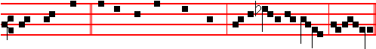
Ought not Christ * to have suffered these things, and to enter his glory? alleluia.
845

At Vespers, unless a Feast of ix Lessons occur, the Office from the Chapter is of S. Mary.
__________________________________________________________________

SATURDAY

From the Acts of the Apostles.
Lesson j Ch. 28
AND when we came to Rome. the centurion delivered the prisoners to the captain of the guard: but Paul was suffered to dwell by himself with a soldier that kept him. And it came to pass, that after three days Paul called the chief of the Jews together: and when they were come together, he said unto them, Men and brethren, though I have committed nothing against the people, or customs of our fathers, yet was I delivered prisoner from Jerusalem into the hands of the Romans, who, when they had examined me, would have let me go, because there was no cause of death in me. But when the Jews spake against it, I was constrained to appeal unto, Cæsar; not that I had ought to accuse my nation of. For this cause therefore have I called for you, to see you, and to speak with you: because that for the hope of Israel I am with this chain.

Lesson ij
AND they said unto him, We neither received letters out of Judæa, concerning thee, neither any of the brethren that came shewed or spake any harm of thee.
But we desire to hear of thee what thou thinkest: for as concerning this sect, we know that every where it is spoken against. And when they had appointed him a day, there came many to him into his lodging: to whom he expounded and testified the kingdom of God, persuading them concerning Jesus, both out of the law of Moses. and out of the prophets, from morning till evening. And some believed the things which were spoken, and some believed not.

Lesson iij
AND when they agreed not among themselves, they departed, after that Paul had spoken one word, Well spake the Holy Ghost by Esaias the prophet unto our fathers, saying, Go unto this people, and say, Hearing ye shall hear, and shall not understand: and seeing ye shall see, and not perceive: for the heart of this people is waxed gross, and their ears are dull of hearing, and their eyes have they closed; lest they should see with their eyes, and hear with their ears, and understand with their heart, and should be converted, and I should heal them.
Be it known therefore unto you, that the salvation of God is sent unto the Gentiles, and that they will hear it. And when he had said these words, the Jews departed, and had great reasoning among themselves. And Paul dwelt two whole years in

846
his own hired house, and received all that came in unto him, preaching the kingdom of God, and teaching those things which concern the Lord Jesus Christ, with all confidence, no man forbidding him.

AT VESPERS
Chapter I Peter 2
DEARLY beloved: I beseech you as strangers and pilgrims, abstain from fleshly lusts, which war against the soul.
Hymn E.H. l25 Ad cenam and  Abide, 459.
On Magnificat, Antiphon. Tone vj.
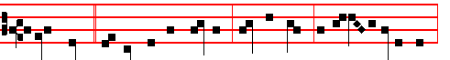
A little while,* and ye shall not see me, saith the Lord: and again, a little while,
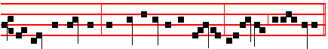
and ye shall see me, because I go to the Father, allelu-ia, al-le- luia.

COLLECT
ALMIGHTY GOD, who shewest to them that be in error the light of thy truth, to the intent that they may return into the way of righteousness: grant unto all them that are admitted into the fellowship of Christ's religion, that they may eschew those things that are contrary to their profession; and follow all such things as are agreeable to the same. Through the same.
Then of the Cross, p. 247.
__________________________________________________________________

THIRD SUNDAY AFTER EASTER

At Matins, Invitatory The Lord, p. 789, Hymn Rex sempiterne, p. 813. Antiphon, Psalms and  as in the Psalter in Eastertide, 5.

IN THE FIRST NOCTURN
The Beginning of the Revelation of S, John the Divine
Lesson j Ch. 1, 1-19
THE Revelation of Jesus Christ, which God gave unto him, to shew unto his servants things which must shortly come to pass; and he sent and signified it by his angel unto his servant John: who bare record of the word of God, and of the testimony of Jesus Christ, and of all things that he saw. Blessed is he that readeth,

847
and they that hear the words of this prophecy, and keep those things which are written therein: for the time is at hand, JOHN to the seven churches which are in Asia: Grace be unto you, and peace, from him which is, and which was, and which is to come: and from the seven Spirits which are before his throne; and from Jesus Christ, who is the faithful witness, and the first begotten of the dead, and the prince of the kings of the earth. Unto him that loved us, and washed us from our sins in his own blood, and hath made us kings and priests unto God and his Father; to him be glory and dominion for ever and ever. Amen.

 Thou art worthy to take the book, and to open the seals thereof, alleluia, for thou wast slain, and hast redeemed us to God * By thy blood, alleluia.
 And hast made us unto our God kings and priests. By thy.

Lesson ij
BEHOLD, he cometh with clouds; and every eye shall see him and they also which pierced him: and all kindreds of the earth shall wail because of him. Even so, Amen. I am Alpha and Omega, the beginning and the ending, saith the Lord, which is, and which is to come, the Almighty. I John, who also am your brother, and companion in tribulation, and in the kingdom and patience of Jesus Christ, was in the isle that is called Patmos, for the word of God, and for the testimony of Jesus Christ. I was in the Spirit on the Lord's day, and heard behind me a great voice, as of a trumpet, saying, I am Alpha and Omega, the first and the last: and, What thou seest, write in a book, and send it unto the seven churches which are in Asia; unto Ephesus, and unto Smyrna, and unto Pergamos, and unto Thyatira, and unto Sardis, and unto Philadelphia, and unto Laodicea.

 As the vine brought I forth pleasant savour, alleluia. * Come unto me, all ye that be desirous of me, and fill yourselves with my fruits, alleluia, alleluia.
 In me is all grace of the way and the truth: in me is all hope of life and of strength. Come unto.

Lesson iij
AND I turned to see the voice that spake with me. And being turned, I saw seven golden candlesticks; and in the midst of the seven candlesticks one like unto the Son of man, clothed with a garment down to the foot, and girt about the paps with a golden girdle. His head and his hairs were white like wool, as white as snow: and his eyes were as a flame of fire; and his feet like unto fine brass, as if they burned in a furnace: and his voice as the sound of many waters. And he had in his right hand seven stars: and out of his mouth went a sharp two-edged sword: and his countenance was as the sun shineth in his strength. And when I saw him, I
fell at his feet as dead. And he laid his right hand upon me, saying unto me, Fear

848

