home. And the Lord visited Hannah, so that she conceived, and bare three sons and two daughters. And the child Samuel grew before the Lord.

 Hearken, O Lord, unto the cry and to the prayer which thy servant prayeth before thee today, that thine eyes may be open, and thine ears attent, * Towards this house day and night.
 Look down from thine high and holy place, O Lord, even from heaven thy dwelling. Towards this. Glory be. Towards this.
__________________________________________________________________

On Thursday
is celebrated the Feast of the Body of Christ.

¶ If on this day there occur a Double or Semidouble Feast, it is transferred after the Octave: if a Simple, no commemoration is made of it.
¶ Within the Octave, nothing is said of a Feast, unless it be a Double: Semidoubles are transferred after the Octave; and of a Simple only a commemoration is made.
¶ On the Octave Day the Office is said only of the Nativity of Saint John, or the Feast of the holy Apostles Peter and Paul, or another of the more solemn feasts, if they occur, with commemoration of the Octave.

ON THE FEAST OF CORPUS CHRISTI
THE BODY OF CHRIST.

AT VESPERS
Antiphon 1. Tone j, 3.
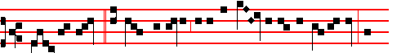
Christ the Lord, * a Priest for ever after the ord- er of Melchisedech, of-
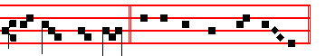
fered bread and wine. Psalm 110, Dixit Dominus, p. 202.
Antiphon 2. Tone ij.
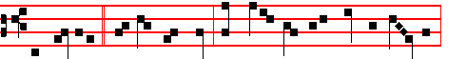
The merciful * and gracious Lord hath given meat unto them that fear him,

977
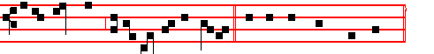
in remembrance of his marvellous doings. Psalm 111 Confitebor tibi, p.105.
Antiphon 3. Tone iij, 3
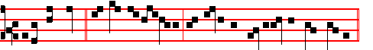
I will receive * the cup of salvation, and offer the sacrifice of thanksgiving.
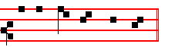
Psalm 116, v.10 Credidi, p. x.
Antiphon 4 . Tone iv, 1.
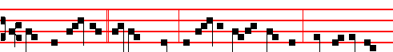
May the children * of the Church be like the olive-branches, round about the
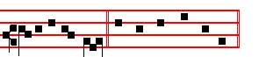
table of the Lord. Psalm 128 Beati omnes.
Antiphon 5 . Tone v.
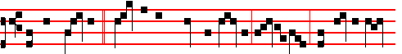 He that maketh * peace in the Church's borders is the Lord, who filleth us
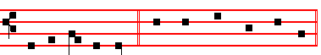
with the flour of wheat. Psalm 147, v.12 Lauda, Jerusalem
Chapter I Cor. 11
BRETHREN: I have received of the Lord that which also I delivered unto you, That the Lord Jesus the same night in which he was betrayed took bread: and when he had given thanks, he brake it, and said, Take,eat: this is my body, which is broken for you: this do in remembrance of me.

978
Hymn. E.H. 326. Pange lingua, gloriosi Corporis mysterium. Mode iij.
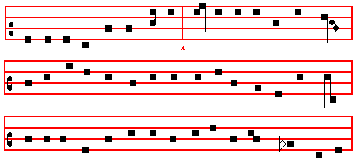

OF the glorious Body telling, 4 Word made Flesh, by word he maketh
O my tongue, its mysteries sing, Very bread his Flesh to be;
And the Blood, all price excelling, Man in wine Christ's Blood partaketh:
Which the world's eternal King, And if senses fail to see,
In a noble womb once dwelling, Faith alone the true heart waketh
Shed for this world's ransoming. To behold tho mystery.
Tantum ergo
2 Given for us, for us descending, 5 Therefore we, before him bending,
Of a Virgin to proceed, This great Sacrament revere;
Man with man in converse blending, Types and shadows have their ending,
Scattered he the Gospel seed, For the newer rite is here;
Till his sojourn drew to ending, Faith, our outward sense befriending,
Which he closed in wondrous deed. Makes the inward vision clear.

3 At the last great Supper lying 6 Glory let us give, and blessing
Circled by his brethren's band, To the Father, and the Son;
Meekly with the law complying, Honour, might, and praise addressing,
First he finished its command, While eternal ages run;
Then, immortal Food supplying, Ever too his love confessing,
Gave himself with his own hand. Who, as God, with both is one.

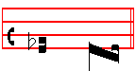
A- men.
 Thou gavest them bread from heaven, alleluia.
 Containing within itself all sweetness, alleluia.

979
On Magnificat, Antiphon. Tone vj
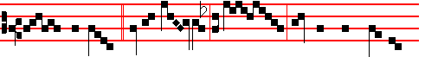
O how sweet * is thy Spi- rit, O Lord, who, that thou mightest
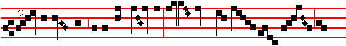
shew thy kindness unto thy children, givest them that sweetest bread from
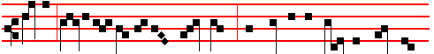
heaven, fillest the hungry with good things, and sendest the rich and scornful
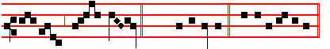
emp-ty a- way. (E. T. Al-le-lu-ia) E u o u a e.
COLLECT
O GOD, who under a wonderful sacrament hast left unto us a memorial of thy Passion: grant us, we beseech thee, so to venerate the sacred mysteries of thy Body and Blood; that we may ever perceive within ourselves the fruit of thy redemption: Who livest and reignest with God the Father.
¶ At Compline, and through the Hours at the end of the Hymns is said:
All honour, laud, and glory be,
O Jesu,Virgin-born, to thee;
And likewise throughout the whole Octave.
AT MATINS
Invitatory. Tone iv.
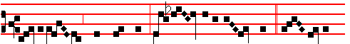
Let us worship Christ the King, Lord of the nat- ions, * Who giveth
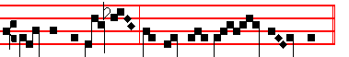
rich-ness of spi- rit to them that eat of him. It is repeated: Let us.

980
Psalm 95 Venite, exultemus Tone iv
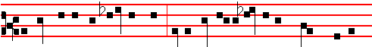
O come let us sing unto the Lord, let us heartily rejoice in the strength of our
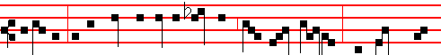
salvation: let us come before his presence with thanksgiv-ing, and shew our-
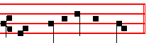
-selves glad in him with psalms. Choir: Let us

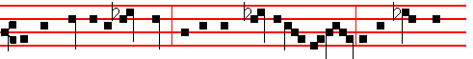
For the Lord is a great God, and a great King above all gods: in his hand are
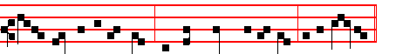
all the corners of the earth, and the strength of the hills is his al- so.

Choir: Who giveth.
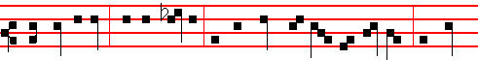
The sea is his, and he made it, and his hands prepared the dry land: O come,
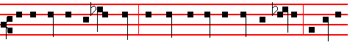
let us worship and fall down, and kneel before the Lord our Maker, for he is
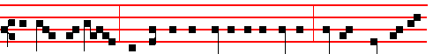
the Lord our God; and we are the people of his pasture, and the sheep of his

981
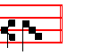
hand. Choir: Let us
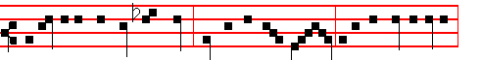
Today if ye will hear his voice, harden not your hearts, as in the provocation,
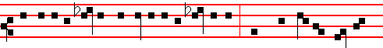
and as in the day of temptation in the wilderness: when your fathers tempt-ed
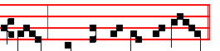
me, proved me, and saw my works. Choir: Who giveth
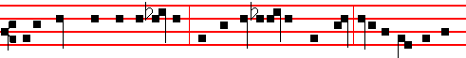
Forty years long was I grieved with this generation, and said: It is a people that
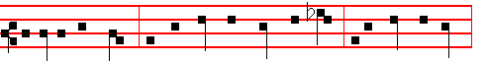
do err in their hearts, for they have not known my ways; unto whom I sware
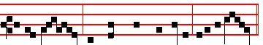
in my wrath, that they should not enter into my rest. Choir: Let us
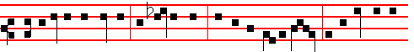
Glory be to the Father, and to the Son, and to the Holy Ghost: As it was in the
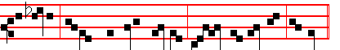
beginning, is now, and ever shall be, world without end. Amen
982
Choir: Who giveth. Cantors: Let us. Choir: Who giveth.

Hymn Sacris solemnis Mode j
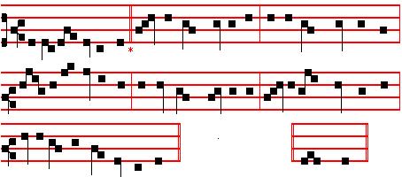
At this our solemn feast 4 HE gave them, weak and frail,
Let holy joys abound, His Flesh their food to be;
And from the inmost breast On them, downcast and sad,
Let songs of praise resound; His Blood bestowed he;
Let ancient rites depart, And thus to them he spake
And all be new around Receive this Cup from me
In every deed, in voice, in heart. And all of you of this partake.

2 Remember we that night 5 When he this Sacrifice
When, the last Supper spread, To institute did will
Christ, as we all believe, He to his priests alone
The lamb with leavenless bread That office to fulfil
Amongst his brethren shared On this wise did confide,
And thus the law obeyed, To whom pertaineth still
Of old unto their sires declared. To take, and to the rest divide.

3 The typick lamb consumed, 6 Lo! Angels' Bread is made
The Paschal feast complete, The Bread of men to-day;
The Lord unto the Twelve The living Bread from heaven
His Body gave to eat; With figures doth away;
The whole to all, no less O wondrous boon indeed!
The whole to each, did mete Though poor and lowly, may
With his own hands, as we confess. The servant on his Master feed. .

7 Thee therefore we implore,
O Godhead, One in Three,
So mayest thou visit us
As we now worship thee;
And lead us on thy way

983
That we at last may see
The light wherein thou dwellest ave. Amen.

IN THE FIRST NOCTURN
Antiphon. Tone j, 3.
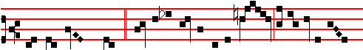
The Lord brought forth * fruit in the season of his death, to be eaten for
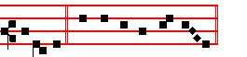
salvation. Psalm 1 Beatus vir, p. 5.
Antiphon. Tone ij.
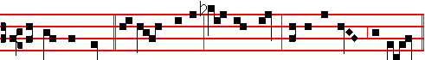
His faithful ones, * increased by his corn and wine, rest in the peace of Christ.
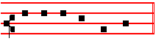
Psalm 4 Cum invocarem, p. 125.
Antiphon. Tone iij, 3.
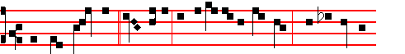
The Lord made us * one body, by partaking of one cup, which is not the
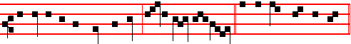
communion of the blood of bulls, but of God himself. Psalm 16 Conserva me
 Thou gavest them bread from heaven, alleluia.
 So man did eat Angels' food, alleluia.
From S. Paul's First Epistle to the Corinthians
Lesson j Ch. 11, 26-32.
WHEN ye come together therefore into one place, this is not to eat the Lord's supper. For in eating every one taketh before other his own supper: and one

984
is hungry, and another is drunken. What? have ye not houses to eat and to drink in? or despise ye the church of God, and shame them that have not? What shall I say to you? shall I praise you in this? I praise you not.

 I Tone j.
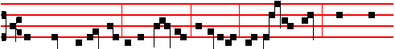
The whole assembly of the children of Israel shall kill the lamb towards the
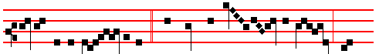
evening of the Pass- over, * And they shall eat the flesh and
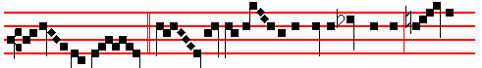
unleavened bread.  Christ our Passov- er is sacrificed for us, therefore
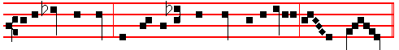
let us keep the feast with the unleavened bread of sincerity and truth.
And they.

Lesson ij
FOR I have received of the Lord that which also I delivered unto you, That the Lord Jesus the same night in which he was betrayed took bread: and when he had given thanks, he brake it, and said, Take, eat: this is my body, which is broken for you: this do in remembrance of me. After the same manner also he took the cup, when he had supped, saying, This cup is the new testament in my blood: this do ye, as oft as ye drink it, in remembrance of me. For as often as ye eat this bread, and drink this cup, ye do shew the Lord's death till he come.

 II Tone ij.
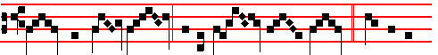
Ye shall eat flesh, and be filled with bread: * This is the

985
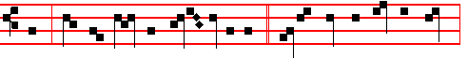
bread which the Lord hath given you to eat.  Moses gave you not that bread
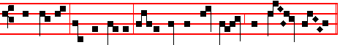
from heaven, but my Father giveth you the true bread from heav- en.
This is.

Lesson iij
WHEREFORE whosoever shall eafthis bread, and drink this cup of the Lord, unworthily, shall be guilty of the body and blood of the Lord. But let a man examine himself, and so let him eat of that bread, and drink of that cup. For he that eateth and drinketh unworthily, eateth and drinketh damnation to himself, not discerning the Lord's body. For this cause many are weak and sickly among you, and many sleep. For if we would judge ourselves, we should not be judged. But when we are judged, we are chastened of the Lord, that we should not be condemned with the world.

 III Tone iij.
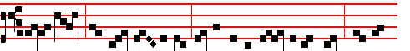
Elijah looked, and there was a cake baken on the coals at his head. And he
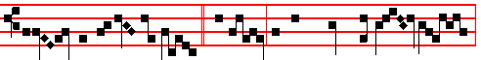
arose and did eat and drink, * And went in the strength of that meat
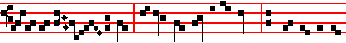
unto the mount of God.  If any man eat of this bread, he shall live fore-

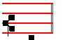
-ver. And went.

986
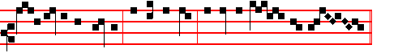
Glory be to the Father, and to the Son, and to the Ho- ly Ghost.
And went.

IN THE SECOND NOCTURN
Antiphon. Tone iv, 1.
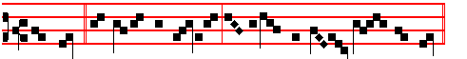
The Lord * remember our offering, and accept our burnt sac- ri- fice.
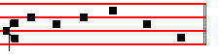
Psalm 20 Exaudiat te Dominus.
Antiphon. Tone v.
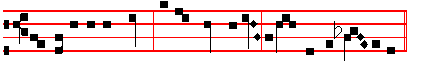
The table of the Lord * is prepared for us against all that trouble us.
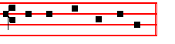
Psalm 23 Dominus regit me.
Antiphon. Tone vj
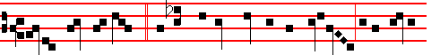
Let the voice of praise * resound among such as keep holy day at the table
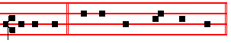
of the Lord. Psalm 42 Quemadmodum cervus.

 He fed them with the finest wheat flour,alleluia.
 And with honey out of the stony rock did he satisfy them, alleluia.

987
** From the Letter of Saint Augustine, Bishop, to Januarius.
Lesson iv Bk. 1 of replies; concerning Maundy Thursday. Ch.6.
AS to the question whether upon that day it is right to partake of food before either offering or partaking of the Eucharist, these words in the Gospel might go far to decide our minds, As they were eating, Jesus took bread and blessed it; taken in connection with the words in the preceding context, When the even was come, He sat down with the twelve: and as they did eat, He said, Verily I say unto you, that one of you shall betray me. For it was after that that He instituted the sacrament; and it is clear that when the disciples first received the body and blood of the Lord, they had not been fasting.

 IV Tone v. 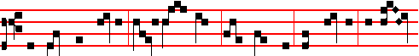
As they were eating, Jesus took bread,and blessed it, and brake it, and gave
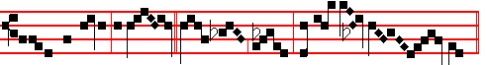
it to his disciples, and said: * Take, eat, this is my bo- dy.
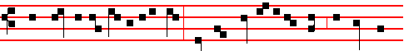
 The men of my tabernacle said, Who can give us of his flesh, that we may
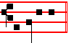
be satisfied? Take, eat.

Lesson v
MUST we therefore censure the universal Church because the sacrament is everywhere partaken of by persons fasting? Nay, verily, for from that time it pleased the Holy Spirit to appoint, for the honour of so great a sacrament, that the body of the Lord should take the precedence of all other food entering the mouth of a Christian; and it is for this reason that the custom referred to is universally observed. For the fact that the Lord instituted the sacrament after other food __________________________________________________________________
** The sermon of Thomas Aquinas is not given here for today and tomorrow. The passage from S.Augustine was chosen as touching on the reasons for the transferrance of this Feast out of Holy week. 988
had been partaken of, does not prove that brethren should come together to partake of that sacrament after having dined or supped, or imitate those whom the apostle reproved and corrected for not distinguishing between the Lord's Supper and an ordinary meal. The Saviour, indeed, in order to commend the depth of that mystery more affectingly to His disciples, was pleased to impress it on their hearts and memories by making its institution His last act before going from them to His Passion.

 V. Tone vj.
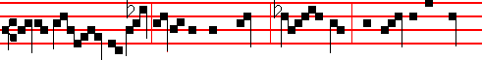
Jesus took the cup after he had supped, say- ing, This cup is the new
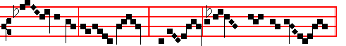
test- ament in my blood. * Do this in rememb-rance of me.
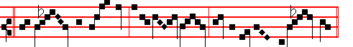
 My soul hath them still in rememb-rance, and is humbled within me.

Do this.

Lesson vj
AND therefore He did not prescribe the order in which it was to be observed, reserving this to be done by the apostles, through whom He intended to arrange all things pertaining to the Churches. Had He appointed that the sacrament should be always partaken of after other food, I believe that no one would have departed from that practice. But when the apostle, speaking of this sacrament, says, Wherefore, my brethren, when ye come together to eat, tarry one for another: and if any man hunger, let him eat at home; that ye come not together unto condemnation: he immediately adds, And the rest will I set in order when I come. Whence we are given to understand that, since it was too much for him to prescribe completely in an epistle the method observed by the universal Church throughout the world, it was one of the things set in order by him in person, for we find its observance uniform amid all the variety of other customs.

 VI. Tone vij
989
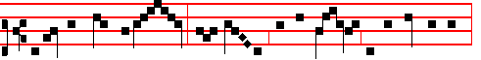
I am the bread of life: your fath-ers did eat man- na in the wilderness,
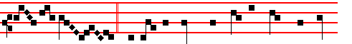
and are dead. * This is the bread which cometh down from heav-
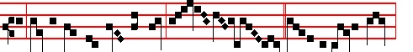
en, that a man may eat thereof and not die.  I am the living bread
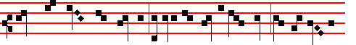
which came down from heaven; if any man eat of this bread, he shall live for
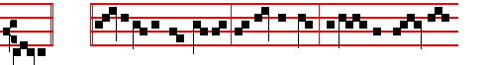
ever. This is. Glo-ry be to the Father, and to the Son, and to the Ho- ly
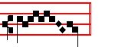
Ghost. This is.

IN THE THIRD NOCTURN
Antiphon. Tone vij, 3.
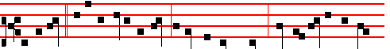
I will go * unto the altar of God; I will receive Christ, who reneweth my joy
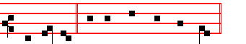
and gladness. Psalm 43 Judica me, Deus, p. 82.
Antiphon. Tone viij, 1.

990
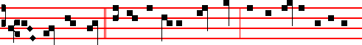
The Lord hath fed * us with the finest wheat flour, and with honey out of the
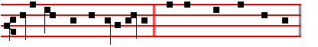
stony rock hath he satisfied us. Psalm 81 Exultate Deo.

Antiphon. Tone vj.
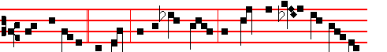
From thy altar,* O Lord, we receive Christ, in whom our heart and soul re-
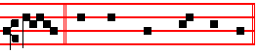
joice. Psalm 84 Quam dilecta, p. .

 Thou bringest bread out of the earth, alleluia.
 And wine that maketh glad the heart of man, alleluia.

The Lesson from the Holy Gospel according to S. John
Lesson vij Ch. 6
JESUS said unto the multitudes of the Jews: My flesh is meat indeed, and my
blood is drink indeed. And the rest.
Homily by S. Augustine, Bishop Homily 26 on John
SEEING that in meat and drink men aim at this, that they hunger not nor thirst, this thing verily and indeed doth nought afford, save only this meat and drink which maketh them by whom it is taken to be immortal and incorruptible: to wit, the very fellowship of saints, where shall be peace and unity, full and perfect. For to this end (as also men of God who were before us have understood this matter) did our Lord Jesus Christ betoken unto us his body and blood in things which are out of many units reduced to some one whole. For out of many grains is several made into one, and several doth out of many berries flow into one. In fine, he now explaineth how that is effected which he saith, and what it is to eat his body and drink his blood.

 VII. Tone vij.

991
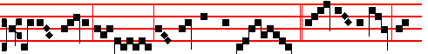
He that eateth my flesh and drinketh my blood * Dwelleth in me, and
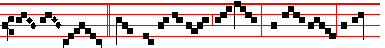
I in him.  What nation is there so great, who hath God so nigh
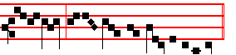
unto them, as the Lord our God is unto us. Dwelleth.

Lesson viij
HE that eateth my fresh, and drinketh my blood, dwelleth in me and I in him. This, then, it is, to eat that meat and drink that drink: to dwell in Christ and to have Christ dwelling in him. And therefore, who dwelleth not in Christ and in whom Christ dwelleth not, without doubt doth neither spiritually eat his flesh nor drink his blood, albeit carnally and visibly he press with his teeth the Sacrament of the body and blood of Christ: but rather doth unto judgment to himself eat and drink the Sacrament of so great a thing, because being unclean he hath presumed to come unto Christ's Sacraments, which no man taketh worthily, save he that is clean; of whom it is said, Blessed are the pure in heart, for they shall see God.

 VIII Tone viij.
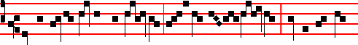
As the living Father hath sent me, and I live by the Father; * So he that eat-
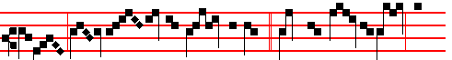
eth me, ev- en he shall live by me. With the bread of life and
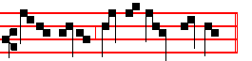
understanding shall the Lord feed him. So he.
992
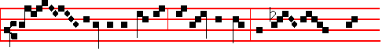
Glo - ry be to the Fa-ther, and to the Son, and to the
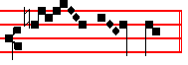
Ho - ly Ghost. So he.

Lesson ix
WHEN he said, As the living Father hath sent me and I live by the Father, so he that eateth me, even he shall live by me, it was as if he should say, That I should live by the Father, that is, should refer my life to him as greater, this was brought about by my emptying of myself wherein he sent me; but that any should live by me is effected by this participation whereby he eateth me. So then, I being brought low live by the Father; man being lifted high liveth by me. If, however, I live by the Father, was said in this sense, that he is of the Father, not the Father of him, it is spoken without disparagement to his equality: yet at the same time in saying, He that eateth me, even he shall live by me, he did not signify our equality and his to be the same, but herein intimated the grace of the Mediator.
Te Deum Laudamus, p. 24.

AT LAUDS, AND THROUGH THE HOURS
Antiphon 1. Tone j, 2.
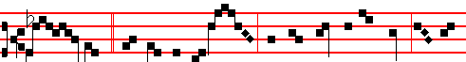
Wis- dom * hath builded her house, she hath mingled her wine, and fur-
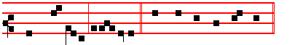
nished her table, alle- luia. Psalm 93 Dominus regnavit, and the rest, p. 28.
Antiphon 2. Tone ij.
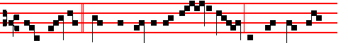
Thou feddest * thine own people with ang-els' food, and didst send them

993
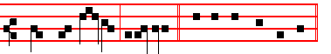
bread from heaven, alle- luia. E u o u a e.
Antiphon 3. Tone iij, 3.
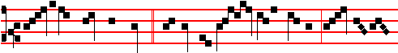
Rich is the bread of Christ,* and he shall yield royal dainties, al- le-
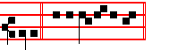
-luia. E u o u a e.
Antiphon 4. Tone iv, 1.
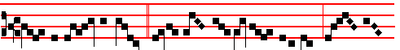
Con- se- crat- ed priests * offer bread and in- cense unto God, al- le-
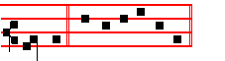
lu- ia. E u o u a e.
Antiphon 5. Tone v.
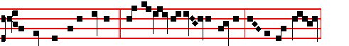
To him that overcometh * will I give the hidden manna, and a new name,
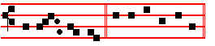
al- le- lu- ia. E u o u a e.

Chapter I Cor. 11
BRETHREN: I have received of the Lord that which also I delivered unto you, That the Lord Jesus the same night in which he was betrayed took bread: and when he had given thanks, he brake it, and said,Take, eat; this is my body, which is broken for you: this do in remembrance of me.

994
Hymn E.H. 330. Mode viij.
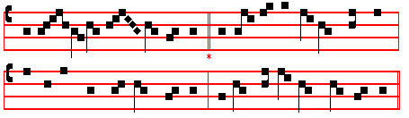
Verbum supernum prodiens, nec Patris
THE Word of God, proceeding forth 4 In birth man's fellow-man was he,
Yet leaving not his Father's side, His meat while sitting at the board;
And going to his work on earth, He died, his ransomer to be,
Had reached at length life's eventide He reigns to be his great reward,
Part 2. O salutaris
2 By false disciple to be given 5 O saving Victim! opening wide
To foemen for his blood athirst, The gate of heaven to man below,
Himself, the living Bread from heaven, Our foes press hard on every side,
He gave to his disciples first. Thine aid supply; thy strength bestow.

3 In hvofold form of sacrament 6 All praise and thanks to thee asoend
He gave his Flesh, he gave his Blood, For evermore, blest One in Three;
That man, of twofold substance blent, O grant us life that shall not end
Might wholly feed on mystic food. In our true native land with thee,
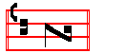
A- men.

 He maketh peace in thy borders, alleluia.
.And filleth thee with the flour of wheat, alleluia.

On Benedictus, Antiphon. Tone j, 2.
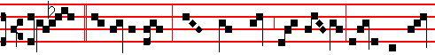
I am * the living bread, which came down from heaven: if any man eat 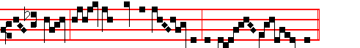 of this bread, he shall live for ev- er, al-le- lu- ia.

995
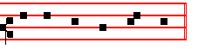
Canticle Benedictus, p.
COLLECT
O GOD,who under a wonderful Sacrament hast left unto us a memorial of thy Passion: grant us, we beseech thee, so to venerate the sacred mysteries of thy Body and Blood; that we may ever pereeive within ourselves the fruit of thy redemption: Who livest and reignest with God the Father.

AT PRIME
in the short 
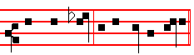
Who wast born of the Virgin Mary,
And so it is said throughout the whole Octave.
Alleluia is not added in the  of Prime and Compline, but in the other Hours.

AT TERCE
Antiphon. Thou feddest, p. 993.
Chapter Brethren: I have received, p. 994.
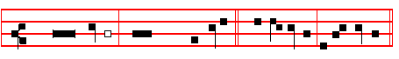
Short  He gave them bread from heaven.* Al-le- lu-ia, al-le- lu-ia.
He gave.
 So man did eat angels' food. Al-le- lu-ia, al-le- lu-ia.
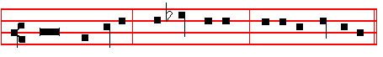
Glory be to the Father, and to the Son, and to the Holy Ghost.
He gave.
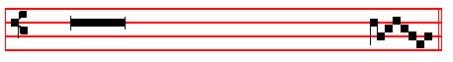
 He fed them with the finest wheat flour, allelu- ia.

996
 And with honey out of the stony rock did he satisfy them, alleluia.

AT SEXT
Antiphon. Rich is the bread of Christ, p. 994.
Chapter I Cor. 11
FOR as often as ye eat this bread,and drink this cup, ye do shew the Lord's death till he come.
Short  , tone as above, p. 996.
He fed them with the finest wheat flour. * Alleluia, alleluia. He fed
 And with honey out of the stony rock did he satisfy them. Alleluia, alleluia. Glory be. He fed.
Thou bringest bread out of the earth, alleluia.
 And wine that maketh glad the heart of man,alleluia

A T NONE
Antiphon. To him that overcometh, p. 994.
Chapter I Cor. 11
WHOSOEVER shall eat this bread, and drink this cup of the Lord, unworthily, shall be guilty of the body and blood of the Lord
Short ., tone as above, p. 996.
Thou bringest bread out of the earth. * Alleluia, alleluia. Thou bringest.
 And wine that maketh glad the heart of man. Alleluia, alleluia.
Glory be. Thou bringest.
 He maketh peace in thy borders, alleluia.
 And filleth thee with the flour of wheat, alleluia.

AT VESPERS
All is said as in I Vespers, 977 ff.
 Thou gavest them bread from heaven, alleluia.
 Containing within itself all sweetness, alleluia.
On Magnificat, Antiphon. Tone v.
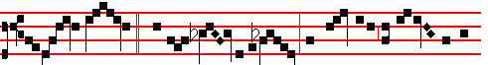
O sacred banquet, * wherein Christ is received, the memory of his passion is
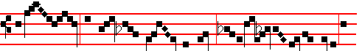
renewed; the soul with grace is filled, and a pledge of future glory is

997
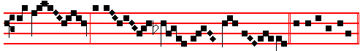
* bestowed, al- le- lu- ia. C. Magnificat.

Collect O God, who under, p. 996.
__________________________________________________________________

Friday within the Octave of Corpus Christi

In the first Nocturn.
From the first book of Kings.
Lesson j I Sam. 2
AND there came a man of God unto Eli, and said unto him, Thus saith the Lord, Did I plainly appear unto the house of thy father, when they were in Egypt in Pharaoh's house? And did I choose him out of all the tribes of Israel to be my priest, to offer upon mine altar, to burn incense, to wear an ephod before me? and did I give unto the house of thy father all the offerings made by fire of the children of Israel? Wherefore kick ye at my sacrifice and at mine offering, which I have commanded in my habitation; and honourest thy sons above me, to make yourselves fat with the chiefest of all the offerings of Israel my people ?
 The whole assembly, p. 985.

Lesson ij
WHEREFORE the Lord God of Israel saith, I said indeed that thy house, and the house of thy father, should walk before me for ever: but now the Lord saith, Be it far from me; for them that honour me I will honour, and they that despise me shall be lightly esteemed. Behold, the days come, that I will cut off thine arm, and the arm of thy father's house, that there shall not be an old man in thine ftouse. And thou shalt see an enemy in my habitation, in all the wealth which God shall give Israel: and there shall not be an old man in thine house forever. And the man of thine, whom I shall not cut off from mine altar, shall be to consume thine eyes, and to grieve thine heart: and all the increase of thine house shall die in the flower of their age.
 Ye shall eat flesh, p. 985.
__________________________________________________________________
* In the votive Office throughout the year it is concluded:
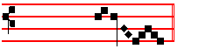
future glory is bestowed.
998
Lesson iij
AND this shall be a sign unto thee, that shall come upon thy two sons, on Hophni and Phinehas; 10 one day they shall die both of them. And I will raise me up a faithful priest, that shall do according to that which is in mine heart and in my mind: and I will build him a sure house; and he shall walk before mine anointed for ever. And it shall come to pass, that everyone that is left in thine house shall come and crouch to him for a piece of silver and a morsel of bread, and shall say, Put me, I pray thee, into one of the priests' offices, that I may eat a piece of bread.
 Elijah looked, p. 986.
IN THE SECOND NOCTURN
From the letter of Saint Augustine, Bishop, to Januarius.
Lesson iv From the same Bk 1.
THERE are, indeed, some to whom it has seemed right (and their view is not unreasonable), that it is lawful for the body and blood of the Lord to be offered and received after other food has been partaken of, on one fixed day of the year, the day on which the Lord instituted the Supper, in order to give special solemnity to the service on that anniversary. I think that, in this case, it would be more seemly to have it celebrated at such an hour as would leave it in the power of any who have fasted to attend the service before the repast which is customary at the ninth hour.
 As they were eating, p. 988.
Lesson v
WHEREFORE we neither compel nor do we dare to forbid any one to break his fast before the Lord's Snpper on that day. I believe, however, that the real ground upon which this custom rests is, that many, nay, almost all, are accustomed in most places to use the bath on that day. And because some continue to fast, it is offered in the morning, for those who take food, because they cannot bear fasting and the use of the bath at the same time; and in the evening, for those who have fasted all day.
 Jesus took the cup, p. 989.
Lesson vj
IF you ask me whence originated the custom of using the bath on that day, nothing occurs to me, when I think of it, as more likely than that it was to avoid the offence to decency which must have been given at the baptismal font, if the bodies of those to whom that rite was to be administered were not washed on some preceding day from the uncleanness consequent upon their strict abstinence from ablutjons during Lent; and that this particular day was chosen for the purpose because of its being the anniversary of the institution of the Supper. And this being granted to those who were about to receive baptism, many others desired to join them in the luxury of a bath, and in relaxation of their fast.
 I am the bread of life, p. 990.
999
IN THE THIRD NOCTURN
The Lesson from the Holy Gospel according to S. John
Lesson vij Ch. 6, 55-58.
JESUS said unto the multitudes of the Jews: My flesh is meat indeed, and my blood is drink indeed. And the rest.
Homily by S. Augustine, Bishop Homily 27 on John
WE have heard out of the Gospel the words of the Lord which follow upon the former discourse. Upon this a sermon is due to your ears and minds, and it is not unseasonable to the present day, for it relates to the Body of the Lord, which he saith that he giveth to be eaten for eternal life. But he expounded the manner of this bestowing; and of his gift, how he would give men his Flesh to eat, when he said, He that eateth my flesh, and drinketh my blood, dwelleth in me, and I in him. The sign which shews that one hath eaten and drunk is this, that if he dwelleth and is dwelt in, if he inhabiteth and is inhabited, if he cleaveth that he be not abandoned.
 He that eateth, p. 992

Lesson. viij
THIS then it is, that he hath taught and admonished us in mystical words, that we be in his Body, under himself the Head in his members, eating his flesh, not forsaking the unity of him. Howbeit, of those that were present, most of them by not understanding were offended: for in hearing these things they thought but of flesh, which they themselves were. But the Apostle saith, and saith truly, To be carnally-minded - to understand according to the flesh - is death. His Flesh the Lord giveth us to eat, and to understand according to the flesh is death; while yet of his Flesh he saith, that in It is life eternal. Therefore even the Flesh we must not understand after the flesh, as in these words following: Many therefore (not of his enemies, but) of his disciples, when they heard this, said, This is an hard saying, who can hear it?
 As the living Father, p. 992.

Lesson ix
IF disciples found this saying hard, what must enemies have done? And yet it was meet that it should be so said, which should not be understood by all. The secret of God ought to make us intent, not adverse. But these men quickly fell off at such speech of the Lord Jesus: they did not believe him to be saying some great thing, and covering with those words some grace; but as they would, so they understood, and after the manner of men, that Jesus was able, or was minding to do this, namely, to distribute, as it were, piecemeal, to them that believe on him, the Flesh with which the Word was clad. This, say they, is an hard saying: who can hear it?
Te Deum Laudamus, p. 24
1000
Saturday
In the first Nocturn
From the first book of Kings.
Lesson j I Sam. 3.
AND the child Samuel ministered unto the Lord before Eli. And the word of the Lord was precious in those days; there was no open vision. And it came to pass at that time, when Eli was laid down in his place, and his eyes began to wax dim, that he could not see; and ere the lamp of God went out in the temple of the Lord, where the ark of God was, and Samuel was laid down to sleep ; that the Lord called Samuel;, and he answered, Here am I. And he ran unto Eli, and said, Here am I; for thou calledst me. And he said, I called not; lie down again. And he went and lay down. And the Lord called yet again, Samuel. And Samuel arose and went to Eli, and said, Here am I; for thou didst call me. And he answered, I called not, my son; lie down again. Now Samuel did not yet know the Lord, neither was the word of the Lord yet revealed unto him.
 The whole assembly, p. 985.

Lesson ij
AND the Lord called Samuel again the third time. And he arose and went to Eli, and said, Here am I; for thou didst call me. And Eli perceived that the Lord had called the child, Therefore Eli said unto Samuel, Go, lie down: and it shall be, if he call thee, that thou shalt say, Speak, Lord; for thy servant heareth, So Samuel went and lay down in his place. And the Lord came, and stood, and called as at other times, Samuel, Samuel. Then Samuel answered, Speak; for thy servant heareth. And the Lord said to Samuel, Behold, I will do a thing in Israel, at which both the ears of everyone that heareth it shall tingle. In that day I will perform against Eli all things which I have spoken concerning his house: when I begin, I will also make an end.
 Ye shall eat flesh, p. 985.

Lesson iij
AND Samuel lay until the morning, and opened the doors of the house of the Lord. And Samuel feared to shew Eli the vision. Then Eli called Samuel, and said, Samuel, my son. And he answered, Here am I. And he said, What is the thing that the Lord hath said unto thee? I pray thee hide it not from me: God do so to thee, and more also, if thou hide any thing from me of all the things that he said unto thee. And Samuel told him every whit, and hid nothing from him. And he said, It is the Lord: let him do what seemeth him good. And Samuel grew, and the Lord was with him, and did let none of his words fall to the ground. And all Israel from Dan even to Beer-sheba knew that Samuel was established to be a prophet of the Lord.
 Elijah looked, p. 986.
1001
IN THE SECOND NOCTURN
Sermon of Saint John Chrysostom.
Lesson iv Homily 61 to the people of Antioch.
IT IS necessory, dearly beloved, to learn the miracle of the mysteries, what it is, and why it was given, and its benefit. We are made one body: members, he says, of his flesh, and of his bones; and having begun, let us follow what is said. And so not only in charity do we become one, but in very truth: for this is accomplished by the food which he bestowed on us, wishing to shew the desire that he has towards us. Therefore he joined himself with us, and mingled his body in us, that we might be a unity as a body joined to a head: for this is the way of those that love ardently.
 As they were eating, p. 958.

Lesson v
THEREFORE let us return from that table like lions breathing fire, having become terrible to the devil, and considering in our minds Him, our Head, and the love that He shews towards us. For some often give their children to others to be fed: but I, he says, not so; but I feed with my flesh, myself I serve forth to you, for I want you all to be of my noble family, and I hold out to you a good hope of things to come: for as here I have given myself to you, much more will I do so in future. I wanted to become your brother, I partook of flesh and blood for your sake: the same flesh and blood, through which I became your blood-brother, I give to you in return.
 Jesus took the cup, p. 989.

Lesson vj
AND so let us take heed to ourselves, dearly beloved, as we enjoy such good things: and when we are about to say some shameful thing, or see ourselves seized by anger, or any other such vice, let us consider what things we have been made worthy of: and let this thought be the correction of irrational passions in us. Therefore, as many of us as have been made partakers of this body, as many as have tasted the blood: let us consider, that we have tasted of him who sits on high, who is adored by Angels at the right hand of incorruptible power. Woe is me! How many ways to salvation there are for us: he has made us his body, he has made us partakers of his body, and none of these things turns us away from our sins.
 I am the bread of life, p. 990.
IN THE THIRD NOCTURN
The Lesson from the Holy Gospel according to S. John
Lesson vij Ch. 6, 55-58
JESUS said unto the multitudes of the Jews, My flesh is meat indeed, and my blood is drink indeed. And the rest.
1002
Homily by S. Augustine, Bishop Homily 27 on John
WE have said, that what the Lord hath given us to understand in the eating of his flesh and drinking of his blood, is, that we should dwell in him and he in us. Now we dwell in him, when we are his members, and he dwelleth in us, when we are his temple. But, that we should be his members, unity doth knit and compact us together. That unity may knit us in one, what save love effecteth? And the love of God, whence is it? Ask the Apostle: The love of God, saith he, is shed abroad in our hearts, by the Holy Spirit which is given us.
 He that eateth, p. 992.

Lesson viij
THEREFORE, It is the Spirit that quickeneth: for the Spirit maketh living members. Nor doth the Spirit make to be living members any save those which the Spirit itself doth find in the body which it quickeneth. For, the spirit which is in thee, O man, whereby it consisteth that thou art man, doth it make alive any member which it shall find separatcd from thy flesh? By thy spirit I mean thy soul; thy soul qulckeneth not, save the members which are in thy flesh; If thou take one away. now is it no more quickened of thy soul, because it is not coupled to the unity of thy body.
 As the living Father, p. 992.
Lesson ix
THESE things are said, that we may love unity, and fear separation. For there is nothing that a Christian ought so much to dread as to be separated from the Body of Christ. Since, if he be separated from the Body of Christ, he is not a member of him, he is not quickened by his Spirit: for, Whoso, saith the Apostle, hath not the Spirit of Christ, the same is none of his. The Spirit, then, it is that quickeneth; the flesh profiteth nothing. The words which I speak unto you, they are Spirit and Life. What meaneth this, Are Spirit and Life? Are spiritually to be understood. Hast thou spiritually understood ? They are Spirit and Life. Hast thou carnally understood? Even so, those are the Spirit and Life, but not to thee.
Te Deum Laudamus, p. 24.
AT VESPERS

Antiphon. Christ the Lord, with the other Antiphons and Psa1ms, p. 977 ff.
Chapter I Jn. 3
MARVEL not, my brethren, if the world hate you. We know that we have passed from death unto life, because we love the brethren.
Hymn E.H.326 Pange lingua, p. 979.
 He fed them with the finest wheat flour,allel!1ia.
 And with honey out of the stony rock did he satisfy them,alleluia.
On Magnificat, Antiphon. Tone vij, 3.

1003
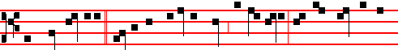
The child Samuel * ministered unto the Lord before Eli, and the word of the
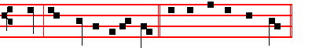
Lord was precious in his sight. Canticle Magnificat. p. 211.

OOLLECT
MAKE us, O Lord, to have a perpetual fear and love of thy holy name: for thou never failest to govern them whom thou dost bring up in thy steadfast love. Through.
Then commemoration is made of the Octave, as in II Vespers of the Feast, p. 997.
_________________________________________________________________

THE SUNDAY WITHIN THE OCTAVE,
WHICH IS THE SECOND AFTER PENTECOST
All is said of the Octave except the following.

IN THE FIRST NOCTURN
From the first book of Kings.
Lesson j I Sam. 4.
AND it came to pass in those days, that the Philistines came together to battle:
Now Israel went out against the Philistines to battle, and pitched beside Ebenezer: and the Philistines pitched in Aphek. And the Philistines put themselves in array against Israel: and when they joined battle, Israel was smitten before the Philistines: and they slew of the army in the field about four thousand men. And when the people were come into the camp, the elders of Israel said, Wherefore hath the Lord smitten us to day before the Philistines? Let us fetch the ark of the covenant of the Lord out of Shiloh unto us, that, when it cometh among us, it may save us out of the hand of our enemies.
 The whole assembly, p. 985.
Lesson ij
SO the people sent to Shiloh, that they might bring from thence the ark of the covenant of the Lord of hosts, which dwelleth between the cherubims: and the two sons of Eli, Hophni and Phineas, were there with the ark of the covenant of God. And when the ark of the covenant of the Lord came into the camp, all Israel shouted with a great shout, so that the earth rang again. And when the Philistines heard the noise of the shout, they said, What meaneth the noise of this great shout

1004
in the camp of the Hebrews? And they understood that the ark of the Lord was come into the camp.
 Ye shall eat flesh, p. 985.
Lesson iij
AND the Philistines were afraid, for they said, God is come into the camp. And they said, Woe unto us! for there hath not been such a thing heretofore. Woe unto us! who shall deliver us out of the hand of these mighty Gods? these are the Gods that smote the Egyptians with all the plagues in the wilderness. Be strong, and quit yourselves like men, O ye Philistines, that ye be not servants unto the Hebrews, as they have been to you: quit yourselves like men, and fight. And the Philistines fought, and Israel was smitten, and they fled every man into his tent: and there was a very great slaughter; for there fell of Israel thirty thousand fotmen. And the ark of God was taken; and the two sons of Eli, Hophni and Phinehas, were slain.
 Elijah looked, p. 986 .
IN THE SECOND NOCTURN
Sermon by S. John Chrysostom Homily 60 to the People of Antioch
Lesson iv
SINCE the Word says, This is my body; let us both confess and believe him, and let us behold him with the eyes of our mind. For Christ gave us not sensible things, but altogether intelligible ones, although disguised in sensible form. It is the same in baptism: the gift is given through sensible matter, namely water, but it is birth and renewal that is intelligibly effected. For if you were bodiless, he would have given you bodiless gifts. But since your soul is joined to your body, he gives you intelligible things in a sensible form. How many of you are saying, I wish I could see him in the flesh, see his face, his clothes, his shoes! Lo, you do see him, you touch him, you eat him, You want to see his clothes, while he indeed allows you not only to see him, but more than that, to eat and to touch and to receive him within you.
 As they were eating, p. 988.

Lesson v
THEN let none draw near in a weak and sickly manner, let all be ardent, all fervent and aroused. For if the Jews ate the Paschal lamb with their shoes on their feet and their staff in their hand, and in haste; how much more alert should you be! They indeed were about to set out for Palestine, and therefore they behaved as travellers: but you must go forth to heaven. Therefore be watchful in all things; for there is no small punishment decreed for those who receive unworthily. Consider how you are roused to indignation against the man who betrayed him, and against those who crucified him: and then consider whether you yourself are guilty of the body and blood of Christ. They killed his most holy body, but you receive it in your polluted soul, after so many benefits conferred. It

1005
was not enough for him to be made man, to be beaten with rods and crucified; he even made himself one with us: not only by faith, but truly in very deed he made us his own hody.
 Jesus took the cup, 989.

Lesson vj
WHO should be more spotless than he who partakes of such a sacrifice? And surely purer than a sunbeam should be the hand distributing this flesh, the mouth filled with this spiritual fire, the tongue reddened by this exceedingly awe-inspiring blood! Consider what tremendous honour is conferred upon you, at what table you are a guest. Angels tremble when they see him, nor do they dare to look on him, because of the dazzling splendour emanating from him: on him do we feed, to him we are united, and we are made of one body and of one flesh with Christ. Who can express the noble acts of the Lord, or shew forth all his praise? What shepherd feeds his flock with his own blood? And why do I say shepherd? Many are the mothers who after the pains of childbirth give their children to strangers to nurse: yet he would not suffer this, but he feeds us with his own blood, and in every way unites us to himself.
 I am the bread of life, p. 990.

IN THE THIRD NOCTURN
The Lesson from the Holy Gospe1 according to S. Luke
Lesson vij Ch. 14
JESUS spake this parable unto the Pharisees: A certain man made a great supper, and bade many. And the rest.
Homily by S. Gregory the Great Homily 36 on the Gospel.
THERE is this difference to be found, beloved brethren, between delights of the body and delights of the heart: with bodily delights, when we are without them we greatly desire them; but when we devour them our enjoyment soon turns to distaste through satiety. With spiritual delights, on the contrary, when we are without them we have no taste for them, but when we have them we desire them: then the more we taste of them, the more we desire them, and the more we desire them, the more we partake of them. With bodily delights, appetite is pleasing, participation displeasing; with spiritual ones, there is at first but little appetite, but participation brings pleasure. In the former, appetite begets abundance, abundance distaste: but in the latter while appetite procures abundance, abundance in turn procures appetite.
 He that eateth, p.992.

Lesson viij
FOR spiritual delights increase the mind's desire at the same time that they satisfy it: because the more they are experienced, the more does the mind

1006
become aware how much it loves them; what we do not possess cannot be loved, because it has not been experienced. For who can love what he has not known? Hence the Psalmist says, O taste and see, how gracious the Lord is. As though he were to say openly, You cannot realize his sweetness, if you have never tasted it, but only let the food of Life touch the palate of your heart, and you will discover its sweetness and be able to love it. Now man lost these delights when he sinned in Eden; and went out from there, when he shut his mouth against the food of everlasting sweetness.
 As the living Father, p. 992.

Lesson ix
WHENCE we also, born in this land of exile, have lost our taste for this food, and we know not what we ought to desire. And the longer the soul refrains from tasting that sweet food, the more this disease of distaste increases: until the soul will at length lose all appetite for inward delights through being so long unaccustomed to partaking of them. Therefore we waste away through our distaste, and are worn out by long and ruinous abstinence, and, not wishing to taste the inward sweetness that has been offered to us, we are so wretched that we love the famine which encompasses us.
Te Deum Laudamus, p. 24.
AT LAUDS

Antiphons as on the feast, p. 993-4.
Chapter I John 3
MARVEL mot, my brethren, if the world hate you. We know that we have passed from death unto life, because we love the brethren.
Hymn E.H. 330 Verbum supernum, p. 995.
 He gave them bread from heaven, alleluia.
 So man did eat angels' food, alleluia.

On Benedictus, Antiphon. Tone iij, 1.
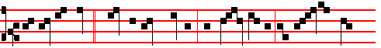
A certain man * made a great supper, and bade many; and sent his ser-
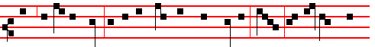
vants at supper time to say to them that were bidden, Come; for all things are

1007
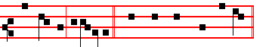
now ready, al-le-lu-ia. Canticle Benedictus, p. 29.

COLLECT
MAKE us, O Lord, to have a perpetual fear and love of thy holy name: for thou never failest to govern them whom thou dost bring up in thy steadfast love. Through.
Commemoration of the Octave as in Lauds of the Feast, p. 995-6. At Prime is said the Chapter of None, My little children, p. 579

AT TERCE
Antiphon. Thou feddest, p. 993 .
Chapter Marvel not, p. 1007.
Short  as above, p. 996.
He gave them bread from heaven.* Alleluia, alleluia. He gave.
 So man did eat Angels' food. Alleluia,alleluia. Glory be. He gave.
 He fed them with the finest wheat flour, alleluia.
 And with honey out of the stony rock did he satisfy them, alleluia.

AT SEXT
Antiphon. Rich is the bread of Christ, p. 994..
Chapter I John 3
HEREBY perceive we the love of God, because he laid down his life for us: and we ought to lay down our lives for the brethren.
Short  He fed them with the finest wheat flour.*Alleluia, alleluia. He fed.
 And with honey out of the stony rock did he satisfy them. Alleluia, alleluia. Glory be. He fed.
 Thou bringest bread out of the earth, alleluia.
 And wine that maketh glad the heart of man, alleluia.

AT NONE
Antiphon. To him that overcometh, p. 994.
Chapter I John 3
MY little children, let us not love in word, neither in tongue; but in deed and in truth.
Short  Thou bringest bread out of the earth.* Alleluia, alleluia. Thou bringest.
 And wine that maketh glad the heart of man. Alleluia, alleluia.
Glory be. Thou bringest.

1008
 He maketh peace in thy borders, alleluia.
 And filleth thee with the flour of wheat, alleluia.

AT VESPERS
Antiphons and Psalms as in I Vespers of the Feast, p. 977.
Chapter Marvel not, p. 1007.
Hymn E.H. 326 Pange lingua, p. 979.
 He fed them with the finest wheat flour, alleluia.
 And with honey out of the stony rock did he satisfy them, alleluia.
On Magnificat, Antiphon. Tone j, 4.
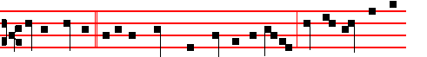
Go out quickly * into the streets and lanes of the ci- ty, and compel them to
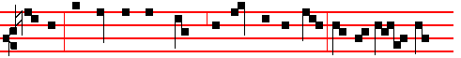
come in; the poor and the maimed, the halt and the blind, that my house may
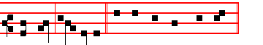
be filled, al-le-lu- ia. Canticle Magnificat, p. 209.
Collect Make us, O Lord, p. 1008.
Then commemoration is made of the Octave as in II Vespers of the Feast, pp. 907, 908, 906.
__________________________________________________________________

Monday

IN THE FIRST NOC'IURN
From the first book of Kings
Lesson j I Sam .5
AND the Philistines took the ark of God, and brought it from Ebenezer unto Ashdod. When the Philistines took the ark of God, they brought it into the house of Dagon, and set it by Dagon. And when they of Ashdod arose early on the morrow, behold, Dagon was fallen upon his face to the earth before the ark of the Lord. And they took Dagon, and set him in his place again. And when they arose early on the morrow morning, behold, Dagon was fallen upon his face to

1009
the ground before the ark of the Lord; and the head of Dagon and both the palms of his hands were cut off upon the threshold; the stump of Dagon was left to him.
 The whole assembly, p. 985.

Lesson ij
BUT the hand of the Lord was heavy upon them of Ashdod, and he destroyed them, and smote them with emerods, even Ashdod and the coasts thereof. And when the men of Ashdod saw that it was so, they said, The ark of the God of Israel shall not abide with us: for his hand is sore upon us, and upon Dagon our god. They sent therefore and gathered all the lords of the Philistines unto them, and said, What shall we do with the ark of the God of Israel? And they answered, Let the ark of the God of Israel be carried about unto Gath.
 Ye shall eat flesh, p. 985.
Lesson iij
AND they carried the ark of the God of Israel about thither. And it was so, that, after they had carried it about, the hand of the Lord was against the city with a very great destruction: and he smote the men of the city, both small and great, and they had emerods in their secret parts. Therefore they sent the ark of God to Ekron. And it came to pass, as the ark of God came to Ekron; that the Ekronites cried out, saying, They have brought about the ark of the God of Israel to us, to slay us and our people. So they sent and gathered together all the lords of the Philistines, and said, Send away the ark of the God of Israel, and let it go again. to his own place, that it slay us not, and our people: for there was a deadly destruction throughout all the city; the hand of God was very heavy there.
 Elijah looked, p. 986.

IN THE SECOND NOCTURN

From the Sermon by S. John Chrysostom.
Lesson iv From the same Homily 60
TO each of the faithful Christ unites Himself through the mysteries, and those whom he begot, he nourishes with Himself, nor gives them to another: through this persuading thee again, that he has assumed thy flesh. Let us, therefore, who have been thought worthy of such love and honour, not be slothful. Do you not see how eagerly little children seize the nipple, and how firmly they fix their lips on the breast? Let us also come with the same eagerness to this table, and to the breast of the spiritual chalice: yea indeed, since like suckling infants, we drink a far greater, the grace of the Spirit; and let our only sorrow be, to be deprived of this food. For they are not the works of human power, that are here laid before us: for He who made them then in that feast, the same also makes them now. We are in the place of ministers: but he that sanctifies

1010
and changes them, is the same. And so let no Judas be present, no miser: for such the table does not receive. If any be a disciple, let him be present: for he says: I keep the Passover with my disciples. This is that table, and has no less. For it was not Christ that made that table, and man this one, but He Himself makes this one also.
 As they were eating, p. 988.

Lesson v
LET no unkind person approach: none cruel and unmerciful, nor any impure. I say this to you who communicate, and to you who minister. For it is necessary to apply the word also to you, that you dispense these gifts with great care. No small punishment awaits you, if you allow anyone whom you know to be guilty in that way to partake of this table: his blood will be required at your hands: whether he be an army officer, or Prefect, or a crowned Prince; if however he approach unworthily, forbid him: for thou hast a greater power than he. For this cause God has invested you with this honour, that you may discern such things. This is your dignity, this your security, this all your crown: not that you go about dressed in a white and shining tunic. But thou layman also, when thou seest a priest offering, think not that the priest makes it, but the hand of Christ invisibly extended.
 Jesus took the cup, p. 989.

Lesson vj
THEREFORE, let us, priests and assistants, hear what a feast we have been made worthy of: let us hear and tremble. He has given us to be filled with his holy flesh, he has presented himself to be sacrificed. Therefore what excuse will there be for us, if having fed on such things we commit such sins, if we become wolves feeding upon the Lamb, if, as those who have fed upon the sheep, we tear them like lions? For this mystery requires us to be completely pure not only from pillage, but from every enmity, even the least: for it is the mystery of peace. God bound the Jews to annual celebrations as reminders of His goodness to them: but you he binds every day by these mysteries. And so let no Judas seek this table, no Simon. For these perished through avarice: let us therefore flee from that pit.
 I am the bread of life, p. 990.

IN THE THIRD NOCTURN
The Lesson from the Holy Gospel according to S. John
Lesson vij Ch. 6, 55-58
JESUS said unto the multitudes of the Jews: My flesh is meat indeed, and my blood is drink indeed. And the rest.
Homily by S. Augustine, Bishop Homily 26 on John
THIS is the bread which cometh down from heaven. This bread the manna signified; this bread the Altar of God doth signify. Those were sacraments: in

1011
signs they are diverse, in the thing signified they are alike. Hear the Apostle. For I would not have you ignorant, brethren, that our fathers were all under the cloud, and all passed through the sea, and were all baptized into Moses in the cloud and in the sea, and did all eat the same spiritual meat. Meaning, of course, that as spiritual it was the same; for as corporal it was another, because they ate manna, we something else; the spiritual meat, however, that which we eat. But it is, Our fathers, not their fathers; they to whom we are like, not to whom they were like. And he adds, And did all drink the same spiritual drink. They, one thing; we, another; but, other, only in the visible object, which however should signify this same thing in its spiritual virtue. For how was it the same drink? They drank, saith he, of the spiritual Rock that followed them, and that Rock was Christ. Thence the bread, thence the drink. The Rock, Christ in a sign: the true Christ, in the Word and in the flesh. And how drank they? The rock was smitten with a rod, twice: the double smiting signifies the two beams of the cross.
 He that eateth, p. 992.

Lesson viij
THE faithful know the body of Christ, if they neglect not to be the body of Christ. Let them become the body of Christ, if they wish to live by the spirit of Christ. By the spirit of Christ liveth not any but the body of Christ. Understand, my brethren, what I would say. Thou art man: both spirit thou hast, and body thou hast. By spirit I mean what is called the soul, in which it consisteth that thou art man: for thou consistest of soul and body. Thou hast, then, a spirit invisible, a body visible. Tell me, whether liveth by other? Doth thy soul live of thy body, or thy body live of thy spirit? Every man that liveth maketh answer; and he that cannot make this answer, I know not whether he liveth: and what answereth every man that liveth? My body, of course, liveth by my spirit. Then wouldst thou also live by the spirit of Christ? Be thou in the body of Christ.
 As the living Father, p. 992.

Lesson ix
FOR, doth my body live by thy spirit? Mine liveth by my spirit, and thine by thine. The body of Christ cannot live but by the Spirit of Christ. Thence it is, that the Apostle Paul, expounding to us this bread, saith, One bread, one body are we, being many. O sacrament of piety! O sign of unity! O bond of charity! Whoso would live, hath where to live, hath whereof to live. Let him come, let him believe: let him be incorporated, that he may be quickened, Let him not shrink from the whole into which the members are compacted together, let him not be a rotten member to deserve to be cut off, not be a distorted member to be ashamed of: let him be a beautiful, let him be a well-fitting, let him be a sound member; let him cleave to the body, let him live to God by God; let him labour now on earth, that thereafter he may reign in heaven.
Te Deum Laudamus, p. 24 1012
Tuesday
IN THE FIRST NOCTURN
From the first book of Kings.
Lesson j I Sam. 6
AND the ark of the LORD was in the country of the Philistines seven months. And the Philistines called fot the priests and the diviners, saying, What shall we do to the ark of the LORD? tell us wherewith we shall send it to his place. And they said, If ye send away the ark of the God of Israel, send it not empty; but in any wise return him a trespass offering: then ye shall be healed, and it shaIl be known to you why his hand is not removed from you.
 The whole assembly, p. 985.

Lesson ij
WHEREFORE then do ye harden your hearts, as the Egyptians. and Pharaoh hardened their hearts? when he had wrought wonderfully among them, did they not let the people go, and they departed? Now therefore make a new cart, and take two milch kine, on which there hath come no yoke, and tie the kine to the cart, and bring their calves home from them: and take the ark of the Lord, and lay it upon the cart; and put the jewels of gold, which ye return him for a trespass offering, in a coffer by the side thereof; and send it away, that it may go. And see, if it goeth up by the way of his own coast to Bethshemesh, then he hath done us this great evil: but if not, then we shall know that it is not his hand that smote us; it was a chance that happened to us. And the men did so.

 Ye shall eat flesh, p. 985.

Lesson iij
AND the kine took the straight way to the way of Beth-shemesh, and went along the highway, lowing as they went, and turned not aside to the right hand or to the left; and the lords of the Philistines went after them unto the border of Beth-shemesh. And they of Beth-shemesh were reaping their wheat harvest in the valley: and they lifted up their eyes, and saw the ark, and rejoiced to see it. And the cart came into the field of Joshua, a Bethshemite, and stood there, where there was a great stone: and they clave the wood of the cart, and offered the kine a burnt offering unto the Lord. And the Levites took down the ark of the Lord.
 Elijah looked, p. 986.

IN THE SECOND NOCTURN
From the Letter of S. Cyprian, Bishop and Martyr, to Caecilius.
Lesson iv Book 2, Ep.3, near the beginning.
IN Melchisedech the priest we see the mystery of the Lord's Sacrifice prefigured, as the divine Scripture witnesses, saying: And Melchisedech, king of Salem,

1013
brought forth bread and wine: and he was the priest of the most high God, and he blessed Abraham. But that Melchisedech was a type of Christ, the Holy Spirit declares in the psalms, in the person of the Father saying to the Son: Before the morning-star I begot thee: Thou art a priest for ever after the order of Melchisedech. And certainly the order is this, coming from that sacrifice, and descending from it, for Melchisedech was priest of the most high God, and offered bread and wine, and blessed Abraham.
 As they were eating, p. 988.

Lesson v
FOR who is more the priest of the most high God, than our Lord Jesus Christ? who offered sacrifice to God the Father; and offered the same thing that Melchisedech had offered, that is, bread and wine, his body and blood. And that former blessing on Abraham concerned our people. For if Abraham believed, and it was reckoned to him as righteousness: so surely everyone who believes God, and lives by faith, is found righteous, and is shown as blessed and justified in faithful Abraham long ago, as the blessed Apostle Paul proves, saying: Abraham believed God, and it was counted unto him for righteousness. Know therefore, that they which are of faith,t hese are the sons of Abranam. And the Scripture, foreseeing that God would justify the Gentiles by faith, foretold to Abraham that in him all nations would be blessed.
 Jesus took the cup, p. 989.

Lesson vj
THEREFORE, that the blessing on Abraham through Melchisedech the priest in Genesis might be rightly celebrated, it was preceded by the image of the sacrifice, in the form of bread and wine. Completing and fulfilling this, the Lord offered bread and a chalice mixed with wine: and he, who is the fulness, fulfilled the truth of the prophetic image. But also through Solomon the Holy Spirit foreshadows a type of the Lord's sacrifice, making mention of the sacrificed victim, and of bread and wine, and also of the altar: Wisdom, he says, hath builded her house, she hath hewn out her seven pillars: she hath killed her beasts; she hath mingled her wine; she hath also furnished her table. She hath sent forth her maidens: she crieth upon the highest places of the city, Whoso is simple, let him turn in hither; as for him that wanteth understanding, she saith to him ,Come, eat of my bread, and drink of the wine which I have mingled.
 I am the bread of life, p. 990.

IN THE THIRD NOCTURN
The Lesson from the Holy Gospel according to S. John
Lesson ix Ch. 6, 55-58.
JESUS said unto the multitudes of the Jews: My flesh is meat indeed, and my blood is drink indeed. And the rest.
1014
Homily by S. Augustine, Bishop Homily 26 On John
YOUR fathers, he saith, ate manna in the wilderness, and died. Why ate and died? Because what they saw, they believed; what they saw not, they did not understand. Your fathers in this, that ye are like them. For, my brethren, so far as it regards this visible and corporal death, do we not die who eat the bread that cometh down from heaven? They died just as we must die, in regard, as I said, of the visible and carnal death of this body.
 He that eateth, p. 992.

Lesson viij
BUT as it regards that death from which the Lord deterreth us, the death by which their fathers died; Moses too ate manna, Aaron ate manna, Phinehas ate manna, many ate there, who pleased the Lord, and died not. Why? Because that visible food they spiritually understood, spiritually hungered after, spiritually tasted, that they might be spiritually filled. For we too at this day do receive visible food; but the Sacrament is one, the virtue of the sacrament another.
 As the living Father, p. 992.

Lesson ix
HOW many receive from the altar, and die, yea, by receiving die? Whence the Apostle saith, Eateth and drinketh damnation to himself. It was not that the sop of the Lord was poison to Judas. And yet he received, and when he received, the enemy entered into him: not that he received an evil thing, but that he being evil did in evil wise receive what was good. Look to it then, brethren, eat ye spiritually the heavenly bread, bring innocence to the altar. Your sins, though they be daily, at least let them not be deadly. Before ye approach the altar, mark well what ye say: Forgive us our debts, as we also forgive our debtors. Thou forgivest, thou shalt be forgiven: approach without fear: it is bread, not poison.
Te Deum Laudamus, p. 24.
__________________________________________________________________

Wednesday
In the First Nocturn
From the first book of Kings.
Lesson j I Sam. 6&7.
AND he smote the men of Beth-shemesh, because they had looked into the ark of the LORD, even he smote of the people fifty thousand and threescore and ten men: and the people lamented, because the Lord had smitten many of the people with a great slaughter. And the men of Beth-shemesh said, Who is able to stand before this holy Lord God? and to whom shall he go up from us? And they sent messengers to the inhabitants of Kirjath-jearim, saying, The Philistines have brought again the ark of the Lord; come ye down, and fetch it up to you. And the

1015
men of Kirjath-jearim came, and fetched up the ark of the Lord and brought it into the house of Abinadab in the hill, and sanctified Eleazar his son to keep the ark of the Lord.
 The whole assembly, p. 985.

Lesson ij
AND it came to pass, while the ark abode in Kirjath-jearim, that the time was long; for it was twenty years: and all the house of Israel lamented after the Lord. And Samuel spake unto all the house of Israel, saving, If ye do return unto the Lord with all your hearts, then put away the strange gods and Ashtaroth from among you, and prepare your hearts unto the Lord, and serve him only: and he will deliver you out of the hand of the Philistines. Then the children of Israel did put away Baalim and Ashtaroth, and served the LORD only.
 Ye shall eat flesh, p.985.

Lesson iij
AND Samuel said, Gather all Israel to Mizpeh, aud I will pray f'or you unto the Lord. And they gathered together to Mizpeh, and drew water, and poured it out before the Lord, and fasted on that day, and said there, We have sinned against the Lord. And Samuel judged the children of Israel in Mizpeh. And when the Philistines heard that the children of Israel were gathered together to Mizpeh, the lords of the Philistines went up against Israel. And when the children of Israel heard it, they were afraid of the Philistines. And the children of Israel said to Samuel, Cease not to cry unto the Lord our God for us, that he will save us out of the hand of the Philistines.
 Elijah looked, p. 986.

IN THE SECOND NOCTURN
From the book of Saint Ambrose, Bishop, on the Sacraments.
Lesson iv Bk. 4, Ch. 4
WHO is the author of the sacraments, but the Lord Jesus? These sacraments came from heaven. For all counsel is from heaven. But truly great and divine is the miracle, that God rained manna from heaven on the people; and the people did eat without labouring. Thou perhaps wilt say: My bread is ordinary. But that bread, is bread before the words of the sacraments: when the consecration comes, from bread it becomes the flesh of Christ. Let us therefore add this. How can that which is bread be the body of Christ? By consecration. So by what words, and by whose words is the consecration? Of the Lord Jesus. For all the rest, that is said, gives praise to God: prayer is offered for the people, for kings, for others: when the time comes for the venerable Sacrament to be made, then the priest uses not his own words, but the words of Christ.

1016
 As they were eating, p. 988.

Lesson v
THEREFORE the word of Christ makes this Sacrament. Which word of Christ? That indeed, by which all things were made. The Lord commanded, and the heavens were made: the Lord commanded, and the seas were made: the Lord commanded, and every creature was brought forth. Thou seest therefore how mighty in operation is the word of Christ. If therefore there is such power in the word of the Lord Jesus that things that were not should begin to be, how much more can it command that things which were should be changed into another? Heaven was not, the sea was not, the earth was not. But hear him that saith: He spake the word, and they were made: he commanded, and they were created. So, to answer thee, it was not the body of Christ before consecration: but after consecration I tell thee that now it is the body of Christ. He said it,and it was done: he commanded,and it was created.
 Jesus took the cup, p. 989.

Lesson vj
NOW come back with me to my proposition. It was indeed great and worthy of veneration, that manna rained from heaven upon the Jews. But understand, which is greater,manna from heaven, or the body of Christ? Surely the body of Christ, who is the maker of heaven. And further, he who ate the manna, died: he who eateth this body, receiveth remission of sins, and shall not die for ever. Therefore it is not in vain that thou sayest: Amen, when thou receivest; already confessing in spirit that thou receivest the body of Christ. The priest saith to thee, The Body of Christ: and thou sayest, Amen, that is, Truly. What the tongue confesseth, let the heart hold fast.
 I am the bread of life, p. 990.

IN THE THIRD NOC1URN
The Lesson from the holy Gospel according to S. John
Lesson vij Ch. 6, 55-58
JESUS said unto the multitudes of the Jews: My flesh is meat indeed, and my blood is drink indeed. And the rest.
Homily by S. Hilary, Bishop Bk. 8 on the Trinity
THE words in which we speak of the things of God must be used in no mere human and worldly sense, nor must the perverseness of an alien and impious interpretation be extorted from the soundness of heavenly words by any violent and headstrong preaching. Let us read what is written, let us understand what we read, and then fulfil the demands of a perfect faith. For as to what we say concerning the reality of Christ's nature within us, unless we have been taught by him, our words are foolish and impious. For he says himself, My flesh is meat

1017
indeed, and my blood is drink indeed. He that eateth my flesh, and drinketh my blood, dwelleth in me, and I in him. As to the verity of the flesh and blood, there is no room left for doubt.
 He that eateth, p. 992.

Lesson viij
FOR now both from the declaration of the Lord himself and our own faith, it is verily flesh and verily blood. And these when eaten and drunk, bring it to pass that both we are in Christ and Christ in us. Is not this true? Yet they who affirm that Christ Jesus is not truly God are welcome to find it false. He therefore himself is in us through the flesh, and we are in him, whilst together with him our own selves are in God. Now how it is that we are in him through the Sacrament of the flesh and blood bestowed upon us, he himself testifies, saying, And the world will no longer see me, but ye shall see me; because I live, ye shall live also: because I am in my Father, and ye in me, and I in you.
 As the living Father, p. 992.

Lesson ix
AGAIN, how natural this unity is in us he has himself testified in this wise: He who eateth my flesh and drinketh my blood dwelleth in me, and I in him. For no man shall dwell in him, save him in whom he dwells himself, for the only flesh which he has taken to himself is the flesh of those who have taken him. Now he had already taught before the sacrament of this perfect unity, saying, As the living Father hath sent me, and I live through the Father, so he that eateth my flesh shall himself also live through me. So then he lives through the Father, and as he lives through the Father in like manner we live through his flesh.
Te Deum Laudamus, p. 24.
AT VESPERS
All as in I Vespers of the Feast, p.562. And if there be any Double Feast on this day, in Vespers only commemoration is made of it, unless it be one of the more solemn feasts, as is said in the Rubric on commemorations.
__________________________________________________________________

THURSDAY
THE OCTAVE OF CORPUS CHRISTI

In the first Nocturn Lessons as on the day of the Feast, p. 565.

IN THE SECOND NOCTURN

Sermon by S. Cyril, Bishop of Jerusalem Mystagogical Catechesis IV
Lesson iv
1018
THIS teaching of the blessed Paul is alone sufficient to give you a full assurance concerning those Divine Mysteries, which when ye are vouchsafed,
ye are of the same body and blood with Christ. For he has just distinctly said, That our Lord Jesus Christ the same night in which he was betrayed, took bread, and when he had given thanks hc brake it, and said, Take, eat: this is my body: and having taken the cup and given thanks he said, Take, drink, this is my blood. Since then he himself has declared and said of the bread, This is my body, who shall dare to doubt any longer? And since he has affirmed and said, This is my blood, who shall ever hesitate, saying that it is not his blood?
 As they were eating, p. 988.

Lesson v
HE once turned water into wine, in Cana of Galilee, at his own will, and is it
incredible that he should have turned wine into blood? That wonderful work he miraculously wrought, when called to an earthly marriage; and shall he not much rathcr be acknowledged to have bestowed the fruition of his body and blood on the children of the bride-chamber? Therefore with fullest assurance let us partake as of the body and blood of Christ: for in the figure of bread is given to thee his body, and in the figure of wine his blood; that thou by partaking of the body and blood of Christ, mightest be made of the same body and the same blood with him. For thus we come to bear Christ in us, because his body and blood are diffused through our members; thus it is that, according to the blessed Peter, we become partakers of the divine nature.
 Jesus took the cup, p. 989.

Lesson vj
CHRIST on a certain occasion discoursing with the Jews said, Except ye eat my flesh and drink my blood, ye have no life in you. They not receiving his saying spiritually were offended, and went backward, supposing that he was inviting them to eat flesh. Even under the Old Testament there was shew-bread; but this as it belonged to the Old Testament came to an end, but in the New Testament there is the bread of heaven, and the cup of salvation. sanctifying soul and body; for as the bread has respect to our body, so is the Word appropriate to our soul. Contemplate therefore the bread and wine not as bare elements, for they are, according to the Lord's declaration, the body and blood of Christ; for though sense suggests this to thee, let faith stablish thee. Judge not the matter from taste, but from faith be fully assured without misgiving, that lhou hast been vouchsafed the body and blood of Christ.
 I am the bread of life, p. 990.

IN THE THIRD NOCTURN
The Lesson from the Holy Gospel according to S. John

1019
Lesson vij Ch. 6
JESUS said unto the multitudes of the Jews: My flesh is meat indeed, and my blood is drink indeed. And the rest.
Homily by S. Cyril Bishop of Alexandria Bk. 4. Ch. 2 on John 6, 57
HE that eateth my flesh, he said, and drinketh my blood. dwelleth in me, and I in him. Just as if someone were to pour one lot of melted wax into another, the obvious result would be that both lots would become entirely mingled together: so he who receives the flesh and blood of the Lord is so united to him that Christ is in him and he in Christ. You will find a somewhat similar comparison in Matthew. The kingdom of heaven, he says, is like unto leaven, which a woman took, and hid in three measures of wheat. A little leaven, as Paul says, leaveneth the whole lump. Thus a little of the Blessing draws the whole man to itself, and fills him with its grace. Thus it is that Christ dwells in us, and we in Christ.
 He that eateth, p. 992.

Lesson viij
AS for us, then, if we wish to attain unto eternal lite, if we desire to have within us the bestower of immortality, let us make all haste to receive this blcssing; and let us be on our guard lest the devil place false reverence as a stumbling block in our way. You say rightly, he would have us say, yet we know that it is written, He that eateth and drinketh unworthily eateth and drinketh damnation to himself. Therefore I examine myself, and find myself unworthy. But then, whoever you are who are speaking thus, when will you find yourselves worthy? When will you offer yourself to Christ? Fot if you are unworthy by reason of your sins, and you will never cease to sin, (Who can tell how oft he offendeth, as the Psalmist says,) then you will for ever lack this means of life and
sanctification.
 As the living Father, p. 992.

Lesson ix
WHEREFORE, I beseech you, let your thoughts be of God, and live an ardent and holy life: and partake of this Blessing. For, as I believe, it banishes not only death, but also all kinds of sickness as well. For when Christ dwells within us, he calms the tumultuous law of sin in our members: he strengthens goodness, he extinguishes passions, he heals diseases, he repairs what has been broken: and, as thc good shepherd who giveth his life for the sheep, he raises us up from
every fall.
Te Deum Laudamus, p. 24.
__________________________________________________________________

Friday

1020
All as in the Psalter, with the Collect of the preceding Sunday, p. 1008.

From the first book of Kings.
Lesson j I Sam. 8
THEN all the elders of lsrael gathered themselves together, and came to Samuel unto Ramah, and said unto him, Behold, thou art old, and thy sons walk not in thy ways: now make us a king to judge us like all the nations. But the thing displeased Samuel, when they said, Give us a king to judge us. And Samuel prayed unto the Lord.

 Saul hath slain his thousands, and David his ten thousands. * The hand of the Lord was with him: he killed the Philistine, and took away the reproach from Israel.
 Is not this David: did they not sing one to another of him in dances, saying, Saul hath slain his thousands, and David his ten thousands? The hand.

Lesson ij
AND the Lord said unto Samuel, Hearken unto the voice of the people in all that they say unto thee,: for they have not rejected thee, but they have rejected me, that I should not reign over them. According to all the works which they have done since the day that I brought them up out of Egypt even unto this day, wherewith they have forsaken me, and served other gods, so do they also unto thee. Now therefore hearken unto their voice: howbeit yet protest solemnly unto them, and shew them the manner of the king that shall reign over them.

 Ye mountains of Gilboa, let there be no dew, neither let there be rain upon you, * For there are the mighty of Israel fallen.
 All ye mountains that stand round about, the Lord look upon you, but let him pass by Gilboa. For there.

Lesson iij
AND Samuel told all the words of the Lord unto the people that asked of him a king. And he said, This will be the manner of the king that shall rule over you: He will take your sons, and appoint them for himself, for his chariots, and to be his horsemen; and some shall run before his chariots. And he will appoint him captains over thousands, and captains over fifties; and will set them to ear his ground and to reap his harvest, and to make him instruments of war, and instruments of his chariots. And he will take your daughters to be confectionaries, and to be cooks and to be bakers. And he will take your fields, and your vineyards, and your oliveyards, even the best of them, and give them to his servants.

1021
 Thus saith the Lord, I took thee out of thy father's house, from following the sheep, to be shepherd and ruler over my people: * And 1 was with thee withersoever thou wentest, to establish thy kingdom for ever.
 And I have made thee a great name, like unto the name of the great men that are in the earth; and I have caused thee to rest from all thine enemies. And I was.
Glory be. And I was.
__________________________________________________________________

Saturday
From the first book of Kings.
Lesson j I Sam. .9
NOW there was a man of Benjamin, whose name was Kish, the son of Abiel, the son of Zeror, the son of Hechorath, the son of Aphiah, a Benjamite, a mighty man of power. And he had a son, whose name was Saul, a choice young man, and a goodly: and there was not among the children of Israel a goodlier person than he: from his shoulders and upward he was higher than any of the people. And the asses of Kish Saul's father were lost. And Kish said to Saul his son, Take now one of the servants with thee, and arise, go seek the asses. And he passed through mount Ephraim, and passed through the land of Shalisha, but they found them not: then they passed through the land of Shalim, and there they were not: and he passed through the land of the Benjamites, but they found them not.

 My sins are many, yea, they are more in number than the sands of the sea; I am not worthy to look up toward heaven because of the multitude of my iniquities, for I have provoked thee to anger, * And done this evil in thy sight.
 For I acknowledge my faults, and my sin is ever before me; against thee only have I sinned. And done.

Lesson ij
AND when they were come to the land of Zuph, Saul said to his servant that was with him, Come, and let us return; lest my father leave caring for the asses, and take thought for us. And he said unto him, Behold now, there is in this city a man of God, and he is an honourable man; all that he saith cometh surely to pass: now let us go thither; peradventure he can shew us our way that we should go. Then said Saul to his servant, But, behold, if we go, what shall we bring the man? for the bread is spent in our vessels, and there is not a present to bring to the man of God: what have we? And the servant answered Saul again, and said, Behold, I have here at hand the fourth part, of a shekel of silver: that will I give to the man of God. to tell us our way.

1022
 O Lord, thou hast hearkened unto the prayer of thy servant, that I might build a temple unto thy Name. * O God of Israel, bless thou and hallow this house for ever.
 O Lord, who keepest covenant with thy servants that walk before thee with all their heart. O God.

Lesson iij
AND they went up into the city: and when they were come into the city, behold, Samuel came out against them, to to go up to the high place. Now the Lord had told Samuel in his ear a day before Saul came, saying, To morrow about this time I will send thee a man out of the land of Benjamin, and thou shalt anoint him to be captain over my people Israel, that he may save my people out of the hand of the Philistines: for I have looked upon my people; because their cry is come unto me. And when Samuel saw Saul, the Lord said unto him, Behold the man whom I spake to thee of! this same shall reign over my people.

 Hearken, O Lord, unto the cry and to the prayer which thy servant prayeth before thee to-day: that thine eyes may be open, and thine ears attent, * Toward this house day and night.
 Look down from thine high and holy place, O Lord, even from heaven thy dwelling. Toward this. Glory be. Toward this.

On Magnificat, Antiphon.
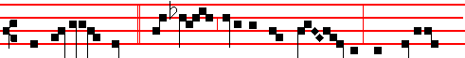
And all Israel knew * from Dan even to Beer- she- ba, that Samuel
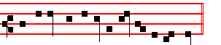
was established to be a prophet of the Lord.
Collect O God, the protector, which is found below after the Lessons of the last week of November, with the other Collects until the last Sunday after Pentecost.
__________________________________________________________________

THE THIRD SUNDAY AFTER PENTECOST
At Matins, Invitatory.- Let us worship the Lord, * For he is our Maker. Psalm 95 Venite, p. 2. Hymn E.H.165 Nocte surgentes, p. 5. Antiphon. Serve the Lord in fear, with the other Antiphons, Psalms and  as in the Psalter, p. 5.

1023
IN THE FIRST NOCTURN
From the First Book of Samuel
Lesson j Ch. 9, 18 -10, 3
THEN Saul drew near to Samuel in the gate, and said, Tell me, I pray thee, where the seer's house is. And Samuel answered Saul, and said, I am the seer: go up before me unto the high place; for ye shall eat with me to day, and to morrow I will let thee go, and will tell thee all that is in thine heart. And as for thine asses that were lost three days ago, set not thy mind on them; for they are found. And on whom is all the desire of Israel? Is it not on thee, and on all thy father's house? And Saul answered and said, Am not I a Benjamite, of the smallest of the tribes of Israel? and my family the least of all the families of the tribe of Benjamin? wherefore then speakest thou so to me?

 Prepare your hearts unto the Lord, and serve him only: * And he will deliver you out of the hands of your enemies.
 Return unto him with all your hearts, and put away the strange gods from among you. And he.
Lesson ij
AND Samuel took Saul and his servant, and brought them into the parlour, and made them sit in the chiefest place among them that were bidden, which were about thirtv persons. And Samuel said unto the cook, Bring the portion which I gave thee, of which I said unto thee, Set it by thee. And the cook took up the shoulder, and that which was upon it, and set it before Saul. And Samuel said, Behold that which is left! set it before thee, and eat: for unto this time hath it been kept for thee, since I said, I have invited the people. So Saul did eat with Samuel that day. And when they were come down from the high place into the city, Samuel communed with Saul upon the top of the house.

 God who heareth all hath sent his Angel, and he took me from keeping my father's sheep: * And anointed me with the oil of his mercy.
 The Lord that delivered me out of the mouth of the lion, and out of the paw of the bear. And anointed.

Lesson iij
AND they arose early: and it came to pass about the spring of the day, that Samuel called Saul to the top of the house, saying, Up, that I may send thee away. And Saul arose, and they went out both of them, he and Samuel, abroad. And as they were going down to the end of the city, Samuel said to Saul, Bid the servant pass on before us, (and he passed on,) but stand thou still a while, that I may show thee the word of God. Then Samuel took a vial of oil, and kissed him, and said, Is it not because the Lord hath anointed thee to be captain over his inheritance?
1024
 The Lord that delivered me out of the mouth of the lion, and out of the paw of
the bear. * He will deliver me out of the hand of mine enemies.
 God hath sent forth his mercy and truth: my soul is among lions. He will.
Glory be. He will
IN THE SECOND NOCTURN
From the exposition by S. Gregory Bk. 4 Ch. 5; on I Kings Ch. 10
the Great on the Books of the Kings (I Samuel Ch.10)
Lesson iv
THEN Samuel took a vial of oil, and poured it upon his head. Clearly this anointing expresses what has now become a custom in holy Church: for he who is made one of her princes receives the sacrament of anointing. Now. since this anointing is a sacrament, he who is thus promoted is well anointed outwardly, if he is inwardly strengthened by sacramental power. First, then, let us consider the virtues of oil. Oil is superior to other liquids, in that it feeds flame and is wont to heal wounds. It therefore signifies mercy, as it is writtcn of the Lord, His mercy is over all his works. In that it feeds flame, it signifies preaching which enlightens the minds of the elect.

 Saul hath slain this thousands, and David his ten thousands. * The hand of the Lord was with him: he killed the Philistine, and took away the reproach from Israel.
 Is not this David: did they not sing one to another of him in dances, saying, Saul hath slain his thousands, and David his ten thousands? The hand.

Lesson v
BUT in that wounds are healed by oil, it is clearly shown that the wounds of sin are to be wiped out. Let the head of the king be anointed, then, that his mind may be filled with the spiritual grace of a teacher. Let him have oil through his anointing, let bim have abundant mercy, which he should prefer to all other virtues. Let him have oil, so that while he kindles within himself the flame of the Holy Spirit, he may enlighten others by means of the Word. Likewise let him have the oil of healing, that he may dispense wisdom, and by it wipe out the stains of sins, and restore the sick in mind to health.

 Ye mountains of Gilboa, let there be no dew, neither let there be rain upon you, * For there are the mighty of Israel fallen.
 All ye mountains that stand round about, the Lord look upon you, but let him pass by Gilboa. For there.
Lesson vj
BUT Saul was anointed from a vial, not to signify teaching, but to indicate his future. For a vial is a very small vessel. Why was it that Saul was anointed

1025
from a vial of oil, if not because he was eventually to be cast out? For after he had refused to obey God, he heard from Samuel, because thou hast rejected the word of the Lord, he hath also rejected thee from being king. As the vial held but little oil, so he who was to be cast away received but little spiritual grace. This may also be taken to apply to the rulers of holy Church. For many of them receive the high dignity of the prelacy who are not perfect in the love of God and of their neighbours.

 Thus saith the Lord, I took thee out of thy father's house, from following the sheep, to be shepherd and ruler over my people: * And I was with thee withersoever thou wentest, to establish thy kingdom for ever.
 And I have made thee a great name, like unto the name of the great men that are in the earth; and I have caused thee to rest from all thine enemies. And I was.
Glory be. And I was.

¶ The Lessons of the third Noctum, from the Homily of the iij Sunday after Pentecost are below at the end of the Season, in order with the other Sundays until the last Sunday after Pentecost. Likewise the Antiphons on Benedictus and Magnificat and the Collects.

 My sins are many, yea, they are more in number than the sands of the sea; I am not worthy to look up toward heaven because of the multitude of my iniquities, for I have provoked thee to anger, * And done this evil in thy sight.
 For I acknowledge my faults, and my sin is ever before me; against thee only have I sinned. And done.

 One Seraph cried unto another, and said, * Holy, holy, holy, is the Lord of hosts: * The whole earth is full of his glory.
 There are Three that bear record in heaven, the Father, the Word, and the Holy Ghost, and these Three are One. Holy, holy. Glory be. The whole.

This  is said after the viij. Lesson on Sundays only, until Advent. But on Wed- nesday and on Saturday until the first Sunday of August, when the Responsories are to be taken from the iij. Nocturn of Sunday, instead is said the second  of Monday following, and in the third place the third  of the same Monday.
__________________________________________________________________

Monday
From the first book of Kings.
Lesson j I Sam. 10

1026
AND Samuel called the people together unto the Lord to Mizpeh; And said unto the children of Israel, Thus saith the LORD God of Israel, I brought up Israel out of Egypt, and delivered you out of the hand of the Egyptians, and out of the hand of all kingdoms, and of them that oppressed you: And ye have this day rejected your God, who himself saved you out of all your adversities and your tribulations; and ye have said unto him, Nay, but set a king over us. Now therefore present yourselves before the Lord by your tribes and by your thousands.

 Remember, O Lord, thy covenant, and say unto the destroying Angel: Stay now thine hand. * That the land be not utterly laid waste, and that thou destroy not every living soul.
 I have sinned and done wickedly ; but these sheep, what have they done? Let thine anger, I pray thee, O Lord, be turned away, from thy people. That the.

Lesson ij
AND when Samuel had caused all the tribes of Israel to come near, the tribe of Benjamin was taken. When he had caused the tribe of .Benjamin to come near by their families, the family of Matri was taken, and Saul the son of Kish was taken; and when they sought him; he could not be found. Therefore they enquired of the Lord further, if the man should yet come thither. And the Lord answered, behold, he hath hid himself among the stuff. And they ran and fetched him thence: and when he stood among the people, he was higher than any of the people from his shoulders and upward. And Samuel said to all the people, See ye him whom the Lord hath chosen, that there is none like him among all the people? And all the people shouted, and said, God save the king.

 O Lord, thou hast hearkened unto the prayer of thy servant, that I might build a temple unto thy Name. * O God of Israel, bless thou and hallow this house for ever.
 O Lord who keepest covenant with thy servants that walk before thee with all their heart. O God.

Lesson vj
THEN Samuel told the people the manner of the kingdom, and wrote it in a book, and laid it up before the Lord. And Samuel sent all the people awa, every man to his house. And Saul also went home to Gibeah; and there went with him a band of men, whose hearts God hacl touched. But the children of Belial said, How shall this man save us? And they despised him, and brought him no presents. But he held his peace.

 Hearken, O Lord, unto the cry and to the prayer which thy servant prayeth

1027
before thee to-day: that thine eyes may be open, and thine ears attent, * Toward this house day and night.
 Look down from thine high and holy place, O Lord, even from heaven thy dwelling. Toward this. Glory be. Toward this.

¶ The  of this Monday are said on all Mondays until the first Sunday of August.
__________________________________________________________________

Tuesday
From the first book of Kings.
Lesson j I Sam. 12
AND Samuel said unto all Israel, Behold, I have hearkened unto your voice in all that ye said unto me, and have made a king over you. And now, behold, the king walketh before you: and I am old and gray-headed; and, behold, my sons are with you: and I have walked before you from my childhood unto this day. Behold, here I am: witness against me before the Lord, and before his anointed: whose ox have I taken? or whose ass have I taken? or whom have I defrauded? whom have I oppressed? or of whose hand have I received any bribe to blind mine eyes therewith? and I will restore it you. And they said, Thou hast not defrauded us, nor oppressed us, neither hast thou taken ought of any man's hand. And he said unto them, The Lord is witness against you, and his anointed is witness this day, that ye have not found ought in my hand. And they answered, He is witness.

 Lord, when thy people shall turn again to thee, and shall pray unto thee in this house, * Then hear thou in heaven, O Lord, and deliver them out of the hand of their enemies.
 If thy people sin against thee, and turn again, and repent, and corne and pray unto thee in this house. Then.

Lesson ij
AND Samuel said unto the people, It is the Lord that advanced Moses and Aaron, and that brought your fathers up out of the land of Egypt. Now therefore stand still, that I may reason with you before the Lord of all the righteous acts of the Lord, which he did to you and to your fathers. When Jacob was corne into Egypt, and your fathers cried unto the Lord, then the Lord sent Moses and Aaron, which brought forth your fathers out of Egypt, and made them dwell in this place. And when they forgat tbe Lord their God, he sold them into the hand of Sisera, captain of the host of Hazar, and into the hand of the Philistines, and into the hand of the king of Moab, and they fought against them.

1028
 It came to pass, when the Lord took up Elijah into heaven in a whirlwind, * Elisha cried, saying: My father, my father, the chariots of Israel, and the horsemen thereof.
 And as they still went on, and talked, behold,a chariot of fire, and horses of fire, parted them both asunder; and Elijah went up by a whirlwind into heaven. Elisha cried.

Lesson iij
AND they cried unto the Lord, and said, We have sinned, because we have forsaken the Lord, and have served Baalim and Ashtaroth: but now deliver us out of the hand of our enemies, and we will serve thee. And the Lord sent Jerubbaal, and Bedan, and Jephthah, and Samuel, and delivered you out of the hand of your enemies on every side, and ye dwelled safe. And when ye saw that Nahash the king of the children of Ammon came against you, ye said unto me, Nay; but a king shall reign over us: when the Lord your God was your king. Now therefore behold the king whom ye have chosen, and whom ye have desired! and, behold, the Lord hath set a king over you. If ye will fear the Lord, and serve him, and obey his voice, and not rebel against the commandment of the Lord, then shall both ye and also the king that reigneth over you continue following the Lord your God:

 Thus saith the Lord, I took thee out of thy father's house, from following the sheep, to be shepherd and ruler over my people: * And I was with thee withersoever thou wentest, to establish thy kingdom for ever.
 And I have made thee a great name, like unto the name of the great men that are in the earth; and I have caused thee to rest from all thine enemies. And I was.
Glory be. And I was.

The  of this Tuesday are said on all Tuesdays until the first Sunday of August.
__________________________________________________________________

Wednesday
From the first book of Kings.
Lesson j I Sam. 13
SAUL reigned one year; and when he had reigned two years over Israel, Saul chose him three thousand men of Israel; whereof two thousand were with Saul in Michmash and in mount Beth-el, and a thousand were with Jonathan in Gibeah of Benjamin: and the rest of the people he sent every man to his tent. And Jonathan smote the garrison of the Philistines that was in Geba, and the Philistines heard of it. And Saul blew the trumpet throughout all the land, saying, Let the Hebrews hear.

1029
And all Israel heard say that Saul had smitten a garrison of the Philistines, and that Israel also was had in abomination with the Philistines. And the people were called together, after Saul to Gilgal.

 My sins are many, yea, they are more in number than the sands of the sea; I am not worthy to look up toward heaven because of the multitude of my iniquities, for I have provoked thee to anger, * And done this evil in thy sight.
 For I acknowledge my faults, and my sin is ever before me; against thee only have I sinned. And done.

Lesson ij
AND the Philistines gathered themselves together to fight with Israel, thirty thousand chariots, and six thousand horsemen, and people as the sand which is on the sea shore in multitude, and they came up, and pitched in Michmash, eastward from Beth-aven. When the men of Israel saw that they were in a strait; (for the people were distressed,) then the people did hide themselves in caves, and in thickets, and in rocks, and in highplaces, and in pits. And some of the Hebrews went over Jordan to the land of Gad and Gilead. As for Saul, he was yet in Gilgal, and all the people followed him trembling.

 O Lord, thou hast hearkened unto the prayer of thy servant, that I might build a temple unto thy Name. * O God of Israel, bless thou and hallow this house for ever.
 O Lord who keepest covenant with thy servants that walk before thee with all their heart. O God.

Lesson iij
AND he tarried seven days; according to the set time that Samuel had appointed: but Samuel came not to Gilgal; and the people were scattered from him. And Saul said, Bring hither a burnt offering to me, and peace offerings. And he offered the burnt offering. And it came to pass, that as soon as he had made an end of offering the burnt offering, behold, Samuel came; and Saul went out to meet him, that he might salute him. And Samuel said, What hast thou done? And Saul said, Because I saw that the people were scattered from me, and that thou camest not within the days appointed, and that the Philistines gathered themselves together at Michmash; Therefore said I, the Philistines will come down now upon me to Gilgal, and I have not made supplication unto the Lord: I forced myself therefore, and offered a burnt offering. And Samuel said to Saul, Thou hast done foolishly: thou hast not kept the commandment of the Lord thy God, which he commanded thee: for now would the Lord have established thy kingdom upon Israel for ever.

1030
But now thy kingdom shall not continue: the Lord hath sought him a man after his own heart, and the Lord hath commanded him to be captain over his people, because thou hast not kept that which the Lord commanded thee.

 Hearken, O Lord, unto the cry and to the prayer which thy servant prayeth before thee to-day: that thine eyes may be open, and thine ears attent, * Toward this house day and night.
 Look down from thine high and holy place, O Lord, even from heaven thy dwelling. Toward this. Glory be. Toward this.
__________________________________________________________________

Thursday
From the first book of Kings.
Lesson j I Sam. 14
AND Jonathan said to the young man that bare his armour, Come, and let us go over unto the garrison of these uncircumcised: it may be that the Lord will work for us: for there is no restraint to the Lord to save by many or by few. And his armourbearer said unto him, Do all that is in thine heart: turn thee; behold, I am with thee according to thy heart. Then said Jonathan, Behold, we will pass over unto these men, and we will discover ourselves unto them. If they say thus unto us, Tarry until we come to you; then we will stand still in our place, and will not go up unto them. But if they say thus, Come up unto us; then we will go up: for the Lord hath delivered them into our hand: and this shall be a sign unto us. And both of them discovered themselves unto the garrison of the Philistines: and the Philistines said, Behold, the Hebrews come forth out of the holes where they had hid themselves.

 Prepare your hearts unto the Lord, and serve him only: * And he will deliver you out of the hands of your enemies,
 Return unto him with all you hearts, and put away the strange gods from among you. And he.

Lesson ij
AND the men of the garrison answered Jonathan and his armour- bearer, and said, Come up to us, and we will shew you a thing. And Jonathan said unto his armourbearer, Come up after me: for the Lord hath delivered them into the hand of Israel. And Jonathan climbed up upon his hands and upon his feet, and his armourbearer after him: and they fell before Jonathan; and his armourbearer slew after him. And that first slaughter, which Jonathan and his armourbearer made, was about twenty men, within as it were an half acre of land, which a yoke
of oxen might plow. And there was trembling in the host, in the field, and among
all the people: the garrison, and the spoilers, they also trembled, and the earth

1031
quaked: so it was a very great trembling.

 God who heareth all hath sent his Angel, and he took me from keeping my fathcr's sheep: * And anointed me with thc oil of his mercy.
 The Lord that delivered me out of the mouth of the lion, and out of the paw of the bear. And anointed.

Lesson iij
AND Saul said unto Ahiah, bring hither the ark of God. For the ark of God was at that time with the children of Israel. And it came to pass, while Saul talked unto the priest, that the noise that was in the host of the Philistines went on and increased: and Saul said unto the priest, Withdraw thine hand. And Saul and all the people that were with him assembled themselves, and they came to the battle: and, behold, every man's sword was against his fellow, and there was a very great discomfiture.

 The Lord that delivered me out of the mouth of the lion, and out of the paw of the bear, * He will deliver me out of the hand of mine enemies.
 God hath sent forth his mercy and truth: my soul is among lions. He will. Glory be. He will.
__________________________________________________________________

Friday
From the first book of Kings.
Lesson j I Sam. 15
SAMUEL also said unto Saul, The Lord sent me to anoint thee to be king over his people, over Israel: now therefore hearken thou unto the voice of the words of the Lord. Thus saith the Lord of hosts, I remember that which Amalek did to Israel, how he laid wait for him in the way, when he came up from Egypt. Now go and smite Amalek, and utterly destroy all that they have, and spare them not; but slay both man and woman, infant and suckling, ox and sheep, camel and ass.

 Saul hath slain his thousands, and David his ten thousands. * The hand of the Lord was with him: he killed the Philistine, and took away the reproach from Israel.
 Is not this David: did they not sing one to another of him in dances, saying, Saul hath slain his thousands, and David his ten thousands? The hand.

Lesson ij
AND Saul gathered the people together, and numbered them in Telaim, two hundred thousand footmen, and ten thousand men of Judah. And Saul came

1032
to a city of Amalek, and laid wait in the valley. And Saul said unto the Kenites, Go, depart, get you down from among the Amalekites; lest I destroy you with them :.for ye shewed kindness to all the children of Israel, when they came up out of Egypt. So the Kenites departed from among the Amalekites. And Saul smote the Amalekites from Havilah until thou comest to Shur, that is over against Egypt.
And he took Agag the king of the Amalekites alive, and utterly destroyed all the people with the edge of the sword.

 Ye mountains of Gilboa, let there be no dew, neither let there be rain upon you, * For there are the mighty of Israel fallen.
 All ye mountains that stand round about, the Lord look upon you, but let him pass by Gilboa. For there.

Lesson iij
BUT Saul and the people spared Agag, and the best of the sheep, and of the oxen, and of the fatlings, and the lambs, and all that was good, and would not utterly destroy them: but every thing that was vile and refuse, that they destroyed utterly. Then came the word of the Lord unto Samuel, saying, It repenteth me that I have set up Saul to be king: for he is turned back from following me, and hath not performed my commandments. And it grieved Samuel; and he cried unto the Lord all night.

 Thus saith the Lord, I took thee out of thy father's house, from following the sheep, to be shepherd and ruler over my people: * And I was with thee withersoever thou wentest, to establish thy kingdom for ever.
 And I have made thee a great name, like unto the name of the great men that are in the earth; and I have caused thee to rest from all thine enemies. And I was.
Glory be. And I was.
__________________________________________________________________

Saturday
From the first book of Kings.
Lesson j I Sam. 16
AND the Lord said unto Samuel, How long wilt thou mourn for Saul, seeing I have rejected him from reigning over Israel? fill thine horn with oil, and go, I will send thee to Jesse the Beth-lehemite: for I have provided me a king among his sons. And Samuel said, How can I go? if Saul hear it, he will kill me. And the Lord said, Take an heifer with thee, and say, I am come to sacrifice to the Lord. And call Jesse to the sacrifice, and I will shew thee what thou shalt do : and thou shalt anoint unto me him whom I name unto thee.

1033
 My sins are many, yea, they are more in number than the sands of the sea; I am not worthy to look up toward heaven because of the multitude of my iniquities, for I have provoked thee to anger, And done this evil in thy sight.
 For I acknowledge my faults, and my sin is ever before me; against thee only have I sinned. And done.

Lesson ij
AND Samuel did that which the Lord spake, and came to Bethlehem. And the elders of the town trembled at his coming, and said, Comest thou peaceably?
And he said, Peaceably: I am come. to sacrifice unto the Lord: sanctify yourselves, and come with me to the sacrifice. And he sanctified Jesse and his sons, and called them to the sacrifice. And it came to pass, when they were come, that he looked on Eliab; and said, Surely the Lord's anointed is before him. But the Lord said unto Samuel, Look not on his countenance, or on the height of his stature; because I have refused him: for the Lord seeth not as man seeth; for man looketh on the outward appearance, but the Lord looketh on the heart.

 O Lord, thou hast hearkened unto the prayer of thy servant, that I might build a temple unto thy Name. * O God of Israel, bless thou and hallow this house for ever.
 O Lord who keepest covenant with thy servants that walk before thee with all their heart.

Lesson iij
THEN Jesse called Abinadab, and made him pass before Samuel. And he said, Neither hath the Lord chosen this. Then Jesse made Shammah to pass by. And he said, Neither hath the Lord chosen this. Again, Jesse made seven of his sons to pass before Samuel. And Samuel said unto Jesse, The Lord hath not chosen these.
And Samuel said unto Jesse, Are here all thy children? And he said, There remaineth yet the youngest, and, behold, he keepeth the sheep. And Samuel said unto Jesse; Send and fetch him.

 Hearken, O Lord, unto the cry and to the prayer which thy servant prayeth before thee to-day: that thine eyes may be open, and thine ears attent, * Toward this house day and night.
 Look down from thine high and holy place, O Lord, even from heaven thy dwelling. Toward this. Glory be. Toward this.
On Magnificat, Antiphon.
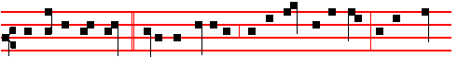
So David prevailed * over the Philistine with a sling and a stone, in the Name
1034
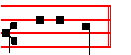
of the Lord. The Collect with the Homily of the fourth Sunday is below at the end of the Office of the Season.
__________________________________________________________________

THE FOURTH SUNDAY AFTER PENTECOST
IN THE FIRST NOCTURN
From the First Book of Samuel
Lesson j Ch. 17.
NOW the Philistines gathered together their armies to battle, and were gathered together at Shochoh, which belongeth to Judah, and pitched between Shochoh and Azekah, in Ephes-dammim. And Saul and the men of Israel were gathered together, and pitched by the valley of Elah, and set the battle in array against the Philistines. And the Philistines stood on a mountain on the one side, and Israel stood on a mountain on the other side: and there was a valley between them. And there went out a champion out of the camp of the Philistines, named Goliath, of Gath, whose height was six cubits and a span. And he had an helmet of brass upon his head, and he was armed with a coat of mail; and the weight of the coat was five thousand shekels of brass. And he had greaves of brass upon his legs, and a target of brass between his shoulders. And the staff of his spear was like a weaver's beam; and his spear's head weighed six hundred shekels of iron: and one bearing a shield went before him.

 Prepare your hearts unto the Lord, and serve him only: * And he will deliver you out of the hands of your enemies.
 Return unto him with all you hearts, and put away the strange gods from among you. And he.

Lesson ij
AND he stood and cried unto the armies of Israel, and said unto them, Why are ye come out to set your battle in array? am not I a Philistine, and ye servants to Saul? choose you a man for you, and let him come down to me. If he be able to fight with me, and to kill me, then will we be your servants: but if I prevail against him, and kill him, then shall ye be our servants, and serve us. And the Philistine said, I defy the armies of Israel this day; give me a man, that we may fight together. When Saul and all Israel heard those words of the Philistine, they were dismayed, and greatly afraid.

 God who heareth all hath sent his Angel, and he took me from keeping my

1035
father's sheep: * And anointed me with the oil of his mercy.
 The Lord that delivered me out of the mouth of the lion, and out of the paw of the bear. And anointed.

Lesson iij
NOW David was the son of that Ephrathite of Bethlehem-judah, whose name was Jesse; and he had eight sons: and the man went among men for an old man in the days of Saul. And the three eldest sons of Jesse went and Foltowed Saul to the battle: and the names of his three sons that wcnt to the battle were Eliab thc first-born, and next unto him Abinadab, and the third Shammah. And David was the youngest: and the three eldest followed Saul. But David went and returned from Saul to feed his father's sheep at Bethlehem. And the Philistine drew near morning and evening, and presented himself forty days.

 The Lord that delivered me out of the mouth of the lion, and out of the paw of the bear, * He will deliver me out of the hand of mine enemies.
 God hath sent forth his mercy and truth: my soul is among lions. He will.
Glory be. He will.

IN THE SECOND NOCTURN
Sermon by S. Augustine, Bishop Appendix; Sermon 197on the seasons.
Lesson iv
THE children of Israel faced their enemies for forty days. These forty days, by reason of the four seasons, and the four quarters of the earth, signify this present life, in which the Christian people do not cease to fight against Goliath or his army, that is, against the devil and his angels. Nor would they have been able to gain the victory, had not Christ, the true David, come down with his staff, that is, the mystery of the cross. For before the coming of Christ, beloved brethren, the devil was at large. When Christ came, he did to him what is described in the Gospel: No-one can enter into a strong man's house, and spoil his goods, except he first bind the strong man. Therefore Christ came and bound the devil.

 Saul hath slain this thousands, and David his ten thousands. * The hand of the Lord was with him: he killed the Philistine, and took away the reproach from Israel.
 Is not this David: did they not sing one to another of him in dances, saying, Saul hath slain his thousands, and David his ten thousands? The hand.

Lesson v
SOMEONE may say, If he has been bound, why is he still so powerful? It is true, beloved brethren, that he has great power, but it is only exercised over

1036
the luke-warm and care1ess and those who do not fear God in truth. For he is bound like a chained-up dog, and cannot bite anyone, except him who goes up to him with a fatal recklessness. Now consider. brethren, how foolish that man is who is bitten by a chained-up dog. Do not wish to go over to him through your worldly lusts and desires, and then he will not dare to come near you. He may bark, he may strain at the leash; but he can in no wise bite, unless you permit it. It is by persuasion. not compulsion, that he does harm; he seeks, but he does not force, our consent.

 Ye mountains of Gilboa, let there be no dew neither let there be rain upon you, * For there are the mighty of Israel fallen.
 All ye mountains that stand round about, the Lord look upon you, but let him pass by Gilboa. For there.

Lesson vj
THEREFORE David carne, and he found the Jewish people battling against the
devil; and since there was no man who would dare to engage him in single combat, David, as a figure of Christ, went forth to battle, took his staff in his hand, and drew near to Goliath. Then was truly enacted under a figure what was fulfilled in our Lord Jesus Christ. For Christ, the true David, when about to join battle with the spiritual Goliath, that is, with the devil, carried his cross. Behold, brethren, where David smote Goliath: it was in his forehead, where the sign of the cross was lacking. Just as the staff was a type of the cross, so also was that stone by which Goliath was smitten a type of Christ the Lord.

 Thus saith the Lord, I took thee out of thy father's house, from following the sheep, to be shepherd and ruler over my people: * And I was with thee withersoever thou wentest, to establish thy kingdom for ever.
 And I have made thee a great name, like unto the name of the great men that are in the earth; and I have caused thee to rest from all thine enemies. And I was.
Glory be. And I was.

In the third Nocturn, Lessons from the Homily on the Gospel of the iv. Sunday after Pentecost, which are placed below.

 vij. My sins are many, yea, they are more in number than the sands of the sea; I am not worthy to look up toward heaven because of the multitude of my iniquities, for I have provoked thee to anger, * And done this evil in thy sight.
 For I acknowledge my faults, and my sin is ever before me; against thee only have I sinned. And done.

1037
 viij. One Seraph cried unto another, and said, * Holy, holy holy is the Lord of hosts: * The whole earth is full of his glory.
 There are Three that bear record in heaven, the Father, the Word, and the Holy Ghost, and these Three are One. Holy, holy. Glory be. The whole.
__________________________________________________________________

Monday
From the first book of Kings.
Lesson j I Sam. 17
AND the men of Israel said, Have ye seen this man that is come up? surely to defy Israel is he come up : and it shall be, that the man .who killeth him, the king will enrich him with great riches, and will give him his daughter, and make his father's house free in Israel. And David spake to the men that stood by him, saying, What shall be done to the man that killeth this Philistine, and taketh away the reproach from Israel? for who is this uncircumcised Philistine, that he should defy the armies of the living God ?

 Remember, O Lord, thy covenant, and say unto the destroying Angel: Stay now thine hand, * That the land be not utterly laid waste, and that thou destroy not every living soul.
 I have sinned and done wickedly; but these sheep, what have they done? Let - thine anger, I pray thee, O Lord, be turned away from thy people. That the.

Lesson ij
AND when the words were heard which David spake, they rehearsed them before Saul: and he sent for him. And David said to Saul, Let no man's heart fail, because of him; thy servant will go and fight with this Philistine. And Saul said to David, Thou art not able to go against this Philistine to fight with him: for thou art but a youth, and he a man of war from his youth.

 O Lord, thou hast hearkened unto the prayer of thy servant, that I might build a temple unto thy Name. * O God of Israel, bless thou and hallow this house for ever.
 O Lord who keepest covenant with thy servants that walk before thee with all their heart. O God.

Lesson iij
AND David said unto Saul, Thy servant kept his father's sheep, and there came a lion, and a bear, and took a lamb out of the flock: And I went out after him, and smote him, and delivered it out of his mouth: and when he arose against me, I

1038
caught him by his beard, and smote him, and slew him. Thy servant slew both the lion and the bear: and this uncircumcised Philistine shall be as one of them, seeing he hath defied the armies of the living God.

 Hearken, O Lord, unto the cry and to the prayer which thy servant prayeth before thee to-day: that thine eyes may be open, and thine
ears attent. * Toward this house day and night.
 Look down from thine high and holy place, O Lord, even from heaven thy dwelling. Toward this. Glory be. Toward this.
__________________________________________________________________

Tuesday
From the first book of Kings.
Lesson j I Sam. 17
AND Saul armed David with his armour, and he put an helmet of brass upon his head; also he armed him with a coat of mail. And David girded his sword upon his armour, and he assayed to go; for he had not proved it. And David said unto Saul, I cannot go with these; for I have not proved them. And David put them off him. And he took his staff in his hand, and chose him five smooth stones out of the brook, and put them in a shepherd's bag which he had, even in a scrip; and his sling was in his hand: and he drew near to the Philistine.

 Lord, when thy people shall turn again to thee, and shall pray unto thee in this house, * Then hear thou in heaven, O Lord, and deliver them out of the hand of their enemies.
 If thy people sin against thee, and turn again, and repent, and come and pray unto thee in this house. Then.

Lesson ij
AND the Philistine came on and drew near unto David; and the man that bare the shield went before him. And when the Philistine looked about, and saw David, he disdained him: for he was but a youth, and ruddy, and of a fair countenance. And the Philistine said unto David, Am I a dog, thatt thou comest to me with staves? And the Philistine cursed David by his gods. And the Philistine said to David, Come to me, and I will give thy flesh unto the fowls of the air, and to the beasts of the field. Then said David to the Philistine, Thou comest to me with a sword, and with a spear, and with a shield: but I come to thee in the name of the Lord of hosts, the God of the armies of Israel, whom thou hast defied. This day will the Lord deliver thee into mine hand; and I will smite thee, and take thine head from thee; and I will give the carcases of the host of the Philistines this day unto the fowls of the air, and to the wild beasts of the earth; that all the earth may know that there is a God in Israel.
1039
 It came to pass, when the Lord took up Elijah into heaven by a whirlwind, * Elisha cried, saying: My father, my father, the chariots of Israel, and the horsemen thereof.
 And as they still went on, and talked, behold,a chariot of fire, and horses of fire, parted them both asunder; and Elijah went up by a whirlwind into heaven. Elisha cried.

Lesson iij
AND it came to pass, when the Philistine arose, and came and drew nigh to meet David, that David hasted, and ran toward the army to meet the Philistine. And David put his hand in his bag, and took thence a stone, and slang it, and smote the Philistine in his forehead, that the stone sunk into his forehead; and he fell upon his face to the earth. So David prevailed over the Philistine with a sling and with a stone, and smote the Philistine, and slew him; but there was no sword in the hand of David. Therefore David ran, and stood upon the Philistine, and took his sword, and drew it out of the sheath thereof, and slew him, and cut off his head therewith.

 Thus saith the Lord, I took thee out of thy father's house, from following the sheep, to be shepherd and ruler over my people: * And I was with thee withersoever thou wentest, to establish thy kingdom for ever.
 And I have made thee a great name, like unto the name of the great men that are in the earth; and I have caused thee to rest from all thine enemies. And I was.
Glory be. And I was.
__________________________________________________________________

Wednesday
From the first book of Kings.
Lesson j I Sam.18
AND it came to pass as they came, when David was returned from the slaughter of the Philistine, that the women came out of all cities of Israel. singing and dancing, to meet king Saul, with tabrets, with joy, and with instruments of musick. And the women answered one another as they played, and said, Saul hath slain his thousands, and David his ten thousands. And Saul was very wroth, and the saying displeased him; and he said, They have ascribed unto David ten thousands, and to me they have ascribed but thousands: and what can he have more but the kingdom ?

 My sins are t many, yea, they are more in number than the sands of the sea; I am not worthy to look up toward heaven because of the multitude of my iniquities, for I have provoked thee to anger, * And done this evil in thy sight.

1040

