COMMON OF THE DEDICATION OF A CHURCH

-Note that, if it shall be within Eastertide, the Rubric is to be observed which is placed above, lii.
__________________________________________________________________

AT VESPERS

Antiphon Holiness becometh, with the rest from Lauds, cxiv. Psalms 110, 111, 112, 113, of Sunday, pp. 202-204, and in the last place 147, vv. 12-20 Lauda, Jerusalem, p.240.
Chapter Rev.21
I SAW the holy city, new Jerusalem, coming down from God out of heaven, prepared as a bride adorned for her husband.
Hymn E.H. 169 Urbs Jerusalem beata Mode j.
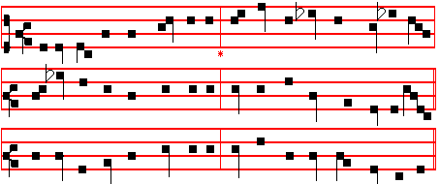
(Or the melody as below in Lauds, p. )

BLESSED City, heavenly Salem, 3 Bright with pearls her portals glitter,
Vision dear of peace and love, They are open evermore;
Who of living stones upbuilded, And by virtue of his merits,
Art the joy of heaven above; Thither faithfu1 souls may soar,
And with Angel cohorts circled, Who for Christ's dear name in this world
As a bride to earth dost move! Pain and tribulation bore.

2 From celestial realms descending, 4 Many a blow and biting sculpture
Bridal glory round her shed, Fashioned well those stones elect,
To his presence, decked with jewels, In their places now compacted
By her Lord shall she be led; By the heavenly Architect,
All her streets, and all her bulwarks, Who therewith hath willed forever
Of pure gold are fashioned.. That his palace should be decked.

cxlix
5 Laud and honour to the Father,
Laud and honour to the Son,
Laud and honour to the Spirit,
Ever Three, and ever One,
Consubstantial, co-eternal,
While unending ages run.
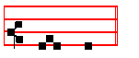
A - men.
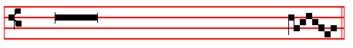
 This is the Lord's house, firmly build - ed.
 It is well founded on the solid rock.
On Magnificat, Antiphon. Tone j, 2.
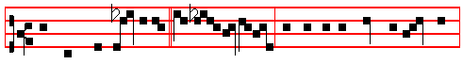
The Lord hath hallowed * his ta- bernacle: for this is the house of the Lord,
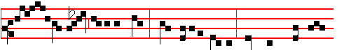
wherein men call upon his Name; whereof it is written, My Name shall be
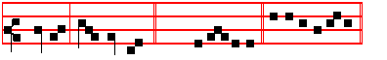
therein, saith the Lord. (E.T. Al-le-lu-ia.) E u o u a e.
On the day itself of the Dedication of a Church and through the Octave, and when the Collect is to be varied because of the concurrence of the Dedication of another Church.
COLLECT
O GOD, who, thyself invisible, containest all things,but dost for the salvation of mankind shew forth visibly the signs of thy power: enlighten this temple with the power of thine indwelling and grant; that all they, who come together here to ask thy mercy, may, in whatsoever tribulations they call upon thee, obtain the blessings of thy consolation.Through.

cl
On the Anniversary of the Dedication of a Church, and through the Octave.
COLLECT

O GOD,who year by year renewest unto us the day of consecration of this thy holy temple,and dost ever bring us again in safety to thy sacred mysteries: graciously hear the prayers of thy people, and grant; that whosoever entereth this temple to ask for blessings may rejoice in the obtaining of all his petitions.Through.
AT MATINS

Invitatory. Tone vij.
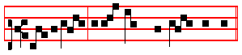
Ho- li-ness becom-eth the house of God:
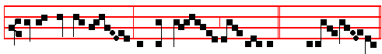
* Let us worship Christ her Bridegroom with- in her.(E.T.Al-le- lu- ia.)

Psalm 95 Venite, exultemus Domino Tone vij.
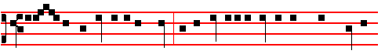
O come, let us sing unto the Lord; let us heartily rejoice in the strength of our
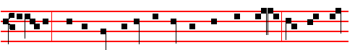
salvation. Let us come before his presence with thanksgiving: and shew our-
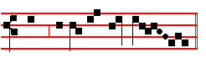
selves glad in him with psalms.

Holiness, as above.

clj
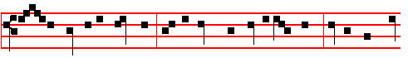
For the Lord is a great God : and a great King above all gods. In his hand are
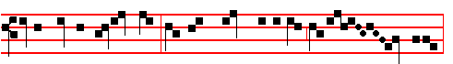
all the corners of the earth : and the strength of the hills is his al-so.
Let us worship as above, p. clj.
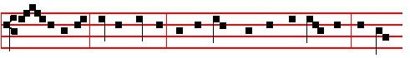
The sea is his, and he made it: and his hands prepared the dry land. O come,
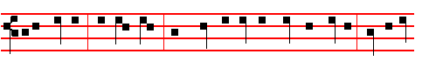
let us worship, and fall down: and kneel before the Lord our Maker. For he is
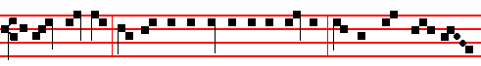
the Lord our God: and we are the people of his pasture, and the sheep of his
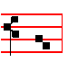
hand. Holiness as above, p.clj.
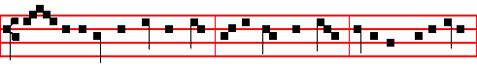
To- day if ye shall hear his voice harden not your hearts as in the provocation,
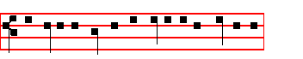
and as in the day of temptation in the wilderness.
clij
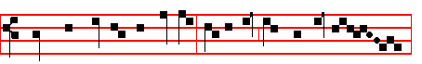
When your fathers tempted me: proved me, and saw my works - - -.
Let us worship as above, p.clj.
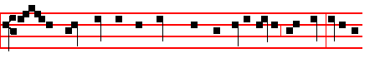
For- ty years long was I grieved with this generation, and said : It is a
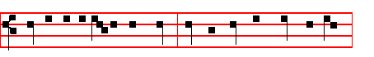
people that do err in their hearts, for they have not known my ways.
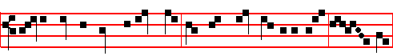 Un-to whom I sware in my wrath : that they should not enter into my rest.
Holiness as above, p. clj.
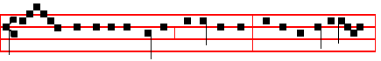
Glo- ry be to the Father, and to the Son, and to the Holy Ghost;
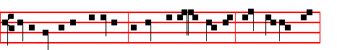
As it was in the beginning, is now, and ever shall be : world without end.
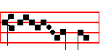
A - men. Let us worship, as above, p. clj.

Cantor Holiness Choir Let us worship, as above, p. clj.

Hymn E.H.169 Urbs Jerusalem beata above, p. cxlix.

cliij
IN THE FIRST NOCTURN

Antiphon. Tone iij, 1.
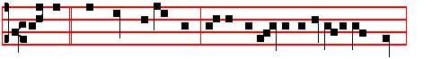
Lift up * your heads, O ye gates, and be ye lift up, ye ev-erlasting doors.
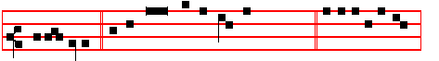
(E.T. Al-le-lu-ia.) Psalm 24 Domini est terra, XXIII, p.38. E u o u a e.
Antiphon. Tone iv, 1.
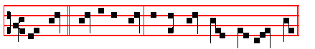
The Lord * shall be my God,and this stone shall be God's house.
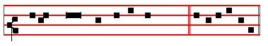
Psalm 46 Deus noster refugium XLV E u o u a e.
Antiphon. Tone vj.
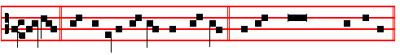
Moses * built an altar for the Lord his God. Psalm 48 Magnus Dominus XLVII
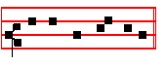
E u o u a e.
 Holiness becometh thine house.
 O Lord, for ev- er.

cliv
Our Father Absolution Hear, O Lord Blessing May the blessing of the eternal
From the Second Book of the Chronicles
Lesson j Ch. 7, 1-9
NOW when Solomon had made an end of praying, the fire came down from heaven, and consumed the burnt offering and the sacrifices; and the glory of the Lord filled the house. And the priests could not enter into the house of the Lord, because the glory of the Lord had filled the Lord's house. And when all the children of Israel saw how the fire came down, and the glory of the Lord upon the house, they bowed themselves with their faces to the ground the upon the pavement, and worshipped, and praised the Lord, saying, For he is good, for his mercy endureth for ever. Then the king and all the people offered sacrifices before the Lord. And king Solomon offered a sacrifice of twenty and two thousand oxen, and an hundred and twenty thousand sheep: so the king and all the people dedicated the house of God.
        j. Tone j  
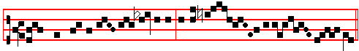
                        When the temple was ded- i- cated the peo - - - ple sang prai - ses,
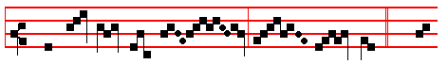
* And sweet in their mouths was the sound. (E.T.Al-
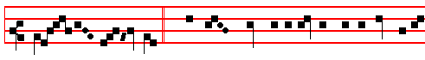
le- lu- ia.) The Lord's house is established in the top of the
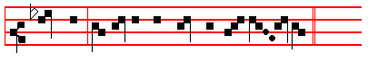
mountains, and all nations shall flow un- to it. And sweet.

Blessing May the Only- begotten.
Lesson ij
AND the priests waited on their offices: the Levites also with instruments of musick of the Lord, which David the king had made to praise the Lord, because his mercy endureth for ever, when David praised by their hand, and
clv
the priests sounded trumpets before them, and all Israel stood. Moreover Solomon hallowed the middle of the court that was before the house of the Lord: for there he offered burnt offerings, and the fat of the peace offerings, because the brasen altar which Solomon had made was not able to receive the burnt offerings and the meat offerings and the fat. Also at the same time Solomon kept the feast seven days, and all Israel with him, a very great congregation, from the entering in of Hamath unto the river of Egypt. And in the eighth day they made a solemn assembly: for they kept the dedication of the altar seven days and the feast seven days.
   ij. Tone ij
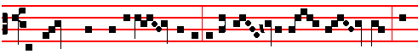                 The Lord's house is estab- lished in the top of the moun- tains, and
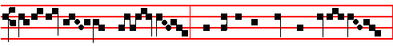
ex-al-ted a- bove the hills: * And all nations shall flow un-to it
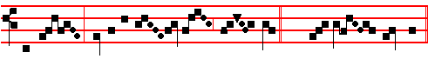
and say: Glory be to thee, O Lord. (E.T. Al-le- lu- ia.)
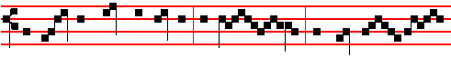
 They shall doubtless come again with joy, and bring their sheaves
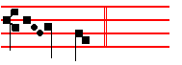
with them. And all.

Blessing May the grace of . . .
Lesson iij
THUS Solomon finished the house of the Lord, and the king's house: and all that came into Solomon's heart to make in the house of the Lord, and in his own house, he prosperously effected. And the Lord appeared to Solomon by night, and said unto him, I have heard thy prayer, and have chosen this place to myself

clvj
for an house of sacrifice. If I shut up heaven that there be no rain, or if I command the locusts to devour the land, or if I send pestilence among my people; if my people, which are called by my name, shall humble themselves, and pray, and seek my face, and turn from their wicked ways: then will I hear from heaven, and will forgive their sin, and will heal their land. Now mine eyes shall be open, and mine ears attent unto the prayer that is made in this place. For now have I chosen and sanctified this house, that my name may be there for ever: and mine eyes and mine heart shall be there perpetually.
         iij. Tone viij
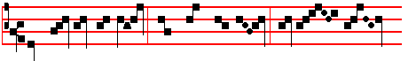
Bless, O Lord, this house which I have built for thy name:
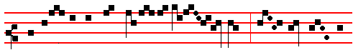 whosoev- er shall come in- to this house and pray,* Then hear thou from
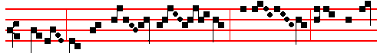
hea-ven thy dwel-ling place.  O Lord, if thy peo-ple
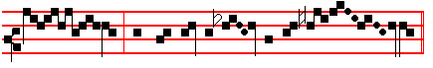
turn and pray before thee in this house. Then hear.
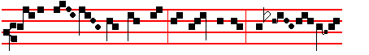
Glo-ry be to the Fa- ther, and to the Son, and to the Holy
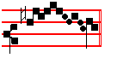
Ghost. Then hear.

IN THE SECOND NOCTURN
Antiphon 1. Tone vij, 1.
clvij
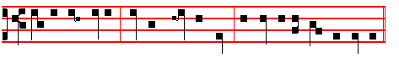
This is none other * but the house of God, and this is the gate of heaven.
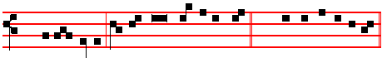
(E.T. Al-le - luia.) Psalm 84 Quam dilecta LXXXIII E u o u a e.
Antiphon 2. Tone vij, 3.
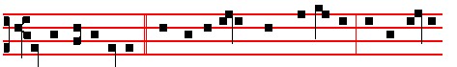
Jacob saw a lad-der,* and the top of it reached to heaven, and the Angels
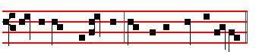
descending, and he said, Surely this place is ho-ly.
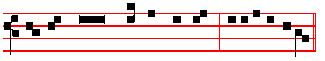
Psalm 87 Fundamenta ejus LXXXVI E u o u a e.
Antiphon. Tone vij, 3.
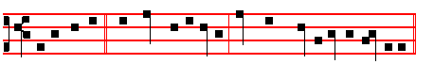
Jacob set up * the stone for a pillar, and poured oil upon the top of it.
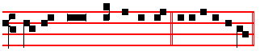
Psalm 88 Domine Deus LXXXVIII E u o u a e.

 My house.  Shall be called the house of prayer.
OUR Father. Absolution May his mercy Blessing May God the Father.
Sermon by S. Augustine, Bishop

clviij
Lesson iv Sermon 229
BELOVED brethren, if, as we celebrate our Dedication Festival, we are ever striving in zeal and faithfulness and are living in holiness and righteousness, then that which has gone into the building of this church is wholly fulfilled in our own spiritual temple. For he lied not who said, The temple temple of God is holy, which temple ye are; and again, Know ye not that your body is the temple of the Holy Ghost, which is in you? We must recognize, beloved brethren, that it is by no merit of our own, but by the grace of God, that we have been found worthy to be made the temples of God. Therefore let us strive with all our might lest the Lord should find in his temple: that is, in ourselves, any thing that might offend the eyes of his Majesty.
 iv. Tone viij.
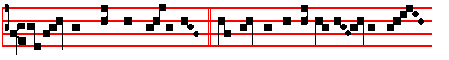 If they pray towards this house, * Forgive the sin of thy peop-le, O
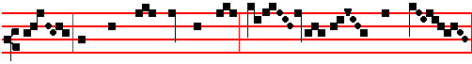
God, and teach them the good way where - in they should walk,
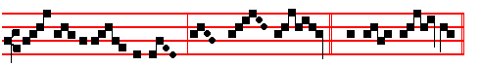
and glo- ri-fy thy Name in this place.(E.T. Al - le- lu - ia.)
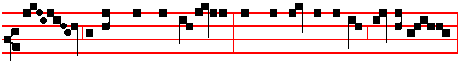
 Hear, O thou Shepherd of Is-rael, thou that leadest Joseph like a sheep,
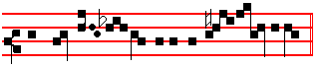
thou that sit - test up-on the Che- ru -bim. Forgive.
Blessing May Christ grant.
Lesson v
LET the tabernacle of our hearts be void of sin and full or virtues shut to the devil and open unto Christ. So let us strive in such a manner that we may be

clix
able to open the gate of the kingdom of heaven with the keys of good works. For as the gate of life is barred against us by evil works, as though with bolts and locks, so, without a doubt, is it opened unto us by means of good works. Therefore, beloved brethren, let each of you examine himself, and if he discover in himself any wound of sin, let him first purge his conscience with prayer, fasting and almsgiving; then let him draw near and receive the Holy Eucharist.
 v. Tone j.
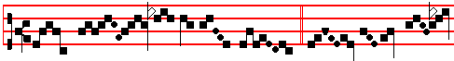 How dread - ful is this place. * This is none o - - -
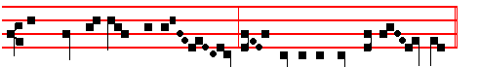 -ther than. the house of God, and this is the gate of heav- en.
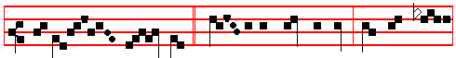
(E.T. Al- le- - lu - ia.) This is the house of God, strongly builded,
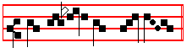
founded upon a sure rock. This is none.

Blessing May God enkindle
Lesson vj
IF, acknowledging his wickedness, he withdraw himself from the holy Altar, then will he obtain pardon through the loving-kindness of God. For whosoever exalteth himself shall I be abased; and he that humbleth himself shall be exalted. As I said, then, he who acknowledging his wickedness, voluntarily and humbly removes himself from the Church's Altar until he amend his life, need not have the least fear of being excommunicated from the heavenly and eternal Banquet.
 vj. Tone iv.
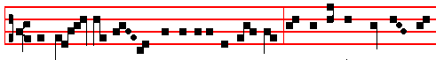 And Ja - cob rose up early in the morning, and set up the stone for a

clx
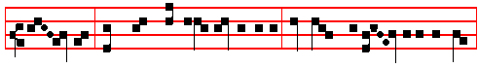
pil- lar, and poured oil upon the top of it; and vowed a vow unto the Lord
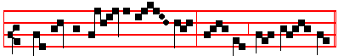
* Surely this place is ho - ly, and I knew it not.
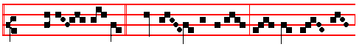 (E.T.Al-le- lu- ia)  And Ja - cob awaked out of his sleep,
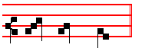
and he said, Surely.
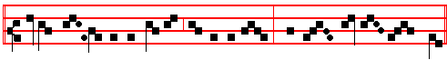
Glory be to the Father, and to the Son, and to the Ho- ly Ghost
Surely.

IN THE THIRD NOCTURN
Antiphon. Tone viij, 1.
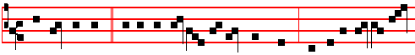 Whoso dwelleth * under the defence of the Most High, shall abide under the
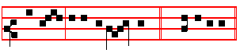
shadow of the Almigh-ty. (E.T. Al-le-lu-ia.)

When this Antiphon is said entire, and Alleluia is not added to it at the end, then the beginning of the Psalm is from the second Verse, I will say unto the Lord.

clxj
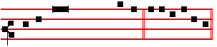
Psalm 91 Qui habitat XC, p. E u o u a e.
Antiphon. Tone ij.
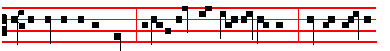
The temple of the Lord * is holy, the founda- tion is God's, and the building
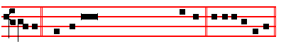
is his. Psalm 96 Cantate Domino XCV, p. E u o u a e.
Antiphon. Tone vij, 3.
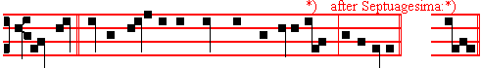
Blessed * be the glory of the Lord from his holy place,al-le-lu-ia. or place.
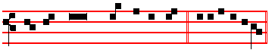
Psalm 99 Dominus regnavit XCVIII, p. E u o u a e.

 This is the house of the Lord, strongly built.
 It is well founded upon a sure rock.
Our Father... . Absolution From the chains. .. May the Gospel
The Lesson from the Holy Gospel according to S. Luke
Lesson vij Ch 19
JESUS entered and passed through Jericho. And behold, there was a man named Zaccheus, which was the chief among the publicans, and he was rich. And the rest.
Homily by S. Ambrose, Bishop Bk 8 on Luke
ZACCHÆUS was small of stature, that is, exalted by no dignity of noble birth and poor in merit, like a nation of the Gentiles. When he heard of he coming of the Lord the Saviour, he was eager to behold him whom his own had not received. But no man sees Jesus without effort: No one can see Jesus while he stands firm upon the earth. And because he possessed not the prophets nor the

clxij
law, but only the grace of nature, he climbed into a sycamore tree, doubtless
erasing with his own footprints the vanity of the Jews, correcting also the errors of his past life: and therefore he received Jesus as his guest into the home of his heart.
 vij Tone j.
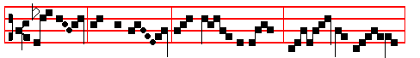
My house shall be called the house of prayer, saith the Lord:
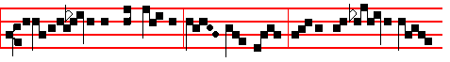
in it ever- y one that asketh re- ceiv- eth; and he that seeketh find -
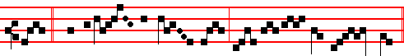
- eth. * And to him that knock- eth, it shall be op - ened.
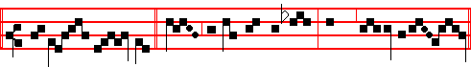
(E.T.Al-le - lu- ia.)  Ask, and ye shall receive, seek, and ye shall find.
And to him.

Blessing May the divine.

Lesson viij
AND he did well to climb into the tree, that the good tree might produce good fruits, and that being cut off from the wild olive and grafted against nature into the good olive, he might be able to bring forth the fruit of the law. For the root was holy though the branches were useless, and the people of the gentiles passed beyond their unfruitful glory through faith in the resurrection as if by a kind of lifting up of the body. Zacchæus therefore was in the sycamore tree; there was on the road a blind man. The one the Lord in his pity awaits, the other he ennobles with the honour of his abiding with him. The one he questions, intending to heal him. He invites himself, uninvited, to the other's house. For he knew his host's possessions to be rich, yet, although he had not yet heard the words invitation, he had already seen his affection.

clxiij
    viij Tone vij.
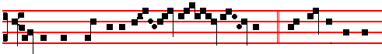
All thy walls shall be of stones most prec- ious, * And the towers of
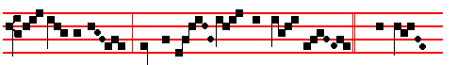
Je- ru- sa- lem shall be built up with jew- els. (E.T. Al- le-
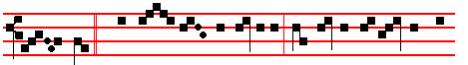
lu- ia.)   The gates of Je- rusalem shall be built of sapphire and
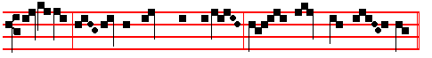
emer-ald, and all her walls round about with stones most prec- ious.
And the.
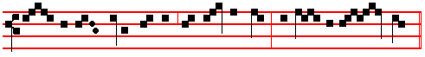
Glor- y be to the Father, and to the Son, and to the Ho- ly
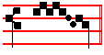
Ghost. And the.
Blessing May the King of Angels.
Lesson ix
LEST we should seem, being scornful of the poor, to have quickly abandoned the blind man and passed on to the rich man, let us await him, for the Lord also waited for: him. Let us question him for Christ also questioned him. As for us, let us ask because we do not know; but he, because he knows. Let us question him, that we may know whence he was cured: he questioned him, that in the one we, the many, might learn whence we deserve to see God. For he questioned him that we might believe that no one can be saved except him who makes confession.
Te Deum Laudamus, 9
clxiv
AT LAUDS, and through the Hours,
Antiphon 1. Tone vij, 3.
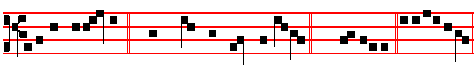
Holiness becometh * thine house, O Lord, for e-ver.(E.T. Al-leluia.) E u o u a e.
Psalm 93 Dominus regnavit XCII, and the rest, p.
Antiphon 2. Tone j, 5.
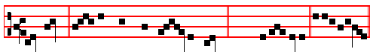
My house * shall be called the house of prayer. (E.T. Alle- luia.) E u o u a e.
Antiphon 3. Tone j, 1.
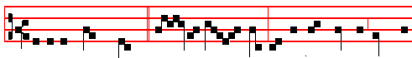
This is the Lord's house, * firm- ly build- ed: it is well founded on the
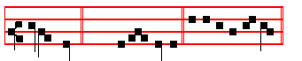
solid rock. (E.T. Al-le- lu-ia.) E u o u a e.
Antiphon 4. Tone viij, 2.
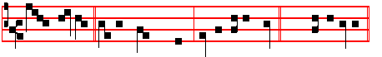
Well founded * is the Lord's house on the solid rock. (E.T. Al-le-lu-ia.)
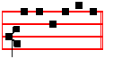
E u o u a e. Antiphon 5. Tone ij.
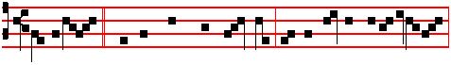
All thy walls * shall be stones most precious; and the towers of Jer-usalem

clxv
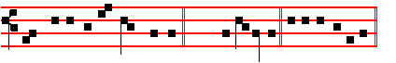
shall be upbuilded with jewels.(E.T. Al-le-lu-ia.) E u o u a e.
Chapter Rev.21
I SAW the holy city, new Jerusalem, coming down from God out of heaven, prepared as a bride adorned for her husband.
Hymn. E.H. 170 Mode j.
( Or the melody as at Vespers above, p. cxlix.)
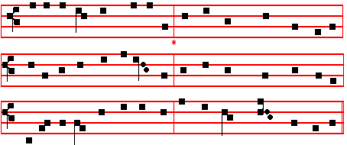

CHRIST is made the sure Foundation, 3 To this temple, where we call thee,
And the precious Corner-stone, Come, O Lord of Hosts, today;
Who, the two walls underlying, With thy wonted loving-kindness
Bound in each, binds both in one, Hear thy people as they pray;
Holy Sion's he1p for ever, And thy fullest benediction
And her confidence alone. Shed within its walls for ay.

2 All that dedicated City, 4 Here vouchsafe to all thy servants
Dearly loved by God on high, What they supplicate to gain;
In exultant jubilation Here to have and hold for ever
Pour perpetual melody: Those good things their prayers obtain,
God the One, and God the Trinal, And hereafter in thy glory
Singing everlastingly. With thy blessed ones to reign.

5. Laud and honour to the Father;
Laud and honour to the Son;
Laud and honour to the Spirit;
Ever Three and ever One:
Consubstantial, co-eternal,
While unending ages run.

clxvj
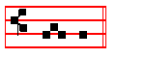
A - men.
 This is the Lord's house, firmly builded.  It is well founded on the solid rock.

On Benedictus, Antiphon. Tone viij, 1. 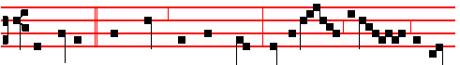
Zacchaeus, * make haste, and come down; for to-day I must a- bide
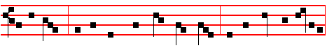
at thy house: and he made haste, and came down, and received him joyfully
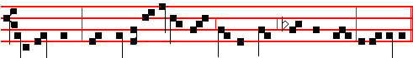
into his house. This day is salvation come to this house from the Lord, al-le-luia.

On the day itself of the Dedication of a Church and through the Octave, and when the Collect is to be varied because of the concurrence of the Dedication of another Church.
COLLECT

OGOD, who, thyself invisible, containest all things, but dost for the salvation of mankind shew forth visibly the signs of thy power: enlighten this temple with the power of thine indwelling and grant; that all they, who come together here to ask thy mercy, may, in whatsoever tribulations they call upon thee, obtain the blessings of thy consolation. Through.

On the Anniversary of the Dedication of a Church, and through the Octave.
COLLECT
O GOD, who year by year renewest unto us the day of consecration of this thy holy temple, and dost ever bring us again in safety to thy sacred mysteries: graciously hear the prayers of thy people, and grant; that whosoever entereth this temple to ask for blessings may rejoice in the obtaining of all his petitions. Through.
clxvij
AT TERCE
Antiphon.My house.
Chapter I saw, cxiv.
Short 
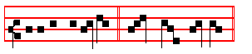
Holiness becometh * Thine house, O Lord.
Holiness.
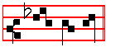
For ev - er. Thine house.
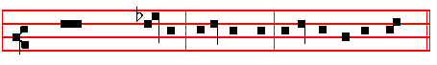
Glory be to the Fa-ther, and to the Son, and to the Ho- ly Ghost.
Holiness becometh.
 This place is holy wherein the priest pray - eth.
 For the sins and offences of the peop- le.

In Eastertide, Short   
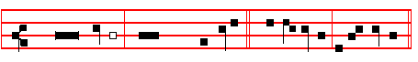
                  Holiness becometh thine house, O Lord. * Al-le- lu- ia, al- le- lu -ia.
Holiness becometh.
 For ev-er. Al-le- lu- ia, al- le- lu -ia.
Glory be as above.
Holiness becometh.
 This place is holy wherein the priest prayeth, alleluia. For the sins and offences of the people, alleluia.
AT SEXT
Antiphon.This is the Lord's house.
clxviij
Chapter Rev. 21
AND I heard a great voice our of heaven, saying, Behold, the tabernacle of God is with men, and he will dwell with them, and they shall be his people, and God himself shall be with them, and be their God.

Short 
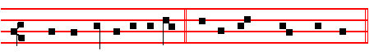
This place is ho - ly * Wherein the priest prayeth.
This place.
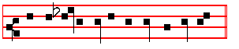
       For the sins and offences of the people. Wherein the.
Glory be. This place.
 This is the Lord's house, firmly builded.  It is well founded on the solid rock.

In Eastertide, short  
  This place is holy wherein the priest prayeth. * Al- le- lu-ia, al-le- lu- ia.
This place.
 For the sins and offences of the people. Al- le- lu-ia, al- le- lu- ia.
Glory be. This place.
 This is the Lord's house, firmly builded, alleluia.
        It is well founded on the solid rock, alleluia.

AT NONE

Antiphon. All thy walls.

Chapter Rev.21
AND God shall wipe away all tears from their eyes; and there shall be no more death, neither sorrow, nor crying, neither shall there be any more pain: for the former things are passed away. And he that sat upon the throne said, Behold, I make all things new.

clxix
Short    
 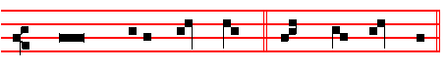
                                               This is the Lord's house, * Firm- ly build- ed.
This is.
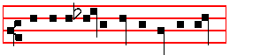
         It is well founded on the sol- id rock. Firm- ly build- ed.
Glory be. This is.
 Well founded is the Lord's house.
 On the solid rock.
In Eastertide, short    
 This is the Lord's house, firm- ly builded. * Al-le- lu-ia, al-le- lu- ia.
This is.
 It is well founded on the solid rock. Al-le- lu-ia, al-le- lu- ia.
Glory be. This is.
 Well founded is the Lord's house, alleluia.  On the solid rock, alleluia.

AT VESPERS
Antiphons, Psalms, Chapter and Hymn as in I Vespers, cxlix.
 Holiness becometh thine house, O Lord.  For ever.
On Magnificat, Antiphon. Tone vj
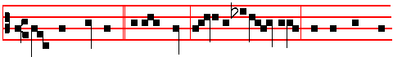
O how dreadful * is this place! truly this is none other but the house of
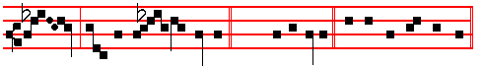
God, and the gate of heaven. (E.T. Al-le-lu-ia.) E u o u a e.
Canticle Magnificat.
clxx
SECOND DAY WITHIN THE OCTAVE

In the first Nocturn Lessons from the occurrent Scripture.

IN THE SECOND NOCTURN

From the Treatise by S. Augustine on the Psalms
Lesson iv On Psalm 122
JERUSALEM that is being built as a city. Brethren, when David was uttering these words, that city had been finished, it was not being built. It is some city he speaketh of, therefore, which is now being built, unto which living stones run in faith, of whom Peter saith, Ye also, as lively stones, are built up a spiritual house; that is, the holy temple of God. What meaneth, Ye are built up as lively stones? Thou livest, if thou believest, thou art made a temple of God; for the Apostle Paul saith, The temple of God is holy, which temple ye are.
 iv. Tone viij.
If they pray towards this house, * Forgive the sin of thy peop-le, O
God, and teach them the good way where - in they should walk,
and glo- ri-fy thy Name in this place.(E.T. Al - le- lu - ia.)
 Hear, O thou Shepherd of Is-rael, thou that leadest Joseph like a sheep,
thou that sit - test up-on the Che- ru -bim. Forgive. .

clxxj
Lesson v
THIS city is therefore now in building; stones are cut down from the hills by the hands of those who preach truth, they are squared that they may enter into an everlasting structure. There are still many stones in the hands of the Builder: let them not fall from his hands, that they may be built perfect into the structure of the temple. This, then, is the Jerusalem that is being built as a city: Christ is its foundation. The Apostle Paul saith, Other foundation can no man lay than that which is laid, which is Christ Jesus.

 v. Tone j.
How dread - ful is this place. * This is none o - - - -ther than. the house of God, and this is the gate of heav- en.
(E.T. Al- le- - lu - ia.) This is the house of God, strongly builded,
founded upon a sure rock. This is none.

Lesson vj
WHEN a foundation is laid on earth, the walls are built above, and the weight of the walls tends towards the lowest parts, because the foundation is laid at the bottom. But if our foundation be in heaven, let us be built towards healven. Bodies have built the edifice of this basilica, the ample size of which ye see; and since bodies have built it, they placed the foundation lowest. but, since we are spiritually built, our foundation is placed at the highest point. Let us therefore run thither, where we may be built; for it is said of Jerusalem herself, Our feet were standing in the courts of Jerusalem.

clxxij
 vj. Tone iv.
And Ja - cob rose up early in the morning, and set up the stone for a
pil- lar, and poured oil upon the top of it; and vowed a vow unto the Lord
* Surely this place is ho - ly, and I knew it not.
(E.T.Al-le- lu- ia)  And Ja - cob awaked out of his sleep,
and he said, Surely.
Glory be to the Father, and to the Son, and to the Ho- ly Ghost
Surely.
NOCTURN III

The Lesson from the Holy ye are. Gospel according to S. Luke
Lesson vij Ch. 19
JESUS entered and passed through Jericho. And behold, there was a man named Zacchæus, which was the chief among the publicans, and he was rich. And the rest.
Homily by S Ambrose Bishop. Bk. 8 on S. Luke
THE Evangelist tells us that when Zacchaeus saw the Lord, he made haste and followed him, glorifying God. On the other hand, he would not see him, did
clxxiij
he not follow Christ, preach the Lord, despise the world. We find grace among the rich also. We do not wish to give offence to the rich, we who wish to heal all men, if it can be done; and they might take offence at the comparison between the camel being squeezed through the eye of a needle, and Zacchæus making all speed to forsake his wealth.

 vij Tone j.
My house shall be called the house of prayer, saith the Lord:
in it ever- y one that asketh re- ceiv- eth; and he that seeketh find -
- eth. * And to him that knock- eth, it shall be op - ened.
(E.T.Al-le - lu- ia.)  Ask, and ye shall receive, seek, and ye shall find.
And to him.

Lesson viij

LET the rich learn that evil lies not in the possession of abundant wealth, but in those who do not know how to use their wealth. For riches, just are as they are encumbrances to evil-doers, are aids to virtue to welldoers. Truly Zacchæus was rich, and he was chosen by Christ; but by bestowing the half of his goods to the poor, and by restoring fourfold of what he had taken by false accusation (on the other hand, this would not have been sufficient, nor would his liberality have availed, if he had continued in wrongdoing; since not plunder but gifts were sought), by this use of his riches, hc received a reward that was more abundant than that which he had given away.

clxxiv
    viij Tone vij.
All thy walls shall be of stones most prec- ious, * And the towers of
Je- ru- sa- lem shall be built up with jew- els. (E.T. Al- le-
lu- ia.)   The gates of Je- rusalem shall be built of sapphire and
emer-ald, and all her walls round about with stones most prec- ious.
And the.
Glor- y be to the Father, and to the Son, and to the Ho- ly
Ghost. And the.

  Lesson ix
RIGHTLY was he called the chief among the publicans. Who will despair of his ownlife now, when this man, who had been guilty of false accusation, attained unto salvation? And, says the Evangelist, He was rich; that you may realize that not all rich men are avaricious. Because he was little of stature: what else could he be, how could Scnpture say that he was any taller? Behold, lest you should think this littleness a bad thing, or understand it as littleness of faith: he had not yet promised restoration, he had not yet seen Christ, deservedly was he yet little. But John was great, because he saw both Christ and the Spirit in the likeness

clxxv
of a dove abiding on Christ, as he himself declared, I saw the Spirit descending from heaven like a dove, and it abode upon him.
Te Deum Laudamus, 9
__________________________________________________________________

THIRD DAY WITHIN THE OCTAVE.

In the first Nocturn Lessons from the occurrent Scripture.

NOCTURN II

Sermon by S. Augustine, Bishop

Lesson iv Sermon 336. Ch. 1-2
THE occasion for this gathering is the dedication of a house of prayer. This is indeed the house of our prayers, but we ourselves the house of God. If we ourselves are the house of God, we are being built up in this world, that we may be dedicated at the end of the world. The building, yea, rather, the act of building. demands labour; the dedication demands rejoicing. What was being done here when these walls were rising, is done now when believers in Christ are gathering together. For believers are as it were the wood and the stones cut from the forests and mountains; and when they are catechized, baptized, and fashioned, they are, so to speak, hewn, levelled and planed by the hands of carpenters and masons. Yet they form not the house of the Lord save when they are joined together by love.

 iv. Tone viij.
If they pray towards this house, * Forgive the sin of thy peop-le, O
God, and teach them the good way where - in they should walk,
and glo- ri-fy thy Name in this place.(E.T. Al - le- lu - ia.)

clxxvj
 Hear, O thou Shepherd of Is-rael, thou that leadest Joseph like a sheep,
thou that sit - test up-on the Che- ru -bim. Forgive. 
 Lesson v
IF these timbers and stones were not fastened together In regular order, if they were not peaceably joined together if they did not, by their being fastened together, in some manner love one another, no one could enter here. Finally, when thou seest the stone and the wood well fastened together in any building, thou enterest confidently, and fearest not that they should fall. Therefore Christ our Lord, desiring to enter ,and to dwell within us, as if in the act of building, said: A new commandment I give unto you, that ye love one another. A new commandment, said he, I give unto you. For ye were worn out with age; ye were not yet building up my house, ye were lying in your ruins. Therefore, that ye may be raised up from your former ruins, love one another.
 v. Tone j.
How dread - ful is this place. * This is none o - - -
-ther than. the house of God, and this is the gate of heav- en.
(E.T. Al- le- - lu - ia.) This is the house of God, strongly builded,
founded upon a sure rock. This is none.
clxxvij
 Lesson vj
OF your charity, consider that this house is yet building throughout the whole world, as was foretold and promised. For when the house was built, after the captivity, it was said, as another psalm has it: O sing unto the Lord a new song; sing unto the Lord, all the whole earth. What is there called a new song, this the Lord called a new commandment. For what means a new song save new love? Songs are for lovers. The voice of this singer is the fervour of holy love. Let us love; let us love freely, for we love the Lord, than whom we find nothing better; let us love him for himself, and ourselves in him, but yet for himself.
 vj. Tone iv.
And Ja - cob rose up early in the morning, and set up the stone for a
pil- lar, and poured oil upon the top of it; and vowed a vow unto the Lord
* Surely this place is ho - ly, and I knew it not.
(E.T.Al-le- lu- ia)  And Ja - cob awaked out of his sleep,
and he said, Surely.
Glory be to the Father, and to the Son, and to the Ho- ly Ghost
Surely.

clxxviij
 IN THE THIRD NOCTURN
The Lesson from the holy Gospel according to Luke.
Lesson vii Ch.19
AT that time: Jesus entered and passed through Jericho. And behold, there was a man named Zacchaeus, which was the chief among the publicans, and he was rich. And the rest.
From the Homily by Saint Ambrose, Bishop. Bk.8 on Luke, end.
AND what is the crowd, if not the confusion of the unskilled mu1titude, which cannot see the height of wisdom? Therefore so long as Zacchæus is in the crowd, he sees not Christ: he climbs above the crowd, and sees: that is, now going beyond the ignorance of the populace, he is worthy to behold him whom he desired. And suitably be added: For the Lord was to pass that way: either where the sycomore was, or he that was to be1ieve: that he might both guard the mystery, and bring forth grace. For so he came, that by way of the Jews he might pass to the Gentiles.
 vij Tone j.
My house shall be called the house of prayer, saith the Lord:
in it ever- y one that asketh re- ceiv- eth; and he that seeketh find -
- eth. * And to him that knock- eth, it shall be op - ened.
(E.T.Al-le - lu- ia.)  Ask, and ye shall receive, seek, and ye shall find.
And to him.
 Lesson viij
AND so he looked up and saw Zacchæus. For already, in the sublimity of faith among the fruits of new works, he surpassed as it were the height of a fruitful tree. And since we have turned from the type to morals, to distend the mind on the

clxxix
Lord's Day in the delight of so many of the faithfu1, it is a pleasure to join in the feast. Zacchæus in the sycomore, that is to say the new fruit of a new season, that in this also that saying might be fulfilled: The fig-tree brought forth her unripe figs.
    viij Tone vij.
All thy walls shall be of stones most prec- ious, * And the towers of
Je- ru- sa- lem shall be built up with jew- els. (E.T. Al- le-
lu- ia.)   The gates of Je- rusalem shall be built of sapphire and
emer-ald, and all her walls round about with stones most prec- ious.
And the.
Glor- y be to the Father, and to the Son, and to the Ho- ly
Ghost. And the.
 Lesson ix
FOR to this end Christ came, that from trees not fruits, but men should be born. We read in another p1ace: When thou i wast under the fig tree, I saw thee. So Nathaniel under a tree, that is, above the root, since righteous; for the root is holy. But Nathaniel under the tree, because under the law: Zacchaeus above the tree, because above the law. The one a hidden defender, the other a public proc1aimer

clxxx
of the Lord. The one hitherto sought Christ from the 1aw: the other already above the law left his possessions, and followed the Lord.
Te Deum Laudamus, 9.
__________________________________________________________________

FOURTH DAY WITHIN THE OCTAVE

In the first Nocturn Lessons from the occurrent Scripture.

IN THE SECOND NOCTURN

Sermon by S. Augustine, Bishop
Lesson iv Sermon 336. Ch. 3
CONSIDER the psalm of dedication which we have just been singing from the midst of our ruins. Thou hast put off my sackcloth: this pertains to ruin. What then pertains to the building? And girded me with gladness. The voice of dedication speaks: Therefore my glory shall sing unto thee, and I shall not be silent, Who is this that speaks? By his words ye may know him. If I expound, the saying is dark. Therefore I will repeat his words; and straightway ye will recognize the speaker, that ye may love him as he speaks to you. Who is it that could say, Thou, Lord, hast brought my soul out of hell? Whose soul has been brought out of hell, save his of whom it is said in another place, Thou shalt not leave my soul in hell?

 iv. Tone viij.
If they pray towards this house, * Forgive the sin of thy peop-le, O
God, and teach them the good way where - in they should walk,
and glo- ri-fy thy Name in this place.(E.T. Al - le- lu - ia.)

clxxxj
 Hear, O thou Shepherd of Is-rael, thou that leadest Joseph like a sheep,
thou that sit - test up-on the Che- ru -bim. Forgive.
 Lesson v
A DEDlCATION is set before us, deliverance is sung, the song of the dedication of the house: and it is said: I will magnify thee, O Lord, for thou hast set me up, and not made my foes to triumph over me. Behold the hostile Jews who deemed that they had slain Christ, that they had conquered him as an enemy, and destroyed him as a man like unto others and mortal.
 v. Tone j.
How dread - ful is this place. * This is none o - - -
-ther than. the house of God, and this is the gate of heav- en.
(E.T. Al- le- - lu - ia.) This is the house of God, strongly builded,
founded upon a sure rock. This is none.
Lesson vj
ON the third day he rose again, and his words are, I will magnify thee, O Lord, for thou hast set me up. Hear the Apostle saying, Wherefore God also hath highly exalted him. And hast not made my foes to triumph over me. They triumphed indeed in the death of Christ, but in his Resurrection and Ascension, in
clxxxij
the preaching of his Name, some of them were pricked to the heart. By that
preaching therefore, and by the publishing of the Apostles' steadfastness, some were pricked and converted; others were hardened and confounded, but none were made to triumph.
 vj. Tone iv.
And Ja - cob rose up early in the morning, and set up the stone for a
pil- lar, and poured oil upon the top of it; and vowed a vow unto the Lord
* Surely this place is ho - ly, and I knew it not.
(E.T.Al-le- lu- ia)  And Ja - cob awaked out of his sleep,
and he said, Surely.
Glory be to the Father, and to the Son, and to the Ho- ly Ghost
Surely.
 IN THE THIRD NOCTURN
The Lesson from the Holy Gospel according to Luke.
Lesson vij Ch.19
AT that time: Jesus entered and passed through Jericho. And behold, there was a man named Zacchæus, which was the chief among the publicans, and he
clxxxiij
was rich. And the rest.
Homily by Saint Gregory, Pope. Bk.27 of Morals, Ch.27.
IF we desire to be truly wise and to contemplate wisdom itself, let us humbly acknowledge ourselves fools. Let us leave harmful wisdom, let us learn praiseworthy foolishness. Hence indeed it is written: God hath chosen the foolish things of the world to confound the wise. Hence again it is said: If any man among you seemeth to be wise in this world, let him become a fool, that he may be wise. Hence the words of the Gospel story testify: for Zacchaeus, when he could not see for the crowd, climbed a sycomore tree, to see the Lord as he passed. For sycamore is, being interpreted, foolish fig.
 vij Tone j.
My house shall be called the house of prayer, saith the Lord:
in it ever- y one that asketh re- ceiv- eth; and he that seeketh find -
- eth. * And to him that knock- eth, it shall be op - ened.
(E.T.Al-le - lu- ia.)  Ask, and ye shall receive, seek, and ye shall find.
And to him.
 Lesson viij
AND so little Zacchaeus submits to the sycamore, and sees the Lord: for they that humbly choose the folly of the world these do clearly perceive the wisdom of God. For truly the crowd impedes our smallness from seeing the Lord: for the tumult of worldly cares presses on the infirmity of the human mind, so that it cannot see the light of truth. But we wisely climb the sycomore, if we providently keep in mind the foolishness which is commanded by God. For what is more foolish in this world, than not to ask for what has been lost, to yield

clxxxiv
possessions to them that seize them, to return no injury for injuries received, yea, to shew patience in other such circumstances?
    viij Tone vij.
All thy walls shall be of stones most prec- ious, * And the towers of
Je- ru- sa- lem shall be built up with jew- els. (E.T. Al- le-
lu- ia.)   The gates of Je- rusalem shall be built of sapphire and
emer-ald, and all her walls round about with stones most prec- ious.
And the.
Glor- y be to the Father, and to the Son, and to the Ho- ly
Ghost. And the.
 Lesson ix
FOR the Lord commands us to climb the sycomore, as it were, when he says, Of him that taketh away thy goods ask them not again. And again, Whosoever shall smite thee on thy right cheek, turn to him the other also. Through the sycomore tree the Lord is discerned as he passes: for through this wise foolishness, though as yet not clearly, yet now through the light of the contemplation of God wisdom is seen as if in passing; which they cannot see, who seem to themselves to be

clxxxv
wise: for caught in the lofty crowd of their own thoughts, they have not yet found the sycamore tree, so as to see the Lord.
Te Deum Laudamus, 9
__________________________________________________________________

FIFTH DAY WITHIN THE OCTAVE

In the first Nocturn Lessons from the occurrent Scripture.

IN THE SECOND NOCTURN

Sermon by S. Augustine, Bishop
Lesson iv Sermon 336. Ch. 3-5
THOU hast not made my foes to triumph over me. Do we really believe that the Jews are triumphant when churches are filled? Churches are built, dedicated, filled; why should they be triumphant? Not only are they not triumphant, they are even put to confusion, and the cry of exultation is fulfilled, I will magnify thee, O Lord, for thou hast set me up, and not made my foes to triumph over me. Thou hast not made them to triumph over me: if they would only believe in me, then they would triumph in me. Lest our sermon be too lengthy, let us pass on to another verse of this psalm. Why does Christ say, Thou hast put off my sackcloth, and girded me with gladness? Because his sackcloth was in the likeness of sinful flesh.

 iv. Tone viij.
If they pray towards this house, * Forgive the sin of thy peop-le, O
God, and teach them the good way where - in they should walk,
and glo- ri-fy thy Name in this place.(E.T. Al - le- lu - ia.)

clxxxvj
 Hear, O thou Shepherd of Is-rael, thou that leadest Joseph like a sheep,
thou that sit - test up-on the Che- ru -bim. Forgive.
 Lesson v
THINK not meanly of that which he calls, My sackcloth; in it was contained the price of thy redemption. Thou hast put off my sackcloth. In his Passion it was put off. Why is it then, that it is said to God the Father, Thou hast put off my sackcloth? Do you wish to hear why it is said to the Father, Thou hast put off my sackcloth? Because, He spared not his own Son, but delivered him up for us all. For by means of the unbelieving Jews he brought it about that the believers were redeemed and the unbelievers were put to confusion. In their lack of belief they knew not what great good was to be done to us by means of their wickedness. The sackcloth was lifted up, and the exultant evil-doers surrounded it as though with gladness. The persecutor put off the sackcloth with a spear, and our Redeemer poured forth our price.
 v. Tone j.
How dread - ful is this place. * This is none o - - -
-ther than. the house of God, and this is the gate of heav- en.
(E.T. Al- le- - lu - ia.) This is the house of God, strongly builded,
founded upon a sure rock. clxxxvij This is none. 
  Lesson vj
LET Christ our Redeemer sing, let Judas who sold him groan, let the Jews who bought him be ashamed. Lo, Judas sold him, the Jews bought him; they concluded a wicked bargain, both were condemned. Both the buyer and the seller doomed themselves. Then let our Head sing, let him sing of his slain body; let him sing, and let us hearken: Thou hast put off my sackcloth, and girded me with gladness: that is, Thou hast put off my mortality, and girded me with immortality and incorruption. That my glory should sing unto thee, and I should not be pricked. What is, I should not be pricked? That the persecutor should no more thrust his spear at me, That I should not be pricked. For Christ being raised from the dead dieth no more; death hath no more dominion over him.
 vj. Tone iv.
And Ja - cob rose up early in the morning, and set up the stone for a
pil- lar, and poured oil upon the top of it; and vowed a vow unto the Lord
* Surely this place is ho - ly, and I knew it not.
(E.T.Al-le- lu- ia)  And Ja - cob awaked out of his sleep,
and he said, Surely.
Glory be to the Father, and to the Son, and to the Ho- ly Ghost
Surely. clxxxviij
 IN THE THIRD NOCTURN

The Lesson from the holy Gospel according to Luke
Lesson vij Ch. 19
AT that time: Jesus entered and passed through Jericho. And behold, there was a man named Zacchæus, which was the chief among the publicans, and he was rich. And the rest.
Homily by the venerable Bede, Priest. Bk.5, Ch.77, on Lk. 19
THE things which are impossible with men are possible with God. For behold a camel laying down the burden of his hump and going through the eye of a needle, that is, a rich publican leaving the burden of riches, despising the deceitful opinion, and climbing through the strait gate and narrow way that leads to life.With wonderful devotion of faith he supplements what he lacked by nature by climbing a tree: and so rightly, although he himself dared not ask it, received the blessing which he desired, and received the Lord.
 vij Tone j.
My house shall be called the house of prayer, saith the Lord:
in it ever- y one that asketh re- ceiv- eth; and he that seeketh find -
- eth. * And to him that knock- eth, it shall be op - ened.
(E.T.Al-le - lu- ia.)  Ask, and ye shall receive, seek, and ye shall find.
And to him.
 Lesson viij
AND mystically Zacchæus, being interpreted, justified, signifies the faithful people of the Gentiles; who, the more occupied they were with worldly cares, the more they were sunk under the weight of evil deeds. But they were washed,

cxxxix
but they were sanctified, but they were justified in the name of our Lord Jesus Christ and in the Spirit of our God. And he sought to see the Saviour as He entered Jericho, but could not because of the crowd: that is, they desired to share the grace which the Saviour brought into the world: but the overgrowth of customary vices hindered them from attaining their desire.
    viij Tone vij.
All thy walls shall be of stones most prec- ious, * And the towers of
Je- ru- sa- lem shall be built up with jew- els. (E.T. Al- le-
lu- ia.)   The gates of Je- rusalem shall be built of sapphire and
emer-ald, and all her walls round about with stones most prec- ious.
And the.
Glor- y be to the Father, and to the Son, and to the Ho- ly
Ghost. And the.
 Lesson ix
FOR indeed the same crowd of evil custom, which shouted down the blind man's cries, to prevent him from asking for his sight, also holds back the publican as he looks up, to prevent him from seeing Jesus.But as the blind man overcame the voices of the crowd by shouting more and more: so the little man

cxc
has to transcend the obstacle of the hostile crowd by seeking higher places; leaving earthly places, climbing the tree of the cross. For indeed the sycomore (which is a tree with leaves like the morus, mulberry, but greater in height, whence by the Latins it is called celsa, lofty,) is, being interpreted, foolish fig. And the same cross of the Lord, which nourishes the faithful like a fig-tree, by the unbelieving is derided as foolish.
Te Deum Laudamus, 9
__________________________________________________________________

SIXTH DAY WITHIN THE OCTAVE

In the first Nocturn Lessons from the occurrent Scripture.

IN THE SECOND NOCTURN

Sermon by S. Augustine, Bishop
Lesson iv Sermon 336. Ch. 6
THEREFORE, while we joyfully behold the new building of his holy church, which to-day we dedicate in the Name of God, we find that we owe to our God the noblest praise, and to you, holy brethren, a sermon befitting the building of the house of God. Then verily our sermon will be fitting, if it contain somewhat of edification, which, God building you up inwardly, may profit to the advantage of your souls. That which we see here materially wrought in our walls, let it be spiritually wrought in our hearts; and that which we here behold perfected in wood and stone, let it, by the edifying grace of God, be perfected in your bodies.
 iv. Tone viij.
If they pray towards this house, * Forgive the sin of thy peop-le, O
God, and teach them the good way where - in they should walk,
and glo- ri-fy thy Name in this place.(E.T. Al - le- lu - ia.)

cxcj
 Hear, O thou Shepherd of Is-rael, thou that leadest Joseph like a sheep,
thou that sit - test up-on the Che- ru -bim. Forgive. .
Lesson v
LET us then first render thanks to the Lord our God, from whom is every good and every perfect gift; and let us praise his loving-kindness with all readiness of heart: because, for the erection of this house of prayer, he visited the souls of the faithful, stirred up their hearts, called forth help, inspired the yet unwilling with good will, assisted the efforts of good will to the fulfilment of action; and by these means God, who worketh in his servants to will and to do his good pleasure, himself began and perfected this whole work.
 v. Tone j.
How dread - ful is this place. * This is none o - - -
-ther than. the house of God, and this is the gate of heav- en.
(E.T. Al- le- - lu - ia.) This is the house of God, strongly builded,
founded upon a sure rock. This is none.
 Lesson vj
AND as he never suffers good works to be vain in his sight, he will bestow worthy reward for so great work on those faithful labourers to whom he has
cxcij
granted the grace of his strength. Moreover greater thanks are to be given to our God. For this Church, which he has caused to be constructed unto His Name, he has caused also to be more greatly honoured by the relics of holy Martyrs.
 vj. Tone iv.
And Ja - cob rose up early in the morning, and set up the stone for a
pil- lar, and poured oil upon the top of it; and vowed a vow unto the Lord
* Surely this place is ho - ly, and I knew it not.
(E.T.Al-le- lu- ia)  And Ja - cob awaked out of his sleep,
and he said, Surely.
Glory be to the Father, and to the Son, and to the Ho- ly Ghost
Surely.

IN THE THIRD NOCTURN
The Lesson from the holy Gospel according to Luke
Lesson vij Ch.19
AT that time: Jesus entered and passed through Jericho. And behold there was a man named Zacchæus, which was the chief among the publicans, and he was rich.And the rest.
cxciij
From the Homily by the venerable Bede, Priest. Bk.5, ch.77 on Luke Ch.19
AND when he came to the place, Jesus looked up and saw him. Passing through Jericho the Saviour came to the place, where Zacchaeus had run ahead and climbed the sycamore: that is, sending throughout the world the preachers of His word, in whom truly He himself also spoke and went, he came to a people of the nations, which already being raised up by faith in His passion, also longed to be blessed by recognizing the face of His divinity.He looked up and saw him, that is, he chose them as rising by the grace of faith above earthly desires and the unbelieving crowds. For to see, when said of God, means to choose, or to love.Whence comes the saying, The eyes of the Lord are over the righteous.For we also see what we love; and from what we detest, we hasten to avert our gaze.
 vij Tone j.
My house shall be called the house of prayer, saith the Lord:
in it ever- y one that asketh re- ceiv- eth; and he that seeketh find -
- eth. * And to him that knock- eth, it shall be op - ened.
(E.T.Al-le - lu- ia.)  Ask, and ye shall receive, seek, and ye shall find.
And to him.
 Lesson viij
SO Jesus saw him, who also saw Him. For He chose him, who also chose Him, and loved him, who loved Him in return.This wise order of proceeding, that is through faith in the Lord's incar- nation to attain to knowledge of his divinity, seeing as it were the face of Jesus through the sycomore, the eminent Doctor shews when he says: For I determined not to know any thing among you, save Jesus Christ, and Him crucified. And expressing the same thing in another way: Ye have need, he says, of milk, not of solid food. Milk he calls the infirmity of the

cxciv
temporary dispensation, solid food the firmness of the everlasting majesty.
    viij Tone vij.
All thy walls shall be of stones most prec- ious, * And the towers of
Je- ru- sa- lem shall be built up with jew- els. (E.T. Al- le-
lu- ia.)   The gates of Je- rusalem shall be built of sapphire and
emer-ald, and all her walls round about with stones most prec- ious.
And the.
Glor- y be to the Father, and to the Son, and to the Ho- ly
Ghost. And the.
 Lesson ix
AND he saith to him, Zacchaeus, make haste, and come down; for today I must abide at thy house. And he made haste and came down, and received him joyfully. The Lord abode once in the house of the chief of the Pharisees, that is, he taught in the synagogue of the Jews: but since they carped with venomous tongues because He washed not before eating, healed on the sabbath, received publicans and sinners, rebuked avarice, and did others deeds worthy of God; being utterly weary of their evil deeds, he departed and went away, saying: Your house is left

cxcv
unto you desolate. But today he is to abide in the house of little Zacchaeus: that is, in the shining of the light of new grace, to rest in the humble hearts of the nations that believe.
Te Deum Laudamus, 9
__________________________________________________________________

SEVENTH DAY WITHIN THE OCTAVE

In the first Nocturn Lessons from the occurrent Scripture.
IN THE SECOND NOCTURN
Sermon by Saint John Chrysostom.
Lesson iv From Homily 33 on Matthew Ch.9
THE Church is the common home of all, and when ye have first occupied it, we enter in, strictly observing the form of the disciples. For this cause also we pronounce Peace in common to all, directly as we enter, according to that law. Let no one therefore be careless, no one inattentive, when the Priests have entered in and are teaching; for there is real1y no small punishment appointed for this. Yea, and I for one would rather enter into any of your houses ten thousand times, and find myself baffled, than not to be heard when I speak here. This latter is to me harder to bear than the other, by how much this House is of greater dignity; our great possessions being verily laid up here, here all the hopes we have.
 iv. Tone viij.
If they pray towards this house, * Forgive the sin of thy peop-le, O
God, and teach them the good way where - in they should walk,
and glo- ri-fy thy Name in this place.(E.T. Al - le- lu - ia.)
 Hear, O thou Shepherd of Is-rael, thou that leadest Joseph like a sheep,
cxcvj
thou that sit - test up-on the Che- ru -bim. Forgive. .
Lesson v
FOR what is here that is not great and awful? Thus both this table is far more precious and delightful than the other, and this candlestick than the candlestick there. And this they know, as many as have put away diseases by anointing themselves with oil, in faith and in due season. And this coffer too is far better and more indispensable than that other chest; for it hath not clothes but alms shut up in it: even though they be few that own them. Here too is a couch better than that other; for the repose of the divine scriptures is more delightful than any couch.
  v. Tone j.
How dread - ful is this place. * This is none o - - -
-ther than. the house of God, and this is the gate of heav- en.
(E.T. Al- le- - lu - ia.) This is the house of God, strongly builded,
founded upon a sure rock. This is none.
 Lesson vj
AND had we attained to excellence in respect of concord, then had we no other home beside this. And that there is nothing overburdensome in this saying, the three thousand bear witness and the five thousand, who had but one home, one Table, one soul. But since we fall far short of their virtue and dwell scattered in our several homes, let us at least, when we meet here, be earnest in so doing. Because though in all other things we be destitute and poor, yet in these we are

cxcvij
rich. Wherefore here at least receive us with love when we come in unto you. And when I say, Peace be unto you, and ye say, And with thy spirit, say it not with the voice only, but also with the mind, not in mouth, but with understanding also.
 vj. Tone iv.
And Ja - cob rose up early in the morning, and set up the stone for a
pil- lar, and poured oil upon the top of it; and vowed a vow unto the Lord
* Surely this place is ho - ly, and I knew it not.
(E.T.Al-le- lu- ia)  And Ja - cob awaked out of his sleep,
and he said, Surely.
Glory be to the Father, and to the Son, and to the Ho- ly Ghost
Surely.
 IN THE THIRD NOCTURN

The Lesson from the holy Gospel according to Luke.
Lesson vij Ch.19
AT that time:Jesus entered and passed through Jericho. And behold, there was a man named Zacchæus, which was the chief among the publicans, and he

cxcviij
was rich. And the rest.
From the Homily by the venerable Bede, Priest. a little on from the last passage.
AND when they saw it, they all murmured, saying, that he was gone to be guest with a man that is a sinner. It is manifest that the Jews always hate to see the Gentiles saved. For it is written: And the next sabbath day came almost the whole city together to hear the word of God. But when the Jews saw the multitudes, they were filled with envy, and spake against those things which were spoken by Paul. And in another place, even believing brethren took exception against the Prince of the Apostles, saying, Why wentest thou in to men uncircumcised, and didst eat with them?
 vij Tone j.
My house shall be called the house of prayer, saith the Lord:
in it ever- y one that asketh re- ceiv- eth; and he that seeketh find -
- eth. * And to him that knock- eth, it shall be op - ened.
(E.T.Al-le - lu- ia.)  Ask, and ye shall receive, seek, and ye shall find.
And to him
 Lesson viij
AND Zacchæus stood, and said unto the Lord: Behold, Lord, the half of my goods I give unto the poor: and if I have taken any thing from any man by false accusation, I restore him fourfold. When others accused the man that was a sinner, Zacchæus himself stood, that is, he stood firm in the truth of the faith in which he had made a beginning, and proved himself to be not only converted from being a sinner, but also conversing among the perfect. For as the Lord says: If thou wilt be perfect, go, sell all that thou hast ,and give to the poor: so whosoever has lived innocently before his conversion, may after his conversion give all to the poor.
cxcix
 
ON THE OCTAVE OF THE DEDICATION OF A CHURCH.
DOUBLE.

All as on the day, except the Lessons of the second Nocturn.
From the First Epistle of Pope Saint Felix IV
Lesson iv On Consecration 1, Ch. 2
WE read that Moses, at the Lord s commandment, made and consecrated the tabernacle, together with its table and altar, and the rest of the vessels and utensils, needful for the holy rites; and we know that he not only consecrated these things with prayers, but, by commandment of the Lord, he also anointed them with holy oil. How these things were done, and how it was none other than the priests who were anointed with holy oil, and, arrayed in priestly vestments, were consecrated to the Lord, and how the Levites fetched, carried, set up, and brought away; all these holy institutions,which by commandment of God were written by Moses, are to be found in the law of the Lord.
 iv. Tone viij.
If they pray towards this house, * Forgive the sin of thy peop-le, O
God, and teach them the good way where - in they should walk,
and glo- ri-fy thy Name in this place.(E.T. Al - le- lu - ia.)
 Hear, O thou Shepherd of Is-rael, thou that leadest Joseph like a sheep,
thou that sit - test up-on the Che- ru -bim. Forgive.
ccj
 Lesson v
IN the Book of the Kings we read how David, that most saintly king, wished to magnify the rites of God and build a temple to the Lord, and how he was forbidden, because he was responsible for much bloodshed. So he collected the costy things needful, while Solomon his son did what he himself had hoped to do, and, by commandment and with the help of God, completed and consecrated the temple, together with the altar and the rest. of the furnishings pertaining to the holy rites; as it is said in the Book of the Kings: At that time Solomon held a feast, and all Israel with him, a great congregation, from the entering in of Hamath unto the river of Egypt, before the Lord our God, seven days and seven days, even fourteen days. On the eighth day he sent the people away.
 v. Tone j.
How dread - ful is this place. * This is none o - - -
-ther than. the house of God, and this is the gate of heav- en.
(E.T. Al- le- - lu - ia.) This is the house of God, strongly builded,
founded upon a sure rock. This is none.
Lesson vj
AN example is given by the Lord himself, that the festivals of the dedication of churches and priests should be celebrated with solemn rite every year; for he came to this celebration of the festival with the rest of the people, thus ordaining that it should be done at every Dedication Festival; as it is written, And it was at Jerusalem the Feast of the dedication, and it was winter. And Jesus walked in the temple in Solomon's porch. You will find in the Book of the Kings, after the account of the dedication of the temple, that these celebrations are to be kept for eight days.

ccij
 vj. Tone iv.
And Ja - cob rose up early in the morning, and set up the stone for a
pil- lar, and poured oil upon the top of it; and vowed a vow unto the Lord
* Surely this place is ho - ly, and I knew it not.
(E.T.Al-le- lu- ia)  And Ja - cob awaked out of his sleep,
and he said, Surely.
Glory be to the Father, and to the Son, and to the Ho- ly Ghost
Surely.
__________________________________________________________________

cciij
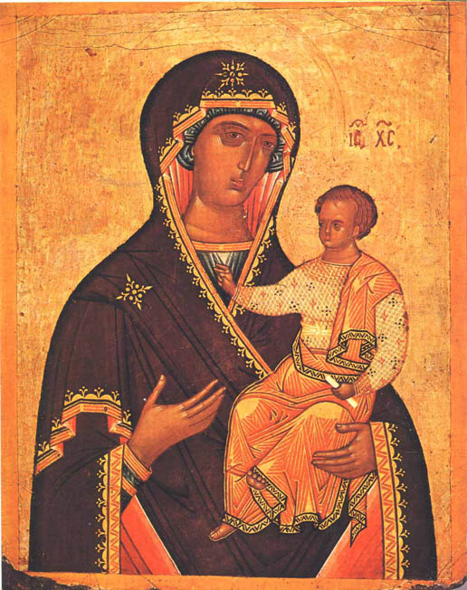
__________________________________________________________________

COMMON OF FEASTS OF THE BLESSED VIRGIN MARY
-Note that, if it shall be within Eastertide, the Rubric is to be observed which is placed above, lii.

cciv

