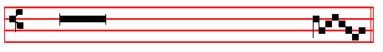
 Light perpetual shall shine upon thy Saints, O Lord Allelu-ia.
 And an ageless eternity, allelu- -ia.

At Sext, Chapter Wisdom 5
HOW is he numbered among the children of God,and his lot is among the Saints!
Short . Light perpetual shall shine upon thy Saints, O Lord. * Alleluia, alleluia. Light perpetual. And an ageless eternity. Alleluia, alleluia.
Glory be. Light perpetual.
 Everlasting joy shall be upon their heads, alleluia.
 They shall obtain joy and gladness, alleluia.

At None, Chapter Romans 8
WE know that all things work together for good to them that love God, to them who are the called according to his purpose.
Short . Everlasting joy shall be upon their heads.* Alleluia, alleluia.
Everlasting.  They shall obtain joy and gladness. Alleluia, alleluia.
Glory be. Everlasting.
 Right dear in the !ight of the Lord, alleluia
 Is the death of his Saints, alleluia

At Vespers, Antiphons of Lauds above, pp. xxiv-xxvj. Psalms of II Vespers of Apostles out of Eastertide, p. xiij-xvj.
Chapter and Hymn as above at I Vespers, p. xxij.
 Right dear in the sight of the Lord, alleluia.
 Is the death of his Saints, alleluia.

On Magnificat, Antiphon. Tone viij, 1. 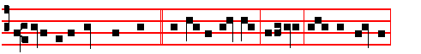
O ye holy and righteous, * rejoice in theLord,alleluia: God hath chosen
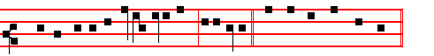 you to him to be his inheritance, alle-luia. Canticle Magnificat, p.
xxviij
THE COMMON OF SAINTS
On the Vigils of Apostles
The Office is of the Feria, as was said in the general Rubrics, except for the Lesson and Collect, which are noted in their proper places. But when there are no proper Lessons, the Gospel with the following Homily is read.
In Lent and Eastertide the Office is not to be said of the Vigil of Apostles, but only a commemoration in the Mass.

Blessing: May the Gospel.
The Lesson from the Holy Gospel according to S. John
Lesson j Ch. 15. 12-16
JESUS said unto his disciples: This is my commandment, That ye love one another, as I have loved you.
Homily by S. Gregory the Great Hom. 27 on the Gospels
SINCE all the sacred sayings of our Lord are full of commandments, why is it that the Lord speaks of our loving one another as though that were the only order given (for he says, This is my commandment, that ye love one another), unless it be that love alone is the sum or all his orders, and all the commandments are contained in this one? No matter what is commanded, it is in charity alone that it is confirmed. Just as many branches of a tree grow from one root, so are many virtues generated from one charity. Neither can a branch bear foliage of good works if it have not its root in charity.
 from the Feria of the Season.

Blessing: May the divine assistance.
Lesson ij
THEREFORE the commandments of our Lord are manifold and yet they are but one: manifold in diversity of operation, one in the root of love. God himself makes known to us how we are to cultivate this virtue of charity, he shows us his ways in many places of the Scriptures and orders us to love our friends in him and our enemies for his sake. There are many who do love their neighbours, but with affections of the flesh and of kinship. There is nothing contrary to the sacred sayings in this love, but it is one thing to expend natural affection on our neighbours, and another to pay out of obedience that kind of charity which our Lord demands.

Blessing: May the King of Angels.
Lesson iij
THESE men truly love their neighbours, but they do not attain to the sublime
j
Antiphon. Tone ij. 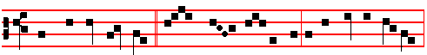 Then shall the righteous * shine forth as the sun in the presence of God,
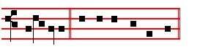
al-le- lu-ia. E u o u a e.
Chapter Wisdom 5.
THEN shall the righteous man stand in great boldness before he face of such as have afflicted him,and made no account of his labours.

Hymn: E.H 124, part 2, Claro paschale gaudio as above, p. xxij, or:
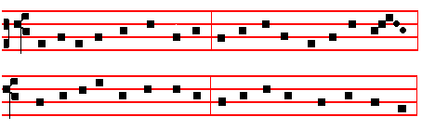

4 On that fair day of Paschal joy 6 O Christ, the King of gentleness,
The sunshine waa without alloy. Our several hearts do thou possess,
When to their very eyes restored That we may render all our days
They looked upon the risen Lord. Thy meed of thankfulness and praise.

5 The wounds before their eyes displayed 7 Maker of all, to thee we pray
They see in living light arrayed, Fulfi1 in us thy joy to-day;
And that they see they testify When death assails, grant, Lord, that we
In open witness fearlessly. May share thy Paschal victory.

8 To thee who, dead, again dost live,
All glory, Lord, thy people give;
All glory, as is ever meet,
To Father and to Paraclete.
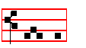
A - men.
xxvj
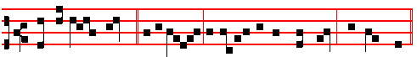 Ye are my friends, * if ye do whatsoever I command you, saith the Lord.
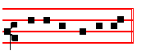
Ps. 112 Beatus vir CXI of Sunday, p. 203.

Antiphon. Tone j,1.
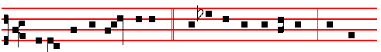
Blessed are the peacemakers, * blessed are the pure in heart, for they
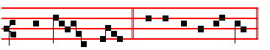
shall see God. Ps. 113 Laudate pueri CXII, p. 203.

Antiphon. Tone ij.
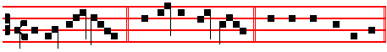
In your pa- tience * possess ye your souls.

Psalm 117 Laudate Dominum omnes Gentes CXVI
O PRAISE the Lord, all ye heathen: * praise him, all ye nations.

2 For his merciful kindness is ever more and more towards us: and the truth of the Lord endureth for ever. Praise the Lord.

Chapter Eph. 2.
BRETHREN: Now therefore ye are no longer strangers and foreigners, but fellow-citizens with the saints, and of the household of God; and are built upon the foundation of the Apostles and Prophets, Jesus Christ himself being the chief corner stone.
iij
 Light perpetual shall shine upon thy Saints, O Lord, alleluia.
 And an ageless eternity, alleluia.

 4. Light perpetual shall shine upon thy Saints, O Lord, * And an ageless eternity, alleluia, alleluia.
 Everlasting joy shall be upon their heads, they shall obtain joy and gladness. And an ageless.
 5. With great power gave the Apostles * Witness of the Resurrection of the Lord Jesus, alleluia, alleluia.
 They were all filled with the Holy Ghost, and they spake the Word of God with boldness. Witness.
 6. These are the new born lambs who have proclaimed, alleluia: they came but just now to the well; * They are all filled with light, alleluia, alleluia.
 They stand before the Lamb, clothed in white robes, with palms in their hands. They are all. Glory be. They are all.

IN THE THIRD NOCTURN

Antiphon.Light perpetual * shall shine upon thy Saints, O Lord, and an ageless eternity, alleluia.
Psalms 75, 97, 99 as above in the Common of Apostles out of E.T.

 Everlasting joy shall be upon their heads, O Lord, alleluia.
 They shall obtain joy and gladness, alleluia.

 7. I am the true vine,ye are the branches, * He that abideth in me, the same bringeth forth much fruit, alleluia, alleluia.
 As the Father hath loved me, so have I loved you. He that.
 8. Her Nazirites are purer than snow, alleluia, they shine with the glory of God, alleluia.* They are whiter than milk, alleluia, alleluia.
 Purer than snow, whiter than milk, they are more ruddy in body than rubies, their polishing is of sapphire. They are. Glory be.They are.

AT LAUDS

Antiphon. Tone viij, 1.
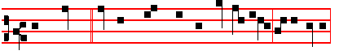
Thy Saints, * O Lord, shall blossom as the li-ly, al-le- lu-ia:
xxiv
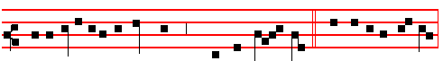 for a testimony against them and the Gen - tiles. Canticle Magnificat
Proper Collect.

AT COMPLINE
and through the Hours
Hymn Te lucis, &c Mode viij.
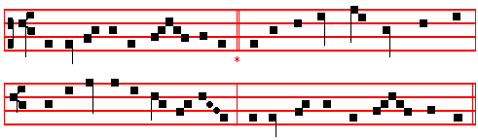
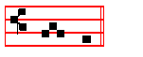
AT MATINS

Invitatory.- The Lord, the King of the Apostles, * O come let us worship.
Psalm 95 Venite exultemus XCIV, p.2.

HYMN EH. 175 Aeterna Christi munera Mode iij.
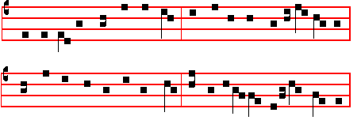
THE eternal gifts of Christ the King, 2 The Church in these her princes boasts,
The Apostles' glorious deeds, we sing; These victor chiefs of warrior hosts;
And while due hymns of praise we pay, The soldiers of the heavenly hall,
Our thankful hearts cast grief away. The lights that rose on earth for all.

v
of Eastertide above.
Chapter Wisdom 5
THEN shall the righteous man stand in great boldness before he face of such as have afflicted him,and made no account of his labours.
Hymn Tristes erant Apostoli Mode iv.
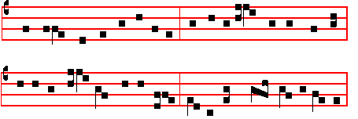

Melody to E.H.123 / 124, pt.2. at Vespers, Matins, Lauds.
THE Apostles hearts were full of pain 5 O Lord of all with us abide
For their dear Lord so lately slain, In this our joyful Eastcrtlde;
By rebel servants doomed to die From every weapon death can wield
A death of cruel agony. Thine own redeemed for ever shield.

2 With gentle voice the angel gave 6 All praise be thine, O risen Lord,
The women tidings from the grave; From death to endless lifc rcstored:
Fear not, your Master ye shall see; All praise to God the Father be
He goes before to Galilee. And Holy Ghost eternally.

3 Then, hastening on their eager way From Ascension to Pentecost:
The joyful tidings to convey,
Their Lord they met, their living Lord, All glory, Lord, to thee we pay,
And falling at his feet ador'd. Ascending o'er thc stars today;
All glory, as is ever meet,
4 The Eleven, when they hear, with speed To Father and to Paraclete.
To Galilee forthwith proceed,
That there once more they may behold
The Lord's dear face, as he foretold.

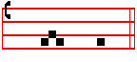
A - men.

 O ye holy and righteous, rejoice in the Lord, alleluia.
 God hath chosen you to him to be his inheritance, alleluia.
xxij
Blessing May the Only begotten. . .
Lesson ij
AND these things, brethren, I have in a figure transferred to myself and to Apollos for your sakes: that ye might learn in us not to think of men above that which is written, that no one of you be puffed up for one against another. For who maketh thee to differ from another? and what hast thou that thou didst not receive? now if thou didst receive it, why dost thou glory, as if thou hadst not received it? Now ye are full, now ye are rich, ye have reigned as kings without us: and I would to God ye did reign, that we also might reign with you. For I think. that God hath set forth us the Apostles last, as it were appointed to death: for we are made a spectacle unto the world, and to angels, and to men.
 Take my yoke upon you, you, saith the Lord, And learn of me, for I am meek and lowly in heart. * For my yoke is easy and my burden is light.
 And ye shall find rest unto your souls. For my.
Blessing May the grace of
Lesson iij
WE are fools for Christ's We are fools for Christ's sake, but ye are wise in Christ: we are weak. but ye are strong: ye are honourable, but we are.despised.Even unto this present hour we both hunger, and thirst, are naked. and are buffetted, and have no certain dwelling-place; and labour, working with our own hands: being reviled, we bless; being persecuted, we suffer it: being defamed, we intreat: we are made as the filth of the world, and are the offscouring of all things unto this day. I write not these things to shame you, but as my beloved sons I warn you. For though ye have ten thousand instructors in Christ, yet have ye not many fathers: for in Christ Jesus I have begotten you through the gospel.

 When ye stand before kings and governors, take no thought how or what ye shall speak: * For it shall be given you in that same hour what ye shall speak.
 For it is not ye that speak, but the Spirit of your Father. which speaketh in you. For it shall. Glory be. For it shall.

IN THE SECOND NOCTURN

Antiphon.The princes of the people * are joined unto the people of the God of Abraham.
Ps.47 Omnes gentes. XLVI
Antiphon. Thou hast given an heritage unto those that fear thy Name, O Lord.
vij
wings were stretched upward; .two wings of every one were joined one to another, and two covered their bodies. And they went everyone straight forward: whither the spirit was to go, they went; and they turned not when they went.

NOCTURN II

From the Commentary of St. Gregory, Pope, on the Prophet Ezechiel
Lesson iv
THE prophet gives a minute description of the four holy living creatures which in the spirit he foresaw, as being to come, when he says: "Each had four faces and four wings." What is signified by face if it be not celebrity: or by wings, unless it be the power of flight? For it is by the face that a man is recognized: but by their wings the bodies of birds are raised in the air. Thus the face pertains to faith, the wings to contemplation. For in our faith we are known by almighty God, as he says of his sheep: "I am the good shepherd; and I know mine, and mine know me." And again he says: "I know whom I have chosen". For by contemplation we are raised above ourselves, as it were, to heaven.

Lesson v.
EVERY one, then, had four faces: for if you enquire what Matthew held concerning the Incarnation of the Lord: he assuredly held the same doctrine as Mark, Luke, and John. If you ask what John held; it was undoubtedly that which was held by Luke, Mark. and Matthew. If you ask what Mark held; it was the same as that of Matthew, John, and Luke. If you ask what Luke held; it was the same as that of John Matthew, and Mark. Every one, then, had four faces; for the knowledge of the faith, in which they are known by God, it is the same in each one, as in all four. For whatsoever you find in one, you will recognize equally in all four.

Lesson vj.
AND every one had four wings: for they all, with one accord, preach our Lord Jesus Christ, the Son of Almighty God: and raising the eyes of their mind to his Godhead, they fly upon the wings of contemplation. Therefore the faces of the Evangelists pertain to the human nature of the Lord, their wings to his Godhcad: for, as if with their faces, they gaze upon him, in whom they see the body: but when they say that in his Godhead he is incomprehensible and incorporeal, they fly heavenwards in contemplation, as if on wings. Since, then, faith in his incarnation is one and the same in all, and the contemplation of his divinity is equal in each one, it is rightly said: "Each had four faces and four wings." .

NOCTURN III

The Lesson from the Holy Gospel according to S. Luke.
xx
 When men shall hate you, and when they shall separate you from their company, and shall reproach you, and cast out your name as evil, for the Son of Man's sake. Rejoice.

Blessing May God enkindle.
Lesson vj
AND now, as we sit close by the sacred body of the Shepherd of the Church, the maid servant who kept the door could tell us how weak and timid he was before the coming of the Spirit. He was so overcome by the voice of one woman that in his terror of death he denied Life. Consider moreover that Peter denied the Lord when he was a prisoner upon earth, while the thief confessed him as he hung upon the cross. But let us hear how strong this timid man became after the coming or the Spirit: the rulers and elders were assembled togcther, and threatened to scourge the Apostles if thcy dared to teach in the name of Jesus, but Peter answered with great boldness, We ought to obey God rather than men.

 These men are conquerors and friends of God, who despised the orders of governors, and earned the everlasting reward: * Now are they crowned and receive palms.
 These are they which came out of great tribulation, and have washed their robes in the blood of the Lamb. Now are they. Glory be. Now are they.
IN THE THIRD NOCTURN
Antiphon. The horns of the righteous *shall be exalted, al1eluia.
Ps. 75 Confitabimur LXXIV
Antiphon. There is sprung up * a light for the righteous, alleluia, and joyful gladness for such as are true-hearted, alleluia.
Ps.91 Dominus regnavit, exultet terra. XC
Antiphon. They kept his testimonies, * and the law that he gave them, alleluia.
Ps.99 Dominus regnavit,irascantur populi XCVIII
 Exceedingly honoured are thy friends, O Lord.
 Firm1y established is their princedom.
Our Father. Absolution. From the chains. Blessing May the Gospel.

Lesson vij Ch 19
Peter said unto Jesus, Behold, we have forsaken all, and followed thee; what shall we have therefore?
Homily by S.Jerome, Priest. Bk.3 on Mat.19
GREAT self-confidence! Peter was a fisherman, he had not been rich, he

ix
was destined to prevail throughout the whole world: whence this edifice is styled a building together unto Christ.

Lesson vj
AND because judges come from all quarters, the twelve thrones are spoken of, just as the twelve gates, from the entering from all sides into that city. Not only therefore have those twelve, and the Apostle Paul, a claim to the twelve thrones, but, from the universal signification, all who are to sit in judgment: in the same manner as all who enter the city, enter by one or other of the twelve gates. There are four quarters of the globe: East, West. North, South: and they are constantly alluded to in the Scriptures. The Lord declares in the Gospel that he will call his sheep from the four winds; therefore from all those four winds is the Church called. And how called? On every side she is called in the Trinity: no otherwise is she called than by Baptism in the name of the Father, the Son, and the Holy Ghost: four, then, being thrice taken, twelve are found. Knock, therefore, with all your hearts at these gates: and let Christ cry within you, Open me the gates of righteousness. For he went before us the Head. He follows himself in his body.

IN THE THIRD NOCTURN

The Lesson from the holy Gospel according to Matthew.
Lesson vij. Chapter 19, 27.
At that time: Peter said unto Jesus: Behold, we have forsaken all, and followed thee: what shall we have therefore? and the rest.
Homily of the Venerable Bede, Priest.
THAT man is perfect, who going selleth all that he hath, and giveth to the poor and coming followeth Christ: for he shall have no lack of treasure in heaven. Therefore when Peter did well to ask, Jesus said to such: Verily I say unto you, that ye which have followed me, in the regeneration, when the Son of man shall sit in the throne of his glory, ye also shall sit upon twelve thrones, judging the twelve tribes of Israel.Those indeed who labour for his name in this life, he teaches to hope for a reward in the other: that is, in the regeneration, when, it is clear, we shall have been regenerated by rising again to immortal life, who had been born to a fleeting, mortal life.

Lesson viij.
AND truly a just return, that they who here for Christ have neglected the glory of human high estate, there glorified by Christ as judges should sit singly with him, who could be dissuaded by no reason from following his footsteps. Let no one think that because Mathias was chosen instead of the traitor Judas there will be only twelve Apostles judging then: as there are also not twelve tribes of

xviij
they do not understand that, though in other things this promised reward would be seemly, in the case of wives it would be unseemly, that a man who had left one wife for the Lord's sake should receive a hundred in the world to come. But the meaning is this: That he who has left earthly things for the sake of the Saviour, shall receive spiritual things; which things will be, by comparison and by their own merit, as if a small number were compared to a hundred.

Te Deum Laudamus , p. 24.
AT LAUDS.
Antiphons as above at Vespers.

Psalm 93 Dominus regnavit XCII
and the rest, p. 28.
Chapter and Hymn as above at Vespers.
 They declared the work of God.
 And wisely considered of his doing.
On Benedictus, Antiphon. Tone ij.
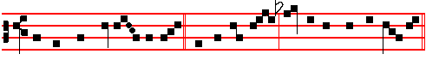 Ye which have forsa- ken all, * and followed me, shall receive an hundredfold,
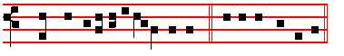
and shall inherit everlasting life. Canticle Benedictus, p. 37.

At the Hours, the Hymns are sung to the Tone Te lucis, p. iij.

At Prime, Antiphon This is, p. ij.

At Terce, Antiphon. Greater love, p. ij.
Chapter as above at I. Vespers, p. iij.
Short 
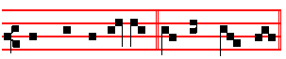
Their sound is gone out * in - to all lands.
Their sound.
xj
7 If I climb up into heaven, thou art there: * if I go down to hell, thou art there also.
8 If I take the wings of the morning: * and remain in the uttermost parts of the sea;
9 Even there also shall thy hand lead me : * and thy right hand shall hold me.

10 If I say, Peradventure the darkness shall cover me: * then shall my night be turned into day.
11 Yea, the darkness is no darkness with thee, but the night is as clear as the day: * the darkness and light to thee are both alike.
12 For my reins are thine: * thou hast covered me in my mother's womb.

13 I will give thanks unto thee, for I am fearfully and wonderfully made: * marvellous are thy works, and that my soul knoweth right well.
14 My bones are not hid from the: * though I be made secretly, and fashioned beneath in the earth.
15 Thine eyes did see my substance, yet being unperfect: * and in thy book were all my members written;
16 Which day by day were fashioned: * when as yet there was none of them.

17 How dear are thy counsels unto me, O God: * O how great is the sum of them !

18 If I tell them, they are more in number than the sand: * when I wake up, I am present with thee.
19 Wilt thou not slay the wicked, O God: * depart from me, ye blood-thirsty men.

20 For they speak unrighteously against thee: * and thine enemies take thy Name in vain.
21 Do not I hate them, O Lord, that hate thee: * and am not I grieved with those that rise up against thee?
22 Yea, I hate them right sore: * even as though they were mine enemies.

23 Try me, O God, and seek the ground of my heart: * prove me, and examine my thoughts.
24 Look well if there be any way of wickedness in me: * and lead me in the way everlasting.

Antiphon. Firmly established, as above.

Chapter and Hymn as above at I Vespers.
They declared the work of God.  And wisely considered of his doing.
xvj
AND they departed from the presence of the council, rejoicing that they were counted worthy to suffer shame for the Name of Jesus.
Short 
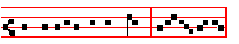
Right honourable are thy friends * Unto me, O God.
Right honourable.
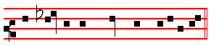
 Right well is their princedom establish-ed.
Unto me. Glory be.
Right honourable.
 They declared the work of God.
 And wisely considered of his doing.

AT II VESPERS
Antiphon. Tone viij, 1
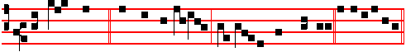 The Lord sware * and wilI not repent: Thou art a priest for ever.
Ps.110 Dixit Dominus as on Sunday
Antiphon. Tone viij, 2
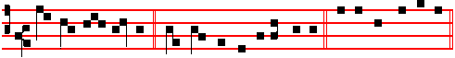 May the Lord set him * with the princes of his people.
Ps.113 Laudate, pueri as on Sunday
Antiphon. Tone vij, 3
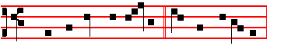
Thou, O Lord, hast broken * my bonds in sunder:
xiij

