THE PROPER OF THE SEASON

ON SATURDAY BEFORE THE FIRST SUNDAY OF ADVENT

AT VESPERS
Chapter. Rom. l.
BRETHREN: It is high time to awake out of sleep: for now is our salvation nearer then when we believed.  Thanks be to God.
This response is always made at the end of Chapters.
Hymn E.H.1 Mode iv.
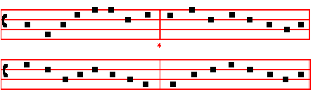
Conditor alme siderum

CREATOR of the stars of night, 4 At whose dread name, majestic now,
Thy people's everlasting light, All knees must bend, all hearts must bow;
Jesu. Redeemer, save us all, And things celestial thee shall own,
And hear thy servants when they call. And things terrestrial, Lord alone.

2 Thou, grieving that the ancient curse 5 O thou whose coming is with dread ,
Should doom to death a universe, To judge and doom tho quick and dead,
Hast found the medicine, full of grace Preserve us, while we dwell below,
To save and heal a ruined race. From every insult of the foe.

3 Thou cam'st, the Bridegroom of the bride, 6 To God the Father, God the Son,
As drew the world to evening-tide; And God the Spirit, Three in One,
Proceeding from a virgin shrine, Laud, honour, might, and glory be
The spotless Victim all divine: From age to age eternally.
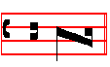
A - men.

 Drop down, ye heavens, from above, and let the skies pour down righteousness.
 Let the earth open, and let them bring forth salvation.

265
On Magnificat, Antiphon. Tone j, 1.
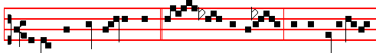
Behold, the Name of the Lord * com- eth from a-far: and his glory filleth
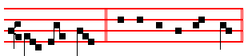
all the earth. Canticle Magnificat, p.209

COLLECT.

STIR UP, we beseech thee, O Lord, thy power and come: that by thy protection we may be found worthy to be set free from the dangers of our sins which beset us, and to be saved by thy deliverance: Who livest and reignest with God the Father in the unity of the Holy Ghost, God: throughout all ages, world without end.  Amen.

The Commemorations or Suffrages of the Saints are not said through all Advent, even in the Office of Saints, nor that of the Cross in the ferial Office.

In Advent nothing is said of a Feast, unless it be a Double or Semidouble: which if it occur on a Sunday, is transferred to the first day not impeded by a similar Feast, according to the Rubric on Translation of Feasts. But of a Simple there is only a Commemoration made.

AT COMPLINE

The Hymn to the Mode as at Lauds below.

THE FIRST SUNDAY OF ADVENT.

At Matins, Invitatory. The Lord, the King that is to come, * O come, let us worship.

And it is said on Ferias also until the third Sunday of Advent.

Hymn.E.H. 2 Mode iv.

266
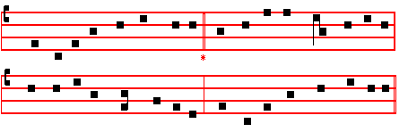
Verbum supernum prodiens
HIGH Word of God, who once didst come, 3 That,when thou comest from the skies,
Leaving thy Father and thy home, Great Judge, to open thine assize,
To succour by thy birth our kind, To give each hidden sin its smart,
When towvards thy advent time declined And crown as kings the pure in heart, - .

2 Pour light upon us from above, 4 We be not set at thy left hand,
And fire our hearts with thy strong love, Where. sentence .due would bid us stand,
That, as we hear thy Gospel read, But wIth the Saints thy face may see,
All fond desires may flee in dread; For ever wholly loving thee.

5. Praise to the Father and the Son,
Through all the ages as they run;
And to the holy Paraclete
Be praise with them and worship meet.
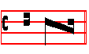
A - men.

IN THE FIRST NOCTURN
Antiphon Behold the King.
Psalm 1 Beatus vir, with the rest, as in the Psalter.
After the  in every Nocturn is said Our Father silently until  And lead us not into temptation. But deliver us from evil. Absolution. Hear, O Lord Jesus Christ, with its Blessings, as in the Psalter.
Blessing. May the blessing of the eternal Father.

Thc Beginning of the Book of the Prophet Isaiah
Lesson j Ch. l.
THE vision of Isaiah thc son of Amoz, which he Saw concerning Judah and Jerusalem in the days of Uzziah. Jotham, Ahaz, and Hezekiah, kings of Judah.
Hear, O heavens, and give ear, O earth: for the Lord hath spoken, I have nourished
267
and brought up children, and they have rebelled against me. The ox knoweth his owner, and the ass his master's crib: but Israel doth not know, my people doth not consider. But thou, O Lord, have mercy upon us.  Thanks be to God.

The Lessons always end in this manner unless otherwise indicated.

 I look from afar, and behold I see the Power of God coming, and a cloud covering all the land. * Go ye out to meet him, and say: * Tell us if thou art he * That shall reign over God's people Israel.
 High and low, rich and poor, one with another. Go ye out to meet him, and say:  Hear, O thou Shepherd of Israel, thou that leadest Joseph like a sheep. Tell us if thou art he.
Lift up your heads, O ye gates, and be ye lift up, ye everlasting doors, and the King of glory shall come in.  That shall reign over God's people Israel.
 Glory be to the Father, and to the Son, and to the Holy Ghost.
Then the  is repeated: I look from afar, and behold I see the Power of God coming, and a cloud covering all the land. Go ye out to meet him, and say: Tell us if thou art he that shall reign over God's people Israel.

Blessing. May the Only-begotten Son of God
Lesson ij
AH sinful nation, a people laden with iniquity, a seed of evildoers, children that are corrupters; they have forsaken the Lord, they have provoked the Holy One of Israel unto anger, they are gone away backward. Why should ye be
stricken any more? ye will revolt more and more: the whole head is sick, and the
whole heart faint. From the sole of the foot even unto the head there is no soundness in it; but wounds, and bruises, and putrifying sores: they have not been closed,. neither bound up, neither mollified with ointment.

 I saw in the night visions, and behold the Son of Man came with the clouds of
heaven: and there was given unto him a kingdom and glory: * That all people and nations and languages should serve him.  His dominion is an everlasting dominion, which shall not pass away, and his kingdom, that which shall not be destroyed. That all.

Blessing. May the grace.
Lesson iij
YOUR country is desolate, your cities are burned with fire, your land, strangers devour it in your presence, and it is desolate, as overthrown by strangers. And the daughter of Zion is left as a cottage in a vineyard, as a lodge in a garden of cucumbers, as a besieged city. Except the Lord of hosts had left unto

268
us a very small remnant, we should have been as Sodom, and we should have been like unto Gomorrah.

 The Angel Gabriel was sent to Mary, a Virgin espoused to Joseph, to bring unto
her the Word of the Lord: and when the Virgin saw the light, she was afraid: Fear not, Mary, for thou hast found favour with the Lord: * Behold, thou shalt conceive, and bring forth a Son, and he shall be called the Son of the Most Highest.
 The Lord God shall give up to him the throne of his father David, and he shall reign over the house of Jacob for ever. Behold.
Glory be to the Father, and to the Son and to the Holy Ghost. Behold.
Glory be is always said in this way at the end of the last Responsory of each Nocturn, unless otherwise noted.

IN THE SECOND NOCTURN
Blessing May God the Father.
Sermon by S. Leo the Great
Lesson iv Serm. xix; On the December Fast. Bk. 8. Ch. 1

OUR Saviour himself instructed his disciples concerning the times and seasons of the coming of the kingdom of God and the end of the world, and he hath given the same teaching to the whole Church in saying by the mouth of his Apostle: Take heed lest your hearts be weighed down through surfeiting and drunkenness and the cares of this life. Dearly beloved, we know that this warning applies more especially to us, for though the day which our Lord foretold is at present hidden from us, yet we doubt not that it is near.

 Hail, Mary, full of grace, the Lord is with thee: * The Holy Ghost shall come upon thee, and the power of the Highest shall overshadow thee: therefore also that holy thing which shall be born of thee shall be called the Son of God.
 How shall this be, seeing I know not a man? And the Angel answered and said unto her. The Holy Ghost.

Blessing. May Christ grant.
Lesson v
LET every man, then, make himself ready against the coming of the Lord, lest it find him a slave to gluttony, or entangled in worldly cares.. For we see by daily experience, dearly beloved, that fulness of drink blunts the keenness of the mind, and excess of food weakens the will. Moreover, the pleasure of eating is opposed to the health of the body, unless temperance withstands desire, and the momentary pleasure of indulgence is checked. by the thought of future discomfort.
269
 We look for the Saviour, the Lord Jesus Christ, * Who shall change our vile body that it may. be fashioned like unto his glorious body.  We should live soberly, righteously and godly in this present world, looking for that blessed hope, and the glorious appearing of the great God. Who shall.

Blessing May God enkindle.
Lesson vj
ALTHOUGH the body has no desires apart from the soul, and its feelings come from the same source as its movements: yet it is the function of the soul to deny things to the body which is subject to it, and, acting on its interior conviction, to keep back the outer man from things unseemly. Then will the soul, more often free from bodily lusts, sit at leisure in the inner court of the mind, meditating on divine wisdom. There, where the turmoil of earthly cares is stilled, will it feed on holy thoughts and find joy in pleasures that will never end.

 O my Lord, send, I pray thee, him whom thou wilt send: see the affliction of thy people: * As thou hast promised * Come and deliver us.
 Hear, O Shepherd of Israel, thou that leadest Joseph like a sheep, thou that sittest upon the Cherubyn. As thou hast. Glory be. Come and deliver us.

IN THE THIRD NOCTURN

The Lesson from the Holy GospeI according to Luke.
Lesson vij Ch. l

JESUS said unto his disciples: . There shall be signs in the sun, and in the moon, and in the stars; and upon the earth distress of nations.
Homily by S. Gregory the Great Homily 1 on the Gospels
OUR Lord and Saviour wanted to find us ready for his coming, and so he denounced beforehand those evil things that would come to pass in the growing-old of the world, with the intent of curbing our earth-bound desires. We are told of the great catastrophes that will take place in the last days, so that if we will not fear God in the time of peace, then at least we may fear our doom at the approach of these catastrophes and his judgment.

 Behold a virgin shall conceive and bear a son, saith the Lord: * And his name
shall be called Wonderful, Counsellor, the Mighty God.
 He shall sit upon the throne of David and of his kingdom there sha1l be no end. And his name.

Lesson viiij

270
MY brethren, in a few verses before this Gospel Lesson, our Lord gives his warning, saying: Nation shall rise against nation, and kingdom against kingdom: and great earthquakes shall be in divers places, and famines, and pesti- lences. Then, after a few more sayings he adds these words that you have heard: And there. shall be signs in the sun, and in the moon, and in the stars; and upon the earth distress of nations with perplexity; the sea and the waves roaring. We recognize that some of these things have already come to pass, and we tremble at the near approach of others.

. Hear the word of the Lord, O ye nations, and declare it in the ends of the earth: * And in the isles afar off, and say: Our Saviour shall come.
 Declare it and make it known: lift up your voice and cry aloud. And in the.

Blessing May the King of.

When a Homily from another Gospel is read, the following blessing is said.
By the words of the Gospel may our sins be blotted out.  Amen.

The Absolutions and. Blessings are said in the above order, when it is an Office of nine Lessons. But when it is of three Lessons, if the three Lessons are from the Scripture, the Absolution and. Blessing of the first Nocturn are said on Monday and Thursday: of the second Nocturn, on Tuesday and Friday: of the third Nocturn on Wednesday and Saturday, omitting the blessing before the Gospel, in whose place is said: May he bless us who liveth and reigneth for ever and ever.  Amen.
But if all three Lessons are not from the Scripture, the Absolutions are said in the same order, but the Blessings are as in the third Nocturn. If it is of a Saint, the first will be May he bless us; the second Whose feast we are keeping; the third May the King of Angels bring us to the society of the heavenly citizens.  Amen.

Lesson ix
NOW the rise of nation against nation and oppression spread through all the earth has become an actuality in our own days, over and above what we read of in books; and you know how often we have heard of earthquakes destroying cities in other parts of the world. We are always suffering from outbreaks of pestilence. Although the signs in the sun and in the moon and in the stars are not yet plainly visible, yet the changes in atmospheric conditions indicate that they may not be long in coming.

 Behold, the days come, saith the Lord, that I will raise unto David a righteous branch, and a king shall reign and prosper, and shall execute judgment and justice in the earth: * And this is the name whereby he shall be called: the Lord our righteousness.
271
 In his days Judah shall be saved and Israel shall dwell safely. And this is.
Glory be. And this is.
¶ From this Sunday until Christmas, and from Septuagesima Sunday until Easter, the ninth Responsory is said on Sundays, because Te Deum is not said, except on Feasts.
AT LAUDS
and through the Hours,
Antiphon 1. Tone viij,1.
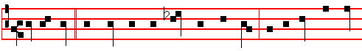
In that day * the mountains shall drop down new wine, and the hills shall flow
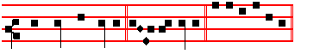
with milk and honey, al- le- luia. E u o u a e. Pss. of Sunday, p. 28.
Antiphon 2. Tone viij, 1.
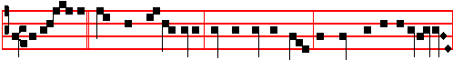
Be joyful, * O daughter of Sion,and exceeding glad, O daughter of Jerusalem,
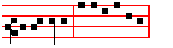
al- le- lu-ia. E u o u a e.
Antiphon 3. Tone v.
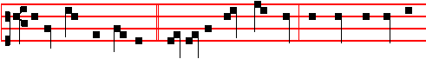 Behold, the Lord cometh,* and all his Saints with him; and there shall be in
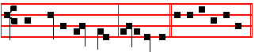
that day a great light, al-le-lu-ia. E u o u a e.

Antiphon 4. Tone vij, 1.

272
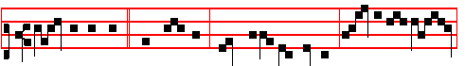
Ho, every one * that thirsteth, come ye to the waters: seek ye the Lord
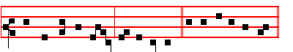
while he may be found, al - le- lu- ia. E u o u a e.
Antiphon 5. Tone iv, 1.
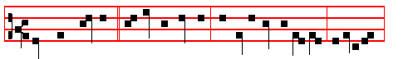
Lo, there cometh * a mighty Prophet: and he alone reneweth Jerusa-lem,
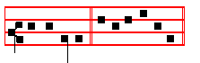
al - le- lu-ia. E u o u a e.
Chapter. Rom.13.
BRETHREN: It is high time to awake out of sleep: for now is our salvation nearer than when we believed.

Hymn Mode vij.
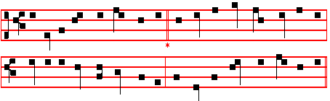

En clara vox redarguit
A THRILLING voice by Jordan rings, 2 Now let each torpid soul arise,
Rebuking guilt and darksome things: That sunk in guilt and wounded lies;
Vain dreams of sin and visions fly; See! the new star's refulgent ray
Christ in his might shines forth on high. Shall chase disease and sin away.

273
3 The Lamb ascends from heaven above 4 That when again he shines revealed,
To pardon sin with freest love: And trembling worlds to terror yield,
For such indulgent mercy shewn He give not sin its just reward,
With tearful joy our thanks we own. But in his love protect and guard.

5 To God the Father, God the Son,
And God the Spirit,Three in One,
Laud, honour, might, and glory be,
From age to age eternally.
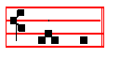
A - men.
 The voice of one crying in the wilderness, Prepare ye the way of the Lord.
 Make his paths straight.
On Benedictus, Antiphon. Tone viij, 1.
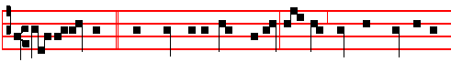
The Holy Ghost * shall come upon thee, Mary; fear not, thou shalt bear in thy
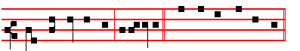
womb the Son of God, al-le-lu-ia. Canticle Benedictus, p. 39.
COLLECT.
STIR up, we beseech the.,O Lord, thy power and come: that by thy protection we may be found worthy to be set free from the dangers of our sins which beset us, and to be saved by thy deliverance: Who livest.

At Prime, Terce, Sext, and None, the Antiphons of Lauds are said in order, omitting the fourth.Which is observed on other Sundays in Advent also.
At Prime, Hymn Iam lucis. Antiphon In that day.
Ps.54 Deus in nomine and the rest in the Psalter. Chapter Now unto the King.
Short 
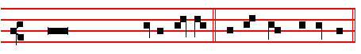
O Christ, Son of the liv-ing God, have mer- cy up- on us. It is
repeated O Christ, Son of the liv-ing God, have mer- cy up- on us.
274
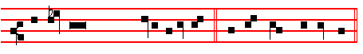
 Who art to come into the world.Have mer-cy up- on us.
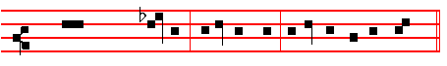
Glory be to the Father, and to the Son, and to the Ho- ly Ghost.
O Christ, Son of the living God, have mercy upon us, as above, p. 274.
 Arise,O Christ,and help us.  And deliver us for thy name's sake.
Thus it is said daily until Christmas, even in the Office of Saints, except on the day of the Conception of blessed Mary, and throughout the Octave.
Then Kyrie, eleison. Christe, eleison. Kyrie, eleison. Our Father. I believe.
 Lord, I have cried unto thee, with the rest, as in the Psalter.
At the Close of the Chapter, Short Lesson O Lord, be gracious, which is said on Sundays and Ferias until the Vigil of the Nativity exclusive.

AT TERCE

Hymn Nunc Sancte. Antiphon Be joyful. Psalm Legem Pone, and the rest.
Chapter Brethren: it is high time, as above.
Short 
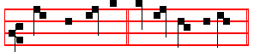
Come and save us, * O Lord God of hosts. And it is repeated
Come and save us, * O Lord God of hosts.
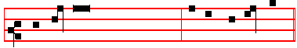
 Shew the light of thy countenance, and we shall be whole.
 O Lord God of hosts.
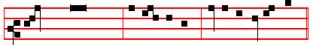
Glory be to the Father, and to the Son, and to the Holy Ghost.
Come and save us, O Lord God of hosts.

275
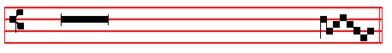
 The heathen shall fear thy name, O Lord.
 And all the kings of the earth thy majes- ty.
¶ Thus the Verses are repeated in all short responsories in the Hours.

AT SEXT
Antiphon Behold, the Lord cometh.
Chapter Rom.13
THE night is far spent, the day is at hand: let us therefore cast off the works of darkness, and let us put on the armour of light.
Short 
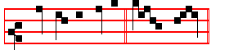
Shew us thy mercy * O Lord.
Shew us.
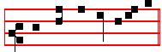
 And grant us thy salvation.  O Lord. G1ory be, as above, p. 275.
Shew us.
 Remember me, O Lord, according to the favour that thou bearest unto thy people. as above.  O visit me with thy salvation. as above.

AT NONE
Antiphon Lo, there cometh.
Chapter. Rom.13.
LET us walk honestly, as in the day; not in rioting and drunkenness, not in chambering and wantonness, not in strife and envying. But put ye on the Lord Jesus Christ.
Short 
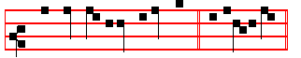
The Lord shall arise upon thee, * O Jerusa1em.
The Lord.

276
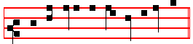
And his glory shall be seen upon thee. O Jerusalem.
Glory be. as above. The Lord. as above.
 Turn us again, O Lord God of hosts. as above.
 Shew the light of thy countenance, and we shall be whole. as above.

AT VESPERS

Antiphon In that day with the rest from Lauds. Psa1m Dixit Dominus 110 and the rest of Sunday. Chapter Brethren: it is high time, as above.
Hymn Creator alme siderum, as above in I Vespers.
 Drop down, ye heavens, from above, and let the skies pour down righteousness.
 Let the earth open, and let them bring forth salvation.
On Magnificat, Antiphon. Tone viij, 1.
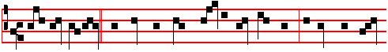
Fear not, Mary,* for thou hast found favour with the Lord: behold, thou sha1t
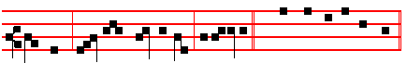
conceive, and bring forth a Son, al-le-luia. Canticle Magnificat, p.
Collect Stir up, we beseech thee, as above at Lauds.
The Hymns, , and Short  of this Sunday are said on the other Sundays of Advent, and on the ferias, as given below, and in the Psalter.
After Vespers of the Day are said Vespers of the Dead.
__________________________________________________________________

MONDAY

At Matins.- The Lord, the King that is to come, * O come, let us worship.
Psa1m 95 Venite.
Hymn E.H. 2 Verbum supernum prodiens, as above on Sunday. Antiphon The Lord. Psa1m 27 Dominus illuminatio, and the rest; as in the Psalter.
After the Versicle and Our Father, the Absolutions and Blessings in this and the following Ferias are said as described above, after the ninth Blessing of Sunday.
From the Prophet Isaiah
277
Lesson j. Ch. l.
WASH you, make you clean; put away the evil of your doings from before mine eyes; cease to do evil; learn to do well; seek judgment, relieve the oppressed. Judge the fatherless, plead for the widow. Come now, and let us reason together, saith the Lord: though your sins be as scarlet, they shall be as white as snow; though they be red like crimson, they shall be as wool.

 Receive the Word, O Virgin Mary, which is brought thee from the Lord by the Angel: conceive and bear him who is both God and man: * That thou mayest be called blessed among all women.
 For thou shalt bear a Son, yet shalt thou remain unspotted in thy Virginity: thou
shalt bring to pass great things, and shalt be a Mother-ever-Virgin. That thou

Blessing May the Only .
Lesson ij
IF ye be willing and obedient, ye shall eat the good of the land: but if ye refuse and rebel, ye shall be devoured with the sword: for the mouth of the Lord hath spoken it. How is the faithful city become an harlot! it was full of judgment; righteousness lodged in it; but now murderers. Thy silver is become dross, thy wine mixed with water: thy princes are rebellious, and companions of thieves: everyone loveth gifts, and followeth after rewards: they judge not the fatherless, neither doth the cause of the widow come unto them.

 Sing, O heavens, and be joyful, O earth, and break forth into singing, O mountains, for our Lord shall come. * And he will have mercy upon his afflicted.
 In his time shall the righteous flourish; yea, and abundance of peace: And he will.

Blessing May the grace of
Lesson iij
THEREFORE saith the Lord, the Lord of hosts, the mighty One of Israel, Ah, I will ease me of mine adversaries, and avenge me of mine enemies, and I will turn my hand upon thee, and purely purge away thy dross, and take away all thy tin. And I will restore thy judges as at the first, and. thy counsellors as at the beginning: afterward thou shalt be called, The city of righteousness, the faithful city. Zion shall be redeemed with judgment, and her converts with righteousness. And the destruction of the transgressors and of the sinners shall be together, and they that forsake the Lord shall be consumed.

 There shall no stranger pass through Jerusalem any more: * For in that day the mountains shall drop down new wine and the hills shall flow with milk and honey,

278
saith the Lord,  God shall come from Lebanon and the Holy One from the thickly wooded mountain. For in. Glory be. For in.

AT LAUDS

Antiphon and Psalm Have mercy 51 miserere with the rest from the Psalter.
Chapter Isaiah 2
COME ye, and let us go up to the mountain of the Lord, to the house of the God of Jacob; and he will teach us of his way, and we will walk in his paths: for out of Sion shall go forth the law, and the word of the Lord from Jerusalem.
Hymn and  as above in Sunday Lauds.
On Benedictus, Antiphon.
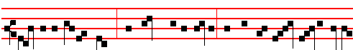
The Angel of the Lord * announced unto Mary, and she conceived by the Holy
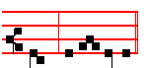
Ghost, al- le- lu-ia.
Then are said the Prayers Kyrie, eleison. Christe, eleison. Kyrie eleison. Our Father.  I said, Lord, as on Monday in the Psalter. Collect Stir up, as above on Sunday.
¶ The Collect of the previous Sunday is always said throughout the week in the ferial Office, when a proper one is not assigned; and at the Hours the Antiphons are taken from Lauds of the preceding Sunday when proper ones are not assigned to Lauds of the Feria.
Today is said the Office of the Dead. At Prime, Antiphon In that day.
Chapter Love the truth and peace, as in the Psalter.
Short  O Christ, Son of the living God, have mercy upon us.
It is repeated. O Christ, Son of the living God, have mercy upon us.
 Who art to come into the wor1d.  Have mercy upon us.
Glory be to the Father, and to the Son, and to the Holy Ghost. O Christ, Son of the living God, have mercy upon us.  Arise, O Christ,and help us.
 And deliver us for thy name's sake.
Then the Prayers, as in the Psalter in the ferial Office. At the Close of the Chapter, O Lord, be gracious, as in the Psalter.

AT TERCE
Antiphon Be joyful. 279
Chapter Jer. 23.
BEHOLD, the days come, saith the Lord ,that I will raise unto David a righteous Branch, and a King shall reign and prosper, and shall execute judgment and justice in the earth.
Short  Come and save us, * O Lord God of hosts. Come and save.  Shew the light of thy countenance, and we shall be whole.  O Lord God of hosts. G1ory be. Come and save.
 The heathen shall fear thy name, O Lord.
 And all the kings of the earth thy majesty.
After the short Responsory is said Kyrie, eleison. Christe, eleison. Kyrie, e1eison. Our Father.  Turn us again, as in the Psalter.

AT SEXT
Antiphon Behold, the Lord cometh.
Chapter Jer.23.
IN his days Judah shall be saved, and Israel shall dwell safely; and this is his Name whereby he shall be called, The Lord our Righteousness.
Short  Shew us thy mercy * O Lord. Shew us.
 And grant us thy sa1vation.  O Lord. Glory be. Shew us.
 Remember me, O Lord, according to the favour that thou bearest unto thy people.
 O visit me with thy salvation.
Then Kyrie, eleison, as above.
AT NONE
Antiphon Lo, there cometh.
Chapter Is.13, 14.
HER time is near to come, and her days shall not be prolonged: for the Lord will have mercy on Jacob, and will yet choose Israel.
Short  The Lord shall arise upon thee, O Jerusalem. The Lord.  And his glory shall be seen upon thee. O Jerusalem. Glory be. The Lord.
 Come, O Lord, and do not tarry.
 Purge the transgressions of thy people.
Then Kyrie, eleison, as above.
AT VESPERS

Antiphon The Lord hath inclined, Ps.116, 1-9 Dilexi, and the rest from the Psalter on Monday.
Chapter Gen .49.
THE sceptre shall not depart from Judah, nor a lawgiver from between his feet, until Shiloh come; and unto him shall the gathering of the people be.
Hymn Conditor alme siderum E.H.1, as above on Saturday, I Vespers of Advent Sunday. 280
 Drop down, ye heavens, from above, and let the skies pour down righteousness.
 Let the earth open, and let them bring forth salvation.
On Magnificat, Antiphon.
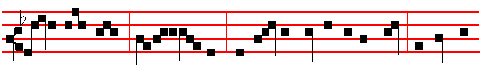
Lift up thine eyes, * O Jerusa-lem, and see the power of the King: Behold, the
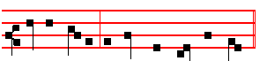
Saviour cometh to loose thee from thy chain.
Then is said Kyrie, eleison, with the Prayers, as above in the Psalter for Monday Vespers.
The above Chapters are said in the ferial Office until the Vigil of the Nativity exclusive.
__________________________________________________________________

TUESDAY
From the Prophet Isaiah
Lesson j Ch. 2.
THE word that Isaiah the son of Amoz saw concerning Judah and Jerusalem. And it shall come to pass in the last days, that the mountain of the Lord's house shall be established in the top of the mountains, and shall be exalted above the hills; and all nations shall flow unto it. And many people shall go and say. Come ye, and let us go up to the mountain of the Lord, to the house of the God of Jacob; and he will teach us of his ways, and we will walk in his paths: for out of Zion shall go forth the law, and the word of the Lord from Jerusalem.

 O mountains of Israel, ye shall shoot. forth your branches, and yield your fruit to my people of Israel; * for they are at hand to come.
 Drop down, ye heavens, from above, and let the skies pour down righteousness: let the earth open, and let them bring forth salvation. For they are.

Lesson ij
AND he shall judge among the nations, and shall rebuke many people: and they shall beat their swords into plowshares, and their spears into pruninghooks: nation shall not lift up sword against nation, neither shall they learn war any more. O house of Jacob, come ye, and let us walk in the light of the Lord. Therefore thou hast forsaken thy people the house of Jacob, because they be

281
replenished from the east, and are soothsayers like the Philistines, and they please themselves in the children of strangers.

 Let the mountains break. forth into singing, and the hills bring forth righteousness. * For the Lord the Light of the world cometh with power.
 Out of Sion shall go forth the law, and the word of the Lord from Jerusalem. For the Lord.

Lesson iij
THEIR land also is full of silver and gold, neither is there any end of their treasures; their land is also full of horses: neither is there any end of their chariots: their land also is full of idols; they worship the work of their own hands,
that which their own fingers have made: and the mean man boweth down. and the great man humbleth himself: therefore forgive them not.

 Behold I the Lord your God, come from the South * To visit you in peace.
 I will look again upon you, and make you to increase: ye shall be multiplied, and I will establish my covenant with you. To visit. Glory be. To visit.

On Benedictus, Antiphon
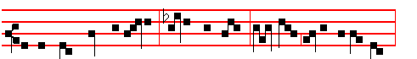
Before they came together, * Mary was found. with child of the Holy Ghost,
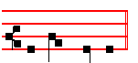
al - le - lu - ia. Then Kyrie, eleison, as above.
On Magnificat, Antiphon.
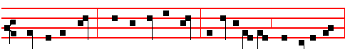
Seek ye the Lord * while he may be found: call ye upon him while he is near,
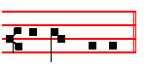
al - le - lu- ia. Then Kyrie, eleison, as above.

282

WEDNESDAY

From the Prophet Isaiah
Lesson j Ch. 3.
FOR behold, the Lord, the Lord of hosts, doth take away from Jerusalem and from Judah the stay and the staff, the whole stay of bread, and the whole stay of water, the mighty man, and the man of war, the judge, and the prophet, and the prudent, and the ancient, the captain of fifty, and the honourable man, and the counsellor, and the cunning artificer, and the eloquent orator. And I will give children to be their princes, and babes shall rule over them.

 Christ our King cometh, * And John hath testified of him, that he is the Lamb that should come.
 The kings shall shut their mouths at him, to him shall the Gentiles seek. And John.

Lesson ij
AND the people shall be oppressed, every one by another, and every one by his neighbour: the child shall behave himself proudly against the ancient, and the base against the honourable. When a man shall take hold of his brother of the house of his father, saying, Thou hast clothing, be thou our ruler, and let this ruin be under thy hand: in that day shall he swear, saying, I will not be an healer; for in
my house is neither bread nor clothing: make me not a ruler of the people.

 Long ago Ezekiel prophesied: I saw the gate shut; behold God went forth from it before the ages for the salvation of the world: * And it was shut again, for it is a
figure of the Virgin, in that after childbirth, she remained a Virgin still.
 The Lord alone shall enter by the gate that thou sawest. And it.

Lesson iij
FOR Jerusalem is ruined, and Judah is fallen; because their tongue and their doings are against the Lord, to provoke the eyes of his glory. The shew of their countenance doth witness against them; and they declare their sin as Sodom, they hide it not. Woe unto their soul! for they have rewarded evil unto themselves.
Say ye to the righteous, that it shall be well with him: for they shall eat the fruit of their doings. Woe unto the wicked! It shall be ill with him: for the the reward of his hands shall be given him.

 Behold, the days come, saith the Lord, that I will raise unto David a righteous branch, and a king shall reign and prosper, and shall execute judgment and justice

283
in the earth: * And this is the name whereby he shall be called: * The Lord our righteousness.
 In his days Judah shall be saved and Israel shall dwell safely. And this is.
Glory be. The Lord.
On. Benedictus, Antiphon.
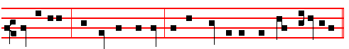
Out of Sion * shall go forth the law, and the word of the Lord from Jerusalem.
Then Kyrie, eleison, as above.
On Magnificat, Antiphon. 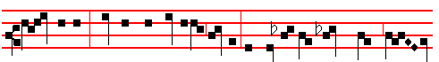
Af - ter me * cometh one mightier than I, the latchet of whose shoes I
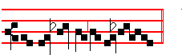
am not worthy to un-loose.
Then Kyrie, eleison as above.
__________________________________________________________________

THURSDAY
From the Prophet Isaiah
Lesson j Ch. 4.
AND in that day seven women shall take hold of one man, saying, We will eat our own bread, and wear our own apparel: only let us be called by thy name, to take away our reproach. In that day shall the branch of the Lord be beautiful and glorious, and the fruit of the earth shall be excellent and comely for them that are escaped of Israel. And it shall come to pass, that he that is left in Zion, and he that remaineth in Jerusalem, shall be called holy, even every one that is written among the living in Jerusalem.

 I saw in the night visions, and behold the Son man came with the clouds heaven: and there was given unto him a kingdom and glory: * That all people and nations and languages should serve him.
 His dominion is an everlasting dominion, which shall not pass away and his kingdom, that which shall not be destroyed. That all.

284
Lesson ij Ch. 5
NOW will I sing to my wellbeloved a song of my beloved touching his vineyard. My wellbeloved hath a vineyard in a very fruitful hill: and he fenced it, and gathered out the stones thereof, and planted it with the choicest vine, and built a tower in the midst of it, and also made a winepress therein: and he looked that it should bring forth grapes, and it brought forth wild grapes. And now, O inhabitants of Jerusalem, and men of Judah, judge, I pray you, betwixt me and my vineyard. What could h:ave been done more to my vineyard, that I have not done in it? wherefore, when I looked that it should bring forth grapes, brought it forth wild grapes?
 The Angel Gabriel was sent to Mary, a Virgin espoused to Joseph, to bring unto her the Word of the Lord: and when the Virgin saw the light, she was afraid: Fear not, Mary, for thou hast found favour with the Lord: * Behold, thou shalt conceive, and bring forth a Son, and he shall be called the Son of the Highest.
 The Lord God shall give unto him the throne of his father David, and he shall
reign over the house of Jacob for ever. Behold.
Lesson iij
AND now go to; I will tell you what I will do to my vineyard: I will take away the hedge thereof, and it shall be eaten up; and break down the wall thereof, and it shall be trodden down: and I will lay it waste: it shall not be pruned, nor digged; but there shall come up briers and thorns: I will also command the clouds that they rain no rain upon it. For the vineyard of the Lord of hosts is the house of Israel, and the men of Judah his pleasant plant: and he looked for judgment, but behold oppression; for righteousness, but behold a cry.

 Receive the Word, O Virgin Mary, which is brought thee from the Lord by the
Angel.: conceive and bear him, who is both God and man: * That thou mayest be called blessed among all women.
 For thou shalt bear a Son, yet shalt thou remain unspotted in thy Virginity: thou shalt bring to pass great things, and shalt be a Mother-ever-Virgin. That thou. Glory be. That thou.

On Benedictus, Antiphon.
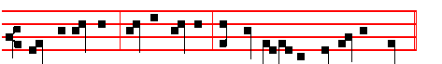
Blessed art thou * among women, and blessed is the fruit of thy womb.
Then Kyrie, eleison, as above.

On Magnificat, Antiphon.

285
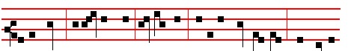
I will wait * upon the Lord my Saviour: and I will look for him while he is
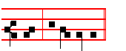
near, al- le - lu- ia.
Then Kyrie, eleison, as above.
__________________________________________________________________

FRIDAY
From the Prophet Isaiah
Lesson j Ch. 6
IN the year that king Uzziah died I saw also the Lord sitting upon a throne, high and lifted up, and his train filled the temple. Above it stood the seraphim: each one had six wings; with twain he covered his face, and with twain he covered his feet, and with twain he did fly. And one cried unto another, and said Holy, holy, holy, is the Lord of hosts: the whole earth is full of his glory.

 Hail, Mary, full of grace, the Lord is with thee: * The Holy Ghost shall come upon thee, and the power of the Highest shall overshadow thee: therefore also that holy thing which shall be born of thee shall be called the Son of God. How shall this be, seeing I know not a man? And the Angel answered and said unto her. The Holy Ghost..

Lesson ij
AND the posts of the door moved at the voice of him that cried, and the house was filled with smoke. Then said I, Woe is me! for I am undone; because I am a man of unclean lips, and I dwell in the midst of a people of unclean lips: for mine eyes have seen the King, the Lord of hosts. Then flew one of the seraphims unto me, having a live coal in his hand, which he had taken with. the tongs from off the altar: and he laid it upon my mouth, and said, Lo, this hath touched thy lips; and thine iniquity is taken away and thy sin purged.

 We look for the Saviour, the Lord Jesus Christ. * Who shall change our vile body that it may be fashioned like unto his glorious body.
 We should live soberly, righteously and godly in this present world, looking for that blessed hope, and the glorious appearing of the great God. Who shall.

286
Lesson iij
ALSO I heard the voice of the Lord, saying, Whom shall I send, and who will go for us? Then said I, Here am I; send me. And he said, Go, and tell this people, Hear ye indeed, but understand not; and see ye indeed, but perceive not. Make the heart of this people fat, and make their ears heavy, and shut their eyes; lest they see with their eyes, and hear with their ears, and understand with their heart, and convert, and be healed.

 O my Lord, send,. I pray thee, him whom thou wilt send: see the affliction of thy people: * As thou hast promised, come * And deliver us.
 Hear, O thou Shepherd of Israel, thou that leadest Joseph like a sheep, thou that sittest upon the cherubim. As thou hast. Glory be. And deliver.

On Benedictus, Antiphon.
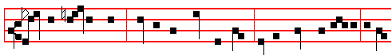
Lo, there cometh one * that is both God and Man, of the house of David, to sit
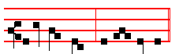
upon the throne, al - le - lu - ia.
Then Kyrie, eleison, as above.

On Magnificat, Antiphon.
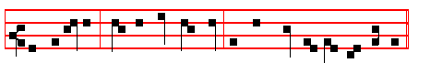
Out of Egypt * have I called my Son: he shall come to save his people.
Then Kyrie, eleison, as above.
__________________________________________________________________

SATURDAY
From the Prophet Isaiah
Lesson j Ch. 7
AND it came to pass in the days of Ahaz the son of Jotham, the son of Uzziah, king of Judah, that Rezin the king of Syria, and Pekah the son of Remaliah king of Israel, went up toward Jerusalem to war against it, but could not prevail

287
against it. And it was told the house of David, saying, Syria is confederate with Ephraim. And his heart was moved, and the heart of his people, as the trees of the wood are moved with the wind. Then said the Lord unto Isaiah, Go forth now to meet Ahaz, thou, and Shear-jashub thy son, at the end of the conduit of the upper pool in the highway of the fuller's field.

 Behold a virgin shall conceive and bear a son, saith the Lord: * And his name
shall be called. Wonderful, Counsellor, the Mighty God.
 He shall sit upon the throne of David, and of his kingdom there shall be no end.
And his name.

Lesson ij
AND say unto him, Take heed, and be quiet: fear. not, neither be fainthearted for the two tails of these smoking firebrands, for the fierce anger of Rezin with Syria. and of theson of Remaliah. Because Syria, Ephraim, and the son of Remaliah, have taken evil counsel against thee, saying, Let us go up against Judah, and vex it, and let us make a breach therein for us, and set a king in the midst of it, even the son of Tabeal: Thus saith the Lord God; It shall not stand; neither shall it come to pass.

 Hear the word of the Lord, ye nations, and declare it in the ends of the earth: * And in the isles afar off, and say: Our Saviour shall come.
 Declare it and make it known: lift up your voice and cry aloud. And in the.

Lesson iij
MOREOVER the Lord spake again unto Ahaz, saying, Ask thee a sign of the Lord thy God; ask it either in the depth, or in the height above. But Ahaz said, I will not ask, neither will I tempt the Lord. And he said, Hear ye now, O house of David; Is it a small thing for you to weary men, but will ye weary my Lord also? Therefore the Lord himself shall give you a sign; Behold, a virgin shall conceive and bear a son, and shall call his name Immanuel. Butter and honey shall he eat, that he may know to refuse the evil, and choose the good.

 Behold, the days come, saith the Lord, that I wiII raise unto David a righteous branch, and a king shall reign and prosper, and shall execute judgment and justice in the earth * And this is his name whereby he shall be called: * The Lord our Righteousness.
 In his days Judah shall be saved and Israel shall dwell safely. And this is. Glory be. The Lord.

On Benedictus, Antiphon.

288
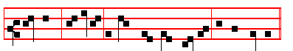
Fear not * O Si- on, behold, thy God cometh, al- le - lu- ia.
Then Kyrie, eleison, as above.
AT VESPERS
Chapter Rom. 15

BRETHREN: Whatsoever things were written aforetime were written for our learning, that we through patience and comfort of the scriptures might have hope.
Hymn and  as on the first Saturday.
On Magnificat, Antiphon.
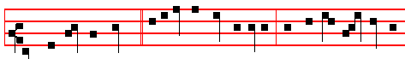
Come O Lord, in peace; * visit us with thy salvation, that we may re - joice be-
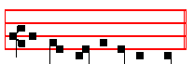
fore thee with a per-fect heart.

COLLECT

STIR up our hearts O Lord, to prepare the God ways of thine only-begotten Son: that througth his Advent we may be worthy to serve thee with pure minds. Who liveth.

__________________________________________________________________

THE SECOND SUNDAY OF ADVENT

All is said as on First Sunday in Advent, except for the following:

IN THE FIRST NOCTURN

From the Prophet Isaiah
Lesson j

289
AND there shall come forth a rod out of the stem of Jesse, and a Branch shall grow out of his roots: and the spirit of the Lord shall rest upon him, the spirit of wisdom and understanding, the spirit of counsel and might, the spirit of knowledge and of the fear of the Lord; and shall make him of quick understanding in the fear of the Lord: and he shall not judge after the sight of his eyes, neither reprove after the hearing of his ears; but with righteousness shall he judge the poor, and reprove with equity for the meek of the earth.

 Thy salvation cometh quickly, O Jerusalem: why art thou wasted with sorrow? Is there no counsellor in thee, that pangs have taken thee? * Fear not, for I will save thee and deliver thee.
 For I am the Lord thy God, the Holy One of Israel, thy Saviour. Fear not.

Lesson ij
AND he shall smite .the earth with the rod of his mouth, and with the breath of his lips shall he slay the wicked. And righteousness shall be the girdle of his loins, and faithfulness the girdle of his reins. The wolf also shall dwell with the lamb, and the leopard shall lie down with the kid. and the calf and the young lion and the fatling together; and a little child shall lead them. And the cow and the bear shall feed; their young ones shall lie down together: and the lion shall eat straw like the ox.

 Behold the Lord shall come, and all his Saints with him, and it shall come to pass in that day that the light shall be great: and they shall go out from Jerusalem like clean water: and the Lord shall be King for ever. * Over all the earth.
 Behold the Lord cometh with an host: and in his hand are the kingdom. and power and dominion. Over.

Lesson iij
AND the sucking child shall play on the hole of the asp, and the weaned child shall put his hand on the cockatrice' den. They shall not hurt nor destroy in all my holy mountain: for the earth shall be full of the knowledge of the Lord, as the waters cover the sea. And in that day there shall be a root of Jesse, which shall stand for an ensign of the people; to it shall the Gentiles seek: and his rest shall be glorious.

 O thou city of Jerusalem, weep not, for the Lord hath repented him concerning thee: * And he will take away from thee all distress.
 Behold the Lord God will come with strong hand, and his arm shall rule. And he will. Glory be. And.
IN THE SECOND NOCTURN

290
From the Exposition by S. Jerome, Priest, on the Prophet Isaiah.
Lesson iv Book 4 on Ch 11, v.6 of Isaiah
AND there shall come forth a rod out of the stem of Jesse. The whole of the first part of the Book of Isaiah up to the vision, or burden, of Babylon, that Isaiah the son of Amoz saw, is all one prophecy of Christ: but it seems best to divide up our exposition, for if we were to propound and treat of it all at once it might confuse the reader. The Jews interpret the rod and flower of the stem of Jesse as the Lord himself, as they see in the rod the power, and in the flower the beauty, of his rule.

 Behold there cometh the Lord, our Defender, the Holy One of Israel, * Wearing a royal crown upon his head.
 And his dominion shall be from sea even to sea, and from the river even to the ends of the earth. Wearing.

Lesson v
ON the other hand, we understand the rod out of the stem of Jesse to mean holy Mary the Virgin, as she may be compared to a young stem on which no fruit has ever hung, as we read above: Behold a virgin shall conceive and bear a son. And the flower we understand to mean our Lord and Saviour who says in the Song of Solomon: I am the rose of Sharon and the lily of the valleys.

 As one whom his mother comforteth, so will I comfort you, saith the Lord: my help also cometh unto you out of Jerusalem, the city which I have chosen. * And when ye see this your heart shall rejoice.
 I will place salvation in Sion, and in Jerusalem my glory. And when.

Lesson vj
THE Spirit of the Lord shall rest upon this flower who will suddenly spring forth from the stem and root of Jesse through Mary the Virgin, for in him the fulness of the Godhead is pleased to dwell bodily. It shall not be a portion of the Spirits, as in the case of the Saints, but as it is written in the Hebrew Gospel read by the Nazarenes: The whole fountain of the Holy Ghost shall be poured forth upon him: where the Spirit of the Lord is, there is liberty.

 Thou shalt yet plant vines upon thy mountains, O Jerusalem: thou shalt sing for joy, for the day of the Lord cometh: arise, O Sion, and turn unto the Lord thy God: rejoice and be glad, O Jacob.* For thy Saviour cometh from the midst of the nations.
 Sing aloud for joy, O daughter of Sion: shout with gladness, O daughter of Jerusalem. For thy. Glory be. For thy.

291
IN THE THIRD NOCTURN
The Lesson from the Holy Gospel according to S. Matthew.
Lesson vij Ch. 11
WHEN John had heard in the prison the works of Chrlst, he sent two of his disciples, and said unto him, Art thou he that should come, or do we look for another?
Homily by S. Gregory the Great Homily 6 on the Gospels
THE sight of all these signs and wonders ought to call forth praise and not be a stumbling block. But to the, minds of the unbelievers it became a stumbling block when, after all his miracles, they saw him dying. As Paul says: But we preach Christ crucified, unto the Jews a stumbling block, and unto the Greeks foolishness. It does indeed seem foolish to man that the Author of life should die for men. And man makes a stumbling block of that very act that really puts him more fully in God's debt. For God deserves more honour from men in proportion to the humiliations that he receives on behalf of men.

 The Lord shall go forth out of Samaria into the gate that looketh toward the East: and he shall come into Bethlehem, walking upon the waters of the Redemption of Judah. * Then shall every one be saved: for behold he cometh.
 And in mercy shall his throne be established, and he shall sit upon it in truth. Then shall.

Lesson viij
WHAT is meant by: And blessed is he, whosoever shall not be offended in me; except an open proclamation of the abjection and humiliation of his death? It is as though he were to say plainly: I do indeed work miracles, but I am not ashamed to suffer insults. Therefore when the time comes for me to die for men, let them take care, lest after worshipping me for my miracles, they despise me in my death.

 Make haste, O Lord, make no tarrying: * And deliver thy people.
 O Lord, come, and make no tarrying: loose the bonds of thy people. And deliver.

Lesson ix
LET us hear what Jesus said to the crowds about John after John's disciples had gone away: What went ye out into the wilderness for to see? A reed shaken with the wind? He points his meaning by denying, not by affirming, this. A reed bends over as soon as a breeze even touches it. And by the reed did he not mean our worldly minds? For as soon as they are touched by praise or blame, they immediately bend to one side or the other.

292
 Behold the Lord cometh down with glory, and his host is with him. * To visit
his people in peace, and to establish them in life everlasting.
 Behold our Lord. cometh with an host. To visit. Glory be. To visit.

AT LAUDS
and through the Hours,
Antiphon 1. Tone ij
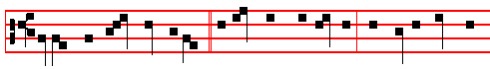
Behold, the Lord shall appear * in the clouds of heaven, with power and great
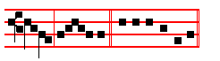
glo-ry, al-le-lu-ia. E u o u a e. Ps.93 Dominus regnavit, and the rest.
Antiphon 2. Tone vij, 2.
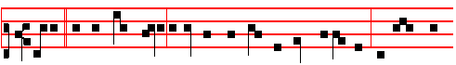
Si-on * is our strong city, a Saviour will God appoint within her for walls and
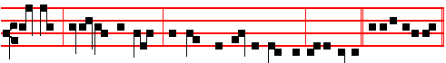
bulwarks: open ye the gates, for God himself is with us, al-le-lu-ia. E u o u a e.
Antiphon 3. Tone vij, 3.
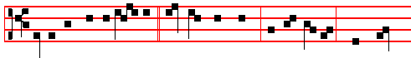
Lo, in the time appointed, * the Lord will come, and will not lie: though he
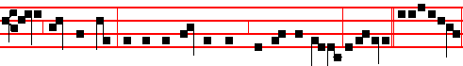
tarry, wait for him; for he will surely come, he will not tarry, alle-luia.E u o u a e.

Antiphon 4. Tone j, 1.
293
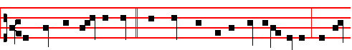
The mountains and the hills * shall break forth before God into singing, and all
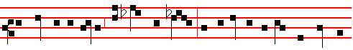
the trees of the forest shall clap their hands: for behold he cometh, our Lord and
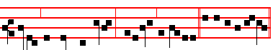
Ruler, to reign for ever, alleluia, al-le- luia. E u o u a e.
Antiphon 5. Tone iij, 1.
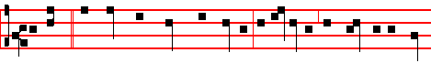
Behold, * our Lord shall come with power, to enlighten the eyes of his ser-
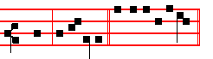
vants, al-le- luia. E u o u a e.

Chapter Rom.15.
BRETHREN: Whatsoever things were written aforetime were written for our learning , that we through patience and comfort of the scriptures might have hope.
Hymn En clara vox as above on the first Sunday.
 The voice of one one crying in the wilderness, Prepare ye the way of the Lord.
 Make his paths straight.
On Benedictus, Antiphon. Tone j, 1.
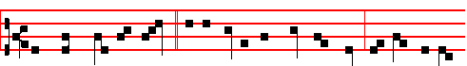
Now when John had heard * in the prison the works of Christ, he sent two of

294
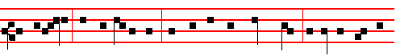
his disciples, and said unto him: Art thou he that should come, or do we look for
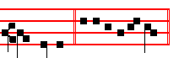
an- other? Cant. Benedictus
COLLECT

STIR UP our hearts, O Lord, to prepare the ways of thine only- Begotten Son: that through his Advent we may be worthy to serve thee with pure minds: Who liveth.
AT TERCE

Antiphon Sion is our strong city, p.293.
Chapter Brethren: whatsoever, as above, p. 294.
Short  as above, p. 275.
Come and save us, * O Lord God of hosts. Come and.
 Shew the light of thy countenance, and we shall be whole. O Lord.
Glory be. Come and.
 The heathen shall fear thy name, O Lord.
 And all the kings of the earth thy majesty.

AT SEXT

Antiphon Lo, in the time appointed, p. 293.
Chapter Rom.15.
NOW the God of patience and consolation grant you to be like-minded one toward another, according to Christ Jesus; that ye may with one mind and one mouth glorify God, even the Father of our Lord Jesus Christ.
Short  as above, p. 276.
Shew us thy mercy, * O Lord. Shew us.
 And grant us thy salvation. O Lord.
Glory be.Shew us
 Remember me, O Lord, according to the favour that thou bearest unto thy people.
 O visit me with thy salvation.
AT NONE
295
Antiphon Behold, our Lord, p. 294.
Chapter Rom.15
NOW the God of hope fill you with all joy and peace in believing, that ye may abound in hope, through the power of the Holy Ghost.

Short  as above, p. 276.
The Lord shall arise upon thee,* O Jerusalem. The Lord.
 And his glory shall be seen upon thee. O Jerusalem. Glory be. The Lord. shall.
 Turn us again, O Lord God of hosts.
 Shew the light of thy countenance, and we shall be whole.

AT VESPERS

Antiphons of Lauds, pp. 293-4. Pss. of Sunday, Chapter from Lauds above, 294. Hymn and  as on the first Sunday, p. 265.
On Magnificat, Antiphon. Tone viij, 1.
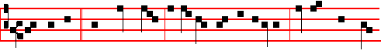
Art thou he * that should come, or do we look for another? Go and shew John
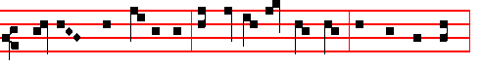
those things which ye do see: the blind receive their sight, the dead are raised,
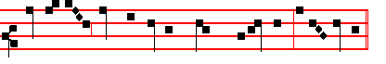
and the poor have the gospel preached unto them, al-le - lu- ia.
Collect Stir up, as above.
After Vespers of the Day are said Vespers of the Dead.
__________________________________________________________________

MONDAY

From the Prophet Isaiah
Lesson j Ch. 13.
THE burden of Babylon, which Isaiah the son of Amoz did see. Lift ye up a banner upon the high mountain, exalt the voice unto them, shake the hand,

296
that they may go into the gates of the nobles. I have commanded my sanctified ones, I have also called my mighty ones for mine anger, even them that rejoice in my highness. The noise of a multitude in the mountains, like as of a great people; a tumultuous noise of the kingdoms of the nations gathered together.

 Receive the word, O Virgin Mary, which is brought thee from the Lord by the
Angel: conceive and bear him who is both God and man, * That thou mayest be called blessed among all women.
 For thou shalt bear a Son, yet shalt thou remain unspotted in thy Virginity: thou shalt bring to pass great things, and shalt be a Mother-ever-Virgin. That thou.

Lesson ij
THE Lord of hosts mustereth the host of the battle. They come from a far country, from the end of heaven, even the Lord, and the weapons of his indignation, to destroy the whole land. Howl ye; for the day of the Lord is at hand; it shall come as a destruction from the Almighty. Therefore shall all hands be faint, and every man's heart shall melt: and they shall be afraid: pangs and sorrows shall take hold of them; they shall be in pain as a woman that travaileth; they shall be amazed one at another; their faces shall be as flames.

 Sing, O heavens, and be joyful, O earth, and break forth into singing, O mountains, for our Lord shall come: * And he will have mercy upon his afflicted.
 In his time shall the righteous flourish ; yea, and abundance of peace. And he will.

Lesson iij
BEHOLD, the day of the Lord cometh. cruel both with wrath and fierce anger, to lay the land desolate: and he shall destroy the sinners thereof out of it. For the stars of heaven and the constellatlons thereof shall not give their light: the sun shall be darkened in his going forth, and the moon shall not cause her light to shine. And I will. punish the world for their evil, and the wicked for their iniquity; and I will cause the arrogancy of the proud to cease, and will lay low the haughtiness of the terrible.

 There shall no stranger pass through. Jerusalem any more: * For in that day the
mountains shall drop down new wine and the hills shall flow with milk and honey,
saith the Lord.
 God shall come from Lebanon and the Holy One from the thickly wooded mountain. For in. Glory be. For in.

At Lauds, Antiphons and Psalms of Monday.
Chapter Is. 2
297
COME ye, and let us go up to the mountain of the Lord, to the house of the God of Jacob; and he will teach us of his ways, and we will walk in his paths:
for out of Sion shall go forth the law, and the word. of the Lord from Jerusalem.
Hymn En clara vox and  as on the first Sunday, p. 273-4.
On Benedictus, Antiphon.
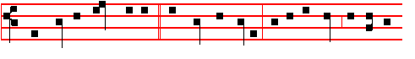
From heaven there cometh * the Lord the Ruler, and in his hand are honour
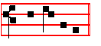
and dominion.
Then the Prayers. Collect Stir up our hearts, as Sunday.
Today the Office of the Dead. At the Hours, Antiphons and the rest as noted on Monday after the first Sunday of Advent, pp. 274-7.
At Vespers Antiphons and Psalms of the Psalter.
Chapter Gen. 49
THE sceptre shall not depart from Judah, nor a lawgiver from between his feet, until Shiloh come; and unto him shall the gathering of the people be.
Hymn E.H. l and Drop down, as above, p. 265.
On Magnificat, Antiphon.
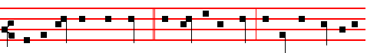
Behold, the King shall come, * the Lord of the earth, and he shall take away
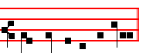
the yoke of our captivity. Then the Prayers.
__________________________________________________________________

TUESDAY
From the Prophet Isaiah
Lesson j Ch. 13.
HER time is near to come and her days shall not be prolonged. For the Lord will have mercy on Jacob, and will yet choose Israel, and set them in their

298
own land: and the strangers shall be joined with them, and they shall cleave to the house of Jacob. And the people shall take them, and bring them to their place: and the house of Israel shall possess them in the land of the Lord for servants and handmaids: and they shall take them captives, whose captives they were; and they shall rule over their oppressors.
 O mountains of Israel, ye shall shoot forth your branches, and yield your fruit to my people of Israel; * For they are at hand to come.
 Drop down, ye heavens, from above, and let the skies pour down righteousness: let the earth open, and let them bring forth salvation. For they are.

Lesson ij
AND it shall come to pass in the day that the Lord shall give thee rest from thy sorrow, and from thy fear, and from the hard bondage wherein thou wast made to serve, that thou shalt take up this proverb against the king of Babylon, and say, How hath the oppressor ceased! the golden city ceased! The Lord hath broken the staff of the wicked, and the sceptre of the rulers. He who smote the people in wrath with a continual stroke, he that ruled the nations in anger, is persecuted, and none hindereth.
 Let the mountains break forth into singing, and the hills bring forth righteousness. * For the Lord the Light of the world cometh with power.
 Out of Sion shall go forth the law, and the word of the Lord from Jerusalem.
For the Lord.

Lesson iij
HOW art thou fallen from heaven, O Lucifer, son of the morning! how art thou cut, down to the ground, which didst weaken the nations! For thou hast said in thine heart, I will ascend into heaven, I will exalt my throne above the stars of God: I will sit also upon the mount of the congregation, in the sides of the north: I will ascend above the heights of the clouds; I will be like the most High. Yet thou shalt be brought down to hell, to the sides of the pit.

 Behold I the Lord your God come from the South * To visit you in peace.
 I will look upon you, and make you to increase: ye shall be multiplied, and I will establish my covenant wIth you. To visit. Glory be. To visit.
On Benedictus, Antiphon.
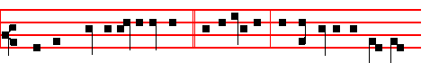
The Lord shall arise upon thee, * O Jerusalem, and his glory shall be seen

299
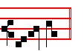
up-on thee.
Then the Prayers.
On Magnificat, Antiphon.
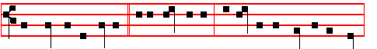
The voice of one crying * in the wilderness, Prepare ye the way of the Lord,
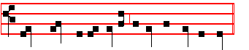
make straight in the desert a highway for our God.
Then the Prayers.
__________________________________________________________________

WEDNESDAY
From the Prophet Isaiah
Lesson j Ch. 16.
SEND ye the lamb to the ruler of the land from Sela to the wilderness, unto the mount of the daughter of Zion. For it shall be, that, as a wandering bird cast out of the net, so the daughters of Moab shall be at the fords of Amon. Take counsel,execute judgment; make thy shadow as the night in the midst of the noonday; hide the outcasts; bewray not him that wandereth. Let mine outcasts dwell with thee Moab; be thou a covert to them from the face of the spoiler.

 Christ our King cometh * And John hath testified of him, that he is the Lamb that should come.
 The kings shall shut their mouths at him, to him shall the Gentiles seek. And

Lesson ij
FOR the extortioner is at an end, the spoiler ceaseth, the oppressors are consumed out of the land. And In mercy shall the throne be established: and he shall sit upon it in truth in the tabernacle of David, judging, and seeking judgment, and hasting righteousness. We have heard of the pride of Moab; he is very proud: even of his haughtiness, and his pride, and his wrath: but his lies shall not be so.

300
 Long ago Ezekiel prophesied: I saw the gate shut: behold God went forth from
it before the ages for the salvation of the world: * And it was shut again, for it is a
figure of. the Virgin, in that after chlildbirth she remained a virgin still.
 The Lord alone shall enter by the gate that thou sawest. And it was.

Lesson iij
THEREFORE shall Moab howl for Moab, every one shall howl: for the foundations of Kir-hareseth shall ye mourn; surely they are stricken. For the fields of Heshbon languish, and the vine of Sibmah: the lords of the heathen have broken down the principal plants thereof, they are come even unto Jazer, they wandered through the wilderness: her branches are stretched out, they are gone over the sea.

 Behold, the days come, saith the Lord: that I will raise unto David a righteous branch, and a king shall reign and prosper, and shall execute judgment and justice, in the earth: * And this is his name whereby he shall be called: * The Lord our righteousness,
 In his days Judah shall be saved and Israel shall dwell safely. And this is. Glory be. The Lord.
On Benedictus, Antiphon.
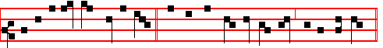
Behold, I send my messsenger, * and he shall prepare my way before thy face.
Then the Prayers.
On Magnificat, Antiphon.
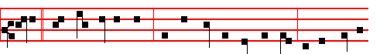
Sion, * thou shalt be renewed, and shalt see thy righteous One, he that cometh
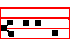
unto thee. Then the Prayers.
__________________________________________________________________

THURSDAY
From the Prophet Isaiah
Lesson j Ch. 19.
301
THE burden of Egypt. Behold, the Lord rideth upon a swift cloud, and shall come into Egypt: and the idols of Egypt shall be moved at his presence, and the heart of Egypt shall melt in the midst of it. And I will set the Egyptians against the Egyptians: and they shall fight every one against his brother, and every one against his neighbour; city against city, and kingdom against kingdom.

 Thy salvation cometh quickly, O Jerusalem: why art thou wasted with sorrow? Is there no counsellor in thee, that pangs have taken thee? * Fear not, for I will save thee and deliver thee.
 For I am the Lord thy God, the Holy One of Israel, thy Saviour. Fear not.

Lesson ij
AND the spirit of Egypt shall fail in the midst thereof; and I will destroy the counsel thereof: and they shall seek to the idols, and to the charmers, and to them that have familiar spirits, and to, the wizards. And the Egyptians will I give over into the hand of a cruel lord; and a fierce king shall rule over them, saith the Lord, the Lord of hosts. And the waters shall fail from the sea, and the river shall be wasted and dried up. And they shall turn the rivers far away; and the brooks of defence shall be emptied and dried up.

 Behold the Lord shall come, and all his Saints with him, and it shall come to pass In that day that the light shall be great: and they shall go out from Jerusalem like clean water: and the Lord shall be King for ever. * Over all the earth.
 Behold the Lord cometh with an host: and in his hand are the kingdom, and power,and dominion. Over all.

Lesson iij
SURELY the princes of Zoan are fools, the counsel of the wise counsellors of Pharaoh is become brutish: how say ye unto Pharaoh, I am the son of the wise, the son of ancient kings? Where are they? where are thy wise men? and let them tell thee now, and let them know what the Lord of hosts hath purposed upon Egypt, The princes of Zoan are become fools, the princes of Noph are deceived; they have also seduced Egypt, even they that are the stay of the tribes thereof..

 O thou city of Jerusalem, weep not, for the Lord hath repented concerning thee: * And he will take away from thee all distress.
 Behold, the Lord God will come with strong hand, and his arm shall rule. And he will. Glory be. And he will.

On Benedictus, Antiphon.

302
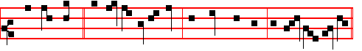
Thou, O Lord, * art he that is to come, for whom we look, to save thy people.
Then the Prayers.
On Magnificat, Antiphon. 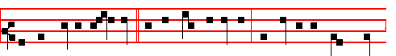
He that cometh after me * is preferred before me, the latchet of whose shoes
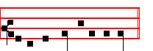
I am not worthy to unloose. Then the Prayers
__________________________________________________________________

FRIDAY
From the Prophet Isaiah
Lesson j Ch 24.
BEHOLD the Lord maketh the earth empty, and maketh it waste, and turneth it upside down, and scattereth abroad the inhabitants thereof. And it shall be, as with the people, so with the priest; as with the servant, so with his master; as with the maid, so with her mistress; as with the buyer, so with the seller; as with the lender, so with the borrower; as with the taker of usury, so with the giver of usury to him. The land shall be utterly emptied, and utterly spoiled: for the Lord hath spoken this word.

 Behold there cometh the Lord, our Defender, the Holy One of Israel, * Wearing a royal crown upon his head.
 And his dominion shall be from sea even to sea, and from the river even to the ends of the earth. Wearing.

Lesson ij
THE earth mourneth and fadeth away, the world languisheth and fadeth away, the haughty people of the earth do languish, The earth also is defiled under the inhabitants thereof; because they have transgressed the laws, changed the ordinance, broken the everlasting covenant. Therefore hath the curse devoured the earth, and they that dwell therein are desolate: therefore the inhabitants of the earth are burned, and few men left. 303
 As one whom his mother comforteth, so will I comfort you, saith the Lord:
My help also cometh unto you out of Jerusalem, the city which I have chosen. * And when ye see this your heart shall rejoice
 I will place salvation in Sion,and in Jerusalem my glory. And when.

Lesson iij
THE new wine mourneth, the vine languisheth, all the merry hearted do sigh. The mirth of tabrets ceaseth, the noise of them that rejoice endeth, the joy of the harp ceaseth. They shall not drink wine with a song; strong drink shall be bitter to them that drink it. The city of confusion is broken down: every house is shut up, that no man may come in. There is a crying for wine in the streets; all joy is darkened, the mirth of the land is gone. In the city is left desolation, and the gate is smitten with destruction. When thus it shall be in the midst of the land among the people, there shall be as the shaking of an olive tree, and as the gleaning grapes when the vintage is done. They shall lift up their voice, they shall sing for the majesty of the Lord, they shall cry aloud from the sea. Wherefore glorify ye the Lord in the fires, even the name of the Lord God of Israel in the isles of the sea. From the uttermost part of the earth have we.heard songs, even glory to the righteous.

 Thou shalt yet plant vines upon thy mountains, O Jerusalem: thou shalt sing for joy, for the. day of the Lord cometh: arise. O Sion, and turn unto the Lord thy God: rejoice and be glad, O Jacob, * For thy Saviour cometh from the midst of the nations.
 Sing aloud for joy, O daughter of Sion: shout with gladness, O daughter of Jerusalem. For thy. Glory be. For thy.

On Benedictus, Antiphon.
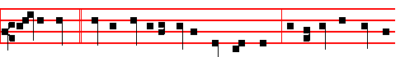
Say to them: * Ye that are of a fearful heart, be strong: for behold the Lord our
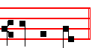
God shall come.
Then the Prayers.

On Magnificat, Antiphon.

304
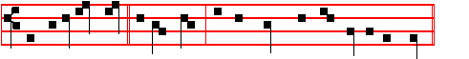
Sing unto the Lord * a new song; and his praise from the end of the earth.
Then the Prayers.
__________________________________________________________________

SATURDAY
From the Prophet Isaiah
Lesson j Ch. 25.
OLORD, thou art my God.; I will exalt thee, I will praise thy name; for thou hast done wonderful things; thy counsels of old are faithfulness and truth. For thou hast made of a city an heap; of a defenced city a ruin: a palace of strangers to be no city; it shall never be built. Therefore shall the strong people glorify thee, the city of the terrible nations shall fear thee. For thou hast been a strength to the poor, a strength to the needy in his distress, a refuge from the storm, a shadow from the heat, when the blast of the. terrible ones is as a storm against the wall.

 The Lord shall go forth out of Samaria into the gate that looketh toward the East: and he shall come into Bethlehem, walking upon the waters of the Redemption of Judah. * Then shall every one be saved: for behold he cometh.
 And in mercy shall his throne be established, and he shall sit upon it in truth. Then shall.

Lesson ij
THOU shalt bring down the noise of strangers, as the heat in a dry place; even the heat with the shadow of a cloud: the branch of the terrible ones.shall.be brought low. And in this mountain shall the Lord of hosts make unto all people a feast of fat things, a feast of wines on the lees, of fat things full of marrow, of wines on the lees well refined. And he will destroy in this mountain the face of the covering cast over all people, and the vail that is spread over all nations.

 Make haste, O Lord, make no tarrying: * And deliver thy people.
 O Lord, come, and make no tarrying: loose the bonds of thy people. And deliver.

Lesson iij
HE will swallow up death in victory; and the Lord God will wipe away tears from off all faces; and the rebuke of his people shall he take away from off all the earth: for the Lord hath spoken it. And it shall be said in that day, Lo, this is

305
our God; we have waited for him, and he will save us: this is the Lord; we have waited for him, we will be glad and rejoice in his salvation. For in this mountain shall the hand of the Lord rest, and Moab shall be trodden down under him, even as straw is trodden down for the dunghill. And he shall spread forth his hands in the midst of them, as he that swimmeth spreadeth forth his hands to swim: and he shall bring down their pride together with the spoils of their hands. And the fortress of the high fort of thy walls shall he bring down, lay low, and bring to the ground, even to the dust.

 Behold the Lord com eth down with glory and his host is with him. * To visit
his people in peace, and to establish them in life everlasting.
 Behold our Lord cometh with an host. To visit. Glory be. To visit.
On Benedictus, Antiphon. 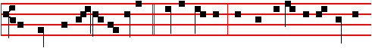
The Lord. shall set up an ensign * for the nations, and shall assemble the outcasts
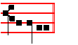
of Israel. Then the Pravers.
__________________________________________________________________

AT VESPERS
Chapter Phil. 4.
BRETHREN: Rejoice in the Lord alway: and. again I say rejoice. Let your moderation be known unto all men.The Lord is at hand.
Hymn and  as on the first Saturday.
On Magnificat, Antiphon.
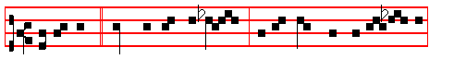
Before me * there was no God formed, neither shall there be af- ter me:
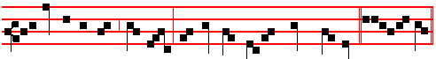
unto me every knee shall bow, and me shall every tongue confess. Canticle Magnificat.
306
COLLECT
INCLINE thine ear to our prayers, we beseech thee, O Lord: and. by the grace of thy visitation enlighten the darkness of our minds. Who livest.

THE THIRD SUNDAY OF ADVENT
AT MATINS.

INVITATORY. The Lord is now at hand, * O come, let us worship.
The Invitatory The Lord is now at hand, is said every day until the Vigil of the Nativity of Our Lord exclusive.
IN THE FIRST NOCTURN
From the Prophet Isaiah
Lesson j Ch 26
IN that day shall this song be sung in the land of Judah; We have a strong city; salvation will God appoint for walls and bulwarks. Open ye the gates, that the righteous nation which keepeth the truth may enter in. Thou wilt keep him in perfect peace, whose mind is stayed on thee: because he trusteth in thee.Trust ye in the Lord for ever: for in the Lord JEHOVAH is everlasting strength: for he bringeth down them that dwell on high; the lofty city, he layeth it low; he layeth it low, even to the ground; he bringeth it even to the dust. The foot shall tread it down, even the feet of the poor, and the steps of the needy.

 Behold the Lord shall appear upon a white cloud, * and ten thousand of his Saints with him; and he shall have on his vesture and on his thigh a name written: King of kings, and Lord of Lords.
 He shall appear and not lie; though he tarry, wait for him, because he will surely come. And ten.

Lesson ij
THE way of the just is uprightness: thou, most upright, dost weigh the path of the just. Yea, in the way of thy judgments, O Lord, have we waited for thee; the desire of our soul is to thy name, and to the remembrance of thee. With my soul have I desired thee in the night; yea, with my spirit within me will I seek thee early: for when thy judgments are in the earth, the inhabitants of the world will learn righteousness. Let favour be shewed to the wicked, yet will he not learn righteousness: in the land of uprightness will he deal unjustly, and will not behold the majesty of the Lord.

 Thou Bethlehem, art the city of the most high God, out of thee shall he come forth, that is to be ruler in Israel: whose goings forth have been from of old, from everlasting; now shall he be great unto the ends of the earth. * And this man shall be the peace in our land, when he shall come.
307
 He shall speak peace unto the Gentiles and shall have dominion from sea to sea.
And this.

Lesson iij
LORD, when thy hand is lifted up, they will not see: but they shall see, and be ashamed for their envy at the people; yea, the fire of thine enemies shall devour them. Lord, thou wilt ordain peace for us: for thou also hast wrought all our works in us. O Lord our God, other lords beside thee have had dominion over us: but by thee only will we make mention of thy name. They are dead, they shall not live; they are deceased, they shall not rise: therefore hast thou visited and destroyed them. and made all their memory to perish.

 He that shall come, will come, and there shall no more be fear in our borders, * For he is our Saviour.
 He will subdue our iniquities and cast all our sins into the depths of the sea. For he is. Glory be. For he is.

IN THE SECOND NOCTURN
Sermon by S. Leo the Great
Lesson iv Sermon 13: 2 on the Fast of the Tenth Month
BELOVED, with pastoral tenderness we preach to you, as the season and our wonted devotion urges. We must keep the fast of the tenth month, in which, in return for the completed gathering in of all the fruits, an offering. of moderation is most worthily made to God, their bounteous giver. What can be more powerful than a fast? By its observance we draw near to God and withstanding the devil, we conquer our alluring sins.

 Weep not, O Egypt, for the Ruler cometh unto thee, and the depths shall be moved at his presence. * To deliver his people out of the hand of the mighty.
. Behold the Lord of hosts, thy God, cometh with power. To deliver.

Lesson v
FOR fasting has always been food for virtue. From abstinence indeed proceed pure thoughts, prudent wishes, more healthful counsels: and through voluntary afflictions, the flesh dies for them that are lustful, and the breath returns to virtues.
But because the salvation of our souls is not only secured by fasting, let us complete our fast by deeds of mercy to the poor. Let us devote to virtue what we withdraw from pleasure. Let the self-denial of him who fasts become the refreshment of the poor.

 Her time is near to come, and her days shall not be prolonged. * For the Lord
will have mercy on Jacob, and Israel shall be saved.
308
 Turn again, O Virgin of Israel, turn again to thy cities. For the Lord.

Lesson vj
LET us be zealous for the defence of widows, the benefit of orphans, the consolation of those who mourn, the reconciliation of those at variance. Let the pilgrim be welcomed, the oppressed be aided, the naked clothed, the sick tended. So that whoever of us by his righteous toils has offered to God the Author of all good gifts the sacrifice of this piety, may be worthy to receive the reward of the heavenly Kingdom. Let us fast therefore, on Wednesday and Fnday; now on the sabbath let us keep vigil together at the tomb of S. Peter the Apostle, by whose merits may we be able to obtain that which we ask, through our Lord Jesus Christ, who with the Father and the Holy Spirit liveth and reigneth, world without end. Amen.

 The Lord. shall come down like the rain, into a fleece of wool. * In his time shall the righteous flourish, yea, and abundance of peace.
 All kings shall fall down before him, all nations shall do him service. In his time. Glory be. In his.

IN THE THIRD NOCTURN

The Lesson from the Holy Gospel according to S. John
Lesson vij Ch.1.
THE Jews sent priests and Levites from Jerusalem to ask him, Who art thou? Homily by S. Gregory the Great Homily 7 on the Gospels
IN these words read to us, beloved brethren, the humility of John is commended: he was so full of virtue that he was believed to be the Christ, and yet he firmly held himself to be no more than what he was, and would not be persuaded by popular opinion into the vanity of thinking more highly of himself. He confessed, and denied not, but confessed, I am not the Christ.In saying: I am not; he gave a plain denial or that which he was not, without denying that which he was. This very act of speakIng the truth made him a member of the One whose name he would not take on a false presumption. By refusing to appropriate the name of Christ he was made a member of Christ: in humbly recognizing his own weakness he won for himself an actual share of the glory of Christ.

 O Lord, come, and make no tarrying; loosen the bonds or thy people. * And gather again into their own land them that are scattered abroad.
 O Lord stir up thy strength, and come, and help us. And gather.

Lesson viij

309
AS we read these words, a saying of our Lord's from another part of the Gospels comes to mind, and it has much bearing on the subject before us. In another place, when the disciples ask our Lord about the coming of Elias, he answers: Elias is come already, and they knew him not, but have done unto him whatsoever they listed. And, if you wish to know, John himself is Elias. When John was questioned, he said: I am not Elias. How is it, beloved brethren, that Truth himself affirms what the Prophet of the Truth denies? There is indeed a great difference between: This is he; on the one hand, and: I am not; on the other. How can he be the Prophet of the Truth if he is not in harmony with the words of this very Truth?

 Behold there shall be a root of Jesse, which shall come forth for salvation unto the people, to it shall the Gentiles seek: * And his name shall be glorious.
 The Lord God shall give unto him the throne of his father David, and he shall reign over the house of Jacob for ever. And his.

Lesson ix.
BUT if subtly we seek the truth itself, we shall find how what sounds self-contradictory is not contrary. For when the Angel told Zacharias about John, he said: He shall go before him in the spirit and power of Elias. This was said, because just as Elias will. come before the second coming of our Lord, so John came before his first coming. As Elias will come as the forerunner of the Judge, so John became the fore-runner of the Redeemer. Therefore John was in the spirit, but not in the person, of Elias. What our Lord affirmed concerning the spirit, John denied concerning the person.

 The Lord will teach us of his ways, and we will walk in his paths. * For out of Sion shall go forth the law, and the word of the Lord from Jerusalem.
 Come ye, and. let us go up to the mountain of the Lord, and to the house of the God of Jacob. For out. Glory be. For out.

AT LAUDS
and the Hours

Antiphon 1. Tone j, 4.
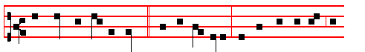
The Lord will surely come, * and will not tarry: and will bring to light the

310
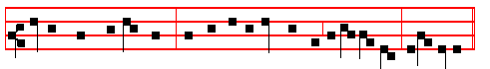
hidden things of darkness, and will manifest himself to all nations, al-le-luia.
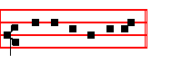
E u o u a e. Psalms of Sunday, p. 28.
Antiphon 2. Tone viij, 1.
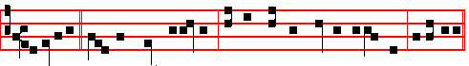 Jerusalem,* joy with great rejoicing, for thy Saviour cometh unto thee, alleluia.
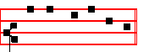
E u o u a e.
Antiphon 3. Tone viij, 1.
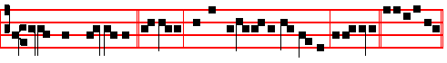
I will place salvation * in Sion, and in Jerusalem my glory, alleluia. E u o u a e
Antiphon 4. Tone v.
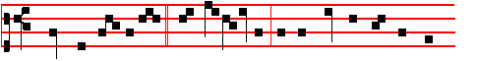
Mountains and all hills * shall be abasèd, and the crookèd shall be made
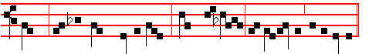straight, and the rough places plain. Come, O Lord, and tarry not, alleluia.
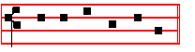
E u o u a e.
311
Antiphon 5. Tone ij.
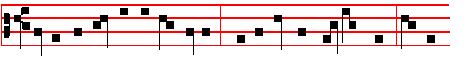
Let us live righteously and godly, * looking for that blessed hope, and the
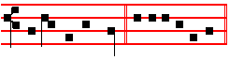
coming of the Lord. E u o u a e.
Chapter Phil. 4:4-5
BRETHREN: Rejoice in the Lord alway: and again I say, Rejoice. Let your moderation be known unto all men. The Lord is at hand.
Hymn and  as on the first Sunday, p. 273-4.
On Benedictus, Antiphon. Tone viij, 1.
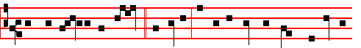
He shall sit upon the throne * of David, and of his kingdom there shall be no
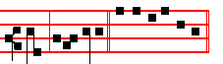
end, al-le-lu-ia. Canticle Benedictus, p..
COLLECT

INCLINE thine ear to our prayers, we beseech thee, O Lord: and by the grace of thy visitation enlighten the darkness of our minds: Who livest.

AT TERCE
Antiphon Jerusalem, joy, p.311.
Chapter Brethren: rejoice, as above.
Short  as above, p.275
Come and save us, * O Lord God of hosts. Come and.
 Shew the light of thy countenance,and we shall be whole. O Lord.
Glory be. Come and.
 The heathen shall fear thy name, O Lord.
 And all the kings of the earth thy majesty.

AT SEXT

312
Antiphon I will place salvation, p.311.
Chapter Phil.4.
BE careful for nothing; but in everything by prayer and supplication, with thanksgiving, let your requests be made known unto God.
Short , as above, p. 276
Shew us thy mercy, * O Lord. Shew us.
 And grant us thy salvation. O Lord. Glory be. Shew us.
 Remember me, O Lord, according to the favour that thou bearest unto thy people.
 O visit me with thy salvation.
AT NONE
Antiphon Let us live righteously and godly.
Chapter Phil.4.
AND the peace of God, which passeth all understanding, shall keep your hearts and minds through Christ Jesus.
Short  , as above. p. 276.
The Lord shall arise upon thee,* O Jerusalem. The Lord.
 And his glory shall be seen upon thee. O Jerusalem. Glory be. The Lord.
 Turn us again, O Lord God of Hosts.
 Shew the light of thy countenance, and we shall be whole.

AT VESPERS

Antiphons from Lauds, Pss. of Sunday. Chapter, Hymn and  as above at I Vespers, p.265.
On Magnificat, Antiphon. Tone viij, 1.
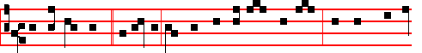
Blessed art thou,* O Mary, for thou hast believed the Lord: and there shall be
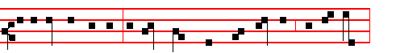
a performance in thee of those things which were told thee from the Lord,
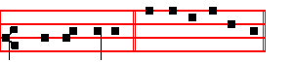
al- le- lu- ia. Canticle Magnificat, p.211

313
Collect Incline thine ear, as above, p. 312.
¶ After Vespers of the Day are said Vespers of the Dead. This Antiphon is omitted, if today in its place be put one of the Great Antiphons, as below, to which yield always the proper Antiphons assigned to the Magnificat on other days.
__________________________________________________________________

The following Great Antiphons on Magnificat are begun on the 17th of December, and all are said complete before and after the Magnificat, as on Doubles, in order, until the day before the Vigil of the Nativity. But if it is a Feast, they are said after the Collect of the Feast for commemoration of Advent.

17th December, Antiphon Tone ij, 2.
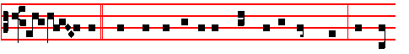
O Wis- dom, * which camest out of the mouth of the most High, and reach-
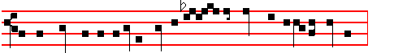
est from one end to another, mightily and sweetly ordering all things:
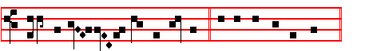
Come and teach us the way of prudence. Canticle Magnificat, p.211.
18th December, Antiphon. Tone ij, 2.
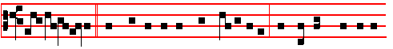
O A-do-na-i, * and Leader of the house of Is-ra-el, who appear-edst in the
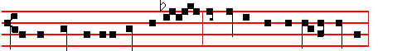
Bush to Mos-es in a flame of fire, and gavest him the law in Sin-ai:
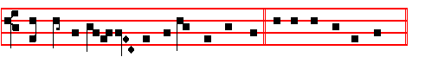
Come and deliv-er us with an out-stretched arm. E u o u a e.

314
19th December, Antiphon. Tone ij, 2.
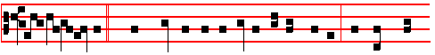
O Root of Jesse, * which standest for an ensign of the people, at whom kings
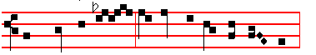
shall shut their mouths, to whom the Gentiles shall seek:
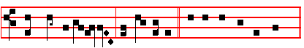
Come and de-li-ver us, and tar-ry not. E u o u a e.
20th December, Antiphon. Tone ij, 2.
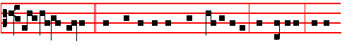
O Key of David, and sceptre of the house of Is-ra-el, that openest, and no
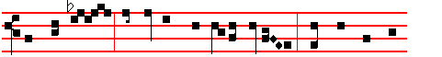
man shut-teth, and shuttest, and no man openeth: Come and bring the
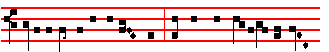
prisoner out of the pri-son-house, and him that sitteth in darkness
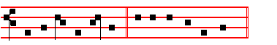
and the shadow of death. E u o u a e.
21st December, Antiphon. Tone ij, 2.
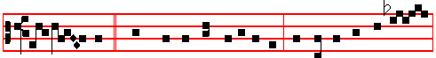
O Day- spring, Brightness of Light everlasting, and Sun of Righteousness:

315
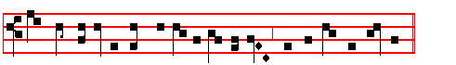
Come and enlighten him that sitteth in darkness, and the shadow of death.
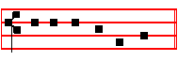
E u o u a e.
22nd December, Antiphon. Tone ij, 2.
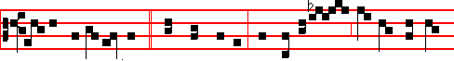
O King of the na-tions, and their Desire, the Cor-ner-Stone, who makest both
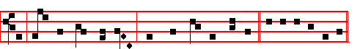
one: Come and save mankind, whom thou formedst of clay. E u o u a e.
23rd December, Antiphon. Tone ij, 2.
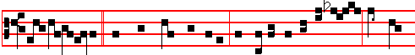
O Emmanuel, our King and Lawgiver, the Desire of all nations, and their
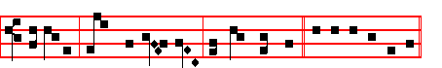
Salvation: Come and save us, O Lord our God. E u o u a e.
__________________________________________________________________

The following Antiphons at Lauds and the Hours are said. on the six Ferias before the Vigil of the Nativity, beginning on the 17th of December, with the Antiphons assigned to that weekday. Likewise the others also are said on the proper weekdays.
If the 17th be a Sunday, the Antiphons are begun on the following Monday, which will be the 18th. But those which should have been said on the day on which the Feast of S. Thomas falls are said on Saturday with the Psalms of

316
Saturday, omitting the fourth Antiphon, in whose place is said. the Antiphon The word of the Lord * shall be looked. for as the rain, and as the dew shall our God come down upon us; unless the Vigil of the Nativity come on a Sunday; for then on Saturday are said the Antiphons from Lauds of Sunday, omitting the fourth, in whose place is said the Antiphon The word. The Antiphon on Benedictus and the Collect are said as on Ember Saturday below. But the Antiphons of Lauds, which occur on S. Thomas's day, are omitted that year: and. on Sunday then are said the Antiphons of the Vigil, as given below in the Rubric of the Vigil. Likewise the Antiphon The word is omitted, when that Feast comes on Saturday.
__________________________________________________________________

MONDAY. At Lauds and the Hours, Antiphons

1.Behold the Lord shall come, * the Prince of the kings of the earth: blessed are they that are prepared to meet him. Pss. of Monday, in the Psalter.
2.When the Son of Man * cometh, shall he find faith on the earth?
3.Lo, now cometh * the fulness of the time, wherein God sent forth his Son into the world.
4.With joy shall ye draw water * out of the wells of salvation.
5.The Lord shall go forth * out of his holy place: he shall come to save his people.
__________________________________________________________________

TUESDAY. At Lauds and the Hours, Antiphons

1.Drop down, ye heavens, from above, * and let the skies pour down righteousness: let the earth open, and let them bring forth salvation. Psalms of Tuesday.
2. Send, O Lord, the Lamb, * the Ruler of the land, from the rock of the desert unto the mount of the daughter of Sion.
3.That thy way, O Lord, * may be known upon earth, thy saving health among all nations.
4.Reward thou them, * O Lord, that wait for thee, and let thy prophets be found faithful.
5.The law was given by Moses, * but grace and truth came by Jesus Christ.
__________________________________________________________________

WEDNESDAY. At Lauds and the Hours, Antiphons

1.The prophets did foretell * that a Saviour should be born of the Virgin Mary. Psalms of Wednesday.
2.The Spirit * of the Lord is upon me: he hath sent me to preach the Gospel to the

317
poor.
3. For Sion's sake * I will not hold my peace, until the righteousness thereof go forth as brightness.
4.Behold the Lord shall come,* that he may sit among princes, and inherit the throne of glory.
5.Tell it out * among the nations,and say: Behold, our God and Saviour cometh.
__________________________________________________________________

THURSDAY. At Lauds and the Hours Antiphons

1.From Sion * draweth nigh the Lord Almighty to bring salvation unto his people.. Psalms of Thursday.
2.Turn thee again, O Lord, * at the last, and do not delay to come unto thy servants.
3.From Sion * cometh he that is to reign as Lord: Emmanuel is his mighty Name.
4.Lo, he is my God, * and I will give him honour: my father's God, and I will exalt himl.
5.The Lord is our Lawgiver,* the Lord is our King, he himself will come, and will save us.
__________________________________________________________________

FRIDAY. At Lauds and the Hours, Antiphons

1.Be ye steadfast, *and see the salvation of the Lord with you. Psalms of Friday.
2.Unto thee, O Lord, * do I lift up mysou1: come and deliver me, for I flee unto thee, O Lord.
3.Come, O Lord, * and do not tarry: forgive the offences of thy people Israel.
4. God shall come from Lebanon, * and his brightness shall be as the light.
5.Therefore * I will look unto the Lord; and I will wait for the God of my salvation.
__________________________________________________________________

SATURDAY.

Antiphons according to the rubric above.
On the Canticle, Antiphon The word of the Lord * shall be looked for as the rain, and as the dew shall our God come town upon us.

Psalms as on Saturday Lauds in the Psalter.

On the Feast of S. Thomas, for commemoration of Advent, Antiphon on Benedictus:
318
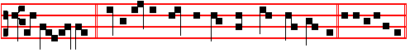
BE not afraid, * for upon the fifth day our Lord shall come to you. Canticle
Benedictus.
But if the Feast of S.Thomas happen to be transferred to the following Feria, the above Antiphon is said at Benedictus on Sunday, instead of the Antiphon Hai1, Mary.
On the last day before the Vigil of the Nativity, on Benedictus, Antiphon.
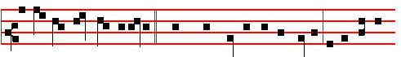
Beho1d all things are fulfilled * which were spoken by the Angel of the Virgin
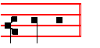
Ma - ry. To these Antiphons yield the other Antiphons assigned to Benedictus in the proper places.
__________________________________________________________________

Monday
From the Prophet Isaiah
Lesson j Ch. 28.
WOE to the crown of pride, to the drunkards of Ephraim, whose glorious beauty is a fading flower, which are on the head of the fat valleys of them that are overcome with wine! Behold, the Lord hath a mighty and strong one, which as a a tempest of hail and a destroying storm, as a flood of mighty waters overftowing, shall cast down to the earth with the hand. The crown of pride, the drunkards of Ephraim, shall be trodden under feet.

 Behold the Lord shall appear upon a white cloud, * And ten thousand of his Saints with him; and he shall have on his vesture and on his thigh a name written: King of kings, and Lord of lords.
 He shall appear and not lie; though he tarry, wait for him, because he will surely come. And ten.

Lesson ij
AND the glorious beauty, which is on the head of the fat valley, shall be a fading flower, and as the hasty fruit , before the summer; which when he that

319
looketh upon it seeth, while it is yet in his hand he eateth it up. In that day shall the Lord of hosts be for a crown of glory, and for a diadem of beauty, unto the residue of his people, and for a spirit of judgment to him that sitteth in judgment, and for strength to them that turn the battle to the gate. But they also have erred through wine, and through strong drink are out of the way; the priest and the prophet have erred through strong drink, they are swallowed up of wine.

 Thou Bethlehem, art the city of the most high God, out of thee shall he come forth, that is to be ruler in Israel: whose goings forth have been from of old, from everlasting; now shall he be great unto the ends of the earth. * And this man shall be the peace in our land, when he shall come.
 He shall speak peace unto the Gentiles, and shall have dominion from sea to sea. And this.

Lesson iij
THEREFORE thus saith the Lord God, Behold, I lay in Zion for a foundation a stone, a tried stone, a precious comer stone, a sure foundation: he that believeth shall not make haste. Judgment also will I lay to the line, and righteousness to the plummet: and the hail shall sweep away the refuge of lies, and the waters shall overflow the hiding place. And your covenant with death shall be disannulled, and your agreement with hell shall not stand.

 He that shall come, will come, and there shall no more be fear in our borders, * For he is our Saviour.
 He will subdue our iniquities and cast all our sins into the depths of the sea. For he is. Glory be. For he is.
AT LAUDS

Antiphon and Psalm Have mercy 51 Miserere with the rest from the Psalter, unless the Antiphons are to be said according to the Rubric above.
Chapter Is 2.
COME ye, and let us go up to the mountain of the Lord, to the house of the God of Jacob, and he will teach us of his ways, and we will walk in his paths: for out of Sion shall go forth the Law, and the word of the Lord from Jerusa1em.
Hymn En clara Vox and  as on the first Sunday.
On Benedictus, Antiphon.
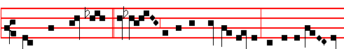
There shall come forth * a rod out of the stem of Jesse, and all the earth

320
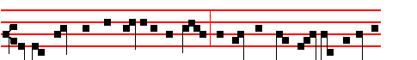
shall be filled with the glory of the Lord: and all flesh shall see the salvation
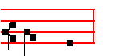
of God. Then the Prayers, as above.
Collect Incline thine ear, as above, on Sunday.
Today the Office of the Dead is said.
At the Hours, Antiphons and the rest as noted on Monday after the first Sunday of Advent.
At Vespers, Antiphons and Psalms from the Psalter.
Chapter Gen.49
THE sceptre shall not depart from Judah, nor a lawgiver from. between his feet, until Shiloh come; and unto him shall the gathering of the people be.
Hymn E.H. l and  Drop down, as above.
On Magnificat, Antiphon.
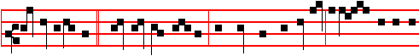 All generations * shall call me blessed: for God hath regarded the lowliness of
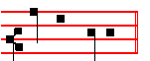
his handmaiden.
¶ Unless an O Antiphon is to be said.
Then the Prayers.
__________________________________________________________________

TUESDAY
From the Prophet Isaiah
Lesson j Ch. 30.
THEREFORE will the Lord wait, that he may be gracious unto you, and therefore will he be exalted, that he may have mercy upon you: for the Lord is a God of judgment: blessed are all they that wait for him. For the people shall dwell in Zion at Jerusalem: thou shalt weep no more: he will be very gracious unto thee at the voice of thy cry; when he shall hear it, he will answer thee. And
321
though the Lord give you the bread of adversity, and the water of affliction, yet shall not thy teachers be removed into a corner any more, but thine eyes shall see thy teachers.

 Weep not, O Egypt, for the Ruler cometh unto thee and the depths shall be moved at his presence. * To deliver his people out of the hand of the mighty.
 Behold the Lord of hosts thy God, cometh with power. To deliver.

Lesson ij
THEN shall he give the rain of thy seed, that thou shalt sow the ground withal; and bread of the increase of the earth, and it shall be fat, and plenteous: in. that day shall thy cattle feed in large pastures. The oxen likewise and the young asses that ear the ground shall eat clean provender, which hath been winnowed with the shovel and with the fan. And there shall be upon every high mountain, and upon every high hill, rivers and streams of waters in the day of the great slaughter, when the towers fall.

 Her time is near to come and her days shall not be prolonged. * For the Lord
will have mercy on Jacob, and Israel shall be saved.
 Turn again, O Virgin of Israel, turn again to thy cities. For the Lord.

Lesson iij
MOREOVER the light of.the moon shall be as the light of the sun, and the light of the sun shall be sevenfold, as the light of seven days, in the day that the Lord bindeth up the breach of his people, and healeth the stroke of their wound. Behold, the name of the Lord cometh from far, the Lord cometh from far, burning with his anger, and the burden thereof is heavy: his lips are full of indignation, and his tongue as a devouring fire: and his breath, as an overflowing stream, shall reach to the midst of. the neck: to sift the nations with the sieve of vanity: and there shall be a bridle in the jaws of the people, causing them to err.

 The Lord shall come down like the rain into a fleece of wool. * In his time shall the righteous flourish, yea, and abundance of peace.
 All kings shall fall down before him, all nations shall do him service. In his time. Glory be. In his time.

On Benedictus, Antiphon.
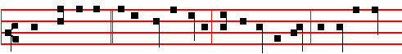
Thou, Bethlehem,* in the land of Juda, shalt not be the least: for out of thee

322
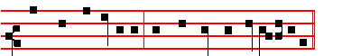
shall come a Governor that shall rule my people Israel.
Then the Prayers
On Magnificat, Antiphon.
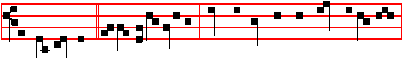
Awake, awake, * arise, O Jerusalem: loose thyself from the bands of thy neck,
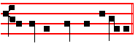
O captive daughter of Sion.
Unless an O Antiphon is to be said.
Then the Prayers.
__________________________________________________________________

Ember Wednesday
Blessing May the Gospel.
The Lesson from the Holy Gospel according to S. Luke Ch. 1
IN the sixth month the angel Gabriel was sent from God unto a city of Galilee, named Nazareth, to a virgin espoused to a man whose name was Joseph, of the house of David; and the virgin's name was Mary.
Homily by S. Ambrose, Bishop Bk. 2 on S. Luke
Lesson j
THE divine mysteries are well hidden and their meanings are not easy to grasp. For, as the prophet says: What man is he that can know the counsel of God? And yet we can gather from other sayings of our Lord and Saviour, that there was some prevalent reason for singling out for the Child-bearing of our Lord one who was espoused to a man. Why was her time not fulfilled before her espousal? To give the devil no chance of saying that she had conceived in adultery.

 O thou that bringest good tidings of peace to Jerusalem, lift up thy voice with strength: * Say unto the cities of Judah, and to the inhabitants of Jerusalem: Behold, our God will come, for whom we waited.
 O thou that tellest good tidings to Zion: get thee up into the high mountain, lift up thy voice with strength. Say unto.

323
Blessing May the divine.
Lesson ij
AND the Angel came in unto her. Mark the virtue of a virgin in her behaviour, mark it in her hesitancy, mark it in her words, in the mystery itself. It is natural for a virgin to be timid, perturbed at the approach of men, and troubled at their salutation. Here is an example of modesty for women to study. She was alone in her chamber, she who would not be seen by men, and an Angel alone discovers her there. She was alone with neither companion nor witness, when the Angel saluted her, so that their converse could not be basely interpreted.

 There shall come a star out of Jacob, and a man shall rise. out of Israel, and shall smite through all the princes of the aliens.* And the earth shall be his possession.
. All kings shall fall down before him, all nations shall do him service. And all.

Blessing May the King of.
Lesson iij
NOW this mystery was not to be entrusted to men, but was to issue from the mouth of an Angel. Today is heard for the first time: The Holy Ghost shall come upon thee. It is both heard and believed. Then she says: Behold the handmaid of the Lord: let it happen to me according to thy word. How humble she is! How she consecrates herself! She who is chosen to be the Mother of the Lord calls herself his handmaid, instead of exalting herself at the unexpected promise.

 The Lord the Ruler cometh quickly. * And his name shall be called Emmanuel.
 In his time shall the righteous flourish, yea, and abundance of peace. And his name. Glory be. And his name.

On Benedictus, Antiphon.
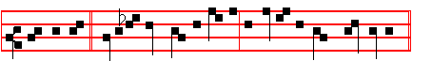
The Angel * Gabriel was sent to Mary, a Virgin espoused to Joseph.
Then the Prayers.
COLLECT

GRANT, we beseech thee, almighty God: that the coming solemnity of our redemption may bestow on us thy succour in this present life, and win for us the rewards of everlasting blessedness. Through.
¶ And it is said at all Hours, except in Vespers.
On Magnificat, Antiphon.
324
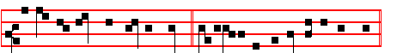
Behold the handmaid of the Lord; * be it unto me according to thy word.
Unless an O Antiphon is to be said.
After the Prayers is said the Collect of the preceding Sunday, Incline thine ear, as above.
__________________________________________________________________

THURSDAY
From the Prophet Isaiah.
Lesson j Ch. 33
WOE to thee that spoilest, and thou wast not spoiled; and dealest treacherously, and they dealt not treacherously with thee! when thou shalt cease to spoil, thou shalt be spoiled; and when thou shalt make an end to deal treacherously, they shall deal treacherously with thee. O Lord, be gracious unto us: we have waited for thee: be thou their arm every morning, our salvation also in the time of trouble.

 The Lord shall go forth and fight against the nations. * And his feet shall stand upon the Mount of Olives on the East.
 And It shall be exalted above the hills, and all nations shall flow unto it. And his feet.

Lesson ij
AT the noise of the tumult the people fled; at the lifting up of thyself the nations were scattered. And your spoil shall be gathered like the gathering of the caterpiller: as the running to and fro of locusts shall he run upon them. The Lord is exalted; for he dwelleth on high: he hath filled Zion with judgment and righteousness. And wisdom and knowledge shall be the stability of thy times, and
strength of salvation: the fear of the Lord is his treasure.

 The Fore-runner is for us entered, even the Lamb without spot, * Made an High Priest for ever after the order of Melchisedek.
 This is that King of Righteousness, without descent nor end of life. Made an.

Lesson iij
THE sinners in Zion are afraid; fearfulness hath surprised the hypocrites. Who among us shall dwell with the devouring fire? who among us shall dwell with everlasting burnings? He that walketh righteously, and speaketh uprightly ; he that
desplseth the gaIn of oppression, that shaketh his hands from holding of bribes, that stoppeth his ears from hearing of blood, and shutteth his eyes from seeing

325
evil. He shall dwell on high: his place of defence shall be the munitions of rocks: bread shall be given him; his waters shall be sure. Thine eyes shall see the king in his beauty: they shall behold the land that is very far off.

 The Gentiles shall see thy right.eous one, and all kings thy glorious one, * And
thou shalt be called by a new name, which the mouth of the Lord shall name.
 Thou shalt also be a crown of glory in the hand of the Lord, and a royal diadem
in the hand of thy God. And thou. Glory be. And thou.

On Benedictus, Antiphon.
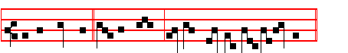
Be ye watchful * in your hearts, for the Lord our God is at hand.
¶ Unless the Feast of S.Thomas occurs, for then it is omitted and is said the Antiphon
Be not afraid, or upon the fifth day our Lord shall come to you.E u o u a e.
¶ Which is observed on the following days also when that Feast occurs.
The Prayers, as above.
On Magnificat, Antiphon.
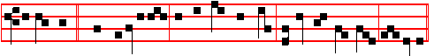
Rejoice ye * with Jerusalem; and be glad with her, all ye that love her, for ever.
Unless an O Antiphon is to be said
Then the Prayers.
__________________________________________________________________

EMBER FRIDAY

The Lesson from the Holy Gospel according to S. Luke
Lesson j Ch. 1.
MARY arose in those days, and went into the hill country with haste, into a city of Juda: and entered into the house of Zacharias, and saluted Elisabeth.
Homily by S. Ambrose, Bishop Book 2 on S. Luke.

326
THOSE who exact faith are generally expected to incite faith. Accordingly when the Angel announced secret counsels, he announced the conception of an aged and barren woman, to incite the faith of the Virgin Mary. For with God nothing shall be impossible, he asserts, of all things that he is pleased to do. Mary set out for the hill country when she heard this, not because she doubted his words nor because she mistrusted the messenger, nor because the example he had given her lacked proof; but she went rejoicing in her consecration, inspired by her sacred office, hastening for very joy. Whither does she go, she who is now bearing God? She hastens with all speed to higher realms, for the grace of the Holy Spirit knows no delay.

 Send forth the Lamb, O Lord, the Ruler of the land, * From the Rock of the wilderness unto the mount of the daughter of Sion.
 Shew us thy mercy, O Lord, and grant us thy salvation. From the.

Lesson ij
LET all devout women mark this, and realize that they too should spare no effort to help their kinsfolk when they are with child. Mary had been accustomed to dwell alone in her chamber, but her virgin modesty did not prevent her from mingling with the crowds, nor did bleak mountains quell her zeal, nor the long journey deter her from doing her duty. The Virgin. went into the hill country wIth haste, a virgin mindful of her duty and heedless of trouble, knowing that she was needed and regardless of her frailty, and so she left her home and set out. Let all young women study her example, and not waste time, paying idle visits on the way, nor wanderipg about in the streets, nor stopping to gossip with those they meet. It was Mary's way to stay within walls and to accomplish her journeying with all speed; and she remained with her cousin three months.

 Drop down, ye heavens, from above, and let the skies pour down righteousness. * Let the earth open, and let them bring forth salvation.
 Send forth the Lamb, O Lord, the Ruler of the land, from the Rock of the wilderness unto. the mount of the daughter of Sion. Let the earth.
.
Lesson iij
MARY'S example of modesty has been shown: let young women also study her humility. She came as one relative to another, as the younger to the elder, nor did she merely come; she was the first to utter her greeting. It should always be the case, that the more chaste a virgin is, the more is she humble. She will know how to submit to her elders. Let whoever makes profession of chastity be expert in, be the mistress of, humility; for this is the root of piety, and the first

327
principle of. its teaching. How wondrous indeed is this incident, when the superior comes to the inferior, to bring aid to the inferior: Mary comes to Elisabeth, Christ to John.

 The waste places have brought forth sweet-smelling buds for Israel: for behold
our God will come with power. * And his brightness is with him.
 Out of Zion shall God appear in perfect beauty: our God shall come and shall not keep silence. And his. Glory be. And his.

On Benedictus, Antiphon.
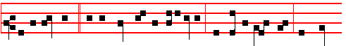
For lo, as soon * as the voice of thy salutation sounded in mine ears, the babe
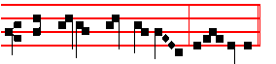
leaped in my womb for joy, al-le – lu-ia.
¶ Unless the Antiphon Be not afraid is to be said.
Then the Prayers.
COLLECT
STIR up, we beseech thee, O Lord, thy power, and come among us: that they who put their confidence in thy goodness may speedily be delivered from all adversity:
Who livest.
¶ And it is said at all Hours, except in Vespers.
On Magnificat, Antiphon.
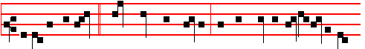
This is the witness * which John bare, saying: He that cometh after me is pre-
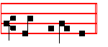
ferred before me.
¶ Unless an O Antiphon is to be said.
Then the Prayers.
Collect of the preceding Sunday.

328
EMBER SATURDAY

The Lesson from the Holy Gospel according to S. Luke
Lesson j Ch. 3. 1-6
NOW in the fifteenth year of the reign of Tiberius Cæsar, Pontius Pilate being governor of Judæa. And the rest.
Homily by S. Gregory the Great Homily 20 on the Gospels
THE date at which the Fore-runner of our Redeemer took up his office is indicated by the mention of the ruler of the Roman State and of those of the Judæan regions. John came to preach him who was to bring redemption to some of the Jews and many of the Gentiles; and therefore his preaching is dated by the mention of the Gentile ruler and the governors of the Jews. This description of territories and dominions indicates that the Gentiles were going to be gathered together, and the Jews scattered because of their guilt and treachery. One ruler of the Roman State is mentioned, and the kingdom of the Jews is described as split up into four with rulers over each part.

 There shall come forth a rod out of the stem of Jesse, and a branch shall grow out of his roots: * And righteousness shall be the girdle of his loins, and faithfulness the girdle of his reins.
 And the spirit of the Lord shall rest upon him, the spirit of wisdom and understanding. And righteousness.

Lesson ij
BY the voice of our Redeemer it is said: Every kingdom divided against itself is brought to desolation. It is clear that the end of the kingdom of the Jews is at hand, when it is divided and subject to so many rulers. Fittingly the names of the high priests as well as of the rulers are given; he whom John the Baptist preached was both the Kmg and the High Priest who was to come; S. Luke the Evangelist fixes the date of his preaching by both rulers and priests.

 Behold the Root of Jesse that shall arise to bring forth judgment to the Gentiles, in him shall the Gentiles trust .* And his name shall be blessed for ever.
 The kings shall shut their mouths at him, to him shall the Gentiles seek. And his name.

Lesson iij
AND he came into all the country about Jordan, preaching the baptism of repentance for the remission of sins. It is clear from all the versions that John actually baptized, as well as preaching the baptism of repentance. Yet his baptism

329
was not able to remit sins; the remission of sins is given us only through the baptism of Christ. Notice how it is expressed: preaching the baptism of repentance for the remission of sins. The baptism that he preached gave the absolution from sins which he himself was not able to give. Just as in the word of his preaching there was the fore-running of the Incarnate Word of the Father, so, in his baptism that could not absolve sins lay the antecedent of that baptism of repentance which did give absolution.

 O Lord, come, and make no tarrying; loosen the bonds of thy people. * And gather again into their own land them that are scattered abroad.
 O Lord, stir up thy strength, and come, and help us. And gather. Glory be. And gather.

On Benedictus, Antiphon.
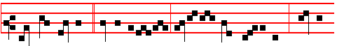
How shall this be, * O Angel of God, seeing I know not a man? Hearken,
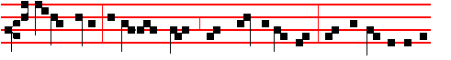
O Virgin Mary: the Holy Ghost shall come upon thee, and the power of the
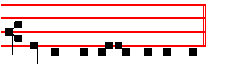
Highest shall ov-er-shadow thee.

¶ Unless the Antiphon Be not afraid is to be said, and unless this is the day before the Vigil of the Nativity: for then, it is omitted and the Antiphon Behold all things are fulfilled which were were spoken by the Angel to the Virgin Mary, is said, as noted above, p. 319.

¶ Which is observed also (if the same happens) on the following days.
Then the Prayers.
COLLECT

O GOD, who seest us that we are afflicted by reason of our iniquity: mercifully grant; that we may be comforted by thy visitation. Who livest.
And it is said at all the Hours.

330
AT VESPERS

Chapter 1 Cor. 4
BRETHREN: Let a man so account of us as of the ministers of Christ, and stewards of the mysteries of God. Moreover, it is required in stewards, that a man be found faithful.
Hymn and  as on the first Saturday.
On Magnificat, one of the Great O Antiphons.

COLLECT

STIR up, we beseech thee, O Lord, thy power, and come: and with great might succour us; that whereas through our sins we are hindered, we may through the help of thy grace speedily obtain thy merciful pardon. Who livest.

THE FOURTH SUNDAY OF ADVENT

At Matins. Invitatory.The Lord is now at hand. * O come, let us worship. Ps.95 Venite. Hymn.E.H.1 as above.
IN THE FIRST NOCTURN
From the Prophet Isaiah
Lesson j Ch. 35.
THE wilderness and the solitary place shall be glad for them, and the desert shall rejoice, and blossom as the rose. It shall blossom abundantly, and rejoice even with joy and singing: the glory of Lebanon shall be given unto it, the excellency of Carmel and Sharon, they shall see the glory of the Lord, and the excellency of our God. Strengthen ye the weak hands, and confirm the feeble knees. Say to them that are of a fearful heart, Be strong, fear not: behold, your God will come with vengeance, even God with a recompence ; he will come and save you. Then the eyes of the blind shall be opened, and the ears of the deaf shall be unstopped. Then shall the lame man leap as an hart, and the tongue of the dumb sing: for in the wilderness shall waters break out, and streams in the desert. And the parched ground shall become a pool, and the thirsty land springs of water.

 Blow ye the trumpet in Sion, call togetber the nations, tell it out among the people, and. say: * Behold, God our Saviour cometh.
 Tell it out, and make it to be heard; cry aloud and say, Behold.

Lesson ij
IN the habitation of dragons, where each lay, shall be grass with reeds and rushes. And an highway shall be there, and a way, and it shall be called The
way of holiness; the unclean shall not pass over it; but it shall be for those: the

331
wayfaring men, though fools, shall not err therein. No lion shall be there, nor any ravenous beast shall go up thereon, it shall not be found there; but the redeemed shall walk there; and the ransomed of the Lord shall return, and come to Zion with
songs and everlasting joy upon their heads: they shall obtain joy and gladness, and sorrow and sighing shall flee away.

 The sceptre shall not depart from Judah, nor a lawgiver from between his feet, until Shiloh come; * And unto him shall the gathering of the people be.
 His eyes shall be red with wine, and his teeth white with milk. And unto.

Lesson iij
KEEP silence before me, O islands; and let the people renew their strength: let
them come near; then let them speak: let us come near together to judgment. Who raised up the righteous man from the east, called him to his foot, gave the nations before him, and made him rule over kings? he gave them as the dust to his sword, and as driven stubble to his bow. He pursued them, and passed safely; even by the way that he had not gone with his feet. Who hath wrought and done it, calling the generations from the beginning? I the Lord, the first, and with the last; I am he.

 I must decrease, but he must increase: he it is, who coming after me is preferred before me. * Whose shoe's latchet I am not worthy to unloose.
 I baptize you with water, but he shall baptize you with the Holy Ghost. Whose shoe's. Glory be. Whose shoe's.

IN THE SECOND NOCTURN

Sermon by S. Leo the Great
Lesson iv Sermon on the December Fast
DEARLY beloved, if we study the origin of our creation with faith and wisdom, we find that man was made in the image of God, that he might imitate his originator; if the form of Divine Goodness is reflected in us, as though in a mirror, then that is the natural, honourable purpose of our species. And indeed every day the grace of our Saviour renews us, so that what fell in the first Adam is raised up in the second.

 Unto us shall a child be born, and his name shall be called the Mighty God. * He shall sit upon the throne of his father David, and shall reign, and the government shall be upon his shoulder.
 In him shall all the kindreds of the earth be blessed; all nations shall serve him. He shall sit.

332
Lesson v
THE loving mercy of God is alone the cause of our restoration: we would not love him had he not first loved us, and put to flight the darkness of our ignorance by the light of his truth. This he declares by the holy Isaiah, And I will bring the blind by a way that they knew not; I will lead them in paths that they have not known: I will make darkness light before them, and crooked things straight. These things will I do unto them, and not forsake them. And again: I was found of them that sought me not; I was made manifest unto them that asked not after me.

 Behold the fulness of the time is come, wherein God hath sent forth his Son into the world, born of a Virgin, made under the law, * To redeem them that were under the law.
 God for his great love wherewith he loved us, hath sent his own Son in the likeness of sinful flesh. To redeem.

Lesson vj
JOHN the Apostle teaches us how this was fulfilled, saying: And we know that the Son of God is come, and hath given us an understanding, that we may know him that is true, and we are in him that is true, even in his Son Jesus Christ. And again: We love God, because he first loved us. God, in his love for us, then, renews us in his image, and, so that he may find in us the fashion of his goodness, he gives us wherewIthal we may do good, lighting up, as it were, the lamps of our minds, enkindling us with the fire of his love, that we may love, not him only but all that he loves as well.

 O Virgin of Israel, turn again to thy cities. * How long wilt thou go about sorrowing? Thou shalt bring forth the Lord thy Saviour, a new offering in the earth: Men shall walk in the paths of salvation.
 I have loved thee with an everlasting love: therefore with lovingkindness have I drawn thee. How long.
IN THE THIRD NOCTURN
The Lesson from the Holy Gospel according to S. Luke
Lesson vij Ch. 3
NOW in the fifteenth year of the reign of Tiberius Cæsar, Pontius Pilate being governor of Judæa. And the rest.
Homily by S. Gregory the Great Homily. 20 on the Gospels
JOHN said to the multitude that came forth to be baptized by him, O generation of vipers, who hath warned you to flee from the wrath to come? For the wrath to come is the punishment of extreme vengeance: this, the sinner who does not now hasten to cries of penitence, cannot then escape. And note, that evil offspring,

333
imitating the deeds of their evil sires, are called a generation of vipers. For because they envy the good and persecute them, because to some they return evil rewards, because they seek out injuries for their kin, since in all this they follow the paths of their fathers according to the flesh, they are born as it were venomous sons of venomous sires.

 I have sworn, saith the Lord, that I will not be wroth any more with the earth: for the mountains and hills shall receive my righteousness. * And the covenant of my peace shall be in Jerusalem.
 My salvation is near to come, and my righteousness to be revealed. And the.

Lesson viij
BUT since we have now sinned because we are entangled in the habit of evil custom, let him say what we should do that we may be able to flee from the wrath to come. There follows: Bring forth therefore fruits worthy of repentance. In these words note that the friend of the bridegroom enjoins not only that the fruits of repentance be brought forth: but fruits worthy of repentance. For it is one thing to produce the fruit of repentance, another to produce fruit worthy of repentance. That we may speak concerning fruits worthy of repentance, know that whoever has committed no unlawful. deeds is rightly granted to enjoy what is lawful: and he may so work the works of piety that if he so wishes he need not leave the things of the world.

 So will not we go back from thee; O let us live, and we shall call upon thy name. * Shew the light of thy countenance, and we shall be whole.
 Remember me, O Lord, according to the favour that thou bearest unto thy people: O visit me with thy salvation. Shew the light.

Lesson ix
BUT if anyone has fallen into the sin of fornication, or perhaps, what is worse,
into adultery, he must cut himself off from lawful pleasures, according as he remembers that he has committed things unlawful. The fruit of good work must not be the same in the case of him who has sinned less and him who has sinned more. Or of him who has fallen in no sins, and of him who has fallen in some ill deeds, and of him who has sunk in many. For this reason therefore is the saying, Bring forth fruits worthy of repentance. Each man's conscience accepts that through repentance he secures the greater profit of good works precisely as by his sin he has brought upon himself the heavier loss.

 Consider how great this man is, who is entered for the salvation of the nations:
he is King of Righteousness, * Without descent nor end of life.

334
 The Fore-runner is for us entered, and made an High Priest for ever after the order of Melchisedek. Without descent. Glory be. Without descent.

AT LAUDS
And through the Hours,

Antiphon 1. Tone j, 1.
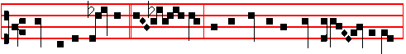
Blow ye the trumpet * in Si - on, for the day of the Lord is nigh at hand:
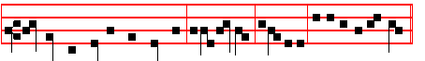
behold, he cometh to save us, al-le- lu-ia, alle-lu- ia. E u o u a e. Ps.93 Dominus regnavit, and the rest, p. 28.
Antiphon 2. Tone j 1.
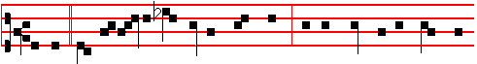
Behold * the Desire of all nations shall come: and the house of the Lord shall
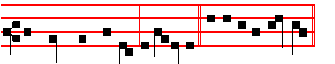
be filled with glory, al-le-lu-ia. E u o u a e.
Antiphon 3. Tone j, 2.
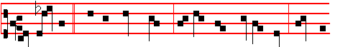
The crooked * shall be made straight, and the rough places plain: come, O
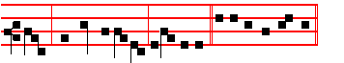
Lord, and do not tarry, al-le-lu-ia. E u o u a e.

Antiphon 4. Tone j, 1.

335
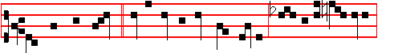
The Lord will come,* go ye out to meet him, saying, Great is his dominion,
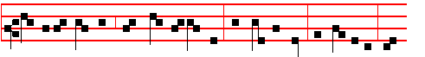
and of his kingdom there shall be no end: the mighty God, the Governor, the
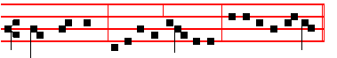
Prince of peace, al-le-lu-ia, al-le-lu-ia. E u o u a e.
Antiphon 5. Tone ij.
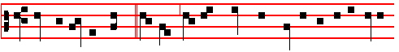
Thine Almighty Word, * O Lord, leapeth down from heaven out of thy royal
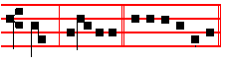
throne, al-le-lu-ia. E u o u a e.
Chapter I Cor.4
BRETHREN: Let a man so account of us as of the ministers of Christ, and stewards of the mysteries of God. Moreover, it is required in stewards, that a man be found faithful.
Hymn En clara vox and  as on the first Sunday, 273-4.
On Benedictus, Antiphon. Tone j, 2.
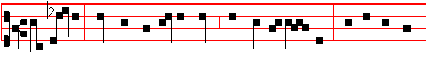
Hail, Mary, * thou that art full of grace, the Lord is with thee; blessed art thou
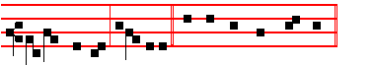
among women, al-le-lu-ia. Canticle Benedictus, p. 37. Unless the Antiphon Be not afraid, or the Antiphon Behold all things, is to be said.
336
COLLECT
STIR up, we beseech thee, O Lord, thy power, and come: and with great might succour us; that whereas through our sins we are hindered, we may through the help of thy grace speedily obtain thy merciful pardon. Who livest.

AT TERCE.
Antiphon Behold.
Chapter Brethren: Let a man account, as above.
Short , as above, p. 275.
Come and save us, * O Lord God of hosts. Come and.
 Shew the light of thy countenance, and we shall be whole. O Lord. Glory be. Come and.
 The heathen shall fear thy name, O Lord.
 And all the kings of the earth thy majesty.

AT SEXT
Antiphon The crooked
Chapter I Cor. 4
BUT with me it is a very small thing that I should be judged of you, or of man's judgment; yea, I judge not mine own self.
Short , as above, p.276.
Shew us thy mercy, * O Lord. Shew us.
 And grant us thy salvation. O Lord. Glory be. Shew us.
 Remember me, O Lord, according to the favour that thou bearest unto thy people.
 O visit me with thy salvation.
AT NONE
Antiphon Thine Almighty Word.
Chapter I Cor.4
THEREFORE judge nothing before the time, until the Lord come, who both will bring to light the hidden things of darkness, and will make manifest the counsels of the hearts: and then shall every man have praise of God.
Short , as above, p. 276-7.
The Lord shall arise upon thee, * O Jerusalem.The Lord.
 And his glory shall be seen upon thee. O Jerusalem. Glory be. The Lord.
 Turn us again, O Lord God of hosts.
 Shew the light of thy countenance, and we shall be whole.

AT VESPERS
Antiphons from Lauds, Psalms of Sunday. Chapter, Hymn and  as above at I Vespers.
337
On Magnificat, O Antiphon.
Collect Stir up, as above.
After Vespers of the Day are said Vespers of the Dead.
__________________________________________________________________

Monday
From the Prophet Isaiah
Lesson j Ch. 41.
BUT thou, Israel, art my servant Jacob whom I have chosen, the seed of Abraham my friend. Thou whom I have taken from the ends of the earth, and called thee from the chief men thereof, and said unto thee, Thou art my servant; I have chosen thee, and not cast thee away. Fear thou not; for I am with thee: be not dismayed; for I am thy God: I will strengthen thee yea, I will help thee; yea, I will uphold thee with the right hand of my righteousness.

 Blow ye the trumpet in Sion, call together the nations, tell it out among the people, and say: * Behold God our Saviour cometh.
 Tell it out, and make it to be heard: cry aloud and say, Behold.

Lesson ij
BEHOLD, all they that were incensed against thee shall be ashamed and confounded: they shall be as nothing; and they that strive with thee shall perish. Thou shalt seek them, and shalt not find them, even them that contended with thee: they that war. against thee shall be as nothing, and as a thing of nought. For I the Lord thy God will hold thy right hand, saying unto thee, Fear not; I will help thee.

 The sceptre shall not depart from Judah, nor a lawgiver from between his feet, until Shiloh come; * And unto him shall the gathering of the people be.
 His eyes shall be red with wine, and his teeth white with milk. And unto.

Lesson iij
FEAR not, thou worm Jacob, and ye men of Israel; I will help thee, saith the Lord, and thy redeemer, the Holy One of Israel. Behold, I will make thee a new sharp threshing instrument having teeth: thou shalt thresh the mountains, and beat them small and shalt make the hills as chaff. Thou shalt fan them, and the wind shall carry them away, and the whirlwind shall scatter them: and thou shalt rejoice in the Lord, and thou shalt glory in the Holy One of Israel.

 I must decrease, but he must increase: he it is, who coming after me, is preferred before me. Whose shoe's latchet I am not worthy to unloose.

338
 I baptize you with water, but he shall baptize you with the Holy Ghost. Whose
shoe's. Glory be. Whose shoe's.

AT LAUDS.

Antiphons according to the Rubric above, after the Third Sunday and the O Antiphons.
Psalms of Monday as in the Psalter.
Chapter Is.2
COME ye, and let us go up to the mountain of the Lord, to the house of the God. of Jacob; and he will teach us of his ways, and we will walk in his paths: for out of Sion shall go forth the law, and the word of the Lord from Jerusalem.
Hymn En clara vox and  as on the first Sunday, p.273-4.
On Benedictus, Antiphon.
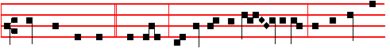
Thus saith the Lord * your God: Repent ye, and turn again; for the kingdom
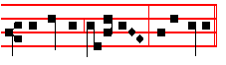
of heaven is at hand, al-le-lu-ia. Unless the Antiphon Be not afraid or the Antiphon Behold all things is to be said.
Then the Prayers.
Collect Stir up of Sunday. Today the Office of the Dead.

AT VESPERS
Antiphons and Psalms of the Psalter.
Chapter Gen. 49
THE sceptre shall not depart from Judah, nor a lawgiver from between his feet, until Shiloh come; and unto him shall the gathering of his people be.
Hymn E.H. l and  Drop down, as above, p. 265.
On Magnificat, O Antiphon. Then the Prayers.
__________________________________________________________________

TUESDAY
From the Prophet Isaiah
Lesson j Ch. 42.

339
BEHOLD my servant, whom I uphold; mine elect, in whom my soul delighteth; I have put my spirit upon him: he shall bring forth judgment to the Gentiles. He shall not cry, nor lift up, nor cause his voice to be heard in the street. A bruised reed shall he not break, and the smoking flax shall he not quench: he shall bring forth judgment unto truth He shall not fail nor be discouraged, till he have set judgment in the earth: and the isles shall wait for his law.

 Unto us shall a child be born, and his name shall be called the Mighty God. * He shall sit upon the throne of his father David, and shall reign, and the government shall be upon his shoulder.
 In him shall all the kindreds of the earth be blessed; all nations shall serve him. He shall sit.

Lesson ij
THUS saith God the Lord, he that created the heavens, and stretched them out; he that spread forth the earth and that which cometh out of it; he that giveth breath unto the people upon it, and spirit to them that walk therein: I the Lord have called thee in righteousness, and will hold thine hand, and will keep thee, and give thee for a covenant of the people, for a light of the Gentiles: to open the blind eyes, to bring out the prisoners from the prison, and them that sit in darkness out of the prison house.

 Behold the fulness of the time is come, wherein God hath sent forth his Son into the world, born of a Virgin, made under the law, * To redeem them that were under the law.
 God for his great love wherewith he loved us, hath sent his own Son in the likeness of sinful flesh. To redeem.

Lesson iij
SING unto the Lord a new song, and his praise from the end of the earth, ye that go down to the sea, and all that is therein; the isles, and the inhabitants thereof. Let the wilderness and the cities thereof lift up their voice, the villages that Kedar doth inhabit: let the inhabitants of the rock sing, let them shout from the top of the mountains. Let them give glory unto the Lord, and declare his praise in the Islands. The Lord shall go forth as a mighty man, he shall stir up jealousy like a man. of war: he shall cry, yea, roar; he shall prevail against his enemies.

 O Virgin of Israel, turn again to thy cities. * How long wilt thou go about sorrowing? Thou shalt bring forth the Lord thy Saviour, a new offering in the earth: * Men shall walk in the paths of salvation. .
 I have loved thee with an everlasting love: therefore with lovingkindness have I

340
drawn thee. How long. Glory be. Men shall.

On Benedictus, Antiphon.
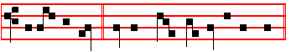
Awake, awake, * put on strength, O arm of the Lord.
Unless the Antiphon. Be not afraid, or the Antiphon Behold, all things, is to be said.
Then Kyrie, eleison, etc.
On Magnificat, O Antiphon.
Then Kyrie, eleison.
__________________________________________________________________

WEDNESDAY
From the Prophet Isaiah
Lesson j Ch. 51.
HEARKEN unto me, ye that follow after righteousness, ye that seek the Lord: Look unto the rock, whence ye are hewn, and to the hole of the pit whence ye are digged. Look unto Abraham your father, and unto Sarah that bare you: for I called him alone, and blessed him, and increased him. For the Lord shall comfort Zion: he will comfort all her waste places; and he will make her wilderness like Eden and her desert like the garden of the Lord; joy and gladness shall be found therein, thanksgiving, and the voice of melody.

 I have sworn, saith the Lord, that I will not be wroth any more with the earth: for the mountains and hills shall receive my righteousness. * And the covenant of my peace shall be In Jerusalem.
 My salvation is near to come, and my righteousness to be revealed. And the.

Lesson ij
HEARKEN unto me, my people; and give ear unto me, O my nation: for a law
shall proceed from me, and I will make my judgment to rest for a light of the people. My righteousness is near; my salvation is gone forth, and mine arms shall judge the people; the isles shall wait upon me, and on mine arm shall they trust. Lift up your eyes to the heavens, and look upon the earth ben.eath: for the heavens
shall vanish away like smoke, and the earth shall wax old like a garment, and they that dwell therein shall die in like manner: but my salvation shall be for ever, and my righteousness shall not be abolished.

 So will not we go back from thee; O let us live, and we shall call upon thy name. * Shew the light of thy countenance, and we shall be whole.

341
 Remember me, O Lord, according to the favour that thou bearest unto thy people: O visit me with thy salvation. Shew the light.

Lesson iij
HEARKEN unto me, ye that know righteousness, the people in whose heart is my law; fear ye not the reproach of men, neither be ye afraid of their revilings. For the moth shall eat them up like a garment, and the worm shall eat them like wool: but my righteousness shall be for ever, and my salvation from generation to generation.

 Consider how great this man is, who is entered for the salvation of the nations:
he is King of Righteousness, * Without descent nor end of life.
 The Fore-runner is for us entered and made an High Priest for ever after the order of Melchisedek. Without descent. Glory be. Without descent.

On Benedictus, Antiphon.
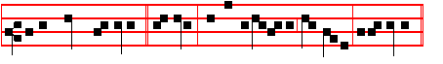
I will place salvation * in Sion and in Jerusalem my glory, al-le-lu-ia.
Unless the Antiphon Be not afraid, or the Antiphon Behold. all things is to be said.
Then Kyrie eleison.
On Magnificat, O Antiphon. Then Kyrie, eleison.
__________________________________________________________________

THURSDAY

From the Prophet Isaiah
Lesson j Ch. 64
OH that thou wouldest rend the heavens, that thou wouldest come down, that the mountains might flow down at thy presence, as when the melting fire burneth, the fire causeth the waters to boil, to make thy name known to thine adversaries, that the nations may tremble at thy presence! When thou didst terrible things which we looked not for, thou camest down, the mountains flowed down at thy presence. For since the beginning of the world men have not heard, nor perceived by the ear, neither hath the eye seen, O God, beside thee, what he hath prepared for him that waiteth for him.

 Blow ye the trumpet in Sion, call together the nations, tell it out among the people, and say, * Behold God our Saviour cometh.

342
 Tell it out, and make it to be heard; cry aloud and say, Behold.

Lesson ij
THOU meetest him that rejoiceth and worketh nghteousness, those that remember thee in thy ways: behold, thou art wroth; for we have sinned: in those is continuance, and we shall be saved. But we are all as an unclean thing, and all our nghteousnesses are as filthy rags, and we all do fade as a leaf; and our iniquities, like the wind, have taken us away. And there is none that calleth upon thy name, that stirreth up himself to take hold of thee: for thou hast hid thy face from us, and hast consumed us, because of our iniquities.

 The sceptre shall not depart from Judah, nor, a law-giver from between his feet,
till Shiloh come: * And unto him shall the gathering of the people be.
 His eyes shall be red with wine, and his teeth white with milk. And unto.

Lesson iij
BUT now, O Lord, thou art our father; we are the clay, and thou our potter; and we all are the work of thy hand, Be not wroth very sore, O Lord, neither remember iniquity for ever: behold see, we beseech thee, we are all thy people. Thy holy cities are a wilderness, Zion is a wilderness, Jerusalem a desolation. Our holy and our beautiful house, where our fathers praised thee, is burned up with fire: and all our pleasant things are laid waste.

 I must decrease, but he must increase: he it is, who coming after me; is preferred before me. * Whose shoe's latchet I am not worthy to unloose.
 I baptize you with water, but he shall baptize you with the Holy Ghost, Whose
shoe's. Glory be. Whose shoe's.
On Benedictus, Antiphon.
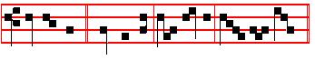
Comfort ye, * comfort ye my people, saith your God.
Unless the Antiphon Be not afraid or the Antiphon Behold all things is to be said.
Then Kyrie, eleison
On Magnificat, O Antiphon.
Then Kyrie, eleison.
__________________________________________________________________

FRIDAY
From the Prophet Isaiah
Lesson j Ch. 66.
343
HEAR the word of the Lord, ye that tremble at his word; Your brethren that hated you, that cast you out for my name's sake, said, Let the Lord be glorified: but he shall appear to your joy, and they shall be ashamed. A voice of noise from the city, a voice from the temple, a voice of the Lord that rendereth recompence to his enemies, Before she travailed, she brought forth; before her pain came, she was delivered of a man child. Who hath heard such a thing? who hath seen such things? Shall the earth be made to bring forth in one day? or shall a nation be born at once? for as soon as Zion travailed, she brought forth her children.

 Unto us shall a child be born, and his name shall called the Mighty God. * He shall sit upon the throne of his father David, and shall reign, and the government shall be upon his shoulder.
 In him shall all the kindreds of the earth be blessed; all nations shall serve him. He shall sit.

Lesson ij
SHALL I bring to the birth, and not cause to bring forth? saith the Lord: shall I cause to bnng forth, and shut the womb? saith thy God. Rejoice ye with Jerusalem and be glad with her, all ye love her: rejoice for joy with her, all ye that mourn for her: that ye may suck, and be satisfied with the breasts of her consolations; that ye may milk out, and be delighted with the abundance of her glory. For thus saith the Lord, Behold I will extend peace to her like a river, and the glory of the Gentiles like a flowing stream: then shall ye suck, ye shall be borne upon her sides, and be dandled upon her knees.

 Behold the fulness of the time is come, wherein God hath sent forth his Son into the world, born of a Virgin, made under the law, * To redeem them that were under the law.
 God for his great love wherewith he loved us, hath sent his own Son in the likeness of sinful flesh. To redeem.

Lesson iij
AS one whom his mother comforteth, so will I comfort you; and ye shall be comforted in Jerusalem. And when ye see this, your heart shall rejoice, and your bones shall flourish like an herb: and the hand of the Lord shall be known toward his servants, and his indignation toward his enemies. For, behold, the Lord
will come with fire, and with his chariots like a whirlwind, to render his anger with fury: and his rebuke with flames of fire. For by fire and by his sword will the Lord plead with all flesh: and the slain of the Lord shall be many.

344
 O Virgin of Israel, turn again to thy cities. * How long wilt thou go about sorrowing?
 Thou shalt bring forth the Lord thy Saviour, a new offering in the earth: * Men
shall walk in the paths of salvation.
 I have loved thee with an everlasting love: therefore with lovingkindness have I drawn thee. How long. Glory be. Men shall.
On Benedictus, Antiphon.
Behold all things are fulfilled * which were spoken by the Angel of the Virgin
Ma - ry.
Then Kyrie, eleison.
On Magnificat,Antiphon. Tone ij,
O EMMANUEL, our King and Lawgiver, the Desire of all nations, and their
Salvation: Come and save us, O Lord our God. E u o u a e.
Then Kyrie,eleison.

¶ If the Vigil of the Nativity of the Lord come on a Sunday the Office is said in this way:
At Matins, Invitatory of the Vigil This day ye shall know, as below. Hymn of Advent, Verbum supernum E.H.2. Antiphons,Psalms, Versicles, Lessons and Responsories in the first and second Nocturns are said from the fourth Sunday; in the third Nocturn, the Antiphons and Psalms of Sunday, Versicle of the Vigil, the three Lessons of the Homily of the Vigil with its Responsories and the Homily of the Sunday is not read for the last Lesson. Lauds of the Vigil, with commemoration of the Sunday Likewise the office of the Vigil is celebrated through the Hours.

345
ON THE VIGIL OF THE NATIVITY OF THE LORD

AT MATINS

Invitatory. This day ye shall know that the Lord. cometh, * And in the morning, then ye shall see his glory. Ps. 95.
Hymn as for Advent. Antiphons and Psalms of the occurrent Feria, as in the Psalter.
 This day ye shall know that the Lord cometh.
 And in the morning, then ye shall see his glory.
Blessing. May the Gospel.
The Lesson from the Holy Gospel according to S. Matthew
Lesson j Ch. 1.
WHEN as his mother Mary was espoused to Joseph, before they came together, she was found with child of the Holy Ghost. And the rest.
Homily by S. Jerome, Priest Comm. on Matthew, Ch. 1.
WHY was he not born simply of a virgin, instead of an espoused one? Firstly, to reveal Mary's lineage by means of Joseph's: secondly, to prevent her being stoned by the Jews as an adulteress: thirdly, to provide a protector for the flight into Egypt. Ignatius the Martyr adds a fourth reason for his being born of an espoused maiden: to hide her child-bearing from the devil, who in would expect him to be born of a married woman.

 Sanctify yourselves this day and be ready: for in the morning ye shall see. * The Glory of God.
 Ye shall know this day that the Lord will come, and in the morning then ye shall see. The Glory.

Blessing May the divine.
Lesson ij
BEFORE they came together, she was found with Child of the Holy Ghost. By Joseph alone was she found; he had the bridegroom's privilege of knowing all about his bride. In the words, Before they came together, there is no indication that they did come together afterwards; but Scripture shows that they had not done so then.

 Be ye steadfast, and see the salvation of the Lord with you: O Judah and Jerusalem, fear not. * To-morrow go ye forth, for the Lord himself will be with you.
 Sanctify yourselves, ye children of Israel, and be ready. To-morrow.

Blessing May the king of
346
Lesson iij
THEN Joseph her husband, being a just man. and not willing to make her a publick example, was minded to put her away privily. If anyone is married to an adulteress, they become one body, and it is laid down in the law that addition to the culprit, any one who is privy to the crime is also guilty: how can Joseph be descnbed as, a just man, if he hid his wife's sin. This is the very testimony of Mary's purity, for Joseph knew that she was chaste, and marvelled at what was happening, and so he hid in silence the mystery that he did not understand.

 Sanctify yourselves, ye children of Israel, saith the Lord: For to-morrow thy God will come: * And he will take away from thee all sickness.
 To-morrow the iniquity of the earth shall be blotted out, and the Saviour of the world shall reign over us. And he will. Glory be. And he will.

¶ Henceforth the Office is Double.
AT LAUDS
and through the Hours
Antiphon 1. Tone viij, 1.
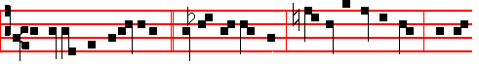
O Judah and Jerusa1em, * be ye not dismayed: tomorrow go ye forth, and the
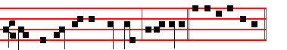
Lord himself will be with you, al-le-luia. E u o u a e. Psalm 93 and the rest,
p. 28.
Antiphon 2 Tone viij, 2.
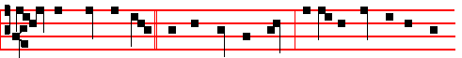
Ye shall know this day * that the Lord will come; and in the morning ye shall
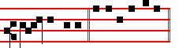
see his glory. E u o u a e.

Antiphon 3. Tone iv, 1.

347
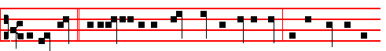
To-morrow * the iniquity of the earth shall be blotted out: and the Saviour of
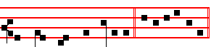
the world shall reign over us. E u o u a e.

Antiphon 4. Tone j, 1.
The Lord will come, * go ye out to meet him, saying: Great is his dominion,
and of his kingdom there shall be no end: the mighty God, the Governor, the
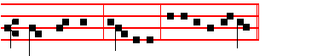
Prince of peace, al-le-lu-ia. E u o u a e.

Antiphon 5. Tone viij, 2.
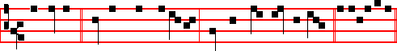
To-morrow * ye shall have salvation, saith the Lord God of hosts. E u o u a e.

Chapter Rom.1
PAUL, a servant of Jesus Christ, cal1ed to be an apost1e, separated unto the Gospel of God, (which he had promised afore by his prophets in the holy scriptures), concerning his Son Jesus Christ our Lord, which was made of the seed of David according to the flesh.

Hymn En clara vox, as on the first Sunday, p. 273.

348
 To-morrow the iniquity of the earth shall be blotted out.
 And the Saviour of the wor1d shall reign over us.
On Benedictus, Antiphon.
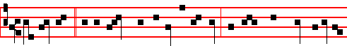
The Saviour * of the world shall arise as the sun: and shall come down into the
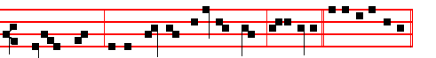
Virgin's womb, as the showers upon the grass, al-le-lu-ia. E u o u a e.

COLLECT

O GOD, who makest us glad with the yearly expectation of our
redemption: vouchsafe; that as we joyfully receive thine Only-begotten Son for our Redeemer, so we may with sure confidence behold him when he shall come to be our judge, even Jesus Christ thy Son our Lord: Who liveth.

And it is said through the Hours.

AT TERCE

Antiphon.Ye shall know this day, p. 347.
Chapter Paul, a servant, as above, p. 348.
Short 
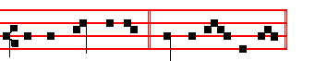
Ye shall know this day * That the Lord will come.
Ye shall.
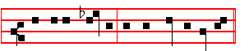
 And in the morning ye shall see his glo- ry That the Lord.

349
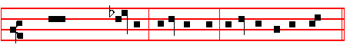
 Glory be to the Father, and to the Son: and to the Hioly Ghost.
Ye shall.
 Be ye stead - - - - - - fast.
 And see the salvation of the Lord with - - you.

AT SEXT

Antiphon. To-morrow the iniquity, p. 348
Chapter Rom.1
WHO was dec1ared to be the Son of God with power, according to the Spirit of holiness, by the resurrection from the dead.
Short 
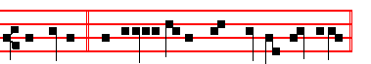
To-morrow * the iniquity of the earth shall be blotted out.
To-morrow
 And the Saviour of the world shall reign over us. The iniquity.
- Glory be, as above. To-morrow the.
 To-morrow ye shall have sa1va - - - - tion.
 Saith the Lord God of hosts.

AT NONE

Antiphon.To-morrow * ye shall have, as above, p. 348.
Chapter Rom. 1
BY whom we have received grace and apostleship, for obedience to the faith among all nations, for his name: among whom are ye also the called of Jesus Christ our Lord.
350
Short 
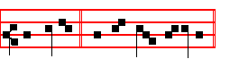
To-morrow * Ye shall have salvation.
To-morrow.
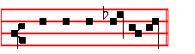
 Saith the Lord God of hosts.
Ye shall have.
G1ory be to the Father, and to the Son, and to the Ho-ly Ghost.
To-morrow ye.
 To-morrow the iniquity of the earth shall be blotted out.
 And the Saviour of the world shall reign over us.



351

